ICE 6A: Analyzing Web Sites with CRAP
Your Name: Yara Grassi Gouffon

Overview
So, you've been web surfing for quite some time now, and you've undoubtedly found some pages that you like and others that you don't like. Sometimes, it's not so easy to really explain why. You now have a new vocabulary with which to describe your thoughts on the matter.

Part 1: Group Evaluations
- Follow this link using the browser of your choice.
http://rochesterhomepage.net/

- Examine this site… at least the first page and a couple of links to sub-pages (pages that are part of the same site).
- Summarize your opinions and why you came to them here:
  - Alignment:

Could be worse, but some parts are a little off. The ads tend to be narrower than the other boxes and there are some occasions of links and pictures being a little higher than the headlines to the left.

  - Proximity:

Things feel like they’re a little too close together in the main section with five or so news. Proximity is appropriate for the Video Center part further down, however.

  - Repetition:

The horizontal, tabbed navigation bars have inconsistent looks. For example, the main one at the top is completely different from the one in the News subpage and both are completely different from the navigation bar in the Weather subpage.

  - Contrast:

Contrast is mostly fine, with black or dark blue text on white or gray background. The white text on the banner can be a little harder to read on some spots where the image has lighter tones of blue, but other than that the page has good contrast.

  - Use of color

The page itself has a good color scheme, with white, light gray and different shades of blue. However, the video thumbnails, news photos and ads have very contrasting and distracting colors. I don’t know if there is anything the designers could have done to prevent that, since they have no control over the news, but it just makes the page look bad.

  - Use of typography

Typography is pretty consistent. The same sans serif font is used for most of the text and is large enough to be easily readable. The sidebar on the right appears to have a slightly different font which doesn’t stand out too much and fits the rest.

- Now go into myCourses, into the Design Principles discussion, and tell the class your opinions on the design of http:// rochesterhomepage.com/. (HINT: You just wrote them in step 3). Each of you should post your thoughts individually – not as a group.
- After you post your review, read the other student comments about this site. Choose one other student review and summarize below:

  - Author of message you’re summarizing: Natalie Magee

  - Alignment:

Some parts aren't lined up correctly but the rest is relatively fine.

  - Proximity:

Things are a little too close together, more spacing would be better.

  - Repetition:

Images are around the same size and repetition is done nicely.

  - Contrast:
Contrast is done well. Colors don't class and the light background works well with the darker fonts.

  - Use of color:
Color scheme is simple and good.

  - Typography
Typography is okay but not great. A couple of sans serif fonts are used but there isn't enough difference between the sizing of titles and paragraphs. (Note: I'm assuming that's what she was going to say, her message got cut off for some reason.)

- Do you agree or disagree with this person about the design elements of the page in question (Why?)

I agree on pretty much all counts, except for the use of color. The site itself works fine, but I maintain my point that the ads don't fit. I also strongly agree with the idea that everything is too close together and needs to be spaced out more.

- Reply to their post (politely) to discuss your agreements and disagreements.

Part 2: Design Critiques
Pick a web site you don’t like (in terms of design), and a web site you do, and describe/critique each using the forms attached to this handout. If you are having trouble finding a bad site, try using a random link generator such as:
http://www.uroulette.com/ or
http://www.randomwebsite.com/

Part 3: Individual Critiques
Pick a color scheme for your own class page and describe it below. (Describe your color scheme in terms of what color(s) you will use for each element.) Feel free to make these determinations as a team.
White background, dark gray text for paragraphs, dark purple for headers and maybe black or another shade of purple for links.
Now, use the space below to sketch an improved layout for your page. Again, work with your neighbors to come up with something really great!
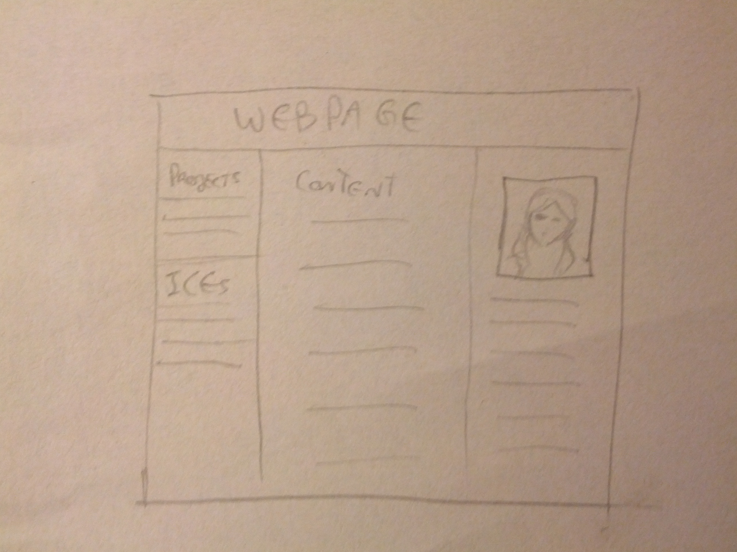
bad site: http://www5.usp.br/
Alignment: How many different styles of alignment can you see on this page? Describe them:
I can see center alignment for most of the content, and left and right alignment for the top navigation bars.

Where is the strongest alignment line on this page? Why?
Center, because almost all of the content is in center-aligned columns.

Proximity: Identify two elements of this site that, due to their proximity, appear to have a relationship.
The pictures and their links/titles in the Ensino section are close enough to be related, and so are the picture-title combinations close enough among themselves that they relate to the same subject, education.
Identify information at this site that "hangs" alone.
I can't really find anything. Maybe the banner with the World University Rankings information appears to be by itself with not much else.
Repetition: Does the repetition on this page draw attention to anything particular? What?
The repetition of news photos in rows and columns draws attention to them.
Describe the repetitive element(s) used to the best advantage on this site.
The little tag thing with a category name over each news picture is fairly consistent and looks nice.

Contrast: Identify the strongest area of contrast at this site.
It's everywhere. Colors are all over the place. I would say the most noticeable contrast is the blue theme with the white background.

Are there areas of this site that seem "muddy" or run together because of a
lack of contrast? What are they?
The navigation bar right at the bottom of the page, titled Comunicação Social, has a background that is too dark in comparison to the font so it's harder to read than the rest which is on white background.

Color & Type: Does the use of color and type on this page enhance or detract from
the content? How?
There is too much color everywhere for my taste. Instead of keeping to three or so colors, there are at least five colors and many other variants. It just makes everything look confusing.

Additional Notes:
The page tried to do a responsive design, but it's not working out too well. It does transform the navigation bars at the top into a menu, but the multi-column layout gets messed up. You end up with some content in two columns, and then a lot of content in a single column which only takes up half of the page.
good site: archiveofourown.org
Alignment: How many different styles of alignment can you see on this page? Describe them:
There is some center alignment for the main content boxes, but some of the text in the right column is left aligned as well as the Twitter box. The navigation bar at the top is left-aligned as well.

Where is the strongest alignment line on this page? Why?
I would say center, since the two main content columns are centered, but most of the text inside the boxes is left-aligned.
Proximity: Identify two elements of this site that, due to their proximity, appear to have a relationship.
The news title and content are close enough to be related, and the various bits of information on each story in the Browse Works page are close enough that it's easy to tell which story they relate to.
Identify information at this site that "hangs" alone.
The website description on the main page feels a little out of place.

Repetition: Does the repetition on this page draw attention to anything particular? What?
The repetition of the pattern for each story in the Browse Works page draws attention to the works.
Describe the repetitive element(s) used to the best advantage on this site.
The icons describing content and rating for each story are a neat idea based on repetition.
Contrast: Identify the strongest area of contrast at this site.
Red navigation bar at the top on white background.

Are there areas of this site that seem "muddy" or run together because of a
lack of contrast? What are they?
Not really. Everything is either white on red, or red or black on white and there is enough contrast.

Color & Type: Does the use of color and type on this page enhance or detract from
the content?
I think the top navigation bar is a little too eye-catching with the dark red, but everything else looks really nice.

Additional Notes:

When you're all done, post this completed file, renamed ICE-CRAP-YOURNAME.docx, to the appropriate dropbox before next class.

