ICE: Site Design

Overview
Your first job out of college is for an entrepreneur who’s made his fortune with his uncanny knack for buying the right domain names, then hiring a small clever creative team to build a killer web site for it. He has purchased what he believes will be one of the biggest killer domain names of his career and assigned it to you. It’s now up to you to design a site for it. To help you out, he has carefully selected teammates to assist you. Needless to say, if you do this job well, your career is assured.
The domain your boss has purchased is: octolist.net

Part 1: Define Purpose
- Why does this site exist?
It exists because the boss asked us to make it.

- What do you hope to achieve with it?

We hope to inform people about events in October and list locations, prices and more information.

- What's the Goal?

Inform people about events occurring in October.

Part 2: Consider Audience
- Who will be using your site?

Pretty much anyone, but maybe with a focus on ages 18 to 35 since they’re more likely to be navigating the web and access the site.

- What are some characteristics of these users?

They’re likely people who are bored or just looking for more information about October events, or even people that moved to a new area and need to know what to do around there.

- What technology will they have?

Computers, cell phones and tablets.

- How might that affect your design?

The design needs to be responsive and have good CSS for print.

Part 3: Gather Ideas & Brainstorm
- List numerous ideas without being critical
- An off-the-wall idea may help bring an excellent 'reasonable' idea to mind
- List features
- Examine other sites
- Ask potential users

- Integration with Google Maps for directions
- Ability to select areas on a map and print them out enlarged
- Export events to an iCal format or something of the sort
- Ability to filter events according to age, interests, location, price and requirements

Part 4: Organize Ideas
- Take ideas and consider them
  - Do they help the goals of the site defined at the beginning?
  - Seek maximum impact with minimum resource consumption
- Sort ideas into categories

Supporting – primary
- Ability to filter events according to age, interests, location, price and requirements

Supporting – secondary
- Integration with Google Maps for directions
- Ability to select areas on a map and print them out enlarged

Not directly supporting but useful
- Export events to an iCal format or something of the sort

Part 5: Organize Information
- The structure upon which you will build the site
- Needs to be thought out before design
- Doesn't need to be absolutely rigid (strong, yet flexible)

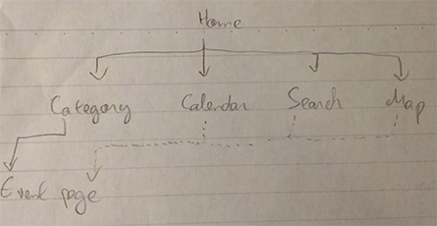

Part 6: Determine Navigation
- How should this be organized?
  - By category?
  - By date?
  - By alphabetical order?
  - Others?
- Draw a conceptual diagram.

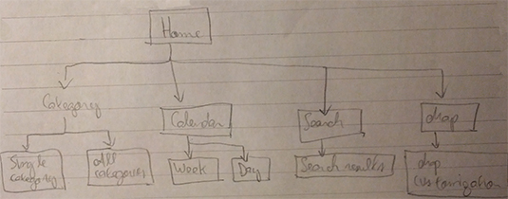

Part 7: Sketch Pages
Use Blank Paper and Design Tools provided by your professor.

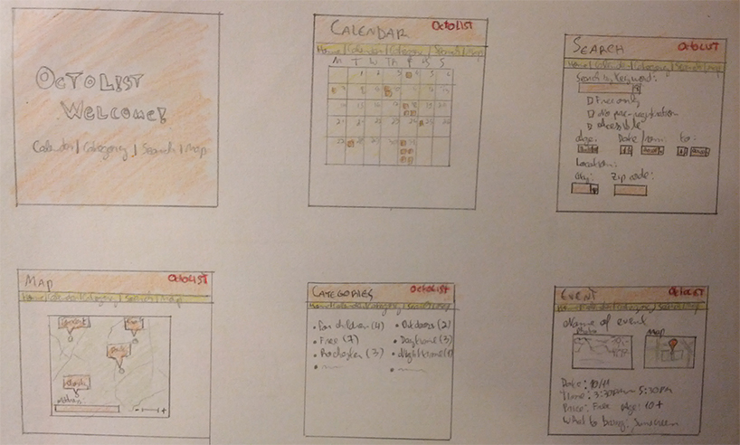

Part 8: Present Design to the Class
Probably at the beginning of next class, unless we have time today!

