Study Guide 1 - Intro to Canvas Name: Yara Grassi Gouffon

Due: Start of class, second meeting of week 2. Submit this DOC and the zipped source files. Answer the questions and fill in the blanks. Late submissions will not be accepted.

• The <canvas> tag defines an area on the page that we can draw into using a procedural drawing API. This bitmap drawing API has methods for drawing lines, paths, rectangles, arcs, circles, curves, and text.

• The canvas drawing API allows a developer to create Flash-like games and experiences without using the Flash SDK and with no need for a browser plug-in.

• The canvas API is focused on drawing, and is fairly lightweight. The full specification is here: http://www.w3.org/TR/2dcontext/

• Our free canvas “textbook” is located here: https://developer.apple.com/library/safari/documentation/AudioVideo/Conceptual/HTML-canvas-guide/Introduction/Introduction.html

• Apple invented canvas in 2004 as a way to add customized dashboard widgets to OS X. It has since been adopted by all major browsers and is supported by the current versions of Chrome, Firefox, Internet Explorer (8>), Konquerer, and Opera.

• We will mostly be using Chrome in class because it is cross-platform, ubiquitous, and has a built-in debugger.

• You can check the canvas compatibility of your browser at these sites:
http://caniuse.com/#feat=canvas

https://html5test.com

I. About Canvas

- Read the “At a glance” section under About Canvas

A. You can add a Canvas element with a few lines of code
(no answer required - we’ll do this in the next section)

B. There are Methods for Drawing rectangles, lines, curves, arcs and complex shapes.

You draw shapes other than rectangles by creating a path, adding line segments, curves, or arcs, and closing the path. Begin a path using beginPath(). Set the starting point, or start a discontinuous subpath, by calling the moveTo(x, y) method. The closePath() method draws a line from the current endpoint to the starting point of the path, creating a closed shape.

The path is not actually drawn until you call stroke() or fill().

Canvas supports matrix transforms—anything you draw can be translated, rotated, scaled and more.

C. It’s Easy To Include JPEGs, GIFs, PNGs and SVGs.

D. You Can Also Render text

E. Canvas is Great for InfoGraphics - give examples: plots, bar graphs and pie charts.

F. Canvas Can Create Fast, Lightweight Animations.
(no answer required - note: Apple’s examples use setInterval() for animation - we’ll instead be using requestAnimationFrame() in our examples)

G. You Can Manipulate Pixels Directly for Image Processing - give examples: detect collisions, apply digital filters and do image processing.

H. Make Games That Play on Desktop and iOS Devices.
(or Android, Blackberry, Windows, … - no answer required )

I. The Web Inspector Provides Built-in JavaScript Debugging

To access the Web Inspector on Chrome and Safari, right-click in the browser window and select “Inspect Element” to bring up the debugger. On Safari, you’ll first have to Choose Safari > Preferences > Advanced and check the “Show Develop in menu bar” box.

no answer required

J. Export to Canvas is Possible from Illustrator or Flash

no answer required
II. Setting Up the Canvas

1) Read over the “Setting Up the Canvas” section - the following steps are listed:

- Start by Adding a <canvas> Tag

- Specify the Fallback Behavior

- Create a Drawing Context

- Support Retina Displays from the Start
(a good practice, but we’re not going to worry about this in the course)

- Save and Restore the Context
(we’ll get into this soon)

2) Your first canvas App:

The canvas drawing API allows a developer to create interactive experiences and games without the need for a browser plug-in.

You need to do the following to get started drawing in canvas on an HTML page:

- Wait for the HTML page to load

- Get a reference to the <canvas> tag on the page

- Get a reference to the “drawing context”, which is the 2D drawing API we use to do the actual drawing.

- Start issuing drawing commands!

Here is a simple example (see mycourses for sg-1.html):

<!DOCTYPE html>
<html lang="en">
<head>
<meta charset="utf-8" />
<title>Canvas 1</title>
<script>

"use strict";
// #1
window.onload = init;

function init(){
// #2
var canvas = document.querySelector('canvas');

// #3
var ctx = canvas.getContext('2d');

/* #4 - start drawing! */
// draw filled square
ctx.fillStyle = "red";
// ctx.fillRect(x,y,width,height);
ctx.fillRect(20,20,100,100);

}

</script>
</head>
<body>
<canvas id="canvas" width="750" height="500">
Get a browser that supports Canvas!
</canvas>
</body>
</html>

Go ahead an load this example in the browser so you can see the exciting red square on the screen. Note that (0,0) is in the upper-left corner of the screen. x-values get larger as you move to the right, and y-values get larger as you move down the screen.

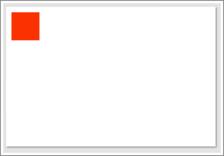

The sg-1.html example that’s posted to mycourses has additional JS code that you can uncomment and see more drawing examples.

Before you move on, go get this file and play with it now. Uncomment the remaining code section-by-section and experiment:

- change the x/y/width/height values,
- change the .fillStyle and .strokeStyle values
- change the startAngle and endAngle values

to see what happens.

Also note that .strokeText() strokes the outline of the text with the current .strokeStyle, and .fillText() fills the text with the current .fillStyle You can use these together to get some nice effects.

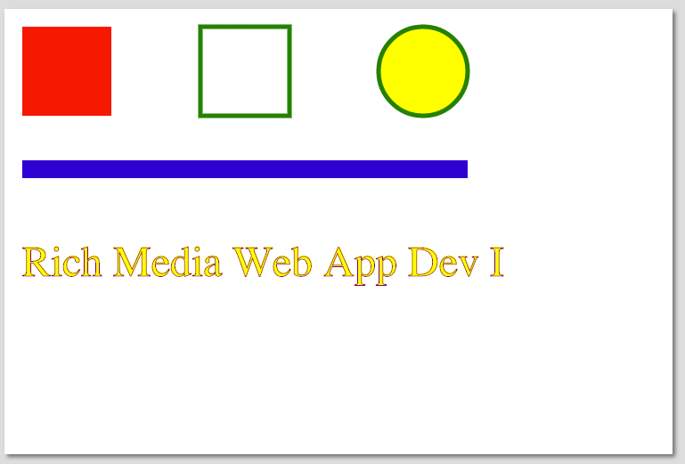
Here’s the default version:

3) For the following, modify the sg-1.html example file to get the answer (first comment out all of the drawing code under step #4).

For your answers, assume that you already have a variable named ctx that points at the drawing context. Note: The squares only require 1 or 2 lines of code, the circles will require a few more.

A. Write code that will fill a black 50x50 square at (0,0)

ctx.fillStyle = "black";
ctx.fillRect(0, 0, 50, 50);

B. Write code that will fill a purple 50x50 square at (300,300)

ctx.fillStyle = "purple";
ctx.fillRect(300, 300, 50, 50);

C. Write code that will stroke a purple 50x50 square at (300,300)

ctx.fillStyle = "purple";
ctx.strokeRect(300, 300, 50, 50);

D. Write code that will stroke a 5 pixel thick green line between (0,100) and (100,500)

ctx.lineWidth = 5;
ctx.strokeStyle = "green";
ctx.beginPath();
ctx.moveTo(0, 100);
ctx.lineTo(100,500);
ctx.closePath();
ctx.stroke();

E. Write code to fill a black circle at (0,0) that has a radius of 50 pixels.

ctx.fillStyle = "black";
ctx.beginPath();
ctx.arc(0, 0, 50, 0, Math.PI * 2, false);
ctx.closePath();
ctx.fill();
ctx.stroke();

F. Write code to fill a yellow semi-circle (180 degrees ie. Math.PI radians) at (200,200) that has a radius of 100 pixels.

ctx.fillStyle = "yellow";
ctx.beginPath();
ctx.arc(200, 200, 100, 0, Math.PI, false);
ctx.closePath();
ctx.fill();
ctx.stroke();

G. What are the default colors for .fillStyle and .strokeStyle if you don’t specify them?

Black, for both.

H. Try giving .fillStyle a non-existent CSS value for a color like “pukegreen” - what color do you get instead?

Black.

I. What is the default value of .lineWidth if you don’t specify a value?

1 pixel.

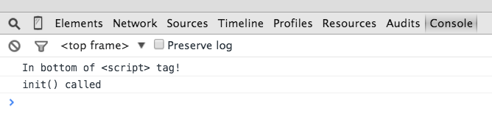
J. Check the console tab in the web inspector - why is “init() called” being logged later than “In the bottom of the <script> tag” even though “init() called” appears first in the source code?

Because the init function is only called after everything else is loaded, and the “In the bottom of the <script> tag” line will have been executed since it's outside of the function.

K. What is the default height and width of the <canvas> tag if you don’t specify a value (use google or the Web Inspector to find out)

The default width is 300 px and the default height is 150 px.

III. More above the Canvas API

- Read over Set the Stroke and Fill Styles:

A. Color can be specified in all of the usual CSS ways - give the .fillStyle color for white in each format below :

i) CSS Keyword: ctx.fillStyle = "white";

ii) Longhand hexadecimal:
ctx.fillStyle = “#ffffff”;

iii) Shorthand hexadecimal:
ctx.fillStyle = “#fff”;

iv) RGB percentage:
ctx.fillStyle = “rgb(100%, 100%, 100%)”;

v) RGB value:
ctx.fillStyle = “rgb(255, 255, 255)”;

vi) RGBa value:
ctx.fillStyle = “rgba(255, 255, 255, 1.0)”;

Note that a gradient or pattern can also be used for .fillStyle and .strokeStyle values. HSL and HSLA values are also supported: http://www.w3schools.com/cssref/css_colors_legal.asp

2) Read over Drawing Rectangles:

List the 3 rectangle methods below:

clearRect()
strokeRect()
fillRect()

There’s also a 4th one, rect(), that creates a rectangle path without filling or stroking it. We’ll get into that one later.

3) Read over Paths and Subpaths
A. You draw shapes other than rectangles by creating a path.

B. Calling stroke() or fill() renders the current path, including all subpaths.

C. A path ends when you call closePath() or beginPath().

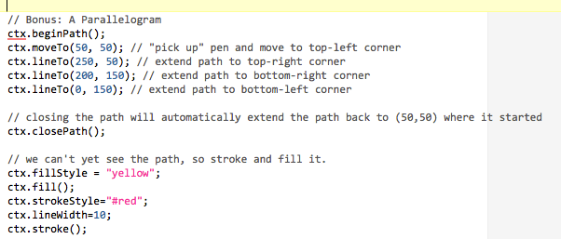
Apple mysteriously left out illustrative example code, so here’s some:

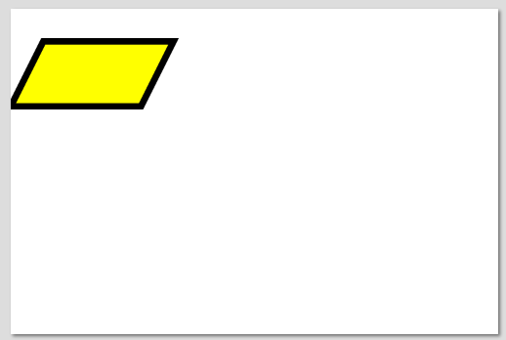
This code drew a parallelogram with side lengths of 200 and 100 units. Note that the stroke goes outside the boundaries of the path. Also note that if you change the order of the .fill() and .stroke() calls, you will get different results.

4) Skip down to Drawing Arcs and Circles:

arc(x,y,radius,startAngle,endAngle)

- What do x and y represent? (note that this is different from the rectangle methods)
They represent the center point of the circle the arc is a section of.

B) Are angle values specified in degrees or radians?
They are specified in radians.

C) By default, which way is the arc drawn, clockwise or counter-clockwise?
It is drawn clockwise.

5. A little review - write a line of code:

  - that sets the current fill color to green
ctx.fillStyle = “green”;

  - that sets the current stroke color to purple
ctx.strokeStyle = “purple”;

  - that sets the stroke width to 20
ctx.lineWidth = 20;
  - that sets the current font to courier
ctx.font = “courier”;
  - that clears an entire <canvas> that is 640 x 480
ctx.clearRect(0, 0, 640, 480);

F. Lastly, where is 0,0 located in the canvas coordinate system?
Top left.
IV. Make something!
HW! - worth 10 points
Create a scene with a “smiley face”:
- 4 arcs
- a horizon line (a line)
- and a tree (a path with 3 points plus a line for a trunk).
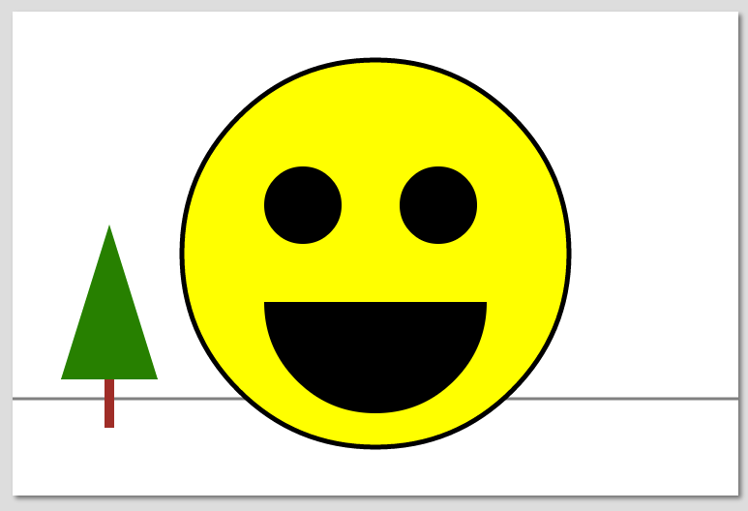
- The Smiley face is black and yellow. The tree is brown and green. See the first example and hints below - it doesn’t have to look exactly like mine.
- Be sure things are drawn in the right order (ex. The horizon line should be behind everything else). Canvas uses the “painters model” where new drawing is drawn on top of and obscures (or partially obscures) old drawing.

Hint I: My example canvas is 750 x 500

<canvas width="750" height="500">
Get a browser that supports Canvas!
</canvas>

Hint II: Here’s the code for the oval of the face:

var canvas = document.querySelector('canvas');

// get pointer to "drawing context" and drawing API
var ctx = canvas.getContext('2d');

// set state variables
ctx.fillStyle = "yellow";
ctx.strokeStyle = “black”;
ctx.lineWidth = 5;

// start drawing
ctx.beginPath();
// ctx.arc(x,y,radius,startAngle,endAngle, clockwise)
ctx.arc(375, 250, 200, 0, Math.PI*2, false);
ctx.closePath();

// fill inside of arc with yellow
ctx.fill();

// stroke outside of arc with black
ctx.stroke();

Hint III: If nothing is getting drawn, check the debugger console for errors!

ExtraCredit - 1 point each - max grade 15/10
- Make the “sky” a skyish color - - use ctx.fillRect();
- Make the “ground” a groundish color - - use ctx.fillRect();

- Other elements? See examples above for ideas

V. Submission
This SG is worth 2 HW assignments.

1) ZIP up your smiley file and submit it to the mycourses dropbox - you can earn up to 15/10 points on this first assignment if you do the extra credit.

2) Post this study guide to the dropbox - this counts as the second assignment.
