ARCHITECTURE DECISION RECORD
Ingestion Layer Strategy: Meltano vs. Lakeflow Connect / Fivetran in the Databricks Lakehouse
Prepared for: Enterprise Architecture Review | Status: Recommended

Document Ownership
Role | Responsibility in This Review
Senior Solution Architect | Overall architecture fit, vendor lock-in, and future-state platform strategy
Senior Data Architect | Data modeling, Bronze/Silver/Gold design, governance and lineage impact
Senior Data Engineer | Connector implementation, CDC, operational effort, pipeline reliability
Project Manager | Cost, timeline, staffing, and delivery risk

1. Executive Summary
This document evaluates whether Meltano, an open-source Extract-and-Load (EL) tool built on the Singer taps/targets specification, should replace or complement Lakeflow Connect and Fivetran in the ingestion layer of our Databricks Lakehouse architecture. The evaluation was conducted jointly across solution architecture, data architecture, data engineering, and project management perspectives, and considers cost, operational effort, scalability, reliability, security, flexibility, and long-term platform strategy — not license price alone.
Recommendation: Do not replace Lakeflow Connect / Fivetran wholesale. Adopt a hybrid ingestion layer — Lakeflow Connect for supported first-party SaaS sources, Meltano for custom REST APIs and unsupported/niche database connectors, and Auto Loader for file-based ingestion — while keeping Lakeflow Declarative Pipelines, dbt, and Unity Catalog unchanged for transformation and governance.
Bottom Line
• License cost decreases with Meltano, but engineering and operational cost increases — the net Total Cost of Ownership (TCO) depends on the number and diversity of sources and on whether the company is single-cloud (Databricks-committed) or multi-cloud.
• For a Databricks-committed enterprise, Lakeflow Connect generally wins on long-term TCO due to lower operational burden.
• For a multi-cloud or platform-agnostic strategy, Meltano wins on portability and reduces future migration cost.
• The recommended design captures the benefits of both: managed connectors where they exist, open-source flexibility where they don't.

2. Reference Architecture
The diagram below shows the persona-aligned service map for the target Databricks Lakehouse, with Meltano positioned as a gap-filling ingestion path alongside Lakeflow Connect, Fivetran, Zerobus, and Auto Loader.
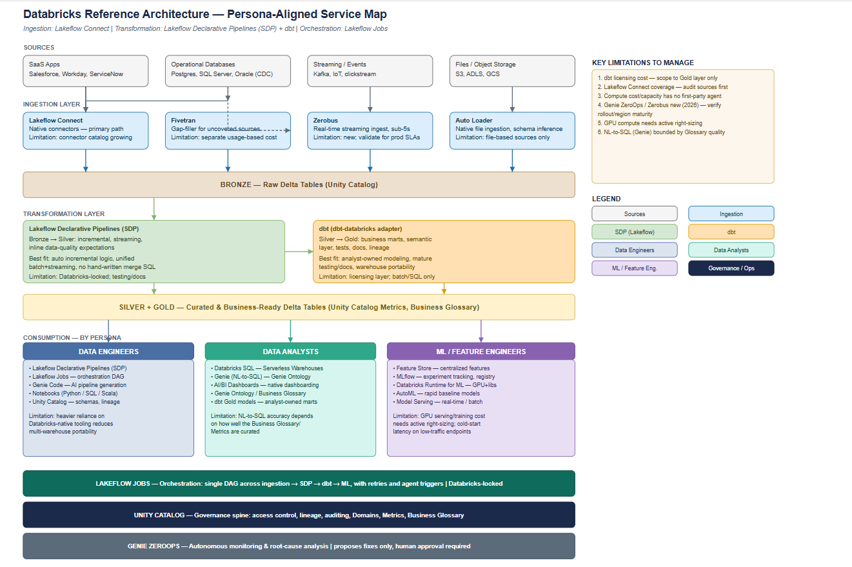
Figure 1: Databricks Reference Architecture — Persona-Aligned Service Map (Ingestion → Bronze → Transformation → Silver/Gold → Consumption).

2.1 Key Limitations to Manage
Carried forward from the reference architecture
• dbt licensing cost — scope usage to the Gold layer only.
• Lakeflow Connect coverage — audit source systems against the supported-connector list before committing.
• Compute cost/capacity has no first-party ingestion agent; size and monitor independently.
• Genie ZeroOps is a 2026 capability — verify rollout and regional maturity before depending on it operationally.
• GPU compute for ML/Feature Engineering needs active right-sizing.
• NL-to-SQL (Genie) accuracy is bounded by the quality of the Business Glossary and Ontology.

3. Where Meltano Fits in the Architecture
Meltano sits in the Ingestion Layer as an EL (Extract and Load) tool, positioned as a peer to Lakeflow Connect and Fivetran — not as a replacement for downstream transformation.

3.1 Role of Meltano
- Extract data from relational databases (Oracle, SQL Server, PostgreSQL, and others)
- Extract data from SaaS applications via Singer taps
- Extract data from REST and custom APIs
- Incremental loading and, via compatible connectors, Change Data Capture (CDC)
- Schema discovery at extraction time
- Optional scheduling of extract/load jobs
After Meltano loads data into Bronze Delta tables, Databricks components take over unchanged: Lakeflow Declarative Pipelines (Bronze → Silver), dbt (Silver → Gold), and Unity Catalog for governance. Meltano does not replace Lakeflow Declarative Pipelines or dbt.

3.2 Position in the Pipeline
Stage | Tool | Purpose
Ingestion | Lakeflow Connect | Native Databricks connectors for supported SaaS sources
Ingestion | Fivetran | Managed EL for a broad set of enterprise sources
Ingestion | Meltano | Open-source EL using Singer taps/targets — gap-filler for unsupported sources
Ingestion | Auto Loader | File ingestion from S3, ADLS, GCS
Ingestion (streaming) | Zerobus | Kafka / event-stream ingestion
Transformation | Lakeflow Declarative Pipelines | Bronze → Silver
Transformation | dbt | Silver → Gold, business logic and semantic layer

3.3 When Meltano Should Be Used
- Connectors are needed that Lakeflow Connect does not support
- An open-source alternative to Fivetran is preferred to avoid per-connector licensing
- There are many custom or internal REST APIs to integrate
- Git-based, version-controlled connector definitions are a requirement

4. Cost Impact Analysis
The direct question — "does cost increase or decrease with Meltano?" — does not have a single answer. License cost decreases; total delivery cost depends on team capability and source complexity.

4.1 Cost Comparison by Factor
Factor | Lakeflow Connect | Meltano
License | Included with Databricks (supported connectors) | Free (open source)
Infrastructure | Databricks-managed | Self-managed (VM / Kubernetes)
Compute | Databricks | VM / Kubernetes / Databricks Job
Connector maintenance | Databricks | Owned by internal team
Upgrades | Automatic | Manual
Monitoring | Native | Must be built (Grafana, Prometheus, Datadog, etc.)
Support | Databricks Enterprise SLA | Community, or paid enterprise support if adopted

4.2 Illustrative Scenario
Example source estate: Oracle, SQL Server, PostgreSQL, Salesforce, Workday, ServiceNow, and 20 custom REST APIs.
Cost Model | Composition | Directional Outcome
Lakeflow Connect / Fivetran | Databricks + connector usage fees + compute | Higher license spend, lower engineering spend
Meltano | VM/compute cost + engineering salary for build & maintenance | Near-zero license spend, higher engineering spend
Net effect: license cost decreases, but engineering effort — and therefore total delivery cost — increases. This is the tradeoff a Project Manager must plan staffing and timeline around.

4.3 Total Cost of Ownership (TCO) — the Metric That Matters
Comparing license cost alone is a common and costly mistake. A defensible TCO model includes:
- License cost
- Infrastructure cost
- Engineering cost (build + ongoing maintenance)
- Operational maintenance cost
- Downtime / incident cost
- Support cost
- Delivery and operational risk
Option | License | Engineering / Infra Effort | Illustrative Total
Lakeflow Connect | $25k | $10k | $35k
Meltano | $0 | $45k (infra $5k + engineering $40k) | $45k
Figures are illustrative, not sourced quotes — the pattern to defend in review is directional: open source can cost more overall once operational overhead is accounted for, particularly at moderate source counts.

5. Database Ingestion: Lakeflow Connect vs. Meltano
Using Oracle as a representative case:
 | Lakeflow Connect | Meltano (tap-oracle → target-databricks)
Path | Oracle → Lakeflow Connect → Bronze | Oracle → tap-oracle → target-databricks → Bronze
Advantages | CDC, schema evolution, retry, monitoring, security — all managed | Free, Git-versioned, highly customizable
Disadvantages | Limited to supported source systems | CDC setup, monitoring, retries, and upgrades are the team's responsibility

6. Operational Complexity
Lakeflow Connect (Databricks-managed) | Meltano (Team-managed)
Connector updates, retry, monitoring, security, schema evolution, and authentication are all handled by Databricks. The engineer's role is largely configuration. | The team owns Docker/Kubernetes or VM hosting, pipeline orchestration, connector updates, Singer tap maintenance, authentication, logging, retry logic, monitoring, failure handling, and alerting.
This is the single largest hidden cost driver in an open-source ingestion strategy and should be staffed for explicitly, not absorbed informally by the data engineering team.

7. Scalability and Reliability

7.1 Scalability — Illustrative Estate: 300 Tables, 15 Databases, 40 APIs
Platform | Effort at Scale
Lakeflow Connect | Minimal additional effort; scaling is largely a configuration exercise
Meltano | Requires maintaining many connectors, configurations, and monitoring surfaces individually

7.2 Reliability
Feature | Lakeflow Connect | Meltano
Retry | Excellent (native) | Manual
Monitoring | Excellent (native) | Requires Grafana / Prometheus / Datadog
Lineage | Native (Unity Catalog) | Manual
Security | Native | Manual integration required
Secret management | Native | Manual
Schema drift handling | Better, out of the box | Depends on the specific connector
Logging | Native | Manual
Lakeflow Connect generally wins on operational maturity; this is expected of a managed, first-party service.

8. Flexibility and Performance

8.1 Flexibility — Meltano's Strength
For a requirement such as "ingest data from an internal API behind custom OAuth, transform the JSON payload, then load to Bronze," Lakeflow Connect may not support the source directly, while Meltano can be extended via Singer taps or a custom connector to handle it.

8.2 Performance
For mainstream relational sources (Oracle, SQL Server, PostgreSQL), both platforms perform comparably. Performance is driven less by the ingestion tool itself and more by network bandwidth, source database load, incremental-extraction strategy, parallelism, and compute sizing — the connector implementation matters more than the platform choice.

9. Vendor Lock-in, Security, and Future Portability

9.1 Vendor Lock-in
Lakeflow Connect | Meltano
Databricks-only | Portable across Snowflake, BigQuery, Databricks, Redshift, Azure, AWS, and GCP targets

9.2 Security
Lakeflow Connect integrates natively with Unity Catalog secrets, IAM, audit, and lineage. Meltano requires the team to integrate its own secrets management, IAM, logging, and audit trail — a real cost that must be scoped into any adoption plan.

9.3 Future Platform Change
Scenario: Migration from Databricks to another warehouse (e.g., Snowflake) after 2 years
Lakeflow Connect | Ingestion layer must be redesigned — no portability
Meltano | Ingestion layer largely unchanged — only the target connector changes

10. Final Verdict by Parameter
Parameter | Winner | Reason
License cost | Meltano | Open source, no per-connector licensing
Operational cost | Lakeflow Connect | Managed service reduces engineering effort
Database support | Tie | Both handle major databases; implementation quality is the differentiator
SaaS connectors | Lakeflow Connect | Rich managed ecosystem for supported applications
Custom APIs | Meltano | Highly flexible via Singer taps or custom connectors
Vendor lock-in | Meltano | Portable across warehouses and clouds
Maintenance | Lakeflow Connect | Databricks manages updates and operations
Monitoring & governance | Lakeflow Connect | Native integration with Unity Catalog
Flexibility | Meltano | Easier to customize and extend
Enterprise support | Lakeflow Connect | Backed by Databricks with SLAs
Long-term TCO (Databricks-only) | Lakeflow Connect | Lower operational burden typically outweighs license savings
Long-term TCO (hybrid / multi-cloud) | Meltano | Portability can reduce future migration cost

11. Recommendation

11.1 If the Organization Is Fully Committed to Databricks
- Use Lakeflow Connect for supported first-party SaaS sources
- Use Auto Loader for file-based ingestion
- Use Lakeflow Declarative Pipelines for Bronze → Silver transformation
- Use dbt for Silver → Gold business modeling
- Introduce Meltano only to fill connector gaps — custom APIs, niche databases, unsupported systems
This keeps day-to-day operations simple while still closing connector coverage gaps.

11.2 If the Organization Is Multi-Cloud or Anticipates a Platform Change
A more portable ingestion design is preferred:
- Sources → Meltano → Bronze → Lakeflow Declarative Pipelines → Silver → dbt → Gold
This reduces vendor lock-in and preserves ingestion investment across a future platform migration, at the cost of higher day-to-day operational ownership.

11.3 Recommended Design for This Architecture
Hybrid Ingestion Layer — Final Recommendation
• Lakeflow Connect for first-party supported SaaS sources (Salesforce, Workday, ServiceNow, and similar).
• Meltano for custom REST APIs, unsupported databases, and niche SaaS connectors.
• Auto Loader for file-based ingestion (S3, ADLS, GCS).
• Zerobus retained for streaming/event ingestion (Kafka, IoT, clickstream).
• Lakeflow Declarative Pipelines, dbt, and Unity Catalog remain unchanged for transformation and governance.
This hybrid approach balances cost, operational simplicity, connector flexibility, and future scalability, and is the design we are prepared to defend in an enterprise architecture review.

