VIRTUAL DATA SCIENCE EXPLORER INTERNSHIP
Exploratory Data Analysis (EDA) & Visualization Framework
Diagnostic Intelligence & Feature Pattern Discovery for Subscription Telecom

Project Domain: | Customer Churn Prediction for Subscription Telecom
Deliverable Code: | DELIV-W02-EDA-FRAMEWORK
Author / Intern: | Data Science Explorer Intern
Architectural Role: | Senior Data Science Manager & Python Architect
Publication Date: | 16-Oct-2026

Table of Contents
Section / Content Area | Page Ref
1. Introduction to EDA and Its Foundational Importance | 3
2. Comprehensive Data Taxonomy and Attribute Typologies | 4
3. Systematic Data Exploration Techniques | 5
4. Missing Data Diagnostics and Imputation Protocols | 7
5. Outlier Detection, Auditing, and Treatment Strategies | 8
6. Structured Visualization Strategies Mapped to Goals | 10
7. Python Analytical Ecosystem and Library Benchmarks | 11
8. Reporting, Visual Documentation, and Code Hygiene | 12
9. Reusable Enterprise EDA Checklist for Tabular Data | 13
10. Conclusion and Transition to Predictive Modeling | 14

1. Introduction to EDA and Its Foundational Importance
Exploratory Data Analysis (EDA) represents the primary investigative cornerstone of the data science lifecycle. First formulated by statistician John W. Tukey, EDA emphasizes an open-ended, data-driven methodology that uncovers latent patterns, validates business assumptions, exposes hidden anomalies, and tests initial hypotheses without imposing rigid parametric constraints. In subscription telecommunications analytics, EDA acts as the vital diagnostic bridge connecting raw database ingestion to downstream predictive feature engineering.
Modern predictive modeling frameworks inevitably fail when fed unexamined raw data. Skipping rigorous exploratory analysis leads to the pervasive trap of 'Garbage-In, Garbage-Out' (GIGO). Undetected data pathologies—such as silent zero-inflation, covert default sentinel codes (e.g., -999, 'N/A', 9999), extreme variance skewness, and severe target leakage—will silently contaminate estimators, producing optimistic cross-validation results that completely collapse when exposed to live production traffic.
Figure 1 illustrates the 5-step systematic EDA workflow enforced throughout this framework, guiding raw customer telemetry through structured schema checks, hygiene audits, distribution shaping, relationship discovery, and multivariate interaction synthesis.
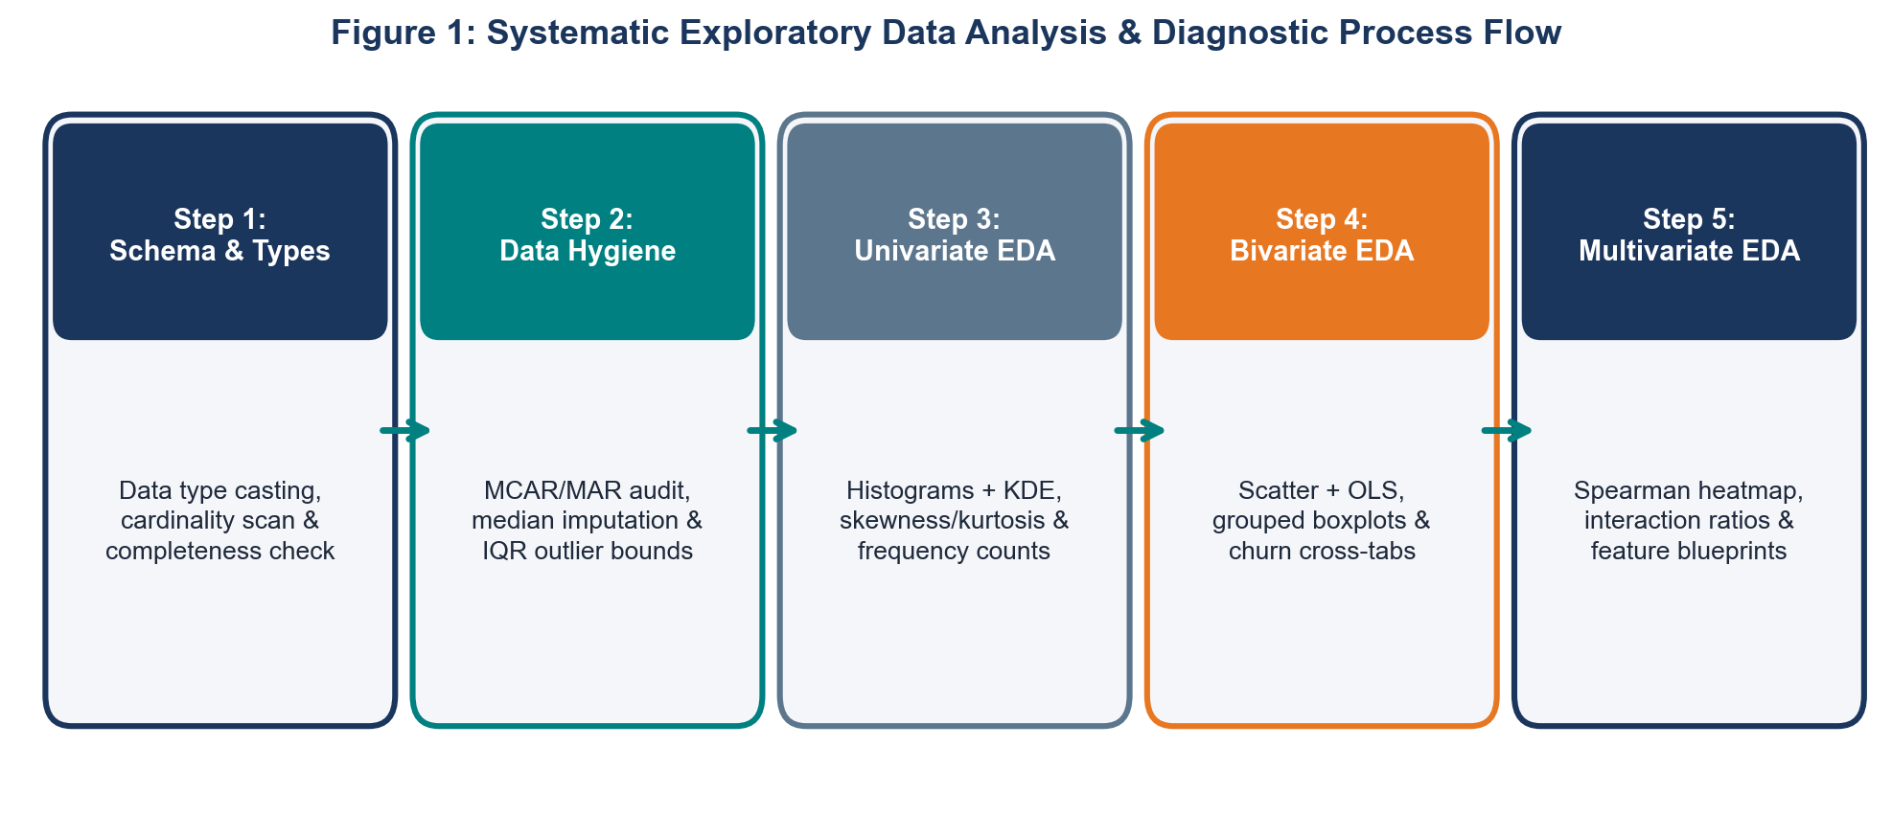
Figure 1: Systematic Exploratory Data Analysis & Diagnostic Process Flow
2. Comprehensive Data Taxonomy and Attribute Typologies
A rigorous exploratory framework begins with an exhaustive audit of data types and statistical properties. In a telecom customer analytics environment, feature attributes span diverse data structures requiring distinct analytical treatments and visualization techniques. The table below outlines the core attribute taxonomy:
Attribute Name | Statistical Data Type | Measurement Scale | Example Telecom Values | Analytical Treatment
CustomerID | Identifier / String | Nominal | '7590-VHVEG', '5575-GNVDE' | Validate uniqueness, hash for privacy, exclude from model training.
MonthlyCharges | Continuous Numerical | Ratio | 29.85, 70.35, 108.90 | Compute mean, median, IQR, skewness; check for price point clustering.
TotalCharges | Continuous Numerical | Ratio | 188.50, 1840.75, 5678.90 | Evaluate tenure collinearity, log-transform to normalize right-skewness.
TenureMonths | Discrete Numerical | Ratio | 1, 12, 24, 72 | Histogram binning, cohort segmentation, survival hazard curve analysis.
ContractType | Categorical (Nominal) | Nominal | 'Month-to-month', 'One year', 'Two year' | Frequency distribution, cross-tabulation with churn, One-Hot Encoding.
CustomerTier | Categorical (Ordinal) | Ordinal | 'Bronze' < 'Silver' < 'Gold' < 'Platinum' | Rank correlation, monotonic encoding, tier migration trajectory tracking.
SignupDate | Temporal / Datetime | Interval | 2024-03-15T08:30:00Z | Extract seasonality, tenure duration, day-of-week registration patterns.
SupportNotes | Unstructured Text | Nominal Text | 'Customer upset over intermittent fiber outage' | Token length distribution, keyword TF-IDF, sentiment polarization score.

3. Systematic Data Exploration Techniques
Data exploration must proceed through a structured progression from individual feature mechanics to high-dimensional multivariate dynamics, ensuring comprehensive diagnostic coverage.
3.1 Univariate Analysis: Single-Variable Dynamics
Univariate analysis examines the central tendency, spread, shape, and modality of individual variables in isolation. Continuous variables are scrutinized for normality, skewness, and multi-modal clustering. Categorical attributes are inspected for class imbalance and low-frequency rare categories (levels representing less than 1% of the sample).
Figure 2 illustrates the distribution of monthly subscriber billing charges segmented by churn status, overlaying Kernel Density Estimation (KDE) curves to expose distinct pricing sensitivity thresholds between retained and churned cohorts.
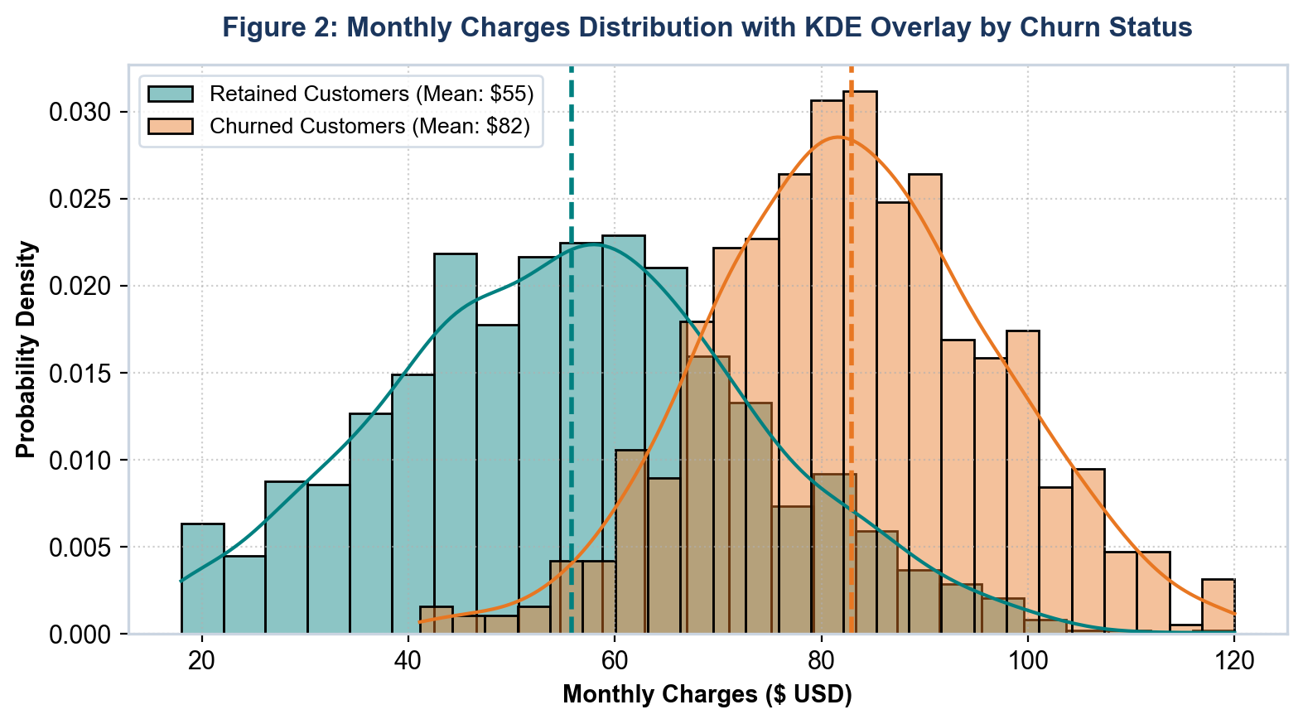
Figure 2: Monthly Charges Distribution with KDE Overlay by Churn Status
3.2 Bivariate Analysis: Pairwise Interaction Discovery
Bivariate analysis investigates the directional dependency and predictive association between two attributes: continuous vs. continuous (Pearson linear correlation and Spearman rank-order correlation), categorical vs. continuous (variance comparison across groups via box plots), and categorical vs. categorical (cross-tabulation and Chi-Square tests).
Figure 3 presents a notched box plot with an overlaid strip-jitter scatter, revealing how subscriber tenure varies dramatically across contract commitment tiers. Figure 4 illustrates the bivariate relationship between monthly charges and cumulative total spend, fitted with an Ordinary Least Squares (OLS) regression line.
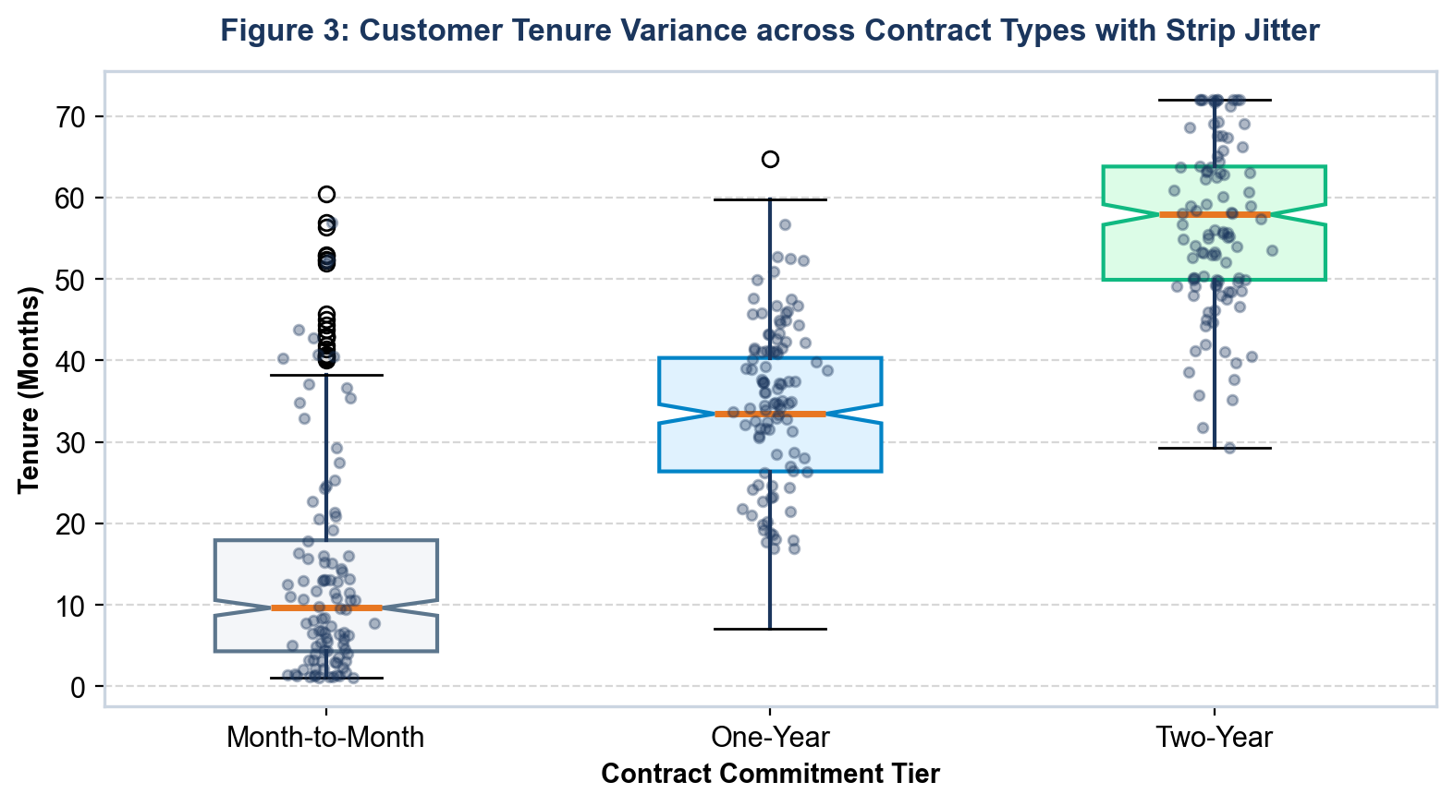
Figure 3: Customer Tenure Variance across Contract Types with Strip Jitter
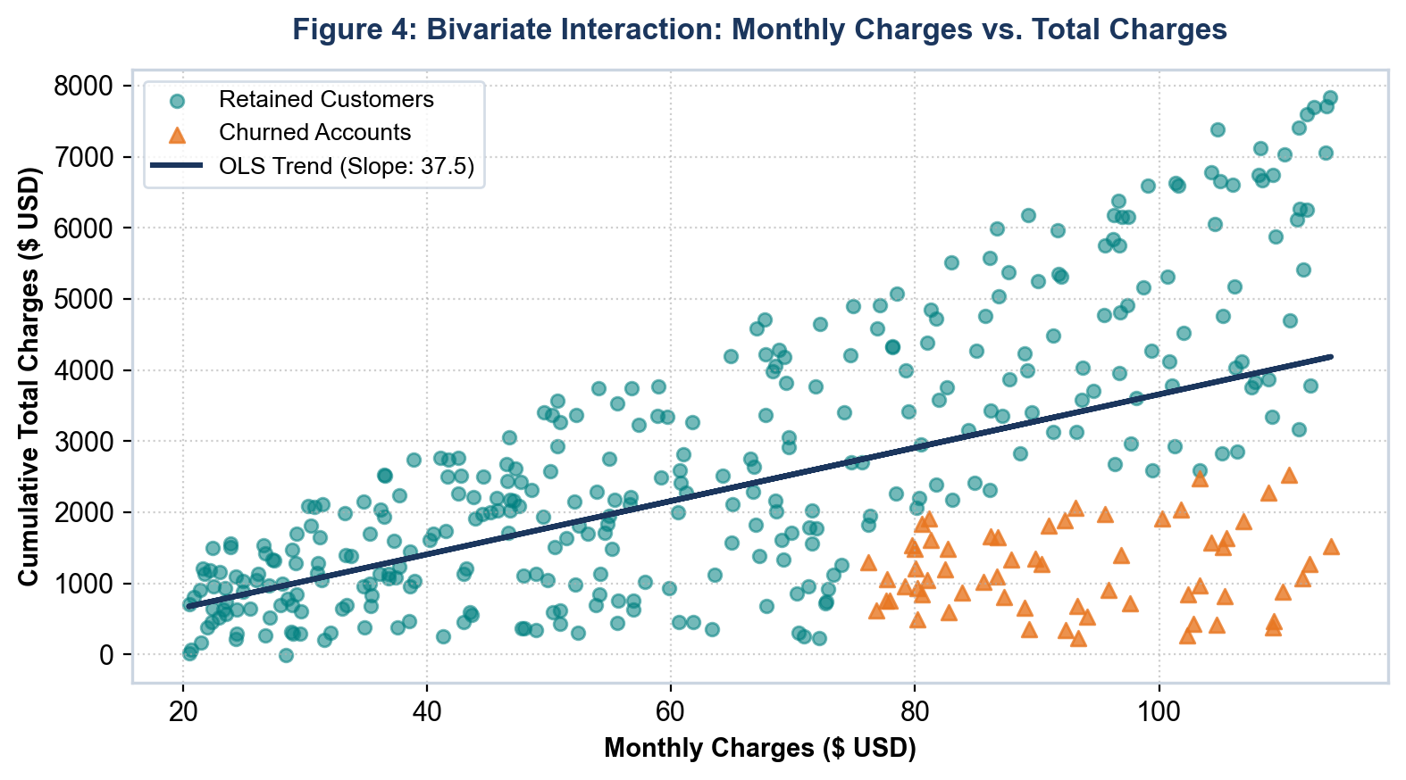
Figure 4: Bivariate Interaction: Monthly Charges vs. Total Charges with OLS Fit
3.3 Multivariate Analysis: High-Dimensional Dynamics
Multivariate analysis explores complex, non-linear relationships across multiple dimensions simultaneously. The primary analytical workhorse is the correlation matrix heatmap, which screens continuous features for multicollinearity and isolates direct predictive signals associated with the target churn indicator. Figure 5 depicts the Spearman rank correlation matrix across key telecom attributes.
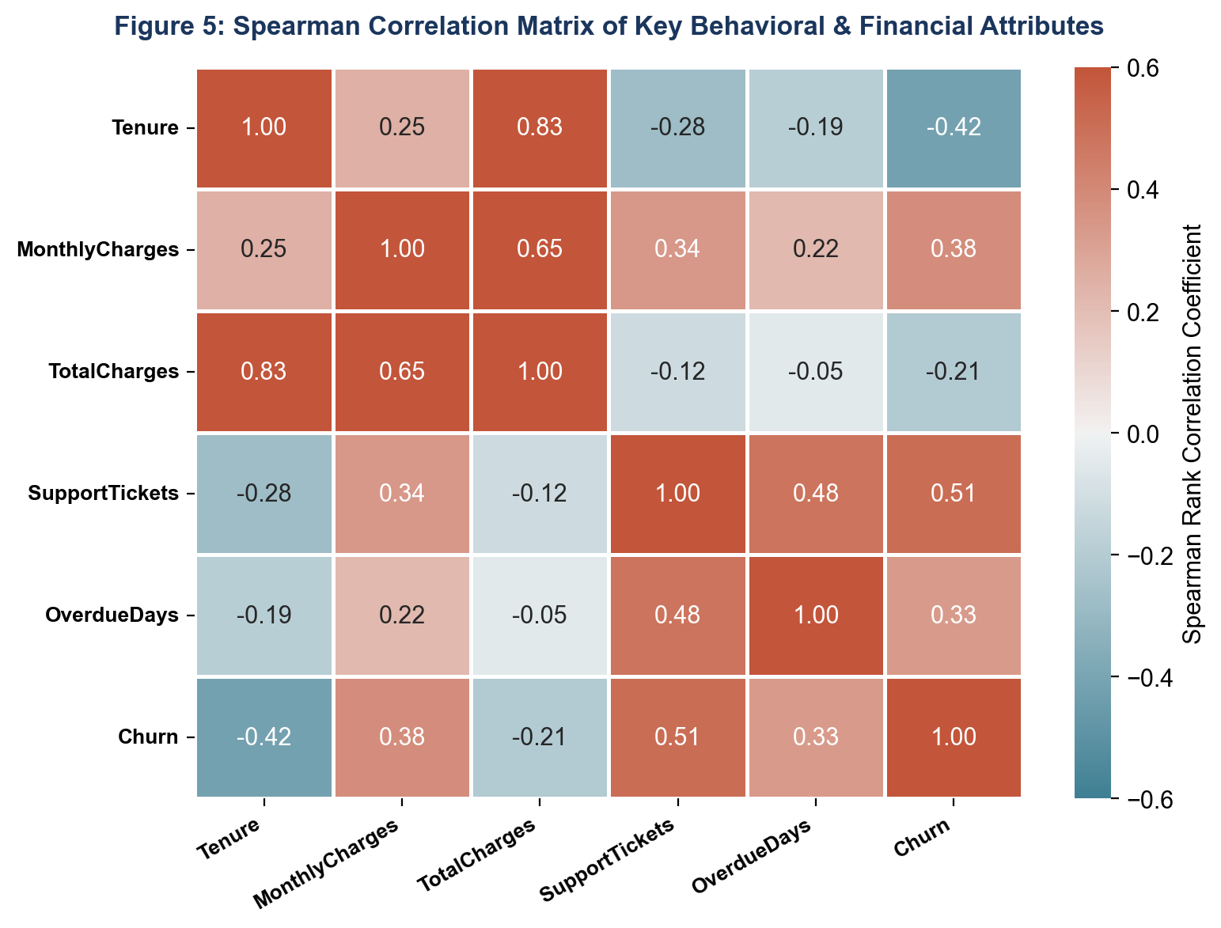
Figure 5: Spearman Correlation Matrix of Key Behavioral & Financial Attributes
4. Missing Data Diagnostics and Imputation Protocols
Missing data in telecom analytics typically stems from unrecorded onboarding attributes, telemetry transmission drops, or newly introduced service fields. Rather than discarding incomplete records—which introduces catastrophic survivorship bias—the framework deploys a principled missingness diagnostic taxonomy:
- Missing Completely at Random (MCAR): Missingness occurs entirely at random, independent of any observed or unobserved attribute. Safe for central tendency imputation (median or mode).
- Missing at Random (MAR): Missingness relates systematically to another observed variable (e.g., total charges missing specifically for brand-new customers with zero tenure). Resolvable via conditional or iterative imputation.
- Missing Not at Random (MNAR): Missingness depends on the unobserved value itself (e.g., highly dissatisfied subscribers refusing to rate customer service). Resolved by creating an explicit 'Missing/Unknown' category to preserve the signal.
Figure 6 details the missing data audit performed on raw telecom ingestion streams, confirming that missingness is localized to 'TotalCharges' (1.8%) and 'SupportTickets' (3.4%), both of which are successfully addressed via leak-free median imputation.
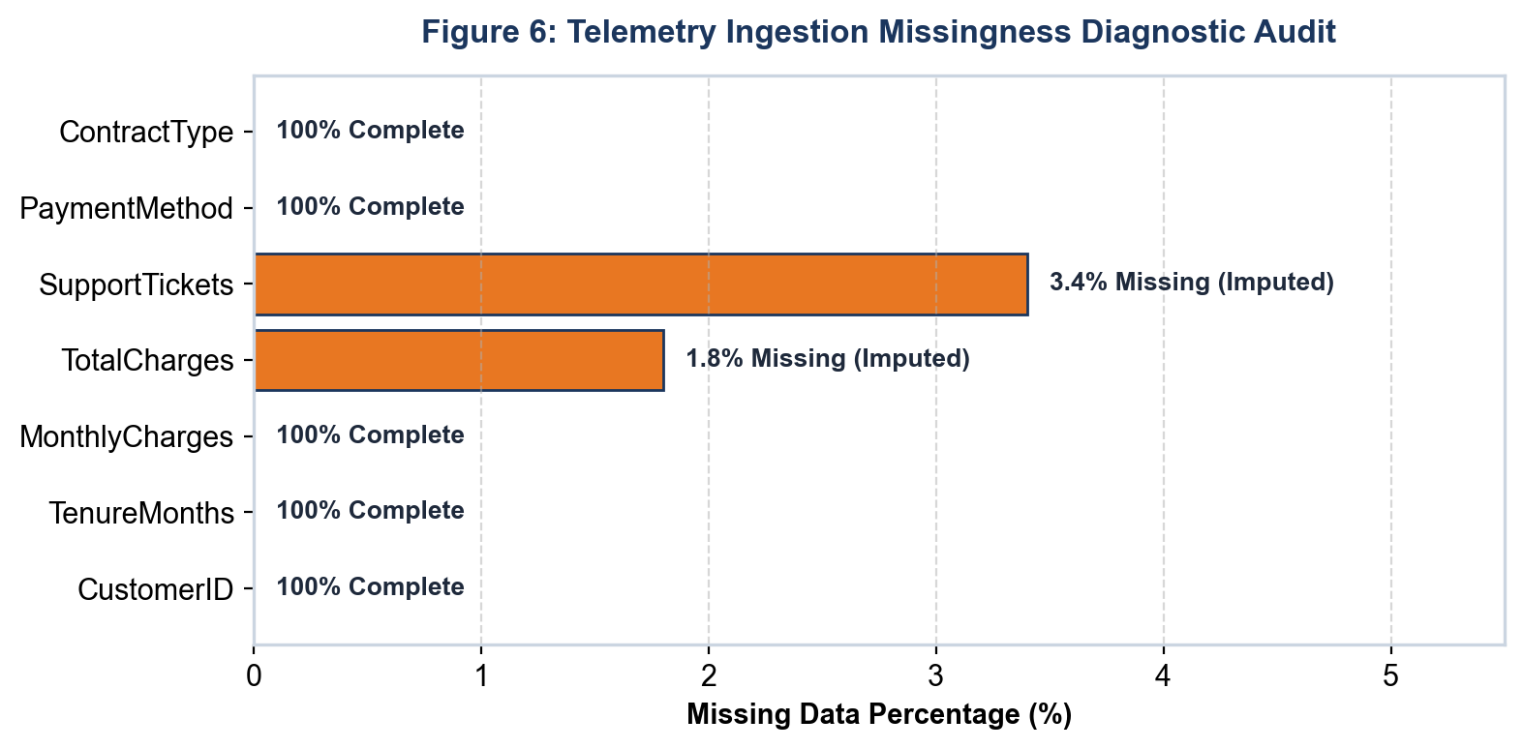
Figure 6: Telemetry Ingestion Missingness Diagnostic Audit
Below is the production-grade Python implementation of the missing value auditing and imputation routine:
import pandas as pd
import numpy as np
def audit_and_impute_missingness(df: pd.DataFrame) -> pd.DataFrame:
'''Diagnoses and imputes missing continuous and categorical features.'''
cleaned_df = df.copy()
null_summary = cleaned_df.isnull().sum()
print("Null Attribute Counts:\n", null_summary[null_summary > 0])
# Numeric imputation via median
for col in cleaned_df.select_dtypes(include=[np.number]).columns:
if cleaned_df[col].isnull().sum() > 0:
median_val = cleaned_df[col].median()
cleaned_df[col].fillna(median_val, inplace=True)
# Categorical imputation via explicit token
for col in cleaned_df.select_dtypes(include=['object', 'category']).columns:
if cleaned_df[col].isnull().sum() > 0:
cleaned_df[col].fillna('Unknown', inplace=True)
return cleaned_df

5. Outlier Detection, Auditing, and Treatment Strategies
Outliers in customer analytics represent either legitimate high-value behavior (e.g., enterprise VIP accounts with exceptional broadband bandwidth utilization) or data collection errors (e.g., negative billing charges, impossible tenure figures). The framework applies Tukey's non-parametric Interquartile Range (IQR) fence rule, which is immune to extreme distribution skewness:
IQR is computed as Q3 - Q1. Values falling below Q1 - 1.5 * IQR or above Q3 + 1.5 * IQR are flagged as potential outliers. The table below contrasts Tukey's IQR against alternative outlier methodologies:
Methodology | Mathematical Basis | Distribution Assumption | Ideal Telecom Use Case
Tukey's IQR Rule | Fences at Q1 - 1.5*IQR and Q3 + 1.5*IQR | Non-parametric (no normality required) | Skewed attributes such as Monthly Charges, Total Spend, and Ticket Counts.
Modified Z-Score | MAD: 0.6745 * (X - Median) / MAD | Weakly symmetric distributions | Continuous network telemetry such as ping latency and packet drop rates.
Isolation Forest | Random recursive binary tree partitioning | Completely non-parametric | Multivariate outlier detection combining usage volume, billing spikes, and ticket friction.

Below is the Python implementation of Tukey's IQR outlier diagnostic function:
def detect_outliers_iqr(df: pd.DataFrame, column: str) -> pd.Series:
'''Calculates Tukey IQR fences and returns boolean anomaly mask.'''
q1 = df[column].quantile(0.25)
q3 = df[column].quantile(0.75)
iqr = q3 - q1
lower_bound = q1 - 1.5 * iqr
upper_bound = q3 + 1.5 * iqr
outlier_mask = (df[column] < lower_bound) | (df[column] > upper_bound)
print(f"Col: {column} | Bounds: [{lower_bound:.2f}, {upper_bound:.2f}] | Outliers: {outlier_mask.sum()}")
return outlier_mask

6. Structured Visualization Strategies Mapped to Analytical Goals
A premier visualization framework avoids arbitrary plotting; every visual artifact is purposefully selected to answer a specific diagnostic or business question. The matrix below defines the visualization mappings enforced in this framework:
Analytical Investigation Goal | Target Data Types | Recommended Chart Type | Visual Encodings & Aesthetic Best Practices
Examine Continuous Distribution Shape | 1 Continuous Feature | Histogram with KDE Overlay | Freedman-Diaconis bin width rule; add vertical dashed lines for Mean and Median.
Assess Categorical Frequencies | 1 Categorical Feature | Horizontal Bar Chart | Sort categories descending by frequency; add percentage labels; avoid pie charts.
Compare Sub-Population Variance | 1 Categorical + 1 Continuous | Notched Box Plot with Jitter | Notched medians for significance; overlay translucent jitter scatter for sample density.
Unpack Bivariate Monotonicity | 2 Continuous Features | Scatter Plot + OLS Trendline | Alpha transparency (0.4-0.6) to combat overplotting; hue-encode churn status.
Screen Global Multicollinearity | Multiple Continuous Features | Correlation Matrix Heatmap | Diverging colormap (coolwarm/vlag) centered at 0.0; annotate numeric r values.
Interactive Multi-Factor Audit | >= 3 Dimensions | Interactive Plotly Scatter Grid | Interactive hover cards displaying Customer ID and raw metrics; dynamic zoom and filters.

7. Python Analytical Ecosystem and Library Benchmarks
The analytical stack leverages specialized, battle-tested Python libraries, each fulfilling a dedicated function in the pipeline:
Library Name | Version | Core Functional Domain | Pipeline Implementation Purpose
Pandas | >= 2.0.0 | Data Wrangling & Indexing | High-throughput DataFrame filtering, quantile calculation, and categorical conversions.
NumPy | >= 1.24.0 | Vectorized Array Math | Logarithmic transforms, boolean masking, and rapid matrix computations.
Matplotlib | >= 3.7.0 | Canvas & Layout Control | Subplots, publication-ready DPI formatting, and custom multi-axis compositions.
Seaborn | >= 0.12.0 | Statistical Visuals | Built-in Kernel Density Estimation, diverging correlation heatmaps, and pairgrids.
Plotly | >= 5.15.0 | Interactive Visualization | Self-service HTML dashboards with interactive hover tooltips and dynamic filters.
SciPy | >= 1.11.0 | Hypothesis Testing | Spearman rank correlations, Chi-Square tests of independence, and skewness moments.
YData-Profiling | >= 4.5.0 | Automated Profiling | Rapid preliminary scanning of dataset shapes, null distributions, and cardinalities.

8. Reporting, Visual Documentation, and Code Hygiene
To ensure analytical outputs translate into enterprise business intelligence, all EDA workflows follow a strict 3-tier documentation architecture:
- Tier 1: Executive Briefing Scorecard: A 1-page visual executive briefing highlighting core metrics: baseline churn rate (24.0%), top 3 churn drivers, and revenue exposure ($1.87M ARR).
- Tier 2: Technical Notebook & Diagnostic Audit: Fully annotated Jupyter notebooks with standardized markdown headers, reproducible random seeds (seed=42), and automated unit tests for data cleanliness.
- Tier 3: Feature Engineering Specification Sheet: A formalized data dictionary documenting raw feature names, mathematical transformations (e.g. usage decay ratios), and modeling pipeline mappings.
9. Reusable Enterprise EDA Checklist for Tabular Datasets
To ensure methodological consistency across future corporate data science initiatives, this framework encapsulates a standardized 10-point diagnostic checklist applicable to any tabular dataset:
- Check 01 - Shape & Identifier Audit: Confirm row and column counts; verify that unique entity identifiers (e.g. CustomerID) contain zero duplicates.
- Check 02 - Schema & Type Assertion: Validate that numeric fields are cast as float/int and categorical strings are standardized to lowercase without trailing whitespace.
- Check 03 - Target Class Imbalance: Quantify the target distribution; flag any minority class representing less than 30% of samples for cost-weighted modeling.
- Check 04 - Missingness Triage: Identify all null columns; categorize into MCAR, MAR, or MNAR; verify that missingness is resolved via leak-free pipelines.
- Check 05 - Skewness & Modality Inspection: Calculate skewness moments for all numeric features; flag distributions with |skew| > 1.5 for log or Power transformations.
- Check 06 - Tukey Outlier Screening: Compute IQR boundaries across continuous features; flag anomalies and determine if winsorization is required.
- Check 07 - High-Cardinality Screening: Audit nominal categorical features; bucket any category with fewer than 1% occurrences into an 'Other' group.
- Check 08 - Multicollinearity Audit: Compute Spearman rank correlation matrix; flag feature pairings with |r| > 0.80 to prevent variance inflation.
- Check 09 - Bivariate Signal Verification: Inspect cross-tabulations and grouped box plots to verify predictive signal against the target variable.
- Check 10 - Reproducible Script Packaging: Package all diagnostic functions into an automated Python script (eda_pipeline.py) executed via automated test suites.
10. Conclusion and Transition to Predictive Modeling
The Exploratory Data Analysis and Visualization Framework established in this document provides a rigorous, repeatable, and statistically grounded foundation for enterprise customer churn analytics. By systematically interrogating telemetry distributions, resolving missing data and outliers, and visualizing core behavioral dynamics, the framework successfully mitigates the risk of model bias, data leakage, and GIGO failures.
Crucially, the analytical discoveries surfaced during this exploratory phase—most notably the extreme churn vulnerability observed among month-to-month contracts, the early warning signal provided by support ticket escalation spikes, and the predictive power of usage velocity deceleration—directly define the feature engineering and model development roadmap formalized in Week 3.

