Учреждения образования «БЕЛОРУССКИЙ ГОСУДАРСТВЕННЫЙ  
ТЕХНОЛОГИЧЕСКИЙ УНИВЕРСИТЕТ»

Факультет информационных технологий

[Кафедра программной инженерии](https://www.belstu.by/fakultety/fit/vm)

Специальность 1-40 01 01 Программное обеспечение информационных технологий

**Отчёт по лабораторной работе №6**

Дисциплина: Операционные системы

Тема: Синхронизация

Выполнила:

студентка 3 курса 5 группы

Вовна Ярослава Руслановна

Минск 2024

**Задание 01**

#include <windows.h>

#include <iostream>

using namespace std;

int bit;

DWORD WINAPI thread(char lpParam) {

_asm

{

getsem:

lock bts bit, 0;

jc getsem

}

for (int i = 0; i < 10; ++i) {

cout << lpParam << " TID: " << GetCurrentThreadId() << endl;

Sleep(500);

}

_asm lock btr bit, 0

return 0;

}

int main() {

HANDLE hThread1, hThread2;

hThread1 = CreateThread(NULL, 0, (LPTHREAD_START_ROUTINE)thread, (char*)'1', 0, NULL);

hThread2 = CreateThread(NULL, 0, (LPTHREAD_START_ROUTINE)thread, (char*)'2', 0, NULL);

WaitForSingleObject(hThread1, INFINITE);

WaitForSingleObject(hThread2, INFINITE);

CloseHandle(hThread1);

CloseHandle(hThread2);

return 0;

}

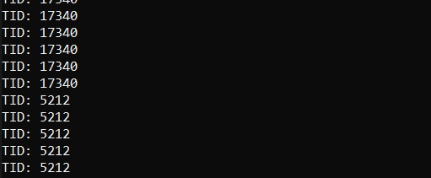

**Задание 02**

2-5)

#include <windows.h>

#include <iostream>

using namespace std;

CRITICAL_SECTION cs;

DWORD WINAPI thread(char* lpParam) {

for (int i = 1; i <= 90; ++i) {

if (i == 30) {

EnterCriticalSection(&cs);

}

else if (i == 60) {

LeaveCriticalSection(&cs);

}

cout << lpParam << ": " << i << endl;

Sleep(100);

}

return 0;

}

int main() {

HANDLE hThread1, hThread2;

hThread1 = CreateThread(NULL, 0, (LPTHREAD_START_ROUTINE)thread, (char*)"A", 0, NULL);

hThread2 = CreateThread(NULL, 0, (LPTHREAD_START_ROUTINE)thread, (char*)"B", 0, NULL);

InitializeCriticalSection(&cs);

thread((char*)"main");

WaitForSingleObject(hThread1, INFINITE);

WaitForSingleObject(hThread2, INFINITE);

CloseHandle(hThread1);

CloseHandle(hThread2);

DeleteCriticalSection(&cs);

return 0;

}

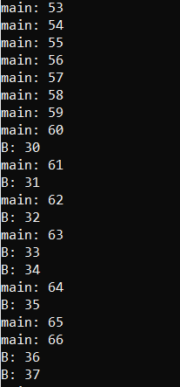 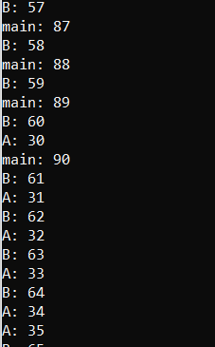 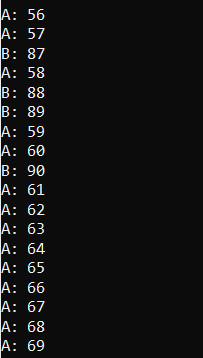

**Задание 03**

6-9) OS06-03

#include <iostream>

#include <mutex>

#include "Windows.h"

using namespace std;

int main()

{

const wchar_t* path1 = L"D:\\лабы\\oc\\lab6\\lab6\\Debug\\OS06_03A.exe";

const wchar_t* path2 = L"D:\\лабы\\oc\\lab6\\lab6\\Debug\\OS06_03B.exe";

HANDLE mutex;

mutex = CreateMutex(NULL, false, L"OS06_03");

STARTUPINFO si1, si2;

PROCESS_INFORMATION pi1, pi2;

ZeroMemory(&si1, sizeof(STARTUPINFO));

ZeroMemory(&si2, sizeof(STARTUPINFO));

si1.cb = sizeof(STARTUPINFO);

si2.cb = sizeof(STARTUPINFO);

if (CreateProcessW(path1, NULL, NULL, NULL, FALSE, CREATE_NEW_CONSOLE, NULL, NULL, &si1, &pi1))

cout << "Process OS06_03A created\n";

else

cout << "Error(1)\n";

if (CreateProcessW(path1, NULL, NULL, NULL, FALSE, CREATE_NEW_CONSOLE, NULL, NULL, &si2, &pi2))

cout << "Process OS06_03B created\n";

else

cout << "Error(2)\n";

for (int i = 1; i <= 90; i++) {

if (i == 30) {

WaitForSingleObject(mutex, INFINITE);

}

else if (i == 60) {

ReleaseMutex(mutex);

}

cout << "Main: " << i << endl;

Sleep(100);

}

CloseHandle(mutex);

return 0;

}

}

OS06_03A/OS06_03B

#include <iostream>

#include <mutex>

#include "Windows.h"

using namespace std;

int main()

{

HANDLE mutex;

mutex = CreateMutex(NULL, false, L"OS06_03");

for (int i = 1; i <= 90; i++) {

if (i == 30) {

WaitForSingleObject(mutex, INFINITE);

}

else if (i == 60) {

ReleaseMutex(mutex);

}

cout << "OS06_03A: " << i << endl;

Sleep(100);

}

CloseHandle(mutex);

return 0;

}

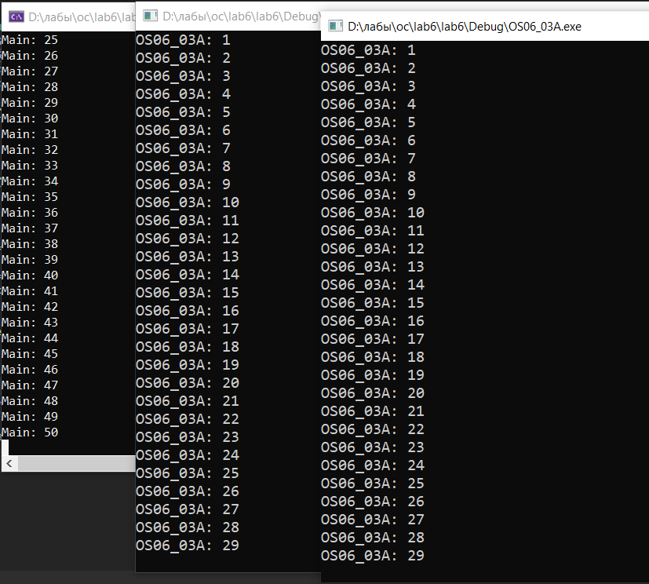 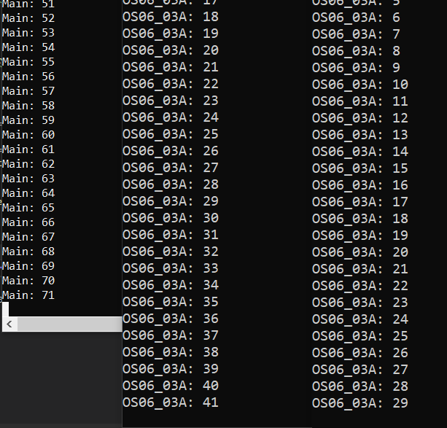

**Задание 04**

10-13) OS06_04

#include <iostream>

#include <mutex>

#include "Windows.h"

using namespace std;

int main()

{

const wchar_t* path1 = L"D:\\лабы\\oc\\lab6\\lab6\\Debug\\OS06_04A.exe";

const wchar_t* path2 = L"D:\\лабы\\oc\\lab6\\lab6\\Debug\\OS06_04B.exe";

HANDLE semaphore;

semaphore = CreateSemaphore(NULL,2 , 2, L"OS06_04");

STARTUPINFO si1, si2;

PROCESS_INFORMATION pi1, pi2;

ZeroMemory(&si1, sizeof(STARTUPINFO));

ZeroMemory(&si2, sizeof(STARTUPINFO));

si1.cb = sizeof(STARTUPINFO);

si2.cb = sizeof(STARTUPINFO);

if (CreateProcessW(path1, NULL, NULL, NULL, FALSE, CREATE_NEW_CONSOLE, NULL, NULL, &si1, &pi1))

cout << "Process OS06_04A created\n";

else

cout << "Error(1)\n";

if (CreateProcessW(path1, NULL, NULL, NULL, FALSE, CREATE_NEW_CONSOLE, NULL, NULL, &si2, &pi2))

cout << "Process OS06_04B created\n";

else

cout << "Error(2)\n";

for (int i = 1; i <= 90; i++) {

cout << "Main: " << i << endl;

if (i == 30) {

WaitForSingleObject(semaphore, INFINITE);

}

else if (i == 60) {

ReleaseSemaphore(semaphore, 1, NULL);

}

Sleep(100);

}

CloseHandle(semaphore);

return 0;

}

OS06_04A/OS06_04B

#include <iostream>

#include <mutex>

#include "Windows.h"

using namespace std;

int main()

{

HANDLE semaphore;

semaphore = CreateSemaphore(NULL, 2, 2, L"OS06_04");

for (int i = 1; i <= 90; i++) {

cout << "OS06_04A: " << i << endl;

if (i == 30) {

WaitForSingleObject(semaphore, INFINITE);

}

else if (i == 60) {

ReleaseSemaphore(semaphore, 1, NULL);

}

Sleep(100);

}

CloseHandle(semaphore);

return 0;

}

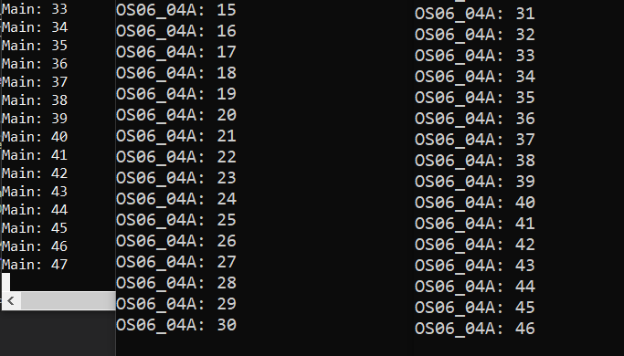

**Задание 05**

14-17) OS06_05

#include <iostream>

#include <mutex>

#include "Windows.h"

using namespace std;

int main()

{

const wchar_t* path1 = L"D:\\лабы\\oc\\lab6\\lab6\\Debug\\OS06_05A.exe";

const wchar_t* path2 = L"D:\\лабы\\oc\\lab6\\lab6\\Debug\\OS06_05B.exe";

HANDLE event;

event = CreateEvent(NULL, FALSE, FALSE, L"OS06_05");

STARTUPINFO si1, si2;

PROCESS_INFORMATION pi1, pi2;

ZeroMemory(&si1, sizeof(STARTUPINFO));

ZeroMemory(&si2, sizeof(STARTUPINFO));

si1.cb = sizeof(STARTUPINFO);

si2.cb = sizeof(STARTUPINFO);

if (CreateProcessW(path1, NULL, NULL, NULL, FALSE, CREATE_NEW_CONSOLE, NULL, NULL, &si1, &pi1))

cout << "Process OS06_05A created\n";

else

cout << "Error(1)\n";

if (CreateProcessW(path1, NULL, NULL, NULL, FALSE, CREATE_NEW_CONSOLE, NULL, NULL, &si2, &pi2))

cout << "Process OS06_05B created\n";

else

cout << "Error(2)\n";

for (int i = 1; i <= 90; i++) {

cout << "Main: " << i << endl;

if (i == 15) {

SetEvent(event);

}

Sleep(1000);

}

CloseHandle(event);

return 0;

}

OS06_05A/OS06_05B

#include <iostream>

#include <mutex>

#include "Windows.h"

using namespace std;

int main()

{

HANDLE event;

event = CreateEvent(NULL, FALSE, FALSE, L"OS06_05");

for (int i = 1; i <= 90; i++) {

WaitForSingleObject(event, INFINITE);

SetEvent(event);

cout << "OS06_05A: " << i << endl;

Sleep(100);

}

CloseHandle(event);

return 0;

}

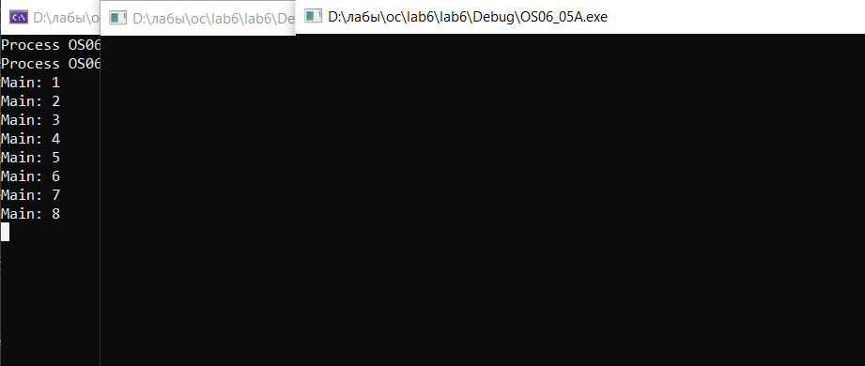

**Задание 06**

18-21)

#include <stdio.h>

#include <time.h>

#include <unistd.h>

#include <pthread.h>

pthread_mutex_t mutex;

void* thread(void* name) {

for (int i = 1; i <= 90; ++i) {

if (i == 30) {

pthread_mutex_lock(&mutex);

} else if (i == 60) {

pthread_mutex_unlock(&mutex);

}

printf( "%s: %d \n", (char*)name, i);

usleep(100000);

}

pthread_exit("Child Thread");

}

int main() {

pthread_t thread1, thread2;

pthread_mutex_init(&mutex, NULL);

pthread_create(&thread1, NULL, thread, (void*)"A");

pthread_create(&thread2, NULL, thread, (void*)"B");

thread((void*)"main");

pthread_join(thread1, NULL);

pthread_join(thread2, NULL);

pthread_mutex_destroy(&mutex);

return 0;

}

