2D-to-3D Vehicle Location System
Technical Project Report
Real-time traffic intelligence from standard camera infrastructure
June 2026

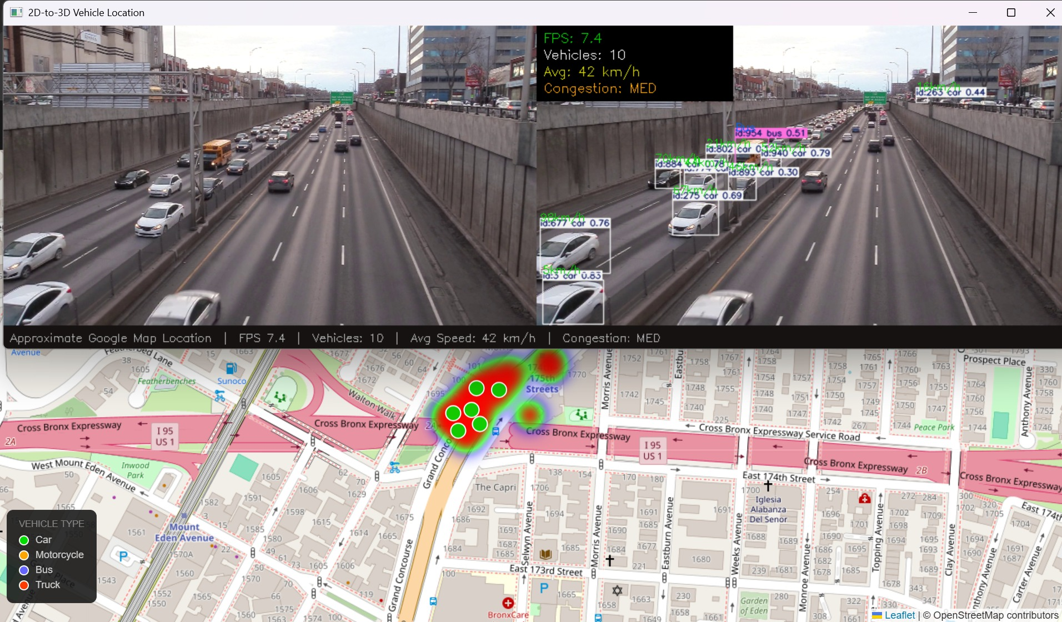
Figure 1: Live pipeline — original feed, YOLO detection, and real-time GPS map overlay running simultaneously

5–13  Avg FPS (CPU) | 65–87%  Detection Confidence | ~10–30m  Location Accuracy | None  GPU Required

1. What This Project Does
Standard traffic cameras produce video that is watched by humans and discarded. This project adds a software layer that transforms that same video feed into structured, location-aware traffic data — in real time, with no hardware changes.
Each vehicle detected by YOLO is assigned a persistent tracking ID, its pixel position is projected to a real GPS coordinate using a homography matrix, its speed is estimated from position change over time, and a live dot appears on an OpenStreetMap map — color-coded by vehicle type with a heatmap showing density over time.
The result: a digital twin of road traffic from a $0 software upgrade to existing cameras.

2. Why This Matters
Cities worldwide have deployed thousands of roadside cameras. Most produce no structured data whatsoever. This project demonstrates what becomes possible when computer vision is applied to that existing infrastructure:
- Real-time vehicle location on a map — no GPS hardware in vehicles
- Per-vehicle speed estimation — automated, continuous, no radar guns
- Traffic density heatmaps — congestion patterns visualized over time
- Vehicle type breakdown — cars, trucks, buses, motorcycles classified automatically
- Congestion alerts — LOW / MED / HIGH updated every frame

Applications include smart city traffic management, highway digital twins, incident detection, infrastructure planning, and autonomous vehicle testing environments.

3. How It Works — The Pipeline
Stage | What Happens
1 — Video Input | OpenCV reads the camera frame by frame at 640×360px — fast enough for real-time processing on CPU
2 — YOLO Detection | YOLOv8n detects vehicles in each frame, producing bounding boxes, class labels, and confidence scores
3 — ByteTrack | Each vehicle gets a persistent ID that follows it across frames — essential for speed estimation and map continuity
4 — Homography | 4 pixel-GPS point pairs define a transformation matrix H. Any pixel (x,y) maps to real GPS (lat,lon) via cv2.perspectiveTransform()
5 — Speed Estimation | GPS position change ÷ elapsed time = speed in m/s, converted to km/h. Outliers above 200 km/h are filtered.
6 — Map + Analytics | Vehicle dots rendered on OpenStreetMap tiles. Heatmap accumulates history. Stats bar updates every frame.

4. Why YOLOv8 and Not a Newer Version?
YOLOv9, v10, and v11 all exist. The choice of v8 was deliberate:
Reason | Detail
Largest ecosystem | Most tutorials, Stack Overflow coverage, and community examples of any YOLO version
Trivial upgrade path | Switching to v11 = changing one word: YOLO('yolo11n.pt'). Zero other changes needed.
CPU performance | YOLOv8n achieves 5–13 FPS on Intel Iris Xe. Newer models gain <3% accuracy at higher CPU cost.
Proven on this task | 65–87% confidence on side-angle highway footage — sufficient for all pipeline stages

5. Limitations & Margin of Error
Homography Calibration (~10–30m error)
The biggest source of inaccuracy. Four pixel-GPS point pairs are needed to compute the transformation matrix. Manual selection introduces:
- 5–15 pixel click error per point
- 5–10 meter GPS precision from Google Maps
- Points that are too close together amplify matrix conditioning errors
This is sufficient for traffic flow analysis and congestion detection, but not for lane-level precision. Accuracy improves significantly with precise ground control points (e.g. road markings with surveyed GPS).

Speed Estimation (~10–20% error)
CPU frame processing time varies, making timestamp deltas inconsistent. Speed estimates are most reliable for vehicles moving in a straight line through the center of the frame. Kalman filter smoothing would reduce this significantly.

Detection Gaps
- YOLOv8n struggles with vehicles far from the camera (small pixel area)
- Top-down aerial angles produce fewer detections than side-angle views
- Heavy occlusion (vehicles behind trucks) may drop detections temporarily

6. Results
Metric | Result
FPS | 5–13 on Intel Iris Xe (no GPU) | 60+ expected on NVIDIA GPU
Vehicles tracked | Up to 20+ simultaneous IDs per frame
Speed range | 0–180 km/h estimated (outliers filtered above 200)
Map accuracy | ~10–30 meters from true position
Vehicle types | Car, truck, bus, motorcycle — color-coded on map
Hardware | Standard laptop — no GPU, no special hardware

7. Next Steps
- Improve calibration accuracy using lane-marking GPS for sub-5m precision
- Upgrade to YOLOv8m for better small-vehicle detection
- Streamlit dashboard — interactive web UI with live charts and map controls
- Kalman filter smoothing on GPS positions to reduce map jitter
- Save annotated output video for GitHub and LinkedIn demo
- RTSP live stream support for real camera feeds
- Multi-camera aggregation into a single unified map view

Conclusion
This project demonstrates a complete, working pipeline from raw camera video to spatial traffic intelligence — built entirely with open-source tools on consumer hardware, with no vehicle-side hardware required.
The core contribution is practical: it shows that existing camera infrastructure can be upgraded with a software-only layer to produce meaningful, location-aware traffic data. The architecture is modular, well-documented, and ready for extension toward real-world deployment on traffic camera networks.
Built from zero computer vision knowledge to a full end-to-end pipeline in a single development session.

