Oleksandr Yardas
Tut-100-17
Paul Hutchison
9/13/2016

Paper 1

Calvin is often seen alone in any given strip. He doesn’t seem to have many friends, and his parents don’t like him. How could a six year old boy to have so many problems? There are only so many things a small child can do to get people to not like them: not sharing toys, being mean, etc. But Calvin is not like most six year olds. He philosophizes and argues, he has a large vocabulary, and he fetishizes graphic violence, but none of these give reason to Calvin’s isolation. It is Calvin’s self-centric worldview that isolates him, literally and socially, as evidenced by his inability to apply a theory of mind – to conceive that other beings are independent of one’s self – to his life.

Calvin has a self centered view of life; When Calvin receives an assignment back, he sees that the grade is a C, and protests the implication that 75% is only average. He explains that “in today’s society, doing something 75% right is outstanding! If government and industry were 75% competent, we’d be ecstatic” (Figure 1, Watterson, Complete C&H, Vol 4, 49). Calvin has a pessimistic impression of society that tells him that average work is excellent. His selfish demeanor blinds him from seeing the value in good work, even if it may benefit him. Calvin contradicts himself, claiming that he “won’t stand for… artificial standard[s] of performance,” and then “demand[s] an ‘A’” (49) for his average work; He wishes to have all the benefits without having to follow any of the rules. He has a self-centered view of life, but he is not a bad person; He cannot apply a theory of mind to his life, so it is very difficult to conceive that people think differently than he does.

Calvin does not apply a theory of mind to his life, which most often shows in the classroom; In Figure 2, Calvin is having trouble focusing on his class, and shouts that it is “BORRRING” (Figure 2, Watterson, Complete, Vol 4, 52). He is sent to the principal’s office, and grumbles to himself “Yeah. Yeah… Kill the messenger” (52). Calvin sees himself as a “messenger” in the context of his class; that he just said what everyone else was thinking. This viewpoint fails to apply a theory of mind that there may be some people in the class who think that it is not boring. There is a similar occurrence in Figure 3, where Calvin appears to have a sudden realization, then shouts “THIS IS A BIG FAT WASTE OF MY TIME” (Figure 3, 82). In the next panel, a pair of hands seem to be reaching at Calvin as if to grab him, while Calvin is shouting “HELLPP!! IT’S THE THOUGHT POLICE” (82). Calvin is implying that he is being censored, which he is, but it is because he is being disruptive and inconsiderate of his classmates’ time, even if he thinks that his own is being wasted, which shows a failure to apply a theory of mind. Calvin is set firm that his classmates have the same thoughts that he does, and so when he makes outbursts in class, he frames the punishments he receives in the context of him being a “messenger” or fighting the “thought police.” This combined with his self-centered worldview means that Calvin has a hard time making friends, and is often lonely.

Calvin is often alone in any given strip. He is the center of his world, but perhaps when the world is not pretty, the only thing to look at is one’s self. To Calvin, the real world is a barren white landscape, with the occasional dwelling or piece of furniture. This desolate monotony is a constant reminder of his lack of meaningful relationships and his isolation from other people. This reality would drive many people to suicide. But Calvin has the forest; the forest is his escape from the real world. He can be free from the eyes of others who would look through him. He can live for a little bit, he can be lonely in solitude, which is preferable to being lonely within company. He creates Hobbes as a way to cope with being isolated, and because Hobbes is part of Calvin’s imagination, he is the only “person” who will ever truly understand Calvin. Hobbes is the only thing that sustains Calvin, and because of this Calvin will be alone forever.
^^
THIS IS NOT A CONCLUSION

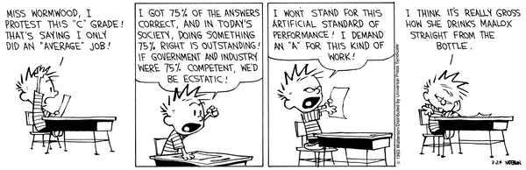

Figure 1

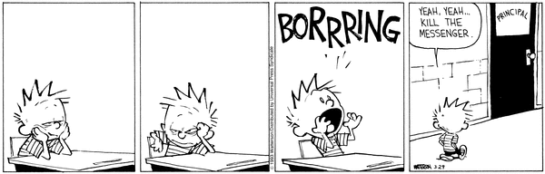

Figure 2

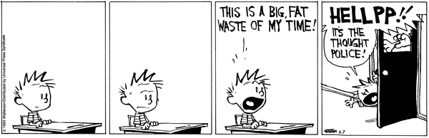

Figure 3

Works cited:

Watterson, Bill. The Complete Calvin and Hobbes, Andrews McMeel, 2012. Volume 4

