In order to get a free copy of Mathmatica on your personal computer follow this link: [https://user.wolfram.com/portal/requestAK/3349559832b6dbec600b7415579a621d15c49f97](https://mail.grinnell.edu/owa/redir.aspx?C=NJ-mbPtL8EGSydrqHFNfff8whdYCBNAI-gC5Wq-AmL-kvvi2EoQEdkXAkTgKtp5L7GJ0fukfCKk.&URL=https%3a%2f%2fuser.wolfram.com%2fportal%2frequestAK%2f3349559832b6dbec600b7415579a621d15c49f97)

To this page where you can select “Create Account”

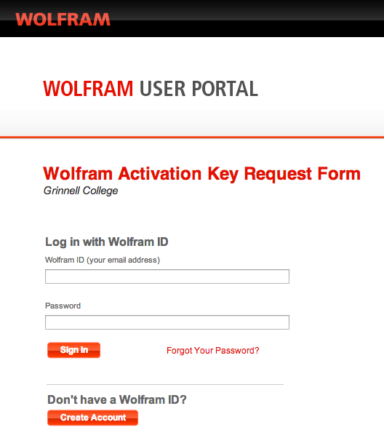

You will be prompted to complete this page

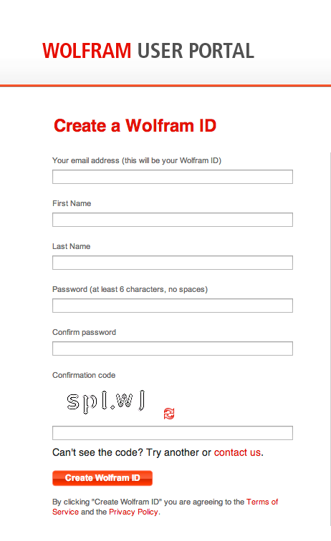

Once successfully completing this page you will receive a confirmation email that you will use to validate your account. The email should look similar to this

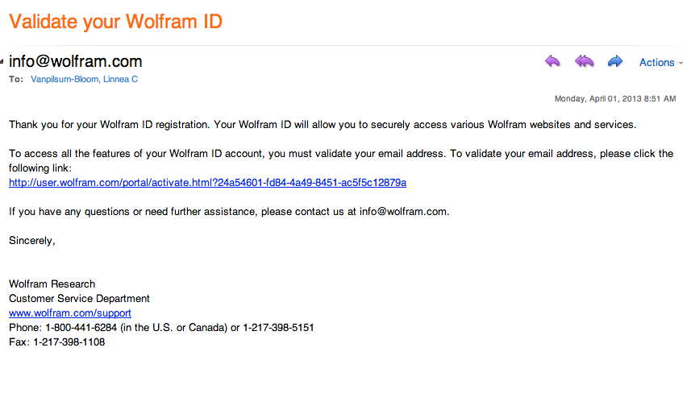

By selecting the provided link in the email, you will validate your account and you should be directed to a site with a message confirming that you have validated your account. This site will also prompt you to log in to Wolfram.

\\psf\Home\Desktop\a.tiff

Once logged in, you will be asked to complete a form with your name and major information. Be sure under “Select a product” you have chosen “Mathematica for Students for Sites 9.0.1 (Single Machine)”. Be sure to enter your graduation date. Once all of this information is completed, click “submit”. You should be prompted to a page similar to:

\\psf\Home\Desktop\c.tiff

Copy down your activation key and select the “Product Summery Page”.

From here, select “Get Downloads”. You should be given the option of downloading the Linux, Macintosh or Windows 9.0.9 version of Mathematica. Choose which operating system you are working on and click that option’s “Download” button.

\\psf\Home\Desktop\d.tiff

This window should pop up:

\\psf\Home\Desktop\e.tiff

Select “start download” to download Mathematica onto your computer.