HW #2 – Signal Processing and Learning Methods for Speech

Please note: the code is rather independent, and I tried to make it as self contained as possible, without need for human intervention.

Question #1
Attached are the STFTs and sound waves of the original used audio signal, the clean signal and the noisy signal (white noise). As requested, the reverb time is 300ms and the noise of 10db
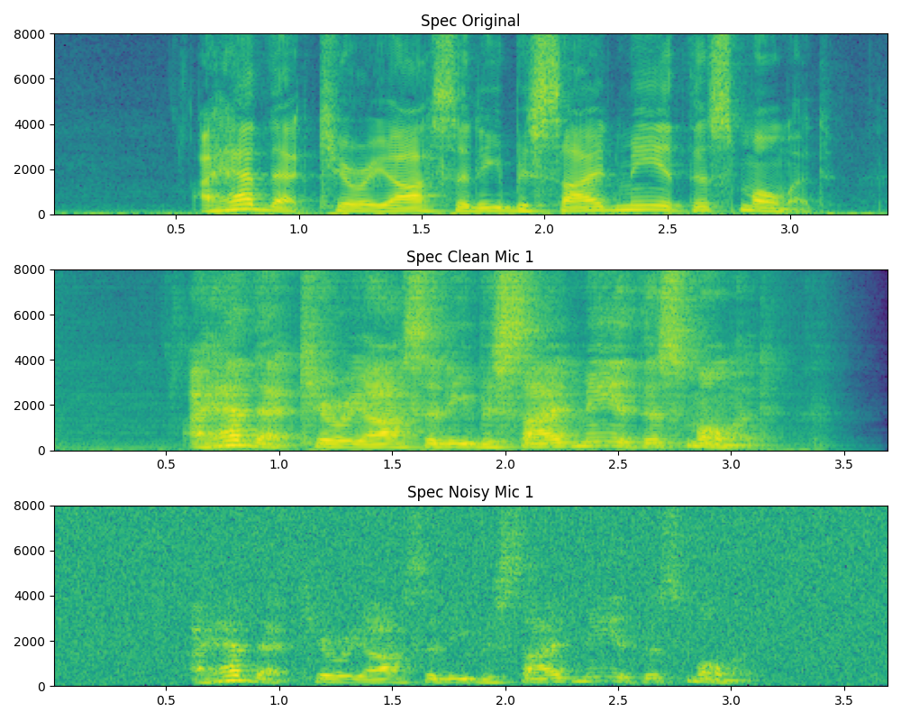
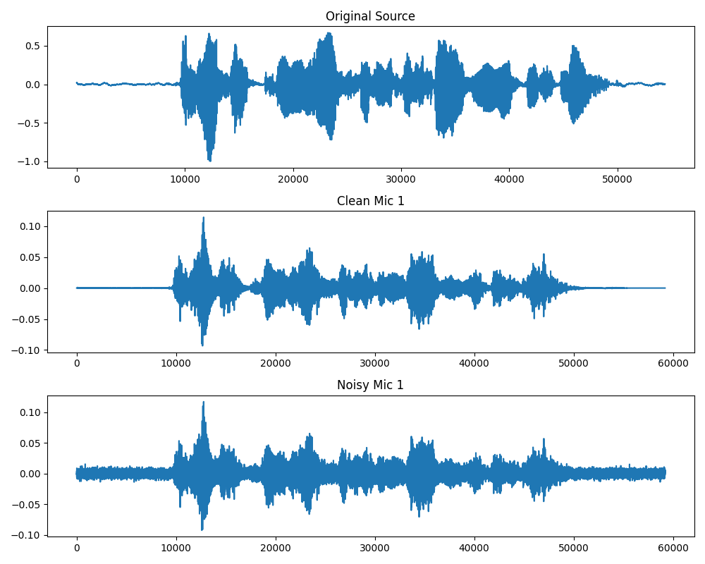

Question #2 & #3 comparison
Attached is a table comparing the quality of the averaging over 20 speech signals with the different variations of T60, snr-s and noise types.
DL_*** = Deep learning (demucs) network results.
Reverberation (T60) [s] | SNR [dB] | Noise Type | MVDR_PESQ | MVDR_ESTOI | MVDR_SI-SDR | DL_PESQ | DL_ESTOI | DL_SI-SDR
0.15 | 0 | gaussian | 1.073 | 0.783 | 7.114 | 1.715 | 0.778 | 13.402
0.15 | 0 | interference | 2.064 | 0.834 | -8.489 | 1.182 | 0.641 | -1.615
0.15 | 10 | gaussian | 1.374 | 0.898 | 14.122 | 2.264 | 0.869 | 18.468
0.15 | 10 | interference | 2.543 | 0.886 | -5.306 | 1.913 | 0.907 | 11.039
0.3 | 0 | gaussian | 1.089 | 0.734 | 7.154 | 1.476 | 0.713 | 8.672
0.3 | 0 | interference | 1.626 | 0.710 | -17.840 | 1.142 | 0.540 | -2.818
0.3 | 10 | gaussian | 1.448 | 0.855 | 13.515 | 1.907 | 0.804 | 9.794
0.3 | 10 | interference | 1.928 | 0.788 | -9.388 | 1.499 | 0.790 | 6.116

Conclusions:
- Noise Types:
  - Gaussian: Both metrics show reasonable performance. The DL model generally outperforms MVDR in PESQ and SI-SDR, especially at lower SNRs.
  - Interference: The MVDR beamformer struggles significantly with SI-SDR (negative values), likely due to the directional nature of the interference not being perfectly nulled or due to reverberation mismatches in the steering vector calculation (using T60=0.3 likely causes mismatch if the beamformer assumes free field or perfect RTF). However, the DL model handles interference much better, achieving positive SI-SDR in high SNR cases and significantly higher PESQ scores.
- Reverberation (T60):
  - As expected, performance generally degrades as T60 increases (0.15s -> 0.3s) for both algorithms, as dereverberation is a difficult task.
Overall - the Deep Learning approach (Demucs) demonstrates superior robustness to different noise types and reverberation conditions compared to the traditional MVDR beamformer implemented here.

