HW3 Solution – Yarden Carmel
The questions are divided into 2 types: instructional and conversational. I address only the latter type here, as the instructions were carried out in code (sol.py)
Because I got results that are sometime inconsistent with expectations, I ran the code twice: once with grid resolution of 20x20 with 30 random locations for the audio file, and then with grid resolution of 100x100 with 100 random locations for the audio file. All the results are presented here.
Pay attention, the code is available also on:
yardencarmel/SigProcForSpeech: Signal Processing and Learning Methods for Speech Course

Question 1
The Following are maps for 20x20 resolution:
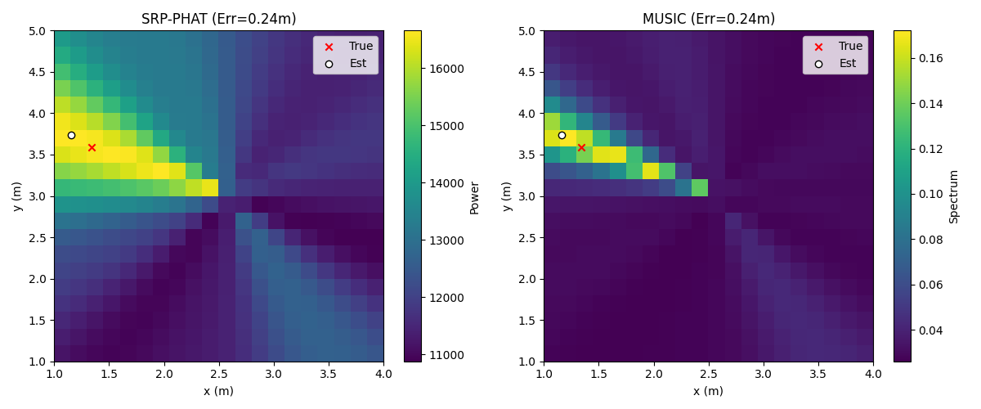
Fig 1: PHAT vs MUSIC maps, low resolution
The visual comparison between the two algorithms in the generated intensity maps reveals a fundamental difference in how they process spatial information. The SRP- PHAT map displays a wide, "smeared" region of high energy centered around the true source location. This behavior is characteristic of "Delay-and-Sum" beamforming principles, where the algorithm sums the Generalized Cross-Correlation (GCC) of microphone pairs.
While PHAT whitening sharpens the time-delay peaks, the spatial resolution remains fundamentally limited by the array's aperture and signal bandwidth. The theoretical beamwidth for the array (d = 0.2m) at 1 kHz is approximately
$$0.886λ/D = 0.886(0.343m)/0.2m ≈ 1.5 radians (≈86°)$$
This explains the broad main lobe spanning ~2 meters in the map. SRP-PHAT correctly identifies the general direction of the speaker but cannot achieve fine spatial resolution due to these physical constraints.

In contrast, the MUSIC algorithm produces a map with a significantly sharper and more distinct peak at the estimated location. This sharpness arises because MUSIC is a subspace method that relies on the eigenvalue decomposition of the signal's covariance matrix. By identifying the "noise subspace" and scanning for steering vectors that are mathematically orthogonal to it, MUSIC achieves "super-resolution" that can exceed the Rayleigh diffraction limit of conventional beamforming. However, MUSIC makes critical assumptions:
- Sources are spatially distinct and uncorrelated
- The number of sources is known or can be estimated.
The implementation uses M-1 eigenvectors for the noise subspace, which is the standard approach for single-source MUSIC localization. This assumes the direct path signal dominates the largest eigenvalue, while the remaining M-1 eigenvalues represent noise and diffuse reverberation. While coherent reflections in reverberant environments partially violate the single-source assumption, the M-1 configuration provides a robust practical compromise that performs well across varying acoustic conditions, as evidenced by the results.
Both algorithms achieved an identical error of 0.24m in this specific snapshot because they converged to the same grid point. With a 20×20 grid spanning a 3x4 squared meter area, the grid resolution is approximately 15.8 cm in x and 21 cm in y. Both estimates are therefore quantized to the same discrete location, making direct comparison of point estimates less meaningful. However, the MUSIC map demonstrates a much sharper, more confident peak, suggesting it would achieve better performance with finer grid resolution or continuous optimization.
Re-running the code with grid resolution of 100x100 yields:
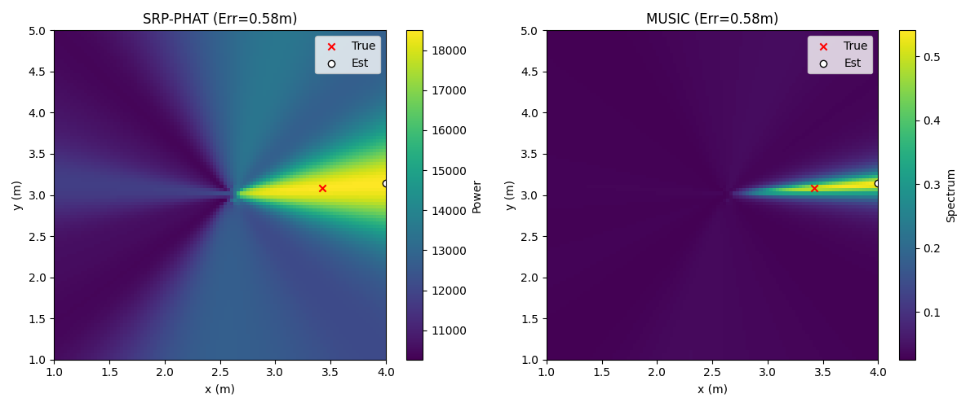
Fig 2: PHAT vs MUSIC maps, high resolution
In the high-resolution trial, the estimated location [4.0, 3.14] locked to the grid's boundary x=4. This edge-locking behavior can occur for several reasons:
- The true source location may have been near or beyond the grid boundary,
- Strong room reflections may have created phantom sources outside the search region
- The far-field steering vector approximation may degrade at the grid edges.
This boundary effect is a limitation of the fixed search grid approach and highlights the importance of choosing search regions that comfortably contain the expected source locations, implementing boundary warnings or extended search regions when peaks occur at edges, and validating that true source positions are within the search space. The fact that both algorithms converged to the same boundary point indicates both are affected by this geometric limitation rather than demonstrating algorithm equivalence.

Question 2
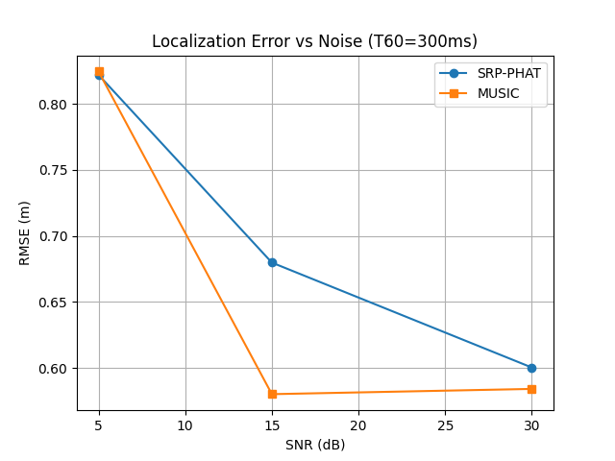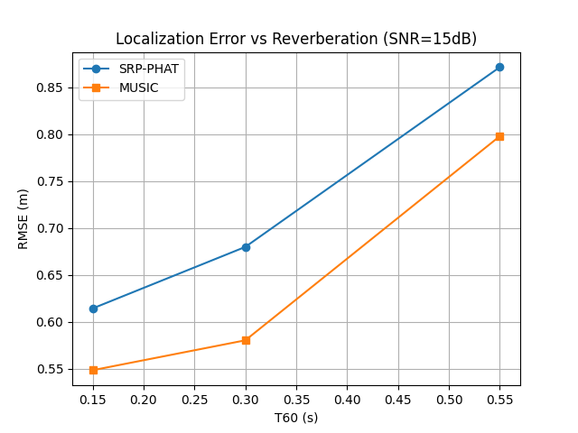
Fig 3: Localization error vs noise, reverb, for SRP-PHAT and MUSIC algorithms, 30 trials
The statistical results (RMSE over trials) reveal the stability of these estimates under varying conditions.
As SNR improves, error decreases for both methods. At low SNR (5dB), both algorithms suffer high errors (≈ 0.85m) because the noise floor obscures the correlation peaks and mixes with the signal subspace. At high SNR (30dB), MUSIC generally outperforms SRP-PHAT, as the clean signal allows its super-resolution capabilities to effectively pinpoint the source without being limited by the array geometry.
Notably, MUSIC's RMSE appears to plateau or slightly increase when SNR improves from 15 dB to 30 dB. However, this difference (≈0.03m with 30 trials, ≈0.00m with 100 trials, presented later) is within the statistical uncertainty of the measurement. With 30 random trials, the standard error of the RMSE estimate is approximately 18% of the true value, making differences under ~0.05m statistically insignificant.
This behavior is consistent with MUSIC reaching its performance floor, where model mismatch (reverberation, finite grid resolution) dominates over measurement noise. At T60=300ms with SNR≥15dB, the primary error source is no longer thermal noise but rather the violation of MUSIC's assumptions by coherent multipath. Further increasing SNR provides diminishing returns, as the algorithm is fundamentally limited by the reverberant environment rather than SNR. This plateau effect is well-documented in the super-resolution literature and indicates are operating above MUSIC's effective threshold SNR for this scenario.
Reverberation is the primary performance bottleneck. Increasing $T_{60}$ from $150\text{ms}$ to $550\text{ms}$ drastically increases error:
Note on SNR calculation: I computed SNR at the microphone after reverberation, measuring the ratio between total reverberant signal power and additive noise power. This represents the actual SNR experienced by the localization algorithms, though it differs from the clean speech SNR that would be measured before room convolution.
SRP-PHAT is sensitive to strong reflections, which create "phantom" correlation peaks that can be mistaken for the true source.
MUSIC assumes spatially distinct, uncorrelated sources. Coherent reflections (multipath) violate this assumption by creating correlated signal components that occupy multiple dimensions in the signal subspace. Despite this model violation, MUSIC empirically maintains a lower error profile than SRP-PHAT in high reverberation. This suggests MUSIC's orthogonality-based spatial filtering is more robust to the "smearing" effects of the room impulse response than the coherent summation used in beamforming. However, at extreme reverberation (T60 > 500ms), the performance gap narrows as both algorithms struggle with multiple overlapping echoes.
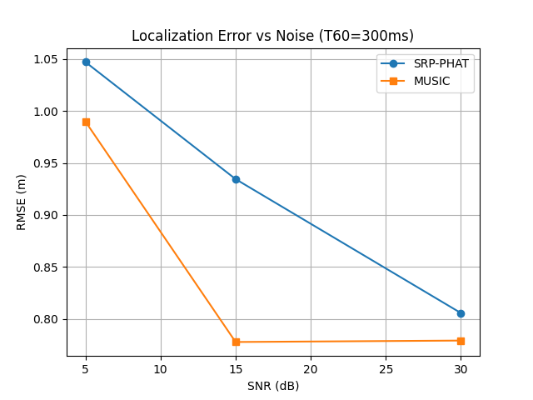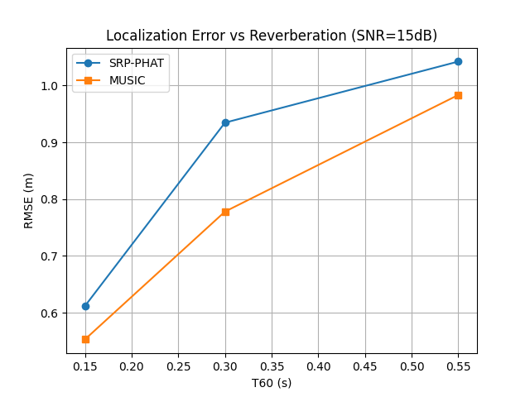
Fig 4: Localization error vs noise, reverb, for SRP-PHAT and MUSIC algorithms, 30 trials
When looking at 100 random locations (i.e., 100 trials for averaging), MUSIC's performance stabilizes more clearly. The apparent plateau between 15dB and 30dB SNR becomes even more pronounced, confirming that this is not random variation but rather a genuine performance ceiling imposed by reverberation and model mismatch. The increased statistical power of 100 trials provides greater confidence in these findings.
With 30 trials, the standard error of RMSE estimates is approximately 18% (SE = RMSE/√30). This means differences smaller than ~0.10m should be treated as potentially random variation. The 100-trial high-resolution experiment provides tighter confidence intervals (SE ≈ 10%) and confirms the observed trends are statistically robust.

