HW #1 – Signal Processing and Learning Methods for Speech

Please note: the code looks for the audio files in the following folder:
path/to/hw1.py-file/assets/dev-clean/LibriSpeech/dev-clean/structure-as-extracted-from-tar-file
path/to/hw1.py-file/assets/test-clean/LibriSpeech/dev-clean/structure-as-extracted-from-tar-file

Question #1

Section A
Number of samples inf the file: 33440
Sample rate: 16000
Length of the audio file in time domain (samples/sample rate) : 2.09 seconds
Max amp.: 0.457489 [FS] (full-scale as librosa gives unit-less amplitude)
Min amp.: -0.465820 [FS] (full-scale as librosa gives unit-less amplitude)

Section B
See the attached image:
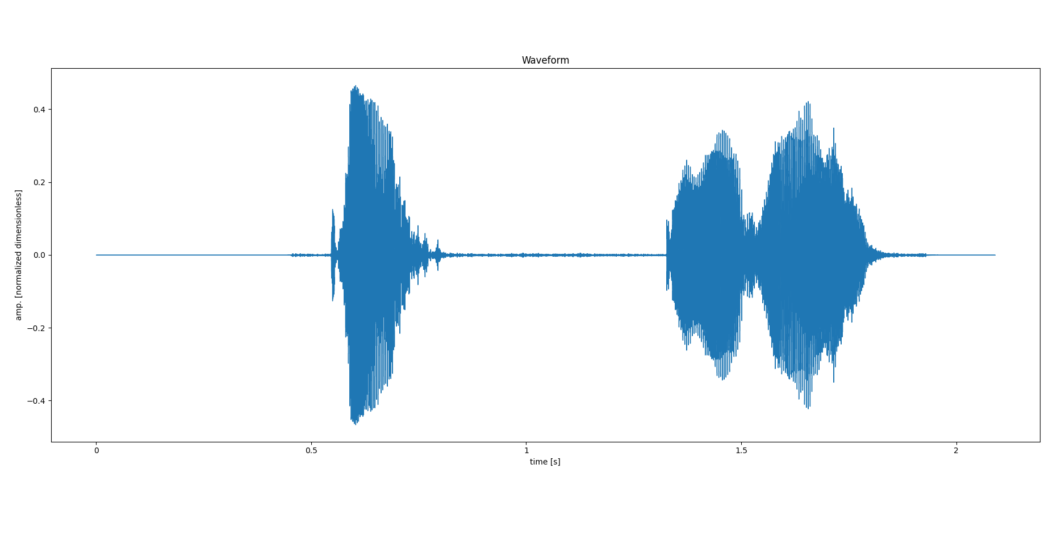
We can clearly see the waveform lasts for just above 2 seconds and the negative and positive amplitudes are just over $±0.4$ in the normalized dimensionless units, matching the calculations based on the information provided by librosa.

Section C
Calculating the STFT with 50[ms] windows and 3[ms] jump size we have:

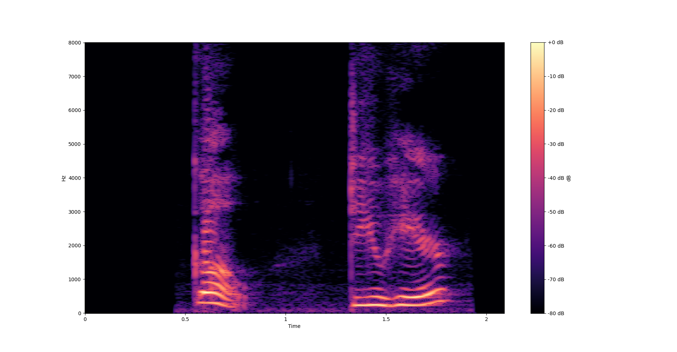
The STFT matches the audio: we see clear rise in the intensity across all frequencies that matches the timing of speaking as presented in the waveform. The spectogram is presented in db, as requested.

Section D
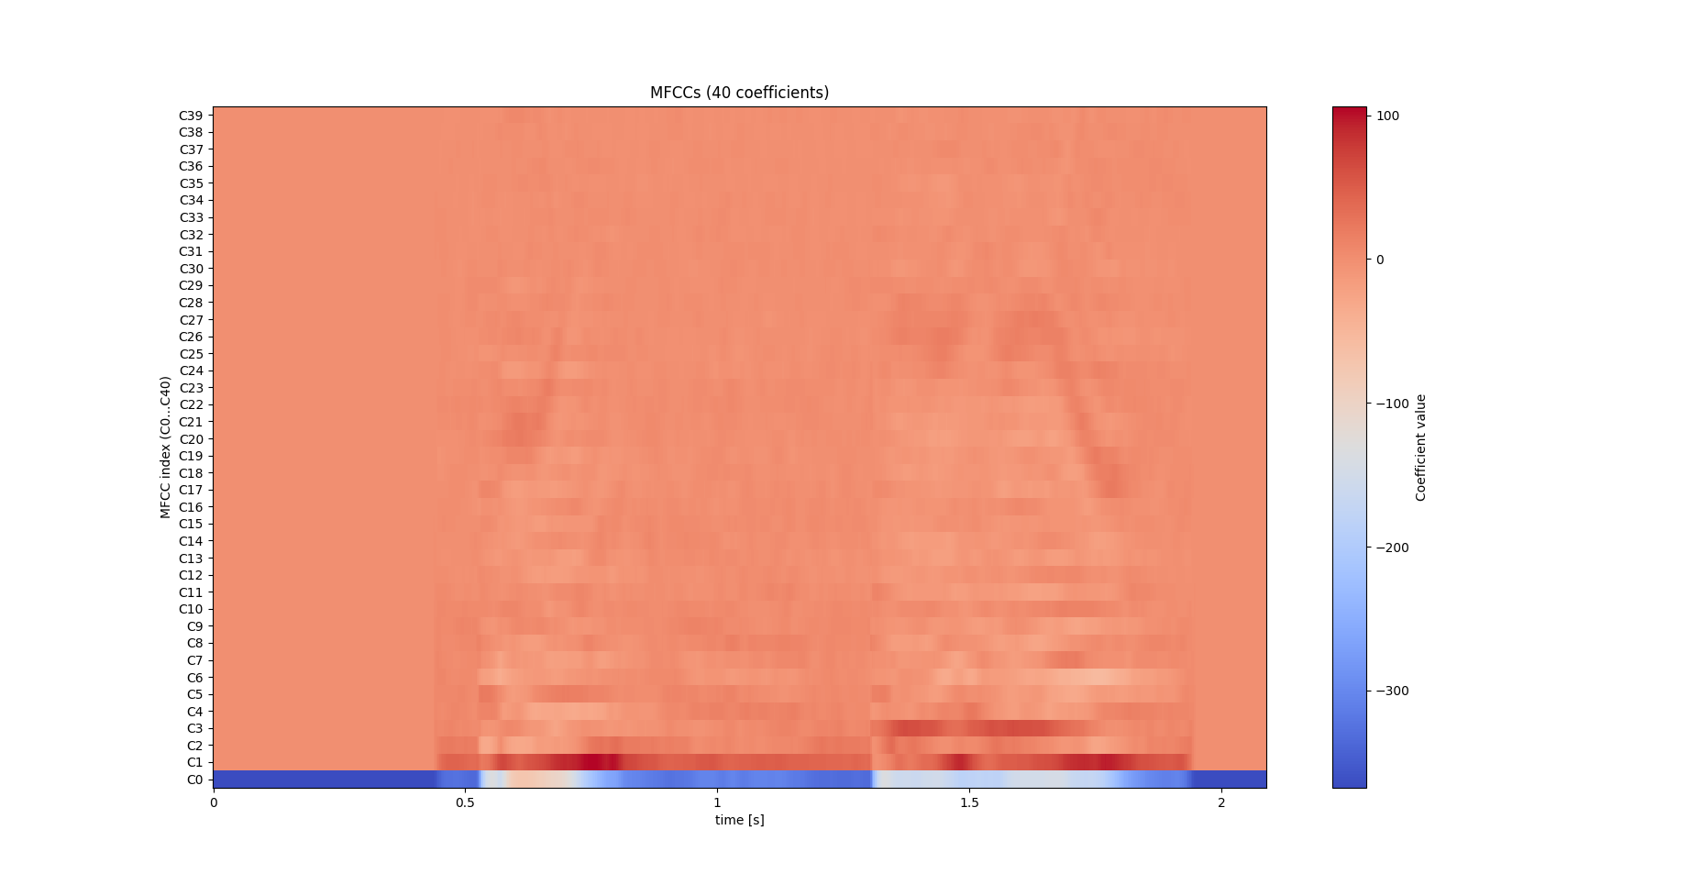
The MFCC coefficients (40 were calculated, matching the suggestion made by Bracha in lecture #3) are presented in the following graph:

Question #2
As requester, I built a speaker–gender classifier using 80 LibriSpeech speakers (40 male, 40 female). I first created a speaker-disjoint random split with 64 speakers for training and 16 for testing, while keeping the gender balance in both sets. For each speaker I loaded up to 20 utterances, labeled them by gender using the SPEAKERS.TXT file, and represented every utterance with two different feature types.
The first feature set was based on MFCCs: I computed 40-dimensional MFCCs (by the recommendation of Bracha) with 50 ms windows and 3 ms hops, and then averaged each coefficient over time to obtain a 40-dimensional “MFCC-mean” vector per utterance. The second feature set was based on pitch: using librosa.yin on the same frame grid, I extracted the fundamental frequency and summarized it with five statistics (minimum, maximum, mean, median, and variance), giving a 5-dimensional “pitch-stats” vector.
For each feature set separately, I trained an SVM classifier with an RBF kernel inside a pipeline with standardization (StandardScaler + SVC(C=10, gamma="scale")) and evaluated it on the held-out test speakers. With MFCC-mean features, the classifier achieved about 0.91 accuracy. It almost never misclassified female utterances (recall ≈ 0.99) but confused some male utterances as female (recall ≈ 0.83), which is reasonable since MFCCs capture general spectral and phonetic information, not only gender.
Using only the pitch-stats features, the SVM performed slightly better, with about 0.93 accuracy and more balanced performance between genders (female recall ≈ 0.96, male recall ≈ 0.89). This matches the expectation that fundamental frequency is a very strong physiological cue for gender: even a low-dimensional summary of F0 already separates male and female voices quite well. Overall, the results show that both MFCCs and pitch are useful for gender classification, but simple pitch statistics alone already provide a very strong and slightly more symmetric classifier. Full output results is present in results.txt

