Lattice Maker – Help

LatticeMaker can create freeform conformal lattices, which are graded along one parametric axis, with input and output as B-rep B-spline geometry imported and exported as surface geometry in the IGES file format.
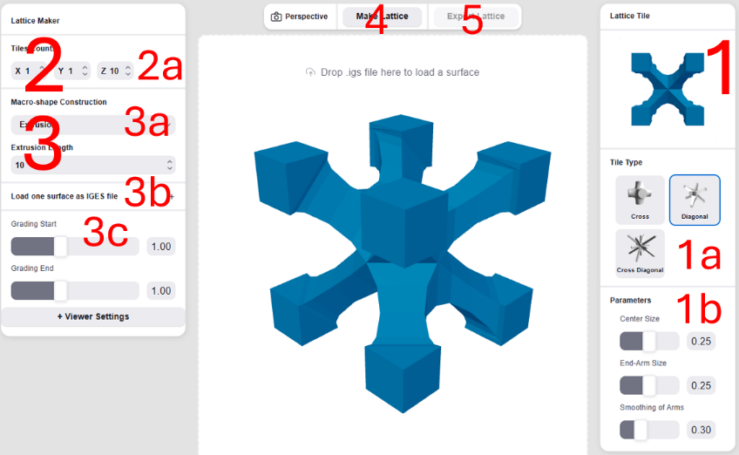
The process of creating a lattice consists of:
- Selecting a tile to employ. In LatticeMaker, we offer three types of tiles – a cross-arms tile, a diagonal-arms tile, and a cross+diagonal arms tile (See 1a on the right). In all three cases, one can control parameters of the tiles, like arms’ thicknesses (See 1b on the right).
- Setting the number of tiles in the macro shape containing volume (See 2a on the right).
- Constructing a macro shape which will contain the lattice as a B-spline trivariate 3D volume, by providing one or two IGES-surfaces, with which the macro shape is created. The macro shape can be created as (See 3a):
  - An extrusion of one IGES-surface into a volume. Extrusion is always in the +Z axis, in an amount that can be set.
  - A Revolution of an IGES-surface into a volume. Revolution is always around the +Z axis, 360 degrees.
  - A ruling between two IGES-surfaces into a volume.
IGES-surfaces can be simply dragged and dropped into the main window, one at a time. Alternatively, one can click on the “Load Geometry as IGES’s files” button (See 3b), in which case two surfaces can be selected simultaneously.
- Press “Make Lattice” (see 4). A progress bar will indicate the progression of the process, only to display the final lattice.
- Press, if you like, “Export Lattice” (see 5) to export the lattice into an IGES (of surfaces) or STL file, on your local machine.
Comments:
- The top has a toggle button to switch between Orthographic and Perspective views.
- The bottom left has a “Viewer Settings” option with which one can control the fore/background colors, tolerances of the tessellations toward display, etc.
- This Web interface also demonstrates the ability to create graded geometry – tiles that change shape along the lattice. Herein, one can affect the arm thickness from beginning to end, in the third parametric axis of the trivariate (not to be confused with the Z axis of 3-space) (See 3c).
- The LatticeMaker is a web-based interface to create 3D lattices, but with some restrictions:
- The Input/loaded IGES-surface(s) files, with which the lattice-containing macro-shape volume is created, should be provided in the IGES file format, holding a single surface each, and the surface should be either a Bezier surface or a B-spline surface with no internal knots. See, for example, DiskSimpleSrf.igs that can be extruded into a cylinder volume and SimpleRevolve.igs that can be revolved around +Z, creating a square-section torus volume.
- As already stated, the Extrusion is only in the +Z axis, an amount that can be set.
- The Revolution construction is only around the Z axis, full circle (360 degrees).
- The number of tiles in the three axes of the containing volume can only be between one and ten in each of the three axes.
If any of these restrictions are overly constraining for you, and/or you have any questions regarding this interface, you are welcome to contact us at lattice@cs.technion.ac.il to see if/how we can help.
This Web interface is based on the volumetric representation (V-rep) abilities of the IRIT solid modeling kernel (See https://gershon.cs.technion.ac.il/irit), and the technology is patented. For a simple introduction, you can read the academic review publication at https://www.sciencedirect.com/science/article/abs/pii/S0010448523001197:
Gershon Elber. “A Review of a B-spline based Volumetric Representation: Design, Analysis and Fabrication of Porous and/or Heterogeneous Geometries”, Computer Aided Design, Vol 163, 2023, 103587.
Use of lattices created using this interface, within the permissible restrictions presented above, is free of charge, including for commercial purposes. Please ack. as follows: “Created using LatticeMaker, https://lattice.cs.technion.ac.il, Gershon Elber, Technion”.
.

