Nginx-Flask-React

Nginx
nginx-1.28.2.zip
- start nginx # Run (From C:\SitesHub\nginx-1.28.2)
- nginx -s stop # Stop
- nginx -s # Reload
- nginx -t # Test ngix.conf file
- nginx -v # Version
- Others
  - Is Nginx running: # tasklist /fi "imagename eq nginx.exe"
  - Kill Nginx: # taskkill /f /im nginx.exe
- Files
  - {root}\ nginx\conf\nginx.conf # Config file
  - {root}\ nginx\conf\access.conf # Access log
  - {root}\ nginx\conf\error.conf # Error log
- netstat -ano | findstr :80 # Check if port 80 is in use

Flask
In the main python (main.py or app.py) run Flask & WebSocket as follow:
socketio.run(app,
host='0.0.0.0',
port=8443,
debug=False,
use_reloader=False
#certfile='cert.pem',
#keyfile='key_nopass.key'
)

React

Prerequisites
- Node.js
- Visual Studio Code

New Project
- Run npm create vite@latest my_project
  - Select React (With arrows)
  - Select JavaScript
- Open new CMD window
- cd react-3d-gui
- npm install
- npm init -y
- npm install react react-dom
- npm install vita
- npm install three
- npm install socket.io-client
- npm run dev or npm run build
  - http://localhost:5173/
  - Network: use --host to expose

Lattice Maker - https://lattice.cs.technion.ac.il/
- Folders
  - Nginx - C:\SitesHub\nginx-1.28.2
  - Python - C:\SitesHub\prodution\LatticeMaker\lattice-website
  - React - C:\SitesHub\prodution\LatticeMaker\lattice-website\react_frontend
- Running
  - If nginx not running do : start nginx
  - cd C:\SitesHub\prodution\LatticeMaker\lattice-website
  - python main.py
  - cd C:\SitesHub\prodution\LatticeMaker\lattice-website\react_frontend
  - npm run dev -- --host

CDML - https://cdml-public.technion.ac.il/
- Folders
  - C:\SitesHub\prodution\imageTechnion_p
- Running
  - cd C:\SitesHub\prodution\imageTechnion_p
  - python app.py

Log Viwer
- Simple (from command line)
  - Install: pip install toolong
  - Run: tl monitor.log
- Advanced
  - Install: Download https://kittyfisto.github.io/Tailviewer/
  - Run: Tailviewer
- Fancy from the browser:
  - https://www.logvoyager.cc/ and select the log file

Other helpers
- Is Nginx running
  - From command line
    - tasklist /FI "IMAGENAME eq nginx.exe"
  - From Task manager under Background Processors

- tasklist /fi "pid eq 1234" # Find process by PID
- netstat -ano | findstr :443 # Find what's using port 443
- netstat -ano | findstr :8080 # Find port 8080
- netstat -ano | findstr LISTENING # Show only listening ports
- Protocol Filters:
  - netstat -an -p tcp # Show only TCP connections
  - netstat -an -p udp # Show only UDP connections
- netstat to show:
  - netstat -ano # Show connections with PID
  - netstat -b # Show executable using the port (run as Admin)
  - netstat -ab # Show all with executable names

DMZ
cmd : ncpa.cpl
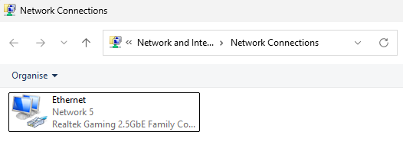
Choose Properties -> Internet Protocol Version 4 (TCP/IPv4)

