**Bookify - Library Management System in Java Swing & SQLite**

**Installation**

* You can install Bookify By Cloning the project files To EclipseIDE and Run From the "Main Class"
* You Can Download winrar File on this [Link](https://github.com/eli1809/Bookify/releases) and run from the CMD this Command : java -jar BookifyRun.jar

**About The Project**

I made this App with Eclipse combined with UI of Swing. Extra libraries:

* *sqlite-jdbc*
* *rs2xml*
* *Junit4.6*
* *Jcalendar*
* *Jgoodies-Looks*

**Features**

* There are two roles: *Librarian interface-manage all the books , book copys , borrow books , ad new Subscriber. *Subscriber interface-manage his Info , borrowing preferable book copy , could look his borrow card and buy books permanently throught online shiping .
* The ability to save and load the last changes.
* Very beautiful and easy to use **modern user interface**

**Code description**

* **MVC** pattern is the basis of this app.
* Used singelton pattern for the sqliteConnection.
* Used Adapter Pattern for the different Listeners.
* Used Observer Pattern for the listeners of keyboard, mouse klicks events
* There is an opportunity to expand the project easily.

**App guide**

**Login**

In the login panel you can login eather as Librarian : eli:123456 / eather as subscriber ilan:123456

[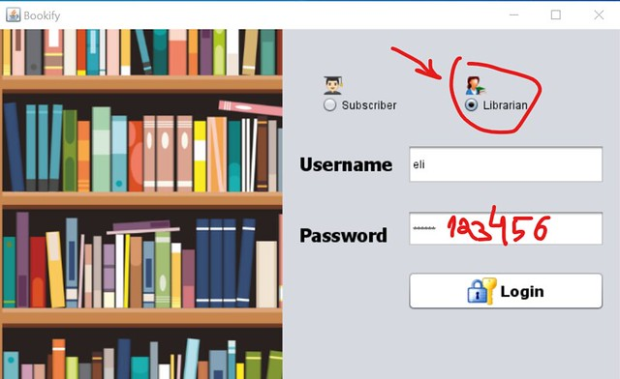](https://camo.githubusercontent.com/8c519169360c157496e22d4c6a9b5f02ede62d67/68747470733a2f2f6c6976652e737461746963666c69636b722e636f6d2f36353533352f34383531343432363130365f373630356262323961385f7a2e6a7067)

In -New Game Menu- you can choose how many players will play, select name and badge color. You need also mark the connection youwant to establish (subscriber or librarian user interface)

**Subscriber Interface**

you can choose between

* *Borrowing* - new borrow
* *My Borrowings* - all borrows that i got
* *Shop* - Internet shop that calculates how match money you spent
* *My info* - showing info about your self

in the borrowing section you need to choose by the arrows what books you want to borrow

[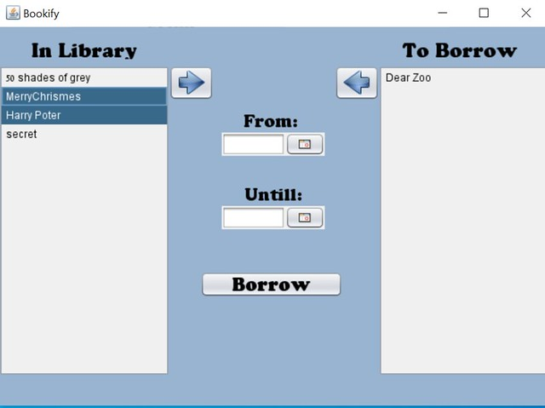](https://camo.githubusercontent.com/2480354b286ffbcf0193039892508cdac003fcc9/68747470733a2f2f6c6976652e737461746963666c69636b722e636f6d2f36353533352f34383531343432353737315f363062383136373136325f7a2e6a7067)

after you choose you need to choose the date of the boorrowing

[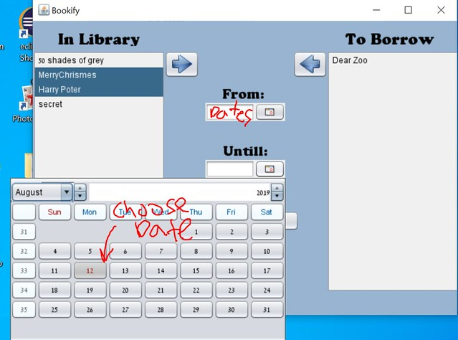](https://camo.githubusercontent.com/743f73273657cab7aa0654d0e62a0a248b4023dd/68747470733a2f2f6c6976652e737461746963666c69636b722e636f6d2f36353533352f34383531343432353837315f303562646462323062315f7a2e6a7067)

Then you just click borrow to finish

now to check what books in your borrow list you need to click "MyBorrowings"

[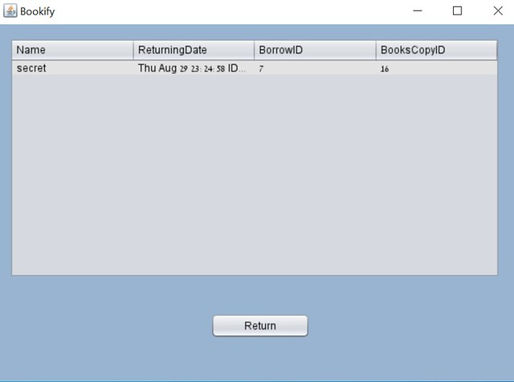](https://camo.githubusercontent.com/5a5666b5873ce58773b3e2512839d1200f6b9b7c/68747470733a2f2f6c6976652e737461746963666c69636b722e636f6d2f36353533352f34383531343630373734325f346337343266663265325f7a2e6a7067)

if You Want to Buy books permanently you go to "Shop"

[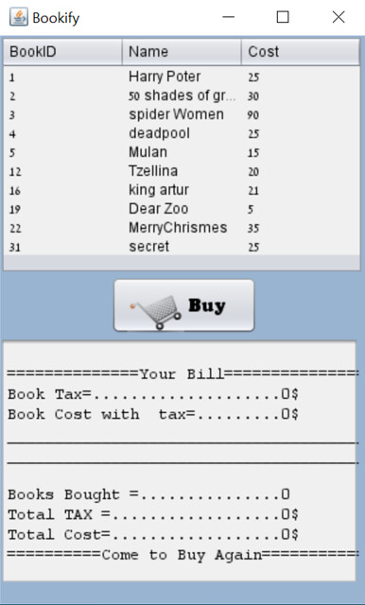](https://camo.githubusercontent.com/1be4c28963d1113dfa56a7c230ef1ea9ba5954cb/68747470733a2f2f6c6976652e737461746963666c69636b722e636f6d2f36353533352f34383531343432353438365f626364346662336330645f7a2e6a7067)

and now if you want to check your info and books borrowed go to "Myinfo"

[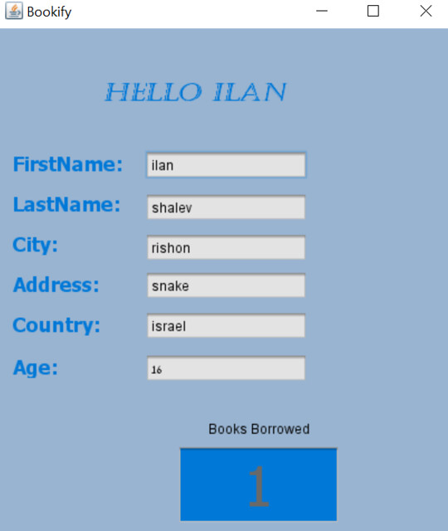](https://camo.githubusercontent.com/90c7805a73c75346f334a2bcee95e2ff3400c850/68747470733a2f2f6c6976652e737461746963666c69636b722e636f6d2f36353533352f34383531343630373932375f373963396635373732625f7a2e6a7067)

**Librarian Interface(admin)**

now you enter the management systemm of the library , all panels have smart search included :

You can manage type of books by Editing/Deleting/Inserting Books(book Catalog)

[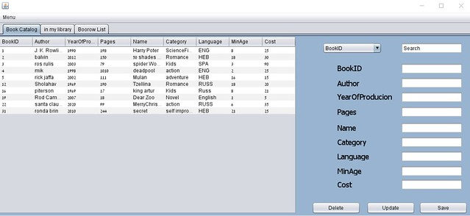](https://camo.githubusercontent.com/c85e81f22672386690db21bd327359cf56f76baf/68747470733a2f2f6c6976652e737461746963666c69636b722e636f6d2f36353533352f34383531343630373532325f383363396136376131655f7a2e6a7067)

On the seconed panel you can manage the bookcopys (real books that exist on your library)

[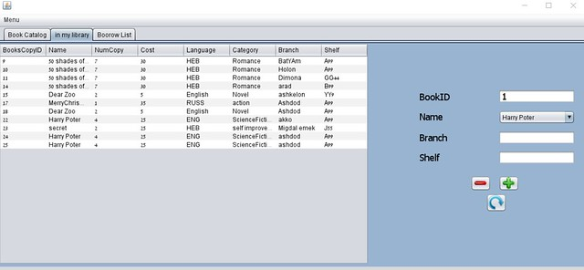](https://camo.githubusercontent.com/f2a37db3f44f576b54c779567c7298f2e7998b64/68747470733a2f2f6c6976652e737461746963666c69636b722e636f6d2f36353533352f34383531343432363330365f613033386264646462385f7a2e6a7067)

Third panel is the borrow panel when you can return books by the librarian

[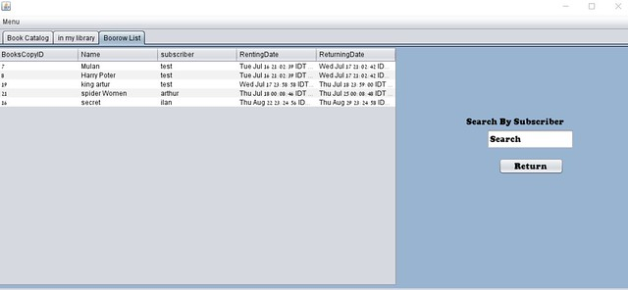](https://camo.githubusercontent.com/5b87ed1bf975c16f438c0533d9e080dc96ed8815/68747470733a2f2f6c6976652e737461746963666c69636b722e636f6d2f36353533352f34383531343432363339365f303334323639626631315f7a2e6a7067)

One more fiture on all the screens you can get to the MenuBar where you can find :

* *Add New Subscriber*
* *Logout*
* *Exit*

[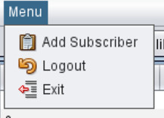](https://camo.githubusercontent.com/ca7a88c72145c346df2aa5847708d3e57dd577e0/68747470733a2f2f6c6976652e737461746963666c69636b722e636f6d2f36353533352f34383531343630383437375f653130303732383132345f6d2e6a7067)