**Example 6.1: Thanksgiving Holiday Weight Gain**  
In a 2006 study published in *Nutrition Journal*, researchers were interested in assessing potential changes that occur in body weight during the Thanksgiving holiday break in college students. This paper’s abstract indicates that “a total of 94 college students reported to the human body composition laboratory at the University of Oklahoma following a 6-hour fast with testing occurring prior to, and immediately following the Thanksgiving holiday break. Body weight was assessed using a balance beam scale while participants were dressed in minimal clothing.”  
  
*Source: Hull et al. The Effects of the Thanksgiving Holiday on Weight Gain.* Nutrition Journal *2006,* ***5****:29; doi:10.1186/1475-2891-5-29.*

Research Question: On average, does body weight of college students increase over the Thanksgiving holiday break?

Questions:

1. What is the response variable of interest?
2. What is the predictor variable of interest?
3. Are the pre-weight and post-weight measurements *dependent on each* other or *independent*? Explain.

The raw data from this study were not available; however, the data in the file **ThanksgivingWeightData.jmp** are similar to the actual results obtained by the researchers. A portion of these data is shown below:  
  
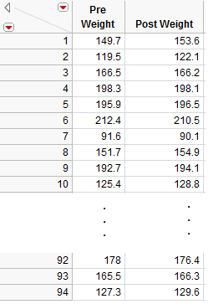

Questions:

1. What can be said about the weight of Subject #1 as compared to Subject #7, for example, regardless of whether the data were collected before or after Thanksgiving?

Comment: For these data, the first pre-weight is related to the first post-weight (the two measurements were made on the same person). Thus, these two samples are **dependent**.

In other words, some of the variability in the responses might be due to differences between time periods (before vs. after), but much of the variability in the observations is likely due to differences between people! **So, to control for this variability in weights from person to person (which will help us isolate the effect of Thanksgiving break), we will work with the DIFFERENCES on each subject, instead.** This will remove the structure of dependence between the pre- and post-Thanksgiving groups and will control for the fact that some people, in general, tend to weigh more (or less) than others. In the end, this helps us to isolate the effect of Thanksgiving break (i.e., before vs. after).

|  |
| --- |
| **Main Point**  When working with two ***dependent*** samples, we will focus on questions about the ***difference*** between measurements. |

**Calculating the Difference in JMP**

First, open the file called **ThanksgivingWeightData.**. To calculate the difference, create an additional column (double click on empty column next to “‘Post Weight”) and title it “Difference.” Right-click on the new column header and select **Formula**.   
  
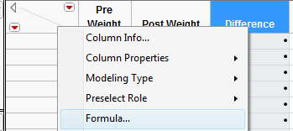

In the edit window, tell JMP to calculate the difference as follows:



Click **Apply** and then **OK**, and JMP returns the following (only the results for the first 10 subjects are shown below):

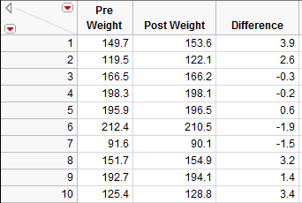

Questions:

1. What does a positive difference of 3.9 indicate?
2. What does a difference of -1.9 indicate?

**Bootstrap Confidence Interval for the Difference**

We will use a bootstrap confidence interval as a first attempt at analyzing these data. To create a bootstrap sample in JMP, you will need to install the JMP add-in titled **SampleWithReplacement v0.14.jmpaddin**. Download and double click the file. You can now sample with replacement by going to **Add-Ins > Sample with Replacement > Sample Now**. Take a bootstrap sample of the differences using this add-in as shown below.

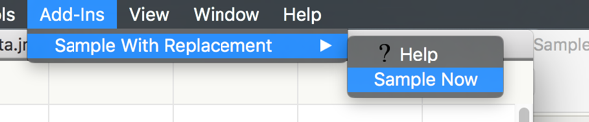 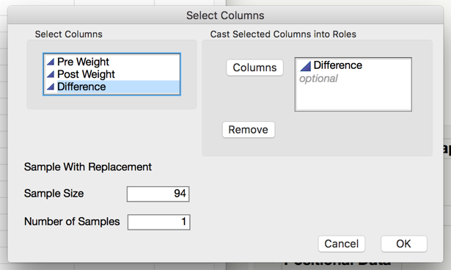

The result in a new table that contains the bootstrap sample of the differences. Compute the mean and standard deviation of this sample use **Analyze > Distribution**.

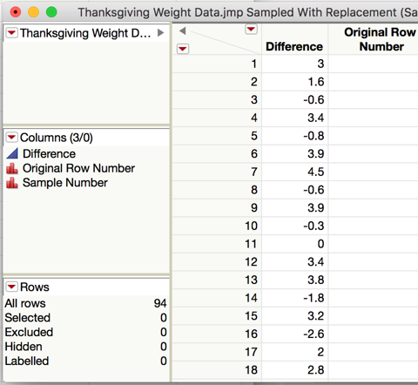 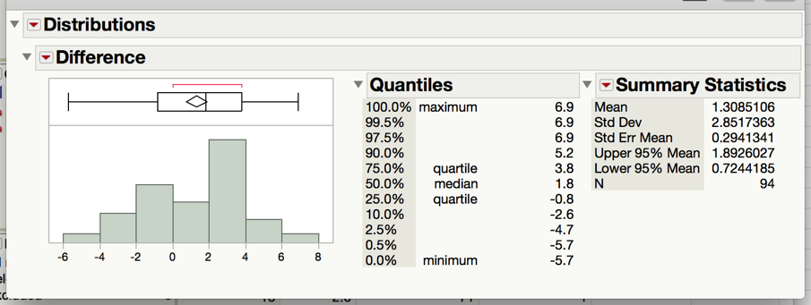

**Task 1: Use JMP to take a few bootstrap samples.**

1. Take 10000 bootstrap samples.
2. Compute the bootstrap mean difference for each sample.
3. Store these means in a new data table.
4. Analyze the distribution.
5. Compute a 95% confidence interval for the mean difference between the pre- and post-Thanksgiving weights. Paste a screen shot below and construct an appropriate sentence for this interval.
6. Based on this interval, what can we confidently say about the differences between pre-and post-Thanksgiving weights? Are we confident that there is, on average, weight gain? Explain.