**Bootstrap Test for Two Independent Means**

Researchers at Pennsylvania State University investigated whether time perception, a simple indication of a person’s ability to concentrate, is impaired during nicotine withdrawal. Twenty smokers were randomly assigned to a 24-hour smoking abstinence and were asked to estimate how much time had passed during a 45-second period. Another 20 smokers were randomly assigned to a group which was *not* forced to abstain from nicotine; they were also asked to estimate how much time had passed during a 45-second period. Suppose the resulting data on perceived elapsed time (in seconds) were analyzed as shown below(these results are artificial but are similar to the actual findings). The data can be found in the file **Nicotine_all.JMP**.

**Research Question:** Do those smokers suffering from nicotine withdrawal tend to believe that more time has elapsed than do those not suffering from nicotine withdrawal?

1. What is the response variable in this study?
2. What is the predictor variable in this study?
3. Explain why the null hypothesis would be $H_{0}:μ_{no}-μ_{with}=0$
4. We will use the bootstrap to perform a test for the difference in means, by following these steps.
   1. Save the data somewhere that is easy to access.
   2. Open the **Randomized Test** add-in, click **Use Other Data**, and open the **Nicotine_all.jmp** data file.

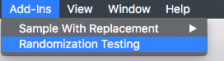 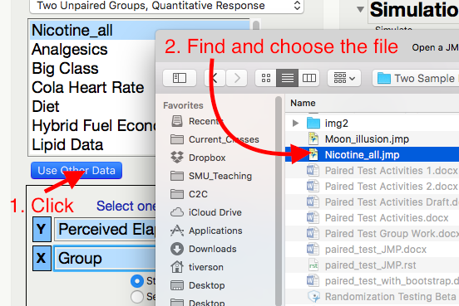

* 1. Highlight the Y and X variables.

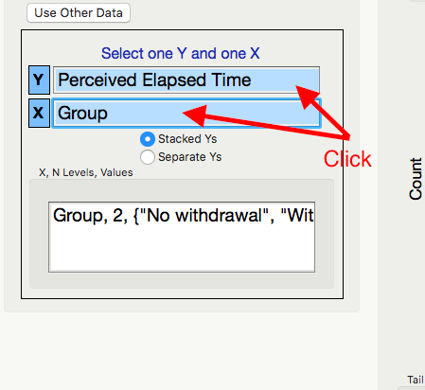

* 1. Generate the bootstrap distribution centered at 0. (Why do we center at 0?)

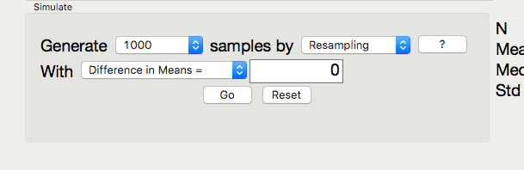

* 1. Note the direction of subtraction on the right hand side. We will need to make sure our alternate hypothesis’s direction matches this subtraction.

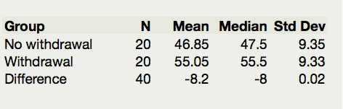

* 1. Explain why the alternate hypothesis is $H_{a}:μ_{no}-μ_{with}<0$.
  2. Pick and record the correct p-value for this test.

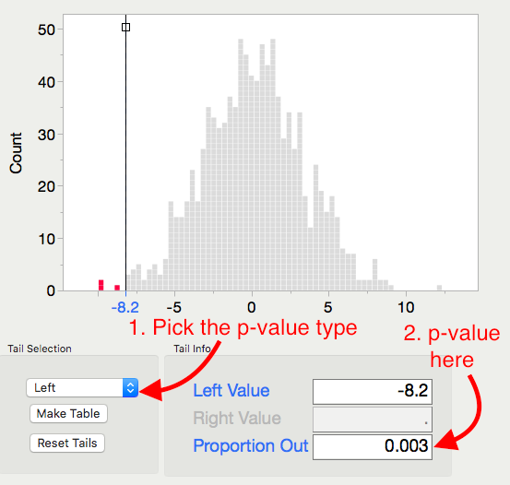

p-value =

* 1. Based on this p-value, write the correct conclusion for this test.