SE445 – HW2 Report
Lead Capture Workflow Using n8n
Name: Yaren Köroğlu
Course: Se445
Instructor: Ruken ZİLAN

1-Introduction:
In this homework, the data pipeline was created by using n8n. The system aim is that the system gets data from the user and save this data to another external system as an automatically without manual entry.
System gets data from the user which comes as a JSON format, processes and saves to Google Sheets. Thus, simple but functional lead capture system was created.
2-Workflow Overview:
Workflow starts with a webhook which receives HTTP POST requests. The data includes name, email and message information. These data are sent to Google Sheets via webhook. Thanks to append row operation, every new request is added to the table. Thanks to this structure, data is transferred automatically without manual data entry.

3-Components Explanation:
- Webhook: It is the beginning point of the system. It listens to HTTP POST requests and gets data from the user.
- Google Sheets: It stores the data which comes from the user. Every new data is added to table as a new row.
- Mapping: JSON data which comes from the Webhook is matched with the Google Sheets’s rows. This operation is made with these expressions: $json.name}}, {{$json.email}} and {{$json.message}}.

4-Testing and Results:
System is tested with an example JSON data which comes from the Webhook. These data include names, email and message fields. As the result of the test, workflow was worked successfully and the data was saved to Google Sheets table. This situation shows that system was worked in a true way and gathered the data requirements.

5-Conclusion
As a result of, data flow was created by using n8n. This project shows that with the basic automation tools we can create efficient data flows. In the future, this system will improve with data verification, filter and AI integration.
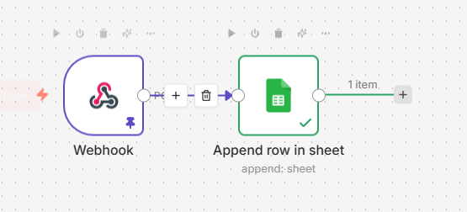
Figure 1 The data pipeline workflow created in n8n
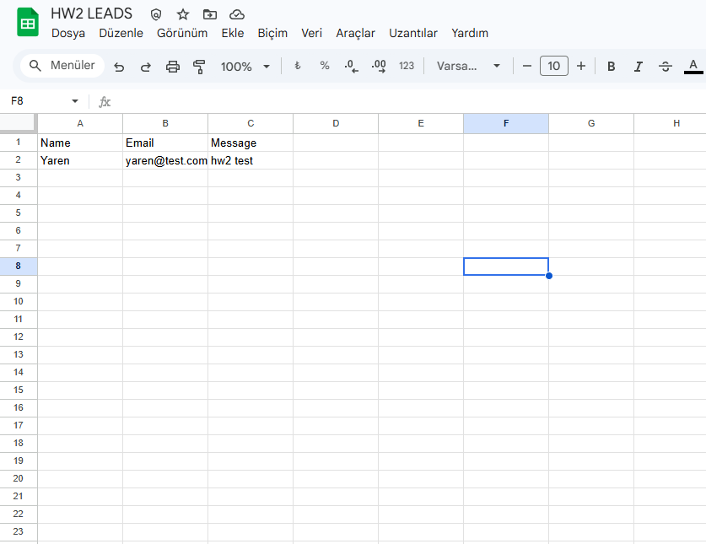
Figure 2 Stored data in Google Sheets
https://github.com/yarenkrg/hw1-lead-capture

