SE445

HW3-REPORT

Name: Yaren Köroğlu
Student Id: 25243510009
Instructor: Ruken Zilan

1-Introduction:
This project aim is improving the previous flow with validation and adding intelligent processing. System gets user data from webhook, controls the data and analyses the content of the message.

2-General Structure of Workflow:
The structure:
Webhook -> Validation -> AI processing -> Final Output
1-Webhook gets data from the user. (name, email, message)
2-Validation controls the missing fields and formats of email.
3-AI identifies purpose of messages and their emergency.
4-Final step makes processed data ready.

3-Logic of Validation:
System controls the data:
-If the name and email field’s is empty, it is pointed as a invalid.
-Email format is controlled with regex.
-If the email is invalid, status will be invalid.
Thus, incorrect and missing data is detected.

4-Processing AI:
System produces two information with analyse message contents.
Intent:
-Support
-Sales
-Partnership
Urgency:
-High
-Medium
-Low
For Example:
- “I want to buy urgently” -> Sales, High
- “I need help” -> Support, Low
This step simulates smart decision behaviour.

5-Output Structure
This output is produced at the end of the operations.
{
"name": "...",
"email": "...",
"message": "...",
"status": "Valid/Invalid",
"intent": "...",
"urgency": "..."
}

6-Data Record
System is designed to save to Google Sheets. But the integration is not completed because of the authorization OAuth problem in the n8n cloud environment.
Nevertheless, Workflow prepare the data which must be saved correctly.

7-Test Scenario
Input:
{
"name": "Yaren",
"email": "yaren@test.com",
"message": "I want to buy urgently"
}

Output:
{
"status": "Valid",
"intent": "Sales",
"urgency": "High"
}

8-Result
This project shows processing data pipeline correctly.
The System:
-Validate the data.
-Analyse the message
-Produce structured output

As a final, data saving operations is not completed because of the technical problem. System is ready logically and it can use in a real environment.

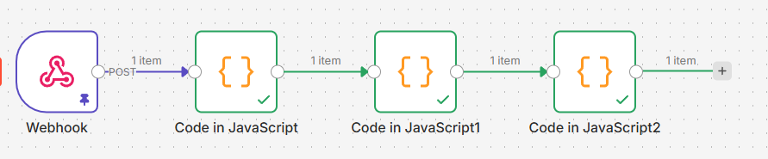
Figure 1. Overall workflow structure (Webhook → Validation → AI processing)

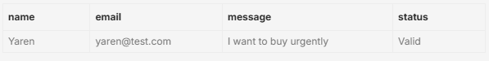
Figure 2. Validation output showing status field (Valid/Invalid)

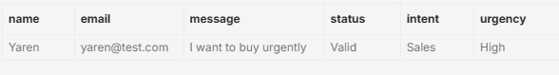
Figure 3. AI processing output showing intent and urgency

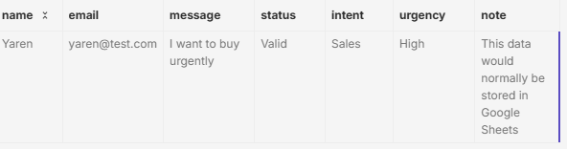
Figure 4 Final processed output including status, intent, and urgency.

