FinVista Capital – Financial Intelligence Assistant

Project Overview:

Purpose
The FinVista Capital-Financial Intelligence Assistant is an enterprise-grade AI solution designed to revolutionize how financial professionals interact with complex documentation. By leveraging a Retrieval-Augmented Generation (RAG) architecture, this application allows users to query large datasets, such as annual reports, market research, and compliance documents, using natural language to receive accurate, context-aware insights.

Key Objectives
- Contextual Intelligence: Move beyond simple keyword searches by providing semantic understanding of financial documents.
- Grounded Accuracy: Eliminate hallucinations by enforcing source-based responses with direct citations (document name and page number).
- Scalable Architecture: Utilize containerization and cloud-native Kubernetes deployment to ensure high availability and elastic performance.
- Production Readiness: Integrate DevOps best practices through automated deployment workflows, secure configuration management, and optimized resource utilization.

Architecture and System Design:

High-Level Architecture
The FinVista Capital - Financial Intelligence Assistant utilizes a cloud-native, microservices-inspired architecture designed for modularity and scalability. The system flow is as follows:
- User Interface: A responsive Streamlit dashboard provides a conversational interface for users to submit natural language queries.
- Intelligence Engine: The backend leverages a Retrieval-Augmented Generation (RAG) pipeline to fetch relevant data from uploaded financial documents and process it via the Gemini API.
- Containerization: The entire application stack is containerized using Docker, ensuring consistency across development, testing, and production environments.
- Cloud Orchestration: The containerized application is deployed on Amazon Elastic Kubernetes Service (EKS), which handles load balancing and high availability.
- Infrastructure Management: The deployment is managed via Kubernetes manifests (deployment.yaml and service.yaml) and orchestrated using eksctl and kubectl.

Data Flow
- Ingestion: Financial reports are uploaded and processed into vector embeddings for semantic search.
- Query: The user submits a question through the web interface.
- Retrieval: The system searches the vector store for context-relevant document segments.
- Generation: The LLM synthesizes an answer based on the retrieved context and presents it to the user with specific source citations.

Technical Implementation (Deployment):
This section details the migration of the application from a local environment to a cloud-native Kubernetes infrastructure.

Infrastructure Provisioning
The application is hosted on Amazon EKS (Elastic Kubernetes Service) to ensure scalability and reliability. The cluster was provisioned using eksctl, an official CLI tool for Amazon EKS.
- Cluster Creation: The command eksctl create cluster --name <cluster-name> --region <region> was utilized to provision the control plane and worker nodes.
- Infrastructure as Code: By utilizing eksctl, the environment setup is repeatable and documented, adhering to industry-standard infrastructure-as-code practices.

Containerization and Orchestration
To ensure environmental consistency, the application was packaged into a Docker container and deployed using Kubernetes manifests.
- Containerization: A Dockerfile was authored to define the environment, install dependencies, and run the Streamlit application.
- Amazon ECR Integration: The application image was pushed to Amazon Elastic Container Registry (ECR). This serves as a centralized, secure repository that allows the EKS cluster to pull the image during deployment.
- Workflow: The process involved authenticating the Docker client with ECR, tagging the local image, and pushing it to the private repository.
- Deployment Configuration: The deployment.yaml manifest defines the desired state, including the container image URI from Amazon ECR and necessary environment variables like GOOGLE_API_KEY for secure API authentication.
- Networking: A Kubernetes service.yaml was configured to expose the application to the internet via an AWS LoadBalancer, allowing end-users to interact with the assistant.

Deployment Verification
Verification was performed using kubectl commands to ensure all services were healthy and operational.
- Pod Status: kubectl get pods was used to confirm that the container reached the Running state.
- Service Accessibility: kubectl get services allowed for the retrieval of the EXTERNAL-IP required to access the application dashboard.

CI/CD Pipeline:
This section demonstrates how you automate the path from code changes to production.
- Workflow Automation: The project utilizes a CI/CD workflow to ensure that updates to the application are automatically built, tested, and deployed.
- Version Control: Git serves as the single source of truth for the codebase.
- Continuous Deployment: Any updates to the source code trigger the build process, leading to a new container image being pushed to Amazon ECR and updated in the EKS cluster.

Tools and Technologies:
The following toolchain was utilized to design, develop, and deploy the FinVista Capital - Financial Intelligence Assistant:
Category | Tools / Technologies
Programming Language | Python
AI / GenAI Framework | Gemini API, LangChain (for RAG pipeline)
Frontend Framework | Streamlit
Containerization | Docker
Container Registry | Amazon Elastic Container Registry (ECR)
Cloud Infrastructure | Amazon Web Services (AWS)
Orchestration | Amazon Elastic Kubernetes Service (EKS), eksctl, kubectl
Version Control | Git, GitHub

Technical Appendix (Implementation Commands):
This section lists the key commands used during the deployment phase, validating the Kubernetes deployment and CI/CD automation criteria.

Docker and ECR Workflow
- Build Image:
docker build -t finvista-app .
Docker image created in Docker Desktop
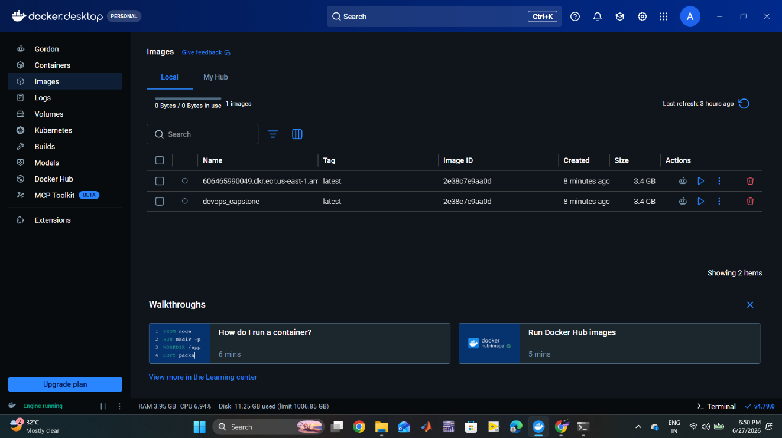

- Tag and Push to ECR:
docker tag finvista-app:latest <aws_account_id>.dkr.ecr.<region>[.amazonaws.com/finvista-app:latest](https://.amazonaws.com/finvista-app:latest)

docker push <aws_account_id>.dkr.ecr.<region>[.amazonaws.com/finvista-app:latest](https://.amazonaws.com/finvista-app:latest)

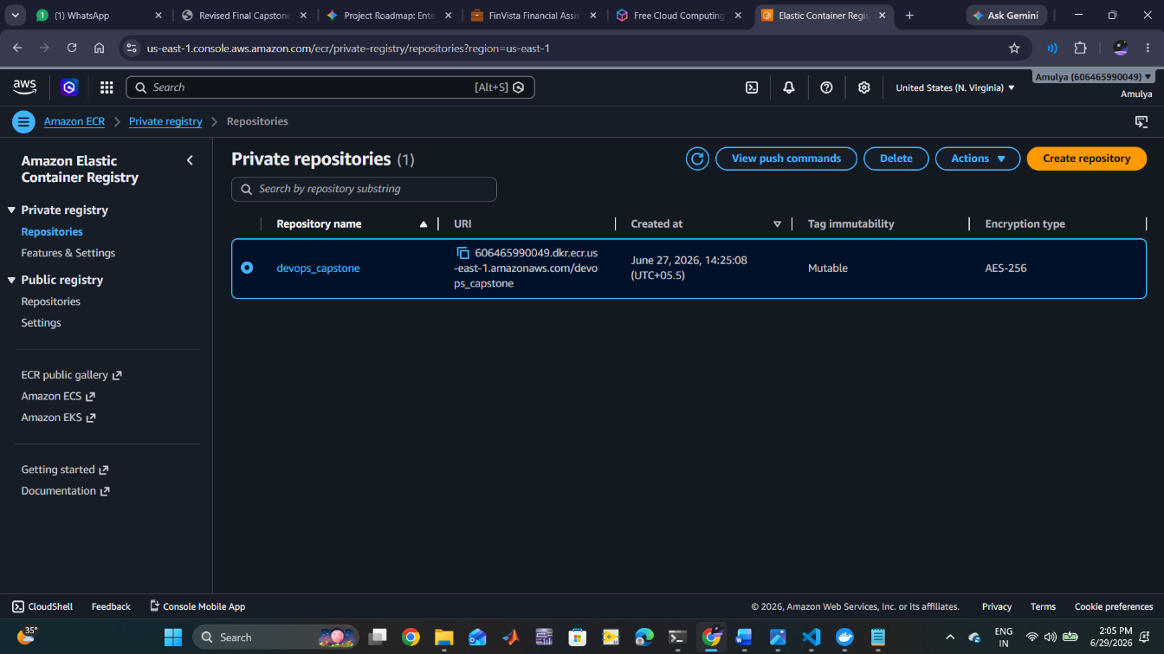
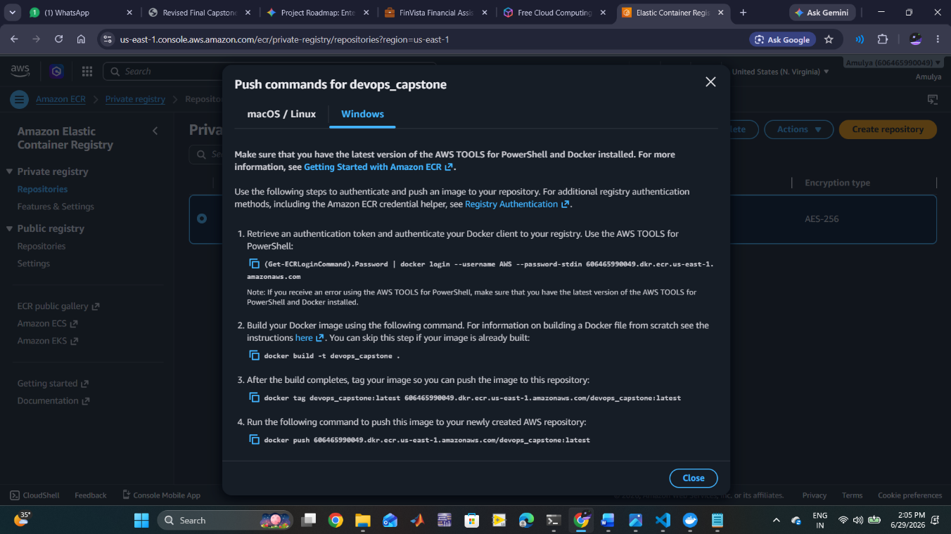

Infrastructure and Deployment
- Create Cluster:
eksctl create cluster --name finvista-cluster --region us-east-1 --nodes 2

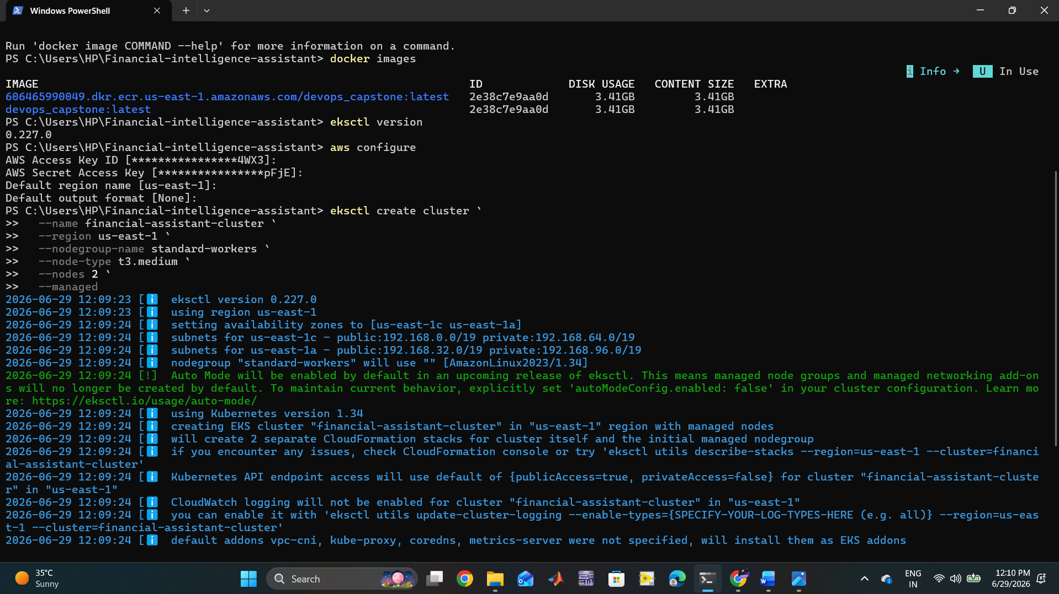

- Deploy Manifests:
kubectl apply -f deployment.yaml
kubectl apply -f service.yaml
- Verify Deployment:
kubectl get pods
kubectl get svc

nodes are created

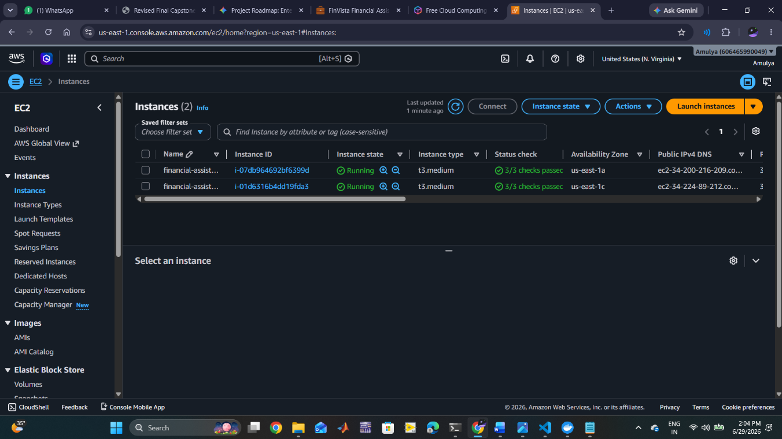

Pods are running

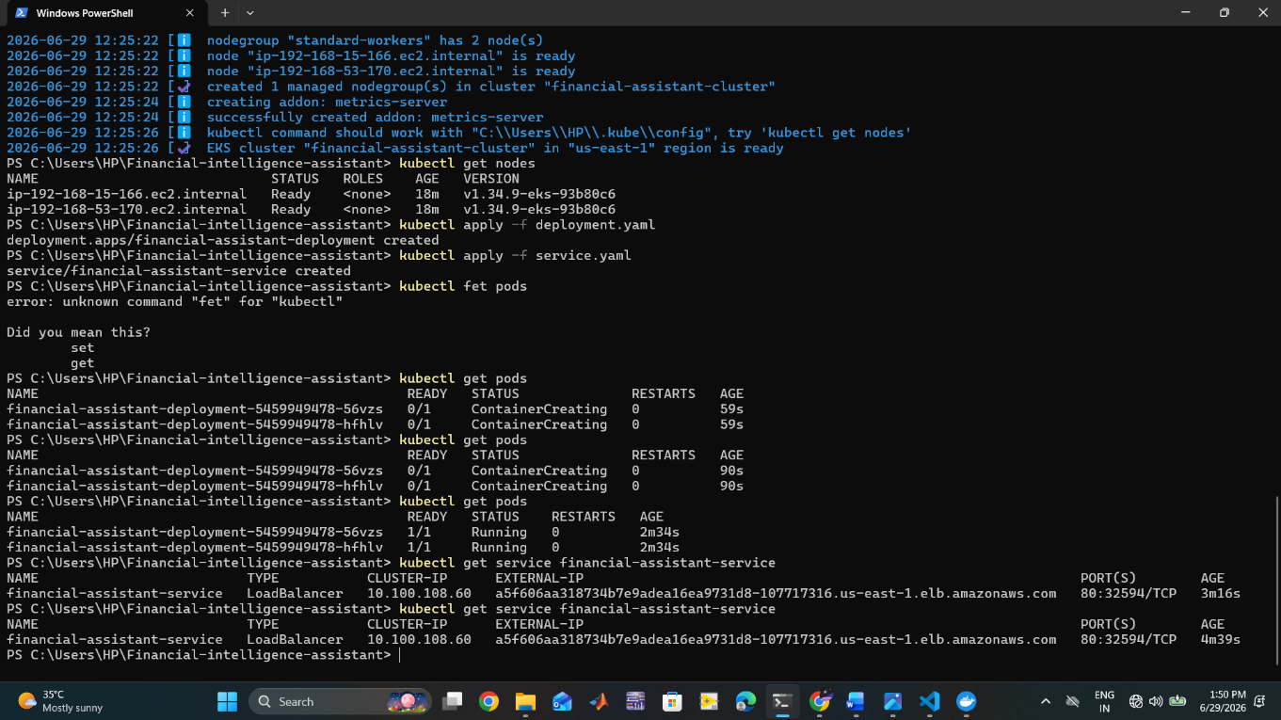

Output:
After get service financial-assistant-service
Copy the external link and paste it in the web browser
The RAG app will open using Streamlit interface
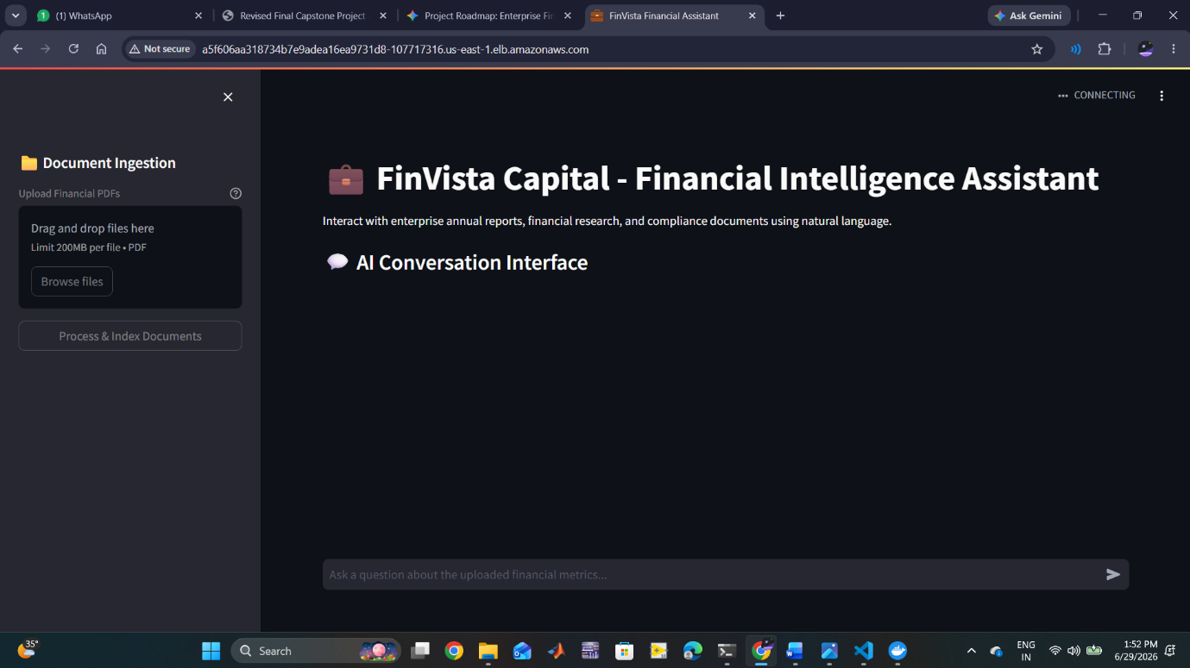

After opening upload the document related to the annual report and process & index the document
Prompt a question to it then it will give you the matched answers with the citations

