CREATE TABLE full_address_of_order
(
full_address_of_order_id int PRIMARY KEY,
street varchar(100) NOT NULL,
home int NOT NULL,
corpus int,
city varchar(50) NOT NULL,
country varchar(50) NOT NULL,
apartment_number int
)

CREATE TABLE author
(
author_id int PRIMARY KEY,
first_name varchar(100) NOT NULL,
last_name varchar(100) NOT NULL,
date_of_birth date,
city varchar(50) NOT NULL,
country varchar(50) NOT NULL
)

CREATE TABLE category
(
category_id int PRIMARY KEY,
category varchar(255) NOT NULL UNIQUE
);

CREATE TABLE full_address_of_publish
(
full_address_of_publish_id int PRIMARY KEY,
street varchar(100) NOT NULL,
home int NOT NULL,
corpus int,
city varchar(50) NOT NULL,
country varchar(50) NOT NULL,
apartment_number int
);

CREATE TABLE publishing
(
publishing_id int PRIMARY KEY,
publishing_name varchar(255) NOT NULL,
date_of_publish date,
place_of_publish_id int REFERENCES full_address_of_publish(full_address_of_publish_id)
);
CREATE TABLE BOOK
(
book_id int PRIMARY KEY,
book_name varchar(50) NOT NULL,
publishing_id int REFERENCES publishing(publishing_id),
description text,
price decimal(10, 2) NOT NULL,
assesment decimal(3, 2) CHECK (assesment >=0 AND assesment <=5)
);
CREATE TABLE author_book
(
author_book_id int PRIMARY KEY,
author_id int REFERENCES author(author_id),
book_id int REFERENCES book(book_id)
);

CREATE TABLE DISCOUNT
(
discount_id int PRIMARY KEY,
code varchar(50) NOT NULL,
percents decimal(3, 2) CHECK (percents >=0 AND percents <=100),
start_date date,
end_date date,
is_active boolean
);

CREATE TABLE role_of_user
(
role_of_user_id int PRIMARY KEY,
role_name varchar(50) NOT NULL UNIQUE
);

CREATE TABLE "USER" (
user_id int PRIMARY KEY,
email VARCHAR(255) NOT NULL,
password VARCHAR(255) NOT NULL,
roleId INTEGER REFERENCES role_of_user(role_of_user_id)
);

CREATE TABLE USER_PROFILE (
user_profile_id int PRIMARY KEY,
phone_number VARCHAR(20) NOT NULL,
date_of_registration date NOT NULL,
user_id int REFERENCES "USER"(user_id)
);
ALTER TABLE "USER"
ADD COLUMN user_profile_id int;

ALTER TABLE "USER"
ADD CONSTRAINT fk_user_profile
FOREIGN KEY (user_profile_id) REFERENCES user_profile(user_profile_id);

CREATE TABLE FEEDBACK
(
feedback_id int PRIMARY KEY,
user_id int REFERENCES "USER"(user_id),
book_id int REFERENCES book(book_id),
assesment decimal(3, 2) CHECK (assesment >=0 AND assesment <=5)
);

CREATE TABLE "action"
(
action_id int PRIMARY KEY,
action_name varchar(100) NOT NULL UNIQUE
);
CREATE TABLE USER_LOG
(
user_log_id int PRIMARY KEY,
user_id int REFERENCES "USER"(user_id),
action_id int REFERENCES "action"(action_id),
date_time timestamp NOT NULL
);

CREATE TABLE "ORDER"
(
order_id int PRIMARY KEY,
user_id int REFERENCES "USER"(user_id),
full_address_of_order_id int REFERENCES full_address_of_order(full_address_of_order_id),
discount_id int REFERENCES discount(discount_id),
order_date date NOT NULL,
"cost" decimal(10, 2) NOT NULL
);
CREATE TABLE order_book
(
order_book_id int PRIMARY KEY,
book_id int REFERENCES book(book_id),
order_id int REFERENCES "ORDER"(order_id)
);
CREATE TABLE category_book
(
category_book_id int PRIMARY KEY,
book_id int REFERENCES book(book_id),
category_id int REFERENCES category(category_id)
);

ЗАПОЛНИМ БД ДАННЫМИ:

INSERT INTO full_address_of_order (full_address_of_order_id, street, home, corpus, city, country, apartment_number)
VALUES
(1, 'Main Street', 10, NULL, 'New York', 'USA', 101),
(2, 'Second Avenue', 22, 1, 'Los Angeles', 'USA', 202),
(3, 'Third Boulevard', 33, NULL, 'Chicago', 'USA', 303);

SELECT * FROM full_address_of_order
INSERT INTO author (author_id, first_name, last_name, date_of_birth, city, country)
VALUES
(1, 'John', 'Smith', '1970-05-15', 'New York', 'USA'),
(2, 'Emily', 'Johnson', '1985-08-20', 'Los Angeles', 'USA'),
(3, 'Michael', 'Brown', '1990-03-10', 'Chicago', 'USA');

INSERT INTO category(category_id, category)
VALUES
(1, 'Fiction'),
(2, 'Non-fiction'),
(3, 'Science fiction')

INSERT INTO full_address_of_publish (full_address_of_publish_id, street, home, corpus, city, country, apartment_number)
VALUES
(1, 'Publish Street', 5, NULL, 'Boston', 'USA', NULL),
(2, 'Literature Lane', 8, 2, 'San Francisco', 'USA', 12);

INSERT INTO publishing (publishing_id, publishing_name, date_of_publish, place_of_publish_id) VALUES (1, 'Penguin Books', '2020-01-10', 1), (2, 'HarperCollins', '2021-07-15', 2);

INSERT INTO book (book_id, book_name, publishing_id, description, price, assesment)
VALUES
(1, 'The Great Adventure', 1, 'A thrilling story about a hero.', 19.99, 4.5),
(2, 'Science Explained', 2, 'An in-depth look into modern science.', 24.99, 4.8),
(3, 'Fictional Realms', 1, 'Dive into a world of fantasy.', 14.99, 4.0);

INSERT INTO author_book (author_book_id, author_id, book_id)
VALUES
(1, 1, 1),
(2, 2, 2),
(3, 3, 3);

insert INTO role_of_user(role_of_user_id, role_name)
VALUES
(1, 'admin'),
(2, 'customer'),
(3, 'author'),
(4, 'guest')

INSERT INTO "USER" (user_id, email, password, roleId, user_profile_id)
VALUES
(1, 'john.doe@example.com', 'password123', 1, NULL),
(2, 'jane.smith@example.com', 'password456', 2, NULL);

INSERT INTO USER_PROFILE (user_profile_id, phone_number, date_of_registration, user_id)
VALUES
(1, '445788672', '2023-01-01', 1),
(2, '297654321', '2023-02-15', 2);

INSERT INTO FEEDBACK (feedback_id, user_id, book_id, assesment)
VALUES
(1, 1, 1, 4.5),
(2, 2, 2, 4.0);

INSERT INTO "action" (action_id, action_name)
VALUES
(1, 'Login'),
(2, 'Purchase'),
(3, 'Leave Feedback');

INSERT INTO USER_LOG (user_log_id, user_id, action_id, date_time)
VALUES
(1, 1, 1, '2023-01-02 10:00:00'),
(2, 2, 2, '2023-02-16 15:30:00');

INSERT INTO "ORDER" (order_id, user_id, full_address_of_order_id, discount_id, order_date, cost)
VALUES
(1, 1, 1, NULL, '2023-01-03', 19.99),
(2, 2, 2, NULL, '2023-02-17', 24.99);

INSERT INTO order_book (order_book_id, book_id, order_id)
VALUES
(1, 1, 1),
(2, 2, 2);

INSERT INTO category_book (category_book_id, book_id, category_id)
VALUES
(1, 1, 1),
(2, 2, 2),
(3, 3, 3);
ALTER TABLE DISCOUNT
ALTER COLUMN percents type decimal(4, 2)

INSERT INTO DISCOUNT (discount_id, code, percents, start_date, end_date, is_active)
values
(1, 'NOVEMBER', 10.00, '2024-11-1', '2024-11-30', true),
(2, 'OCTOBER2024', 10.00, '2024-10-1', '2024-10-30', false)

ЗАПРОСЫ:

SELECT code, percents FROM discount

SELECT code AS КОД, percents AS процент
FROM discount

SELECT code AS КОД, ROUND(percents * percents, 2) AS процент
FROM discount

select CASE
WHEN code = 'NOVEMBER'
THEN percents
ELSE 0
End AS NOVEMBER_CODE
FROM discount

SELECT code, percents
FROM DISCOUNT
WHERE percents>5.00;

SELECT code, percents
FROM DISCOUNT
WHERE percents>5.00 AND code = 'NOVEMBER';

SELECT code, percents
FROM DISCOUNT
WHERE percents>5.00 OR code = 'NOVEMBER';

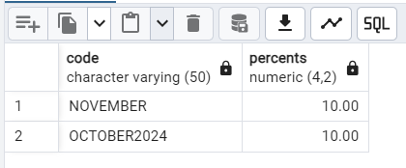

select book_name, description, price
FROM book
Order by book_name ASC;
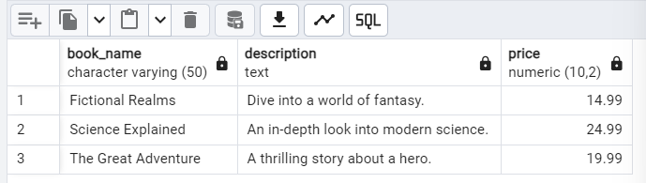

select book_name, description, price
FROM book
Order by book_name DESC;
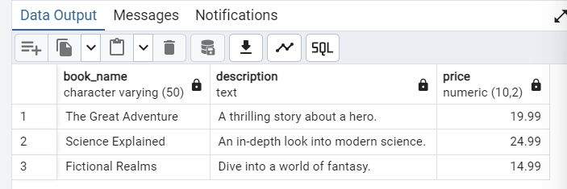

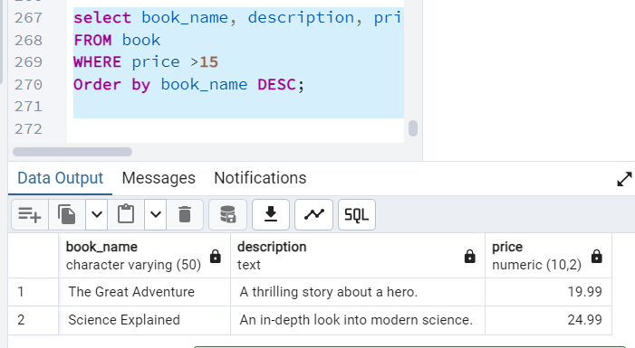

Выбрать только те строки, где 3 и больше строк.

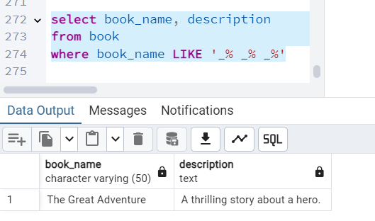

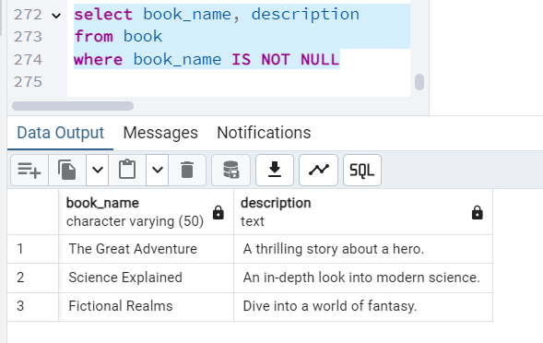

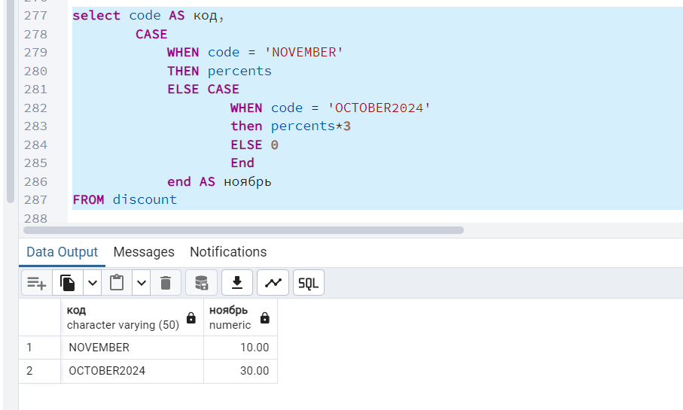

select user_id, email AS login, password
from "USER"
where email LIKE '%.com'

select DISTINCT ON (email) email, password
from "USER"

select DISTINCT ON (email) * from "USER"

SELECT * FROM "USER"
WHERE roleId in(0, 1)

SELECT * FROM "USER"
WHERE roleId between 0 AND 2
order by email desc

UPDATE "USER"
set password = 'newpassword'
where password = 'password123'

INSERT INTO "USER"
(user_id, email, password, roleId, user_profile_id)
values
(6, 'veroni.rmk@gmail.com', 'password901', 2, 2)

select * from "USER"

select distinct on(email) * FROM "USER"
order by email desc
limit 2
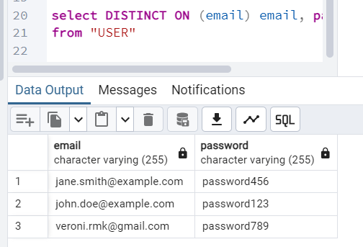

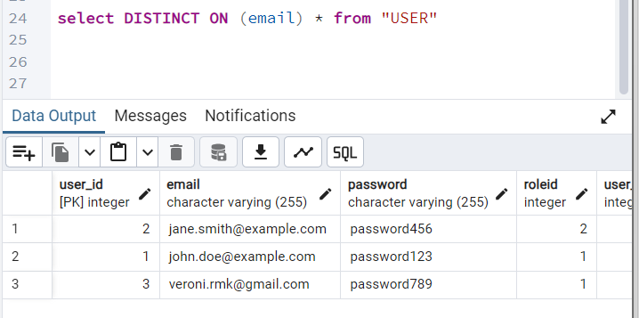

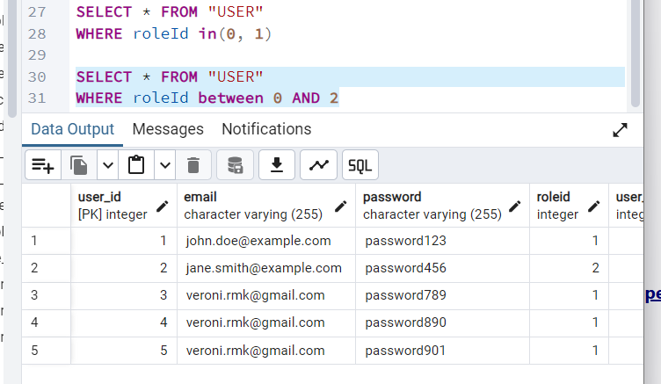

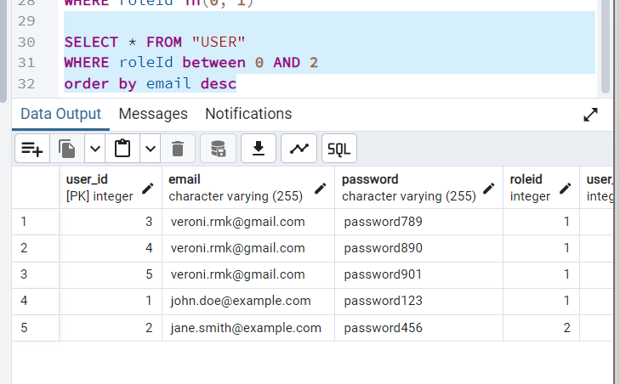

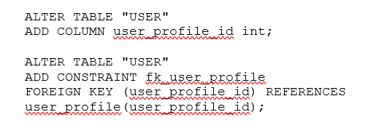

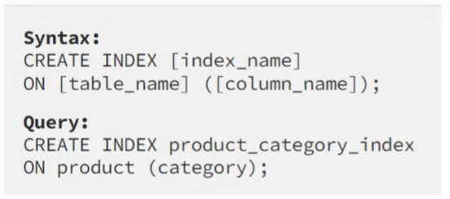

ЛАБОРАТОРНАЯ РАБОТА НОМЕР 4

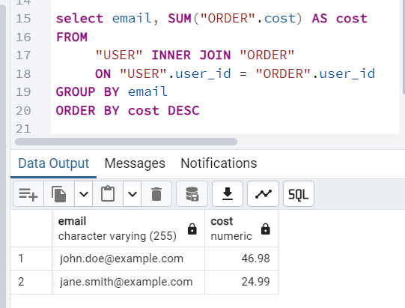

2)
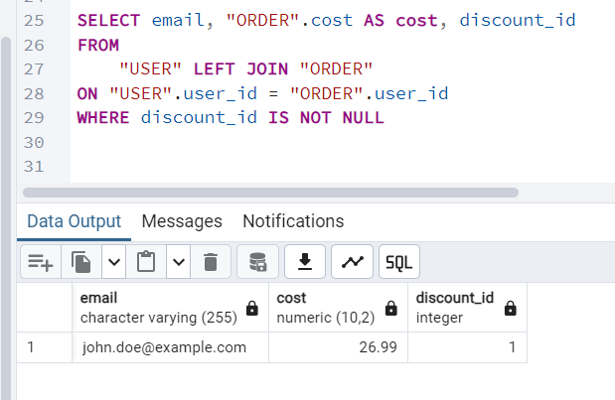

3) SELF JOIN
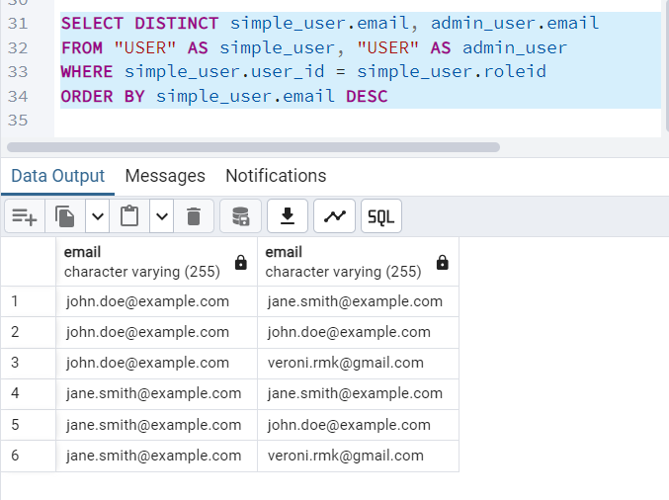
4) 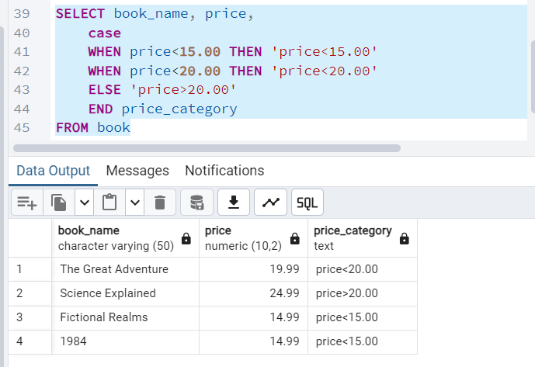
5) 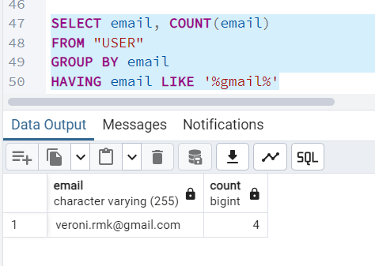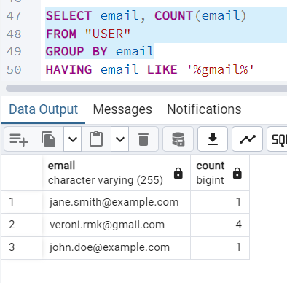

6) 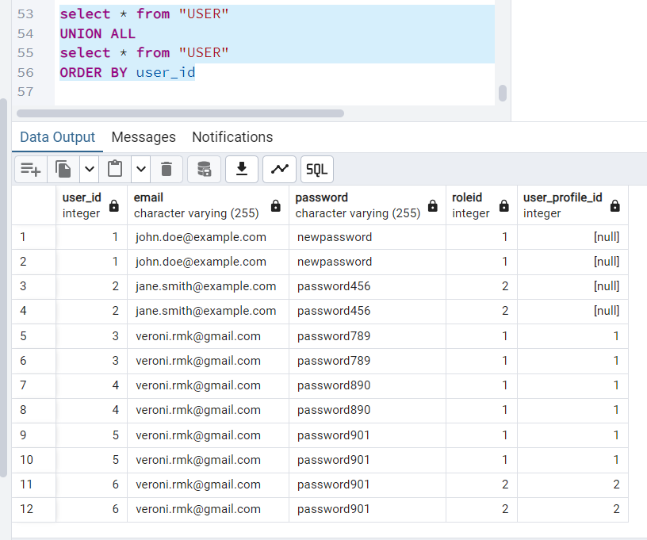
7) 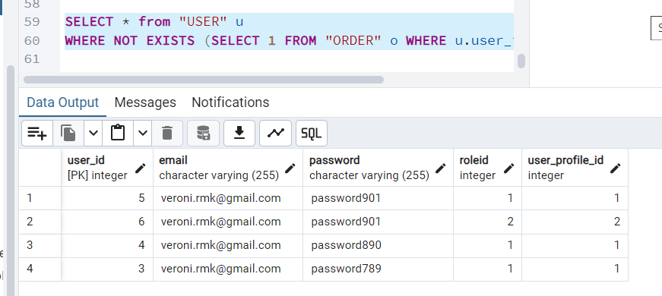

8) Изначальная таблица:
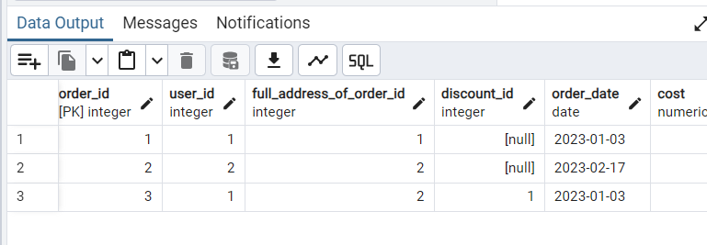

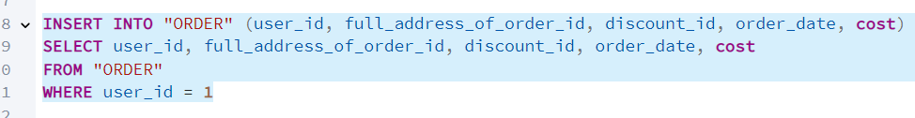
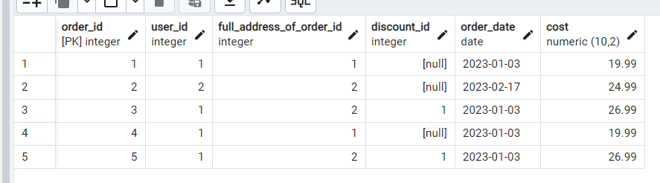

9) 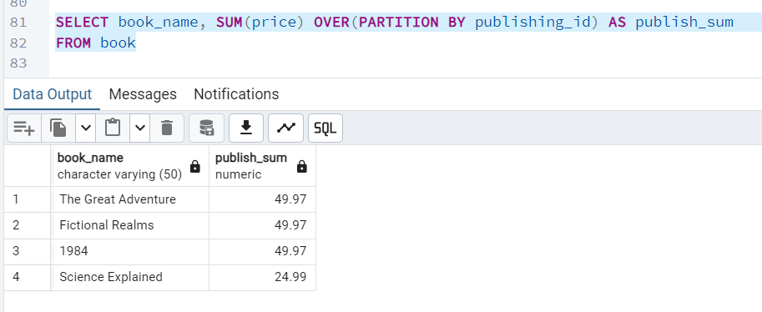

SELECT
book_name,
publishing_id,
price,
SUM(price) OVER (PARTITION BY publishing_id) AS total_price_per_publisher,
AVG(price) OVER (PARTITION BY publishing_id) AS avg_price_per_publisher,
MAX(price) OVER (PARTITION BY publishing_id) AS max_price_per_publisher,
MIN(price) OVER (PARTITION BY publishing_id) AS min_price_per_publisher
FROM BOOK;

SELECT
book_name,
publishing_id,
price,
ROW_NUMBER() OVER (PARTITION BY publishing_id ORDER BY price DESC) AS row_number_by_price,
RANK() OVER (PARTITION BY publishing_id ORDER BY price DESC) AS rank_by_price,
DENSE_RANK() OVER (PARTITION BY publishing_id ORDER BY price DESC) AS dense_rank_by_price,
NTILE(3) OVER (PARTITION BY publishing_id ORDER BY price DESC) AS ntile_by_price
FROM BOOK;

SELECT
book_name,
publishing_id,
price,
LAG(price) OVER (PARTITION BY publishing_id ORDER BY price ASC) AS prev_price,
LEAD(price) OVER (PARTITION BY publishing_id ORDER BY price ASC) AS next_price,
FIRST_VALUE(price) OVER (PARTITION BY publishing_id ORDER BY price ASC) AS first_price,
LAST_VALUE(price) OVER (PARTITION BY publishing_id ORDER BY price ASC ROWS BETWEEN UNBOUNDED PRECEDING AND UNBOUNDED FOLLOWING) AS last_price
FROM BOOK;

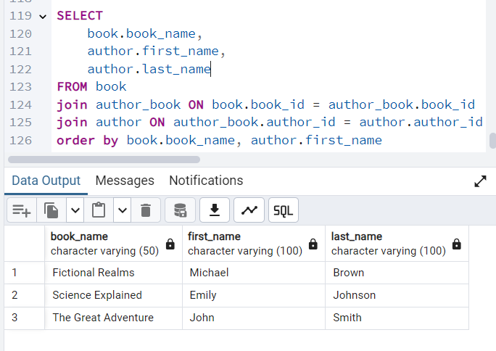

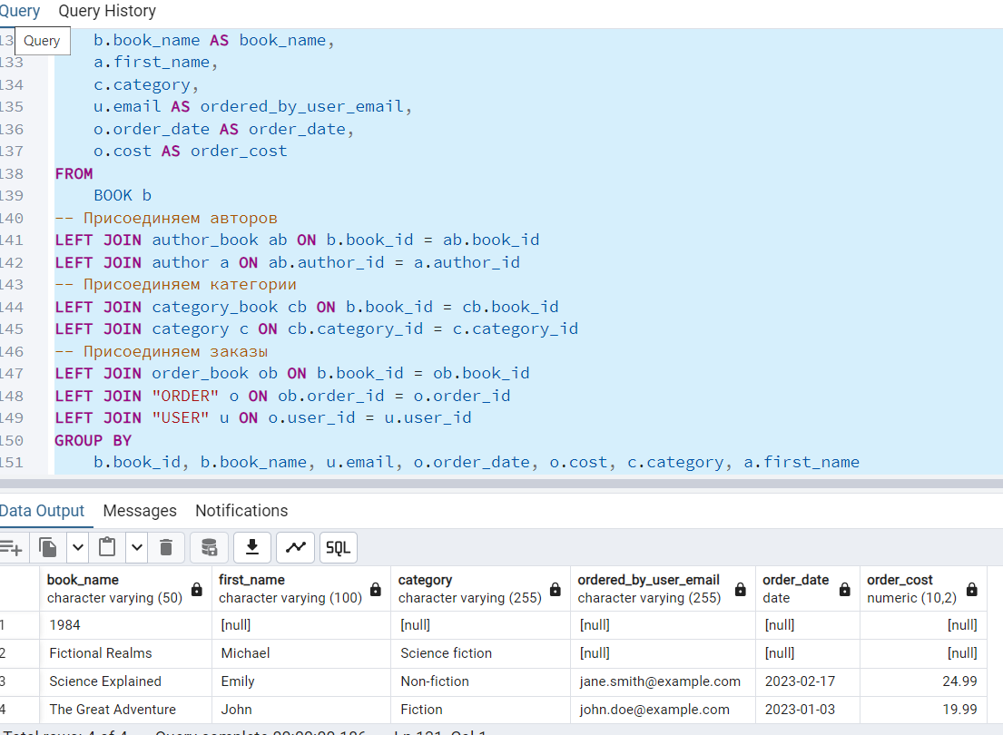

USER, BOOK, order, orderbook, feedback

CREATE TABLE BOOK
(
book_id int PRIMARY KEY,
book_name varchar(50) NOT NULL,
publishing_id int REFERENCES publishing(publishing_id),
description text,
price decimal(10, 2) NOT NULL,
assesment decimal(3, 2) CHECK (assesment >=0 AND assesment <=5)
);

CREATE TABLE "USER" (
user_id int PRIMARY KEY,
email VARCHAR(255) NOT NULL,
password VARCHAR(255) NOT NULL,
roleId INTEGER REFERENCES role_of_user(role_of_user_id)
);

CREATE TABLE "ORDER"
(
order_id int PRIMARY KEY,
user_id int REFERENCES "USER"(user_id),
full_address_of_order_id int REFERENCES full_address_of_order(full_address_of_order_id),
discount_id int REFERENCES discount(discount_id),
order_date date NOT NULL,
"cost" decimal(10, 2) NOT NULL
);

CREATE TABLE order_book
(
order_book_id int PRIMARY KEY,
book_id int REFERENCES book(book_id),
order_id int REFERENCES "ORDER"(order_id)
);
CREATE TABLE FEEDBACK
(
feedback_id int PRIMARY KEY,
user_id int REFERENCES "USER"(user_id),
book_id int REFERENCES book(book_id),
assesment decimal(3, 2) CHECK (assesment >=0 AND assesment <=5)
);

SELECT u.user_id, u.email, SUM(o.cost) AS total_order_cost
FROM FEEDBACK f JOIN "USER" u ON f.user_id = u.user_id JOIN order_book ob ON f.book_id = ob.book_id
JOIN "ORDER" o ON ob.order_id = o.order_id WHERE f.assesment = 5 -- Оценка 5 GROUP BY u.user_id, u.email ORDER BY total_order_cost DESC;

SELECT *
FROM "USER";

SELECT * FROM book;

SELECT * FROM "ORDER";

INSERT INTO "ORDER" (user_id, full_address_of_order_id, discount_id, order_date, cost)
SELECT user_id, full_address_of_order_id, discount_id, order_date, cost
FROM "ORDER"
WHERE user_id = 1

CREATE SEQUENCE order_order_id_seq;
ALTER TABLE "ORDER"
ALTER COLUMN order_id
SET DEFAULT nextval('order_order_id_seq');

SELECT setval('order_order_id_seq', COALESCE(MAX(order_id), 0)) FROM "ORDER";

ALTER TABLE "ORDER"
ADD CONSTRAINT add_autoinkrement
AUTOINCREMENT

INSERT INTO "ORDER"
(order_id, user_id, full_address_of_order_id, discount_id, order_date, cost)
values (3, 1, 2, 1, '2023-01-03', 26.99)

INSERT INTO "ORDER"
(order_id, user_id, full_address_of_order_id, discount_id, order_date, cost)
values (4, 1, 2, 1, '2023-01-03', 77.99)

SELECT email, "ORDER".cost AS cost FROM "USER"
INNER JOIN "ORDER"
ON "USER".user_id = "ORDER".user_id

select email, SUM("ORDER".cost) AS cost
FROM
"USER" INNER JOIN "ORDER"
ON "USER".user_id = "ORDER".user_id
GROUP BY email
ORDER BY cost DESC

SELECT email, "ORDER".cost AS cost, discount_id
FROM
"USER" LEFT JOIN "ORDER"
ON "USER".user_id = "ORDER".user_id
WHERE discount_id IS NOT NULL

SELECT DISTINCT simple_user.email, admin_user.email
FROM "USER" AS simple_user, "USER" AS admin_user
WHERE simple_user.user_id = simple_user.roleid
ORDER BY simple_user.email DESC

SELECT book_name, price,
case
WHEN price<15.00 THEN 'price<15.00'
WHEN price<20.00 THEN 'price<20.00'
ELSE 'price>20.00'
END price_category
FROM book

SELECT email, COUNT(email)
FROM "USER"
GROUP BY email
HAVING email LIKE '%gmail%'

select * from "USER"
UNION ALL
select * from "USER"
ORDER BY user_id

SELECT * from "USER" u
WHERE NOT EXISTS (SELECT 1 FROM "ORDER" o WHERE u.user_id=o.user_id)

SELECT book_name, SUM(price) OVER(PARTITION BY publishing_id) AS publish_sum
FROM book

SELECT
book_name,
publishing_id,
price,
SUM(price) OVER (PARTITION BY publishing_id) AS total_price_per_publisher,
AVG(price) OVER (PARTITION BY publishing_id) AS avg_price_per_publisher,
MAX(price) OVER (PARTITION BY publishing_id) AS max_price_per_publisher,
MIN(price) OVER (PARTITION BY publishing_id) AS min_price_per_publisher
FROM BOOK;

SELECT
book_name,
publishing_id,
price,
ROW_NUMBER() OVER (PARTITION BY publishing_id ORDER BY price DESC) AS row_number_by_price,
RANK() OVER (PARTITION BY publishing_id ORDER BY price DESC) AS rank_by_price,
DENSE_RANK() OVER (PARTITION BY publishing_id ORDER BY price DESC) AS dense_rank_by_price,
NTILE(3) OVER (PARTITION BY publishing_id ORDER BY price DESC) AS ntile_by_price
FROM BOOK;

SELECT
book_name,
publishing_id,
price,
LAG(price) OVER (PARTITION BY publishing_id ORDER BY price ASC) AS prev_price,
LEAD(price) OVER (PARTITION BY publishing_id ORDER BY price ASC) AS next_price,
FIRST_VALUE(price) OVER (PARTITION BY publishing_id ORDER BY price ASC) AS first_price,
LAST_VALUE(price) OVER (PARTITION BY publishing_id ORDER BY price ASC ROWS BETWEEN UNBOUNDED PRECEDING AND UNBOUNDED FOLLOWING) AS last_price
FROM BOOK;

SELECT
book.book_name,
author.first_name,
author.last_name
FROM book
join author_book ON book.book_id = author_book.book_id
join author ON author_book.author_id = author.author_id
order by book.book_name, author.first_name

SELECT * FROM category

SELECT
b.book_name AS book_name,
a.first_name,
c.category,
u.email AS ordered_by_user_email,
o.order_date AS order_date,
o.cost AS order_cost
FROM
BOOK b
JOIN author_book ab ON b.book_id = ab.book_id
JOIN author a ON ab.author_id = a.author_id
JOIN category_book cb ON b.book_id = cb.book_id
JOIN category c ON cb.category_id = c.category_id
JOIN order_book ob ON b.book_id = ob.book_id
JOIN "ORDER" o ON ob.order_id = o.order_id
JOIN "USER" u ON o.user_id = u.user_id

Where book_name LIKE 'The%'
GROUP BY
b.book_id, b.book_name, u.email, o.order_date, o.cost, c.category, a.first_name
ORDER BY
b.book_name, o.order_date;

INSERT INTO feedback
(feedback_id, user_id, book_id, assesment)
values (3, 1, 1, 5.00)

INSERT INTO feedback
(feedback_id, user_id, book_id, assesment)
values (4, 2, 1, 5.00)

SELECT * from feedback

SELECT "USER".email, SUM("ORDER".cost)
FROM feedback
JOIN "USER" ON feedback.user_id = "USER".user_id
JOIN order_book ON order_book.book_id = feedback.book_id
JOIN "ORDER" ON "ORDER".order_id = order_book.order_id

WHERE feedback.assesment = 5
GROUP BY "USER".email

ЛАБ 54

//подсчет стоимости заказа по стоимости всех книг в заказе
CREATE OR REPLACE FUNCTION update_order_cost()
RETURNS TRIGGER AS $$
BEGIN
UPDATE "ORDER"
SET "cost" = (
SELECT SUM(price)
FROM order_book ob
JOIN book b ON ob.book_id = b.book_id
WHERE ob.order_id = NEW.order_id
)
WHERE order_id = NEW.order_id;

RETURN NEW;
END;
$$ LANGUAGE plpgsql;

CREATE TRIGGER trig_update_order_cost
AFTER INSERT OR DELETE ON order_book
FOR EACH ROW
EXECUTE FUNCTION update_order_cost();

//логгирование
CREATE OR REPLACE FUNCTION log_order_actions()
RETURNS TRIGGER AS $$
BEGIN
INSERT INTO USER_LOG (user_id, action_id, date_time)
VALUES (NEW.user_id, (SELECT action_id FROM "action" WHERE action_name = 'Order Action'), NOW());

RETURN NEW;
END;
$$ LANGUAGE plpgsql;

CREATE TRIGGER trig_log_order_actions
AFTER INSERT OR UPDATE OR DELETE ON "ORDER"
FOR EACH ROW
EXECUTE FUNCTION log_order_actions();

//средняя оценка книги по фидбекам пользователей
CREATE OR REPLACE FUNCTION update_book_assesment()
RETURNS TRIGGER AS $$
BEGIN
UPDATE book
SET assesment = (
SELECT AVG(assesment)
FROM feedback
WHERE book_id = NEW.book_id
)
WHERE book_id = NEW.book_id;

RETURN NEW;
END;
$$ LANGUAGE plpgsql;

CREATE TRIGGER trig_update_book_assesment
AFTER INSERT ON feedback
FOR EACH ROW
EXECUTE FUNCTION update_book_assesment();

select * from "author"

create or replace function public.update_authors_name()
returns trigger AS $$
begin
new.name = concat(new.first_name, ' ', new.last_name)
return new;
end;
$$
language plpgsql volatile
cost 100;

create trigger "update_authors_name_on_insert_trigger"
before insert on author
for each row
execute procedure "update_authors_name"()

ПОЛНОСТЬЮ КОД СОЗДАНИЯ ТРИГГЕРА НА СОЗДАНИЕ:
select * from author

alter table author add name varchar(100);

update author set name = concat(first_name, ' ', last_name)

create or replace function public.update_authors_name()
returns trigger AS $BODY$
begin
NEW.name = concat(NEW.first_name, ' ', NEW.last_name);
return NEW;
end;
$BODY$
language plpgsql volatile
cost 100;

create trigger "update_authors_name_on_insert_trigger"
before insert on author
for each row
execute procedure "update_authors_name"()

INSERT INTO author (author_id, first_name, last_name, date_of_birth, city, country)
VALUES
(5, 'Vero', 'Nika', '1970-05-15', 'New York', 'USA')

select * from action

CREATE PROCEDURE insert_data_into_action(a integer, b varchar(100))
LANGUAGE SQL
AS $$
INSERT INTO action VALUES (a, b);
$$;

CALL insert_data_into_action(5, 'Create action');

--------------------------------------------------------------------------------------------------------
SELECT
b.book_id,
b.book_name,
b.description,
b.price,
b.assesment,
p.publishing_name,
p.date_of_publish,
fap.street,
fap.city,
fap.country,
STRING_AGG(DISTINCT CONCAT(a.first_name, ' ', a.last_name), ', ') AS authors,
STRING_AGG(DISTINCT c.category, ', ') AS categories
FROM book b
LEFT JOIN publishing p ON b.publishing_id = p.publishing_id
LEFT JOIN full_address_of_publish fap ON p.place_of_publish_id = fap.full_address_of_publish_id
LEFT JOIN author_book ab ON b.book_id = ab.book_id
LEFT JOIN author a ON ab.author_id = a.author_id
LEFT JOIN category_book cb ON b.book_id = cb.book_id
LEFT JOIN category c ON cb.category_id = c.category_id
GROUP BY
b.book_id,
b.book_name,
b.description,
b.price,
b.assesment,
p.publishing_name,
p.date_of_publish,
fap.street,
fap.city,
fap.country;

SELECT category_id, name FROM category;

ALTER TABLE book
ADD COLUMN book_id SERIAL PRIMARY KEY;

select * from "ORDER"
select * from user_log

SELECT * FROM user_log WHERE user_log_id IS NULL;

INSERT INTO user_log (user_log_id, user_id, action_id, date_time)
VALUES
(3, 3, 1, '2023-01-03')

INSERT INTO "ORDER" (order_id, user_id, full_address_of_order_id, discount_id, order_date, cost)
VALUES
(6, 3, 1, 1, '2023-01-03', 19.99)

INSERT INTO user_log (user_id, action_id, date_time)
VALUES (3, (SELECT action_id FROM action WHERE action_name = 'Order Action'), NOW());

INSERT INTO user_log (user_id, action_id, date_time)
VALUES (3, (SELECT action_id FROM action WHERE action_name = 'Order Action'), NOW());

select * from author

alter table author add name varchar(100);

update author set name = concat(first_name, ' ', last_name)

create or replace function public.update_authors_name()
returns trigger AS $BODY$
begin
NEW.name = concat(NEW.first_name, ' ', NEW.last_name);
return NEW;
end;
$BODY$
language plpgsql volatile
cost 100;

create trigger "update_authors_name_on_insert_trigger"
before insert on author
for each row
execute procedure "update_authors_name"()

INSERT INTO author (author_id, first_name, last_name, date_of_birth, city, country)
VALUES
(5, 'Vero', 'Nika', '1970-05-15', 'New York', 'USA')

create trigger "update_authors_name_on_update_trigger"
before update on author
for each row
execute procedure "update_authors_name"()

create trigger "update_assesment_on_book"
before update on book
for each row
execute procedure "update_book_assesment"()

select * from action

CREATE PROCEDURE insert_data_into_action(a integer, b varchar(100))
LANGUAGE SQL
AS $$
INSERT INTO action VALUES (a, b);
$$;

CALL insert_data_into_action(5, 'Create action');

CREATE PROCEDURE select_book_data()
LANGUAGE SQL
AS $$
INSERT INTO full_address_of_order (full_address_of_order_id, street, home, corpus, city, country, apartment_number)
VALUES
(full_address_of_order_id, street, home, corpus, city, country, apartment_number),
$$;

CALL select_book_data();

INSERT INTO full_address_of_order (full_address_of_order_id, street, home, corpus, city, country, apartment_number)
VALUES
(1, 'Main Street', 10, NULL, 'New York', 'USA', 101),
(2, 'Second Avenue', 22, 1, 'Los Angeles', 'USA', 202),
(3, 'Third Boulevard', 33, NULL, 'Chicago', 'USA', 303);

