**QA Software Engineering Specifications**

**Yovani R. Mendez**

|  |  |  |  |
| --- | --- | --- | --- |
| Date | Engineer | Revision | Comment |
|  | Yovani R. Mendez | 5 | Removal of QA methods. |
|  | Yovani R. Mendez | 6 | Symmetry changes. |
|  | Yovani R. Mendez | 8 | Cleanup, QA new UI. UV to RS232. |
|  | Yovani R. Mendez | 9 | Laser Slide added. Symmetry changes. |
|  | Yovani R. Mendez | 10 | Digital microscope Service added. |
|  | Yovani R. Mendez | 11 | UV additions. |
|  | Yovani R. Mendez | 15 | Laser data log added. |
|  | Yovani R. Mendez | 16 | UV Pulse Modulation System added. |
|  | Yovani R. Mendez | 17 | Change wording on instructions. |

QA VisionPro:

VisionPro is part of the inspection process of the OB Cleaner cell. VisionPro is managed through a web service that communicates the x32 PC client service with the x64 PC control service. VisionPro consists of two cameras positioned at the IPQC rotary stage. These two cameras have different assignments in order to find defects in the part. As the part rotates in the rotary stage the cameras will take pictures at these positions, the pictures will be saved in the x64 computer and external storage device installed in the work cell.

Requirements:

a) Cognex VisionPro 8.2.

b) VisionPro Control web service.

c) VisionPro client service(integrated in QA menu).

d) Vieworks Imagining Solutions (VIS) 6.x.

VisionPro Cameras Setup:

1. First setup the two cameras using VIS and GigE Vision Configuration Tool.
2. Click Programs -> Cognex -> Utilities -> GigE Vision Configuration Tool.
3. 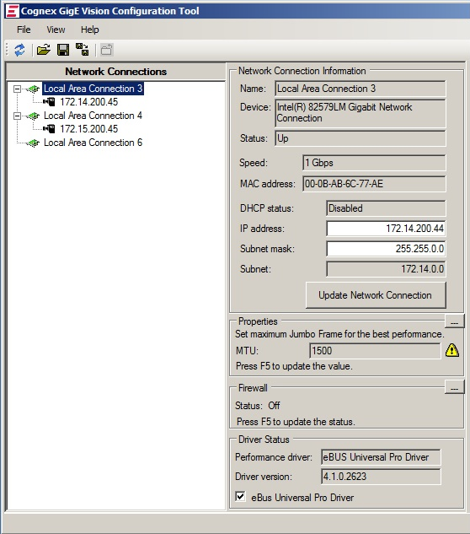The tool will display cameras connected to the computer and their options.

* The tool also displays the cameras/Ethernet cards IP/TCP options.
* These options can be modified to configure the cameras/Ethernet connections.

1. First step is to make sure the camera and the Ethernet adapter are in the same subnet.

5.1 e.g. Camera IP address: 172.12.200.45

Camera subnet: 255.255.0.0

Ethernet card IP address: 172.12.xxx.xxx

Ethernet card IP address: 255.255.0.0

1. If there is a conflict the tool will display next to the camera icon a small warning or error icon. If the cameras are successfully configured the tool will not display warning or error icon.

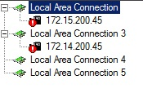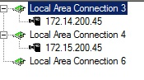

1. IF the connection indicates a conflict with the IP addresses and/or Cameras and network adapters.

- Go to Control Panel -> Network and Sharing Center -> Change Adapter Settings,

- Right click on the adapter on which the camera is connected -> click Properties,

- Click on Internet Protocol Version 4 -> Properties -> Check Obtain an IP address automatically.

* Now go back to the Cognex GigE Vision Configuration tool and set the IP addresses as indicated on the instructions, step 5.

1. Test your camera by using Cognex Quick Build tools.

6.1 Go to Quickbuild.

6.2 Click on the camera icon of the default loaded project. This will take you to the Image Source window.

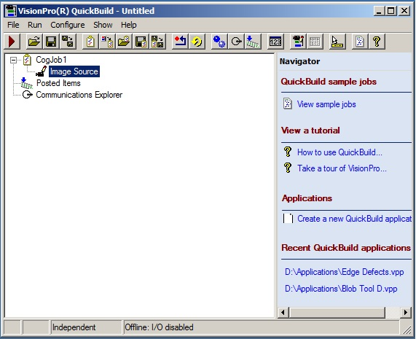

6.3 Click on the Camera button.

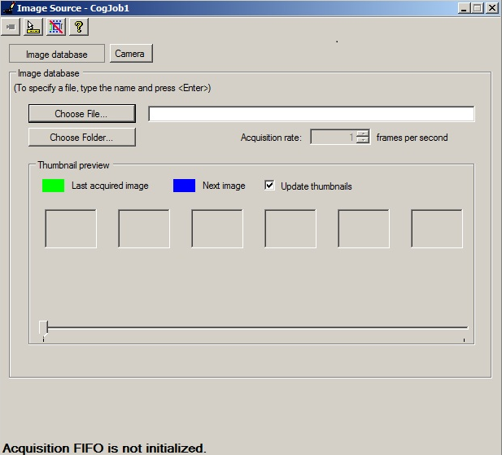

6.4 Choose the camera option, and click the type of capture. Usually for Vieworks camera is recommended to use Mono-12 packed and for the Basler is recommended to use Mono-8.

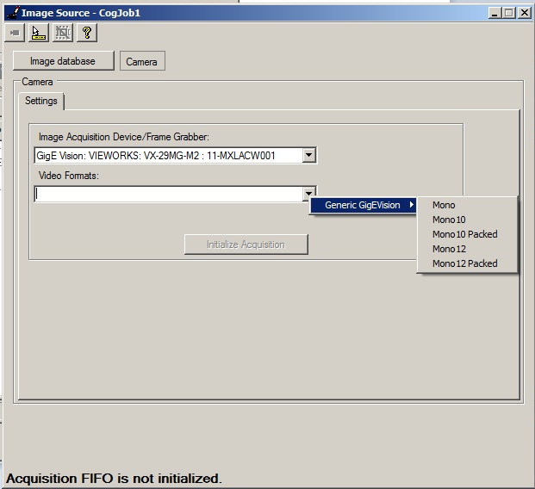

6.5 Click on the small camera icon to show live feed. If successful the camera will show live feed back.

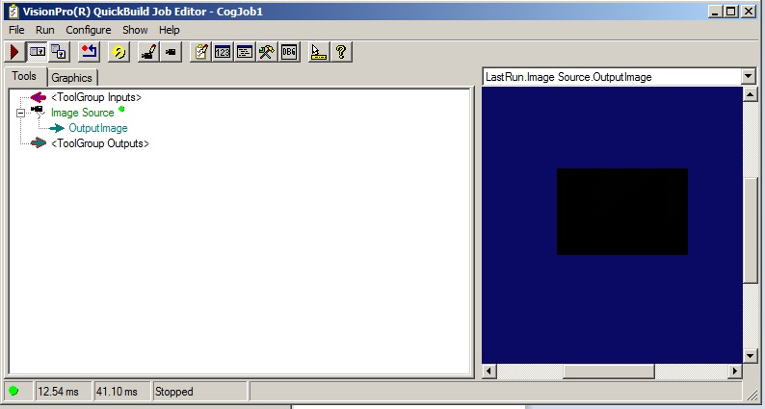

1. To adjust image settings, it’s recommended to use VIS , this software will also install the required frameworks( if needed) on the control service computer(x64 PC VIS), this software also has many features to test and configure the cameras. Although you can accomplish this with VisionPro QuickBuild.

VisionPro Service Setup:

1. Make sure the service application is running before QA system. This is to ease the communication between applications
2. On the x64 computer right click on the VisionPro Service and Run As Administrator.
3. 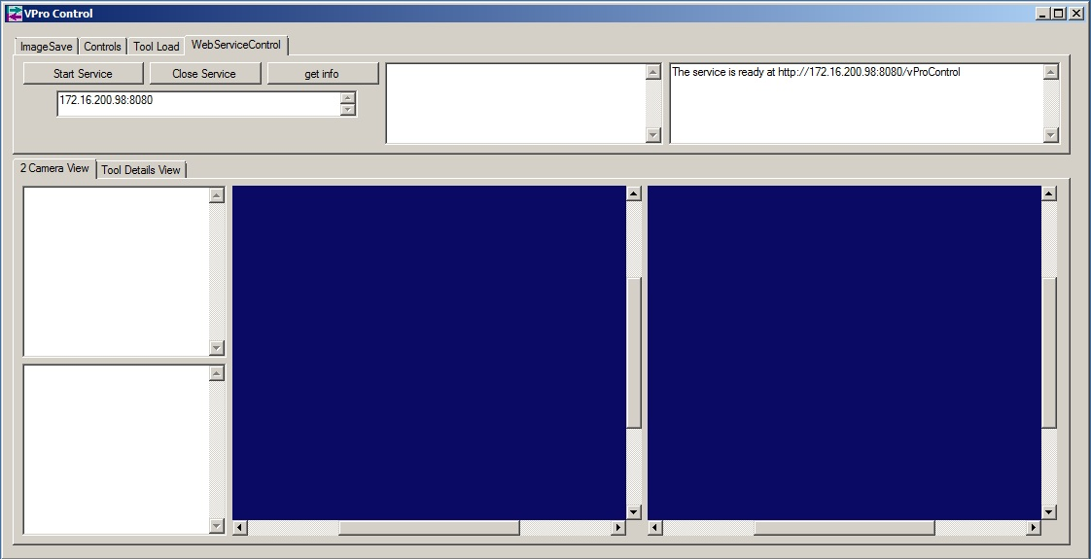The web service will display a message on the status window;

Service is ready at http://XXX.XXX.XXX.XXX:XXXX/vProControl

1. To test the connection, click on initiate VisionPro Connect or VisionPro Echo. These functions will return a successful or failed message on the QA status window. If the function was successful in the status window will show; ret status = 100. Anything else than ret status = 100, means the service fail to communicate. A restart of the service and QA might be required.

Notes:

* After every successful VisionPro service, in the service status window will displaya message including retcode = 100.
* Before a VisionPro button is clicked, make sure the correct camera is been chosen.
* Make sure the client application’s IP address and port coincide with the web service application’s IP and port information. As of right now we can configure the clients IP and port, find the information at C:\\\Hardware.mdb.

QA Rotary Stage:

QA station consist of two parts. One is the gripper and the second one is the rotary stage. The gripper will hold the part while the rotary stage moves to different positions. The rotary stage consist of a pneumatic driver which has preloaded angular positions going from 0 to 360 angular degrees. The operator should load this position to the rotary stage driver (ACT driver) before this is used.

Requirements:

1. ACT Controller software.
2. Ethernet to USB adapter from ACT hardware peripherals.
3. ACT Driver for USB adapter from ACT software package.

Rotary Stage Setup:

* Make sure the ACT driver is properly connected to power and positioned on a safe position.

1. Connect the Ethernet end of the adapter to the ACT controller.
2. Connect the USB end of the adapter to a computer.
3. Load the ACT Controller software.
4. A window will pop up showing the two mode operational system for the ACT Controller. If this is your first time connecting to the device you must click Easy Mode.

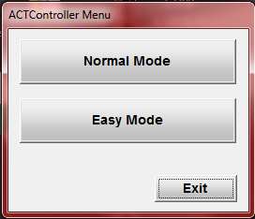

1. A communication setting window will pop up. Like the one below. Click Yes.

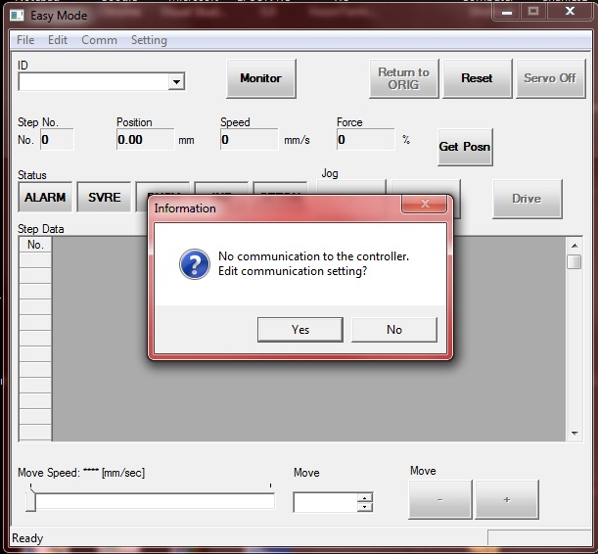

1. A new window will pop up. In this window there will be the options that need to be completed before connecting to the controller. Make sure the correct port is been indicated. Click Ok.

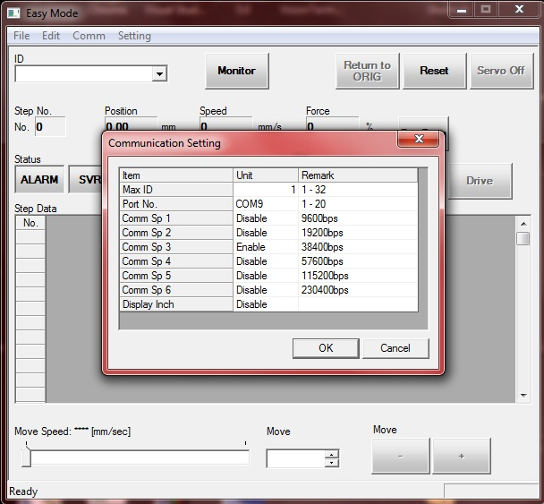

1. If the correct parameters were given a loading bar will show, meaning there is a connection been established. Like the one below.

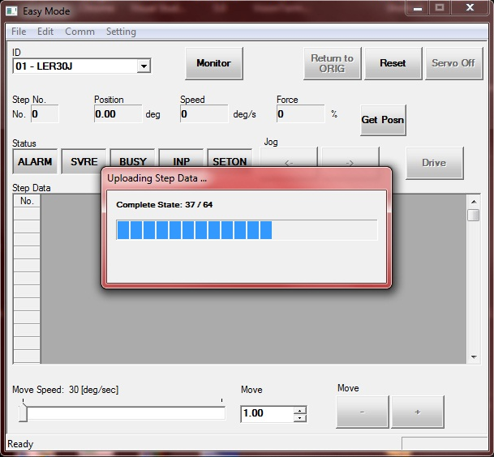

1. Once the controller is done loading all the data, an information dialog will appear. Click Ok.

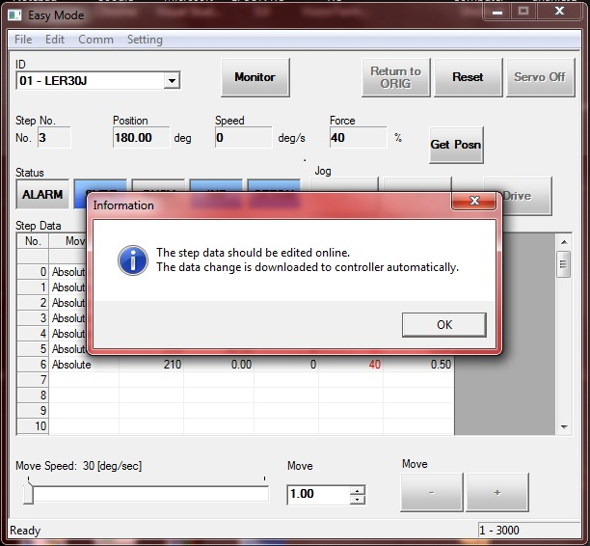

1. Once the Easy Mode is loaded, exit the software. And the Mode Window will appear again.



1. This time click on Normal Mode. The controller will load to a new window, like the one below.

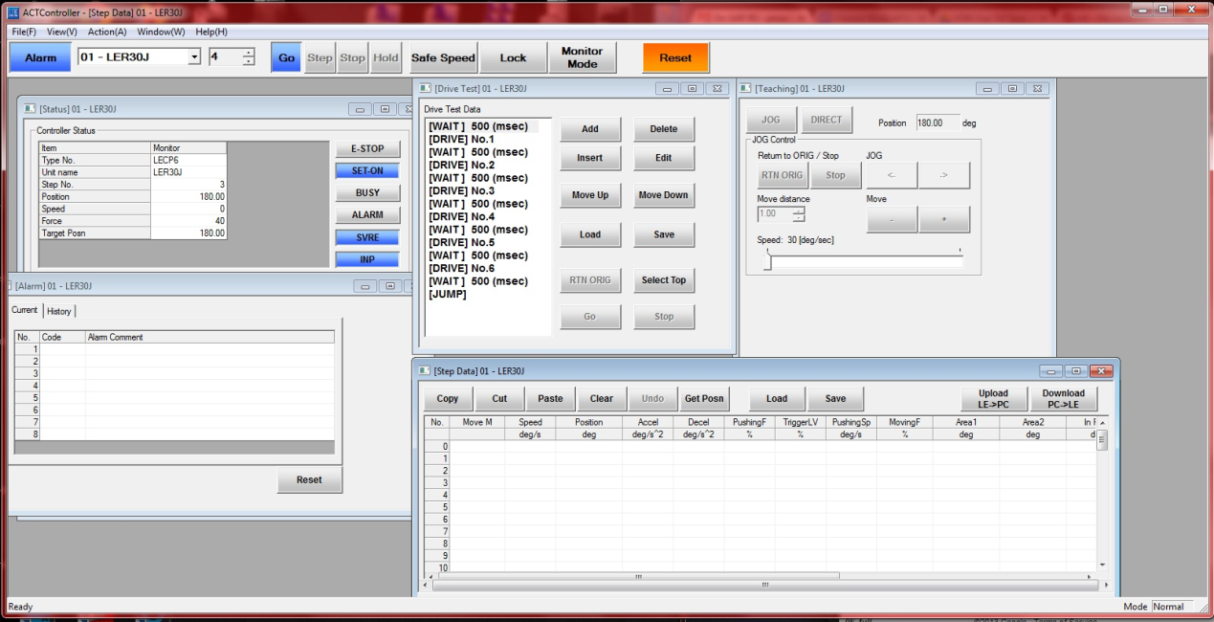

1. If nothing is showing, click on View on the menu and click on the needed tool. In this case click on Step Data. A window will pop, like the one below.

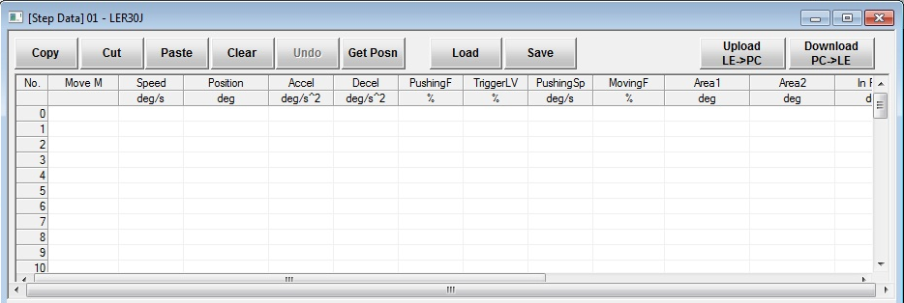

1. This window will manage the positions on the controller. To create a new position, click on the number of the position which you want to implement.
2. Click on the corresponding number of position and Move M cell, and two options will show in a ShowDown menu. Absolute and Relative. Absolute has its origin on homing position(0 degrees) and Relative has its origin on the last executed position.

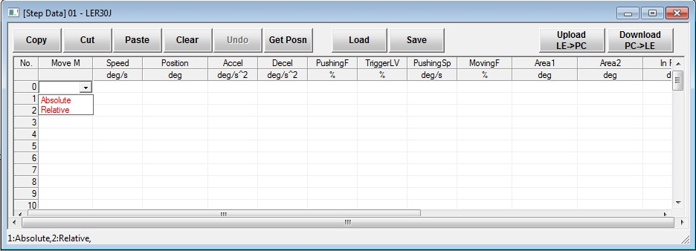

1. Choose the type of position, specify the Speed, Position, Accel and the other properties needed.
2. Once all positions needed are completed, click Download (PC -> LE). Wait for the data to be downloaded in the controller.

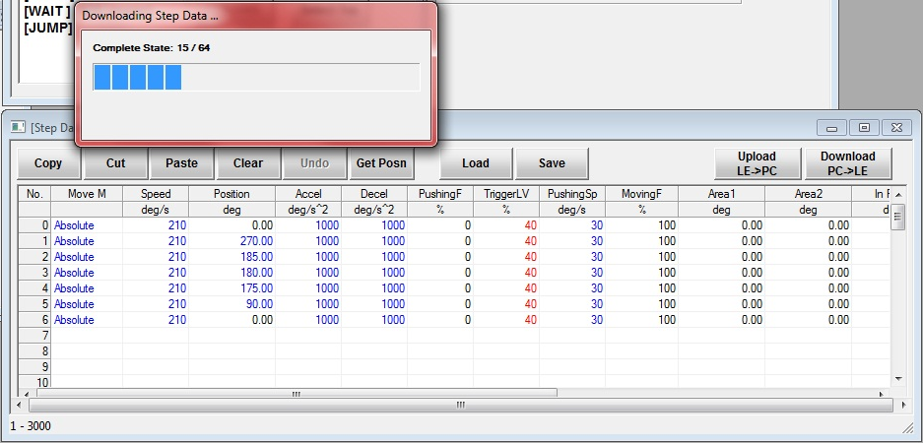

Once all positions were downloaded, the font on the Step Data window will turn color black, meaning positions were downloaded successfully.

QA Rotary Stage how-to:

In order to move to a position the rotary stage requires some conditions to be ON/OFF:

1. In Position status light must be ON (green).
2. Stage Ready status light must be ON(green).
3. Alarm needs status light must be ON(grey).
4. Stage Ready status light must be ON(green).
5. Stage Busy status light must be OFF(grey).

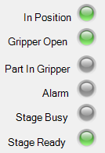

How-to:

* If the conditions above are met.
* Click on the button “Position X” button, this button will move the rotary stage to the position. The status of the movement will be displayed on the Status Window.

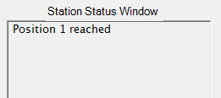

Issues:

* After E-Stop or power outage the rotary stage needs to be homed.
* Click Stage Homing button, this might need to be clicked two times, wait five seconds between clicks.
* If the move failed, make sure the position number is loaded in the rotary stage controller and the Stage Ready status light is ON.

QA Laser:

QA laser will take step measurements from the sides of the part. If the step measure on the world side, the eye side and sky side. The step measurement shall not be greater than 0.05 mm for each step side and 0.08 mm for the symmetry check which is the two opposite sides symmetry offset.

Requirements:

1. LJ Navigator 2 or later version.

Laser configuration:

1. Keyence LJ-Navigator 2
2. Configuring the laser communication. Open LJ-Navigator 2. A small window will pop up asking for the configuration. Like the one below:

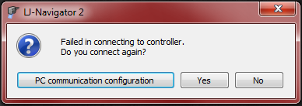

1. Click on PC communication configuration. This will bring a small window with the configuration settings for the laser controller.

2.1 Choose the way you want to communicate with the laser, USB or Ethernet.

2.2 If Ethernet is chosen make sure the correct network card is chosen from the drop down menu.

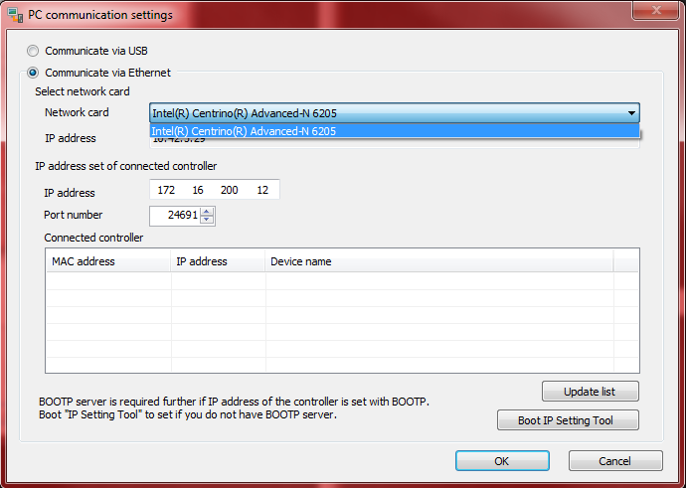

2.2.1 Check the IP address of the network card to be in the same subnet as the laser controller.

2.2.2 Check the port number to be the same as the laser controller.

2.2.3 Click on Update List button.

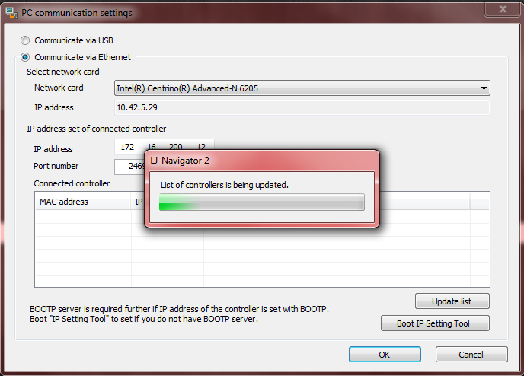

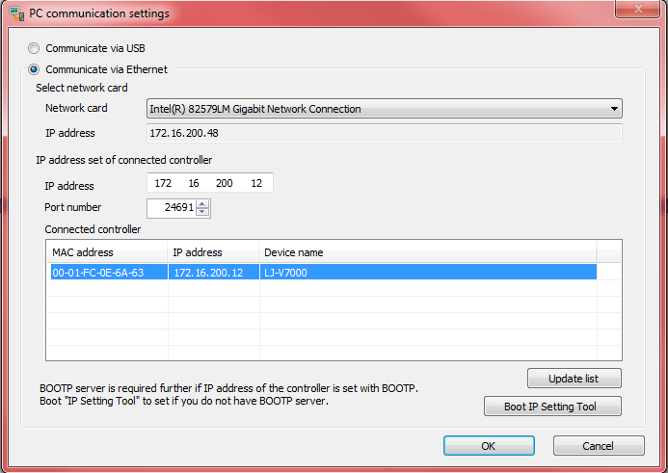2.3 In the list the laser controllers available will show, click on the one that needs to be configured and click the OK button.

2.4 The LJ-Navigator 2 will pop up again, click OK button.



2.5 Choose USB if available for faster configuration.

2.6 Once in the LJ-Navigator 2, click on Configuration -> Device Information. All the information about the device can be found here. Change what is needed to configure the laser-PC configuration.

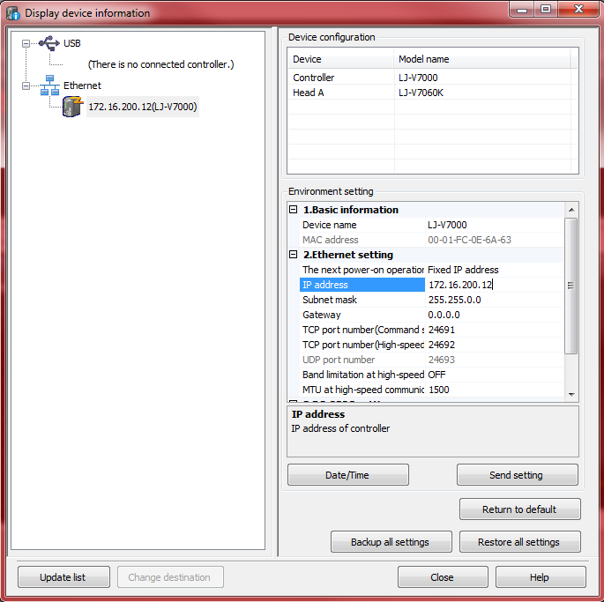

2.6.1 Once all the changes are made in the device information. Click on Send Setting button.

2.6.2 Two windows will pop up advising about the changes made and a needed reboot of the device in order to save the changes. Click OK.

1. Once the LJ-Navigator is open there will be measures and programs. At the bottom of the window you can find the Program number and other options for this one.

Laser Symmetry Inspection Procedure:

1. Part will be placed on the QA gripper.
2. Laser will take the first measurement, e.g. E step
3. Station will move to the next position.
4. Laser will take the first measurement, e.g. S step
5. Station will move to the next position.
6. Laser will take the first measurement, e.g. W step
7. Station will move to the next position.
8. Laser will take the first measurement, e.g. G step
9. QA will calculate the symmetry based on the step size results.

This part of the inspection will look for symmetry of the part using the next algorithm:

1. After the measurements are obtained, the symmetry check will calculate the offset:
2. Pass or Reject part will be dictated according to algorithm below:

Minimum measurement units to PASS inspection:

IF

|Sky side 1| AND |Sky side 2| < 50 micrometers

AND

|*Eye side 1| AND |*Eye side 2| < 50 micrometers

AND

|World side 1| AND |World side2| < 50 micrometers

AND

|Ground side 1| AND |Ground side 2| < 50 micrometers

AND

|Symmetry| < 80 micrometers

**Part PASSED** laser inspection.

T = Flatness tolerance = 50 µm

F = Flatness

A = Symmetry tolerance = 80 µm

X = Symmetry

Mx = Wedge angle

S1 = Sky side 1, *E1 = Eye side 1, W1 = World side 1, G1 = Ground side 1

S2 = Sky side 2, *E2 = Eye side 2, W2 = World side 2, G2 = Ground side 2

QA Station Procedure:

The QA station is in charge of two processes. One is the inspection for bubbles and other imperfections and the second one is inspection for part symmetry. In other for the part to pass the QA station, the part must passed both of the inspections. If part does not pass either one, the part will be rejected.

QA data requirements:

1. Three of 5MP pictures.
2. One of 29MP picture.
3. Six or eight laser measurements.

IPQC procedure:

* Setup QA Rotating stage, LJ7000 laser device, Vieworks camera, Basler camera, laser slider, VisionPro web services, DinoLite web services and stage lighting devices.

1. Part will be placed at the loading/unloading position on the QA gripper(Position 1).
   1. Basler camera will take the one 5MP picture. This picture will be saved in the x64 computer hard drive.
   2. Laser slider will move to position #1.
   3. Laser will retrieve one measurement(1).
   4. Laser slide will move to position #2.
   5. Laser will retrieve one measurement(2).
2. The IPQC gripper will move to next position (Position 2).
   1. *Basler camera will take the one 5MP picture. This picture will be saved in the x64 computer hard drive. (Edge inspection)
3. The IPQC gripper will move to next position (Position 3).
   1. At this step both cameras will take a picture. Vieworks camera will take a 29MP picture and execute the Cognex tool to look for bubbles and other imperfections on the part, the tool consists of 3 steps that might take up to 3 seconds (bubble inspection).
   2. Basler camera will take one 5MP picture. This picture will be saved.
   3. Laser slider will move to position its #1.
   4. Laser will retrieve one measurement(*3).
   5. Laser slider will move to its position #2.
   6. Laser will retrieve one measurement(*4).
4. The QA gripper will move to next position (Position 4).

4.1 Basler camera will take the one 5MP picture of 4 pictures. This picture will be saved in the x64 computer hard drive. (Edge inspection)

1. The QA gripper will move to next position (Position 5).

5.1 Laser slider will move to its position #1.

5.2 Laser will retrieve measurement.(*3 or 5)

5.3 Laser slider will move to its position #2.

5.4 Laser will retrieve measurement.(*4 or 6)

1. The QA gripper will move to the next position (Position 6).

6.1 Laser slider will move to its position #1.

6.2 Laser will retrieve measurement. (*5 or 7)

6.3 Laser slider will move to its position #2.

6.4 Laser will retrieve measurement. (*6 or 8)

1. According to the results of the Cognex tool’s results and the symmetry inspection output, the part will pass or be rejected.
2. If part is rejected this one will go to rejection tray. If part pass it will be drop off at the good tray.
3. Laser measurements and other Laser’s data will be logged to a specified log file.

9.1- Laser log file will be created on C:\\Laser\.

9.2- Laser log files will be deleted automatically when QA app is running, if files are 30 days or older.

QA Menu Operation:

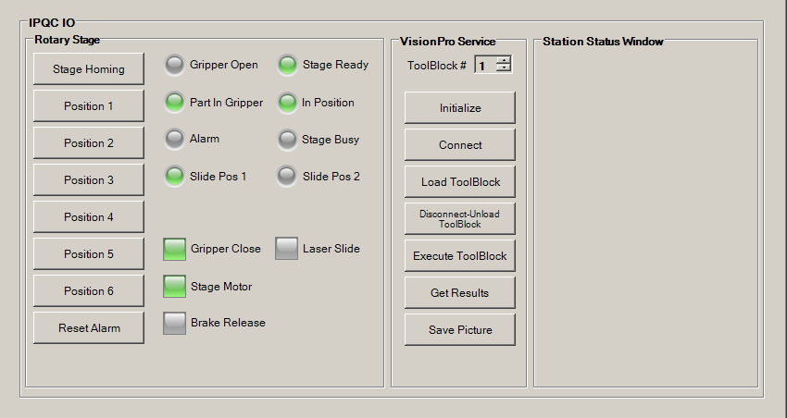

How To:

1. To move to a certain position, click on the Position #X button.
2. If move is successful, the status window will display; Position # reached.
3. If Alarm goes off, there is a chance that an error happened in the rotary stage controller. To fix this issue try the next:

3.1- Click Reset Alarm button and try to move again.

3.2- Click the Reset Alarm button and click Home Stage button. This option will home the station to its origin position. Sometimes the Home Stage will need to be pressed twice, click once wait 5 seconds and click again.

3.3- Make sure the position is loaded in the rotary stage controller.

3.4- If any other issues happened, make sure the connection between the Epson controller, rotary stage controller and the computer are correct.

Rotary Stage Panel:

Stage Homing button; This button will home the rotating stage.

Position # button; These buttons will move the rotary stage to the assigned position number.

Reset Alarm button; This button will reset the rotary stage alarm.

Gripper Open light: This light will set green when QA station’s gripper is open.

Part In Gripper light: This light will set green when there’s a part present in the QA station’s gripper.

Alarm light: This light will set red when an alarm is detected in the rotary stage.

In Position light: This light will set green when the rotary stage is in an assigned position.

Stage Busy light: This light will set green when the rotary stage is currently busy.

Stage Ready light: This light will set green when the rotary stage is ready to move.

Slide Pos 1 light: This light will set green when the laser slide is on position 1.

Slide Pos 2 light: This light will set green when the laser slide is on position 2.

Gripper Close button: This button will CLOSE/OPEN the rotary stage’s gripper. If gripper is close, the button’s color will be set green.

Stage Motor button: This button will turn OFF/ON the rotary stage’s motor. If the motor is ON, the button’s color will be set green.

Brake Release button: This button will SET/RELEASE the rotary stage’s brake. If the brake is set, the button’s color will be set green.

Laser Slide button: This button will MOVE the laser slide from one position to the other. The button’s color will set green when the slide is in position 2.

VisionPro Service Panel:

ToolBlock # choice; This numeric preset option will display the number of toolblocks in the IPQC station. Choose the toolblock number and then press the button with the function needed. Remember that each toolblock it’s assigned to its corresponding camera number.

Initialize VisionPro button; This button will initialize the web service – camera services.

Connect VisionPro button; This button will make the connections between the web service and the chosen camera.

Load ToolBlock button; This button will load the Cognex toolblock indicated in the ToolBlock # option.

Execute ToolBlock button; This button will execute the LOADED toolblock using the ToolBlock # option.

Get Results button; This button will obtain the results from the EXECUTED tools and chosen camera.

Save Picture button; This button will save the last taken picture from the last loaded, executed tool and chosen camera.

Disconnect-Unload button; This button will disconnect web service from chosen camera and toolblock.

Station Status Window:

This is the QA IO status information window.

Laser Slide:

The laser slider will work moving the laser device to two positions. The slider, will move to its first position, take a laser measurement of the part, then the slider will move to the next position and take a second measurement of the part. The two measurements will be in the same side of the part, but in different locations. The slider will be controlled using the EPSON controller with input 89, 90 and output 91.

Laser Slide Configuration:

* Slide will be controlled through Epson Controller.
* Slide will travel around a distance of 8.8mm (or as set up) from one side to the other side.
* Slide will position the laser 0.6mm from the part’s edge.

Laser Slide How To:

To move the laser from one position to the other, on the QA Tab, there is a button called Laser Slide, which will trigger the laser slide position alternatively.



The Laser Slide signal lights will display the position on which the slide is located.



UV Stations:

The UV stations are in charge of curing the part after this one has gone through the cleaner station.

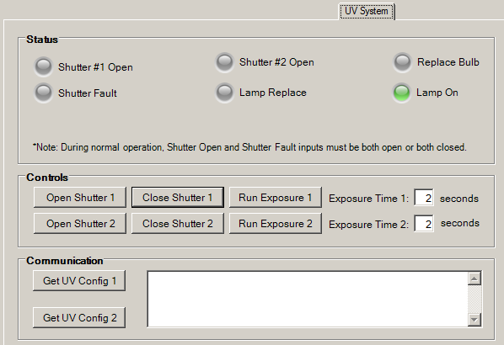

Status Panel:

Shutter #1 Open light: This light will set green when the UV shutter #1 is open.

Shutter #2 Open light: This light will set green when the UV shutter #2 is open.

Replace Bulb light: This light will set green when the bulb needs to be replaced on the OmniCure S2000.

Lamp On light: This light will set green when the lamp is ON.

Shutter Fault light:

Lamp Replace light: This light will set green when the lamp needs to be replaced.

Controls Panel:

Shutter Close #1 button: This button will set green when the shutter #1 is closed.

Shutter Open #1 button: This button will set green when the shutter #1 is open.

Shutter Close #2 button: This button will set green when the shutter #2 is closed.

Shutter Open #2 button: This button will set green when the shutter #2is open.

Run Exposure #1 button: This button will open shutter #1 using the exposure time from Set Exposure Time 1 text box. This button will close shutter after exposure time is been reached.

Run Exposure #2 button: This button will open shutter #2 for using the exposure time from Set Exposure Time 2 text box . This button will close shutter after exposure time is been reached.

Set Exposure Time 1 text box: This text box is used to set the exposure time at which shutter #1 will Run. Units are specified in seconds. Minimum exposure time is 2 seconds and a maximum of 9999 seconds.

Set Exposure Time 2 text box: This text box is used to set the exposure time at which shutter #2 will Run. Units are specified in seconds. Minimum exposure time is 2 seconds and a maximum of 9999 seconds.

Communication Panel:

Get Configuration Panel: This button will retrieve the configuration on the OmniCure S2000 device.

UV Pulse Modulation System:

This system will cure the part by using pulses of UV light.

The system is configurable by using the UVPulseModulation.xml file.

The parameters for this system can be found in the file, e.g. Pulse quantities, pulse duration and delay between pulses.

To enable this system, the file MUST exist in the Data folder (C:\\Data\); IF file does NOT exist, then the UV system will cure using the parameters from the recipe.

The pulse modulation system will execute the quantity of pulses indicated in the configuration file, PLUS one last pulse using the parameters from Recipe settings.

DinoLite Services:

The DinoLite Service is a web service that communicates with QA app. The goal of this service is to record the cleaner process. There are two DinoLite cameras positioned in front of the cleaners. These cameras will allow the user to record and take pictures of the cleaning process.

DinoLite Configurations:

* DinoCapture 2.0 1.4.1 or later.
* DinoLite Cameras USB.
* Avidemux Player 2.6.4 or later.
* DNVideoX 3.0.28 or later.

DinoLite Service How To:

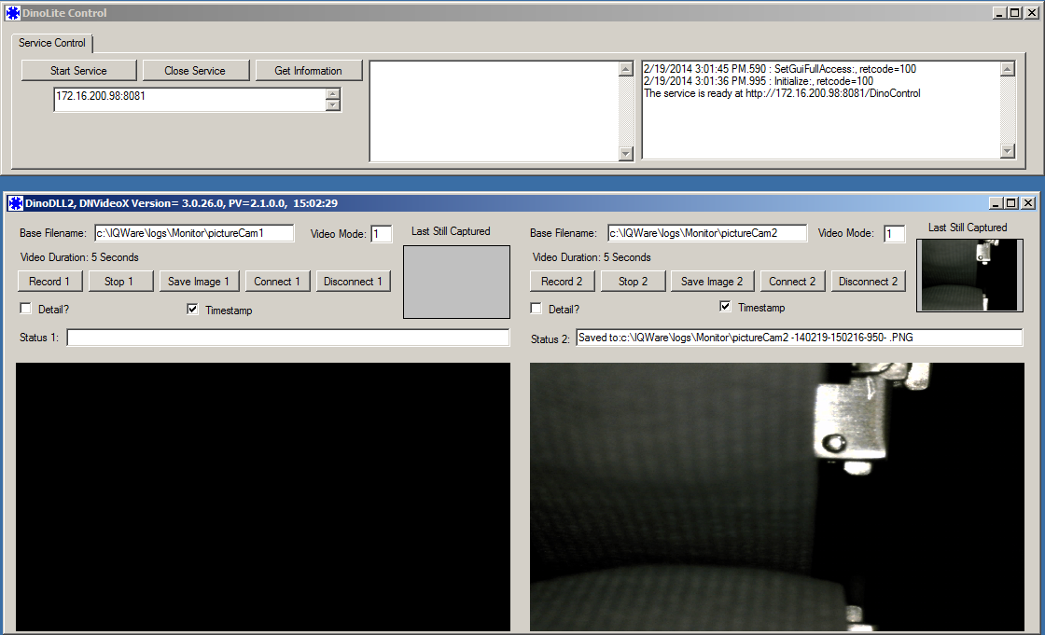

Initilialize DinoLite Service:

* On the Vision PC load the DinoLite Control service.
* Start QA, the DinoLite Control should get initialize as QA loads. To ensure such communication between IQWare and DinoLite Control, check for the status of the service on the DinoLite Control status window. The retcode for a successful command is 100.
* When DinoLite Control is initialized, the first message on the status window will be; The service is ready at http://172.16.200.98:8081/DinoControl.

GUI Access level:

* DinoLite Control will default the access level according to QA’s user. To access full GUI, log in as Technician.

Connect with camera:

* Select the camera 1 or 2.
* Type the video mode from 1-5 in the Video Mode text box. 1 is for the highest and 5 is for the lowest resolution.
* Click on Connect# button.
* A short moment later the live image will populate the video screen of the connected camera.

Take Picture:

* Connect to the camera, remember to use the correct Video Mode. The video mode affects the quality of the picture to be taken.
* Type the correct path and name for the picture on the Base Filename text box.
* Check Timestamp checkbox if the timestamp is needed.
* Click Save Image #.
* Check for message status on Status # text box.

Record Video:

* Connect to desired camera using the desired Video Mode.
* Type the correct path and name for the video on the Base Filename text box.
* Video Duration is configurable on MonitorSetup.xml. In order to change this is required to modify the MonitorSetup.xml file and restart QA app.
* Click Stop # button. This is a requirement for right now, due to the fact that user can start recording at any time when QA app might be requiring access to DinoLite Control service. A fix is coming on next update.
* The service will record the time specified on the Video Duration setting and stop automatically.
* While recording video, all other buttons on the application will be disabled except the Stop button. To enable the other buttons you must stop the video recording by clicking on the Stop button.

Other Specifications:

* Sometimes the DinoLite cameras lag at high video mode.
* When DinoLite cameras are not fast responding, click Stop -> Disconnect -> Connect.
* Timestamp for videos is been overridden, fix in next update.

**User configurable settings**

User can change this setting in the .xml files in the C:\\Data\.

|  |  |  |
| --- | --- | --- |
| Setting | Application | Path |
| Picture name | VisionPro Service | C:\\Data\IPQCio.xml |
| Picture path | VisionPro Service | C:\\Data\IPQCio.xml |
| Inspection tools | VisionPro Service | C:\\Data\IPQCio.xml |
| Asymmetric tolerance | Laser measuring | C:\\Data\IPQCio.xml |
| Flatness tolerance | Laser measuring | C:\\Data\IPQCio.xml |
| IP/TCP config | VisionPro Service | C:\\bin\appXXXX.config |
| Laser IP/TCP config | Laser measuring | C:\\Data\Hardware.mdb |
| Enable Eye-side inspection | IPQC | C:\\Data\IPQCio.xml |
| Rotary Stage Settle Delay | IPQC | C:\\Data\IPQCio.xml |
| Distance | Laser measuring | C:\\Data\IPQCio.xml |
| Laser trigger set up time | Laser measuring | C:\\Data\IPQCio.xml |
| Inspection files duration on the system | VisionPro and DinoLite services | C:\\Data\MonitorSetUp.xml |
| Video Duration time | DinoLite Service | C:\\Data\MonitorSetUp.xml |
| VisionPro Log path | VisionPro Service | C:\\Data\MonitorSetUp.xml |
| Video Log Path | DinoLite Service | C:\\Data\MonitorSetUp.xml |
| Picture Log Path | DinoLite Service | C:\\Data\MonitorSetUp.xml |
| Laser slide travel distance | IPQC | C:\\Data\IPQCio.xml |
| UV Pulse modulation | UV curing | C:\\Data\UVPulseModulation.xml |

-Note: Remember when changing these settings to restart QA app in order for changes to take effect.