What is the goal of OOP?
Consider 2 spaces. The problem space (Where the actual problem is) and the solution space (The computer, where the solution is actually implemented). We want to be able to represent the problem space clearly and easily. Creating new types (e.g. new classes) allows us to represent the elements in the problem space easily.

What is a program?
A program is a set of objects that interact with each other and call each other’s methods in order to achieve some goal for the client. A object is a mix of state, methods and identity. Additionally, objects with the same behavior when their state is the same are grouped into classes (essentially data types).

Access control
Private, only methods in that class can modify it.
Protected, same as private except that inheriting classes can modify protected members.
Package/default, only classes in the same package can modify that class.
Public, anything can modify it.

Why OOP?
It makes reasoning simpler because we dont need to care aboput the specific underlying details of the object’s implementation.
Flexibility. By hiding the implementation ,it can be changed without impacting the user.
Code reuse. Objects can be composed. Or Inherited.

Code reuse via composition/aggregation
An object can be placed inside a new class, that object is then a member object (Typically the member object is private). That class is then composed of multiple objects. If the composition occurs at runtime, it is called an aggregation instead.

If it is private, one benefit is that you can rewrite the code of the member objects without affecting users. Another benefit is that member objects can be changed at run-time. The same cannot be said for inheritance because for one, compile-time restrictions are placed on the inheriting object.

Inheritance: Code reuse
If we are making a new class that is extremely similar to an existing class, it would be a big pain to rewrite it. Thus, there is the capability to inherit from an existing when making a new class. Essentially, the parent class is cloned and modified. But if any modifications are made to the parent class, the clone receives those modifications as well.

A child class has has the same members as the parent class (Cannot access private members) and it has the same interface. New behavior can be added by creating

Types: Compile-time safety and relationships (Type hierarchy)

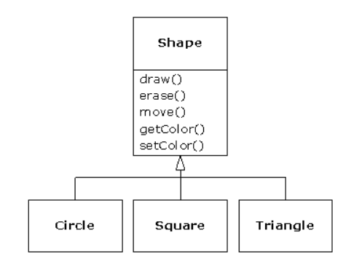
There typically is a base class that expresses the core of the idea but they can be expressed slightly differently. We then have different classes that inherit from it and override it as needed. Big advantage is that we can represent the problem space without much intermediate complexity.
Pure substitution
If an object inherits from a parent class and adds no methods, it is a pure substitution. They are exactly the same type. On the other hand, if it adds new methods, it is like the parent rather than being exactly the same as the parent.

Polymorphism
To allow for extensible code, we typically call methods on a base class. In this way, the programmer can easily add new types that inherit from the base class and thus extend the features of the program while not having to change existing code that interact with the base class.

Function calls: Early binding / Late binding
In non-OOP, the compiler makes a call to a function name and at runtime, it is resolved to the absolute address of the code. Basically, the function is known at compile-time.
In OOP, the compiler doesn’t know the exact type being executed due to polymorphism. Instead, it just checks the method exists in the base class and type-checks arguments and return arguments. At the runtime, we pass a message to the object and the object has a bit of code that determines which method to actualyl run. Thus, the binding happens much later.

Upcasting
Treating a chidl type as the parent type (As typically happens when we call methods on the base class rather than the child classes) is known as upcasting. Going up the type hierarchy and casting a child class as the parent class.

Generics (Parametrized types)
In early versions of Java, we wanted containers that could contain arbitrary types. Since all types inherited from object, we had containers that held objects. But when withdrawing items from the container, they were type object and had to be downcasted manually. Now we have generics where the type is a parameter and it can be seen by <>. ArrayList<Shape> shapes = new ArrayList<Shape>();

Java memory management
In C, one has the choice of creating objects on the heap (Create objects as needed at runtime) or in the stack (Scoped variables/automatic variables) or in static data. In Java, all objects are created on the heap using the assumption that the time taken to find space in the heap and empty out the heap is not very significant compared to the large and complex objects in any case. This introduces the problem of garbage collection. It is handled automatically in javba.

Exception handling
Error handling is wired into the languiage in the form of exceptions. It cannot be ignored unlike flags or bad values and it guarantees that problems are resolved at some point in time and gives the programmer a chance to restore normal execution. Exception handling can be seen as a parallel path of execution when things go wrong.

References (Interacting with objects)
Each reference can be seen as a remote controller and the object as the TV. Java passes around the remote controllers on the stack but not the object itself. In fact, a controller might not even point to any TV at all.

Storage in Java
Registers: Basically invisible to Java but fastest access and extremely small.
Stack: Processor has direct access to this via the stack pointer. Lifetime of all object references on the stack is known at all times.
Heap: Objects dynamically created and created here. Slower to create objects here, need to find space. And must be cleaned up at times.
Constant storage: Constant values placed directly in teh code segment.

Why primitives
They are created on the stack rather than the heap for efficiency reasons. Too much overhead to create a new object for each. All numeric types are signed. (byte 8, short 16, int 32, long 64) (chars 16). 4 integral types all signed, 2 floating point types (floats 4 bytes, double 8 bytes), char and boolean. Ranges of the values are same everywhere. The compiler must be able to verify it has been initialized before execution .

Number formats
232E10 <- 232 * 10 ^ 10
0xff <- hexa
0111 <- octal
0b10101011 <- binary

number types
23232L
232.3f
23232.5d. Double.POSITIVE_INFINITY and Double.NEGATIVE_INFINITY. Not suitable for applications where roundoff errors not acceptable.

Note that converting from int to float or long to float/doubel can cause a loss in precision. Floats only have 6-7 significant digits and doubles have 15 significant digits. Ints have 9 digits and longs have19 significant digits.

Char
‘J’ is value 74 in ascii or 4A in hexadecimal. It can be expressed as ‘\u004A’.
Arrays
2 common problems are references to outside the array and non-initialized arrays in previous languages. The first is checked in java and the second is avoided by always initializing the array. A list of references to objects. They initially point to null, a value that tells the runtime that it is not pointing to any object. Primitive arrays are also initilized in the sense that memory is zeroed out.

Scopes of primitives
Curly brackets determine the visibility (and thus the lifetime also) of a variable. Primitives last till the curly bracket vanishes. Also, one cannot use the same name in the inner scope after using it first in the outer scope. Language designers thought it might be confusing.

Scope of objects
Curly brackets DO NOT determine the lifetime of the object.The objects stay around until they have no references leading to them and the GC runs.

Fields
Primitive fields of a object have default values but it is best to explicitly intiialize it. This isn’t true for local variables, they do not get automatically initialized.

Methods
<return type> <methodName> (<argument 1>, <argument 2> , ..){
functionbody...
}
The top line (excluding return type) is the function signature. When a method is called, execution of caller pauses, a new stack frame including the arguments is created atop the stack. Function is evaluated, adding on local variables as necessary before finally popping them and the initial argument values. Return argument is placed atop stack before control is returned to the caller.

Namespace management
At the top of each file, it is declared which package the file belongs to. This defines a namespace for each file and all classes within a file must have a unique identifier. When using classes from some other source, we import a collection of classes at one time (Known as a package).

Static
Normally we have a bunch of objects with its own fields and methods talking to each other. We may however want to associate some variables/methods with an entire class rather than a specific instance of a class. In that case, we use the keyword static and access it via an object or it’s classname.

Explain system.out.println
System is a class with the static field out where out is of type PritnStream. PrintStream has the method println which sends output to some output stream.

Basic info on javadoc
Maintaining documentation is difficult when comments and code are kept separate. So keep them together. Javadoc is a tool to extract these comments and uses a special syntax to identify the relevant bits and displays it as a HTML page. Stuff starting within /** are javadoc commands. Can take in HTML or special @tags.

Operators
Essentially functions that operate on one or more operands. They generally only work with primitives except for ‘==’, ‘!=’ and = which works for objects and ‘+’, ‘+=’ which works for Strings.

For numeric operators, rules work in this order . if a x is involved, both are cast to x where x is from (double, float, long, int) in that specific order.

Operator precedence (Basically always associate to left except for unary operators or assignment operators)
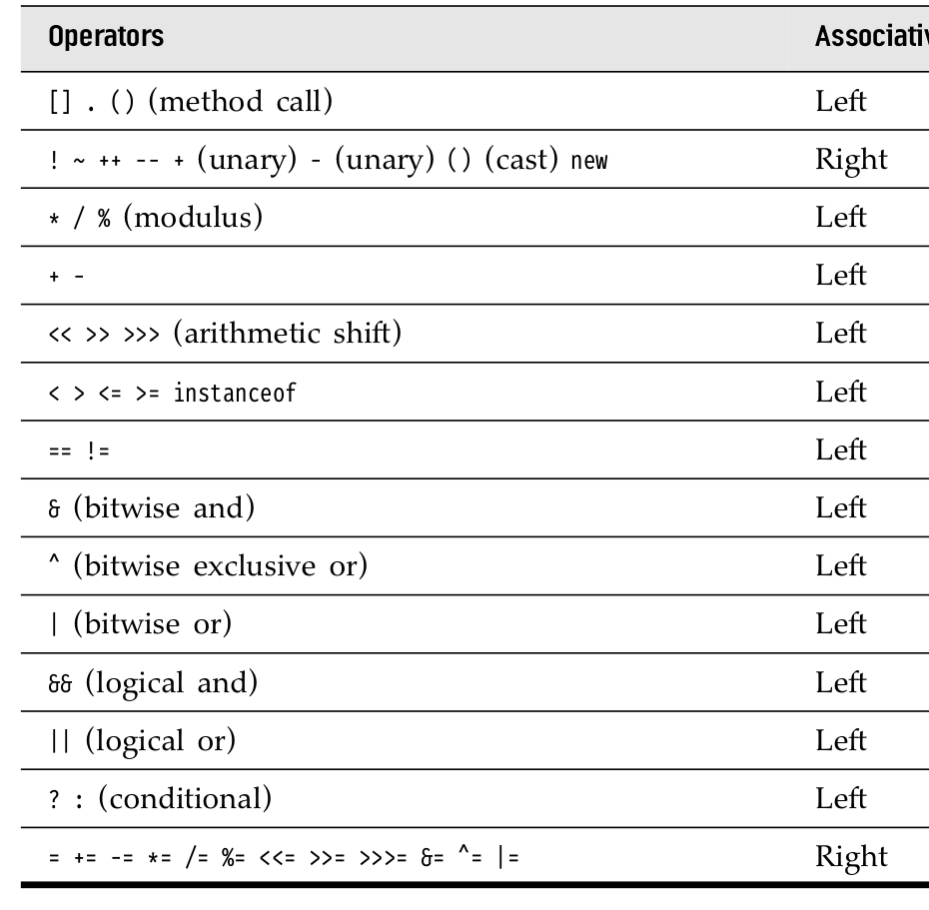
Divison by zero
Causes an exception for integers but does not cause one for floating point divison by zero, instead returns a NaN.

Modulus
Negative number modulo n returns a negative number. Instead use Math.floorMod which always returns a positive number (unless the divisor is negative,....)

Prefix increment vs postfix increment
++n : Increment happens before anything else.
N++: Increment happens after everything else.
Assignment
On the left is a distinct named variable which has a physical space associated with it. On the right is an expression that evaluates to a value or a constant or a variable that has been initialized. If the value on the right is a primitive, it is deepcopied to the variable on the left. If it is an object referenceo n the right, the reference is copied but not the actual object. Thus both still refer to the same object. Prefix ++ has the increment before assignment, postfix ++ has increment after assignment.

Equality
== checks whether two references are equal i.e. whether they refer to the same object. The equals method for built-in classes checks whether all the fields of the two objects are the same and if it is the same type. The equals method in user defined classes, by default, does the same thign as ==.

boolean operators
&&, ||, !
These operators are shortcircuiting operators.

Special numeric literals: Doesn’t matter if capitalized or not
0177 (Octal, abse 8)
0x[0-9a-zA-Z]+ (Hexadecimal, base 16)
232l (Long)
232 f (Float)
232d (Double)
Use Integer.toBinaryString or Long.toBinaryString for string representations of the binary form. No special binary literals.

Bitwise boolean operators
&, |, ^, ~ (NOT)
<< , >> shift operators (Sign extension, fills in values on the left with ones)
>>> unsigned shift operators (Doesn’t do sign extension, always fills in values on the left with 0s)

ternary expression (Actually produces a value)
<condition> ? <if-expr> : <else expr>

String operator
If an expression starts with String, all operands are treated as strings. To treat it as expressions, use brackets.

Casting
Works for primitives except for boolean. Widening ones are done automatically. Narrowing ones such as long to int require explicit casts cuz maybe info can be lost.
Truncation (Java always truncates! Use java.lang.Round for rounding)

Conditional Control flow
if (bool-expr)
<body>
else if (bool-expr) <---- this actualyl starts a new if statement, else if is NOT a keyword.
<body>
else
<body>
----------------------------------------
while (bool-expr)
<body>
----------------------------------------
do
<body>
while (bool-expr)
----------------------------------------\
for (<init>; <bool-expr> ; <increment op>)
<body>

Advanced for (Using commas to insert multiple statements that get evaluated sequentially)
for(int i = 1, j = i + 10; i < 5; i++, j = i * 2)
The initialized variables must be of the same type.

Foreach (Works with any iterable)
for (float x: arr)
----------------------------------------
switch (<variable>) { <---wiorks only with integral types, enum types or String
case <val1> : <body>; break;
case <val2> : <body>; break;
case <val3> : <body>; break;
}
Unconditional control flow
return specifies the returned value AND returns control to calling method.

Break: Ends execution of the loop entirely

continue: Skips the rest of the current iteration but continues onto the next iteration in the loop

Constructor
A problem in programming is initialization and cleanup of unused resources. Java handles the first with a standardized constructor and the secodn with a garbage collector. Java ensures objects are always initialized by calling the constructor before the user can get a reference to a object. The name of the class is used to avoid naming clashes, note that the constructor does not return a value, not even void. This is because the compiler must know what to do with different possible return values and it does not.

If a class has no constructor, one is automatically created for it.

In a constructor, this can also be treated as a function. It has to be the first call and can only be called once. It calsl another constructor and the constructed object becomes the new this for the rest of this constructor call and it eventually gets returned by new.

Overloading
Identifying the method to be called is done via the ordered sequence of argument types. Note that the return type DOES NOT matter. The reason is that a call like “f()” is indistinguishable even if there are different return types.

Method overloading for primitives is done by finding an exact match of that primitive type in the list of functions with the same name. If there is no match and the caller’s provided argument’s type is ‘smaller’ than the required argument in the method, the ‘supremum’ function is used and the argument is promoted. If the caller’s provided argument is ‘wider’ than the method’s requirements, it must be manually downcast.

How does a method know which object to mess with
All non-static method calls actually get passed a reference to the current object which can be referred to via the this keyword. Calls to other methods in the same class from a method in that class get passed that object reference. To chain operations, one can return the object reference from a method call.

Static methods
Only have access to static fields and are not tied to a particular instance of a class. i.e. no access to this.

Garbage collection
1. It is about releasing memory that is no longer needed
2. Objects dont always get Gced, for example u might have more tha nenough memory
3. GC can be ‘customized’ with the finalize method. If a object is garbage collected, finalize is called and we can customize the finalize method ourselves. It is meant for cleanup if we allocate memory in ways other than using java’s object creation such as using malloc. Thats an obscure case. Teh primary value is probably to test if a object was cleaned up properly by having some conditions to print a message if there is something odd about it’s fields when its being cleaned up.

Useful stuff

Casting
float x = (float) 23
(int) 23.2 == 23 (int casts truncate)

Arbitrary precision
BigInteger and BigDecimal from Math
BigInteger.valueOf(1231231L)
BigInteger.valueOf(123L).multiply(n.add(k)); //123 * (n+k)

String
String.valueOf(123)
String.join(“, “, “Peter”, “John”)
“a b c d”.split(“ “); //get an array [“a”, “b”, “c”]
“abcd”.equals(“abcd”) <- put the literal on the left, in case the variable is a null
“abcd”.equalsIgnoreCase(location);
first.compareTo(second) <- get lexicographic order sorta. Actually based on lexicographic value. Whether first is before second. (negative value if first is second, 0 if equal, positive if first is after second)
“abcd”.substring(0,1)
StringBuilder builder = new StringBuilder(); builder.append(“more strings”); builder.toString();

Integer
Integer.toString(<someInt>, <baseChosen>)
Integer.parseInt(<someInt) <- gets a int
Integer.class.isInstance(23.0)
Character.isLowerCase(‘a’)

final for constants. Can be initialized exactly once but can be declared and initialized at different times.
Enum for a set of constants. Enum Weekday {MONDAY, TUESDAY,..,SUNDAY};

Math.round, Math.pow, Math.min, Math.max

