Movie Recommendation System
Final project, Databases for Data Analytics, Reichman University, 2026B
Team five_signals
Yaron Besser, ID 324943109 Nevo Aloni, ID 322815820
Working repository, with the tuning scripts, the per model findings and every query behind the numbers below: github.com/yaron-besser/five-signals

1. Goal and method
We built five models. Each one gives a different reason why two movies are similar. Each returns a list of movie pairs with a raw score. A final step combines all five into one table, my_models_agg, which the course confusion matrix reads.
We optimised precision. A recommendation system shows a short list. A bad film on that list costs more than a good film we failed to show. All five models are built to return fewer pairs and be right more often. We report recall everywhere, but it never drove a threshold choice.
How we count precision. A pair counts as an error only when the class rated it and gave it 5 or below. Pairs the class never rated are dropped from the denominator, because an unrated pair is unknown rather than wrong. The course file counts unrated pairs as errors, so running it against our table prints 25.3% where we report 82.4%. Both describe the same 776 pairs and the same 196 correct ones.
We tuned every threshold on train only. We measured test once, after all five models were locked.

2. The data
Table | Rows | Role
gt_pairs_train | 5,341 | Train ground truth, 2025 class
movies_recommendations_agg | 4,710 | Test ground truth, 2026 class
personal_movies_ranking | 7,045 | Personal taste, 35 raters, 1,810 movies
gs_movies | 3,569 | Trimmed movie universe, 0.9% of the full table
gs_roles | 84,232 | Trimmed cast, 2.5% of the full table

Baseline. A model that calls every pair good scores 51.3% on train and 49.1% on test. Every number below is read against those two.
Why the cutoff sits at 5. The class scores fall into two groups. Both years peak at bucket 3 and again at buckets 8 and 9. Bucket 6 is the low point, with 45 train pairs against 1,129 at bucket 3. The class decided good or bad, not a scale. A cutoff at 5 lands in the emptiest part of the data, so small score changes do not flip labels.

3. The five models

Model 1. Style and Era
Two movies share at least 3 genres and came out within 20 years of each other.
Why 3 and not 2: precision rises from 76.7% to 81.8%, the largest single step in the grid. Why not 4: precision falls to 77.6%, and it rests on 58 rated pairs. That is worse on both counts.
The year window does nothing, and we report that. At 3 shared genres, precision across windows of 2, 5, 10, 15 and 20 years reads 81.1%, 81.1%, 79.7%, 81.4%, 81.8%. That is a 2.1 point spread with no direction, while volume grows 3.7 times. A parameter that does not move precision should not throw away 73% of the output, so we kept the widest window we measured. In practice this model is "two movies share 3 or more genres".
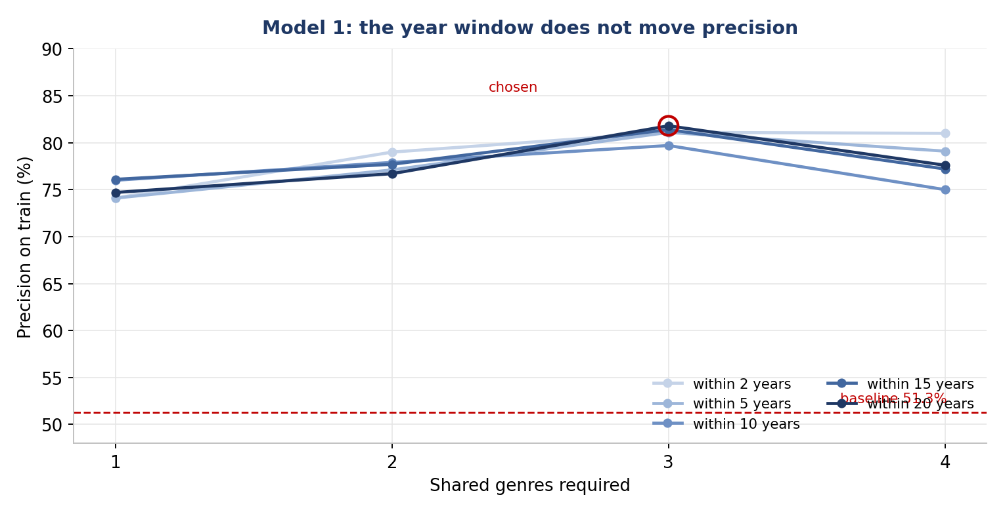
Figure 1. The five lines are five year windows. They sit on top of each other, which is the finding: only the genre count moves precision.

Model 2. Common Cast
Two movies share at least 3 credited actors.
Precision by threshold: 73.2% at 1 shared actor, 84.7% at 2, 91.8% at 3, 94.8% at 4, 95.2% at 5. The gain collapses after 3, and 3 returns twice the volume of 4. Above 8 shared actors precision reaches 100%, but on 118 rated pairs or fewer, and those pairs are almost all sequels from one series. Perfect precision on a tiny sample is not evidence, so we report volume next to precision everywhere.
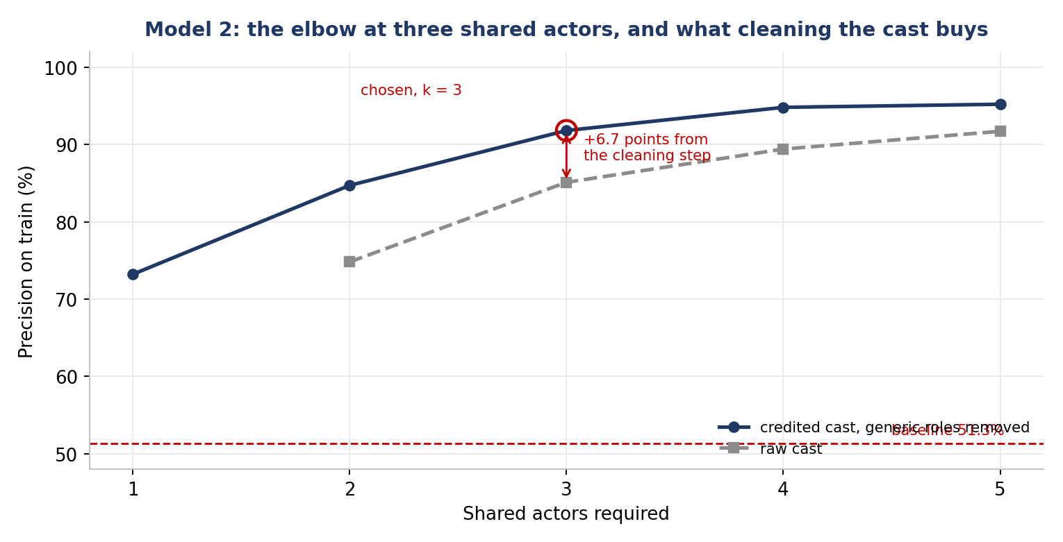
Figure 2. The gap between the two lines is the cleaning step described in section 6. The circle marks the threshold we chose.

Model 3. Director Genre DNA
Two movies share a genre, and both directors are strongly tied to that genre. The two directors do not have to be the same person. The link is the genre signature, not the person.
We score each director and genre as (films in genre + 1) divided by (total films + 21), where 21 is the number of genres. The probability column already in the data gives a director with one film a score of 1.0. This correction pulls those extremes back in proportion to how little evidence supports them. A director with 3 films working only in one genre reaches at most 0.167, so the whole scale sits low and a bar of 0.15 is strict, not loose. The score for a pair is the weaker of the two directors.
Why 0.15 and not 0.12: 90.3% to 93.4%, the largest step in the curve. Why not 0.20: it adds 0.3 points, but volume falls from 158,306 pairs to 54,392 and recall halves. Why not 0.35, where precision reads 100%: that rests on 122 rated pairs, while 0.15 rests on 594.
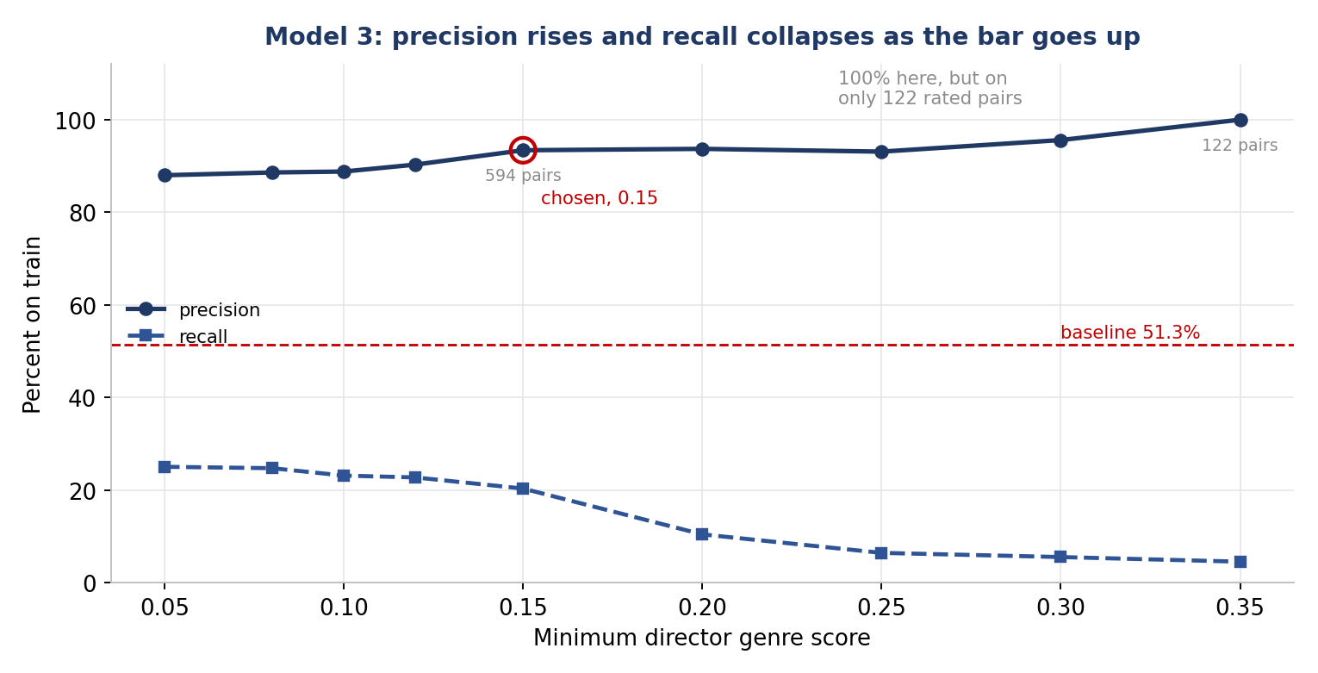
Figure 3. Precision keeps climbing to the right, but the evidence behind it thins out. We stopped at the last point that still rests on a large sample.

Model 4. Shared Star Actor
Two movies share at least one actor from a list of 22 stars.
Model 2 asks how many actors two films share and needs 3. Model 4 asks whether the shared actor is a star, and one is enough. They are different questions. We rejected a film count threshold on purpose, because it would let in prolific but unknown character actors and shut out stars with short filmographies in this dataset.
On train the star list adds nothing. We ran a control with the list removed, so any shared credited actor qualifies. We also tried a third definition, an actor with 3 or more credits here. All three land within 0.2 points of each other. On this data, sharing any credited actor carries the whole signal, and who that actor is carries none of it.

Definition of a star | Rated pairs | Train | Test
Curated list of 22 names | 237 | 73.0% | 64.8%
Any shared credited actor | 1,206 | 73.2% | 60.2%
Actor with 3 or more credits | 1,188 | 73.1% | 60.3%

On test the result turns around. The curated list reads 64.8% while the two controls read 60.2% and 60.3%. So the list costs 92% of the volume and buys nothing on train, but it holds up better on data it never saw. Both halves of this belong in the report. The train result rules out the claim that star status is a strong signal here. It does not rule out the list being the steadier of the three definitions.

Model 5. Collaborative Filtering
Two movies are similar if the same people liked both. We compute an item to item Jaccard score over the personal rankings, grouped by rater. Liked means a score above 5, the same cutoff used everywhere else in the project. This is the only model that reads taste instead of metadata, which is the argument for its place in the set.
It has two parameters: at least 2 raters must like both films, and the Jaccard score must reach 0.50.
Why the support floor: 63.4% of all candidate pairs rest on a single rater, 270,758 of 427,056. One rater who liked few films, two of which are this pair, scores a perfect 1.0 on no evidence at all. Moving the floor from 1 to 2 adds 2.9 points, the largest step in that table. Moving it higher does not help. Floors 2 through 5 give 90.9%, 90.4%, 90.4% and 91.2%. That is not even a rising line, which is the signature of noise rather than signal.
Why 0.50: at a floor of 2, precision rises at every step of the cutoff and never flattens, so there is no elbow to point at. Our precision first rule decided it.
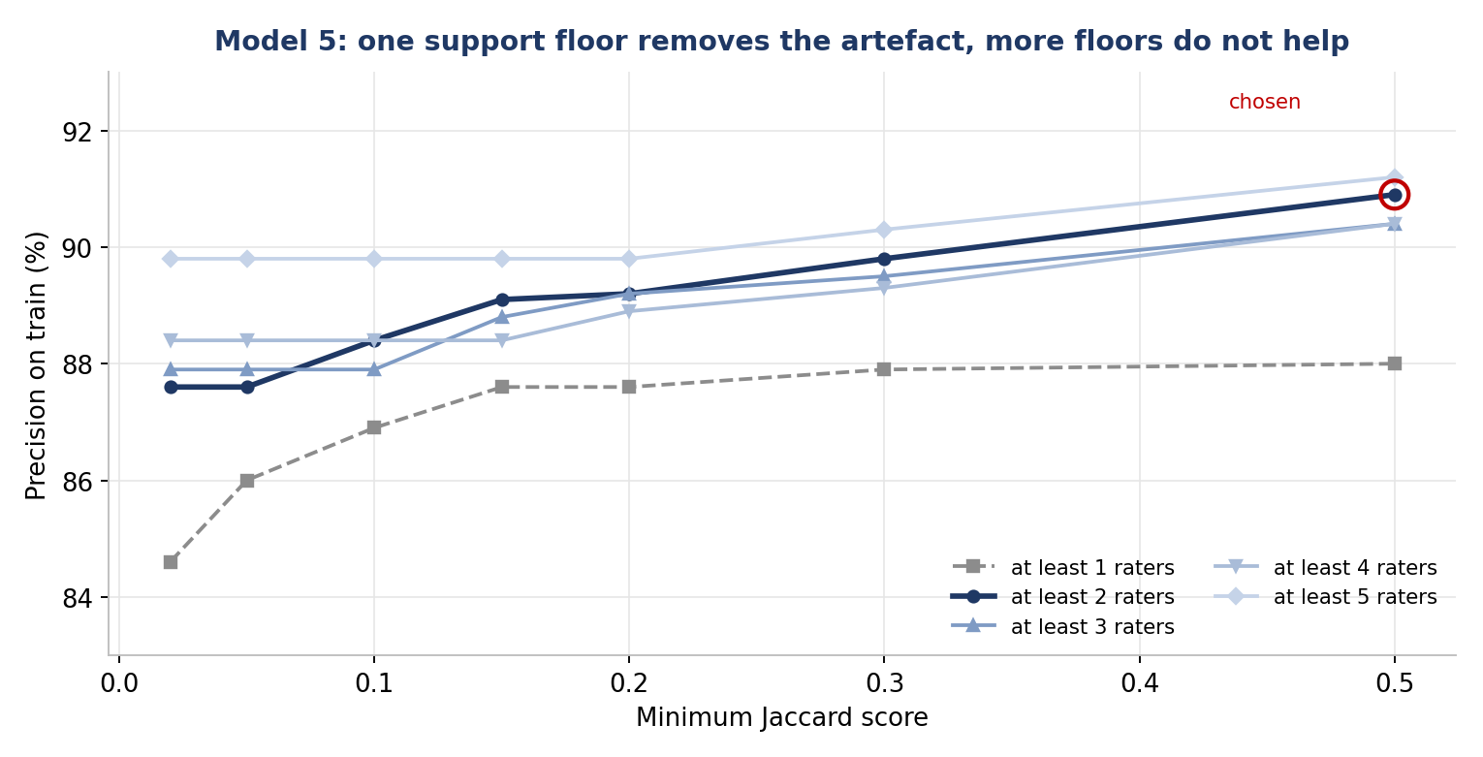
Figure 4. Moving from one rater to two lifts the whole line. Moving from two to five does not, and the order of the lines even reverses, which is what noise looks like.
This model can only see part of the data. The personal rankings cover 1,810 of 3,569 movies, so only 1,704 of the 5,341 train pairs are visible to it, which is 31.9%. That subset is not a random sample. 81.2% of it is already labelled good, against 51.3% for train as a whole. So the honest comparison for this model is 90.9% against 81.2%, not against 51.3%. Most of its apparent lift comes from which films people chose to rank, not from the model.
No leakage. This model reads only the personal rankings table. It never reads the ground truth. A collaborative model built on the ground truth would be trained on the answers, and its precision would mean nothing.

4. Combining the five models
Each model hands over its raw signal, not a fixed score. We scale each signal to a 0 to 1 range, multiply it by that model’s measured train precision, and add across the models that fire on a pair.
Score = sum over models of (train precision x scaled signal)
Models 3 and 5 already return 0 to 1. Model 4 is yes or no. Model 1 divides by 10, the most shared genres we saw, and Model 2 divides by 47, the most shared actors. The highest score possible is 4.3097. The highest we actually saw is 2.2471. We keep pairs scoring 1.0 or more, then map the score onto 6 to 10. The column is DECIMAL, because the ground truth is an average and is DECIMAL too.

Split | Pairs returned | Rated | Correct | Precision | Recall | Baseline
Train | 776 | 142 | 126 | 88.7% | 4.6% | 51.3%
Test | 776 | 238 | 196 | 82.4% | 8.5% | 49.1%

5. What the results say
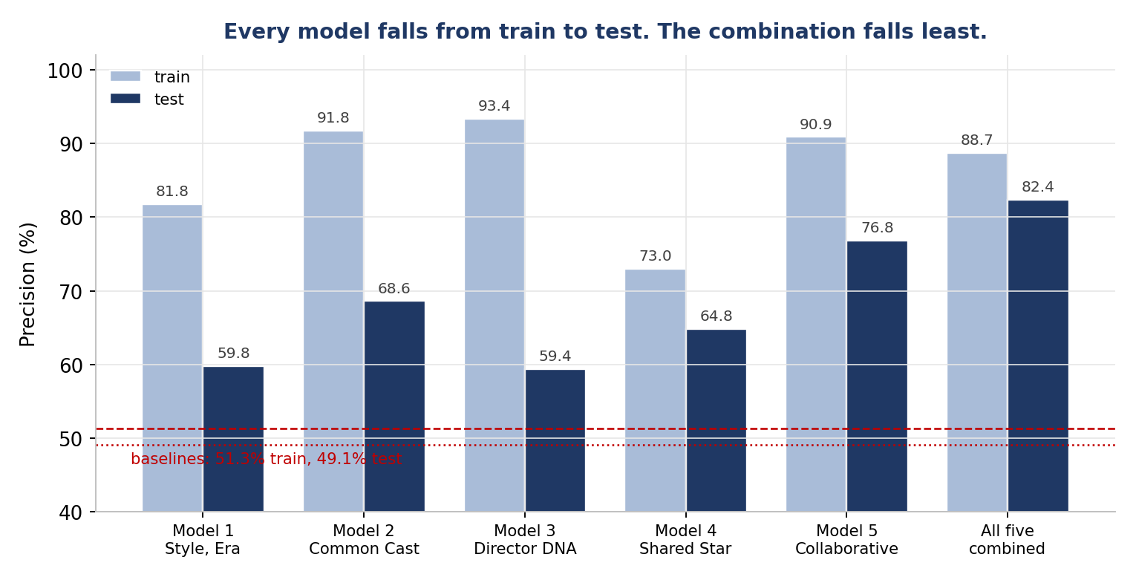
Figure 5. Train against test for every model and for the combination. The combination has the shortest drop and the tallest test bar.
Model | Train prec | Train rec | Test prec | Test rec | Change
Model 3, Director Genre DNA | 93.4% | 20.3% | 59.4% | 31.7% | -34.0
Model 2, Common Cast | 91.8% | 13.9% | 68.6% | 12.0% | -23.2
Model 5, Collaborative Filtering | 90.9% | 11.7% | 76.8% | 30.2% | -14.1
Model 1, Style and Era | 81.8% | 6.9% | 59.8% | 16.0% | -22.0
Model 4, Shared Star Actor | 73.0% | 6.3% | 64.8% | 6.4% | -8.2
All five combined | 88.7% | 4.6% | 82.4% | 8.5% | -6.3

A metric that weights both sides. Precision and recall move against each other, so we also computed F1, their harmonic mean. It ranks the models differently from anything above.

Model | Train F1 | Test F1
Model 5, Collaborative Filtering | 20.8 | 43.4
Model 3, Director Genre DNA | 33.3 | 41.3
Model 1, Style and Era | 12.7 | 25.3
Model 2, Common Cast | 24.1 | 20.5
All five combined | 8.7 | 15.4
Model 4, Shared Star Actor | 11.6 | 11.7

The combination sits second from bottom on F1, and that is the honest reading of our choice. F1 treats a good pair we missed as costly as a wrong pair we showed. We decided at the outset that it is not, and every threshold in this project follows from that. The 776 pairs are right 82.4% of the time and reach 8.5% of what is there. Model 5 alone scores 43.4 because it reaches 30.2%. If the goal were a balanced system rather than a short reliable list, Model 5 or a lower cut would be the answer, and section 6 says so. F1 is the number that makes that trade explicit instead of leaving it implicit.
The combination beats every single model on test. On train it does not. Model 3 alone reaches 93.4% against 88.7% for the combination, because Models 1 and 4 enter the mix at 81.8% and 73.0% and there is not enough agreement between models to filter them out. What the combination buys is stability. It loses 6.3 points from train to test, while the individual models lose between 8.2 and 34.0. On the set that matters, the one the models never saw, the combined table is the best result we have.
The ranking changes almost completely between train and test. The strongest model on train is the second weakest on test. The weakest on train holds up best. Model 4 is the one with no threshold to tune, which is the likely reason: a model with nothing to fit cannot overfit. This is also why we do not lead with the 93.4%. That figure rests on 594 rated pairs, while its test figure rests on 1,235.
The models rarely agree with each other. 94.8% of the pairs in the final table come from exactly one model. Only 16 pairs fire on all five. So the weighted sum is mostly one model’s opinion scaled by its precision, rather than a vote between five. This also settles a risk we expected: double counting the same signal was never the problem.
Measured pair by pair, no two models overlap by much. The pair worth checking is Models 2 and 4, because both key on shared actors and a reader could reasonably ask whether they are one model twice. They agree on 316 pairs out of the 2,934 Model 2 returns, so 89% of what Model 2 finds, Model 4 never sees. The largest overlap anywhere in the set is 15.4%.

Model pair | Pairs in common | Share of the smaller model
Model 2 and Model 4 | 316 | 10.8%
Model 1 and Model 3 | 5,678 | 12.3%
Model 3 and Model 5 | 3,208 | 15.4%
Model 2 and Model 5 | 258 | 8.8%
Model 1 and Model 5 | 684 | 3.3%

Part of the drop from train to test is built into the data. 1,177 train pairs and 617 test pairs appear in both directions. Where a pair appears twice, the two directions land on opposite sides of the cutoff in 3.9% of those train rows and 17.7% of those test rows. Four of our five models are symmetric and cannot tell one direction from the other, so those test rows are out of reach by design rather than by failure.
One rater contributes a large block of easy pairs. 924 train pairs come from a single rater and a single film series. Those films share cast, directors, genres and era, so every model fires on them. We expected this to inflate our numbers. Measured, those pairs are labelled good 45.5% of the time against 52.5% for every other rater, so whether they raise or lower a model depends on how selectively it fires inside the series. For Model 1 the effect is small: 81.8% with them, 79.9% without.

6. What we would improve
The system is strong on precision and weak on recall. At the cut we chose it returns 776 pairs at 82.4% precision on test, but reaches only 8.5% of the good pairs. Three things would move that.
Reconsider the cut, but not on the train curve alone. On train the trade looks cheap. Dropping the cut from 1.0 to 0.1 raises recall from 4.6% to 33.0% and costs 2.0 points of precision, 88.7% down to 86.7%. On test the same move costs 21.0 points, 82.4% down to 61.4%, while recall rises from 8.5% to 56.5%. The train curve is flat because every threshold inside every model was already fitted to those labels, so little was left for the combined score to separate. On test the score does that work and the cut earns its place. The move still worth testing is smaller: a cut at 0.8 reads 79.2% precision at 14.8% recall on test, which buys 6.3 points of recall for 3.2 points of precision.
Widen what Model 5 can see. It is the best model on test and the most limited in reach. It can only speak about pairs where both films were personally ranked, which is 31.9% of train pairs, and its recall ceiling is 50.5% no matter how the thresholds move. More ranked films would help it more than any parameter change.
Add a model that reads direction. Four of our five models are symmetric and cannot tell one direction of a pair from the other, while 17.7% of the mirrored test rows are labelled on opposite sides of the cutoff. A model built on an asymmetric relation, recommending a newer film from an older one but not the reverse, would reach rows the current set cannot.

7. The data quality layer
The class file of personal rankings held 7,445 rows. Two raters submitted their whole file twice. We removed 400 duplicate rows and kept 7,045. All 400 matched on every column, so nothing was lost. We kept both versions of the table so the layer could be measured with it on and with it off.
Model 2 gains 6.7 points. We removed generic role names from the cast table before the model ran. A role name counts as generic when it appears in 38 or more distinct films. The boundary sits there: at 38 the band holds Man and Newscaster, both job titles. Nothing sits at 37. At 36 it holds Tony, a real character. A cut at 39 would keep two labels, and a cut at 36 would delete a character. Three given names appear well above the cut and are kept by name, and we checked the whole band above it to be sure there are no others. At 3 shared actors precision goes from 85.1% to 91.8%, and the filter helps at every threshold we tested. It is not free: it removes 13,212 of 84,232 role rows, 5,349 blank and 7,863 generic labels, and 471 films lose their entire cast and drop out of this model.
Model 5 gains nothing, and that is a real result rather than a failed test. It is the only model that reads the personal rankings, so it is the only place the duplicate filter can act at all. Precision is identical with the filter on and off. The reason is that the model already removes duplicates as it reads. The filter and that step guard against the same fault, and the measurement shows the second one holding. Without it, 337 duplicated rows would have been counted twice and would have corrupted the Jaccard score on the affected pairs.
We did not measure the layer for Models 1, 3 and 4.

8. Limits
- We did not analyse individual false positives and false negatives.
- We did not produce a sensitivity curve across cutoffs of 6, 7 and 8.
- We measured the data quality layer for two models out of five.
- Model 1’s year window sits at the edge of the range we tested. Precision is flat and volume is still climbing at 20 years, so we do not know where the window should stop.
- We measured the two Model 4 controls on test as well as on train, and looked at the test set at three parameter settings for Model 5 instead of one. The choice was argued from train and cites no test figure, but that makes 76.8% a slightly less clean hold out number than a single measurement would be.
- Recall is low across the board by design. These models are built to be right rather than complete, and we did not try to raise coverage.

9. Note on the course confusion matrix
Two of the five queries in the supplied file do not run. One has unbalanced parentheses and calls IF with two arguments. One names a column precision, which is a reserved word in MySQL 8. The remaining queries compute the same two metrics correctly, so nothing is lost. We left the errors in place rather than suppressing them, because suppressing them would also hide our own.

