Provision IaC and Deploy Web Application to AKS

The document describes a web application deployment to Azure Kubernetes (AKS) on Azure.

Tools and applications:
- Azure Cloud
- Azure DevOps
- ASP .NET Core Web Application
- Visual Studio Code
- Azure CLI
- Kubectl
- Terraform

Provision IaC using Terraform
The terraform will provision the services below:
- Azure Continuer Registry (ACR)
- Azure Kubernetes Cluster (AKS)
- Azure SQL Server
- Empty database

Create Service Principal with Contributor role in Azure AD:
az ad sp create-for-rbac --role="Contributor" --scopes="subscriptions/133bc1d5-767e-4628-a9d1-0914ff59665c" --name="TerraformServicePrincipal”"

Create backend storage in Azure for terraform.state:
The powershell script creates the storage and provides access key like this: xaoKqIfd8j8y2txJCfat95rRMMKG15vKkZsX5PTuoKUn801d7mXo/qpkgPRPpPBlSLAPpHxAUTwcRFJK9NbmFg==

Set the access key in the environment variable:
setx ARM_ACCESS_KEY xaoKqIfd8j8y2txJCfat95rRMMKG15vKkZsX5PTuoKUn801d7mXo/qpkgPRPpPBlSLAPpHxAUTwcRFJK9NbmFg==

Create basic main.tf for ACR, AKS and SQL Server with empty Database:
terraform init
terraform plan
terraform apply

Check the AKS is up and running:
az aks get-credentials --resource-group rgyaronz --name aksyaronz --overwrite-existing
kubectl get nodes
Deploy the Web Application to AKS
Clone the web application source code from:
https://github.com/yaronzlot/EmployeeManagement
git clone https://github.com/yaronzlot/EmployeeManagement.git
Update the Azure SQL Server connection string in the web app code and update the empty database in Azure (using EF migration):
dotnet ef database update
dotnet build
dotnet run
http://localhost:5000 – verify the web application works against the update database in Azure SQL Server

Create Dockerfile:

Create deployment.yml and service.yml in manifest folder:

Create project in Azure DevOps and push the code into the Azure GIT repo:
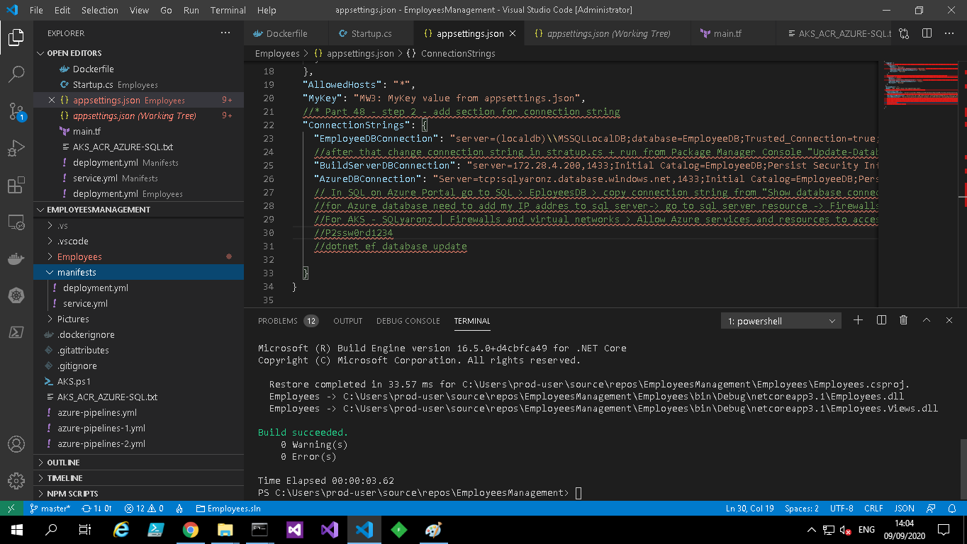
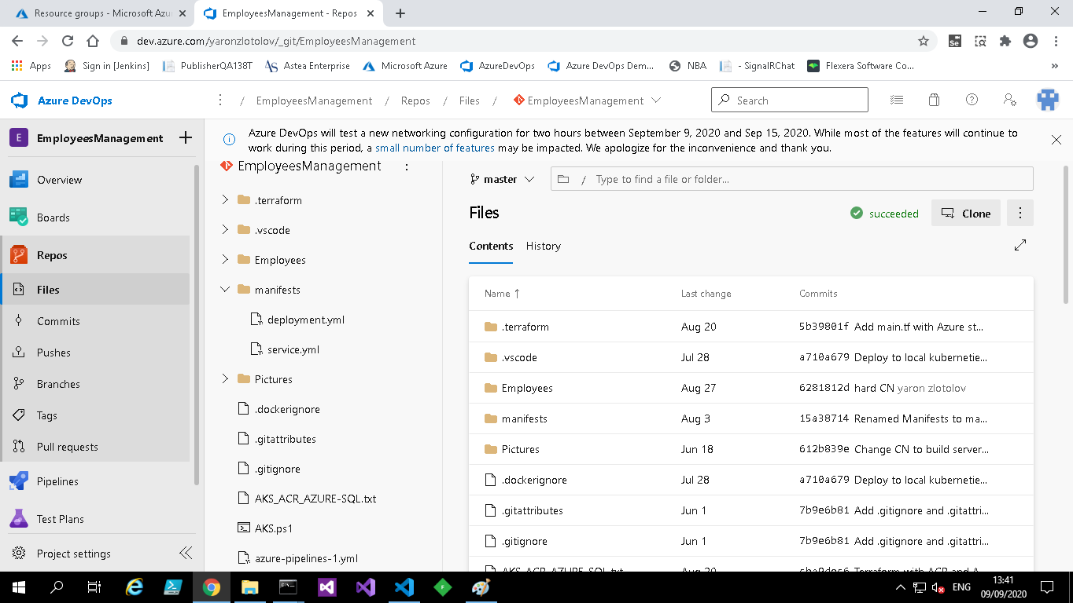

Create the pipeline (below is the pipeline yml):

NOTE: Before this step it is required to remove locks and IP restrictions from AKS done by Terraform:
az lock list
az lock delete –ids $lockid
az aks update --resource-group rgyaronz --name aksyaronz --api-server-authorized-ip-ranges=

Build:
- Checkout the code from GIT repo
- Build the web application
- Create docker image
- Push the docker image to ACR
- Publish artifact for deployment
Deploy:
- Download the artifact
- Pull the image from ACR
- Deploy the docker image to AKS
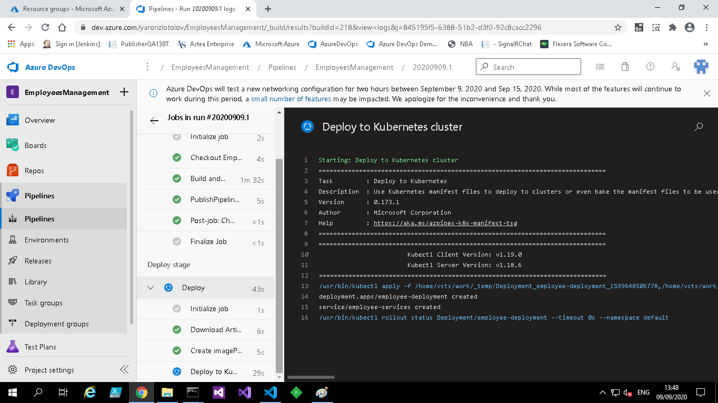
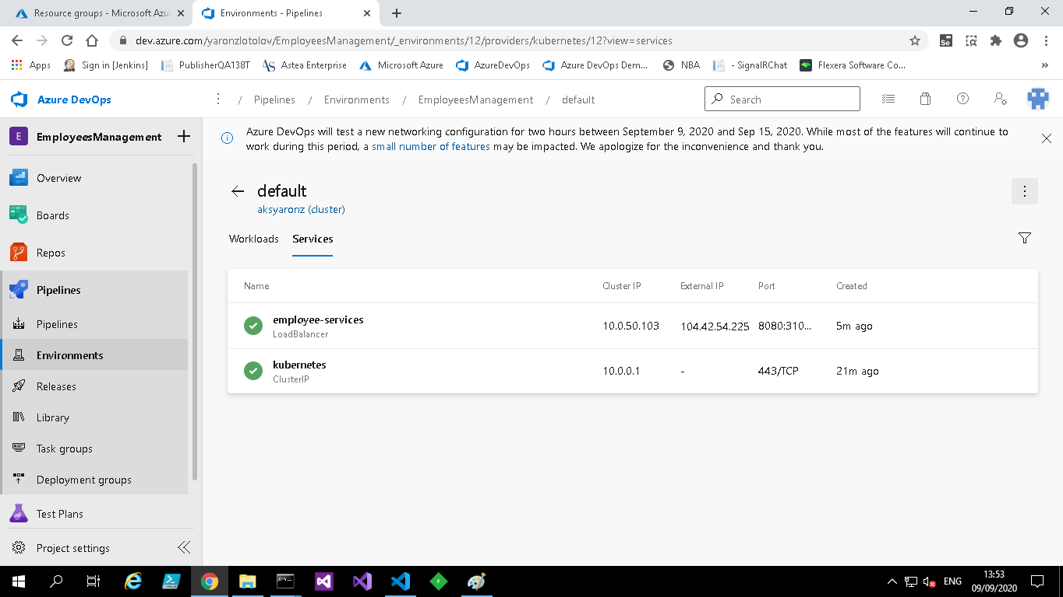

In case of problems with Azure DevOps need to deploy manually:

Web application is running on Azure:
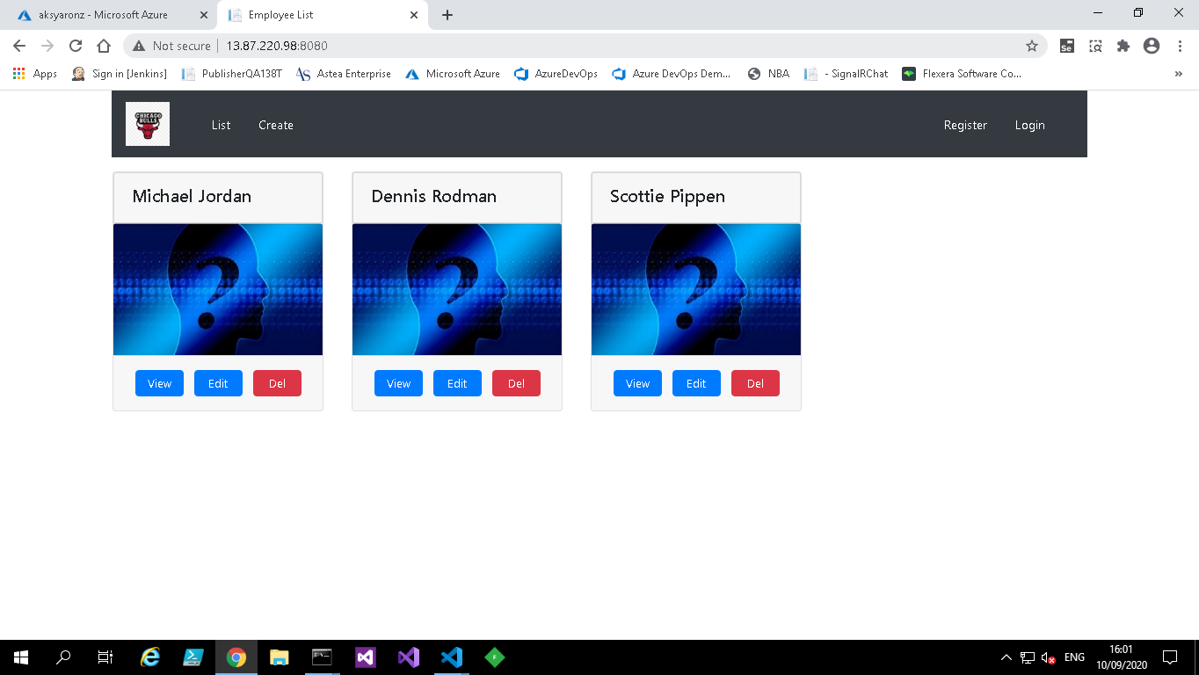

Monitoring AKS Memory and CPU usage:
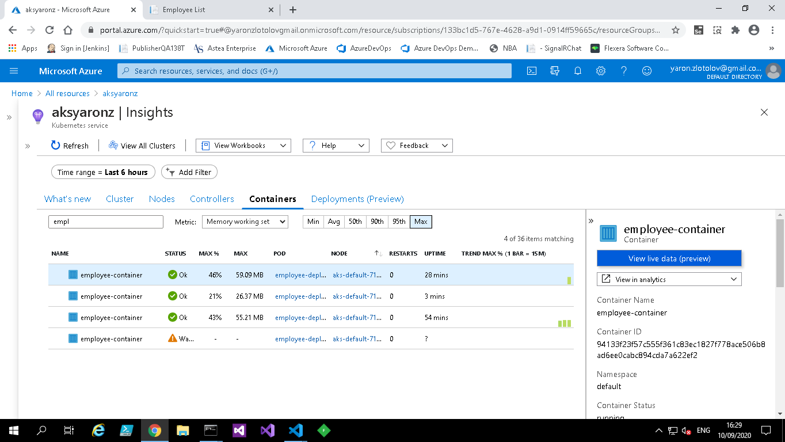

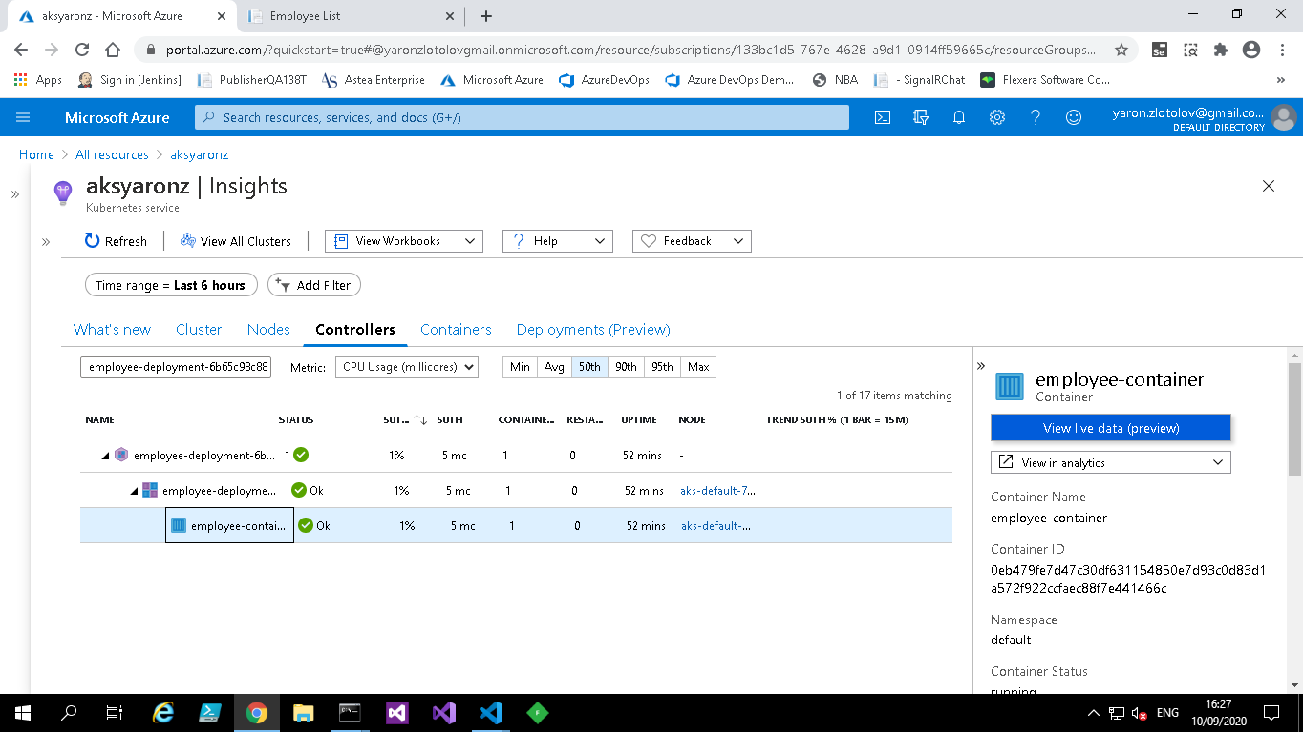

Done - Set the lock and the IP restriction again to AKS

