**Login to OpenShift using oc**

<https://docs.okd.io/3.11/minishift/openshift/openshift-client-binary.html>

Get the **oc.exe** (OpenShift Client tool) location and add its path to the paths in the environment variable:

**minishift oc-env**

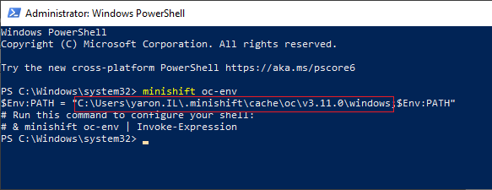

**oc config use-context minishift**

**oc login -u system:admin**

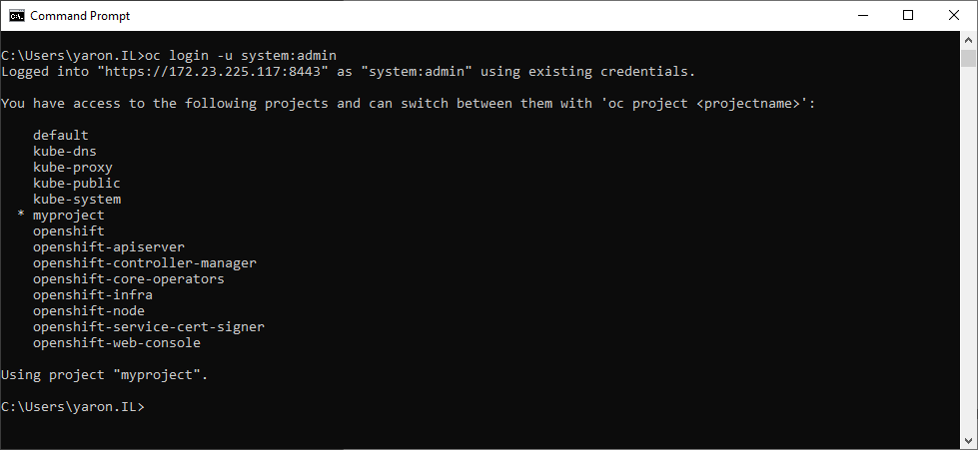

**oc config view**

Accessing the Web Console:

**minishift console --url**

**minishift console**

Viewing OpenShift Logs

**minishift logs**

**minishift openshift config view**

**Login to OpenShift console**

<https://172.23.225.117:8443/login?then=%2Foauth%2Fauthorize%3Fclient_id%3Dopenshift-web-console%26response_type%3Dcode%26state%3DeyJ0aGVuIjoiL2NhdGFsb2ciLCJub25jZSI6IjE2NDEyODYwMTM5NDctMjg2ODkwOTQ5OTE1MTI4MTE2NjYzNzEzMzE0NTE5MjI3MzQ5MDM4ODQwMTk2MTQwMjMyMzAwNDIzMTM3MjM4NzI3OTUzMDMyNTgxNDE3OTcifQ%26redirect_uri%3Dhttps%253A%252F%252F172.23.225.117%253A8443%252Fconsole%252Foauth>

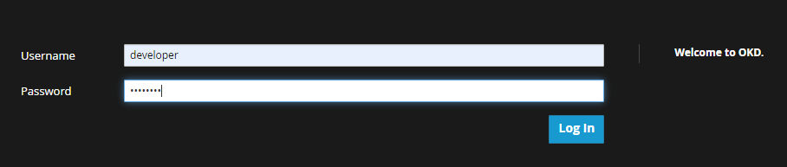

After login we get the browser catalog page and se the default project “My Project”

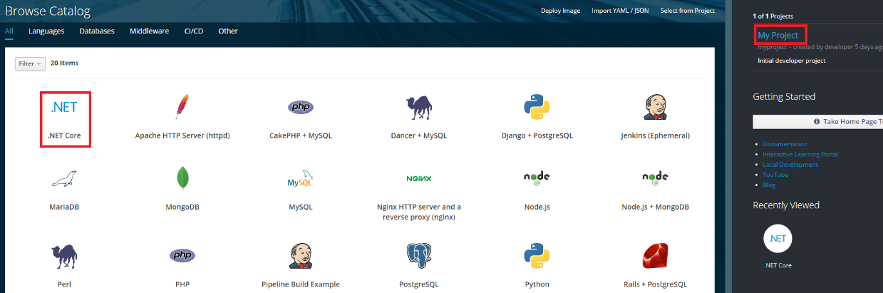

We see .NET (.NET Core) language but it supports by default only. netcore2.0

**Add .NET 5.0 to catalog**

<https://access.redhat.com/documentation/en-us/net/5.0/html/getting_started_with_.net_on_rhel_8/using_net_5_0_on_openshift_container_platform>

**oc describe is dotnet | more**

**oc create -f** [**https://raw.githubusercontent.com/redhat-developer/s2i-dotnetcore/master/dotnet_imagestreams.json**](https://raw.githubusercontent.com/redhat-developer/s2i-dotnetcore/master/dotnet_imagestreams.json)

**oc replace -f** [**https://raw.githubusercontent.com/redhat-developer/s2i-dotnetcore/master/dotnet_imagestreams.json**](https://raw.githubusercontent.com/redhat-developer/s2i-dotnetcore/master/dotnet_imagestreams.json)

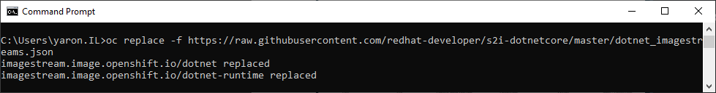

**oc describe is dotnet | more**

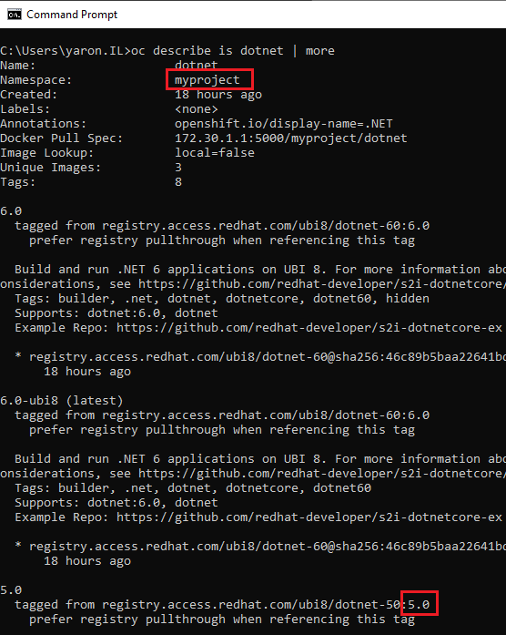

**Deploy .NET5.0 WebAPI Microservice**

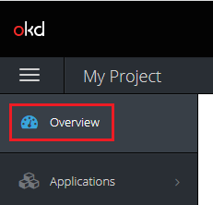

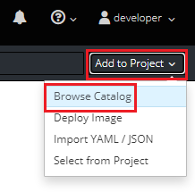

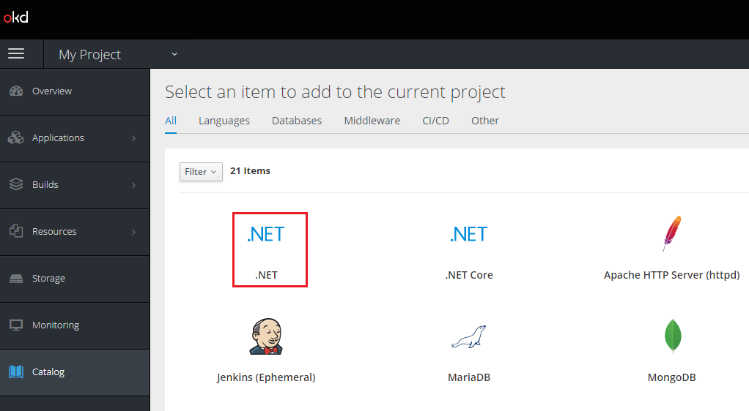

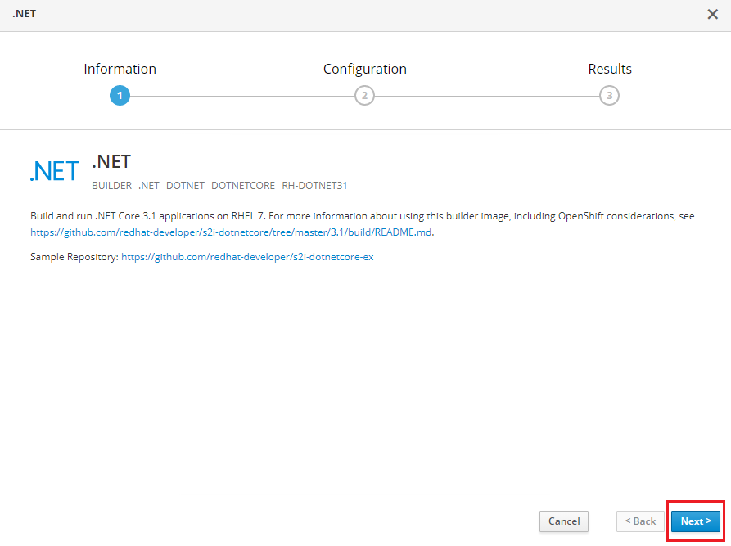

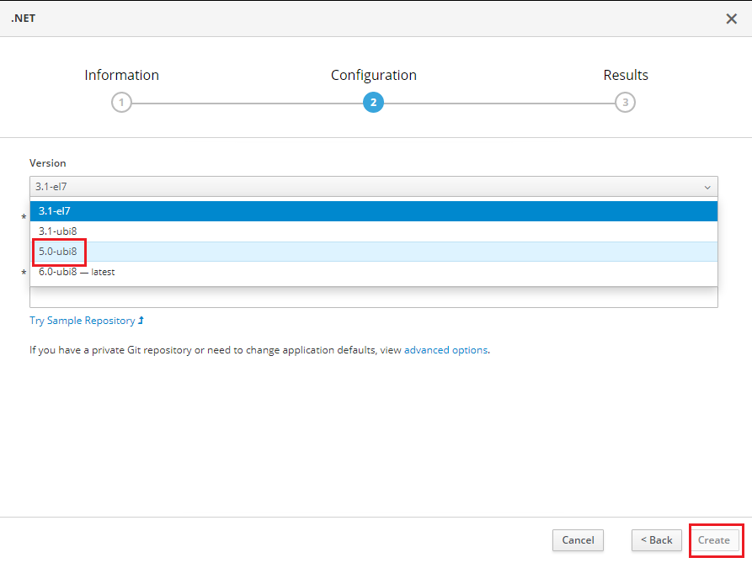

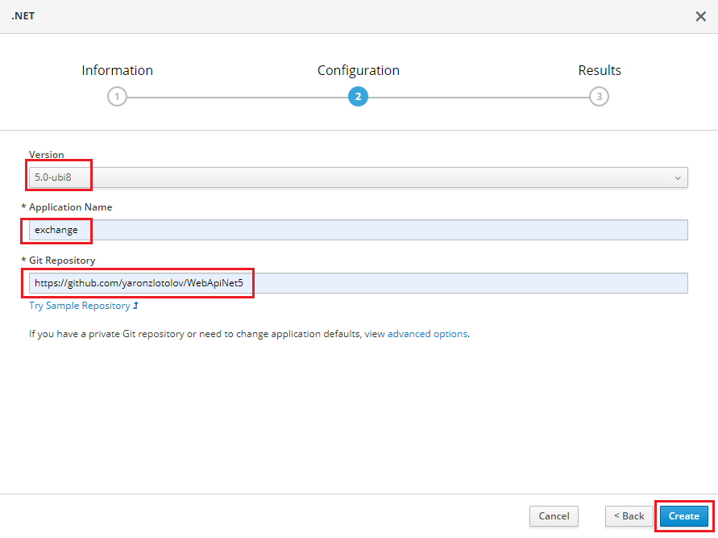

**.NET version**: 5.0

**Git repo**: <https://github.com/yaronzlotolov/WebApiNet5>

**Application name**: exchange-rate

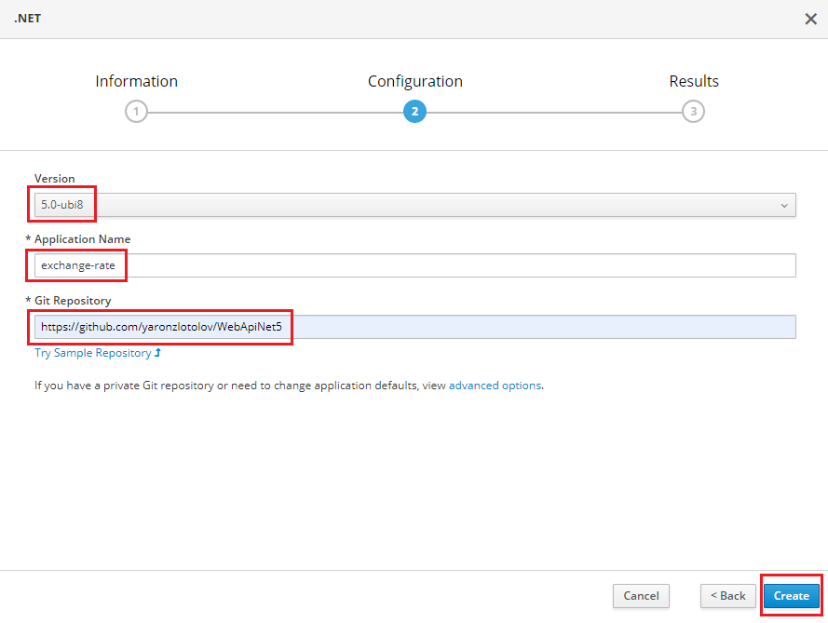

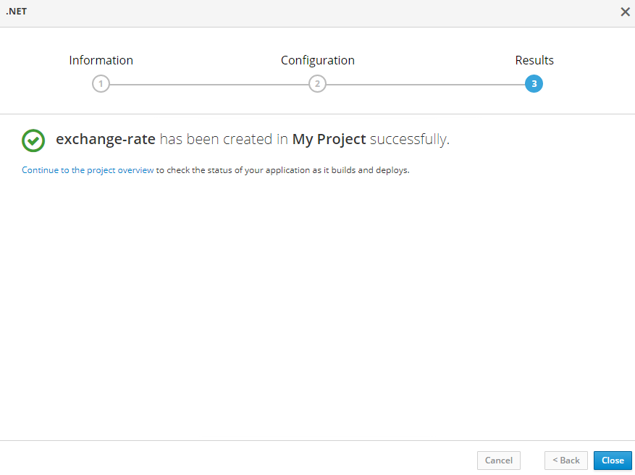



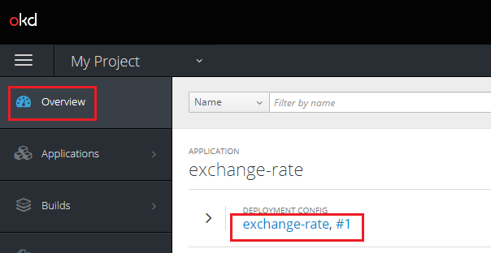

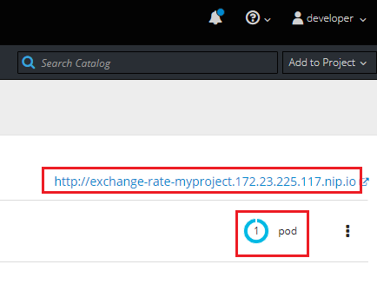

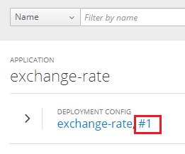

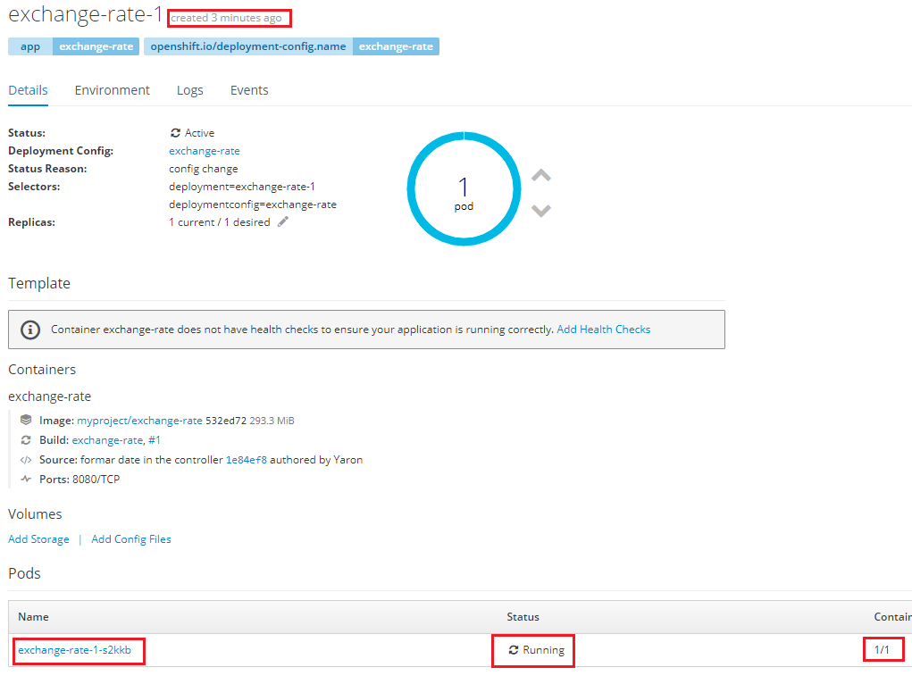

**oc --help**

**oc get nodes**

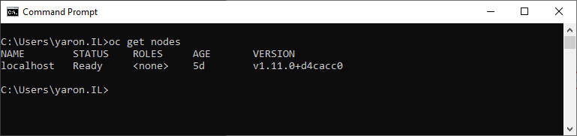

**oc get pods**

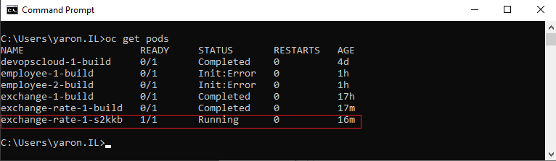

**oc get -o wide pods**

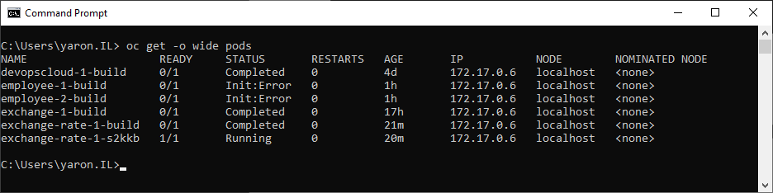

**oc describe pod exchange-rate-1-s2kkb**

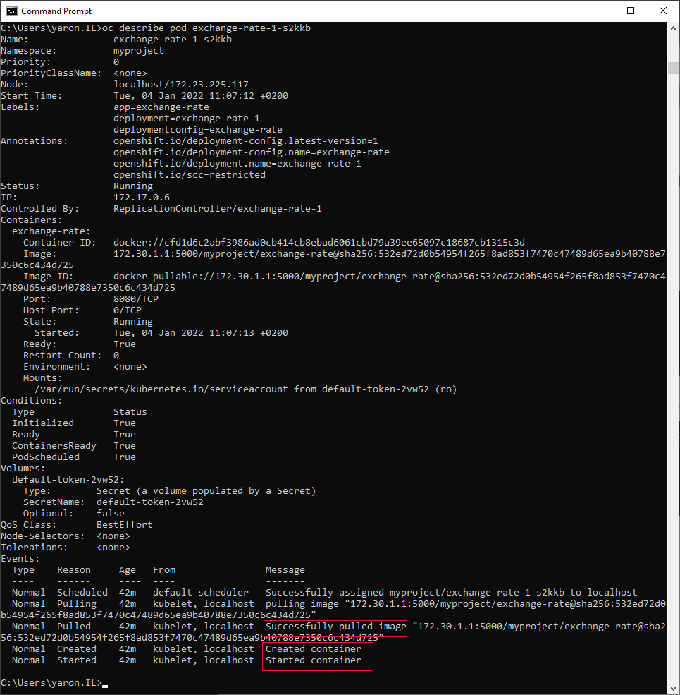

**oc get svc**

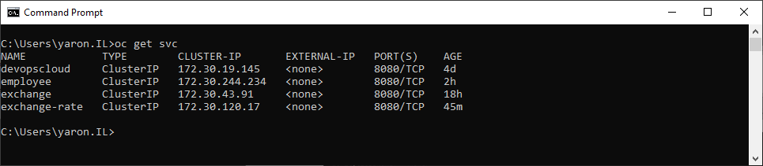

**oc get routes**

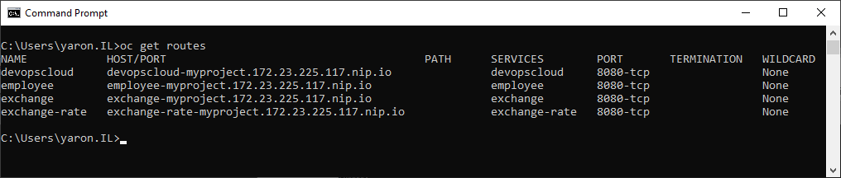

**oc get images | more**

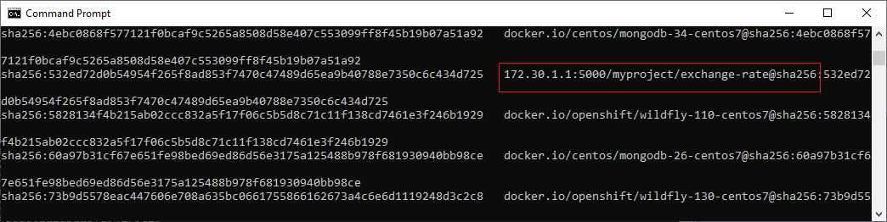

**oc get imagestream**

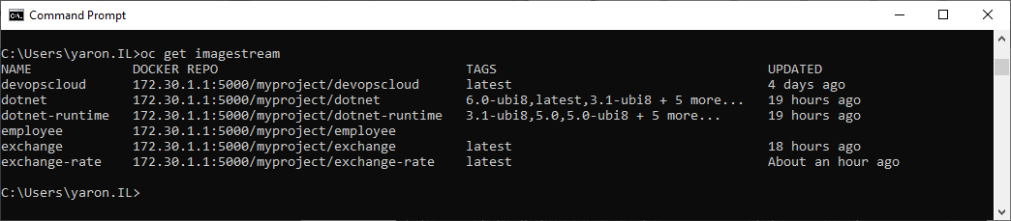

**oc get builds**

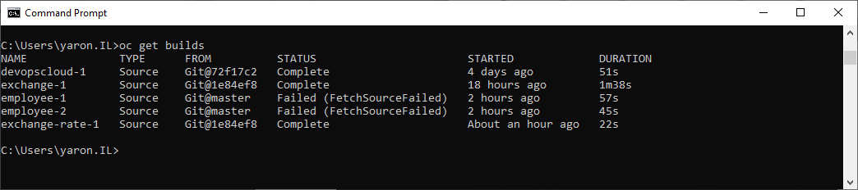

**oc get replicationcontroller**

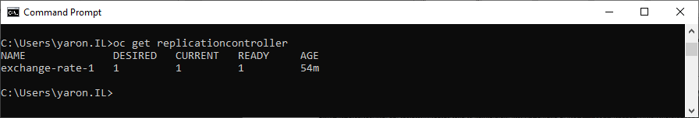

Scale-up 2 pods

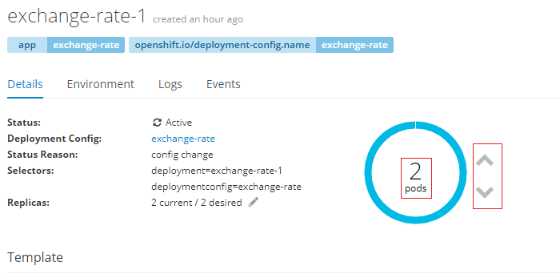

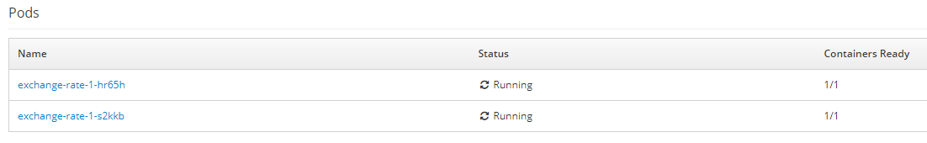

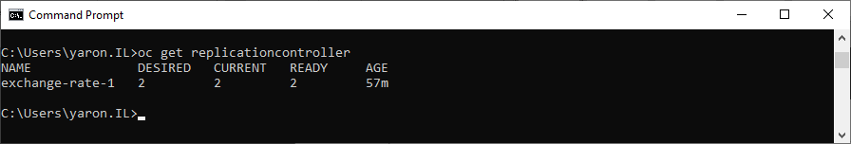

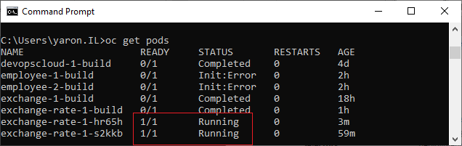

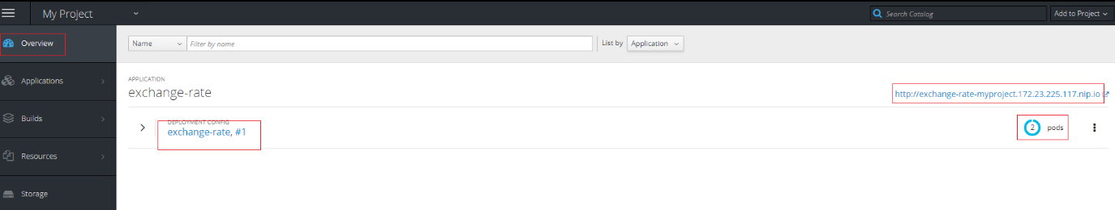

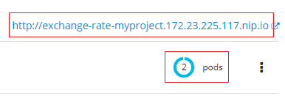

<http://exchange-rate-myproject.172.23.225.117.nip.io/ExchangeRate/USD/ILS>

<http://exchange-rate-myproject.172.23.225.117.nip.io/ExchangeRate/EUR/ILS>

