**Enable Hyper-V using PowerShell**

**Enable-WindowsOptionalFeature -Online -FeatureName Microsoft-Hyper-V -All**

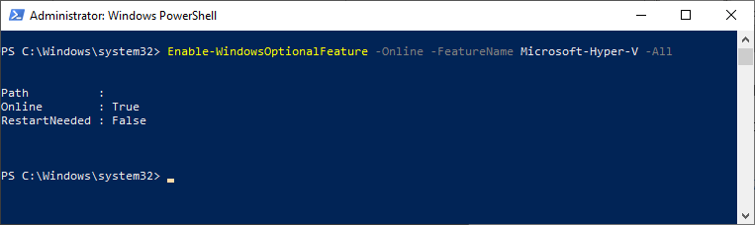

Add External VM switch in Hyper-V:

<https://docs.microsoft.com/en-us/virtualization/hyper-v-on-windows/quick-start/connect-to-network>

Add Nat switch (internal):

<https://docs.microsoft.com/en-us/virtualization/hyper-v-on-windows/user-guide/setup-nat-network>

**New-VMSwitch -SwitchName "Nat" -SwitchType Internal**

<https://docs.okd.io/3.11/minishift/getting-started/preparing-to-install.html>

<https://www.youtube.com/watch?v=SUh2mRqDRi4>

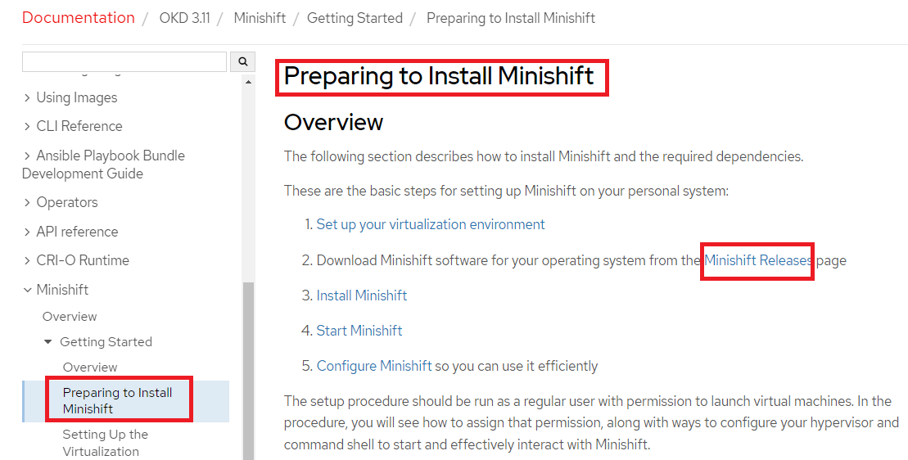

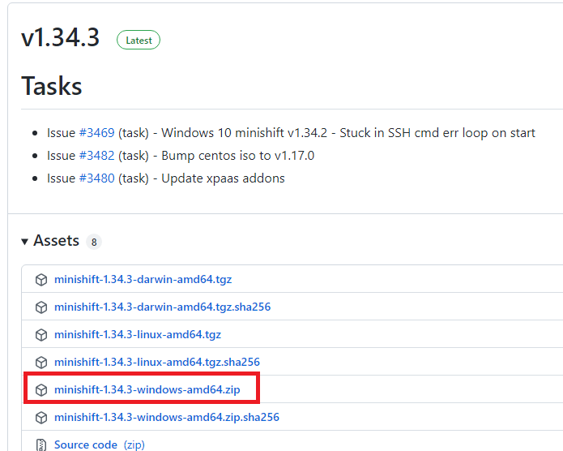

Extract the zip to - C:\openshift\minishift-1.34.3-windows-amd64\minishift-1.34.3-windows-amd64

Add the path ‘C:\openshift\minishift-1.34.3-windows-amd64\’ to environment variables

Run **minishift start --vm-driver Hyper-V**

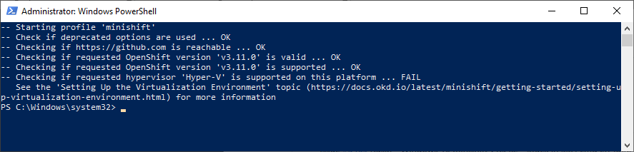

**minishift start --show-libmachine-logs -v5**

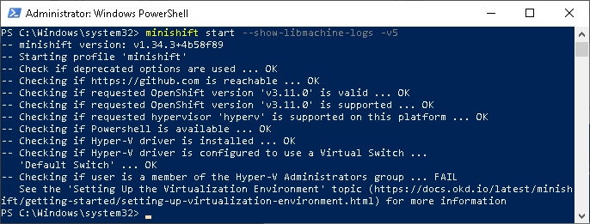

**minishift setup** (after adding Nat switch run again minishift setup)

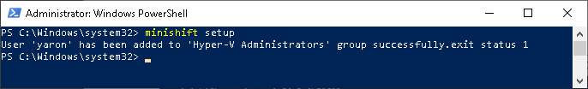

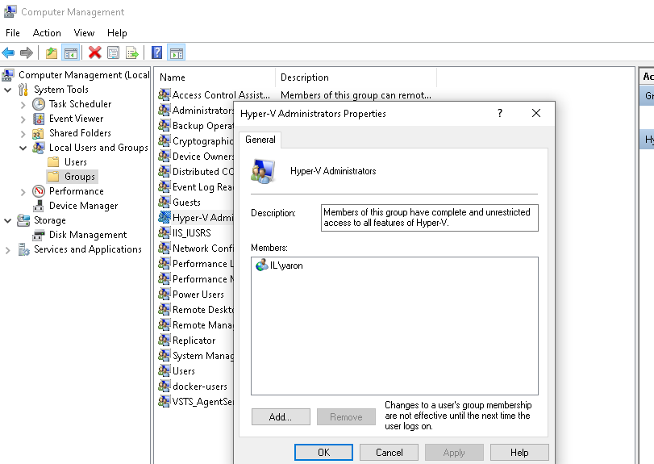

**If still problem with domain user:**

**minishift config set skip-check-hyperv-driver true**

**minishift start**

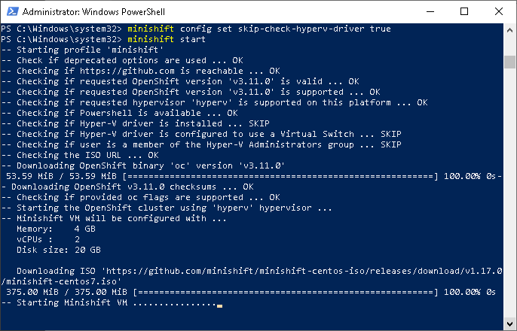

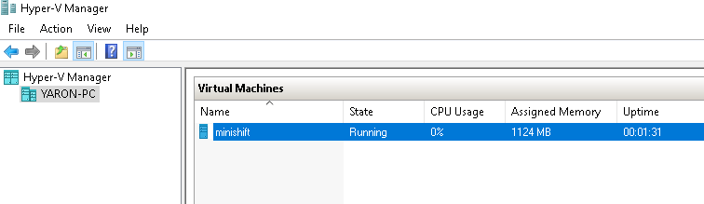

**minishift delete -f**

**minishift start**

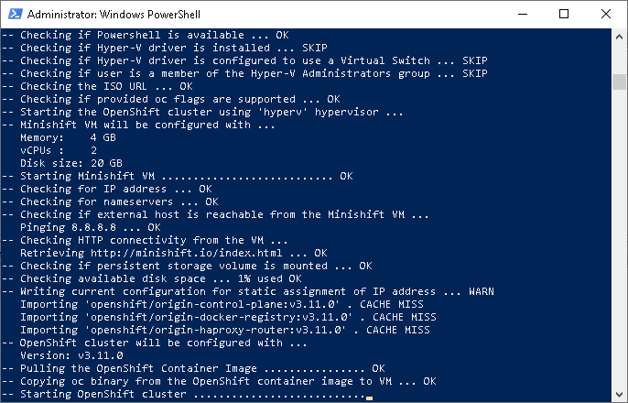

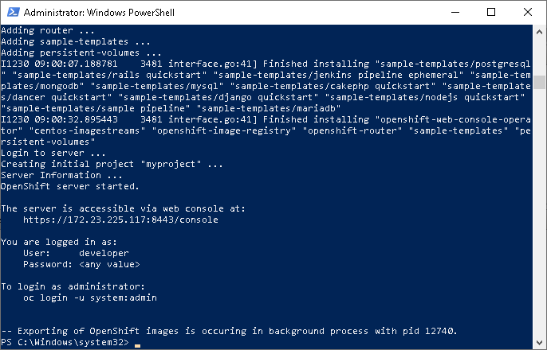

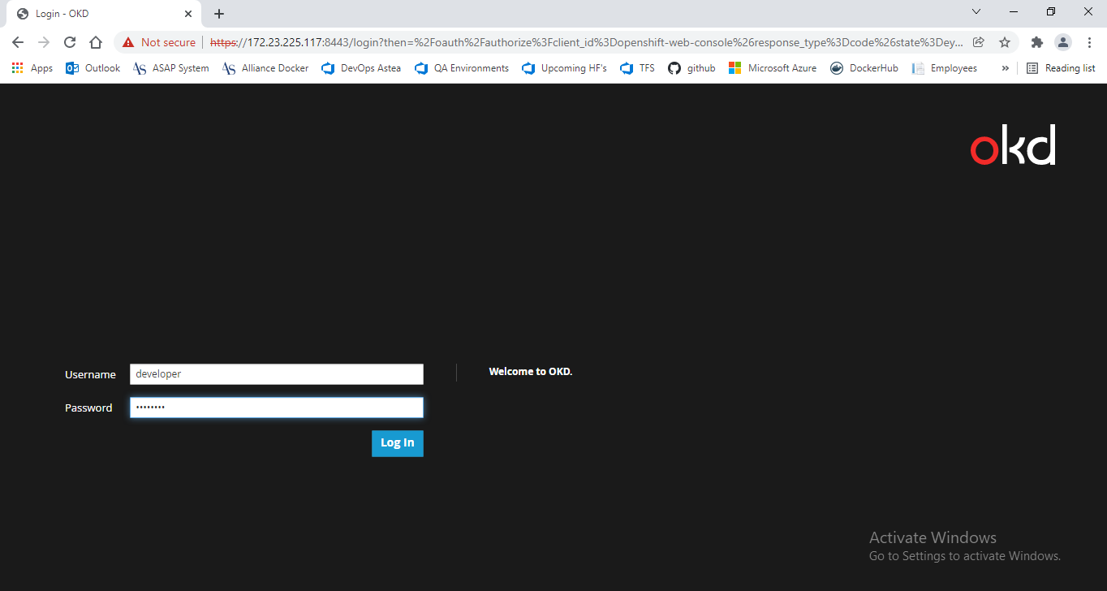

<https://172.23.225.117:8443/console/catalog>

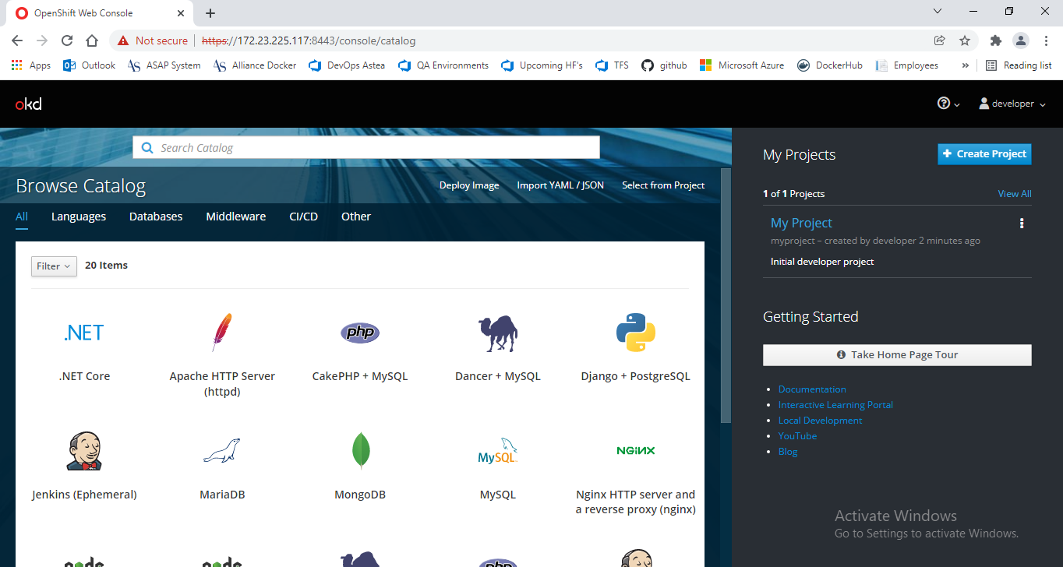

User:developer

Password- any password