**Overview** -> display the applications that running, the pods and the external URL (route)

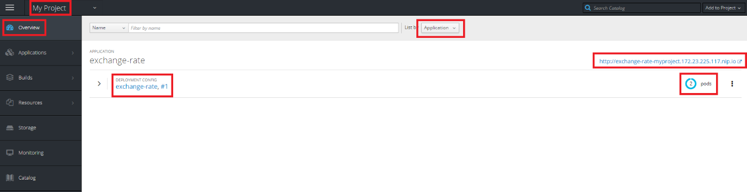

**Builds** -> show the application name and the git repo that pulled from github

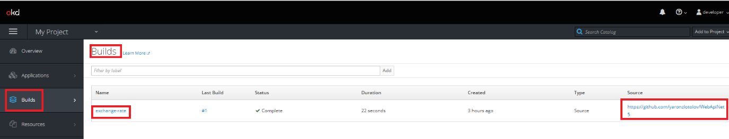

Click on the build shows the status “complete” under history tab

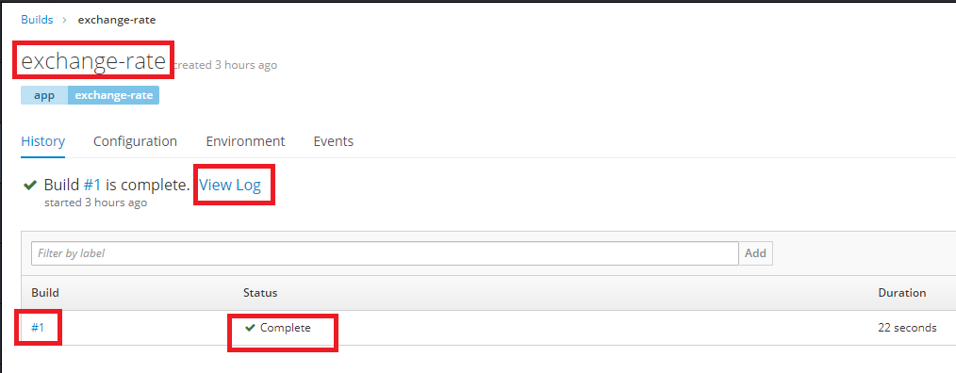

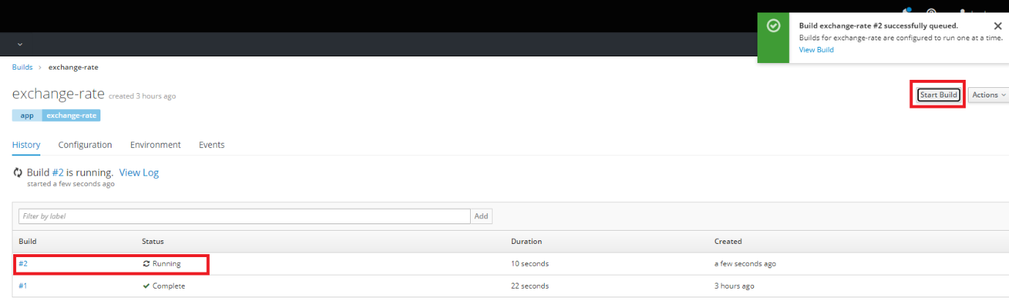

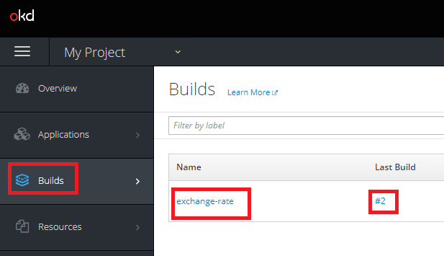

The build log shows that the code was cloned from github > compiled with NET5.0 > Image was created and pushed to local registry.

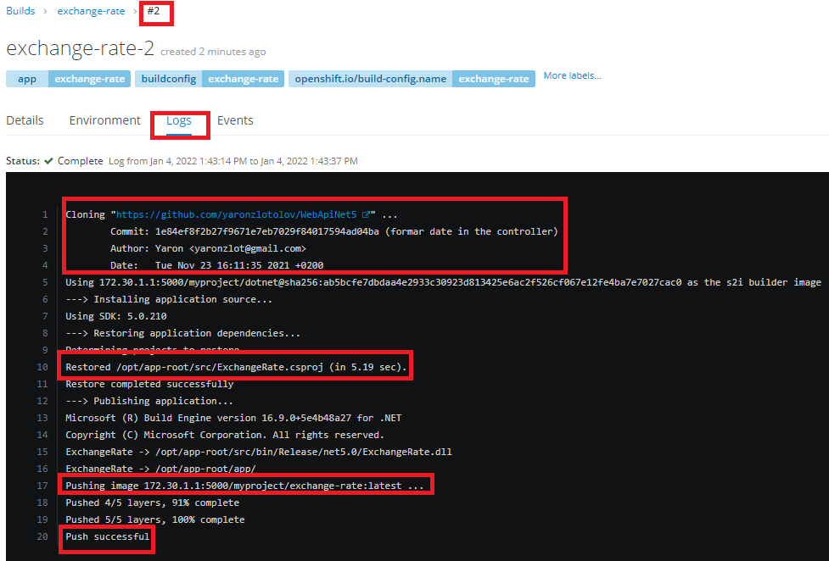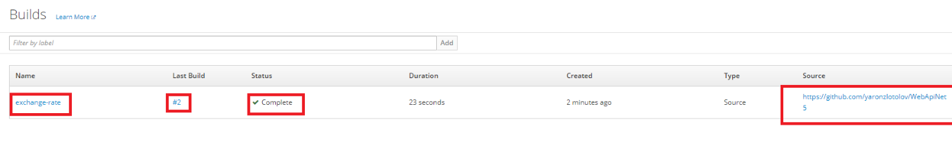

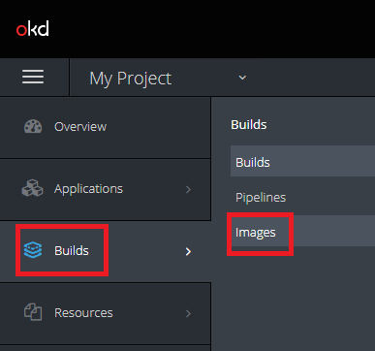

Shows the images that pulled from github for exchange-rate application

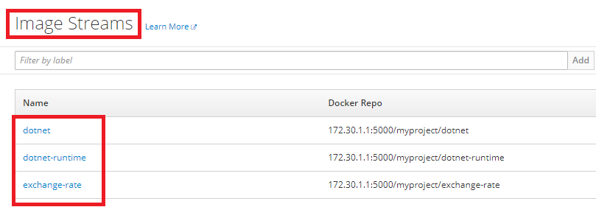

The images exchange-rate was tagged and pushed to the local registry on Build process

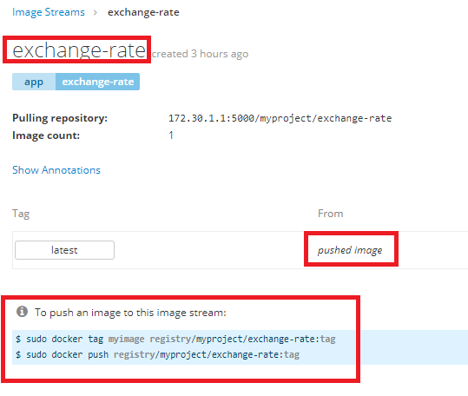

Application > Deployments > shows the deployments status

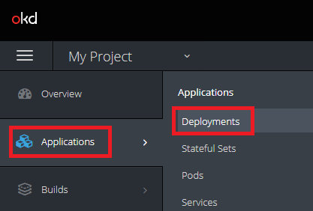

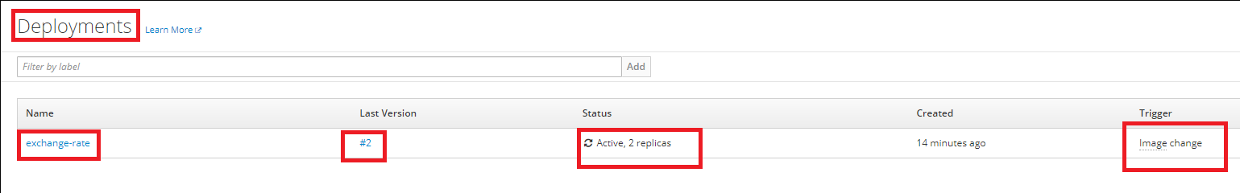

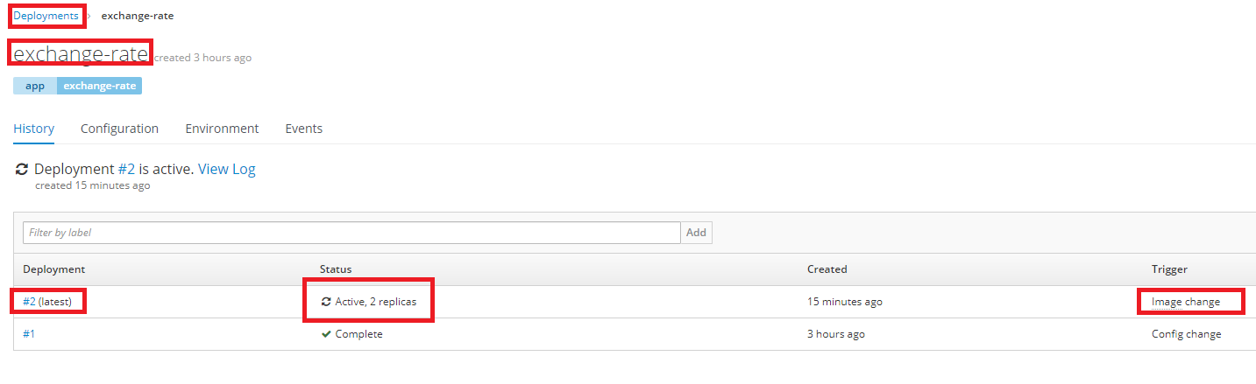

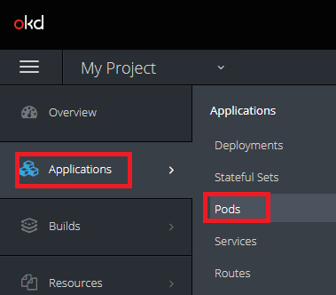

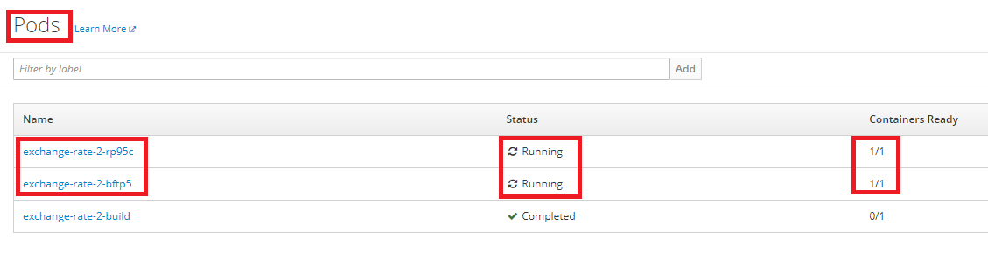

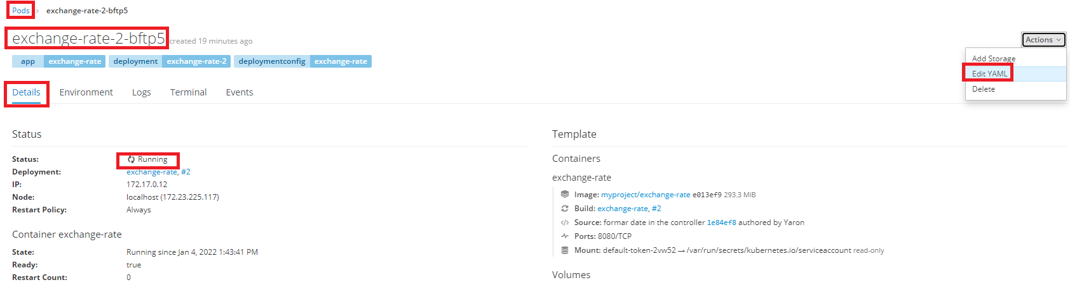

Edit YAML:

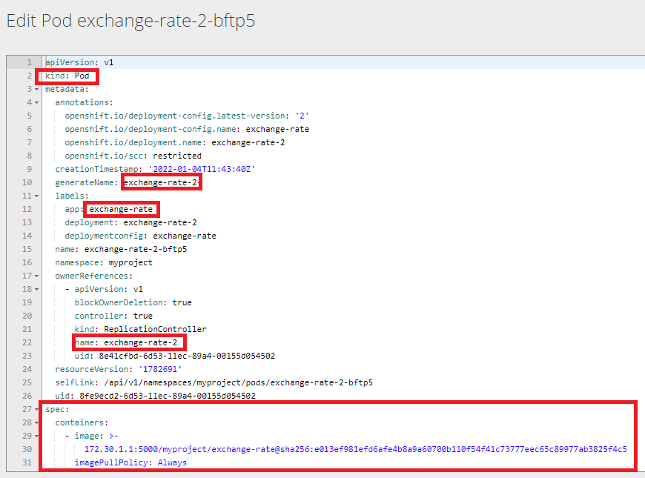

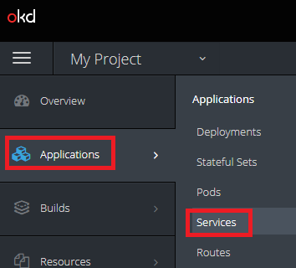

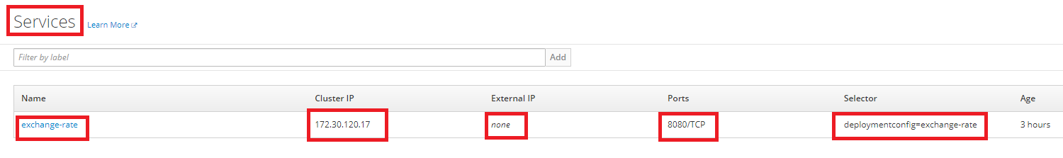

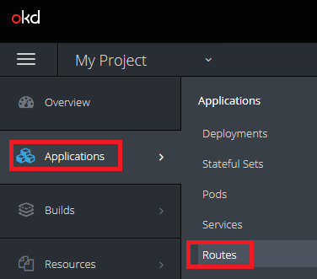

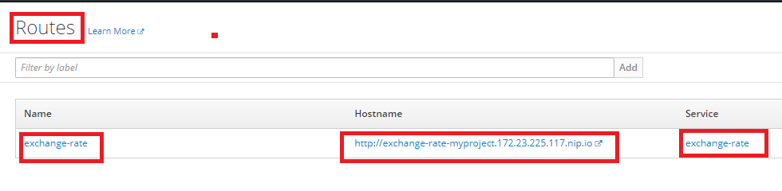

Monitoring:

