1. Define
   1. Who the website is for: people who want to create a simple and clear CV quickly.
   2. What the website is for: creating a CV by quickly filling out necessary forms, choosing a template and generating a pdf.
   3. A target audience: people searching for jobs who don’t want to spend a lot of time doing unnecessary formatting and looking up information on what to include in a CV.
2. Plan
   1. Website content (copy, images, videos etc.)
   2. The sitemap:
      1. Starting page with a brief description of what the site is used for;
      2. Editor with simultaneous preview of the CV
   3. What sections each page needs to convey the content’s message.
      1. Starting page: brief description of the website’s purpose and a single “Create CV” button.
      2. Editor: left half with the input fields and, right half with the CV preview and a button somewhere to generate the CV.
   4. The website personality: minimalist/simple.
   5. What components you need and how to use them in layout patterns;
      1. Input fields;
      2. Accordion for the input fields where I can hide and unhide individual sections (e.g. personal details, work experience, skills etc) with check boxes or sliders.
      3. Preview pane for the CV preview
      4. Carousel for the preview pane where you can cycle between different styles
      5. Buttons
      6. *Panel with the styles selection (maybe hidden and shown with a button) – for the future*.
   6. Functionalities:
      1. Showing the content in the preview pane as it is typed by the user.
      2. Changing the styles of the CV on the go.
      3. Selecting which sections should be included in the CV
      4. Generating a pdf out of the project.
      5. Adding new items for work and education with the relevant details:
         1. job title, company name, city, start and end dates and responsibilities.
         2. University, master/bachelor/other, specialisation, years, additional description (optional).
      6. Adding multiple skills with levels.
      7. Adding certifications.
      8. Adding personal information and links to external sources.
      9. Adding a photograph.
      10. *Full screen view for the preview pane.*
      11. *Hints regarding commonly used expressions in CVs (e.g. which skills to include).*
      12. *Saving the project using the browser storage.*
      13. *Auto-completing of universities – maybe using an API?*
   7. User stories:
      1. As a user I want everything I type to be displayed so that I can check it in the preview pane.
      2. As a user I want to switch between the styles of the CV at every point so that I can assess which one I like better.
      3. As a user I want to select, which sections should be included in the resume so that it is automatically adjusted.
      4. As a user I want to generate a pdf of the project so that I can save it on my device.
      5. As a user I want to be able to add new items in the work experience, education, skills etc. sections so that multiple items are displayed in the resume.
      6. As a user I want to be able to include the details such so that the resume includes job title, company name, city, start and end dates and responsibilities.
      7. As a user I want to be able to include the details regarding my education so that the resume includes information about the university, type of education, start and end dates, specialisation and optional description.
      8. As a user I want to be able to add multiple skills and their levels so that an employer can easily assess them.
      9. As a user I want to add my certifications so that the employer can see them.
      10. As a user I want to include all the personal information and necessary contact and external sources so that they are clearly and prominently displayed on the resume.
      11. As a user I want to include a photo so that it is elegantly presented in an appropriate place and with an appropriate size.
      12. *As a user I want to enter a full screen view so that I can preview my resume on a full screen.*
      13. *As a user I want to have hints of commonly used skills so that I can select it and automatically include it on my CV.*
      14. *As a user I want to be able to save the project in a memory so that I can access it later.*
   8. Sketch with pen and paper or some design software;
3. Fonts: rubik, verdana, cambria, arial, lato, raleway, bitter, Montserrat
4. Sketch:
   1. Starting page: 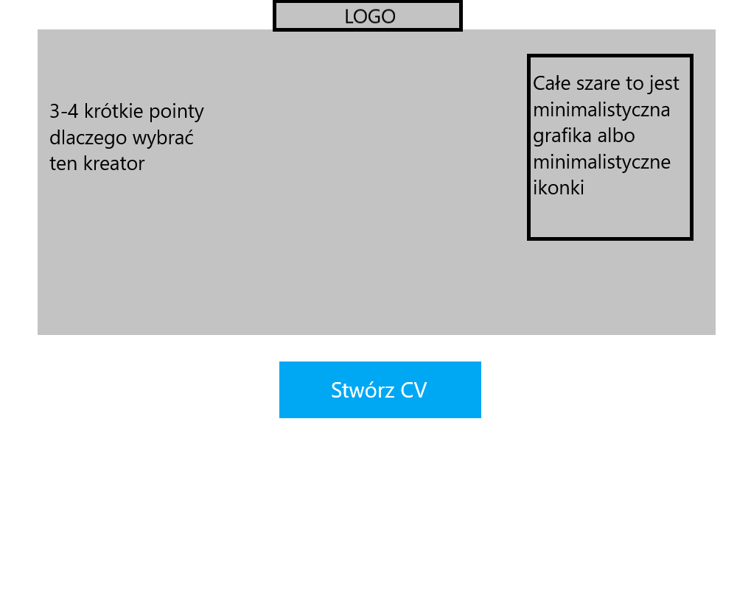
   2. Editor:

