Лекция 06

ПСКП

ПОИТ-3

**Node.js-HTTP-сервер**

1. **HTTP-сервер:** серверная часть web-приложения.
2. **HTTP-сервер:** простейший сервер

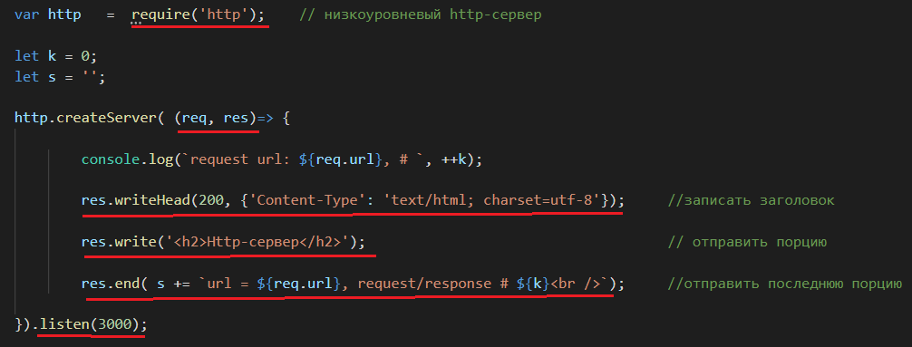

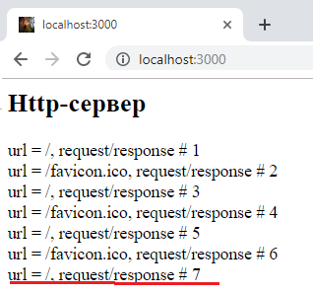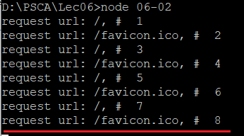

1. **HTTP-сервер:** простейший сервер

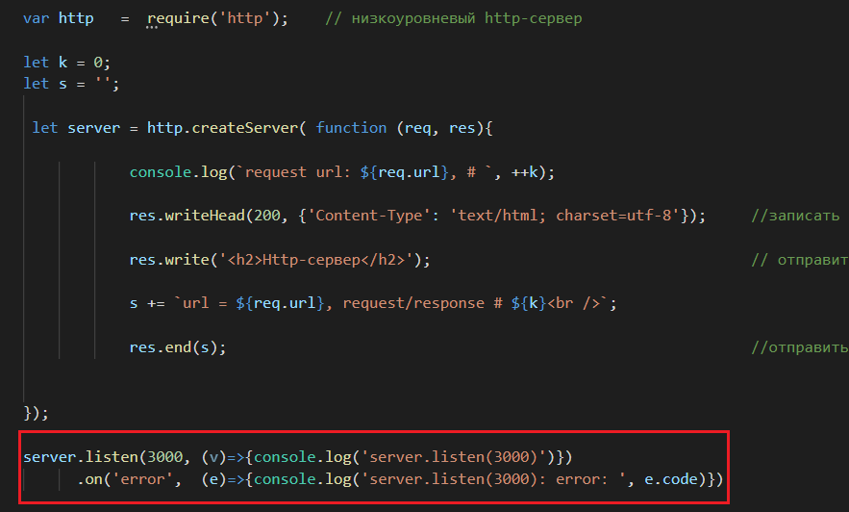

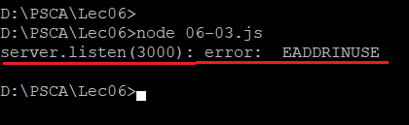

1. **HTTP-сервер:** простейший сервер

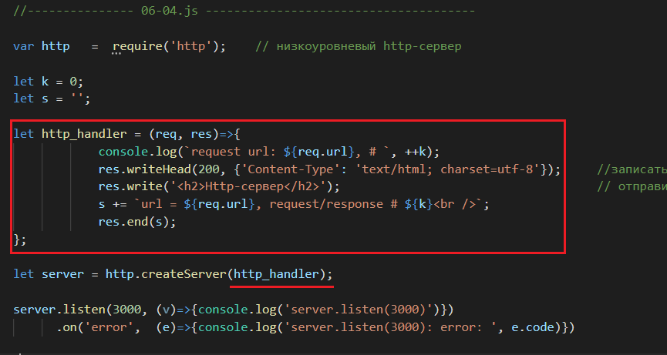

1. **HTTP-сервер:** простейший сервер

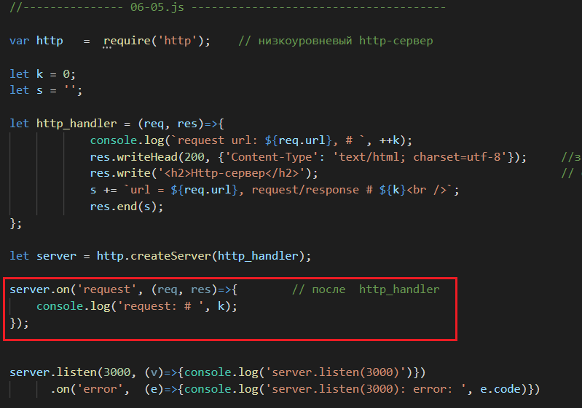

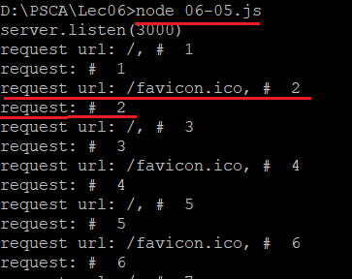

1. **HTTP-сервер:** простейший сервер

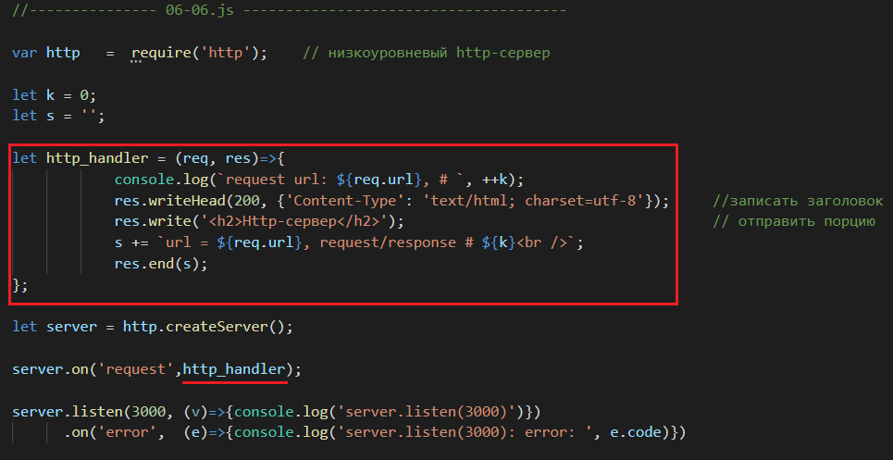

1. **HTTP-сервер:** простейший сервер **server.on(‘conection’)**

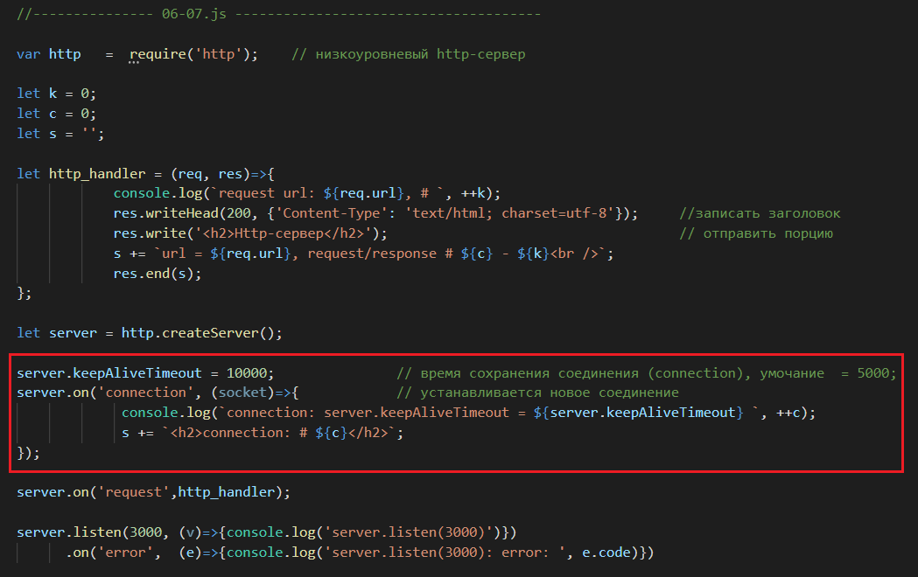

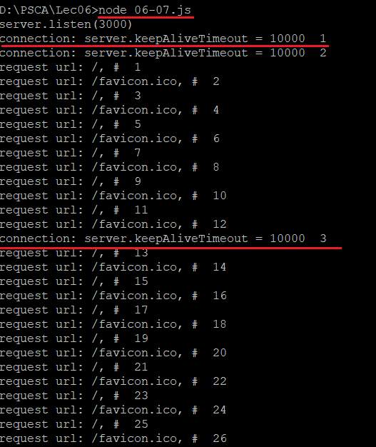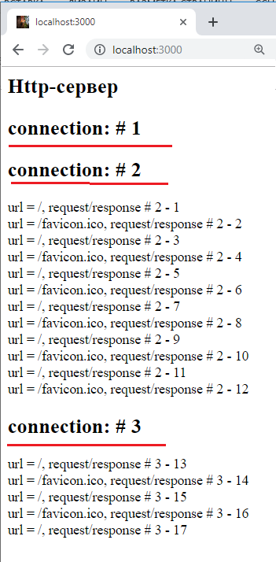

1. **HTTP-сервер:** простейший сервер **server.close()**

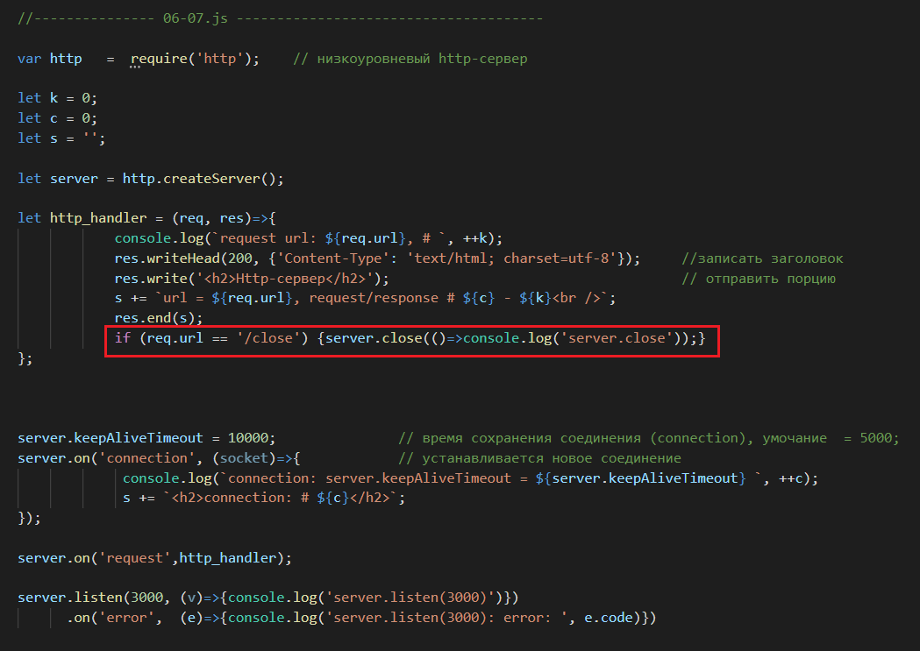

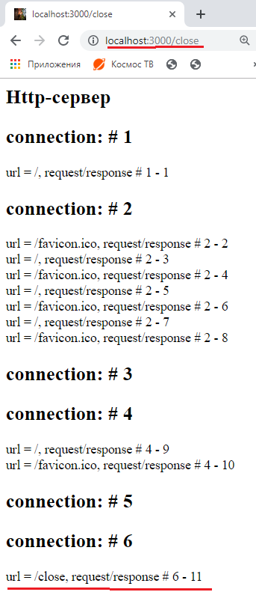 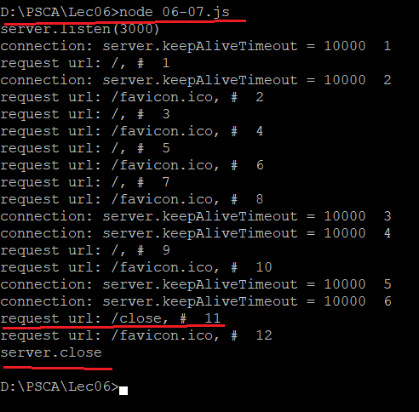

1. **HTTP-сервер:** простейший сервер **server.on(‘close’)**

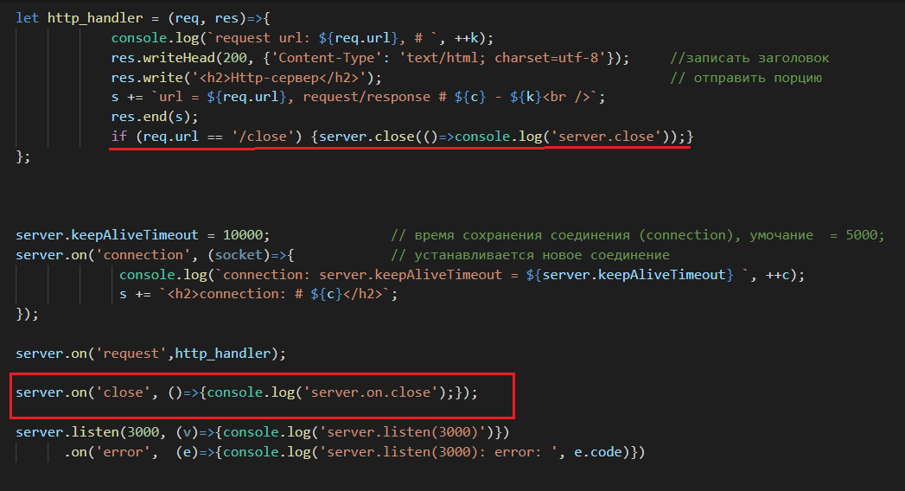

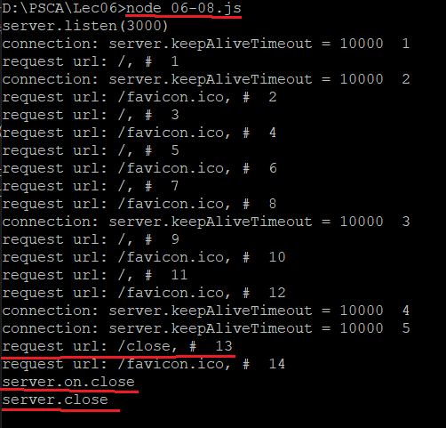

1. **HTTP-сервер:** простейший сервер **server.on(‘timeout’)**

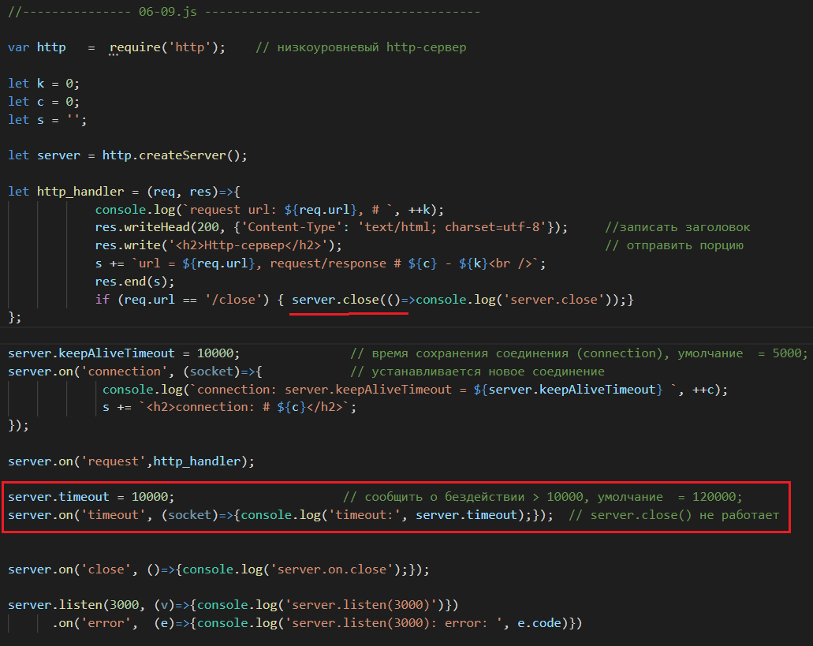

1. **HTTP-сервер:** простейший сервер, **socket properties**

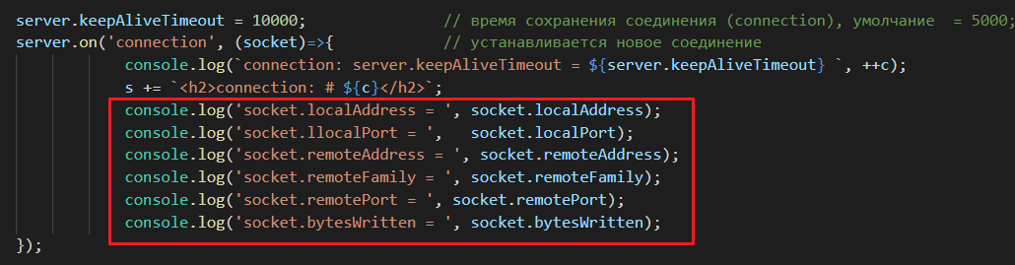

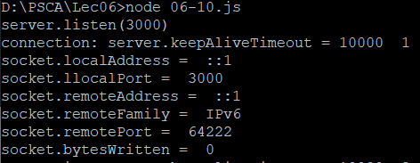

1. **HTTP-сервер:** простейший сервер **request.on**

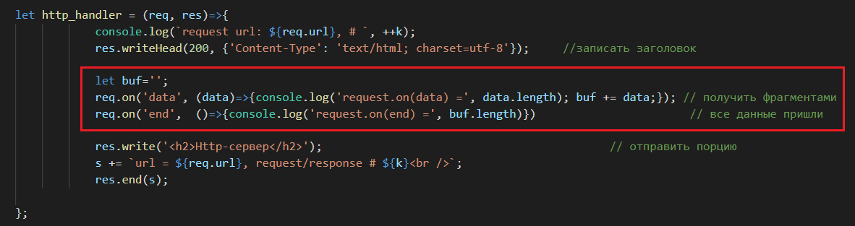

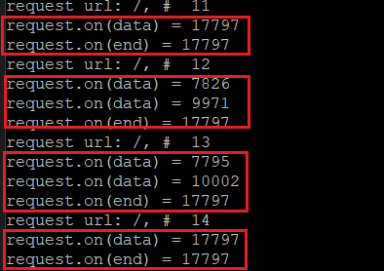

1. **HTTP-сервер:** простейший сервер, типичный цикл работы



1. **HTTP-сервер:** простейший сервер, **method**

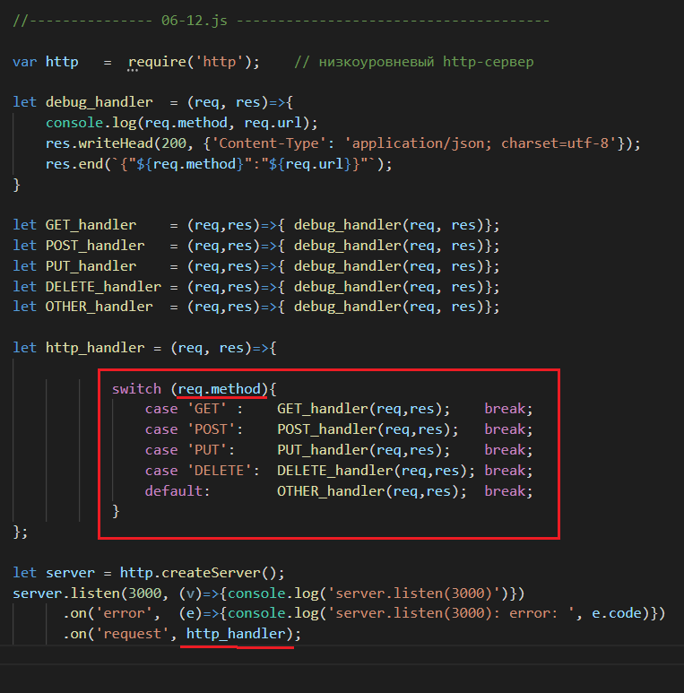

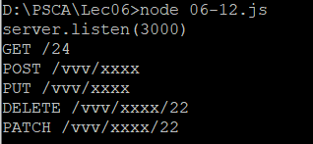

1. **HTTP-сервер:** простейший сервер, url, 404

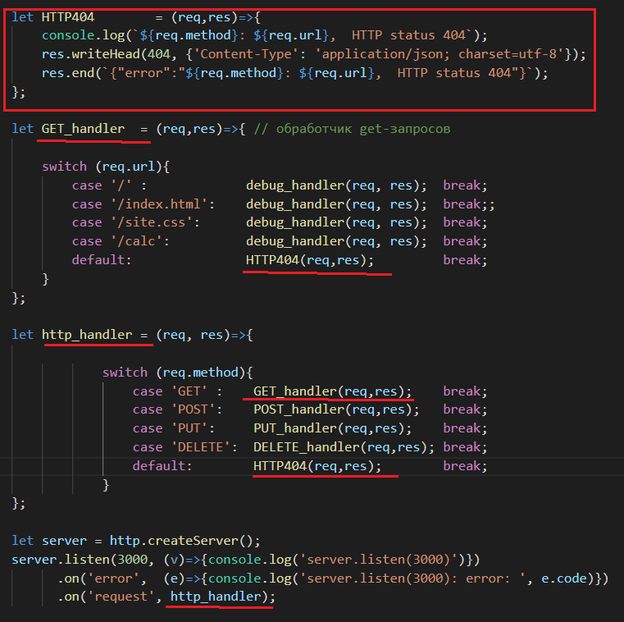

1. **HTTP-сервер:** простейший сервер, request, response

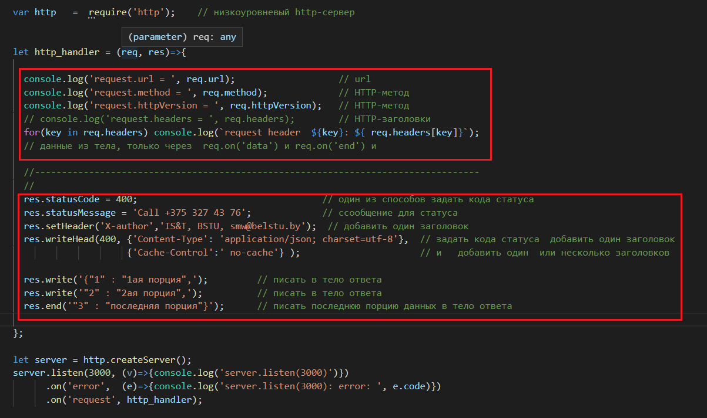

1. **HTTP-сервер:** простейший сервер, статические ресурсы



1. **HTTP-сервер:** простейший сервер, статические ресурсы

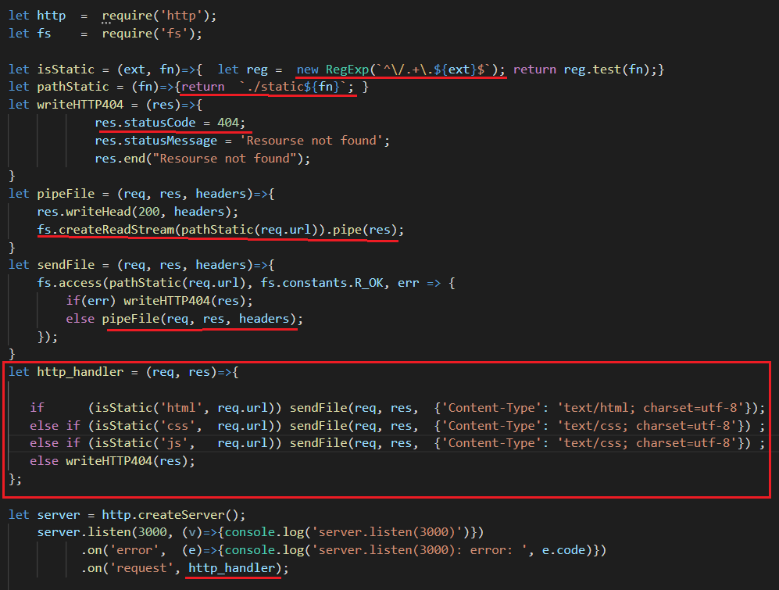

1. **HTTP-сервер:** простейший сервер, статические ресурсы, параметризируемый модуль.

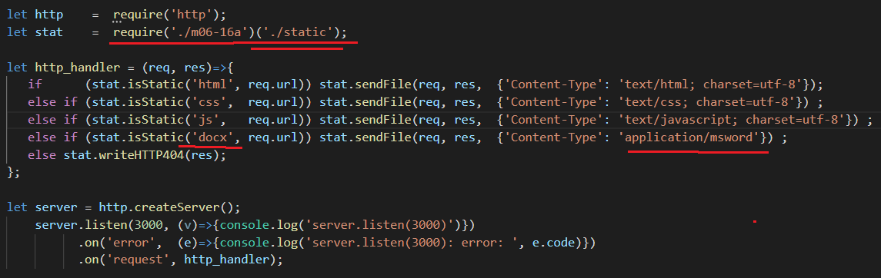

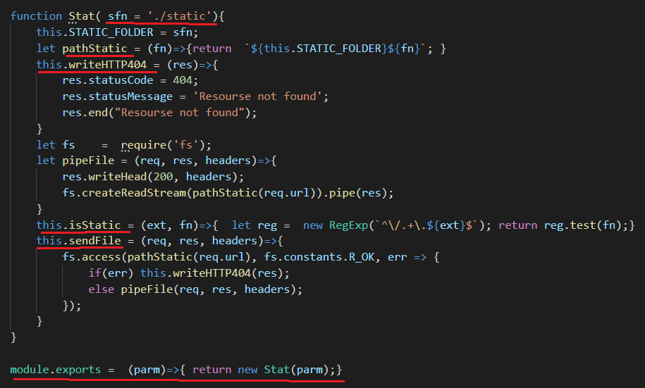

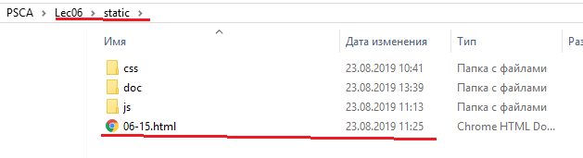

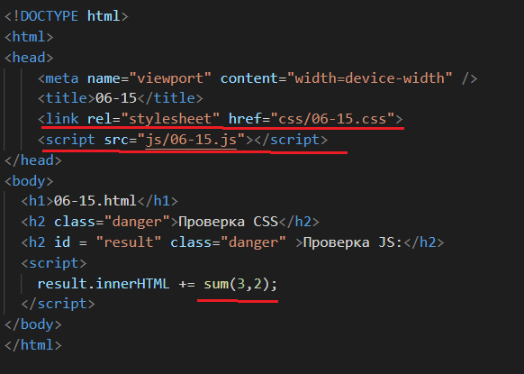

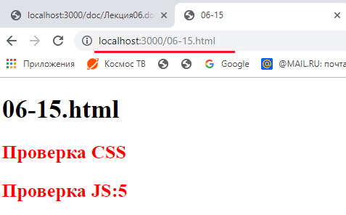

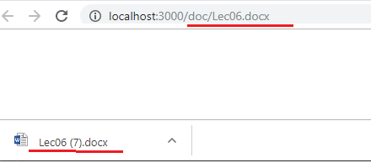

1. **HTTP-сервер:** простейший сервер, обработка параметров GET-запроса.

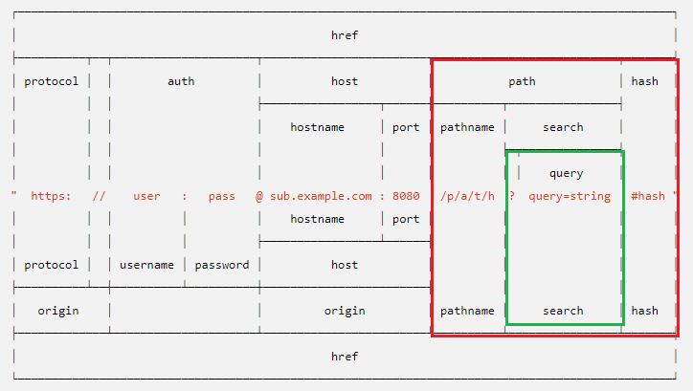

1. **HTTP-сервер:** простейший сервер, query-параметры,GET-запросы.

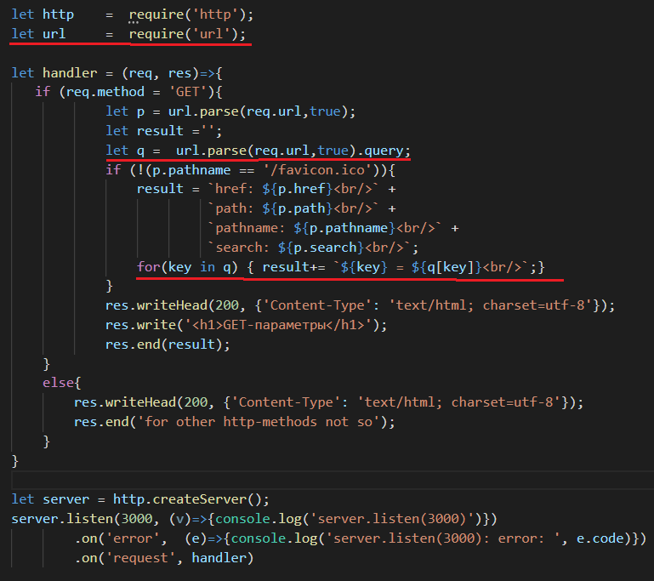

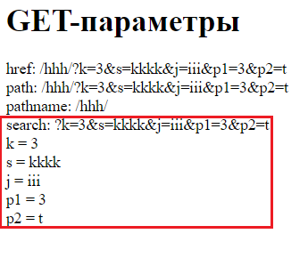

1. **HTTP-сервер:** простейший сервер, url-параметры,GET-запросы.

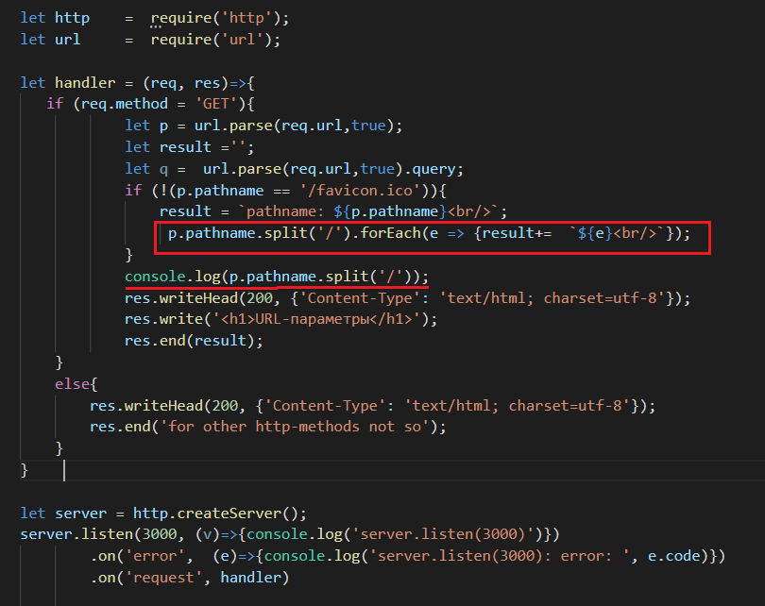

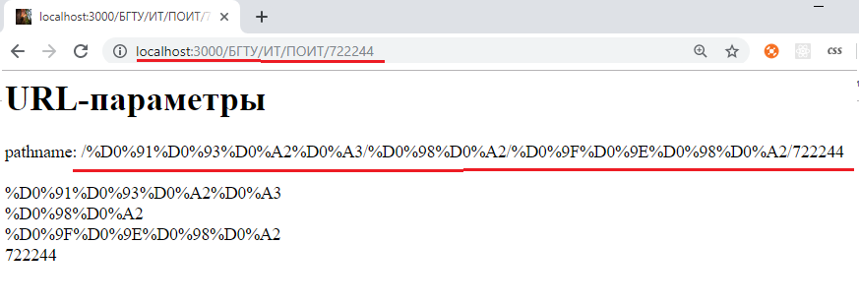

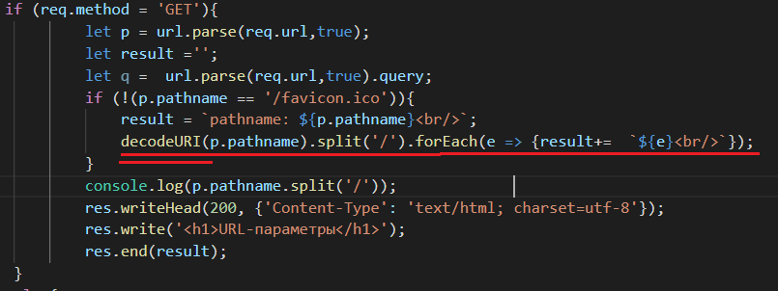

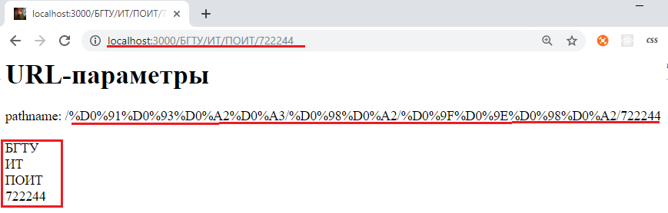

1. **HTTP-сервер:** обработка GET-параметров

|  |  |
| --- | --- |
| Модуль | Функции, классы |
| url | Parse/format, classes: URL, URLSearchParams |
| querystring | parse/stribgify, escape/unescspe |

1. **HTTP-сервер:** простейший сервер, POST-параметры
2. **STATUS**

http.STATUS_CODES

{ '100': 'Continue',

'101': 'Switching Protocols',

'102': 'Processing',

'200': 'OK',

'201': 'Created',

'202': 'Accepted',

'203': 'Non-Authoritative Information',

'204': 'No Content',

'205': 'Reset Content',

'206': 'Partial Content',

'207': 'Multi-Status',

'300': 'Multiple Choices',

'301': 'Moved Permanently',

'302': 'Moved Temporarily',

'303': 'See Other',

'304': 'Not Modified',

'305': 'Use Proxy',

'307': 'Temporary Redirect',

'400': 'Bad Request',

'401': 'Unauthorized',

'402': 'Payment Required',

'403': 'Forbidden',

'404': 'Not Found',

'405': 'Method Not Allowed',

'406': 'Not Acceptable',

'407': 'Proxy Authentication Required',

'408': 'Request Time-out',

'409': 'Conflict',

'410': 'Gone',

'411': 'Length Required',

'412': 'Precondition Failed',

'413': 'Request Entity Too Large',

'414': 'Request-URI Too Large',

'415': 'Unsupported Media Type',

'416': 'Requested Range Not Satisfiable',

'417': 'Expectation Failed',

'418': 'I\'m a teapot',

'422': 'Unprocessable Entity',

'423': 'Locked',

'424': 'Failed Dependency',

'425': 'Unordered Collection',

'426': 'Upgrade Required',

'428': 'Precondition Required',

'429': 'Too Many Requests',

'431': 'Request Header Fields Too Large',

'500': 'Internal Server Error',

'501': 'Not Implemented',

'502': 'Bad Gateway',

'503': 'Service Unavailable',

'504': 'Gateway Time-out',

'505': 'HTTP Version Not Supported',

'506': 'Variant Also Negotiates',

'507': 'Insufficient Storage',

'509': 'Bandwidth Limit Exceeded',

'510': 'Not Extended',

'511': 'Network Authentication Required' }

## Codes

| **Constant** | **Code** | **Status Text** |
| --- | --- | --- |
| ACCEPTED | 202 | Accepted |
| BAD_GATEWAY | 502 | Bad Gateway |
| BAD_REQUEST | 400 | Bad Request |
| CONFLICT | 409 | Conflict |
| CONTINUE | 100 | Continue |
| CREATED | 201 | Created |
| EXPECTATION_FAILED | 417 | Expectation Failed |
| FAILED_DEPENDENCY | 424 | Failed Dependency |
| FORBIDDEN | 403 | Forbidden |
| GATEWAY_TIMEOUT | 504 | Gateway Timeout |
| GONE | 410 | Gone |
| HTTP_VERSION_NOT_SUPPORTED | 505 | HTTP Version Not Supported |
| IM_A_TEAPOT | 418 | I'm a teapot |
| INSUFFICIENT_SPACE_ON_RESOURCE | 419 | Insufficient Space on Resource |
| INSUFFICIENT_STORAGE | 507 | Insufficient Storage |
| INTERNAL_SERVER_ERROR | 500 | Server Error |
| LENGTH_REQUIRED | 411 | Length Required |
| LOCKED | 423 | Locked |
| METHOD_FAILURE | 420 | Method Failure |
| METHOD_NOT_ALLOWED | 405 | Method Not Allowed |
| MOVED_PERMANENTLY | 301 | Moved Permanently |
| MOVED_TEMPORARILY | 302 | Moved Temporarily |
| MULTI_STATUS | 207 | Multi-Status |
| MULTIPLE_CHOICES | 300 | Multiple Choices |
| NETWORK_AUTHENTICATION_REQUIRED | 511 | Network Authentication Required |
| NO_CONTENT | 204 | No Content |
| NON_AUTHORITATIVE_INFORMATION | 203 | Non Authoritative Information |
| NOT_ACCEPTABLE | 406 | Not Acceptable |
| NOT_FOUND | 404 | Not Found |
| NOT_IMPLEMENTED | 501 | Not Implemented |
| NOT_MODIFIED | 304 | Not Modified |
| OK | 200 | OK |
| PARTIAL_CONTENT | 206 | Partial Content |
| PAYMENT_REQUIRED | 402 | Payment Required |
| PERMANENT_REDIRECT | 308 | Permanent Redirect |
| PRECONDITION_FAILED | 412 | Precondition Failed |
| PRECONDITION_REQUIRED | 428 | Precondition Required |
| PROCESSING | 102 | Processing |
| PROXY_AUTHENTICATION_REQUIRED | 407 | Proxy Authentication Required |
| REQUEST_HEADER_FIELDS_TOO_LARGE | 431 | Request Header Fields Too Large |
| REQUEST_TIMEOUT | 408 | Request Timeout |
| REQUEST_TOO_LONG | 413 | Request Entity Too Large |
| REQUEST_URI_TOO_LONG | 414 | Request-URI Too Long |
| REQUESTED_RANGE_NOT_SATISFIABLE | 416 | Requested Range Not Satisfiable |
| RESET_CONTENT | 205 | Reset Content |
| SEE_OTHER | 303 | See Other |
| SERVICE_UNAVAILABLE | 503 | Service Unavailable |
| SWITCHING_PROTOCOLS | 101 | Switching Protocols |
| TEMPORARY_REDIRECT | 307 | Temporary Redirect |
| TOO_MANY_REQUESTS | 429 | Too Many Requests |
| UNAUTHORIZED | 401 | Unauthorized |
| UNPROCESSABLE_ENTITY | 422 | Unprocessable Entity |
| UNSUPPORTED_MEDIA_TYPE | 415 | Unsupported Media Type |
| USE_PROXY | 305 | Use Proxy |