Лекция XX

ПСКП

ПОИТ-3

**Node.js: GraphQL**

1. **GraphQL:** формальныйязык запросов;особенности: позволяет делать агрегированные запросы (можно в одном запросе запросить все необходимые данные), использует систему типов.

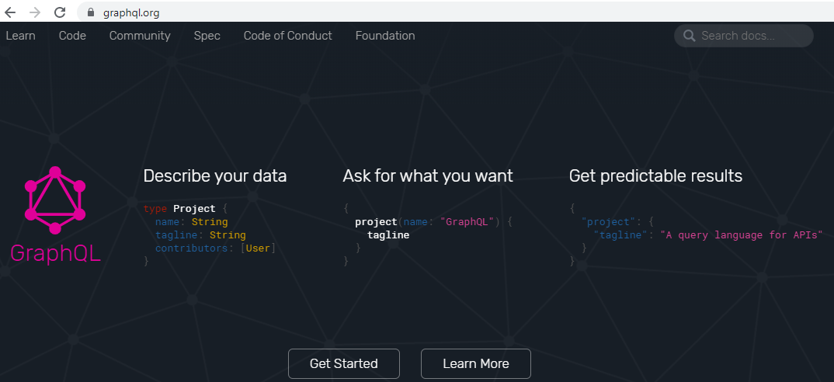

1. **GraphQL:** diskstation, ЛИТЕРАТУРА/GRAPHQL
2. **GraphQL:**несколько реализаций: Node.js, Java, .NET C#, Python,…
3. **GraphQL:** Node.js, npm install graphql, <https://graphql.org/graphql-js/>,
4. **GraphQL:** основных компонента: **schema**, **query/mutation/** **subscription**, **resolvers**.
5. **GraphQL:** архитектура



1. **GraphQL:** схема, SDL (Schema Definition Language)

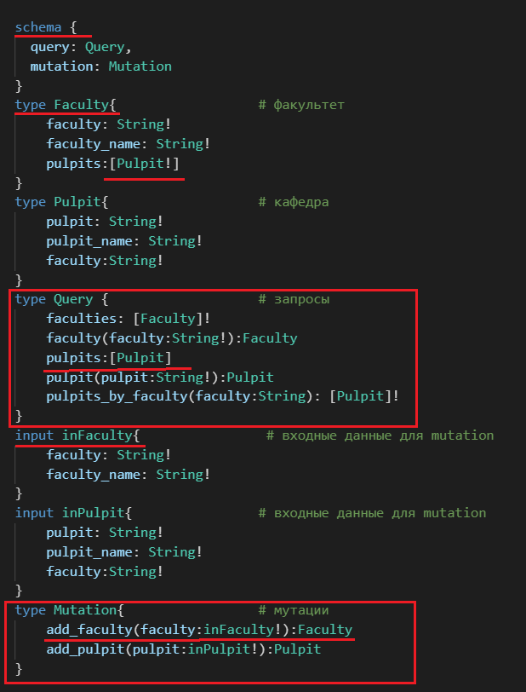

1. **GraphQL:** schema, resolvers, context

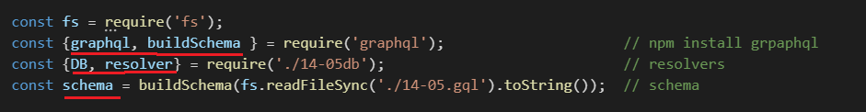

1. **GraphQL:** graphql, schema, resolvers, context(DB)

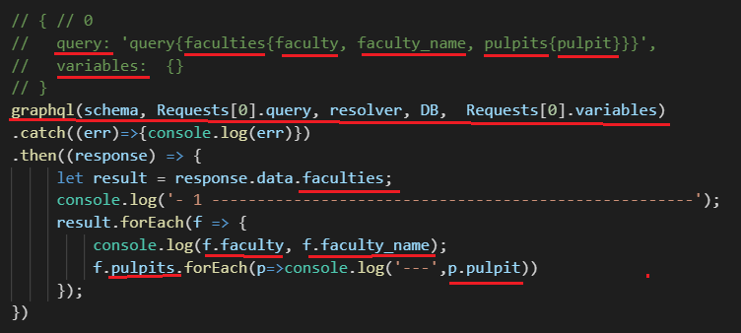

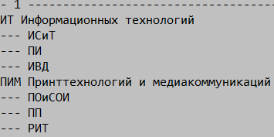

1. **GraphQL:** graphql, schema, resolvers, context(DB)

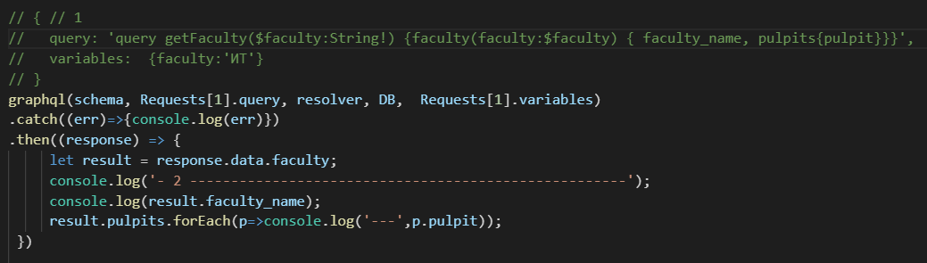

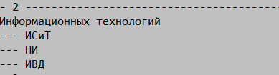

1. **GraphQL:** graphql, schema, resolvers, context(DB)

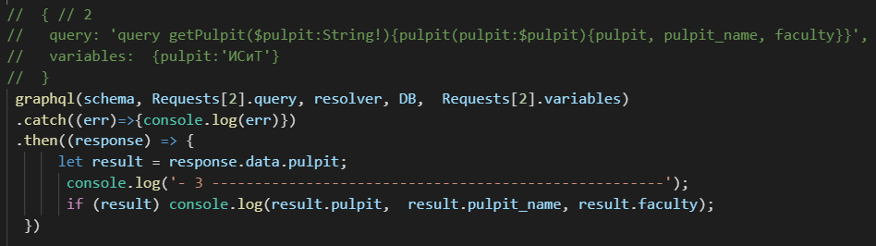



1. **GraphQL:** graphql, schema, resolvers, context(DB)

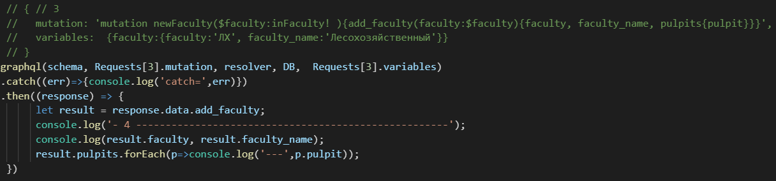



1. **GraphQL:** graphql, schema, resolvers, context(DB)

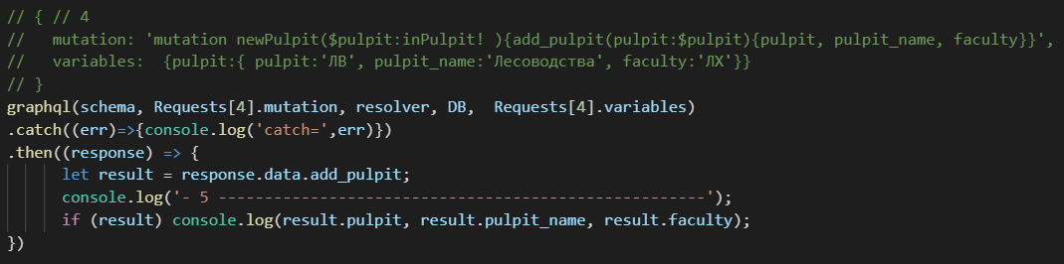



1. **GraphQL:** graphql, schema, resolvers, context(DB)

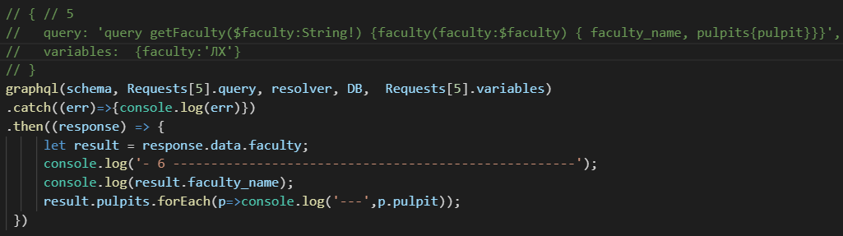



1. **GraphQL:** schema, query, mutation

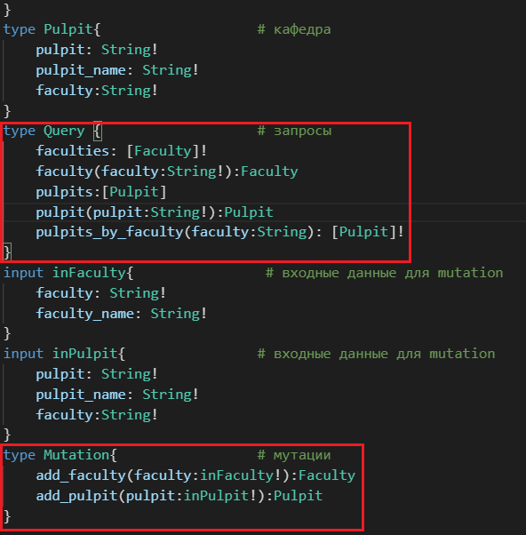

1. **GraphQL:** query, mutation, resolvers

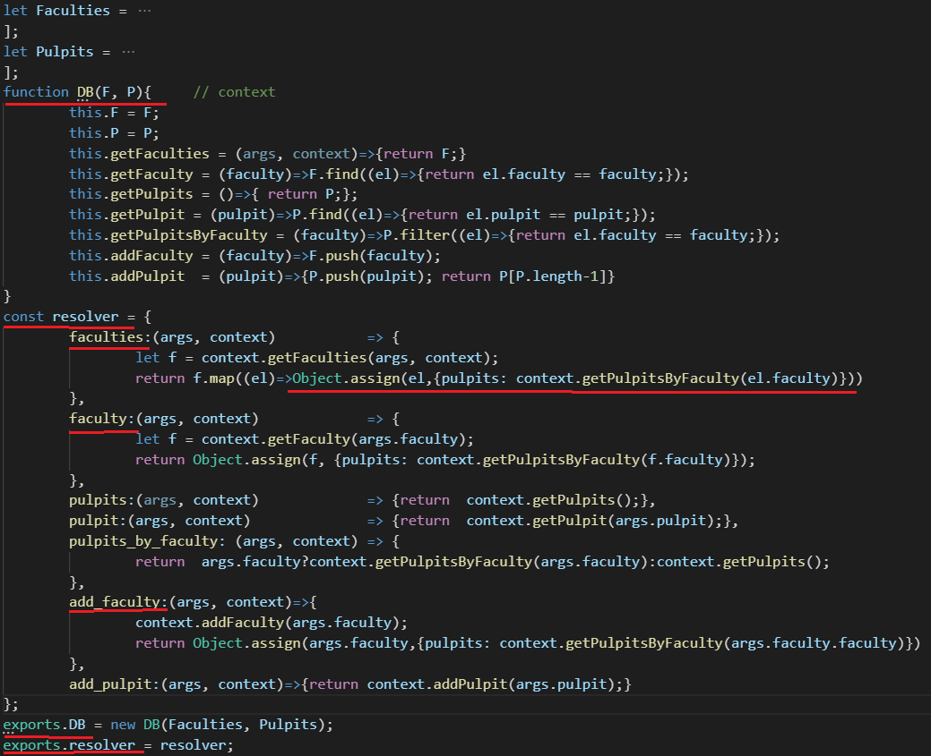

1. **GraphQL:** http, graphql, postman

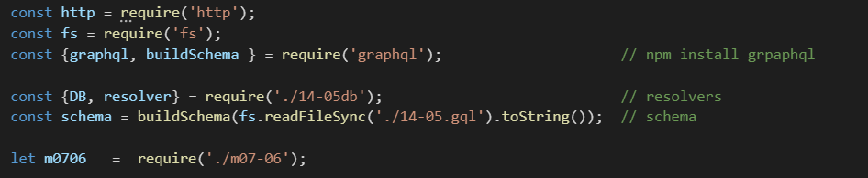

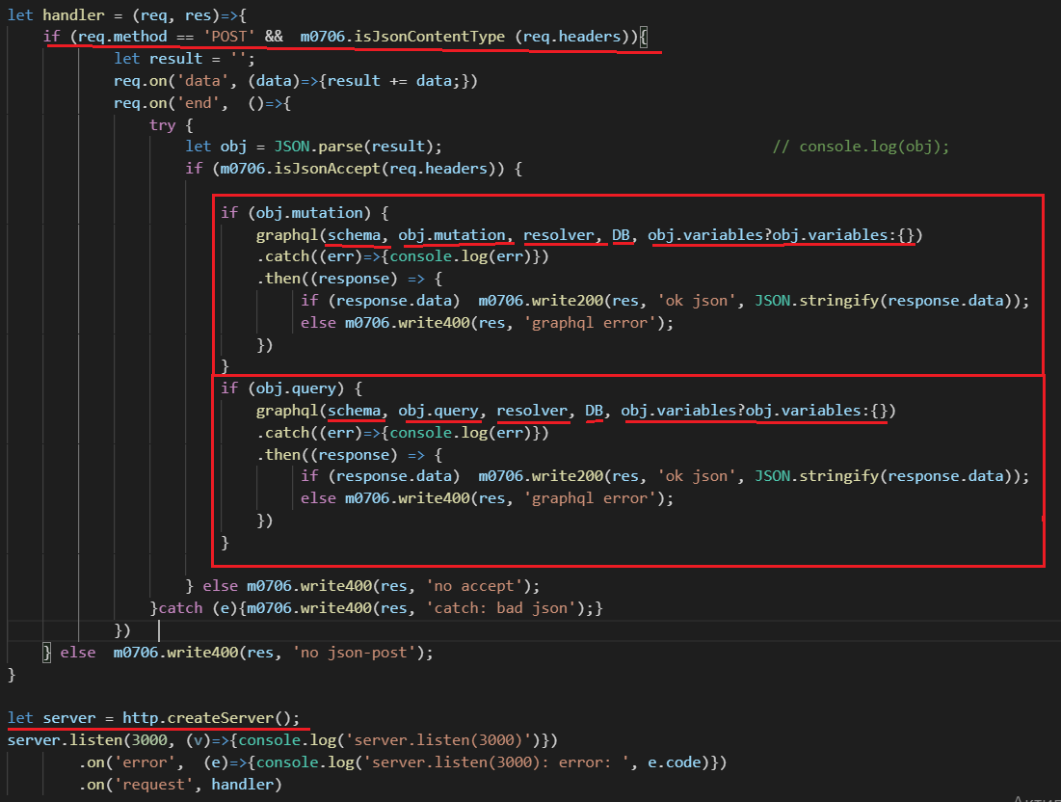

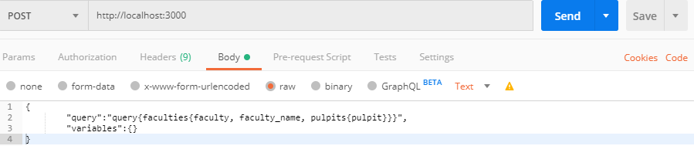

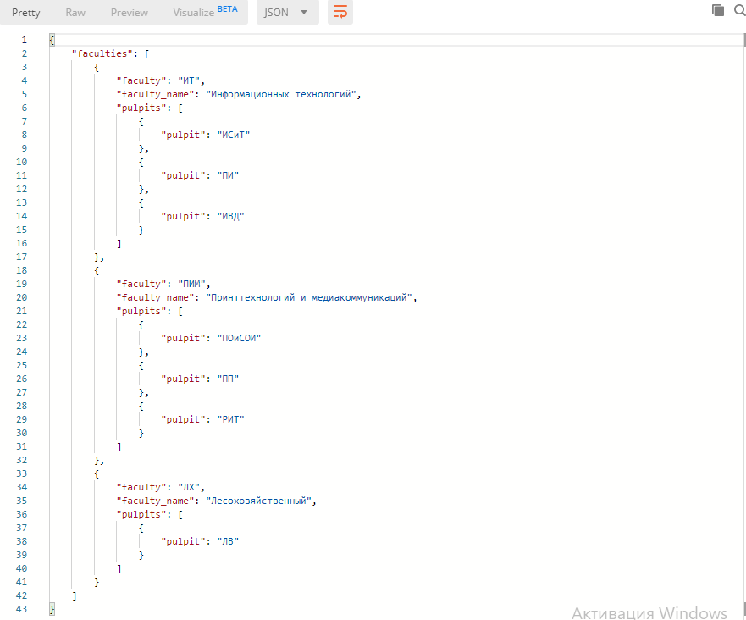

1. **GraphQL:** http, graphql, mssql

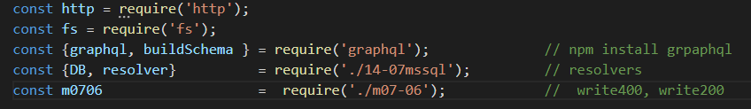

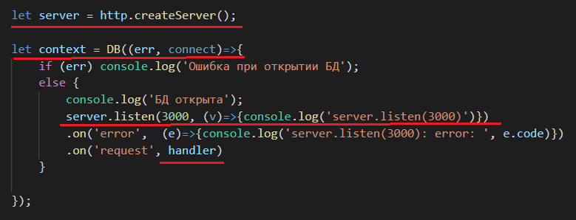

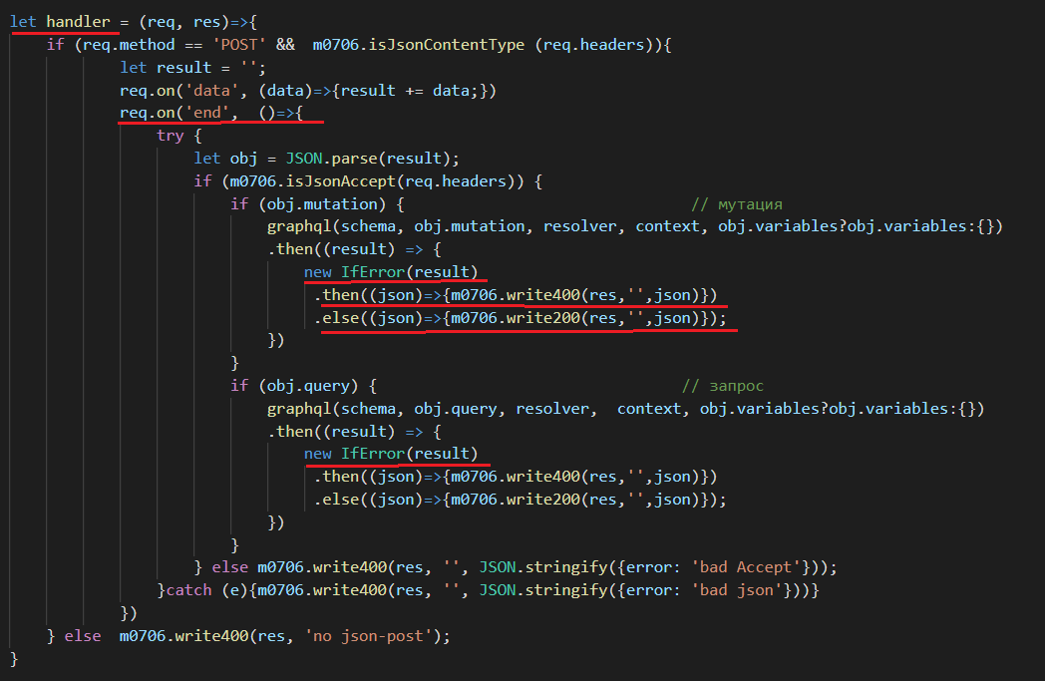

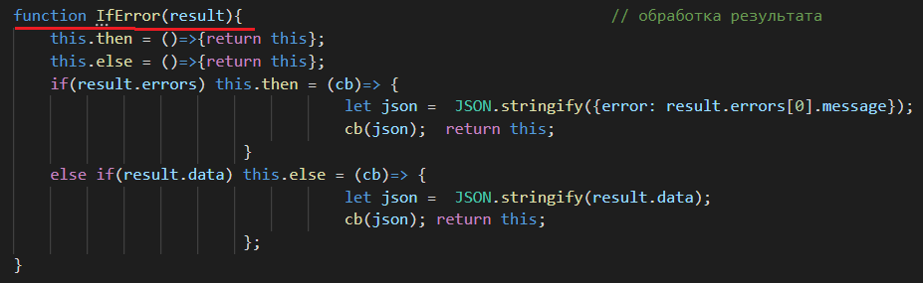

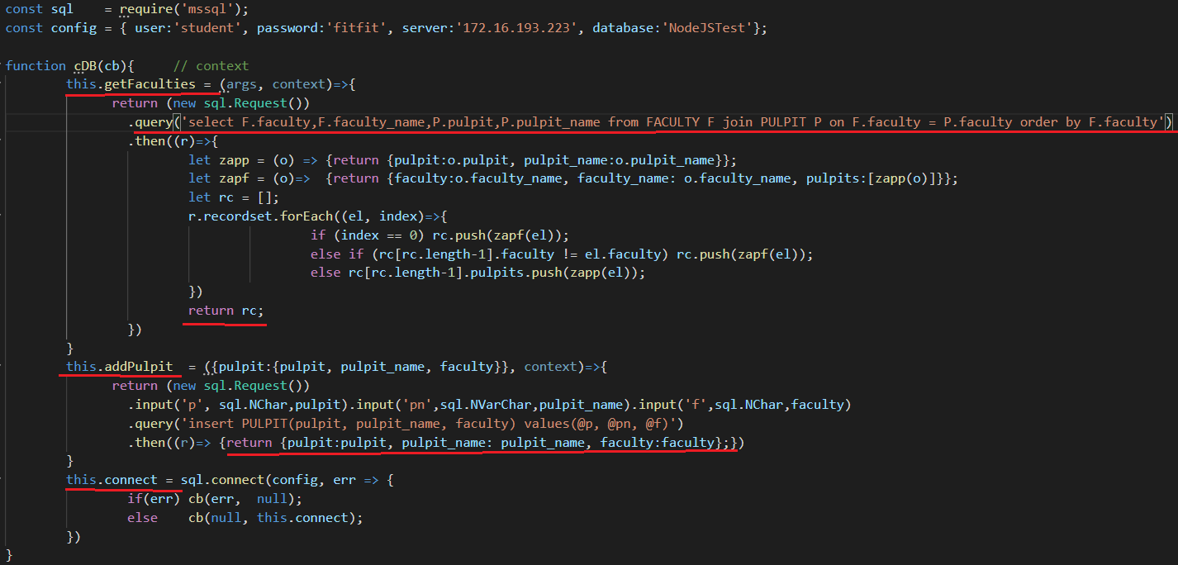

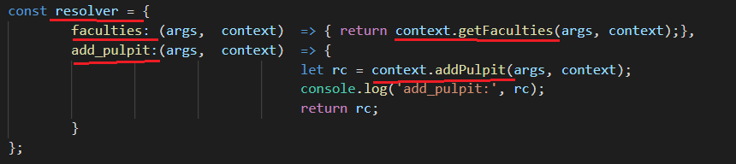

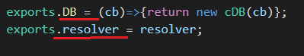

1. **GraphQL:** subscription, interface, enum, fragment, union