Essential Skills Training (EST-TM)
Time Management & Prioritization

Objective
Improve personal effectiveness through the efficient management of time and priorities.

Actions
- Use a time management log to plan daily activities listed below in the tasks section for one week
  - Use the EST-TM-RECORD.xls template
- Record the actual use of time
- Compare the actual use to the plan
- Identify gaps between the plan and actual results and determine the cause(s)
- Total the number of hours per week spent in the following activity categories:
  - Travel / Commuting
  - School (includes any activities related to school)
  - Work (paid or volunteer)
  - Leisure, fitness/sports, recreation (downtime)
  - Regularly scheduled meetings/events, such as clubs, church, hobby groups, civic organizations, etc…
- Average the total number of hours for each category

Resources
Lesson 3 Managing Time & Priorities (pdf document)
EST-TimeManagement lecture
EST-TM-RECORD.xlsx/.xls template

Tasks
- Read lesson 3 Managing Time and Priorities
- Watch the TimeManagement lecture (it contains information excluded from the reading)
- Download EST-TM-RECORD in the correct format for Microsoft Excel [.xlsx (2007-2010) or .xls (1997-2003)]
- Open the template and complete a save as to rename the file as follows:
  - EST-TM-LastnameFirstname.xls or EST-TM-LastnameFirstname.xlsx
- Each day of the week is represented by a different tab. Complete the following for each day of the week.
- Plan out your activities for the week and include the following.
  - Any regularly scheduled appointments: work, classes, meetings, time for personal study, fitness/gym time, sports or club activities, leisure activities including family or friends, personal leisure activities such as reading, television programs or movies (just list TV, you do not have to write down what you are watching). Basically plan out what you know you need to do. You will have five categories: work, travel/commute, school, leisure/recreation, and scheduled events.
  - Include the necessary commute time between your activities.
  - The activity column is the place where you write out your plan for each day.
  - List an activity or commute time by selecting a start time and dragging the mouse to a stopping point say from 7-8 AM.
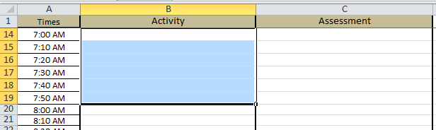

Select the merge and center button to consolidate your information into a single field that includes the time frames from 7 AM to 8 AM
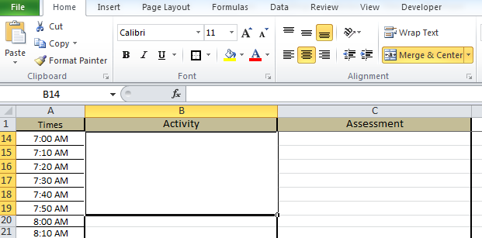

Type in your activity
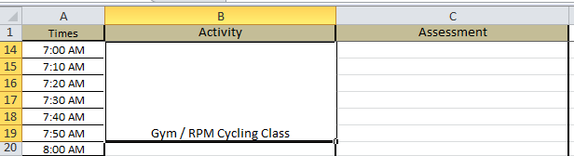

If your activity requires traveling to and from the venue set up a commute time in blocks before and after your event.
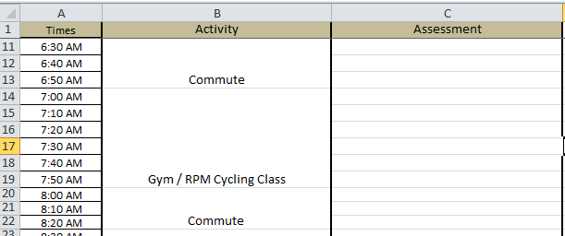

Do this for all of your activities.

If you are taking online classes, you should schedule specific times for each class just as if you were going to attend a class on campus. A campus class usually meets twice a week in 90-minute block for a total of 3 hours per week. Set up your online courses in the same way.

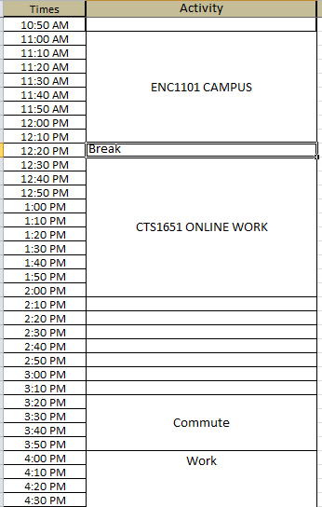

Complete your plan for the week. Then use the assessment column to keep track of how well your plan is working.
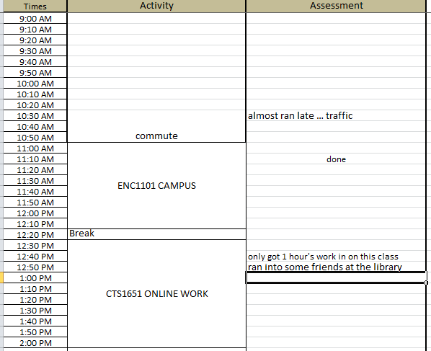

Notice the assessment next to the scheduled online course work. In this case, the student noted that the amount of time planned for studying did not happen. Anytime you have a change in the amount of time you expected to complete a task, make sure you note what happened and why. Sometimes your schedule changes because it took less time to complete a task than you planned. In this case, note what you did to fill in that time.

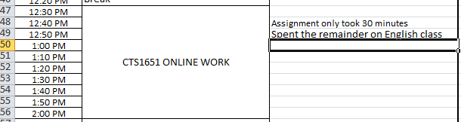

Do this for an entire week. At the end of the week, complete the questions and time chart on the next page.

You will turn in this document with your reflections and the time management record to your instructor. Rename this file as follows: EST-TM-LastnameFirstname.docx or .doc. Post your assignments in the appropriate drop box on Angel.

EST-TM
Summary & Reflection
For each category total the number of hours devoted those activities, round up to the next hour for any fraction. Then divide the total by the number of days (7).

Category | Total Time (Mon-Sun) | Daily Average
Travel/Commute
School
Work
Leisure

- Based on your results, rank each category in order of importance. This indicates your priorities. Use 1 for the top priority and 4 for the lowest priority.

___ Travel ___ School ___ Work ___ Leisure

- Review your assessment logs and identify at least three things that kept you from executing your planned schedule. List those things below. Do you see a pattern?

- What does the record indicate about how you prioritize your time?

- Based on these results, what one thing are you going to do to improve your effectiveness?

- Describe at least one thing that you learned about your time management skills from this assignment.

