Mass spectra were acquired with AccuTOF 4G+ mass-spectrometer with either an electrospray ion source (ESI), or with a Direct Analysis in Real Time (DART) ion source operated with helium gas at 300 °C. This is a high-resolution instrument providing spectral lines approximately 100 ppm wide (full-width at half-maximum), but its sampling interval is just 3-4 times smaller than that. To minimize the inaccuracy caused by such sparse sampling, for each peak the position of its maximum was estimated as the position of maximum of an asymmetric gaussian curve fitted to the peak.

While the independently measured spectra of calibrants matched the expected values within several ppm uncertainty as per instrument’s specifications, measurement of nanoparticle samples was accompanied by ≈0.1 Da shift of calibration (perhaps caused by space charge effects). For the mass spectrum of TMA NPs measured with ESI source (**Figure S_MASSSPEC1),** we found that the calibration offset was a near-perfect linear function of the m/z (**Figure S_MASSSPEC0**): after applying this linear recalibration the mass error did not exceed 3 ppm for any of the 13 assigned molecules. Such recalibration is only present in plots **Figure S_MASSSPEC1** and **Figure S_MASSSPEC4**; the rest of the plots are showing raw data.

The data shows with high confidence that TMA, MUA, and MUS ligands are indeed present in the respective mix-charge nanoparticles.

In comparison, the evidence for presence of MUP in TMA:MUP MCNPs is weaker: in low m/z range(**Figure S_MASSSPEC3**) several peaks in TMA:MUP MCNPs mass spectrum match the peaks from MUP NP mass spectrum, yet these matching peaks could not be assigned with confidence. In the high m/z range (**Figure S_MASSSPEC4)**, peaks MUP disulfides visible in MUP NPs spectrum are absent from TMA:MUP MCNPs spectrum. Instead, the MCNPs spectrum (**Figure S_MASSSPEC4,** orange) has two new peaks that may be assigned to MUP disulfides coupled to two TMA ions or to one TMA-ligand fragment (indicated in **Figure S_MASSSPEC4,** bottom), although these assignments have mass errors of 0.017 Da and 0.073 Da, respectively. Given that MUP comprises only 4% of ligands in respective MCNPs, it is not surprising that detecting MUP in MCNPs proved to be more challenging than in the case of other surface ligands.

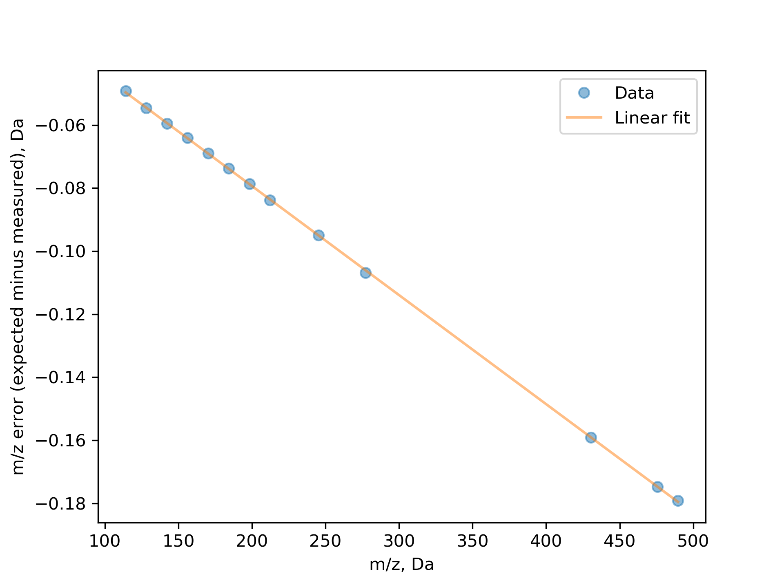

**Figure S_MASSSPEC0**. Mass error (difference between expected and measured mass-to-charge ratios) for mass spectrum of TMA NPs measured with ESI source. Each blue circle corresponds to one molecule as annotated on **Figure S_MASSSPEC1.** Orange line is a linear function fitted to the data.

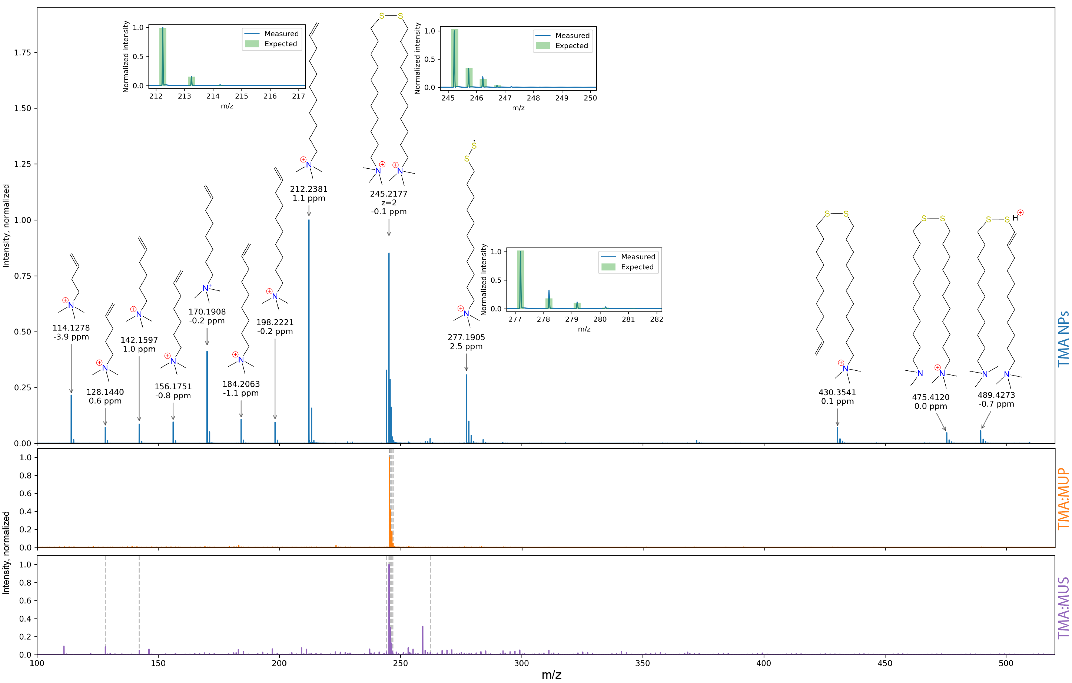

**Figure S_MASSSPEC1**. Mass spectra taken with positive-mode ESI for TMA NPs (top. blue), TMA:MUP MCNPs (orange) and TMA:MUS (purple). For each assigned molecule, mass error in ppm is indicated under the measured mass value. Grey dashed lines in the latter two spectra indicate peaks matching (within 0.01 Da) to TMA NPs peaks — most prominently, the 245.2177 peak of doubly-charged TMA disulfide. Insets show isotopic patterns. This plot shows data after the linear recalibration (**Figure S_MASSSPEC0**)**.**

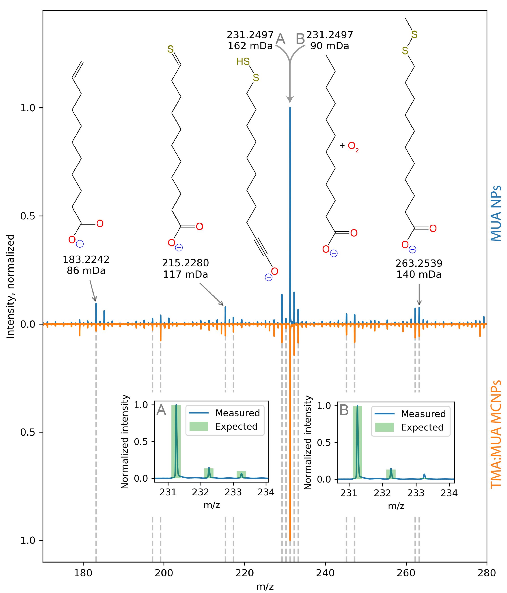

**Figure S_MASSSPEC2**. Annotated mass spectrum of MUA NPs (blue) and TMA:MUA MCNPs (orange) measured with DART ion source in negative mode. For each assigned molecule, mass error in mDa is indicated under the measured mass value. Grey dashed lines indicate peaks whose positions in both spectra match within 0.01 Da. For the 231.2497 peak, candidate molecule **A** with a triple C-C bond was predicted by CFM-ID 3.0 Fragmentation Model [<https://doi.org/10.3390/metabo9040072>] and has a better match of its isotopic pattern (bottom left) than the candidate molecule **B** with O2 adduct and deprotonated carboxylic group (isotopic pattern is bottom right), although the latter molecule has a lower mass error. Perhaps this mass peak is composed of a mix of these two molecules. No recalibration was applied, and the mass errors of assigned molecules remain at roughly 0.1 Da level.

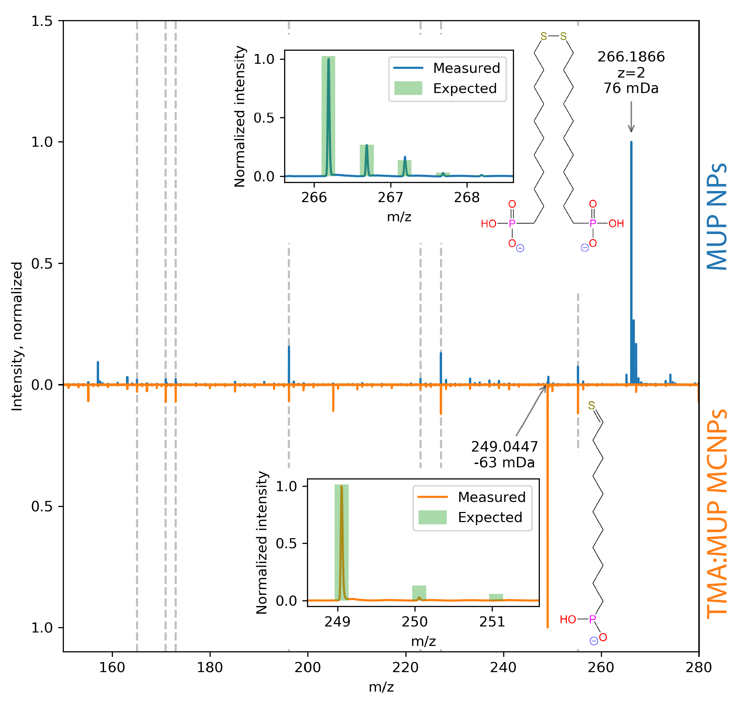

**Figure S_MASSSPEC3**. Annotated mass spectra of MUP NPs (blue) and TMA:MUP MCNPs (orange) measured with negative-mode electrospray ionization (ESI). For each assigned molecule, mass error in mDa is indicated under the measured mass value. Grey dashed lines indicate peaks whose positions in both spectra match within 0.01 Da. Isotopic pattern (upper inset) of main peak in MUP NPs for doubly-charged (z=2) disulfide matches well with the data. Assignment of main peak in TMA:MUP MCNPs at 249.0521 Da, which is also present in MUP NPs at 249.0447 Da, has reasonable agreement of its peak position, but poor agreement of its isotopic pattern (lower inset) with data. High m/z portion of this spectrum is shown in **Figure S_MASSSPEC4**.

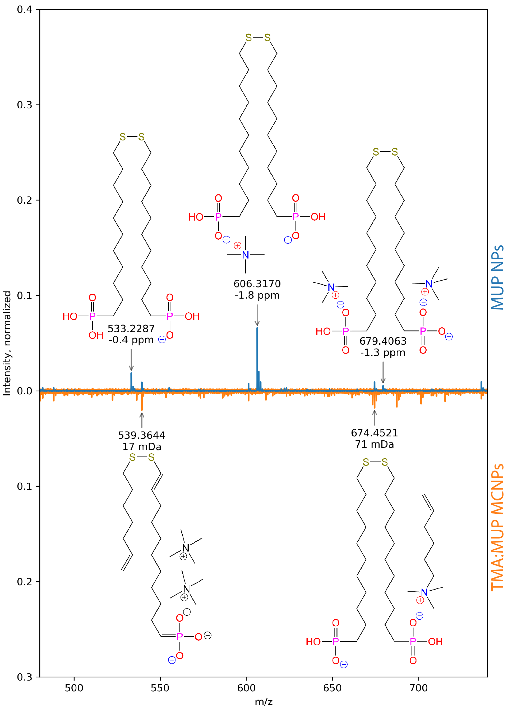

**Figure S_MASSSPEC4**. Annotated mass spectra of MUP NPs (blue) and TMA:MUP MCNPs (orange) measured with negative-mode electrospray ionization (ESI) in the 500-600 Da range (for low m/z range, see **Figure S_MASSSPEC3**). For each assigned molecule, mass error in either ppm (top) or mDa (bottom) is indicated under the measured mass value. Linear recalibration (see Section XXX) has been applied to the m/z axis. Intensity of MCNPs spectrum in this plot was increased five-fold for clarity.

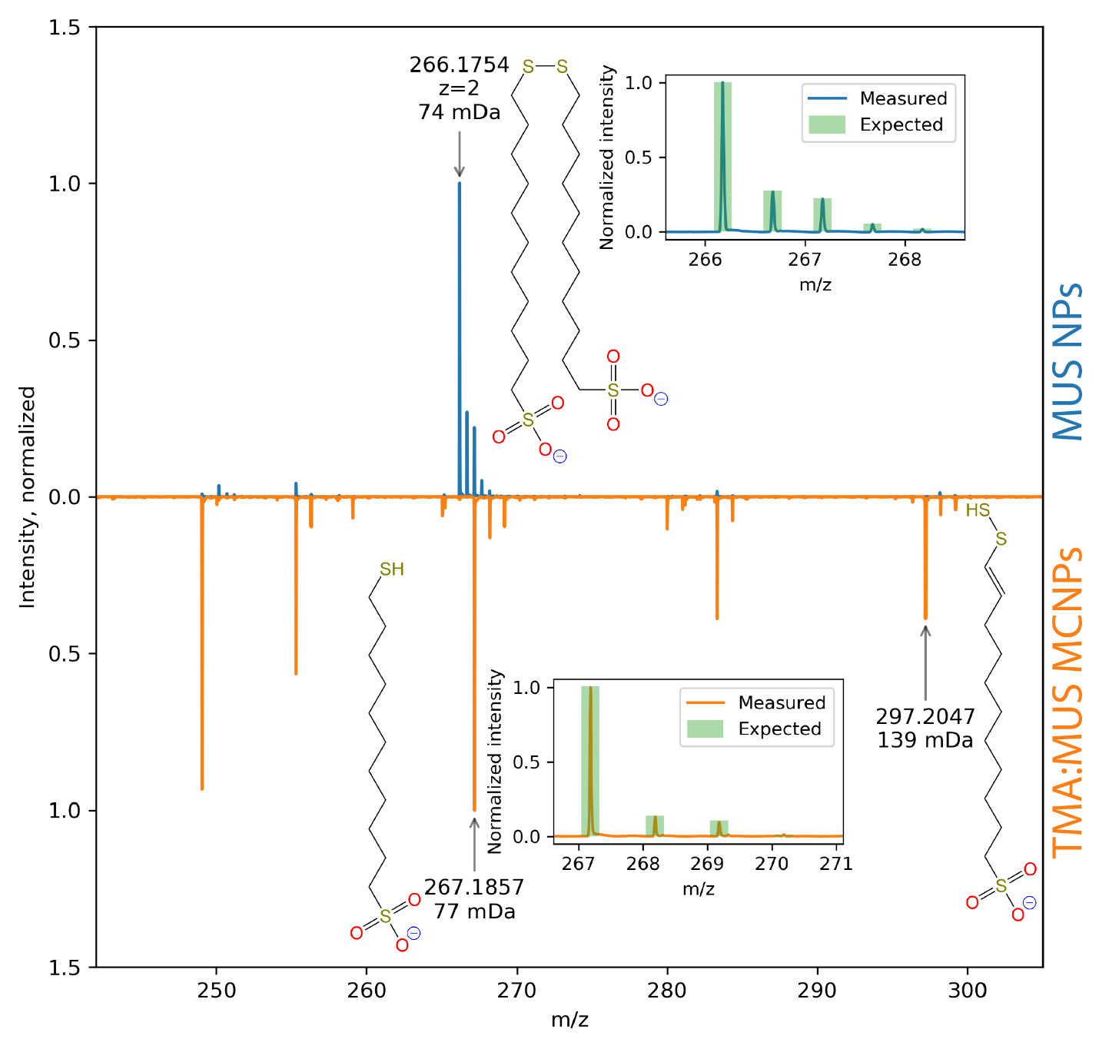

**Figure S_MASSSPEC5**. Annotated mass spectra of MUS NPs (blue) and TMA:MUS MCNPs (orange) measured with negative-mode electrospray ionization (ESI). For each assigned molecule, mass error in mDa is indicated under the measured mass value. Isotopic pattern (upper inset) of doubly-charged (z=2) MUS disulfide matches well with the main peak (266.1754) of MUS NPs mass spectrum (blue). Main peak of TMA:MUS MCNPs (orange) at 267.1857 matches single deprotonated MUS, with a near-perfect match of isotopic pattern (lower inset). MCNP spectrum also has a peak at 297.2047 matching a fragment of MUS disulfide.