Mehdi Ali

CSC-18F-068

CSC3A

ASSIGNMENT 1

**CODE FIRST APPROACH IN ENTITY FRAMEWORK**

What is Code-First?

Entity Framework introduced the Code-First approach with Entity Framework 4.1. Code-First is mainly useful in [Domain Driven Design](https://msdn.microsoft.com/en-us/magazine/dd419654.aspx). In the Code-First approach, you focus on the domain of your application and start creating classes for your domain entity rather than design your database first and then create the classes which match your database design. The following figure illustrates the code-first approach.

[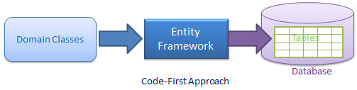](https://www.entityframeworktutorial.net/images/EF5/code-first.png)

As you can see in the above figure, EF API will create the database based on your domain classes and configuration. This means you need to start coding first in C# or VB.NET and then EF will create the database from your code.

Code-First Workflow

The following figure illustrates the code-first development workflow.

[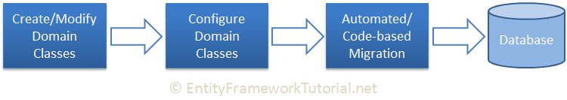](https://www.entityframeworktutorial.net/images/codefirst/dev-workflow.png)

The development workflow in the code-first approach would be: Create or modify domain classes -> configure these domain classes using Fluent-API or data annotation attributes -> Create or update the database schema using automated migration or code-based migration.

**WINDOWS FORM**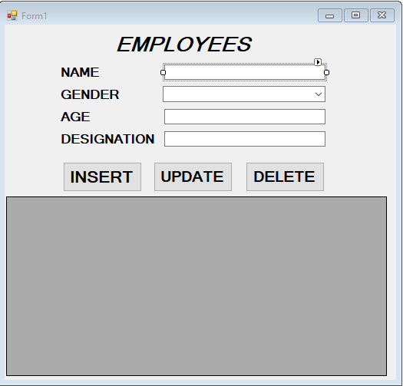

**FIRST INSTALL ENTITY FRAMEWORK FROM MANAGE NUGET PACKAGES.**

**THEN MAKE MODLE FOLDER**

**THEN MAKE A CLASS IN MODEL NAME IS EMPLOYEE**

using System;

using System.Collections.Generic;

using System.ComponentModel.DataAnnotations;

using System.Linq;

using System.Text;

using System.Threading.Tasks;

namespace codefirstapproachentityframework.model

{

class employee

{

[Key]

public int id { get; set; }

public string name { get; set; }

public string gender { get; set; }

public int age { get; set; }

public string designation { get; set; }

}

}

THEN MAKE A NEW CLASS NAME IS DATACONTEXT.

using System;

using System.Collections.Generic;

using System.Data.Entity;

using System.Linq;

using System.Text;

using System.Threading.Tasks;

namespace codefirstapproachentityframework.model

{

class DatabaseContext:DbContext

{

public DbSet<employee> employees { get; set; }

}

}

THE CONNECTION DATABASE

<connectionStrings>

<add name="DatabaseContext" connectionString="Data Source=DESKTOP-KJIMQL2\SQLEXPRESS;Initial Catalog=CFDBWF;Integrated Security=true" providerName="System.Data.SqlClient"/>

</connectionStrings>

**FORMCS1 CODE**

using codefirstapproachentityframework.model;

using System;

using System.Collections.Generic;

using System.ComponentModel;

using System.Data;

using System.Drawing;

using System.Linq;

using System.Text;

using System.Threading.Tasks;

using System.Windows.Forms;

namespace codefirstapproachentityframework

{

public partial class Form1 : Form

{

employee model = new employee();

DatabaseContext db = new DatabaseContext();

public Form1()

{

InitializeComponent();

bindGridView();

}

void bindGridView()

{

dataGridView1.DataSource = db.employees.ToList<employee>();

}

private void textBox5_TextChanged(object sender, EventArgs e)

{

}

private void label6_Click(object sender, EventArgs e)

{

}

private void Form1_Load(object sender, EventArgs e)

{

}

private void textBox3_TextChanged(object sender, EventArgs e)

{

}

private void insertbutton_Click(object sender, EventArgs e)

{

model.name = nametextBox.Text;

model.gender = gendercomboBox.SelectedItem.ToString();

model.age = Convert.ToInt32(agetextBox.Text);

model.designation = desigtextBox.Text;

db.employees.Add(model);

int a= db.SaveChanges();

if(a>0)

{

MessageBox.Show("Data Inserted!", "Success", MessageBoxButtons.OK, MessageBoxIcon.Information);

bindGridView();

}

else

{

MessageBox.Show("Data Not Inserted!", "Fail", MessageBoxButtons.OK, MessageBoxIcon.Information);

}}

**THEN RUN EXCUTE YOUR PROJECT**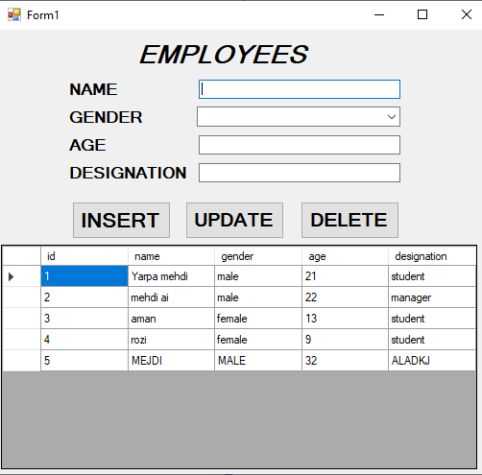

**THEN INSERT INFORMATION AND CLICK ON INSERT BUTTON**

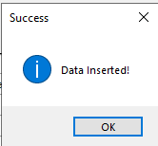

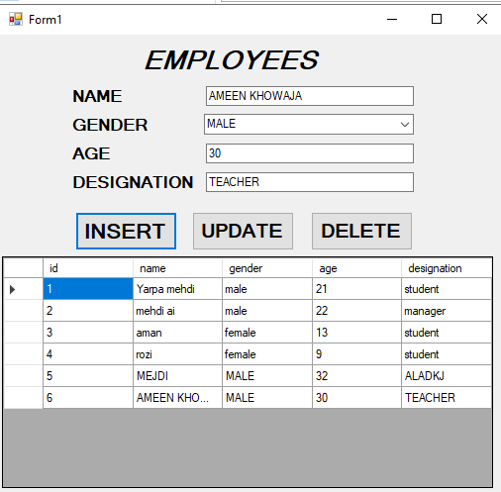

**HERE YOU SEE AT 6 ROW AMEEN KHOWAJA INFORMATION ARE INSERT.**