Table of Contents

Chapter 9
Waveform_Generation

1 9.1 Introduction
The circuits that generate the various waveforms used in electronic systems are called oscillators. Very good approximations to the idealized waveforms such as rectangular waves and sine waves are readily generated by rather simple oscillator circuits. Other waveforms can be derived by wave-shaping operations performed on one of the basic waveforms. It is apparent that there is some overlap between the functions called wave shaping and actual waveform generation. We shall distinguish between them by considering the generator or oscillator to be the simplest circuit that will generate a sustained repetitive waveform of voltage or current. Additional circuitry then falls into the category of wave-shaping equipment.

2 9.2 Properties of Oscillators
Oscillators can be designed to produce power outputs ranging from a few microwatts to many kilowatts, frequencies ranging from a fraction of a cycle per second to thousands of megacycles per second, and waveforms ranging from sine waves to markedly discontinuous waves.
The three essential components required to generate self-sustained oscillations are a power supply, an energy storage system, and a control valve capable of releasing power from the supply to the energy storage system. The control of the power supply may be exercised by vacuum tubes, gas tubes, transistors, or any other device capable of providing power gain. Inductors, capacitors, electromechanical transducers (such as piezoelectric crystals or magnetostrictive rods), or combinations thereof, can be used as energy storage systems. In electromechanical transducers, oscillations are actually in the form of mechanical vibrations, and the energy storage is in the form of potential and kinetic energy. However, such devices present equivalent inductance and capacitance at their electrical terminals. For our purposes, it is unnecessary to go beyond the electrical description of the energy storage system in terms of inductance and capacitance.
The energy storage system plays a major role in determining the waveform of the oscillator output. For example, a single inductance or capacitance tends to produce a non-sinusoidal waveform called relaxation oscillations. When the energy storage system includes both inductance and capacitance, the oscillator tends to produce a nearly sinusoidal waveform. An ideal lossless LC circuit will sustain sinusoidal oscillations if the capacitor is initially charged or if the inductance has an initial current. Since every physical circuit includes resistance, the natural oscillations for a physical inductor and capacitor are damped sinusoids. The power supplied by the control device must make up for the power loss due to the dissipation in the resistance associated with the LC circuit, in addition to any power that must be delivered to the oscillator's load. The behavior of oscillator circuits with three- or four-terminal energy storage circuits is easily demonstrated by an amplifier connected to the energy storage elements as shown in Fig. 9.1(a). The energy storage elements are most likely to be intimately associated with the amplifier circuitry. A detailed analysis of such oscillators naturally evolves from examining the stability of linear amplifiers.
An oscillator circuit in which the primary energy storage elements are connected between a pair of terminals can be easily analyzed in terms of incremental negative resistance. In contrast to positive resistance, which dissipates power, negative resistance can be thought of as a power-providing source, thus providing a mechanism for maintaining oscillations. A physical circuit that produces negative resistance must be nonlinear because linear negative resistance implies an infinite source of power.
In Chapters 5 to 8, we discussed several simple circuits that exhibit incremental power gain. When this transfer property exists in a circuit, a negative driving-point resistance may also be obtained. If we include transformers among our circuit elements, any circuit that can provide incremental power gain from one pair of terminals to another pair can be modified to yield a negative incremental resistance...
import schemdraw
import schemdraw.elements as elm
import matplotlib.pyplot as plt
import matplotlib.image as mpimg
import numpy as np
fig, axs = plt.subplots(1, 2, figsize=(12, 6))
with schemdraw.Drawing(show=False) as d:
d += elm.Line().up().length(2.5).at((0,4))
d += elm.Line().right().length(3.5)
d += elm.Line().down().length(2.5)
d += elm.Line().left().length(3.5)
d += elm.Line().down().length(1.5).at((.5,4))
d += elm.Dot().at((0.5, -0.8+4))
d += elm.Line().down().length(1.5).at((3,0+4))
d += elm.Dot().at((3, -0.8+4))
d += elm.Line().up().length(2.5).at((0,-4+4))
d += elm.Line().right().length(3.5)
d += elm.Line().down().length(2.5)
d += elm.Line().left().length(3.5)
d += elm.Line().left().length(2.5).at((0,-2+4))
d += elm.Dot().at((-0.8, -2+4)).label('A')
d += elm.Line().left().length(1.5).at((0,-3.5+4))
d += elm.Dot().at((-0.8, -3.5+4)).label('B', loc='bottom')
d += elm.Line().down().length(5.5).at((-2.5,-2+4))
d += elm.Line().down().length(2.5).at((-1.5,-3.5+4))
d += elm.Line().right().length(1.5).at((-1.5,-6+4))
d += elm.Dot().at((-0.8, -6+4))
d += elm.Line().right().length(2.5).at((-2.5,-7.5+4))
d += elm.Dot().at((-0.8, -7.5+4))
d += elm.Line().up().length(2.5).at((0,-8+4))
d += elm.Line().right().length(3.5)
d += elm.Line().down().length(2.5)
d += elm.Line().left().length(3.5)
d += elm.Line().right().length(2.5).at((0+3.5,-2+4))
d += elm.Dot().at((-0.8+5, -2+4)).label('A\'')
d += elm.Line().right().length(1.5).at((0+3.5,-3.5+4))
d += elm.Dot().at((-0.8+5, -3.5+4)).label('B\'', loc='bottom')
d += elm.Line().down().length(5.5).at((-2.5+8.5,-2+4))
d += elm.Line().down().length(2.5).at((-1.5+6.5,-3.5+4))
d += elm.Line().right().length(1.5).at((-1.5+5,-6+4))
d += elm.Dot().at((-0.8+5, -6+4))
d += elm.Line().right().length(2.5).at((-2.5+6,-7.5+4))
d += elm.Dot().at((-0.8+5, -7.5+4))
d += elm.Gap().down().label('d-c power supply', fontsize=12).at((1.7, 2.8+4))
d += elm.Gap().down().label('Amplifier', fontsize=12).at((1.7, -1.4+4))
d += elm.Gap().down().label('Energy Storage System', fontsize=10).at((1.7, -5.2+4))
d += elm.Gap().down().label('input', fontsize=12).at((-1.0, -1.3+4))
d += elm.Gap().down().label('output', fontsize=12).at((4.5, -1.3+4))
d += elm.Line().up().length(2.5).at((2.5+5, 0+4))
d += elm.Line().right().length(3.5)
d += elm.Line().down().length(2.5)
d += elm.Line().left().length(3.5)
d += elm.Line().down().length(1.5).at((3+5, 0+4))
d += elm.Dot().at((5.5+5, -0.8))
d += elm.Line().down().length(1.5).at((5.5+5, 0+4))
d += elm.Dot().at((3+5, -0.8+4))
d += elm.Line().up().length(2.5).at((2.5+5, -4+4))
d += elm.Line().right().length(3.5)
d += elm.Line().down().length(2.5)
d += elm.Line().left().length(3.5)
d += elm.Line().down().length(1.5).at((3+5, -4+4))
d += elm.Dot().at((3+5, -4.8+4)).label('C', loc='left', fontsize=12, ofst=(-0.3+0, 0+4))
d += elm.Line().down().length(1.5).at((5.5+5, -4+4))
d += elm.Dot().at((5.5+5, -4.8+4)).label('C\'', loc='right', fontsize=12, ofst=(0.3+0, -0+4))
d += elm.Line().up().length(2.5).at((2.5+5, -8+4))
d += elm.Line().right().length(3.5)
d += elm.Line().down().length(2.5)
d += elm.Line().left().length(3.5)
d += elm.Gap().down().label('d-c power supply', fontsize=12, loc='top', ofst=(0+5, 0.5)).at((1.3+2.5+5, 7.8))
d += elm.Gap().down().label('Negative resistance', fontsize=12, loc='top', ofst=(0+5, 0.5)).at((1.3+2.5+5, -1.4+5))
d += elm.Gap().down().label('Energy-storage system', fontsize=10, loc='top', ofst=(0+5, 0.5)).at((1.3+2.5+5, -5.2+5+12))
d.save('./Drawing/fig9.1.jpg')
d.save('./Drawing/fig9.1.svg')
img = mpimg.imread('./Drawing/fig9.1.jpg')
axs[0].imshow(img)
axs[0].axis('off')
axs[0].set_title('Circuit Diagram (developed)')
img_sample = mpimg.imread('./Images/fig9.1.jpg')
axs[1].imshow(img_sample)
axs[1].axis('off')
axs[1].set_title('Original')
plt.show()
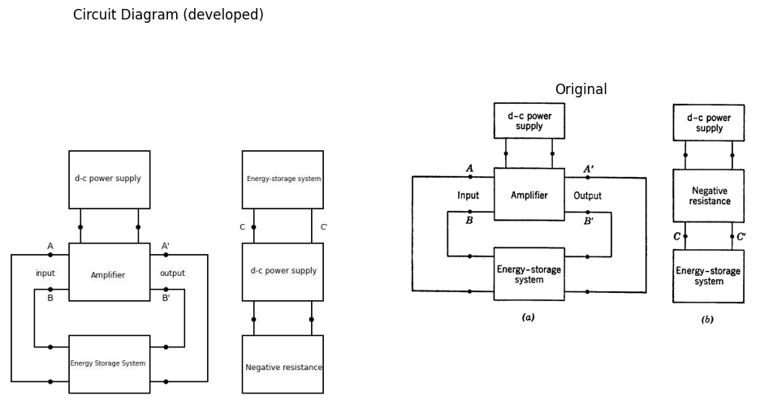

2.0.0.1 Fig. 9.1. Waveform generation based on incremental power gain or incremental negative resistance.
over a part of the driving-point curve that exists at a single pair of terminals. Relaxation oscillators and many types of sine wave oscillators fall into the category shown in Fig. 9.1(b) and hence are readily analyzed by using the negative-resistance concept. Before proceeding to the details of oscillator behavior, let us examine a number of circuits that produce a negative resistance.

3 9.3 Negative Resistance in the Common-Base, Point-Contact Transistor Circuit
A simple illustration of negative incremental resistance is provided by a common-base, point-contact transistor circuit. As shown in Fig. 9.2(a) it is a common-base circuit with an external resistance R_b added between base and ground. Because the short-circuit current gain of a point-contact transistor is greater than unity (α = 2 to 3 for i_e > 0) any of the single-transistor circuits can exhibit a negative incremental resistance. For a circuit that includes only one junction transistor (α < 1) a transformer is necessary to obtain negative resistance.
The expressions given in Fig. 9.2 for slopes, intercepts, break points, and the relation between v_1 and i_e can be derived by break-point analysis.
The curve shown in Fig. 9.2(d) determines voltage uniquely if the current i_e is specified, but yields multiple values of current i_e for some values of voltage v_1. Such a curve is called a current-controlled negative resistance.

4 9.4 Negative Resistance in a Common-Emitter, Point-Contact Transistor Circuit
The input curve of a common-emitter circuit using a point-contact transistor provides another example of negative resistance. The schematic diagram is shown in Fig. 9.3(a), and the circuit model is shown in (b). The equation in (c) relating v_1 and i_b can be readily derived from the circuit model. The circuit differs only in numerical values (particularly that of current-gain α) from the corresponding junction transistor circuit.
In this circuit, no values of the input variables v_1 and i_b ever yield the conditions for state I; hence, only II, III, and IV are pertinent. The curve of Fig. 9.3(d) shows that the current i_b is a single-valued function of v_1, whereas the voltage can have multiple values over a part of the range of i_b. The unique specification of i_b in terms of v_1 leads to the designation of this type of curve as a voltage-controlled negative resistance.
When piecewise-linear models are used to approximate nonlinear devices, break-point analysis must be supplemented by physical reasoning. Suppose two different circuits yield driving-point curves such as
import schemdraw
import schemdraw.elements as elm
import matplotlib.pyplot as plt
import matplotlib.image as mpimg
import numpy as np
fig, axs = plt.subplots(1, 2, figsize=(12, 6))
with schemdraw.Drawing(show=False) as d:
Q1 = d.add(elm.BjtPnp(circle=True).label('Q1').up())
d += elm.Line().left().length(1.3).at(Q1.emitter).dot(open=True)
d += elm.Line().down().length(1.1).at(Q1.base)
d += elm.Resistor().label('$R_b$').down()
d += elm.Line().down().length(1.13).dot()
d.push()
d += elm.Line().down().length(0.5)
d += elm.Ground()
d.pop()
d += elm.Line().left().length(2).dot(open=True)
d += elm.Line().right().length(1).at(Q1.collector).dot(open=True).label('c')
d += elm.Line().right().length(1)
d += elm.Resistor().label('$R_c$', loc='bottom').down()
d += elm.Battery().label('$V_{cc}$', loc='bottom').down().reverse()
d += elm.Line().left().length(2.7)
d += elm.Arrow().right().at((-1.5, 1.2)).length(0.75).label('$i_e$', 'top')
d += elm.Label('+').at((-2.4,0.2))
d += elm.Label('_').at((-2.4,-4.8))
d += elm.Arrow().up().length(2.0).at((-2, -1.4))
d += elm.Arrow().up().length(0.1).at((-2.3, -2.3)).color('white').label('$v_1$', loc='bottom', color='black')
d += elm.Arrow().down().length(2.0).at((-2, -2.9))
d += elm.Label('+').at((-2.4+6.5,0.2))
d += elm.Label('_').at((-2.4+6.5,-4.8))
d += elm.Arrow().up().length(2.0).at((-2+6.5, -1.4))
d += elm.Arrow().up().length(0.1).at((-2.3+6.5, -2.3)).color('white').label('$v_2$', loc='bottom', color='black')
d += elm.Arrow().down().length(2.0).at((-2+6.5, -2.9))
d += elm.Dot(open=True).at((7,0.7)).label('$V_1$','bottom')
d += elm.Resistor().label('$r_e$', loc='bottom').right().dot()
d += elm.Line().right().length(0.7).dot()
d.push()
d += elm.Resistor().label('$r_c$', loc='bottom').right().dot()
d += elm.Line().right().length(0.7).dot()
d += elm.Resistor().label('$R_c$', loc='bottom').down()
d += elm.Battery().label('$V_{cc}$', loc='bottom').down().reverse()
d += elm.Line().left().length(4.4).dot()
d.push()
d += elm.Line().up().length(1.5)
d += elm.Resistor().label('${r_b+R_b}$', loc='bottom').up()
d += elm.Line().up().length(1.5)
d.pop()
d += elm.Ground()
d += elm.Arrow().right().at((7, 1.2)).length(0.75).label('$i_e$', 'top')
d.pop()
d += elm.Line().up().length(1.5)
d += elm.SourceI().right().label('$ai_e$', 'top')
d += elm.Line().down().length(1.5)
d += elm.Line().right().length(1.5).at((14.4,0.7))
d += elm.Dot(open=True).label('$V_2$','bottom')
d.save('./Drawing/fig9.2.jpg')
d.save('./Drawing/fig9.2.svg')
img = mpimg.imread('./Drawing/fig9.2.jpg')
axs[0].imshow(img)
axs[0].axis('off')
axs[0].set_title('Circuit Diagram (developed)')
img_sample = mpimg.imread('./Images/fig9.2.jpg')
axs[1].imshow(img_sample)
axs[1].axis('off')
axs[1].set_title('Original')
plt.show()
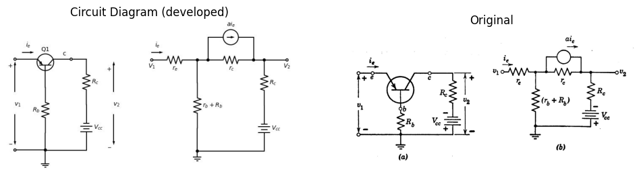
$$v_{1}=i_{e}\left[r_{e}+\frac{\left(r_{b}+R_{b}\right)\left(R_{c}+r_{c}\left(1−a\right)\right)}{r_{b}+R_{b}+r_{c}+R_{c}}\right]−\frac{\left(r_{b}+R_{b}\right)V_{cc}}{r_{b}+R_{b}+r_{c}+R_{c}}$$

import pandas as pd
import matplotlib.pyplot as plt
import matplotlib.gridspec as gridspec
data = {'State': ['I', 'II', 'III', 'IV'],
'r_e': ['r_er', 'r_er', 'r_ef', 'r_ef'],
'r_c': ['r_cf', 'r_cr', 'r_cr', 'r_cf'],
'a': ['0', '0', 'a', 'a']}
df = pd.DataFrame(data)
fig = plt.figure(figsize=(4, 4))
gs = gridspec.GridSpec(1, 1)
ax = fig.add_subplot(gs[0])
ax.axis('tight')
ax.axis('off')
table = ax.table(cellText=df.values,
colLabels=df.columns,
cellLoc='center',
loc='center')
table.auto_set_font_size(False)
table.set_fontsize(12)
table.scale(1.2, 1.2)
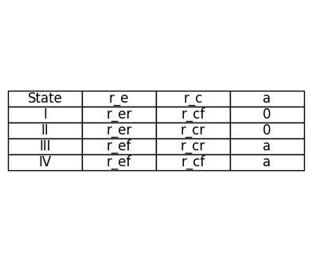

4.0.0.1 Fig. 9.2. Common-base point-contact transistor circuit.
Analysis of these circuits might lead to the curves shown in (c) and (d) where break-point coordinates and slopes (resistances) are much the same. From the three state lines alone, it is impossible to tell whether the curve is voltage controlled as in (e) or current controlled as in (f). We must consider the physical behavior of the circuit to determine the sequence of linear states as current or voltage is varied.
import schemdraw
import schemdraw.elements as elm
import matplotlib.pyplot as plt
import matplotlib.image as mpimg
import numpy as np
fig, axs = plt.subplots(1, 2, figsize=(12, 6))
with schemdraw.Drawing(show=False) as d:
Q1 = d.add(elm.BjtPnp(circle=True).label('Q1').left().reverse())
d += elm.Line().left().length(1.3).at(Q1.base).dot(open=True)
d += elm.Line().down().length(0.5).at(Q1.emitter)
d += elm.Resistor().label('$R_b$').down()
d += elm.Line().down().length(1.13).dot()
d += elm.Line().down().length(0.2)
d += elm.Ground()
d += elm.Line().right().length(1).at(Q1.collector).dot(open=True).label('c')
d += elm.Line().right().length(1.5)
d += elm.Resistor().label('$R_c$', loc='bottom').down()
d += elm.Battery().label('$V_{cc}$', loc='bottom').down().reverse()
d += elm.Line().left().length(4.7).dot(open=True)
d += elm.Arrow().right().at((-2.7, 0.5)).length(0.75).label('$i_e$', 'top')
d += elm.Label('+').at((-2.8,-0.4))
d += elm.Label('_').at((-2.8,-4.8))
d += elm.Arrow().up().length(2.0).at((-3, -2.4))
d += elm.Arrow().up().length(0.1).at((-3.6, -2.7)).color('white').label('$v_1$', loc='bottom', color='black')
d += elm.Arrow().down().length(2.0).at((-3, -2.9))
d += elm.Label('+').at((-2.4+5,0.2))
d += elm.Label('_').at((-2.4+5,-4.8))
d += elm.Arrow().up().length(2.0).at((-2+5, -1.4))
d += elm.Arrow().up().length(0.1).at((-2.3+5, -2.3)).color('white').label('$v_2$', loc='bottom', color='black')
d += elm.Arrow().down().length(2.0).at((-2+5, -2.9))
d += elm.Dot(open=True).at((7,0.7)).label('$V_1$','bottom')
d += elm.Resistor().label('$r_b$', loc='bottom').right().dot()
d += elm.Line().right().length(0.7).dot()
d.push()
d += elm.Resistor().label('$r_c$', loc='bottom').right().dot()
d += elm.Line().right().length(0.7).dot()
d += elm.Resistor().label('$R_c$', loc='bottom').down()
d += elm.Battery().label('$V_{cc}$', loc='bottom').down().reverse()
d += elm.Line().left().length(4.4).dot()
d.push()
d += elm.Resistor().label('$R_e$', loc='bottom').up()
d += elm.Resistor().label('$r_e$', loc='bottom').up()
d.pop()
d += elm.Ground()
d += elm.Arrow().right().at((7, 1.2)).length(0.75).label('$i_e$', 'top')
d.pop()
d += elm.Line().up().length(1.5)
d += elm.SourceI().right().label('$ai_e$', 'top')
d += elm.Line().down().length(1.5)
d += elm.Line().right().length(1.5).at((14.4,0.7))
d += elm.Dot(open=True).label('$V_2$','bottom')
d.save('./Drawing/fig9.3.jpg')
d.save('./Drawing/fig9.3.svg')
img = mpimg.imread('./Drawing/fig9.3.jpg')
axs[0].imshow(img)
axs[0].axis('off')
axs[0].set_title('Circuit Diagram (developed)')
img_sample = mpimg.imread('./Images/fig9.3.jpg')
axs[1].imshow(img_sample)
axs[1].axis('off')
axs[1].set_title('Original')
plt.show()
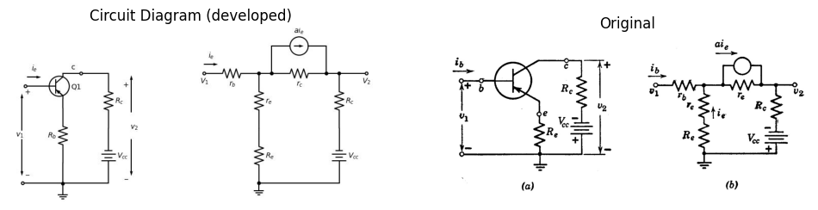
$$v_{1}=i_{b}\left[r_{b}+\frac{\left(r_{e}+R_{e}\right)\left(r_{c}+R_{c}\right)}{r_{e}+R_{e}+r_{c}\left(1−a\right)+R_{c}}\right]−\frac{V_{cc}\left(r_{e}+R_{e}\right)}{r_{e}+R_{e}+r_{c}\left(1−a\right)+R_{c}}$$

4.0.0.2 Fig 9.3. Common emitter point-contact transistor circuit.

5 9.5 Negative Resistance in a Series Triode Circuit
The series-connected triodes shown in Fig. 9.5(a) provide another example of a simple circuit which exhibits a negative-resistance region in a driving-point curve. If the triodes are represented by piecewise-linear models, the break-point method can be used to determine the state lines in the curve of $i$ vs. $v$. Since total plate current ($i_{b1}$ or $i_{b2}$) is unidirectional, the only possible direction of current in either of the resistors $R$ is downward. Thus $e_{c1}$ and $e_{c2}$ cannot exceed zero and the
only triode states that are of interest are those for $e_{c}≤0$ as tabulated in Fig. 9.5(b).
The circuit models shown in Fig. 9.5(c) and (d) specify the relation between $v$ and $i$ in states I and II. It is apparent from these models that triode $T_{2}$ conducts with zero grid voltage when the circuit is in state I.
import schemdraw
import schemdraw.elements as elm
import matplotlib.pyplot as plt
import matplotlib.image as mpimg
import numpy as np
fig, axs = plt.subplots(1, 2, figsize=(12, 6))
with schemdraw.Drawing(show=False) as d:
d += elm.Line().left().length(1).dot(open=True).at((3+2,0))
d += elm.Line().left().length(1).dot(open=True).at((3+2,-3))
d += elm.Line().up().length(4).at((3+2,-3.5))
d += elm.Line().right().length(2).at((3+2,0.5))
d += elm.Line().down().length(4).at((3+4,0.5))
d += elm.Line().left().length(2).at((3+4,-3.5))
d += elm.Label('+').at((3+1.4,-0.3))
d += elm.Label('_').at((3+1.3,-2.5))
d += elm.Arrow().right().length(0.2).at((2.7+3.3, -1)).color('white').label(r'$\mathbf{A}$', loc='bottom', color='black', fontsize=16)
d += elm.Arrow().up().length(1.0).at((3+1, -1.2))
d += elm.Arrow().up().length(0.1).at((3+0.6, -1.6)).color('white').label('$V_a$', loc='bottom', color='black')
d += elm.Arrow().down().length(1.0).at((3+1, -1.9))
d += elm.Arrow().right().length(0.7).at((3+1.2, 0.3)).label('$i_a$')
d += elm.Label('(a)').at((6-0, -4.5))
d += elm.Line().left().length(1).dot(open=True).at((3+2+5,0))
d += elm.Line().left().length(1).dot(open=True).at((3+2+5,-3))
d += elm.Line().up().length(4).at((3+2+5,-3.5))
d += elm.Line().right().length(2).at((3+2+5,0.5))
d += elm.Line().down().length(4).at((3+4+5,0.5))
d += elm.Line().left().length(2).at((3+4+5,-3.5))
d += elm.Label('+').at((3+1.4+5,-0.3))
d += elm.Label('_').at((3+1.3+5,-2.5))
d += elm.Arrow().right().length(0.2).at((2.7+3.3+5, -1)).color('white').label(r'$\mathbf{B}$', loc='bottom', color='black', fontsize=16)
d += elm.Arrow().up().length(1.0).at((3+1+5, -1.2))
d += elm.Arrow().up().length(0.1).at((3+0.6+5, -1.6)).color('white').label('$V_b$', loc='bottom', color='black')
d += elm.Arrow().down().length(1.0).at((3+1+5, -1.9))
d += elm.Arrow().right().length(0.7).at((3+1.2+5, 0.3)).label('$i_b$')
d += elm.Label('(b)').at((5+6-0, -4.5))
d.save('./Drawing/fig9.4.jpg')
d.save('./Drawing/fig9.4.svg')
img = mpimg.imread('./Drawing/fig9.4.jpg')
axs[0].imshow(img)
axs[0].axis('off')
axs[0].set_title('Circuit Diagram (developed)')
img_sample = mpimg.imread('./Images/fig9.4.jpg')
axs[1].imshow(img_sample)
axs[1].axis('off')
axs[1].set_title('Original')
plt.show()
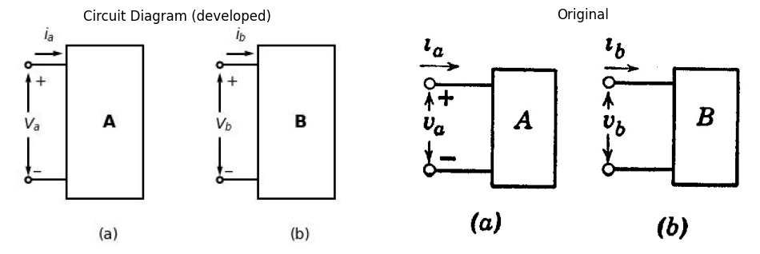

5.0.0.1 Fig. 9.4. Voltage-controlled and current-controlled negative resistance.
and T₁ conducts with zero grid voltage when the circuit is in state II, The plate-current cutoff condition
$$e_{c1}=−\frac{e_{b1}}{μ}$$
(9.1)
marks the break point between states I and III, while
$$e_{c1}=−\frac{e_{b1}}{μ}$$
(9.2)
import schemdraw
import schemdraw.elements as elm
import matplotlib.pyplot as plt
import matplotlib.image as mpimg
import numpy as np
fig, axs = plt.subplots(1, 2, figsize=(12, 6))
with schemdraw.Drawing() as d:
d += elm.Dot(open=True).label('$E_{bb}$','top')
d += (M := elm.AnalogNFet(offset_gate = False).reverse().right().label('$T_2$','right'))
d += elm.Resistor().down().at(M.source).label('$R$','bottom').dot()
d.push()
d += (M := elm.AnalogNFet(offset_gate = False).reverse().right().label('$T_1$','right'))
d.pop()
d += elm.Line().left().length(1.5)
d += elm.Line().up().length(3.84)
d += elm.Line().right().length(1.2-0.5)
d += elm.Resistor().down().at(M.source).label('$R$','bottom').dot()
d.push()
d += elm.Ground()
d.pop()
d += elm.Line().left().length(2-0.5)
d += elm.Line().up().length(3.84)
d += elm.Line().right().length(1.2-0.5)
d += elm.Label('+').at((-2.4+4,0.2-2.1))
d += elm.Label('_').at((-2.4+4,-4.8-1.7))
d += elm.Arrow().up().length(2.0).at((-2+4, -1.4-2.1))
d += elm.Arrow().up().length(0.1).at((-2.3+4, -2.3-1.7)).color('white').label('$v$', loc='bottom', color='black')
d += elm.Arrow().down().length(2.0).at((-2+4, -2.9-1.7))
d += elm.Line().right().length(1.5).at((0.5,-1.5)).dot(open=True)
d += elm.Line().right().length(1.5).at((0.5,-6.8)).dot(open=True)
d += elm.Arrow().left().length(0.7).at((2, -1.3)).label('$i$')
d += elm.Arrow().down().length(0.7).at((0.8, -0.3)).label('$i_{b2}$',loc='bottom')
d += elm.Arrow().down().length(0.7).at((1, -5.2)).label('$i_{b1}$',loc='bottom')
d += elm.Battery().label('$E_{bb}$', loc='bottom').up().reverse().at((5,-6))
d += elm.Line().up().length(3)
d += elm.Line().right().length(3.5)
d += elm.Resistor().down().label('$R$','bottom').dot(open=True)
d += elm.Resistor().down().label('$R$','bottom').dot(open=True)
d += elm.Line().down().length(4).at((5,-6))
d += elm.Line().right().length(3.5).dot()
d.push()
d += elm.Ground()
d.pop()
d += elm.Resistor().up().label('$R$','bottom').dot(open=True)
d += elm.Gap().down().label(['+' , '$e_{b2}$' , '-'] , fontsize = 16).at((7.6,-5))
d += elm.Gap().down().label(['-' , '$e_{c1}$' , '+'] , fontsize = 16).at((7.6,-7.2))
d += elm.Gap().down().label(['-' , '$e_{c2=0}$' , '+'] , fontsize = 16).at((7.6,-3))
d += elm.Gap().down().label(['+' , '$e_{b2}$' , '-'] , fontsize = 16).at((7.6,-0))
d += elm.Label('+').at((-2.4+4+9,0.2-2.1-1.5))
d += elm.Label('_').at((-2.4+4+9,-4.8-1.7-1))
d += elm.Arrow().up().length(2.0).at((-2+4+9, -1.4-2.1-1.5))
d += elm.Arrow().up().length(0.1).at((-2.3+4+9, -2.3-1.7-1.3)).color('white').label('$v$', loc='bottom', color='black')
d += elm.Arrow().down().length(2.0).at((-2+4+9, -2.9-1.7-1))
d += elm.Line().right().length(1.5).at((0.5+9,-1.5-1.5)).dot(open=True)
d += elm.Line().right().length(1.5).at((0.5+9,-6.8-1)).dot(open=True)
d += elm.Arrow().left().length(0.7).at((12-1, -1.3-1.5)).label('$i$')
d += elm.Battery().label('$E_{bb}$', loc='bottom').up().reverse().at((14,-6))
d += elm.Line().up().length(3)
d += elm.Line().right().length(3.5)
d += elm.Resistor().down().label('$R$','bottom').dot(open=True)
d += elm.Resistor().down().label('$R$','bottom').dot(open=True)
d += elm.Line().down().length(4).at((5,-6))
d += elm.Line().right().length(3.5).dot()
d.push()
d += elm.Ground()
d.pop()
d += elm.Resistor().up().label('$R$','bottom').dot(open=True)
d += elm.Gap().down().label(['+' , '$e_{b2}$' , '-'] , fontsize = 16).at((7.6+9,-5))
d += elm.Gap().down().label(['-' , '$e_{c1}$' , '+'] , fontsize = 16).at((7.6+9,-7.2))
d += elm.Gap().down().label(['-' , '$e_{c2=0}$' , '+'] , fontsize = 16).at((7.6+9,-3))
d += elm.Gap().down().label(['+' , '$e_{b2}$' , '-'] , fontsize = 16).at((7.6+9,-0))
d += elm.Label('+').at((-2.4+4+9+9,0.2-2.1-1.5))
d += elm.Label('_').at((-2.4+4+9+9,-4.8-1.7-1))
d += elm.Arrow().up().length(2.0).at((-2+4+9+9, -1.4-2.1-1.5))
d += elm.Arrow().up().length(0.1).at((-2.3+4+9+9, -2.3-1.7-1.3)).color('white').label('$v$', loc='bottom', color='black')
d += elm.Arrow().down().length(2.0).at((-2+4+9+9, -2.9-1.7-1))
d += elm.Line().right().length(1.5).at((0.5+9+9,-1.5-1.5)).dot(open=True)
d += elm.Line().right().length(1.5).at((0.5+9+9,-6.8-1)).dot(open=True)
d += elm.Arrow().left().length(0.7).at((12-1+9, -1.3-1.5)).label('$i$')
d.save('./Drawing/fig9.5.jpg')
d.save('./Drawing/fig9.5.svg')
img = mpimg.imread('./Drawing/fig9.5.jpg')
axs[0].imshow(img)
axs[0].axis('off')
axs[0].set_title('Circuit Diagram (developed)')
img_sample = mpimg.imread('./Images/fig9.5.jpg')
axs[1].imshow(img_sample)
axs[1].axis('off')
axs[1].set_title('Original')
plt.show()
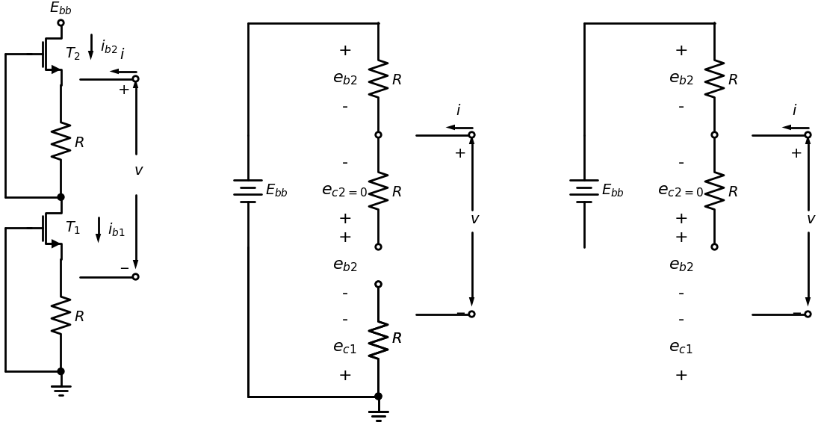
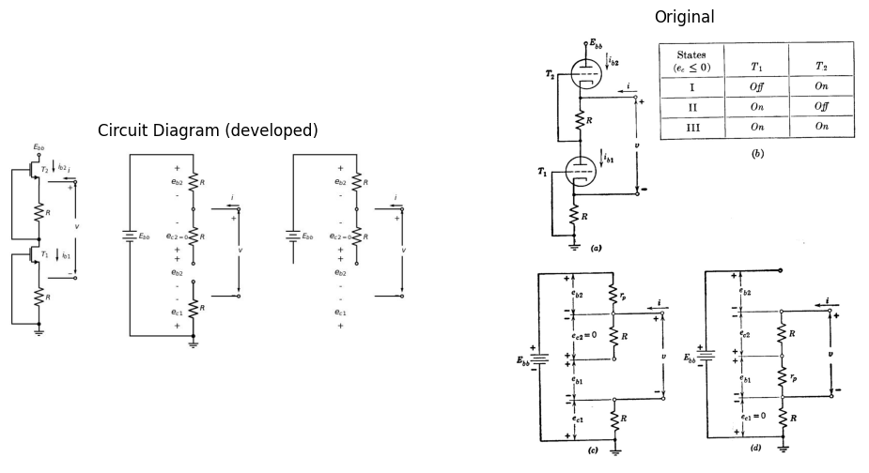

5.0.0.2 Fig 9.5. Series-connected triodes.
marks the break point between states II and III. The i vs. v curve plotted in Fig. 9.5(e) is obtained by drawing the lines for states I and II, locating the break points, and joining them to specify the state III line.

import matplotlib.pyplot as plt
import numpy as np
# Define the function for the exponential decay
def exponential_decay(t, E0, RC):
return E0 * np.exp(-t / RC)
# Parameters
E0 = 1 # Initial value
RC = 1 # Time constant
# Time values
t = np.linspace(0, 5, 400)
# Calculate the exponential decay
v = exponential_decay(t, E0, RC)
# Plotting the graph
plt.figure(figsize=(8, 6))
plt.plot(t, v, label='$v = E_0 e^{-t/RC}$')
plt.axhline(y=E0, color='k', linestyle='--')
plt.text(0, E0, '$E_0$', verticalalignment='bottom', horizontalalignment='right')
plt.xlabel('$\\frac{t}{RC}$')
plt.ylabel('$v$')
plt.title('Exponential Decay in an RC Circuit')
plt.grid(True)
plt.legend()
plt.show()
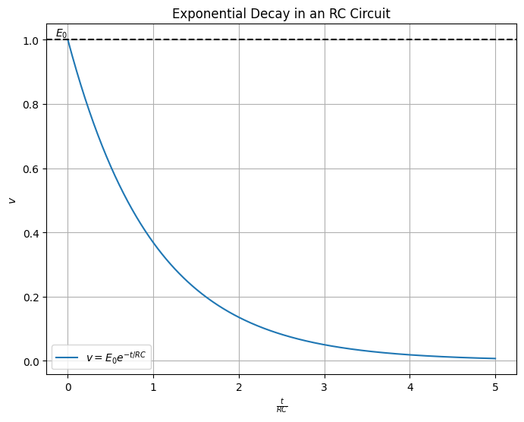

5.0.0.3 Fig. 9.6. Effects of variations in R on the i vs. v curve of the series-connected triode circuit. (a) R = 0; (b) R = r_p / (μ - 1); (c) R > r_p / (μ - 1).
The equation for i vs. v in state III can be written directly from the break-point coordinates. The intercept at E_bb / 2 is logical, in view of the circuit symmetry with i = 0 in state III. The portions of the state I and II lines that are pertinent are found by considering the values of v and i needed to hold the circuit in the specified state.
The slope of the state III line will be negative for R greater than r_p/(μ - 1). With R equal to r_p/(μ - 1), the apparent resistance in state III is zero; and for R less than this value, the resistance becomes positive, as shown in Fig. 9.6. The variation of R shows the effect of a circuit parameter on the negative-resistance curve. The effect of changing μ or r_p can be considered in a similar manner.
import schemdraw
import schemdraw.elements as elm
import matplotlib.pyplot as plt
import matplotlib.image as mpimg
import numpy as np
fig, axs = plt.subplots(1, 2, figsize=(12, 6))
with schemdraw.Drawing(show=False) as d:
d +=elm.Dot(open=True)
d += elm.Line().right().length(1.5)
d.push()
d += elm.Line().up().length(1)
d += elm.Line().right().length(2)
d += elm.Line().down().length(1)
d += elm.Line().right().length(1)
d += elm.Resistor().down().label('$R_2$','bottom')
d += elm.Line().left().length(4.5).dot(open=True)
d.pop()
d += elm.Line().down().length(1)
d += elm.Line().right().length(2)
d += elm.Line().up().length(1)
d += elm.Gap().down().label(['$R_N= -R_{1}$'] , fontsize = 12).at((2.4,1.5))
d += elm.Label('+').at((3+1.4-4.7,-0.3))
d += elm.Label('_').at((3+1.3-4.6,-2.5))
d += elm.Arrow().up().length(1.0).at((3+1-4, -1.2))
d += elm.Arrow().up().length(0.1).at((3+0.6-4, -1.6)).color('white').label('$V$', loc='bottom', color='black')
d += elm.Arrow().down().length(1.0).at((3+1-4, -1.9))
d += elm.Arrow().right().length(0.7).at((3+1.2-4, 0.3)).label('$i$')
d +=elm.Dot(open=True).at((7,0))
d += elm.Line().right().length(1.5)
d.push()
d += elm.Line().up().length(1)
d += elm.Line().right().length(2)
d += elm.Line().down().length(1)
d += elm.Line().right().length(1)
d += elm.Line().down().length(3)
d += elm.Line().left().length(4.5).dot(open=True)
d.pop()
d += elm.Line().down().length(1)
d += elm.Line().right().length(2)
d += elm.Line().up().length(1)
d += elm.Gap().down().label(['$R_N= -R_{1}$'] , fontsize = 12).at((2.4+7,1.5))
d += elm.Label('+').at((3+1.4-4.7+7,-0.3))
d += elm.Label('_').at((3+1.3-4.6+7,-2.5))
d += elm.Arrow().up().length(1.0).at((3+1-4+7, -1.2))
d += elm.Arrow().up().length(0.1).at((3+0.6-4+7, -1.6)).color('white').label('$V$', loc='bottom', color='black')
d += elm.Arrow().down().length(1.0).at((3+1-4+7, -1.9))
d += elm.Arrow().right().length(0.7).at((3+1.2-4+7, 0.3)).label('$i$')
d += elm.Resistor().down().label('$R_2$','bottom').at((7.7,0))
d.save('./Drawing/fig9.7.jpg')
d.save('./Drawing/fig9.7.svg')
img = mpimg.imread('./Drawing/fig9.7.jpg')
axs[0].imshow(img)
axs[0].axis('off')
axs[0].set_title('Circuit Diagram (developed)')
img_sample = mpimg.imread('./Images/fig9.7.jpg')
axs[1].imshow(img_sample)
axs[1].axis('off')
axs[1].set_title('Original')
plt.show()
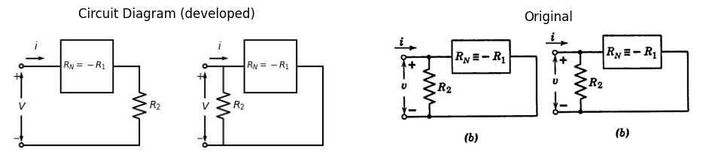
$$ R_T = \frac{dv}{di} = R_N + R_2 \\
= -R_1 + R_2
$$
(a)
$$R_{T}=\frac{dv}{di}=\frac{R_{N}R_{2}}{R_{N}+R_{2}}=\frac{R_{1}R_{2}}{R_{1}−R_{2}}$$
$$G_{T}=\frac{di}{dv}=G_{N}+G_{2}=−G_{1}+G_{2}$$
(b)

5.0.0.4 Fig. 9.7. Series and parallel combination of positive and negative linear resistances.

6 9.6 Some General Properties of Negative Resistance
The properties of negative incremental resistance are clarified when contrasted with those of positive resistance. A current produces a voltage drop in a positive resistance, and a voltage rise in a negative resistance. Positive resistance dissipates power, hence negative resistance acts as a power source in an incremental circuit model. Conservation of energy demands that any circuit that exhibits a negative resistance at a pair of terminals must draw more power from a primary source than the negative resistance can supply to a load. From this statement we infer that for any physical circuit a driving-point curve that has a negative resistance region must be nonlinear. Thus the driving-point curve at a pair of terminals may exhibit negative resistance over a limited range of current or voltage, but the apparent resistance must eventually become positive as current or voltage is increased either in the positive or negative direction. However, for the purposes of circuit analysis, it is no more artificial to postulate a linear negative resistance than to postulate a linear positive resistance.
Resistive circuit theory is readily extended to include negative resistance. For example, the sketches shown in Fig. 9.7 (a) and (b) indicate series and parallel connections of positive and negative resistances.
import schemdraw
import schemdraw.elements as e
import schemdraw as schem
import matplotlib.pyplot as plt
import matplotlib.image as mpimg
import numpy as np
fig, axs = plt.subplots(1, 2, figsize=(12, 12))
d = schemdraw.Drawing()
S1 = d.add(e.Switch().left().flip().label('$closes at$\n$t=0$',ofst=(1.4,0.2)))
C1 = d.add(e.Capacitor().down().label(['+','$C$ $E_o$','- '],ofst=-1))
R1 = d.add(e.Resistor().down().at(S1.start).label('$R$'))
l1 = d.add(e.Line().left())
d += e.Line().right().length(0.8).linewidth(0.6).at(S1.start).color('gray')
d += e.Line().right().length(0.8).linewidth(0.6).at(R1.end).color('gray')
d += e.Arrow().right().linewidth(0.6).length(0.6).color('black').label('$i$', loc='top', color='black',ofst=0.2). at((-1,0.3))
d += e.Arrow().up().length(1).linewidth(0.6).color('white').label('$V$', loc='start', color='black',ofst=0.3). at((1.2,-1.4))
d += e.Arrow().up().length(0.8).linewidth(0.6).color('black').label('+',loc='end', color='black',ofst=-0.1). at((0.8,-0.9))
d += e.Arrow().down().length(0.8).linewidth(0.6).color('black').label(r'_', loc='end', color='black',ofst=(-0.4,0.2)). at((0.8,-2.2))
d += e.Arrow().length(0.4).at((-2, 0.5)).theta(-110)
d.save('./Drawing/fig9.8.jpg')
d.save('./Drawing/fig9.8.svg')
img = mpimg.imread('./Drawing/fig9.8.jpg')
axs[0].imshow(img)
axs[0].axis('off')
axs[0].set_title('Circuit Diagram (developed)')
img_sample = mpimg.imread('./Images/fig9.8.jpg')
axs[1].imshow(img_sample)
axs[1].axis('off')
axs[1].set_title('Original')
plt.show()
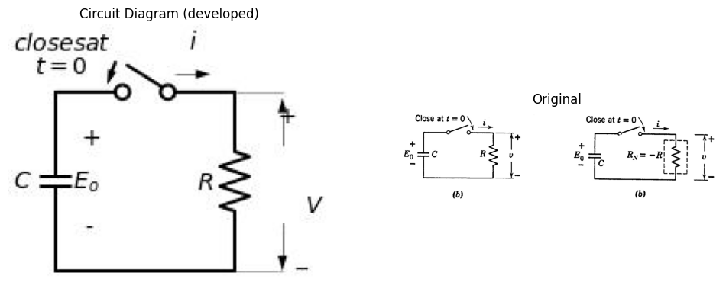

6.0.0.1 Fig. 9.8. Simple RC transients with positive and negative resistance.
In order to draw attention to a point that sometimes causes confusion, the linear negative resistance is designated both as ( R_N ) and as ( -R_1 ). Here the symbol ( R_N ) contains the negative sign implicitly, while the symbol ( R_1 ) is assumed to be a positive numeric, such as 10 kilohms. The designation with sign implicit is convenient because it leaves formulae unchanged. The designation with sign explicit is sometimes preferred.
because it emphasizes the presence of the negative resistance. From the equations we see that the total series resistance is negative if the magnitude of the negative resistance exceeds that of the positive resistance. The total parallel resistance is negative if the magnitude of the negative resistance is smaller than that of the positive resistance (negative conductance exceeds positive conductance).
The transient behavior of the basic RC circuit with negative R is indicated in Fig. 9.8. It is apparent from the voltage waveforms in (a) and (b) that changing the sign of the resistance is mathematically equivalent to changing the sign associated with time t. The waveforms of current show an additional difference. The current for positive resistance is in the positive reference direction and is a decaying exponential for t greater than zero. Thus it is a replica of the voltage waveform except for the scale factor. For negative resistance, the current is negative, since the resistance $R_{N}=−R$ appears in the scale factor as well as in the exponent. The direction of the current flow bears out the fact that a negative resistance behaves like a power source, since current emerges from the positive voltage terminal just as it does from a battery. The corresponding transient behavior for a circuit consisting of inductance and negative resistance is readily specified by duality.
The general behavior of a circuit consisting of a negative resistance and one or more energy-storage elements can be explained without reference to the details of the electronic devices and associated circuit elements from which the driving-point curve is derived. The "black-box" representation of a negative resistance circuit is shown in Fig. 9.9(a). For graphical calculations, the piecewise-linear curve shown in
import schemdraw
import schemdraw.elements as elm
import matplotlib.pyplot as plt
import matplotlib.image as mpimg
import numpy as np
fig, axs = plt.subplots(1, 2, figsize=(12, 6))
with schemdraw.Drawing(show=False) as d:
d += elm.Line().left().length(1).dot(open=True).at((3+2,0))
d += elm.Line().left().length(1).dot(open=True).at((3+2,-3))
d += elm.Line().up().length(4).at((3+2,-3.5))
d += elm.Line().right().length(2).at((3+2,0.5))
d += elm.Line().down().length(4).at((3+4,0.5))
d += elm.Line().left().length(2).at((3+4,-3.5))
d += elm.Label('+').at((3+1.4,-0.3))
d += elm.Label('_').at((3+1.3,-2.5))
d += elm.Arrow().up().length(1.0).at((3+1, -1.2))
d += elm.Arrow().up().length(0.1).at((3+0.6, -1.6)).color('white').label('$V$', loc='bottom', color='black')
d += elm.Arrow().down().length(1.0).at((3+1, -1.9))
d += elm.Arrow().right().length(0.7).at((3+1.2, 0.3)).label('$i$')
d += elm.Label('(a)').at((6-0, -4.5))
d += elm.Line().at((0.4+6, 0.4-1)).to((-0.4+6, -0.4-1))
d += elm.Line().at((-0.4+6, -0.4-1)).to((0.4+6, -1.2-1))
d += elm.Line().at((0.4+6, -1.2-1)).to((-0.4+6, -1.8-1))
d += elm.Dot(open=True).at((3+2+5,0))
d += elm.Resistor().right().label('$R_j$','bottom')
d += elm.Battery().label('$E_{j}$', loc='bottom').down()
d += elm.Line().left().length(3).dot(open=True)
d += elm.Label('+').at((3+1.4+5,-0.3))
d += elm.Label('_').at((3+1.3+5,-2.5))
d += elm.Arrow().up().length(1.0).at((3+1+5, -1.2))
d += elm.Arrow().up().length(0.1).at((3+0.6+5, -1.6)).color('white').label('$V$', loc='bottom', color='black')
d += elm.Arrow().down().length(1.0).at((3+1+5, -1.9))
d += elm.Arrow().right().length(0.7).at((3+1.2+5+1, 0.3)).label('$i$')
d += elm.Label('(b)').at((5+6-0, -4.5))
d.save('./Drawing/fig9.9.jpg')
d.save('./Drawing/fig9.9.svg')
img = mpimg.imread('./Drawing/fig9.9.jpg')
axs[0].imshow(img)
axs[0].axis('off')
axs[0].set_title('Circuit Diagram (developed)')
img_sample = mpimg.imread('./Images/fig9.9.jpg')
axs[1].imshow(img_sample)
axs[1].axis('off')
axs[1].set_title('Original')
plt.show()
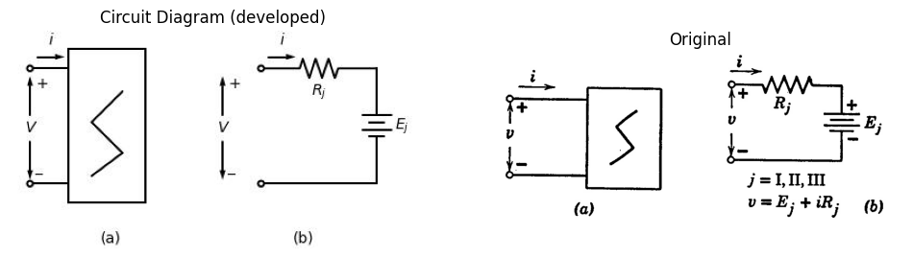
import matplotlib.pyplot as plt
import numpy as np
# Define the points
E_I = 1
E_III = 0.5
E_II = 0
# Define the resistances (slopes)
R_I = -1
R_III = 1
R_II = 2
# Create the plot
fig, ax = plt.subplots()
# Plot the lines
v = np.linspace(-1, 2, 400)
ax.plot(v, R_I * (v - E_I), label='$R_I$')
ax.plot(v, R_III * (v - E_III), label='$R_{III}$')
ax.plot(v, R_II * (v - E_II), label='$R_{II}$')
# Plot the points
ax.plot(E_I, 0, 'o', label='$E_I$')
ax.plot(E_III, 0, 'o', label='$E_{III}$')
ax.plot(E_II, 0, 'o', label='$E_{II}$')
# Add labels and title
ax.set_xlabel('$v$')
ax.set_ylabel('$i$')
ax.axhline(0, color='black', linewidth=0.5)
ax.axvline(0, color='black', linewidth=0.5)
ax.grid(color='gray', linestyle='--', linewidth=0.5)
ax.legend()
# Show the plot
plt.show()
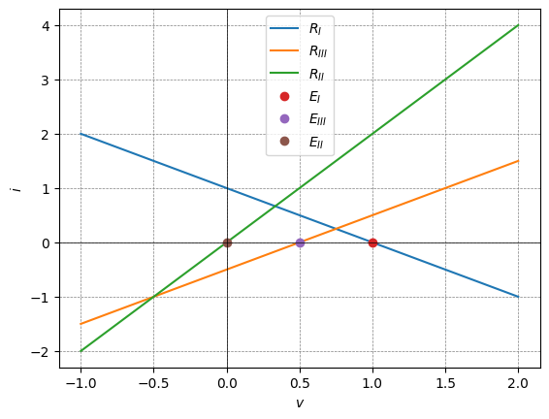

6.0.0.2 Fig. 9.9. Representation of a piece-wise-linear driving-point resistance.
Fig. 9.9(b) is convenient. The analytical counterpart of this curve is the circuit model shown in (c), where the subscript j represents the various circuit states. This is the linear model for any one region of either a current-controlled or a voltage-controlled curve.
import schemdraw
import schemdraw.elements as elm
import matplotlib.pyplot as plt
import matplotlib.image as mpimg
import numpy as np
fig, axs = plt.subplots(1, 2, figsize=(12, 6))
with schemdraw.Drawing(show=False) as d:
d += elm.Line().left().length(1).dot(open=True).at((3+2,0))
d += elm.Line().left().length(1).dot(open=True).at((3+2,-3))
d += elm.Line().up().length(4).at((3+2,-3.5))
d += elm.Line().right().length(2).at((3+2,0.5))
d += elm.Line().down().length(4).at((3+4,0.5))
d += elm.Line().left().length(2).at((3+4,-3.5))
d += elm.Label('+').at((3+1.4,-0.3))
d += elm.Label('_').at((3+1.3,-2.5))
d += elm.Arrow().up().length(1.0).at((3+1, -1.2))
d += elm.Arrow().up().length(0.1).at((3+0.6, -1.6)).color('white').label('$V$', loc='bottom', color='black')
d += elm.Arrow().down().length(1.0).at((3+1, -1.9))
d += elm.Arrow().right().length(0.7).at((3+1.2, 0.3)).label('$i$')
d += elm.Switch().left().flip().label('$closes at$\n$t=0$',ofst=(1.4,-0.2)).at((4,-0))
d += elm.Line().left().length(1)
d += elm.Capacitor().down().label(['+','$C$ $e_x$','- '],ofst=-1)
d += elm.Line().right().length(4)
d += elm.Arrow().up().length(0.7).at((-.2, -0.5)).label('$i_x$')
d += elm.Line().at((0.4+6, 0.4-1)).to((-0.4+6, -0.4-1))
d += elm.Line().at((-0.4+6, -0.4-1)).to((0.4+6, -1.2-1))
d += elm.Line().at((0.4+6, -1.2-1)).to((-0.4+6, -1.8-1))
d.save('./Drawing/fig9.10.jpg')
d.save('./Drawing/fig9.10.svg')
img = mpimg.imread('./Drawing/fig9.10.jpg')
axs[0].imshow(img)
axs[0].axis('off')
axs[0].set_title('Circuit Diagram (developed)')
img_sample = mpimg.imread('./Images/fig9.10.jpg')
axs[1].imshow(img_sample)
axs[1].axis('off')
axs[1].set_title('Original')
plt.show()
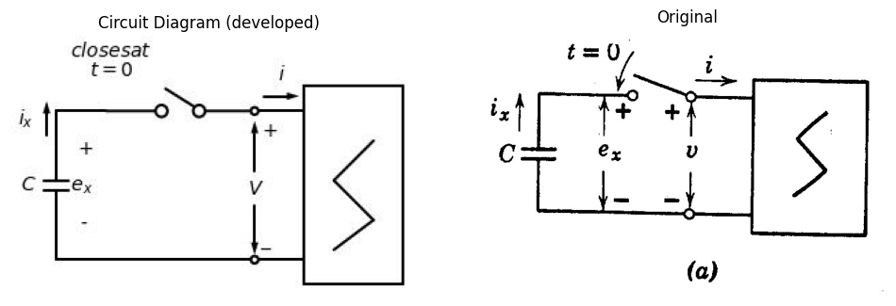

6.0.0.3 Fig. 9.10. Current-controlled curve with capacitance load.

7 9.7 A Simple Relaxation Oscillator
Suppose an initially uncharged capacitance is connected to a current-controlled negative resistance at ( t = 0 ) as indicated in Fig. 9.10(a).
Since the capacitor voltage cannot be changed instantaneously by finite currents, at t = 0 we have capacitor voltage e_x and therefore voltage v both equal to zero. This condition can be satisfied only at point A' on the i vs. v plane shown in (b).
At point A', the current i has a large negative value; hence dv/dt is positive, and the capacitor tends to charge. Thus the operating point moves from A' through A toward B. We can see from the plot that, as the operating point moves along the state I line, the negative current diminishes as the voltage increases. This means that dv/dt decreases as v increases. The state I line corresponds to a resistance R_I in series with a battery E_I. With a capacitor C connected, the voltage v will rise exponentially toward E_I as current i proceeds exponentially toward zero with a time constant of R_I C. The waveforms of voltage v(t) and current i(t) are shown with the v and i axes aligned with the i vs. v plane [(c) and (d)]. For completeness, v(t) is also shown below i(t) with the time axes aligned. See Fig. 9.10(e).
When the operating point reaches B in the i vs. v plane, the current i is still negative and dv/dt still positive, but any motion beyond point B (in state I) fails to satisfy the relation i = f(v). The relation between capacitor voltage and current cannot be satisfied by moving the operating point along the state III line from point B, since the necessary decrease in v cannot take place with negative current. We conclude, therefore, that the operating point of the resistive circuit must switch instantaneously from B to C, where equilibrium can again be established for both the capacitor and the negative-resistance circuit. The transition from B to C takes place along a vertical line, since the capacitor voltage cannot change instantaneously. In this idealized circuit there is no constraint to prevent the instantaneous change of current from a negative value at B to a positive value at C.
At point C, dv/dt is negative, because the current i is positive. Since the state II line passes through the origin, the circuit model for this state is merely the positive resistance R_II. Both v and i approach zero exponentially with a time constant R_II C. The operating point moves from C to D, where a downward transition to A must occur. The reasoning is similar to that described for the B to C transition. At point A, the capacitor voltage begins to increase again and the operation proceeds continuously around the locus ABCD. Thus, except for the first interval, the waveforms i(t) and v(t) are repetitive.
The intervals δ_1 and δ_2, during which the resistive circuit is in state I and state II, respectively, can be calculated from the time constants R_I C and R_II C and the initial and final values of the exponentials. The expressions for the intervals are given in (f).
Let us take as a specific example of a relaxation oscillator the series triode circuit of Fig. 9.5(a) with capacitor connected to the driving-point terminals, as shown in Fig. 9.11. It is evident that the amplitude dimensions on the waveforms of (v(t)) and (i(t)) are obtainable directly
import schemdraw
import schemdraw.elements as elm
import matplotlib.pyplot as plt
import matplotlib.image as mpimg
import numpy as np
fig, axs = plt.subplots(1, 2, figsize=(12, 6))
with schemdraw.Drawing(show=False) as d:
d += elm.Dot(open=True).label('$E_{bb}$','top')
d += (M := elm.AnalogNFet(offset_gate = False).reverse().right().label('$T_2$','right'))
d += elm.Resistor().down().at(M.source).label('$R$','bottom').dot()
d.push()
d += (M := elm.AnalogNFet(offset_gate = False).reverse().right().label('$T_1$','right'))
d.pop()
d += elm.Line().left().length(1.5)
d += elm.Line().up().length(3.84)
d += elm.Line().right().length(1.2-0.5)
d += elm.Resistor().down().at(M.source).label('$R$','bottom').dot()
d.push()
d += elm.Ground()
d.pop()
d += elm.Line().left().length(2-0.5)
d += elm.Line().up().length(3.84)
d += elm.Line().right().length(1.2-0.5)
d += elm.Label('+').at((-2.4+6,0.2-2.1))
d += elm.Label('_').at((-2.4+6,-4.8-1.7))
d += elm.Arrow().up().length(2.0).at((-2+6, -1.4-2.1))
d += elm.Arrow().up().length(0.1).at((-2.3+6, -2.3-1.7)).color('white').label('$v$', loc='bottom', color='black')
d += elm.Arrow().down().length(2.0).at((-2+6, -2.9-1.7))
d += elm.Line().right().length(1.5).at((0.5+2,-1.5)).dot(open=True)
d += elm.Line().right().length(1.5).at((0.5+2,-6.8)).dot(open=True)
d += elm.Arrow().left().length(0.7).at((2+2, -1.3)).label('$i$')
d += elm.Arrow().down().length(0.7).at((0.8, -0.3)).label('$i_{b2}$',loc='bottom')
d += elm.Arrow().down().length(0.7).at((1, -5.2)).label('$i_{b1}$',loc='bottom')
d += elm.Gap().up().label(['\u2193',' ',' ',' ',' ',' ',' ',' ',' ', '$e_1$' ,' ',' ',' ',' ',' ',' ',' ',' ','\u2191'] ,
fontsize = 16).color('black').at((-2,-9))
d += elm.Gap().up().label(['\u2193',' ',' ',' ',' ', '$e_{k1}$' ,' ',' ',' ',' ','\u2191'] ,
fontsize = 14).color('black').at((2+2,-10))
d += elm.Line().right().length(1.8).at((0,-1.8))
d += elm.Line().down().length(1)
d += elm.Capacitor().down().label('$C$','bottom')
d += elm.Line().down().length(1)
d += elm.Line().left().length(1.8)
d += elm.Battery().label('$E_{bb}$', loc='top').up().reverse().at((0,-15))
d += elm.Resistor().right().label('$State_1$','top')
d += elm.Capacitor().down().label('$C$','bottom')
d += elm.Line().left().length(3)
d += elm.Resistor().up().label('$R+r_p$','top').at((6,-15))
d += elm.Line().right().length(2).label('$State_2$','top')
d += elm.Capacitor().down().label('$C$','bottom')
d += elm.Line().left().length(2)
d.save('./Drawing/fig9.11.jpg')
d.save('./Drawing/fig9.11.svg')
img = mpimg.imread('./Drawing/fig9.11.jpg')
axs[0].imshow(img)
axs[0].axis('off')
axs[0].set_title('Circuit Diagram (developed)')
img_sample = mpimg.imread('./Images/fig9.11.jpg')
axs[1].imshow(img_sample)
axs[1].axis('off')
axs[1].set_title('Original')
plt.show()
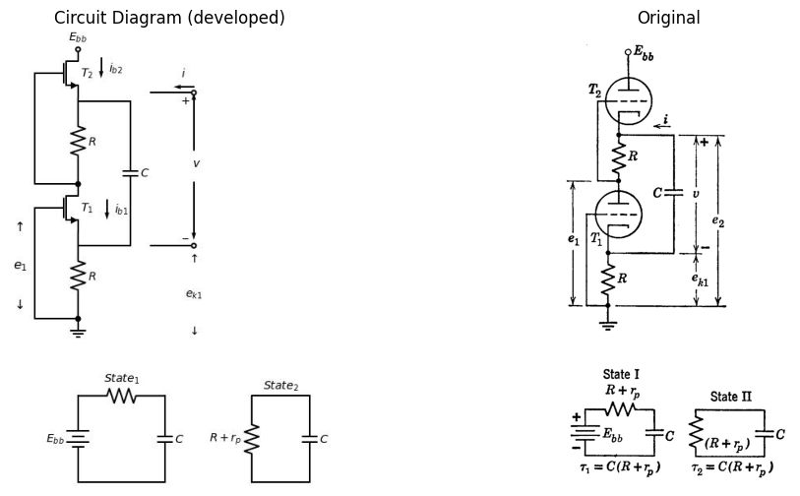

7.0.0.1 Fig. 9.11. Waveforms in series-triode relaxation oscillator.
from the i vs. v curve given in Fig. 9.5(e). Dimensions of all other waveforms in the circuit are readily found from these. In a similar manner, the general results obtained in Fig. 9.10 can be applied to other circuits in which a capacitor faces a current-controlled driving-point curve. Using the duality principle, the results can also be applied to circuits with a voltage-controlled curve and inductance as the major energy-storage element.

8 9.8 Relaxation Oscillator Transition Time
As the operating point moves around the locus ABCD in Fig. 9.10(b), the capacitor voltage is identical with the voltage across the negative resistance circuit during the intervals δ₁ (A to B) and δ₂ (C to D). However, during the instantaneous transitions (B to C and D to A), the capacitor voltage deviates from the voltage across the negative resistance, even though the voltages are measured between the same two points. This irregularity was ignored in the preceding article on the basis that it literally did not exist with instantaneous transitions. The anomaly of two different voltages apparently existing between the same two points is the result of over-idealizing the circuit.
In order to examine the transitions between state I and state II in detail, let us consider the circuit of Fig. 9.12(a). Here a small series inductance representing the inductance of the interconnecting wires is included to absorb the difference between v and eₓ when di/dt is large. With inductance L very small, the transitions will still be quite rapid, though not instantaneous. The charge on capacitor C will remain essentially constant during the transition time, hence the capacitor can be replaced by a battery for this interval. We see from the i vs. v plot that the transition occurs in two distinct stages corresponding to states III and II. The two circuits for the transition from B to C are shown in Fig. 9.12(b) and (c). Note that the plots of waveforms i(t) and e_L(t) in this figure are drawn to a time scale which is radically expanded relative to the time scale used for the waveforms of Fig. 9.10 or 9.11. For convenience, assume t = 0 corresponds to the time the operating point (i vs. eₓ) reaches B on the locus.
We postulate L to be so small that it does not influence the behavior of the circuit during the intervals δ₁ and δ₂. This implies that e_L is negligibly small except at the transitions. The current i has a value -I_B and a rate of change
$$\frac{di}{dt}=\frac{I_{B}}{R_{I}C}$$
(9.3)
at the break point B, so the actual value of e_L at B is
$$e_{L}=−\frac{LI_{B}}{R_{I}C}$$
(9.4)
From these initial conditions, both e_L and i build up along rising exponentials, since the circuit model for v = f(i) involves the negative resistance (-R_III) in state III, as indicated by (b). The current goes through zero and positive to (I_D), while (e_L) builds up to a maximum of ((E_y - E_x)) at break point (D). When point (P) is reached on the locus,
import schemdraw
import schemdraw.elements as elm
import matplotlib.pyplot as plt
import matplotlib.image as mpimg
import numpy as np
fig, axs = plt.subplots(1, 2, figsize=(12, 6))
with schemdraw.Drawing(show=False) as d:
d += elm.Line().left().length(1).dot(open=True).at((3+2,0))
d += elm.Line().left().length(1).dot(open=True).at((3+2,-3))
d += elm.Line().up().length(4).at((3+2,-3.5))
d += elm.Line().right().length(2).at((3+2,0.5))
d += elm.Line().down().length(4).at((3+4,0.5))
d += elm.Line().left().length(2).at((3+4,-3.5))
d += elm.Label('+').at((3+1.4,-0.3))
d += elm.Label('_').at((3+1.3,-2.5))
d += elm.Arrow().up().length(1.0).at((3+1, -1.2))
d += elm.Arrow().up().length(0.1).at((3+0.6, -1.6)).color('white').label('$V$', loc='bottom', color='black')
d += elm.Arrow().down().length(1.0).at((3+1, -1.9))
d += elm.Arrow().right().length(0.7).at((3+1.2, 0.3)).label('$i$')
d += elm.Inductor2().left().flip().label('$L$').at((4,-0))
d += elm.Line().left().length(1)
d += elm.Capacitor().down().label(['+','$C$ $e_x$','- '],ofst=-1)
d += elm.Line().right().length(4)
d += elm.Label('(a)').at((3, -4))
d += elm.Line().at((0.4+6, 0.4-1)).to((-0.4+6, -0.4-1))
d += elm.Line().at((-0.4+6, -0.4-1)).to((0.4+6, -1.2-1))
d += elm.Line().at((0.4+6, -1.2-1)).to((-0.4+6, -1.8-1))
d += elm.Line().left().length(1).dot(open=True).at((3+2,-6))
d += elm.Line().left().length(1).dot(open=True).at((3+2,-6))
d += elm.Line().up().length(4).at((3+2,-3.5-6))
d += elm.Line().right().length(2).at((3+2,0.5-6))
d += elm.Line().down().length(4).at((3+4,0.5-6))
d += elm.Line().left().length(2).at((3+4,-3.5-6))
d += elm.Label('+').at((3+1.4,-0.3-6))
d += elm.Label('_').at((3+1.3,-2.5-6))
d += elm.Arrow().up().length(1.0).at((3+1, -1.2-6))
d += elm.Arrow().up().length(0.1).at((3+0.6, -1.6-6)).color('white').label('$V$', loc='bottom', color='black')
d += elm.Arrow().down().length(1.0).at((3+1, -1.9-6))
d += elm.Arrow().right().length(0.7).at((3+1.2, 0.3-6)).label('$i$')
d += elm.Inductor2().left().flip().label(['+','$e_L$','- '],ofst=0.5).at((4,-6))
d += elm.Battery().down().label(['+','$E_y$','- '],ofst=0.3)
d += elm.Line().right().length(4)
d += elm.Line().right().length(1)
d += elm.Battery().up().label('$E_III$', loc='bottom').reverse().scale(0.7).length(1)
d += elm.Resistor().up().scale(0.7).length(2).label('$-R_{III}$',loc='bottom')
d += elm.Line().left().length(1)
d += elm.Label('(b)').at((3, -10))
d += elm.Line().left().length(1).dot(open=True).at((3+2,-12))
d += elm.Line().left().length(1).dot(open=True).at((3+2,-12))
d += elm.Line().up().length(4).at((3+2,-3.5-12))
d += elm.Line().right().length(2).at((3+2,0.5-12))
d += elm.Line().down().length(4).at((3+4,0.5-12))
d += elm.Line().left().length(2).at((3+4,-3.5-12))
d += elm.Label('+').at((3+1.4,-0.3-12))
d += elm.Label('_').at((3+1.3,-2.5-12))
d += elm.Arrow().up().length(1.0).at((3+1, -1.2-12))
d += elm.Arrow().up().length(0.1).at((3+0.6, -1.6-12)).color('white').label('$V$', loc='bottom', color='black')
d += elm.Arrow().down().length(1.0).at((3+1, -1.9-12))
d += elm.Arrow().right().length(0.7).at((3+1.2, 0.3-12)).label('$i$')
d += elm.Inductor2().left().flip().label(['+','$e_L$','- '],ofst=0.5).at((4,-12))
d += elm.Battery().down().label(['+','$E_y$','- '],ofst=0.3)
d += elm.Line().right().length(4)
d += elm.Line().right().length(1)
d += elm.Resistor().up().scale(0.9).length(3).label('$-R_{II}$',loc='bottom')
d += elm.Line().left().length(1)
d += elm.Label('(c)').at((3, -17))
d.save('./Drawing/fig9.12.jpg')
d.save('./Drawing/fig9.12.svg')
img = mpimg.imread('./Drawing/fig9.12.jpg')
axs[0].imshow(img)
axs[0].axis('off')
axs[0].set_title('Circuit Diagram (developed)')
img_sample = mpimg.imread('./Images/fig9.12.jpg')
axs[1].imshow(img_sample)
axs[1].axis('off')
axs[1].set_title('Original')
plt.show()
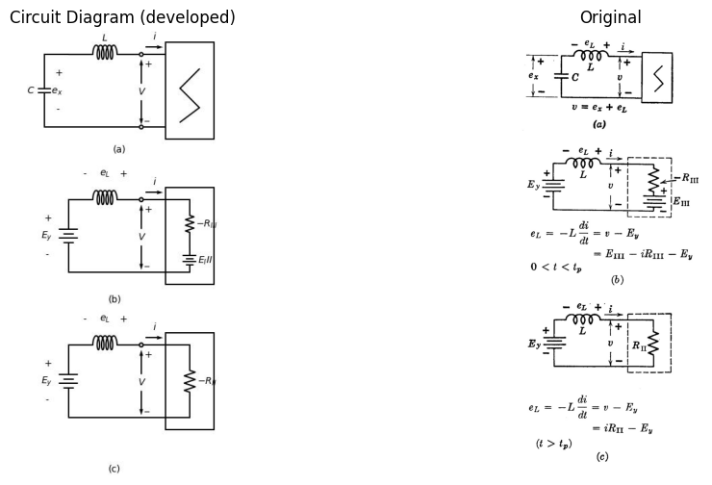

8.0.0.1 Fig. 9.12. Relaxation oscillator transition time. (t = 0 corresponds to point B.)
The circuit switches from state III to state II. As the transition proceeds from P to C, voltage e_L decays exponentially to zero with time constant "L/R_II, while i builds up to I_c with the same time constant L/R_{11}, while i builds up to I_c with the same time constant. The voltage e_L is continuous at point P; hence di/dt must be continuous. The rate of change of voltage (de_L/dt) has no such restraint, hence the cusp at point P. The time t_p required to reach point P can be calculated as the time required for current i to go from -I_B to +I_D, or for e_L to build up from (L I_B/R_IC) to (E_y - E_x). The total transition time can be taken to be approximately t_p + 5 L/R_II.
As L decreases, the time scale shrinks on the transition waveforms. As L approaches zero, di/dt increases toward infinity in a manner that makes e_L always increase to (E_y - E_x) and return to zero. Hence, even when L does not appear in the circuit, we can envision the "instantaneous" transition involving a voltage drop e_L which just accounts for the difference between v and e_x.
The transition from D to A is readily obtained by the procedure just outlined for the transition from B to C. In the circuit model of Fig. 9.12(b), we need only change the voltage representing capacitor voltage from E_y to E_x. This change must also be made in the circuit of Fig. 9.12(c); and, in addition, R_II must be replaced by R_I.
Separate consideration of the effects of the major energy-storage element C and the stray element L is valid when the time constant involving C is much greater than that involving L. The procedure is similar to that used in analyzing the RC coupling circuit in the preceding chapter, where the effects of coupling capacitance and shunt capacitances were considered separately. In a qualitative way, the stray inductance inserted in the oscillator circuit to make transition time nonzero approximates the effects of interelectrode and wiring capacitances within the circuit that produces the negative driving-point resistance. The analysis of stray effects in terms of a single series inductance is very much simpler than one that considers the energy-storage elements actually associated with the circuit that produces the negative resistance.

9 9.9 Relaxation Oscillator Locus and Waveforms with Nonzero Transition Time
From the results of Fig. 9.12 we can now see how the locus and waveforms of Fig. 9.10 must be modified when both a large capacitance C and a small inductance L are included in the oscillator circuit. Since the inductance is expected to produce only a minor modification, we begin from the locus and waveforms obtained with the inductance absent. This locus is indicated by the dashed lines in Fig. 9.13, while the solid line shows the qualitative effects of including a small inductance L.
The relations given in Fig. 9.13(a) suffice to trace the modified locus of i vs. e_x shown in (b) and the waveforms shown in (c), (d), and (e).
import schemdraw
import schemdraw.elements as elm
import matplotlib.pyplot as plt
import matplotlib.image as mpimg
import numpy as np
fig, axs = plt.subplots(1, 2, figsize=(12, 6))
with schemdraw.Drawing(show=False) as d:
d += elm.Line().left().length(1).dot(open=True).at((3+2,0))
d += elm.Line().left().length(1).dot(open=True).at((3+2,-3))
d += elm.Line().up().length(4).at((3+2,-3.5))
d += elm.Line().right().length(2).at((3+2,0.5))
d += elm.Line().down().length(4).at((3+4,0.5))
d += elm.Line().left().length(2).at((3+4,-3.5))
d += elm.Label('+').at((3+1.4,-0.3))
d += elm.Label('_').at((3+1.3,-2.5))
d += elm.Arrow().up().length(1.0).at((3+1, -1.2))
d += elm.Arrow().up().length(0.1).at((3+0.6, -1.6)).color('white').label('$V$', loc='bottom', color='black')
d += elm.Arrow().down().length(1.0).at((3+1, -1.9))
d += elm.Arrow().right().length(0.7).at((3+1.2, 0.3)).label('$i$')
d += elm.Inductor().left().flip().label('$L$').at((4,-0))
d += elm.Line().left().length(1)
d += elm.Capacitor().down().label(['+','$C$ $e_x$','- '],ofst=-1)
d += elm.Line().right().length(4)
d += elm.Label('(a)').at((3, -4))
d += elm.Line().at((0.4+6, 0.4-1)).to((-0.4+6, -0.4-1))
d += elm.Line().at((-0.4+6, -0.4-1)).to((0.4+6, -1.2-1))
d += elm.Line().at((0.4+6, -1.2-1)).to((-0.4+6, -1.8-1))
d.save('./Drawing/fig9.13.jpg')
d.save('./Drawing/fig9.13.svg')
img = mpimg.imread('./Drawing/fig9.13.jpg')
axs[0].imshow(img)
axs[0].axis('off')
axs[0].set_title('Circuit Diagram (developed)')
img_sample = mpimg.imread('./Images/fig9.13.jpg')
axs[1].imshow(img_sample)
axs[1].axis('off')
axs[1].set_title('Original')
plt.show()
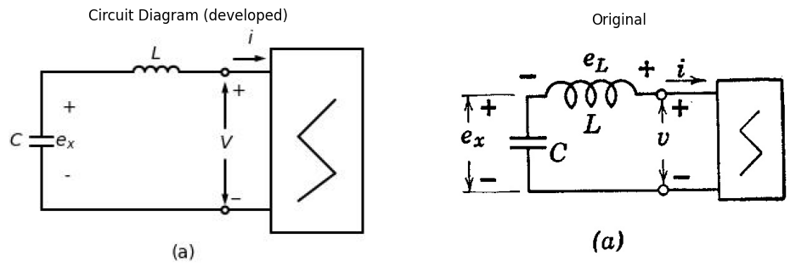
\begin{align} i &= f(v) \ i &= -C \frac{de_x}{dt} \ e_L &= -L \frac{di}{dt} \ e_L &= v - e_x \end{align}

9.0.0.1 Fig. 9.13. Relaxation oscillator with nonzero transition time.
Beginning at $t=0$ (point 0) with $i=0$ and $e_{x}=0$, we have $e_{L}=E_{III}$. Since current $i=0$, the slope of the capacitance voltage $\left(\frac{de_{x}}{dt}\right)$ is zero at $t=0$. The slope of the current waveform is $\frac{di}{dt}=−\frac{E_{III}}{L}$,
hence current starts to build up in the negative direction. As it does, $v$ increases faster than $e_{x}$, causing $e_{L}$ to increase until it reaches a maximum nearly equal to $E_{y}$ at point 1. Here the current waveform will have its maximum negative slope ($di/dt≈−E_{y}/L$). During this rapid transition, the capacitor voltage changes only very slightly.
Beyond point 1, $e_{L}$ diminishes; but since it is still positive, $di/dt$ remains negative and decreases to zero with $e_{L}$ at point 2. The current $i$ has its maximum negative value here so that $de_{x}/dt$ is a maximum, and the waveform $e_{x}\left(t\right)$ has its point of maximum slope. With $de_{x}/dt$ nonzero and $di/dt$ zero at this point, $di/de_{x}$ is zero. In other words, the locus of $i$ vs. $e_{x}$ crosses the curve $v=f\left(i\right)$ with zero slope. Beyond point 2 the magnitude of the modified current exceeds that of the exponential obtained with only $C$ in the circuit. This fact predicts a crossover of the exponential and the modified waveforms of $e_{x}$, for the integral of the modified current will eventually exceed the integral of the exponential current. The crossover will occur where the areas under the two current waveforms become equal.
We can logically say that point 2 marks the end of the rapid transition and after passing this point we have $e_{L}$ negative and $di/dt$ positive. As the magnitude of the current diminishes, its rate of change must also diminish, since the exponential change of the capacitance dominates the circuit behavior during this portion of the charging interval. Thus we have a maximum of $di/dt$ at point 3, a corresponding negative maximum for $e_{L}$ and a maximum of $d^{2}e_{x}/dt^{2}$.
Approaching break-point $B$, we have $di/dt$ nearly the same for the exponential and the modified current waveforms. This gives us a good approximation for the value of $e_{L}$ at point 4 which is located at $−I_{B}$ and marks the beginning of another rapid transition. Beyond point 4, the inductance voltage $e_{L}$ goes rapidly to a large negative value, causing $di/dt$ to increase rapidly. Prior to reaching point 5, the current has been negative; hence $de_{x}/dt$ has been positive. At point 5, $i=0$, $de_{x}/dt=0$, hence $e_{x}$ has reached a maximum. The locus of $i$ vs. $e_{x}$ must be moving vertically ($di/de_{x}=∞$) at point 5, since $de_{x}/dt$ is zero, whereas $di/dt$ is nonzero.
Point 6 is at the negative peak of $e_{L}$ corresponding to a maximum of $di/dt$, and at point 7, $e_{L}$ and $di/dt$ are zero. At point 8, $e_{L}$ reaches a maximum (analogous to point 3) and current $i$ therefore has a maximum slope. Point 9, analogous to point 4, marks the beginning of a transition which takes the path of operation through points 10, 11, and 12 in rapid succession. At point 10 (analogous to 5) we have zero current and hence minimum $e_{x}$; at point 11, a maximum $e_{L}$ which produces maximum $di/dt$. At point 12, $di/dt$, $e_{L}$, and $di/de_{x}$ are all zero. Sometime after.
point 12, the path of operation very nearly merges with the path followed previously and the waveforms and locus become essentially repetitive. The shape of the waveform of $e_{L}$ is seen to be a series of pulses which approximate impulses. If inductance $L$ is allowed to approach zero, these pulses indeed approach impulses with area just equal to that required to jump the current $i$ from point $B$ to point $C$ or from $D$ to $A$. The voltage $e_{L}$ would then be zero between impulses, since $L$ is zero and $\frac{di}{dt}$ is finite.
We have described a general relaxation oscillator based on a current- controlled negative resistance which, together with a capacitance, determines the intervals $δ_{1}$ and $δ_{2}$. A small series inductance approxi- mates the effects of stray energy-storage elements which limit the rate of transition from one state to another. Comparable results are obtained for the dual of this circuit which is a voltage-controlled negative resist- nance and an inductance. A small parallel capacitance accounts for the finite transition time.

10 9.10. Shifting from Astable to Monostable Operation
Minor modification of the circuits used for generating relaxation oscillations (astable circuits) makes them operate in a monostable or bistable mode. A \textit{monostable} circuit is stable in one state only. An external signal must be applied to switch to the unstable state. The circuit then switches itself back to the stable state and remains there until another external signal causes the cycle of operation to repeat. A \textit{bistable} circuit has two stable states, and remains in either state unless an externally applied signal causes a transition.
Relaxation oscillations occur when a circuit has no stable states. Referring to Fig. 9.10 or Fig. 9.13, we see that the charging of capacitor $C$ tends to drive the circuit out of state I, through III, and into II. The capacitor then discharges, driving the circuit out of state II, through III, and into I, and the cycle repeats. To obtain monostable operation, we need only modify the circuit in such a way that the exponential charge or discharge of capacitor $C$ can reach completion ($i=0$) before a transition occurs.
As indicated in Fig. 9.14(a), the relaxation oscillator circuit is in equilibrium at point $P$, since we have $e_{x}=v$, and $i=−C\frac{dv}{dt}=0$. This, however, is a point of unstable equilibrium, since the slightest deviation from $P$ will result in a motion of the operating point away from $P$. A minute positive current tends to decrease the charge on capacitor $C$, thus diminishing $v$, and increasing the current. To produce
a stable equilibrium, the point ( P ) for which capacitor current is zero must be shifted to state I or state II. Such a shift requires a direct-current bias source as indicated in Fig. 9.14(b). Here the capacitor current is $\left(i+i_{0}\right)$, which will be zero when ( i = -i_0 ); hence the point ( P )
import schemdraw
import schemdraw.elements as elm
import matplotlib.pyplot as plt
import matplotlib.image as mpimg
import numpy as np
fig, axs = plt.subplots(1, 2, figsize=(12, 6))
with schemdraw.Drawing(show=False) as d:
d += elm.Line().left().length(1).at((3+2,0))
d += elm.Line().left().length(1).at((3+2,-3))
d += elm.Line().up().length(4).at((3+2,-3.5))
d += elm.Line().right().length(2).at((3+2,0.5))
d += elm.Line().down().length(4).at((3+4,0.5))
d += elm.Line().left().length(2).at((3+4,-3.5))
d += elm.Label('+').at((3+1.4,-0.3))
d += elm.Label('_').at((3+1.3,-2.5))
d += elm.Arrow().up().length(1.0).at((3+1, -1.2))
d += elm.Arrow().up().length(0.1).at((3+0.6, -1.6)).color('white').label('$V$', loc='bottom', color='black')
d += elm.Arrow().down().length(1.0).at((3+1, -1.9))
d += elm.Arrow().right().length(0.7).at((3+1.2, 0.3)).label('$i$')
d += elm.Line().left().at((4,-0))
d += elm.Line().left().length(1)
d += elm.Capacitor().down().label('$C$')
d += elm.Line().right().length(4)
d += elm.Label('(a)').at((3, -4))
d += elm.Line().at((0.4+6, 0.4-1)).to((-0.4+6, -0.4-1))
d += elm.Line().at((-0.4+6, -0.4-1)).to((0.4+6, -1.2-1))
d += elm.Line().at((0.4+6, -1.2-1)).to((-0.4+6, -1.8-1))
d += elm.Line().left().length(1).at((3+2,0-5))
d += elm.Line().left().length(1).at((3+2,-3-5))
d += elm.Line().up().length(4).at((3+2,-3.5-5))
d += elm.Line().right().length(2).at((3+2,0.5-5))
d += elm.Line().down().length(4).at((3+4,0.5-5))
d += elm.Line().left().length(2).at((3+4,-3.5-5))
d += elm.Label('+').at((3+1.4,-0.3-5))
d += elm.Label('_').at((3+1.3,-2.5-5))
d += elm.Arrow().up().length(1.0).at((3+1, -1.2-5))
d += elm.Arrow().up().length(0.1).at((3+0.6, -1.6-5)).color('white').label('$V$', loc='bottom', color='black')
d += elm.Arrow().down().length(1.0).at((3+1, -1.9-5))
d += elm.Arrow().right().length(0.7).at((3+1.2, 0.3-5)).label('$i$')
d += elm.Line().left().at((4,-0-5))
d += elm.Line().left().length(1)
d += elm.Capacitor().down().label('$C$')
d += elm.Line().right().length(4)
d += elm.Label('(b)').at((3, -4-5))
d += elm.Line().at((0.4+6, 0.4-1-5)).to((-0.4+6, -0.4-1-5))
d += elm.Line().at((-0.4+6, -0.4-1-5)).to((0.4+6, -1.2-1-5))
d += elm.Line().at((0.4+6, -1.2-1-5)).to((-0.4+6, -1.8-1-5))
d += elm.SourceI().at((2, -5)).down().label('$i_O$')
d += elm.Arrow().right().length(0.7).at((3+1.2-4, 0.3-5)).label('$i+i_o$')
d += elm.Line().left().length(1).at((3+2,0-10))
d += elm.Line().left().length(1).at((3+2,-3-10))
d += elm.Line().up().length(4).at((3+2,-3.5-10))
d += elm.Line().right().length(2).at((3+2,0.5-10))
d += elm.Line().down().length(4).at((3+4,0.5-10))
d += elm.Line().left().length(2).at((3+4,-3.5-10))
d += elm.Label('+').at((3+1.4,-0.3-10))
d += elm.Label('_').at((3+1.3,-2.5-10))
d += elm.Arrow().up().length(1.0).at((3+1, -1.2-10))
d += elm.Arrow().up().length(0.1).at((3+0.6, -1.6-10)).color('white').label('$V$', loc='bottom', color='black')
d += elm.Arrow().down().length(1.0).at((3+1, -1.9-10))
d += elm.Arrow().right().length(0.7).at((3+1.2, 0.3-10)).label('$i$')
d += elm.Line().left().at((4,-0-10))
d += elm.Line().left().length(1)
d += elm.Capacitor().down().label('$C$')
d += elm.Line().right().length(4)
d += elm.Label('(c)').at((3, -4-10))
d += elm.Line().at((0.4+6, 0.4-1-10)).to((-0.4+6, -0.4-1-10))
d += elm.Line().at((-0.4+6, -0.4-1-10)).to((0.4+6, -1.2-1-10))
d += elm.Line().at((0.4+6, -1.2-1-10)).to((-0.4+6, -1.8-1-10))
d += elm.SourceI().at((2, -10)).down().label('$i_O$')
d += elm.Arrow().right().length(0.7).at((3+1.2-4, 0.3-10)).label('$i_x$')
d.save('./Drawing/fig9.14.jpg')
d.save('./Drawing/fig9.14.svg')
img = mpimg.imread('./Drawing/fig9.14.jpg')
axs[0].imshow(img)
axs[0].axis('off')
axs[0].set_title('Circuit Diagram (developed)')
img_sample = mpimg.imread('./Images/fig9.14.jpg')
axs[1].imshow(img_sample)
axs[1].axis('off')
axs[1].set_title('Original')
plt.show()
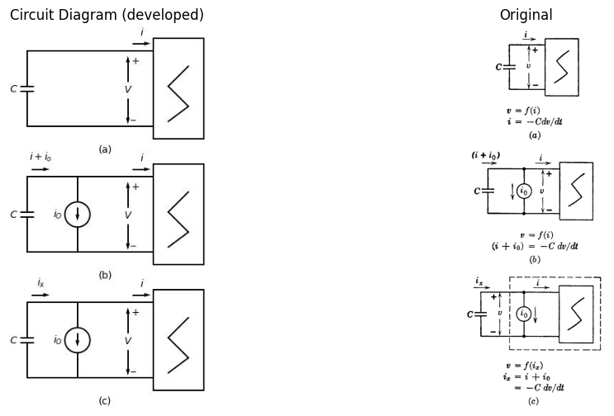

10.0.0.1 Fig 9.14 Use of current bias to shift from astable to monostable circuit conditions.
has been shifted to state I. Now any change in current away from the point $P$ results in a polarity for $dv/dt$ that tends to return the operating point to $P$. Thus the point $P$ is stable.
In the circuit and graphical plot of Fig. 9.14(b), we have assumed the fixed current $i_{0}$ and the capacitance $C$ as the load on the resistive circuit specified by $v=f\left(i\right)$. The alternative viewpoint, illustrated by
Fig. 9.14(c), considers $i_{0}$ as part of the resistive circuit. The result is a modification of the curve of $v$ vs. $i$. The viewpoint expressed by Fig. 9.14(c) is useful, since all of the resistive circuit elements are lumped together.
Referring to Fig. 9.14(b) or (c), we conclude that the operating point must reach point $P$ and remain there, regardless of its initial location in the $i$ vs. $v$ plane. For example, if by some means the circuit is put into state II, the capacitor voltage will decrease as the operating point moves toward point $D$. There, a transition to point $A$ in state I takes place. Negative capacitor current then causes the voltage to increase until point $P$ is reached and the circuit is in stable equilibrium.

11 9.11 Triggering the Monostable Circuit
A monostable circuit is usually "triggered" by a pulse which initiates a transition from the stable state to the unstable state. The time during which the circuit remains in the unstable state is determined by the exponential charge or discharge of the capacitor. During this interval the operation is like that of a free-running relaxation oscillator. At the end of the interval the circuit switches back to the stable state, and remains there until the next triggering pulse initiates the cycle again, as illustrated by Fig. 9.15.
The current-controlled resistance in the circuit of Fig. 9.15(a) is assumed to have a stable equilibrium, as indicated by point $P$ on the curve $v=f\left(i\right)$ shown in (b). The waveform of current from the synchronizing source $i_{s}$ is the train of pulses in Fig. 9.15. The circuit model shown in (c) indicates the circuit conditions just prior to the occurrence of one of the synchronizing pulses; thus all currents are zero, and the circuit is in stable equilibrium.
In order to switch the circuit from state I to state II, the synchronizing pulse must drive the operating point from $P$ to slightly beyond break point $B$. The operating point will return to point $P$ when the trigger pulse ends, unless the capacitor voltage is increased by the amount
$ \Delta v \geq (E_b - E_p) \tag{9.5} $
which requires a charge content
$ Q = I_s \delta_s \geq C(E_b - E_p) \quad \text{for} \quad R_1C \gg \delta_s \tag{9.6} $
At break point $B$ the circuit switches to state II and follows the operating path $CDAP$. Since the current pulses cannot change the capacitor voltage instantaneously, current $i$ shows no jump at the trailing edge of
the trigger pulse. The negative jump at the end of the trigger pulse appears in $i_{x}$, since
$ i_x = i - i_s $ (9.7)
import schemdraw
import schemdraw.elements as elm
import matplotlib.pyplot as plt
import matplotlib.image as mpimg
import numpy as np
fig, axs = plt.subplots(1, 2, figsize=(12, 6))
with schemdraw.Drawing(show=False) as d:
d += elm.Line().left().length(1).at((3+2,0-5))
d += elm.Line().left().length(1).at((3+2,-3-5))
d += elm.Line().up().length(4).at((3+2,-3.5-5))
d += elm.Line().right().length(2).at((3+2,0.5-5))
d += elm.Line().down().length(4).at((3+4,0.5-5))
d += elm.Line().left().length(2).at((3+4,-3.5-5))
d += elm.Label('+').at((3+1.4,-0.3-5))
d += elm.Label('_').at((3+1.3,-2.5-5))
d += elm.Arrow().up().length(1.0).at((3+1, -1.2-5))
d += elm.Arrow().up().length(0.1).at((3+0.6, -1.6-5)).color('white').label('$V$', loc='bottom', color='black')
d += elm.Arrow().down().length(1.0).at((3+1, -1.9-5))
d += elm.Arrow().right().length(0.7).at((3+1.2, 0.3-5)).label('$i$')
d += elm.Line().left().at((4,-0-5))
d += elm.Line().left().length(1)
d += elm.SourceI().down().label('$i_s$').reverse()
d += elm.Line().right().length(4)
d += elm.Label('(a)').at((3, -4-5))
d += elm.Line().at((0.4+6, 0.4-1-5)).to((-0.4+6, -0.4-1-5))
d += elm.Line().at((-0.4+6, -0.4-1-5)).to((0.4+6, -1.2-1-5))
d += elm.Line().at((0.4+6, -1.2-1-5)).to((-0.4+6, -1.8-1-5))
d += elm.Capacitor().at((2, -5)).down().label('C')
d += elm.Arrow().up().length(0.7).at((3+1.2-2.0, 0.3-6)).label('$i_x$',loc='bottom')
d += elm.SourceI().down().label('$i_s$').reverse().at((0,-10))
d += elm.Line().right().length(1.5).dot()
d.push()
d += elm.Line().right().length(2.5)
d += elm.Battery().up().label('$E_P$',loc='bottom').reverse()
d += elm.Resistor().left().label('$R$',loc='top')
d += elm.Line().left().length(1)
d.pop()
d += elm.Capacitor().up().label('C').dot()
d += elm.Label('(c)').at((3, -4-5-5))
d.save('./Drawing/fig9.15.jpg')
d.save('./Drawing/fig9.15.svg')
img = mpimg.imread('./Drawing/fig9.15.jpg')
axs[0].imshow(img)
axs[0].axis('off')
axs[0].set_title('Circuit Diagram (developed)')
img_sample = mpimg.imread('./Images/fig9.15.jpg')
axs[1].imshow(img_sample)
axs[1].axis('off')
axs[1].set_title('Original')
plt.show()
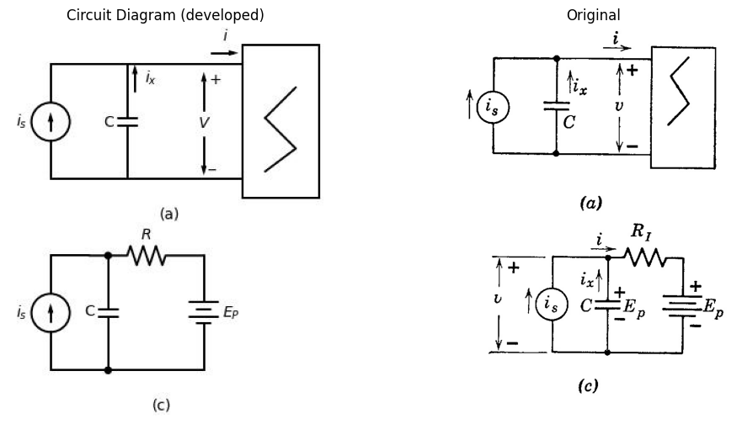

11.0.0.1 Fig. 9.15. Monostable operation with current pulse triggering.
The interval during which the circuit is in state II can be calculated in the same way as the corresponding interval in the waveforms of the relaxation oscillator. In order to assure return to the stable point $P$ after interval $δ_{2}$, the repetition interval of the synchronizing signal should be
$ \delta_r \geq (\delta_2 + 5 R_1 C) $ (9.8)
Allowing about five time constants for recovery permits the capacitor to recharge to the voltage $E_{p}$.
The time required to accomplish triggering will vary inversely with the trigger amplitude $I_{s}$, because the larger the trigger amplitude, the
import schemdraw
import schemdraw.elements as elm
import matplotlib.pyplot as plt
import matplotlib.image as mpimg
import numpy as np
fig, axs = plt.subplots(1, 2, figsize=(12, 6))
with schemdraw.Drawing(show=False) as d:
d += elm.Line().left().length(1).at((3+2,0))
d += elm.Line().left().length(1).at((3+2,-3))
d += elm.Line().up().length(4).at((3+2,-3.5))
d += elm.Line().right().length(2).at((3+2,0.5))
d += elm.Line().down().length(4).at((3+4,0.5))
d += elm.Line().left().length(2).at((3+4,-3.5))
d += elm.Label('+').at((3+1.4,-0.3))
d += elm.Label('_').at((3+1.3,-2.5))
d += elm.Arrow().up().length(1.0).at((3+1, -1.2))
d += elm.Arrow().up().length(0.1).at((3+0.6, -1.6)).color('white').label('$V$', loc='bottom', color='black')
d += elm.Arrow().down().length(1.0).at((3+1, -1.9))
d += elm.Arrow().right().length(0.7).at((3+1.2, 0.3)).label('$i$')
d += elm.Line().left().at((4,-0)).length(1)
d += elm.Inductor().right().label('$L$').at((1,0))
d += elm.SourceV().left().label('$e_s$').reverse().at((1.5,0))
d += elm.Capacitor().down().label('$C$')
d += elm.Line().right().length(3)
d += elm.Line().right().length(3)
d += elm.Label('(a)').at((1, -4))
d += elm.Line().at((0.4+6, 0.4-1)).to((-0.4+6, -0.4-1))
d += elm.Line().at((-0.4+6, -0.4-1)).to((0.4+6, -1.2-1))
d += elm.Line().at((0.4+6, -1.2-1)).to((-0.4+6, -1.8-1))
d.save('./Drawing/fig9.16.jpg')
d.save('./Drawing/fig9.16.svg')
img = mpimg.imread('./Drawing/fig9.16.jpg')
axs[0].imshow(img)
axs[0].axis('off')
axs[0].set_title('Circuit Diagram (developed)')
img_sample = mpimg.imread('./Images/fig9.16.jpg')
axs[1].imshow(img_sample)
axs[1].axis('off')
axs[1].set_title('Original')
plt.show()
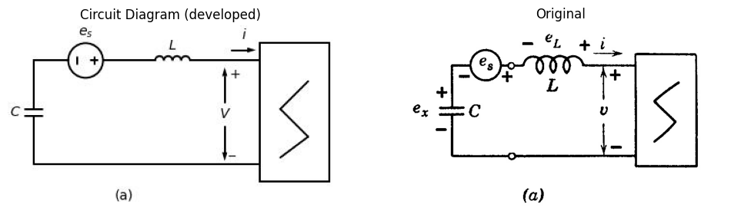

11.0.0.2 Fig. 9.16. Monostable operation with voltage pulse triggering.
Larger the value of (\frac{dv}{dt}). It is not proper to assume that instantaneous triggering could be had by letting the pulses approach impulses of the same area, since the effects of the stray parameters would then have to be included in the form of a small series inductance. We have tacitly assumed the pulse duration (\delta_s) to be large compared with the time required to build up current from 0 to (I_s) in the stray inductance. If inductance is included, the instantaneous changes of current shown in the waveforms of current in Fig. 9.15(d) must be rounded off to approximate exponentials as in Fig. 9.13.
A circuit for obtaining faster triggering is shown in Fig. 9.16(a). Instead of trying to change the capacitor voltage from (E_p) to (E_b), we can bias the resistive curve in the opposite direction. This has the
effect of sliding the entire curve of $v=f\left(i\right)$ to the left until break point $B$ passes the capacitor voltage $E_{p}$. Then a transition must occur from $B$ to some point $C′$ in state II. This shift of the curve along the voltage axis is readily accomplished by a series voltage source $e_{s}$ subtracted from $v$, as indicated in Fig. 9.16(a). Alternatively, we can think of the voltage $e_{s}$ as being added to capacitor voltage $e_{x}$ instead of being subtracted from $v$. The net result will be the same.
If we idealize the circuit by neglecting the series inductance, the triggering transition occurs instantaneously. The only requirement is a series-connected voltage source producing pulses of amplitude $E_{s}>\left(E_{b}−E_{p}\right)$. With a nonzero inductance present, we shall see from Fig. 9.16 that a minimum pulse area $E_{s}δ_{s}$ is required. This is the change in flux linkages required to change the current in the inductor sufficiently to trigger the circuit.
Let us assume that the triggering transition takes place so rapidly that the charge on the capacitor remains essentially constant. Then we can use the method of calculation given in Fig. 9.12. For the circuit of Fig. 9.16(a), the values of $e_{L}$ during the transition are shown on the $i$ vs. $v$ plane in (b). It is apparent that the voltage across the inductance ($e_{L}=−L\frac{di}{dt}$) varies directly with $E_{s}$; hence, the larger $E_{s}$, the more rapid the transition. Transition waveforms for a specific value of $E_{s}$ are shown in Fig. 9.16(c) for three values of synchronizing-pulse duration.
The duration of the pulse must exceed $δ_{1}$, the value required to change the current from zero to $I_{1}$. Beyond that point the transition goes to completion without dependence on the trigger pulse, since the negative value of $e_{L}$ leaves $\frac{di}{dt}$ positive. If the current has not reached $I_{1}$, removal of the synchronizing voltage pulse makes $e_{L}$ positive, a condition that makes $\frac{di}{dt}$ negative. Therefore, the operating point will be driven downward out of state III to point $P$ in state I.
Maintaining the trigger pulse for the duration $δ_{2}$ required for the current to reach the value $I_{2}$ at point $C$ results in minimum transition time for a given amplitude of $e_{s}$. If the trigger pulse persists for a duration $δ_{3}$ the current reaches too large a value ($I_{3}$ at point $C′$) and the transition time becomes considerably longer. However, these transition times are all short in comparison with those resulting from current-pulse triggering, particularly if capacitor $C$ is large.

12 9.12 Bistable Operation
Since a current-controlled curve, $v=f\left(i\right)$, is by definition a single-valued function of current, it crosses the axis of zero current only once. Thus there can be only one stable point ($\dot{i}=0$) with capacitance as
the energy-storage element. However, if an inductance is used the transient is completed when the voltage across the inductor is zero. If we use a bias voltage to shift the curve along the voltage axis in order to obtain three intercepts on the axis of zero voltage, bistable operation is obtained.
The location of the bias voltage $E_{0}$ and the synchronizing voltage $e_{s}$ is shown in Fig. 9.17(a). The curve $v=f\left(i\right)$ is assumed to be like the one used in preceding examples. The sketch in Fig. 9.17(b) indicates $E_{0}$ as a load on the negative-resistance device. Under steady-state conditions, with $e_{s}$ and $e_{L}$ both zero, we have circuit equilibrium at points $P$, $S_{1}$, and $S_{2}$. Thus, for $v=E_{0}$ we have three points for which $e_{L}$ is zero, and two of these are stable.
The curve $v′=f\left(i′\right)$ shown in Fig. 9.17(c) is the curve of (b) with a change of variable ($v′=v−E_{0}$), which effectively includes the bias voltage $E_{0}$ as part of the resistive circuit. The alternative viewpoints, indicated in (b) and (c), are related to specific circuits in (d) and (e). The circuit in (d) shows the necessary voltage translation achieved by an external battery of value $E_{0}=E_{bb}/2$. The circuit in (e) makes the necessary internal modification to shift the axis of symmetry from $v=E_{bb}/2$ to $v=0$. In either case we can indicate the circuit properties as in Fig. 9.17(f).
To switch the circuit from state I to state II and back again requires alternately positive and negative pulses from the synchronizing source. The method of triggering is like that described in Fig. 9.16 for monostable operation. The waveforms drawn in Fig. 9.17(f) assume that the stray inductance is very small. These waveforms can be modified to make the transitions more realistic by using the results obtained in Figs. 9.12 and 9.16.

13 9.13 Limitations of Negative-Resistance Methods
A nonlinear driving-point resistance combined with one or more energy-storage elements is a very useful model for examining the be havior of many oscillator circuits. This general method of analysis shows directly the conditions for bistable, monostable or astable relaxation oscillations as well as sinusoidal oscillations. Equally important is the fact that a large number of actual circuits can be represented quite accurately by this simple but general model. In principle the concepts described thus far can be applied to any oscillator circuit, but as a practical matter it is inconvenient to try to fit all circuits into the same mold. The negative-resistance concept is not particularly convenient,
import schemdraw
import schemdraw.elements as elm
import matplotlib.pyplot as plt
import matplotlib.image as mpimg
import numpy as np
fig, axs = plt.subplots(1, 2, figsize=(12, 6))
with schemdraw.Drawing(show=False) as d:
# section1
d += elm.Line().left().length(1).at((3+2,0))
d += elm.Line().left().length(1).at((3+2,-3))
d += elm.Line().up().length(4).at((3+2,-3.5))
d += elm.Line().right().length(2).at((3+2,0.5))
d += elm.Line().down().length(4).at((3+4,0.5))
d += elm.Line().left().length(2).at((3+4,-3.5))
d += elm.Label('+').at((3+1.4,-0.3))
d += elm.Label('_').at((3+1.3,-2.5))
d += elm.Arrow().up().length(1.0).at((3+1, -1.2))
d += elm.Arrow().up().length(0.1).at((3+0.6, -1.6)).color('white').label('$V$', loc='bottom', color='black')
d += elm.Arrow().down().length(1.0).at((3+1, -1.9))
d += elm.Arrow().right().length(0.7).at((3+1.2, 0.3)).label('$i$')
d += elm.Line().left().at((4,-0)).length(1)
d += elm.Inductor2().right().label('$L$').at((1,0))
d += elm.SourceV().left().label('$e_s$').reverse().at((-0,0))
d += elm.Battery().left().label('$E_O$').at((2,0))
d += elm.Line().down().at((-3,0))
d += elm.Line().right().length(4)
d += elm.Line().right().length(3)
d += elm.Label('(a)').at((1, -4))
d += elm.Line().at((0.4+6, 0.4-1)).to((-0.4+6, -0.4-1))
d += elm.Line().at((-0.4+6, -0.4-1)).to((0.4+6, -1.2-1))
d += elm.Line().at((0.4+6, -1.2-1)).to((-0.4+6, -1.8-1))
# section2
d += (M := elm.AnalogNFet(offset_gate = False).reverse().right().label('$T_2$','right').at((0,-7)))
d += elm.Resistor().down().at(M.source).label('$R$','bottom').dot()
d.push()
d += (M := elm.AnalogNFet(offset_gate = False).reverse().right().label('$T_1$','right'))
d.pop()
d += elm.Line().left().length(1.5)
d += elm.Line().up().length(3.84)
d += elm.Line().right().length(1.2-0.5)
d += elm.Resistor().down().at(M.source).label('$R$','bottom').dot()
d.push()
d += elm.Ground()
d.pop()
d += elm.Line().left().length(2-0.5)
d += elm.Line().up().length(3.84)
d += elm.Line().right().length(1.2-0.5)
d += elm.Label('+').at((-2.4+4,0.2-2.1-7))
d += elm.Label('_').at((-2.4+4,-4.8-1.7-7))
d += elm.Arrow().up().length(2.0).at((-2+4, -1.4-2.1-7))
d += elm.Arrow().up().length(0.1).at((-2.3+4, -2.3-1.7-7)).color('white').label('$v$', loc='bottom', color='black')
d += elm.Arrow().down().length(2.0).at((-2+4, -2.9-1.7-7))
d += elm.Line().right().length(1.5).at((0.5,-1.5-7)).dot(open=True)
d += elm.Line().right().length(1.5).at((0.5,-6.8-7)).dot(open=True)
d += elm.Arrow().left().length(0.7).at((2, -1.3-7)).label('$i$')
d += elm.Arrow().down().length(0.7).at((0.8, -0.3-7)).label('$i_{b2}$',loc='bottom')
d += elm.Arrow().down().length(0.7).at((1, -5.2-7)).label('$i_{b1}$',loc='bottom')
d += elm.Line().left().length(3).at((0,-7))
d += elm.Line().down().length(3)
d += elm.Battery().down().label('$E_{b}$',loc='bottom')
d += elm.Line().down().length(3.5)
d += elm.Line().right().length(3)
d += elm.Battery().right().label('$E_{o}$',loc='bottom').at((2,-8.5))
d += elm.Line().down().length(1.2)
d += elm.SourceV().down().label('$e_{s}$',loc='bottom').reverse()
d += elm.Line().down().length(1.1)
d += elm.Line().left().length(3)
d += elm.Label('(b)').at((1, -18))
# section3
d += (M := elm.AnalogNFet(offset_gate = False).reverse().right().label('$T_2$','right').at((10,-7)))
d += elm.Resistor().down().at(M.source).label('$R$','bottom').dot()
d.push()
d += (M := elm.AnalogNFet(offset_gate = False).reverse().right().label('$T_1$','right'))
d.pop()
d += elm.Line().left().length(1.5)
d += elm.Line().up().length(3.84)
d += elm.Line().right().length(1.2-0.5)
d += elm.Resistor().down().at(M.source).label('$R$','bottom').dot()
d.push()
d += elm.Ground()
d.pop()
d += elm.Line().left().length(2-0.5)
d += elm.Line().up().length(3.84)
d += elm.Line().right().length(1.2-0.5)
d += elm.Label('+').at((-2.4+4+10,0.2-2.1-7))
d += elm.Label('_').at((-2.4+4+10,-4.8-1.7-7))
d += elm.Arrow().up().length(2.0).at((-2+4+10, -1.4-2.1-7))
d += elm.Arrow().up().length(0.1).at((-2.3+4+10, -2.3-1.7-7)).color('white').label('$v$', loc='bottom', color='black')
d += elm.Arrow().down().length(2.0).at((-2+4+10, -2.9-1.7-7))
d += elm.Line().right().length(1.5).at((0.5+10,-1.5-7)).dot(open=True)
d += elm.Line().right().length(1.5).at((0.5+10,-6.8-7)).dot(open=True)
d += elm.Arrow().left().length(0.7).at((2+10, -1.3-7)).label('$i$')
d += elm.Arrow().down().length(0.7).at((0.8+10, -0.3-7)).label('$i_{b2}$',loc='bottom')
d += elm.Arrow().down().length(0.7).at((1+10, -5.2-7)).label('$i_{b1}$',loc='bottom')
d += elm.Line().left().length(3).at((0+10,-7))
d += elm.Line().down().length(3)
d += elm.Line().down()
d += elm.Line().down().length(3.5)
d += elm.Line().right().length(3)
d += elm.Line().right().at((2+10,-8.5))
d += elm.Line().down().length(1.2)
d += elm.SourceV().down().label('$e_{s}$',loc='bottom').reverse()
d += elm.Line().down().length(1.1)
d += elm.Line().left().length(3)
d += elm.Label('(c)').at((10, -18))
d.save('./Drawing/fig9.17.jpg')
d.save('./Drawing/fig9.17.svg')
img = mpimg.imread('./Drawing/fig9.17.jpg')
axs[0].imshow(img)
axs[0].axis('off')
axs[0].set_title('Circuit Diagram (developed)')
img_sample = mpimg.imread('./Images/fig9.17.jpg')
axs[1].imshow(img_sample)
axs[1].axis('off')
axs[1].set_title('Original')
plt.show()
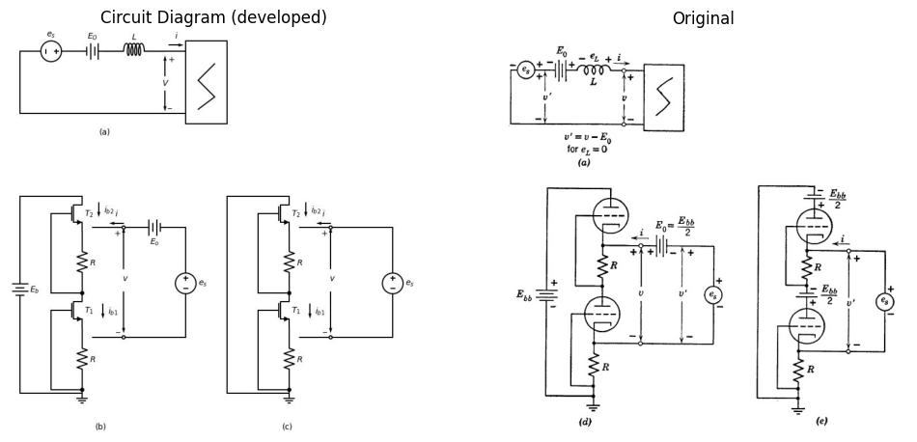

13.0.0.1 Fig 9.17. Bistabel operation
import schemdraw
import schemdraw.elements as elm
import matplotlib.pyplot as plt
import matplotlib.image as mpimg
import numpy as np
fig, axs = plt.subplots(1, 2, figsize=(12, 6))
with schemdraw.Drawing() as d:
d += elm.Dot(label='$-E_{cc}$',loc='right').down()
d += elm.Line().down().length(1)
d += elm.Line().left().length(6)
d += elm.Resistor().down().label('$R_{b1}$').dot()
d += elm.Line().down().length(1)
d += (M1 := elm.AnalogNFet(offset_gate = False).anchor('drain').theta(0).label('$M_1$','left'))
d += elm.Line().down().at(M1.source).length(3)
d += elm.Line().right().length(3).dot()
d.push()
d += ( V1 := elm.BatteryCell().up().length(1.9).scale(0.9).label(['-','$E_1$','+'], loc='top'))
d += elm.Resistor().up().label('$R_{g1}$').dot().scale(0.9).length(1.9)
d += elm.Line().right().at(M1.gate).length(2.5)
d += (C1 := elm.Capacitor().right().label('$C_1$').scale(0.9).length(2))
d.pop()
d += elm.Line().right().length(3).dot()
d.push()
d += elm.Ground()
d.pop()
d += elm.Line().right().length(3).dot()
d.push()
d += ( V2 := elm.BatteryCell().up().length(1.9).scale(0.9).label(['-','$E_2$','+'], loc='top'))
d += elm.Resistor().up().label('$R_{g2}$').dot().scale(0.9).length(1.9)
d += (C2 := elm.Capacitor().left().label('$C_2$').scale(0.9).length(2))
d.pop()
d += elm.Line().right().length(3)
d += elm.Line().up().length(4.65).color('white')
d += (M2 := elm.AnalogNFet(offset_gate = False).anchor('drain').reverse().right().theta(0).label('$M_2$','right'))
d += elm.Line().down().at(M2.source).length(3)
d += elm.Line().left().at(M2.gate).length(2)
d += elm.Line().up().at(M2.drain).length(1).dot()
d.push()
d += (L2 :=elm.Line().left().length(5))
d += (L1 :=elm.Line().right().length(5).at((-6,-4)))
d += elm.Line().at(L2.end).to(C1.end)
d += elm.Line().at(L1.end).to(C2.end)
d.pop()
d += elm.Resistor().up().label('$R_{b2}$')
d += elm.Line().left().length(6)
d.save('./Drawing/fig9.18.a.jpg')
d.save('./Drawing/fig9.18.a.svg')
img = mpimg.imread('./Drawing/fig9.18.a.jpg')
axs[0].imshow(img)
axs[0].axis('off')
axs[0].set_title('Circuit Diagram (developed)')
img_sample = mpimg.imread('./Images/fig9.181.jpg')
axs[1].imshow(img_sample)
axs[1].axis('off')
axs[1].set_title('Original')
plt.show()
C:\MLPack\PortablePython-3.10.5x64\App\Python\lib\site-packages\schemdraw\elements\elements.py:153: UserWarning: Duplicate direciton parameter in element: `right` replaced with `theta=0`
warnings.warn("Duplicate direciton parameter in element:"
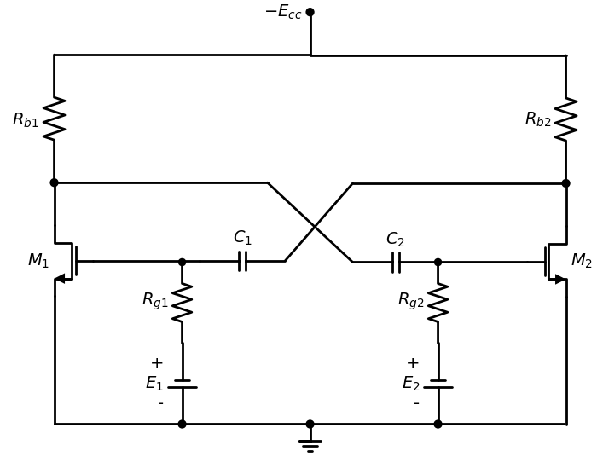
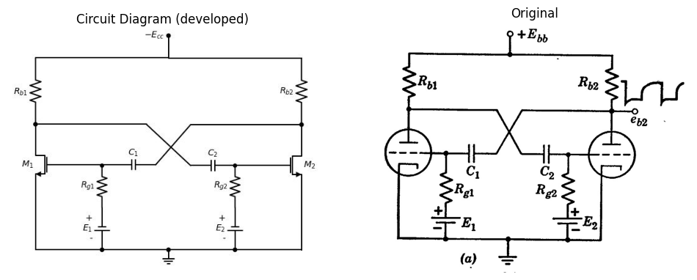
import schemdraw
import schemdraw.elements as elm
import matplotlib.pyplot as plt
import matplotlib.image as mpimg
import numpy as np
fig, axs = plt.subplots(1, 2, figsize=(12, 6))
with schemdraw.Drawing(show=False) as d:
d += elm.Dot(label='$-E_{cc}$',loc='right').down()
d += elm.Line().down().length(1)
d += elm.Line().left().length(6)
d += elm.Resistor().down().label('$R_{c1}$').dot()
d += elm.Line().down().length(1)
d += (Q1 := elm.BjtPnp(circle=True).left().anchor('collector'))
d += elm.Line().down().at(Q1.emitter).length(3)
d += elm.Line().right().length(3).dot()
d.push()
d += ( V1 := elm.BatteryCell().up().length(1.9).scale(0.9).label(['-','$E_1$','+'], loc='top'))
d += elm.Resistor().up().label('$R_{c1}$').dot().scale(0.9).length(1.8)
d += elm.Line().right().at(Q1.base).length(2.5)
d += (C1 := elm.Capacitor().right().label('$C_1$').scale(0.9).length(2))
d.pop()
d += elm.Line().right().length(3).dot()
d.push()
d += elm.Ground()
d.pop()
d += elm.Line().right().length(3).dot()
d.push()
d += ( V2 := elm.BatteryCell().up().length(1.9).scale(0.9).label(['-','$E_2$','+'], loc='top'))
d += elm.Resistor().up().label('$R_{c1}$').dot().scale(0.9).length(1.8)
d += (C2 := elm.Capacitor().left().label('$C_2$').scale(0.9).length(2))
d.pop()
d += elm.Line().right().length(3)
d += elm.Line().up().length(3)
d += (Q2 := elm.BjtPnp(circle=True).left().anchor('emitter').reverse())
d += elm.Line().left().at(Q2.base).length(2.3)
d += elm.Line().up().at(Q2.collector).length(1).dot()
d.push()
d += (L2 :=elm.Line().left().length(5))
d += (L1 :=elm.Line().right().length(5).at((-6,-4)))
d += elm.Line().at(L2.end).to(C1.end)
d += elm.Line().at(L1.end).to(C2.end)
d.pop()
d += elm.Resistor().up().label('$R_{c1}$')
d += elm.Line().left().length(6)
d.save('./Drawing/fig9.18.b.jpg')
d.save('./Drawing/fig9.18.b.svg')
img = mpimg.imread('./Drawing/fig9.18.b.jpg')
axs[0].imshow(img)
axs[0].axis('off')
axs[0].set_title('Circuit Diagram (developed)')
img_sample = mpimg.imread('./Images/fig9.18.b.jpg')
axs[1].imshow(img_sample)
axs[1].axis('off')
axs[1].set_title('Original')
plt.show()
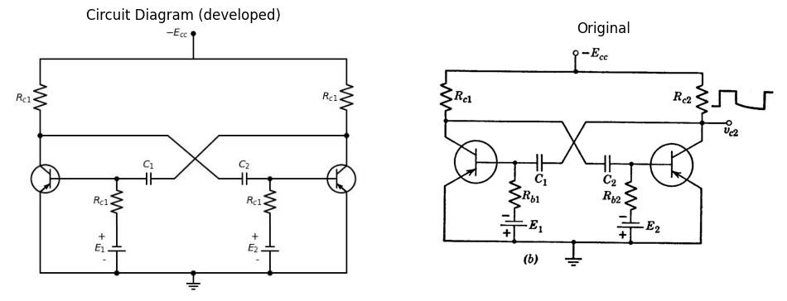
import schemdraw
import schemdraw.elements as elm
import matplotlib.pyplot as plt
from schemdraw import dsp
from schemdraw import logic
fig, axs = plt.subplots(1, 2, figsize=(12, 6))
with schemdraw.Drawing(unit=2,show=False) as d:
d += (M1 := elm.AnalogNFet(offset_gate = False).anchor('drain').theta(0).reverse())
x = d.add(elm.Transformer(loop=True).at((-1.4,1)))
l1 = d.add(elm.Line().up(d.unit*.5).at(M1.drain))
G = d.add(elm.Ground().at((-1.4,1)))
l2 = d.add(elm.Line().left(d.unit*1).at((-1.4,3.1)))
l3 = d.add(elm.Line().down(d.unit*1.97))
d += (C1 := elm.Capacitor().right(d.unit*1.25).label('$C$', 'top'))
d += (R1 := elm.Resistor().down().label('$R$', 'top').at((-1.5,-.85)))
d += elm.BatteryCell().right(d.unit*.75).label('E1', 'bottom').at(R1.end)
l5 = d.add(elm.Line().up(d.unit*.7))
G = d.add(elm.Ground().at(l5.start))
l5 = d.add(elm.Line().up(d.unit*.5).dot(open=True).at((0,3.1)).label('Ebb', 'right'))
l5 = d.add(elm.Line().right(d.unit*.5).dot(open=True).at((0,0)).label('eb', 'right'))
d += elm.Dot().at((-0.3,3.3))
d += elm.Dot().at((-1,3.3))
d.save('./Drawing/fig9.18.c.jpg')
d.save('./Drawing/fig9.18.c.svg')
img = mpimg.imread('./Drawing/fig9.18.c.jpg')
axs[0].imshow(img)
axs[0].axis('off')
axs[0].set_title('Circuit Diagram (developed)')
img_sample = mpimg.imread('./Images/fig9.183.jpg')
axs[1].imshow(img_sample)
axs[1].axis('off')
axs[1].set_title('Original')
plt.show()
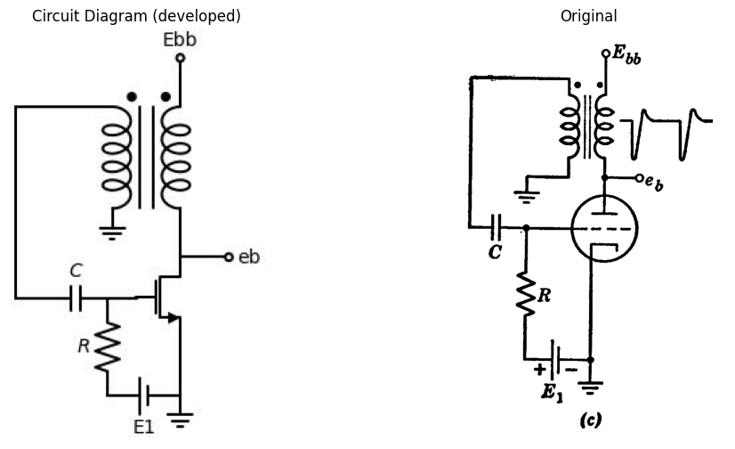
import schemdraw.elements as elm
import matplotlib.pyplot as plt
from schemdraw import dsp
from schemdraw import logic
fig, axs = plt.subplots(1, 2, figsize=(12, 6))
with schemdraw.Drawing(show=False,unit=2,) as d:
d += (M1 := elm.BjtPnp(circle=True).left().anchor('collector').reverse())
x = d.add(elm.Transformer(loop=True).at((-0.0,3)))
l1 = d.add(elm.Line().up(d.unit*.45).at(M1.collector))
G = d.add(elm.Ground().at((-1.4,0.9)))
l2 = d.add(elm.Line().left(d.unit*1).at((-1.4,3.0)))
l3 = d.add(elm.Line().down(d.unit*1.84))
d += (C1 := elm.Capacitor().right(d.unit*1.30).scale(1.3).label('$C$', 'top'))
d += (R1 := elm.Resistor().down().label('$R$', 'top').at((-1.5,-.70)))
d += elm.BatteryCell().right(d.unit*.75).label('E1', 'bottom').at(R1.end)
l5 = d.add(elm.Line().up(d.unit*.7))
G = d.add(elm.Ground().at(l5.start))
l5 = d.add(elm.Line().up(d.unit*.5).dot(open=True).at((0,3.0)).label('$-E_{cc}$', 'right'))
l5 = d.add(elm.Line().right(d.unit*.5).dot(open=True).at((0,0)).label('$V_c$', 'right'))
d += elm.Dot().at((-0.3,3.3))
d += elm.Dot().at((-1,3.3))
d.save('./Drawing/fig9.18.d.jpg')
d.save('./Drawing/fig9.18.d.svg')
img = mpimg.imread('./Drawing/fig9.18.d.jpg')
axs[0].imshow(img)
axs[0].axis('off')
axs[0].set_title('Circuit Diagram (developed)')
img_sample = mpimg.imread('./Images/fig9.184.jpg')
axs[1].imshow(img_sample)
axs[1].axis('off')
axs[1].set_title('Original')
plt.show()
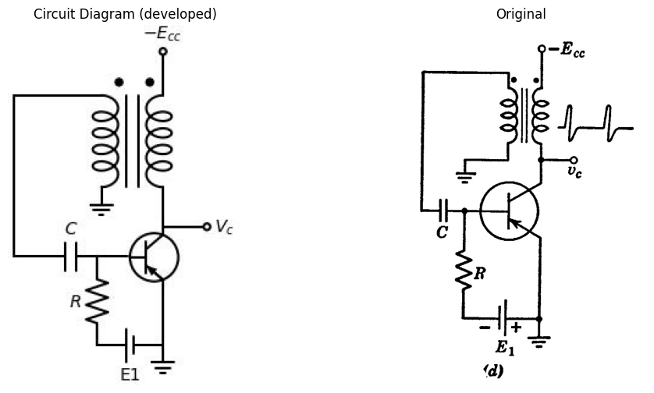
import schemdraw
import schemdraw.elements as elm
import matplotlib.pyplot as plt
from schemdraw import dsp
from schemdraw import logic
fig, axs = plt.subplots(1, 2, figsize=(12, 6))
with schemdraw.Drawing(unit=2,show=False) as d:
d += (M1 := elm.AnalogNFet(offset_gate = False).anchor('drain').theta(0).reverse())
x = d.add(elm.Transformer(loop=True).at((-1.4,1)))
l1 = d.add(elm.Line().up(d.unit*.5).at(M1.drain))
G = d.add(elm.Ground().at((-1.4,1)))
l2 = d.add(elm.Line().left(d.unit*0.5).at((-1.4,1)))
d += (C1 := elm.Capacitor().up(d.unit*1.05).label('$C$', 'top').dot())
l2 = d.add(elm.Line().left(d.unit*1).at((-1.4,3.1)))
l3 = d.add(elm.Line().down(d.unit*1.97))
d += (C1 := elm.Capacitor().right(d.unit*0.85).label('$C$', 'top'))
d.push()
d += (R1 := elm.Resistor().down().label('$R$', 'top').at((-1.5,-.85)))
d += elm.Line().right(d.unit*.75).at(R1.end)
l5 = d.add(elm.Line().up(d.unit*.7))
G = d.add(elm.Ground().at(l5.start))
l5 = d.add(elm.Line().up(d.unit*.5).dot(open=True).at((0,3.1)).label('Ebb', 'right'))
l5 = d.add(elm.Line().right(d.unit*.5).dot(open=True).at((0,0)).label('eb', 'right'))
d.pop()
d += elm.Line().right(d.unit*.5)
d.save('./Drawing/fig9.18.e.jpg')
d.save('./Drawing/fig9.18.e.svg')
img = mpimg.imread('./Drawing/fig9.18.e.jpg')
axs[0].imshow(img)
axs[0].axis('off')
axs[0].set_title('Circuit Diagram (developed)')
img_sample = mpimg.imread('./Images/fig9.185.jpg')
axs[1].imshow(img_sample)
axs[1].axis('off')
axs[1].set_title('Original')
plt.show()
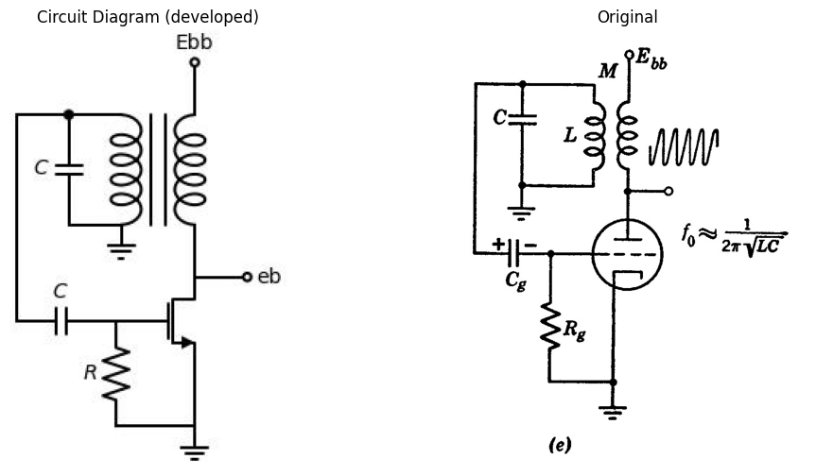
import schemdraw
import schemdraw.elements as elm
import matplotlib.pyplot as plt
from schemdraw import dsp
from schemdraw import logic
fig, axs = plt.subplots(1, 2, figsize=(12, 6))
with schemdraw.Drawing(unit=2,show=False) as d:
d += (M1 := elm.AnalogNFet(offset_gate = False).anchor('drain').theta(0).reverse())
l1 = d.add(elm.Line().up(d.unit*.5).at(M1.drain).dot())
d.push()
L = d.add(elm.Inductor2().right().label('$L_o$',loc='bottom').length(1.3).scale(1))
l5 = d.add(elm.Line().right(d.unit*.5).dot(open=True).label('Ebb', 'right'))
d.pop()
d += (C1 := elm.Capacitor().left(d.unit*0.85).label('$C_o$', 'top'))
d += (C2 := elm.Capacitor().right(d.unit*0.85).at((-3.4,-0.85)).label('$C_g$', 'top'))
d.push()
d += (R1 := elm.Resistor().down().label('$R_g$', 'top').at((-1.5,-.85)))
d += elm.Line().right(d.unit*.75).at(R1.end)
l5 = d.add(elm.Line().up(d.unit*.7))
G = d.add(elm.Ground().at(l5.start))
d.pop()
d += elm.Line().right(d.unit*.5)
l1 = d.add(elm.Line().left(d.unit*1.5).at(C1.end).dot())
l1 = d.add(elm.Line().down(d.unit*.8))
d += (C3 := elm.Capacitor().down(d.unit*0.85).label('$C$', 'top'))
d.push()
l1 = d.add(elm.Line().left(d.unit*.8))
L = d.add(elm.Inductor2().up().label('L',loc='bottom').length(3.3).scale(1))
l1 = d.add(elm.Line().right(d.unit*.8))
d.pop()
l1 = d.add(elm.Line().right(d.unit*.6))
l1 = d.add(elm.Line().up(d.unit*.72))
d += elm.Dot().at((-6.8,-0.7))
l1 = d.add(elm.Line().left(d.unit*.22))
l1 = d.add(elm.Line().down(d.unit*1.06))
l1 = d.add(elm.Line().right(d.unit*3))
d.save('./Drawing/fig9.18.f.jpg')
d.save('./Drawing/fig9.18.f.svg')
img = mpimg.imread('./Drawing/fig9.18.f.jpg')
axs[0].imshow(img)
axs[0].axis('off')
axs[0].set_title('Circuit Diagram (developed)')
img_sample = mpimg.imread('./Images/fig9.18.f.jpg')
axs[1].imshow(img_sample)
axs[1].axis('off')
axs[1].set_title('Original')
plt.show()
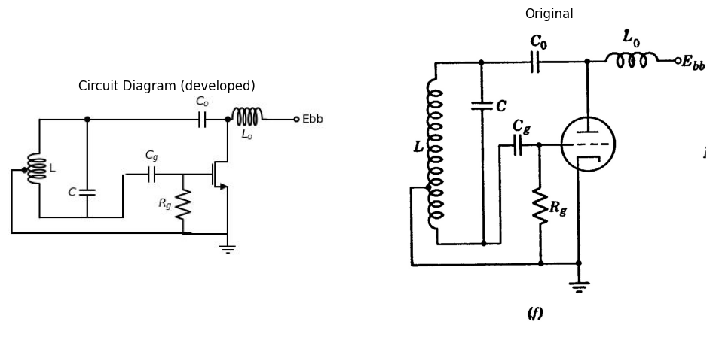
import schemdraw
import schemdraw.elements as elm
import matplotlib.pyplot as plt
from schemdraw import dsp
from schemdraw import logic
fig, axs = plt.subplots(1, 2, figsize=(12, 6))
with schemdraw.Drawing(unit=2,show=False) as d:
d += (M1 := elm.AnalogNFet(offset_gate = False).anchor('drain').theta(0).reverse())
l1 = d.add(elm.Line().up(d.unit*.5).at(M1.drain).dot())
d.push()
l5 = d.add(elm.Line().right(d.unit*.5))
L = d.add(elm.Inductor2().right(d.unit*.5).label('$L_o$',loc='bottom'))
l5 = d.add(elm.Line().right(d.unit*.5).dot(open=True).label('Ebb', 'right'))
d.pop()
l5 = d.add(elm.Line().left(d.unit*1.5).dot())
l5 = d.add(elm.Line().down(d.unit*.5))
d += (C1 := elm.Capacitor().down(d.unit*0.85).label('$C_1$', 'top'))
l5 = d.add(elm.Line().down(d.unit*1.3).dot())
d += (C2 := elm.Capacitor().down(d.unit*0.88).label('$C_2$', 'top'))
l5 = d.add(elm.Line().down(d.unit*0.08))
d.push()
l5 = d.add(elm.Line().left(d.unit*0.65))
l5 = d.add(elm.Line().up(d.unit*1.33))
L = d.add(elm.Inductor2().up(d.unit*1).label('$L$',loc='bottom'))
l5 = d.add(elm.Line().up(d.unit*1.31))
l5 = d.add(elm.Line().right(d.unit*0.65))
d.pop()
d += (C2 := elm.Capacitor().right(d.unit*0.6).dot().label('$C_g$', 'top'))
d += (R := elm.Resistor().right(d.unit*0.9).dot().label('$R_g$', 'top'))
d.push()
G = d.add(elm.Ground())
d.pop()
l5 = d.add(elm.Line().up(d.unit*2.5))
l6 = d.add(elm.Line().left(d.unit*.45).at(M1.gate))
l6 = d.add(elm.Line().down(d.unit*2.7))
l6 = d.add(elm.Line().right(d.unit*1.5).dot().at((-3,-4.3)))
d.save('./Drawing/fig9.18.g.jpg')
d.save('./Drawing/fig9.18.g.svg')
img = mpimg.imread('./Drawing/fig9.18.g.jpg')
axs[0].imshow(img)
axs[0].axis('off')
axs[0].set_title('Circuit Diagram (developed)')
img_sample = mpimg.imread('./Images/fig9.18.g.jpg')
axs[1].imshow(img_sample)
axs[1].axis('off')
axs[1].set_title('Original')
plt.show()
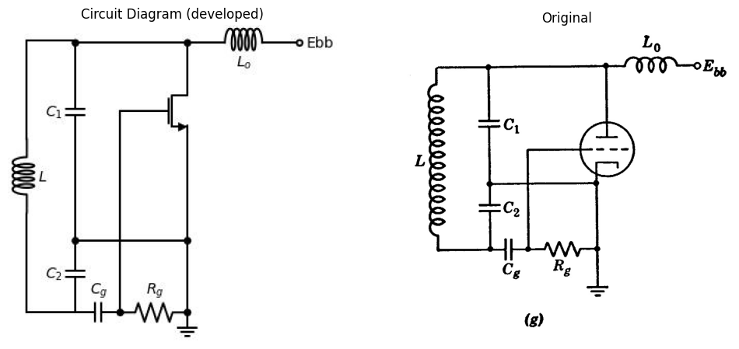
import schemdraw
import schemdraw.elements as elm
import matplotlib.pyplot as plt
import matplotlib.image as mpimg
fig, axs = plt.subplots(1, 2, figsize=(12, 6))
with schemdraw.Drawing(unit=2,show=False) as d:
d += (M1 := elm.AnalogNFet(offset_gate=False, circle=True).anchor('drain').theta(0).reverse())
l1 = d.add(elm.Line().up(d.unit * 0.5).at(M1.drain))
l2 = d.add(elm.Line().right(d.unit * 1.5))
l2 = d.add(elm.Line().down(d.unit).dot())
d.push()
d += (L1 := elm.Inductor2().down().label('$L_2$', 'top'))
l2 = d.add(elm.Line().left(d.unit * 0.5).dot())
d.pop()
l2 = d.add(elm.Line().left(d.unit * 0.5))
d += (C1 := elm.Capacitor().down(d.unit*1).label('$C_2$', 'top'))
d.push()
l2 = d.add(elm.Line().down(d.unit * 0.3))
d += (L1 := elm.Dot(open=True).label('$E_{bb}$','left'))
d.pop()
l2 = d.add(elm.Capacitor().label('$C_o$', 'top').left(d.unit * 0.99).dot())
d.push()
l1 = d.add(elm.Line().down(d.unit * 0.9).at(M1.source))
G = d.add(elm.Ground())
d.pop()
l2 = d.add(elm.Line().left(d.unit * 0.99).dot())
d += (R1 := elm.Resistor().up(d.unit*1.081).label('$R_g$', 'top'))
l1 = d.add(elm.Line().left(d.unit * 0.7).at(M1.gate))
d += (C1 := elm.Capacitor().left(d.unit*0.85).label('$C_g$', 'top').dot())
d.push()
d += (C1 := elm.Capacitor().down(d.unit*1.081).label('$C_1$', 'top'))
l2 = d.add(elm.Line().right(d.unit * 1))
d.pop()
l2 = d.add(elm.Line().left(d.unit * 1))
d += (C1 := elm.Inductor2().down(d.unit*1.081).label('$L_1$', 'top'))
l2 = d.add(elm.Line().right(d.unit * 1).dot())
l1 = d.add(elm.Line(style='--').up(d.unit * 0.91).at(M1.gate))
d += (C1 := elm.Capacitor(style='--').right(d.unit * 0.481).label('$C_{gp}$', 'top'))
d.save('./Drawing/fig9.18.h.jpg')
d.save('./Drawing/fig9.18.h.svg')
img = mpimg.imread('./Drawing/fig9.18.h.jpg')
axs[0].imshow(img)
axs[0].axis('off')
axs[0].set_title('Circuit Diagram (developed)')
img_sample = mpimg.imread('./Images/fig9.186.jpg')
axs[1].imshow(img_sample)
axs[1].axis('off')
axs[1].set_title('Original')
Text(0.5, 1.0, 'Original')
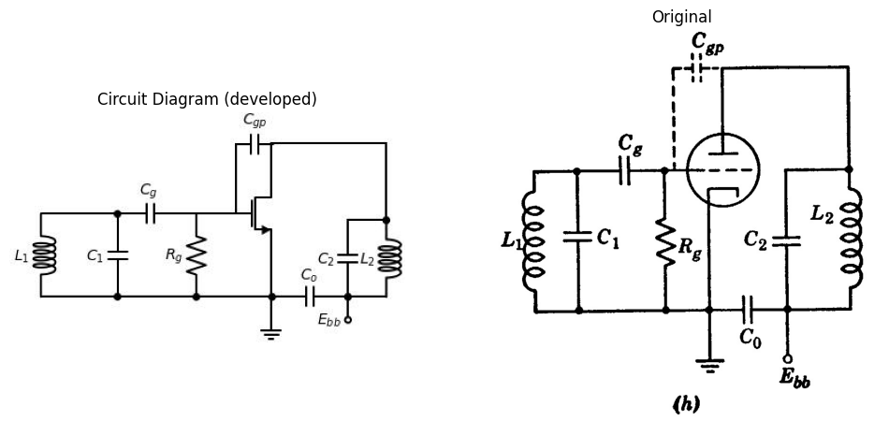

13.0.0.2 Fig 9.18.Typical oscillator circuits with major energy-storage elements at two pairs of terminals.(a) Plate-coupled multivibrator (b) Collector-coupled multivibrator (c) Triode blocking oscillator (d) Transistor blocking oscillator (e) Transformer-coupled sine wave oscillator (f) Hartley oscillator (g) Colpitts oscillator (h) Tuned-plate, tuned-grid oscillator
for analyzing oscillator circuits in which major energy-storage elements appear at more than one pair of terminals. For example, consider the plate-coupled and collector-coupled multivibrators, shown in Fig. 9.18(a) and (b) respectively. The relaxation oscillations generated by these circuits depend upon two major energy-storage elements, $C_{1}$ and $C_{2}$. At the terminals of either capacitor, the apparent driving-point relation is a family of negative-resistance curves involving the voltage across the other capacitor as a parameter. Thus, instead of a single resistive curve we have two families of curves, $v_{1}=f_{1}\left(i_{1},v_{2}\right)$ and $v_{2}=f_{2}\left(i_{2},v_{1}\right)$ describing the terminal conditions faced by the two capacitors. Tracing the corresponding trajectories $e_{x1}$ vs. $i_{1}$ and $e_{x2}$ vs. $i_{2}$ on the two planes is rather tedious.
These circuits can be analyzed by the methods discussed in Chapter 8, since each is nothing more than a two-stage RC-coupled amplifier with the output of the second stage connected to the input of the first. Analysis of the coupling circuits permits calculation of the waveforms, but the conditions for relaxation oscillations must be established separately. To establish relaxation oscillations, each stage must produce an output of sufficient amplitude (when driven from cutoff to quiescent conduction) to drive the other stage from conduction to cutoff.
Another method for determining whether or not a circuit meets the conditions necessary to establish oscillations is based on an incremental power-gain calculation. For example, in the multivibrator of Fig. 9.18(a) assume both triodes are operating in the linear amplification region. Then apply a signal at one grid and calculate the return signal that would occur with the circuit opened at that point. If the return signal is greater than the signal applied, the circuit is unstable and can generate oscillations.
The transformer-coupled circuits shown in Fig. 9.18(c), (d), and (e) are further examples of circuits with major energy-storage at more than one pair of terminals. The waveforms generated depend both upon the grid-coupling capacitor $C_{g}$ and upon the properties of the transformer. In the blocking oscillator circuits shown in (c) and (d) the transformer is one designed to transmit brief (one- to ten-microsecond) rectangular pulses. The circuit will generate pulses whose duration depends largely on the pulse transformer magnetizing inductance. The spacing between pulses depends primarily on $C$ and $R$. In the blocking oscillator, a single control valve provides the necessary power gain, whereas the transformer performs the essential function of polarity inversion. In the multivibrator circuits, the second control valve provides the polarity inversion.
The circuit shown in Fig. 9.18(e) is essentially the same as the blocking oscillator circuit of (c) but the coefficient of coupling $M$ is considerably
less because an air-core coil is used instead of the iron-core coils. The resonant circuit consisting of capacitance $C$ and the equivalent inductance $L$ of the coupled coils produces nearly sinusoidal oscillations at a frequency approximating $f_{0}=\frac{1}{2π\sqrt{LC}}$. In this mode of operation, $C_{g}$ and $R_{g}$ have relatively little effect on frequency but do influence the amplitude of oscillations. Rectification due to the difference between $r_{g}$ and $R_{g}$ produces an average voltage across $C_{g}$ having the polarity shown. This "grid-leak" bias controls the amplitude of oscillations. If $R_{g}$ is made too large, the average voltage across $C_{g}$ builds up during each succeeding cycle of oscillation until eventually plate current is cut off and the oscillations cannot be sustained. Then the capacitor must be discharged through $R_{g}$ until plate-current conduction begins and oscillations again build up. This "self-pulsed" mode of operation is analogous to blocking oscillator operation except that here each pulse consists of a number of cycles instead of approximately a half cycle.
Three other common sine wave oscillators are shown in Fig. 9.18 (f), (g), and (h). In the Hartley circuit the input (grid-to-cathode) voltage is a portion of the output (plate-to-cathode) voltage obtained by tapping the coil. In the Colpitts circuit the same thing is accomplished by a capacitive voltage divider. In the tuned-grid, tuned-plate circuit no coupling is apparent between output and input. The coupling occurs through the grid-to-plate interelectrode capacitance.

14 9.14 Plate-Coupled Multivibrator
The waveforms generated by the plate-coupled multivibrator circuit can be determined by the procedure used in Chapter 8 for calculating waveforms due to a rectangular-wave input to a resistance-capacitance-coupled amplifier. Assume that the circuit of Fig. 9.19(a) is a relaxation oscillator that remains in state I for an interval $δ_{1}$ and in state II for an interval $δ_{2}$. The transition from I to II or from II to I via state III occurs very rapidly (instantaneously if stray capacitances are neglected). The rapid transitions are reasonable in view of the high gain available in the circuit and the fact that the circuit is regenerative (output reinforces input). If the circuit is in state III, the "open-loop" voltage gain is $G_{1}G_{2}$; namely, the gain of the two triode amplifier stages. Let the grid of triode 1 be disconnected from $R_{g1}$ and let $e_{c1}$ be changed by a small positive increment $Δe_{c1}$. Then
$$Deltae_{b1}=−G_{1}Δe_{c1} \left(9.9\right)$$
import schemdraw
import schemdraw.elements as elm
import matplotlib.pyplot as plt
import matplotlib.image as mpimg
import numpy as np
fig, axs = plt.subplots(1, 2, figsize=(12, 6))
with schemdraw.Drawing(show=False) as d:
# section1
d += elm.Dot(label='$E_{bb}$',loc='right').down()
d += elm.Line().down().length(1)
d += elm.Line().left().length(6)
d += elm.Resistor().down().label('$R_{b1}$').dot()
d += elm.Line().down().length(1)
d += (M1 := elm.AnalogNFet(offset_gate = False).anchor('drain').theta(0).label('$M_1$','left'))
d += elm.Line().down().at(M1.source).length(3)
d += elm.Line().right().length(3).dot()
d.push()
d += ( V1 := elm.BatteryCell().up().length(1.9).scale(0.9).label(['-','$E_1$','+'], loc='top'))
d += elm.Resistor().up().label('$R_{g1}$').dot().scale(0.9).length(1.9)
d += elm.Line().right().at(M1.gate).length(2.5)
d += (C1 := elm.Capacitor().right().label('$C_1$').scale(0.9).length(2))
d.pop()
d += elm.Line().right().length(3).dot()
d.push()
d += elm.Ground()
d.pop()
d += elm.Line().right().length(3).dot()
d.push()
d += ( V2 := elm.BatteryCell().up().length(1.9).scale(0.9).label(['-','$E_2$','+'], loc='top'))
d += elm.Resistor().up().label('$R_{g2}$').dot().scale(0.9).length(1.9)
d += (C2 := elm.Capacitor().left().label('$C_2$').scale(0.9).length(2))
d.pop()
d += elm.Line().right().length(3)
d += elm.Line().up().length(4.65).color('white')
d += (M2 := elm.AnalogNFet(offset_gate = False).anchor('drain').reverse().right().label('$M_2$','right'))
d += elm.Line().down().at(M2.source).length(3)
d += elm.Line().left().at(M2.gate).length(2)
d += elm.Line().up().at(M2.drain).length(1).dot()
d.push()
d += (L2 :=elm.Line().left().length(5))
d += (L1 :=elm.Line().right().length(5).at((-6,-4)))
d += elm.Line().at(L2.end).to(C1.end)
d += elm.Line().at(L1.end).to(C2.end)
d.pop()
d += elm.Resistor().up().label('$R_{b2}$')
d += elm.Line().left().length(6)
# section2
d += elm.Battery().up().label('$E_{bb}$').reverse().at((-5,-15))
d += elm.Line().right().length(2)
d += elm.Resistor().down().label('$R_{b2}$').dot(open=True)
d += elm.Capacitor().right().label('$R_{b2}$').dot()
d.push()
d += elm.Line().right().length(2)
d += elm.Diode(fill=True).down().scale(0.9).length(1.5)
d += elm.Resistor().down().label('$r_{g2}$').scale(0.9).length(1.5)
d += elm.Line().left().length(7)
d += elm.Line().up().length(3)
d.pop()
d += elm.Resistor().down().label('$R_{g2}$').scale(0.9).length(1.5)
d += ( V2 := elm.BatteryCell().down().length(1.5).scale(0.9).label(['+','$E_2$','-'], loc='top'))
# section3
d += elm.Capacitor().right().label('$C_{1}$').length(1.5).dot(open=True).at((-2,-20))
d += elm.Line().right().length(1)
d += elm.Resistor().right().label('$r_{p2}$').scale(0.9).length(1.5)
d += elm.Battery().down().label('$E_{a2}$').scale(0.9).length(2.6)
d += elm.Line().left().length(5)
d += ( V1 := elm.BatteryCell().up().reverse().length(1.5).scale(0.9).label(['+','$E_1$','-'], loc='top'))
d += elm.Resistor().up().label('$R_{g1}$').scale(0.9).length(1.1)
d += elm.Line().right().length(1)
d.save('./Drawing/fig9.19.jpg')
d.save('./Drawing/fig9.19.svg')
img = mpimg.imread('./Drawing/fig9.19.jpg')
axs[0].imshow(img)
axs[0].axis('off')
axs[0].set_title('Circuit Diagram (developed)')
img_sample = mpimg.imread('./Images/fig9.19.jpg')
axs[1].imshow(img_sample)
axs[1].axis('off')
axs[1].set_title('Original')
plt.show()
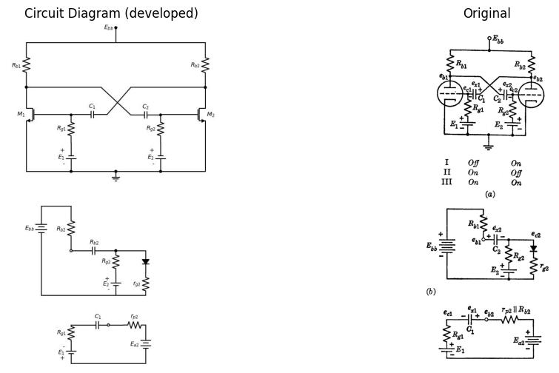

14.0.0.1 Fig. 9.19. Waveforms for free-running (astable) plate-coupled multivibrator.
This change is coupled to the grid of the second triode by $C_{2}$ so that
$$Δe_{b2}=−G_{2}Δe_{c2}=G_{1}G_{2}Δe_{c1}$$
This change in turn is coupled through $C_{1}$ and appears across $R_{θ1}$. For typical circuit parameters, $G_{1}G_{2}$ might be 100. If the grid of the first triode is now reconnected to $R_{θ1}$ the circuit is unstable in state III since any change in $e_{c1}$ immediately calls for a change in $e_{c1}$ 100 times as
Thus the circuit will drive itself out of state III into one of the other states.
If we assume the circuit to be in state I, the two circuit models given in Fig. 9.19(b) and (c) apply. In circuit (b) the capacitor $C_{2}$ will tend to charge toward a voltage very nearly equal to $E_{bb}$. This is true since in most cases $R_{g2}≫r_{g2}$ and hence the quiescent value of $e_{c2}$ is approximately zero* in state I. Since this leaves triode 2 conducting, the assumption that the circuit is in state I is valid. Now, referring to (c), it is apparent that the voltage $e_{a1}$ must approach the value $\left(E_{a2}−E_{1}\right)$ where $E_{a2}$ is the quiescent open-circuit plate voltage for tube 2 corresponding to the quiescent grid voltage $e_{c2}$ given by the circuit in (b). Circuit models similar to those of (b) and (c) can be obtained for state II by the simple expedient of interchanging all subscripts.
Since state I occurs just after state II, we expect the initial value of $e_{a1}$ to be near $E_{bb}$. Hence in Fig. 9.19(c) capacitor $C_{1}$ is discharging and voltage $e_{c1}$ is rising toward $E_{1}$. But $e_{a1}$ must be more negative than $E_{bb}/μ$ to maintain plate-current cutoff in tube 1. This means that the current through $R_{g1}$ and hence the discharge current for $C_{1}$ must exceed $\left(E_{1}+E_{bb}/μ\right)/R_{g1}$ to maintain state I. When the current falls to this value, the grid voltage $e_{c1}$ rises above the cutoff potential. The resulting onset of plate current $i_{b1}$ causes a drop in $e_{b1}$ and $e_{c2}$, a rise in $e_{b2}$ and hence a further rise in $e_{c1}$. Thus a rapid transition to state II occurs. In this state $C_{1}$ recharges rapidly to a voltage $E_{bb}$, while $C_{2}$ discharges until the second triode begins to conduct and initiates the transition returning the circuit to state I. This circuit behavior is illustrated by the waveforms in Fig. 9.19(d).
The duration of the interval $δ_{1}$ is determined by the exponential expression for $e_{c1}$. The initial value of $e_{a1}$ is assumed to be $E_{bb}$ and this fixes the initial value of $e_{c1}$ in the interval $δ_{1}$. The final value of $e_{c1}$ is $−E_{c1}=−E_{bb}/μ$. Thus the expression for the interval $δ_{1}$ is
$$δ_{1}=τ_{d1}ln\left[\frac{R_{g1}}{R_{g1}+\left(r_{p2}\left|\right|R_{b2}\right)}\right]\left[\frac{E_{1}+E_{bb}−E_{a2}}{E_{1}+E_{c1}}\right]$$
A similar expression is obtained for $δ_{2}$ by interchanging subscripts. Assuming the initial value of $e_{a1}$ to be $E_{bb}$ amounts to saying that each capacitor charges fully during the interval generated by the discharge of the other capacitor. For this condition to exist, we should have $τ_{c2}$ much less than $τ_{d1}$ and $τ_{c1}$ much less than $τ_{d2}$. If capacitors $C_{1}$ and $C_{2}$ have comparable values this requirement reduces to $R_{g1}$ much greater than $R_{b2}$ and $R_{g2}$ much greater than $R_{b1}$. With these restrictions, the resist-
ances $r_{p11}\left|\right|R_{b1}$ and $r_{p21}\left|\right|R_{b2}$ can be neglected in the circuit models and in the expressions for $δ$. The waveforms in (d) are drawn subject to this assumption so that $e_{b1}=E_{a1}$ during interval $δ_{2}$ and $e_{b2}=E_{a2}$ during $δ_{1}$.
Assuming that both $r_{g1}$ and $r_{g2}$ are zero, we obtain perfect limiting of $e_{c1}$ and $e_{c2}$ at zero. With a more realistic value of grid-to-cathode resistance, the recharge of capacitor $C_{1}$ causes a positive overshoot on the waveform of $e_{c1}$ at the beginning of interval $δ_{2}$ (shown as a dotted line). This variation in $e_{c1}$ causes an amplified replica of the overshoot to appear on the waveform of $e_{b1}$. The overshoot on $e_{b1}$ is coupled by $C_{2}$ to the waveform of $e_{c2}$. Since this grid voltage is more negative than the cutoff value the overshoot has no effect on the plate voltage $e_{b2}$ and hence proceeds no further in the circuit. In similar fashion an overshoot on $e_{c2}$ at the beginning of interval $δ_{1}$ appears on $e_{b2}$ and $e_{c1}$ (shown in light line). We can include the effects of such an overshoot on the calculation of the interval by means of an exponentially time-varying generator $GΔe_{c1}$ in series with $E_{a2}$ in the circuit model of Fig. 9.19(c). If we approximate the overshoot by an impulse with the same area, we see that the effect of the overshoot is to remove some charge from the discharging capacitor and thus shorten the interval slightly. In most cases the error in $δ$ owing to neglecting overshoot is very small.
The numerical values of pertinent points on the waveforms of Fig. 9.19(d) are readily determined once the extremes of the capacitor voltages are known. Thus if $τ_{c2}<δ_{1}/5$ and $τ_{c1}<δ_{2}/5$ we know the maximum value of capacitor voltage ($e_{x1}$ or $e_{x2}$) is $E_{bb}$. The minimum values are ($E_{a2}+E_{c01}$) and ($E_{a1}+E_{c02}$) respectively. Since $Δe_{x1}=Δe_{x2}=0$ at the transitions between states I and II, we have $Δe_{b1}=Δe_{c2}$ and $Δe_{b2}=Δe_{c1}$ at these instants.
During interval $δ_{1}$, grid voltage $e_{c1}$ heads toward $+E_{1}$ and during $δ_{2}$, the waveform of $e_{c2}$ heads toward $+E_{2}$. So long as each of these end points lies above $−E_{c}$ the circuit will be astable and hence will generate waveforms of the general character shown. If the polarity of either $E_{1}$ or $E_{2}$ is reversed and made large enough so that the final value of one grid voltage is more negative than that required for plate-current cutoff, the circuit will be monostable. The triode with the negative grid-return voltage will be normally off and the other one will be conducting. An externally generated trigger pulse can then be used to initiate a transition to the unstable state. After an interval $δ_{1}$, the circuit will switch back to the stable state and remain dormant until another trigger pulse is applied. The circuit and typical waveforms for monostable operation are shown in Fig. 9.20 with state II stable and state I unstable. In the waveforms shown, the interval $δ_{1}$ is generated as before but $δ_{2}$ becomes $δ_{s}−δ_{1}$, where $δ_{s}$ is the repetition interval of the synchronizing signal.
For this mode of operation we require
$$C_{2}R_{g2}≫C_{1}R_{g1}\text{ so that }e_{c2}\text{ remains near zero during the interval }δ_{1}.\text{ Otherwise }δ_{1}\text{ will depend on }τ_{c2}^{\left(+\right)}\text{ and }τ_{c2}^{\left(−\right)}\text{ more heavily than on }τ_{d1}.$$
import schemdraw
import schemdraw.elements as elm
import matplotlib.pyplot as plt
import matplotlib.image as mpimg
import numpy as np
fig, axs = plt.subplots(1, 2, figsize=(12, 6))
with schemdraw.Drawing(show=False) as d:
# section1
d += elm.Dot(label='$E_{bb}$',loc='right').down()
d += elm.Line().down().length(1)
d += elm.Line().left().length(6)
d += elm.Resistor().down().label('$R_{b1}$').dot()
d += elm.Line().down().length(1)
d += (M1 := elm.AnalogNFet(offset_gate = False).anchor('drain').theta(0).label('$M_1$','left'))
d += elm.Line().down().at(M1.source).length(3)
d += elm.Line().right().length(3).dot()
d.push()
d += ( V1 := elm.BatteryCell().up().length(1.9).scale(0.9).label(['-','$E_1$','+'], loc='top'))
d += elm.Resistor().up().label('$R_{g1}$').dot().scale(0.9).length(1.9)
d += elm.Line().right().at(M1.gate).length(2.5)
d += (C1 := elm.Capacitor().right().label('$C_1$').scale(0.9).length(2))
d.pop()
d += elm.Line().right().length(3).dot()
d.push()
d += elm.Ground()
d.pop()
d += elm.Line().right().length(3).dot()
d.push()
d += ( V2 := elm.BatteryCell().up().length(1.9).scale(0.9).label(['-','$E_2$','+'], loc='top'))
d += elm.Resistor().up().label('$R_{g2}$').dot().scale(0.9).length(1.9)
d += (C2 := elm.Capacitor().left().label('$C_2$').scale(0.9).length(2))
d.pop()
d += elm.Line().right().length(3)
d += elm.Line().up().length(4.65).color('white')
d += (M2 := elm.AnalogNFet(offset_gate = False).anchor('drain').reverse().right().label('$M_2$','right'))
d += elm.Line().down().at(M2.source).length(3)
d += elm.Line().left().at(M2.gate).length(2)
d += elm.Line().up().at(M2.drain).length(1).dot()
d.push()
d += (L2 :=elm.Line().left().length(5))
d += (L1 :=elm.Line().right().length(5).at((-6,-4)))
d += elm.Line().at(L2.end).to(C1.end)
d += elm.Line().at(L1.end).to(C2.end)
d.pop()
d += elm.Resistor().up().label('$R_{b2}$')
d += elm.Line().left().length(6)
d += elm.Line().left().length(0.5).at((-6,-4))
d += elm.Capacitor().left()
d += elm.Resistor().down()
d += elm.SourceV().down().label('$e_{1}$').length(2.65).reverse()
d += elm.Line().right().length(3.6)
# section2
d += elm.Dot(label='$E_{bb}$',loc='right').down().at((-3,-15))
d += elm.Line().down().length(1)
d += elm.Line().left().length(6)
d += elm.Resistor().down().label('$R_{b1}$').dot()
d += elm.Line().down().length(1)
d += (M1 := elm.AnalogNFet(offset_gate = False).anchor('drain').theta(0).label('$M_1$','left'))
d += elm.Line().down().at(M1.source).length(3)
d += elm.Line().right().length(3).dot()
d.push()
d += ( V1 := elm.BatteryCell().up().length(1.9).scale(0.9).label(['-','$E_1$','+'], loc='top'))
d += elm.Resistor().up().label('$R_{g1}$').dot().scale(0.9).length(1.9)
d += elm.Line().right().at(M1.gate).length(2.5)
d += (C1 := elm.Capacitor().right().label('$C_1$').scale(0.9).length(2))
d.pop()
d += elm.Line().right().length(3).dot()
d.push()
d += elm.Ground()
d.pop()
d += elm.Line().right().length(3).dot()
d.push()
d += ( V2 := elm.BatteryCell().up().length(1.9).scale(0.9).label(['-','$E_2$','+'], loc='top'))
d += elm.Resistor().up().label('$R_{g2}$').dot().scale(0.9).length(1.9)
d += (C2 := elm.Capacitor().left().label('$C_2$').scale(0.9).length(2))
d.pop()
d += elm.Line().right().length(3)
d += elm.Line().up().length(4.65).color('white')
d += (M2 := elm.AnalogNFet(offset_gate = False).anchor('drain').reverse().right().label('$M_2$','right'))
d += elm.Line().down().at(M2.source).length(3)
d += elm.Line().left().at(M2.gate).length(2)
d += elm.Line().up().at(M2.drain).length(1).dot()
d.push()
d += (L2 :=elm.Line().left().length(5))
d += (L1 :=elm.Line().right().length(5).at((-6-3,-4-15)))
d += elm.Line().at(L2.end).to(C1.end)
d += elm.Line().at(L1.end).to(C2.end)
d.pop()
d.push()
d += elm.Resistor().up().label('$R_{b2}$')
d += elm.Line().left().length(6)
d.pop()
d += elm.Line().right().length(0.5)
d += elm.Capacitor().right()
d += elm.Resistor().down()
d += elm.SourceV().down().label('$e_{2}$').length(2.65).reverse()
d += elm.Line().left().length(3.6)
d.save('./Drawing/fig9.20.jpg')
d.save('./Drawing/fig9.20.svg')
img = mpimg.imread('./Drawing/fig9.20.jpg')
axs[0].imshow(img)
axs[0].axis('off')
axs[0].set_title('Circuit Diagram (developed)')
img_sample = mpimg.imread('./Images/fig9.20.jpg')
axs[1].imshow(img_sample)
axs[1].axis('off')
axs[1].set_title('Original')
plt.show()
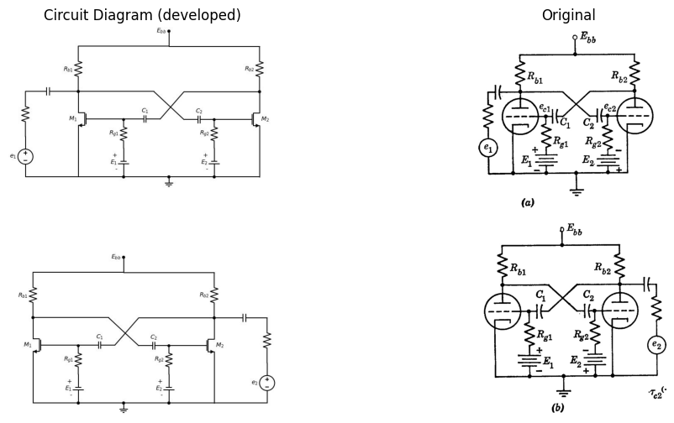

14.0.0.2 Fig. 9.20. Monostable operation of plate-coupled multivibrator.
The synchronizing signal must be large enough to turn the $off$ triode $on$ in order to effect triggering. With positive-going pulses applied as shown in $Fig.9.20\left(a\right)$ the amplitude required must exceed the difference between the grid voltage and the cutoff voltage. Alternatively, as shown in (b), triggering can be accomplished with a negative-going pulse of smaller amplitude applied to the opposite side of the circuit. In this case the trigger pulse is amplified and inverted by the normally $on$ triode and applied to the grid of the $off$ triode.

15 9.15 Plate-Coupled Bistable Circuit}
If both grids of a symmetrical two-stage plate-coupled circuit are returned to voltages more negative than $−E_{bb}/μ$, the circuit becomes bistable. One form of the circuit is shown in Fig. 9.21(a). Direct-

15.0.0.1 Fig. 9.21. Bistable plate-coupled circuit.
current plate-to-grid couplings are provided by $R_{1}$ and $R_{2}$. An alterna- tive form of the circuit is shown in (b). Here the negative supply voltage is avoided by operating the cathodes at a positive potential. Let $R_{k}$ be chosen so that
$$E_{k}=E_{cc}=I_{a}R_{k}$$
where $I_{a}$ is quiescent plate current for either triode. Then if
$$E_{bb}′=E_{bb}+E_{cc}$$
and all element values correspond, the circuit of (b) is exactly like that of (a), except for the voltage reference level.
The two circuit models shown in (c) correspond to state I (first triode off, second triode on). Similar circuits with subscripts 1 and 2 inter- changed apply to state II. However, since the circuit is symmetrical we need only consider one of the two states.
Transitions from state I to state II or from II to I can occur only when initiated by a trigger source. Two modes of bistable operation result from the two methods of triggering shown with dotted lines in Fig. 9.21 (a) and (b). Either method can be used with either circuit. As shown by the idealized waveforms, for the triggering circuit used in (a), each of the alternatively positive and negative pulses in the synchronizing wave- form induces a transition, when $e_{s}$ is applied at only one plate. When the synchronizing pulses are applied to both plates as in (b), the positive pulses have no effect since they are not passed by the diodes. The on tube has a low plate voltage that back-biases the diode connected to its plate, so if $E_{bb}=200$ and $E_{a}=100$, negative synchronizing pulses of amplitude less than 100 volts will be coupled only to the plate of the off tube. Thus negative pulses are applied alternately to one plate and then the other so that transitions occur as indicated by the waveforms in (b). In this mode of operation the circuit is a scale-of-two counter since two complete cycles of $e_{s}$ are required to produce one cycle of $e_{b1}$ or $e_{b2}$. The compensating capacitor ($C_{1}$ or $C_{2}$) couples the negative pulse to the grid of the on tube where the pulse is amplified and inverted. It is then coupled to the grid of the off tube by the other capacitor. If we let $CR=C_{gk}R_{g}$ in Fig. 9.22 (where $C_{gk}$ is the tube and wiring capacitance between grid and cathode), the coupling from plate to grid is "compensated." We then have a voltage divider with high-frequency attenuation equal to low-frequency attenuation. In a practical circuit, the coupling capacitors are made several times larger than the value thus specified ($C>C_{gk}R_{g}/R$) in order to enhance circuit gain during the rapid transitions. However, a transition is not complete until one coupling capacitor has charged and the other discharged to the appro- priate new values. This condition places a practical upper limit on the value of $C$ because the recovery time following a transition increases with the value of $C$. If we assume that $C_{gk}=10 μ\text{F}$, $R=400$ kilohms, and $R_{g}=100$ kilohms, then "compensation" would occur with $C=2.5 μ\text{F}$, whereas the value of $C$ more likely to be used is 25 or 50 $μ\text{F}$.
import os
import schemdraw
import schemdraw.elements as elm
import matplotlib.pyplot as plt
import matplotlib.image as mpimg
fig, axs = plt.subplots(1, 2, figsize=(12, 6))
with schemdraw.Drawing(unit=2, show=False) as d:
d += (S := elm.SourceV().up().label('$E$', 'top'))
l1 = d.add(elm.Line().right(d.unit * 0.5).dot())
d.push()
l2 = d.add(elm.Line().up(d.unit*0.7))
d += (C1 := elm.Capacitor().right(d.unit*1).label('$C$', 'top'))
l2 = d.add(elm.Line().down(d.unit*0.7).dot())
d.pop()
d += (R1 := elm.Resistor().right(d.unit*1.0).label('$R$', 'top'))
l1 = d.add(elm.Line().right(d.unit * 0.5).dot())
d.push()
d += (R1 := elm.Resistor().down(d.unit*1.0).label('$R_g$', 'top'))
d.pop()
l1 = d.add(elm.Line().right(d.unit * 0.5))
d.push()
d += (C5 := elm.Capacitor().down(d.unit*1.0).label('$C_{gk}$', 'bottom'))
d.pop()
l1 = d.add(elm.Line().right(d.unit * 0.5).dot(open=True))
l5 = d.add(elm.Line().left(d.unit * 0.5).dot().at(C5.end))
l1 = d.add(elm.Line().left(d.unit * 2))
#
d += (S := elm.SourceV().up().label('$E$', 'top').at((0,-6)))
d += (R6 := elm.Resistor().right(d.unit*1.0).label('$R_g$', 'top'))
l1 = d.add(elm.Line().right(d.unit * 0.5).dot())
d.push()
l2 = d.add(elm.Line().up(d.unit*0.7))
d += (C1 := elm.Capacitor().right(d.unit*1).label('$C$', 'top'))
l2 = d.add(elm.Line().down(d.unit*0.7).dot())
d.pop()
d += (R1 := elm.Resistor().right(d.unit*1.0).label('$R$', 'top'))
l1 = d.add(elm.Line().right(d.unit * 0.5).dot())
d.push()
d += (R1 := elm.Resistor().down(d.unit*1.0).label('$R_g$', 'top'))
d.pop()
l1 = d.add(elm.Line().right(d.unit * 0.5))
d.push()
d += (C5 := elm.Capacitor().down(d.unit*1.0).label('$C_{gk}$', 'bottom'))
d.pop()
l1 = d.add(elm.Line().right(d.unit * 0.5).dot(open=True))
l5 = d.add(elm.Line().left(d.unit * 0.5).dot().at(C5.end))
l1 = d.add(elm.Line().left(d.unit * 3))
d += (C4 := elm.Capacitor().down(d.unit*1.0).at(R6.end).label('$C_P$', 'bottom'))
#
d += (S := elm.SourceV().up().label('$E$', 'top').at((0,-10)))
d += (R6 := elm.Resistor().right(d.unit*1.0).label('$R_b$', 'top'))
l1 = d.add(elm.Line().right(d.unit * 0.5))
d += (R1 := elm.Capacitor().right(d.unit*1.0).label('$C$', 'top'))
l1 = d.add(elm.Line().right(d.unit * 0.5))
d.push()
d += (C5 := elm.Capacitor().down(d.unit*1.0).label('$C_{gk}$', 'bottom'))
d.pop()
l1 = d.add(elm.Line().right(d.unit * 0.5).dot(open=True))
l5 = d.add(elm.Line().left(d.unit * 0.5).at(C5.end))
l1 = d.add(elm.Line().left(d.unit * 2.5))
d += (C4 := elm.Capacitor().down(d.unit*1.0).at(R6.end).label('$C_P$', 'bottom'))
d.save('./Drawing/fig9.22.jpg')
d.save('./Drawing/fig9.22.svg')
img = mpimg.imread('./Drawing/fig9.22.jpg')
axs[0].imshow(img)
axs[0].axis('off')
axs[0].set_title('Circuit Diagram (developed)')
img = mpimg.imread('./Images/fig9.22.jpg')
axs[1].imshow(img_sample)
axs[1].axis('off')
axs[1].set_title('Original')
plt.show()
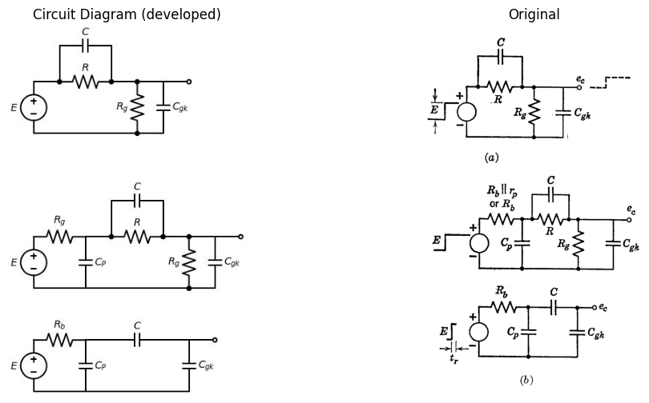
$$τ=\left[C+C_{0k}\right]\left[\frac{RR_{g}}{R+R_{g}}\right]$$
$$C<\frac{C_{0k}R_{g}}{R}$$
$$C=\frac{C_{0k}R_{g}}{R}$$
$$C>\frac{C_{0k}R_{g}}{R}$$
$$τ_{2}=CR=C_{0k}R_{0}$$
$$τ_{1}<τ_{2}<τ_{3}$$
(a)
$$τ=\left[C_{p}+\frac{CC_{gk}}{C+C_{gk}}\right]R_{b}$$
(b)

15.0.0.2 Fig. 9.22.Step response of coupling circuit.
The step response of the coupling circuit (neglecting source resistance $R_{b}$ or $R_{b}∥r_{p}$) is indicated in Fig. 9.22(a) for capacitance $C$ less than, equal to, and greater than the value required for "compensation." If source resistance (and capacitance) are included as in (b), the instananeous change in the voltages are replaced by finite rise or fall times. These can be determined approximately by neglecting the shunting effects of the large resistances $R$ and $R_{g}$ during the rapid rise. The simplified analysis of the coupling circuit outlined in Fig. 9.22 indicates the considerations involved in making a rapid determination of the approximate transition time of the plate-coupled bistable circuit.

16 9.16 Blocking Oscillator
Although the blocking oscillator circuit may take a variety of forms, either of the circuits shown in Fig. 9.18(c) or (d) can be used to describe typical circuit behavior. In a physical circuit, drastic nonlinearities can occur either in the active element due to cutoff, etc., or in the iron-core transformer due to saturation, or in both. Let us consider the case in which the transformer can be treated as a linear circuit element for the range of currents and voltages involved in the circuit operation and let the active element be a $p−n−p$ junction transistor.
With the polarity of the bias voltage $E_{1}$ as shown in Fig. 9.23(a), the transistor is normally in the \textit{off} state, hence the circuit will be monostable. Triggering is accomplished by making the emitter diode conduct with a negative-going pulse applied between base and ground. This effect can be obtained by applying a positive-going pulse between collector and ground since the transformer will invert the pulse and apply it to the base. Alternatively, a third winding on the transformer can be used to couple the trigger pulse to the base circuit.
The trigger pulse initiates the flow of base current which in turn produces a collector current $a/\left(1−a\right)$ larger in the forward-gain state. With the $n:1$ turns ratio shown, the base current will be ideally $n$ times the collector current and the total current gain available is approximately $na/\left(1−a\right)$. For nominal values of transformer turns ratio this gain will exceed unity by an appreciable amount. The circuit is therefore unstable in the forward-gain state, so that the transistor is driven into the saturation state (both emitter and collector diodes closed). Referring to the circuit model of Fig. 9.23(b), we see that the current $i_{d}$ in the collector diode is the excess over that required to sustain the circuit in the saturation state. Since the collector is at ground potential under these conditions, the voltage across the transformer primary is constant at $E_{cc}$, hence in this idealized case the magnetizing current $i_{m}$ builds up linearly with time. As it does, there is less excess current available for the collector diode, and when $i_{d}=0$ the saturation state can no longer be sustained. Then the transformer voltage $v_{1}$ diminishes
import schemdraw.elements as elm
import matplotlib.pyplot as plt
from schemdraw import dsp
from schemdraw import logic
fig, axs = plt.subplots(1, 2, figsize=(12, 6))
with schemdraw.Drawing(unit=2,show=False) as d:
d += (M1 := elm.BjtPnp(circle=True).left().anchor('collector').reverse())
x = d.add(elm.Transformer(loop=True).at((-0.0,3)))
l1 = d.add(elm.Line().up(d.unit*.45).at(M1.collector))
G = d.add(elm.Ground().at((-1.4,0.9)))
l2 = d.add(elm.Line().left(d.unit*1).at((-1.4,3.0)))
l3 = d.add(elm.Line().down(d.unit*1.84))
d += (C1 := elm.Capacitor().right(d.unit*1.30).scale(1.3).label('$C$', 'top'))
d += (R1 := elm.Resistor().down().label('$R$', 'top').at((-1.5,-.70)))
d += elm.Battery().right(d.unit*.75).label('E1', 'bottom').at(R1.end)
l5 = d.add(elm.Line().up(d.unit*.7))
G = d.add(elm.Ground().at(l5.start))
l5 = d.add(elm.Line().up(d.unit*.5).dot(open=True).at((0,3.0)).label('$-E_{cc}$', 'right'))
l5 = d.add(elm.Line().right(d.unit*1.1).dot().at((0,0)))
d.push()
l5 = d.add(elm.Line().right(d.unit*0.5).dot(open=True).label('$V_c$', 'right'))
d.pop()
d += (R1 := elm.Resistor().down(d.unit*0.67).label('$R_s$', 'top'))
d += (V := elm.SourceV().down(d.unit*0.67).reverse().label('$e_s$', 'top'))
l5 = d.add(elm.Line().left(d.unit*1.1).dot())
d += elm.Dot().at((-0.3,3.3))
d += elm.Dot().at((-1,3.3))
x = d.add(elm.Transformer(loop=True).at((-0.0,-6)))
G = d.add(elm.Ground().at((-1.4,0.9-9)))
l2 = d.add(elm.Line().left(d.unit*1).at((-1.4,0-6)))
l2 = d.add(elm.Line().down(d.unit*3))
d += (R1 := elm.Line().right(d.unit*0.6))
d += (C1 := elm.Capacitor().right(d.unit*1.30).label('$C$', 'top'))
d += (R1 := elm.Line().right(d.unit*0.7).dot())
d.push()
d += (R1 := elm.Resistor().down(d.unit*1.3).label('$R$', 'top'))
d += elm.Battery().right(d.unit*1).label('E1', 'bottom')
d.pop()
d += (R1 := elm.Resistor().right().dot(open=True).label('$r_b$', 'top'))
d.push()
l2 = d.add(elm.Line().up(d.unit*0.4))
d += (D1 := elm.Diode(fill=True).reverse().up(d.unit*1).label('$D$', 'top'))
L2 = d.add(elm.Line().up(d.unit*0.1))
d.pop()
d += (D2 := elm.Diode(fill=True).reverse().down(d.unit*1.3).label('$D$', 'top'))
G = d.add(elm.Ground())
l2 = d.add(elm.Line().up(d.unit*0.46).at(L2.end).dot())
L3 = d.add(elm.Line().left(d.unit*1).dot())
d.push()
l2 = d.add(elm.Line().left(d.unit*.9))
d.pop()
l2 = d.add(elm.Inductor2().up(d.unit*1.04).label('$L_m$', 'bottom'))
d.push()
l2 = d.add(elm.Line().left(d.unit*.9))
d.pop()
l2 = d.add(elm.Line().right(d.unit*.5))
l5 = d.add(elm.Line().up(d.unit*.5).dot(open=True).label('$-E_{cc}$', 'right'))
l2 = d.add(elm.Line().right(d.unit*2.9).at(L3.end))
d.push()
l2 = d.add(elm.Line().down(d.unit*1.45))
d += (R1 := elm.Resistor().down().label('$R_s$', 'top'))
d += (V := elm.SourceV().down(d.unit*0.8).reverse().label('$e_s$', 'top'))
l2 = d.add(elm.Line().left(d.unit*1.9))
l2 = d.add(elm.Dot(open=True).at(D1.end))
l2 = d.add(elm.Line().right(d.unit*0.6))
d += (I := elm.SourceI().down(d.unit*0.9).reverse().label('$i$', 'bottom'))
l2 = d.add(elm.Line().left(d.unit*0.6).dot())
d.pop()
l5 = d.add(elm.Line().right(d.unit*.5).dot(open=True).label('$V_{c}$', 'right'))
d += elm.Dot().at((-0.3,-5.7))
d += elm.Dot().at((-1,-5.7))
d.save('./Drawing/fig9.23.jpg')
d.save('./Drawing/fig9.23.svg')
img = mpimg.imread('./Drawing/fig9.23.jpg')
axs[0].imshow(img)
axs[0].axis('off')
axs[0].set_title('Circuit Diagram (developed)')
img_sample = mpimg.imread('./Images/fig9.23.jpg')
axs[1].imshow(img_sample)
axs[1].axis('off')
axs[1].set_title('Original')
plt.show()
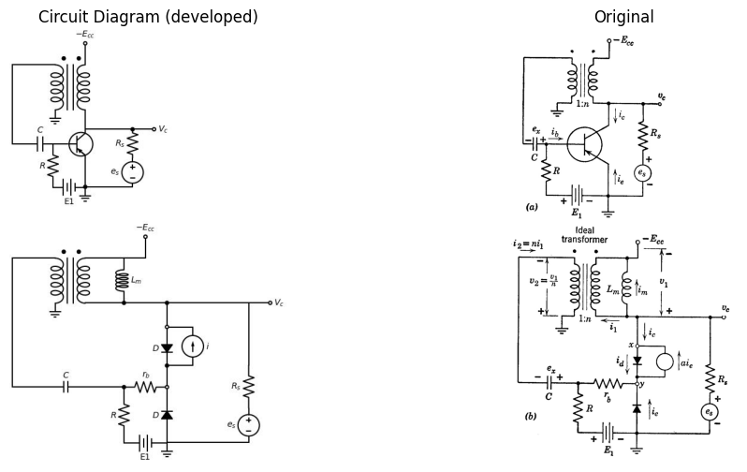

Assume $ r_b \ll R $ and $R_{s}$; $ e_x = E_1$
$i_2 = \left( \frac{E_{cc}/n - E_1}{r_b} \right) \\
= n[a i_e - i_d - i_m] \\
= i_e (1 - a) + i_d$ $ At t = 0, , i_m = 0 \text{ and } i_d = \left[ \frac{E_{cc}/n - E_1}{r_b} \right] \left[ a - \frac{1 - a}{n} \right]$
$ At t = \delta, , i_d = 0 \text{ and } i_m = I_m = \left[ \frac{E_{cc}/n - E_1}{r_b} \right] \left[ \frac{a}{1 - a} - \frac{1}{n} \right]; , \delta = \frac{I_m L_m}{E_{cc}} $

16.0.0.1 Fig. 9.23. Monostable blocking oscillator (} \delta \text{ controlled by } L_m \text{).
from the value $E_{cc}$ and this change produces a regenerative transition through the forward-gain state to the inactive or off state. The magnetizing current then decays exponentially, and, if $i_{m}$ reaches zero prior to the next trigger, the next cycle of operation will be identical. The assumption that the interval between trigger pulses is very long, compared with the duration of the pulse generated by the circuit, permits $i_{m}$ to return to zero and $e_{x}$ to return to the voltage $E_{1}$ prior to each trigger pulse.
The duration of the pulse generated may depend on the capacitor, the transformer magnetizing inductance, or both. Which of these cases occurs is determined by the rate at which the capacitor charges relative to the rate at which current builds up in the magnetizing inductance of the transformer. For the case in which the build-up of magnetizing current is largely responsible for controlling the pulse duration, the analysis is simplified if we assume the capacitor voltage remains relatively constant during the pulse and hence never departs appreciably from the value $E_{1}$. In this case the capacitor $C$ can be represented by a battery of voltage $E_{1}$ in the circuit model of (b). The transformer is represented by an ideal transformer of ratio $n:1$ shunted by the magnetizing inductance $L_{m}$. The effects of stray parameters such as leakage inductances and shunt capacitances are not included in this simplified analysis. One additional assumption made in deriving the equations of Fig. 9.23(c) is that $r_{b}$ is much less than $R$ or $R_{s}$. The current $i_{2}$ immediately following the synchronizing pulse must be
$i_{2}=\frac{E_{cc}/n−e_{x}}{r_{b}}=\frac{E_{cc}/n−E_{1}}{r_{b}}$ Since $i_{2}$ must be positive to drive the transistor through the forward gain state and into saturation we must satisfy the condition $E_{cc}/n>E_{1}$. Two other equations for $i_{2}$ which express the continuity of current at the nodes $x$ and $y$ respectively are
$i_{2}=n\left[ai_{e}−i_{d}−i_{m}\right]$ $i_{2}=i_{e}\left(1−a\right)+i_{d}$ When a trigger pulse occurs ($t=0$), the magnetizing current is zero and the current equations can be solved for $i_{d}$. The fact that $i_{d}$ must be greater than zero imposes another relationship on $E_{cc}$, $E_{1}$, and $n$. The pulse duration
$δ=\frac{L_{m}I_{m}}{E_{cc}}$ is found by noting that the same current equation can be solved for $I_{m}$, the value of $i_{m}$ when $i_{d}=0$. After the pulse, the current $i_{m}$ decreases
exponentially with time constant
$ \tau = \frac{L_m}{(R_s \parallel n^2 R)} $
since the inductor faces resistance (R_s) in parallel with (n^2 R) reflected through the transformer. The waveforms of (i_m) and (v_c) shown in Fig. 9.23(d) illustrate these points. Note that the average voltage (v_1) across the inductor (L_m) must be zero. Thus the area of the rectangular pulse ((E_{cc} \delta)) is also the area of the exponential overshoot measured with respect to (-E_{cc}). This area is the amplitude of the exponential times the time constant, namely
$ \text{Area} = \left[ I_m (R_s \parallel n^2 R) \right] \left[ \frac{L_m}{(R_s \parallel n^2 R)} \right] = I_m L_m = E_{cc} \delta $
The magnetizing current has an average value readily calculated from the waveform by computing the area and dividing by (\delta_s).
The current (i_2) is constant during the pulse and small between pulses. With (i_m) known, Eqs. 9.15 and 9.16 can be used to determine (i_d) and (i_e) in terms of (i_2) and (i_m) to complete the specification of all pertinent variables in the circuit.
We have calculated a pulse duration based on magnetizing current buildup, subject to the assumption that the coupling-capacitor voltage remains unchanged during the pulse. Let us now consider the other extreme case; namely, a pulse duration determined by the coupling capacitor alone.
For simplicity let the pulse transformer be ideal so that magnetizing current is zero during the pulse. The circuit model of Fig. 9.23(b) can be used for this calculation if we let the magnetizing inductance (L_m) be very large.
At the instant a synchronizing pulse occurs, the transistor is driven through the active state to the saturation state. If the interval between synchronizing pulses is large, we can assume the initial capacitor voltage to be (E_1). The equilibrium conditions calculated for the previous case at (t = 0) also apply in this case. The circuit model for calculating the waveforms is shown in Fig. 9.24(a). The Thevenin equivalent in (b) applies only during the pulse interval (\delta).
As the capacitor charges, the charging current (i_2) diminishes exponentially toward zero. The pulse terminates when capacitor voltage is nearly (E_{cc}/n) and charging current is approximately (E_1/R). At these values, the current in the collector diode is zero so that the saturation state can no longer be sustained. When (i_d) is zero we have (-i_c = i_1 = i_2/n = i_{a}f/(1-a)), but since (anR \gg (1-a)(R+r_b)) the base voltage is nearly zero and (E_1/R) is a valid approximation for (i_2). At (t = \delta) the transistor returns rapidly to the off state and the capacitor discharges.
slowly through the large resistance ( R ) in series with ( R_s / n^2 ) to the quiescent value ( E_1 ).
import schemdraw.elements as elm
import matplotlib.pyplot as plt
from schemdraw import dsp
from schemdraw import logic
fig, axs = plt.subplots(1, 2, figsize=(12, 6))
with schemdraw.Drawing(unit=2, show=False) as d:
G = d.add(elm.Ground())
d += (S := elm.SourceV().up().reverse().label('$E_{cc}/n$', 'top'))
l1 = d.add(elm.Line().right(d.unit * 0.3))
d += (C1 := elm.Capacitor().right(d.unit*1).label('$C$', 'top').dot())
d.push()
d += (R1 := elm.Resistor().right(d.unit*1.0).label('$r_b$', 'top'))
d += (R1 := elm.Diode(fill=True).reverse().down(d.unit*1.0))
d.pop()
d += (R1 := elm.Resistor().down(d.unit*1.0).label('$R$', 'top'))
d += (R1 := elm.Battery().right(d.unit*1.0).label('$E_1$', 'top'))
G = d.add(elm.Ground())
G = d.add(elm.Ground().at((0,-5)))
d += (S := elm.SourceV().up(d.unit * 1.5).reverse().label('$E_{cc}/n$', 'top'))
l1 = d.add(elm.Line().right(d.unit * 0.5))
d += (C1 := elm.Capacitor().right(d.unit*1).label('$C$', 'top'))
l1 = d.add(elm.Line().right(d.unit * 0.5))
d += (R1 := elm.Resistor().down(d.unit*0.8).label('$r_b$', 'top'))
d += (R1 := elm.Battery().down(d.unit*0.7).label('$E_1$', 'top'))
G = d.add(elm.Ground())
d.save('./Drawing/fig9.24.jpg')
d.save('./Drawing/fig9.24.svg')
img = mpimg.imread('./Drawing/fig9.24.jpg')
axs[0].imshow(img)
axs[0].axis('off')
axs[0].set_title('Circuit Diagram (developed)')
img_sample = mpimg.imread('./Images/fig9.24.jpg')
axs[1].imshow(img_sample)
axs[1].axis('off')
axs[1].set_title('Original')
plt.show()
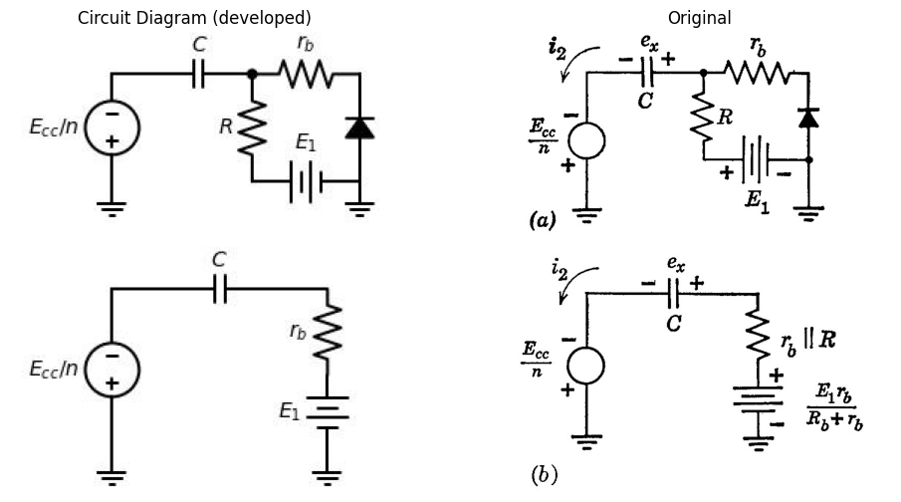

16.0.0.2 Fig. 9.24. Monostable blocking oscillator (δ controlled by C).
The pulse duration δ depends on the capacitor charging current. This current is
$ i_2 = \frac{\frac{E_{cc}}{n} + \frac{E_1 r_b}{R + r_b} - e_x}{r_b \parallel R} \tag{9.20} $
Since $ e_x = E_1 $ at $ t = 0 $ we have
$ i_2 = \frac{\frac{E_{cc}}{n} - \frac{E_1 R}{R + r_b} e^{-\frac{t}{C(r_b \parallel R)}}}{r_b \parallel R} \tag{9.21} $
The collector diode current, which determines the end-point of the pulse, is given by ...
interval, is given by
$ i_d = \frac{E_{cc} - e_x}{nr_{b}||R} \left[ \left( \frac{R}{R + r_b} \right) \left( \frac{a}{1 - a} \right) - \frac{1}{n} \right] - \frac{E_1}{nR} \tag{9.22} $
with magnetizing current assumed to be zero. If this expression is compared with the one given in Fig. 9.23(c), we see that the major difference is the replacement of the constant $E_{1}$ by the variable $e_{x}$. The inclusion of $R$ in parallel with $r_{b}$ makes relatively little difference numerically since we still assume $R$ to be much greater than $r_{b}$. When $i_{d}=0$ in Eq. 9.22, the end value of $e_{x}$ is $E_{cc}/n$ if the factor involving turns ratio and current gain is positive. The restriction imposed on the transformer turns ratio $n$ by this requirement is easily satisfied in practice.
The value of pulse duration calculated from the capacitor voltage waveform is
$ \delta = C(r_b||R) \ln \left[ \frac{E_{cc}}{n} - \frac{E_1R}{R + r_b} \middle/ \frac{E_1r_b}{R + r_b} \left( 1 + \frac{1}{\frac{R}{R + r_b} \left( \frac{a}{1 - a} \right) - \frac{1}{n}} \right) \right] \tag{9.23} $
Since $R≫r_{b}$ and $na≫\left(1−a\right)$ we have
$ \delta \approx Cr_b \ln \left[ \frac{R}{r_b} \left( \frac{E_{cc} - nE_1}{nE_1} \right) \right] \tag{9.24} $
Both the magnetizing-current and the capacitor voltage influence the astable behavior of the blocking oscillator circuit. To obtain continuous oscillations from the circuit of Fig. 9.23(a), we need only reverse the polarity of $E_{1}$, so that the transistor is normally biased on. The synchronizing source can then be removed as in Fig. 9.25(a). However, the resistance is retained to dissipate the energy in $L_{m}$ after the pulse.
In most free-running blocking oscillator circuits, the pulse duration is controlled largely by $L_{m}$ whereas the interval between pulses is controlled largely by $C$. When a pulse occurs, the transistor switches to the saturation state and magnetizing current builds up in $L_{m}$. If we assume that $i_{2}$ remains approximately constant as in the first case considered for monostable operation, the pulse duration $δ$ will be very nearly given by $L_{m}I_{m}/E_{cc}$. The constant current $i_{2}$ passing through $C$ for the interval will produce a change $Δe_{2}=i_{2}δ/C$. Equations relating variables during the pulse are given in Fig. 9.25(b).
The increment $Δe_{2}$ must be small compared with $E_{cc}/n$ to avoid reducing $i_{2}$ during the pulse, and be slightly positive in order to hold the transistor off while $C$ discharges through $R\left(τ_{c}=RC\right)$. If the value of E_1 is made small, this condition can be met. An approximation for the interval between pulses is given in (c) and pertinent waveforms are shown in (d). In general, the calculation of pulse duration
import schemdraw.elements as elm
import matplotlib.pyplot as plt
from schemdraw import dsp
from schemdraw import logic
fig, axs = plt.subplots(1, 2, figsize=(12, 6))
with schemdraw.Drawing(unit=2,show=False) as d:
d += (M1 := elm.BjtPnp(circle=True).left().anchor('collector').reverse())
x = d.add(elm.Transformer(loop=True).at((-0.0,3)))
l1 = d.add(elm.Line().up(d.unit*.45).at(M1.collector))
G = d.add(elm.Ground().at((-1.4,0.9)))
l2 = d.add(elm.Line().left(d.unit*1).at((-1.4,3.0)))
l3 = d.add(elm.Line().down(d.unit*1.84))
d += (C1 := elm.Capacitor().right(d.unit*1.30).scale(1.3).label('$C$', 'top'))
d += (R1 := elm.Resistor().down().label('$R$', 'top').at((-1.5,-.70)))
d += elm.Battery().right(d.unit*.75).label('E1', 'bottom').at(R1.end)
l5 = d.add(elm.Line().up(d.unit*.7))
G = d.add(elm.Ground().at(l5.start))
l5 = d.add(elm.Line().right(d.unit*1.1).dot().at((0,0)))
d.push()
l5 = d.add(elm.Line().right(d.unit*0.5).dot(open=True).label('$V_c$', 'right'))
d.pop()
l5 = d.add(elm.Line().up(d.unit*0.5))
d += (R1 := elm.Resistor().up(d.unit*1).label('$R_s$', 'top'))
l5 = d.add(elm.Line().left(d.unit*0.5).dot())
d.push()
l5 = d.add(elm.Line().left(d.unit*0.6))
d.pop()
l5 = d.add(elm.Line().up(d.unit*.5).dot(open=True).label('$-E_{cc}$', 'right'))
d += elm.Dot().at((-0.3,3.3))
d += elm.Dot().at((-1,3.3))
d.save('./Drawing/fig9.25.jpg')
d.save('./Drawing/fig9.25.svg')
img = mpimg.imread('./Drawing/fig9.25.jpg')
axs[0].imshow(img)
axs[0].axis('off')
axs[0].set_title('Circuit Diagram (developed)')
img_sample = mpimg.imread('./Images/fig9.25.jpg')
axs[1].imshow(img_sample)
axs[1].axis('off')
axs[1].set_title('Original')
plt.show()
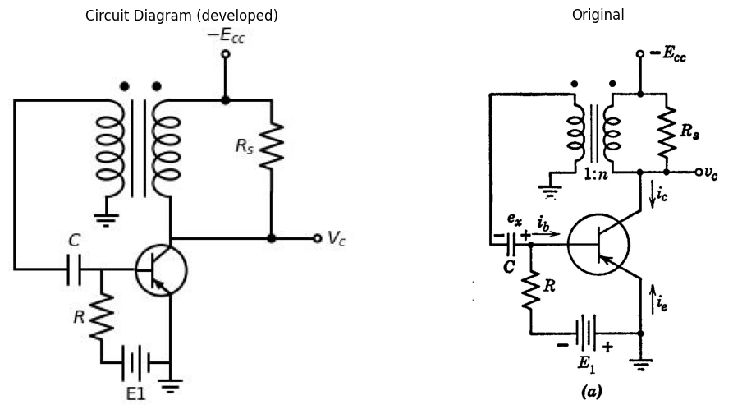
Assume $ r_b \ll R$, $, n^2 R_s $
$ \Delta e_x $ small
During pulse
$$\frac{di_{m}}{dt}=\frac{E_{cc}}{L_{m}}$$
$$I_{m}=\left(\frac{E_{cc}/n}{r_{b}}\right)\left[\frac{a}{1−a}−\frac{1}{n}\right]$$
$$δ=\frac{L_{m}I_{m}}{E_{cc}}$$
$$i_{2}≈\frac{\left[E_{cc}/n\right]}{r_{b}}=\text{constant}$$
$$∴Δe_{x}=\frac{i_{2}δ}{C}=\left(\frac{δE_{cc}}{nr_{b}C}\right)$$
$$\left(b\right)$$
$$\left(δ_{r}−δ\right)=RCln\left(\frac{Δe_{x}+E_{1}}{E_{1}}\right)$$
$$\left(b\right)$$

16.0.0.3 Fig. 9.25. Astable blocking oscillator.
include the effects of both magnetizing current build-up and coupling capacitor charge.
Practical free-running blocking oscillators readily generate very un-symmetrical rectangular waveforms with large values of the ratio $δ_{1}/δ_{2}$. Multivibrators, however, are more suitable for generating rectangular waves with small values of $δ_{1}/δ_{2}$(say, less than 20).

17 9.17 Sinusoidal Oscillations
If we can predict that nearly sinusoidal oscillations will occur in a particular circuit, a linear incremental analysis can yield a rapid indication of the conditions for oscillation and the approximate frequency. As an illustrative example, consider the tuned-plate circuit shown in Fig. 9.26(a). The circuit is essentially the same as that of the blocking oscillator considered in the preceding article. However, the coefficient of mutual coupling in the transformer is relatively small here, whereas in the pulse transformer used in the blocking oscillator, the coupling coefficient is very close to unity.
In the operation of the tuned-plate circuit the power to the load resistor $R$ plus any incidental circuit losses are supplied by the incremental power gain of the triode. The grid of the triode is driven sufficiently negative to produce plate-current cutoff and sufficiently positive to cause grid current. Waveforms of plate current and grid voltage will be approximately as indicated in Fig. 9.26(b). The pulses of plate current can be thought of as current impulses that charge $C$ and cause the circuit to oscillate at its natural frequency. The time constant $C_{g}R_{g}$ is assumed large compared to the period so that $e_{x}$ remains nearly constant during a cycle. The energy given to the tuned circuit will build up the amplitude of oscillations until the energy dissipated equals the energy supplied. As the amplitude increases, the duration of plate-current pulses diminishes, since the grid-cathode voltage is more negative than $−E_{c0}$ during a larger fraction of a cycle. This means that the "average amplification" of the triode decreases as the amplitude of oscillations increases and hence an equilibrium amplitude is established.
Fourier analysis of the plate current $i_{b}$ shows the presence of a sinusoidal component $i_{b1}$ at the fundamental frequency. The linear incremental analysis indicated in Fig. 9.26(c) assumes each waveform of current or voltage to be represented by a sine wave at this fundamental frequency. We can therefore consider the circuit to be a single-frequency amplifier with the incremental grid voltage $e_{g}$ being amplified by the triode and coupled back to the grid circuit. (See Article 8.32.) Self-oscillations occur when the voltage coupled back has the amplitude and phase required to sustain the oscillations. Under these conditions the linear incremental circuit shown in Fig. 9.26(c) sustains any value of $e_{g}$ and/or $e_{p}$ that has been established. Since this relation holds for
import schemdraw
import schemdraw.elements as elm
import matplotlib.pyplot as plt
from schemdraw import dsp
from schemdraw import logic
fig, axs = plt.subplots(1, 2, figsize=(12, 6))
with schemdraw.Drawing(unit=2, show=False) as d:
d += (M1 := elm.AnalogNFet(offset_gate=False).anchor('drain').theta(0).reverse())
x = d.add(elm.Transformer(loop=True).at((-1.4, 1)))
l1 = d.add(elm.Line().up(d.unit * 0.5).at(M1.drain))
G = d.add(elm.Ground().at((-1.4, 1)))
l2 = d.add(elm.Line().left(d.unit * 1).at((-1.4, 3.1)))
l3 = d.add(elm.Line().down(d.unit * 1.97))
d += (C1 := elm.Capacitor().right(d.unit * 1.25).label('$C$', 'top'))
d += (R1 := elm.Resistor().down().label('$R$', 'top').at((-1.5, -0.85)))
d += elm.BatteryCell().right(d.unit * 0.75).label('$E_1$', 'bottom').at(R1.end)
l5 = d.add(elm.Line().up(d.unit * 0.7))
G = d.add(elm.Ground().at(l5.start))
l5 = d.add(elm.Line().up(d.unit * 0.5).dot(open=True).at((0, 3.1)).label('$E_{bb}$', 'right'))
l5 = d.add(elm.Line().right(d.unit * 0.8).dot().at((0, 0)))
d.push()
l5 = d.add(elm.Line().right(d.unit * 1).dot(open=True).label('$e_b$', 'right'))
d.pop()
l5 = d.add(elm.Line().up(d.unit * 0.4))
d += (C1 := elm.Capacitor().up(d.unit * 1.25).label('$C$', 'top'))
d.push()
l5 = d.add(elm.Line().left(d.unit * 0.8))
d.pop()
l5 = d.add(elm.Line().right(d.unit * 0.6))
l5 = d.add(elm.Line().down(d.unit * 0.2))
d += (R1 := elm.Resistor().down().label('$R$', 'top'))
l5 = d.add(elm.Line().down(d.unit * 0.45).dot())
d += elm.Dot().at((-0.3, 3.3))
d += elm.Dot().at((-1, 3.3))
d += (F := elm.Arrow().left().length(0.7).at((-2, -5)).label('$e_{g}$',loc='top'))
d += (L1 := elm.Inductor2().down().at(F.start).label('$L_g$', 'top').reverse())
l5 = d.add(elm.Line().right(d.unit * 0.7).dot())
d += (L2 := elm.Inductor2().up().label('$L$', 'top').reverse())
l5 = d.add(elm.Line().right(d.unit * 0.7).dot())
d.push()
d += (C1 := elm.Capacitor().down(d.unit * 1).label('$C$', 'top'))
l5 = d.add(elm.Line().left(d.unit * 0.7).dot())
G = d.add(elm.Ground())
d.pop()
l5 = d.add(elm.Line().right(d.unit * 0.7).dot())
d.push()
d += (R1 := elm.Resistor().down().label('$R$', 'top'))
l5 = d.add(elm.Line().left(d.unit * 0.7).dot())
d.pop()
l5 = d.add(elm.Line().right(d.unit * 0.7).dot())
d.push()
d += (R1 := elm.Resistor().down().label('$r_p$', 'top'))
l5 = d.add(elm.Line().left(d.unit * 0.7).dot())
d.pop()
l5 = d.add(elm.Line().right(d.unit * 0.7))
d += (I := elm.SourceI().down().label('$g_m e_g$', 'bottom'))
l5 = d.add(elm.Line().left(d.unit * 0.7).dot())
d.save('./Drawing/fig9.26.jpg')
d.save('./Drawing/fig9.26.svg')
img = mpimg.imread('./Drawing/fig9.26.jpg')
axs[0].imshow(img)
axs[0].axis('off')
axs[0].set_title('Circuit Diagram (developed)')
img_sample = mpimg.imread('./Images/fig9.26.jpg')
axs[1].imshow(img_sample)
axs[1].axis('off')
axs[1].set_title('Original')
plt.show()
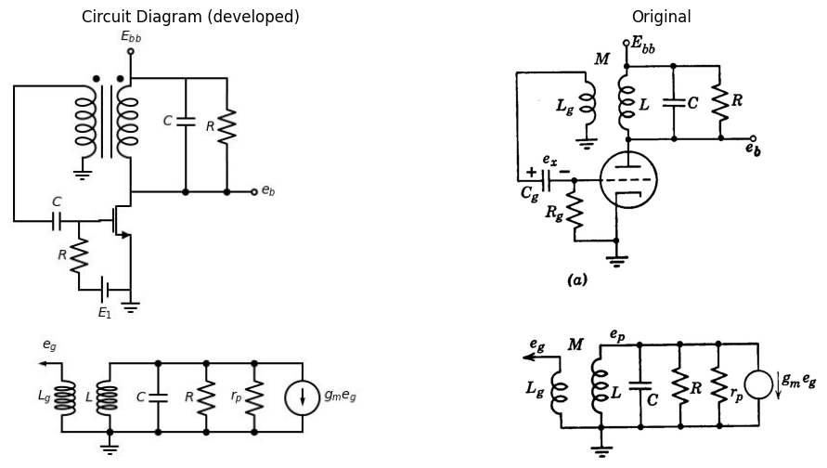
$$g_{m}E_{0}+E_{p}\left(\frac{1}{r_{p}}+\frac{1}{R}+\frac{1}{jωL}+jωC\right)=0$$
$$E_{0}=±jωM\left(\frac{E_{p}}{jωL}\right)$$
$$±g_{m}\frac{M}{L}E_{p}+E_{p}\left(\frac{1}{r_{p}}+\frac{1}{R}+\frac{1}{jωL}+jωC\right)=0$$
$$\text{Imaginary terms}$$
$$\frac{1}{jωL}+jωC=0$$
$$1−ω^{2}LC=0$$
$$ω=\frac{1}{\sqrt{LC}}$$
$$\text{Real terms}$$
$$±g_{m}\frac{M}{L}+\frac{1}{r_{p}}+\frac{1}{R}=0$$
$$g_{m}=\frac{L}{M}\left(\frac{1}{r_{p}}+\frac{1}{R}\right)$$

17.0.0.1 Fig. 9.26.Tuned-plate circuit to generate sinusoidal oscillations.
any (nonzero) value of ( e_p ), the real and imaginary parts must separately equate to zero. These two equations yield the oscillation frequency
$ \omega = \frac{1}{\sqrt{LC}} \quad (9.25) $
and the condition for oscillations to start,
$ g_m \geq \frac{L}{M} \left[ \frac{1}{r_p} + \frac{1}{R} \right] \quad (9.26) $
In an actual nonlinear circuit an appropriately weighted "average" current gain corresponds to the $g_{m}$ appearing here.

18 SUPPLEMENTARY READING
A. A. Andronow, C. E. Chaikin, \textit{Theory of Oscillations}, Princeton University Press, Princeton, N.J., 1949. B. Chance, \textit{Waveforms}, McGraw-Hill, New York, 1948. William A. Edson, \textit{Vacuum-Tube Oscillators}, John Wiley and Sons, New York, 1953. L. P. Hunter, editor \textit{Handbook of Semiconductor Electronics}, McGraw-Hill, New York, 1956. J. Millman and H. Taub, \textit{Pulse and Digital Circuits}, McGraw-Hill, New York, 1956. J. F. Reintjes and G. T. Coate, \textit{Principles of Radar}, 3rd edition, McGraw-Hill, New York, 1952. Samuel Seely, \textit{Electron-Tube Circuits}, McGraw-Hill, New York, 1950.

19 PROBLEMS (See Appendices for device curves)
9.1. Referring to Fig. 9.2, plot the driving-point curve ($v_{1}$ vs. $i_{e}$) for $\left(R_{b}+r_{b}\right)$ equal to 0.1 kilohm, 1 kilohm, 10 kilohms, and 100 kilohms. Let $V_{cc}=50$ volts, $R_{c}=10$ kilohms, $r_{ef}=r_{cf}=0$, and $r_{er}=r_{cr}=30$ kilohms, and assume that $a=0$ for $i_{e}<0$, and $a=2.5$ for $i_{e}≥0$. Determine the numerical value of $\left(r_{b}+R_{b}\right)$ for which $dv/di=0$ in the forward-gain state. Note that if the base resistance $r_{b}$ exceeds this value, the circuit has a negative-resistance region even with $R_{b}=0$. Alternatively, with $R_{b}=0$, determine the range of values of $R_{c}$ for which a negative-resistance region is obtained.
import schemdraw
import schemdraw.elements as elm
import matplotlib.pyplot as plt
from schemdraw import dsp
from schemdraw import logic
fig, axs = plt.subplots(1, 2, figsize=(12, 6))
with schemdraw.Drawing(unit=2, show=False) as d:
Q1 = d.add(elm.BjtPnp(circle=True).label('Q1').up())
l5 = d.add (elm.Line().left(d.unit * 0.30).at(Q1.emitter).dot(open=True))
l5 = d.add (elm.Line().down(d.unit * 0.27).at(Q1.base))
l5 = d.add (elm.Resistor().label('$R_b$').down())
d.push()
l5 = d.add (elm.Line().left(d.unit * 0.5).dot(open=True))
d.pop()
l5 = d.add (elm.BatteryCell().right(d.unit * 0.75).label('$E_{cc}$', 'bottom'))
l5 = d.add (elm.Line().up(d.unit * 0.3))
l5 = d.add (elm.Resistor().label('$R_c$').up())
l5 = d.add (elm.Line().up(d.unit * 0.33))
l5 = d.add (elm.Line().left(d.unit * 0.55))
l5 = d.add (elm.Dot(open=True).at((6,0)))
l5 = d.add (elm.Line().right(d.unit * 0.2))
l5 = d.add (elm.Diode(fill=True).right().dot())
d.push()
l5 = d.add (elm.Resistor().label('$R_b$').down())
l5 = d.add (elm.Line().left(d.unit * 1.2).dot(open=True))
d.pop()
D = d.add (elm.Diode(fill=True).right().reverse().dot())
l5 = d.add (elm.Resistor().label('$R_b$').down())
l5 = d.add (elm.BatteryCell().reverse().dot().left(d.unit * 1).label('$E_{cc}$', 'bottom'))
l5 = d.add (elm.Line().up(d.unit * 0.5).at(D.end))
d += (I := elm.SourceI().left().reverse().label('$3i$', 'top'))
l5 = d.add (elm.Line().down(d.unit * 0.5))
d.save('./Drawing/figP.1.jpg')
d.save('./Drawing/figP.1.svg')
img = mpimg.imread('./Drawing/figP.1.jpg')
axs[0].imshow(img)
axs[0].axis('off')
axs[0].set_title('Circuit Diagram (developed)')
img_sample = mpimg.imread('./Images/figP.1.jpg')
axs[1].imshow(img_sample)
axs[1].axis('off')
axs[1].set_title('Original')
plt.show()
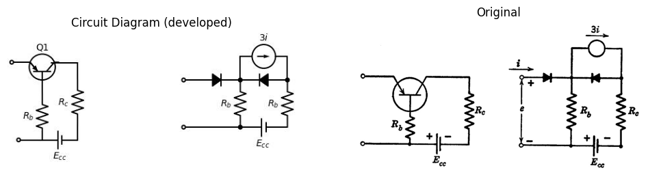

19.0.0.1 Fig P9.1
9.2. Sketch and dimension the input $ e-i $ characteristics for the circuit shown in Fig. P9.1 assuming the idealized piecewise-linear model as given.
9.3. From Fig. P9.2, sketch and dimension $ i(t) $ and $ v(t) $ assuming $v = 0 $ at $t=0$.
import schemdraw
import schemdraw.elements as elm
import matplotlib.pyplot as plt
import matplotlib.image as mpimg
import numpy as np
fig, axs = plt.subplots(1, 2, figsize=(12, 6))
with schemdraw.Drawing(show=False) as d:
d += elm.Line().left().length(1).at((3+2,0-5))
d += elm.Line().left().length(1).at((3+2,-3-5))
d += elm.Line().up().length(4).at((3+2,-3.5-5))
d += elm.Line().right().length(2).at((3+2,0.5-5))
d += elm.Line().down().length(4).at((3+4,0.5-5))
d += elm.Line().left().length(2).at((3+4,-3.5-5))
d += elm.Label('+').at((3+1.4,-0.3-5))
d += elm.Label('_').at((3+1.3,-2.5-5))
d += elm.Arrow().up().length(1.0).at((3+1, -1.2-5))
d += elm.Arrow().up().length(0.1).at((3+0.6, -1.6-5)).color('white').label('$V$', loc='bottom', color='black')
d += elm.Arrow().down().length(1.0).at((3+1, -1.9-5))
d += elm.Arrow().right().length(0.7).at((3+1.2, 0.3-5)).label('$i$')
d += elm.Line().at((0.4+6, 0.4-1-5)).to((-0.4+6, -0.4-1-5))
d += elm.Line().at((-0.4+6, -0.4-1-5)).to((0.4+6, -1.2-1-5))
d += elm.Line().at((0.4+6, -1.2-1-5)).to((-0.4+6, -1.8-1-5))
d += elm.Capacitor().at((2.5, -5)).down().label('C')
d += elm.Line().right().length(1.5)
d += elm.Line().right().length(1.5).at((2.5,-0-5))
d.save('./Drawing/figP.2.jpg')
d.save('./Drawing/figP.2.svg')
img = mpimg.imread('./Drawing/figP.2.jpg')
axs[0].imshow(img)
axs[0].axis('off')
axs[0].set_title('Circuit Diagram (developed)')
img_sample = mpimg.imread('./Images/figP.2.jpg')
axs[1].imshow(img_sample)
axs[1].axis('off')
axs[1].set_title('Original')
plt.show()
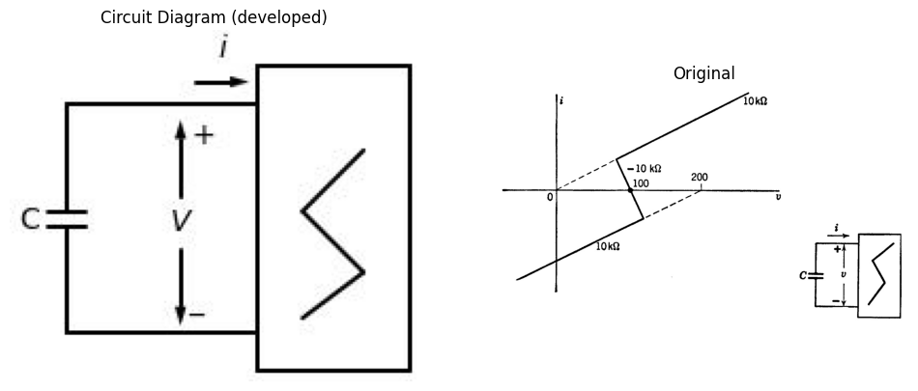

19.0.0.2 Fig P9.2
9.4. Sketch and dimension the waveforms $ v(t) $ and $ i(t) $ for the relaxation oscillator shown in Fig. P9.3.
import schemdraw
import schemdraw.elements as elm
import matplotlib.pyplot as plt
import matplotlib.image as mpimg
import numpy as np
fig, axs = plt.subplots(1, 2, figsize=(12, 6))
with schemdraw.Drawing(show=False) as d:
d += elm.Line().left().length(1).at((3+2,0-5))
d += elm.Line().left().length(1).at((3+2,-3-5))
d += elm.Line().up().length(4).at((3+2,-3.5-5))
d += elm.Line().right().length(2).at((3+2,0.5-5))
d += elm.Line().down().length(4).at((3+4,0.5-5))
d += elm.Line().left().length(2).at((3+4,-3.5-5))
d += elm.Label('+').at((3+1.4,-0.3-5))
d += elm.Label('_').at((3+1.3,-2.5-5))
d += elm.Arrow().up().length(1.0).at((3+1, -1.2-5))
d += elm.Arrow().up().length(0.1).at((3+0.6, -1.6-5)).color('white').label('$V$', loc='bottom', color='black')
d += elm.Arrow().down().length(1.0).at((3+1, -1.9-5))
d += elm.Arrow().right().length(0.7).at((3+1.2, 0.3-5)).label('$i$')
d += elm.Line().at((0.4+6, 0.4-1-5)).to((-0.4+6, -0.4-1-5))
d += elm.Line().at((-0.4+6, -0.4-1-5)).to((0.4+6, -1.2-1-5))
d += elm.Line().at((0.4+6, -1.2-1-5)).to((-0.4+6, -1.8-1-5))
d += elm.Capacitor().at((2.5, -5)).down().label('1')
d += elm.Line().right().length(1.5)
d += elm.Line().right().length(1.5).at((2.5,-0-5))
d.save('./Drawing/figP.3.jpg')
d.save('./Drawing/figP.3.svg')
img = mpimg.imread('./Drawing/figP.3.jpg')
axs[0].imshow(img)
axs[0].axis('off')
axs[0].set_title('Circuit Diagram (developed)')
img_sample = mpimg.imread('./Images/figP.3.jpg')
axs[1].imshow(img_sample)
axs[1].axis('off')
axs[1].set_title('Original')
plt.show()
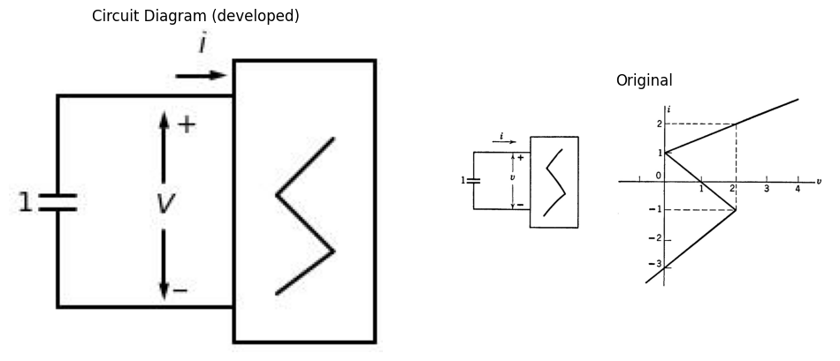

19.0.0.3 Fig P9.3
9.5. A vacuum tube circuit exhibits a current-controlled negative-resistance characteristic that may be represented by segments of the following straight lines:
$ v - 50i - 50 = 0 $
$ v + 25i - 200 = 0 $
$ v - 75i - 300 = 0 $
Determine the free-running repetition frequency obtained when a 1000 μf capacitor is connected to the terminals of the circuit.
9.6. The driving-point characteristic of an electronic device may be represented by the circuit model shown in Fig. P9.4. Determine the energy-storage element that should be connected to the terminals in order to generate 50 kcps relaxation oscillations.
import schemdraw
import schemdraw.elements as elm
import matplotlib.pyplot as plt
from schemdraw import dsp
from schemdraw import logic
fig, axs = plt.subplots(1, 2, figsize=(12, 6))
with schemdraw.Drawing(unit=2, show=False) as d:
l5 = d.add(elm.Dot(open=True))
l5 = d.add(elm.Line().right(d.unit * 1).dot())
d.push()
d += (C1 := elm.Resistor().down(d.unit * 1).label('$10kohm$', 'top'))
d += (C1 := elm.Diode(fill=True).down(d.unit * 1))
d += (C1 := elm.Battery().down(d.unit * 1).label('$30v$', 'top'))
l5 = d.add(elm.Line().left(d.unit * 1).dot(open=True))
d.pop()
l5 = d.add(elm.Line().right(d.unit * 1).dot())
d.push()
d += (R1 := elm.Resistor().down().label('$10kohm$', 'top'))
d += (C1 := elm.Diode(fill=True).reverse().down(d.unit * 1))
d += (C1 := elm.Battery().reverse().down(d.unit * 1).label('$30v$', 'top'))
l5 = d.add(elm.Line().left(d.unit * 1).dot())
d.pop()
l5 = d.add(elm.Line().right(d.unit * 1))
l5 = d.add(elm.Line().down(d.unit * 1))
d += (R1 := elm.Resistor().down().label('$-30kohm$', 'bottom'))
l5 = d.add(elm.Line().down(d.unit * 1))
l5 = d.add(elm.Line().left(d.unit * 1).dot())
d += elm.Label('+').at((-.6,-0.8))
d += elm.Label('_').at((-0.6,-5))
d += elm.Arrow().up().length(2.3).at((4-5, -6.2+3.5))
d += elm.Arrow().up().length(0.1).at((3+0.6-5, -6.6+3.5)).color('white').label('$V$', loc='bottom', color='black')
d += elm.Arrow().down().length(2.3).at((4-5, -6.9+3.5))
d.save('./Drawing/figP.4.jpg')
d.save('./Drawing/figP.4.svg')
img = mpimg.imread('./Drawing/figP.4.jpg')
axs[0].imshow(img)
axs[0].axis('off')
axs[0].set_title('Circuit Diagram (developed)')
img_sample = mpimg.imread('./Images/figP.4.jpg')
axs[1].imshow(img_sample)
axs[1].axis('off')
axs[1].set_title('Original')
plt.show()
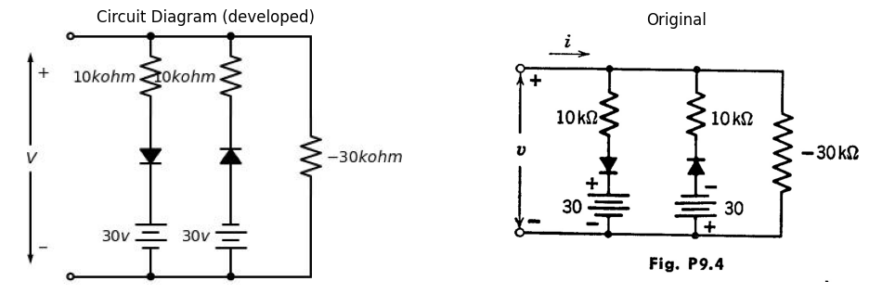

19.0.0.4 Fig P9.4
9.7 Sketch and dimension the waveforms of $ v $ and $ i $ for the circuit shown in Fig. P9.5. Assume $ v = 10 $ volts and $ i = 1 $ mA at $ t = 0 $.
import schemdraw
import schemdraw.elements as elm
import matplotlib.pyplot as plt
from schemdraw import dsp
from schemdraw import logic
fig, axs = plt.subplots(1, 2, figsize=(12, 6))
with schemdraw.Drawing(unit=2, show=False) as d:
d += elm.Line().left().length(1).at((3+2,0-5))
d += elm.Line().left().length(1).at((3+2,-3-5))
d += elm.Line().up().length(4).at((3+2,-3.5-5))
d += elm.Line().right().length(2).at((3+2,0.5-5))
d += elm.Line().down().length(4).at((3+4,0.5-5))
d += elm.Line().left().length(2).at((3+4,-3.5-5))
d += elm.Label('+').at((3+1.4,-0.3-5))
d += elm.Label('_').at((3+1.3,-2.5-5))
d += elm.Arrow().up().length(1.0).at((3+1, -1.2-5))
d += elm.Arrow().up().length(0.1).at((3+0.6, -1.6-5)).color('white').label('$V$', loc='bottom', color='black')
d += elm.Arrow().down().length(1.0).at((3+1, -1.9-5))
d += elm.Arrow().right().length(0.7).at((3+1.2, 0.3-5)).label('$i$')
d += elm.Line().at((0.4+6, 0.4-1-5)).to((-0.4+6, -0.4-1-5))
d += elm.Line().at((-0.4+6, -0.4-1-5)).to((0.4+6, -1.2-1-5))
d += elm.Line().at((0.4+6, -1.2-1-5)).to((-0.4+6, -1.8-1-5))
d += elm.Inductor2().at((2.5, -5)).down().label('100mh')
d += elm.Line().down().length(1)
d += elm.Line().right().length(1.5)
d += elm.Line().right().length(1.5).at((2.5,-0-5))
d.save('./Drawing/figP.5.jpg')
d.save('./Drawing/figP.5.svg')
img = mpimg.imread('./Drawing/figP.5.jpg')
axs[0].imshow(img)
axs[0].axis('off')
axs[0].set_title('Circuit Diagram (developed)')
img_sample = mpimg.imread('./Images/figP.5.jpg')
axs[1].imshow(img_sample)
axs[1].axis('off')
axs[1].set_title('Original')
plt.show()
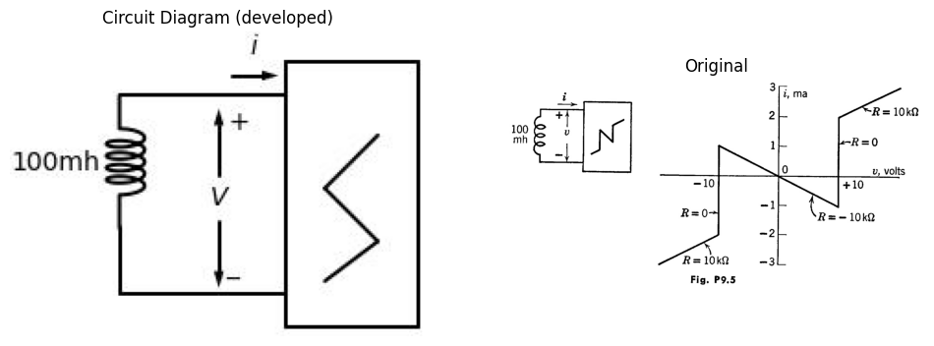

19.0.0.5 Fig P9.5
9.8. The driving-point characteristic of a circuit is shown in Fig. P9.6. Sketch and dimension the waveform $ v(t) $ that results when a 100 mH inductance (initial current 5 mA) is connected to the terminals at $ t = 0 $
import schemdraw
import schemdraw.elements as elm
import matplotlib.pyplot as plt
from schemdraw import dsp
from schemdraw import logic
fig, axs = plt.subplots(1, 2, figsize=(12, 6))
with schemdraw.Drawing(unit=2, show=False) as d:
d += elm.Line().left().length(1).at((3+2,0-5))
d += elm.Line().left().length(1).at((3+2,-3-5))
d += elm.Line().up().length(4).at((3+2,-3.5-5))
d += elm.Line().right().length(2).at((3+2,0.5-5))
d += elm.Line().down().length(4).at((3+4,0.5-5))
d += elm.Line().left().length(2).at((3+4,-3.5-5))
d += elm.Label('+').at((3+1.4,-0.3-5))
d += elm.Label('_').at((3+1.3,-2.5-5))
d += elm.Arrow().up().length(1.0).at((3+1, -1.2-5))
d += elm.Arrow().up().length(0.1).at((3+0.6, -1.6-5)).color('white').label('$V$', loc='bottom', color='black')
d += elm.Arrow().down().length(1.0).at((3+1, -1.9-5))
d += elm.Arrow().right().length(0.7).at((3+1.2, 0.3-5)).label('$i$')
d += elm.Line().at((0.4+6, 0.4-1-5)).to((-0.4+6, -0.4-1-5))
d += elm.Line().at((-0.4+6, -0.4-1-5)).to((0.4+6, -1.2-1-5))
d += elm.Line().at((0.4+6, -1.2-1-5)).to((-0.4+6, -1.8-1-5))
'
d.save('./Drawing/figP.6.jpg')
d.save('./Drawing/figP.6.svg')
img = mpimg.imread('./Drawing/figP.6.jpg')
axs[0].imshow(img)
axs[0].axis('off')
axs[0].set_title('Circuit Diagram (developed)')
img_sample = mpimg.imread('./Images/figP.6.jpg')
axs[1].imshow(img_sample)
axs[1].axis('off')
axs[1].set_title('Original')
plt.show()
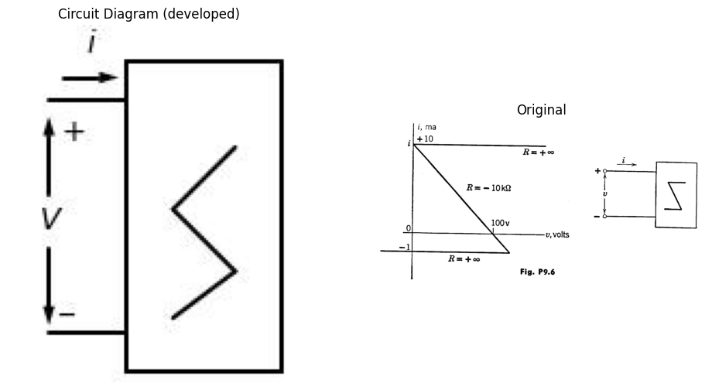

19.0.0.6 Fig P9.6
import schemdraw
import schemdraw.elements as elm
import matplotlib.pyplot as plt
from schemdraw import dsp
from schemdraw import logic
fig, axs = plt.subplots(1, 2, figsize=(12, 6))
with schemdraw.Drawing(unit=2, show=False) as d:
d += elm.Line().left().length(1).at((3+2,0-5))
d += elm.Line().left().length(1).at((3+2,-3-5))
d += elm.Line().up().length(4).at((3+2,-3.5-5))
d += elm.Line().right().length(2).at((3+2,0.5-5))
d += elm.Line().down().length(4).at((3+4,0.5-5))
d += elm.Line().left().length(2).at((3+4,-3.5-5))
d += elm.Label('+').at((3+1.4,-0.3-5))
d += elm.Label('_').at((3+1.3,-2.5-5))
d += elm.Arrow().up().length(1.0).at((3+1, -1.2-5))
d += elm.Arrow().up().length(0.1).at((3+0.6, -1.6-5)).color('white').label('$V$', loc='bottom', color='black')
d += elm.Arrow().down().length(1.0).at((3+1, -1.9-5))
d += elm.Arrow().right().length(0.7).at((3+1.2, 0.3-5)).label('$i$')
d += elm.Line().at((0.4+6, 0.4-1-5)).to((-0.4+6, -0.4-1-5))
d += elm.Line().at((-0.4+6, -0.4-1-5)).to((0.4+6, -1.2-1-5))
d += elm.Line().at((0.4+6, -1.2-1-5)).to((-0.4+6, -1.8-1-5))
d.save('./Drawing/figP.7.jpg')
d.save('./Drawing/figP.7.svg')
img = mpimg.imread('./Drawing/figP.7.jpg')
axs[0].imshow(img)
axs[0].axis('off')
axs[0].set_title('Circuit Diagram (developed)')
img_sample = mpimg.imread('./Images/figP.7.jpg')
axs[1].imshow(img_sample)
axs[1].axis('off')
axs[1].set_title('Original')
plt.show()
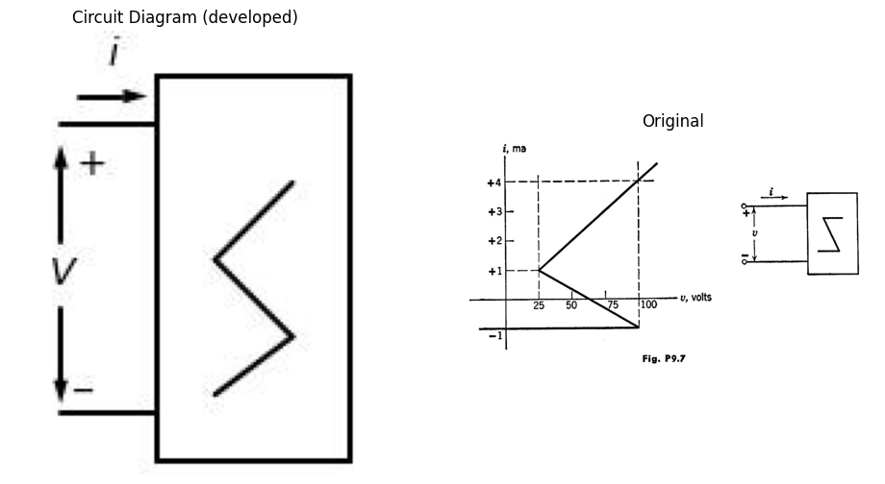

19.0.0.7 Fig P9.7
9.9. The driving point characteristic for a circuit is shown in Fig. P9.7. Sketch and dimension the waveform of v obtained if:
(a) An initially uncharged 1000 μF capacitor is connected to the terminals;
(b) An initially uncharged 1000 μF capacitor in series with a 10-kilohm resistor is connected to the terminals.
9.10. The magnetic deflection coil for a cathode-ray tube is to be driven by a linearly varying current waveform as indicated in Fig. P9.8. It has been proposed that a two-terminal device with the appropriate negative resistance characteristic could be connected to the coil to produce this required waveform. If the coil has an inductance L = 0.1 H and resistance R = 100 ohms, sketch and dimension a v-i curve that would produce the desired inductor current waveform.
9.11. Assume that Tubes T₁ and T₂ in Fig. P9.9 are resistive and piecewise-linear with cutoff for e_b₁ + μ₁e_c₁ and e_b₂ + μ₂e_c₂ negative, respectively.
(a) Sketch and dimension the curve of i vs. v, as determined by the resistive portion of the circuit.
(b) What are the conditions on R₁ and R₂ that result in a negative-resistance region?
(c) Sketch the path of operation in the i vs. v plane when a negative resistance region is present.
import schemdraw
import schemdraw.elements as elm
import matplotlib.pyplot as plt
from schemdraw import dsp
from schemdraw import logic
fig, axs = plt.subplots(1, 2, figsize=(12, 6))
with schemdraw.Drawing(show=False) as d:
d += ( T := dsp.Box(w=3, h=4).anchor('W').fill('white').label('V Vs.i'))
d += dsp.Line().length(d.unit*0.25).at((3,1.7)).dot(open=True)
d.push()
d += dsp.Line().length(d.unit*0.25).at((3,-1.7)).dot(open=True)
d.pop()
d += dsp.Line().length(d.unit*0.25)
d += dsp.Line().length(d.unit*0.15).down()
d += elm.Resistor().length(d.unit*0.25).down().label('R=100ohm',loc='bottom')
d += dsp.Line().length(d.unit*0.15).down()
d += elm.Inductor2().length(d.unit*0.25).down().label('L=0.1H',loc='bottom')
d += dsp.Line().length(d.unit*0.17).down()
d += dsp.Line().length(d.unit*0.25).left()
d += elm.Arrow().left().length(0.7).at((4, 2)).label('$i$')
d.save('./Drawing/figP.8.jpg')
d.save('./Drawing/figP.8.svg')
img = mpimg.imread('./Drawing/figP.8.jpg')
axs[0].imshow(img)
axs[0].axis('off')
axs[0].set_title('Circuit Diagram (developed)')
img_sample = mpimg.imread('./Images/figP.8.jpg')
axs[1].imshow(img_sample)
axs[1].axis('off')
axs[1].set_title('Original')
plt.show()
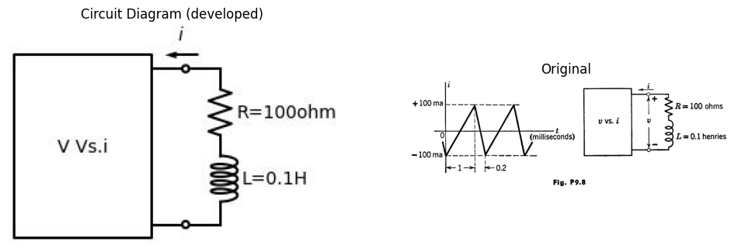

19.0.0.8 Fig P9.8
import schemdraw
import schemdraw.elements as elm
import matplotlib.pyplot as plt
from schemdraw import dsp
from schemdraw import logic
fig, axs = plt.subplots(1, 2, figsize=(12, 6))
with schemdraw.Drawing(show=False) as d:
d += elm.Dot(open=True).label('$E_{bb}$','top')
d += (M := elm.AnalogNFet(offset_gate = False,circle=True).reverse().right().label('$T_1$','right'))
d += elm.Resistor().down().at(M.source).label('$R_1$','bottom').dot()
d.push()
d += (M := elm.AnalogNFet(offset_gate = False).reverse().right().label('$T_2$','right'))
d.pop()
d += elm.Line().left().length(1.5)
d += elm.Line().up().length(3.84)
d += elm.Line().right().length(1.2-0.5)
d += elm.Resistor().down().at(M.source).label('$R_2$','bottom').dot()
d.push()
d += elm.Ground()
d.pop()
d += elm.Line().left().length(2-0.5)
d += elm.Line().up().length(3.84)
d += elm.Line().right().length(1.2-0.5)
d += elm.Label('+').at((-2.4+3,0.2-2.1))
d += elm.Label('_').at((-2.4+3,-4.8-1.7))
d += elm.Arrow().up().length(2.0).at((-2+3, -1.4-2.1))
d += elm.Arrow().up().length(0.1).at((-2.3+3, -2.3-1.7)).color('white').label('$v$', loc='bottom', color='black')
d += elm.Arrow().down().length(2.0).at((-2+3, -2.9-1.7))
d += elm.Line().right().length(1.5).at((0.5+2-2.5,-1.5)).dot(open=True)
d += (L := elm.Line().right().length(1.5).at((0.5+2-2.5,-6.8)).dot(open=True))
d += elm.Arrow().left().length(0.7).at((3-1, -1.2)).label('$i$')
d += elm.Line().right().length(1.5).at(L.end)
d += elm.Line().up().length(1.1)
d += elm.Capacitor().up().label('$c$','bottom')
d += elm.Line().up().length(1.2)
d += elm.Line().left().length(1.5)
d.save('./Drawing/figP.9.jpg')
d.save('./Drawing/figP.9.svg')
img = mpimg.imread('./Drawing/figP.9.jpg')
axs[0].imshow(img)
axs[0].axis('off')
axs[0].set_title('Circuit Diagram (developed)')
img_sample = mpimg.imread('./Images/figP.9.jpg')
axs[1].imshow(img_sample)
axs[1].axis('off')
axs[1].set_title('Original')
plt.show()
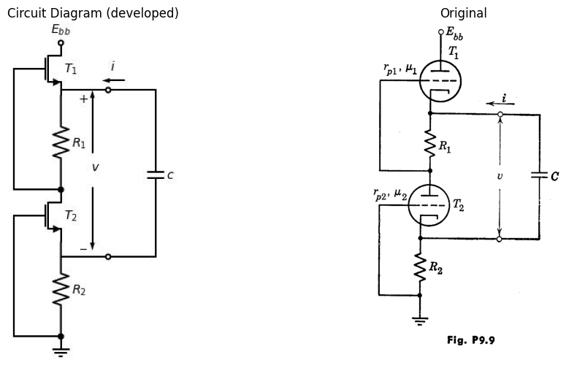

19.0.0.9 Fig P9.9
import schemdraw
import schemdraw.elements as elm
import matplotlib.pyplot as plt
from schemdraw import dsp
from schemdraw import logic
fig, axs = plt.subplots(1, 2, figsize=(12, 6))
with schemdraw.Drawing(unit=2, show=False) as d:
Q1 = d.add(elm.BjtPnp(circle=True).theta(90).reverse())
l5 = d.add (elm.Line().left(d.unit * 0.30).at(Q1.emitter).dot())
d.push()
l5 = d.add (elm.Resistor().label('$40kohm$').up().dot(open=True))
l5 = d.add (elm.Dot(open=True).label('$+20v$', 'top'))
d.pop()
l5 = d.add (elm.Line().down(d.unit * 0.8))
l5 = d.add (elm.Line().right(d.unit * 0.5).dot(open=True))
l5 = d.add (elm.Line().up(d.unit * 0.4).at(Q1.base).dot())
d.push()
l5 = d.add (elm.Line().up(d.unit * 0.2))
l5 = d.add (elm.Dot(open=True).label('$+10v$', 'top'))
d.pop()
l5 = d.add (elm.Line().right(d.unit * 1.88))
Q2 = d.add(elm.BjtNpn(circle=True).theta(0).at((3,0.75)))
l5 = d.add (elm.Line().down(d.unit * 0.5).at(Q2.emitter).dot())
d.push()
l5 = d.add (elm.Resistor().label('$40kohm$').down())
G = d.add (elm.Ground())
d.pop()
l5 = d.add (elm.Line().left(d.unit * 0.7).dot(open=True))
l5 = d.add (elm.Line().up(d.unit * 0.4).at(Q2.collector))
d.add(elm.Line().at(Q1.collector).to(Q2.base))
d.save('./Drawing/figP.10.jpg')
d.save('./Drawing/figP.10.svg')
img = mpimg.imread('./Drawing/figP.10.jpg')
axs[0].imshow(img)
axs[0].axis('off')
axs[0].set_title('Circuit Diagram (developed)')
img_sample = mpimg.imread('./Images/figP.10.jpg')
axs[1].imshow(img_sample)
axs[1].axis('off')
axs[1].set_title('Original')
plt.show()
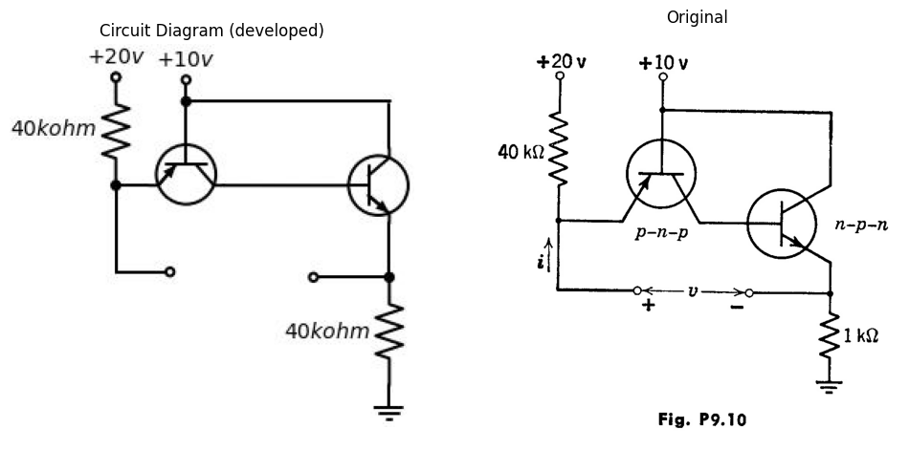

19.0.0.10 Fig P9.10
(d) Calculate the period of oscillation and sketch the waveforms of ( v ) and ( i ).
(e) As capacitance ( C ) is made smaller, the frequency of oscillation increases. Why not, then, use this circuit to generate a frequency of 1000 megacycles, simply by choosing ( C ) small enough?
(f) Will the circuit oscillate with a large resistance in series with ( C )?
(g) Will the circuit oscillate with large capacitances added in parallel with ( R_1 ) and ( R_2 )?
9.12. Using ideal-diode models for the ( p-n-p ) and ( n-p-n ) transistors in the circuit of Fig. P9.10, sketch and dimension the driving-point curve ( v ) vs. ( i ). Assume ( a = 0.98 ) for both transistors.
9.13. Modify the result of the preceding problem to include the effects of a 100-ohm base resistance in each transistor model.
9.14. Sketch and dimension the waveforms ( v(t) ) and ( i(t) ) obtained with a 1000 ( \mu )F capacitance between the driving-point terminals in Fig. P9.10.
import schemdraw
import schemdraw.elements as elm
import matplotlib.pyplot as plt
from schemdraw import dsp
from schemdraw import logic
fig, axs = plt.subplots(1, 2, figsize=(12, 6))
with schemdraw.Drawing(unit=2, show=False) as d:
D = d.add(elm.Diode(circle=True,fill=True).down())
l5 = d.add (elm.Line().down(d.unit * 0.4))
l5 = d.add (elm.Line().right(d.unit * 0.8).dot(open=True))
l5 = d.add (elm.Line().right(d.unit * 0.8).dot())
l5 = d.add (elm.Battery().reverse().up(d.unit * 0.8).dot())
l5 = d.add (elm.Resistor().label('$R$').up(d.unit * 0.8).dot())
d.push()
l5 = d.add (elm.Line().right(d.unit * 0.8))
l5 = d.add (elm.Line().down(d.unit * 0.4))
l5 = d.add (elm.Capacitor().label('$C$').down(d.unit * 0.8))
l5 = d.add (elm.Line().down(d.unit * 0.4))
l5 = d.add (elm.Line().left(d.unit * 0.8))
d.pop()
l5 = d.add (elm.Line().left(d.unit * 0.8).dot(open=True))
l5 = d.add (elm.Line().left(d.unit * 0.8))
l5 = d.add (elm.Line().down(d.unit * 0.2))
d += elm.Label('+').at((1.5,0))
d += elm.Label('_').at((1.5,-2))
d += elm.Arrow().up().length(1.0).at((-2+4, -1.4-2.1+2.8))
d += elm.Arrow().up().length(0.1).at((-2.3+4, -2.3-1.7+2.8)).color('white').label('$v$', loc='bottom', color='black')
d += elm.Arrow().down().length(1.0).at((-2+4, -2.9-1.7+2.8))
d.save('./Drawing/figP.11.jpg')
d.save('./Drawing/figP.11.svg')
img = mpimg.imread('./Drawing/figP.11.jpg')
axs[0].imshow(img)
axs[0].axis('off')
axs[0].set_title('Circuit Diagram (developed)')
img_sample = mpimg.imread('./Images/figP.11.jpg')
axs[1].imshow(img_sample)
axs[1].axis('off')
axs[1].set_title('Original')
plt.show()
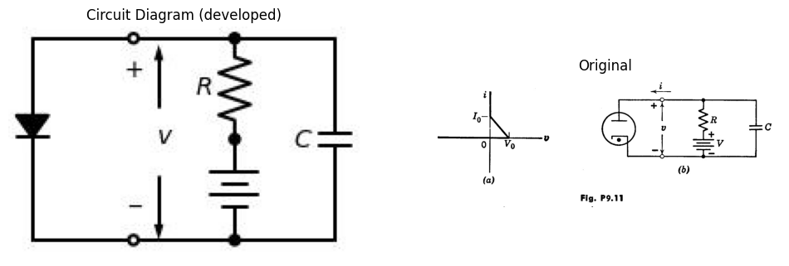

19.0.0.11 Fig P9.11
9.15. A gas diode curve is approximated as shown in Fig. P9.11. Sketch and dimension the waveform of $ v(t) $ for $ V = 2V_0 $ and $ R = 4V_0/I_0 $. 9.16. Each cold-cathode gas diode in the circuit of Fig. P9.12(a) has the odd-symmetric volt-ampere characteristic shown in Fig. P9.12(b). Let us assume the circuit has been at rest for some time with switch K closed. At time $ t = 0 $, K opens. Sketch and dimension $ e_1 $ and $ e_2 $ as functions of time.
9.16. Each cold-cathode gas diode in the circuit of Fig. P9.12(a) has the odd-symmetric volt-ampere characteristic shown in Fig. P9.12(b). Let us assume the circuit has been at rest for some time with switch K closed. At time $ t = 0 $, K opens. Sketch and dimension $ e_1 $ and $ e_2 $ as functions of time.
import schemdraw
import schemdraw.elements as elm
import matplotlib.pyplot as plt
from schemdraw import dsp
from schemdraw import logic
fig, axs = plt.subplots(1, 2, figsize=(12, 6))
with schemdraw.Drawing(unit=2, show=False) as d:
l5 = d.add (elm.Dot(open=True).label('$2E$', 'top'))
l5 = d.add (elm.Line().down(d.unit * 0.4))
l5 = d.add (elm.Resistor().label('$R$').down(d.unit * 0.8).dot())
d.push()
D = d.add(elm.Diode(fill=True).down())
G = d.add (elm.Ground())
d.pop()
l5 = d.add (elm.Capacitor().label('$C$').right(d.unit * 1).dot())
d.push()
L5 = d.add (elm.Resistor().label('$R$').up(d.unit * 0.8))
l5 = d.add (elm.Line().up(d.unit * 0.4))
l5 = d.add (elm.Dot(open=True).label('$2E$', 'top'))
d.pop()
l5 = d.add (elm.Line().right(d.unit * 1))
l5 = d.add (elm.Switch().label('$K$').down(d.unit * 1).reverse())
G = d.add (elm.Ground())
D = d.add(elm.Diode(fill=True).down().at(L5.start))
G = d.add (elm.Ground())
d.save('./Drawing/figP.12.jpg')
d.save('./Drawing/figP.12.svg')
img = mpimg.imread('./Drawing/figP.12.jpg')
axs[0].imshow(img)
axs[0].axis('off')
axs[0].set_title('Circuit Diagram (developed)')
img_sample = mpimg.imread('./Images/figP.12.jpg')
axs[1].imshow(img_sample)
axs[1].axis('off')
axs[1].set_title('Original')
plt.show()
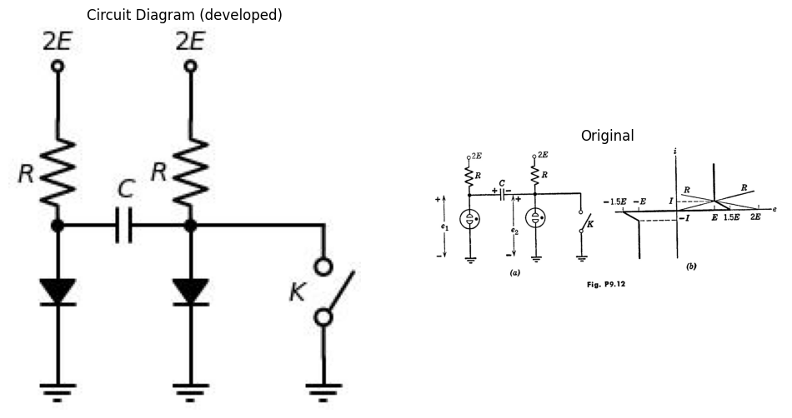

19.0.0.12 Fig P9.12
9.17. The $ e_b $ vs. $ i_b $ characteristic for the tetrode in the circuit of Fig. P9.13 is shown in Fig. P9.14.
(a) Sketch and dimension the $ i $ vs. $ e $ characteristic.
import schemdraw
import schemdraw.elements as elm
import matplotlib.pyplot as plt
from schemdraw import dsp
from schemdraw import logic
fig, axs = plt.subplots(1, 2, figsize=(12, 6))
with schemdraw.Drawing(unit=2, show=False) as d:
l5 = d.add (elm.Dot(open=True).label('$2E$', 'top'))
l5 = d.add (elm.Line().down(d.unit * 0.4))
l5 = d.add (elm.Inductor2().label('$L$').down(d.unit * 0.8))
l5 = d.add (elm.Dot(open=True).label('$A$', 'bottom'))
l5 = d.add (elm.Gap().down(d.unit * 0.8))
l5 = d.add (elm.Dot(open=True).label('$B$', 'top'))
d.push()
L5 = d.add (elm.Resistor().label('$R$').down(d.unit * 0.8))
d += (M := elm.AnalogNFet(offset_gate = False,circle=True).reverse().right().label('$T_1$','right'))
L = d.add(elm.Line().left(d.unit * 0.4).at(M.gate))
l5 = d.add (elm.Battery().down(d.unit * 1))
l = d.add(elm.Line().right(d.unit * 0.85))
G = d.add (elm.Ground())
L = d.add(elm.Line().down(d.unit * 0.6).at(M.source))
l = d.add(elm.Line().right(d.unit * 0.85).dot(open=True))
d.pop()
l = d.add(elm.Line().right(d.unit * 0.85).dot(open=True))
d.save('./Drawing/figP.13.jpg')
d.save('./Drawing/figP.13.svg')
img = mpimg.imread('./Drawing/figP.13.jpg')
axs[0].imshow(img)
axs[0].axis('off')
axs[0].set_title('Circuit Diagram (developed)')
img_sample = mpimg.imread('./Images/figP.13.jpg')
axs[1].imshow(img_sample)
axs[1].axis('off')
axs[1].set_title('Original')
plt.show()
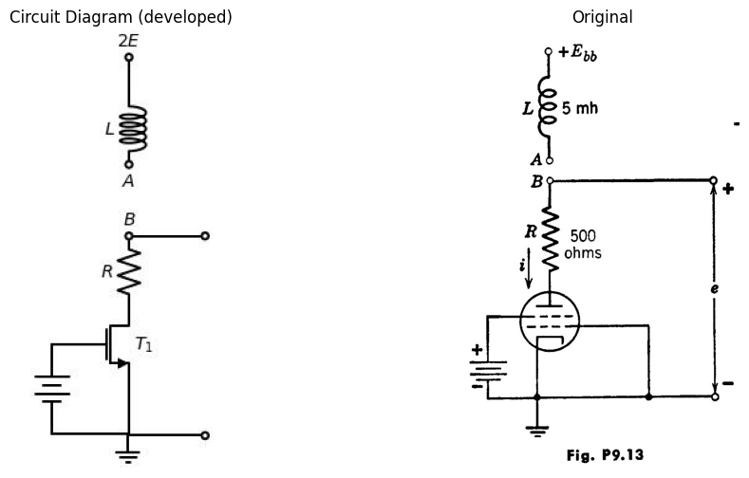

19.0.0.13 Fig P9.13

19.0.0.14 Fig P9.14
(b) Let $ E_{bb} $ equal the value of $ e $ at the center of the negative resistance region. What is this value?
(c) Show the operating path on the $ i $ vs. $ e $ characteristic with terminals $ A $ and $ B $ connected.
(d) Sketch carefully $ i $ versus time for two cycles around the operating path.
9.18. Determine the minimum value of current source required to ensure monostable operation for the series triode relaxation oscillator in Fig. 9.11. Using a source having twice this magnitude, determine the required charge.
Consider the content of the trigger pulses. Sketch and dimension the resulting waveforms. (Let $ E_{bb} = 200 $, $ R = r_p = 10 $ kilohms, and $ \mu = 20 $

19.0.0.15 Fig P9.15
9.19.
(a) Which of the v vs. i curves shown in Fig. P9.15 are astable or monostable with parallel capacitance? Why?
(b) Show how the path of operation for the monostable cases always ends at the same point no matter what the capacitor voltage was initially.

19.0.0.16 Fig P9.16
9.20. Apply the results of Article 9.9 to the dual case of a small "parasitic" capacitance in parallel with an inductance in the voltage-controlled case (Fig. P9.16).
9.21. The piecewise-linear representation of an active circuit is shown in Fig. P9.17.

19.0.0.17 Fig P9.17
(a) If an inductor with an initial current $ I_0 = 6 mA $ and an inductance of 1 millihenry is connected at time $ t = 0 $ to the terminals of the box, sketch and dimension the waveforms of $ i(t) $ and $ v(t) $. What is the path of operation on the $ v $ vs. $ i $ plane?
(b) Repeat part (a) for a capacitor of 1 microfarad with zero initial voltage. Again, find the path of operation on the $ v-i $ plane.

19.0.0.18 Fig P9.18
9.22. (a) A nonlinear device having the volt-ampere characteristic shown in Fig. P9.18 is connected in series with a one-volt battery and a one-ohm resistor. Which of the two possible operating points is stable with shunt capacitance across the device terminals? Explain.
(b) The nonlinear device of Fig. P9.18 is replaced by one having the volt-ampere characteristic of Fig. P9.19. Which of the operating points is stable with shunt capacitance across the device terminals? Explain.

19.0.0.19 Fig P9.19
9.23. The triodes in the circuit of Fig. P9.20 can be represented by a piecewise-linear model with \(\mu = 20\), \(r_p = 10\) kilohms, and \(r_o = 1\) kilohm.
import schemdraw
import schemdraw.elements as elm
import matplotlib.pyplot as plt
from schemdraw import dsp
from schemdraw import logic
fig, axs = plt.subplots(1, 2, figsize=(12, 6))
with schemdraw.Drawing(show=False) as d:
d += elm.Dot(label='$200V$',loc='right').down()
d += elm.Line().down().length(1)
d += elm.Line().left().length(6)
d += elm.Resistor().down().label('$10k$').dot()
d += elm.Line().down().length(1)
d += (M1 := elm.AnalogNFet(offset_gate = False).anchor('drain').theta(0).label('$M_1$','left'))
d += elm.Line().down().at(M1.source).length(3)
d += elm.Line().right().length(3).dot()
d.push()
d += ( V1 := elm.Line().up().length(1.9))
d += elm.Resistor().up().label('$500k$').dot().scale(0.9).length(1.9)
d += elm.Line().right().at(M1.gate).length(2.5)
d += (C1 := elm.Capacitor().right().label('$C$').scale(0.9).length(2))
d.pop()
d += elm.Line().right().length(3).dot()
d.push()
d += elm.Ground()
d.pop()
d += elm.Line().right().length(3).dot()
d.push()
d += ( V2 := elm.Line().up().length(1.9))
d += elm.Resistor().up().label('$500k$').dot().scale(0.9).length(1.9)
d += (C2 := elm.Capacitor().left().label('$C$').scale(0.9).length(2))
d.pop()
d += elm.Line().right().length(3)
d += elm.Line().up().length(4.65).color('white')
d += (M2 := elm.AnalogNFet(offset_gate = False).anchor('drain').reverse().right().theta(0).label('$M_2$','right'))
d += elm.Line().down().at(M2.source).length(3)
d += elm.Line().left().at(M2.gate).length(2)
d += elm.Line().up().at(M2.drain).length(1).dot()
d.push()
d += (L2 :=elm.Line().left().length(5))
d += (L1 :=elm.Line().right().length(5).at((-6,-4)))
d += elm.Line().at(L2.end).to(C1.end)
d += elm.Line().at(L1.end).to(C2.end)
d.pop()
d += elm.Resistor().up().label('$10k$')
d += elm.Line().left().length(6)
d.save('./Drawing/figP.20.jpg')
d.save('./Drawing/figP.20.svg')
img = mpimg.imread('./Drawing/figP.20.jpg')
axs[0].imshow(img)
axs[0].axis('off')
axs[0].set_title('Circuit Diagram (developed)')
img_sample = mpimg.imread('./Images/figP.20.jpg')
axs[1].imshow(img_sample)
axs[1].axis('off')
axs[1].set_title('Original')
plt.show()
plt.show()
C:\MLPack\PortablePython-3.10.5x64\App\Python\lib\site-packages\schemdraw\elements\elements.py:153: UserWarning: Duplicate direciton parameter in element: `right` replaced with `theta=0`
warnings.warn("Duplicate direciton parameter in element:"
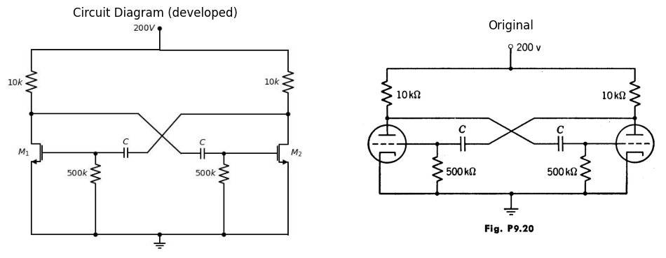

19.0.0.20 Fig P9.20
The free-running repetition frequency is to be 1000 cps. Find the value of capacitance required.
9.24. Sketch and dimension the waveforms of pertinent voltages and currents for the transistor multivibrator circuit shown in Fig. P9.21. Assume each junction transistor can be represented by an ideal diode model with a = 0.98.
9.25. A multivibrator using a single point-contact transistor is shown in Fig. P9.22 together with the transistor model. Sketch and dimension all pertinent waveforms.
9.26. Calculate the repetition frequency of the free-running multivibrator shown in Fig. P9.23. Assume rg = 1 kilohm for ec > 0. Neglect the effects of stray capacitances.
9.27. Sketch and dimension the waveform of voltage e0 obtained from the free-running multivibrator shown in Fig. P9.24. Each triode is Type I.
import schemdraw
import schemdraw.elements as elm
import matplotlib.pyplot as plt
from schemdraw import dsp
from schemdraw import logic
fig, axs = plt.subplots(1, 2, figsize=(12, 6))
with schemdraw.Drawing(show=False) as d:
d += elm.Dot(label='$-E_{cc}$',loc='right').down()
d += elm.Line().down().length(1)
d += elm.Line().left().length(6)
d += elm.Resistor().down().label('$R_{c1}$').dot()
d += elm.Line().down().length(1)
d += (Q1 := elm.BjtPnp(circle=True).left().anchor('collector'))
d += elm.Line().down().at(Q1.emitter).length(3)
d += elm.Line().right().length(3)
d.push()
#d += ( V1 := elm.BatteryCell().up().length(1.9).scale(0.9).label(['-','$E_1$','+'], loc='top'))
#d += elm.Resistor().up().label('$R_{c1}$').dot().scale(0.9).length(1.8)
d += elm.Line().right().at(Q1.base).length(2.5)
d += (C1 := elm.Capacitor().right().label('$C_1$').scale(0.9).length(2))
d.pop()
d += elm.Line().right().length(3).dot()
d.push()
d += elm.Ground()
d.pop()
d += elm.Line().right().length(3).dot()
d.push()
d += ( V2 := elm.BatteryCell().up().length(1.9).scale(0.9).label(['-','$E_2$','+'], loc='top'))
d += elm.Resistor().up().label('$R_{c1}$').dot().scale(0.9).length(1.8)
d += (C2 := elm.Capacitor().left().label('$C_2$').scale(0.9).length(2))
d.pop()
d += elm.Line().right().length(3)
d += elm.Line().up().length(3)
d += (Q2 := elm.BjtPnp(circle=True).left().anchor('emitter').reverse())
d += elm.Line().left().at(Q2.base).length(2.3)
d += elm.Line().up().at(Q2.collector).length(1).dot()
d.push()
d += (L2 :=elm.Line().left().length(5))
d += (L1 :=elm.Line().right().length(5).at((-6,-4)))
d += elm.Line().at(L2.end).to(C1.end)
d += elm.Line().at(L1.end).to(C2.end)
d.pop()
d += elm.Resistor().up().label('$R_{c1}$')
d += elm.Line().left().length(6)
d.save('./Drawing/figP.21.jpg')
d.save('./Drawing/figP.21.svg')
img = mpimg.imread('./Drawing/figP.21.jpg')
axs[0].imshow(img)
axs[0].axis('off')
axs[0].set_title('Circuit Diagram (developed)')
img_sample = mpimg.imread('./Images/figP.21.jpg')
axs[1].imshow(img_sample)
axs[1].axis('off')
axs[1].set_title('Original')
plt.show()
plt.show()
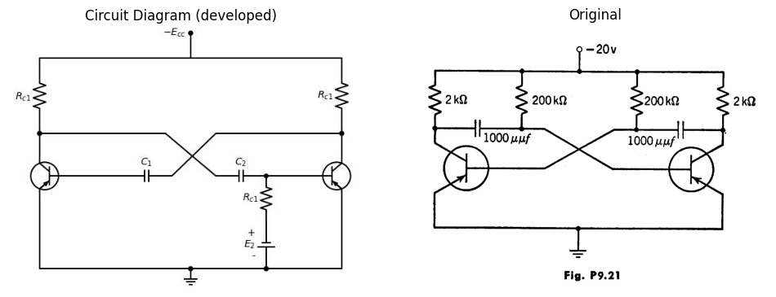

19.0.0.21 Fig P9.21

19.0.0.22 Fig P9.22

19.0.0.23 Fig P9.23

19.0.0.24 Fig P9.24
Assume $ r_o = 1 $ kilohm for $ e_c \geq 0 $ and neglect the effects of tube and wiring capacitances.
9.28. Determine the repetition frequency of the free-running multivibrator shown in Fig. P9.25. Type I triodes are used. The effects of shunt capaci-

19.0.0.25 Fig P9.25
9.29. The triodes in the circuit of Fig. P9.26 can be represented by a piecewise-linear model with $ \mu = 20 $, $ r_p = 10 $ kilohms, and $ r_g = 0 $. Triodes $ T_1 $ and $ T_2 $ constitute a monostable multivibrator triggered by $ e_1(t) $ applied to triode 4 $T_0 $.
(a) What is the minimum value of input pulse amplitude $ E_1 $ that will effect triggering?
(b) What is the maximum value of amplitude $ E_1 $ that will result in plate-current cutoff in $ T_0 $ as soon as the circuit has been triggered?
(c) What value of $ C $ (in $ \mu \mu $f) will produce a 100 $ \mu $sec positive-going pulse at $ e_2 $ each time a trigger pulse occurs?
(d) Sketch and dimension $ e_2(t) $.

19.0.0.26 Fig P9.26
9.30. The monostable multivibrator shown in the diagram of Fig. P9.27 is triggered through diode D₁ by a brief negative voltage pulse. The plate characteristics for the triodes can be represented by piecewise-linear curves with the $e_{c}=0$ curve passing through the origin. Let $r₀=1\text{kiloohm}$.

19.0.0.27 Fig P9.27
(a) What must be the value of bias potential $ E $ to make the duration of the unstable state equal to 100 $μ$sec?
(b) What is the time constant of recovery of the circuit at the end of the unstable state?
9.31. For the free-running multivibrator circuit shown in Fig. P9.28, express the repetition interval $δ_{r}$ in terms of $R_{b}$, $R$, (C), and the triode constants $μ$ and $r_{p}$. Assume $r_{g}=0$ when grid current flows.
9.32. Type I triodes are used in the monostable circuit shown in Fig. P9.29. The circuit is synchronized by brief pulses having a repetition frequency of

19.0.0.28 Fig P9.28

19.0.0.29 Fig P9.29

19.0.0.30 Fig P9.30
1000 per second. The output pulse resulting from each input pulses is required to have a peak-to-peak amplitude of 70 volts and a duration of 300 μsec. Determine the required values of R_b2 and C. Assume e_c2 = 0 during conduction of the output triode.
9.33. A tuned-plate oscillator is shown in Fig. P9.30. The transformer is represented by an ideal inductor L and an ideal transformer. The losses of the tuned circuit are represented by R. Find the turns ratio n required for sustained oscillations in the linear region of the tube. What is the frequency of oscillations?

