Table of Contents

Oscillation in RLC Circuits

1 10.1 Introduction
The $LC$ circuit is the basic electrical oscillator. Since the circuit is lossless, the total stored energy remains constant with time. However, the current and voltage oscillate sinusoidally as the stored energy is transferred back and forth from capacitor to inductor. Such ideal oscillations can actually occur at very low temperatures (say 4° Kelvin) where superconductivity exists in certain materials such as lead. How- ever, no power can be supplied to a useful load by the ideal oscillator, because any power output results in a decrease in current and voltage amplitudes.
The linear $RLC$ circuit is a more general oscillatory circuit than the LC circuit. If all elements are linear, continuous oscillations cannot be sustained. If the resistance is positive, any energy initially stored in the inductance or capacitance is eventually dissipated, hence currents and voltages approach zero. If the resistance is negative, currents and voltages increase without limit. With nonlinear resistance, positive during part of the cycle and negative during part of the cycle, continuous oscillations can occur. The amplitudes of currents and voltages stabilize at the level for which energy given to the $LC$ circuit by the negative resistance each cycle equals energy dissipated in the positive resistance.The relaxation oscillations described in Chapter 9 are special cases in which only one energy-storage element need be considered at any one time. For this approximation, the circuit operation can be represented by first-order equations. When sinusoidal (or nearly sinusoidal) wave- forms are being generated, two energy-storage elements are important throughout the cycle. The equilibrium conditions for the circuit are therefore described by a second-order differential equation. For actual circuits such equations will be nonlinear. The use of a piecewise-linear model for a nonlinear resistance is very helpful in simplifying the analysis.
import matplotlib.pyplot as plt
from matplotlib import rcParams
import matplotlib.image as mpimg
import numpy as np
from schemdraw import dsp
import schemdraw
import schemdraw.elements as e
import PySpice.Logging.Logging as Logging
logger = Logging.setup_logging()
from PySpice.Probe.Plot import plot
from PySpice.Spice.Netlist import Circuit
from PySpice.Unit import *
# Create the figure and subplots
fig, axs = plt.subplots(1, 2, figsize=(15, 15))
d = schemdraw.Drawing()
C1 = d.add(e.Capacitor().up().label('C','bottom').label(['-',' ',' ','$e_{x}$',' ',' ','+'] , fontsize = 16))
L1 = d.add(e.Inductor().right().label('L','bottom').label('- $e_L$ +','top').dot(open=True))
R = d.add(e.Resistor().right().label('R','bottom'))
E = d.add(e.Battery().down().label('$E$'))
l1 = d.add(e.Line().left().dot(open=True))
l2 = d.add(e.Line().left())
d += ( T := dsp.Box(w=4, h=4).anchor('W').linestyle('--').at((3.5,1.5)))
d += e.Gap().up().label( '$V$' , ofst=-1.7 , fontsize = 16).color('black').at((1.25,.25))
d += e.Arrow().up().length(.7).linewidth(.6).color('black').label('+',loc='end', color='black',ofst=.5). at((3,2.3))
d += e.Arrow().down().length(.7).linewidth(.6).color('black').label(r'_', loc='end', color='black',ofst=(-.5, -.3)). at((3,.8))
G = d.add(e.Ground().at(l1.end).label('$V=E+iR$ \n $=e_x+e_L$ \n $i=C de_x/d_t$\n $e_L = - L d_iL/d_t$','bottom'))
d += e.Arrow().right().length(.7).color('black').label('$i$', loc='top', color='black'). at((2.5,3.5))
d.save('Drawings/10-1a.jpg') # Save the drawing to a PNG file
img = mpimg.imread('Drawings/10-1a.jpg')
axs[0].imshow(img)
axs[0].axis('off') # Hide axes for image display
axs[0].set_title('Circuit Diagram (developed)')
# **Subplot (1, 2): PNG Sample File**
img_sample = mpimg.imread('images/10-1.jpg') # Load the PNG file
axs[1].imshow(img_sample)
axs[1].axis('off') # Hide axes for image display
axs[1].set_title('Original')
Text(0.5, 1.0, 'Original')
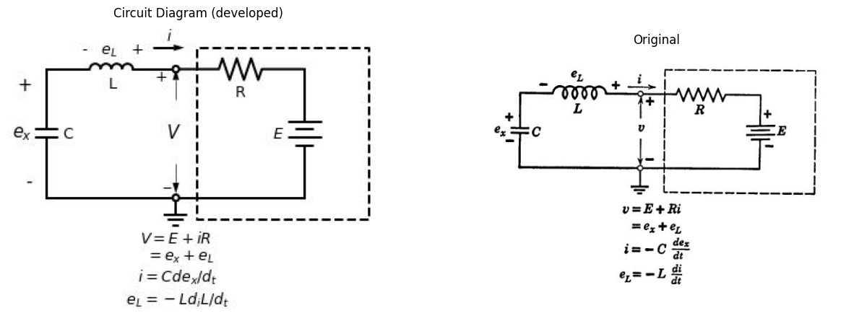

1.1 Fig 10.1 Linear oscillatory Circuit.

2 10.2 Series Oscillatory Circuit
The series circuit shown in Fig. 10.1 is a general linear oscillatory circuit. Since any one state of a piecewise-linear resistive circuit reduces to a resistance and a source, the behavior of this circuit is an aid to understanding the generation of continuous "sinusoidal" oscillations.
From the terminal relations given in Fig. 10.1 we can write the equilibrium equation for the circuit as follows:
$$E+Ri+L\frac{d_{i}}{d_{t}}+\frac{1}{c}∫id_{t}=0$$
$$\left(10.1\right)$$
The homogeneous equation, obtained by differentiation, is
$$\frac{d^{2}i}{dt^{2}}+\frac{R}{L}\frac{di}{dt}+\frac{i}{LC}=0$$
$$\left(10.2\right)$$
From this equation, the characteristic equation is
$$S^{2}+\frac{R}{L}S+\frac{1}{LC}=0$$
$$\left(10.3\right)$$
Which has the roots
$$S_{1}=−\frac{R}{2L}−\sqrt{{\left(\frac{R}{2L}\right)}^{2}−\frac{1}{LC}}$$
$$\left(10.4\right)$$
$$S_{1}=−\frac{R}{2L}+\sqrt{{\left(\frac{R}{2L}\right)}^{2}−\frac{1}{LC}}$$
$$\left(10.5\right)$$
The solution of Eq.10.2 has the form
$$i=\frac{K}{s_{2}−s_{1}}\left(e^{s1t}−e^{s2t}\right)$$
$$\left(10.6\right)$$
for the initial condition $i=0$at $t=0.$ Any of the voltages can be obtained once the current is known.
The character of the current and voltage waveforms depends on the values of the roots $s₁$ and $s_{2}$.* For comparison with the results obtained for relaxation oscillators in Chapter 9 we shall consider the waveforms i(t) and ex(t). In addition, a plot of i vs. ex for corresponding instants of time yields a compact representation of oscillatory circuit behavior. If the waveforms i(t) and ex(t) have been determined, the phase-planet trajectory (i vs. ex) can be plotted point-by-point for successive values of time t. The expressions for i(t) and ex(t) are thus seen to be a parametric-equation representation of i(ex). The functional relation between i and ex can also be expressed as a differential equation written directly from the equations given in Fig 10.1
$$\frac{e_{L}}{i}=\frac{E+Ri−e_{x}}{i}=\frac{L}{C}\frac{d_{i}}{dex}$$
$$\left(10.7\right)$$
Thus the differential equation relating i and ez is a first-order equation, whereas the equilibrium equation is second-order. In general, the equation for the phase trajectory is one order lower than the equilibrium equation.
Taking the undamped circuit (R = 0) as a simple example, we have
$$\left(E−e_{x}\right)dex=\frac{L}{C}id_{i}$$
$$\left(10.8\right)$$
If We Let E-e_x =e, then de dez so that (Eq. 10.7) reduces to
$$\frac{L}{C}id_{i}+ede=0$$
$$\left(10.9\right)$$
- Note that the series RLC circuit under discussion is the dual of the parallel RLC circuit described in Article 8.32.
† A plane in which the axes represent a variable and its time derivative is called a phase-plane.
import matplotlib.pyplot as plt
from matplotlib import rcParams
import matplotlib.image as mpimg
import numpy as np
from schemdraw import dsp
import schemdraw
import schemdraw.elements as elm
import PySpice.Logging.Logging as Logging
logger = Logging.setup_logging()
from PySpice.Probe.Plot import plot
from PySpice.Spice.Netlist import Circuit
from PySpice.Unit import *
# Create the figure and subplots
fig, axs = plt.subplots(3, 2, figsize=(15, 15))
d = schemdraw.Drawing()
C1 = d.add(e.Capacitor().up().label('C','bottom').label(['-',' ',' ','$e_{x}$',' ',' ','+'] , fontsize = 16))
L1 = d.add(e.Inductor().right().length(5).label('L','bottom').label('- $e_L$ +','top'))
E = d.add(e.Battery().down().label('$E$','bottom'))
l1 = d.add(e.Line().left().length(2.5))
l2 = d.add(e.Line().left().length(2.5))
G = d.add(e.Ground().at(l1.end))
d += e.Arrow().right().length(.7).color('black').label('$i$', loc='top', color='black'). at((3.75,3.2))
d += e.Arrow().right().length(.7).color('black').label(r'$w_0= \frac {1}{\sqrt{LC}}, A= I \sqrt{\frac {L}{C}}$', loc='right', color='black'). at((7.5,1.5))
d.save('images/10-2a.png') # Save the drawing to a PNG file
img = mpimg.imread('images/10-2a.png')
axs[0,0].imshow(img)
axs[0,0].axis('off') # Hide axes for image display
axs[0,0].set_title('Circuit Diagram (developed)')
# **Subplot (1, 2): PNG Sample File**
img_sample = mpimg.imread('images/10-2.jpg') # Load the PNG file
axs[0,1].imshow(img_sample)
axs[0,1].axis('off') # Hide axes for image display
axs[0,1].set_title('Original')
# Ellipse parameters
a = 3.5 # semi-major axis
b = 2 # semi-minor axis
# Ellipse points
t = np.linspace(0, 2*np.pi, 300)
x = a * np.cos(t)
y = b * np.sin(t)
axs[1,0].plot(x, y, color='black') # Ellipse
# Draw direction arrows along the ellipse
arrow_indices = [40, 120, 200]
for idx in arrow_indices:
dx = x[idx+1] - x[idx]
dy = y[idx+1] - y[idx]
ax.arrow(x[idx], y[idx], dx, dy, shape='full', lw=0, length_includes_head=True,
head_width=0.15, head_length=0.25, color='black')
# Draw axes
axs[1,0].axhline(0, color='black', lw=1)
axs[1,0].axvline(0, color='black', lw=1)
# Add dashed vertical line at x = a/2 (for E)
axs[1,0].axvline(a/2, color='black', linestyle='dashed', lw=1)
# Add labels
axs[1,0].text(0, -0.3, 'O', fontsize=14, ha='center', va='top')
axs[1,0].text(a/2, -0.3, 'E', fontsize=14, ha='center', va='top')
axs[1,0].text(a+0.2, 0, '$e_x$', fontsize=14, ha='left', va='center')
axs[1,0].text(0, b+0.3, 'i', fontsize=14, ha='center', va='bottom')
# Set aspect ratio and limits
axs[1,0].set_aspect('equal')
axs[1,0].set_xlim(-a-0.5, a+0.5)
axs[1,0].set_ylim(-b-0.5, b+0.5)
axs[1,0].axis('off') # Hide axes
# Parameters
L = 1
C = 1
I = 1
omega_0 = 1 / np.sqrt(L * C)
# Time axis
t = np.linspace(0, 2 * np.pi * np.sqrt(L * C), 500)
i = I * np.cos(omega_0 * t)
axs[1,1].plot(t, i, color='black')
# Draw axes
axs[1,1].axhline(0, color='black', linewidth=1)
axs[1,1].axvline(0, color='black', linewidth=1)
# Dashed vertical lines at t = pi*sqrt(LC) and t = 2pi*sqrt(LC)
for n in [1, 2]:
x = n * np.pi * np.sqrt(L * C)
axs[1,1].axvline(x, color='black', linestyle='dashed', linewidth=1)
axs[1,1].text(x + 0.1, -1.2, f"${n}\\pi\\sqrt{{LC}}$", fontsize=14, va='center')
# Dashed horizontal lines at y = I and y = -I
for sign in [1, -1]:
axs[1,1].axhline(sign * I, color='black', linestyle='dashed', linewidth=1)
axs[1,1].text(0.1, sign * I, f"${sign:+}I$", fontsize=14, va='center')
# Labels
axs[1,1].text(-0.3, 0, "O", fontsize=14, ha='right', va='center')
axs[1,1].text(t[-1] + 0.2, 0, "$t'$", fontsize=14, ha='left', va='center')
axs[1,1].text(0, 1.1 * I, "$i$", fontsize=14, ha='center', va='bottom')
# Annotate the equation
axs[1,1].annotate(r'$i = I \cos \omega_0 t$',
xy=(t[60], i[60]), xytext=(t[60]+1, i[60]+0.5),
arrowprops=dict(arrowstyle="->", color='black'),
fontsize=14)
# Parameters
L = 1
C = 1
I = 1
E = 1
omega_0 = 1 / np.sqrt(L * C)
# Time axis
t = np.linspace(0, 2 * np.pi * np.sqrt(L * C), 500)
e_x = E - I * np.sqrt(L / C) * np.sin(omega_0 * t)
# Plot the sinusoidal curve
axs[2,0].plot(e_x, -t, color='black') # Swapped and inverted t
# Draw axes
axs[2,0].axvline(E, color='black', linewidth=1)
axs[2,0].axhline(0, color='black', linewidth=1)
# Dashed vertical lines at t = pi*sqrt(LC) and t = 2pi*sqrt(LC)
for n in [1, 2]:
x = n * np.pi * np.sqrt(L * C)
axs[2,0].axhline(-x, color='black', linestyle='dashed', linewidth=1) # Inverted t
axs[2,0].text(E - 1.2, -x + 0.1, f"${n}\\pi\\sqrt{{LC}}$", fontsize=14, va='center') # Inverted t
# Horizontal line representing I*sqrt(L/C) distance
e_x_offset = E - I * np.sqrt(L / C)
axs[2,0].axvline(e_x_offset, color='black', linestyle='dashed', linewidth=1)
axs[2,0].text(e_x_offset, 0.1, f"$-I\\sqrt{{L/C}}$", fontsize=14, va='center')
# Labels
axs[2,0].text(E, -0.5, "O", fontsize=14, ha='center', va='top')
axs[2,0].text(E + 0.2, 0, "E", fontsize=14, ha='left', va='center')
axs[2,0].text(E, -t[-1] - 0.2, "$e_x$", fontsize=14, ha='center', va='bottom') # Inverted t
axs[2,0].text(e_x.min() - 0.2, -0.5, "$t'$", fontsize=14, ha='right', va='center') # Inverted t
# Annotate the equation
axs[2,0].annotate(r'$(E - e_x) = I\sqrt{\frac{L}{C}}\sin \omega_0 t$',
xy=(e_x[100], -t[100]), xytext=(e_x[100] - 3, -t[100] + 1), # Inverted t
arrowprops=dict(arrowstyle="->", color='black'),
fontsize=14)
img_sample = mpimg.imread('images/10-2a1.jpg') # Load the PNG file
axs[2,1].imshow(img_sample)
axs[2,1].axis('off') # Hide axes for image display
axs[2,1].set_title('Original')
Text(0.5, 1.0, 'Original')
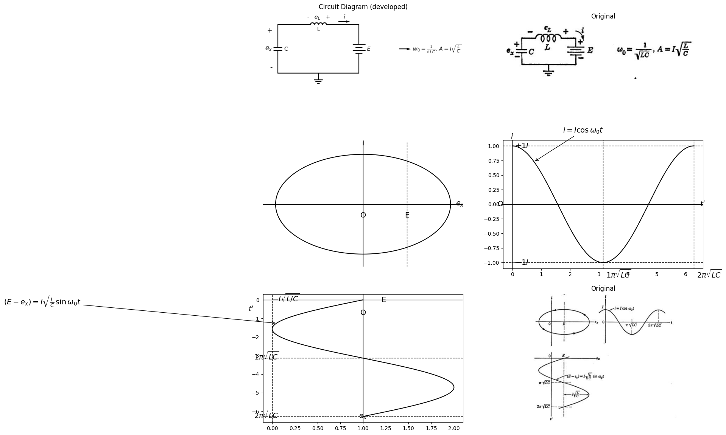

2.1 Fig. 10.2 The undamped oscillatory circuit.
Integrating this equation and substituting for e, we obtain
$$\frac{L}{C}i^{2}+{\left(E−ex\right)}^{2}=A^{2}$$
$$\left(10.10\right)$$
The corresponding undamped differential equation for the current is
$$\frac{d^{2}i}{dt^{2}}+\frac{i}{LC}=0$$
$$\left(10.11\right)$$
Which yields
$$i=Icos\left(t/\sqrt{LC}\right)$$
$$\left(10.12\right)$$
and
$$\left(E−e_{x}\right)=I\sqrt{L/C}sin\left(t/\sqrt{LC}\right)$$
$$\left(10.13\right)$$
Comparing Eq. 10.10 with Eqs. 10.12 and 10.13 we can establish A = IVL٫C. The waveforms of current and voltage as well as the elliptical phase-plane trajectory are shown in Fig. 10.2 for one specific value of A. For different values of A, corresponding to different values of stored energy in the system, the trajectories are concentric ellipses.

3 10.3 Scale Factors and Normalization
In any analysis, normalization of variables is usually desirable because the results are somewhat more general. When graphical methods are to be used, as in oscillator analysis, either normalization or a suitable choice of scale factors is virtually a necessity. For example, in a circuit like that of Fig. 10.2, the ratio L٫C may be of the order of 10º or more, so that in terms of volts and amperes the major and minor axes of the ellipse may have a ratio of 103 or more. Thus, comparable scales for volts and milliamperes yield reasonable plots. Actually, the most con- venient form for the elliptical trajectory is a circle, which can be obtained
TABLE 10.1 nORMALIZATION OF OSCILLATOR EQUATIONS
Let $i`= \sqrt {Li} , v` = \sqrt {C}.v, and t` = t/ \sqrt {LC}$
Then $e{L}` = \sqrt {C} e{L} , e{x}` = \sqrt {C}e{x}, E` = \sqrt{C} E, etc.$
and $w0`$= $w0\sqrt{LC}=1$
and $R`= R/ \sqrt {L/C}$
Original Equations
$i=−C\frac{dex}{dt}$
$eL=−L\left(di/dt\right)$
$\left(d²i/dt²\right)+\left(R/L\right)\left(di/dt\right)+\left(i/LC\right)=0$
$s1=−\frac{R}{2L}−\sqrt{\left(\frac{R}{2L}\right)²}−\frac{1}{LC}$
$s2=−\left(R/2L\right)+\sqrt{(\left(R/2L\right)²}−\left(1/LC\right))$
$\frac{\left(v−e_{x}\right)}{i}=\frac{L}{C}\frac{d_{i}}{d_{e}x}$
$$NormalizedEquations$$
$$i′=−\left(dex′/dt′\right)$$
$$eL′=−\left(di′/dt′\right)$$
$$\left(d²i′/dt′²\right)+R′*\left(di′/dt′\right)+i′=0$$
$$s1′=−\left(R′/2\right)−√\left(\left(R′/2\right)²−1\right)$$
$$s2′=−\left(R′/2\right)+√\left(\left(R′/2\right)²−1\right)$$
$$\left(v′−ex′\right)/i′=\left(di′/dex′\right)$$
by expanding the current scale by $ \sqrt{L/C }$or (more symmetrically) by multiplying current by $\sqrt L $and voltage by $\sqrt{C}$. It is also convenient to express time in terms of $\sqrt{LC}$. The effects of normalization on all of the quantities involved in the more general oscillatory circuit of Fig. 10.1 are given in Table 10.1. Note that the normalized variables i' and e' actually have different dimensions than voltage and current.
The normalization in Table 10.1 changes the dimensions of the varia- bles used to describe the oscillations. The same form of equations can be obtained by setting Land C equal to unity, in which case the variables are still current and voltage. Since it is more convenient to think in terms of current and voltage than in terms of the square root of joules ($\sqrt{L}$ $i$ or$\sqrt{C}e$) we shall assume L and C equal to unity in the following discussions. We know from the normalization procedure that there is no loss of generality in this simplification, since we can always replace current and voltage by the normalized variables in any of the equations.

4 10.4 Oscillation in Linear Circuits
In the simplified RLC circuit shown in Fig. 10.3, the only adjustable parameter is the damping resistance R. We shall select a number of resistance values to illustrate the distinctly different character of current
import matplotlib.pyplot as plt
from matplotlib import rcParams
import matplotlib.image as mpimg
import numpy as np
from schemdraw import dsp
import schemdraw
import schemdraw.elements as e
import PySpice.Logging.Logging as Logging
logger = Logging.setup_logging()
from PySpice.Probe.Plot import plot
from PySpice.Spice.Netlist import Circuit
from PySpice.Unit import *
# Create the figure and subplots
fig, axs = plt.subplots(1, 2, figsize=(15, 15))
d = schemdraw.Drawing()
C1 = d.add(e.Capacitor().up().label(' 1','bottom').label(['-',' ',' ','$e_{x}$',' ',' ','+'] , fontsize = 16))
L1 = d.add(e.Inductor().right().label('1','bottom').label('- $e_L$ +','top').dot(open=True))
R = d.add(e.Resistor().right().label('R','bottom'))
E = d.add(e.Battery().down().label('$ 1$', 'bottom'))
l1 = d.add(e.Line().left().dot(open=True))
l2 = d.add(e.Line().left())
d += ( T := dsp.Box(w=4, h=4).anchor('W').linestyle('--').at((3.5,1.5)))
d += e.Gap().up().label( '$V$' , ofst=-1.7 , fontsize = 16).color('black').at((1.25,.25))
d += e.Arrow().up().length(.7).linewidth(.6).color('black').label('+',loc='end', color='black',ofst=.5). at((3,2.3))
d += e.Arrow().down().length(.7).linewidth(.6).color('black').label(r'_', loc='end', color='black',ofst=(-.5, -.3)). at((3,.8))
G = d.add(e.Ground().at(l1.end))
d.save('Drawings/10-3a.jpg') # Save the drawing to a PNG file
img = mpimg.imread('Drawings/10-3a.jpg')
axs[0].imshow(img)
axs[0].axis('off') # Hide axes for image display
axs[0].set_title('Circuit Diagram (developed)')
# **Subplot (1, 2): PNG Sample File**
img_sample = mpimg.imread('images/10-3.jpg') # Load the PNG file
axs[1].imshow(img_sample)
axs[1].axis('off') # Hide axes for image display
axs[1].set_title('Original')
Text(0.5, 1.0, 'Original')
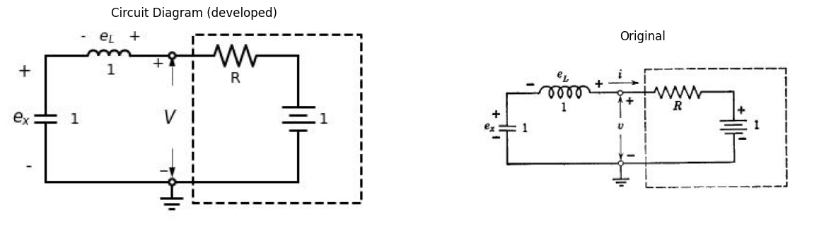

4.1 fig 10.3 Simplified Linear RLC circuit
and voltage waveforms for various amounts of damping. In addition, we shall plot the trajectories in the phase plane (i vs. ex), since these curves are generally more useful than the waveforms when we examine nonlinear or piecewise-linear oscillatory circuits.
For the circuit of Fig. 10.3, the homogeneous differential equation is
$$\frac{d^{2}i}{dt^{2}}+R\frac{di}{dt}+i=0$$
$$\left(10.14\right)$$
thr roots of the characteristic equation are
$$S_{1}=−\frac{R}{2}−\sqrt{{\left(\frac{R}{2}\right)}^{2}−1}$$
$$\left(10.15\right)$$
$$S_{2}=−\frac{R}{2}+\sqrt{{\left(\frac{R}{2}\right)}^{2}−1}$$
$$\left(10.16\right)$$
Case I: Overdamped (R> 2 , $s1$ and $s2$ both negative real)
The solution for the current is
$$i=\frac{1}{s_{2}−s_{1}}\left(e^{s1t}−e^{s2t}\right)$$
$$\left(10.17\right)$$
and the Capacitor voltage is
$$e_{x}=\frac{1}{s_{2}−s_{1}}\left[\frac{1}{s_{1}}\left(1−e^{s1t}\right)−\frac{1}{s_{2}}\left(1−e^{s2t}\right)\right]$$
$$\left(10.18\right)$$
import matplotlib.pyplot as plt
from matplotlib import rcParams
import matplotlib.image as mpimg
import numpy as np
from schemdraw import dsp
import schemdraw
import schemdraw.elements as e
import PySpice.Logging.Logging as Logging
logger = Logging.setup_logging()
from PySpice.Probe.Plot import plot
from PySpice.Spice.Netlist import Circuit
from PySpice.Unit import *
# Create the figure and subplots
fig, axs = plt.subplots(1, 3, figsize=(10, 8))
d = schemdraw.Drawing()
# Define the circuit
circuit = Circuit('Series RLC Step Response')
# Voltage source: Step from 0V to 1V at t=0
circuit.PulseVoltageSource('input', 'in', circuit.gnd,
initial_value=0@u_V, pulsed_value=1@u_V,
pulse_width=10@u_s, period=20@u_s)
# Inductor: 1 H
circuit.L('1', 'in', 'n1', 1@u_H)
# Resistor: 4 Ω
circuit.R('1', 'n1', 'n2', 4@u_Ohm)
# Capacitor: 1 F
circuit.C('1', 'n2', circuit.gnd, 1@u_F)
simulator = circuit.simulator(temperature=25, nominal_temperature=25)
analysis = simulator.transient(step_time=1e-3, end_time=5)
circuit.PulseVoltageSource('input1', 'in3', circuit.gnd,
initial_value=0@u_V, pulsed_value=1@u_V,
pulse_width=10@u_s, period=20@u_s)
# Inductor: 1 H
circuit.L('2', 'in3', 'n11', 1@u_H)
# Resistor: 4 Ω
circuit.R('2', 'n11', 'n22', 2.5@u_Ohm)
# Capacitor: 1 F
circuit.C('2', 'n22', circuit.gnd, 1@u_F)
#simulator = circuit.simulator(temperature=25, nominal_temperature=25)
analysis = simulator.transient(step_time=1e-3, end_time=5)
analysis = simulator.transient(step_time=1e-3, end_time=5)
axs[0].plot(analysis.time, u_A(-analysis.L1),color='black',linewidth=3)
axs[0].plot(analysis.time, u_A(-analysis.L2),linestyle='--',color='black',linewidth=3)
axs[0].text(1, -.18, 'R=4', ha='center', va='center')
axs[0].text(2, -.25, 'R=2.5', ha='center', va='center')
axs[0].annotate('', xy=(1.1,-0.21), xytext=(1,-.18 ), arrowprops=dict(arrowstyle='->'))
axs[0].axhline(0, color='black', linewidth=1)
axs[0].axvline(0, color='black', linewidth=1)
# Define the circuit
circuit = Circuit('Series RLC Step Response')
# Voltage source: Step from 0V to 1V at t=0
circuit.PulseVoltageSource('input', 'in', circuit.gnd,
initial_value=0@u_V, pulsed_value=1@u_V,
pulse_width=10@u_s, period=20@u_s)
# Inductor: 1 H
circuit.L('1', 'in', 'n1', 1@u_H)
# Resistor: 4 Ω
circuit.R('1', 'n1', 'n2', 4@u_Ohm)
# Capacitor: 1 F
circuit.C('1', 'n2', circuit.gnd, 1@u_F)
simulator = circuit.simulator(temperature=25, nominal_temperature=25)
analysis = simulator.transient(step_time=1e-3, end_time=5)
circuit.PulseVoltageSource('input1', 'in3', circuit.gnd,
initial_value=0@u_V, pulsed_value=1@u_V,
pulse_width=10@u_s, period=20@u_s)
# Inductor: 1 H
circuit.L('2', 'in3', 'n11', 2.5@u_H)
# Resistor: 4 Ω
circuit.R('2', 'n11', 'n22', 2.5@u_Ohm)
# Capacitor: 1 F
circuit.C('2', 'n22', circuit.gnd, 1@u_F)
#simulator = circuit.simulator(temperature=25, nominal_temperature=25)
analysis = simulator.transient(step_time=1e-3, end_time=5)
analysis = simulator.transient(step_time=1e-3, end_time=5)
axs[1].plot(analysis.time, u_A(-analysis.L1),color='black',linewidth=3)
axs[1].plot(analysis.time, u_A(-analysis.L2),linestyle='--',color='black',linewidth=3)
axs[1].text(1, -.18, 'R=4', ha='center', va='center')
axs[1].text(2, -.25, 'R=2.5', ha='center', va='center')
axs[1].annotate('', xy=(1.1,-0.21), xytext=(1,-.18 ), arrowprops=dict(arrowstyle='->'))
axs[1].axhline(0, color='black', linewidth=1)
axs[1].axvline(0, color='black', linewidth=1)
img_sample = mpimg.imread('images/10-4a.jpg') # Load the PNG file
axs[2].imshow(img_sample)
axs[2].axis('off') # Hide axes for image display
axs[2].set_title('Original')
Text(0.5, 1.0, 'Original')
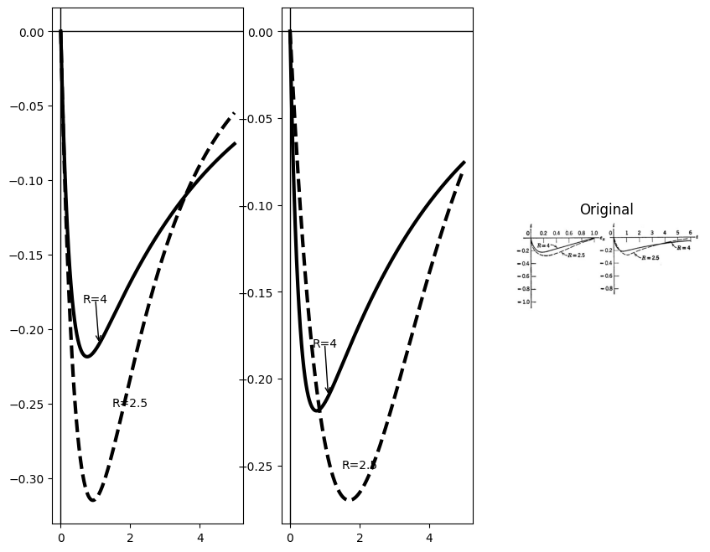
import matplotlib.pyplot as plt
from matplotlib import rcParams
import matplotlib.image as mpimg
import numpy as np
from schemdraw import dsp
import schemdraw
import schemdraw.elements as e
import PySpice.Logging.Logging as Logging
logger = Logging.setup_logging()
from PySpice.Probe.Plot import plot
from PySpice.Spice.Netlist import Circuit
from PySpice.Unit import *
# Create the figure and subplots
fig, axs = plt.subplots(1, 2, figsize=(15, 10))
d = schemdraw.Drawing()
# Define the circuit
circuit = Circuit('Series RLC Step Response')
# Voltage source: Step from 0V to 1V at t=0
circuit.PulseVoltageSource('input', 'in', circuit.gnd,
initial_value=0@u_V, pulsed_value=1@u_V,
pulse_width=10@u_s, period=20@u_s)
# Inductor: 1 H
circuit.L('1', 'in', 'n1', 1@u_H)
# Resistor: 4 Ω
circuit.R('1', 'n1', 'n2', 4@u_Ohm)
# Capacitor: 1 F
circuit.C('1', 'n2', circuit.gnd, 1@u_F)
simulator = circuit.simulator(temperature=25, nominal_temperature=25)
analysis = simulator.transient(step_time=1e-3, end_time=5)
circuit.PulseVoltageSource('input1', 'in3', circuit.gnd,
initial_value=0@u_V, pulsed_value=1@u_V,
pulse_width=10@u_s, period=20@u_s)
# Inductor: 1 H
circuit.L('2', 'in3', 'n11', 1@u_H)
# Resistor: 4 Ω
circuit.R('2', 'n11', 'n22', 2.5@u_Ohm)
# Capacitor: 1 F
circuit.C('2', 'n22', circuit.gnd, 1@u_F)
#simulator = circuit.simulator(temperature=25, nominal_temperature=25)
analysis = simulator.transient(step_time=1e-3, end_time=5)
analysis = simulator.transient(step_time=1e-3, end_time=5)
axs[0].plot(analysis.time, analysis['n2'],color='black')
axs[0].plot(analysis.time, analysis['n22'],linestyle='--',color='black')
axs[0].axhline(0, color='black', linewidth=1)
axs[0].axvline(0, color='black', linewidth=1)
axs[0].text(2, .3, 'R=4', ha='center', va='center')
axs[0].text(2, .6, 'R=2.5', ha='center', va='center')
axs[0].annotate('', xy=(2.1,0.4), xytext=(2,.3 ), arrowprops=dict(arrowstyle='->'))
img_sample = mpimg.imread('images/10-4b.jpg') # Load the PNG file
axs[1].imshow(img_sample)
axs[1].axis('off') # Hide axes for image display
axs[1].set_title('Original')
Text(0.5, 1.0, 'Original')
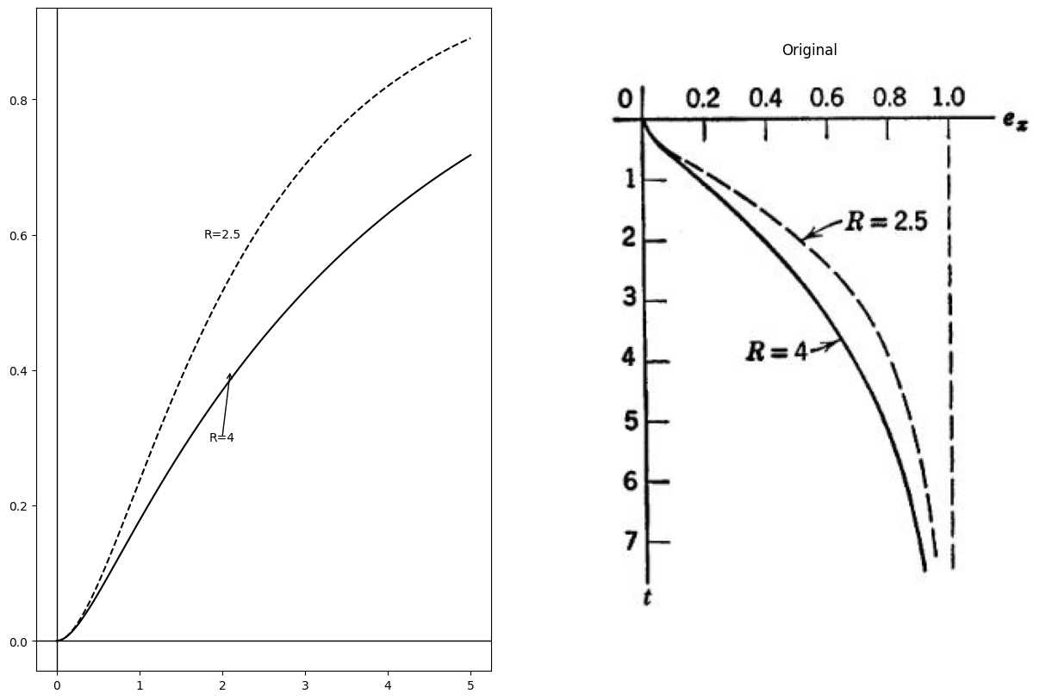

4.2 Fig. 10.4. Normalized response of overdamped linear circuit (R > 2)
These waveforms are plotted in Fig. 10.4 together with i vs. $e_{x}$ for R = 4 and R = 2.5 The plot of i vs. $e_{x}$ is most readily obtained by taking corresponding values of i and $e_{x}$ from the waveforms.
Case II: Critically Damped $( R = 2 , s_{1} = s_{2} = - 1 ) $ Since in this case $s_{1}$ equals $s_{2}$ the expression for current given in Eq. 10.17 is indeterminate. Evaluating the limit for the indeterminacy (0/0) as R approaches the critical value, we have
$$i=−te^{−t}$$
$$\left(10.19\right)$$
And
$$e_{x}=1−e^{−t}\left(1+t\right)$$
$$\left(10.20\right)$$
Critical damping yields the most rapid return to zero possible for the current waveform without an overshoot or reversal.
import matplotlib.pyplot as plt
from matplotlib import rcParams
import matplotlib.image as mpimg
import numpy as np
from schemdraw import dsp
import schemdraw
import schemdraw.elements as e
import PySpice.Logging.Logging as Logging
logger = Logging.setup_logging()
from PySpice.Probe.Plot import plot
from PySpice.Spice.Netlist import Circuit
from PySpice.Unit import *
# Create the figure and subplots
fig, axs = plt.subplots(1, 3, figsize=(15, 10))
d = schemdraw.Drawing()
# Define the circuit
circuit = Circuit('Series RLC Step Response')
# Voltage source: Step from 0V to 1V at t=0
circuit.PulseVoltageSource('input', 'in', circuit.gnd,
initial_value=0@u_V, pulsed_value=1@u_V,
pulse_width=10@u_s, period=20@u_s)
# Inductor: 1 H
circuit.L('1', 'in', 'n1', 1.5@u_H)
# Resistor: 2 Ω
circuit.R('1', 'n1', 'n2', 2@u_Ohm)
# Capacitor: 1 F
circuit.C('1', 'n2', circuit.gnd, .75@u_F)
simulator = circuit.simulator(temperature=25, nominal_temperature=25)
analysis = simulator.transient(step_time=1e-3, end_time=5)
axs[0].plot(analysis.time, u_A(-analysis.L1),color='black')
axs[0].axhline(0, color='black', linewidth=1)
axs[0].axvline(0, color='black', linewidth=1)
axs[0].plot([0,5], [-.37,0], color='black', linestyle='-', label='Membership = 1')
axs[0].text(.5 ,-.37, r'$ v=1+2i $', ha='center', va='center')
# Define the circuit
circuit = Circuit('Series RLC Step Response')
# Voltage source: Step from 0V to 1V at t=0
circuit.PulseVoltageSource('input', 'in', circuit.gnd,
initial_value=0@u_V, pulsed_value=1@u_V,
pulse_width=10@u_s, period=20@u_s)
# Inductor: 1 H
circuit.L('1', 'in', 'n1', 1@u_H)
# Resistor: 2 Ω
circuit.R('1', 'n1', 'n2', 2@u_Ohm)
# Capacitor: 1 F
circuit.C('1', 'n2', circuit.gnd, 1@u_F)
simulator = circuit.simulator(temperature=25, nominal_temperature=25)
analysis = simulator.transient(step_time=1e-3, end_time=5)
axs[1].plot(analysis.time, u_A(-analysis.L1),color='black')
axs[1].axhline(0, color='black', linewidth=1)
axs[1].axvline(0, color='black', linewidth=1)
axs[1].plot([0,5], [-.37,-.37], color='black', linestyle='--', label='Membership = 1')
axs[1].text(3 ,-.35, r'$ \frac {1}{e}=0.36 $', ha='center', va='center')
img_sample = mpimg.imread('images/10-5a.jpg') # Load the PNG file
axs[2].imshow(img_sample)
axs[2].axis('off') # Hide axes for image display
axs[2].set_title('Original')
Text(0.5, 1.0, 'Original')
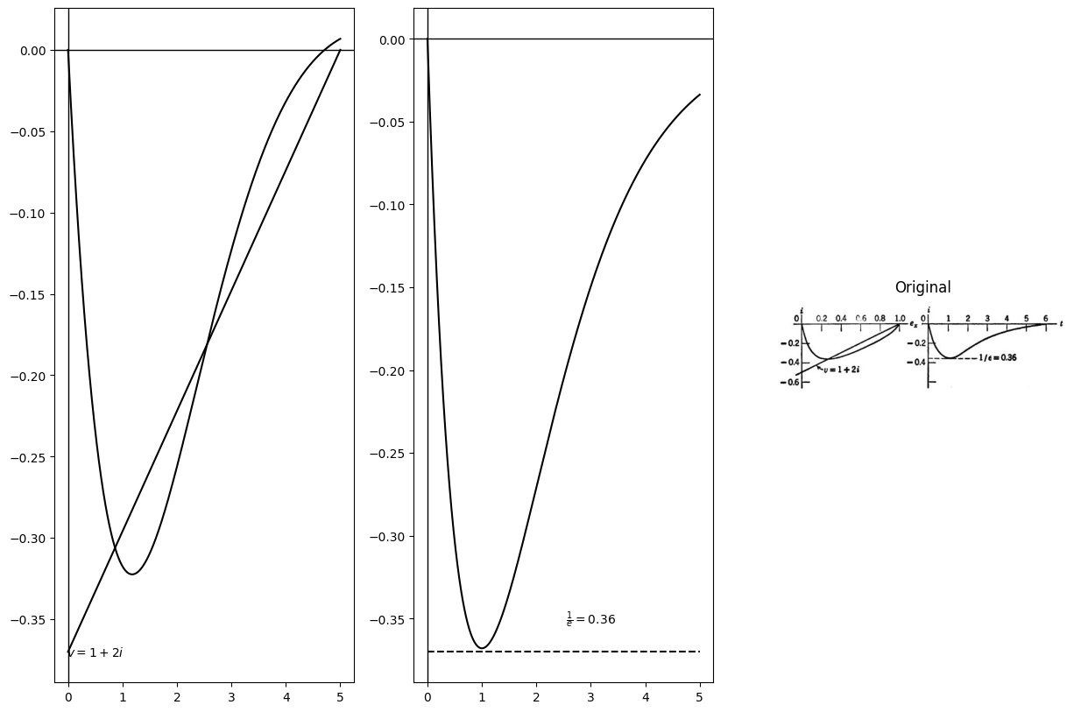
import matplotlib.pyplot as plt
from matplotlib import rcParams
import matplotlib.image as mpimg
import numpy as np
from schemdraw import dsp
import schemdraw
import schemdraw.elements as e
import PySpice.Logging.Logging as Logging
logger = Logging.setup_logging()
from PySpice.Probe.Plot import plot
from PySpice.Spice.Netlist import Circuit
from PySpice.Unit import *
# Create the figure and subplots
fig, axs = plt.subplots(1, 2, figsize=(15, 10))
d = schemdraw.Drawing()
# Define the circuit
circuit = Circuit('Series RLC Step Response')
# Voltage source: Step from 0V to 1V at t=0
circuit.PulseVoltageSource('input', 'in', circuit.gnd,
initial_value=0@u_V, pulsed_value=1@u_V,
pulse_width=10@u_s, period=20@u_s)
# Inductor: 1 H
circuit.L('1', 'in', 'n1', 1.3@u_H)
# Resistor: 4 Ω
circuit.R('1', 'n1', 'n2', 2@u_Ohm)
# Capacitor: 1 F
circuit.C('1', 'n2', circuit.gnd, .9@u_F)
simulator = circuit.simulator(temperature=25, nominal_temperature=25)
analysis = simulator.transient(step_time=1e-3, end_time=5)
# Plot voltage across capacitor (node n2 to ground)
axs[0].axhline(0, color='black', linewidth=1)
axs[0].axvline(0, color='black', linewidth=1)
axs[0].plot(analysis.time, analysis['n2'],color='black', linewidth=3)
axs[0].plot([0,5], [1,1], color='black', linestyle='--', label='Membership = 1')
img_sample = mpimg.imread('images/10-5c.jpg') # Load the PNG file
axs[1].imshow(img_sample)
axs[1].axis('off') # Hide axes for image display
axs[1].set_title('Original')
Text(0.5, 1.0, 'Original')
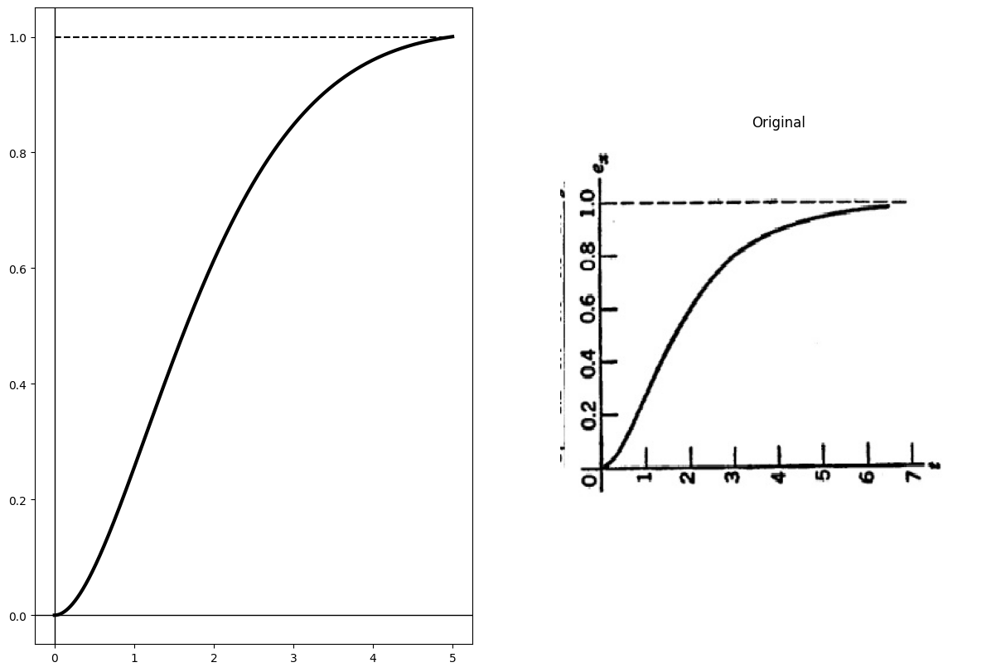

4.3 Fig. 10.5. Normalized response of critically-damped linear circuit (R = 2)
The waveforms i(t) and $e_{x}\left(t\right)$ are shown in Fig. 10.5 along with the plot of i vs. $e_{x}$ The resistive relation v = 1 + 2i is also shown on the current versus voltage plane.
Case III: Underdamped ( $0<R<2,s_{1}ands_{2}$ are complex conjugates with negative real parts) For values of R between zero and two, the waveforms are oscillatory. Since s_{1} and s_{2} are complex, it is convenient to express them as
$$s_{1}=−α−j*β$$
$$\left(10.21\right)$$
$$s_{2}=−α+j*β$$
$$\left(10.22\right)$$
import matplotlib.pyplot as plt
from matplotlib import rcParams
import matplotlib.image as mpimg
import numpy as np
from schemdraw import dsp
import schemdraw
import schemdraw.elements as e
import PySpice.Logging.Logging as Logging
logger = Logging.setup_logging()
from PySpice.Probe.Plot import plot
from PySpice.Spice.Netlist import Circuit
from PySpice.Unit import *
# Create the figure and subplots
fig, axs = plt.subplots(1, 3, figsize=(15, 10))
d = schemdraw.Drawing()
# Define the circuit
circuit = Circuit('Series RLC Step Response')
# Voltage source: Step from 0V to 1V at t=0
circuit.PulseVoltageSource('input', 'in', circuit.gnd,
initial_value=0@u_V, pulsed_value=1@u_V,
pulse_width=10@u_s, period=20@u_s)
# Inductor: 1 H
circuit.L('1', 'in', 'n1', 1@u_H)
# Resistor: >2 Ω
circuit.R('1', 'n1', 'n2', 1.2@u_Ohm)
# Capacitor: 1 F
circuit.C('1', 'n2', circuit.gnd, .1@u_F)
simulator = circuit.simulator(temperature=25, nominal_temperature=25)
analysis = simulator.transient(step_time=1e-3, end_time=5)
axs[0].plot(analysis['n2'], u_A(-analysis.L1),color='black')
axs[0].axhline(0, color='black', linewidth=1)
axs[0].axvline(0, color='black', linewidth=1)
axs[0].plot([.6,1.315], [-.25,.15], color='black', linestyle='-', label='Membership = 1')
axs[0].text(1.4 ,.15, r'$ v=1+\frac {i}{2} $', ha='center', va='center')
# Define the circuit
circuit = Circuit('Series RLC Step Response')
# Voltage source: Step from 0V to 1V at t=0
circuit.PulseVoltageSource('input', 'in', circuit.gnd,
initial_value=0@u_V, pulsed_value=1@u_V,
pulse_width=10@u_s, period=20@u_s)
# Inductor: 1 H
circuit.L('1', 'in', 'n1', 1@u_H)
# Resistor: 2 Ω
circuit.R('1', 'n1', 'n2', 1.2@u_Ohm)
# Capacitor: 1 F
circuit.C('1', 'n2', circuit.gnd, .6@u_F)
simulator = circuit.simulator(temperature=25, nominal_temperature=25)
analysis = simulator.transient(step_time=1e-3, end_time=5)
axs[1].plot(analysis.time, u_A(-analysis.L1),color='black')
axs[1].axhline(0, color='black', linewidth=1)
axs[1].axvline(0, color='black', linewidth=1)
img_sample = mpimg.imread('images/10-6.jpg') # Load the PNG file
axs[2].imshow(img_sample)
axs[2].axis('off') # Hide axes for image display
axs[2].set_title('Original')
# Time array
t = np.linspace(0, 7, 500)
# Given parameters
beta = np.pi / 2 # Example value for beta
# Define the function for ex(t)
def ex_t(t, beta):
return 1 + np.sin(beta * t) * np.exp(-t/3) # Example function
# Calculate ex(t)
ex = ex_t(t, beta)
# Plotting the image
plt.figure(figsize=(6, 8))
plt.plot(ex, t, label='$e_x(t)$',color='black')
# Customize the plot
plt.xlabel('$e_x$')
plt.ylabel('t')
plt.title('Plot of $e_x$ vs t')
plt.xlim(0, 2)
plt.ylim(7, 0) # Invert the y-axis
plt.yticks([0, 1, 1.63, 2, 3.26, 4, 5, 6, 7])
plt.axhline(y=1, color='gray', linestyle='--', linewidth=0.5)
plt.axhline(y=1.63, color='gray', linestyle='--', linewidth=0.5)
plt.axhline(y=2, color='gray', linestyle='--', linewidth=0.5)
plt.axhline(y=3.26, color='gray', linestyle='--', linewidth=0.5)
plt.axhline(y=4, color='gray', linestyle='--', linewidth=0.5)
plt.axhline(y=5, color='gray', linestyle='--', linewidth=0.5)
plt.axhline(y=6, color='gray', linestyle='--', linewidth=0.5)
plt.plot([0,1], [-800,7], color='black', linestyle='--', label='Membership = 1')
# Add labels for horizontal lines
plt.text(2.1, 1, r'$\beta t = \frac{\pi}{4}$', color='black', ha='left', va='center')
plt.text(2.1, 1.63, r'$\beta t = \frac{\pi}{2}$', color='black', ha='left', va='center')
plt.text(2.1, 3.26, r'$\beta t = \pi$', color='black', ha='left', va='center')
plt.text(2.1, 5, r'$\beta t = \frac{3\pi}{2}$', color='black', ha='left', va='center')
plt.text(2.1, 7, r'$\beta t = 2\pi$', color='black', ha='left', va='center')
plt.axhline(0, color='black', linewidth=1)
plt.axvline(0, color='black', linewidth=1)
<matplotlib.lines.Line2D at 0x25280470fa0>
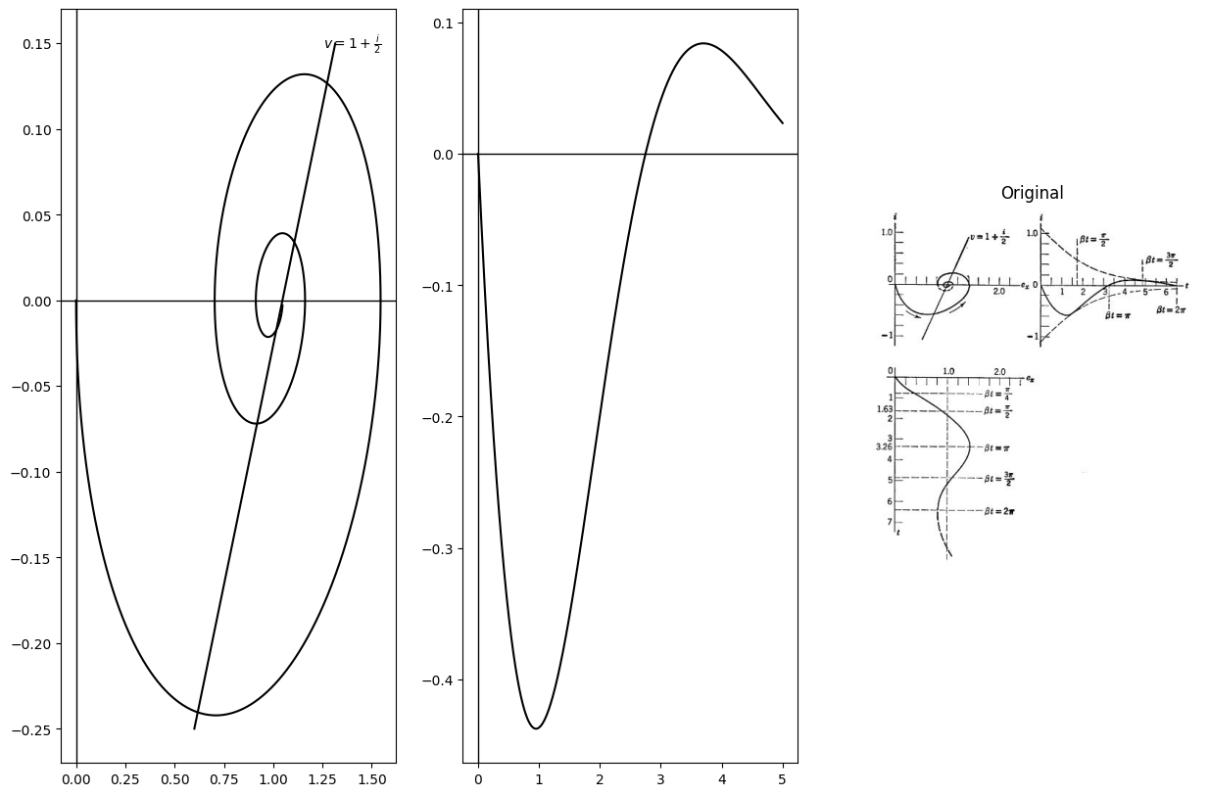
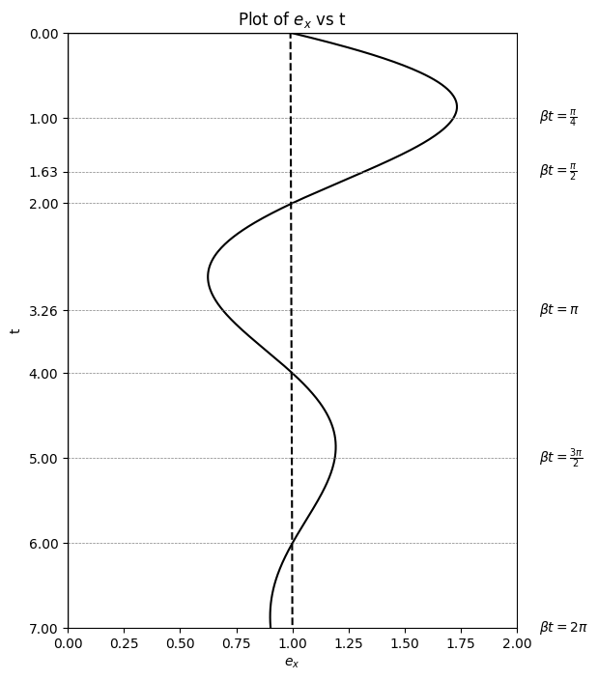

4.4 Fig. 10.6. Normalized response of underdamped linear circuit (R = 1/2) .
where $α=R/2$ and $β=\sqrt{1−{\left(R/2\right)}^{2}}$ . In terms of $α$ and $β$ the current is
$$i=e^{−αt}*\frac{\left(e^{−jβt}−e^{jβt}\right)}{\left(2jbeta\right)}$$
$$\left(10.23\right)$$
$$=−\frac{e^{−αt}}{β}sinβt$$
$$\left(10.24\right)$$
The expression for capacitor voltage is
$$e_{x}=1−\frac{e^{−αt}}{β}\left[αsinβt+βcosβt\right]$$
$$\left(10.25\right)$$
The curves in Fig. 10.6 are drawn for $R = \frac{1}{2} whereas those in Fig. 10.7 are drawn for $R = \frac {1}{5} For the latter we have $α=0.1$ and $β=0.995$ (closely approaching the undamped case, $α=0$ , $β=1$ ) .
import matplotlib.pyplot as plt
from matplotlib import rcParams
import matplotlib.image as mpimg
import numpy as np
from schemdraw import dsp
import schemdraw
import schemdraw.elements as e
import PySpice.Logging.Logging as Logging
logger = Logging.setup_logging()
from PySpice.Probe.Plot import plot
from PySpice.Spice.Netlist import Circuit
from PySpice.Unit import *
# Create the figure and subplots
fig, axs = plt.subplots(1, 3, figsize=(15, 10))
d = schemdraw.Drawing()
# Define the circuit
circuit = Circuit('Series RLC Step Response')
# Voltage source: Step from 0V to 1V at t=0
circuit.PulseVoltageSource('input', 'in', circuit.gnd,
initial_value=0@u_V, pulsed_value=1@u_V,
pulse_width=10@u_s, period=20@u_s)
# Inductor: 1 H
circuit.L('1', 'in', 'n1', .5@u_H)
# Resistor: 2 Ω
circuit.R('1', 'n1', 'n2', .9@u_Ohm)
# Capacitor: 1 F
circuit.C('1', 'n2', circuit.gnd, .1@u_F)
simulator = circuit.simulator(temperature=25, nominal_temperature=25)
analysis = simulator.transient(step_time=1e-3, end_time=5)
axs[0].plot(analysis['n2'], u_A(-analysis.L1),color='black')
axs[0].axhline(0, color='black', linewidth=1)
axs[0].axvline(0, color='black', linewidth=1)
axs[0].plot([.6,1.25], [-.25,.15], color='black', linestyle='-', label='Membership = 1')
axs[0].text(1.3 ,.1, r'$ v=1+\frac {i}{5} $', ha='center', va='center')
# Define the circuit
circuit = Circuit('Series RLC Step Response')
# Voltage source: Step from 0V to 1V at t=0
circuit.PulseVoltageSource('input', 'in', circuit.gnd,
initial_value=0@u_V, pulsed_value=1@u_V,
pulse_width=10@u_s, period=20@u_s)
# Inductor: 1 H
circuit.L('1', 'in', 'n1', 1.2@u_H)
# Resistor: 2 Ω
circuit.R('1', 'n1', 'n2', .3@u_Ohm)
# Capacitor: 1 F
circuit.C('1', 'n2', circuit.gnd, .5@u_F)
simulator = circuit.simulator(temperature=25, nominal_temperature=25)
analysis = simulator.transient(step_time=1e-3, end_time=5)
axs[1].plot(analysis.time, u_A(-analysis.L1),color='black')
axs[1].axhline(0, color='black', linewidth=1)
axs[1].axvline(0, color='black', linewidth=1)
#ax.plot([0,5], [-.37,-.37], color='black', linestyle='--', label='Membership = 1')
axs[1].text(2.5 ,-.05, r'$ \pi $', ha='center', va='center')
axs[1].text(1.25 ,-.05, r'$ \pi/2 $', ha='center', va='center')
axs[1].text(3.5 ,-.05, r'$ 3\pi/2 $', ha='center', va='center')
axs[1].text(4.8 ,-.05, r'$ 2\pi $', ha='center', va='center')
img_sample = mpimg.imread('images/10-7.jpg') # Load the PNG file
axs[2].imshow(img_sample)
axs[2].axis('off') # Hide axes for image display
axs[2].set_title('Original')
t = np.linspace(0, 7, 500)
# Given parameters
beta = np.pi / 2 # Example value for beta
# Define the function for ex(t)
def ex_t(t, beta):
return 1 + np.sin(beta * t) * np.exp(-t/3) # Example function
# Calculate ex(t)
ex = ex_t(t, beta)
# Plotting the image
plt.figure(figsize=(6, 8))
plt.plot(ex, t, label='$e_x(t)$',color='black')
# Customize the plot
plt.xlabel('$e_x$')
plt.ylabel('t')
plt.title('Plot of $e_x$ vs t')
plt.xlim(0, 2)
plt.ylim(7, 0) # Invert the y-axis
plt.yticks([0, 1, 1.63, 2, 3.26, 4, 5, 6, 7])
plt.axhline(y=1, color='gray', linestyle='--', linewidth=0.5)
plt.axhline(y=1.63, color='gray', linestyle='--', linewidth=0.5)
plt.axhline(y=2, color='gray', linestyle='--', linewidth=0.5)
plt.axhline(y=3.26, color='gray', linestyle='--', linewidth=0.5)
plt.axhline(y=4, color='gray', linestyle='--', linewidth=0.5)
plt.axhline(y=5, color='gray', linestyle='--', linewidth=0.5)
plt.axhline(y=6, color='gray', linestyle='--', linewidth=0.5)
plt.plot([0,1], [-800,7], color='black', linestyle='--', label='Membership = 1')
# Add labels for horizontal lines
plt.text(2.1, 1, r'$\beta t = \frac{\pi}{4}$', color='black', ha='left', va='center')
plt.text(2.1, 1.63, r'$\beta t = \frac{\pi}{2}$', color='black', ha='left', va='center')
plt.text(2.1, 3.26, r'$\beta t = \pi$', color='black', ha='left', va='center')
plt.text(2.1, 5, r'$\beta t = \frac{3\pi}{2}$', color='black', ha='left', va='center')
plt.text(2.1, 7, r'$\beta t = 2\pi$', color='black', ha='left', va='center')
plt.axhline(0, color='black', linewidth=1)
plt.axvline(0, color='black', linewidth=1)
<matplotlib.lines.Line2D at 0x2528c009060>
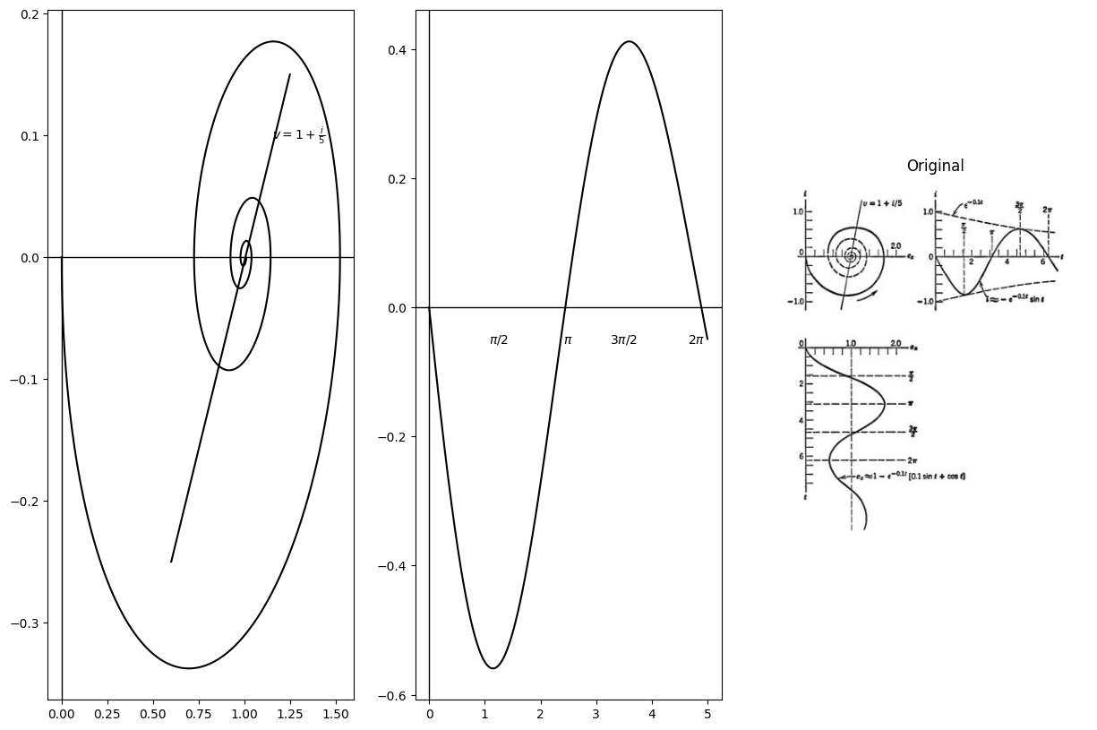

4.5 Fig. 10.7. Normalized response of underdamped linear circuit (R = 1/5)
Case IV: Undamped ( R = 0 , 81 and s2 imaginary)
Although we have already discussed the undamped case (see Fig. 10.2) it is desirable to include the normalized representation here for the sake of completeness. Furthermore, it is instructive to obtain the expressions for current and voltage as limiting forms of the underdamped case as R approaches zero. We see from Eqs. 10.21 and 10.22 that a approaches zero and $β$ approaches unity. Therefore, we have
$$i=−sint$$
$$\left(10.26\right)$$
and
$$e_{x}=1−coswt$$
$$\left(10.27\right)$$
These waveforms and the circular locus of $i$ vs. $e_{x}$ are shown in Fig. 10.8.
import matplotlib.pyplot as plt
from matplotlib import rcParams
import matplotlib.image as mpimg
import numpy as np
from schemdraw import dsp
import schemdraw
import schemdraw.elements as e
import PySpice.Logging.Logging as Logging
logger = Logging.setup_logging()
from PySpice.Probe.Plot import plot
from PySpice.Spice.Netlist import Circuit
from PySpice.Unit import *
# Create the figure and subplots
fig, axs = plt.subplots(1, 3, figsize=(15, 10))
d = schemdraw.Drawing()
# Define the circuit
circuit = Circuit('Series RLC Step Response')
# Voltage source: Step from 0V to 1V at t=0
circuit.PulseVoltageSource('input', 'in', circuit.gnd,
initial_value=0@u_V, pulsed_value=1@u_V,
pulse_width=10@u_s, period=20@u_s)
# Inductor: 1 H
circuit.L('1', 'in', 'n1', .5@u_H)
# Resistor: 2 Ω
circuit.R('1', 'n1', 'n2', 0@u_Ohm)
# Capacitor: 1 F
circuit.C('1', 'n2', circuit.gnd, .1@u_F)
simulator = circuit.simulator(temperature=25, nominal_temperature=25)
analysis = simulator.transient(step_time=1e-3, end_time=5)
axs[0].plot(analysis['n2'], u_A(-analysis.L1),color='black')
axs[0].axhline(0, color='black', linewidth=1)
axs[0].axvline(0, color='black', linewidth=1)
axs[0].plot([1,1], [-.55,.55], color='black', linestyle='-', label='Membership = 1')
axs[0].text(1.1 ,.56, r'$ v=1 $', ha='center', va='center')
# Define the circuit
circuit = Circuit('Series RLC Step Response')
# Voltage source: Step from 0V to 1V at t=0
circuit.PulseVoltageSource('input', 'in', circuit.gnd,
initial_value=0@u_V, pulsed_value=1@u_V,
pulse_width=10@u_s, period=20@u_s)
# Inductor: 1 H
circuit.L('1', 'in', 'n1', 1.2@u_H)
# Resistor: 2 Ω
circuit.R('1', 'n1', 'n2', 0@u_Ohm)
# Capacitor: 1 F
circuit.C('1', 'n2', circuit.gnd, .5@u_F)
simulator = circuit.simulator(temperature=25, nominal_temperature=25)
analysis = simulator.transient(step_time=1e-3, end_time=5)
axs[1].plot(analysis.time, u_A(-analysis.L1),color='black')
axs[1].axhline(0, color='black', linewidth=1)
axs[1].axvline(0, color='black', linewidth=1)
#ax.plot([0,5], [-.37,-.37], color='black', linestyle='--', label='Membership = 1')
axs[1].text(2.5 ,-.05, r'$ \pi $', ha='center', va='center')
axs[1].text(1.25 ,-.05, r'$ \pi/2 $', ha='center', va='center')
axs[1].text(3.5 ,-.05, r'$ 3\pi/2 $', ha='center', va='center')
axs[1].text(4.8 ,-.05, r'$ 2\pi $', ha='center', va='center')
img_sample = mpimg.imread('images/10-8a.jpg') # Load the PNG file
axs[2].imshow(img_sample)
axs[2].axis('off') # Hide axes for image display
axs[2].set_title('Original')
# Define the circuit
circuit = Circuit('Series RLC Step Response')
# Voltage source: Step from 0V to 1V at t=0
circuit.PulseVoltageSource('input', 'in', circuit.gnd,
initial_value=0@u_V, pulsed_value=1@u_V,
pulse_width=10@u_s, period=20@u_s)
# Inductor: 1 H
circuit.L('1', 'in', 'n1', 1.2@u_H)
# Resistor: 2 Ω
circuit.R('1', 'n1', 'n2', 0@u_Ohm)
# Capacitor: 1 F
circuit.C('1', 'n2', circuit.gnd, .2@u_F)
simulator = circuit.simulator(temperature=25, nominal_temperature=25)
analysis = simulator.transient(step_time=1e-3, end_time=5)
figure,ax = plt.subplots(figsize=(10, 5))
plt.plot(analysis.time, analysis['n2'],color='black')
plt.axhline(0, color='black', linewidth=1)
plt.axvline(0, color='black', linewidth=1)
plt.title('Voltage Across Capacitor')
plt.xlabel('Time [s]')
plt.ylabel('Capacitor Voltage [V]')
#ax.plot([0,5], [-.37,-.37], color='black', linestyle='--', label='Membership = 1')
ax.text(2.5 ,-.05, r'$ \pi $', ha='center', va='center')
ax.text(1.25 ,-.05, r'$ \pi/2 $', ha='center', va='center')
ax.text(3.5 ,-.05, r'$ 3\pi/2 $', ha='center', va='center')
ax.text(4.8 ,-.05, r'$ 2\pi $', ha='center', va='center')
Text(4.8, -0.05, '$ 2\\pi $')
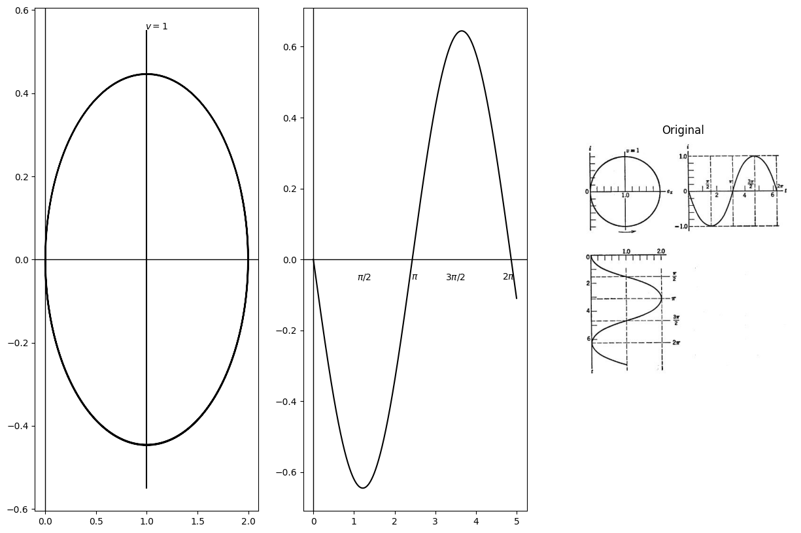
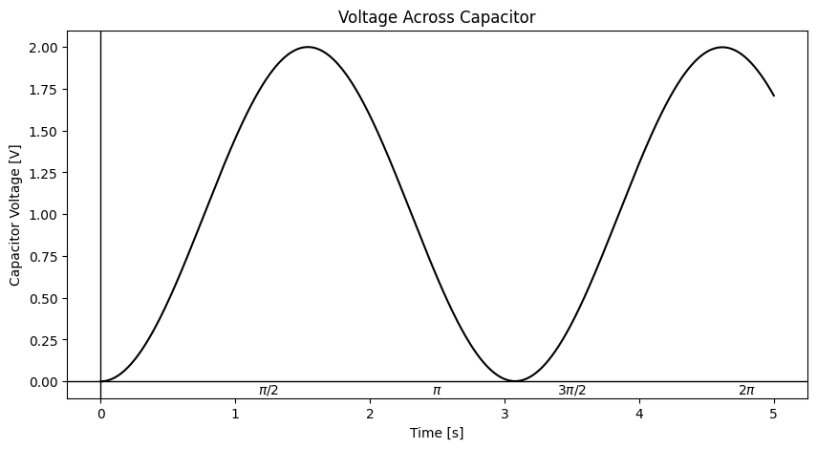

4.6 Fig. 10.8. Normalized response of undamped linear circuit (R = 0)
Case V: Negative Underdamped ( 0 > R > - 2 , s1 and s2 complex conjugates with positive real parts)
A negative damping resistance reverses the sign of a but does not change 8. Thus, just as in Case III, we have
$$s_{1}=−α−jβ;s_{2}=α+jß$$
$$\left(10.28\right)$$
but now
$$α<0$$
$$\left(10.29\right)$$
The general equations for current and capacitor voltage are the same as Eqs. 10.23-10.25. In Fig. 10.9 we have chosen R = - 1/5 for com parison with the corresponding positive underdamped circuit (Case III) illustrated in Fig. 10.7. The exponential envelope for the waveforms of current and voltage describing the negative-underdamped circuit are like negative extensions of those for the positive-underdamped circuit because a reversal of the sign of a or t has the same effect. However, in both cases the sine wave begins with the negative half cycle.
import matplotlib.pyplot as plt
from matplotlib import rcParams
import matplotlib.image as mpimg
import numpy as np
from schemdraw import dsp
import schemdraw
import schemdraw.elements as e
import PySpice.Logging.Logging as Logging
logger = Logging.setup_logging()
from PySpice.Probe.Plot import plot
from PySpice.Spice.Netlist import Circuit
from PySpice.Unit import *
# Create the figure and subplots
fig, axs = plt.subplots(1, 3, figsize=(15, 10))
d = schemdraw.Drawing()
circuit = Circuit('Series RLC Step Response')
# Voltage source: Step from 0V to 1V at t=0
circuit.PulseVoltageSource('input', 'in', circuit.gnd,
initial_value=0@u_V, pulsed_value=1@u_V,
pulse_width=10@u_s, period=20@u_s)
# Inductor: 1 H
circuit.L('1', 'in', 'n1', 1@u_H)
# Resistor: 2 Ω
circuit.R('1', 'n1', 'n2', -.2@u_Ohm)
# Capacitor: 1 F
circuit.C('1', 'n2', circuit.gnd, .5@u_F)
simulator = circuit.simulator(temperature=25, nominal_temperature=25)
analysis = simulator.transient(step_time=1e-3, end_time=5)
axs[0].plot(analysis['n2'], u_A(-analysis.L1),color='black')
axs[0].axhline(0, color='black', linewidth=1)
axs[0].axvline(0, color='black', linewidth=1)
axs[0].plot([.4,1.1], [1.1,-.85], color='black', linestyle='-', label='Membership = 1')
axs[0].text(.9 ,.56, r'$ v=1-\frac {i}{5} $', ha='center', va='center')
circuit = Circuit('Series RLC Step Response')
# Voltage source: Step from 0V to 1V at t=0
circuit.PulseVoltageSource('input', 'in', circuit.gnd,
initial_value=0@u_V, pulsed_value=1@u_V,
pulse_width=10@u_s, period=20@u_s)
# Inductor: 1 H
circuit.L('1', 'in', 'n1', 1.2@u_H)
# Resistor: 2 Ω
circuit.R('1', 'n1', 'n2', -.2@u_Ohm)
# Capacitor: 1 F
circuit.C('1', 'n2', circuit.gnd, .5@u_F)
simulator = circuit.simulator(temperature=25, nominal_temperature=25)
analysis = simulator.transient(step_time=1e-3, end_time=5)
axs[1].plot(analysis.time, u_A(-analysis.L1),color='black')
axs[1].axhline(0, color='black', linewidth=1)
axs[1].axvline(0, color='black', linewidth=1)
axs[1].plot([1.3,1.3], [-.7,.37], color='black', linestyle='--', label='Membership = 1')
axs[1].plot([2.45,2.45], [-.7,.37], color='black', linestyle='--', label='Membership = 1')
axs[1].plot([3.65,3.65], [-.2,.9], color='black', linestyle='--', label='Membership = 1')
axs[1].plot([4.9,4.9], [-.2,.37], color='black', linestyle='--', label='Membership = 1')
axs[1].text(2.45 ,.5, r'$ \pi $', ha='center', va='center')
axs[1].text(1.25 ,.5, r'$ \pi/2 $', ha='center', va='center')
axs[1].text(3.7 ,-.3, r'$ 3\pi/2 $', ha='center', va='center')
axs[1].text(4.9 ,-.25, r'$ 2\pi $', ha='center', va='center')
img_sample = mpimg.imread('images/10-9.jpg') # Load the PNG file
axs[2].imshow(img_sample)
axs[2].axis('off') # Hide axes for image display
axs[2].set_title('Original')
# Define the circuit
circuit = Circuit('Series RLC Step Response')
# Voltage source: Step from 0V to 1V at t=0
circuit.PulseVoltageSource('input', 'in', circuit.gnd,
initial_value=0@u_V, pulsed_value=1@u_V,
pulse_width=10@u_s, period=20@u_s)
# Inductor: 1 H
circuit.L('1', 'in', 'n1', 1.2@u_H)
# Resistor: 2 Ω
circuit.R('1', 'n1', 'n2', -.2@u_Ohm)
# Capacitor: 1 F
circuit.C('1', 'n2', circuit.gnd, .2@u_F)
simulator = circuit.simulator(temperature=25, nominal_temperature=25)
analysis = simulator.transient(step_time=1e-3, end_time=5)
figure,ax = plt.subplots(figsize=(10, 5))
plt.plot(analysis.time, analysis['n2'],color='black')
plt.axhline(0, color='black', linewidth=1)
plt.axvline(0, color='black', linewidth=1)
plt.title('Voltage Across Capacitor')
plt.xlabel('Time [s]')
plt.ylabel('Capacitor Voltage [V]')
#ax.plot([0,5], [-.37,-.37], color='black', linestyle='--', label='Membership = 1')
ax.text(2.5 ,-.05, r'$ \pi $', ha='center', va='center')
ax.text(1.25 ,-.05, r'$ \pi/2 $', ha='center', va='center')
ax.text(3.5 ,-.05, r'$ 3\pi/2 $', ha='center', va='center')
ax.text(4.8 ,-.05, r'$ 2\pi $', ha='center', va='center')
Text(4.8, -0.05, '$ 2\\pi $')
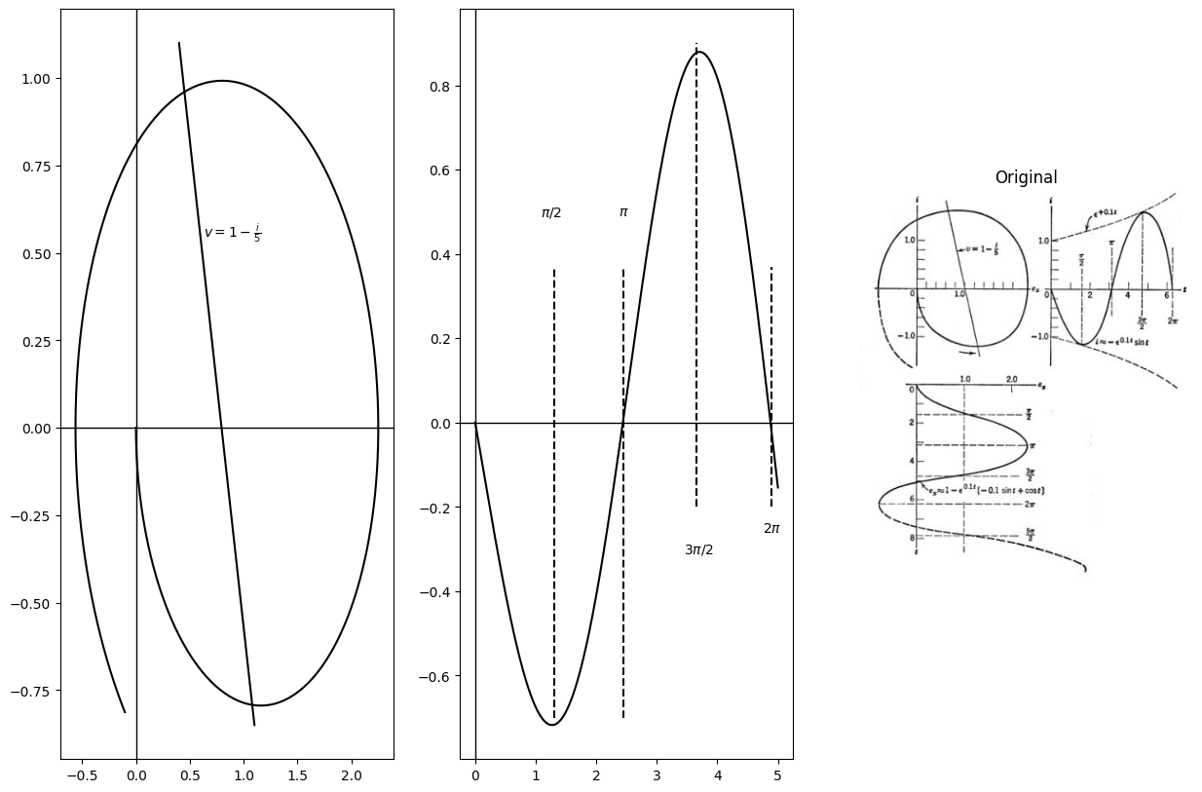
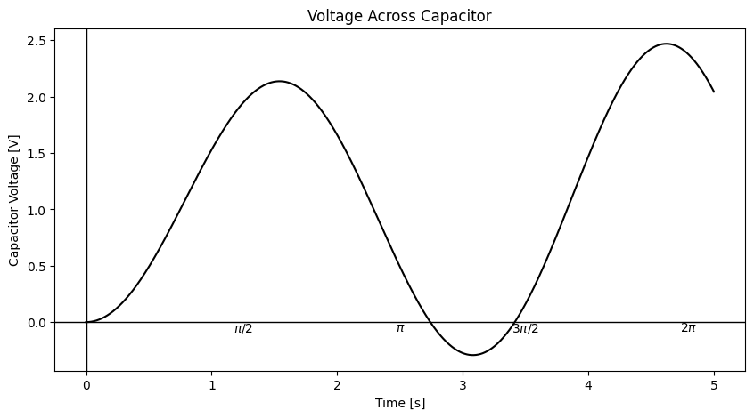

4.7 Fig. 10.9. Normalized response of linear circuit with negative damping (R=-1/5).
Case VI: Negative Critically Damped $( R = - 2 , s_{1} = s_{2} = 1 ) $ The current and capacitor voltage in this case tend to increase indefinitely without ever being oscillatory. The pertinent equations are
$$i=−te^{t}$$
$$\left(10.30\right)$$
and
$$ex=1+e^{t}\left(t−1\right)$$
$$\left(10.31\right)$$
Case VII: Negative Overdamped ( R < - 2 , s1 and s2 both positive)
As resistance becomes more negative, the current and capacitor voltage merely tend toward infinite values more rapidly than in the previous case. The expressions given in Eqs. 10.17 and 10.18 apply directly, but we note that the values of $s_{1}$ and $s_{2}$ are now positive.
import matplotlib.pyplot as plt
from matplotlib import rcParams
import matplotlib.image as mpimg
import numpy as np
from schemdraw import dsp
import schemdraw
import schemdraw.elements as e
import PySpice.Logging.Logging as Logging
logger = Logging.setup_logging()
from PySpice.Probe.Plot import plot
from PySpice.Spice.Netlist import Circuit
from PySpice.Unit import *
# Create the figure and subplots
fig, axs = plt.subplots(1, 2, figsize=(15, 10))
d = schemdraw.Drawing()
circuit = Circuit('Series RLC Step Response')
# Voltage source: Step from 0V to 1V at t=0
circuit.PulseVoltageSource('input', 'in', circuit.gnd,
initial_value=0@u_V, pulsed_value=1@u_V,
pulse_width=10@u_s, period=20@u_s)
# Voltage source: Step from 0V to 1V at t=0
circuit.PulseVoltageSource('input1', 'in1', circuit.gnd,
initial_value=0@u_V, pulsed_value=1@u_V,
pulse_width=10@u_s, period=20@u_s)
circuit.PulseVoltageSource('input2', 'in2', circuit.gnd,
initial_value=0@u_V, pulsed_value=1@u_V,
pulse_width=10@u_s, period=20@u_s)
circuit.PulseVoltageSource('input3', 'in3', circuit.gnd,
initial_value=0@u_V, pulsed_value=1@u_V,
pulse_width=10@u_s, period=20@u_s)
circuit.PulseVoltageSource('input4', 'in4', circuit.gnd,
initial_value=0@u_V, pulsed_value=1@u_V,
pulse_width=10@u_s, period=20@u_s)
circuit.PulseVoltageSource('input5', 'in5', circuit.gnd,
initial_value=0@u_V, pulsed_value=1@u_V,
pulse_width=10@u_s, period=20@u_s)
circuit.PulseVoltageSource('input6', 'in6', circuit.gnd,
initial_value=0@u_V, pulsed_value=1@u_V,
pulse_width=10@u_s, period=20@u_s)
# Inductor: 1 H
circuit.L('1', 'in', 'n1', 1@u_H)
# Resistor: 2 Ω
circuit.R('1', 'n1', 'n2', -.2@u_Ohm)
# Capacitor: 1 F
circuit.C('1', 'n2', circuit.gnd, .63@u_F)
# Inductor: 1 H
circuit.L('2', 'in1', 'n11', 1@u_H)
# Resistor: 2 Ω
circuit.R('2', 'n11', 'n21', 0@u_Ohm)
# Capacitor: 1 F
circuit.C('2', 'n21', circuit.gnd, .63@u_F)
# Inductor: 1 H
circuit.L('3', 'in2', 'n12', 1@u_H)
# Resistor: 2 Ω
circuit.R('3', 'n12', 'n22', .2@u_Ohm)
# Capacitor: 1 F
circuit.C('3', 'n22', circuit.gnd, .63@u_F)
# Inductor: 1 H
circuit.L('4', 'in3', 'n13', 1@u_H)
# Resistor: 2 Ω
circuit.R('4', 'n13', 'n23', .5@u_Ohm)
# Capacitor: 1 F
circuit.C('4', 'n23', circuit.gnd, .63@u_F)
# Inductor: 1 H
circuit.L('5', 'in4', 'n14', 1@u_H)
# Resistor: 2 Ω
circuit.R('5', 'n14', 'n24', 2@u_Ohm)
# Capacitor: 1 F
circuit.C('5', 'n24', circuit.gnd, .5@u_F)
# Inductor: 1 H
circuit.L('6', 'in5', 'n15', 1@u_H)
# Resistor: 2 Ω
circuit.R('6', 'n15', 'n25', 4@u_Ohm)
# Capacitor: 1 F
circuit.C('6', 'n25', circuit.gnd, .5@u_F)
simulator = circuit.simulator(temperature=25, nominal_temperature=25)
analysis = simulator.transient(step_time=1e-3, end_time=5)
axs[0].plot(analysis['n2'], u_A(-analysis.L1),color='black')
axs[0].plot(analysis['n21'], u_A(-analysis.L1),color='black')
axs[0].plot(analysis['n22'], u_A(-analysis.L1),color='black')
axs[0].plot(analysis['n23'], u_A(-analysis.L1),color='black')
axs[0].plot(analysis['n24'], u_A(-analysis.L1),color='black')
axs[0].plot(analysis['n25'], u_A(-analysis.L1),color='black')
axs[0].axhline(0, color='black', linewidth=1)
axs[0].axvline(0, color='black', linewidth=1)
img_sample = mpimg.imread('images/10-10.jpg') # Load the PNG file
axs[1].imshow(img_sample)
axs[1].axis('off') # Hide axes for image display
axs[1].set_title('Original')
Text(0.5, 1.0, 'Original')
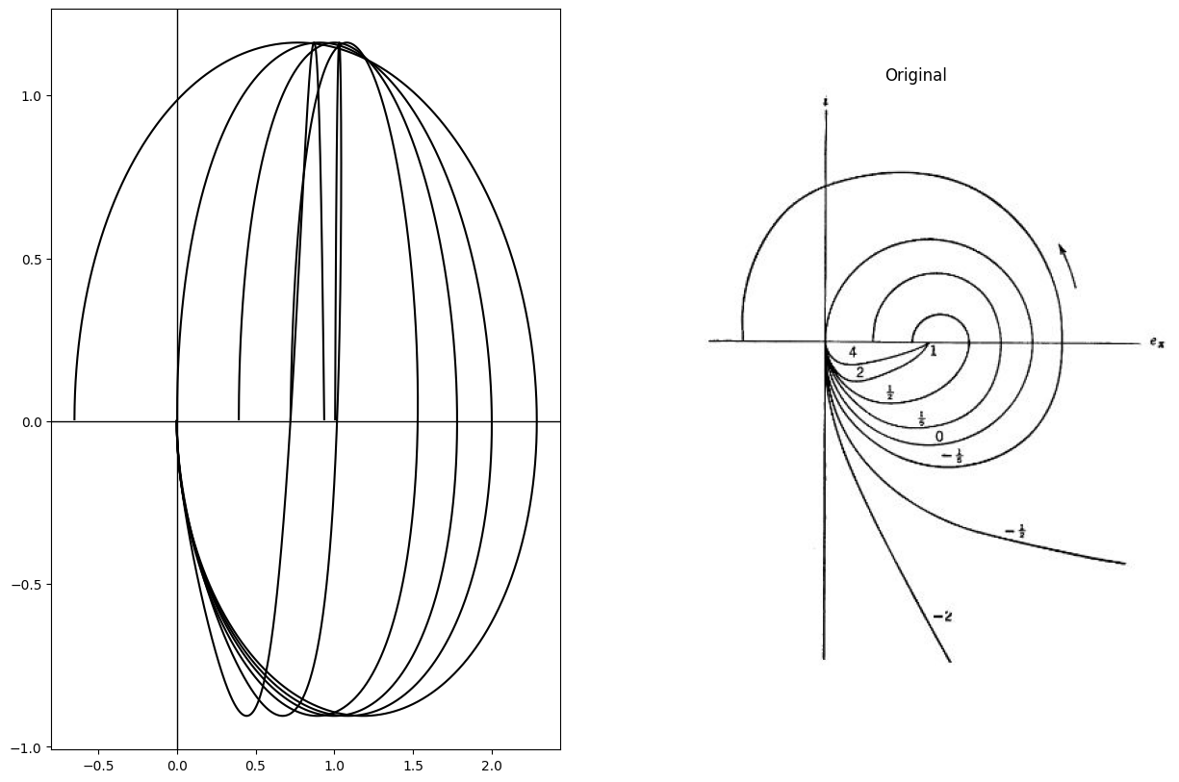

4.8 Fig. 10.10. Normalized operating paths for various values of R.
Summary. For ease of comparison, the trajectories of current versus capacitor voltage for both positive and negative damping resistances are shown in Fig. 10.10. For the initial conditions used here ( $i=e_{x}=0$ at $t = 0 $) all trajectories start at the origin. All values of positive damping lead to the final value $i = 0 $,$e_{x} = 1$ With no damping the trajectory is a circle (continuous sinusoidal waveforms) while for negative damping
the final values are infinite.

5 10.5 Some Properties of Phase-Plane Trajectories
In Article 10.4, phase-plane trajectories for a linear series RLC circuit are obtained from the waveforms $i\left(t\right)$ and $e_{x}\left(t\right)$ by eliminating the time t. In nonlinear circuit problems, phase-plane trajectories are often easier to determine than waveforms. The phase-plane trajectories determine the character of the solution and can be used to plot waveforms if these are desired.
As an aid to determining trajectories in more complicated systems, let us deduce some basic properties of phase-plane plots. From the differ- ential equation for the trajectories,
$$\frac{v−ex}{i}=\frac{di}{dx}$$
$$\left(10.32\right)$$
it is apparent that the slope d٫de (i) x is everywhere unique except at the
point $ex$ = v, i = 0 At this point the slope is indeterminate since 0/0
can have any value. The slope of any given trajectory in the vicinity of such a "singular" point must be found by a limiting process as the trajectory approaches or recedes from the point.
From the uniqueness of slope $di/dx$ at all but singular points we conclude the following:
A. A specific trajectory can never cross itself at a nonsingular point in the finite plane.
B. Two different trajectories cannot cross each other at a nonsingular point in the finite plane.
These points are illustrated by Fig. 10.11 (a), where three trajectories corresponding to different initial conditions are drawn for R = 1/5 Different starting points on the same trajectory (like points B and C) correspond only to a shift of the time reference, but an initial point not on any trajectory shown, must result in a separate curve.
For the undamped case illustrated in Fig. 10.11(b), different initial conditions may produce a change in the phase of current and voltage waveforms, or a change of amplitude or both. For initial conditions
$ex0$ and i_{0} the amplitude of $e_{x}$ or $i$ for the normalized case will be $\sqrt{{\left(ex0−1\right)}^{2}+i_{0}^{2}}$, since the trajectories are circles centered at $e_{x}=1$, i = 0 Initial points O, B and C on the same trajectory merely represent different time origins but the same total energy in the system. The trajectory starting at point A yields waveforms having the same phase relations but smaller amplitudes than those for the circle through point C.
import matplotlib.pyplot as plt
from matplotlib import rcParams
import matplotlib.image as mpimg
import numpy as np
from schemdraw import dsp
import schemdraw
import schemdraw.elements as e
import PySpice.Logging.Logging as Logging
logger = Logging.setup_logging()
from PySpice.Probe.Plot import plot
from PySpice.Spice.Netlist import Circuit
from PySpice.Unit import *
# Create the figure and subplots
fig, axs = plt.subplots(2, 2, figsize=(15, 10))
d = schemdraw.Drawing()
# Define the circuit
circuit = Circuit('Series RLC Step Response')
# Voltage source: Step from 0V to 1V at t=0
circuit.PulseVoltageSource('input', 'in', circuit.gnd,
initial_value=0@u_V, pulsed_value=1@u_V,
pulse_width=10@u_s, period=20@u_s)
circuit.PulseVoltageSource('input1', 'in1', circuit.gnd,
initial_value=0@u_V, pulsed_value=1@u_V,
pulse_width=10@u_s, period=20@u_s)
# Inductor: 1 H
circuit.L('1', 'in', 'n1', .2@u_H)
# Resistor: 2 Ω
circuit.R('1', 'n1', 'n2', .2@u_Ohm)
# Capacitor: 1 F
circuit.C('1', 'n2', circuit.gnd, 100@u_mF)
# Inductor: 1 H
circuit.L('2', 'in1', 'n11', .2@u_H)
# Resistor: 2 Ω
circuit.R('2', 'n11', 'n21', .25@u_Ohm)
# Capacitor: 1 F
circuit.C('2', 'n21', circuit.gnd, 100@u_mF)
simulator = circuit.simulator(temperature=25, nominal_temperature=25)
analysis = simulator.transient(step_time=1e-3, end_time=5)
axs[0,0].plot(analysis['n2'], u_A(-analysis.L1),color='black')
axs[0,0].plot(analysis['n21'], u_A(-analysis.L1),color='black',linestyle='--')
axs[0,0].axhline(0, color='black', linewidth=1)
axs[0,0].axvline(0, color='black', linewidth=1)
img_sample = mpimg.imread('images/10-11.jpg') # Load the PNG file
axs[0,1].imshow(img_sample)
axs[0,1].axis('off') # Hide axes for image display
axs[0,1].set_title('Original')
# Define the parameters for the circles
radii = [0.25, 0.5, 0.75, 1.0] # Example radii for the dashed circles
solid_radii = [0.6, 0.9] # Example radii for the solid circles
# Draw the dashed circles
for r in radii:
circle = plt.Circle((0, 0), r, color='black', linestyle='--', fill=False)
axs[1,0].add_artist(circle)
# Draw the solid circles
for r in solid_radii:
circle = plt.Circle((0, 0), r, color='black', fill=False)
axs[1,0].add_artist(circle)
# Draw the axes
#axs[1,0].axhline(0, color='black', linewidth=1)
#axs[1,0].axvline(0, color='black', linewidth=1)
# Set the limits of the plot
axs[1,0].set_xlim([-1.1, 1.1])
axs[1,0].set_ylim([-1.1, 1.1])
# Add labels and annotations
axs[1,0].text(1.1, 0, '$e_x$', ha='center', va='center')
axs[1,0].text(0, 1.1, '$i$', ha='center', va='center')
axs[1,0].text(1, 0, '1', ha='center', va='bottom')
axs[1,0].text(0, 0, '1', ha='right', va='center')
axs[1,0].text(0.2, -0.2, '$e_{x0}, i_0$', ha='left', va='top')
axs[1,0].text(0, -1.3, 'R = 0', ha='center', va='top')
axs[1,0].text(1, -1.3, '(b)', ha='center', va='top')
# Draw example lines and points
axs[1,0].plot([0.2, 0.1], [-0.2, -0.6], color='black', linewidth=1) # Line from A to B
axs[1,0].plot([0.2, 0], [-0.2, -0.6], color='black', linestyle='--', linewidth=1) # Dashed line from A to C
axs[1,0].plot([1, 0.2], [0, -0.2], color='black', linewidth=1) # Line from origin to A
axs[1,0].scatter(0.2, -0.2, color='black', s=20) # Point A
axs[1,0].scatter(0.1, -0.6, color='black', s=20) # Point B
axs[1,0].scatter(0, -0.6, color='black', s=20) # Point C
axs[1,0].text(0.08, -0.6, 'B', ha='right', va='top')
axs[1,0].text(0.18, -0.2, 'A', ha='right', va='bottom')
axs[1,0].text(-0.02, -0.6, 'C', ha='right', va='bottom')
# Set aspect ratio to be equal so circles are not distorted
axs[1,0].set_aspect('equal')
# Remove axis ticks
axs[1,0].set_xticks([])
axs[1,0].set_yticks([])
img_sample = mpimg.imread('images/10-11a.jpg') # Load the PNG file
axs[1,1].imshow(img_sample)
axs[1,1].axis('off') # Hide axes for image display
axs[1,1].set_title('Original')
Text(0.5, 1.0, 'Original')
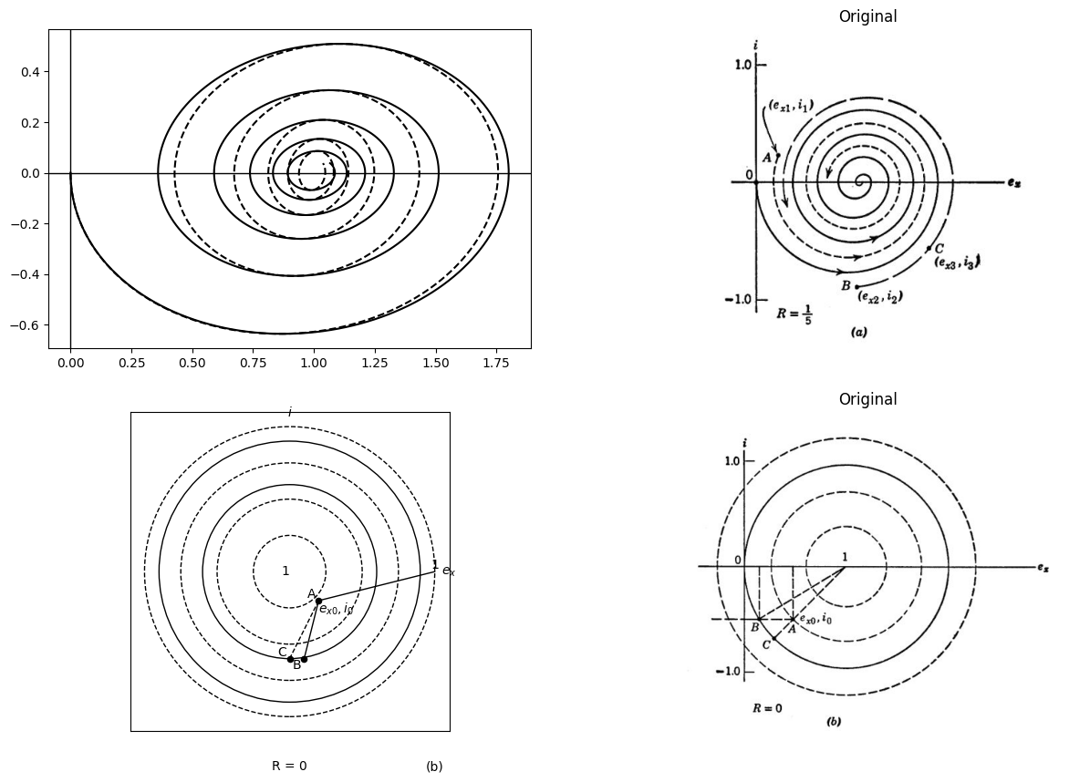

5.1 Fig. 10.11. Effect of initial conditions on operating path with R constant.

6 10.6 Circular-Arc Construction of Trajectories
The circular phase-plane trajectories of the undamped circuit [Fig. 10.11 (b)] lead to an approximate method of constructing trajectories for damped circuits using only a compass. Suppose we make a stepwise
*R. D. Thornton (M.I.T. Research Laboratory of Electronics, Quarterly Progress Report, July 1955, pp. 95-100).
approximation to a resistive curve as indicated in Fig. 10.12(a). This amounts to replacing the resistance by a number of voltage sources, each of which applies over a small range of current. The circuit is therefore
import matplotlib.pyplot as plt
from matplotlib import rcParams
import matplotlib.image as mpimg
import numpy as np
from schemdraw import dsp
import schemdraw
import schemdraw.elements as e
import PySpice.Logging.Logging as Logging
logger = Logging.setup_logging()
from PySpice.Probe.Plot import plot
from PySpice.Spice.Netlist import Circuit
from PySpice.Unit import *
# Create the figure and subplots
fig, axs = plt.subplots(2, 2, figsize=(15, 10))
d = schemdraw.Drawing()
i = np.linspace(-1.2, 1.2, 100)
v = 1 + i / 5
# Create the staircase effect by rounding i to the nearest 0.2
i_stair = np.round(i / 0.2) * 0.2
v_stair = 1.4 + i_stair / 5
axs[0,0].plot(v_stair, i, color='black')
axs[0,0].axvline(1, color='black', linewidth=1)
axs[0,0].axhline(0, color='black', linewidth=1)
for y in [-1, 0, 1]:
axs[0,0].axhline(y, color='black', linestyle='dashed', linewidth=1)
for y in [-.5, -.25, .25,.5,.75,-.75]:
axs[0,0].axhline(y, color='black', linestyle='dashed', linewidth=1)
axs[0,0].axvline(1, color='black', linestyle='dashed', linewidth=1)
axs[0,0].text(1.35, 1.1, r'$v = 1 + \frac{i}{5}$', fontsize=12)
axs[0,0].annotate('', xy=(1.65, 1.2), xytext=(1.15,-1.3 ), arrowprops=dict(arrowstyle='-'))
d = schemdraw.Drawing()
C1 = d.add(e.Capacitor().up().label('C','bottom').label(['-',' ',' ','$e_{x}$',' ',' ','+'] , fontsize = 16))
L1 = d.add(e.Inductor().right().label('L','bottom').label('- $e_L$ +','top').dot(open=True))
l1 = d.add(e.Line().right())
E = d.add(e.Battery().down().label('$E_j$', 'bottom'))
l1 = d.add(e.Line().left().dot(open=True))
l2 = d.add(e.Line().left())
d += ( T := dsp.Box(w=4, h=4).anchor('W').linestyle('-').at((3.5,1.5)))
d += e.Gap().up().label( '$V$' , ofst=-1.7 , fontsize = 16).color('black').at((1.25,.25))
d += e.Arrow().up().length(.7).linewidth(.6).color('black').label('+',loc='end', color='black',ofst=.5). at((3,2.3))
d += e.Arrow().down().length(.7).linewidth(.6).color('black').label(r'_', loc='end', color='black',ofst=(-.5, -.3)). at((3,.8))
G = d.add(e.Ground().at(l1.end).label('$V=Ej$ \n $for -0.2 <i < 0.2 v=1$ \n $-0.6 <i < -0.2 v= 0.92 $\n $-1 < i < -0.6 v= 0.84$','bottom'))
d.save('./Drawings/fig3-9a.jpg')
d.save('./Drawings/fig3-9a.svg')
# Load the saved PNG file into the subplot
img = mpimg.imread('./Drawings/fig3-9a.jpg')
axs[0,1].imshow(img)
axs[0,1].axis('off') # Hide axes for image display
axs[0,1].set_title('Circuit Diagram (developed)')
# Draw circles (dashed)
circle1 = plt.Circle((1,0), 1, color='black', fill=False, linestyle='dashed', linewidth=1.5)
circle2 = plt.Circle((2,0), 1.8, color='black', fill=False, linestyle='dashed', linewidth=1.5)
axs[1,0].add_artist(circle1)
axs[1,0].add_artist(circle2)
# Draw axes
axs[1,0].axhline(0, color='black', linewidth=1)
axs[1,0].axvline(0, color='black', linewidth=1)
#ax.plot([1, np.cos(np.pi/3)], [-1, np.sin(np.pi/3)], color='black', linewidth=1)
axs[1,0].annotate('', xy=(1,0.01), xytext=(.25,-.8 ), arrowprops=dict(arrowstyle='-'))
axs[1,0].annotate('', xy=(1.5,0.01), xytext=(.25,-.8 ), arrowprops=dict(arrowstyle='-'))
# Mark points
axs[1,0].plot([1, 1.5], [0, 0], 'ko') # E1 and E2 on x-axis
# Annotate points
axs[1,0].text(1, 0.05, r'$E_1$', fontsize=12)
axs[1,0].text(1.5, 0.05, r'$E_2$', fontsize=12)
axs[1,0].text(0.1, 1.2, 'i', fontsize=14)
axs[1,0].text(4, 0.1, '$e_x$', fontsize=14)
# Set limits and aspect
axs[1,0].set_xlim(-2,4)
axs[1,0].set_ylim(-2,4)
axs[1,0].set_aspect('equal')
axs[1,0].axis('off') # Hide axes
i = np.linspace(-1.2, 1.2, 100)
v = 1 + i / 5
# Create the staircase effect by rounding i to the nearest 0.2
i_stair = np.round(i / 0.2) * 0.2
v_stair = 1.4 + i_stair / 5
# Draw the main "staircase" line
axs[1,1].plot(v_stair, i, color='black')
# Draw the vertical axis (i)
axs[1,1].axvline(1, color='black', linewidth=1)
# Draw the horizontal axis (ex)
axs[1,1].axhline(0, color='black', linewidth=1)
# Draw horizontal dashed lines for i = -1, 0, 1
for y in [-1, 0, 1]:
axs[1,1].axhline(y, color='black', linestyle='dashed', linewidth=1)
for y in [-.5, -.25, .25,.5,.75,-.75]:
axs[1,1].axhline(y, color='black', linestyle='dashed', linewidth=1)
# Draw vertical dashed line for ex = 1
axs[1,1].axvline(1, color='black', linestyle='dashed', linewidth=1)
# Add the equation label
axs[1,1].text(1.35, 1.1, r'$v = 1 + \frac{i}{5}$', fontsize=12)
axs[1,1].annotate('', xy=(1.65, 1.2), xytext=(1.15,-1.3 ), arrowprops=dict(arrowstyle='-'))
circuit = Circuit('Series RLC Step Response')
# Voltage source: Step from 0V to 1V at t=0
circuit.PulseVoltageSource('input', 'in', circuit.gnd,
initial_value=0@u_V, pulsed_value=1.4@u_V,
pulse_width=10@u_s, period=20@u_s)
# Inductor: 1 H
circuit.L('1', 'in', 'n1', .5@u_H)
# Resistor: 2 Ω
circuit.R('1', 'n1', 'n2', .9@u_Ohm)
# Capacitor: 1 F
circuit.C('1', 'n2', circuit.gnd, .1@u_F)
simulator = circuit.simulator(temperature=25, nominal_temperature=25)
analysis = simulator.transient(step_time=1e-3, end_time=5)
#figure,ax = plt.subplots(figsize=(10, 5))
axs[1,1].plot(analysis['n2'], u_A(-analysis.L1),color='black',linewidth=2)
axs[1,1].axhline(0, color='black', linewidth=1)
axs[1,1].axvline(0, color='black', linewidth=1)
fig = plt.figure(figsize=(15, 3))
img = plt.imread('./images/10-12q.jpg')
plt.imshow(img)
plt.axis('off')
plt.title('\nReference image from the book:', fontsize=15, pad=10,loc='left')
plt.show()
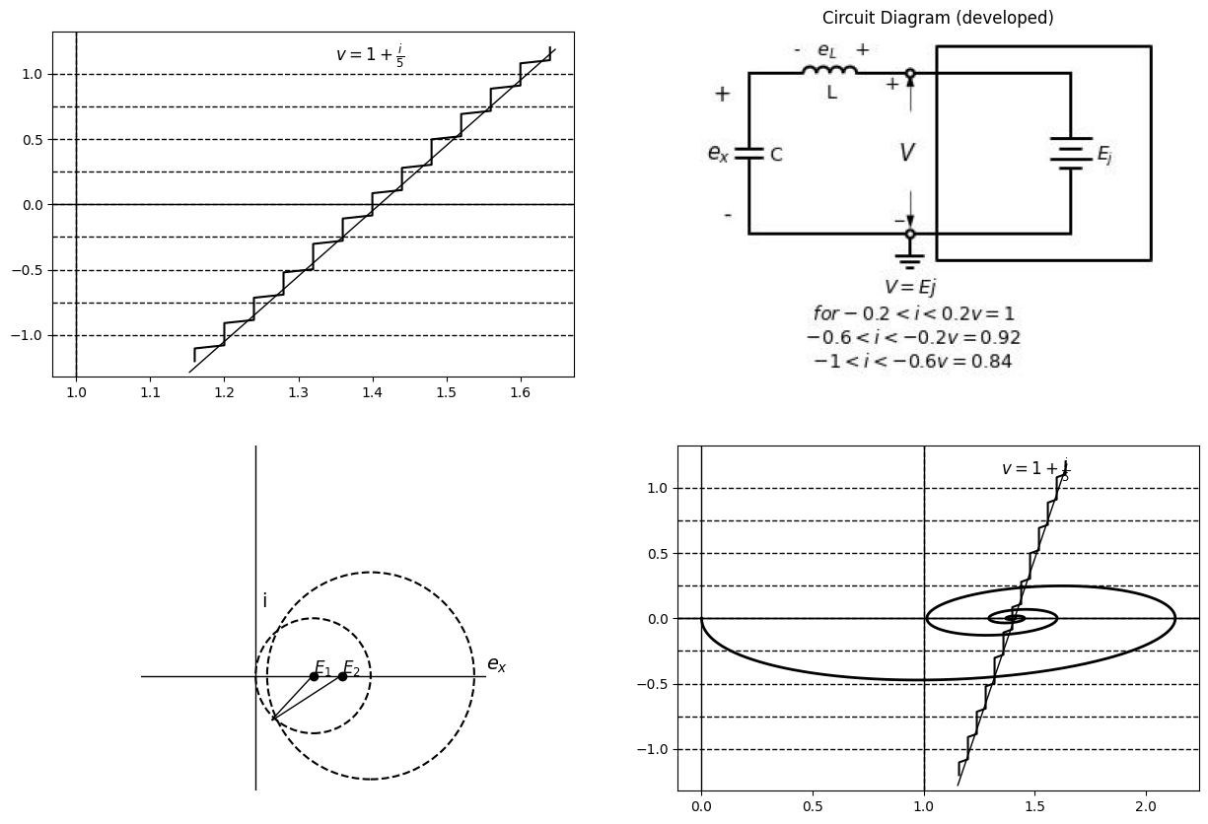
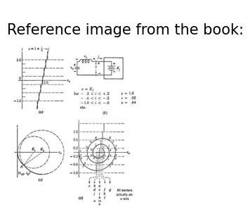

6.1 Fig. 10.12. Circular-are approximation to trajectory resulting from stepwise approximation to resistance
undamped as indicated by the model shown in (b) and the approximate trajectory will consist of segments of circular arcs.
At a transition from one range of currents to the next, the step change in voltage amounts to nothing more than a corresponding change in the circle center and radius. Compare the change from E1 to E2 in Fig. 10.12(c) with the change from initial point A to B in Fig. 10.11 (6).
The step change of voltage appears across the inductance which holds current i constant at the instant of change.
The circular-arc method is indicated in Fig. 10.12(d). Beginning with $e_{x}=i=0$, the centers used and the extremities of the corresponding circular arcs have been given the same letter designations. Following the letters in sequence leads to the complete trajectory for $R=\frac{1}{5}$. As the trajectory re-enters a current interval that has been encountered previously, the center used before is used again. Thus, if the arcs are
import matplotlib.pyplot as plt
from matplotlib import rcParams
import matplotlib.image as mpimg
import numpy as np
from schemdraw import dsp
import schemdraw
import schemdraw.elements as e
import PySpice.Logging.Logging as Logging
logger = Logging.setup_logging()
from PySpice.Probe.Plot import plot
from PySpice.Spice.Netlist import Circuit
from PySpice.Unit import *
# Create the figure and subplots
fig, axs = plt.subplots(1, 3, figsize=(15, 10))
d = schemdraw.Drawing()
i = np.linspace(-1.2, 1.2, 100)
v = 1 + i / 5
# Create the staircase effect by rounding i to the nearest 0.2
i_stair = np.round(i / 0.2) * 0.2
v_stair = 1.4 + i_stair / 5
axs[0].plot(v_stair, i, color='black')
# Draw the vertical axis (i)
axs[0].axvline(1, color='black', linewidth=1)
axs[0].plot([1.24, 1.24], [-1.2, 1.2],'black', linewidth=1,linestyle='--',dashes=(10, 3))
axs[0].plot([1.28, 1.28], [-1.2, 1.2],'black', linewidth=1,linestyle='--',dashes=(10, 3))
axs[0].plot([1.32, 1.32], [-1.2, 1.2],'black', linewidth=1,linestyle='--',dashes=(10, 3))
axs[0].axhline(0, color='black', linewidth=1)
axs[0].plot([1.36, 1.36], [-1.2, 1.2],'black', linewidth=1,linestyle='--',dashes=(10, 3))
axs[0].plot([1.40, 1.40], [-1.2, 1.2],'black', linewidth=1,linestyle='--',dashes=(10, 3))
axs[0].plot([1.44, 1.44], [-1.2, 1.2],'black', linewidth=1,linestyle='--',dashes=(10, 3))
axs[0].plot([1.48, 1.48], [-1.2, 1.2],'black', linewidth=1,linestyle='--',dashes=(10, 3))
axs[0].plot([1.52, 1.52], [-1.2, 1.2],'black', linewidth=1,linestyle='--',dashes=(10, 3))
axs[0].plot([1.56, 1.56], [-1.2, 1.2],'black', linewidth=1,linestyle='--',dashes=(10, 3))
axs[0].plot([1.6, 1.6], [-1.2, 1.2],'black', linewidth=1,linestyle='--',dashes=(10, 3))
axs[0].text(1.35, 1.1, r'$v = 1 + \frac{i}{5}$', fontsize=12)
axs[0].annotate('', xy=(1.65, 1.2), xytext=(1.15,-1.3 ), arrowprops=dict(arrowstyle='-'))
d = schemdraw.Drawing()
C1 = d.add(e.Capacitor().up().label('C','bottom').label(['-',' ',' ','$e_{x}$',' ',' ','+'] , fontsize = 16))
L1 = d.add(e.Inductor().right().label('L','bottom').label('- $e_L$ +','top').dot(open=True))
l1 = d.add(e.Line().right())
E = d.add(e.Battery().down().label('$I_j$', 'bottom'))
l1 = d.add(e.Line().left().dot(open=True))
l2 = d.add(e.Line().left())
d += ( T := dsp.Box(w=4, h=4).anchor('W').linestyle('-').at((3.5,1.5)))
d += e.Gap().up().label( '$V$' , ofst=-1.7 , fontsize = 16).color('black').at((1.25,.25))
d += e.Arrow().right().linewidth(0.6).length(0.5).color('black').label('i',loc='start',color='black',ofst=0.3, fontsize=9).at((2.5,3.3))
d += e.Arrow().up().length(.7).linewidth(.6).color('black').label('+',loc='end', color='black',ofst=.5). at((3,2.3))
d += e.Arrow().down().length(.7).linewidth(.6).color('black').label(r'_', loc='end', color='black',ofst=(-.5, -.3)). at((3,.8))
G = d.add(e.Ground().at(l1.end).label('$i=Ij$ \n $for 1.0<v < 1.8 i=0.2$ \n $1.08 <v < 1.16 i= 0.6 $\n $etc$\n $0.92<v<1.0 i=-2$\n $etc$','bottom'))
d.save('./Drawings/fig10-13.jpg')
d.save('./Drawings/fig10-13.svg')
# Load the saved PNG file into the subplot
img = mpimg.imread('./Drawings/fig10-13.jpg')
axs[1].imshow(img)
axs[1].axis('off') # Hide axes for image display
axs[1].set_title('Circuit Diagram (developed)')
img_sample = mpimg.imread('images/10-13.jpg') # Load the PNG file
axs[2].imshow(img_sample)
axs[2].axis('off') # Hide axes for image display
axs[2].set_title('Original')
Text(0.5, 1.0, 'Original')
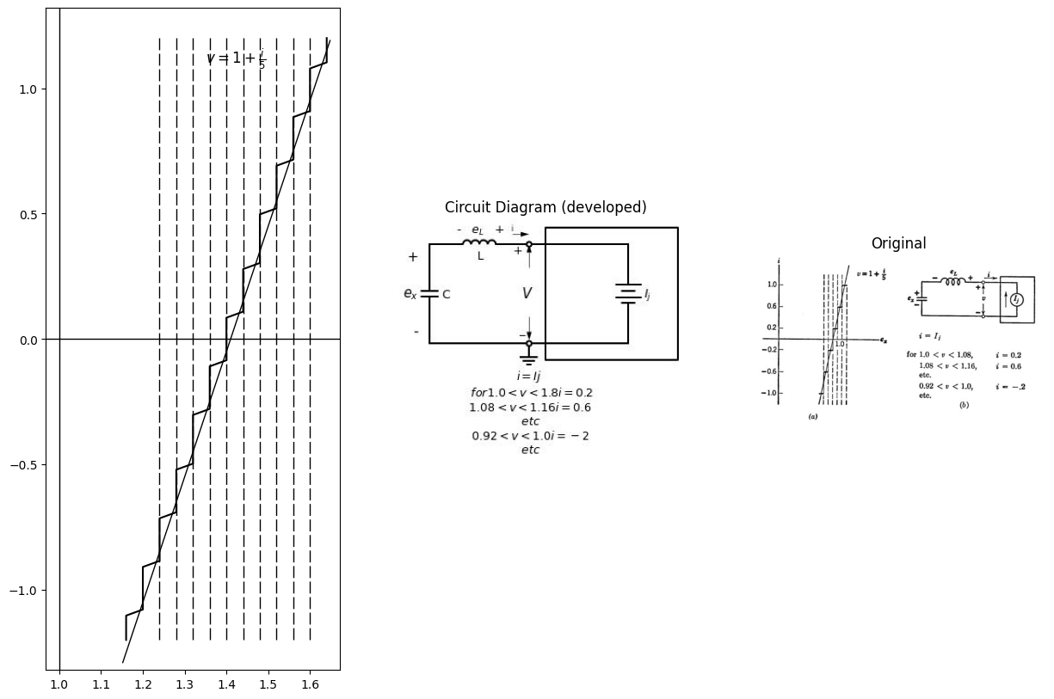

6.2 Fig. 10.13. Current-source model for stepwise-resistance approximation.
labelled in sequence, the centers will each have several designations for an oscillatory case such as the one illustrated. Comparing the complete trajectory in (d) with that in Fig. 10.7, we see that a relatively coarse stepwise approximation to the resistance yields a fairly good approxima- tion to the trajectory until the size of the spiral becomes comparable to the size of the steps. Since the steps need not be uniform, more can be used where needed to obtain greater accuracy.
It is apparent that an alternate representation for a stepwise approxi- mation to a resistance is a series of current sources, each of which applies over a small range of voltage. Use of a current-source model like that shown in Fig. 10.13 is not appropriate for the series circuit, since i and $e_{x}$ will be independent of inductance L. Connecting a circuit element in series with a current source has no effect on the terminal current. With the current source model, the voltage across the inductance will be zero while the current is constant and will have an impulse discontinuity as each step in current occurs. This is obviously not a good approximation
to the actual current waveform in a series RLC circuit. The current- source model is the appropriate one to use for a parallel LC circuit connected to a stepwise resistance approximation.

7 10.7 Oscillator Limit Cycles by Circular-Arc Method
With a current-controlled negative resistance connected to a series $LC$ circuit, continuous oscillations can be obtained. When repetitive waveforms are thus generated, the corresponding phase-plane trajectory must also repeat itself. The resulting closed path in the phase plane is called a limit cycle. If specific trajectories approach such a limit cycle from both sides, the limit cycle is stable. The free-running relaxation oscillators described in Chapter 9 exhibited closed trajectories (limit cycles) in the phase plane.
The physical argument for the existence of a limit cycle is based on the fact that negative resistance acts as a power source and causes growing transients while positive resistance dissipates power and causes decaying transients. Equilibrium occurs when the amplitude of the oscillations reaches the value for which the energy dissipated during each cycle just equals the energy given to the tuned circuit each cycle.
Although simple in physical concept, an analytical solution of this problem is difficult (even for a piecewise-linear negative resistance). However, various techniques permit rapid construction of limit cycles. The circular-arc method is particularly convenient for comparing oscillatory systems. The stepwise approximation can be applied directly to a nonlinear curve or to a piecewise-linear curve. For ease of com- parison with results already obtained in Chapter 9, we shall assume a symmetrical current-controlled negative resistance.
The character of the waveforms and phase-plane trajectories of an oscillator circuit depends on the positive and negative damping resist- ances. Furthermore, since a linear negative resistance causes a growing transient we know that a limit cycle can only exist somewhere outside of the break points, so the trajectory spends some time in the positive- damped regions (states I and II) as well as in the negative-damped region (state III). As a convenience, and without loss of generality, the break points are set at $i=±1$ for all of the following analyses. The construction of the limit cycle proceeds in the same manner as the construction for the linear circuits considered in the preceding article.
The limit cycles shown in Fig. 10.14 correspond to a negative resistance $RIII=−\frac{1}{5}$ and positive resistances ranging over the values,∞, 4, 2, and
.This sequence of limit cycles goes from a relaxation oscillation in (a) to a nearly sinusoidal oscillation in (d). Thus with a specific negative resistance, the value of positive resistance alone sets the mode of opera- tion. If states $I$ and $II$ are heavily overdamped we tend to have relaxation oscillations, whereas the underdamped case yields nearly sine

7.1 Fig. 10.14. Limit cycles by circular-are method for RIII =$ - \frac {1}{5}$.
waves. Note that as the positive damping is decreased the size of the limit cycle increases, as might be expected.
For small damping resistances (both positive and negative) the curve $j=f\left(i\right)$ approaches the vertical line that corresponds to no damping.

7.2 Fig. 10.15. Limit cycles by circular-are method for RIIT =-1.0.
Note how nearly circular the limit cycle is in Fig. 10.14(d). The corre- sponding waveforms will be nearly sinusoidal. However for such small values of damping, the oscillation amplitude is sensitive to changes in load.
The limit cycles constructed in Fig. 10.15 have a negative resistance RI111 (a stronger power source than the $RIII=−1$ of Fig. 10.14). The positive damping is infinite in (a) and critical in (b). Note the tendency of both limit cycles to "elongate." The waveforms will be relaxation oscillations in both cases. If a positive underdamped resistance is used here [say as in Fig. 10.14(d)], the limit cycle will be very large and will again tend to be nearly circular.

8 10.8 The Method of Isoclines
An isocline is a line in the phase plane along which the slope of a trajectory must have a fixed value. Any trajectory must intersect the isocline with a unique slope anywhere along the line except at a singular point. Let us apply the method of isoclines to the series $RLC$ circuit, first with linear and then piecewise linear resistance.
The differential equation for $RLC$ circuit trajectories shows slopes explicitly. Thus we merely let di٫dez take on a succession of constant values
$$\frac{v−ex}{i}=\frac{d_{i}}{dex}=K$$
$$\left(10.33\right)$$
The equation for an isocline in this case is
$$v−ex=Ki$$
$$\left(10.34\right)$$
We note immediately that for k equal to zero we have ex equal to v, whereas for infinite k we must have i equal to zero. Other convenient values for k, such as plus and minus one, two, three, etc., are then selected. As indicated in Fig. 10.16 the slope for each isocline is in- dicated at frequent intervals along the isocline by a short line called a "director." When a number of these have been drawn, a trajectory can be sketched relatively easily beginning from any initial point.
Note that the directors do not specify the direction of rotation of the trajectory for positive time. The direction is readily obtained from the terminal relations such as those specified by Fig. 10.3. In this case,$e_{L}=−di/dt$ and $i=dex/dt$ and thus the rotation is counterclockwise with increasing time.
The values of damping resistance and initial conditions in Fig. 10.16(a) and (b) correspond to those used in Figs. 10.7 and 10.8, whereas (c) is drawn for R =1 and the singular point as the starting place. Each trajectory emerges from the singular point with a different slope.
The method of isoclines is readily extended to nonlinear or piecewise- linear resistance curves. For a piecewise-linear curve we merely treat each state like the linear examples shown in Fig. 10.16, hence the isoclines form a family of radial lines centered at the voltage intercept for that state. As shown in Fig. 10.17, the negative-resistance region $\left(stateIII\right)$ for the current-controlled curve extends between break points. States I and II flank this region. The isoclines in this case form a set of curves like the negative-resistance curve $v=f\left(i\right)$ but distorted or "sheared" clockwise.
In Fig. 10.17, $RIII=1$, hence the trajectories within state $III$ will be like those of Fig. 10.16(c). The positive damping is critical, hence the resulting oscillations tend to be fairly nonsinusoidal. The particular value $RI,RII=2$ make the isocline for k1 in states $I$ and$ II $
import matplotlib.pyplot as plt
from matplotlib import rcParams
import matplotlib.image as mpimg
import numpy as np
from schemdraw import dsp
import schemdraw
import schemdraw.elements as e
import PySpice.Logging.Logging as Logging
logger = Logging.setup_logging()
from PySpice.Probe.Plot import plot
from PySpice.Spice.Netlist import Circuit
from PySpice.Unit import *
# Create the figure and subplots
fig, axs = plt.subplots(2, 2, figsize=(15, 10))
d = schemdraw.Drawing()
circuit = Circuit('Series RLC Step Response')
# Voltage source: Step from 0V to 1V at t=0
circuit.PulseVoltageSource('input', 'in', circuit.gnd,
initial_value=0@u_V, pulsed_value=1@u_V,
pulse_width=10@u_s, period=20@u_s)
# Inductor: 1 H
circuit.L('1', 'in', 'n1', .1@u_H)
# Resistor: 2 Ω
circuit.R('1', 'n1', 'n2', .2@u_Ohm)
# Capacitor: 1 F
circuit.C('1', 'n2', circuit.gnd, .1@u_F)
simulator = circuit.simulator(temperature=25, nominal_temperature=25)
analysis = simulator.transient(step_time=1e-3, end_time=5)
axs[0,0].plot(analysis['n2'], u_A(-analysis.L1),color='black')
axs[0,0].axhline(0, color='black', linewidth=1)
axs[0,0].axvline(0, color='black', linewidth=1)
axs[0,0].annotate('', xy=(.45, -.9), xytext=(1.48,.8 ), arrowprops=dict(arrowstyle='-'))
axs[0,0].annotate('', xy=(1.5, -.9), xytext=(.55,.8 ), arrowprops=dict(arrowstyle='-'))
axs[0,0].annotate('', xy=(1, -.9), xytext=(1,.8 ), arrowprops=dict(arrowstyle='-'))
# Draw circles (dashed)
circle1 = plt.Circle((2,0), 1, color='black', fill=False, linestyle='-', linewidth=1.5)
circle2 = plt.Circle((2,0), 2, color='black', fill=False, linestyle='-', linewidth=1.5)
axs[0,1].add_artist(circle1)
axs[0,1].add_artist(circle2)
# Draw axes
axs[0,1].axhline(0, color='black', linewidth=1)
axs[0,1].axvline(0, color='black', linewidth=1)
#ax.plot([1, np.cos(np.pi/3)], [-1, np.sin(np.pi/3)], color='black', linewidth=1)
#plt.annotate('', xy=(1,0.01), xytext=(.25,-.8 ), arrowprops=dict(arrowstyle='-'))
#plt.annotate('', xy=(1.5,0.01), xytext=(.25,-.8 ), arrowprops=dict(arrowstyle='-'))
axs[0,1].annotate('', xy=(-1.5, -3), xytext=(5.51,3 ), arrowprops=dict(arrowstyle='-'))
axs[0,1].annotate('', xy=(3.2, -3), xytext=(.9,3 ), arrowprops=dict(arrowstyle='-'))
axs[0,1].annotate('', xy=(.9, -3), xytext=(3.2,3 ), arrowprops=dict(arrowstyle='-'))
axs[0,1].annotate('', xy=(4.01, -3), xytext=(.1,3 ), arrowprops=dict(arrowstyle='-'))
axs[0,1].annotate('', xy=(.1, -3), xytext=(4.01,3 ), arrowprops=dict(arrowstyle='-'))
axs[0,1].annotate('', xy=(2, -3), xytext=(2,3 ), arrowprops=dict(arrowstyle='-'))
axs[0,1].text(0.1, 4.2, 'i', fontsize=14)
axs[0,1].text(6, 0.1, '$e_x$', fontsize=14)
axs[0,1].text(1.7, 3, '$v=1$', fontsize=10)
axs[0,1].text(2.7, 3, r'$k=-\frac {1}{2}$', fontsize=10)
axs[0,1].text(4.2, 3, r'$k=-1$', fontsize=8)
axs[0,1].set_xlim(-4,6)
axs[0,1].set_ylim(-4,4)
axs[0,1].set_aspect('equal')
# Define the circuit
circuit = Circuit('Series RLC Step Response')
# Voltage source: Step from 0V to 1V at t=0
circuit.PulseVoltageSource('input', 'in', circuit.gnd,
initial_value=1@u_V, pulsed_value=2@u_V,
pulse_width=10@u_s, period=20@u_s)
# Inductor: 1 H
circuit.L('1', 'in', 'n1', .1@u_H)
# Resistor: 2 Ω
circuit.R('1', 'n1', 'n2', -1@u_Ohm)
# Capacitor: 1 F
circuit.C('1', 'n2', circuit.gnd, .33@u_F)
simulator = circuit.simulator(temperature=25, nominal_temperature=25)
analysis = simulator.transient(step_time=1e-3, end_time=5)
circuit.PulseVoltageSource('input2', 'in2', circuit.gnd,
initial_value=1@u_V, pulsed_value=2@u_V,
pulse_width=10@u_s, period=20@u_s)
# Inductor: 1 H
circuit.L('2', 'in2', 'n12', .1@u_H)
# Resistor: 2 Ω
circuit.R('2', 'n12', 'n22', -1@u_Ohm)
# Capacitor: 1 F
circuit.C('2', 'n22', circuit.gnd, .3@u_F)
simulator = circuit.simulator(temperature=25, nominal_temperature=25)
analysis = simulator.transient(step_time=1e-3, end_time=5)
circuit.PulseVoltageSource('input3', 'in3', circuit.gnd,
initial_value=1@u_V, pulsed_value=2@u_V,
pulse_width=10@u_s, period=20@u_s)
# Inductor: 1 H
circuit.L('3', 'in3', 'n13', .1@u_H)
# Resistor: 2 Ω
circuit.R('3', 'n13', 'n23', -1@u_Ohm)
# Capacitor: 1 F
circuit.C('3', 'n23', circuit.gnd, .27@u_F)
simulator = circuit.simulator(temperature=25, nominal_temperature=25)
analysis = simulator.transient(step_time=1e-3, end_time=5)
circuit.PulseVoltageSource('input4', 'in4', circuit.gnd,
initial_value=1@u_V, pulsed_value=2@u_V,
pulse_width=10@u_s, period=20@u_s)
# Inductor: 1 H
circuit.L('4', 'in4', 'n4', .1@u_H)
# Resistor: 2 Ω
circuit.R('4', 'n4', 'n43', -1@u_Ohm)
# Capacitor: 1 F
circuit.C('4', 'n43', circuit.gnd, .24@u_F)
circuit.PulseVoltageSource('input5', 'in5', circuit.gnd,
initial_value=1@u_V, pulsed_value=2@u_V,
pulse_width=10@u_s, period=20@u_s)
# Inductor: 1 H
circuit.L('5', 'in5', 'n5', .1@u_H)
# Resistor: 2 Ω
circuit.R('5', 'n5', 'n45', -1@u_Ohm)
# Capacitor: 1 F
circuit.C('5', 'n45', circuit.gnd, .2@u_F)
simulator = circuit.simulator(temperature=25, nominal_temperature=25)
analysis = simulator.transient(step_time=1e-3, end_time=5)
axs[1,0].plot(analysis['n45'], u_A(-analysis.L5),color='black')
simulator = circuit.simulator(temperature=25, nominal_temperature=25)
analysis = simulator.transient(step_time=1e-3, end_time=5)
axs[1,0].plot(analysis['n2'], u_A(-analysis.L1),color='black')
simulator = circuit.simulator(temperature=25, nominal_temperature=25)
analysis = simulator.transient(step_time=1e-3, end_time=5)
axs[1,0].plot(analysis['n22'], u_A(-analysis.L2),color='black')
simulator = circuit.simulator(temperature=25, nominal_temperature=25)
analysis = simulator.transient(step_time=1e-3, end_time=5)
axs[1,0].plot(analysis['n23'], u_A(-analysis.L3),color='black')
simulator = circuit.simulator(temperature=25, nominal_temperature=25)
analysis = simulator.transient(step_time=1e-3, end_time=5)
axs[1,0].plot(analysis['n43'], u_A(-analysis.L4),color='black')
circuit.PulseVoltageSource('input6', 'in56', circuit.gnd,
initial_value=1@u_V, pulsed_value=2@u_V,
pulse_width=10@u_s, period=20@u_s)
# Inductor: 1 H
circuit.L('6', 'in56', 'n56', .1@u_H)
# Resistor: 2 Ω
circuit.R('6', 'n56', 'n46', -1@u_Ohm)
# Capacitor: 1 F
circuit.C('6', 'n46', circuit.gnd, .17@u_F)
simulator = circuit.simulator(temperature=25, nominal_temperature=25)
analysis = simulator.transient(step_time=1e-3, end_time=5)
axs[1,0].plot(analysis['n46'], u_A(-analysis.L6),color='black')
circuit.PulseVoltageSource('input7', 'in7', circuit.gnd,
initial_value=1@u_V, pulsed_value=2@u_V,
pulse_width=10@u_s, period=20@u_s)
# Inductor: 1 H
circuit.L('7', 'in7', 'n75', .1@u_H)
# Resistor: 2 Ω
circuit.R('7', 'n75', 'n76', -1@u_Ohm)
# Capacitor: 1 F
circuit.C('7', 'n76', circuit.gnd, .15@u_F)
simulator = circuit.simulator(temperature=25, nominal_temperature=25)
analysis = simulator.transient(step_time=1e-3, end_time=5)
axs[1,0].plot(analysis['n76'], u_A(-analysis.L7),color='black')
axs[1,0].axhline(0, color='black', linewidth=1)
axs[1,0].axvline(0, color='black', linewidth=1)
img_sample = mpimg.imread('images/4-16.jpg') # Load the PNG file
axs[1,1].imshow(img_sample)
axs[1,1].axis('off') # Hide axes for image display
axs[1,1].set_title('Original')
Text(0.5, 1.0, 'Original')
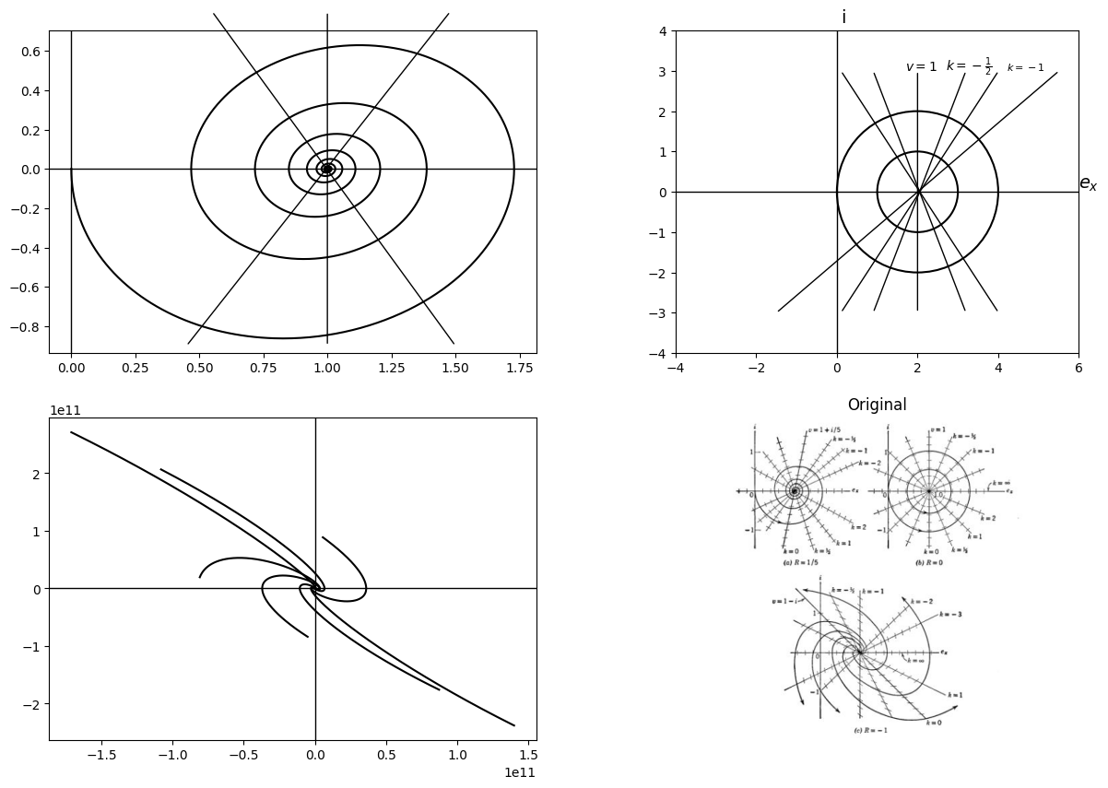

8.1 Fig. 10.16. Phase-plane trajectories by the method of isoclines.
different from all the others, because the directors lie along the isocline. This means that a trajectory cannot cross these lines; the operating point can be tangent or move along this isocline until a break point is reached. See, for example, the trajectory originating at point Q. The trajectories starting at 0 and M in Fig. 10.17 illustrate the
formation of a limit cycle. The trajectory that begins at the origin spirals inward while the trajectory beginning at point M spirals outward. The limit cycle is the repetitive path approached by the two. A third trajectory from an initial point N would fall between the successive
import matplotlib.pyplot as plt
from matplotlib import rcParams
import matplotlib.image as mpimg
import numpy as np
from schemdraw import dsp
import schemdraw
import schemdraw.elements as e
import PySpice.Logging.Logging as Logging
logger = Logging.setup_logging()
from PySpice.Probe.Plot import plot
from PySpice.Spice.Netlist import Circuit
from PySpice.Unit import *
# Create the figure and subplots
fig, axs = plt.subplots(1, 2, figsize=(15, 10))
d = schemdraw.Drawing()
# Define the circuit
circuit = Circuit('Series RLC Step Response')
# Voltage source: Step from 0V to 1V at t=0
circuit.PulseVoltageSource('input', 'in', circuit.gnd,
initial_value=0@u_V, pulsed_value=1@u_V,
pulse_width=10@u_s, period=20@u_s)
# Inductor: 1 H
circuit.L('1', 'in', 'n1', .1@u_H)
# Resistor: 2 Ω
circuit.R('1', 'n1', 'n2', .1@u_Ohm)
# Capacitor: 1 F
circuit.C('1', 'n2', circuit.gnd, .25@u_F)
simulator = circuit.simulator(temperature=25, nominal_temperature=25)
analysis = simulator.transient(step_time=1e-3, end_time=5)
axs[0].plot(analysis['n2'], u_A(-analysis.L1),color='black')
axs[0].axhline(0, color='black', linewidth=1)
axs[0].axvline(0, color='black', linewidth=1)
axs[0].annotate('', xy=(.45, -.9), xytext=(1.48,.8 ), arrowprops=dict(arrowstyle='-'))
axs[0].annotate('', xy=(1.5, -.9), xytext=(.55,.8 ), arrowprops=dict(arrowstyle='-'))
img_sample = mpimg.imread('images/10-17.jpg') # Load the PNG file
axs[1].imshow(img_sample)
axs[1].axis('off') # Hide axes for image display
axs[1].set_title('Original')
Text(0.5, 1.0, 'Original')
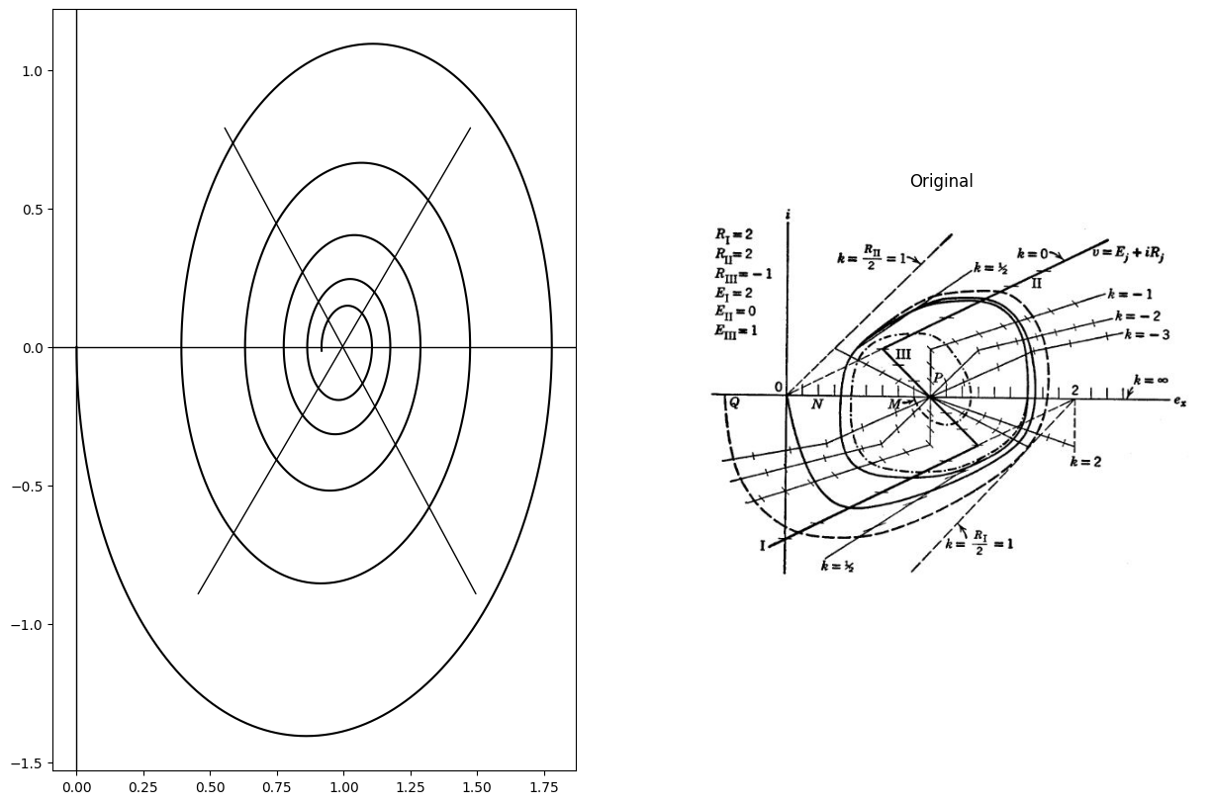

8.2 Fig. 10.17. Limit cycle by the method of isoclines.
rotations of the trajectory starting at the origin since two trajectories cannot cross each other.
The limit cycle in Fig. 10.17 resembles that of a relaxation oscillator. If the positive and negative damping is reduced, the trajectory becomes more nearly circular as in Fig. 10.14(d) and the current and voltage waveforms will be nearly sinusoidal.
SUPPLEMENTARY READING
A. A. Andronow and C. E. Chaikin, Theory of Oscillations, Princeton University Press, Princeton, N. J., 1949.
William A. Edson, Vacuum-Tube Oscillators, John Wiley and Sons, New York, 1953.
PROBLEMS
10.1. A current generator connected across the terminals of capacitance C in Fig. 10.2 applies a brief pulse of current (approximately an impulse) to change the voltage $e_{x}$ Assume the area of the pulse $Ioδ0$ =$ Q{0}$ changes the voltage $ex$ by an amount $Δe_{x}$ = $E0$ = $Q0/C$ Sketch waveforms $i\left(t\right)$, $ex\left(t\right)$ and the locus of i vs. $ex$ for $E0$ = 0 ,$E/2$ ,$E$, $3E/2 $and $2E$ if the pulse is applied
10.2. Plot waveforms $i\left(t\right)$ $ex\left(t\right)$ and the locus of i vs. $ex$ for the circuit of Fig. 10.3 with $R=1$ .
10.3. Referring to Fig. 10.5, indicate the effect of an initial capacitor voltage e_{z}(0) on the waveforms and locus of i vs. $ex$ Let $ex\left(0\right)$ = $−1,−0.5,0,0.51.0,1.5,and2.0$.
import matplotlib.pyplot as plt
from matplotlib import rcParams
import matplotlib.image as mpimg
import numpy as np
from schemdraw import dsp
import schemdraw
import schemdraw.elements as e
import PySpice.Logging.Logging as Logging
logger = Logging.setup_logging()
from PySpice.Probe.Plot import plot
from PySpice.Spice.Netlist import Circuit
from PySpice.Unit import *
# Create the figure and subplots
fig, axs = plt.subplots(1, 2, figsize=(15, 10))
d = schemdraw.Drawing()
C1 = d.add(e.Capacitor().up().label('C','bottom') )
l1 = d.add(e.Line().right())
L1 = d.add(e.Inductor().down().label('L','bottom'))
l2 = d.add(e.Line().left())
l3 = d.add(e.Line().right().at(L1.start))
R1 = d.add(e.Resistor().down().label('R','bottom'))
l4 = d.add(e.Line().left().label('$fig.p10.1$','bottom'))
l5 = d.add(e.Line().right().at(R1.start))
I1 = d.add(e.SourceI().down().label('$I$','bottom').reverse())
l6 = d.add(e.Line().left())
d += e.Arrow().up().linewidth(0.6).length(0.5).color('black').label('$i_c$',color='black',ofst=-0.3, fontsize=9).at((.5,2.3))
d += e.Arrow().up().linewidth(0.6).length(0.5).color('black').label('$i_L$',color='black',ofst=-0.3, fontsize=9).at((3.5,2.3))
d += e.Arrow().up().linewidth(0.6).length(0.5).color('black').label('$i_R$',color='black',ofst=-0.3, fontsize=9).at((6.5,2.3))
d.save('Drawings/p10-1a.jpg') # Save the drawing to a PNG file
img = mpimg.imread('Drawings/p10-1a.jpg')
axs[0].imshow(img)
axs[0].axis('off') # Hide axes for image display
axs[0].set_title('Circuit Diagram (developed)')
# **Subplot (1, 2): PNG Sample File**
img_sample = mpimg.imread('images/p10-1.jpg') # Load the PNG file
axs[1].imshow(img_sample)
axs[1].axis('off') # Hide axes for image display
axs[1].set_title('Original')
Text(0.5, 1.0, 'Original')
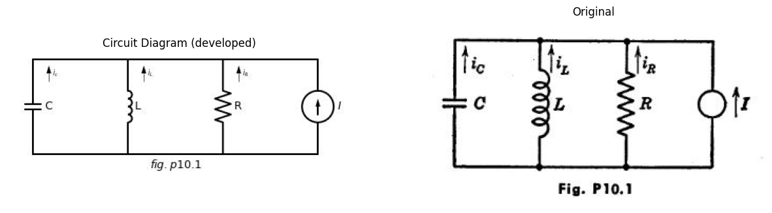
10.4. Write the differential equations relating vand $i_{L}$ for the linear $RLC$ circuit shown in Fig. P10.1.
10.5. Normalize the equations for the circuit of Fig. P10.1 so that the only parameter appearing in the oscillatory equation is the damping factor.
10.6. By means of duality, relate the results of Problems 10.4 and 10.5 to the corresponding results for the series $RLC$ circuit.
10.7. What values of damping resistance R (or conductance $G=1/R$ ) yield the seven possible cases of damping for the parallel RLC circuit?
10.8. Consider a parallel RLC circuit with Land C equal to unity and with
an initial unit current in the inductor. Let R assume convenient values such
import matplotlib.pyplot as plt
from matplotlib import rcParams
import PySpice.Logging.Logging as Logging
logger = Logging.setup_logging()
from PySpice.Probe.Plot import plot
from PySpice.Spice.Netlist import Circuit
from PySpice.Unit import *
rcParams['font.weight'] = 'bold'
fig, axs = plt.subplots(1, 2, figsize=(10, 10))
circuit = Circuit('Transitional characteristic1')
circuit.model('BAV21','D' ,IS = 1@u_uA ,BV = 293.10@u_V, IBV = 0.001293@u_A , RS = 10@u_Ohm )
Vi = circuit.V('i', '1', circuit.gnd, 0@u_V)
circuit.D(1, '2','1', model = 'BAV21')
circuit.I(1, '1', '2', 1@u_mA)
circuit.D(2, '2', '3', model = 'BAV21')
circuit.V(1, '3', circuit.gnd,1@u_V)
circuit.D(13, '4','1', model = 'BAV21')
circuit.I(2, '1', '4', 1@u_mA)
circuit.D(4, '4', '5', model = 'BAV21')
circuit.V(2, '5', circuit.gnd, 3@u_V)
circuit.D(5, '6','1', model = 'BAV21')
circuit.I(3, '1', '6', 2@u_mA)
simulator = circuit.simulator(temperature=25, nominal_temperature=25)
analysis = simulator.dc(Vi=slice(0, 4, .01))
axs[0].plot(analysis['1'],u_mA(-analysis.Vi),'black',linewidth=3)
circuit = Circuit('Transitional characteristic1')
circuit.model('BAV21','D' ,IS = 1@u_uA ,BV = 293.10@u_V, IBV = 0.001293@u_A , RS = 10@u_Ohm )
Vi = circuit.V('i', '1', circuit.gnd, 0@u_V)
circuit.D(1, '2','1', model = 'BAV21')
circuit.I(1, '1', '2', -1@u_mA)
circuit.D(2, '2', '3', model = 'BAV21')
circuit.V(1, '3', circuit.gnd,0@u_V)
circuit.D(13, '4','1', model = 'BAV21')
circuit.I(2, '1', '4', -1@u_mA)
circuit.D(4, '4', '5', model = 'BAV21')
circuit.V(2, '5', circuit.gnd, -1@u_V)
circuit.D(5, '6','1', model = 'BAV21')
#circuit.I(3, '1', '6', -1@u_mA)
simulator = circuit.simulator(temperature=25, nominal_temperature=25)
analysis = simulator.dc(Vi=slice(-4, 0, .01))
axs[0].plot(analysis['1'],u_mA(-analysis.Vi),'black',linewidth=3)
axs[0].axhline(0, color='black', linewidth=1)
axs[0].axvline(0, color='black', linewidth=1)
axs[0].plot([0, 0], [-0.5, 0], color='black', linewidth=3)
axs[0].annotate('-1', xy=(0.1, -1), xytext=(-0.5, -1),
textcoords='offset points', ha='center', color='black', fontsize=12, fontweight='medium')
axs[0].annotate('-2', xy=(0.1, -2), xytext=(-0.5, -2),
textcoords='offset points', ha='center', color='black', fontsize=12, fontweight='medium')
axs[0].annotate('1', xy=(-0.1, 1), xytext=(-0.5, 1),
textcoords='offset points', ha='center', color='black', fontsize=12, fontweight='medium')
axs[0].annotate('2', xy=(-0.1, 2), xytext=(-0.5, 2),
textcoords='offset points', ha='center', color='black', fontsize=12, fontweight='medium')
axs[0].annotate('', xy=(-2.7, -2.5), xytext=(2.7,2.5 ), arrowprops=dict(arrowstyle='-'))
axs[0].annotate('R', xy=(2.6, 2.6), xytext=(2.6, 2.6),
textcoords='offset points', ha='center', color='black', fontsize=12, fontweight='medium')
axs[0].plot([2, 2], [0, .2], color='black', linewidth=1)
axs[0].plot([0.1,0], [2,2], color='black', linewidth=1)
axs[0].plot([0.1,0], [1,1], color='black', linewidth=1)
axs[0].set_xlim(-4, 4)
axs[0].set_ylim(-3, 3)
axs[0].set_xlabel('v [V]')
axs[0].set_ylabel('i [mA]')
img_sample = mpimg.imread('images/p10-2.jpg') # Load the PNG file
axs[1].imshow(img_sample)
axs[1].axis('off') # Hide axes for image display
axs[1].set_title('Original')
Text(0.5, 1.0, 'Original')
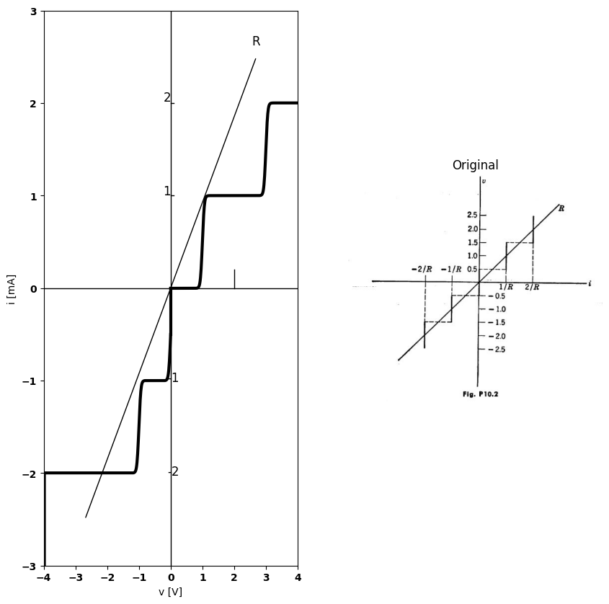
as ± 0.25 , ± 0.5 , ± 1 , and ± 2 .in each case the resistance is to be approximated by a stepwise-linear curve as indicated in Fig. P10.2. Construct phase-plane trajectories.
10.9. In what region (or regions) of the phase plane is the approximation used in Problem 10.8 inadequate for each value of R considered?
import matplotlib.pyplot as plt
from matplotlib import rcParams
import PySpice.Logging.Logging as Logging
logger = Logging.setup_logging()
from PySpice.Probe.Plot import plot
from PySpice.Spice.Netlist import Circuit
from PySpice.Unit import *
rcParams['font.weight'] = 'bold'
fig, axs = plt.subplots(1, 2, figsize=(10, 10))
# Set up parameters
R = 1 # You can adjust R as needed
# Create the range for i
i = np.linspace(-3, 3, 1000)
v_linear = R * i
# Step function definition
i_steps = np.array([-3, -2, -1, 0, 1, 2, 3]) / R
v_steps = np.array([-2, -1, 0, 1, 2, 3])
# Prepare step y-values (repeat each value to create horizontal lines)
v_step_plot = np.repeat(v_steps, 2)
# Prepare step x-values (repeat all but first and last for vertical lines)
i_step_plot = []
for idx in range(len(i_steps)-1):
i_step_plot.extend([i_steps[idx], i_steps[idx+1]])
i_step_plot = np.array(i_step_plot)
axs[0].plot(i, v_linear, label='R', color='black')
# Plot the step function
axs[0].plot(i_step_plot, v_step_plot, drawstyle='steps-post', linestyle='-', color='black')
# Axis labels
axs[0].set_xlabel('i')
axs[0].set_ylabel('v')
# Custom ticks and labels
axs[0].set_xticks([-3/R, -1.5/R, -1/R, -0.5/R, 0, 0.5/R, 1/R, 1.5/R, 3/R])
axs[0].set_xticklabels([r'$-\frac{3}{R}$', r'$-\frac{1.5}{R}$', r'$-\frac{1}{R}$', r'$-\frac{0.5}{R}$', '0',
r'$\frac{0.5}{R}$', r'$\frac{1}{R}$', r'$\frac{1.5}{R}$', r'$\frac{3}{R}$'])
axs[0].set_yticks(np.arange(-2.5, 3, 0.5))
axs[0].set_yticklabels([f'{y:.1f}' if y != 0 else '0' for y in np.arange(-2.5, 3, 0.5)])
axs[0].axhline(0, color='black', linewidth=1)
axs[0].axvline(0, color='black', linewidth=1)
# Set limits
axs[0].set_xlim(-3.2, 3.2)
axs[0].set_ylim(-2.5, 2.5)
axs[0].text(2.7, 2.7, 'R', fontsize=12, rotation=45)
img_sample = mpimg.imread('images/p10-3.jpg') # Load the PNG file
axs[1].imshow(img_sample)
axs[1].axis('off') # Hide axes for image display
axs[1].set_title('Original')
Text(0.5, 1.0, 'Original')
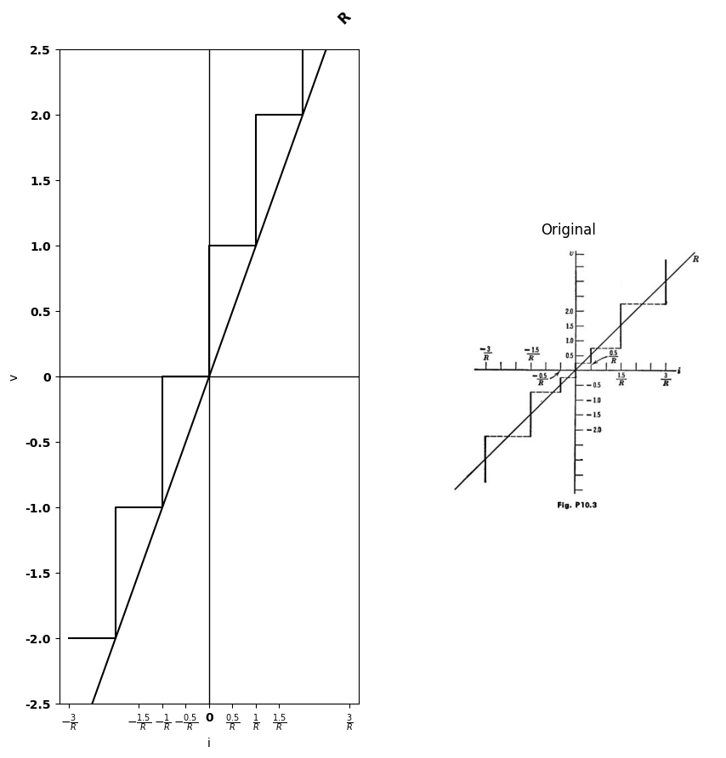
10.10. Compare the results of Problem 10.8 with the results obtained from the approximation shown in Fig. P10.3.
import matplotlib.pyplot as plt
from matplotlib import rcParams
import matplotlib.image as mpimg
import numpy as np
from schemdraw import dsp
import schemdraw
import schemdraw.elements as e
import PySpice.Logging.Logging as Logging
logger = Logging.setup_logging()
from PySpice.Probe.Plot import plot
from PySpice.Spice.Netlist import Circuit
from PySpice.Unit import *
# Create the figure and subplots
fig, axs = plt.subplots(1, 3, figsize=(15, 10))
# Define the step points
v = np.array([-2,-1,1,1,0,-1,-1,3 ])
i = np.array([-1,-1,-1,0,0,0,1,1 ])
axs[0].step(v, i, where='mid', linewidth=3, color='black')
axs[0].axhline(0, color='black', linewidth=1)
axs[0].axvline(0, color='black', linewidth=1)
d = schemdraw.Drawing()
C1 = d.add(e.Capacitor().up().label('C','bottom').label(['-',' ',' ','$e_{x}$',' ',' ','+'] , fontsize = 16))
L1 = d.add(e.Inductor().up().label('L','bottom'))
l1 = d.add(e.Line().right(d.unit*1.5))
l2 = d.add(e.Line().down(d.unit*.7))
l3 = d.add(e.Line().right(d.unit*.5).dot(open=True))
l4 = d.add(e.Line().right(d.unit*1.5).at(C1.start).label('$L=C=1$ \n $p10-4 $','bottom'))
l5 = d.add(e.Line().up(d.unit*.7))
l6 = d.add(e.Line().right(d.unit*.5).dot(open=True))
d += ( T := dsp.Box(w=2.5, h=2.5).anchor('W').fill('white').at((5.5,3)).label('v,i'))
d += e.Arrow().right().linewidth(0.6).length(0.5).color('black').label('$i$',color='black',ofst=-0.3, fontsize=9).at((.5,5.5))
d += e.Arrow().up().length(.5).linewidth(.6).color('black').label('+',loc='end', color='black',ofst=.5). at((4.5,3.5))
d += e.Arrow().down().length(.5).linewidth(.6).color('black').label(r'_', loc='end', color='black',ofst=(-.5, -.3)). at((4.5,2.6))
d += e.Gap().up().label( '$V$' , ofst=-1.7 , fontsize = 16).color('black').at((2.7,1.5))
d.save('Drawings/p10-4.jpg') # Save the drawing to a PNG file
img = mpimg.imread('Drawings/p10-4.jpg')
axs[1].imshow(img)
axs[1].axis('off') # Hide axes for image display
axs[1].set_title('Circuit Diagram (developed)')
# **Subplot (1, 2): PNG Sample File**
img_sample = mpimg.imread('images/p10-4.jpg') # Load the PNG file
axs[2].imshow(img_sample)
axs[2].axis('off') # Hide axes for image display
axs[2].set_title('Original')
Text(0.5, 1.0, 'Original')
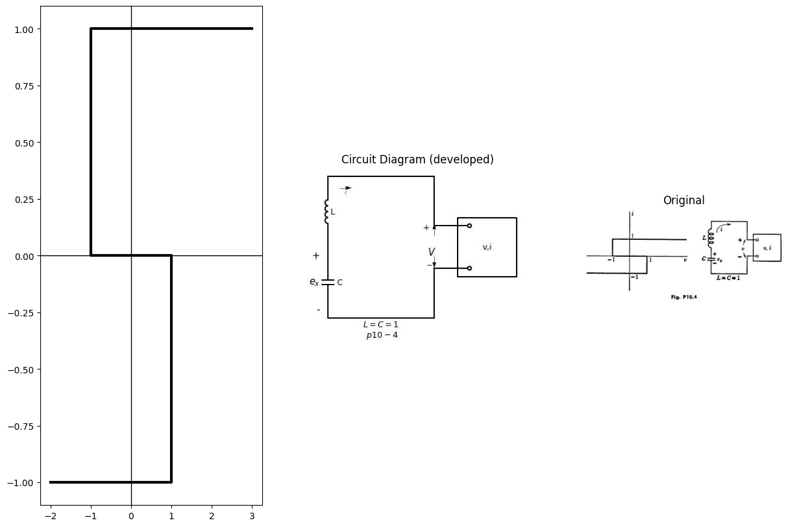
10.11. (a) For the device illustrated in Fig. P10.4, write the differential equations governing v, $ex$, and i, and construct a limit cycle.
(b) Sketch and dimension the waveforms of $ex$, and i vs. t.
(c) Using the information in parts (a) and (b), sketch v(t) and ex(t).
import matplotlib.pyplot as plt
from matplotlib import rcParams
import matplotlib.image as mpimg
import numpy as np
from schemdraw import dsp
import schemdraw
import schemdraw.elements as e
import PySpice.Logging.Logging as Logging
logger = Logging.setup_logging()
from PySpice.Probe.Plot import plot
from PySpice.Spice.Netlist import Circuit
from PySpice.Unit import *
# Create the figure and subplots
fig, axs = plt.subplots(1, 3, figsize=(15, 10))
v = np.array([-1,-1,0,0,3 ])
i = np.array([ -3,1,1,0,0])
axs[0].step(v, i, where='mid', linewidth=3, color='black')
# Draw axes
axs[0].axhline(0, color='black', linewidth=1)
axs[0].axvline(0, color='black', linewidth=1)
d = schemdraw.Drawing()
L1 = d.add(e.Inductor().up().label('L','bottom'))
l1 = d.add(e.Line().right(d.unit*.75))
C1 = d.add(e.Capacitor().down().label('C','bottom'))
l2 = d.add(e.Line().left(d.unit*.75))
l3 = d.add(e.Line().right(d.unit*.75).at(C1.start).dot(open=True))
l4 = d.add(e.Line().right(d.unit*.75).at(C1.end).dot(open=True).label('$L=C=1$','bottom'))
l5 = d.add(e.Line().right(d.unit*.5).at(l3.end))
l6 = d.add(e.Line().right(d.unit*.5).at(l4.end))
d += ( T := dsp.Box(w=2.5, h=3.5).anchor('W').fill('white').at((6,1.5)).label('v,i'))
d += e.Arrow().up().linewidth(0.6).length(0.5).color('black').label('$i_L$',color='black',ofst=0.2, fontsize=9).at((-.5,2.5))
d += e.Arrow().right().linewidth(0.6).length(0.5).color('black').label('$i$',color='black',ofst=0.2, fontsize=9).at((5,3.5))
d += e.Arrow().up().length(.5).linewidth(.6).color('black').label('+',loc='end', color='black',ofst=.5). at((4.5,2.5))
d += e.Arrow().down().length(.5).linewidth(.6).color('black').label(r'_', loc='end', color='black',ofst=(-.5, -.3)). at((4.5,0.6))
d += e.Gap().up().label( '$V$' , ofst=-1.7 , fontsize = 16).color('black').at((2.7,0.5))
d.save('Drawings/p10-5.jpg') # Save the drawing to a PNG file
img = mpimg.imread('Drawings/p10-5.jpg')
axs[1].imshow(img)
axs[1].axis('off') # Hide axes for image display
axs[1].set_title('Circuit Diagram (developed)')
# **Subplot (1, 2): PNG Sample File**
img_sample = mpimg.imread('images/p10-5.jpg') # Load the PNG file
axs[2].imshow(img_sample)
axs[2].axis('off') # Hide axes for image display
axs[2].set_title('Original')
Text(0.5, 1.0, 'Original')
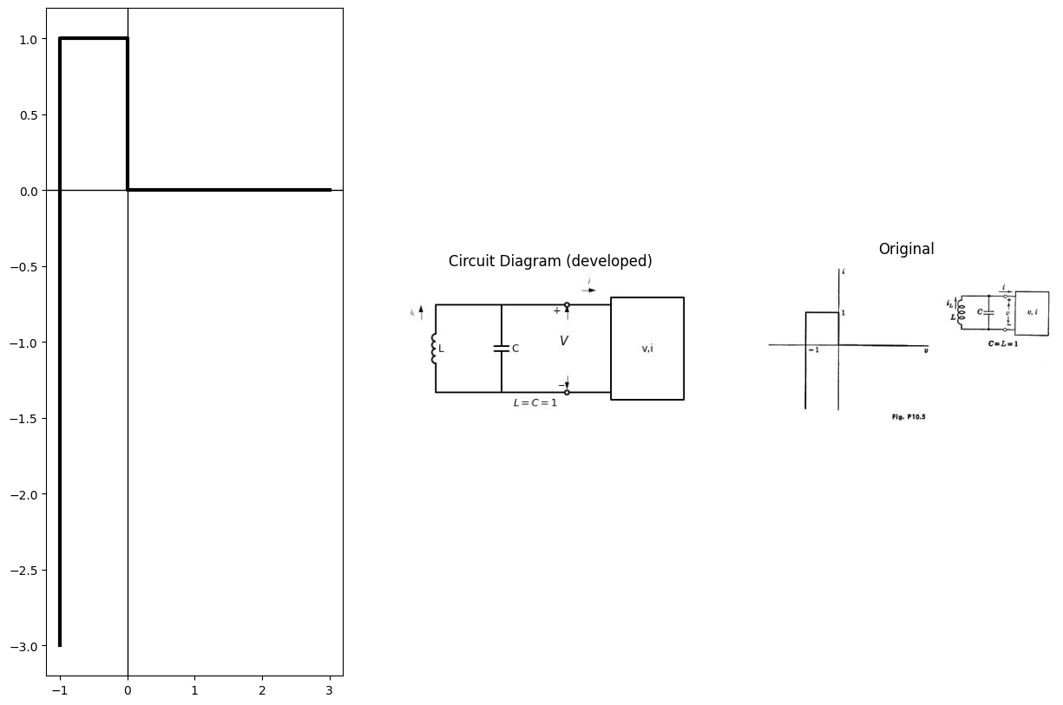
10.12 (a) Find the limit cycle for the circuit shown in Fig. P10.5.
(b) What is the maximum energy stored in the tuned circuit at any instant of time?
(c) By utilizing the differential equations for the circuit and the limit cycle, carefully plot and dimension the waveforms, v(t) and i(t).
import matplotlib.pyplot as plt
from matplotlib import rcParams
import matplotlib.image as mpimg
import numpy as np
from schemdraw import dsp
import schemdraw
import schemdraw.elements as e
import PySpice.Logging.Logging as Logging
logger = Logging.setup_logging()
from PySpice.Probe.Plot import plot
from PySpice.Spice.Netlist import Circuit
from PySpice.Unit import *
fig, axs = plt.subplots(1, 2, figsize=(15, 10))
d = schemdraw.Drawing()
L1 = d.add(e.Inductor().up().label('L','bottom'))
l1 = d.add(e.Line().right(d.unit*.75))
C1 = d.add(e.Capacitor().down().label('C','bottom'))
l2 = d.add(e.Line().left(d.unit*.75))
l3 = d.add(e.Line().right(d.unit*1).at(C1.start).dot(open=True))
l4 = d.add(e.Line().right(d.unit*1).at(C1.end).dot(open=True).label('$L=C=1$','bottom'))
d += ( T := dsp.Box(w=2.5, h=4).anchor('W').fill('white').at((4.6,1.5)))
d += e.Arrow().up().linewidth(0.6).length(0.5).color('black').label('$i_L$',color='black',ofst=0.2, fontsize=9).at((-.5,2.5))
d += e.Arrow().right().linewidth(0.6).length(0.5).color('black').label('$i$',color='black',ofst=0.2, fontsize=9).at((3.5,3.5))
d += e.Arrow().up().length(.5).linewidth(.6).color('black').label('+',loc='end', color='black',ofst=.5). at((5.3,2.5))
d += e.Arrow().down().length(.5).linewidth(.6).color('black').label(r'_', loc='end', color='black',ofst=(-.5, -.3)). at((5.3,0.6))
d += e.Gap().up().label( '$V$' , ofst=-1.7 , fontsize = 16).color('black').at((3.7,0.5))
d += e.Arrow().right().length(15).linewidth(0.6).color('black'). at((-8,-4)).label('$v$','right')
d += e.Arrow().up().length(12).linewidth(0.6).color('black'). at((-4,-10)).label('$i$','right')
l5 = d.add(e.Line().right(d.unit*2).at((-2.5,-4)))
l6 = d.add(e.Line().up(d.unit*2).at((-5.5,-7)))
l7 = d.add(e.Line().right(d.unit*2).endpoints(l6.end,l5.start).label('$10$','right'))
d.save('Drawings/p10-6.jpg') # Save the drawing to a PNG file
img = mpimg.imread('Drawings/p10-6.jpg')
axs[0].imshow(img)
axs[0].axis('off') # Hide axes for image display
axs[0].set_title('Circuit Diagram (developed)')
# **Subplot (1, 2): PNG Sample File**
img_sample = mpimg.imread('images/p10.6.jpg') # Load the PNG file
axs[1].imshow(img_sample)
axs[1].axis('off') # Hide axes for image display
axs[1].set_title('Original')
Text(0.5, 1.0, 'Original')
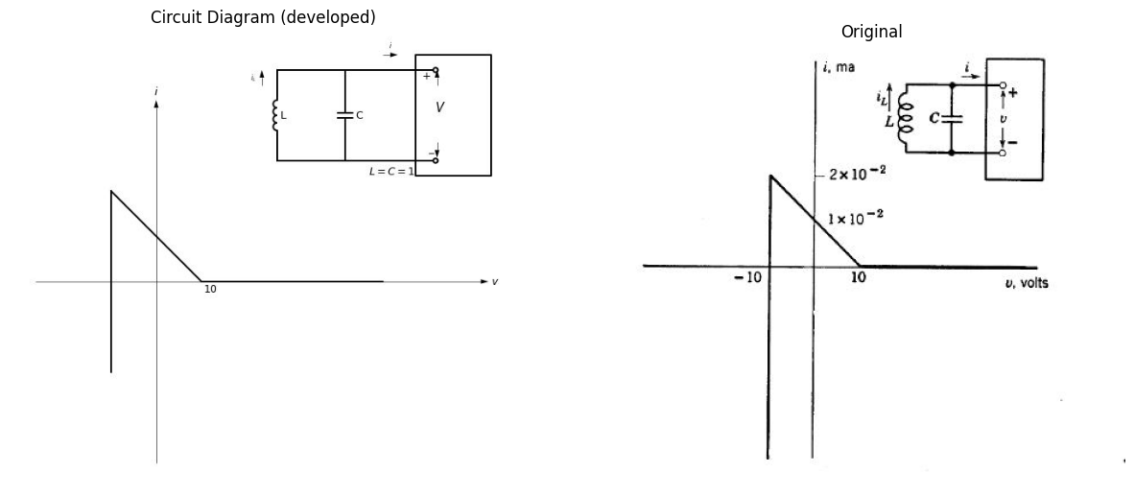
10.13. For $L={10}^{−4}h$, $C=1μf$ find from Fig. P10.6 (by using step approximation for the linear slope) the limit cycle of $x=\sqrt{C}v$ and $y=\sqrt{L}i_{L}$ What is the maximum energy in the circuit?
10.14. (a) From Fig. P10.7, find the differential equations relating iz with $ v$ and $i$.
(b) Using isoclines, find the phase-plane trajectory for v vs. iz with an initial charge qo on C (giving $v=V0$ at t=0 .)
import matplotlib.pyplot as plt
from matplotlib import rcParams
import matplotlib.image as mpimg
import numpy as np
from schemdraw import dsp
import schemdraw
import schemdraw.elements as e
import PySpice.Logging.Logging as Logging
logger = Logging.setup_logging()
from PySpice.Probe.Plot import plot
from PySpice.Spice.Netlist import Circuit
from PySpice.Unit import *
fig, axs = plt.subplots(1, 3, figsize=(15, 10))
d = schemdraw.Drawing()
L1 = d.add(e.Inductor().up().label('L','bottom'))
l1 = d.add(e.Line().right(d.unit*.75))
C1 = d.add(e.Capacitor().down().label('C','bottom'))
l2 = d.add(e.Line().left(d.unit*.75))
l3 = d.add(e.Line().right(d.unit*1).at(C1.start).dot(open=True))
l4 = d.add(e.Line().right(d.unit*1).at(C1.end).dot(open=True))
d += ( T := dsp.Box(w=2.5, h=4).anchor('W').fill('white').at((4.6,1.5)).label('$v.i$'))
d += e.Arrow().up().linewidth(0.6).length(0.5).color('black').label('$i_L$',color='black',ofst=0.2, fontsize=9).at((-.5,2.5))
d += e.Arrow().right().linewidth(0.6).length(0.5).color('black').label('$i$',color='black',ofst=0.2, fontsize=9).at((3.5,3.5))
d += e.Arrow().up().length(.5).linewidth(.6).color('black').label('+',loc='end', color='black',ofst=.5). at((4.3,2.5))
d += e.Arrow().down().length(.5).linewidth(.6).color('black').label(r'_', loc='end', color='black',ofst=(-.5, -.3)). at((4.3,0.6))
d += e.Gap().up().label( '$V$' , ofst=-1.7 , fontsize = 16).color('black').at((2.5,0.5))
d.save('Drawings/p10-7.jpg') # Save the drawing to a PNG file
img = mpimg.imread('Drawings/p10-7.jpg')
axs[0].imshow(img)
axs[0].axis('off') # Hide axes for image display
axs[0].set_title('Circuit Diagram (developed)')
rcParams['font.weight'] = 'bold'
circuit = Circuit('v-i curve')
Vi = circuit.V('i', '1', circuit.gnd, 0@u_V)
circuit.R(1 ,'1', circuit.gnd, 1@u_Ohm )
simulator = circuit.simulator(temperature=25, nominal_temperature=25)
analysis = simulator.dc(Vi=slice(-5, 5, 0.1))
axs[1].plot(analysis['1'], u_A(-analysis.Vi),'black',linewidth=2)
axs[1].set_title('I-V Analysis (Ngspice Simulation via Pyspice)')
axs[1].set_ylabel('V [V]')
axs[1].set_xlabel('I [A]')
axs[1].text( 3.5, 4.545, 'slope=G', ha='center', va='center')
axs[1].text( 0.2, -0.2, '0', ha='center', va='center')
axs[1].axhline(0, color='black', linewidth=2)
axs[1].axvline(0, color='black', linewidth=2)
# **Subplot (1, 2): PNG Sample File**
img_sample = mpimg.imread('images/p10-7.jpg') # Load the PNG file
axs[2].imshow(img_sample)
axs[2].axis('off') # Hide axes for image display
axs[2].set_title('Original')
Text(0.5, 1.0, 'Original')
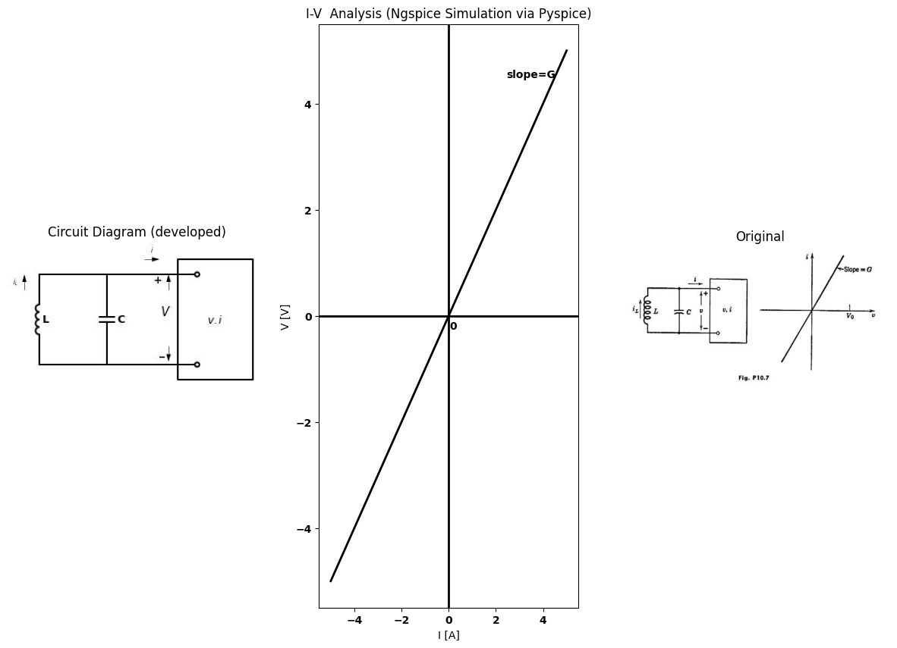
10.15. A number of phase-plane trajectories for various initial conditions constitutes the "phase-plane portrait" of a circuit [Fig. 10.16(c) is an example). Using the method of isoclines, construct phase-plane portraits for various values of positive damping in a linear parallel RLC circuit with Land C equal to unity. Use and iz for the phase-plane variables and distribute initial conditions equally around a unit circle..
10.16. From the results of Problem 10.15 deduce and sketch the phase- plane portraits for the corresponding values of negative damping.
10.17. Using the method of isoclines, find the limit cycle for the oscillator represented by the normalized circuit shown in Fig. P10.8.
import matplotlib.pyplot as plt
from matplotlib import rcParams
import matplotlib.image as mpimg
import numpy as np
from schemdraw import dsp
import schemdraw
import schemdraw.elements as e
import PySpice.Logging.Logging as Logging
logger = Logging.setup_logging()
from PySpice.Probe.Plot import plot
from scipy import signal
from PySpice.Spice.Netlist import Circuit
from PySpice.Unit import *
fig, axs = plt.subplots(1, 3, figsize=(15, 10))
d = schemdraw.Drawing()
L1 = d.add(e.Inductor().up().label('L','bottom'))
l1 = d.add(e.Line().right(d.unit*.75))
C1 = d.add(e.Capacitor().down().label('C','bottom'))
l2 = d.add(e.Line().left(d.unit*.75))
l3 = d.add(e.Line().right(d.unit*1).at(C1.start).dot(open=True))
l4 = d.add(e.Line().right(d.unit*1).at(C1.end).dot(open=True))
d += ( T := dsp.Box(w=2.5, h=4).anchor('W').fill('white').at((4.6,1.5)))
d += e.Arrow().up().linewidth(0.6).length(0.5).color('black').label('$i_L$',color='black',ofst=0.2, fontsize=9).at((-.5,2.5))
d += e.Arrow().right().linewidth(0.6).length(0.5).color('black').label('$i$',color='black',ofst=0.2, fontsize=9).at((3.5,3.5))
d += e.Arrow().up().length(.5).linewidth(.6).color('black').label('+',loc='end', color='black',ofst=.5). at((4.3,2.5))
d += e.Arrow().down().length(.5).linewidth(.6).color('black').label(r'_', loc='end', color='black',ofst=(-.5, -.3)). at((4.3,0.6))
d += e.Gap().up().label( '$V$' , ofst=-1.7 , fontsize = 16).color('black').at((2.5,0.5))
l5 = d.add(e.Line().right(d.unit*.005).at((5.5,0)))
l6 = d.add(e.Line().right(d.unit*.005).at((6.5,1.5)))
l7 = d.add(e.Line().right(d.unit*.005).at((5.5,2.5)))
l8 = d.add(e.Line().right(d.unit*.005).at((6.5,3.25)))
l9 = d.add(e.Line().right(d.unit*.5).endpoints(l5.end,l6.end))
l9 = d.add(e.Line().right(d.unit*.5).endpoints(l7.end,l6.end))
l9 = d.add(e.Line().right(d.unit*.5).endpoints(l7.end,l8.end))
d.save('Drawings/p10-8.jpg') # Save the drawing to a PNG file
img = mpimg.imread('Drawings/p10-8.jpg')
axs[0].imshow(img)
axs[0].axis('off') # Hide axes for image display
axs[0].set_title('Circuit Diagram (developed)')
# Generate x values from -180 to 180 (degrees)
x = np.linspace(-180, 180, 1000)
# Generate a triangular wave with period 360 (so it repeats every 360 units)
y = signal.sawtooth(2 * np.pi * x / 180, width=0.5) # width=0.5 gives a triangle wave
# Rotate axes: plot x on vertical axis, y on horizontal axis
axs[1].plot(y, x, color='black', linewidth=2)
axs[1].axhline(0, color='black', linewidth=2)
axs[1].axvline(0, color='black', linewidth=2)
# **Subplot (1, 2): PNG Sample File**
img_sample = mpimg.imread('images/p10-8.jpg') # Load the PNG file
axs[2].imshow(img_sample)
axs[2].axis('off') # Hide axes for image display
axs[2].set_title('Original')
Text(0.5, 1.0, 'Original')
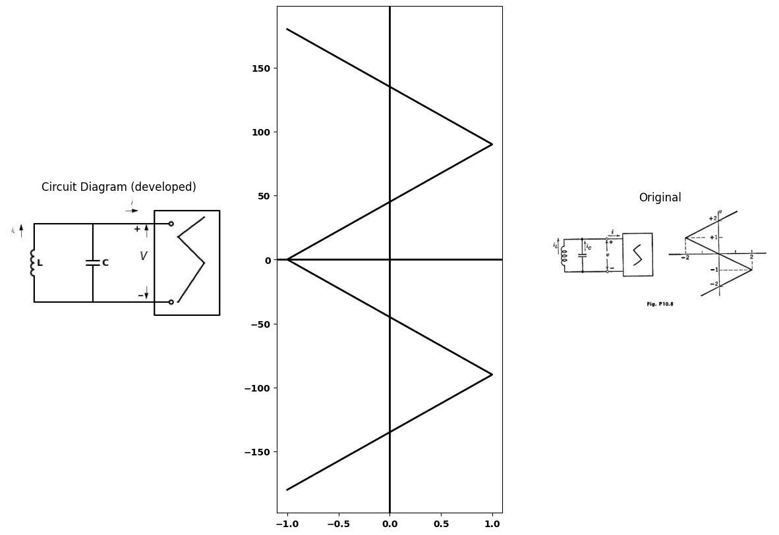
10.18. Modify the resistive curve of Problem 10.17 to include the effects of a 1-ohm load resistance connected in parallel with the tuned circuit. Deter- mine the limit cycle. For what value of load resistance will the circuit cease to sustain oscillations?
10.19. (a) Making reasonable approximations, find the piecewise-linear representation of v vs. i (as a function of R) for the circuit of Fig. P10.9(a).
import matplotlib.pyplot as plt
from matplotlib import rcParams
import matplotlib.image as mpimg
import numpy as np
from schemdraw import dsp
import schemdraw
import schemdraw.elements as e
import PySpice.Logging.Logging as Logging
logger = Logging.setup_logging()
from PySpice.Probe.Plot import plot
from scipy import signal
from PySpice.Spice.Netlist import Circuit
from PySpice.Unit import *
fig, axs = plt.subplots(2, 2, figsize=(15, 10))
d = schemdraw.Drawing()
l1 = d.add(e.Line().right(d.unit*.005).dot(open=True))
l2 = d.add(e.Line().right(d.unit*.75))
L1 = d.add(e.Inductor2().down(d.unit*1.3).label('L','top'))
l3 = d.add(e.Line().left(d.unit*.75).dot(open=True))
l4 = d.add(e.Line().right(d.unit*1).at(L1.start))
d += (M1 := e.BjtPnp(circle=True).anchor('base').theta(180).reverse())
l5 = d.add(e.Line().down(d.unit*.5).at(M1.emitter))
R1 = d.add(e.Resistor().left(d.unit*1.1).label('R','top').dot())
l6 = d.add(e.Line().right(d.unit*.75).at(M1.collector).label('$P-N-P$','top'))
l7 = d.add(e.Line().down(d.unit*1.53))
l8 = d.add(e.BatteryCell().left(d.unit*2).reverse().label('$ + V_c -$','bottom'))
d += e.Arrow().up().length(.5).linewidth(.6).color('black').label('+',loc='end', color='black',ofst=.5). at((0,-.6))
d += e.Arrow().down().length(.5).linewidth(.6).color('black').label(r'_', loc='end', color='black',ofst=(-.5, -.3)). at((0,-3.3))
d += e.Gap().up().label( '$V$' , ofst=-1.7 , fontsize = 16).color('black').at((-1.7,-3))
d += e.Arrow().right().linewidth(0.6).length(0.5).color('black').label('$i$',color='black',ofst=0.2, fontsize=9).at((.5,0.5))
d.save('Drawings/p10-9.jpg') # Save the drawing to a PNG file
img = mpimg.imread('Drawings/p10-9.jpg')
axs[0,0].imshow(img)
axs[0,0].axis('off') # Hide axes for image display
axs[0,0].set_title('Circuit Diagram (developed)')
# **Subplot (1, 2): PNG Sample File**
img_sample = mpimg.imread('images/p10-9a.jpg') # Load the PNG file
axs[0,1].imshow(img_sample)
axs[0,1].axis('off') # Hide axes for image display
axs[0,1].set_title('Original')
d = schemdraw.Drawing()
l1 = d.add(e.Line().right(d.unit*.005))
l2 = d.add(e.Line().right(d.unit*.75))
L1 = d.add(e.Inductor2().down(d.unit*1.3).label('L','top'))
l3 = d.add(e.Line().left(d.unit*.75))
l4 = d.add(e.Line().right(d.unit*1).at(L1.start))
d += (M1 := e.BjtPnp(circle=True).anchor('base').theta(180).reverse())
l5 = d.add(e.Line().down(d.unit*.5).at(M1.emitter))
R1 = d.add(e.Resistor().left(d.unit*1.1).label('R','top').dot())
l6 = d.add(e.Line().right(d.unit*.75).at(M1.collector).label('$P-N-P$','top'))
l7 = d.add(e.Line().down(d.unit*1.53))
l8 = d.add(e.BatteryCell().left(d.unit*2).reverse().label('$ + V_c -$','bottom'))
d += e.Arrow().up().length(.5).linewidth(.6).color('black').label('+',loc='end', color='black',ofst=.5). at((1,-.6))
d += e.Arrow().down().length(.5).linewidth(.6).color('black').label(r'_', loc='end', color='black',ofst=(-.5, -.3)). at((1,-3.3))
d += e.Gap().up().label( '$V$' , ofst=-1.7 , fontsize = 16).color('black').at((-.7,-3))
d += e.Arrow().right().linewidth(0.6).length(0.5).color('black').label('$i$',color='black',ofst=0.2, fontsize=9).at((.5,0.5))
L2 = d.add(e.Inductor2().down(d.unit*1.3).label('L','top').at(l1.start))
l9 = d.add(e.Line().left(d.unit*.75).at(L2.start))
R2 = d.add(e.Resistor().down(d.unit*1.3).label('$R_o$','top'))
l10 = d.add(e.Line().right(d.unit*.75))
l11 = d.add(e.Line().left(d.unit*.75).at(R2.start))
C1 = d.add(e.Capacitor().down(d.unit*1.3).label('$C$','top'))
l12 = d.add(e.Line().right(d.unit*.75))
d.save('Drawings/p10-9b1.jpg') # Save the drawing to a PNG file
img = mpimg.imread('Drawings/p10-9b1.jpg')
axs[1,0].imshow(img)
axs[1,0].axis('off') # Hide axes for image display
axs[1,0].set_title('Circuit Diagram (developed)')
# **Subplot (1, 2): PNG Sample File**
img_sample = mpimg.imread('images/p10-9b.jpg') # Load the PNG file
axs[1,1].imshow(img_sample)
axs[1,1].axis('off') # Hide axes for image display
axs[1,1].set_title('Original')
Text(0.5, 1.0, 'Original')
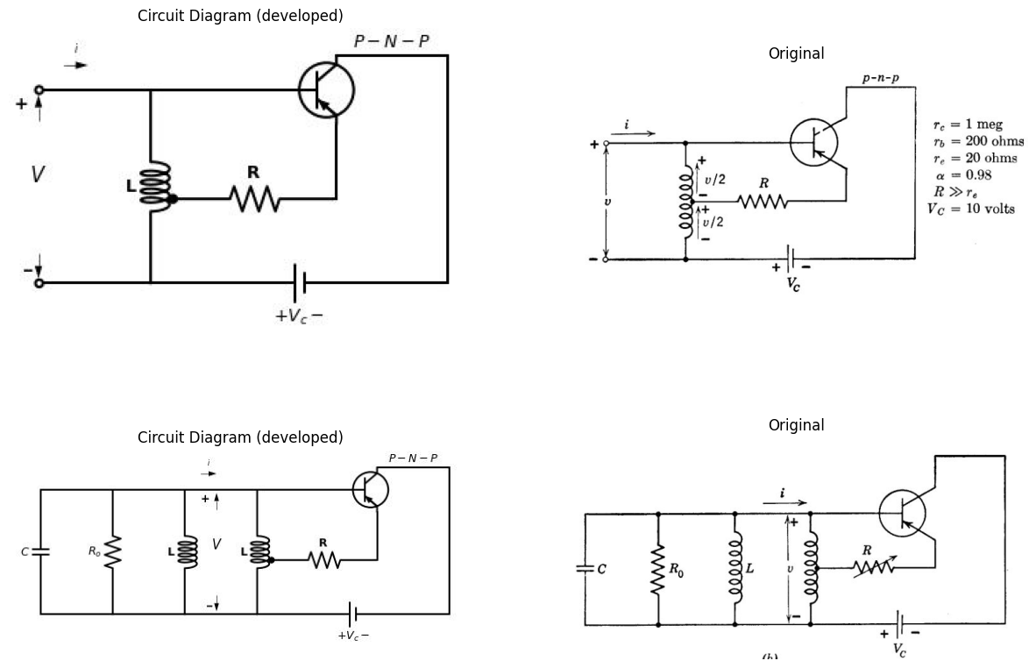
(b) If the actual resonant circuit consists of a parallel RLC combination with $R_{0}=10$ kilohms as shown in Fig. P10.9(b), sketch the phase-plane operation for the ranges of R from nonoscillation, to barely sustained, to over- driven. What value of R will just sustain sinusoidal oscillations?

