Table of Contents

Chapter eleven
Symmetray and Balanced Circuits

1 11.1 Introduction
The exploitation of symmetry is a basic principle of circuit analysis and design a revealing principle whose foundations lie in the mathe- matical theory of transformation groups. In circuit problems the recognition of some form of symmetry is almost certain to lighten the work of analysis. By restricting attention mainly to one or two forms of symmetry that are very common in electronic circuits we can avoid much of the formalism required in a general theory and at the same time illustrate the simplicity, precision, and power of the funda- mental idea.

2 11.2 Symmetry, Symmetrical Components, and Superposition
Figure 11.1 shows an elementary balanced circuit exhibiting "lateral symmetry." Indeed, the left is the same as the right. This is too crude a notion of symmetry, however, and intuition will fail in more compli- cated examples unless we make the concept of symmetry more precise. Fortunately, a definition of symmetry does exist and it is both precise and simple. In the circuit of Fig. 11.1 the situation is unchanged by turning the diagram over as one turns the page of a book. A mathe- matician might say that the geometrical entity is invariant under half-revolution about the y axis, or, for that matter, under any integral number of half revolutions. Inversion about the yz plane, equivalent to reflection in a mirror, would do just as well. These remarks give the key. Let it be understood henceforth that $symmetry $ is exhibited by, consists of, and can be defined rigorously only as the invariance of a structure
import matplotlib.pyplot as plt
from matplotlib import rcParams
import matplotlib.image as mpimg
import numpy as np
from schemdraw import dsp
import schemdraw
import schemdraw.elements as e
import PySpice.Logging.Logging as Logging
logger = Logging.setup_logging()
from PySpice.Probe.Plot import plot
from PySpice.Spice.Netlist import Circuit
from PySpice.Unit import *
# Create the figure and subplots
fig, axs = plt.subplots(1, 2, figsize=(15, 15))
d = schemdraw.Drawing()
L1 = d.add(e.Inductor().up().label('L','bottom').label(['-',' ',' ','$v_{a}$',' ',' ','+'] , fontsize = 16))
l1 = d.add(e.Line().right())
C1 = d.add(e.Capacitor().down().label('C','bottom'))
l2 = d.add(e.Line().left())
C2 = d.add(e.Capacitor().right().label('C`','bottom').length(2).at(C1.start).dot(open=True))
C3 = d.add(e.Capacitor().right().length(2).label('C``','bottom'))
C4 = d.add(e.Capacitor().down().label('C','bottom'))
l3 = d.add(e.Line().left().length(2).dot(open=True))
l4 = d.add(e.Line().left().length(2))
l5 = d.add(e.Line().right().length(2).at(C4.start))
L2 = d.add(e.Inductor().down().label('L','top').label(['+',' ',' ','$v_{b}$',' ',' ','-'] , fontsize = 16,loc='bottom'))
l6 = d.add(e.Line().left().length(2))
d += e.Arrow().up().length(3).linewidth(.6).color('black').label('y',loc='end', color='black',ofst=.5). at((4,-3.6))
d += e.Arrow().right().length(3).linewidth(.6).color('black').label('x',loc='end', color='black',ofst=.5). at((3.8,-3.5))
d += e.Arrow().right().length(.7).color('black').label('$i_o$', loc='top', color='black'). at((4.5,3.5))
d += e.Gap().up().label( '$v_o$' , ofst=-1.7 , fontsize = 16).color('black').at((3.25,.25))
d += e.Arrow().up().length(.7).linewidth(.6).color('black').label('+',loc='end', color='black',ofst=.5). at((5,2.3))
d += e.Arrow().down().length(.7).linewidth(.6).color('black').label(r'_', loc='end', color='black',ofst=(-.5, -.3)). at((5,.8))
d.save('Drawings/11-1a.jpg') # Save the drawing to a PNG file
img = mpimg.imread('Drawings/11-1a.jpg')
axs[0].imshow(img)
axs[0].axis('off') # Hide axes for image display
axs[0].set_title('Circuit Diagram (developed)')
# **Subplot (1, 2): PNG Sample File**
img_sample = mpimg.imread('images/11-1.jpg') # Load the PNG file
axs[1].imshow(img_sample)
axs[1].axis('off') # Hide axes for image display
axs[1].set_title('Original')
Text(0.5, 1.0, 'Original')
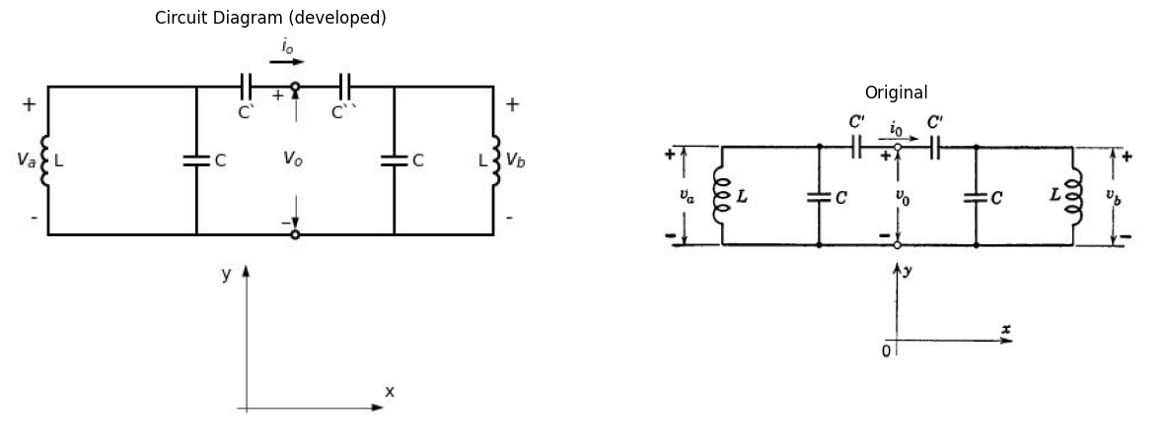

2.1 Fig 11.1 A Balanced Circuit.
under some transformation or group of transformations. In the simple problems to be treated here, the structure is a circuit model and the transformations are rotations, translations, or inversions, all in three- dimensional space.
Having identified certain geometrical symmetries in a given circuit model, our next step is to look for electrical symmetry. Electrical symmetry is exhibited by, consists of, and can be defined rigorously only as the invariance of an electrical experiment under some transformation or group of transformations.
In particular, let xi represent the voltage (or current) in the ith branch of the network. Assume that the transformation not only moves branch i to the position originally occupied by branch j, but that it also multiplies x by some number K. Thus the transformation can be represented as $ Kx_i→ x_j$ for various pairs ij $\left(11.1\right)$
If the electrical experiment is to be invariant, then we must have $Kx_i=x_j $ $\left(11.2\right)$ for the pairs ij
Solution of the Eqs. 11.2 gives, in general, a set of permissible values $ K^{(1)}$, $K^{(2)} $, $K^{\left(3\right)}$,...,$ K^{(n)}$, for the parameter K, and each of these values of K defines a related set of voltages (or currents) $x^{\left(k\right)}$ which is symmetric; that is, invariant under the transformation. In particular
$K^{k}x_{i}^{k}$ = $x_{j}^{k}$ (11.3)
In Fig. 11.1, for example, mirror-reflection about the $y$ axis and multiplication of each voltage and current by $K$ gives
$Kv_{a}=v_{b}$ (11.4)
$Kv_{b}=v_{a}$ (11.5)
$Kv_{0}=v_{0}$ (11.6)
$Ki_{0}=−i_{0}$ (11.7)
Eliminating rt from Eqs. 11.4 and 11.5, we obtain
$K^{2}v_{a}=v_{a}$ (11.8)
or
$K^{2}$ =1 (11.9)
Hence
$K^{1}$ =1 (11.10)
$K^{2}$ =-1 (11.11)
Taking the first value $K^{1}$ we find, from Eq. 11.3,
$v_{a}^{1}$ = $v_{b}^{1}$ (11.12)
$i_{0}^{1}$ = $−i_{0}^{1}$ (11.13)
with the result that
$i_{0}^{1}$ (11.14)
The second value $K^{2}$ gives
$−v_{a}^{2}$ = $v_{b}^{2}$ (11.15)
$−v_{0}^{2}$ = -$v_{0}^{2}$ (11.16)
so that
$v_{0}^{2}$=0 (11.17)
Figure 11.2 shows the circuit-model interpretation of Eqs. 11.12 through 11.17.
Now back to the general case. The variables $x^{k}$ are called $symtnetrical$ $components$. The advantage of symmetrical components lies in the fact that the circuit equations become simpler, as illustrated in Fig. 11.2. Moreover, since superposition is valid in linear circuits, the solution of any problem can be represented as a superposition of sym- metrical components.
Using Fig. 11.1 once more as the example, we see that all possible solutions for $v_{a}$ and $v_{b}$ can be represented as
$v_{a}$ = $v_{a}^{1}$ + $v_{a}^{2}$ (11.18)
$v_{b}$ = -$v_{b}^{1}$ + $v_{b}^{2}$ (11.19)
import ipywidgets as widgets
from ipywidgets import *
import schemdraw
import schemdraw.elements as e
import matplotlib.pyplot as plt
@interact(Mode1=(True) , Mode2=(True))
def response(Mode1=True , Mode2=True):
with schemdraw.Drawing() as d:
if (Mode1):
L1 = d.add(e.Inductor().up().label('L','bottom').label(['-',' ',' ','$v_{a}^1$',' ',' ','+'] , fontsize = 16))
l1 = d.add(e.Line().right())
C1 = d.add(e.Capacitor().down().label('C','bottom'))
l2 = d.add(e.Line().left().label('(a)','bottom'))
C2 = d.add(e.Capacitor().right().label('C`','bottom').length(3).at(C1.start).dot(open=True))
l3 = d.add(e.Line().right().length(3).dot(open=True).at(C1.end))
d += e.Arrow().right().length(.7).color('black').label('$i_o^{(1)} =0$', loc='top', color='black'). at((5,3.5))
if (Mode2):
L1 = d.add(e.Inductor().up().label('L','bottom').label(['-',' ',' ','$v_{a}^1$',' ',' ','+'] , fontsize = 16).at((8,0)))
l1 = d.add(e.Line().right())
C1 = d.add(e.Capacitor().down().label('C','bottom'))
l2 = d.add(e.Line().left().label('(b)','bottom'))
C2 = d.add(e.Capacitor().right().label('C`','bottom').length(3).at(C1.start).dot(open=True))
l3 = d.add(e.Line().right().length(3).dot(open=True).at(C1.end))
l4 = d.add(e.Line().up().label(['-',' ',' ','$v_{o}^{(2)}$',' ',' ','+'] , fontsize = 16, loc='bottom'))
fig = plt.figure(figsize=(5, 3))
img = plt.imread('./images/11-2.jpg')
plt.imshow(img)
plt.axis('off')
plt.title('\nReference image from the book:', fontsize=8, pad=10,loc='left')
plt.show()
{"model_id":"6adccbfb6649446ca0c0e24b8a515349","version_major":2,"version_minor":0}
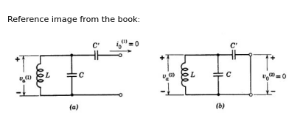

2.2 Fig. 11.2. Circuit modela for ($a$) even-symmetric voltages $v^{1}$ and ($b$) odd-symmetric voltages $v^{2}$ .
where $v_{a}^{1}$ and $v_{a}^{2}$ are solutions of the simpler circuit problems posed in Fig. 11.2. In view of Eqs. 11.12 and 11.15, it follows from Eqs. 11.18 and 11.19 that
$v_{a}^{1}$ = 1/2 $v_{a}+v_{b}$ (11.20)
$v_{a}^{2}$ = 1/2 $v_{a}−v_{b}$ (11.21)
Hence we could have written Eq. 11.19 as
$v_{b}$ = $v_{a}^{1}−v_{b}^{2}$ (11.22)
import matplotlib.pyplot as plt
from matplotlib import rcParams
import matplotlib.image as mpimg
import numpy as np
from schemdraw import dsp
import schemdraw
import schemdraw.elements as e
import PySpice.Logging.Logging as Logging
logger = Logging.setup_logging()
from PySpice.Probe.Plot import plot
from PySpice.Spice.Netlist import Circuit
from PySpice.Unit import *
# Create the figure and subplots
fig, axs = plt.subplots(1, 2, figsize=(15, 15))
d = schemdraw.Drawing()
l1 = d.add(e.Line().right().length(12))
d += e.Arrow().up().length(4).color('black').label('$v{a}$', loc='top', color='black'). at((1,0))
d += e.Arrow().up().length(2.5).color('black').label('$v{even}$', loc='top', color='black'). at((4,0))
d += e.Arrow().up().length(2.5).color('black').label('$v{even}$', loc='top', color='black'). at((7,0))
d += e.Arrow().up().length(1.25).color('black').label('$v{b}$', loc='bottom', color='black'). at((10,0))
l2 = d.add(e.Line().right().length(4).linestyle('--').at((0,4)))
l3 = d.add(e.Line().right().length(6).linestyle('--').at((2.8,2.5)))
l4 = d.add(e.Line().right().length(3).linestyle('--').at((8,1.2)))
d += e.Arrow().up().length(1.5).color('black').label('$v{odd}$', loc='top', color='black'). at((3,2.5))
d += e.Arrow().down().length(1.25).color('black').label('$v{odd}$', loc='bottom', color='black'). at((8.2,2.5))
d.save('Drawings/11-3a.jpg') # Save the drawing to a PNG file
img = mpimg.imread('Drawings/11-3a.jpg')
axs[0].imshow(img)
axs[0].axis('off') # Hide axes for image display
axs[0].set_title('Circuit Diagram (developed)')
# **Subplot (1, 2): PNG Sample File**
img_sample = mpimg.imread('images/11-3.jpg') # Load the PNG file
axs[1].imshow(img_sample)
axs[1].axis('off') # Hide axes for image display
axs[1].set_title('Original')
Text(0.5, 1.0, 'Original')
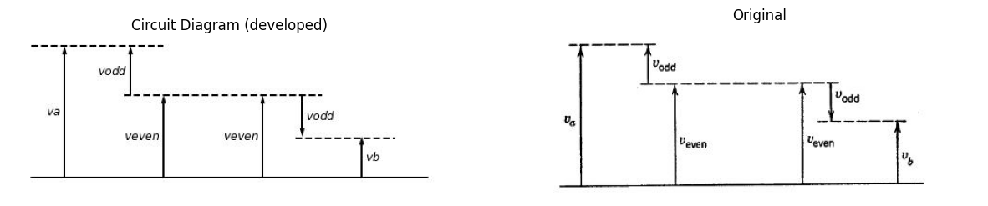

2.3 Fig. 11.3. Resolution of an arbitrary pair ($v_{a},v_{b}$) into even and odd components.
In a laterally symmetric circuit, therefore, the electrical variables are associated in pairs ($v_{a}$ and $v_{b}$ in Fig. 11.1) or degenerate pairs ($v_{b}$ “and” $v_{0}$ or $i_{0}$ “and” $−i_{0}$). An arbitrary pair can always be resolved into even and odd components, as indicated in Fig. 11.3, in terms of which the circuit problem reduces to an independent pair of simpler problems.

3 11.3 Some Elementary Symmetries
In the preceding article, the general definition of symmetry was introduced and “lateral” symmetry was used as a running example. Lateral symmetry leads to even-symmetric and odd-symmetric com-
import ipywidgets as widgets
from ipywidgets import *
import schemdraw
import schemdraw.elements as elm
@interact(Mode_1=(True) , Mode_2=(True) ,Mode_3=(True) ,Mode_4=(True))
def response(Mode_1=True , Mode_2=True, Mode_3=True, Mode_4=True):
with schemdraw.Drawing() as d:
if (Mode_1):
V1 = d.add(e.SourceSin().right().label('$+ V_1 -$','bottom'))
V2 = d.add(e.SourceSin().right().label('$- V_2 +$','bottom'))
l1 = d.add(e.Line().up())
R1 = d.add(e.Resistor().left().label('$R_4$','bottom'))
R2 = d.add(e.Resistor().down().label('$R_2$','bottom'))
R3 = d.add(e.Resistor().up().label('$R_1$','bottom').at(R1.end))
R4 = d.add(e.Resistor().left().label('$R_4$','bottom').at(R1.end))
R5 = d.add(e.Resistor().right().label('$R_3$','bottom').at(R3.end))
R6 = d.add(e.Resistor().left().label('$R_3$','bottom').at(R3.end))
l2 = d.add(e.Line().down().at(R5.end))
l3 = d.add(e.Line().down().at(R6.end).length(6))
d += e.Arrow().up().length(.5).color('black').label('$I_1$', loc='top', color='black'). at((-0.3,.5))
d += e.Arrow().up().length(.5).color('black').label('$I_2$', loc='bottom', color='black'). at((6.5,.5))
if (Mode_2):
V1 = d.add(e.SourceSin().right().label('$+ V_1 -$','bottom').at((9,0)))
R5 = d.add(e.Resistor().right().label('$R_3$','bottom'))
l1 = d.add(e.Line().up())
R1 = d.add(e.Resistor().left().label('$R_2$','bottom'))
R2 = d.add(e.Resistor().down().label('$R_1$','bottom'))
R3 = d.add(e.Resistor().up().label('$R_1$','bottom').at(R1.end))
R4 = d.add(e.Resistor().left().label('$R_2$','bottom').at(R1.end))
V2 = d.add(e.SourceSin().right().label('$- V_2 +$','bottom').at(R3.end))
R6 = d.add(e.Resistor().left().label('$R_3$','bottom').at(R3.end))
l2 = d.add(e.Line().down().at(V2.end))
l3 = d.add(e.Line().down().at(R6.end).length(6))
d += e.Arrow().up().length(1).color('black').label('$I_1$', loc='top', color='black'). at((8.7,.5))
d += e.Arrow().down().length(1).color('black').label('$I_2$', loc='bottom', color='black'). at((15.7,5))
if (Mode_3):
R1 = d.add(e.Resistor().right().label('$R_2$','bottom').length(8).at((0,-10)))
l1 = d.add(e.Line().right().length(0.002).at((2.1,-8.5)))
l2 = d.add(e.Line().right().length(0.002).at((4,-3)))
R2 = d.add(e.Resistor().right().label('$R_2$','bottom').endpoints(R1.start,l2.end))
R3 = d.add(e.Resistor().right().label('$R_2$','bottom').endpoints(R1.end,l2.end))
R4 = d.add(e.Resistor().down().label('$R_1$','bottom').at(l2.end).length(2.5))
V1 = d.add(e.SourceSin().down().length(1.5))
R5 = d.add(e.Resistor().right().label('$R_1$','bottom').endpoints(R1.start,l1.end))
V2 = d.add(e.SourceSin().down().length(1.5).endpoints(R5.end,V1.end).dot())
l3 = d.add(e.Line().right().length(0.002).at((6.1,-8.5)))
R6 = d.add(e.Resistor().right().label('$R_1$','bottom').endpoints(R1.end,l3.end))
V3 = d.add(e.SourceSin().down().length(1.5).endpoints(R6.end,V1.end))
d += e.Arrow().right().length(1).color('black').label('$I_3$', loc='bottom', color='black'). at((4,-11))
l4 = d.add(e.Line().right().length(0.002).at((8.1,-8.5)))
l5 = d.add(e.Line().right().length(0.002).at((7.5,-7.5)))
d += e.Arrow().right().length(1).color('black').label('$I_1$', loc='top', color='black').endpoints(l4.end,l5.end)
l6 = d.add(e.Line().right().length(0.002).at((2,-5)))
l7 = d.add(e.Line().right().length(0.002).at((1.5,-6)))
d += e.Arrow().right().length(1).color('black').label('$I_2$', loc='top', color='black').endpoints(l6.end,l7.end)
if (Mode_4):
d += elm.Dot(open=True).at((12,-5))
R1 = d.add(e.Resistor().right().label('$R_1$','bottom'))
R2 = d.add(e.Resistor().down().label('$R_2$','top'))
l1 = d.add(e.Line().left().dot(open=True))
l2 = d.add(e.Line().right().dot(open=True).length(1).at(R2.start))
l3 = d.add(e.Line().right().dot(open=True).length(1).at(R2.end))
R3 = d.add(e.Resistor().right().label('$R_1$','bottom').at(l2.end))
R4 = d.add(e.Resistor().down().label('$R_2$','top'))
l4 = d.add(e.Line().left())
l5 = d.add(e.Line().right().dot(open=True).length(2).at(R4.start))
l6 = d.add(e.Line().right().dot(open=True).length(2).at(R4.end))
l7 = d.add(e.Line().right().linestyle('--').length(1).at(l5.end))
l8 = d.add(e.Line().right().linestyle('--').length(1).at(l6.end))
l9 = d.add(e.Line().left().linestyle('--').length(1).at(R1.start))
l10 = d.add(e.Line().left().linestyle('--').length(1).at(l1.end))
d += e.Arrow().right().length(1).color('black').label('$I{k-1}$', loc='top', color='black'). at((12,-4.5))
d += e.Arrow().right().length(1).color('black').label('$I{k}$', loc='top', color='black'). at((16.5,-4.5))
d += e.Gap().up().label( '$V{k-1}$' , ofst=-1.7 , fontsize = 16).color('black').at((10,-8))
d += e.Arrow().up().length(.7).linewidth(.6).color('black').label('+',loc='end', color='black',ofst=.5). at((12,-5.8))
d += e.Arrow().down().length(.7).linewidth(.6).color('black').label(r'_', loc='end', color='black',ofst=(-.5, -.3)). at((12,-7.2))
d += e.Gap().up().label( '$V$' , ofst=-1.7 , fontsize = 16).color('black').at((14.5,-8))
d += e.Arrow().up().length(.7).linewidth(.6).color('black').label('+',loc='end', color='black',ofst=.5). at((16,-5.8))
d += e.Arrow().down().length(.7).linewidth(.6).color('black').label(r'_', loc='end', color='black',ofst=(-.5, -.3)). at((16,-7.2))
d += e.Gap().up().label( '$V{k+1}$' , ofst=-1.7 , fontsize = 16).color('black').at((20,-8))
d += e.Arrow().up().length(.7).linewidth(.6).color('black').label('+',loc='end', color='black',ofst=.5). at((21,-5.8))
d += e.Arrow().down().length(.7).linewidth(.6).color('black').label(r'_', loc='end', color='black',ofst=(-.5, -.3)). at((21,-7.2))
fig = plt.figure(figsize=(5, 3))
img = plt.imread('./images/11-4.jpg')
plt.imshow(img)
plt.axis('off')
plt.title('\nReference image from the book:', fontsize=8, pad=10,loc='left')
plt.show()
{"model_id":"f8383e4d57824116a3688c7f8bd37afb","version_major":2,"version_minor":0}
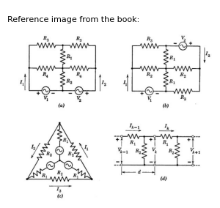

3.1 Fig. 11.4. Various elementary symmetries. ($a$) Inversion about the vertical center line; ($b$) π-rotation (or inversion about the center point); ($c$) 2 /3πrotation (or three different line inversions) ; ($d$) Translation (through distance $d$).
ponents. Other symmetries yield other components, but the $principle$ $is$ $the$ $same$. The networks shown in Fig. 11.4 offer a few illustrations. The experiment shown in Fig. 11.4($b$) is invariant under π-rotation (180° rotation about an axis normal to the paper), provided $I_{2}=KI_{1}$ and $I_{1}=KI_{2}$ (and the same for the other current pairs and voltage pairs). Hence both lateral symmetry, Fig. 11.4($a$), and π-rotation symmetry, Fig. 11.4($a$), lead to even and odd symmetric components. In Fig. 11.4($c$) we see a slightly different symmetry. Consider a transformation which rotates the diagram counterclockwise through 120° and at the same time multiplies all currents and voltages in the circuit by some factor $K$. If the experiment is to be invariant, then
$I_{2}=KI_{1}$ (11.23)
$I_{3}=KI_{2}$(11.24)
$I_{1}=KI_{3}$(11.25)
with similar triple-relationships holding for the other symmetrically disposed current or voltage triplets in the circuit. It follows directly that the permissible values of $K$ are the cube roots of unity ; three complex numbers lying 120° apart in the complex plane. Each value of $K$ deter- mines a symmetric-component-set. The three possible symmetric triplets are, therefore,
$I_{1}^{1}=I_{2}^{1}=I_{3}^{1}$(11.25)
$I_{1}^{2}=aI_{2}^{2}=a^{2}I_{3}^{1}$(11.25)
$I_{1}^{4}=a^{2}I_{2}^{3}=aI_{3}^{3}$(11.28)
where
$a=e^{−}j2π/3$ (11.29)
Any distribution of voltage and current which satisfies the circuit equations can be represented as a superposition of such components. Symmetric-triplets are a basic tool in the study of unbalanced faults, loads, or interconnections on three-phase power transmission systems.
Figure 11.4($d$) offers a final example. The structure is an extended ladder network, only two of whose sections are shown. Assume that all sections are identical. The symmetry test here involves translation of the diagram through a distance d together with multiplication of all currents and voltages by some complex factor K as yet unspecified. The set of symmetrical components is therefore determined by the invariance relations
$ I_k$ = $KI_{k}−1$ = $I_0 K^k $ (11.30)
$ V_k$ = $KV_{k}−1$ = $KZI_k-1 = ZI_0 K^k $ (11.31)
for any section $k$, where $I_{0}$ and $Z$ are convenient const.ants to be deter- mined later. A study of Fig. 11.4($d$) yields the circuit equations
$ V_k-1$ $−$ $V_k $ = $R_1 I_k-1 $ (11.32)
$ R_2$ ($I_{k}−1−I_{k}$) = $V_{k}$ (11.33)
which become, with the aid of Eqs. 11.30 and 11.31,
$ Z(1-K) = R_1 $ (11.34)
$ R_2 (1-K) = ZK $ (11.35)
Quantity $I_{0}$ has cancelled and thus is relegated to the role of an arbitrary constant. Equations 11.34 and 11.35 lead to a quadratic in $K$,
$ K^2 - (R_1/R_2 + 2) K + 1 = 0 $ (11.36)
and the two solutions determine two sets of symmetrical components. Each set has its own value of $Z$, found from $K$ through Eqs. 11.34 or 11.35. Thus, all possible currents in the extended ladder network are simple superpositions of two basic components of the form
$I_k^1 = A [K^1]^K $ (11.37)
$I_k^2 =B [K^2]^K $ (11.38)
The arbitrary constants $A$ and $B$ can be adjusted to meet the specified boundary conditions at the left and right terminations of the ladder.
import matplotlib.pyplot as plt
from matplotlib import rcParams
import matplotlib.image as mpimg
import numpy as np
from schemdraw import dsp
import schemdraw
import schemdraw.elements as e
import PySpice.Logging.Logging as Logging
logger = Logging.setup_logging()
from PySpice.Probe.Plot import plot
from PySpice.Spice.Netlist import Circuit
from PySpice.Unit import *
# Create the figure and subplots
fig, axs = plt.subplots(1, 2, figsize=(15, 15))
d = schemdraw.Drawing()
d += (M1 := elm.AnalogNFet(offset_gate = False).anchor('drain').theta(0).reverse())
l1 = d.add(e.Line().left().dot(open=True).at(M1.gate).length(1).label('$e$','left'))
l2 = d.add(e.Line().up().at(M1.drain).length(1))
l3 = d.add(e.Line().down().at(M1.source).length(1))
l4 = d.add(e.Line().right().at(l2.end).length(2))
l5 = d.add(e.Line().up().length(.7).dot(open=True).label('$E{bb}$','right'))
l6 = d.add(e.Line().right().at(l5.start).length(2))
l7 = d.add(e.Line().down().length(1))
d += (M2 := elm.AnalogNFet(offset_gate = False).anchor('drain').theta(0))
l8 = d.add(e.Line().down().at(M2.source).length(1))
l9 = d.add(e.MeterV().down().length(1).endpoints(l3.end,l8.end).label('$e{k}$','right').label('$e{k}$','left'))
R1 = d.add(e.Resistor().down().label('$R$','bottom').at(l9.start))
R2 = d.add(e.Resistor().down().label('$R$','bottom').at(l9.end))
l10 = d.add(e.Line().right().length(2).at(R1.end))
l11 = d.add(e.Line().right().length(2))
l12 = d.add(e.Line().right().length(2).at(M2.gate))
l13 = d.add(e.Line().down().length(4.83))
l14 = d.add(e.Line().left().length(3))
G = d.add(elm.Ground().at(l10.end))
d.save('Drawings/11-5a.jpg') # Save the drawing to a PNG file
img = mpimg.imread('Drawings/11-5a.jpg')
axs[0].imshow(img)
axs[0].axis('off') # Hide axes for image display
axs[0].set_title('Circuit Diagram (developed)')
# **Subplot (1, 2): PNG Sample File**
img_sample = mpimg.imread('images/11-5.jpg') # Load the PNG file
axs[1].imshow(img_sample)
axs[1].axis('off') # Hide axes for image display
axs[1].set_title('Original')
Text(0.5, 1.0, 'Original')
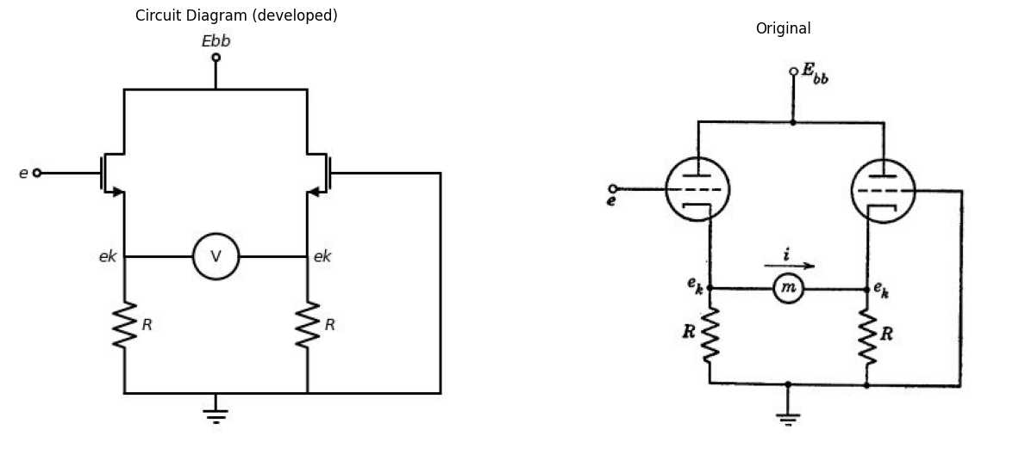

3.2 Fig. 11.5. A balanced vacuum-tube voltmeter circuit.

4 11.4 A Balanced Vacuum-Tube Voltmeter Circuit
The circuit of Fig. 11.5 may be used as a d-c vacuum-tube voltmeter, with the milliammeter $m$ calibrated to indicate values of the applied voltage $e$. Let us assume that the two tubes are identical and that the meter $m$ has negligible internal resistance. Moreover, we shall consider only small values of $e$ so that operation is linear and superposition is consequently valid.
When $e$ takes the value zero, the circuit is perfectly symmetrical and $i$, having no preferred direction, must also vanish. The immediate
result of symmetry, therefore, is that the voltmeter transfer curve, $i=f\left(e\right)$, must pass through the origin. Let us now see how symmetry can be exploited to calculate the slope of this curve at the origin. First observe that the grid-to-ground voltages shown in Fig. 11.5 can be resolved into the even and odd components indicated in Fig. 11.6. Current $i$ remains zero for even grid excitation [Fig.11.6($a$)]. Further- more, the common cathode voltage eg is unchanged by odd grid inputs
import ipywidgets as widgets
from ipywidgets import *
import schemdraw
import schemdraw.elements as e
@interact(Mode_1=(True) , Mode_2=(True) )
def response(Mode_1=True , Mode_2=True):
with schemdraw.Drawing() as d:
if (Mode_1):
d += (M1 := e.AnalogNFet(offset_gate = False).anchor('drain').theta(0).reverse())
l1 = d.add(e.Line().left().dot(open=True).at(M1.gate).length(1).label(r'$+\frac {e}{2}$','left'))
l2 = d.add(e.Line().up().at(M1.drain).length(1))
l3 = d.add(e.Line().down().at(M1.source).length(1))
l4 = d.add(e.Line().right().at(l2.end).length(2))
l5 = d.add(e.Line().up().length(.7).dot(open=True).label('$E{bb}$','right'))
l6 = d.add(e.Line().right().at(l5.start).length(2))
l7 = d.add(e.Line().down().length(1))
d += (M2 := e.AnalogNFet(offset_gate = False).anchor('drain').theta(0))
l8 = d.add(e.Line().down().at(M2.source).length(1))
l9 = d.add(e.Line().down().length(1).endpoints(l3.end,l8.end))
R1 = d.add(e.Resistor().down().label('$R$','bottom').at(l9.start))
R2 = d.add(e.Resistor().down().label('$R$','bottom').at(l9.end))
l10 = d.add(e.Line().right().length(2).at(R1.end))
l11 = d.add(e.Line().right().length(2))
l12 = d.add(e.Line().right().length(1.5).at(M2.gate).label(r'$+\frac {e}{2}$','right').dot(open=True))
G = d.add(e.Ground().at(l10.end))
d += e.Arrow().right().length(1).color('black').label('$i=0$', loc='top', color='black'). at((1.5,-2))
d += e.Arrow().down().length(1).color('black').label('$∆i_b$', loc='top', color='black'). at((-.5,-3))
d += e.Arrow().down().length(1).color('black').label('$∆i_b$', loc='bottom', color='black'). at((5,-3))
if (Mode_1):
d += (M1 := e.AnalogNFet(offset_gate = False).anchor('drain').theta(0).reverse().at((11,0)))
l1 = d.add(e.Line().left().dot(open=True).at(M1.gate).length(1).label(r'$+\frac {e}{2}$','left'))
l2 = d.add(e.Line().up().at(M1.drain).length(1))
l3 = d.add(e.Line().down().at(M1.source).length(1))
l4 = d.add(e.Line().right().at(l2.end).length(2))
l5 = d.add(e.Line().up().length(.7).dot(open=True).label('$E{bb}$','right'))
l6 = d.add(e.Line().right().at(l5.start).length(2))
l7 = d.add(e.Line().down().length(1))
d += (M2 := e.AnalogNFet(offset_gate = False).anchor('drain').theta(0))
l8 = d.add(e.Line().down().at(M2.source).length(1))
l9 = d.add(e.Line().down().length(1).endpoints(l3.end,l8.end))
R1 = d.add(e.Resistor().down().label('$R$','bottom').at(l9.start))
R2 = d.add(e.Resistor().down().label('$R$','top').at(l9.end))
l10 = d.add(e.Line().right().length(2).at(R1.end))
l11 = d.add(e.Line().right().length(2))
l12 = d.add(e.Line().right().length(1.5).at(M2.gate).label(r'$-\frac {e}{2}$','right').dot(open=True))
G = d.add(e.Ground().at(l10.end))
l13 = d.add(e.Line().right().length(1).at((15.3,-2.7)))
l14 = d.add(e.Line().right().length(1).at((15.3,-5.7)))
d += e.Gap().up().label( '$∆e{k}$' , ofst=-1.7 , fontsize = 16).color('black').at((14.5,-5.5))
d += e.Arrow().up().length(.7).linewidth(.6).color('black').label('+',loc='end', color='black',ofst=.5). at((16,-3.4))
d += e.Arrow().down().length(.7).linewidth(.6).color('black').label(r'_', loc='end', color='black',ofst=(-.5, -.3)). at((16,-5))
d += e.LoopCurrent([M1,l9,M2,l7,l6,l4,l3] , pad = 0.1).label('$∆i_b=i$')
fig = plt.figure(figsize=(5, 3))
img = plt.imread('./images/11-6.jpg')
plt.imshow(img)
plt.axis('off')
plt.title('\nReference image from the book:', fontsize=8, pad=10,loc='left')
plt.show()
{"model_id":"0b5f0a344bfc4495b52eb83cf4726ad1","version_major":2,"version_minor":0}
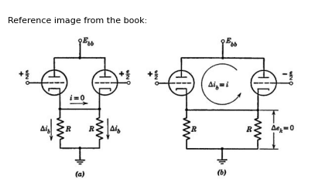

4.1 Fig. 11.6. Symmetrical components in the voltmeter circuit. ($a$) Even components;($b$) Odd components.
($b$) , provided $e$ is small enough so that operation is linear. Since $e_{k}$ is fixed in ($b$), the two plate voltages are fixed and the grid-to-cathode voltage increments are just equal to the corresponding applied grid-to- ground voltages, $e/2$ and minus $e/2$. Hence the plate current of the left tube increases by
$∆ i_b = g_m e/2 $ (11.39)
and the right tube current decreases by the same amount. Since no change can occur in the current carried by either of the cathode resistors $R$, it follows that the flow of incremental current takes the circulatory pattern shown in ($b$), down through the left tube, across through the meter and up in the right-hand triode. Hence we have the very simple result,
$ i/e = gm /2 $ (11.40)
giving the slope of the voltmeter transfer curve at the origin. Sym-
metry considerations have been much help here, offering a simple path to the simple answer. Failure to exploit symmetry would have detoured us along a more complicated path to the same answer.

5 11.5 A Balanced Power Amplifier with Direct-Coupled Load
Figure 11.7($a$) shows an amplifier designed for good linearity at a relatively high level of output power to the load $R$. The three-winding input transformer applies the input signal $e_{g}$ to the two grids with the
import ipywidgets as widgets
from ipywidgets import *
import schemdraw
import schemdraw.elements as e
@interact(Mode_1=(True) , Mode_2=(True) )
def response(Mode_1=True , Mode_2=True):
with schemdraw.Drawing() as d:
if (Mode_1):
d += e.Dot(open=True)
l1 = d.add(e.Line().right())
L1 = d.add(e.Inductor2().down())
l2 = d.add(e.Line().left().dot(open=True))
l3 = d.add(e.Line().up().length(7).at((3.5,-5)))
l4 = d.add(e.Line().up().length(7).at((3.8,-5)))
L2 = d.add(e.Inductor2().up().at((4.5,-5)))
l5 = d.add(e.Line().right())
d += (M1 := e.AnalogNFet(offset_gate = False).anchor('gate').theta(0).reverse())
E1 = d.add(e.Battery().right().reverse().at(L2.start).label('$- ٍٍٍE{cc} +$','bottom').length(3.9))
l6 = d.add(e.Line().down().at(M1.source).dot(open=True).label('$- ٍٍٍE{bb}$','left'))
L3 = d.add(e.Inductor2().up().at((4.5,0)))
l5 = d.add(e.Line().right())
d += (M2 := e.AnalogNFet(offset_gate = False).anchor('gate').theta(0).reverse())
E2 = d.add(e.Battery().right().reverse().at(L3.start).label('$- ٍٍٍE{cc} +$','bottom').length(3.9))
l6 = d.add(e.Line().up().at(M2.drain).dot(open=True).label('$+ ٍٍٍE{bb}$','right').length(1))
l7 = d.add(e.Line().down().endpoints(M2.source,M1.drain))
l8 = d.add(e.Line().right().at(E2.end))
R1 = d.add(e.Resistor().down().label('$R$','top').label(['+',' ',' ','$e$',' ',' ','-'] , fontsize = 16,loc='bottom'))
G = d.add(e.Ground().at(R1.end))
d += e.Arrow().up().length(1).color('black').label('$e_g$', loc='top', color='black'). at((.5,-2))
d += e.Arrow().up().length(1).color('black').label('$e_g$', loc='bottom', color='black'). at((5,1))
d += e.Arrow().down().length(1).color('black').label('$e_g$', loc='bottom', color='black'). at((5,-3))
d += e.Arrow().right().length(1).color('black').label('$i$', loc='top', color='black'). at((9,0.5))
if (Mode_2):
d += e.Dot(open=True).at((15,2)).label('$+$','left')
l1 = d.add(e.Line().right().length(1))
d += (M1 := e.AnalogNFet(offset_gate = False).anchor('gate').theta(0).reverse())
l2 = d.add(e.Line().down().length(.7).at(M1.source))
l3 = d.add(e.Line().left().length(2).dot(open=True).label('$-$','left').label('$e_c$','top'))
E1 = d.add(e.Battery().down().reverse().at(l3.start).length(1.5).label(['-',' ',' ','$E{cc}$',' ',' ','+'] , fontsize = 16,loc='top'))
R1 = d.add(e.Resistor().down().label('$R{bb}$','top'))
l4 = d.add(e.Line().right().length(4))
l5 = d.add(e.Line().up().length(2))
d += (M2 := e.AnalogNFet(offset_gate = False).anchor('source').theta(0))
l6 = d.add(e.Line().right().length(1).at(M2.gate).dot(open=True).label('$+$','right'))
R2 = d.add(e.Resistor().right().label('$R$','top').length(4).at(l3.start))
l7 = d.add(e.Line().up().length(.85).at(M2.drain).dot())
E2 = d.add(e.Battery().up().reverse().at(l7.end).length(2).label(['-',' ',' ','$E{bb}$',' ',' ','+'] , fontsize = 16,loc='bottom'))
R3 = d.add(e.Resistor().up().label('$R{bb}$','top').length(2))
l8 = d.add(e.Line().left().length(4))
l9 = d.add(e.Line().down().length(2))
l10 = d.add(e.Line().right().length(2).dot(open=True).label('$-$','right').at(R2.end).label(r'$ e{c}$','bottom'))
d += e.Arrow().right().length(1).color('black').label('$i$', loc='top', color='black'). at((18,1.5))
d += e.Arrow().right().length(1).color('black').label('$i_b1$', loc='bottom', color='black'). at((18,-4.5))
d += e.Arrow().left().length(1).color('black').label('$i_b$', loc='top', color='black'). at((19,5))
fig = plt.figure(figsize=(5, 3))
img = plt.imread('./images/11-7.jpg')
plt.imshow(img)
plt.axis('off')
plt.title('\nReference image from the book:', fontsize=8, pad=10,loc='left')
plt.show()
{"model_id":"cfe354f850a84bbb92035fc70fc2be6c","version_major":2,"version_minor":0}
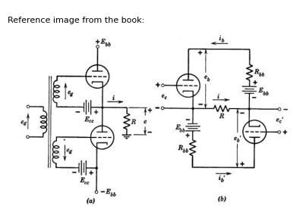

5.1 Fig. 11.7. A balanced power amplifier.
polarities indicated in the figure. Recognition of symmetry is facilitated by interchanging the series connection of the lower tube and its plate supply voltage $E_{b}$ $​_{b}$, to obtain the modified circuit shown in ($b$). This does not affect the operation of the amplifier. The input transformer and grid-biasing batteries are omitted from ($b$) for simplicity and the effect of internal plate-supply resistance is accounted for by the resist- ances fitt. Circuit ($b$) exhibits the same form of symmetry as that shown in Fig. 11.4($b$).
For a qualitative description of performance, suppose that the tubes are biased almost to cutoff, so that neither tube conducts much current when $e_{g}$ is zero. Now apply a large signal $e_{g}$ varying sinusoidally with time. As $e_{g}$ swings positive, the lower tube cuts off and the upper tube
conducts, producing a nearly-sinusoidal positive load current $i$ during the first half cycle of the sine wave. In the following half cycle, $e_{g}$ goes negative, the upper tube is cut off, and the lower tube supplies a nearly sinusoidal negative surge of load current. The load current, therefore, is nearly sinusoidal over the entire cycle, although the operation of each tube is grossly nonlinear. This permits more than twice the amplitude of load current obtainable with one tube alone for a specified amount of distortion.
So much for the qualitative behavior; now to calculate the precise manner in which the load current $i$ varies with the input voltage $e_{g}$, taking into account the actual nonlinearity of the tubes. By inspection of Fig. 11.7($b$),
$e_{b}=E_{b}$ $​_{b}$ $R_{b}$ $​_{b}$ $i_{b}$ $−R_{i}$ (11.41)
$e_{b}=E_{b}$ $​_{b}$ $R_{b}$ $​_{b}$ $i_{b}$ $−R_{i}$ (11.42)
$i=i_{b}−i_{b}$ (11.43)
Now let us resolve the plate currents and plate voltages into even and odd symmetrical components
$e_{b}=e_{b}$ $​_{e}$ $+e_{b}$ $​_{0}$ (11.44)
$e_{b}=e_{b}$ $​_{e}$ $−e_{b}$ $​_{0}$ (11.45)
$i_{b}=i_{b}$ $​_{e}$ $+e_{b}$ $​_{0}$ (11.46)
$i_{b}=i_{b}$ $​_{e}$ $−i_{b}$ $​_{0}$ (11.47)
Substitution into Eqs. 11.41 and 11.42 and elimination of $i$ with the aid of Eq. 11.43 gives a pair of equations which may be added and subtracted to obtain
$e_{b}$ $​_{e}$ = $E_{b}$ $​_{b}$ $R_{b}$ $​_{b}$ $i_{b}$ $​_{e}$ (11.48)
$e_{b}$ $​_{0}$= $−(R_{b}$ $​_{b}$ $+$ $2R$) $i_{b}$ $​_{0}$ (11.49)
The even-symmetric current component may be visualized as a current running counterclockwise around the outside loop of circuit in Fig. 11.7(b), whereas the odd component appears as two loop currents, counterclockwise in the upper loop of the circuit and clockwise in the lower loop. Resistance $R$ is doubled in Eq. 11.49 because both odd currents flow in the same direction through $R$, thereby doubling the voltage drop. Voltages $E_{b}$ $​_{b}$ form an even pair and hence are absent from Eq. 11.49. Even-component current does not flow in the load so that $R$ does not appear in Eq. 11.48. Thus, Eqs. 11.48 and 11.49 could have been deduced directly from the pattern of symmetrical components in the circuit.
Equations 11.48 and 11.49 have the advantage over 11.41 and 11.42 in that they lend themselves to a much simpler interpretation as a graphical construction on the triode plate curves. The construction is shown in Fig. 11.8. For a specified pair of grid-voltage values the upper tube operates at point A and the lower tube at point A' . The resistance in Eq. 11.49 determines the slope of the “odd” load line AA', but does not say where this line should be located. The constants in
import matplotlib.pyplot as plt
from matplotlib import rcParams
import matplotlib.image as mpimg
import numpy as np
from schemdraw import dsp
import schemdraw
import schemdraw.elements as e
import PySpice.Logging.Logging as Logging
logger = Logging.setup_logging()
from PySpice.Probe.Plot import plot
from PySpice.Spice.Netlist import Circuit
from PySpice.Unit import *
# Create the figure and subplots
fig, axs = plt.subplots(1, 2, figsize=(15, 15))
d = schemdraw.Drawing()
# Parameters (example values for NMOS)
Vth = .4 # Threshold voltage (V)
Vds = 2.0 # Drain-source voltage (V)
mu_n = 400e-4 # Mobility (cm^2/Vs)
Cox = 3e-8 # Oxide capacitance per unit area (F/cm^2)
W = 10e-4 # Width (cm)
L = 1e-4 # Length (cm)
beta = mu_n * Cox * (W / L) # Process transconductance parameter
# VGS sweep range
Vgs = np.linspace(0, 3, 300)
# Initialize Ids array
Ids = np.zeros_like(Vgs)
# Calculate Ids for each Vgs
for i, Vg in enumerate(Vgs):
if Vg < Vth:
Ids[i] = 0 # Cutoff region
elif Vds < (Vg - Vth):
# Linear (triode) region
Ids[i] = beta * ((Vg - Vth) * Vds - 0.5 * Vds**2)
else:
# Saturation region
Ids[i] = 0.5 * beta * (Vg - Vth)**2
axs[0].plot(Vgs, Ids,color='black',linestyle='--')
# Parameters (example values for NMOS)
Vth1 = 4 # Threshold voltage (V)
Vds1 = 2 # Drain-source voltage (V)
mu_n = 400e-4 # Mobility (cm^2/Vs)
Cox = 3e-8 # Oxide capacitance per unit area (F/cm^2)
W = 10e-4 # Width (cm)
L = 1e-4 # Length (cm)
beta = mu_n * Cox * (W / L) # Process transconductance parameter
# VGS sweep range
Vgs1 = np.linspace(0, 6, 100)
# Initialize Ids array
Ids1 = np.zeros_like(Vgs1)
# Calculate Ids for each Vgs
for i, Vg1 in enumerate(Vgs1):
if Vg1 < Vth1:
Ids1[i] = 0 # Cutoff region
elif Vds1 < (Vg1 - Vth1):
# Linear (triode) region
Ids1[i] = beta * ((Vg1 - Vth1) * Vds1 - 0.5 * Vds1**2)
else:
# Saturation region
Ids1[i] = 0.5 * beta * (Vg1 - Vth1)**2
axs[0].plot(Vgs1, Ids1,color='black',linestyle='--')
axs[0].plot([3.5, 3], [0, 3e-8], color='black', linestyle='-', label='Membership = 2')
axs[0].plot([0, 5.3], [1e-8, 1e-8], color='black', linestyle='-', label='Membership = 2')
axs[0].plot([0, 3.25], [1.5e-8, 1.5e-8], color='black', linestyle='-', label='Membership = 2')
axs[0].plot([0, 2.2], [2e-8, 2e-8], color='black', linestyle='-', label='Membership = 2')
axs[0].text(3.2,-.2e-8, ' $ E{bb} $ ', fontsize=10)
axs[0].text(3,3.2e-8, ' $R{bb} $ ', fontsize=10)
axs[0].text(3,3.9e-8, ' $ e{c} $ ', fontsize=10)
axs[0].text(6,2.5e-8, ' $ e{c1} $ ', fontsize=10)
axs[0].axhline(0, color='black', linewidth=1)
axs[0].axvline(0, color='black', linewidth=1)
img_sample = mpimg.imread('images/11-8.jpg') # Load the PNG file
axs[1].imshow(img_sample)
axs[1].axis('off') # Hide axes for image display
axs[1].set_title('Original')
Text(0.5, 1.0, 'Original')
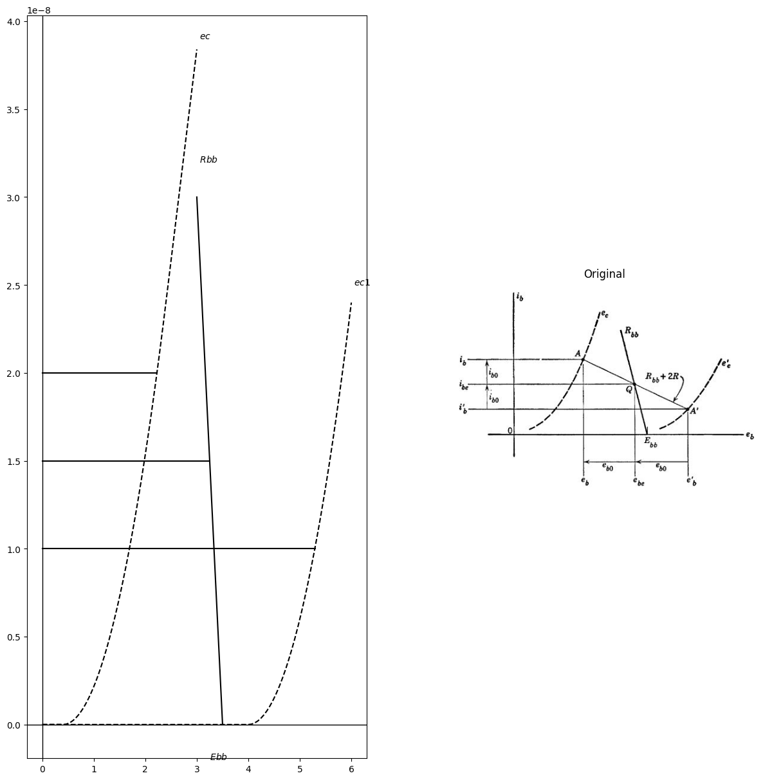

5.2 Fig.11.8. Construction of symmetrical components on the triode plate curves.
Eq. 11.48, on the other hand, completely fix the “even” load line as shown on the diagram, giving its resistance-slope Rbband its intercept $E_{b}$ $​_{b}$. The odd load line intersects the even load line at some point $Q$. If we now slide the odd load line up and down, maintaining the specified resistance-slope $R_{b}$ $​_{b}$ $+2R$, we will find one position for which point $Q$ lies midway between $A$ and $A’$. This is the proper location, since Eqs. 11.44 through 11.47 are then satisfied, as indicated by the constructions and dimensions below and to the left in Fig. 11.8.
For a different pair of grid-voltage values point $Q$ would shift to a new position along the even load line and two new operating points $A$ and $A’$ would be found. The actual construction is not as time consuming as it may appear. A pair of draftsman's triangles may be used to shift the odd load line parallel to itself and the proper position can be esti- mated by eye and checked with a pair of dividers. For a given input signal $e_{g}$, the two grid voltages are
$e_{c}$ = $−E_{c}$ $​_{c}$ $+e_{g}$ (11.50)
$e_{c}′$ = $−E_{c}$ $​_{c}$ $+e_{g}$ (11.51)
Choosing a number of difierent values of eg, we compute the correspond- ing grid-voltage pairs and locate $A$ and $A’$ for each pair. A smooth curve drawn through the various points A (shown in Fig. 11.9 but not in Fig. 11.8) represents the operating locus of the upper tube as $e_{g}$ is varied, and the same for points $A’$ along the operating locus of the lower tube.
import matplotlib.pyplot as plt
from matplotlib import rcParams
import matplotlib.image as mpimg
import numpy as np
from schemdraw import dsp
import schemdraw
import schemdraw.elements as e
import PySpice.Logging.Logging as Logging
logger = Logging.setup_logging()
from PySpice.Probe.Plot import plot
from PySpice.Spice.Netlist import Circuit
from PySpice.Unit import *
# Create the figure and subplots
fig, axs = plt.subplots(1, 2, figsize=(15, 15))
d = schemdraw.Drawing()
# Parameters (example values for NMOS)
Vth = .2 # Threshold voltage (V)
Vds = 2.0 # Drain-source voltage (V)
mu_n = 400e-4 # Mobility (cm^2/Vs)
Cox = 3e-8 # Oxide capacitance per unit area (F/cm^2)
W = 10e-4 # Width (cm)
L = 1e-4 # Length (cm)
beta = mu_n * Cox * (W / L) # Process transconductance parameter
# VGS sweep range
Vgs = np.linspace(0, 3, 300)
# Initialize Ids array
Ids = np.zeros_like(Vgs)
# Calculate Ids for each Vgs
for i, Vg in enumerate(Vgs):
if Vg < Vth:
Ids[i] = 0 # Cutoff region
elif Vds < (Vg - Vth):
# Linear (triode) region
Ids[i] = beta * ((Vg - Vth) * Vds - 0.5 * Vds**2)
else:
# Saturation region
Ids[i] = 0.5 * beta * (Vg - Vth)**2
axs[0].plot(Vgs, Ids,color='black',linestyle='-')
# Parameters (example values for NMOS)
Vth1 = 2 # Threshold voltage (V)
Vds1 = 2 # Drain-source voltage (V)
mu_n = 400e-4 # Mobility (cm^2/Vs)
Cox = 3e-8 # Oxide capacitance per unit area (F/cm^2)
W = 10e-4 # Width (cm)
L = 1e-4 # Length (cm)
beta = mu_n * Cox * (W / L) # Process transconductance parameter
# VGS sweep range
Vgs1 = np.linspace(0, 4, 100)
# Initialize Ids array
Ids1 = np.zeros_like(Vgs1)
# Calculate Ids for each Vgs
for i, Vg1 in enumerate(Vgs1):
if Vg1 < Vth1:
Ids1[i] = 0 # Cutoff region
elif Vds1 < (Vg1 - Vth1):
# Linear (triode) region
Ids1[i] = beta * ((Vg1 - Vth1) * Vds1 - 0.5 * Vds1**2)
else:
# Saturation region
Ids1[i] = 0.5 * beta * (Vg1 - Vth1)**2
axs[0].plot(Vgs1, Ids1,color='black',linestyle='-')
Vth2 = .5 # Threshold voltage (V)
Vds2 = 2 # Drain-source voltage (V)
mu_n = 400e-4 # Mobility (cm^2/Vs)
Cox = 3e-8 # Oxide capacitance per unit area (F/cm^2)
W = 10e-4 # Width (cm)
L = 1e-4 # Length (cm)
beta = mu_n * Cox * (W / L) # Process transconductance parameter
# VGS sweep range
Vgs2 = np.linspace(0, 3, 100)
# Initialize Ids array
Ids2 = np.zeros_like(Vgs2)
# Calculate Ids for each Vgs
for i, Vg2 in enumerate(Vgs2):
if Vg2 < Vth2:
Ids2[i] = 0 # Cutoff region
elif Vds2 < (Vg2 - Vth2):
# Linear (triode) region
Ids2[i] = beta * ((Vg2 - Vth2) * Vds1 - 0.5 * Vds1**2)
else:
# Saturation region
Ids2[i] = 0.5 * beta * (Vg2 - Vth2)**2
axs[0].plot(Vgs2, Ids2,color='black',linestyle='-')
Vth3 = .8 # Threshold voltage (V)
Vds3 = 2 # Drain-source voltage (V)
mu_n = 400e-4 # Mobility (cm^2/Vs)
Cox = 3e-8 # Oxide capacitance per unit area (F/cm^2)
W = 10e-4 # Width (cm)
L = 1e-4 # Length (cm)
beta = mu_n * Cox * (W / L) # Process transconductance parameter
# VGS sweep range
Vgs3 = np.linspace(0, 3.5, 100)
# Initialize Ids array
Ids3 = np.zeros_like(Vgs3)
# Calculate Ids for each Vgs
for i, Vg3 in enumerate(Vgs3):
if Vg3 < Vth3:
Ids2[i] = 0 # Cutoff region
elif Vds3 < (Vg3 - Vth3):
# Linear (triode) region
Ids3[i] = beta * ((Vg3 - Vth3) * Vds3 - 0.5 * Vds3**2)
else:
# Saturation region
Ids3[i] = 0.5 * beta * (Vg3 - Vth3)**2
axs[0].plot(Vgs3, Ids3,color='black',linestyle='-')
Vth4 = 1.3 # Threshold voltage (V)
Vds4 = 2 # Drain-source voltage (V)
mu_n = 400e-4 # Mobility (cm^2/Vs)
Cox = 3e-8 # Oxide capacitance per unit area (F/cm^2)
W = 10e-4 # Width (cm)
L = 1e-4 # Length (cm)
beta = mu_n * Cox * (W / L) # Process transconductance parameter
# VGS sweep range
Vgs4 = np.linspace(0, 4, 100)
# Initialize Ids array
Ids4 = np.zeros_like(Vgs4)
# Calculate Ids for each Vgs
for i, Vg4 in enumerate(Vgs4):
if Vg4 < Vth4:
Ids4[i] = 0 # Cutoff region
elif Vds4 < (Vg4 - Vth4):
# Linear (triode) region
Ids4[i] = beta * ((Vg4 - Vth4) * Vds4 - 0.5 * Vds4**2)
else:
# Saturation region
Ids4[i] = 0.5 * beta * (Vg4 - Vth4)**2
axs[0].plot(Vgs4, Ids4,color='black',linestyle='-')
axs[0].text( 3, 4.4e-8, '$+5$', ha='center', va='center')
axs[0].text( 3, 3.7e-8, '$0$', ha='center', va='center')
axs[0].text( 3.5, 4.2e-8, '$-5$', ha='center', va='center')
axs[0].text( 4, 4.2e-8, '$+10$', ha='center', va='center')
axs[0].text( 4, 2.6e-8, '$+15$', ha='center', va='center')
axs[0].axhline(0, color='black', linewidth=1)
axs[0].axvline(0, color='black', linewidth=1)
img_sample = mpimg.imread('images/11-9.jpg') # Load the PNG file
axs[1].imshow(img_sample)
axs[1].axis('off') # Hide axes for image display
axs[1].set_title('Original')
Text(0.5, 1.0, 'Original')
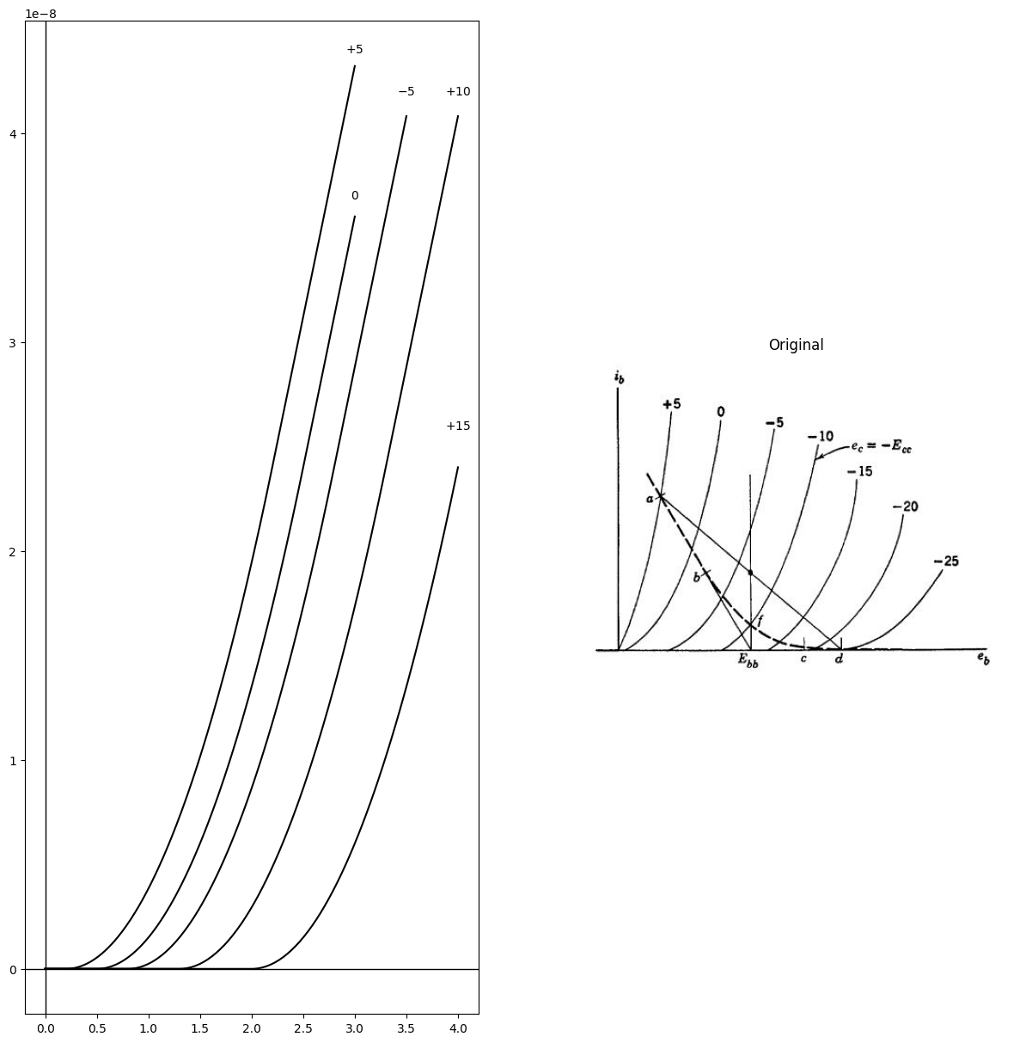

5.3 Fig.11.9. Common operating locus of the two tubes.
It is tacitly assumed that the tubes are identical, although the con- struction of operating loci could be carried out on the superimposed plate curves of two difierent tubes in just the same manner. For identical tubes, and for the balanced input specified by Eqs. 11.50 and 11.51, the two operating loci coincide, as shown by the dashed curve in Fig. 11.9. This is assured by symmetry. When $e_{g}$ is zero both tubes operate at point $f$. As $e_{g}$ goes positive, the operating point of the upper tube moves up the locus toward $b$ and that of the lower tube slides down toward cutoff at $c$. For a value of $e_{g}$ greater than about 7.5 volts, the lower tube is cut off and has no effect upon current flow in the upper loop of the circuit. Hence the upper tube operates along the straight load line $ba$, whose resistance-slope is just $−E_{b}$ $​_{b}$ + $R$. At 15 volts input the odd load line has shifted upward as far as position $ad$. For a sinusoidal input signal the operating points of the two tubes run back and forth along the locus in opposite directions, meeting at point $f$ twice during each cycle.
Once the locus is determined, the amplifier transfer curve shown in Fig. 11.10 may be plotted by taking values of $ib$ and $i_{b}′$ directly from the locus. An odd grid-signal pair e produces both even and odd changes in the plate currents since the circuit of Fig. 11.7 is not linear. Only the odd component of plate current appears in the load, however, so that the transfer curve is odd-symmetric. The curvature of triode char- acteristics is such that for proper choice of $−E_{c}$ $​_{c}$ the transfer curve is actually very nearly linear.
import matplotlib.pyplot as plt
from matplotlib import rcParams
import matplotlib.image as mpimg
import numpy as np
from schemdraw import dsp
import schemdraw
import schemdraw.elements as e
import PySpice.Logging.Logging as Logging
logger = Logging.setup_logging()
from PySpice.Probe.Plot import plot
from PySpice.Spice.Netlist import Circuit
from PySpice.Unit import *
# Create the figure and subplots
fig, axs = plt.subplots(1, 2, figsize=(15, 15))
d = schemdraw.Drawing()
# Create data for a nonlinear curve (e.g., a cubic function for demonstration)
x = np.linspace(-2, 2, 400)
y = x**3 + x
axs[0].plot(x, y, color='black', linewidth=2)
# Draw axes lines at x=0 and y=0
axs[0].axhline(0, color='black', linewidth=1)
axs[0].axvline(0, color='black', linewidth=1)
# Remove top and right spines for a cleaner look
axs[0].spines['top'].set_visible(False)
axs[0].spines['right'].set_visible(False)
# Set labels similar to your image
axs[0].set_xlabel(r'$e_g$', fontsize=14)
axs[0].set_ylabel(r'$e = R(i_b - i_b^\prime)$', fontsize=14, rotation=0, labelpad=40)
# Hide ticks
axs[0].set_xticks([])
axs[0].set_yticks([])
img_sample = mpimg.imread('images/11-10.jpg') # Load the PNG file
axs[1].imshow(img_sample)
axs[1].axis('off') # Hide axes for image display
axs[1].set_title('Original')
Text(0.5, 1.0, 'Original')
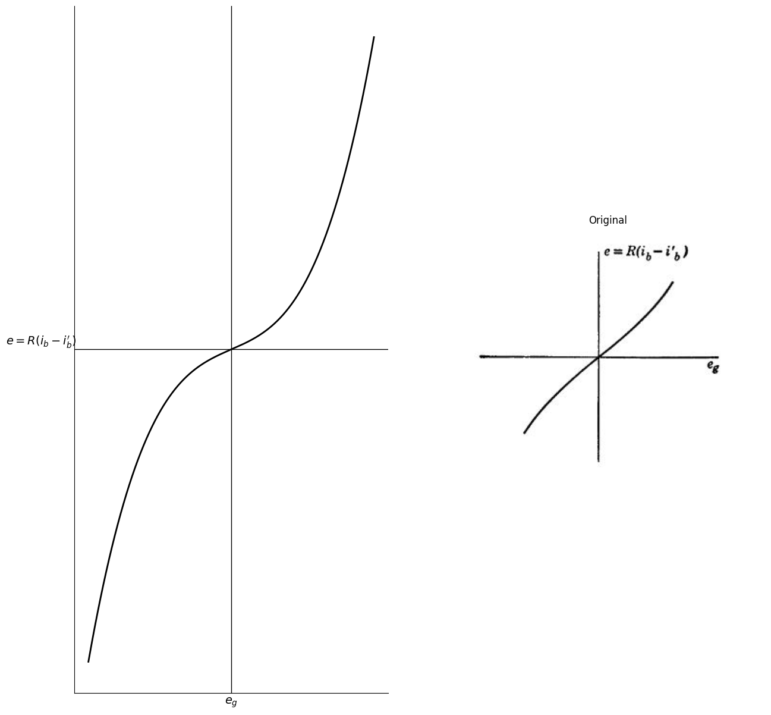

5.4 Fig.11.10. Voltage transfer curve of the balanced amplifier.
The slope of the transfer curve at the origin is
$G_{0}=\frac{2μ0R}{r_{p}0+R_{b}b+2R}$ (11.52)
where $μ_{0}$ and $r_{p}$ $​_{0}$ the triode amplification factor and plate resistance measured at point J in Fig. 11.9. At the upper extremity of operation, in region $ab$ of the locus, the amplifier voltage gain is
$G=\frac{μR}{rp+R_{b}b+R}$ (11.53)
where $μ$ and $r_{p}$ are measured in region $ab$. The bias voltage $E_{c}$ $​_{c}$ , may be increased so long as the approximation
$G_{0}≈G$ (11.54)
is valid. A further increase in $E_{c}$ $​_{c}$ would then cause the transfer curve to depart more drastically from linearity.

6 11.6 The Transformer-Coupled Push-Pull Amplifier
No discussion of balanced amplifiers would be complete without mention of the push-pull amplifier, which is widely used as a driver for loudspeakers. The basic circuit is shown in Fig. 11.11, with the output transformer idealized except for resistances $R_{w}$, which account for trandozmer winding resistances. The transformer has n turns in each half of the primary winding, per turn on the secondary winding, as indicated in the figure. In comparison with the circuit of Fig. 11.7($a$), the push-pull amplifier in Fig. 11.11 has its two tubes in parallel (rather than in series) with respect to the plate-voltage supply $E_{b}$ $​_{b}$,and in series (rather than in parallel) with respect to the output load.
import matplotlib.pyplot as plt
from matplotlib import rcParams
import matplotlib.image as mpimg
import numpy as np
from schemdraw import dsp
import schemdraw
import schemdraw.elements as e
import PySpice.Logging.Logging as Logging
logger = Logging.setup_logging()
from PySpice.Probe.Plot import plot
from PySpice.Spice.Netlist import Circuit
from PySpice.Unit import *
# Create the figure and subplots
fig, axs = plt.subplots(1, 2, figsize=(15, 15))
d = schemdraw.Drawing()
d += e.Dot(open=True)
l1 = d.add(e.Line().right())
d += ( R1 := e.Resistor().down().label('$R_g$' , 'top'))
d += ( R2 := e.Resistor().down().label('$R_g$' , 'top'))
l2 = d.add(e.Line().left().dot(open=True))
l3 = d.add(e.Line().left().at(R1.end).length(1))
G = d.add(e.Ground())
l4 = d.add(e.Line().right().at(R1.start))
d += (M1 := e.AnalogNFet(offset_gate = False).anchor('gate').theta(0).reverse())
l5 = d.add(e.Line().right().at(R2.end))
d += (M2 := e.AnalogNFet(offset_gate = False).anchor('gate').theta(180))
l6 = d.add(e.Line().down().at(M1.source).length(1.5))
l7 = d.add(e.Line().right().length(1))
l8 = d.add(e.Line().up().length(.75))
d += ( C1 := elm.Capacitor().label('$C$','top').right().length(2))
l9 = d.add(e.Line().down().length(.75))
l91 = d.add(e.Line().down().length(.75))
d += ( R3 := e.Resistor().left().label('$R_k$' , 'top').length(2))
l10 = d.add(e.Line().up().length(.75))
l11 = d.add(e.Line().right().length(.75).dot().at(l91.start))
G = d.add(e.Ground())
E1 = d.add(e.Battery().right().reverse().at(l11.end).label('$- ٍٍٍE{bb} +$','bottom').length(2))
d += ( R4 := e.Resistor().right().label('$R{bb}$' , 'top').length(3).dot())
l12 = d.add(e.Line().up().length(1).at(M1.drain))
l13 = d.add(e.Line().right().length(9))
d += ( R4 := e.Resistor().down().label('$R{w}$' , 'bottom').length(2.7))
L1 = d.add(e.Inductor2().down())
d += ( R5 := e.Resistor().down().label('$R{w}$' , 'bottom').length(2.95))
l14 = d.add(e.Line().up().length(3).at(M2.source))
l15 = d.add(e.Line().right().length(9).at(M2.drain))
l16 = d.add(e.Line().up().length(3).at((16.5,-4)))
l17 = d.add(e.Line().up().length(3).at((16.8,-4)))
L2 = d.add(e.Inductor2().up().at((17.5,-4)))
l18 = d.add(e.Line().right().length(1.5).at(L2.start))
d += ( R5 := e.Resistor().up().label('$R$' , 'top').label(['-',' ',' ','$e$',' ',' ','+'], 'bottom'))
l19 = d.add(e.Line().left().length(1.5))
d += e.Gap().up().label( '$e{1}$' , ofst=-1.7 , fontsize = 16).color('black').at((-1.5,-4))
d += e.Arrow().up().length(1).linewidth(.6).color('black').label('+',loc='end', color='black',ofst=.5). at((0,-1))
d += e.Arrow().down().length(1).linewidth(.6).color('black').label(r'_', loc='end', color='black',ofst=(-.5, -.3)). at((0,-5))
d.save('images/11-11a.png') # Save the drawing to a PNG file
img = mpimg.imread('images/11-11a.png')
axs[0].imshow(img)
axs[0].axis('off') # Hide axes for image display
axs[0].set_title('Circuit Diagram (developed)')
# **Subplot (1, 2): PNG Sample File**
img_sample = mpimg.imread('images/11-11.jpg') # Load the PNG file
axs[1].imshow(img_sample)
axs[1].axis('off') # Hide axes for image display
axs[1].set_title('Original')
Text(0.5, 1.0, 'Original')
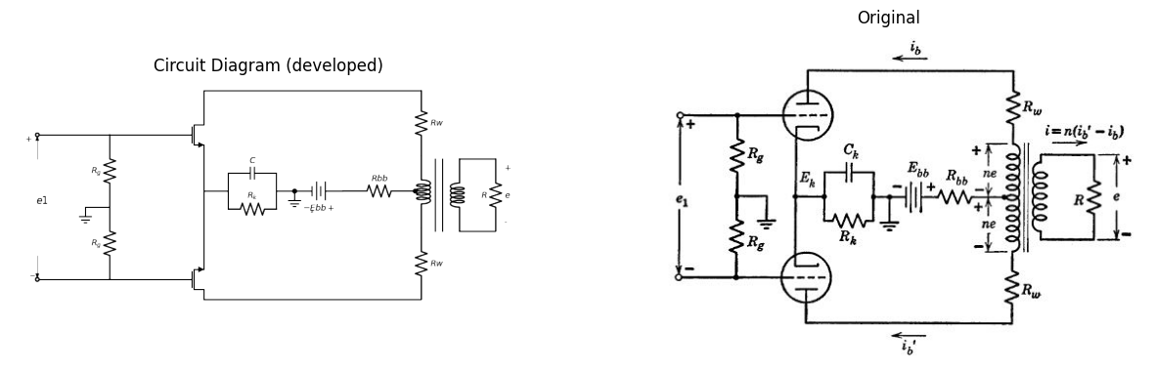

6.1 Fig. 11.11. A push-pull amplifier with transformer-coupled load.
The grid-biasing circuit in Fig. 11.11, consisting of $R_{k}$ and $C_{k}$, may be replaced by a battery $E_{k}$ for purposes of analysis. The bias actually increases somewhat for large input signal amplitudes but we shall assume that $R_{k}$ has been adjusted to produce the proper value of $E_{k}$ with a given signal applied. The equations of the two principal loops of the push-pull circuit are
$e_{b}$ $​_{b}$ = ($E_{b}$ $​_{b}$ $−E_{k}$) $+ne$ $−R_{w}i_{b}$ $−R_{b}$ $​_{b}$ $(i_{b}+i_{b}′$) (11.55)
$e_{b}$ $​_{b}′$ = ($E_{b}$ $​_{b}$ $−E_{k}$) $+ne$ $−R_{w}i_{b}′$ $−R_{b}$ $​_{b}$ $(i_{b}+i_{b}′$) (11.56)
Addition and subtraction of these, together with substitution of the transformer relation
$i=n\left(i_{b}′−i_{b}\right)$ (11.57)
leads to the symmetrical equations
$ \frac {e_b + e_b'}{2}= (E{bb}-E_k)-(R_w -R{bb})(\frac {i_b'+i_b}{2})$ (11.58)
$ \frac {e_b - e_b'}{2}= -(R_w -R{bb})(\frac {i_b'-i_b}{2})$ (11.59)
With even and odd subscript notation, these become $ebe=\left(Ebb−Ek\right)−\left(Rw+2Rbb\right)ibe$ (11.60)
$ebe=−\left(Rw+2Rbb\right)ibe$ (11.61)
From here on the analysis picks up the previous trail at Eqs. 11.48 and 11.49 and follows exactly the same path to a transfer curve of output voltage $nR\left(i_{b}′−i_{b}\right)$ versus input voltage e₁. Notice that in the push- pull circuit the odd component of grid signal is only half of the input voltage, since e₁ splits equally across the two resistors Rg. For the push- pull form of symmetry the even component of plate current flows counterclockwise in the upper loop and clockwise in the lower, producing no magnetization of the transformer core. Hence output voltage arises entirely from the odd component of plate current, which runs downward through both tubes in series and returns upward through the transformer primary winding.
Before leaving the push-pull circuit we should say something about the choice of the transformer turns-ration. The optimum n will depend, of course, upon the particular conditions and restrictions laid down, and these are somewhat arbitrary. One possible set of conditions is the following.
- Load power to be a maximum
- Grid voltage never positive
- Plate supply voltage (E- Ek) fixed
- Rbb and Rw negligible
- Input signal adjustable to any desired amplitude
- Grid bias near cutoff
Under these conditions the operating path has the general shape shown in Fig. 11.9, with the special dimensions indicated in Fig. 11.12. For any given waveform, the output power is proportional to the product of the output current and voltage amplitudes. Examination of Figs. 11.11 and 11.12 shows that
$x=ne{max} $\left(11.62\right)$ y= \frac {1}{n} i{max}$(11.63)
so that (for a specified signal waveform) output power is proportional to the product
$ p=xy $(11.64)
Since grid voltage is restricted to nonpositive values, the greatest power output will occur when the extremity of the operating path lies somewhere along the zero-grid-voltage curve; at point q in Fig. 11.12. Geo- metrically speaking, our job is to maximize the area of the triangular region zy by varying the resistance-slope n²R. As point q moves upward along the zero-grid-voltage curve, a position is reached at which y is increasing percentagewise just as fast as x is decreasing percentagewise.
import matplotlib.pyplot as plt
from matplotlib import rcParams
import matplotlib.image as mpimg
import numpy as np
from schemdraw import dsp
import schemdraw
import schemdraw.elements as e
import PySpice.Logging.Logging as Logging
logger = Logging.setup_logging()
from PySpice.Probe.Plot import plot
from PySpice.Spice.Netlist import Circuit
from PySpice.Unit import *
fig, axs = plt.subplots(1, 2, figsize=(15, 15))
d = schemdraw.Drawing()
# Create the figure# Parameters (example values for NMOS)
Vth = .4 # Threshold voltage (V)
Vds = 2.0 # Drain-source voltage (V)
mu_n = 400e-4 # Mobility (cm^2/Vs)
Cox = 3e-8 # Oxide capacitance per unit area (F/cm^2)
W = 10e-4 # Width (cm)
L = 1e-4 # Length (cm)
beta = mu_n * Cox * (W / L) # Process transconductance parameter
# VGS sweep range
Vgs = np.linspace(0, 4, 300)
# Initialize Ids array
Ids = np.zeros_like(Vgs)
# Calculate Ids for each Vgs
for i, Vg in enumerate(Vgs):
if Vg < Vth:
Ids[i] = 0 # Cutoff region
elif Vds < (Vg - Vth):
# Linear (triode) region
Ids[i] = beta * ((Vg - Vth) * Vds - 0.5 * Vds**2)
else:
# Saturation region
Ids[i] = 0.5 * beta * (Vg - Vth)**2
axs[0].plot(Vgs, Ids,color='black',linestyle='-')
axs[0].plot([4.2, 4.2], [0, 6e-8], color='black', linestyle='-', label='Membership = 2')
axs[0].plot([4.2, 2.73], [0, 3.2e-8], color='black', linestyle='--', label='Membership = 2')
axs[0].plot([2.73, 2.73], [0, 3.2e-8], color='black', linestyle='--', label='Membership = 2')
axs[0].plot([0, 2.73], [3.2e-8, 3.2e-8], color='black', linestyle='--', label='Membership = 2')
axs[0].plot([2.73, 6.73], [3.2e-8, 0], color='black', linestyle='-', label='Membership = 2')
axs[0].text(2.6,3.5e-8, ' $ q $ ', fontsize=10)
axs[0].text(-.6,3.2e-8, ' $ib{max} $ ', fontsize=10)
axs[0].axhline(0, color='black', linewidth=1)
axs[0].axvline(0, color='black', linewidth=1)
# **Subplot (1, 2): PNG Sample File**
img_sample = mpimg.imread('images/11-12.jpg') # Load the PNG file
axs[1].imshow(img_sample)
axs[1].axis('off') # Hide axes for image display
axs[1].set_title('Original')
Text(0.5, 1.0, 'Original')
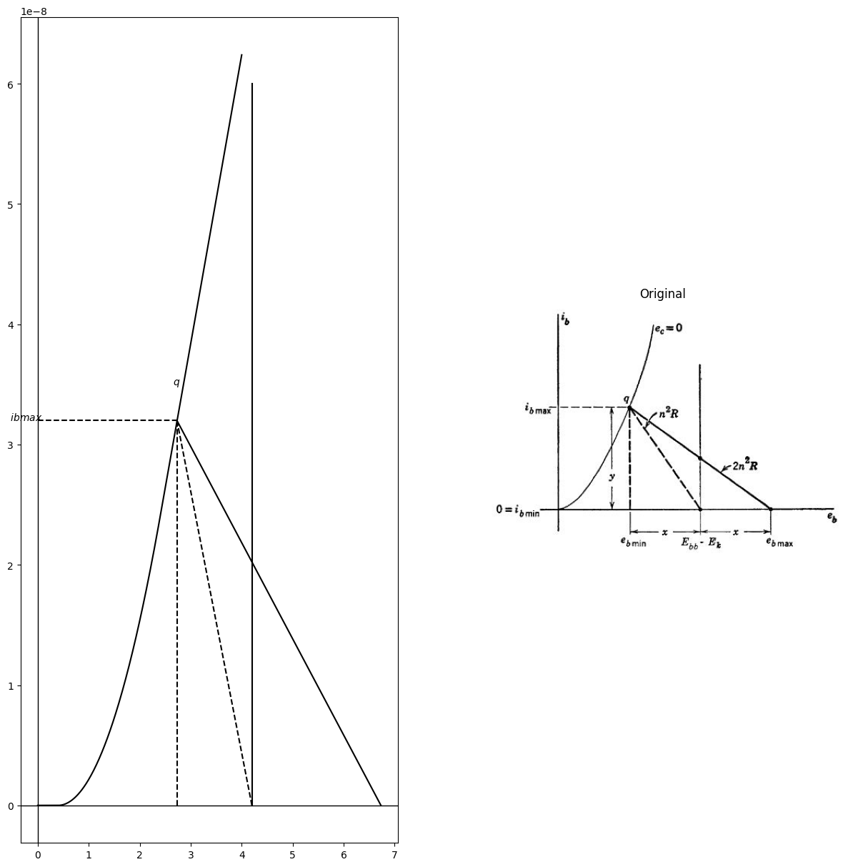

6.2 Fig. 11.12. Maximization of push-pull power output.
At this point the product zy is stationary and also evidently a maximum. In short,
$ \frac {d_y}{y}=- \frac {d_x}{x} $ (11.65) The relation given in Eq. 11.65 can be obtained formally by setting the total differential of Eq. 11.64 equal to zero. By inspection of Fig. 11.12,
$r_{p} = -\frac {d_x}{d_y} $ (11.66)
$n ^ 2 R = \frac {x}{y} $ (11.67)
and from Eq. 11.65 we see that the condition for maximum output power is
$r_p = n^2 R $ (11.68)
where r_{p} is measured at point q. Thus the transformer turns-ratio n should be chosen to "match" the load resistance R to the value of the incremental plate resistance $r_{p}$ at the extremity of the operating swing,
where one tube is cut off and only half of the transformer primary winding is effective. The load resistance reflected into the plate circuit by half of the winding is, of course, just equal to $n^{2}*R$

7 11.7 A Classical Puzzle
The story is told of a classical puzzle put to a famous mathematician. Two players sit at a rectangular table, each with a pile of identical ideal short sticks in his lap. The first player takes his turn by placing one little stick on the table. The second player then places another stick so that it does not overlie or otherwise disturb the first. The turns alternate and the last player able to place a stick legally on the table wins the game. The problem is to give a plan for winning, if possible, and to decide whether or not it is advantageous to have the first move. The famous mathematician, so the story goes, came to the solution in twelve seconds. This problem would be hopeless without help from the elegant and powerful concept of symmetry. [Solution: The first player places his first stick in the center of the table; the orientation is immaterial. Thereafter, he simply matches every move of the second player, main- taining symmetry about the center.] An interesting extension of the problem arises from the question, "Can the first player win without placing his first stick in the center?"
SUPPLEMENTARY READING
Herman Weyl, Symmetry, Princeton University Press, Princeton, N. J., 1952.
T. S. Gray, Applied Electronics, John Wiley and Sons, New York, 1954.
E. A. Guillemin, Introductory Circuit Theory, John Wiley and Sons, New York, 1953.
PROBLEMS
11.1. In the circuit of Fig. P11.1 (a), let$ v_{1} = v_{1} ^ {(1)} + v_{1} ^ {(2)} v_{2} = v_{1} ^ {(1)} - v_{1} ^ {(2)}$ and similarly for $i_{1}$ and $i_{2}$ Show that $v_{1} ^ {(1)} v_{1} ^ {(2)} i_{1} ^ {(1)} $and $i_{1}^{\left(2\right)}$ are related as in the circuits of Fig. P11.1(6) and (c). Using superposition of symmetrical components, find $v_{1} / i_{1} $when v_{2} is zero. Find $v_{1}/i_{1}$ when $i_{2} $is zero.
11.2. Show that the construction in Fig. P11.2(b) determines the currents and voltages in the circuit of Fig. P11.2(a). The conditions are: vand i are the coordinates of point p; v' and i' are the coordinates of point p' and O bisects p * p' Show how you would find v_{1} and v_{2} from the construction
import ipywidgets as widgets
from ipywidgets import *
import schemdraw
import schemdraw.elements as elm
@interact( Mode_1=(True),Mode_2=(True),Mode_3=(True))
def response( Mode_1=True,Mode_2=True,Mode_3=True):
with schemdraw.Drawing() as d:
if (Mode_1):
d += elm.SourceI().up().label('$i_1$ ','top' )
d+= elm.Line().right().length(2).dot(open=True)
d += (R1:= elm.Resistor().down().label('$1$' , 'bot', ofst=.2).dot(open=True))
d+= elm.Line().left().length(2)
d += (R2:= elm.Resistor().right().label('$1$' , 'bot', ofst=-1).at(R1.start))
d += (R3:= elm.Resistor().right().label('$1$' , 'bot', ofst=-1).dot(open=True))
d += (R4:= elm.Resistor().down().label('$1$' , 'bot', ofst=-1).dot(open=True))
d += (R5:= elm.Resistor().left().label('$1$' , 'bot', ofst=-1))
d += (R6:= elm.Resistor().left().label('$1$' , 'bot', ofst=.5))
d+= (l1:= elm.Line().right().length(.02).at((5,1.5)))
d+= (l2:= elm.Line().right().length(.02).at((4.55,1.8)))
d += (R7:= elm.Resistor().left().label('$1$' , 'bot', ofst=-1).endpoints(R6.end,l1.end))
d += (R8:= elm.Resistor().left().label('$1$' , 'bot', ofst=.2).endpoints(R3.end,l1.end))
d += (R9:= elm.Resistor().left().label('$1$' , 'bot', ofst=-1).endpoints(R4.end,l2.end).dot())
d += (R10:= elm.Resistor().left().label('$1$' , 'bot', ofst=.2).endpoints(R1.start,l2.end))
d+= (l3:= elm.Line().right().length(2).at(R3.end))
d += elm.SourceI().down().label('$i_2$ ','bottom' ).reverse()
d+= (l3:= elm.Line().left().length(2))
d += e.Gap().up().label( '$v_1$' , ofst=-1.7 , fontsize = 16).color('black').at((-.5,.25))
d += e.Arrow().up().length(.7).linewidth(.6).color('black').label('+',loc='end', color='black',ofst=.5). at((1,2.3))
d += e.Arrow().down().length(.7).linewidth(.6).color('black').label(r'_', loc='end', color='black',ofst=(-.5, -.3)). at((1,.8))
d += e.Gap().up().label( '$v_2$' , ofst=-1.7 , fontsize = 16).color('black').at((7.5,.25))
d += e.Arrow().up().length(.7).linewidth(.6).color('black').label('+',loc='end', color='black',ofst=.5). at((9,2.3))
d += e.Arrow().down().length(.7).linewidth(.6).color('black').label(r'_', loc='end', color='black',ofst=(-.5, -.3)). at((9,.8))
if (Mode_2):
d.move(4,0)
d += elm.SourceI().up().label('$i_1^{(1)}$ ','top' )
d+= elm.Line().right().length(2).dot(open=True)
d += (R1:= elm.Resistor().down().label('$1$' , 'bot', ofst=.2).dot(open=True))
d+= elm.Line().left().length(2)
d += (R2:= elm.Resistor().right().label('$1$' , 'bot', ofst=.2).dot(open=True).at(R1.end).length(4))
d += (R3:= elm.Resistor().right().label('$1$' , 'bot', ofst=-.8).dot(open=True).at(R1.start).length(4))
d += (l1:= elm.Dot(open=True).at((18,1.8)))
d += (R4:= elm.Resistor().right().label('$1$' , 'bot', ofst=.1).dot(open=True).endpoints(l1.start,R1.end))
d += (R4:= elm.Resistor().right().label('$1$' , 'bot', ofst=.1).dot(open=True).endpoints(l1.start,R1.start))
d += e.Gap().up().label( '$v_1^{(1)}$' , ofst=-1.7 , fontsize = 16).color('black').at((12.5,.25))
d += e.Arrow().up().length(.7).linewidth(.6).color('black').label('+',loc='end', color='black',ofst=.5). at((14,2.3))
d += e.Arrow().down().length(.7).linewidth(.6).color('black').label(r'_', loc='end', color='black',ofst=(-.5, -.3)). at((14,.8))
if (Mode_3):
d.move(7,0)
d += elm.SourceI().up().label('$i_1^{(2)}$ ','top' )
d+= elm.Line().right().length(2).dot(open=True)
d += (R1:= elm.Resistor().down().label('$1$' , 'bot', ofst=.2).dot(open=True))
d+= elm.Line().left().length(2)
d += (R2:= elm.Resistor().right().label('$1$' , 'bot', ofst=.2).dot(open=True).at(R1.end).length(4))
d += (R3:= elm.Resistor().right().label('$1$' , 'bot', ofst=-.8).dot(open=True).at(R1.start).length(4))
d += (l1:= elm.Dot(open=True).at((26,2)))
d += (l2:= elm.Dot(open=True).at((26,1.7)))
d += (R4:= elm.Resistor().right().label('$1$' , 'bot', ofst=.1).dot(open=True).endpoints(l2.start,R1.end))
d += (R4:= elm.Resistor().right().label('$1$' , 'bot', ofst=.1).dot(open=True).endpoints(l1.start,R1.start))
d+= elm.Line().right().length(2).endpoints(R2.end,R3.end)
d += e.Gap().up().label( '$v_1^{(2)}$' , ofst=-1.7 , fontsize = 16).color('black').at((20.5,.25))
d += e.Arrow().up().length(.7).linewidth(.6).color('black').label('+',loc='end', color='black',ofst=.5). at((22,2.3))
d += e.Arrow().down().length(.7).linewidth(.6).color('black').label(r'_', loc='end', color='black',ofst=(-.5, -.3)). at((22,.8))
fig = plt.figure(figsize=(5, 3))
img = plt.imread('./images/p11-1.jpg')
plt.imshow(img)
plt.axis('off')
plt.title('\nReference image from the book:', fontsize=8, pad=10,loc='left')
plt.show()
{"model_id":"c231bd6ca472414a8ce25b2e1f3e053e","version_major":2,"version_minor":0}
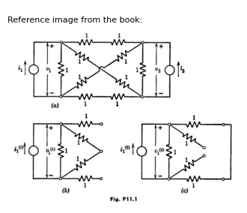
import matplotlib.pyplot as plt
from matplotlib import rcParams
import matplotlib.image as mpimg
import numpy as np
from schemdraw import dsp
import schemdraw
import schemdraw.elements as e
import PySpice.Logging.Logging as Logging
logger = Logging.setup_logging()
from PySpice.Probe.Plot import plot
from PySpice.Spice.Netlist import Circuit
from PySpice.Unit import *
fig, axs = plt.subplots(1, 3, figsize=(15, 15))
d = schemdraw.Drawing()
d += (E1:= e.SourceV().up().label('$e_1$ ','top' ))
D1 = d.add(e.Diode(fill=True).right().reverse())
ss1 = d.add(e.Source().right().at(D1.start))
d += e.Line().right().length(3).at(E1.start).color('black')
d += (E2:= e.SourceV().right().label('$e_2$ ','top' ))
d += (R1:= e.Resistor().right().label('$R_2$' , 'bot', ofst=.2).label(['-',' ',' ','$v_2$',' ',' ','+'], 'top'))
d += (R2:= e.Resistor().down().label('$R_1$' , 'bot', ofst=.2).at(R1.end))
d += (R3:= e.Resistor().up().label('$R_1$' , 'bot', ofst=.2).at(R1.end))
d += e.Line().left().length(6).color('black')
d += e.Line().left().length(6).color('black').at(R2.end)
D2 = d.add(e.Diode(fill=True).left())
ss2 = d.add(e.Source().left().at(D2.start))
d += (E2:= e.SourceV().up().label('$e_1$ ','top' ))
d += e.Gap().up().label( '$v$' , ofst=-1.7 , fontsize = 16).color('black').at((.5,.25))
d += e.Arrow().up().length(.7).linewidth(.6).color('black').label('+',loc='end', color='black',ofst=.5). at((2.5,2.3))
d += e.Arrow().down().length(.7).linewidth(.6).color('black').label(r'_', loc='end', color='black',ofst=(-.5, -.3)). at((2.5,.8))
d += e.Gap().up().label( '$v&$' , ofst=-1.7 , fontsize = 16).color('black').at((.5,-2.5))
d += e.Arrow().up().length(.7).linewidth(.6).color('black').label('+',loc='end', color='black',ofst=.5). at((2.5,-.8))
d += e.Arrow().down().length(.7).linewidth(.6).color('black').label(r'_', loc='end', color='black',ofst=(-.5, -.3)). at((2.5,-2.2))
d += e.Gap().up().label( '$v_1$' , ofst=-1.7 , fontsize = 16).color('black').at((9.5,-1.5))
d += e.Arrow().up().length(.7).linewidth(.6).color('black').label('+',loc='end', color='black',ofst=.5). at((11,2.3))
d += e.Arrow().down().length(.7).linewidth(.6).color('black').label(r'_', loc='end', color='black',ofst=(-.5, -.3)). at((11,-2.2))
d += e.Line().right().length(1).color('black').at((10.5,3))
d += e.Line().right().length(1).color('black').at((10.5,-3))
d += e.Arrow().left().length(1).color('black').label('$i$', loc='top', color='black'). at((3,3.5))
d += e.Arrow().left().length(1).color('black').label('$i1$', loc='bottom', color='black'). at((3,-3.5))
d.save('images/p11-1a.png') # Save the drawing to a PNG file
img = mpimg.imread('images/p11-1a.png')
axs[0].imshow(img)
axs[0].axis('off') # Hide axes for image display
axs[0].set_title('Circuit Diagram (developed)')
# **Subplot (1, 2): PNG Sample File**
circuit = Circuit('v-i curve')
circuit.model('BAV21','D' ,IS = 100@u_uA , N = 1.906 ,BV = 110@u_V, IBV = 0.0001@u_V, VJ = 20@u_V ,CJO = 7.048E-13 ,RS = 20@u_Ohm ,TT = 3.48E-9)
Vi = circuit.V('i', '1', circuit.gnd, 0@u_V)
circuit.R(1, '1', '2', 10@u_Ohm)
circuit.D(1, '2',circuit.gnd , model = 'BAV21')
circuit.I(1, circuit.gnd,'2', 300@u_uA)
simulator = circuit.simulator(temperature=25, nominal_temperature=25)
analysis = simulator.dc(Vi=slice(-2,8, 0.1))
axs[1].plot(analysis['1'], u_mA(-analysis.Vi),'black',linewidth=2,linestyle='-')
axs[1].set_xlim(-2, 4)
axs[1].set_ylim(-1, 2)
axs[1].set_xlabel('V [V]')
axs[1].set_ylabel('I [mA]')
axs[1].text(0.3, 1.5, 'r', ha='center', va='center', fontsize=12)
axs[1].text(.1, -0.2, '$-Io$', ha='center', va='center', fontsize=12)
axs[1].axhline(0, color='black', linewidth=1 )
axs[1].axvline(0, color='black', linewidth=1)
img_sample = mpimg.imread('images/p11-2.jpg') # Load the PNG file
axs[2].imshow(img_sample)
axs[2].axis('off') # Hide axes for image display
axs[2].set_title('Original')
Text(0.5, 1.0, 'Original')
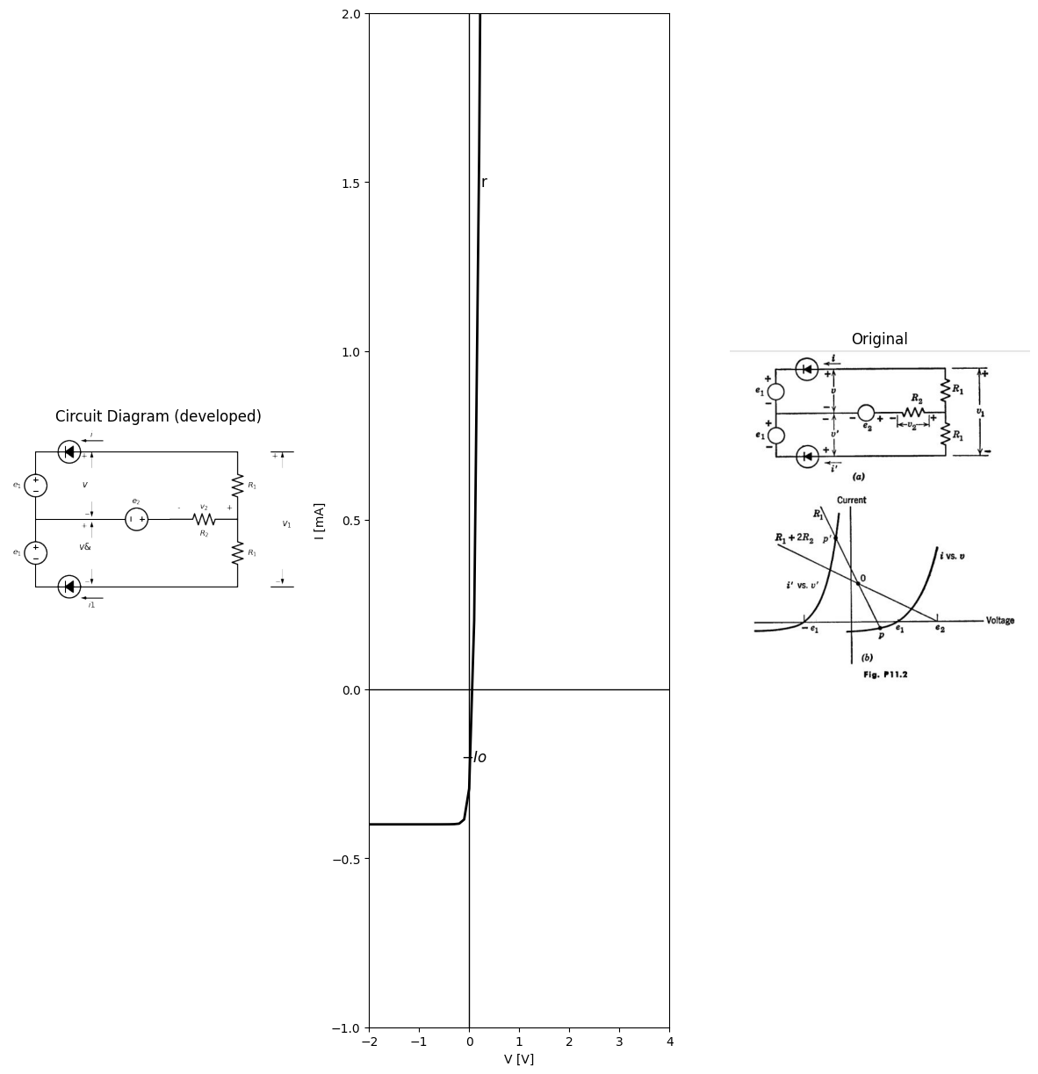
11.3. For the push-pull class A power amplifier circuit shown in Fig. P11.3, determine R and $E {cc} $for maximum undistorted power output without exceeding the tube ratings. For this load locate the path of operation in the $e_{b}vs.i_{b}$ plane and determine the maximum power output.
import matplotlib.pyplot as plt
from matplotlib import rcParams
import matplotlib.image as mpimg
import numpy as np
from schemdraw import dsp
import schemdraw
import schemdraw.elements as e
import PySpice.Logging.Logging as Logging
logger = Logging.setup_logging()
from PySpice.Probe.Plot import plot
from PySpice.Spice.Netlist import Circuit
from PySpice.Unit import *
fig, axs = plt.subplots(2, 2, figsize=(15, 15))
d = schemdraw.Drawing()
d += e.Dot(open=True)
l1 = d.add(e.Line().right())
d += (M1 := e.AnalogNFet(offset_gate = False).anchor('gate').theta(0).reverse())
l2 = d.add(e.Line().down().length(1))
E1 = d.add(e.BatteryCell().left().label('$- ٍٍٍE{cc} +$','bottom').length(4).dot(open=True))
l3 = d.add(e.Line().down().length(1.5).at(l2.end))
d += (M2 := e.AnalogNFet(offset_gate = False).anchor('drain').theta(0).reverse())
l3 = d.add(e.Line().left().length(3).at(M2.gate).dot(open=True))
l4 = d.add(e.Line().down().length(1).at(M2.source))
E2 = d.add(e.BatteryCell().left().label('$- ٍٍٍE{cc} +$','bottom').length(4).dot(open=True))
l5 = d.add(e.Line().up().length(1).at(M1.drain).label('$130 $','right').dot(open=True))
l6 = d.add(e.Line().down().length(1).at(l4.end).label('$-130 $','left').dot(open=True))
l7 = d.add(e.Line().right().length(2).at(E1.start))
d += ( R1 := e.Resistor().down().label('$R$' , 'top').label(['+',' ',' ','$e$',' ',' ','-'], 'bottom'))
G = d.add(e.Ground().at(R1.end))
d += e.Gap().up().label( '$e_1$' , ofst=-1.7 , fontsize = 16).color('black').at((-1.5,-2))
d += e.Arrow().up().length(.4).linewidth(.6).color('black').label('+',loc='end', color='black',ofst=.5). at((0,-.5))
d += e.Arrow().down().length(.4).linewidth(.6).color('black').label(r'_', loc='end', color='black',ofst=(-.5, -.3)). at((0,-1.3))
d += e.Gap().up().label( '$e_1$' , ofst=-1.7 , fontsize = 16).color('black').at((-1.5,-6.5))
d += e.Arrow().up().length(.4).linewidth(.6).color('black').label('_',loc='end', color='black',ofst=.3). at((0,-4.6))
d += e.Arrow().down().length(.4).linewidth(.6).color('black').label(r'+', loc='end', color='black',ofst=(-.5, -.3)). at((0,-5.5))
l8 = d.add(e.Line().right().length(.5).at((8,0)).color('white').label('Type IV rtings per triode:\n\n $E{bb max} = 250 volt$ \n\n $I{bb max} = 120 ma$\n\n $P_b {max}= 13 Watts$','right',color='black'))
d.save('images/p11-3a.png') # Save the drawing to a PNG file
img = mpimg.imread('images/p11-3a.png')
axs[0,0].imshow(img)
axs[0,0].axis('off') # Hide axes for image display
axs[0,0].set_title('Circuit Diagram (developed)')
img_sample = mpimg.imread('images/p11-3.jpg') # Load the PNG file
axs[0,1].imshow(img_sample)
axs[0,1].axis('off') # Hide axes for image display
axs[0,1].set_title('Original')
d = schemdraw.Drawing()
d += e.Dot(open=True)
l1 = d.add(e.Line().right().length(2))
d += ( R1 := e.Resistor().down().label('$100kΩ$' , 'bottom'))
d += ( R2 := e.Resistor().down().label('$100kΩ$' , 'bottom'))
l2 = d.add(e.Line().left().length(2).dot(open=True))
l3 = d.add(e.Line().right().length(4).at(R1.start))
d += (M1 := e.AnalogNFet(bulk=True).anchor('gate').theta(0).reverse())
E1 = d.add(e.Battery().right().label('$30_V $','bottom').length(4.92).at(R1.end).reverse())
l4 = d.add(e.Line().up().length(2.6))
l5 = d.add(e.Line().right().length(4).at(R2.end))
d += (M2 := e.AnalogNFet(bulk=True).anchor('gate').theta(0).reverse())
l4 = d.add(e.Line().down().length(1.85).at(E1.end))
d += ( R3 := e.Resistor().right().label('$125Ω$' , 'top').length(6).at(M1.drain))
d += ( R4 := e.Resistor().right().label('$125Ω$' , 'top').length(6).at(M2.source))
L1 = d.add(e.Inductor2().down().endpoints(R3.end,R4.end))
l5 = d.add(e.Line().right().length(2).at(E1.end))
E2 = d.add(e.Battery().right().label('$250_V $','bottom').length(3.8).reverse().dot())
l6 = d.add(e.Line().up().length(2).at((13.5,-3.5)).label('$10:1 $','right'))
l7 = d.add(e.Line().up().length(2).at((13.9,-3.5)))
L2 = d.add(e.Inductor2().up().at((15,-4)))
d += ( R5 := e.Resistor().right().label('$2.5Ω$' , 'top').length(3).dot(open=True))
d += ( R6 := e.Resistor().down().label('$45Ω$' , 'top').label(['+',' ',' ','$e_2$',' ',' ','-'], 'bottom'))
l7 = d.add(e.Line().left().length(3))
d += e.Gap().up().label( '$e_1=60sinwt$' , ofst=-1.7 , fontsize = 16).color('black').at((-2,-4))
d += e.Arrow().up().length(1).linewidth(.6).color('black').label('+',loc='end', color='black',ofst=.5). at((0,-1.1))
d += e.Arrow().down().length(1).linewidth(.6).color('black').label(r'_', loc='end', color='black',ofst=(-.5, -.3)). at((0,-5))
d += e.Gap().up().label( '$e_c$' , ofst=-1.7 , fontsize = 16).color('black').at((4,-2.8))
d += e.Arrow().up().length(.6).linewidth(.6).color('black').label('+',loc='end', color='black',ofst=.5). at((6,-.7))
d += e.Arrow().down().length(.6).linewidth(.6).color('black').label(r'_', loc='end', color='black',ofst=(-.5, -.3)). at((6,-2.3))
d += e.Gap().up().label( '$e_c$' , ofst=-1.7 , fontsize = 16).color('black').at((4,-5.8))
d += e.Arrow().up().length(.6).linewidth(.6).color('black').label('-',loc='end', color='black',ofst=.5). at((6,-3.7))
d += e.Arrow().down().length(.6).linewidth(.6).color('black').label(r'+', loc='end', color='black',ofst=(-.5, -.3)). at((6,-5.3))
l8 = d.add(e.Line().up().length(.5).at(M1.bulk))
l9 = d.add(e.Line().down().length(.5).at(M2.bulk))
d.save('images/p11-4a.png') # Save the drawing to a PNG file
img = mpimg.imread('images/p11-4a.png')
axs[1,0].imshow(img)
axs[1,0].axis('off') # Hide axes for image display
axs[1,0].set_title('Circuit Diagram (developed)')
img_sample = mpimg.imread('images/p11-4.jpg') # Load the PNG file
axs[1,1].imshow(img_sample)
axs[1,1].axis('off') # Hide axes for image display
axs[1,1].set_title('Original')
Text(0.5, 1.0, 'Original')
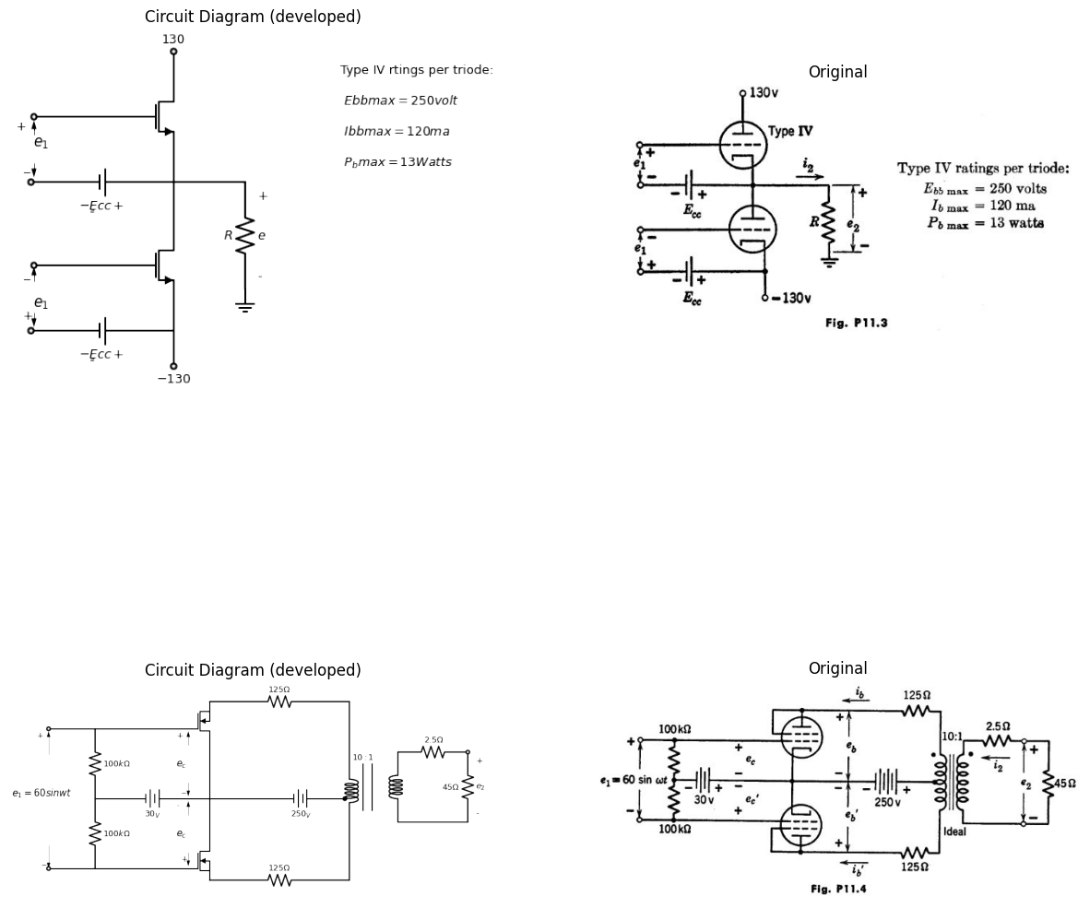
11.4. Two Type V triodes are used in the push-pull amplifier of Fig. P11.4. Under operating conditions with the input signal applied, show that the instantaneous plate voltages and currents are:
$Esum=\left(\frac{eb+eb′}{2}\right)+Rsum\left(\frac{ib+ib′}{2}\right)$
0= $\left(\frac{eb−eb′}{2}\right)$+$R {dif} ( \frac {i b - i b' }{ 2} ) $
volts, $Rsum=125ohms$, $Rdif=2500ohms$.
11.5. For the circuit of Fig. P11.4,
must be the mid-point of line segment A * A' in Fig. P11.5.
(b) Using the Type V curves compute $ec$ , $e_{c}′$ ,$ib$, $i_{b}' $and $i_{b} -i_{b}' $for $e_{1}=0,15,30,45,60$. Notice that the operating path is a straight line for $e_{c} > - 15 $
import matplotlib.pyplot as plt
from matplotlib import rcParams
import matplotlib.image as mpimg
import numpy as np
from schemdraw import dsp
import schemdraw
import schemdraw.elements as e
import PySpice.Logging.Logging as Logging
logger = Logging.setup_logging()
from PySpice.Probe.Plot import plot
from PySpice.Spice.Netlist import Circuit
from PySpice.Unit import *
fig, axs = plt.subplots(1, 2, figsize=(15, 15))
d = schemdraw.Drawing()
l1 = d.add(e.Line().right().length(8).label('$e $','right'))
l2 = d.add(e.Line().up().length(8).at((1,-1)).label('$i $','right'))
l3 = d.add(e.Line().right().length(.001).at((2,6)).dot().label('$A$','top'))
l4 = d.add(e.Line().right().length(.001).at((7,3)))
l5 = d.add(e.Line().right().length(.001).endpoints(l3.end,l4.end).dot().label('$A ̅ $','right'))
l6 = d.add(e.Line().left().length(2).at(l3.end).label('$i_b$','left').linewidth(.6))
l7 = d.add(e.Line().left().length(7).at(l4.end).label('$i_b$','left').linewidth(.6))
l8 = d.add(e.Line().down().length(6.5).at(l3.end).label('$e_b$','left').linewidth(.6))
l9 = d.add(e.Line().down().length(3.5).at(l4.end).linewidth(.6).label('$e_b ̅ $','left'))
l10 = d.add(e.Line().right().length(.001).at((4,8)))
l11 = d.add(e.Line().up().length(.5).at((6,-.3)).label('$E_sum$','left'))
l12 = d.add(e.Line().up().length(.5).endpoints(l11.end,l10.end))
l10 = d.add(e.Line().right().length(.001).at((5,4.2)).dot().label('$Q$','top'))
d.save('images/p11-5a.png') # Save the drawing to a PNG file
img = mpimg.imread('images/p11-5a.png')
axs[0].imshow(img)
axs[0].axis('off') # Hide axes for image display
axs[0].set_title('Circuit Diagram (developed)')
img_sample = mpimg.imread('images/p11-5.jpg') # Load the PNG file
axs[1].imshow(img_sample)
axs[1].axis('off') # Hide axes for image display
axs[1].set_title('Original')
Text(0.5, 1.0, 'Original')
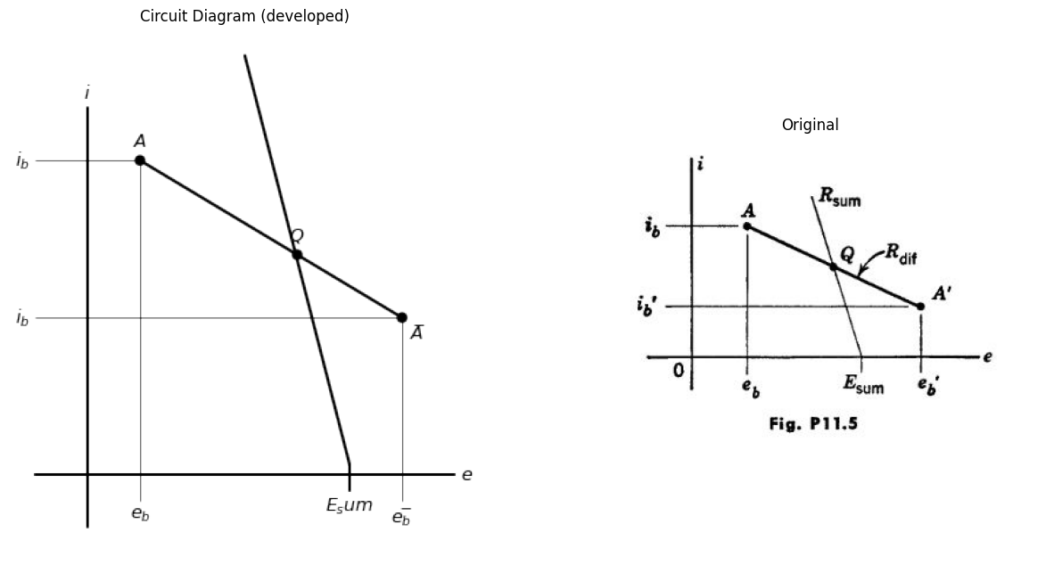
11.6. For the circuit of Fig. P11.4,
(a) Show that $e_{2} = 225(i_{b}' - i_{b}) $
(b) Show that the transfer curve $e_{2}=f\left(e_{1}\right)$ is an odd function.
(c) Plot $e_{2}=f\left(e_{1}\right)$ for $0<e_{1}<60$ roughly 10 volts per inch for $e_{1} $ and 2.5 volts per inch for $e_{2}$ This curve can be used to find the output waveform $e_{2}\left(t\right)$ due to any symmetrical input wave $e_{1}\left(t\right)$
(d) Approximate $e_{2}=f\left(e_{1}\right)$ by a straight line $e_{2}=A*e_{1}$ choosing A for least magnitude of error $e_{2}$ over the range $0 < e_{1} < 60 $Now sketch and dimension the output distortion voltage $e_{2d}=e_{2}−A*e_{1}$ versus t for one-half
cycle of the input e_{1} = 60sin omega*t What distortion frequency is strongly evident? What is the distortion amplitude in per cent of the $e_{2}\left(t\right)$ amplitude? What is the gain A? What is the output power?
import matplotlib.pyplot as plt
from matplotlib import rcParams
import matplotlib.image as mpimg
import numpy as np
from schemdraw import dsp
import schemdraw
import schemdraw.elements as e
import PySpice.Logging.Logging as Logging
logger = Logging.setup_logging()
from PySpice.Probe.Plot import plot
from PySpice.Spice.Netlist import Circuit
from PySpice.Unit import *
fig, axs = plt.subplots(1, 2, figsize=(15, 15))
d = schemdraw.Drawing()
d += e.Dot(open=True)
l1 = d.add(e.Line().right().length(2))
L1 = d.add(e.Inductor2().down())
l2 = d.add(e.Line().left().length(2).dot(open=True))
l3 = d.add(e.Line().up().length(4).at((2.75,-3.5)))
l4 = d.add(e.Line().up().length(4).at((2.95,-3.5)))
L2 = d.add(e.Inductor2().up().at((3.7,-5)).dot())
L3 = d.add(e.Inductor2().up())
l5 = d.add(e.Line().right().length(4))
d += (M1 := e.AnalogNFet(offset_gate = False).anchor('gate').theta(0).reverse())
l6 = d.add(e.Line().right().length(4).at(L2.start))
d += (M2 := e.AnalogNFet(offset_gate = False).anchor('gate').theta(180))
l7 = d.add(e.Line().right().length(4).endpoints(M1.source,M2.source))
E1 = d.add(e.Battery().right().label('$- E_{cc} +$','bottom').length(4.92).at(L2.end).reverse())
E2 = d.add(e.Battery().right().label('$- E_{bb} +$','bottom').length(4.92).reverse().label('$200$','top'))
L4 = d.add(e.Inductor2().up().length(3.8))
l8 = d.add(e.Line().right().length(4).endpoints(M1.drain,L4.end))
L5 = d.add(e.Inductor2().down().length(3.8).at(L4.start))
l9 = d.add(e.Line().right().length(4).endpoints(M2.drain,L5.end))
l10 = d.add(e.Line().up().length(4).at((14,-4)))
l11 = d.add(e.Line().up().length(4).at((14.3,-4)))
L5 = d.add(e.Inductor2().down().length(4).at((14.7,0)))
l12 = d.add(e.Line().right().length(2).at(L5.start))
l13 = d.add(e.Line().right().length(2).at(L5.end))
d += ( R1 := e.Resistor().up().label('$R_L =8Ω$' , 'top').endpoints(l12.end,l13.end))
d += e.Gap().up().label( '$e_1=60sinwt$' , ofst=-1.7 , fontsize = 16).color('black').at((-2,-3))
d += e.Arrow().up().length(.5).linewidth(.6).color('black').label('+',loc='end', color='black',ofst=.5). at((0,-.5))
d += e.Arrow().down().length(.5).linewidth(.6).color('black').label(r'_', loc='end', color='black',ofst=(-.5, -.3)). at((0,-2.5))
d.save('images/p11-6a.png') # Save the drawing to a PNG file
img = mpimg.imread('images/p11-6a.png')
axs[0].imshow(img)
axs[0].axis('off') # Hide axes for image display
axs[0].set_title('Circuit Diagram (developed)')
img_sample = mpimg.imread('images/p11.6.jpg') # Load the PNG file
axs[1].imshow(img_sample)
axs[1].axis('off') # Hide axes for image display
axs[1].set_title('Original')
Text(0.5, 1.0, 'Original')
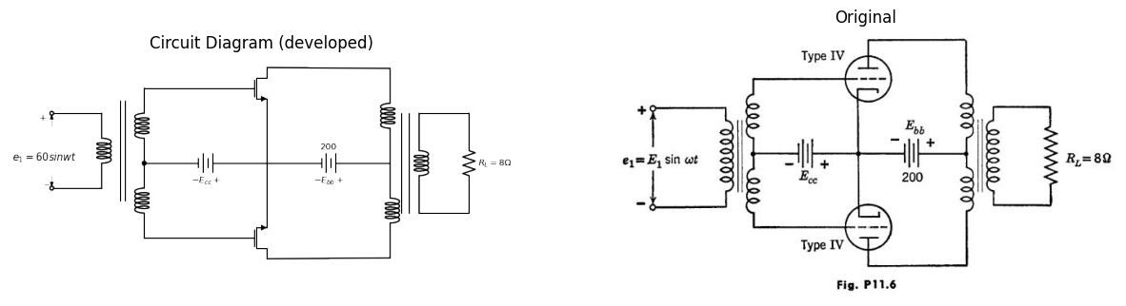
11.7. The basic circuit for a push-pull amplifier is shown in Fig. P11.6. The input transformer has a turns ratio of 1:2 from primary to each half of the secondary. The turns ratio n:1 of the output transformer from either half of the primary to the secondary is to be determined for a load resistance of 8 ohms.
Determine E1, Eco, and n to yield maximum power output with each triode conducting plate current during approximately one-half cycle, with $e{c}< 0 $(class B). What is the power output?
The end

