Table of Contents

1 Logic Design with MOSFETs 2
CMOS integrated circuits use bi-directional devices called MOSFETs as logic switches. This chapter examines the logical characteristics of MOSFETs and develops techniques for building digital networks.

1.1 2.1 Ideal Switches and Boolean Operations
All digital designs are based on primitive logic operations. The first task in our study of VLSI will be to create electronic logic gates that can be used as building blocks in complex switching networks. Logic gates are created by using sets of controlled switches. The characteristics of an assert-high controlled switch are illustrated by the drawings in Figure 2.1. In this idealized situation, the state of the switch (open or closed) is determined by the value of the control variable A. In Figure 2.1(a), the control bit has the value of A = 0 which is defined to give an open switch. This means that there is no relationship between the two variables x and y as represented by the gap between the left and right sides. The opposite case is a closed switch where we visualize the top portion of the switch being “pushed down” as shown in Figure 2.1(b). This condition occurs when A = 1 and connects the two sides of the switches
import schemdraw
import schemdraw.elements as elm
import matplotlib.pyplot as plt
from schemdraw import dsp
from schemdraw import logic
with schemdraw.Drawing() as d:
d += (l1 :=elm.Line().down(d.unit*.001).dot().label('$A=0$','right'))
d += (l2 :=elm.Line().down(d.unit*.3))
d += (l3 :=elm.Line().right(d.unit*.3))
d += (l4 :=elm.Line().left(d.unit*.3).at(l3.start))
d += (l5 :=elm.Line().right(d.unit*.003).dot().at((-.5,-1.5)))
d += (l6 :=elm.Line().right(d.unit*.003).dot().at((.5,-1.5)))
d += (l7 :=elm.Line().left(d.unit*.3).at(l5.start).label('$x$','left').label('\n\n\n\n(a) open','right'))
d += (l8 :=elm.Line().right(d.unit*.3).at(l6.start).label('$y$','right'))
d += (l9 :=elm.Line().down(d.unit*.001).dot().label('$A=1$','right').at((6,0)))
d += (l10 :=elm.Line().down(d.unit*.3))
d += (l11 :=elm.Line().right(d.unit*.3))
d += (l12 :=elm.Line().left(d.unit*.3).at(l11.start))
d += (l13 :=elm.Line().right(d.unit*.003).dot().at((5.5,-1)))
d += (l14 :=elm.Line().right(d.unit*.003).dot().at((6.5,-1)))
d += (l15 :=elm.Line().left(d.unit*.3).at(l13.start).label('$x$','left').label('\n\n\n\n(b) close','right'))
d += (l16 :=elm.Line().right(d.unit*.3).at(l14.start).label('$y=x$','right'))
d += elm.Arrow().down().length(.5).linewidth(0.6).color('black'). at((5.75,-.1))
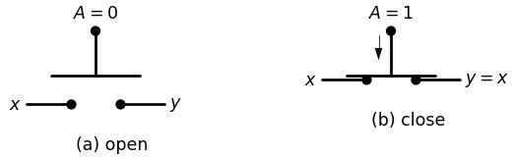

1.1.1 FIG 2.1 Behavior of an assert-high switch
So That
$$y=x$$
$$\left(2.1\right)$$
is valid. If we interpret the left side variable x as the input and the side as the output, then we can say th a t the condition A = 1 allow
input variable to flow through the switch and establish the value output. This is called an “assen-high” switch because a high contra:.A = 1 is required w close the circuit.
A different approach to characterizing the behavior off the switch write the logic equationy
$$y=x.AiffA=1$$
$$\left(2.2\right)$$
By itself, the relationship between x and y is undefined if A = 0. Alther this appears to be a serious defidenev. in practice w will avoid thejr tern by using additional switches to define th e value of y far this case Let u s now proceed to create a logic netw ork by combining thean of an ideal sw itch w ith a voltage so u rc e . S u p p o se th at wetfit switches th at are controlled by th e in d ep en d en t variables candh connect them as shown by the diagram in Figure 2.2. The two switch are sa id to be in se rie s w ith each other. As we tra c e the signal through the firs-, switch, equation (2.2) show s th a t the output hte after the switch, is given by a 1 as indicated nn the drawing This Arts th e in p u t to the second sw itch, so th a t a p p h ln g equation (2.2) yields
$$g=\left(a.1\right).b=a.b$$
$$\left(2.3\right)$$
for the ou tp u t This is easy to interpret using a quabtairre analysis sw itches m u st be closed w ith a = 1 AND b = 1 to allow the inputs reach the output and result in g = 1. The circuit appears to provides —0 2 operation.- However, note th a t eq u a tio n (2.2) is valid only if cantrol hr. h a s a value of 1; it if is 0, th e n them » no direct relation between the left and right sides of the switch There are three other
import schemdraw
import schemdraw.elements as elm
import matplotlib.pyplot as plt
from schemdraw import dsp
from schemdraw import logic
with schemdraw.Drawing() as d:
d += (l1 :=elm.Line().down(d.unit*.001).dot().label('$a$','right'))
d += (l2 :=elm.Line().down(d.unit*.3))
d += (l3 :=elm.Line().right(d.unit*.3))
d += (l4 :=elm.Line().left(d.unit*.3).at(l3.start))
d += (l5 :=elm.Line().down(d.unit*.001).dot().label('$b$','right').at((5,0)))
d += (l6 :=elm.Line().down(d.unit*.3))
d += (l7 :=elm.Line().right(d.unit*.3))
d += (l8 :=elm.Line().left(d.unit*.3).at(l7.start))
d += (l9 :=elm.Line().right(d.unit*.003).dot().at((-.5,-1.5)))
d += (l10 :=elm.Line().right(d.unit*.003).dot().at((.5,-1.5)))
d += (l11 :=elm.Line().left(d.unit*.5).at(l9.start).label('$1$','left').label('\n\n\n\nINPUT','left').dot())
d += (l12 :=elm.Line().right(d.unit*1.3).at(l10.start).label('$a-1$','bottom').dot())
d += (l13 :=elm.Line().right(d.unit*.003).dot().at((5.5,-1.5)))
d += (l14 :=elm.Line().right(d.unit*.8).label('$(a-1)-b$','bottom').dot().label('$g=a.b$\n\n output','right'))
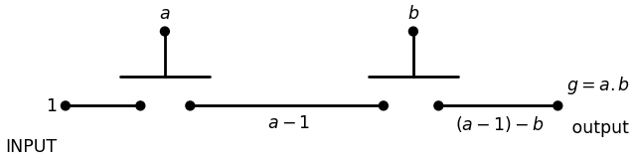

1.1.2 Fig 2.2 series conected switch
bilities for the two inputs:
$$\left(a.b\right)=\left(1,0\right),\left(0,1\right),\left(0,0\right)$$
$$\left(2.4\right)$$
Any of these input com binations should result in a logical o utput of g = 0 b u t the logic equations say th a t g is undefined. . Before proceeding any further, let u s clarify our approach to portraying logic networks. In general, the switch draw ings will be called sc h e m a tic diag ram s since they show the “schem e” used in the wiring. We extend th is term inology to inclu d e d iag ram s th a t c o n ta in electronic devices. Since we w ant to keep the drawings relatively com pact and neat looking, wiring lines will often cross one another in the drawing. W hen this occurs, we will adopt the convention shown in Figure 2.3. In Figure 2.3(a), Wire 1 and Wire 2 are assum ed to be totally separate. The signal a on Wire 1 has no relationship to the signal b on Wire 2. If we w ish to create a connec tion, we will use a “dot" as in Figure 2.3(b). In this case, the two wires are connected so th a t placing a signal a on one of th e lines re su lts in the same value on all points of both lines.
import schemdraw
import schemdraw.elements as elm
import matplotlib.pyplot as plt
from schemdraw import dsp
from schemdraw import logic
with schemdraw.Drawing() as d:
d += (l1 :=elm.Line().right(d.unit*.9).label('$b$','left').label('$Wire 2$','right'))
d += (l2 :=elm.Line().down(d.unit*.9).label('$a$\n\n (a) no connection','left').label('$Wire 1$','right').at((1.5,1.2)))
d += (l3 :=elm.Line().right(d.unit*.9).label('$a$','left').label('$a$','right').at((6,0)))
d += (l4 :=elm.Line().down(d.unit*.9).label('$a$\n\n (b) connection','left').label('$a$','right').at((7.5,1.2)))
d += (l5 :=elm.Line().right(d.unit*.003).dot().at((7.5,0)))
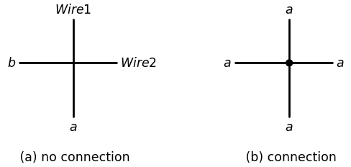

1.1.3 Figure 2.3 connection convention used in schematic diagrams
Let u s examine another circuit th a t h as the sam e problem. Figure 2.4 shows two sw itches th a t are controlled by the independent variables a and b, b u t the two are wired in p a ra lle l w ith one another; th is m eans th a t the left (input) sides are connected together and the right (output) sides are connected together. The o u t p u t/ c a n be constructed by recog-
import schemdraw
import schemdraw.elements as elm
import matplotlib.pyplot as plt
from schemdraw import dsp
from schemdraw import logic
with schemdraw.Drawing() as d:
d += (l1 :=elm.Line().down(d.unit*.001).dot().label('$a$','right'))
d += (l2 :=elm.Line().down(d.unit*.3))
d += (l3 :=elm.Line().right(d.unit*.3))
d += (l4 :=elm.Line().left(d.unit*.3).at(l3.start))
d += (l5 :=elm.Line().right(d.unit*.003).dot().at((-.5,-1.5)))
d += (l6 :=elm.Line().right(d.unit*.003).dot().at((.5,-1.5)))
d += (l7 :=elm.Line().left(d.unit*.6).at(l5.start))
d += (l8 :=elm.Line().right(d.unit*.6).at(l6.start).label('$a.1$','top'))
d += (l9 :=elm.Line().down(d.unit*.001).dot().label('$b$','right').at((0,-2.5)))
d += (l10 :=elm.Line().down(d.unit*.3))
d += (l11 :=elm.Line().right(d.unit*.3))
d += (l12 :=elm.Line().left(d.unit*.3).at(l11.start))
d += (l13 :=elm.Line().right(d.unit*.003).dot().at((-.5,-4)))
d += (l14 :=elm.Line().right(d.unit*.003).dot().at((.5,-4)))
d += (l15 :=elm.Line().left(d.unit*.6).at(l13.start).dot())
d += (l16 :=elm.Line().right(d.unit*.6).at(l14.start).dot().label('$b.1$','bottom'))
d += (l17 :=elm.Line().right(d.unit*.6).endpoints(l15.end,l7.end))
d += (l17 :=elm.Line().right(d.unit*.6).endpoints(l16.end,l8.end).label('$+$','top'))
d += (l18 :=elm.Line().left(d.unit*.6).at(l15.end).dot().label('$1$\n\n Input','left'))
d += (l18 :=elm.Line().right(d.unit*.6).at(l16.end).dot().label('$f=a+b$\n\n output','right'))
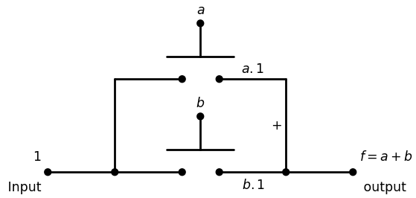

1.1.4 Figure 2.4 parallel- connected switch
nizing that according to equation (2.2), the top switch produces ane of a . 1 iff a = 1, while the lower switch produces an output of b.1and a.1 Both expressions are shown at the appropriate points in the diac We conclude th at if either a = 1 OR b = 1 (or both), then the other. described by the single expression
$$g=a+b$$
$$\left(2.5\right)$$
which appears to be the OR2 operation at this point in the analysis allel-connected switches can th u s be used to OR variables together:fc indicated on the diagram by including the “+” between the switches? however, that if a = 0 and b = 0 at the sam e time, then the outputjj. switching network is undefined. It th u s fails to provide the entire- function. The preceding examples illustrate th a t sw itches have characters that can be used as a basis for implem enting logic operations. Hott since the logic equation (2.2) is valid only if the switch is closed, w not able to obtain complete AND and OR gates as neither network produce a logic 0 output. It is useful a t th is point to in tro d u c e a n o th e r type of switch: behaves in the exact opposite manner. This is called an assert-low switch and is defined to have the ch aracteristics illustrated in Figure 2.5 have added a logic “bubble” to the top of the symbol to distinguish ii- an assert-high switch. By definition, an assert-low switch is close we the control bit is at a value of A = 0 as shown in Figure 2.5(a). Toop switch we m ust apply a value of A = 1 to the device as in Figure 2.5 This behavior can be described by the logic equation
$$y=x.A̅iffA=0$$
$$\left(2.6\right)$$
In this case, the value of y is not defined if A = 1. Comparing the two?' of switches we see that they behave in a complementary manner. As an example of how this type of sw itch can be used, consider series-connected pair in Figure 2.6. T racing th e signal path from input through the first switch gives an output of a • 1 which is valid iff A=0 . This acts as the input to the second switch so th a t the output of
import schemdraw
import schemdraw.elements as elm
import matplotlib.pyplot as plt
from schemdraw import dsp
from schemdraw import logic
with schemdraw.Drawing() as d:
d += (l1 :=elm.Line().down(d.unit*.001).dot().label('$A=1$','right'))
d += (l2 :=elm.Line().down(d.unit*.3).dot(open=True))
d += (l3 :=elm.Line().right(d.unit*.3))
d += (l4 :=elm.Line().left(d.unit*.3).at(l3.start))
d += (l5 :=elm.Line().right(d.unit*.003).dot().at((-.5,-1.5)))
d += (l6 :=elm.Line().right(d.unit*.003).dot().at((.5,-1.5)))
d += (l7 :=elm.Line().left(d.unit*.3).at(l5.start).label('$x$','left').label('\n\n\n\n(b) open','right'))
d += (l8 :=elm.Line().right(d.unit*.3).at(l6.start).label('$y=x$','right'))
d += (l9 :=elm.Line().down(d.unit*.001).dot().label('$A=0$','right').at((6,0)))
d += (l10 :=elm.Line().down(d.unit*.3).dot(open=True))
d += (l11 :=elm.Line().right(d.unit*.3))
d += (l12 :=elm.Line().left(d.unit*.3).at(l11.start))
d += (l13 :=elm.Line().right(d.unit*.003).dot().at((5.5,-1)))
d += (l14 :=elm.Line().right(d.unit*.003).dot().at((6.5,-1)))
d += (l15 :=elm.Line().left(d.unit*.3).at(l13.start).label('$x$','left').label('\n\n\n\n(a) close','right'))
d += (l16 :=elm.Line().right(d.unit*.3).at(l14.start).label('$y$','right'))
d += elm.Arrow().up().length(.5).linewidth(0.6).color('black'). at((5.75,-.5))
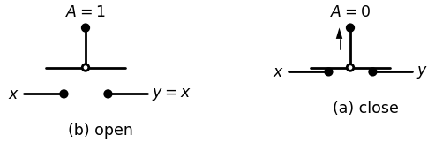

1.1.5 Figure 2.5 An assert-low switch
import schemdraw
import schemdraw.elements as elm
import matplotlib.pyplot as plt
from schemdraw import dsp
from schemdraw import logic
with schemdraw.Drawing() as d:
d += (l1 :=elm.Line().down(d.unit*.001).dot().label('$a ̅$','right'))
d += (l2 :=elm.Line().down(d.unit*.3).dot(open=True))
d += (l3 :=elm.Line().right(d.unit*.3))
d += (l4 :=elm.Line().left(d.unit*.3).at(l3.start))
d += (l5 :=elm.Line().down(d.unit*.001).dot().label('$b ̅$','right').at((5,0)))
d += (l6 :=elm.Line().down(d.unit*.3).dot(open=True))
d += (l7 :=elm.Line().right(d.unit*.3))
d += (l8 :=elm.Line().left(d.unit*.3).at(l7.start))
d += (l9 :=elm.Line().right(d.unit*.003).dot().at((-.5,-1.5)))
d += (l10 :=elm.Line().right(d.unit*.003).dot().at((.5,-1.5)))
d += (l11 :=elm.Line().left(d.unit*.5).at(l9.start).label('$1$','left').label('\n\n\n\nINPUT','left').dot())
d += (l12 :=elm.Line().right(d.unit*1.3).at(l10.start).label('$a ̅.1$','bottom').dot())
d += (l13 :=elm.Line().right(d.unit*.003).dot().at((5.5,-1.5)))
d += (l14 :=elm.Line().right(d.unit*.8).label('$(a ̅.1).b ̅$','bottom').dot().label('$h=a ̅.b ̅$\n\n output','right'))
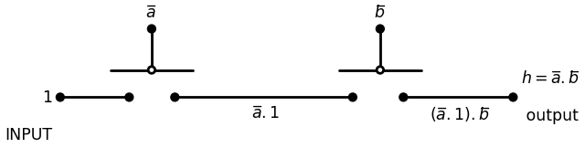

1.1.6 Figure 2.6 Series Connected complementary switches
series chain is given by
$$h=\left(a̅.1\right).b̅=\left(a+b\right)̅$$
$$\left(2.7\right)$$
where we have used the DeMorgan relation to write the second line. This looks like the NOR2 operation. However, since the second switch m u st be closed with b = 0, this resu lt is correct only if b o th a = 0 an d b = 0. If either a or b is a 1, then g is undefined. We th u s have th e sam e type of problem experienced in our earlier examples. Let us now progress to the idea of using both types of sw itches in a single network. We will provide both logic 1 and logic 0 in p u ts in an effort to produce an output th at is defined for all possible in p u t com binations. In Figure 2.7, the assert-high switch SW1 is u sed to connect a logic 0 input to the output y, while the assert-low switch SW2 connects a logic 1 input to y. The variable a controls both switches. Since the two are in p a r allel, we may write the OR relation between the upper and lower bran ch es to give the output in the form
$$y=a̅.1+a.0$$
$$\left(2.8\right)$$
The operation of the circuit can be understood by specifying a value for a. If a = 0, then SW1 is open and SW2 is closed which gives
$$y=0̅.1+0.0=1$$
$$\left(2.9\right)$$
If a = 1, then SW1 is closed and SW2 is open. S u b s titu tin g in to th e expression we have
$$y=1̅.1+1.0=0$$
$$\left(2.10\right)$$
This circuit thus eliminates the problem of an undefined voltage. M ore over, since logically a 0 = 0, the expression reduces to
$$y=a̅$$
$$\left(2.11\right)$$
In other words, this circuit implements the NOT operation.
import schemdraw
import schemdraw.elements as elm
import matplotlib.pyplot as plt
from schemdraw import dsp
from schemdraw import logic
with schemdraw.Drawing() as d:
d += (l1 :=elm.Line().down(d.unit*.001).dot().label('$a$','right'))
d += (l2 :=elm.Line().down(d.unit*.3).dot(open=True))
d += (l3 :=elm.Line().right(d.unit*.3))
d += (l4 :=elm.Line().left(d.unit*.3).at(l3.start))
d += (l5 :=elm.Line().right(d.unit*.003).dot().at((-.5,-1.5)))
d += (l6 :=elm.Line().right(d.unit*.003).dot().at((.5,-1.5)))
d += (l7 :=elm.Line().left(d.unit*.6).at(l5.start).dot().label('$1$','left').label('\n\n\n\n\n\n\n\n Input','left'))
d += (l8 :=elm.Line().right(d.unit*.6).at(l6.start).label('$a ̅.1$','top').label('\nsw2','left'))
d += (l9 :=elm.Line().down(d.unit*.001).dot().label('$a$','right').at((0,-2.5)))
d += (l10 :=elm.Line().down(d.unit*.3))
d += (l11 :=elm.Line().right(d.unit*.3))
d += (l12 :=elm.Line().left(d.unit*.3).at(l11.start))
d += (l13 :=elm.Line().right(d.unit*.003).dot().at((-.5,-4)))
d += (l14 :=elm.Line().right(d.unit*.003).dot().at((.5,-4)))
d += (l15 :=elm.Line().left(d.unit*.6).at(l13.start).label('$0$','left'))
d += (l16 :=elm.Line().right(d.unit*.6).at(l14.start).dot().label('$a.0$','bottom').label('\nsw1','left'))
d += (l17 :=elm.Line().up(d.unit*.4).at(l16.end).dot())
d += (l18 :=elm.Line().up(d.unit*.43).label('$+$','top'))
d += (l19 :=elm.Line().right(d.unit*.4).at(l17.end).dot().label('$y=a ̅.1 + a.0= a ̅$','right').label('\n\n\n\n\n\n output','right'))
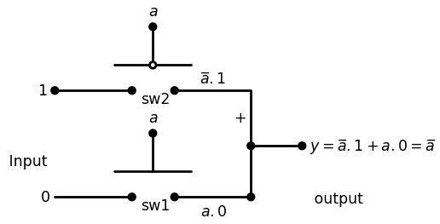

1.1.7 Figure 2.7 A switch-based NOT gate
$$y=NOT\left(a\right)=a̅$$
$$\left(2.12\right)$$
This demonstrates that using two switches w ith opposite characteris allows us to build a network with well-defined results. The NOT circuit in Figure 2.7 is based on the behavior of a 2:1 mu plexor as shown in Figure 2.8. The M U X u ses the input a to self between input 0 (that has a “ 1" applied to it) when a = 0, or input 1(th') has a "O’ applied to it) when a = 1. The output is given by the expressic
$$y=a̅.1+a.0$$
$$\left(2.13\right)$$
which reduces to y = a. A close exam ination o f the switching circuit Figure 2.7 verifies that there is a one-to-one correspondence with the multiplexor.

1.2 MOSFETs as Switches
MOSFETs are electronic devices that are used to direct and control in signals in high-density digital IC design.3 The acronym “MOSFET star
import schemdraw
import schemdraw.elements as elm
import matplotlib.pyplot as plt
from schemdraw import dsp
from schemdraw import logic
with schemdraw.Drawing() as d:
d += (l1 :=elm.Line().right(d.unit*.7).label('$2:1$','bottom'))
d += (l2 :=elm.Line().down(d.unit*1.2))
d += (l3 :=elm.Line().left(d.unit*.7))
d += (l4 :=elm.Line().up(d.unit*1.2))
d += (l5 :=elm.Line().left(d.unit*.5).label('$a$','left').dot().at((0,-.75)).label(r'0} $G=\frac {0}{1}$','right'))
d += (l6 :=elm.Line().left(d.unit*.5).label('"1"','left').dot().at((0,-1.75)).label('$0$','right'))
d += (l7 :=elm.Line().left(d.unit*.5).label('"0"','left').dot().at((0,-2.75)).label('$1$','right'))
d += (l8 :=elm.Line().right(d.unit*.5).label('$F(x)=a ̅.1 + a.0 $','right').dot().at((2.1,-1.75)))
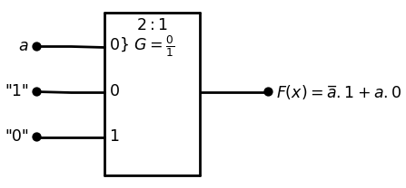

1.2.1 Figure 2.8 A MUX-based NOT gate
for m etal-oxide-sem iconductor fie ld -effe c t tran sisto r, but w e w ill not worry about the details just yet. In many ways, M OSFETs behave like the idealized switches introduced in the previous section. There are im portant differences that must be taken into account before they are used. These arise from the fact that MOSFETs must obey circuit equations and their ultimate performance is limited by the laws o f physics. In this section we will concentrate on creating switching m odels for the devices. Th e m ore complicated aspects of current flow will be discussed in later chapters. Complementary MOS (CM OS) uses two types o f M O SFE Ts to create logic networks. One type is called an n-channel M O S FE T (or n F E T fo r short), and uses negatively charged electrons for electrical current flow. The circuit symbol for an nFET is shown in Figure 2.9(a). The g a te term i nal acts as the control electrode for the device. Applying a voltage on the gate electrode determines the current flow between the drain and so u rce terminals. The other type o f transistor is called a p-channel M O SFE T or pFET. It uses positive charges for current flow and has the circuit sym bol drawn in Figure 2.9(b). The only graphical difference betw een the n FE T and pFET symbols is the inversion bubble at the gate. As w ith the nFET, the voltage applied to the gate determines the current flow betw een the source and drain terminals. Do not confuse the gate term in a l o f a M O S FET with a logic gate, as the two “gates” are not related. The context o f the discussion always helps clarify the usage. MOSFETs are intrinsically electronic devices. T o use them as logic- controlled switches, we must first define how to translate betw een B ool ean values and electrical parameters. This is accomplished by using vo lt ages that exist on the chip when we apply an external power supply. In the most general case, two power supply voltages VD D and are defined as shown in Figure 2.10. The reference terminal is taken to be the g ro u n d connection (which is at 0 volts) between the two sources so that the chip receives both a positive power voltage VD D and a negative pow er su pply voltage Vss. Early generations o f silicon MOS logic circuits used both pos itive and negative supply voltages. However, modern designs require only a single positive voltage VDD and the ground connection; common values are VDD=5 V and 3.3 V or lower. The remaining source is set to a value o f
import schemdraw
import schemdraw.elements as elm
import matplotlib.pyplot as plt
from schemdraw import dsp
from schemdraw import logic
with schemdraw.Drawing() as d:
d += (M1 := elm.AnalogNFet(offset_gate = False).anchor('drain').theta(270).label('$Gate$','right').reverse())
d += (l1 :=elm.Line().down(d.unit*.001).dot().label('$source$','top').at(M1.source))
d += (l2 :=elm.Line().down(d.unit*.001).dot().label('$drain$','bottom').at(M1.drain))
d += (l3 :=elm.Line().down(d.unit*.001).label('(a) nFET symbol','bottom',color='black').at((-2.5,-2)).color('white'))
d += (M2 := elm.PFet2().anchor('gate').theta(0).label('$Gate$','top').at((8,1)))
d += (l4 :=elm.Line().down(d.unit*.001).dot().label('$source$','bottom').at(M2.source))
d += (l5 :=elm.Line().down(d.unit*.001).dot().label('$drain$','top').at(M2.drain))
d += (l6 :=elm.Line().down(d.unit*.001).label('(b) pFET symbol','bottom',color='black').at((6,-2)).color('white'))
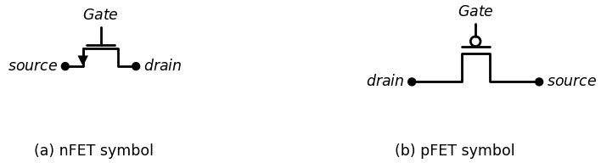

1.2.2 Figure 2.9 Symbol used for nFETs and pFETs
import schemdraw
import schemdraw.elements as elm
import matplotlib.pyplot as plt
from schemdraw import dsp
from schemdraw import logic
with schemdraw.Drawing() as d:
d += ( V1 := elm.SourceV().label('$V{SS}$'))
d += ( V2 := elm.SourceV().label('$V{DD}$'))
d += (l1 :=elm.Line().right(d.unit*.6).label('$Ground$\n\n 0','right').at(V2.start))
d += elm.Ground().at(l1.end)
d += (l2 :=elm.Line().right(d.unit*2).dot().label('$V{DD}>0$','right').at(V2.end))
d += (l3 :=elm.Line().right(d.unit*2).dot().label('$V{SS}<0$','right').at(V1.start).label('$Power Supply$','bottom'))
d += (l4 :=elm.Line().down(d.unit*.001).label('⇒ To chip','bottom',color='black').at((5.5,3.5)).color('white'))
l = d.add(elm.Line().down().length(9).color('gray'). at((4.5,7)).linestyle('--'))
l = d.add(elm.Line().left().length(6).color('gray'). at((4.5,7)).linestyle('--'))
l = d.add(elm.Line().down().length(9).color('gray').linestyle('--'))
l = d.add(elm.Line().right().length(6).color('gray').linestyle('--'))
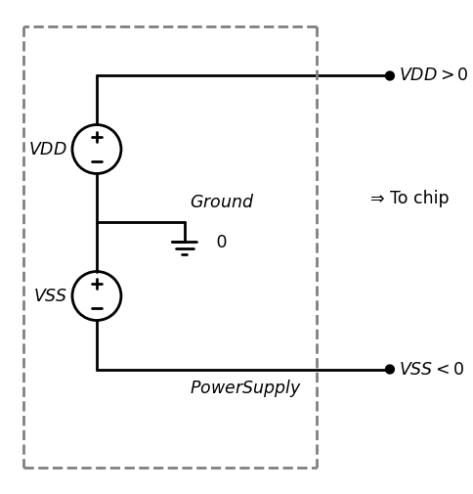

1.2.3 Figure 2.10 Dual Power Supply Voltages
VSS= 0 V. which results in the power supply network portrayed in fig (2 .11a). We will assume that all of our circuits use only a single per voltage source VDD In practice it is still common to use VSS to dan lowest voltage in the circuit such th at Vgs ^ a s an implied value of$0V$ We can now define the relationship betw een logic variables and ages. Recall th at Boolean variables are discrete; a binary variable in have the value of x = 0 or x = 1 only. At the circuit level we represent vanable x using a voltage Vx such th at
$$0≤VX≤VDD$$
$$\left(2.14\right)$$
fives the normal range of values with a power supply providing $0V$, $VDD$ directly to the circuit. The p o sitiv e logic convention then the ideal logic 0 and logic 1 voltages as
import schemdraw
import schemdraw.elements as elm
import matplotlib.pyplot as plt
from schemdraw import dsp
from schemdraw import logic
with schemdraw.Drawing() as d:
d += ( V1 := elm.SourceV().label('$V{DD}$'))
d += (l1 :=elm.Line().right(d.unit*2).at(V1.end))
d += (l2 :=elm.Line().down(d.unit*.3).label('$V{DD}$','right'))
d += ( T := dsp.Box(w=3, h=3).anchor('W').fill('white').at((4.5,.6)).label('CMOS\nLogic \ncircuit'))
d += (l3 :=elm.Line().down(d.unit*.3).at((6,-.9)).label('$Ground$ $0{V}$','left'))
d += (Al4 :=elm.Line().left(d.unit*2).dot())
d += (l5 :=elm.Line().up(d.unit*.8))
d += elm.Ground().at(l4.end)
l = d.add(elm.Line().down().length(7).color('gray'). at((3.2,4)).linestyle('--'))
l = d.add(elm.Line().left().length(5).color('gray').linestyle('--').label('\n\n (a) power supply connection','bottom',color='black'))
l = d.add(elm.Line().up().length(7).color('gray').linestyle('--'))
l = d.add(elm.Line().right().length(5).color('gray').linestyle('--').label('$power supply$','bottom',color='black'))
d += ( T := dsp.Box(w=.3, h=1.5).anchor('W').fill('gray').at((11.5,-1)).label('$ Logic = 0$','right'))
d += (l6 :=elm.Line().up(d.unit*.5).at((11.65,-.2)).label('$Undefined$','bottom',color='black'))
d += ( T := dsp.Box(w=.3, h=1.5).anchor('W').fill('gray').at((11.5,2.05)).label('$ Logic = 1 {V}$','right'))
d += elm.Arrow().up().length(.75).linewidth(1).color('black'). at((11.6,2.8)).label('$V{x}$','right')
d += (l7 :=elm.Line().right(d.unit*.3).at((11.2,2.8)).label('$V{DD}$','left'))
d += (l8 :=elm.Line().right(d.unit*.3).at((11.2,-1.75)).label('$0$','left').label('\n\n (b) Logic definitions','bottom',color='black'))
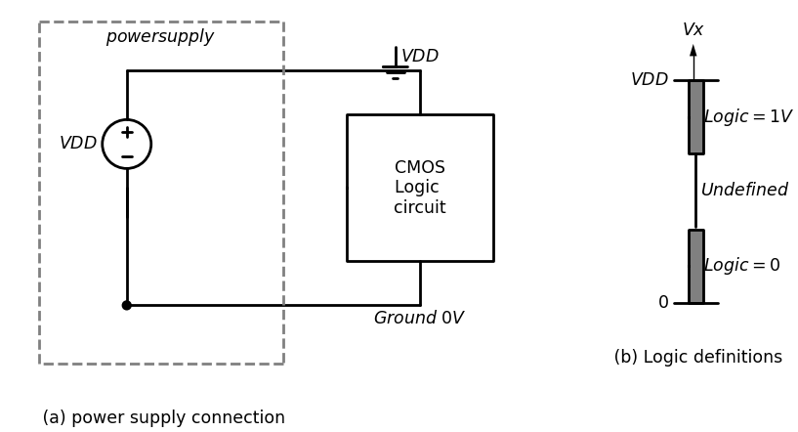

1.2.4 Figure 2.11 Single Voltage power supply
$$X=0,meansthat,VX=0v$$
$$X=1,meansthat,Vx=VDD$$
$$\left(2.15\right)$$
Realistic circuits are more lenient and allow u s to u se a range of voltages for both logic Os and logic Is as portrayed in Figure 2 .1 1(b). In general, • Low voltages correspond to logic 0 values • High voltages correspond to logic 1 values The transition region between the highest logic 0 voltage a n d the lowest logic 1 voltage is undefined in that it does not represent either a 0 or a 1. The actual extent of both voltage ranges is determ ined by the ch aracteris tics of the logic circuits and will be dealt with later. With the logic-voltage conversion defined, let u s now ex am in e th e switching characteristics of MOSFETs. Ideally, a n nFET behaves like an assert-high switch. This is shown in Figure 2.12 w here A is the logic vari able applied to the gate. If A = 0 corresponding to a low voltage, th en the nFET acts like an open switch and there is no relationship betw een the left and right sides; this is illustrated in Figure 2.12(a). Increasing the gate voltage to a high value is the same as changing to A = 1. This results in a closed switch as shown in Figure 2.12(b). As w ith the assert-high switch, this can be described by the logic equation
$$y=X.A$$
$$\left(2.16\right)$$
Which is valid iff A=1. The pFET is exactly opposite in that it behaves like an a ssert-low switch. In Figure 2.13(a), the signal applied to the gate h a s a logical value of A = 1 corresponding to a high voltage. This gives an open circuit an d there is no direct relationship betw een x a n d y. If th e g ate voltage is reduced to give A = 0, then the pFET acts a s a closed switch. This allows us to write the ideal relationship
$$y=X.A̅$$
$$\left(2.17\right)$$
which is valid so long as A = 0 is true; this condition is show n in Figure 2.13(b).
import schemdraw
import schemdraw.elements as elm
import matplotlib.pyplot as plt
from schemdraw import dsp
from schemdraw import logic
with schemdraw.Drawing() as d:
d += (M1 := elm.AnalogNFet(offset_gate = False).anchor('drain').theta(270).label('$A=0$','right').reverse())
d += (l1 :=elm.Line().down(d.unit*.001).dot().label('$X$','top').at(M1.source))
d += (l2 :=elm.Line().down(d.unit*.001).dot().label('$y=?$','bottom').at(M1.drain))
d += (M2 := elm.AnalogNFet(offset_gate = False).anchor('drain').theta(270).label('$A=1$','right').reverse().at((5,0)))
d += (l3 :=elm.Line().down(d.unit*.001).dot().label('$X$','top').at(M2.source))
d += (l4 :=elm.Line().down(d.unit*.001).dot().label('$y=x$','bottom').at(M2.drain))
d += (l5 :=elm.Line().down(d.unit*.001).label('(a) open',color='black').at((0,-1)).color('white'))
d += (l6 :=elm.Line().down(d.unit*.001).label('(b) Close',color='black').at((5.5,-1)).color('white'))
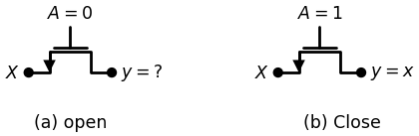

1.2.5 Figure 2.12 nFET switching characteristics
import schemdraw
import schemdraw.elements as elm
import matplotlib.pyplot as plt
from schemdraw import dsp
from schemdraw import logic
with schemdraw.Drawing() as d:
d += (M1 := elm.PFet2(offset_gate = False).anchor('gate').theta(0).label('$A=1$','top').reverse())
d += (l1 :=elm.Line().down(d.unit*.001).dot().label('$X$','top').at(M1.source))
d += (l2 :=elm.Line().down(d.unit*.001).dot().label('$y=?$','bottom').at(M1.drain))
d += (M2 := elm.PFet2(offset_gate = False).anchor('gate').theta(0).label('$A=0$','top').reverse().at((6,0)))
d += (l3 :=elm.Line().down(d.unit*.001).dot().label('$X$','top').at(M2.source))
d += (l4 :=elm.Line().down(d.unit*.001).dot().label('$y=x$','bottom').at(M2.drain))
d += (l5 :=elm.Line().down(d.unit*.001).label('(a) open',color='black').at((0,-3)).color('white'))
d += (l6 :=elm.Line().down(d.unit*.001).label('(b) Close',color='black').at((7,-3)).color('white'))
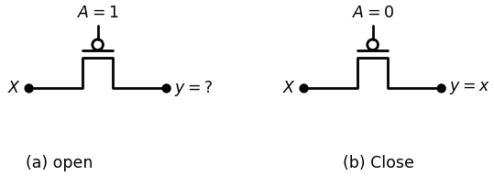

1.2.6 Figure 2.13 pFET switching characteristics
MOSFETs allow us to design logic circu its using the techniquit assert-high and assert-low switching networks. However, FETs are Physical devices that do not behave exactly like the ideal switch models a,b This is not a severe problem so long as we understand the differences learn the limitations.

1.3 FET Threshold Voltages
The switching equations assume that the binary variable .A applied to gate of a FET is either a 0 or a 1. The corresponding voltage V{A} is Physical cal quantity and does not behave in such a discrete manner. More over want to define a range of voltages for both cases o f A = 0 and A = 1 to in the design o f working circuits. Every M O SFE T has a charactering parameter called the threshold voltage $VT$ that helps us define important gate voltage ranges. The specific value o f V-j-is established doing the manufacturing process, and is thus taken to be a given value the VLSI designer. One complicating factor is that nFETs and pFETs different threshold voltages.
An nFET is characterized by a threshold voltage that is a pos number with values around VT n = 0.5 V to 0.7 V being typical. Then- i n § ° f ^Tn c a n be understood by referring to the parameters shownin ure 2.14(a). First note that the drain term inal has been identified8' one closest to the power supply VD D , while the source terminal has: connected to ground (0 V). The gate-sou rce voltage Vcsn shown it drawing is the important param eter that determ ines whether then neacts as an open or closed switch. In particular, if
$$VGSn≤VTn$$
$$\left(2.18\right)$$
then the transistor acts like an open circuit and there is no current between the drain and source; this condition is said to describe a transistor that is off. If instead
$$VGSn≥VTn$$
$$\left(2.19\right)$$
then the nFET drain and source are connected and the equivalent switch is closed. A transistor that conducts current is said to be on. This behavier
import schemdraw
import schemdraw.elements as elm
import matplotlib.pyplot as plt
from schemdraw import dsp
from schemdraw import logic
with schemdraw.Drawing() as d:
d += (M1 := elm.AnalogNFet(offset_gate = False).anchor('drain').theta(0).reverse().label('$Mn$','right'))
d += (l1 :=elm.Line().up(d.unit*.2).dot().label('$Drain$','right').at(M1.drain))
d += (l2 :=elm.Line().down(d.unit*.2).label('$source$','bottom').at(M1.source).label('$-$','top'))
d += (l3 :=elm.Line().left(d.unit*.2).dot().label('$V{A}$','left').at(M1.gate).label('$Gate$','top').label('$+$','bottom'))
d += (l4 :=elm.Line().down(d.unit*.001).label('$V{GSn}$',color='black').at((-.2,-1.5)).color('white'))
d += elm.Ground().at(l2.end)
d += (l5 :=elm.Line().down(d.unit*.001).label('$↑ to V{DD}$',color='black').at((1,2)).color('white'))
d += elm.Arrow().up().length(4).linewidth(1).color('black'). at((6,-2.8)).label('$V{A}$','right')
d += (l6 :=elm.Line().right(d.unit*.2).label('$0$','left').at((5.7,-2.8)))
d += (l7 :=elm.Line().right(d.unit*.2).label('$V{Tn}$','left').at((5.7,-2)))
d += (l8 :=elm.Line().right(d.unit*.2).label('$V{DD}$','left').at((5.7,.7)))
d += (l9 :=elm.Line().down(d.unit*.001).label('A=0 Mn off',color='black').at((8.2,-2.5)).color('white'))
d += elm.Arrow().up().length(2.8).linewidth(1).color('black'). at((6.5,-2)).label('A=1 Mn On','bottom')
d += (l10 :=elm.Line().down(d.unit*.001).label('(a) Gate-source Voltage',color='black').at((2,-3.5)).color('white'))
d += (l11 :=elm.Line().down(d.unit*.001).label('(b) Logic Translation',color='black').at((8,-3.5)).color('white'))
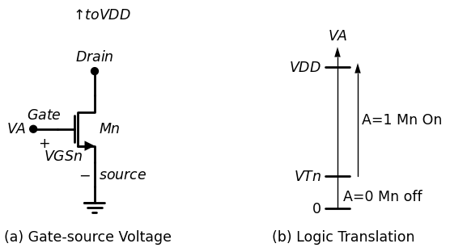

1.3.1 Figure 2.14 Threshold Voltage of an nFET
allows us to create the voltage diagram show n in Figure 2.14(b) to define the voltage VA that is associated w ith the binary variable A. In particular, we note that
$$VA=VGSn$$
$$\left(2.20\right)$$
This shows that A = 0 correspon ds to va lu es o f VA ≤ VTn , while A = 1 implies that VA ≥VTn . These relations establish the voltage ranges needed to control the nFET. A pFET behaves in a complementary manner. Consider the transistor shown in Figure 2 .15(a). For the pFET, the source term inal has been con nected to the power supply $VDD$ while the drain is th e side closest to ground; this is opposite to that used for the nFET. In this device, the source-gate voltage VsGp is the im portant applied voltage. B y convention, the pFET threshold voltage VTp is referenced to the gate-source voltage
import schemdraw
import schemdraw.elements as elm
import matplotlib.pyplot as plt
from schemdraw import dsp
from schemdraw import logic
with schemdraw.Drawing() as d:
d += (M1 := elm.PFet2(offset_gate = False).anchor('drain').theta(90).reverse().label('$Mp$','bottom'))
d += (l1 :=elm.Line().up(d.unit*.2).dot().label('$source$','right').at(M1.drain).label('$+$','top'))
d += (l2 :=elm.Line().down(d.unit*.2).label('$drain$','bottom').at(M1.source).dot())
d += (l3 :=elm.Line().left(d.unit*.2).dot().label('$V{A}$','left').at(M1.gate).label('$Gate$','bottom').label('$-$','top'))
d += (l4 :=elm.Line().down(d.unit*.001).label('$V{SGp}$',color='black').at((-.2,-.5)).color('white'))
#d += elm.Ground().at(l2.end)
d += (l5 :=elm.Line().down(d.unit*.001).label('$↓ to Ground$',color='black').at((1,-4)).color('white'))
d += elm.Arrow().up().length(4).linewidth(1).color('black'). at((6,-2.8)).label('$V{A}$','right')
d += (l6 :=elm.Line().right(d.unit*.2).label('$0$','left').at((5.7,-2.8)))
d += (l7 :=elm.Line().right(d.unit*.2).label('$(V{DD}-|V{Tp}|$)','left').at((5.7,-.5)))
d += (l8 :=elm.Line().right(d.unit*.2).label('$V{DD}$','left').at((5.7,.7)))
d += (l9 :=elm.Line().down(d.unit*.001).label('A=0 Mp on',color='black').at((8.7,-1.5)).color('white'))
d += elm.Arrow().up().length(1.8).linewidth(1).color('black'). at((6.5,-2.7))
d += (l10 :=elm.Line().down(d.unit*.001).label('(a) source-GateVoltage',color='black').at((2,-5)).color('white'))
d += (l11 :=elm.Line().down(d.unit*.001).label('(b) Logic Translation',color='black').at((8,-4.5)).color('white'))
d += elm.Arrow().up().length(1).linewidth(1).color('black'). at((6.5,-.3)).label('A=1 Mp Off','bottom')
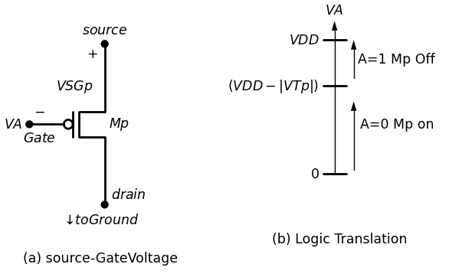

1.3.2 Figure 2.15 Threshold Voltage of an nFET
VGSp and is a negative number with typical values in the range of ab VTp = - 0.5 V to VTp = - 0.8 V. In this book we will describe pFETs by us VSGp = -VGSp GSp a s this allows us to use the absolute value |VTp| for threshold voltage. The meaning o f the threshold voltage is as follows:
$$VSGp≤\left|VTp\right|$$
$$\left(2.21\right)$$
then the pFET is o ff and it acts as an open switch. Conversely, a last source-gate voltage of
$$VSGp≥\left|VTp\right|$$
$$\left(2.22\right)$$
turns the pFET on and it behaves as a closed switch. To relate this behavior to the applied voltage VA we first sum voltages to write
$$VA+VSGp=VDD$$
$$\left(2.23\right)$$
Thus,
$$VA=VDD−VSGp$$
$$\left(2.24\right)$$
shows that a low value of VA implies a large VGp a n d the pFET is on. Stilarly, if VA is large then $VSGp$ is small and the pFET is off. This gives The logic 0 and logic 1 ranges summarized in Figure 2.15(b). Note that transition between a logic 0 and a logic 1 is at
$$VDD−\left|VTp\right|$$
$$\left(2.25\right)$$
since this corresponds to the source-gate voltage where the device turn on. It is important to note that the logic 0 and logic 1 voltage ranges of are different for the two types of FETs. One w ay around this problem is note that there are regions o f overlap for both A = 0 and A = 1 valuestif can be used if a uniform definition is needed. The ideal values of
$$VA=0$$
$$VA=VDD$$
$$\left(2.25\right)$$
are, however, valid for both devices.

1.4 Pass Characteristics
An ideal electrical switch can pass any volta ge applied to it. This we implicitly assumed in our development o f switch logic networks where we used the switches to pass logic 0 and logic 1 levels equally well. MOSFET are more limited in their capabilities and are not able to pass arbitran voltages from source to drain or vice versa. Let us examine the pass characteristics o f nFETs first. Figure 2.16 summarizes the behavior of the device when w e attempt to use it to pass
import schemdraw
import schemdraw.elements as elm
import matplotlib.pyplot as plt
from schemdraw import dsp
from schemdraw import logic
with schemdraw.Drawing() as d:
d += (M1 := elm.AnalogNFet(offset_gate = False).anchor('drain').theta(270).reverse())
d += (l1 :=elm.Line().up(d.unit*.2).dot().label('$V{DD}$','right').at(M1.gate))
d += (l2 :=elm.Line().left(d.unit*.2).dot().label('$IN$','left').at(M1.source).label('$+$','bottom'))
d += (l3 :=elm.Line().right(d.unit*.1).dot().at(M1.drain).label('$+$','bottom'))
d += elm.Arrow().right().length(.8).linewidth(2).color('black'). at(l3.end).label('out','right')
d += elm.Ground().at((-2,-1.75)).label('$-$','top').label('\n(a) Logic 0 transfer','bottom')
d += (l4 :=elm.Line().right(d.unit*.001).dot().at((-2,-1.75)))
d += (l5 :=elm.Line().right(d.unit*.1).at((-3.5,-1)).label('$V{x}=0{V}$','right',color='black').color('white'))
d += elm.Ground().at((0.3,-1.75)).label('$-$','top')
d += (l6 :=elm.Line().right(d.unit*.001).dot().at((0.3,-1.75)))
d += (l7 :=elm.Line().right(d.unit*.1).at((-.3,-1)).label('$V{y}=0{V}$','right',color='black').color('white'))
d += (M2 := elm.AnalogNFet(offset_gate = False).anchor('drain').theta(270).reverse().at((8,0)))
d += (l8 :=elm.Line().up(d.unit*.2).dot().label('$V{DD}$','right').at(M2.gate).label('$+$','bottom').label('\n VTn','bottom'))
d += (l9 :=elm.Line().left(d.unit*.2).dot().label('$IN$','left').at(M2.source).label('$+$','bottom'))
d += (l10:=elm.Line().right(d.unit*.1).dot().at(M2.drain).label('$+$','bottom').label('$-$','top'))
d += elm.Arrow().right().length(.8).linewidth(2).color('black'). at(l10.end).label('out','right')
d += elm.Ground().at((6,-1.75)).label('$-$','top').label('\n(b) Logic 1 transfer','bottom')
d += (l11 :=elm.Line().right(d.unit*.001).dot().at((6,-1.75)))
d += (l12 :=elm.Line().right(d.unit*.1).at((4.5,-1)).label('$V{x}=V{DD}$','right',color='black').color('white'))
d += elm.Ground().at((8.3,-1.75)).label('$-$','top')
d += (l13 :=elm.Line().right(d.unit*.001).dot().at((8.3,-1.75)))
d += (l14 :=elm.Line().right(d.unit*.1).at((7.7,-1)).label('$V{y}=V{1}=(V{DD}-VT{n})$','right',color='black').color('white'))
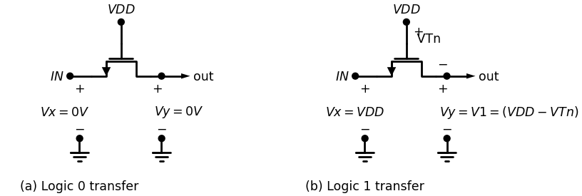

1.4.1 Figure 2.16 nFET pass characteristics
voltage from left to right. Applying VD D to the gate insures that the nFET is on and the device acts like a closed switch. In Figure 2 .16(a) a logic 0 voltage of Vx = 0 V is applied to the left side. This results in an output voltage of Vy = 0 V as desired. Increasing the input volta ge resu lts in th at value being transmitted to the output side. However, a problem occurs if we apply an ideal logic 1 input voltage o f Vx = VDD as show n in Figure 2.16(b). In this case, the output voltage Vy is reduced to a value
$$V1=VDD−VTn$$
$$\left(2.27\right)$$
which is less than the input voltage VD D . This is referred to as a threshold voltage loss. It arises from the fact that the minimum value of the gate-source voltage need to maintain an on state is
$$VGSn=VTn$$
$$\left(2.28\right)$$
Using the Kirchhoff voltage law, this subtracts from the voltage VD D that is applied to the gate as shown in the draw ing. Since the transmitted voltage Vy is less than the ideal logic 1 value o f VDD , we say that the nFET can only pass a weak logic 1. In the same terminology, the nFET is said to pass a strong logic 0 since it is capable of producing an output voltage of Vy = 0V without any problems. In general, the nFET can pass a voltage in the range [0,V1], but nothing above V1. A pFET has opposite pass characteristics. To examine the pFET properties we apply a logic 0 to the gate by grounding it. Figure 2.17 shows the circuits for both input values. Figure 2 .17(a) portrays the case where Vx = VDD corresponding to a logic 1 input. The output voltage is
$$Vy=VDD$$
$$\left(2.29\right)$$
import schemdraw
import schemdraw.elements as elm
import matplotlib.pyplot as plt
from schemdraw import dsp
from schemdraw import logic
with schemdraw.Drawing() as d:
d += (M1 := elm.PFet2(offset_gate = False).anchor('drain').theta(360).reverse())
d += (l1 :=elm.Line().up(d.unit*.2).at(M1.gate))
d += (l2 :=elm.Line().left(d.unit*.2))
d += elm.Ground().at(l2.end)
d += (l3 :=elm.Line().left(d.unit*.2).dot().label('$IN$','left').at(M1.source).label('$+$','bottom'))
d += (l4 :=elm.Line().right(d.unit*.1).dot().at(M1.drain).label('$+$','bottom'))
d += elm.Arrow().right().length(.8).linewidth(2).color('black'). at(l4.end).label('out','right')
d += elm.Ground().at((-3.4,-1.75)).label('$-$','top').label('\n(a) Logic 1 transfer','bottom')
d += (l5 :=elm.Line().right(d.unit*.001).dot().at((-3.4,-1.75)))
d += (l6 :=elm.Line().right(d.unit*.1).at((-4.5,-1)).label('$V{x}=V{DD}$','right',color='black').color('white'))
d += elm.Ground().at((0.3,-1.75)).label('$-$','top')
d += (l7 :=elm.Line().right(d.unit*.001).dot().at((.3,-1.75)))
d += (l8 :=elm.Line().right(d.unit*.1).at((-.3,-1)).label('$V{y}=V{DD}$','right',color='black').color('white'))
d += (M2 := elm.PFet2(offset_gate = False).anchor('drain').theta(360).reverse().at((10,0)))
d += (l9 :=elm.Line().up(d.unit*.2).at(M2.gate).label('$+$','bottom').label('\n\n |VTp|','bottom'))
d += (l10 :=elm.Line().left(d.unit*.2))
d += elm.Ground().at(l10.end)
d += (l11 :=elm.Line().left(d.unit*.2).dot().label('$IN$','left').at(M2.source).label('$+$','bottom'))
d += (l12 :=elm.Line().right(d.unit*.1).dot().at(M2.drain).label('$+$','bottom').label('$-$','top'))
d += elm.Arrow().right().length(.8).linewidth(2).color('black'). at(l12.end).label('out','right')
d += elm.Ground().at((6.6,-1.75)).label('$-$','top').label('\n(b) Logic 0 transfer','bottom')
d += (l13 :=elm.Line().right(d.unit*.001).dot().at((6.6,-1.75)))
d += (l14 :=elm.Line().right(d.unit*.1).at((6,-1)).label('$V{x}=0{V}$','right',color='black').color('white'))
d += elm.Ground().at((10.3,-1.75)).label('$-$','top')
d += (l7 :=elm.Line().right(d.unit*.001).dot().at((10.3,-1.75)))
d += (l8 :=elm.Line().right(d.unit*.1).at((10.3,-1)).label('$V{y}=V{0}=|VTp|$','right',color='black').color('white'))
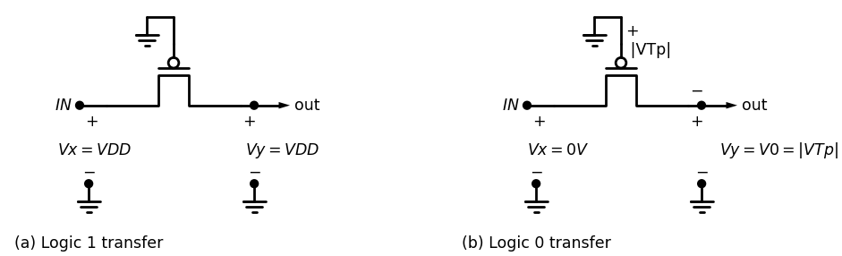

1.4.2 Figure 2.17 pFET pass characteristics
which is an ideal logic 1 level. The pFET is therefore capable of pass strong logic 1 voltage. The problem arises w hen we attempt tops ideal logic 0 voltage of Vy = 0V and is presented in Figure 2.17(b).becase, the transmitted voltage can only drop to a minimum value of
$$Vy=\left|VTp\right|$$
$$\left(2.30\right)$$
This is also due to a thresh old effect. In o rd e r to keep the pFf requires a minimum source-gate voltage of
$$VSGp=\left|VTp\right|$$
$$\left(2.31\right)$$
as shown in the drawing. Since the gate is at 0 V, this represents an a voltage of |VTp |, which is turn affects the output. Obviously, the transmits a weak logic 0 voltage. In summary, a pFET can pass in the range $\left[VDD,Vo\right]$, but nothing below Vo . Let us restate the results o f the above discussion: • nFETs pass strong logic 0 voltages, but weak logic 1 values • pFETs pass strong logic 1 voltages, but weak logic 0 levels Complementary MOS (CMOS) circuits are designed to account fc transmission levels. In particular, we can write down the following as a basis for our design:
- Use PEETS'to pass logic 1 voltages o f VD D
- Use nFETs to pass logic 0 voltages o f Vgg = 0 V These allow us to build circuits that can pass the ideal logic voW and VD D to the output terminal. We will find, however, that ideal not always needed in practice.

2.3 Basic Logic Gates in CMOS
The concept o f a general CMOS digital logic gate can be undent referring to the drawing In Figure 2.18. In this example, a, b, and c
import schemdraw
import schemdraw.elements as elm
import matplotlib.pyplot as plt
from schemdraw import dsp
from schemdraw import logic
with schemdraw.Drawing() as d:
d += ( T := dsp.Box(w=1, h=4).anchor('W').fill('white').label('$control block$','top'))
d += (l1 :=elm.Line().left(d.unit*.3).dot().at((0,-1)).label('$c$','left'))
d += (l2 :=elm.Line().left(d.unit*.3).dot().at((0,0)).label('$b$','left'))
d += (l3 :=elm.Line().left(d.unit*.3).dot().at((0,1)).label('$a$','left'))
d += (l4 :=elm.Line().left(d.unit*.3).at((-3,0)).label('$Inputs$','right',color='black').color('white'))
d += (l5 :=elm.Line().right(d.unit*.3).dot(open=True).at((1,1)))
d += (l6 :=elm.Line().up(d.unit*.3).at((2,.5)))
d += (l5 :=elm.Line().right(d.unit*.33).at((1,-1)))
d += (l6 :=elm.Line().up(d.unit*.3).at((2,-1.5)))
d += elm.Ground().at((2.5,-1.75)).label('$SWn$','top').label('$V{SS}$','right').label('$0$','left')
d += (l7 :=elm.Line().right(d.unit*.001).dot().at((2.5,-1.75)))
d += (l8 :=elm.Line().right(d.unit*.001).dot().at((2.5,-.75)))
d += (l9 :=elm.Line().up(d.unit*.25).dot())
d += (l10 :=elm.Line().up(d.unit*.2).dot().label('$SWp$','right'))
d += (l11 :=elm.Line().right(d.unit*.5).dot().at(l9.end).label('f(a,b,c)','right'))
d += (l12 :=elm.Line().right(d.unit*.3).at((5,0)).label('$output$','right',color='black').color('white'))
d += (l13 :=elm.Line().right(d.unit*.001).dot().at((2.5,1.5)))
d += (l14 :=elm.Line().up(d.unit*.3).dot())
d += (l15 :=elm.Line().right(d.unit*.15).label('$V{DD}$','right'))
d += (l16 :=elm.Line().left(d.unit*.15).label('$1$','left').at(l15.start))
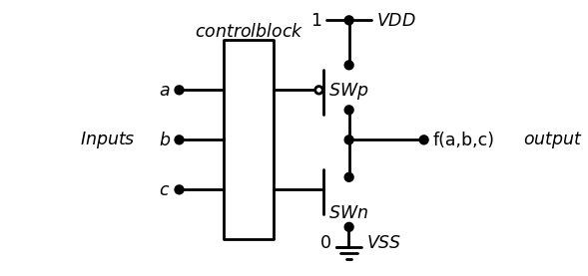

1.4.3 Figure 2.18 General CMOS logic gate
input bits that combine to give the output function bit f[a , b, c). Since this is by definition a digital circuit, all o f the quantities are restricted to v a l ues of 0 or 1. Digital logic circuits are nonlinear networks that use tran sistors as electronic switches to divert one o f the supply voltages VD D or 0 V to the output. This corresponds to a logical result o f/ = 1 or_f = 0. In ter nally, we may view the output netw ork o f the gate as con sistin g o f tw o switches SWp (an assert-low device) and SWn (an assert-high device) as shown. These are wired In to Insure that one sw itch is closed w h ile the other switch is open. The operation of the general logic gate is shown in Figure 2.19 for both output possibilities. In Figure 2 .19(a), the upper switch is closed w hile the lower switch is open. This connects the output to the power supply and yields a value o f f = 1. The opposite situation is shown in Figure 2 .19(b): the upper switch is open and the lower switch is closed. Because the ou t put is now connected to Vss = 0 V, the logical result is f = 0. Although this
import schemdraw
import schemdraw.elements as elm
import matplotlib.pyplot as plt
from schemdraw import dsp
from schemdraw import logic
with schemdraw.Drawing() as d:
d += ( T := dsp.Box(w=1, h=4).anchor('W').fill('white').label('$control block$','top'))
d += (l1 :=elm.Line().left(d.unit*.3).dot().at((0,-1)).label('$c$','left'))
d += (l2 :=elm.Line().left(d.unit*.3).dot().at((0,0)).label('$b$','left'))
d += (l3 :=elm.Line().left(d.unit*.3).dot().at((0,1)).label('$a$','left'))
d += (l4 :=elm.Line().left(d.unit*.3).at((-3,0)).label('$Inputs$','right',color='black').color('white'))
d += (l5 :=elm.Line().right(d.unit*.45).dot(open=True).at((1,1)))
d += (l6 :=elm.Line().up(d.unit*.3).at((2.37,.5)).label('$Close$','bottom'))
d += (l5 :=elm.Line().right(d.unit*.33).at((1,-1)))
d += (l6 :=elm.Line().up(d.unit*.3).at((2,-1.5)))
d += elm.Ground().at((2.5,-1.75)).label('$open$','top').label('$V{SS}$','right').label('$0$','left')
d += (l7 :=elm.Line().right(d.unit*.001).dot().at((2.5,-1.75)))
d += (l8 :=elm.Line().right(d.unit*.001).dot().at((2.5,-.75)))
d += (l9 :=elm.Line().up(d.unit*.25).dot())
d += (l10 :=elm.Line().up(d.unit*.2).dot())
d += (l11 :=elm.Line().right(d.unit*.5).dot().at(l9.end).label('f=1','right'))
d += (l12 :=elm.Line().right(d.unit*.3).at((4.5,0)).label('$output$','right',color='black').color('white'))
d += (l13 :=elm.Line().right(d.unit*.001).dot().at((2.5,1.5)))
d += (l14 :=elm.Line().up(d.unit*.3).dot())
d += (l15 :=elm.Line().right(d.unit*.15).label('$V{DD}$','right'))
d += (l16 :=elm.Line().left(d.unit*.15).label('$1$','left').at(l15.start))
d += ( T := dsp.Box(w=1, h=4).anchor('W').fill('white').label('$control block$','top').at((11,0)))
d += (l1 :=elm.Line().left(d.unit*.3).dot().at((11,-1)).label('$c$','left'))
d += (l2 :=elm.Line().left(d.unit*.3).dot().at((11,0)).label('$b$','left'))
d += (l3 :=elm.Line().left(d.unit*.3).dot().at((11,1)).label('$a$','left'))
d += (l4 :=elm.Line().left(d.unit*.3).at((8,0)).label('$Inputs$','right',color='black').color('white'))
d += (l5 :=elm.Line().right(d.unit*.33).dot(open=True).at((12,1)))
d += (l6 :=elm.Line().up(d.unit*.3).at((13,.5)).label('$open$','bottom'))
d += (l5 :=elm.Line().right(d.unit*.45).at((12,-1)))
d += (l6 :=elm.Line().up(d.unit*.3).at((13.35,-1.5)).label('$close$','bottom'))
d += elm.Ground().at((13.5,-1.5)).label('$V{SS}$','right').label('$0$','left')
d += (l7 :=elm.Line().right(d.unit*.001).dot().at((13.5,-1.5)))
d += (l8 :=elm.Line().right(d.unit*.001).dot().at((13.5,-.75)))
d += (l19 :=elm.Line().up(d.unit*.25).dot())
d += (l10 :=elm.Line().up(d.unit*.2).dot())
d += (l11 :=elm.Line().right(d.unit*.5).dot().at(l19.end).label('f=0','right'))
#d += (l12 :=elm.Line().right(d.unit*.3).at((15.5,0)).label('$output$','right',color='black').color('white'))
d += (l13 :=elm.Line().right(d.unit*.001).dot().at((13.5,1.5)))
d += (l14 :=elm.Line().up(d.unit*.3).dot())
d += (l15 :=elm.Line().right(d.unit*.15).label('$V{DD}$','right'))
d += (l16 :=elm.Line().left(d.unit*.15).label('$1$','left').at(l15.start))
d += (l13 :=elm.Line().right(d.unit*.001).color('white').at((0,-4)).label('(a) F=1 output','right',color='black'))
d += (l13 :=elm.Line().right(d.unit*.001).color('white').at((11,-4)).label('(b) F=0 output','right',color='black'))
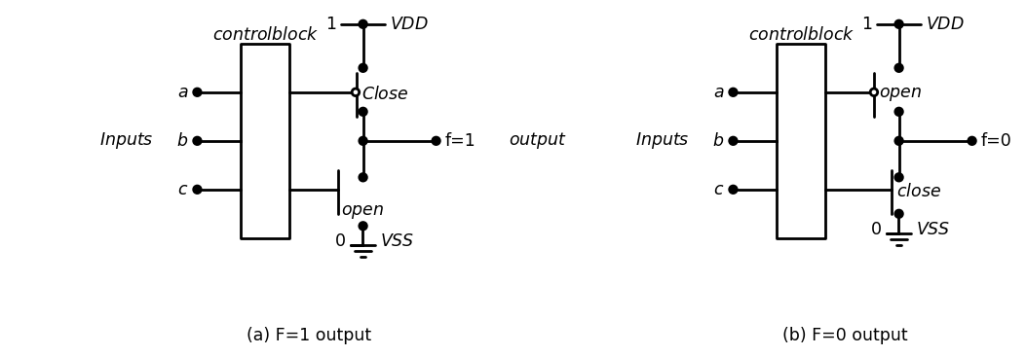

1.4.4 Figure 2.19 Operation o f a CMOS logic gate
view is quite simplified, it does illustrate how CMOS logic circuits: The only missing feature in this model is the method used to cost output switches using the input variab les. This is accomplished MOSFETs. The Complementary Pair CMOS logic circuits are based on the concept o f using complexed pairs o f transistors for switching. A com plem entary pair const pFET and an nFET that have their gate term inals connected togeder shown in Figure 2.20. The input signal x simultaneously control conduction through both FETs. N ote th at the top of the pFET assumed to be close to the power supply voltage VDD , while the nFET is close to the ground (Vss). The behavior o f the complementary easily understood by observing the state o f each FET for the two input values as in Figure 2.21. An input o f x = 0 turns Mp on while nFET Mn is o ff and acts like an open sw itch; this is shown in figure 2.21(a). The opposite case shown in Figure 2.21(b) is where x=l.V pFET MP is off while Mn is on. The name “complementary” is dertt this operation: when one FET is on, the other is off. The important of this behavior is that the nFET and pFET are electrical opposite translates directly into a coherent switching scheme. Now that we have seen the overall structure o f CMOS logic gate the idea o f a complementary pair, w e have all o f the concepts need create and analyze basic logic gate circuits.

1.5 2.3.1 The NOT Gate
The NOT or INVERT function is often considered the simplest be operation. It has an input x and produces an output $f\left(x\right)$ of
$$f\left(x\right)=NOT\left(x\right)=X̅$$
$$\left(2.32\right)$$
import schemdraw
import schemdraw.elements as elm
import matplotlib.pyplot as plt
from schemdraw import dsp
from schemdraw import logic
with schemdraw.Drawing() as d:
d += (M1 := elm.PFet2(offset_gate = False).anchor('gate').theta(90).reverse().length(1).label('$Mp$','bottom'))
d += (l1 :=elm.Line().left(d.unit*.3).at(M1.gate))
d += (l2 :=elm.Line().down(d.unit*.5).dot())
d += (l3 :=elm.Line().left(d.unit*.3).dot().label('$X$','left'))
d += (l4 :=elm.Line().down(d.unit*.5).at(l3.start))
d += (l5 :=elm.Line().right(d.unit*.45))
d += (M2 := elm.AnalogNFet(offset_gate = False).anchor('gate').theta(0).reverse().at(l5.end).label('$Mn$','right'))
d += elm.Arrow().up().length(.8).linewidth(2).color('black'). at((1.5,1)).label('to VDD','bottom')
d += elm.Arrow().down().length(.8).linewidth(2).color('black'). at((1.5,-4)).label('to VSS','bottom')
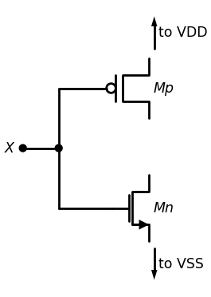

1.5.1 Figure 2.20 A CMOS complementary pair
import schemdraw
import schemdraw.elements as elm
import matplotlib.pyplot as plt
from schemdraw import dsp
from schemdraw import logic
with schemdraw.Drawing() as d:
d += (M1 := elm.PFet2(offset_gate = False).anchor('gate').theta(90).reverse().length(1).label('Mp on','bottom'))
d += (l1 :=elm.Line().left(d.unit*.3).at(M1.gate))
d += (l2 :=elm.Line().down(d.unit*.5).dot())
d += (l3 :=elm.Line().left(d.unit*.3).dot().label('$X=0$','left'))
d += (l4 :=elm.Line().down(d.unit*.5).at(l3.start))
d += (l5 :=elm.Line().right(d.unit*.45))
d += (M2 := elm.AnalogNFet(offset_gate = False).anchor('gate').theta(0).reverse().at(l5.end).label('Mn off','right').linestyle('--'))
d += (l6 :=elm.Line().right(d.unit*.005).at((-.5,-5)).label('(a) X=0 input','right',color='black').color('white'))
d += (M3 := elm.PFet2(offset_gate = False).anchor('gate').theta(90).reverse().length(1).label('Mp off','bottom').linestyle('--').at((7,0)))
d += (l7 :=elm.Line().left(d.unit*.3).at(M3.gate))
d += (l8 :=elm.Line().down(d.unit*.5).dot())
d += (l9 :=elm.Line().left(d.unit*.3).dot().label('$X=1$','left'))
d += (l10 :=elm.Line().down(d.unit*.5).at(l9.start))
d += (l11 :=elm.Line().right(d.unit*.45))
d += (M4 := elm.AnalogNFet(offset_gate = False).anchor('gate').theta(0).reverse().at(l11.end).label('Mn on','right'))
d += (l12 :=elm.Line().right(d.unit*.005).at((6.5,-5)).label('(b) X=1 input','right',color='black').color('white'))
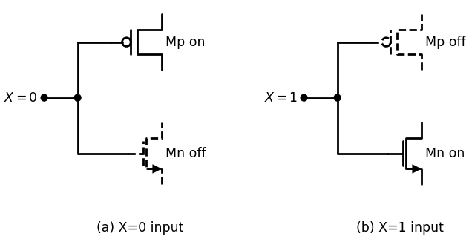

1.5.2 Figure 2.21 Operation o f the complem entary pair
such that
$$ifx=0thenX̅=1$$
$$ifx=1thenX̅=0$$
$$\left(2.33\right)$$
defines the notation. The logic symbol and truth table are provided in Figure 2.22 for future reference. A CMOS NOT gate is shown in Figure 2.23. This has been constructed using the same idea as for the sw itch-based circuit discussed earlier in the context o f Figure 2.7. The circuit uses a com plem entary pair o f MOSFETs such that the input variable x controls both transistors. The operation follows directly from the properties o f the complementary pair. If the input x has a value of 0, then pFET MP is on and the nFET Mn is off. As shown in Figure 2.24(a), this connects the output node to the power supply voltage VD D , giving an output o f $X ̅ $ = 1. Conversely, i f x = 1 then Mp is o ff and Mn is on. The output is then connected to the ground node and gives $X̅=0$as verified by the circuit in Figure 2.24(b). It is clear that this simple circuit does indeed provide the NO T operation. This can be verified analytically by applying the FET logic rules to write the output $f$ as
import schemdraw
import schemdraw.elements as e
import matplotlib.pyplot as plt
from schemdraw import dsp
from schemdraw import logic
with schemdraw.Drawing(unit=2) as d:
Not = d.add(logic.Not().right().label('X', loc='left', color='black').label('$X ̅ $','right'))
d.move(5, 0)
col_labels = ['X', 'X ̅ ']
table_vals = [
[0, 1],
[1, 0]
]
fig, ax = plt.subplots()
ax.axis('off')
table = ax.table(cellText=table_vals, colLabels=col_labels, loc='center', cellLoc='center')
table.scale(1, 2)
plt.title('Karnaugh Table for NOT Gate')
plt.show()
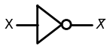
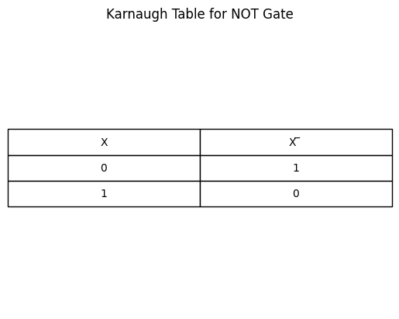
import ipywidgets as widgets
from ipywidgets import interact
import matplotlib.pyplot as plt
from matplotlib import rcParams
import PySpice.Logging.Logging as Logging
logger = Logging.setup_logging()
from PySpice.Probe.Plot import plot
from PySpice.Spice.Netlist import Circuit
from PySpice.Unit import *
rcParams['font.weight'] = 'bold'
figure = plt.figure(figsize=(15, 10))
circuit = Circuit('Pulse Sources ')
circuit.model('2N7000', 'NMOS', L=0.6E-6, W=1.2E-6,LAMBDA = 0.1 ,Kp=0.007, Vto=.4)
circuit.model('2N7100', 'PMOS', L=.6E-6, W=4E-6,LAMBDA = 0.1 ,Kp=0.007, Vto=-.4)
circuit.V(1, '1', circuit.gnd, 1.8@u_V)
pulse1 = circuit.PulseVoltageSource('V1', 'A', circuit.gnd, initial_value=1.8@u_V, pulsed_value=0@u_V,rise_time=1@u_ps,fall_time=1@u_ps, pulse_width=8@u_ns, period=20@u_ns)
pulse2 = circuit.PulseVoltageSource('V2', 'B', circuit.gnd, initial_value=0@u_V, pulsed_value=1.8@u_V,delay_time=2.5@u_ns,rise_time=1@u_ps,fall_time=1@u_ps,pulse_width=10@u_ns, period=20@u_ns)
#NOT1
circuit.MOSFET(1, 'A_', 'A', '1','1', model='2N7100')
circuit.MOSFET(2, 'A_', 'A', circuit.gnd,circuit.gnd, model='2N7000')
simulator = circuit.simulator(temperature=25, nominal_temperature=25)
analysis = simulator.transient(step_time=1@u_ns, end_time=40@u_ns)
fig, (ax1, ax2) = plt.subplots(2, 1, figsize=(10, 6), sharex=True)
ax1.plot(analysis.time, analysis['A'], 'red', linewidth=2, label='A')
ax1.set_xlabel('Time [s]', color='black', weight='black', fontsize=10)
ax1.set_ylabel('IN', color='black', weight='black', fontsize=10)
ax2.plot(analysis.time, analysis['A_'], 'blue', linewidth=2, label='B')
ax2.set_xlabel('Time [s]', color='black', weight='black', fontsize=10)
ax2.set_ylabel('out', color='black', weight='black', fontsize=10)
plt.tight_layout()
plt.show()
<Figure size 1500x1000 with 0 Axes>
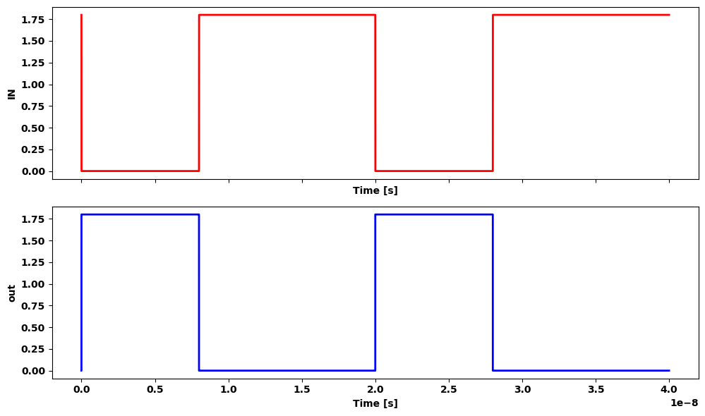

1.5.3 Figure 2.22 NOT gate
import schemdraw
import schemdraw.elements as elm
import matplotlib.pyplot as plt
from schemdraw import dsp
from schemdraw import logic
with schemdraw.Drawing() as d:
d += (M1 := elm.PFet2(offset_gate = False).anchor('drain').theta(180).reverse().length(2).label('Mp','top'))
d += (l1 :=elm.Line().left(d.unit*.3).at(M1.drain))
d += elm.Vdd().at(l1.end).label('VDD','top')
d += (l2 :=elm.Line().down(d.unit*.3).at(M1.gate))
d += (M2 := elm.AnalogNFet(offset_gate = False).anchor('gate').theta(270).reverse().label('Mn','left'))
d += (l3 :=elm.Line().left(d.unit*.3).at(M2.source))
d += elm.Ground().at(l3.end)
d += (l4 :=elm.Line().right(d.unit*.3).at(M1.source))
d += (l5 :=elm.Line().down(d.unit*.55).dot())
d += (l6 :=elm.Line().right(d.unit*.4).dot().label('$X ̅ $','right'))
d += (l7 :=elm.Line().down(d.unit*.51).at(l5.end))
d += (l8 :=elm.Line().left(d.unit*.35))
d += (l9 :=elm.Line().right(d.unit*.67).at((-1,-1.7)).dot().label('$X$','left'))
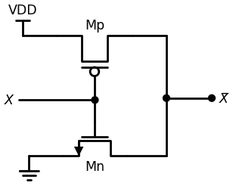

1.5.4 Figure 2.23 CMOS NOT gate
$$f=X̅.1+x.0$$
$$\left(2.34\right)$$
where the first term describes Mp and the second term is due to Mn splifying gives
$$f=X̅$$
$$\left(2.35\right)$$
as expected. One of the most important characteristics of the CMOS NOT gate Is manner in which the complementary FET pair insures that, for a give input logic state of x = 0 or 1, the output is connected to either VDD ground and gives a well-defined value. This circuit specifically avoids, possibilities where (i) both FETs are o ff at the same time, or (ii) both FET are on at the same time; either situation would give an ill-defined output

1.6 2.3.2 The CMOS NOR Gate
now that we have seen the basic NOT gate, let us extend the concepts create a2-inputs NOR gate using the same principles. These are
import schemdraw
import schemdraw.elements as elm
import matplotlib.pyplot as plt
from schemdraw import dsp
from schemdraw import logic
with schemdraw.Drawing() as d:
d += (M1 := elm.PFet2(offset_gate = False).anchor('drain').theta(180).reverse().length(2).label('Mp on','top'))
d += (l1 :=elm.Line().left(d.unit*.3).at(M1.drain))
d += elm.Vdd().at(l1.end).label('VDD','top')
d += (l2 :=elm.Line().down(d.unit*.3).at(M1.gate))
d += (M2 := elm.AnalogNFet(offset_gate = False).anchor('gate').theta(270).reverse().label('Mn off','left').linestyle('--'))
d += (l3 :=elm.Line().left(d.unit*.3).at(M2.source).linestyle('--'))
d += elm.Ground().at(l3.end)
d += (l4 :=elm.Line().right(d.unit*.3).at(M1.source))
d += (l5 :=elm.Line().down(d.unit*.55).dot())
d += (l6 :=elm.Line().right(d.unit*.4).dot().label('$X ̅ =1$','right'))
d += (l7 :=elm.Line().down(d.unit*.51).at(l5.end))
d += (l8 :=elm.Line().left(d.unit*.35).linestyle('--'))
d += (l9 :=elm.Line().right(d.unit*.67).at((-1,-1.7)).dot().label('$X=0$','left'))
d += (M3 := elm.PFet2(offset_gate = False).anchor('drain').theta(180).reverse().length(2).label('Mp off','top').at((11,0)).linestyle('--'))
d += (l10 :=elm.Line().left(d.unit*.3).at(M3.drain))
d += elm.Vdd().at(l10.end).label('VDD','top')
d += (l11 :=elm.Line().down(d.unit*.3).at(M3.gate))
d += (M4 := elm.AnalogNFet(offset_gate = False).anchor('gate').theta(270).reverse().label('Mn on','left'))
d += (l12 :=elm.Line().left(d.unit*.3).at(M4.source))
d += elm.Ground().at(l12.end)
d += (l13 :=elm.Line().right(d.unit*.3).at(M3.source))
d += (l14 :=elm.Line().down(d.unit*.55).dot())
d += (l15 :=elm.Line().right(d.unit*.4).dot().label('$X ̅ =0$','right'))
d += (l16 :=elm.Line().down(d.unit*.51).at(l14.end))
d += (l17 :=elm.Line().left(d.unit*.35))
d += (l18 :=elm.Line().right(d.unit*.67).at((10,-1.7)).dot().label('$X=1$','left'))
d += (l19 :=elm.Line().right(d.unit*.35).label('(a) x=0 input','right',color='black').color('white').at((-1,-5)))
d += (l20 :=elm.Line().right(d.unit*.35).label('(b) x=1 input','right',color='black').color('white').at((11,-5)))
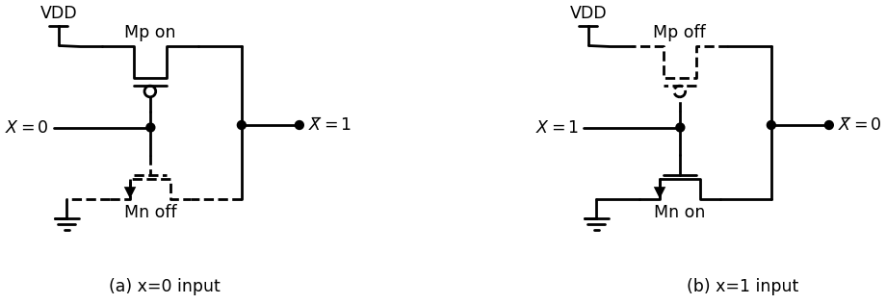

1.6.1 Figure 2.24 Operation o f the CMOS NOT
• Use a complementary nFET/pFET pair for each input • Connect the output node to the power supply VD D through pFETs • Connect the output node to ground through nFETs, and • Insure that the output is always a well-defined high or low voltage This set o f guidelines helps us design logic circuits that have input and output characteristics which are compatible with the N O T gate. The logic symbol and truth table for the NOR2 gate are provided in Fig ure 2.25 With input variables x and y, the NOR2 produces the output
$$g\left(x.y\right)=\left(x+y\right)̅$$
$$\left(2.36\right)$$
such that a 1 at either input gives g = 0. Only the input com bination (x, y) = (1,1) yields an output o f g = 1. One way to synthesize the NOR2 operation at the logic design level is to use a 4:1 MUX as shown in Figure 2.26(a). Path selection is ob tain ed using the input pair (x, y) such that every combination gives either a 1 or a 0 to the output. The Boolean expression for the output o f the MUX is
$$g\left(x,y\right)=X̅.y̅.1+X̅.y.0+x.y̅.0+x.y.0$$
$$\left(2.37\right)$$
which reduces to the desired form
$$g\left(x,y\right)=\left(x+y\right)̅$$
$$\left(2.38\right)$$
using the DeMorgan theorem. A voltage-equivalent circuit is obtained by replacing the binary quantities w ith voltages, and results in the circuit shown in Figure 2.26(b). In the notation o f the drawing, Vx and Vy respec tively represent the Boolean variables x and y. This inform ation provides the basis for constructing the CMOS NOR2 circuit.
import schemdraw
import schemdraw.elements as e
import matplotlib.pyplot as plt
from schemdraw import dsp
from schemdraw import logic
with schemdraw.Drawing(unit=2) as d:
Not = d.add(logic.Nor().right().label('X', loc='left', color='black').label('$(x+y) ̅$','right').label('\n\n y', loc='left', color='black'))
d.move(5, 0)
import matplotlib.pyplot as plt
col_labels = ['X', 'Y', '(x+y) ̅']
table_vals = [
[0, 0, 1],
[0, 1, 0],
[1, 0, 0],
[1, 1, 0]
]
fig, ax = plt.subplots()
ax.axis('off')
table = ax.table(cellText=table_vals, colLabels=col_labels, loc='center', cellLoc='center')
table.scale(1, 2)
plt.title('(b) Truth table')
plt.show()
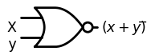
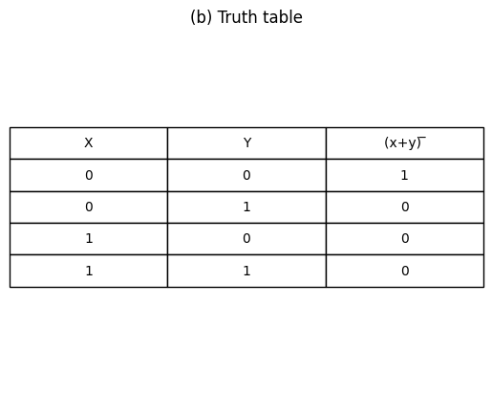
import ipywidgets as widgets
from ipywidgets import interact
import matplotlib.pyplot as plt
from matplotlib import rcParams
import PySpice.Logging.Logging as Logging
logger = Logging.setup_logging()
from PySpice.Probe.Plot import plot
from PySpice.Spice.Netlist import Circuit
from PySpice.Unit import *
rcParams['font.weight'] = 'bold'
figure = plt.figure(figsize=(15, 10))
circuit = Circuit('Pulse Sources ')
circuit.model('2N7000', 'NMOS', L=0.6E-6, W=1.2E-6,LAMBDA = 0.1 ,Kp=0.007, Vto=.4)
circuit.model('2N7100', 'PMOS', L=.6E-6, W=2.4E-6,LAMBDA = 0.1 ,Kp=0.007, Vto=-.4)
circuit.V(1, '1', circuit.gnd, 1.8@u_V)
circuit.MOSFET(1, '2', 'B', '1','1', model='2N7100')
circuit.MOSFET(2, 'out', 'A', '2','1', model='2N7100')
circuit.MOSFET(3, 'out', 'A', circuit.gnd,circuit.gnd, model='2N7000')
circuit.MOSFET(4, 'out', 'B', circuit.gnd,circuit.gnd, model='2N7000')
circuit.C(1, 'out',circuit.gnd , 0.02@u_pF)
pulse1 = circuit.PulseVoltageSource('V1', 'A', circuit.gnd, initial_value=1.8@u_V, pulsed_value=0@u_V,rise_time=1@u_ps,fall_time=1@u_ps, pulse_width=10@u_ns, period=20@u_ns)
pulse2 = circuit.PulseVoltageSource('V2', 'B', circuit.gnd, initial_value=0@u_V, pulsed_value=1.8@u_V,delay_time=2.5@u_ns,rise_time=1@u_ps,fall_time=1@u_ps,pulse_width=10@u_ns, period=20@u_ns)
simulator = circuit.simulator(temperature=25, nominal_temperature=25)
analysis = simulator.transient(step_time=1@u_ns, end_time=40@u_ns)
fig, (ax1, ax2, ax3) = plt.subplots(3, 1, figsize=(10, 6), sharex=True)
ax1.plot(analysis.time, analysis['A'], 'red', linewidth=2, label='A')
ax1.set_xlabel('Time [s]', color='black', weight='black', fontsize=10)
ax1.set_ylabel('INA [V]', color='black', weight='black', fontsize=10)
ax2.plot(analysis.time, analysis['B'], 'blue', linewidth=2, label='B')
ax2.set_xlabel('Time [s]', color='black', weight='black', fontsize=10)
ax2.set_ylabel('INB [V]', color='black', weight='black', fontsize=10)
ax3.plot(analysis.time, analysis['out'], 'green', linewidth=2, label='out')
ax3.set_xlabel('Time [s]', color='black', weight='black', fontsize=10)
ax3.set_ylabel('out [V]', color='black', weight='black', fontsize=10)
ax3.legend()
plt.tight_layout()
plt.show()
<Figure size 1500x1000 with 0 Axes>
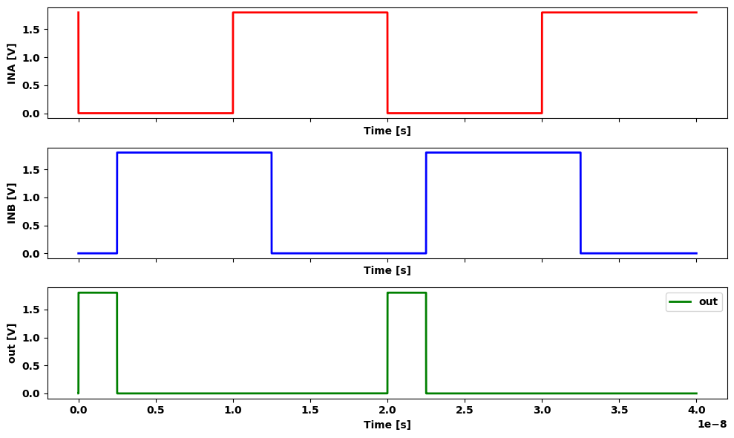

1.6.2 Figure 2.25 NOR logic gate
import schemdraw
import schemdraw.elements as elm
import matplotlib.pyplot as plt
from schemdraw import dsp
from schemdraw import logic
with schemdraw.Drawing() as d:
d += (l1 :=elm.Line().left(d.unit*.5).label('$4:1$','bottom'))
d += (l2 :=elm.Line().down(d.unit*1.5))
d += (l3 :=elm.Line().right(d.unit*.5).label('(a) Logic diagram','bottom'))
d += (l4 :=elm.Line().up(d.unit*1.5))
d += (l5 :=elm.Line().left(d.unit*.3).label('$X$','left').at((-1.5,-.75)).dot().label('$0$','right'))
d += (l6 :=elm.Line().left(d.unit*.3).label('$y$','left').at((-1.5,-1.25)).dot().label('$1$','right'))
d += (l7 :=elm.Line().left(d.unit*.3).label('"1"','left').at((-1.5,-2.25)).dot().label('$0$','right'))
d += (l8 :=elm.Line().left(d.unit*.3).label('"0"','left').at((-1.5,-2.75)).dot().label('$1$','right'))
d += (l9 :=elm.Line().left(d.unit*.3).label('"0"','left').at((-1.5,-3.25)).dot().label('$2$','right'))
d += (l10 :=elm.Line().left(d.unit*.3).label('"0"','left').at((-1.5,-3.75)).dot().label('$3$','right'))
d += (l11 :=elm.Line().right(d.unit*.3).label('g(x,y)=(x+y) ̅','right').at((0,-2.5)).dot().label('\n\n output','right'))
d += (l12 :=elm.Line().right(d.unit*.03).label('G{0/3','right',color='black').at((-1.25,-.75)).color('white'))
d += (l13 :=elm.Line().left(d.unit*.6).label('$4:1$','bottom').at((10,0)))
d += (l14 :=elm.Line().down(d.unit*1.5))
d += (l15 :=elm.Line().right(d.unit*.6).label('(b) Voltage Network','bottom'))
d += (l16 :=elm.Line().up(d.unit*1.5))
d += (l17 :=elm.Line().left(d.unit*.3).label('$V{X}$','left').at((8.2,-.75)).dot().label('$0$','right'))
d += (l18 :=elm.Line().left(d.unit*.3).label('$V{y}$','left').at((8.2,-1.25)).dot().label('$1$','right'))
d += (l19 :=elm.Line().left(d.unit*.3).label('$V{DD}$','left').at((8.2,-2.5)).dot().label('$0$','right'))
d += (l20 :=elm.Line().left(d.unit*.3).at((8.2,-3)).label('$1$','right'))
d += (l21 :=elm.Line().left(d.unit*.3).at((8.2,-3.5)).dot().label('$2$','right'))
d += (l22 :=elm.Line().left(d.unit*.3).label('$0{v}$','left').at((8.2,-4)).dot().label('$3$','right'))
d += (l23 :=elm.Line().left(d.unit*.3).endpoints(l20.end,l22.end))
d += elm.Ground().at(l22.end)
d += (l24 :=elm.Line().right(d.unit*.3).label('Vout','right').at((10,-2)).dot())
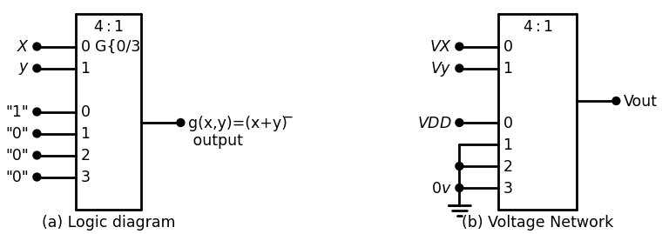

1.6.3 Figure 2.26 N0R2 operation using a 4:1 m ultiplexor
One approach to building the logic gate is to use the Karnaugh map drawn in Figure 2.27. CMOS generally produces inverting logic becaus our gates are constructed using the NOT circuit as a basis. This create the situation where we are generally interested in the occurrence of boat $l’s$ and $0’s$ when dealing with K-maps. In particular, note that we haw created two O-groupings in the drawing. The map allows us to write the logic expression in the form
$$g\left(x,y\right)=X̅.y̅.1+X.0+y.0$$
$$\left(2.37\right)$$
and work backward to construct the circuit. Each term represents aFET path to the output. The first term connects the output to 1 (the power supply VDD ) and is controlled by complements of the input variables in a series-connected AND arrangement. The second and third terms report sent two independent nFET paths betw een the output and 0 (ground Combining these statements results in the CMOS NOR2 circuit shown in
import schemdraw
import schemdraw.elements as elm
import matplotlib.pyplot as plt
from schemdraw import dsp
from schemdraw import logic
with schemdraw.Drawing() as d:
d += ( T := dsp.Box(w=2, h=2).anchor('W').fill('white').label('$0$').label('$1$','left'))
d += ( T := dsp.Box(w=2, h=2).anchor('W').fill('white').at((2,0)).label('$0$'))
d += ( T := dsp.Box(w=2, h=2).anchor('W').fill('white').at((2,2)).label('$0$').label('$1$','top'))
d += ( T := dsp.Box(w=2, h=2).anchor('W').fill('white').at((0,2)).label('$0$','top').label('$0$','left'))
d += ( T := dsp.Box(w=1, h=1).anchor('W').fill('white').at((.5,2)).label('$1$'))
d += ( T := dsp.Box(w=3, h=1).anchor('W').fill('white').at((.5,0)))
d += ( T := dsp.Box(w=1, h=3).anchor('W').fill('white').at((2.4,1.1)))
d += (l1 :=elm.Line().right(d.unit*.3).label('x','top').at((-.9,3)))
d += (l2 :=elm.Line().up(d.unit*.4).label('y','top'))
d += (l3 :=elm.Line().right(d.unit*.00003).at((-.9,4)))
d += (l4 :=elm.Line().right(d.unit*.03).endpoints(l3.end,l1.end))
d += elm.Arrow().up().length(1.2).linewidth(2).color('black'). at((1.5,-1.7)).label('X.0','left')
d += elm.Arrow().left().length(1.5).linewidth(2).color('black'). at((4.8,2)).label('y.0','right')
d += elm.Arrow().down().length(1.5).linewidth(2).color('black'). at((1.3,4)).label('1.X ̅.y ̅','right')
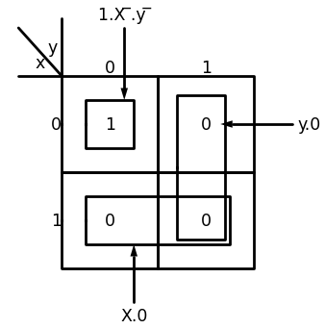

1.6.4 Figure 2.27 NOR2 gate Karnaugh map
import schemdraw
import schemdraw.elements as elm
import matplotlib.pyplot as plt
from schemdraw import dsp
from schemdraw import logic
with schemdraw.Drawing() as d:
d += (M1 := elm.PFet2(offset_gate = False).anchor('drain').theta(180).reverse().length(3).label('$Mp{X}$','top'))
d += (M2 := elm.PFet2(offset_gate = False).anchor('drain').theta(180).reverse().length(3).label('$Mp{y}$','top').at(M1.source))
d += (M3 := elm.AnalogNFet(offset_gate = False).anchor('gate').theta(270).reverse().label('$Mn{x}$','left').at((1.5,-3)))
d += (M4 := elm.AnalogNFet(offset_gate = False).anchor('gate').theta(270).reverse().label('$Mn{y}$','left').at((4.5,-2)))
d += (l1 :=elm.Line().down(d.unit*1.5).label('y','left').at(M2.gate).dot())
d += (l2 :=elm.Line().down(d.unit*1.5).label('x','left').at(M1.gate).dot())
d += (l3 :=elm.Line().right(d.unit*.2).label('1.x ̅.y ̅','top').at(M2.source))
d += (l4 :=elm.Line().down(d.unit*.97).label('+','top').at(l3.end).dot())
d += (l5 :=elm.Line().left(d.unit*.44).label('0.y','top'))
d += (l6 :=elm.Line().right(d.unit*.44).label('g(x,y)=(x+y) ̅','right').at(l4.end).dot())
d += (l7 :=elm.Line().right(d.unit*1.42).label('0.x','right').at(M3.drain))
d += (l8 :=elm.Line().up(d.unit*.3).label('+','top'))
d += (l9 :=elm.Line().left(d.unit*1).at(M4.source))
d += (l10 :=elm.Line().down(d.unit*.42))
d += elm.Ground().at(l10.end)
d += elm.Vdd().at(M1.drain).label('VDD','top')
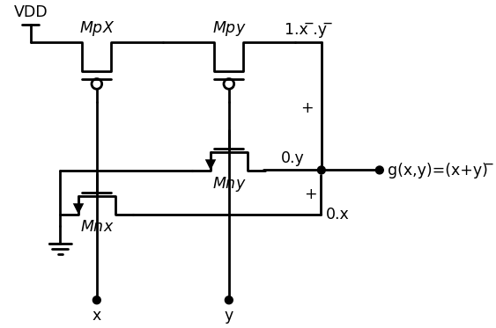

1.6.5 Figure 2.28 CMOS NOR2 gate
Figure 2.28; the one-to-one correspondence betw een each lin e in the equation and the circuit is obvious. To verify that this circuit does have the proper electrical behavior, we may construct the table shown in Figure 2.29. This shows the state (on or off) of every FET for each o f the four input possibilities. Tracin g the output connections for each possibility easily shows that the switching circuit is consistent with the truth table.
def nor2_cmos_status(a, b):
pmos1 = 'ON' if a == 0 else 'OFF'
pmos2 = 'ON' if b == 0 else 'OFF'
nmos1 = 'ON' if a == 1 else 'OFF'
nmos2 = 'ON' if b == 1 else 'OFF'
output = int(not (a or b))
return pmos1, pmos2, nmos1, nmos2, output
print(f"| A | B | MPX | MPY | MnX | MnY | خروجی NOR |")
print(f"|-----|-----|--------|--------|--------|--------|------------|")
for a in [0, 1]:
for b in [0, 1]:
pmos1, pmos2, nmos1, nmos2, output = nor2_cmos_status(a, b)
print(f"| {a} | {b} | {pmos1:^5} | {pmos2:^5} | {nmos1:^5} | {nmos2:^5} | {output} |")
| A | B | MPX | MPY | MnX | MnY | خروجی NOR |
|-----|-----|--------|--------|--------|--------|------------|
| 0 | 0 | ON | ON | OFF | OFF | 1 |
| 0 | 1 | ON | OFF | OFF | ON | 0 |
| 1 | 0 | OFF | ON | ON | OFF | 0 |
| 1 | 1 | OFF | OFF | ON | ON | 0 |

1.6.6 Figure 2.29 Operational summary o f the NOR2 gate
The electrical structure o f the NO R2 gate alsoillu strates another important point in the manner in which the FETs are w ired togther, Note that the two pFETs Mpx and Mpy are connected in series such that both must be on to establish a conducting path from VDD to the output The nFETs Mnx and Mny, on the other hand, are wired in parallel so that a connection between the output and ground is created if either nFET is on. This is called a series-parallel transistor arrangement; the principle allows us to design more complex gates. As an example, let us construct a 3-input N O R (NOR3) gate using the NOR2 topology as a guideline. Let us label the inputs as x, y. and z. Each input is connected to the gate o f a com plem entary nFET /pFET pair. The logical output expression for the gate is given by
$$f=\left(x+y+z\right)̅$$
$$\left(2.38\right)$$
This says that the output has a value f = 0 if one or more of the tape a logic 1. Since output 0’s are controlled by the nFETs, placing thet nFETs in parallel gives the proper functional behavior. If v e apply principle of series-parallel structuring, then the pFETs should be tost with one another. Figure 2.30 shows the logic circuit constructed in. manner; note the similarity with the NOR2 circuit in Figure 2.28. > verify the operation of the NOR3 logic gate by inspection: if any input. 1, then the output is connected to ground giving $f=0$. The only cast, yields an output o f f = 1 is if all three inputs are 0; this turns on alii pFETs while simultaneously turning the nFETs off. 2.3.3 Another approach to verifying the logic is to use the equations of the switches and derive the MUX equations. The top branch in Figure 2.32 through a series group of three pFETs as described by the term
$$1.x̅.y̅.z̅$$
$$\left(2.39\right)$$
where we recognize th at the power supply voltage Vpp is equivalent logic 1. Each of the three nFET branches consists of a single FETpas the ground to the output. Since a ground is a logic 0, we can OR the in branches together to give a complete output expression of
$$f=1.x̅.y̅.z̅+0.x+0.y+0.z$$
$$\left(2.40\right)$$
The nFET terms insure that the output voltage of the circuit is O V wher ever one or more of the inputs is 1. Logically, however, they evaluate leaving the final form
$$f=1.x̅.y̅.z̅=\left(x+y+z\right)̅$$
$$\left(2.41\right)$$
where we have use a DeMorgan relation in the reduction. This shows the
import schemdraw
import schemdraw.elements as e
import matplotlib.pyplot as plt
from schemdraw import dsp
from schemdraw import logic
with schemdraw.Drawing(unit=2) as d:
Not = d.add(logic.Nor(inputs=3).right().label('x\n y\n z', loc='left', color='black').label('$(x+y+z) ̅$','right'))
d += (M1 := elm.PFet2(offset_gate = False).anchor('drain').theta(180).reverse().length(3).at((6,0)))
d += (M2 := elm.PFet2(offset_gate = False).anchor('drain').theta(180).reverse().length(3).at(M1.source))
d += (M3 := elm.PFet2(offset_gate = False).anchor('drain').theta(180).reverse().length(3).at(M2.source))
d += (M4 := elm.AnalogNFet(offset_gate = False).anchor('gate').theta(270).reverse().at((10.5,-3)))
d += (M5 := elm.AnalogNFet(offset_gate = False).anchor('gate').theta(270).reverse().at((13.5,-1.5)))
d += (M6 := elm.AnalogNFet(offset_gate = False).anchor('gate').theta(270).reverse().at((7.5,-4.5)))
d += (l1 :=elm.Line().down(d.unit*2.5).label('x','left').at(M1.gate).dot())
d += (l2 :=elm.Line().down(d.unit*2.5).label('y','left').at(M2.gate).dot())
d += (l3 :=elm.Line().down(d.unit*2.5).label('z','left').at(M3.gate).dot())
d += elm.Ground().at(M6.source)
d += elm.Vdd().at(M1.drain).label('VDD','top')
d += (l4 :=elm.Line().left(d.unit*3).at(M5.source))
d += (l5 :=elm.Line().down(d.unit*1.5).dot())
d += (l6 :=elm.Line().left(d.unit*1.5).at(M4.source).dot())
d += (l7 :=elm.Line().right(d.unit*.2).at(M3.source).label('1.(x.y.z) ̅','top'))
d += (l8 :=elm.Line().down(d.unit*1.21).label('+','top').dot())
d += (l9 :=elm.Line().left(d.unit*.55).label('0.x','top'))
d += (l10 :=elm.Line().right(d.unit*.6).label('(x+y+z) ̅','right').dot().at(l8.end))
d += (l11 :=elm.Line().down(d.unit*.75).label('+','top').dot().at(l10.start))
d += (l12 :=elm.Line().left(d.unit*2.2).label('0.y','top'))
d += (l13 :=elm.Line().down(d.unit*.75).label('+','top').dot().at(l11.end))
d += (l14 :=elm.Line().left(d.unit*3.7).label('0.z','top'))
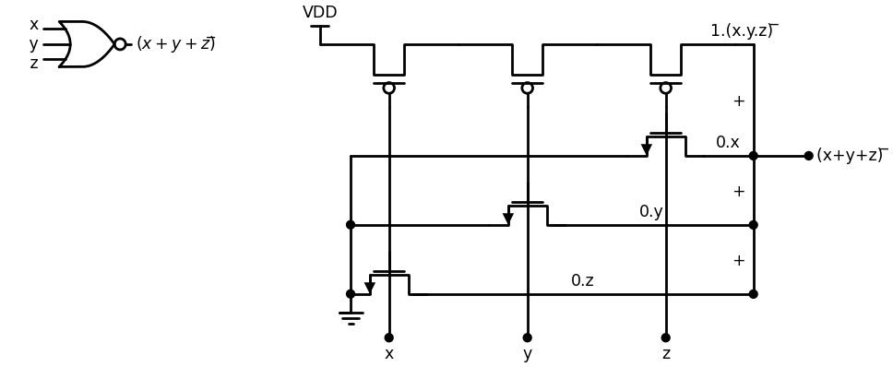
import ipywidgets as widgets
from ipywidgets import interact
import matplotlib.pyplot as plt
from matplotlib import rcParams
import PySpice.Logging.Logging as Logging
logger = Logging.setup_logging()
from PySpice.Probe.Plot import plot
from PySpice.Spice.Netlist import Circuit
from PySpice.Unit import *
rcParams['font.weight'] = 'bold'
figure = plt.figure(figsize=(15, 10))
circuit = Circuit('Pulse Sources ')
circuit.model('2N7000', 'NMOS', L=0.6E-6, W=1.2E-6,LAMBDA = 0.1 ,Kp=0.007, Vto=.4)
circuit.model('2N7100', 'PMOS', L=.6E-6, W=2.4E-6,LAMBDA = 0.1 ,Kp=0.007, Vto=-.4)
circuit.V(1, '1', circuit.gnd, 1.8@u_V)
circuit.MOSFET(1, '2', 'B', '1','1', model='2N7100')
circuit.MOSFET(11, '3', 'C', '2','1', model='2N7100')
circuit.MOSFET(2, 'out1', 'A', '3','1', model='2N7100')
circuit.MOSFET(3, 'out1', 'A', circuit.gnd,circuit.gnd, model='2N7000')
circuit.MOSFET(4, 'out1', 'B', circuit.gnd,circuit.gnd, model='2N7000')
circuit.MOSFET(44, 'out1', 'C', circuit.gnd,circuit.gnd, model='2N7000')
#circuit.MOSFET(5, 'out', 'out1', '1','1', model='2N7100')
#circuit.MOSFET(6, 'out', 'out1', circuit.gnd,circuit.gnd, model='2N7000')
circuit.C(1, 'out1',circuit.gnd , 0.02@u_pF)
pulse1 = circuit.PulseVoltageSource('V1', 'A', circuit.gnd, initial_value=1.8@u_V, pulsed_value=0@u_V,rise_time=1@u_ps,fall_time=1@u_ps, pulse_width=10@u_ns, period=20@u_ns)
pulse2 = circuit.PulseVoltageSource('V2', 'B', circuit.gnd, initial_value=0@u_V, pulsed_value=1.8@u_V,delay_time=2.5@u_ns,rise_time=1@u_ps,fall_time=1@u_ps,pulse_width=10@u_ns, period=20@u_ns)
pulse3 = circuit.PulseVoltageSource('V3', 'C', circuit.gnd, initial_value=0@u_V, pulsed_value=1.8@u_V,delay_time=3.5@u_ns,rise_time=1@u_ps,fall_time=1@u_ps,pulse_width=10@u_ns, period=20@u_ns)
simulator = circuit.simulator(temperature=25, nominal_temperature=25)
analysis = simulator.transient(step_time=1@u_ns, end_time=40@u_ns)
fig, (ax1, ax2, ax3,ax4) = plt.subplots(4, 1, figsize=(10, 6), sharex=True)
ax1.plot(analysis.time, analysis['A'], 'red', linewidth=2, label='A')
ax1.set_xlabel('Time [s]', color='black', weight='black', fontsize=10)
ax1.set_ylabel('INA [V]', color='black', weight='black', fontsize=10)
ax2.plot(analysis.time, analysis['B'], 'blue', linewidth=2, label='B')
ax2.set_xlabel('Time [s]', color='black', weight='black', fontsize=10)
ax2.set_ylabel('INB [V]', color='black', weight='black', fontsize=10)
ax3.plot(analysis.time, analysis['C'], 'Chocolate', linewidth=2, label='C')
ax3.set_xlabel('Time [s]', color='black', weight='black', fontsize=10)
ax3.set_ylabel('INC [V]', color='black', weight='black', fontsize=10)
ax4.plot(analysis.time, analysis['out1'], 'green', linewidth=2, label='out1')
ax4.set_xlabel('Time [s]', color='black', weight='black', fontsize=10)
ax4.set_ylabel('out1 [V]', color='black', weight='black', fontsize=10)
ax4.legend()
plt.tight_layout()
plt.show()
<Figure size 1500x1000 with 0 Axes>
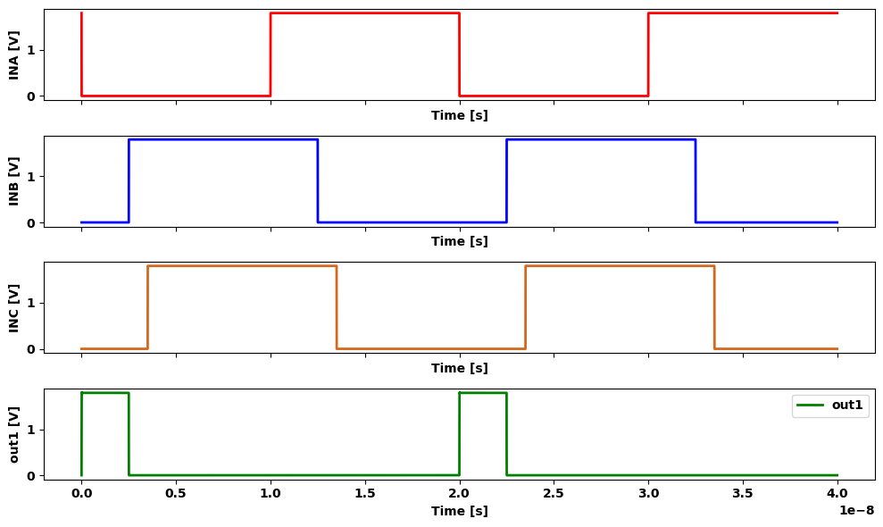

1.6.7 Figure 2.30 A NOR3 gate in CMOS
the circuit does in fact provide the NOR3 operation. In principle, one may use the sam e arg u m en ts to c o n stru c t m ultiple input NOR gates in CMOS such as a NOR4 or a NOR6. This technique is easy to apply and yields functional logic circuits. For VLSI applications, however, the choice of logic circuits is based on more th a n Ju st th e ability to provide a logic operation. Hardware characteristics su ch as sw itching speed and area consum ption on th e silicon chip m u s t be ta k e n in to account. In this chapter, we will concentrate solely on form ing logic func tions through the circuit topology. More detailed co n sid eratio n s will be discussed later in the text.

1.7 2.3.3 The CMOS NAND Gate
Let us next construct the CMOS circuit for the NAND2 gate w ith the logi cal symbol and behavior summarized in Figure 2.31. This gate is c h a ra c terized by an output th at is 0 unless both of the in p u ts are 1. The tru th table can be used to build the 4:1 MUX im plem entation draw n in Figure 2.32(a) such that the output is described by
$$h\left(x,y\right)=x̅.y̅.1+x̅.y.1+x.y̅.1+x.y.0$$
$$\left(2.42\right)$$
The voltage-equivalent netw ork in Figure 2.32(b) is now som ew hat o b vious.
As with the NOR2 gate, it is useful to exam ine the K arnaugh m ap for the NAND2 function. Figure 2.33 shows the m ap along with twogroup ings that simplify the cases w here h = 1. U sing the sereductions, our expression can be rewritten to read
$$h\left(x,y\right)=x̅.1+y̅.1+x.y.0$$
$$\left(2.45\right)$$
Translating each term to FET groups yields the CMOS circuit show n in Figure 2.34. This gives the NAND2 function as can be verified by the oper-
import schemdraw
import schemdraw.elements as e
import matplotlib.pyplot as plt
from schemdraw import dsp
from schemdraw import logic
with schemdraw.Drawing(unit=2) as d:
Not = d.add(logic.Nand().right().label('X', loc='left', color='black').label('$(x+y) ̅$','right').label('\n\n y', loc='left', color='black'))
d.move(5, 0)
import matplotlib.pyplot as plt
col_labels = ['X', 'Y', '(x+y) ̅']
table_vals = [
[0, 0, 1],
[0, 1, 1],
[1, 0, 1],
[1, 1, 0]
]
fig, ax = plt.subplots()
ax.axis('off')
table = ax.table(cellText=table_vals, colLabels=col_labels, loc='center', cellLoc='center')
table.scale(1, 2)
plt.title('(b) Truth table')
plt.show()
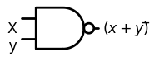
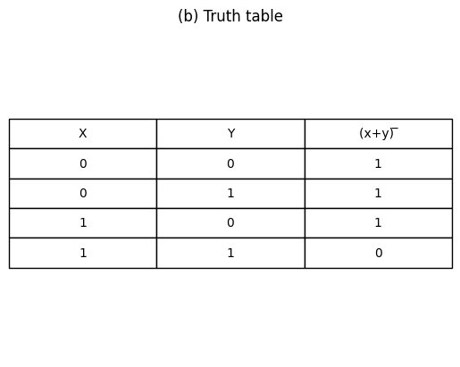
import ipywidgets as widgets
from ipywidgets import interact
import matplotlib.pyplot as plt
from matplotlib import rcParams
import PySpice.Logging.Logging as Logging
logger = Logging.setup_logging()
from PySpice.Probe.Plot import plot
from PySpice.Spice.Netlist import Circuit
from PySpice.Unit import *
rcParams['font.weight'] = 'bold'
figure = plt.figure(figsize=(15, 10))
circuit = Circuit('Pulse Sources ')
circuit.model('2N7000', 'NMOS', L=0.6E-6, W=1.2E-6,LAMBDA = 0.1 ,Kp=0.007, Vto=.4)
circuit.model('2N7100', 'PMOS', L=.6E-6, W=2.4E-6,LAMBDA = 0.1 ,Kp=0.007, Vto=-.4)
circuit.V(1, '1', circuit.gnd, 1.8@u_V)
circuit.MOSFET(1, 'out', 'A', '1','1', model='2N7100')
circuit.MOSFET(2, 'out', 'B', '1','1', model='2N7100')
circuit.MOSFET(3, 'out', 'A', '2',circuit.gnd, model='2N7000')
circuit.MOSFET(4, '2', 'B', circuit.gnd,circuit.gnd, model='2N7000')
circuit.C(1, 'out',circuit.gnd , 0.01@u_pF)
pulse1 = circuit.PulseVoltageSource('V1', 'A', circuit.gnd, initial_value=1.8@u_V, pulsed_value=0@u_V,rise_time=1@u_ps,fall_time=1@u_ps, pulse_width=10@u_ns, period=20@u_ns)
pulse2 = circuit.PulseVoltageSource('V2', 'B', circuit.gnd, initial_value=0@u_V, pulsed_value=1.8@u_V,delay_time=2.5@u_ns,rise_time=1@u_ps,fall_time=1@u_ps,pulse_width=10@u_ns, period=20@u_ns)
simulator = circuit.simulator(temperature=25, nominal_temperature=25)
analysis = simulator.transient(step_time=1@u_ns, end_time=40@u_ns)
fig, (ax1, ax2, ax3) = plt.subplots(3, 1, figsize=(10, 6), sharex=True)
ax1.plot(analysis.time, analysis['A'], 'red', linewidth=2, label='A')
ax1.set_xlabel('Time [s]', color='black', weight='black', fontsize=10)
ax1.set_ylabel('A [V]', color='black', weight='black', fontsize=10)
ax2.plot(analysis.time, analysis['B'], 'blue', linewidth=2, label='B')
ax2.set_xlabel('Time [s]', color='black', weight='black', fontsize=10)
ax2.set_ylabel('B [V]', color='black', weight='black', fontsize=10)
ax3.plot(analysis.time, analysis['out'], 'green', linewidth=2, label='out')
ax3.set_xlabel('Time [s]', color='black', weight='black', fontsize=10)
ax3.set_ylabel('out [V]', color='black', weight='black', fontsize=10)
ax3.legend()
plt.tight_layout()
plt.show()
<Figure size 1500x1000 with 0 Axes>
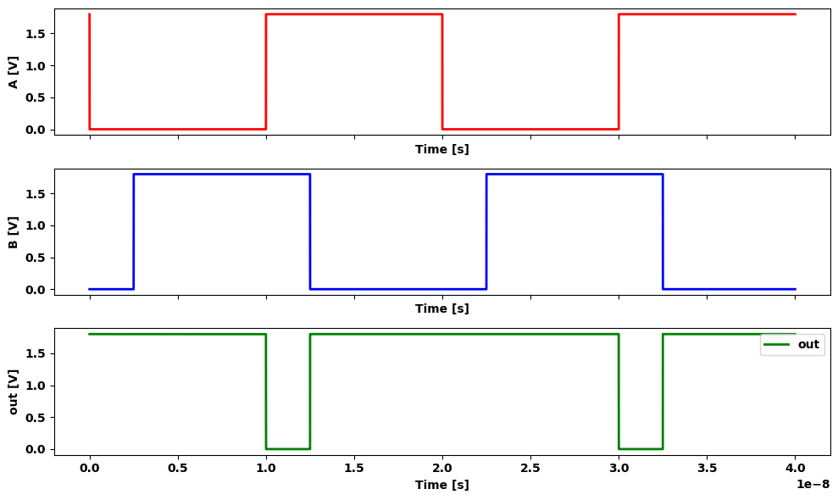

1.7.1 Figure 2.31 NAND2 logic gate
import schemdraw
import schemdraw.elements as elm
import matplotlib.pyplot as plt
from schemdraw import dsp
from schemdraw import logic
with schemdraw.Drawing() as d:
d += (l1 :=elm.Line().left(d.unit*.5).label('$4:1$','bottom'))
d += (l2 :=elm.Line().down(d.unit*1.5))
d += (l3 :=elm.Line().right(d.unit*.5).label('(a) Logic diagram','bottom'))
d += (l4 :=elm.Line().up(d.unit*1.5))
d += (l5 :=elm.Line().left(d.unit*.3).label('$X$','left').at((-1.5,-.75)).dot().label('$0$','right'))
d += (l6 :=elm.Line().left(d.unit*.3).label('$y$','left').at((-1.5,-1.25)).dot().label('$1$','right'))
d += (l7 :=elm.Line().left(d.unit*.3).label('"1"','left').at((-1.5,-2.25)).dot().label('$0$','right'))
d += (l8 :=elm.Line().left(d.unit*.3).label('"1"','left').at((-1.5,-2.75)).dot().label('$1$','right'))
d += (l9 :=elm.Line().left(d.unit*.3).label('"1"','left').at((-1.5,-3.25)).dot().label('$2$','right'))
d += (l10 :=elm.Line().left(d.unit*.3).label('"0"','left').at((-1.5,-3.75)).dot().label('$3$','right'))
d += (l11 :=elm.Line().right(d.unit*.3).label('h(x,y)=(x.y) ̅','right').at((0,-2.5)).dot().label('\n\n output','right'))
d += (l12 :=elm.Line().right(d.unit*.03).label('G{0/3','right',color='black').at((-1.25,-.75)).color('white'))
d += (l13 :=elm.Line().left(d.unit*.6).label('$4:1$','bottom').at((10,0)))
d += (l14 :=elm.Line().down(d.unit*1.5))
d += (l15 :=elm.Line().right(d.unit*.6).label('(b) Voltage Network','bottom'))
d += (l16 :=elm.Line().up(d.unit*1.5))
d += (l17 :=elm.Line().left(d.unit*.3).label('$V{X}$','left').at((8.2,-.75)).dot().label('$0$','right'))
d += (l18 :=elm.Line().left(d.unit*.3).label('$V{y}$','left').at((8.2,-1.25)).dot().label('$1$','right'))
d += (l19 :=elm.Line().left(d.unit*.3).label('$V{DD}$','left').at((8.2,-2.5)).dot().label('$0$','right'))
d += (l20 :=elm.Line().left(d.unit*.3).at((8.2,-3)).label('$1$','right'))
d += (l21 :=elm.Line().left(d.unit*.3).at((8.2,-3.5)).dot().label('$2$','right'))
d += (l22 :=elm.Line().left(d.unit*.3).label('$0{v}$','left').at((8.2,-4)).dot().label('$3$','right'))
d += (l23 :=elm.Line().left(d.unit*.3).endpoints(l21.end,l19.end))
d += elm.Ground().at(l22.end)
d += (l24 :=elm.Line().right(d.unit*.3).label('Vout','right').at((10,-2)).dot())
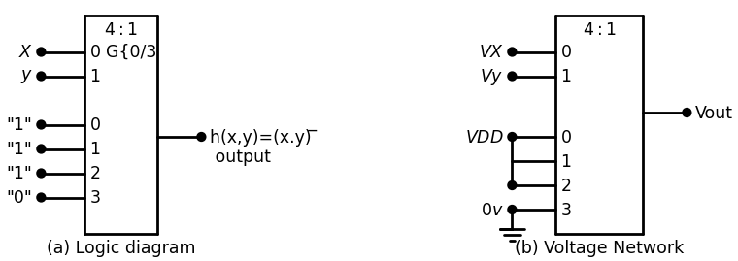

1.7.2 Figure 2.32 NAND2 operation using a 4:1 multiplexor
import schemdraw
import schemdraw.elements as elm
import matplotlib.pyplot as plt
from schemdraw import dsp
from schemdraw import logic
with schemdraw.Drawing() as d:
d += ( T := dsp.Box(w=2, h=2).anchor('W').fill('white').label('$1$').label('$1$','left'))
d += ( T := dsp.Box(w=2, h=2).anchor('W').fill('white').at((2,0)).label('$0$'))
d += ( T := dsp.Box(w=2, h=2).anchor('W').fill('white').at((2,2)).label('$1$').label('$1$','top'))
d += ( T := dsp.Box(w=2, h=2).anchor('W').fill('white').at((0,2)).label('$0$','top').label('$0$','left').label('$1$'))
d += ( T := dsp.Box(w=1, h=1).anchor('W').fill('white').at((2.4,0)))
d += ( T := dsp.Box(w=3, h=1).anchor('W').fill('white').at((.5,2)))
d += ( T := dsp.Box(w=1, h=3).anchor('W').fill('white').at((.7,1.1)))
d += (l1 :=elm.Line().right(d.unit*.3).label('x','top').at((-.9,3)))
d += (l2 :=elm.Line().up(d.unit*.4).label('y','top'))
d += (l3 :=elm.Line().right(d.unit*.00003).at((-.9,4)))
d += (l4 :=elm.Line().right(d.unit*.03).endpoints(l3.end,l1.end))
d += elm.Arrow().up().length(1.2).linewidth(2).color('black'). at((1.5,-1.7)).label('y ̅=y ̅.1','left')
d += elm.Arrow().left().length(1.5).linewidth(2).color('black'). at((4.8,2)).label('x ̅=x ̅.1','right')
d += elm.Arrow().left().length(1.5).linewidth(2).color('black'). at((4.8,0)).label('0.x.y','right')
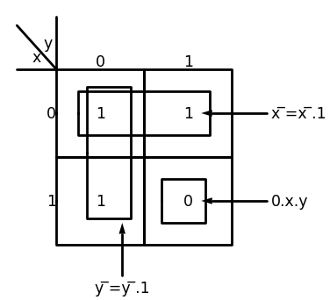

1.7.3 Figure 2.33 NAND2 K-map
import schemdraw
import schemdraw.elements as elm
import matplotlib.pyplot as plt
from schemdraw import dsp
from schemdraw import logic
with schemdraw.Drawing(unit=2) as d:
d += (M1 := elm.PFet2().anchor('gate').theta(90).label('$MP_x$','bottom'))
d += (M2 := elm.PFet2().anchor('gate').theta(90).label('$MP_y$','bottom').at((3,0)))
d += (M3 := elm.AnalogNFet(offset_gate = False).anchor('drain').theta(0).label('$MN_X$','right').at((3,-2)).reverse())
d += (M4 := elm.AnalogNFet(offset_gate = False).anchor('drain').theta(0).label('$MN_y$','right').at(M3.source).reverse())
d += elm.Ground().at(M4.source).label('$ NAND $','bottom')
d += (l1 :=elm.Line().right(d.unit*.5).endpoints(M1.source,M2.source))
d += (l2 :=elm.Line().right(d.unit*.5).endpoints(M1.drain,M2.drain))
d += (l3 :=elm.Line().up(d.unit*.5).at(M3.drain))
d += (l4 :=elm.Line().left(d.unit*.1).at(M1.gate).label('$x$','left').dot(open=True))
d += (l5 :=elm.Line().left(d.unit*.1).at(M2.gate).label('$y$','left').dot(open=True))
d += (l6 :=elm.Line().left(d.unit*.1).at(M3.gate).label('$x$','left').dot(open=True))
d += (l7 :=elm.Line().left(d.unit*.1).at(M4.gate).label('$y$','left').dot(open=True))
d += elm.Vdd().at((2.8,1)).label('$V{DD}$','top')
d += (l8 :=elm.Line().right(d.unit*1).at((3,-2)))
#d += (C1:=elm.Capacitor2().down(d.unit*.9).at(l8.end))
d += (l8 :=elm.Line().right(d.unit*.5).at(C1.start).dot(open=True).label('$ out=(x.y) ̅ $','right'))
#d += elm.Ground().at(C1.end)
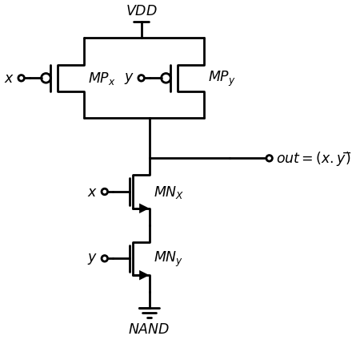

1.7.4 Figure 2.35 Operational sum m ary of the NAND2 circuit
ation summarized in the table of Figure 2.35. An im portant characteristic of the NAND2 gate is that it uses two parallel-connected pFETs, while the nFETs are in series. This is exactly opposite to the stru c tu re of the NOR2 gate. A NAND3 gate can be created u sin g th e sam e topology. It requires three sets of complementary pairs, each driven by a separate input. The nFETs are placed in series, while the pFETs are wired in parallel. This gives the gate shown in Figure 2.36. To verify the operation of the circuit, note that all three inputs must be l's to provide aconduction path between the output and ground. If any one (or more) of the inputs is a 0. then the corresponding nFET is off while the pFET it drives acts like a closed switch; this gives a logic 1 voltage of VDD a t the output. Switch logic analysis can also be applied by treatin g th e circuit as a multiplexor. The series-connected nFET chain at the bottom of the circuit is described by the logic term
$$0.x.y.z$$
$$\left(2.46\right)$$
Each pFET branch consists of a single tra n sisto r th a t a cts like a closed switch when a 0 is applied. Performing the OR operation am ong the four
import schemdraw
import schemdraw.elements as elm
import matplotlib.pyplot as plt
from schemdraw import dsp
from schemdraw import logic
with schemdraw.Drawing() as d:
d += (M1 := elm.PFet2(offset_gate = False).anchor('drain').theta(180).reverse().length(3))
d += (M2 := elm.PFet2(offset_gate = False).anchor('drain').theta(180).reverse().length(3).at((2,-2)))
d += (M3 := elm.PFet2(offset_gate = False).anchor('drain').theta(180).reverse().length(3).at((4,-4)))
d += (M4 := elm.AnalogNFet(offset_gate = False).anchor('gate').theta(270).reverse().at((5.5,-5.5)))
d += (M5 := elm.AnalogNFet(offset_gate = False).anchor('gate').theta(270).reverse().at((3.5,-5.5)))
d += (M6 := elm.AnalogNFet(offset_gate = False).anchor('gate').theta(270).reverse().at((1.5,-5.5)))
d += (l1 :=elm.Line().down(d.unit*2.5).label('x','left').at(M1.gate).dot())
d += (l2 :=elm.Line().down(d.unit*1.9).label('y','left').at(M2.gate).dot())
d += (l3 :=elm.Line().down(d.unit*1.2).label('z','left').at(M3.gate).dot())
d += elm.Ground().at(M6.source)
d += elm.Vdd().at(M1.drain).label('VDD','top')
d += (l4 :=elm.Line().left(d.unit*.65).at(M2.drain).dot())
d += (l5 :=elm.Line().left(d.unit*1.335).at(M3.drain).dot())
d += (l6 :=elm.Line().up(d.unit*1.33).dot())
d += (l7 :=elm.Line().right(d.unit*1.5).at(M1.source).label('1.x ̅','top'))
d += (l8 :=elm.Line().right(d.unit*.85).at(M2.source).label('1.y ̅','top'))
d += (l9 :=elm.Line().down(d.unit*.66).dot().at(l7.end).label('+','top'))
d += (l10 :=elm.Line().down(d.unit*.675).dot().at(l9.end).label('+','top'))
d += (l11 :=elm.Line().left(d.unit*.3).label('1.z ̅','top'))
d += (l12 :=elm.Line().down(d.unit*.8).label('+','top').at(l11.start))
d += (l13 :=elm.Line().left(d.unit*.4).label('0.x.y.z','top'))
d += (l14 :=elm.Line().left(d.unit*.2).at(M4.source))
d += (l14 :=elm.Line().left(d.unit*.2).at(M5.source))
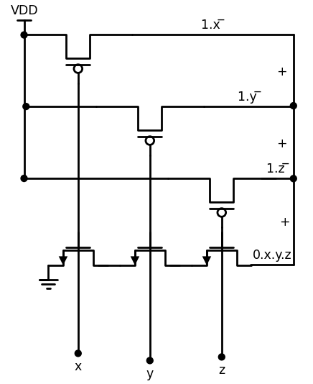
import ipywidgets as widgets
from ipywidgets import interact
import matplotlib.pyplot as plt
from matplotlib import rcParams
import PySpice.Logging.Logging as Logging
logger = Logging.setup_logging()
from PySpice.Probe.Plot import plot
from PySpice.Spice.Netlist import Circuit
from PySpice.Unit import *
rcParams['font.weight'] = 'bold'
figure = plt.figure(figsize=(15, 10))
circuit = Circuit('Pulse Sources ')
circuit.model('2N7000', 'NMOS', L=0.6E-6, W=1.2E-6,LAMBDA = 0.1 ,Kp=0.007, Vto=.4)
circuit.model('2N7100', 'PMOS', L=.6E-6, W=2.4E-6,LAMBDA = 0.1 ,Kp=0.007, Vto=-.4)
circuit.V(1, '1', circuit.gnd, 1.8@u_V)
circuit.MOSFET(1, 'out1', 'A', '1','1', model='2N7100')
circuit.MOSFET(2, 'out1', 'B', '1','1', model='2N7100')
circuit.MOSFET(22, 'out1', 'C', '1','1', model='2N7100')
circuit.MOSFET(3, 'out1', 'A', '2',circuit.gnd, model='2N7000')
circuit.MOSFET(4, '2', 'B', '3',circuit.gnd, model='2N7000')
circuit.MOSFET(44, '3', 'C', circuit.gnd,circuit.gnd, model='2N7000')
#circuit.MOSFET(5, 'out', 'out1', '1','1', model='2N7100')
#circuit.MOSFET(6, 'out', 'out1', circuit.gnd,circuit.gnd, model='2N7000')
circuit.C(1, 'out1',circuit.gnd , 0.01@u_pF)
pulse1 = circuit.PulseVoltageSource('V1', 'A', circuit.gnd, initial_value=1.8@u_V, pulsed_value=0@u_V,rise_time=1@u_ps,fall_time=1@u_ps, pulse_width=10@u_ns, period=20@u_ns)
pulse2 = circuit.PulseVoltageSource('V2', 'B', circuit.gnd, initial_value=0@u_V, pulsed_value=1.8@u_V,delay_time=2.5@u_ns,rise_time=1@u_ps,fall_time=1@u_ps,pulse_width=10@u_ns, period=20@u_ns)
pulse3 = circuit.PulseVoltageSource('V3', 'C', circuit.gnd, initial_value=0@u_V, pulsed_value=1.8@u_V,delay_time=3.5@u_ns,rise_time=1@u_ps,fall_time=1@u_ps,pulse_width=10@u_ns, period=20@u_ns)
simulator = circuit.simulator(temperature=25, nominal_temperature=25)
analysis = simulator.transient(step_time=1@u_ns, end_time=40@u_ns)
fig, (ax1, ax2, ax3,ax4) = plt.subplots(4, 1, figsize=(10, 6), sharex=True)
ax1.plot(analysis.time, analysis['A'], 'red', linewidth=2, label='A')
ax1.set_xlabel('Time [s]', color='black', weight='black', fontsize=10)
ax1.set_ylabel('A [V]', color='black', weight='black', fontsize=10)
ax2.plot(analysis.time, analysis['B'], 'blue', linewidth=2, label='B')
ax2.set_xlabel('Time [s]', color='black', weight='black', fontsize=10)
ax2.set_ylabel('B [V]', color='black', weight='black', fontsize=10)
ax3.plot(analysis.time, analysis['C'], 'Chocolate', linewidth=2, label='C')
ax3.set_xlabel('Time [s]', color='black', weight='black', fontsize=10)
ax3.set_ylabel('C [V]', color='black', weight='black', fontsize=10)
ax4.plot(analysis.time, analysis['out1'], 'green', linewidth=2, label='out1')
ax4.set_xlabel('Time [s]', color='black', weight='black', fontsize=10)
ax4.set_ylabel('out1 [V]', color='black', weight='black', fontsize=10)
ax4.legend()
plt.tight_layout()
plt.show()
<Figure size 1500x1000 with 0 Axes>
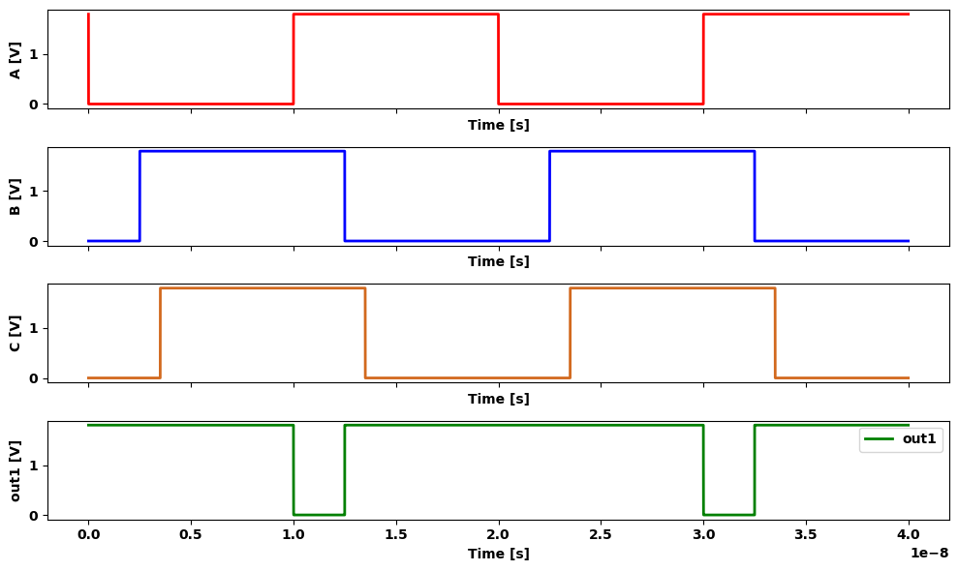

1.7.5 Figure 2.36 A NANAD3 logic gate in CMOS
branches gives
$$0.x.y.z+1.x̅+1.y̅+1.z̅$$
$$\left(2.47\right)$$
Eliminating the 0 terms and using DeMorgan reduction gives the function as
$$\left(x.y.z\right)̅$$
$$\left(2.48\right)$$
which is the NAND3 function. T h is technique can be extended the CMOS circuitry for NAND gates with more inputs

1.8 2.4 Complex Logic Gates in CMOS
One of the most powerful aspects o f b u ild in g lo gic circuits in CMOS ability to create a single circuit that p ro vid es several primitive open (NOT. AND. and OR) in an integrated m an n er. T h e s e will be callel plex or combinational logic gates in our discussion . Complex logic are very useful in VLSI system-level design. To illustrate the main idea of a complex logic gate, consider the ean expression
$$F\left(a,b,c\right)=\left(a.\left(b+c\right)\right)̅$$
$$\left(2.49\right)$$
The simplest way to construct the logic network for this function is on OR-gate, ONE AND gate, and one NOT gate as shown in fig 2.37(a). Alternately, we might simplify the network to that in fig 2.37(b) if NAND2 gate is available, if w build the electronic equity of either implementation, then the traditional approach would be one-to-one map: each gate requires on electronic logic circuit for first case (a).this would require three separate gates, while (b) reduen gate count to two. for many applications, this method is perfectly are able; it is intuitive and straightforward to implement. the design constraints on a VLSI implemention are more difficsatisfy.Transistor occupy area on the silicon chip and every logic.
import schemdraw
import schemdraw.elements as e
import matplotlib.pyplot as plt
from schemdraw import dsp
from schemdraw import logic
with schemdraw.Drawing(unit=2) as d:
Or = d.add(logic.Or().right().label('b', loc='left', color='black').label('\n\n c', loc='left', color='black'))
And = d.add(logic.And().right().label('\n\n a', loc='left', color='black').at((1.85,-.26)).label(' (a)', loc='bottom', color='black'))
Not = d.add(logic.Not().right().label(' F', loc='right', color='black'))
Or = d.add(logic.Or().right().label('b', loc='left', color='black').label('\n\n c', loc='left', color='black').at((8,0)))
Nand = d.add(logic.Nand().right().label('\n\n a', loc='left', color='black').at((9.85,-.26)).label(' F', loc='right', color='black').label(' (b)', loc='bottom', color='black'))
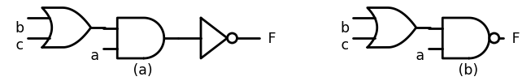

1.8.1 Figure 2.37 Logic function example
uses transistors. Since the gate count on a VLSI chip can easily exceed several hundred thousand , we often look for techniques that reducethe number of gates and / or FETs while still perform in gtherequired logic. In the p resen t discussion , we will achieve th is ob jective by building a single logic gate th at im p lem en ts the en tire function . Let us investigate the ch a racteristics of the function F in more detail by applying DeM drgan expansions to the function to write
$$F=\left(a.\left(b+c\right)\right)̅$$
$$=a̅+\left(\left(b+c\right)\right)̅$$
$$=\left[a̅+\left(b̅+c̅\right)\right].1$$
$$\left(2.50\right)$$
The last step is simply ANDing the result with a logical 1. Expanding gives
$$F=a̅.1+\left(b̅.c̅\right).1$$
$$\left(2.51\right)$$
which is in a form that can be used to build the pFET switching circuit shown in Figure 2.38. The correspondence can be verified by checking each term . The first term implies a pFET connected be tween the power supply (VDD ) and the output that is con trolled by the input a. The second term is identical in form to th at encountered for the NOR2 gate. It repre sents two series -connected pFETs (with control variables band c) that connect the power supply to the output.
import schemdraw
import schemdraw.elements as elm
import matplotlib.pyplot as plt
from schemdraw import dsp
from schemdraw import logic
with schemdraw.Drawing() as d:
d += (M1 := elm.PFet2(offset_gate = False).anchor('drain').theta(180).reverse().length(3))
d += (M2 := elm.PFet2(offset_gate = False).anchor('drain').theta(180).reverse().length(3).at(M1.source))
d += (l1 :=elm.Line().right(d.unit*.5).label('1.b ̅.c ̅','top').at(M2.source))
d += (M3 := elm.PFet2(offset_gate = False).anchor('drain').theta(180).reverse().length(3).at((-1.5,-3)))
d += (l2 :=elm.Line().up(d.unit*1).at(M3.drain))
d += elm.Vdd().at(M1.drain).label('VDD','top')
d += (l3 :=elm.Line().down(d.unit*1).at(l1.end).label('+','top'))
d += (l4 :=elm.Line().left(d.unit*2).label('1.b ̅','right'))
d += (l5 :=elm.Line().right(d.unit*.5).at(l2.end))
d += (l6 :=elm.Line().down(d.unit*1.3).at(M1.gate).dot().label('b','left'))
d += (l7 :=elm.Line().down(d.unit*1.3).at(M2.gate).dot().label('c','left'))
d += (l8 :=elm.Line().down(d.unit*.3).at(M3.gate).dot().label('a','left'))
d += (l9 :=elm.Line().right(d.unit*.5).at(l4.start).dot().label('out','right'))
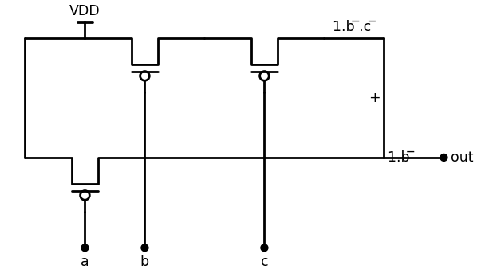

1.8.2 Figure 2.38 pFET circuit for F from equation (2.51)
The pFET circuit alone is not sufficient to create a functional electronic network . We mustadd an nFET array that gives F = 0 when necessary. The original form of the function in equation (2 .49) shows that F=0 occurs when
$$a=1AND\left(b+c\right)=1$$
This is equivalent to writing the output expression
$$0.\left[a.\left(b+c\right)\right]$$
$$\left(2.52\right)$$
import schemdraw
import schemdraw.elements as elm
import matplotlib.pyplot as plt
from schemdraw import dsp
from schemdraw import logic
with schemdraw.Drawing(unit=2) as d:
d += (M1 := elm.AnalogNFet(offset_gate = False).anchor('gate').theta(270).label('0.(b+c)','right'))
d += (M2 := elm.AnalogNFet(offset_gate = False).anchor('gate').theta(270).at((-2,-2)).label('OR','right'))
d += (M3 := elm.AnalogNFet(offset_gate = False).anchor('gate').theta(270).at((2.5,-2)).label('AND','right'))
d += (l1 :=elm.Line().right(d.unit*1.5).at(M2.drain))
d += (l2 :=elm.Line().down(d.unit*1).dot().at(M1.drain))
d += (l3 :=elm.Line().left(d.unit*1).at(M1.source))
d += (l4 :=elm.Line().down(d.unit*1.3).at(l3.end))
d += (l5 :=elm.Line().down(d.unit*1.5).at(M1.gate).dot().label('c','left'))
d += (l6 :=elm.Line().down(d.unit*.5).at(M2.gate).dot().label('b','left'))
d += (l7 :=elm.Line().down(d.unit*.5).at(M3.gate).dot().label('a','left'))
d += (l8 :=elm.Line().right(d.unit*.5).at(M3.drain).dot().label('out','right').label('\n\n 0.[a.(b+c)]','right'))
d += elm.Ground().at(l4.end)
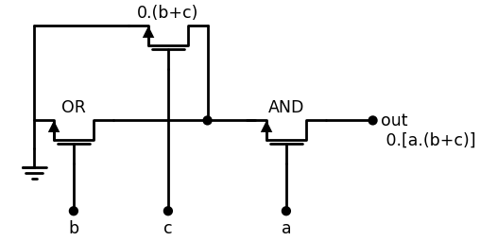
import ipywidgets as widgets
from ipywidgets import interact
import matplotlib.pyplot as plt
from matplotlib import rcParams
import PySpice.Logging.Logging as Logging
logger = Logging.setup_logging()
from PySpice.Probe.Plot import plot
from PySpice.Spice.Netlist import Circuit
from PySpice.Unit import *
rcParams['font.weight'] = 'bold'
figure = plt.figure(figsize=(15, 10))
circuit = Circuit('Pulse Sources ')
circuit.model('2N7000', 'NMOS', L=0.6E-6, W=1.2E-6,LAMBDA = 0.1 ,Kp=0.007, Vto=.4)
circuit.model('2N7100', 'PMOS', L=.6E-6, W=2.4E-6,LAMBDA = 0.1 ,Kp=0.007, Vto=-.4)
#circuit.V(1, '1', circuit.gnd, 1.8@u_V)
circuit.MOSFET(1, 'out', 'A', '2',circuit.gnd, model='2N7000')
circuit.MOSFET(2, '2', 'C', circuit.gnd,circuit.gnd, model='2N7000')
circuit.MOSFET(3, '2', 'B', circuit.gnd,circuit.gnd, model='2N7000')
circuit.C(1, 'out',circuit.gnd , 0.1@u_pF)
pulse1 = circuit.PulseVoltageSource('V1', 'A', circuit.gnd, initial_value=1.8@u_V, pulsed_value=0@u_V,rise_time=1@u_ps,fall_time=1@u_ps, pulse_width=5@u_ns, period=20@u_ns)
pulse2 = circuit.PulseVoltageSource('V2', 'B', circuit.gnd, initial_value=1.8@u_V, pulsed_value=0@u_V,rise_time=1@u_ps,fall_time=1@u_ps,pulse_width=5@u_ns, period=20@u_ns)
pulse3 = circuit.PulseVoltageSource('V3', 'C', circuit.gnd, initial_value=0@u_V, pulsed_value=1.8@u_V,rise_time=1@u_ps,fall_time=1@u_ps,pulse_width=5@u_ns, period=20@u_ns)
simulator = circuit.simulator(temperature=25, nominal_temperature=25)
analysis = simulator.transient(step_time=1@u_ns, end_time=40@u_ns)
fig, (ax1, ax2, ax3,ax4) = plt.subplots(4, 1, figsize=(10, 6), sharex=True)
ax1.plot(analysis.time, analysis['A'], 'red', linewidth=2, label='A')
ax1.set_xlabel('Time [s]', color='black', weight='black', fontsize=10)
ax1.set_ylabel('A [V]', color='black', weight='black', fontsize=10)
ax2.plot(analysis.time, analysis['B'], 'blue', linewidth=2, label='B')
ax2.set_xlabel('Time [s]', color='black', weight='black', fontsize=10)
ax2.set_ylabel('B [V]', color='black', weight='black', fontsize=10)
ax3.plot(analysis.time, analysis['C'], 'Chocolate', linewidth=2, label='C')
ax3.set_xlabel('Time [s]', color='black', weight='black', fontsize=10)
ax3.set_ylabel('C [V]', color='black', weight='black', fontsize=10)
ax4.plot(analysis.time, analysis['out'], 'green', linewidth=2, label='out')
ax4.set_xlabel('Time [s]', color='black', weight='black', fontsize=10)
ax4.set_ylabel('out [V]', color='black', weight='black', fontsize=10)
ax4.legend()
plt.tight_layout()
plt.show()
<Figure size 1500x1000 with 0 Axes>
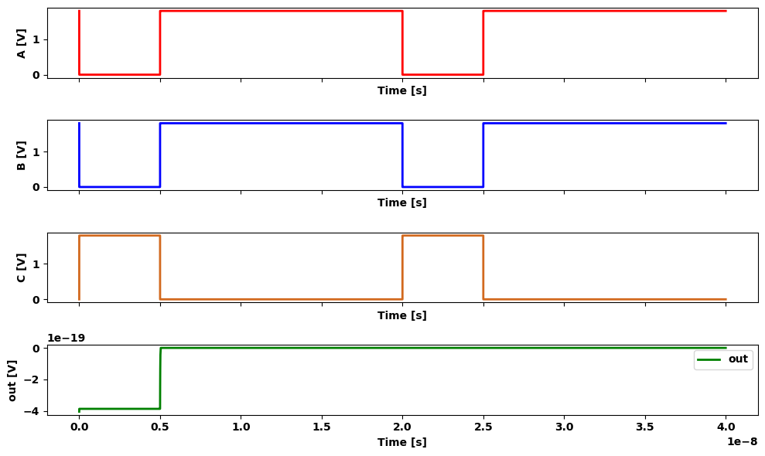

1.8.3 Figure 2.39 nFET logic circuit for F
which can in turn be used to describe the nFET array shown in Fig 2.39. Two parallel-connected nFETs that are controlled by b and the OR operation. This group is in series with the a-input nFET duce the AND. The logic can be verified by the Karnaugh map ground shown in Figure 2.40. Simplification to using a single a-input occurs because of the common term encompassed by the two group The completed CMOS logic gate is built by combining the nFET pFET circuits, and results in the circuit o f Figure 2.41. We haver the orientation of the FETs by 90 degrees to arrive at the finished matic. This is the most common way to draw CMOS logic circuits! makes series and parallel-connected FETs more obvious. The equfc of the circuit can be verified by tracing out each branch and compare with the simpler circuits developed above. This example illustrates that a complex function can be implement with a single CMOS logic circuit that replaces a cascade made up or more primitive gates. Complex logic gate circuits can be more in VLSI design since they simplify the circuit requirements and the flows. One powerful aspect o f a CMOS technology is that it allows design logic networks using several different techniques, such as logic gates. This helps increase the in tegration density, which measure the amount of logic that can be placed on the silicon chip.
import schemdraw
import schemdraw.elements as elm
import matplotlib.pyplot as plt
from schemdraw import dsp
from schemdraw import logic
with schemdraw.Drawing() as d:
d += ( T := dsp.Box(w=2, h=2).anchor('W').fill('white').label('$1$').label(' 0','left').label('$00$','top'))
d += ( T := dsp.Box(w=2, h=2).anchor('W').fill('white').label('$1$').label('$01$','top').at((2,0)))
d += ( T := dsp.Box(w=2, h=2).anchor('W').fill('white').label('$1$').label('$11$','top').at((4,0)))
d += ( T := dsp.Box(w=2, h=2).anchor('W').fill('white').label('$1$').label('$10$','top').at((6,0)))
d += ( T := dsp.Box(w=2, h=2).anchor('W').fill('white').label('$1$').label('$1$','left').at((0,-2)))
d += ( T := dsp.Box(w=2, h=2).anchor('W').fill('white').label('$1$').at((2,-2)))
d += ( T := dsp.Box(w=2, h=2).anchor('W').fill('white').label('$1$').at((4,-2)))
d += ( T := dsp.Box(w=2, h=2).anchor('W').fill('white').label('$1$').at((6,-2)))
d += ( T := dsp.Box(w=3.5, h=1).anchor('W').fill('red').at((2.3,-2)))
d += ( T := dsp.Box(w=3.5, h=1.4).anchor('W').fill('red').at((4.2,-2)))
d += elm.Arrow().up().length(1.2).linewidth(2).color('black'). at((2.5,-3.7)).label('a.c','left')
d += elm.Arrow().up().length(1.2).linewidth(2).color('black'). at((4.5,-3.7)).label('a.b','left')
d += elm.Arrow().right().length(1.2).linewidth(2).color('white'). at((3.5,2)).label('b.c','left',color='black')
d += elm.Arrow().right().length(.2).linewidth(2).color('white'). at((-1,-1)).label('a','left',color='black')
d += elm.Arrow().right().length(.2).linewidth(2).color('white'). at((12,-1)).label('f=(a.b+a.c) ̅','left',color='black')
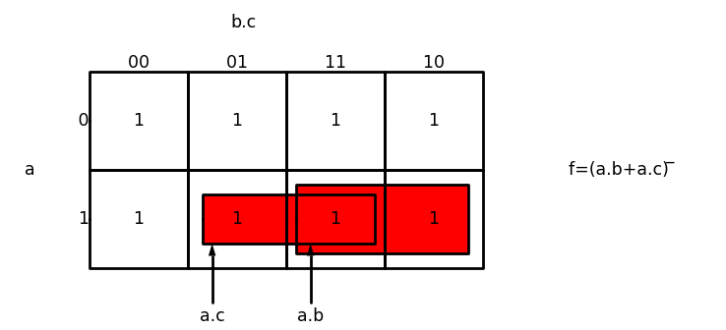

1.8.4 Figure 2.40 Karnaugh map grouping for the nFET circuit
import schemdraw
import schemdraw.elements as elm
import matplotlib.pyplot as plt
from schemdraw import dsp
from schemdraw import logic
with schemdraw.Drawing() as d:
d += (M1 := elm.PFet2(offset_gate = False).anchor('drain').theta(90).reverse().length(2).label(' c','top'))
d += (M2 := elm.PFet2(offset_gate = False).anchor('source').theta(90).reverse().length(2).at(M1.drain).label(' b','top'))
d += (M3 := elm.PFet2(offset_gate = False).anchor('drain').theta(270).length(2).label(' a','bottom').at((3,1)))
d += (l1 :=elm.Line().right(d.unit*1).at(M2.drain))
d += (l2 :=elm.Line().down(d.unit*.5))
d += (l3 :=elm.Line().down(d.unit*.322).at(M3.source).dot())
d += (l4 :=elm.Line().left(d.unit*1).dot())
d += (l5 :=elm.Line().right(d.unit*.5).dot().at(l4.start).label('F','right'))
d += (M4 := elm.AnalogNFet(offset_gate = False).anchor('drain').theta(0).label('a','left').at((0,-2)).reverse())
d += (M5 := elm.AnalogNFet(offset_gate = False).anchor('drain').theta(0).label('b','left').at((0,-3.5)).reverse())
d += (M6 := elm.AnalogNFet(offset_gate = False).anchor('drain').theta(0).label('c','right').at((2,-3.5)))
d += (l6 :=elm.Line().left(d.unit*.65).at(M6.drain))
d += elm.Ground().at(M6.source)
d += elm.Ground().at(M5.source)
d += elm.Vdd().at(M2.drain).label('VDD','top')
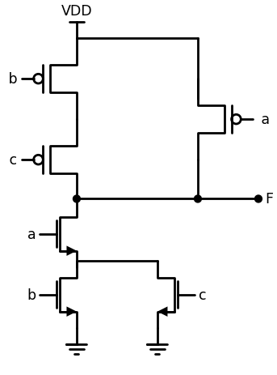
import ipywidgets as widgets
from ipywidgets import interact
import matplotlib.pyplot as plt
from matplotlib import rcParams
import PySpice.Logging.Logging as Logging
logger = Logging.setup_logging()
from PySpice.Probe.Plot import plot
from PySpice.Spice.Netlist import Circuit
from PySpice.Unit import *
rcParams['font.weight'] = 'bold'
figure = plt.figure(figsize=(15, 10))
circuit = Circuit('Pulse Sources ')
circuit.model('2N7000', 'NMOS', L=0.6E-6, W=1.2E-6,LAMBDA = 0.1 ,Kp=0.007, Vto=.4)
circuit.model('2N7100', 'PMOS', L=.6E-6, W=2.4E-6,LAMBDA = 0.1 ,Kp=0.007, Vto=-.4)
circuit.V(1, '1', circuit.gnd, 1.8@u_V)
circuit.MOSFET(1, '2', 'B', '1','1', model='2N7100')
circuit.MOSFET(2, 'F', 'C', '2','1', model='2N7100')
circuit.MOSFET(3, 'F', 'A', '1','1', model='2N7100')
circuit.MOSFET(4, 'F', 'A', '3',circuit.gnd, model='2N7000')
circuit.MOSFET(5, '3', 'B', circuit.gnd,circuit.gnd, model='2N7000')
circuit.MOSFET(6, '3', 'C', circuit.gnd,circuit.gnd, model='2N7000')
circuit.C(1, 'F',circuit.gnd , 0.1@u_pF)
pulse1 = circuit.PulseVoltageSource('V1', 'A', circuit.gnd, initial_value=1.8@u_V, pulsed_value=0@u_V,rise_time=1@u_ps,fall_time=1@u_ps, pulse_width=10@u_ns, period=20@u_ns)
pulse2 = circuit.PulseVoltageSource('V2', 'B', circuit.gnd, initial_value=0@u_V, pulsed_value=1.8@u_V,delay_time=2.5@u_ns,rise_time=1@u_ps,fall_time=1@u_ps,pulse_width=10@u_ns, period=20@u_ns)
pulse3 = circuit.PulseVoltageSource('V3', 'C', circuit.gnd, initial_value=0@u_V, pulsed_value=1.8@u_V,delay_time=3.5@u_ns,rise_time=1@u_ps,fall_time=1@u_ps,pulse_width=10@u_ns, period=20@u_ns)
simulator = circuit.simulator(temperature=25, nominal_temperature=25)
analysis = simulator.transient(step_time=1@u_ns, end_time=40@u_ns)
fig, (ax1, ax2, ax3,ax4) = plt.subplots(4, 1, figsize=(10, 6), sharex=True)
ax1.plot(analysis.time, analysis['A'], 'red', linewidth=2, label='A')
ax1.set_xlabel('Time [s]', color='black', weight='black', fontsize=10)
ax1.set_ylabel('A [V]', color='black', weight='black', fontsize=10)
ax2.plot(analysis.time, analysis['B'], 'blue', linewidth=2, label='B')
ax2.set_xlabel('Time [s]', color='black', weight='black', fontsize=10)
ax2.set_ylabel('B [V]', color='black', weight='black', fontsize=10)
ax3.plot(analysis.time, analysis['C'], 'Chocolate', linewidth=2, label='C')
ax3.set_xlabel('Time [s]', color='black', weight='black', fontsize=10)
ax3.set_ylabel('C [V]', color='black', weight='black', fontsize=10)
ax4.plot(analysis.time, analysis['F'], 'green', linewidth=2, label='F')
ax4.set_xlabel('Time [s]', color='black', weight='black', fontsize=10)
ax4.set_ylabel('F [V]', color='black', weight='black', fontsize=10)
ax4.legend()
plt.tight_layout()
plt.show()
<Figure size 1500x1000 with 0 Axes>
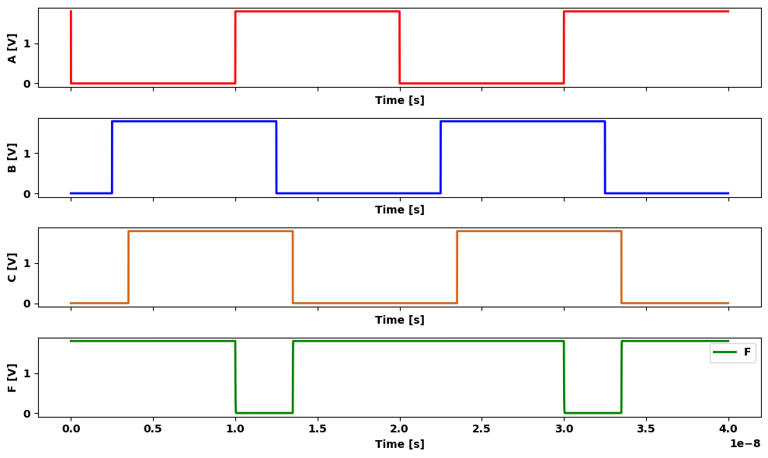

1.8.5 Figure 2.41 Finished complex CMOS logic gate circuit

1.9 2.4.1 Structured Logic Design
A structured approach to designing complex logic gates can be developed by focusing on the circuit characteristics. CMOS logic gates are in trinsi cally inverting; this means that the output always produces a NOT oper ation acting on the input variables. The simple inverter in Figure 2.42 illustrates the origin o f this property. If the input a is a logic 1, then the nFET is ON and the pFET is OFF. The nFET passes the logic 0 (ground) to the output, giving a there. This characteristic w as also ob served in the NAND and NOR circuits. The inverting nature o f CMOS logic circuits allows us to construct logic circuits for AOI and OAI logic expressions using a structured approach. An AOI logic function is one that im plem ents the operations in the order AND then OR then NOT (invert). For example.
import schemdraw
import schemdraw.elements as elm
import matplotlib.pyplot as plt
from schemdraw import dsp
from schemdraw import logic
with schemdraw.Drawing() as d:
d += (M1 := elm.PFet2(offset_gate = False).anchor('drain').theta(90).reverse().length(2).linestyle('--'))
d += (l1 :=elm.Line().left(d.unit*.5).at(M1.gate).linestyle('--'))
d += (l2 :=elm.Line().down(d.unit*.3).linestyle('--'))
d += (l3 :=elm.Line().down(d.unit*.315))
d += (l4 :=elm.Line().right(d.unit*.65))
d += (M2 := elm.AnalogNFet(offset_gate = False).anchor('drain').theta(0).at((0,-2)).reverse())
d += (l5 :=elm.Line().left(d.unit*.3).at(l2.end).dot().label('a=1','left'))
d += elm.Vdd().at(M1.drain).label('VDD','top').label('1','left')
d += elm.Ground().at(M2.source).label('0','left')
d += (l6 :=elm.Line().right(d.unit*.3).at(M2.drain).dot().label('f=0','right').label('\n\n\n\n\n\n this give \n f=0 at the \n output','right'))
d += (l7 :=elm.Line().right(d.unit*.15).label('A logic 1 \n input turns \n on the nFET','right').at()
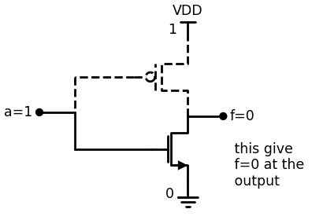

1.9.1 Figure 2.42 Origin o f the inverting characteristic o f CMOS gates
$$g\left(a,b,c,d\right)=\left(a.b+c.d\right)̅$$
has an implied operational order o f finding $\left(aANDb\right)$ and $\left(cANDd\right)$ and then perform the OR operation such that the final result is $g=NOTl\left(aANDb\right)$ OR $\left(cANDd\right)]$ Another example is found using the preceding CMOS gate examp expanding the function to read
$$f\left(a,b,c\right)=\left(a.\left(b+c\right)\right)̅=\left(a.b+a.c\right)̅$$
The operational order A-O-I is seen after distributing the terms. Ans nate description of an AOI function is to say that it is an inverted sue products (SOP). An OR-AND-INVERT (OAI) function reverses the orc-: the AND and OR operations. An example o f an OAI form is
$$h\left(x,y,z,m\right)=\left(\left(x+y\right).\left(z+w\right)\right)̅$$
since this implies that we first calculate
$$\left(xORy\right)alongwith\left(u;ORz\right)$$
and then
$$h=NOT\left[\left(xORy\right)AND\left(mORz\right)\right]$$
to evaluate the value of h. An OAI form is equivalent to an invertedp uct-of-sums (POS) expression. CMOS switching characteristics provide a natural means for te menting inverting logic form s such as A O I and OAI. The techniqt based on using nFET and pFET arrays in a consistent manner. Con- logic gates of this type allow the designer to compress three or morep itive operations into a single logic gate. Consider first the logic forme, properties of nFETs. From the NAND analysis, w e learned that nFE? series provide AND-INVERT logic; this is shown in Figure 2.43(a). larly, the NOR gate analysis showed us that parallel connected re produce the OR-INVERT operations as sum m arized in Figure 2. 43(a) These results may be generalized to a larger num ber of transistors example, 4 series-connected nFETs with inputs a, b, c, d would product
$$\left(a.b.c.d\right)̅$$
while parallel-connecting the FETs would give the OR-INVERT operation
$$\left(a+b+c+d\right)̅$$
The power of this observation is that we may combine series- and par connected nFETs to produce com plex logic gates. An example of this shown in Figure 2.44. This array consists o f parallel-connected ground
import schemdraw
import schemdraw.elements as elm
import matplotlib.pyplot as plt
from schemdraw import dsp
from schemdraw import logic
with schemdraw.Drawing() as d:
d += (M1 := elm.PFet2(offset_gate = False).anchor('drain').theta(90).reverse().label('$a$','top'))
d += (M2 := elm.PFet2(offset_gate = False).anchor('drain').theta(90).reverse().label('$b$','top').at(M1.source))
d += (l1 :=elm.Line().right(d.unit*.2).dot().label('$(a.b) ̅ $','right').at(M1.drain).dot())
d += elm.Ground().at(M2.source).label('$(a) series -connected nFET$','bottom')
Nand = d.add(logic.Nand().right().label('a \n b', loc='left', color='black').label('(a.b) ̅ ', loc='right', color='black').at((4,-3)))
d += (M3 := elm.PFet2(offset_gate = False).anchor('drain').theta(90).reverse().label('$a$','top').at((10,-1)))
d += (l2 :=elm.Line().right(d.unit*.5).at(M3.drain))
d += (M4 := elm.PFet2(offset_gate = False).anchor('drain').theta(270).label('$b$','bottom'))
d += (l3 :=elm.Line().right(d.unit*.5).at(l2.end).dot())
d += elm.Ground().at(M3.source)
d += elm.Ground().at(M4.source).label('$(b) Parallel -connected nFET$','bottom')
Nor = d.add(logic.Nor().right().label('a \n b', loc='left', color='black').label('(a+b) ̅ ', loc='right', color='black').at((15,-2.5)))
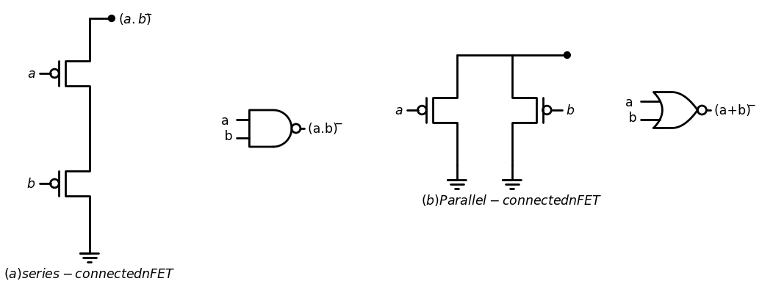

1.10 Figure 2.43 nFET logic formation
with each group m ade o f 2 series-connected nFETs. T h e tran sistors on the left side form the AND operation $\left(a.b\right)$ w hile the right group o f nFETs yields $\left(c•d\right)$; the parallel connection o f the tw o groups gives the O R opera tion, while the final output from the gate yields the NOT. W e thus see that the function is described by
$$x=\left(\left(a.b\right)+\left(c.d\right)\right)̅$$
$$\left(2.58\right)$$
which is an AOI expression that is represented b y the logic circuit shown next to the circuit. It is important to note that the N O T operation is viewed at the exit point o f the logic (i.e., only for the function X ). The AND opera tion is provided by series-connected nFETs, w hile the O R is accom plished by using a parallel-connected group. Although this approach is based on
import schemdraw
import schemdraw.elements as elm
import matplotlib.pyplot as plt
from schemdraw import dsp
from schemdraw import logic
with schemdraw.Drawing() as d:
d += (M1 := elm.PFet2(offset_gate = False).anchor('drain').theta(90).reverse().label('$a$','top'))
d += (M2 := elm.PFet2(offset_gate = False).anchor('drain').theta(90).reverse().label('$b$','top').at(M1.source))
d += (l1 :=elm.Line().right(d.unit*.6).dot().at(M1.drain))
d += elm.Ground().at(M2.source)
d += (M3 := elm.PFet2(offset_gate = False).anchor('drain').theta(270).label('$c$','bottom').at(l1.end))
d += (M4 := elm.PFet2(offset_gate = False).anchor('drain').theta(270).label('$d$','bottom'))
d += elm.Ground().at(M4.source)
d += (l1 :=elm.Line().right(d.unit*.6).dot().label('$X$','right').at(l1.end).dot())
Nand1= d.add(logic.Nand().right().label('a \n b', loc='left', color='black').at((6,-3)))
Nand2= d.add(logic.Nand().right().label('c \n d', loc='left', color='black').at((6,-4.5)))
Nor = d.add(logic.Nor().right().label('X', loc='right', color='black').at((8.5,-3.8)))
d += (l3 :=elm.Line().right(d.unit*.2).at(Nand1.end))
d += (l4 :=elm.Line().right(d.unit*.2).at(Nand2.end))
d += (l5 :=elm.Line().down(d.unit*.18).at(l3.end))
d += (l6 :=elm.Line().up(d.unit*.16).at(l4.end))
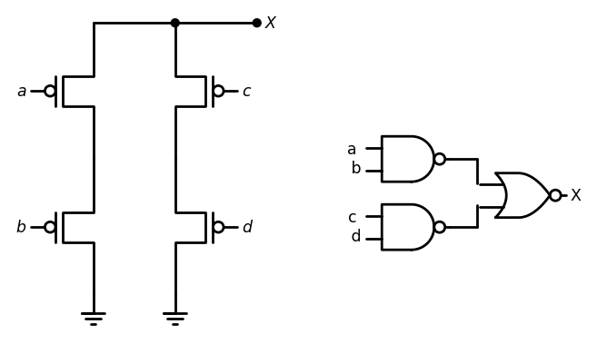
import ipywidgets as widgets
from ipywidgets import interact
import matplotlib.pyplot as plt
from matplotlib import rcParams
import PySpice.Logging.Logging as Logging
logger = Logging.setup_logging()
from PySpice.Probe.Plot import plot
from PySpice.Spice.Netlist import Circuit
from PySpice.Unit import *
rcParams['font.weight'] = 'bold'
figure = plt.figure(figsize=(15, 10))
circuit = Circuit('Pulse Sources ')
circuit.model('2N7000', 'NMOS', L=0.6E-6, W=1.2E-6,LAMBDA = 0.1 ,Kp=0.007, Vto=.4)
circuit.model('2N7100', 'PMOS', L=.6E-6, W=2.4E-6,LAMBDA = 0.1 ,Kp=0.007, Vto=-.4)
circuit.V(1, '1', circuit.gnd, 1.8@u_V)
circuit.MOSFET(1, '1', 'A', 'X','1', model='2N7100')
circuit.MOSFET(2, '2', 'C', 'X','1', model='2N7100')
circuit.MOSFET(3,circuit.gnd, 'B', '1','1', model='2N7100')
circuit.MOSFET(4,circuit.gnd, 'D', '2','1', model='2N7100')
#circuit.C(1, 'X',circuit.gnd , 0.1@u_pF)
pulse1 = circuit.PulseVoltageSource('V1', 'A', circuit.gnd, initial_value=1.8@u_V, pulsed_value=0@u_V,rise_time=1@u_ps,fall_time=1@u_ps, pulse_width=10@u_ns, period=20@u_ns)
pulse2 = circuit.PulseVoltageSource('V2', 'B', circuit.gnd, initial_value=1.8@u_V, pulsed_value=0@u_V,rise_time=1@u_ps,fall_time=1@u_ps, pulse_width=5@u_ns, period=20@u_ns)
pulse3 = circuit.PulseVoltageSource('V3', 'C', circuit.gnd, initial_value=1.8@u_V, pulsed_value=0@u_V,rise_time=1@u_ps,fall_time=1@u_ps, pulse_width=10@u_ns, period=20@u_ns)
pulse4 = circuit.PulseVoltageSource('V4', 'D', circuit.gnd, initial_value=1.8@u_V, pulsed_value=0@u_V,rise_time=1@u_ps,fall_time=1@u_ps, pulse_width=5@u_ns, period=20@u_ns)
simulator = circuit.simulator(temperature=25, nominal_temperature=25)
analysis = simulator.transient(step_time=1@u_ns, end_time=40@u_ns)
fig, (ax1, ax2, ax3,ax4,ax5) = plt.subplots(5, 1, figsize=(10, 6), sharex=True)
ax1.plot(analysis.time, analysis['A'], 'red', linewidth=2, label='A')
ax1.set_xlabel('Time [s]', color='black', weight='black', fontsize=10)
ax1.set_ylabel('A [V]', color='black', weight='black', fontsize=10)
ax2.plot(analysis.time, analysis['B'], 'blue', linewidth=2, label='B')
ax2.set_xlabel('Time [s]', color='black', weight='black', fontsize=10)
ax2.set_ylabel('B [V]', color='black', weight='black', fontsize=10)
ax3.plot(analysis.time, analysis['C'], 'Chocolate', linewidth=2, label='C')
ax3.set_xlabel('Time [s]', color='black', weight='black', fontsize=10)
ax3.set_ylabel('C [V]', color='black', weight='black', fontsize=10)
ax4.plot(analysis.time, analysis['D'], 'green', linewidth=2, label='D')
ax4.set_xlabel('Time [s]', color='black', weight='black', fontsize=10)
ax4.set_ylabel('D [V]', color='black', weight='black', fontsize=10)
ax5.plot(analysis.time, analysis['X'], 'brown', linewidth=2, label='X')
ax5.set_xlabel('Time [s]', color='black', weight='black', fontsize=10)
ax5.set_ylabel('X [V]', color='black', weight='black', fontsize=10)
ax4.legend()
plt.tight_layout()
plt.show()
<Figure size 1500x1000 with 0 Axes>
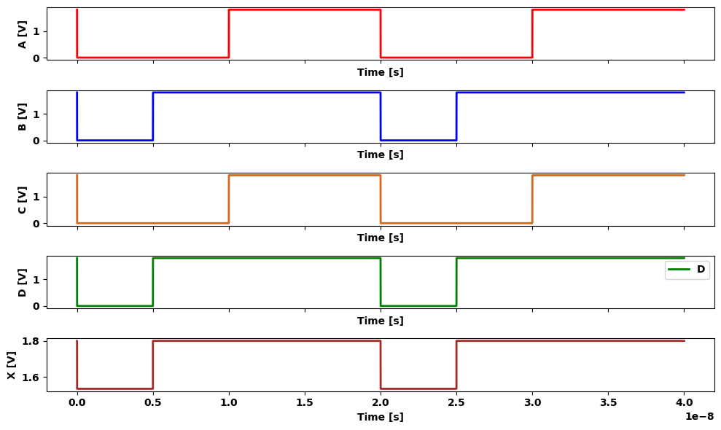

1.11 Figure 2.44 nFET AOI circuit
visually tracing the formation of the logic, we m ay use the formalist switching equations to verify th e resu lt. Applying the nFET equate gives the output as
$$0.\left[\left(a.b\right)+\left(c.d\right)\right]$$
$$\left(2.59\right)$$
which is equivalent to the stated form for X. Figure 2.45 illustrates a modified circuit. Com paring this with Flf 2.43 shows th at a connection h a s been added such th at now the up two transistors (with inputs a and e) are in parallel with one another. ilarly, the nFETs with inputs band / are in parallel. Both, parallel gro; implement the OR operations giving the terms $\left(a+e\right)$ and $\left(b+f\right)$. Sert connecting the parallel groups gives the AND operation, so that inver: the output results in
$Y=\overset{‾}{\left(\left(a+e\right)\left(b+f\right)\right)}$ $\left(2.60\right)$
which has OAI form. To verify this result, u se the switch-level equate to write
$0.\left[\left(a+e\right)\left(b+f\right)\right]$ $\left(2.61\right)$
This is equivalent to the expression in equation (2.60) for Y. Now recall that a CMOS logic gate uses nFETs to pass a 0 to theo: put, and pFETs to pass a logic 1. Since pFETs complement nFETs, wer construct the logic formation characteristics sum m arized in Figure 2.41 The parallel-connected pFETs shown in Figure 2.46(a) are described the logic equation
1.($\overset{‾}{x}$+$\overset{‾}{y}$ )=1.($\overset{‾}{x}$.$\overset{‾}{y}$ ) $\left(2.62\right)$
which is the AND-NOT operation sequence. To obtain the OR-NOT oprea tion, we m ust use series-connected pFETs a s in Figure 2.46(b). n case, the logic is formed from switching equations as
1.$\overset{‾}{x}$.$\overset{‾}{y}$ =1.($\overset{‾}{x}$+$\overset{‾}{y}$ ) $\left(2.63\right)$
which verifies the statement
import schemdraw
import schemdraw.elements as elm
import matplotlib.pyplot as plt
from schemdraw import dsp
from schemdraw import logic
with schemdraw.Drawing() as d:
d += (M1 := elm.PFet2(offset_gate = False).anchor('drain').theta(90).reverse().label('$a$','top'))
d += (M2 := elm.PFet2(offset_gate = False).anchor('drain').theta(90).reverse().label('$b$','top').at(M1.source))
d += (l1 :=elm.Line().right(d.unit*.6).dot().at(M1.drain))
d += elm.Ground().at(M2.source)
d += (M3 := elm.PFet2(offset_gate = False).anchor('drain').theta(270).label('$e$','bottom').at(l1.end))
d += (M4 := elm.PFet2(offset_gate = False).anchor('drain').theta(270).label('$f$','bottom'))
d += elm.Ground().at(M4.source)
d += (l1 :=elm.Line().right(d.unit*.6).dot().label('$Y$','right').at(l1.end).dot())
d += (l2 :=elm.Line().right(d.unit*.6).idot().endpoints(M2.drain,M4.drain).dot())
Or= d.add(logic.Or().right().label('a \n b', loc='left', color='black').at((6,-3)))
Or= d.add(logic.Or().right().label('e \n f', loc='left', color='black').at((6,-4.5)))
Nand = d.add(logic.Nand().right().label('Y', loc='right', color='black').at((8.5,-3.8)))
d += (l3 :=elm.Line().right(d.unit*.2).at(Nand1.end))
d += (l4 :=elm.Line().right(d.unit*.2).at(Nand2.end))
d += (l5 :=elm.Line().down(d.unit*.18).at(l3.end))
d += (l6 :=elm.Line().up(d.unit*.16).at(l4.end))
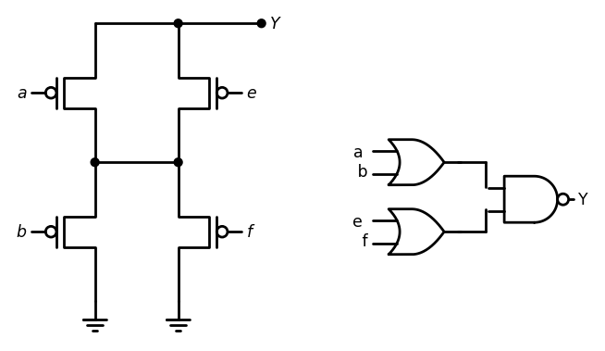
import ipywidgets as widgets
from ipywidgets import interact
import matplotlib.pyplot as plt
from matplotlib import rcParams
import PySpice.Logging.Logging as Logging
logger = Logging.setup_logging()
from PySpice.Probe.Plot import plot
from PySpice.Spice.Netlist import Circuit
from PySpice.Unit import *
rcParams['font.weight'] = 'bold'
figure = plt.figure(figsize=(15, 10))
circuit = Circuit('Pulse Sources ')
circuit.model('2N7000', 'NMOS', L=0.6E-6, W=1.2E-6,LAMBDA = 0.1 ,Kp=0.007, Vto=.4)
circuit.model('2N7100', 'PMOS', L=.6E-6, W=2.4E-6,LAMBDA = 0.1 ,Kp=0.007, Vto=-.4)
circuit.V(1, '1', circuit.gnd, 1.8@u_V)
circuit.MOSFET(1, '2', 'A', 'Y','1', model='2N7100')
circuit.MOSFET(2, '2', 'E', 'Y','1', model='2N7100')
circuit.MOSFET(3,circuit.gnd, 'B', '2','1', model='2N7100')
circuit.MOSFET(4,circuit.gnd, 'F', '2','1', model='2N7100')
#circuit.C(1, 'Y',circuit.gnd , 0.1@u_pF)
pulse1 = circuit.PulseVoltageSource('V1', 'A', circuit.gnd, initial_value=0@u_V, pulsed_value=1.8@u_V,rise_time=1@u_ps,fall_time=1@u_ps, pulse_width=10@u_ns, period=20@u_ns)
pulse2 = circuit.PulseVoltageSource('V2', 'B', circuit.gnd, initial_value=0@u_V, pulsed_value=1.8@u_V,rise_time=1@u_ps,fall_time=1@u_ps, pulse_width=10@u_ns, period=20@u_ns)
pulse3 = circuit.PulseVoltageSource('V3', 'E', circuit.gnd, initial_value=0@u_V, pulsed_value=1.8@u_V,rise_time=1@u_ps,fall_time=1@u_ps, pulse_width=10@u_ns, period=20@u_ns)
pulse4 = circuit.PulseVoltageSource('V4', 'F', circuit.gnd, initial_value=1.8@u_V, pulsed_value=0@u_V,rise_time=1@u_ps,fall_time=1@u_ps, pulse_width=10@u_ns, period=20@u_ns)
simulator = circuit.simulator(temperature=25, nominal_temperature=25)
analysis = simulator.transient(step_time=1@u_ns, end_time=40@u_ns)
fig, (ax1, ax2, ax3,ax4,ax5) = plt.subplots(5, 1, figsize=(10, 6), sharex=True)
ax1.plot(analysis.time, analysis['A'], 'red', linewidth=2, label='A')
ax1.set_xlabel('Time [s]', color='black', weight='black', fontsize=10)
ax1.set_ylabel('A [V]', color='black', weight='black', fontsize=10)
ax2.plot(analysis.time, analysis['B'], 'blue', linewidth=2, label='B')
ax2.set_xlabel('Time [s]', color='black', weight='black', fontsize=10)
ax2.set_ylabel('B [V]', color='black', weight='black', fontsize=10)
ax3.plot(analysis.time, analysis['E'], 'Chocolate', linewidth=2, label='E')
ax3.set_xlabel('Time [s]', color='black', weight='black', fontsize=10)
ax3.set_ylabel('E [V]', color='black', weight='black', fontsize=10)
ax4.plot(analysis.time, analysis['F'], 'green', linewidth=2, label='F')
ax4.set_xlabel('Time [s]', color='black', weight='black', fontsize=10)
ax4.set_ylabel('F [V]', color='black', weight='black', fontsize=10)
ax5.plot(analysis.time, analysis['Y'], 'brown', linewidth=2, label='Y')
ax5.set_xlabel('Time [s]', color='black', weight='black', fontsize=10)
ax5.set_ylabel('Y [V]', color='black', weight='black', fontsize=10)
ax4.legend()
plt.tight_layout()
plt.show()
<Figure size 1500x1000 with 0 Axes>
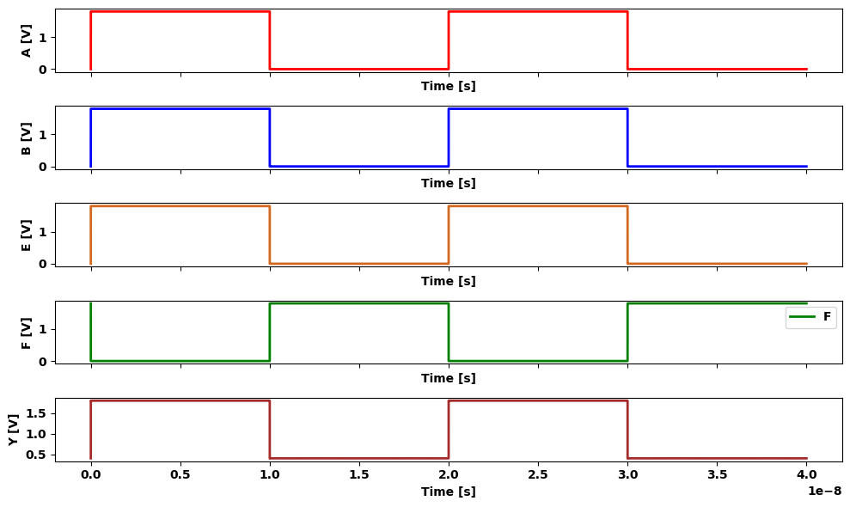

1.12 Figure 2.45 nFET OAI network
import schemdraw
import schemdraw.elements as elm
import matplotlib.pyplot as plt
from schemdraw import dsp
from schemdraw import logic
with schemdraw.Drawing() as d:
d += (M1 := elm.PFet2(offset_gate = False).anchor('drain').theta(90).reverse().label('$X$','top'))
d += (l1 :=elm.Line().right(d.unit*.6).dot().at(M1.drain).idot().label('$V{DD}$','top'))
d += (M2 := elm.PFet2(offset_gate = False).anchor('drain').theta(270).label('$Y$','bottom').at(l1.end))
d += (l2 :=elm.Line().right(d.unit*1).dot().at(M1.source).idot().label(r'($\bar{x}$. $\bar {y}$)','right'))
Nand = d.add(logic.Nand().right().label(r'($\bar{x}$. $\bar {y}$)','right').at((7,-1)).label('X \n Y', loc='left', color='black').label('$(a) Parallel-connected pFETs$','bottom'))
d += (M3 := elm.PFet2(offset_gate = False).anchor('drain').theta(90).reverse().label('$X$','top').at((0,-5)).dot().label('$V{DD}$','right'))
d += (M4 := elm.PFet2(offset_gate = False).anchor('drain').theta(90).reverse().label('$Y$','top').at(M3.source))
d += (l3 :=elm.Line().right(d.unit*.6).dot().at(M4.source).idot().label(r'($\bar{x}$+$\bar {y}$ )','right'))
Nor = d.add(logic.Nor().right().label(r'($\bar{x}$+ $\bar {y}$)','right').at((7,-8)).label('X \n Y', loc='left', color='black').label('$(b) Series-connected pFETs$','bottom'))
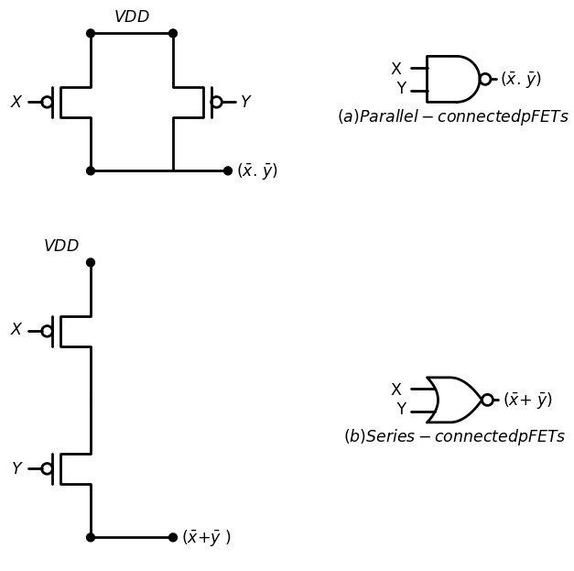

1.13 Figure 2.46 pFET logic formation
Let us examine the pFET array needed for the AOI function
X= ($\overset{‾}{a}$. $\overset{‾}{b}$)+($\overset{‾}{c}$. $\overset{‾}{d}$) $\left(2.64\right)$
discussed earlier for the nFET circuit show n in Figure 2.44. U sing th e pFET rules results in the network illustrated in Figure 2.47(a). Similarly, the OAI function
Y= ($\overset{‾}{a}$+ $\overset{‾}{e}$).($\overset{‾}{b}$+ $\overset{‾}{d}$) $\left(2.65\right)$
yields the pFET array in Figure 2.47(b).
import schemdraw
import schemdraw.elements as elm
import matplotlib.pyplot as plt
from schemdraw import dsp
from schemdraw import logic
with schemdraw.Drawing() as d:
d += (M1 := elm.PFet2(offset_gate = False).anchor('drain').theta(90).reverse().label('$a$','top'))
d += (M2 := elm.PFet2(offset_gate = False).anchor('drain').theta(90).reverse().label('$c$','top').at(M1.source))
d += (l1 :=elm.Line().right(d.unit*.6).dot().at(M1.drain))
d += (M3 := elm.PFet2(offset_gate = False).anchor('drain').theta(270).label('$b$','bottom').at(l1.end))
d += (M4 := elm.PFet2(offset_gate = False).anchor('drain').theta(270).label('$e$','bottom'))
d += (l2 :=elm.Line().right(d.unit*.6).dot().label('$V{DD}$','right').at(l1.end).dot())
d += (l3 :=elm.Line().right(d.unit*1.3).dot().label('$X$','right').at(M2.source).dot().label('$(a) pFET AOI circuit$','bottom'))
d += (l3 :=elm.Line().right(d.unit*.6).dot().at(M1.source).idot())
d += (M11 := elm.PFet2(offset_gate = False).anchor('drain').theta(90).reverse().label('$a$','top').at((10,0)))
d += (M12 := elm.PFet2(offset_gate = False).anchor('drain').theta(90).reverse().label('$e$','top').at(M11.source))
d += (l11 :=elm.Line().right(d.unit*.6).dot().at(M11.drain))
d += (M13 := elm.PFet2(offset_gate = False).anchor('drain').theta(270).label('$b$','bottom').at(l11.end))
d += (M14 := elm.PFet2(offset_gate = False).anchor('drain').theta(270).label('$f$','bottom'))
d += (l12 :=elm.Line().right(d.unit*.6).dot().label('$V{DD}$','right').at(l11.end).dot())
d += (l13 :=elm.Line().right(d.unit*1.3).dot().label('$Y$','right').at(M12.source).dot().label('$(b) pFET AOI circuit$','bottom'))
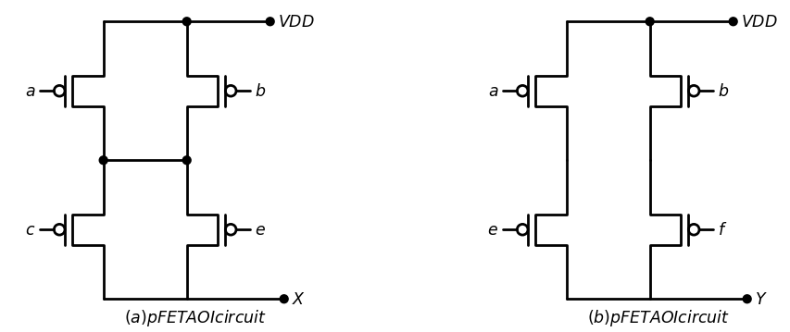
import ipywidgets as widgets
from ipywidgets import interact
import matplotlib.pyplot as plt
from matplotlib import rcParams
import PySpice.Logging.Logging as Logging
logger = Logging.setup_logging()
from PySpice.Probe.Plot import plot
from PySpice.Spice.Netlist import Circuit
from PySpice.Unit import *
rcParams['font.weight'] = 'bold'
figure = plt.figure(figsize=(15, 10))
circuit = Circuit('Pulse Sources ')
circuit.model('2N7000', 'NMOS', L=0.6E-6, W=1.2E-6,LAMBDA = 0.1 ,Kp=0.007, Vto=.4)
circuit.model('2N7100', 'PMOS', L=.6E-6, W=2.4E-6,LAMBDA = 0.1 ,Kp=0.007, Vto=-.4)
circuit.V(1, '1', circuit.gnd, 1.8@u_V)
circuit.MOSFET(1, '2', 'A', '1','1', model='2N7100')
circuit.MOSFET(2, '2', 'B', '1','1', model='2N7100')
circuit.MOSFET(3,'X', 'C', '2','1', model='2N7100')
circuit.MOSFET(4,'X', 'E', '2','1', model='2N7100')
circuit.C(1, 'X',circuit.gnd ,1@u_pF)
pulse1 = circuit.PulseVoltageSource('V1', 'A', circuit.gnd, initial_value=0@u_V, pulsed_value=1.8@u_V,rise_time=1@u_ps,fall_time=1@u_ps, pulse_width=10@u_ns, period=20@u_ns)
pulse2 = circuit.PulseVoltageSource('V2', 'B', circuit.gnd, initial_value=0@u_V, pulsed_value=1.8@u_V,rise_time=1@u_ps,fall_time=1@u_ps, pulse_width=10@u_ns, period=20@u_ns)
pulse3 = circuit.PulseVoltageSource('V3', 'C', circuit.gnd, initial_value=0@u_V, pulsed_value=1.8@u_V,rise_time=1@u_ps,fall_time=1@u_ps, pulse_width=10@u_ns, period=20@u_ns)
pulse4 = circuit.PulseVoltageSource('V4', 'E', circuit.gnd, initial_value=0@u_V, pulsed_value=1.8@u_V,rise_time=1@u_ps,fall_time=1@u_ps, pulse_width=10@u_ns, period=20@u_ns)
simulator = circuit.simulator(temperature=25, nominal_temperature=25)
analysis = simulator.transient(step_time=1@u_ns, end_time=40@u_ns)
fig, (ax1, ax2, ax3,ax4,ax5) = plt.subplots(5, 1, figsize=(10, 6), sharex=True)
ax1.plot(analysis.time, analysis['A'], 'red', linewidth=2, label='A')
ax1.set_xlabel('Time [s]', color='black', weight='black', fontsize=10)
ax1.set_ylabel('A [V]', color='black', weight='black', fontsize=10)
ax2.plot(analysis.time, analysis['B'], 'blue', linewidth=2, label='B')
ax2.set_xlabel('Time [s]', color='black', weight='black', fontsize=10)
ax2.set_ylabel('B [V]', color='black', weight='black', fontsize=10)
ax3.plot(analysis.time, analysis['E'], 'Chocolate', linewidth=2, label='E')
ax3.set_xlabel('Time [s]', color='black', weight='black', fontsize=10)
ax3.set_ylabel('E [V]', color='black', weight='black', fontsize=10)
ax4.plot(analysis.time, analysis['C'], 'green', linewidth=2, label='C')
ax4.set_xlabel('Time [s]', color='black', weight='black', fontsize=10)
ax4.set_ylabel('C [V]', color='black', weight='black', fontsize=10)
ax5.plot(analysis.time, analysis['X'], 'brown', linewidth=2, label='X')
ax5.set_xlabel('Time [s]', color='black', weight='black', fontsize=10)
ax5.set_ylabel('X [V]', color='black', weight='black', fontsize=10)
ax4.legend()
plt.tight_layout()
plt.show()
<Figure size 1500x1000 with 0 Axes>
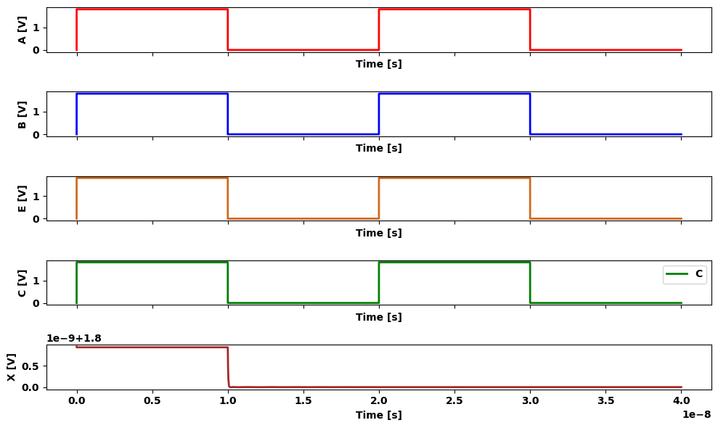

1.14 Figure 2.47 pFET arrays for AOI and OAI gates
This discussion shows that nFET anc pFET groups behaver in diffrent ways. Parallel-connected nFETs yjeiaec the OR-NOT operations While allel-connected pFETs give the AND-NOT sequence. Series connection nFETs provide AND-NOT. but senes pFET s give us OR-NOT we measure these results to state that equivalently wirec groups of nFETs and are logical duais of one another in other words if an nFET group yield function of tne form.
$g= \bar{a}.(\bar{b}+\bar{c}) $ $ (2.66)$
then an identically-wired pFET array gives the dual function.
$G= \bar{a}+(\bar{b}.\bar{c}) $ $ (2.67)$
where the AND and OR operations have been interchanged. This. interesting propern' of nFET-pFET logic th a : can be explotted in the CMOS designs The most important aspect of these ex am ples is seen by const, the complete CMOS circuit for each both are shown in Figure 2.41 sloe- first the AOI circuit m Figure 2.48ia. The ifFETs with inputs are in series, while the correspondm t pFETs are wired in parallel scheme is also applied to the FETs with input variables c and d Find the nFET group with inputs(a,b) is in parallel -with the input group so the corresponding pFET groups are in series. This is another ear of series-parallel. structuring of the nFET-pFET arrays The OAI circuit Figure 2 .48(b)exhibits the ’same features in this case. the nfETs
import schemdraw
import schemdraw.elements as elm
import matplotlib.pyplot as plt
from schemdraw import dsp
from schemdraw import logic
with schemdraw.Drawing(unit=2) as d:
d += (M1 := elm.PFet2().anchor('gate').theta(90).label('$a$','top'))
d += (M2 := elm.PFet2().anchor('gate').theta(270).at((5,0)).label('$b$','bottom'))
d += (M3 := elm.PFet2().anchor('source').theta(90).at(M1.drain).label('$c$','top'))
d += (M4 := elm.PFet2().anchor('drain').theta(270).at(M2.source).label('$d$','bottom'))
d += (M5 := elm.AnalogNFet(offset_gate = False).anchor('drain').theta(0).at(M3.drain).reverse().label('$a$','left'))
d += (M6 := elm.AnalogNFet(offset_gate = False).anchor('drain').theta(360).at(M4.source).label('$c$','right'))
d += (M7 := elm.AnalogNFet(offset_gate = False).anchor('drain').theta(0).at(M5.source).reverse().label('$ b $','left'))
d += (M8 := elm.AnalogNFet(offset_gate = False).anchor('drain').theta(360).at(M6.source).label('$d$','right'))
d += elm.Ground().at(M7.source).label('$ (a) AOI circuit $','bottom')
d += elm.Ground().at(M8.source)
d += (l1 :=elm.Line().right(d.unit*.75).endpoints(M1.source,M2.drain))
d += (l2 :=elm.Line().right(d.unit*.75).endpoints(M3.source,M4.drain))
d += (l3 :=elm.Line().right(d.unit*.75).endpoints(M5.drain,M6.drain))
d += (l4 :=elm.Line().right(d.unit*.75).at(l3.end).dot().label('$X$','right'))
d += elm.Vdd().at(M1.source).label('$V{DD}$','top')
d += (M9 := elm.PFet2().anchor('gate').theta(90).label('$a$','top').at((10,0)))
d += (M10 := elm.PFet2().anchor('gate').theta(270).at((15,0)).label('$b$','bottom'))
d += (M11 := elm.PFet2().anchor('source').theta(90).at(M9.drain).label('$e$','top'))
d += (M12 := elm.PFet2().anchor('drain').theta(270).at(M10.source).label('$f$','bottom'))
d += (M13 := elm.AnalogNFet(offset_gate = False).anchor('drain').theta(0).at(M11.drain).reverse().label('$a$','left'))
d += (M14 := elm.AnalogNFet(offset_gate = False).anchor('drain').theta(360).at(M12.source).label('$e$','right'))
d += (M15 := elm.AnalogNFet(offset_gate = False).anchor('drain').theta(0).at(M13.source).reverse().label('$ b $','left'))
d += (M16 := elm.AnalogNFet(offset_gate = False).anchor('drain').theta(360).at(M14.source).label('$f$','right'))
d += elm.Ground().at(M15.source).label('$ (b) OAI circuit $','bottom')
d += elm.Ground().at(M16.source)
d += (l1 :=elm.Line().right(d.unit*.75).endpoints(M9.source,M10.drain))
d += (l2 :=elm.Line().right(d.unit*.75).endpoints(M11.source,M12.drain))
d += (l3 :=elm.Line().right(d.unit*.75).endpoints(M13.drain,M14.drain))
d += (l4 :=elm.Line().right(d.unit*.75).at(l3.end).dot().label('$Y$','right'))
d += elm.Vdd().at(M9.source).label('$V{DD}$','top')
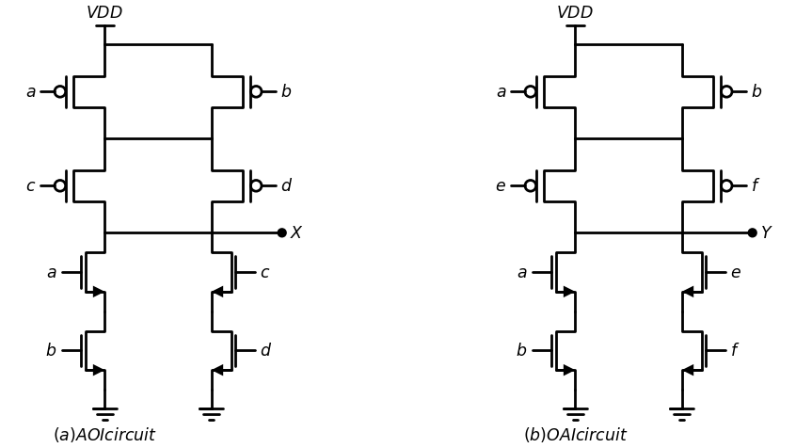
import ipywidgets as widgets
from ipywidgets import interact
import matplotlib.pyplot as plt
from matplotlib import rcParams
import PySpice.Logging.Logging as Logging
logger = Logging.setup_logging()
from PySpice.Probe.Plot import plot
from PySpice.Spice.Netlist import Circuit
from PySpice.Unit import *
rcParams['font.weight'] = 'bold'
figure = plt.figure(figsize=(15, 10))
circuit = Circuit('Pulse Sources ')
circuit.model('2N7000', 'NMOS', L=0.6E-6, W=1.2E-6,LAMBDA = 0.1 ,Kp=0.007, Vto=.4)
circuit.model('2N7100', 'PMOS', L=.6E-6, W=2.4E-6,LAMBDA = 0.1 ,Kp=0.007, Vto=-.4)
circuit.V(1, '1', circuit.gnd, 1.8@u_V)
circuit.MOSFET(1, '2', 'A', '1','1', model='2N7100')
circuit.MOSFET(2, '2', 'B', '1','1', model='2N7100')
circuit.MOSFET(3, 'X', 'C', '2','1', model='2N7100')
circuit.MOSFET(4, 'X', 'D', '1','1', model='2N7100')
circuit.MOSFET(5, 'X', 'A', '3',circuit.gnd, model='2N7000')
circuit.MOSFET(6, 'X', 'C', '4',circuit.gnd, model='2N7000')
circuit.MOSFET(7, '3', 'B', circuit.gnd,circuit.gnd, model='2N7000')
circuit.MOSFET(8, '4', 'D', circuit.gnd,circuit.gnd, model='2N7000')
circuit.C(1, 'X',circuit.gnd ,1@u_pF)
pulse1 = circuit.PulseVoltageSource('V1', 'A', circuit.gnd, initial_value=0@u_V, pulsed_value=1.8@u_V,rise_time=1@u_ps,fall_time=1@u_ps, pulse_width=10@u_ns, period=20@u_ns)
pulse2 = circuit.PulseVoltageSource('V2', 'B', circuit.gnd, initial_value=0@u_V, pulsed_value=1.8@u_V,rise_time=1@u_ps,fall_time=1@u_ps, pulse_width=10@u_ns, period=20@u_ns)
pulse3 = circuit.PulseVoltageSource('V3', 'C', circuit.gnd, initial_value=0@u_V, pulsed_value=1.8@u_V,rise_time=1@u_ps,fall_time=1@u_ps, pulse_width=10@u_ns, period=20@u_ns)
pulse4 = circuit.PulseVoltageSource('V4', 'D', circuit.gnd, initial_value=0@u_V, pulsed_value=1.8@u_V,rise_time=1@u_ps,fall_time=1@u_ps, pulse_width=10@u_ns, period=20@u_ns)
simulator = circuit.simulator(temperature=25, nominal_temperature=25)
analysis = simulator.transient(step_time=1@u_ns, end_time=40@u_ns)
fig, (ax1, ax2, ax3,ax4,ax5) = plt.subplots(5, 1, figsize=(10, 6), sharex=True)
ax1.plot(analysis.time, analysis['A'], 'red', linewidth=2, label='A')
ax1.set_xlabel('Time [s]', color='black', weight='black', fontsize=10)
ax1.set_ylabel('A [V]', color='black', weight='black', fontsize=10)
ax2.plot(analysis.time, analysis['B'], 'blue', linewidth=2, label='B')
ax2.set_xlabel('Time [s]', color='black', weight='black', fontsize=10)
ax2.set_ylabel('B [V]', color='black', weight='black', fontsize=10)
ax3.plot(analysis.time, analysis['D'], 'Chocolate', linewidth=2, label='D')
ax3.set_xlabel('Time [s]', color='black', weight='black', fontsize=10)
ax3.set_ylabel('D [V]', color='black', weight='black', fontsize=10)
ax4.plot(analysis.time, analysis['C'], 'green', linewidth=2, label='C')
ax4.set_xlabel('Time [s]', color='black', weight='black', fontsize=10)
ax4.set_ylabel('C [V]', color='black', weight='black', fontsize=10)
ax5.plot(analysis.time, analysis['X'], 'brown', linewidth=2, label='X')
ax5.set_xlabel('Time [s]', color='black', weight='black', fontsize=10)
ax5.set_ylabel('X [V]', color='black', weight='black', fontsize=10)
ax4.legend()
plt.tight_layout()
plt.show()
<Figure size 1500x1000 with 0 Axes>
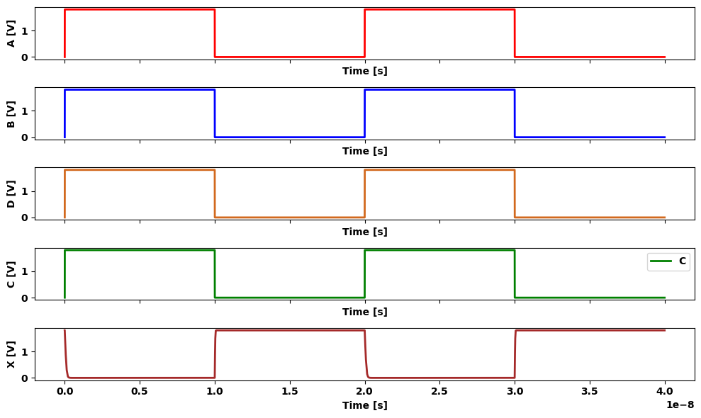

1.15 Figure 2.48 Complete CMOS AOI and OAI Circuits
inputs a and e are in parallel, as are the nFETs w ith in p u ts b an d f . The pFET group with inputs a and e are wired in series; the sam e com m ent holds for the pFETs driven by b and f . Finally, since th e nFET (a, e) group is in series with the (b, f] group, the corresponding pFETs groups are in parallel. This may be used to construct any AOI or OAI circuit in CMOS.

2 Example 2.1
Consider the complex function
X= $\overset{‾}{a}$+$\overset{‾}{b}$.($\overset{‾}{c}$.$\overset{‾}{d}$) $\left(2.68\right)$
The nFET circuit can be constructed by using the following arrangem ents:
Group 1: nFETs with inputs c and d are in parallel;
Group 2: an nFET with input b is in series with Group 1;
Group 3: an nFET w ith in p u t a is in parallel w ith th e Group 1-Group 2 circuit.
The circuit in Figure 2.49 shows each group explicitly. The pFETs are arranged using series-parallel structuring. Each group of pFETs c a n be associated with the nFET group th at has the sam e in p u ts such that
Group 1: pFETs with inputs c and d are in series;
Group 2: a pFET with input b is in parallel w ith Group 1 pFETs;
Group 3: a pFET with input a is in series with the Group 1-Group2 pFETs.
The equivalent logic diagram for the circuit is show n in Figure 2.50.
import schemdraw
import schemdraw.elements as elm
import matplotlib.pyplot as plt
from schemdraw import dsp
from schemdraw import logic
with schemdraw.Drawing(unit=2) as d:
d += (M1 := elm.PFet2().anchor('gate').theta(90).label('$b$','top').length(4.3))
d += (M2 := elm.PFet2().anchor('gate').theta(270).at((5,1.08)).label('$b$','bottom').length(2.15))
d += (M3 := elm.PFet2().anchor('drain').theta(270).at(M2.source).label('$d$','bottom').length(2.15))
d += (l1 :=elm.Line().right(d.unit*.75).endpoints(M1.source,M2.drain))
d += (l2 :=elm.Line().right(d.unit*.75).endpoints(M1.drain,M3.source))
d += (M4 := elm.PFet2().anchor('source').theta(90).at(M1.drain).label('$a$','top').length(2.15))
d += (l1 :=elm.Line().right(d.unit*2).at(M4.drain).label('$Group 1$','top'))
d += (M6 := elm.AnalogNFet(offset_gate = False).anchor('drain').theta(0).label('$b$','right'))
d += (l2 :=elm.Line().left(d.unit*.5).at(M6.source))
d += (M7 := elm.AnalogNFet(offset_gate = False).anchor('drain').theta(0).reverse().label('$c$','left'))
d += (l3 :=elm.Line().right(d.unit*.5).at(M6.source))
d += (M8 := elm.AnalogNFet(offset_gate = False).anchor('drain').theta(0).label('$d$','right'))
d += elm.Ground().at(M7.source)
d += elm.Ground().at(M8.source)
d += (l4 :=elm.Line().down(d.unit*.5).at(M4.drain))
d += (M5 := elm.AnalogNFet(offset_gate = False).anchor('drain').theta(0).at(l4.end).reverse().label('$a$','left'))
d += (l5 :=elm.Line().down(d.unit*.4).at(M5.source))
d += elm.Ground().at(l5.end)
d += (l6 :=elm.Line().right(d.unit*.8).at(M6.drain).dot().label('$X$','right'))
d += elm.Vdd().at(M1.source).label('$V{DD}$','top')
d += ( T := dsp.Box(w=1.5, h=2).anchor('W').linestyle('--').at((0.25,0)))
d += ( T := dsp.Box(w=1.5, h=2).anchor('W').linestyle('--').at((0.25,-3)))
d += ( T := dsp.Box(w=1.5, h=2).anchor('W').linestyle('--').at((0.35,-6)))
d += ( T := dsp.Box(w=2, h=3.2).anchor('W').linestyle('--').at((3,0)))
d += ( T := dsp.Box(w=1.5, h=1.5).anchor('W').linestyle('--').at((5,-5)))
d += ( T := dsp.Box(w=4, h=2).anchor('W').linestyle('--').at((3,-7)))
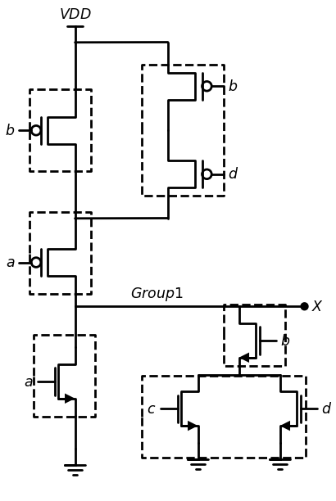

2.1 Figure 2.49 AOI circuit for Example 2.1
Tracing the data flow from the inputs to the output shows that the has OAOI structuring. This is ju s t an AO I circuit with an aditional inputs
import schemdraw
import schemdraw.elements as elm
import matplotlib.pyplot as plt
from schemdraw import dsp
from schemdraw import logic
with schemdraw.Drawing(unit=2) as d:
Or= d.add(logic.Or().right().label('a \n b', loc='left', color='black').at((6,-3)).label('$Or$','bottom'))
And= d.add(logic.And().right().at((7.9,-2.75)).label('b ', loc='left', color='black').label('$And$','bottom'))
Nor = d.add(logic.Nor().right().label('X', loc='right', color='black').at((9.8,-2.5)).label('a ', loc='left', color='black').label('Or Invert','bottom'))
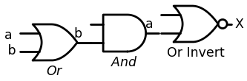

2.2 Figure 2.50 Equivalent logic diagram for Example 2.1

3 Bubble Pushing
Series-parallel wiring o f com plex CM O S logic circuits can be using an approach that is based on logic diagrams The proceture obtained by applying the DeMorgan rules to the pFET relations ilhuse in . figure 2.46. Recall that pFETs can be modeled as assert-low switch Let us therefore model pFET groups as logic gates that have asst1 inputs. This leads to the modified logic associations shown in Figure 2.51(b) In Figure 2.51(a). we apply the DeMorgan rate to write
import schemdraw
import schemdraw.elements as elm
import matplotlib.pyplot as plt
from schemdraw import dsp
from schemdraw import logic
with schemdraw.Drawing(unit=2) as d:
d += (M1 := elm.PFet2().anchor('gate').theta(90).label('$x$','top'))
d += (l1 :=elm.Line().right(d.unit*.5).at(M1.source).idot().dot().label('$V{DD}$','top'))
d += (l2 :=elm.Line().right(d.unit*.5).at(M1.drain).dot().label('(a) Parallel-connected pFETs','bottom'))
d += (M1 := elm.PFet2().anchor('source').theta(270).label('$y$','bottom').reverse().at(l1.end))
d += (l3 :=elm.Line().right(d.unit*.75).at(l2.end).dot().label(r'($\bar {x}$+$\bar {y}$)','right'))
Or= d.add(logic.Or().right().at((7,0)))
d += (l1 :=elm.Line().right(d.unit*.4).at((6.2,0.25)).label('$X$','left').idot().dot(open=True))
d += (l2 :=elm.Line().right(d.unit*.4).at((6.2,-0.25)).label('$y$','left').idot().dot(open=True))
d += (l1 :=elm.Line().right(d.unit*.4).at((8.9,-0)).label(r'($\bar {x}$+$\bar {y}$)','right').dot())
d += (M3 := elm.PFet2().anchor('gate').theta(90).label('$x$','top').at((0,-4)).dot().label('$V{DD}$','right'))
d += (M4 := elm.PFet2().anchor('source').theta(90).label('$y$','top').at(M3.drain))
d += (l5 :=elm.Line().right(d.unit*.75).at(M4.drain).dot().label(r'($\bar {x}$.$\bar {y}$)','right').label('(b) Series-connected pFETs','bottom'))
And= d.add(logic.And().right().at((7,-4)))
d += (l1 :=elm.Line().right(d.unit*.4).at((6.2,-3.75)).label('$X$','left').idot().dot(open=True))
d += (l2 :=elm.Line().right(d.unit*.4).at((6.2,-4.25)).label('$y$','left').idot().dot(open=True))
d += (l1 :=elm.Line().right(d.unit*.4).at((8.9,-4)).label(r'($\bar {x}$.$\bar {y}$)','right').dot())
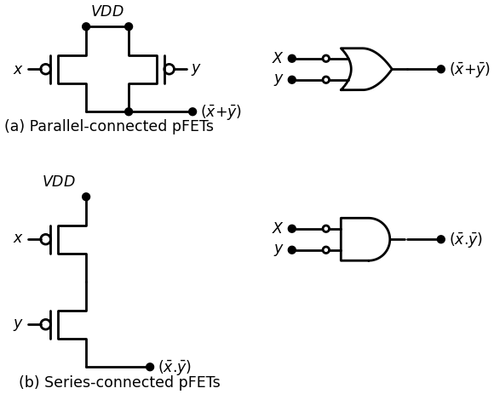

3.1 Figure 2.51 .Assert-low models for pFETs
1.($\overset{‾}{x}$.$\overset{‾}{y}$)=1.$\overset{‾}{x}$+$\overset{‾}{y}$ $\left(2.69\right)$
so that parallel-connected pFETs m ay be viewed as an O R operation w ith assert-low (bubbled) inputs. In the sam e m anner, the series-con n ected pFETs in Figure 2.51(b) provide the AND operation w ith assert-low inputs as verified by the identity
1.($\overset{‾}{x}$+$\overset{‾}{y}$)=1.$\overset{‾}{x}$.$\overset{‾}{y}$ $\left(2.70\right)$
Both operations can be represented graphically by the operations shown in Figure 2.52 where we visualize pushing the bubble backward through the gate to the inputs to create the dual operation w ith assert-low input ports. The procedure for designing the transistor circuitry for a CM O S logic gate can be summarized by the following steps.
• Construct the logic diagram using basic AOI or OAI structuring. Deeper nesting, such a OAOI and AOAI, is allowed.
• Use the gate-nFET relations summarized in Figure 2.43 to construct the nFET logic circuit between the output and ground.
• To obtain the topology of the pFET array, start with the original logic diagram and push the bubble back toward the inputs using the DeMorgan rules. Continue the backward pushing until ev eiy input is bubbled. The pFET circuitry between the output and VD D is then obtained using the rules in Figure 2.51.
Note that both the nFETs and the pFETs are wired such that parallel-con nected transistors give the OR operation, w h ile series-con n ected FETs provide the AND operation. The only difference betw een the tw o is that nFETs are assert-high devices while pFETs are assert-low (bubbled-input) switches.
import schemdraw
import schemdraw.elements as elm
import matplotlib.pyplot as plt
from schemdraw import dsp
from schemdraw import logic
with schemdraw.Drawing(unit=2) as d:
Nand= d.add(logic.Nand().right().label('a \n b', loc='left', color='black').label(r'($\bar {a}$.$\bar {b}$)','right'))
d += (l1 :=elm.Arrow(double=True).right(d.unit*1).at((6,0)).label('$aquvalent$','top').label('$(a) Nand-or$','bottom'))
Or= d.add(logic.Or().right().at((10,0)))
d += (l1 :=elm.Line().right(d.unit*.4).at((9.2,-0.25)).label('$a$','left').idot().dot(open=True))
d += (l2 :=elm.Line().right(d.unit*.4).at((9.2,0.25)).label('$b$','left').idot().dot(open=True))
d += (l1 :=elm.Line().right(d.unit*.4).at((11.9,0)).label(r'($\bar {a}$.$\bar {b}$)','right').dot())
Nor= d.add(logic.Nor().right().label('a \n b', loc='left', color='black').label(r'($\bar {a}$+$\bar {b}$)','right').at((0,-4)))
d += (l1 :=elm.Arrow(double=True).right(d.unit*1).at((6,-4)).label('$aquvalent$','top').label('$(b) Nor-And$','bottom'))
And= d.add(logic.And().right().at((10,-4)))
d += (l1 :=elm.Line().right(d.unit*.4).at((9.2,-3.75)).label('$a$','left').idot().dot(open=True))
d += (l2 :=elm.Line().right(d.unit*.4).at((9.2,-4.25)).label('$b$','left').idot().dot(open=True))
d += (l1 :=elm.Line().right(d.unit*.4).at((11.9,-4)).label(r'($\bar {a}$.$\bar {b}$)','right').dot())
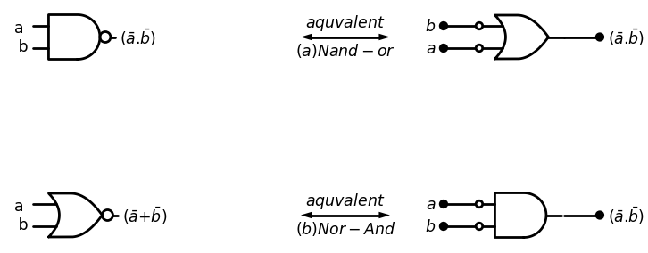

3.2 Figure 2.52 Bubble pushing using DeMorgan rules

4 Example 2.2
Consider the logic diagram shown in Figure 2.53. This provides using map for building the nFET logic array. We see that the nFETs with input a and b are in series (due to the AND gate), as are the nFETs with input c and d. These series-connected groups are in parallel with an nFET. has the input e since they are OR’ed at the output. The NOT operating the NOR gate) is automatic in the nFET array
import schemdraw
import schemdraw.elements as elm
import matplotlib.pyplot as plt
from schemdraw import dsp
from schemdraw.parsing import logicparse
from schemdraw import logic
with schemdraw.Drawing(unit=2) as d:
And1= d.add(logic.And().right().label('a \n b', loc='left', color='black'))
And2= d.add(logic.And().right().label('c \n d', loc='left', color='black').at((0,-2)))
Nor= d.add(logic.Nor(inputs=3).right().at((3,-2)).label(' \n \n e', loc='left', color='black').label('G','right'))
d += (l1 :=elm.Line().right(d.unit*.6).at((1.8,-2)))
d += (l2 :=elm.Line().right(d.unit*.6).at((1.8,0)))
d += (l3 :=elm.Line().down(d.unit*.83))
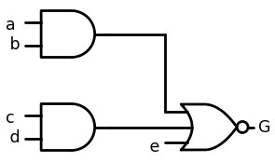

4.1 Figure 2.53 AOI logic diagram for bubble-pushing example
To obtain the wiring of the pFETs, w e push the bubble back as show in Figure 2.54. The first step is to transform the output NOR gate inputs AND gate with assert-low inputs; this results in the intermediate diagram drawn in Figure 2.54(a). Pushing the bu bb les back through the And gates gives assert-low OR gates as in Figure 2.54(b). This shows that
import schemdraw
import schemdraw.elements as elm
import matplotlib.pyplot as plt
from schemdraw import dsp
from schemdraw.parsing import logicparse
from schemdraw import logic
with schemdraw.Drawing(unit=2) as d:
Nand= d.add(logic.Nand().right().label('a \n b', loc='left', color='black'))
Nan2d= d.add(logic.Nand().right().label('c \n d', loc='left', color='black').at((0,-2)))
Nand= d.add(logic.Nand(inputs=3, inputnots=[3]).right().at((3,-2)).label(' \n \n e', loc='left', color='black').label('G','right').label('(a) First transformation','bottom'))
d += (l1 :=elm.Line().right(d.unit*.6).at((1.8,-2)))
d += (l2 :=elm.Line().right(d.unit*.6).at((1.8,0)))
d += (l3 :=elm.Line().down(d.unit*.83))
Or= d.add(logic.Or(inputnots=[1,2]).right().label('a \n b', loc='left', color='black').at((0,-5)))
Or2= d.add(logic.Or(inputnots=[1,2]).right().label('c \n d', loc='left', color='black').at((0,-7)))
And= d.add(logic.And(inputs=3, inputnots=[3]).right().at((3,-7)).label(' \n \n e', loc='left', color='black').label('G','right').label('(b) Final form','bottom'))
d += (l4 :=elm.Line().right(d.unit*.6).at((1.8,-7)))
d += (l5 :=elm.Line().right(d.unit*.6).at((1.8,-5)))
d += (l6 :=elm.Line().down(d.unit*.83))
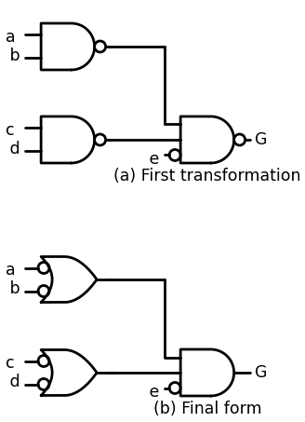

4.2 Figure 2.54 Bubble pushing to obtain the topology o f the pFET array
import schemdraw
import schemdraw.elements as elm
import matplotlib.pyplot as plt
from schemdraw import dsp
from schemdraw import logic
with schemdraw.Drawing(unit=2) as d:
d += (M1 := elm.PFet2().anchor('gate').theta(90).label('$a$','top'))
d += (M2 := elm.PFet2().anchor('gate').theta(270).at((5,0)).label('$b$','bottom'))
d += (M3 := elm.PFet2().anchor('source').theta(90).at(M1.drain).label('$c$','top'))
d += (M4 := elm.PFet2().anchor('drain').theta(270).at(M2.source).label('$d$','bottom'))
d += (l1 :=elm.Line().right(d.unit*.6).endpoints(M1.source,M2.drain).idot().dot().label('$V{DD}$','top'))
d += (l2 :=elm.Line().right(d.unit*.6).endpoints(M3.source,M4.drain).idot().dot())
d += (l3 :=elm.Line().right(d.unit*.6).endpoints(M4.source,M3.drain).idot().dot())
d += (M5 := elm.PFet2().anchor('source').theta(90).label('$e$','top').at(M3.drain))
d += (M6 := elm.AnalogNFet(offset_gate = False).anchor('drain').theta(0).reverse().label('$a$','left').at(M5.drain))
d += (M7 := elm.AnalogNFet(offset_gate = False).anchor('drain').theta(0).reverse().label('$b$','left').at(M6.source))
d += elm.Ground().at(M7.source)
d += (l4 :=elm.Line().right(d.unit*1.5).at(M6.drain).dot())
d += (M8 := elm.AnalogNFet(offset_gate = False).anchor('drain').theta(0).reverse().label('$c$','left').at(l4.end))
d += (M9 := elm.AnalogNFet(offset_gate = False).anchor('drain').theta(0).reverse().label('$d$','left').at(M8.source))
d += elm.Ground().at(M9.source)
d += (l5 :=elm.Line().right(d.unit*1.5).at(M8.drain).dot())
d += (l6 :=elm.Line().down(d.unit*.5))
d += (M10 := elm.AnalogNFet(offset_gate = False).anchor('drain').theta(0).label('$e$','right'))
d += (l7:=elm.Line().down(d.unit*.4).at(M10.source))
d += elm.Ground().at(l7.end)
d += (l8 :=elm.Line().right(d.unit*.85).at(l6.start).dot().label('$G$','right'))
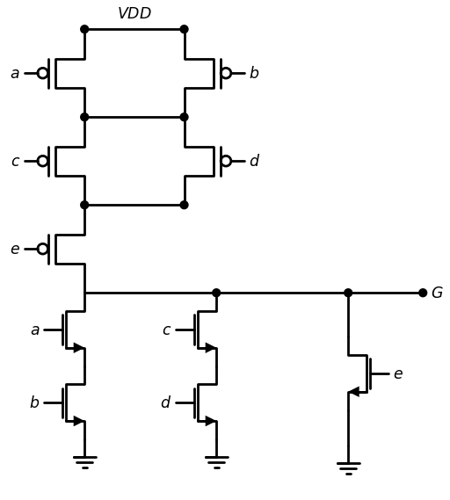
import ipywidgets as widgets
from ipywidgets import interact
import matplotlib.pyplot as plt
from matplotlib import rcParams
import PySpice.Logging.Logging as Logging
logger = Logging.setup_logging()
from PySpice.Probe.Plot import plot
from PySpice.Spice.Netlist import Circuit
from PySpice.Unit import *
rcParams['font.weight'] = 'bold'
figure = plt.figure(figsize=(15, 10))
circuit = Circuit('Pulse Sources ')
circuit.model('2N7000', 'NMOS', L=0.6E-6, W=1.2E-6,LAMBDA = 0.1 ,Kp=0.007, Vto=.4)
circuit.model('2N7100', 'PMOS', L=.6E-6, W=2.4E-6,LAMBDA = 0.1 ,Kp=0.007, Vto=-.4)
circuit.V(1, '1', circuit.gnd, 1.8@u_V)
circuit.MOSFET(1, '2', 'A', '1','1', model='2N7100')
circuit.MOSFET(2, '2', 'B', '1','1', model='2N7100')
circuit.MOSFET(3, 'X', 'C', '2','1', model='2N7100')
circuit.MOSFET(4, 'X', 'D', '2','1', model='2N7100')
circuit.MOSFET(44, 'G', 'E', 'X','1', model='2N7100')
circuit.MOSFET(5, 'G', 'A', '3',circuit.gnd, model='2N7000')
circuit.MOSFET(6, 'G', 'C', '4',circuit.gnd, model='2N7000')
circuit.MOSFET(7, '3', 'B', circuit.gnd,circuit.gnd, model='2N7000')
circuit.MOSFET(8, '4', 'D', circuit.gnd,circuit.gnd, model='2N7000')
circuit.MOSFET(9, 'G', 'E', circuit.gnd,circuit.gnd, model='2N7000')
circuit.C(1, 'G',circuit.gnd ,1@u_pF)
pulse1 = circuit.PulseVoltageSource('V1', 'A', circuit.gnd, initial_value=0@u_V, pulsed_value=1.8@u_V,rise_time=1@u_ps,fall_time=1@u_ps, pulse_width=5@u_ns, period=20@u_ns)
pulse2 = circuit.PulseVoltageSource('V2', 'B', circuit.gnd, initial_value=0@u_V, pulsed_value=1.8@u_V,rise_time=1@u_ps,fall_time=1@u_ps, pulse_width=10@u_ns, period=20@u_ns)
pulse3 = circuit.PulseVoltageSource('V3', 'C', circuit.gnd, initial_value=0@u_V, pulsed_value=1.8@u_V,rise_time=1@u_ps,fall_time=1@u_ps, pulse_width=5@u_ns, period=20@u_ns)
pulse4 = circuit.PulseVoltageSource('V4', 'D', circuit.gnd, initial_value=0@u_V, pulsed_value=1.8@u_V,rise_time=1@u_ps,fall_time=1@u_ps, pulse_width=5@u_ns, period=20@u_ns)
pulse5 = circuit.PulseVoltageSource('V5', 'E', circuit.gnd, initial_value=0@u_V, pulsed_value=1.8@u_V,rise_time=1@u_ps,fall_time=1@u_ps, pulse_width=5@u_ns, period=20@u_ns)
simulator = circuit.simulator(temperature=25, nominal_temperature=25)
analysis = simulator.transient(step_time=1@u_ns, end_time=40@u_ns)
fig, (ax1, ax2, ax3,ax4,ax5,ax6) = plt.subplots(6, 1, figsize=(10, 6), sharex=True)
ax1.plot(analysis.time, analysis['A'], 'red', linewidth=2, label='A')
ax1.set_xlabel('Time [s]', color='black', weight='black', fontsize=10)
ax1.set_ylabel('A [V]', color='black', weight='black', fontsize=10)
ax2.plot(analysis.time, analysis['B'], 'blue', linewidth=2, label='B')
ax2.set_xlabel('Time [s]', color='black', weight='black', fontsize=10)
ax2.set_ylabel('B [V]', color='black', weight='black', fontsize=10)
ax3.plot(analysis.time, analysis['D'], 'Chocolate', linewidth=2, label='D')
ax3.set_xlabel('Time [s]', color='black', weight='black', fontsize=10)
ax3.set_ylabel('D [V]', color='black', weight='black', fontsize=10)
ax4.plot(analysis.time, analysis['C'], 'green', linewidth=2, label='C')
ax4.set_xlabel('Time [s]', color='black', weight='black', fontsize=10)
ax4.set_ylabel('C [V]', color='black', weight='black', fontsize=10)
ax6.plot(analysis.time, analysis['G'], 'brown', linewidth=2, label='G')
ax6.set_xlabel('Time [s]', color='black', weight='black', fontsize=10)
ax6.set_ylabel('G [V]', color='black', weight='black', fontsize=10)
ax5.plot(analysis.time, analysis['E'], 'Chocolate', linewidth=2, label='E')
ax5.set_xlabel('Time [s]', color='black', weight='black', fontsize=10)
ax5.set_ylabel('E [V]', color='black', weight='black', fontsize=10)
ax4.legend()
plt.tight_layout()
plt.show()
<Figure size 1500x1000 with 0 Axes>
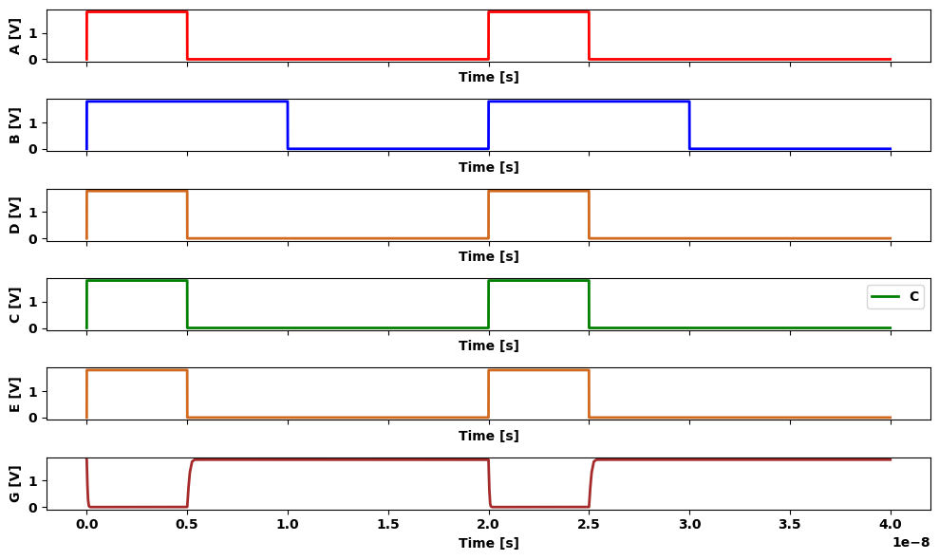

4.3 Figure 2.55 Final circuit for the bubble-pushing example
pFET array consists of
• Two pFETs with inputs a and b w ired in parallel
• Two pFETs with inputs c and d wired in parallel
• One pFET with an input e that is in series with the two groups above.
The final circuit is drawn in Figure 2.55. It is w orth the effort to trace through the construction procedure. And, it is im portant to rem em b er that the CMOS logic gate implements the entire function G portrayed in the logic diagram. It is not possible to break the circuit dow n into m ore primitive logic.

5 2.4.2 XOR and XNOR Gates
An important example o f using an AOI circuit is constructing Exclusive- OR (XOR) and Exclusive-NOR circuits. Th ese often-used gates are c o n structed from logic primitives. Figure 2.56 gives the circuit sym bol and truth table for the XOR. Reading the logic 1 outputs gives the standard SOP equation
a ⊕ b = $\overset{‾}{a}$.b+a.$\overset{‾}{b}$ $\left(2.71\right)$
from the second and third lines. This is not in AOI form . However, if Ve read the 0 output lines, then the XNOR expression is
$\overset{‾}{a}$⊕$\overset{‾}{b}$=a.b+$\overset{‾}{a}$.$\overset{‾}{b}$ $\left(2.72\right)$
import schemdraw
import schemdraw.elements as elm
import matplotlib.pyplot as plt
from schemdraw import dsp
from schemdraw.parsing import logicparse
from schemdraw import logic
with schemdraw.Drawing(unit=2) as d:
Xor= d.add(logic.Xor().right().label('a \n b', loc='left', color='black').label('a ⊕ b', loc='right', color='black'))
def or_gate_truth_table():
print("Xor Gate Truth Table")
print("A B | Output")
print("---------")
for A in range(2):
for B in range(2):
output = A ^ B
print(f"{A} {B} | {output}")
or_gate_truth_table()
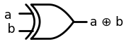
Xor Gate Truth Table
A B | Output
---------
0 0 | 0
0 1 | 1
1 0 | 1
1 1 | 0
import ipywidgets as widgets
from ipywidgets import interact
import matplotlib.pyplot as plt
from matplotlib import rcParams
import PySpice.Logging.Logging as Logging
logger = Logging.setup_logging()
from PySpice.Probe.Plot import plot
from PySpice.Spice.Netlist import Circuit
from PySpice.Unit import *
rcParams['font.weight'] = 'bold'
figure = plt.figure(figsize=(15, 10))
circuit = Circuit('Pulse Sources ')
circuit.model('2N7000', 'NMOS', L=0.18E-6, W=2E-6,LAMBDA = 0.2 ,Kp=0.007, Vto=.01)
circuit.model('2N7100', 'PMOS', L=0.18E-6, W=4E-6,LAMBDA = 0.1 ,Kp=0.007, Vto=-.01)
circuit.model('2N7200', 'NMOS', L=0.18E-6, W=1E-6,LAMBDA = 0.2 ,Kp=0.007, Vto=.1)
circuit.V(1, '1', circuit.gnd,1@u_V)
pulse1 = circuit.PulseVoltageSource('V1', 'A', circuit.gnd, initial_value=2.5@u_V, pulsed_value=0@u_V,rise_time=1@u_ps,fall_time=1@u_ps, pulse_width=15@u_ns, period=20@u_ns)
pulse2 = circuit.PulseVoltageSource('V2', 'B', circuit.gnd, initial_value=0@u_V, pulsed_value=2.5@u_V,delay_time=2.5@u_ns,rise_time=1@u_ps,fall_time=1@u_ps,pulse_width=10@u_ns, period=20@u_ns)
#NOT1
circuit.MOSFET(1, 'A_', 'A', '1','1', model='2N7100')
circuit.MOSFET(2, 'A_', 'A', circuit.gnd,circuit.gnd, model='2N7000')
#NOT2
circuit.MOSFET(3, 'B_', 'B', '1','1', model='2N7100')
circuit.MOSFET(4, 'B_', 'B', circuit.gnd,circuit.gnd, model='2N7000')
# xnor
circuit.MOSFET(5, '2', 'A', '1','1', model='2N7100')
circuit.MOSFET(6, '2', 'A_', '1','1', model='2N7100')
circuit.MOSFET(7, 'out', 'B', '2','1', model='2N7100')
circuit.MOSFET(8, 'out', 'B_', '1','1', model='2N7100')
circuit.MOSFET(9, 'out', 'A_', '4',circuit.gnd, model='2N7200')
circuit.MOSFET(10, 'out', 'A', '5',circuit.gnd, model='2N7200')
circuit.MOSFET(11, '4', 'B_', circuit.gnd,circuit.gnd, model='2N7000')
circuit.MOSFET(12, '5', 'B', circuit.gnd,circuit.gnd, model='2N7000')
circuit.C(1, 'out',circuit.gnd , 2@u_pF)
simulator = circuit.simulator(temperature=25, nominal_temperature=25)
analysis = simulator.transient(step_time=1@u_ns, end_time=40@u_ns)
fig, (ax1, ax2,ax3) = plt.subplots(3, 1, figsize=(10, 6), sharex=True)
ax1.plot(analysis.time, analysis['A'], 'red', linewidth=2, label='A')
ax1.set_xlabel('Time [s]', color='black', weight='black', fontsize=10)
ax1.set_ylabel('IN A', color='black', weight='black', fontsize=10)
ax2.plot(analysis.time, analysis['B'], 'blue', linewidth=2, label='B')
ax2.set_xlabel('Time [s]', color='black', weight='black', fontsize=10)
ax2.set_ylabel('IN B', color='black', weight='black', fontsize=10)
ax3.plot(analysis.time, analysis['out'], 'green', linewidth=2, label='B')
ax3.set_xlabel('Time [s]', color='black', weight='black', fontsize=10)
ax3.set_ylabel('out(NOR)', color='black', weight='black', fontsize=10)
plt.tight_layout()
plt.show()
<Figure size 1500x1000 with 0 Axes>
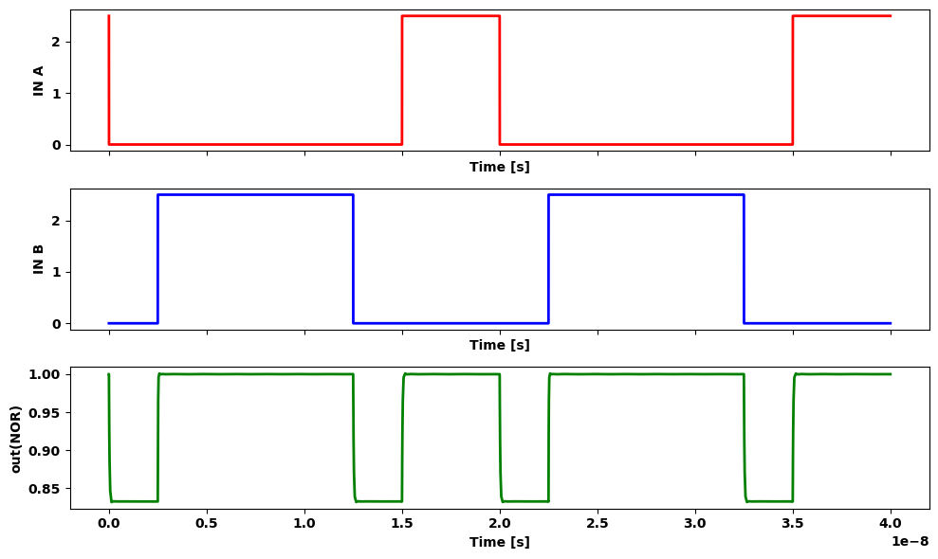

5.1 Figure 2.56 Exclusive-OR (XOR) symbol and truth table
The XOR can thus be expressed as
$a⊕b=((a⊕b) ) ̿=(a.b+a ̅.b ̅ ) ̅ $ $\left(2.72\right)$
which has AOI structure. Using the circu it in Figure 2.48(a) basic AOI XOR circuit shown in Figure 2.57(a). Since theXORf inputs of (a, b) only, two inverters are needed to provide the 4-iif (a, b, $\overset{‾}{a}$, $\overset{‾}{b}$) in this circuit. To obtain an XNOR circuit, we ju st complement the XORSOPsJ to write
$ \bar{a}$⊕$ \bar{b}$=$(a ̅.b+.ab ̅ ) ̅ $ $\left(2.73\right)$
Interchanging a and a in the XO R circuit thus gives the XNOR gate ure 2.57(b). Switching the b and b variables would have given it result.
import schemdraw
import schemdraw.elements as elm
import matplotlib.pyplot as plt
from schemdraw import dsp
from schemdraw import logic
with schemdraw.Drawing(unit=2) as d:
d += (M1 := elm.PFet2().anchor('gate').theta(90).label('$a$','top'))
d += (M2 := elm.PFet2().anchor('gate').theta(270).at((5,0)).label('$a ̅ $','bottom'))
d += (M3 := elm.PFet2().anchor('source').theta(90).at(M1.drain).label('$b ̅ $','top'))
d += (M4 := elm.PFet2().anchor('drain').theta(270).at(M2.source).label('$b$','bottom'))
d += (M5 := elm.AnalogNFet(offset_gate = False).anchor('drain').theta(0).at(M3.drain).reverse().label('$ a ̅ $','left'))
d += (M6 := elm.AnalogNFet(offset_gate = False).anchor('drain').theta(360).at(M4.source).label('$a$','right'))
d += (M7 := elm.AnalogNFet(offset_gate = False).anchor('drain').theta(0).at(M5.source).reverse().label('$b ̅ $','left'))
d += (M8 := elm.AnalogNFet(offset_gate = False).anchor('drain').theta(360).at(M6.source).label('$ b$','right'))
d += elm.Ground().at(M7.source).label('$ (a) Exclusive-OR $','bottom')
d += elm.Ground().at(M8.source)
d += (l1 :=elm.Line().right(d.unit*.75).endpoints(M1.source,M2.drain))
d += (l2 :=elm.Line().right(d.unit*.75).endpoints(M3.source,M4.drain))
d += (l3 :=elm.Line().right(d.unit*.75).endpoints(M5.drain,M6.drain))
d += (l4 :=elm.Line().right(d.unit*.75).at(l3.end).dot().label('$f= a⊕b$','right'))
d += elm.Vdd().at(M1.source).label('$V{DD}$','top')
d += (M9 := elm.PFet2().anchor('gate').theta(90).label('$a ̅ $','top').at((10,0)))
d += (M10 := elm.PFet2().anchor('gate').theta(270).at((15,0)).label('$a$','bottom'))
d += (M11 := elm.PFet2().anchor('source').theta(90).at(M9.drain).label('$ b ̅ $','top'))
d += (M12 := elm.PFet2().anchor('drain').theta(270).at(M10.source).label('$b$','bottom'))
d += (M13 := elm.AnalogNFet(offset_gate = False).anchor('drain').theta(0).at(M11.drain).reverse().label('$ a$','left'))
d += (M14 := elm.AnalogNFet(offset_gate = False).anchor('drain').theta(360).at(M12.source).label('$a ̅ $','right'))
d += (M15 := elm.AnalogNFet(offset_gate = False).anchor('drain').theta(0).at(M13.source).reverse().label('$b ̅ $','left'))
d += (M16 := elm.AnalogNFet(offset_gate = False).anchor('drain').theta(360).at(M14.source).label('$b$','right'))
d += elm.Ground().at(M15.source).label('$ (b) Exclusive-NOR $','bottom')
d += elm.Ground().at(M16.source)
d += (l5 :=elm.Line().right(d.unit*.75).endpoints(M9.source,M10.drain))
d += (l6 :=elm.Line().right(d.unit*.75).endpoints(M11.source,M12.drain))
d += (l7 :=elm.Line().right(d.unit*.75).endpoints(M13.drain,M14.drain))
d += (l8 :=elm.Line().right(d.unit*.75).at(l7.end).dot().label('$f=(a⊕b) ̅ $','right'))
d += elm.Vdd().at(M9.source).label('$V{DD}$','top')
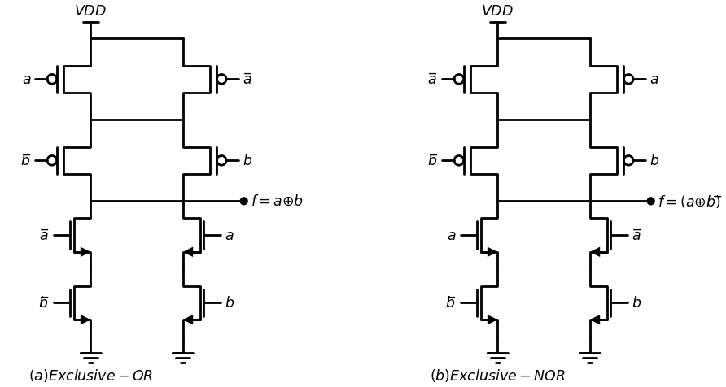
import ipywidgets as widgets
from ipywidgets import interact
import matplotlib.pyplot as plt
from matplotlib import rcParams
import PySpice.Logging.Logging as Logging
logger = Logging.setup_logging()
from PySpice.Probe.Plot import plot
from PySpice.Spice.Netlist import Circuit
from PySpice.Unit import *
rcParams['font.weight'] = 'bold'
figure = plt.figure(figsize=(15, 10))
circuit = Circuit('Pulse Sources ')
circuit.model('2N7000', 'NMOS', L=0.18E-6, W=2E-6,LAMBDA = 0.2 ,Kp=0.007, Vto=.01)
circuit.model('2N7100', 'PMOS', L=0.18E-6, W=4E-6,LAMBDA = 0.1 ,Kp=0.007, Vto=-.01)
circuit.model('2N7200', 'NMOS', L=0.18E-6, W=1E-6,LAMBDA = 0.2 ,Kp=0.007, Vto=.1)
circuit.V(1, '1', circuit.gnd,1@u_V)
pulse1 = circuit.PulseVoltageSource('V1', 'A', circuit.gnd, initial_value=2.5@u_V, pulsed_value=0@u_V,rise_time=1@u_ps,fall_time=1@u_ps, pulse_width=8@u_ns, period=20@u_ns)
pulse2 = circuit.PulseVoltageSource('V2', 'B', circuit.gnd, initial_value=0@u_V, pulsed_value=2.5@u_V,delay_time=2.5@u_ns,rise_time=1@u_ps,fall_time=1@u_ps,pulse_width=10@u_ns, period=20@u_ns)
#NOT1
circuit.MOSFET(1, 'A_', 'A', '1','1', model='2N7100')
circuit.MOSFET(2, 'A_', 'A', circuit.gnd,circuit.gnd, model='2N7000')
#NOT2
circuit.MOSFET(3, 'B_', 'B', '1','1', model='2N7100')
circuit.MOSFET(4, 'B_', 'B', circuit.gnd,circuit.gnd, model='2N7000')
# xnor
circuit.MOSFET(5, '2', 'A_', '1','1', model='2N7100')
circuit.MOSFET(6, '2', 'A', '1','1', model='2N7100')
circuit.MOSFET(7, 'out', 'B_', '2','1', model='2N7100')
circuit.MOSFET(8, 'out', 'B', '1','1', model='2N7100')
circuit.MOSFET(9, 'out', 'A', '4',circuit.gnd, model='2N7200')
circuit.MOSFET(10, 'out', 'A_', '5',circuit.gnd, model='2N7200')
circuit.MOSFET(11, '4', 'B_', circuit.gnd,circuit.gnd, model='2N7000')
circuit.MOSFET(12, '5', 'B', circuit.gnd,circuit.gnd, model='2N7000')
circuit.C(1, 'out',circuit.gnd , 0.02@u_pF)
simulator = circuit.simulator(temperature=25, nominal_temperature=25)
analysis = simulator.transient(step_time=1@u_ns, end_time=40@u_ns)
fig, (ax1, ax2,ax3) = plt.subplots(3, 1, figsize=(10, 6), sharex=True)
ax1.plot(analysis.time, analysis['A'], 'red', linewidth=2, label='A')
ax1.set_xlabel('Time [s]', color='black', weight='black', fontsize=10)
ax1.set_ylabel('IN A', color='black', weight='black', fontsize=10)
ax2.plot(analysis.time, analysis['B'], 'blue', linewidth=2, label='B')
ax2.set_xlabel('Time [s]', color='black', weight='black', fontsize=10)
ax2.set_ylabel('IN B', color='black', weight='black', fontsize=10)
ax3.plot(analysis.time, analysis['out'], 'green', linewidth=2, label='B')
ax3.set_xlabel('Time [s]', color='black', weight='black', fontsize=10)
ax3.set_ylabel('out(XNOR)', color='black', weight='black', fontsize=10)
plt.tight_layout()
plt.show()
<Figure size 1500x1000 with 0 Axes>
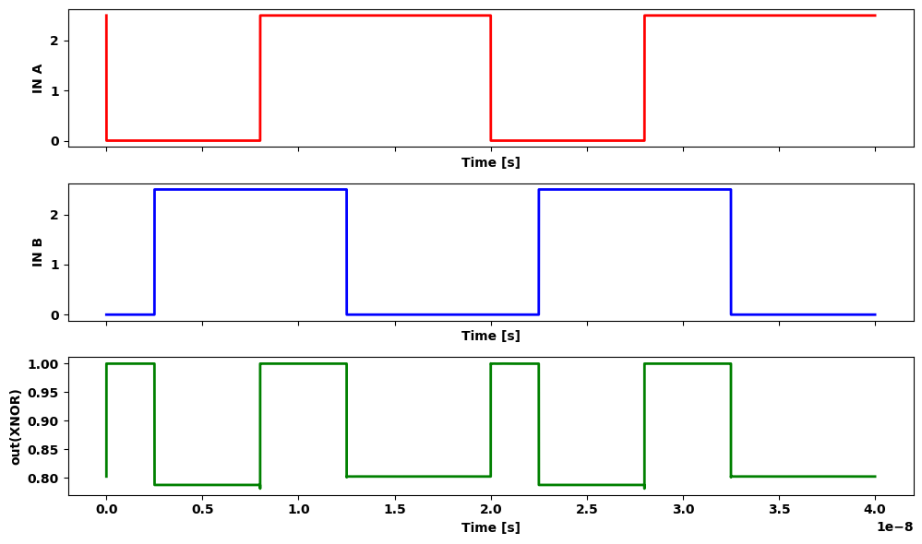

5.2 Figure 2.57 AOI XOR and XNOR gates

6 2.4.3 Generalized AOI and OAI Logic Gates
Standard logic design is often simplified using generalized m ultiple-input AOI and OAI logic gates. This is particularly true in A S IC -typ e circu its that rely on predesigned logic circuits. A straightforward nom enclature for distinguishing among various input configurations is developed in Figure 2.58. The network in Figure 2.58(a) has an AOI pattern w ith 2 inputs to each AND gate; it is therefore called an AO I22 gate. Sim ilarly, the logic pattern in Figure 2.58(b) is called an AOI 321, where a “ 1” label im plies an input that bypasses the AND gates and is connected directly to an O R gate. The third example, shown in Figure 2.58(c), is term ed an OA1221 gate using the same convention. The CMOS circuits are easily designed using series-parallel wiring or bubble pushing.
import schemdraw.elements as elm
import matplotlib.pyplot as plt
from schemdraw import dsp
from schemdraw.parsing import logicparse
from schemdraw import logic
with schemdraw.Drawing(unit=2) as d:
And1= d.add(logic.And().right())
And2= d.add(logic.And().right().label('(a) AOI22 gate', loc='bottom', color='black').at((0,-2)))
Nor= d.add(logic.Nor().right().at((3,-1)))
d += (l1 :=elm.Line().right(d.unit*.6).at((1.8,0)))
d += (l2 :=elm.Line().down(d.unit*.38))
d += (l3 :=elm.Line().right(d.unit*.6).at((1.8,-2)))
d += (l4 :=elm.Line().up(d.unit*.38))
And3= d.add(logic.And(inputs=3).right().at((8,0)))
And4= d.add(logic.And().right().at((8,-2)))
Nor2= d.add(logic.Nor(inputs=3).right().at((11.5,-1)))
d += (l5 :=elm.Line().right(d.unit*.6).at((9.8,0)))
d += (l6 :=elm.Line().down(d.unit*.33))
d += (l7 :=elm.Line().right(d.unit*.6).at((9.8,-2)))
d += (l8 :=elm.Line().up(d.unit*.5))
d += (l9 :=elm.Line().right(d.unit*.34).at(l6.end))
d += (l10 :=elm.Line().right(d.unit*.34).at(l8.end))
d += (l11 :=elm.Line().down(d.unit*.9).at((11.5,-1.3)))
d += (l12 :=elm.Line().left(d.unit*1.7).label('(b) AOI321 gate', loc='bottom', color='black'))
Or= d.add(logic.Or().right().at((16,0)))
Or= d.add(logic.Or().right().at((16,-2)))
Nand= d.add(logic.Nand(inputs=3).right().at((19.5,-1)))
d += (l13 :=elm.Line().right(d.unit*.6).at((17.8,0)))
d += (l14 :=elm.Line().down(d.unit*.33))
d += (l15 :=elm.Line().right(d.unit*.6).at((17.8,-2)))
d += (l16 :=elm.Line().up(d.unit*.5))
d += (l17 :=elm.Line().right(d.unit*.34).at(l14.end))
d += (l18 :=elm.Line().right(d.unit*.34).at(l16.end))
d += (l11 :=elm.Line().down(d.unit*.9).at((19.5,-1.3)))
d += (l12 :=elm.Line().left(d.unit*1.7).label('(c) OA1221 gate', loc='bottom', color='black'))
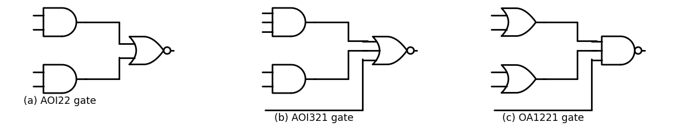

6.1 Figure 2.58 General naming convention
Generalized complex logic gates provide a u niform basis for creating different logic operations using a generic gate. As a simple example, con sider the AOI22 gate shown in Figure 2.59(a). This provides an output of
$AOI22\left(a,b,c,d\right)={\left(a•b+c•d\right)}^{−}$ $\left(2.75\right)$
To create an XOR circuit, we can define the inputs as show n in Figure 2.59(b), which allows us to write
a ⊕ b = AO I22(a, b, $\overset{‾}{a}$, $\overset{‾}{b}$) $\left(2.76\right)$
Using the same reasoning, the XNOR function can be obtained using
$\overset{‾}{a}$⊕$ \bar{b}$=AOI22(a, $\overset{‾}{b}$, $\overset{‾}{a}$, b) $\left(2.77\right)$
design illustrates how generic iogic gates can be used in random logic design.

7 2.2.5 Transmission Gate Circuits
A CMOS transmission gate is created by connecting an nFET and pFE T in parallel as shown in figure 2.60 ( a ) - The nFET Mn is controlled by the signals whiles the pFET Mp is controlled by the complements. W hen wired in this manner, the pair acts as a good electrical switch between the input and output variable x and y respectivity.

8 2.2.5.1 Logic Design
Transmission gate logic design has been used extensively in CMOS design for many years. The simplicity of the switching and the ability to transmit the entire range of voltages made it attractive for many applications. TG circuits are found in many ASIC structures, making them worth studying in more detail.
Multiplexors
The ideal-switch characteristics of TGs make them useful for creating some rather unique circuits. An example is the 2-to-l MUX shown in Fig ure 2.61. The operation of the circuit is summarized in the table. When the selector signal has a value s = 0, TGO is closed and T G I is open, so that Po is transmitted to the output. If s = 1, the situation is reversed with TGO open and TGI closed; in this case, F = P1 Combining these results gives
F = $Po$ .$\overset{‾}{s}$ + $P1$ .s $\left(2.79\right)$
which is the required equation. Note that the use of a pair of TGs elimi nates the possibility of having a floating (disconnected) output since one TG is always closed while the other will be open. The 2-to-1 architecture can be extended to a 4:1 network by using the 2-bit selector word (s1 s0 ) that has values of (0 0), (0 1), (1 0), and (1 1). Each input line (Po , Pp P2 , P3) will have two TGs in its path such that the output is
F = Po $\overset{‾}{s1}$.$\overset{‾}{s0}$+ $P1$. $\overset{‾}{s1}$ • s0 + $P2$ • s1 .$\overset{‾}{s0}$ + P 3 • S1 .s0 $\left(2.80\right)$
For example, the Po path will have TGs that are closed with (s1 s0 ) = (0 0). The construction of the network is left as an exercise for the reader. The 2:1 MUX can be modified to produce other useful functions. One is 1 ustrated in Figure 2.62(a). The input to the top TG is a; this is inverted so that a enters the lower TG. Variable b and its complement are used to ontrol the TGs. When b = 0, the upper TG is closed and a is passed to the
import schemdraw.elements as elm
import matplotlib.pyplot as plt
from schemdraw import dsp
from schemdraw.parsing import logicparse
from schemdraw import logic
with schemdraw.Drawing(unit=2) as d:
Buf= d.add(logic.Buf().right())
Buf1= d.add(logic.Buf().right().reverse().at((0,0)).idot().label('$P{o}$','left'))
d += (l1 :=elm.Line().down(d.unit*.4).at((1,1.1)).dot(open=True).idot().label('$S$','right'))
d += (l2 :=elm.Line().right(d.unit*.3).at(Buf1.end).label('$TG{0}$','top'))
d += (l3 :=elm.Line().down(d.unit*.6).dot())
d += (l4 :=elm.Line().right(d.unit*.4).dot().label('$F$','right'))
d += (l5 :=elm.Line().down(d.unit*.6).at(l3.end))
d += (l6 :=elm.Line().left(d.unit*.3).label('$TG{1}$','bottom'))
Buf2= d.add(logic.Buf().left())
Buf3= d.add(logic.Buf().right().idot().label('$P{1}$','left'))
d += (l7 :=elm.Line().down(d.unit*.4).at((1,-.3)).dot())
d += (l8 :=elm.Line().left(d.unit*.3).dot().label(r'$\bar{S}$','left'))
d += (l9 :=elm.Line().down(d.unit*.5).at(l7.end).dot(open=True))
d += (l10 :=elm.Line().down(d.unit*.4).at((1,-2.7)).dot().label('$S$','left'))
# تعریف داده‌ها
data = {
's': ['0', '1'],
'TGO': ['Closed', 'Open'],
'TG1': ['Open', 'Closed'],
'F': ['P₀', 'P₁']
}
# ساخت DataFrame
df = pd.DataFrame(data)
# نمایش جدول به شکل زیبای ساده
print(tabulate(df, headers='keys', tablefmt='grid', showindex=False))
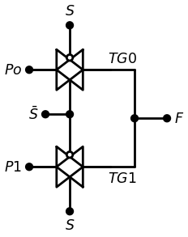
+-----+--------+--------+-----+
| s | TGO | TG1 | F |
+=====+========+========+=====+
| 0 | Closed | Open | P₀ |
+-----+--------+--------+-----+
| 1 | Open | Closed | P₁ |
+-----+--------+--------+-----+

8.1 figure 2.61 ATG-based 2-to-1 multiplexor
import schemdraw.elements as elm
import matplotlib.pyplot as plt
from schemdraw import dsp
from schemdraw.parsing import logicparse
from schemdraw import logic
with schemdraw.Drawing(unit=2) as d:
Buf= d.add(logic.Buf().right())
Buf1= d.add(logic.Buf().right().reverse().at((0,0)))
d += (l1 :=elm.Line().down(d.unit*.4).at((1,1.1)).dot(open=True).idot().label('$b$','right'))
d += (l2 :=elm.Line().right(d.unit*.3).at(Buf1.end))
d += (l3 :=elm.Line().down(d.unit*.6).dot())
d += (l4 :=elm.Line().right(d.unit*.4).dot().label('$a⊕b$','right'))
d += (l5 :=elm.Line().down(d.unit*.6).at(l3.end))
d += (l6 :=elm.Line().left(d.unit*.3))
Buf2= d.add(logic.Buf().left())
Buf3= d.add(logic.Buf().right())
d += (l7 :=elm.Line().down(d.unit*.4).at((1,-.3)).dot())
d += (l8 :=elm.Line().left(d.unit*.3).dot().label(r'$\bar{b}$','left'))
d += (l9 :=elm.Line().down(d.unit*.5).at(l7.end).dot(open=True))
d += (l10 :=elm.Line().down(d.unit*.4).at((1,-2.7)).dot().label('b \n\n (a) XOR circuit','left'))
d += (l11 :=elm.Line().left(d.unit*.9).at(Buf.start).dot().label('$a$','left'))
Not= d.add(logic.Not().down().length(2.4))
d += (l12 :=elm.Line().right(d.unit*.9))
Buf4= d.add(logic.Buf().right().at((12,0)))
Buf5= d.add(logic.Buf().right().reverse().at((12,0)))
d += (l13 :=elm.Line().down(d.unit*.4).at((13,1.1)).dot(open=True).idot().label(r'$\bar{b}$','right'))
d += (l14 :=elm.Line().right(d.unit*.3).at(Buf5.end))
d += (l15 :=elm.Line().down(d.unit*.6).dot())
d += (l16 :=elm.Line().right(d.unit*.4).dot().label('$(a⊕b) ̅ $ ','right'))
d += (l17 :=elm.Line().down(d.unit*.6).at(l15.end))
d += (l18 :=elm.Line().left(d.unit*.3))
Buf6= d.add(logic.Buf().left())
Buf7= d.add(logic.Buf().right())
d += (l19 :=elm.Line().down(d.unit*.4).at((13,-.3)).dot())
d += (l20 :=elm.Line().left(d.unit*.3).dot().label('b','left'))
d += (l21 :=elm.Line().down(d.unit*.5).at(l19.end).dot(open=True))
d += (l22 :=elm.Line().down(d.unit*.4).at((13,-2.7)).dot().label(r'$\bar{b}$','left').label('\n\n (b) XNOR circuit','left'))
d += (l23 :=elm.Line().left(d.unit*.9).at(Buf4.start).dot().label('$a$','left'))
Not1= d.add(logic.Not().down().length(2.4))
d += (l24 :=elm.Line().right(d.unit*.9))
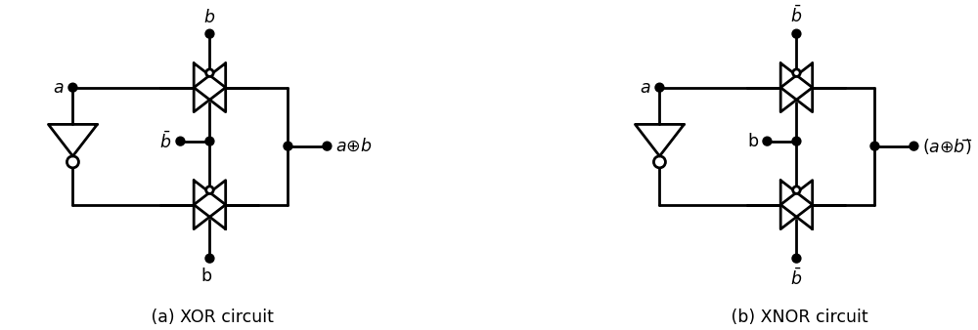

8.2 Figure 2.62 TG-based exclusive-OR and exclusive-NOR circuits
output, while b = I closes the lower TG a n d steers a to the outre gives
a. $\overset{‾}{b}$+ $\overset{‾}{a}$.b= a ⊕ b $\left(2.81\right)$
le .. the circuit precedes the XOR texclusive-OR function. The expert can be verified using the 2; 1 MUX result. An XNOR function
a ⊕ b= a.b+$\overset{‾}{a}$.$\overset{‾}{b}$ $\left(2.82\right)$
is obtioned if we intercharge b and $\overset{‾}{b}$. The circuit for this simple meantion is shown n. Figure 2.62{b}.
OR Gate
Transansmisstion gate ch aractertsccs can. be used to create simple circuit shown in Figure 2. 63; this is useful since complementary gates can only provide the NOR operation. The operation of circuit
import schemdraw.elements as elm
import matplotlib.pyplot as plt
from schemdraw import dsp
from schemdraw.parsing import logicparse
from schemdraw import logic
with schemdraw.Drawing(unit=2) as d:
d += (l1 :=elm.Line().right(d.unit*.6).dot().idot().label('$a$','left'))
d += (M1 := elm.PFet2().anchor('drain').theta(0).label(r'$\bar{a}$','top').at(l1.end))
d += (l2 :=elm.Line().right(d.unit*.6).dot().idot().label('$f=a+b$','right').at(M1.source))
d += (l3 :=elm.Line().down(d.unit*.85).dot(open=True).at(l1.end))
Buf1= d.add(logic.Buf().left().at((2.2,-2)).label('$b$','left'))
Buf2= d.add(logic.Buf().right().at((0.2,-2)))
d += (l4 :=elm.Line().right(d.unit*.5).at(Buf1.start))
d += (l5 :=elm.Line().up(d.unit*1))
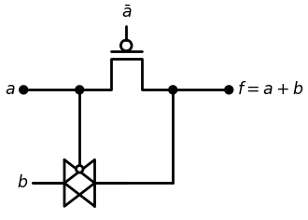

8.3 Figure 2.63 A TG-based OR gate
be understood by examining the effect that a has on the switches. If a = 0, then the pFET is OFF (since a = 1 drives it into cutoff) while the TG a c ts as a closed switch. This gives an output if f= b. If a = 1, th en the pFET is ON and the value of f = a = 1 is transm itted to the output. T hus, the o u t put is f = 1 if either input is a 1, which establishes the OR operation. We can alternately use logic equations for the TG and th e pFET to w rite the output as
f=a.((a ̅ ) ) ̅ +$\overset{‾}{a}$.b
=a+$\overset{‾}{a}$.b $\left(2.83\right)$
=a+b
where the last step follows by absorption. This verifies the sim pler bit-by- bit analysis. Alternate XOR/XNOR Circuits Mixing TGs and FETs as in the OR gate circuit gives rise to m any v a ria tions for the design of basic logic gates. M any of th e se d esig n s a re for exclusive-OR and equivalence (XNOR) functions due to th eir im portance in adders and error detection/correction algorithm s. An example of this type of circuit is the XNOR netw ork in Figure 2.64. This uses the input pair (b, b) to control the transm ission gate. To u n d e r stand the operation, rem em ber th a t the o u tp u t of a n XNOR gate is 1 if and only if the in p u ts are equal. Suppose that b = 1; th e TG acts as a closed switch and a is tran sm itted to th e o u tp u t to give g = a. For th is case, the output is a 1 iff a = 1. The circuit operates differently if b = 0. Now, the TG is off and a is directed toward the gates of the M p/M n pair. Since b = 0 is applied to the source of the nFET Mn and b = 1 is connected to the source (upper side) of the pFET, the (b, b) = (0, VDD ) pair provides power to the FETs, resulting in an inverter! For this case, the output is g = a, so that g is 1 iff a = 0. This establishes the circuit as an XNOR gate as stated. Interchanging b and b gives a n XOR gate.
import schemdraw
import schemdraw.elements as elm
import matplotlib.pyplot as plt
from schemdraw import dsp
from schemdraw import logic
with schemdraw.Drawing(unit=2) as d:
d += (M1 := elm.PFet2().anchor('gate').theta(90))
d += (M2 := elm.AnalogNFet(offset_gate = False).anchor('drain').theta(0).at(M1.drain).reverse())
d += (l1 :=elm.Line().left(d.unit*2.5).dot().at(M1.source))
d += (l2 :=elm.Line().left(d.unit*.5).dot().label(r'$\bar{b}$','left'))
Buf1= d.add(logic.Buf().left().at((-2.5,-1)))
Buf2= d.add(logic.Buf().right().at((-4.7,-1)))
d += (l3 :=elm.Line().down(d.unit*.9).dot(open=True).at(l1.end))
d += (l4 :=elm.Line().left(d.unit*2.5).idot().endpoints(M1.drain,Buf1.start))
d += (l5 :=elm.Line().left(d.unit*2.35).at(M1.gate))
d += (l6 :=elm.Line().down(d.unit*.5).dot())
d += (l7:=elm.Line().left(d.unit*.5).dot().label('$a$','left'))
d += (l8 :=elm.Line().left(d.unit*2.58).at(M2.gate))
d += (l9 :=elm.Line().up(d.unit*.4))
d += (l10 :=elm.Line().left(d.unit*2.5).at(M2.source).dot())
d += (l11 :=elm.Line().up(d.unit*.73))
d += (l12 :=elm.Line().left(d.unit*.5).dot().label('b','left').at(l10.end))
d += (l13 :=elm.Line().right(d.unit*.5).dot().label(r'$g= ¯(a⊕b)$','right').at(M1.drain))
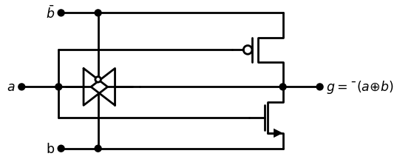

8.4 Figure 2.64 An XNOR gate th a t uses both TGs and FETs

9 2.6 Clocking and Dataflow Control
Synchronous digital design relies on the ability to control the flow of date usin g a clockin g signal ∅. Th e sw itching characteristics of TGs can used to provide a simple approach to system clocking. Since complemen tary signals are required to switch a TG, both ∅and $\overset{‾}{∅}$ are used in this try of design; waveform s are shown in Figure 2.65. The period T is the tims seconds needed for one complete cycle. The frequency f is defined by
$f=\frac{1}{T}$ $\left(2.84\right)$
and has units o f Hertz [Hz] = [1/sec], where 1 hertz means one cycle completed in 1 second. We will assume that the clock is at a logic 1vi o f on e-h alf o f the period, and at a logic 0 value for the remaining hai the period. Let us exam ine the effect o f applying the complementary clocks transm ission gate. Figure 2.66(a) shows that when a value o f ∅ = 1 applied to the nFET and $\overset{‾}{∅}$ = 0 to the pFET, the TG is On and acts little closed switch. Reversing these values as in Figure 2.66(b) gives an switch. Under static conditions, the value of y would not be known white the switch is opened. However, the electrical characteristics of CMOS allow us to temporarily hold the value o f y = x for a very short time typically, th old is less than 1 second. If we use a high-frequency clock time the periodic open-closed change occurs at every half clock cycle. Then can hold the previous value so long as (T/2) < t hold. This provides accurate time base for controlling data flow in a complex network.
import matplotlib.pyplot as plt
import numpy as np
from matplotlib import rcParams
import PySpice.Logging.Logging as Logging
from PySpice.Probe.Plot import plot
from PySpice.Spice.Library import SpiceLibrary
from PySpice.Spice.Netlist import Circuit
from PySpice.Unit import *
logger = Logging.setup_logging()
circuit = Circuit('Pulse Sources ')
circuit.model('2N7000', 'NMOS', L=0.18E-6, W=.5E-6,LAMBDA = 0.1 ,Kp=0.007, Vto=.3)
circuit.model('2N7100', 'PMOS', L=0.18E-6, W=4E-6,LAMBDA = 0.1 ,Kp=0.007, Vto=-.3)
pulse1 = circuit.PulseVoltageSource('V1', 'D', circuit.gnd, initial_value=1.8@u_V, pulsed_value=0@u_V,delay_time=5@u_ns,rise_time=.01@u_ns,fall_time=.01@u_ns, pulse_width=5@u_ns, period=10@u_ns)
pulse2 = circuit.PulseVoltageSource('V2', 'CP', circuit.gnd, initial_value=0@u_V, pulsed_value=1.8@u_V,delay_time=5@u_ns,rise_time=1@u_ps,fall_time=1@u_ps,pulse_width=5@u_ns, period=10@u_ns)
circuit.V(1, '1', circuit.gnd, 1.8@u_V)
#NOT1
circuit.MOSFET(1, 'D_', 'D', '1','1', model='2N7100')
circuit.MOSFET(2, 'D_', 'D', circuit.gnd,circuit.gnd, model='2N7000')
simulator = circuit.simulator(temperature=25, nominal_temperature=25)
analysis = simulator.transient(step_time=1@u_ns, end_time=40@u_ns)
fig, (ax1, ax2) = plt.subplots(2, 1, figsize=(10, 6), sharex=True)
ax1.plot(analysis.time, analysis['CP'], 'black', linewidth=2, label='CP')
ax1.set_xlabel('Time [s]', color='black', weight='black', fontsize=10)
ax1.set_ylabel('∅', color='black', weight='black', fontsize=10)
ax2.plot(analysis.time, analysis['D'], 'black', linewidth=2, label='D')
ax2.set_xlabel('Time [s]', color='black', weight='black', fontsize=10)
ax2.set_ylabel(r'$\bar{∅}$', color='black', weight='black', fontsize=10)
ax1.axhline(0, color='black', linewidth=2)
ax1.axvline(0, color='black', linewidth=2)
ax2.axhline(0, color='black', linewidth=2)
ax2.axvline(0, color='black', linewidth=2)
<matplotlib.lines.Line2D at 0x1e64c4cecb0>
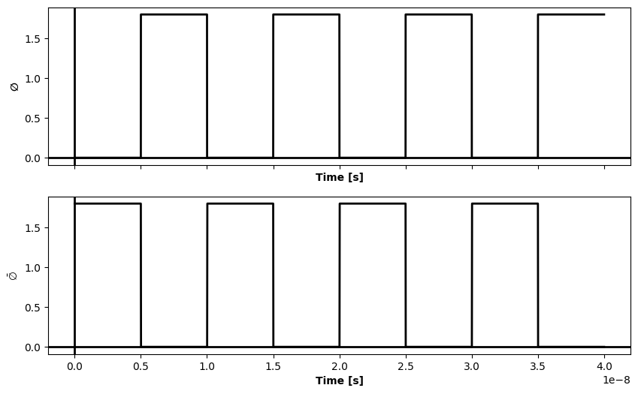

9.1 Figure 2.65 Complem entaiy clocking signals
import schemdraw.elements as elm
import matplotlib.pyplot as plt
from schemdraw import dsp
from schemdraw.parsing import logicparse
from schemdraw import logic
with schemdraw.Drawing(unit=2) as d:
Buf= d.add(logic.Buf().right())
Buf1= d.add(logic.Buf().right().reverse().at((0,0)).idot().label('$X$','left').label('$y=X$','right').dot().label('ON','top'))
d += (l1 :=elm.Line().down(d.unit*.4).at((1,1.1)).dot(open=True).idot().label(r'$\bar{φ}$=0','right'))
d += (l2 :=elm.Line().down(d.unit*.4).at((1,-.3)).dot().label('φ=1','left').label('\n\n(a) Closed switch','left'))
Buf= d.add(logic.Buf().right().at((5,0)))
Buf1= d.add(logic.Buf().right().reverse().at((5,0)).idot().label('$W$','left').label('$y=X$','right').dot().label('Off','top'))
d += (l1 :=elm.Line().down(d.unit*.4).at((6,1.1)).dot(open=True).idot().label(r'$\bar{φ}$=1','right'))
d += (l2 :=elm.Line().down(d.unit*.4).at((6,-.3)).dot().label('φ=0','left').label('\n\n(a) Open switch','left'))
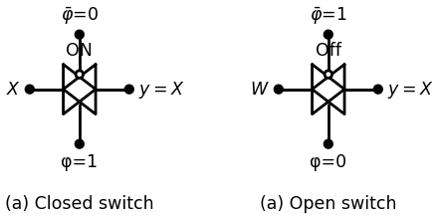

9.2 Figure 2.66 Behavior of a clocked TG
To use clocked TGs for data flow control, we place oppositely phased TGs at the inputs and outputs o f logic blocks. A gate-level exam p le is shown in Figure 2.67. The inputs on the left side are adm itted w hen the clock is high with 0 = 1; the first group o f logic gates evaluates the input bits and produce outputs/and g during this time. Since the output TG s are off, the outputs are held until the clock changes to 0 = 0. W hen this happens,/and g are allowed to enter the next group o f logic gates, which results in F, G, and H. These are held at the outputs until they are trans ferred out when the clock returns to the value 0 = 1 . This shows how data flow through the system is synchronized by the clocked TG. Data flow can be visualized using system level block tim ing diagram s as in Figure 2.68. Each clock plane is shown graphically by a dashed line with either 0 or 0 next to it. These represent a clock-controlled TG at every input. When the variable is true (equal to 1), then data is allowed to pass the plane from one side to the other. Otherwise the data is held on the left side until a clock transition takes place. W ith the labelin g shown, this
import schemdraw
import schemdraw.elements as elm
import matplotlib.pyplot as plt
from schemdraw import dsp
from schemdraw import logic
with schemdraw.Drawing(unit=2) as d:
Buf= d.add(logic.Buf().right())
Buf1= d.add(logic.Buf().right().reverse().at((0,0)))
Buf2= d.add(logic.Buf().right().at((0,-3)))
Buf3= d.add(logic.Buf().right().reverse().at((0,-3)))
Buf4= d.add(logic.Buf().right().at((0,-6)))
Buf5= d.add(logic.Buf().right().reverse().at((0,-6)))
Buf6= d.add(logic.Buf().right().at((0,-9)))
Buf7= d.add(logic.Buf().right().reverse().at((0,-9)))
d += (l1 :=elm.Line().left(d.unit*.5).at(Buf1.start).dot())
d += (l1 :=elm.Line().left(d.unit*.5).at(Buf3.start).dot())
d += (l1 :=elm.Line().left(d.unit*.5).at(Buf5.start).dot())
d += (l1 :=elm.Line().left(d.unit*.5).at(Buf7.start).dot())
d += (l2 :=elm.Line().down(d.unit*.4).at((1,-.3)))
d += (l3 :=elm.Line().down(d.unit*.4).at((1,-3.3)))
d += (l4 :=elm.Line().down(d.unit*.4).at((1,-6.3)))
d += (l5 :=elm.Line().down(d.unit*.4).at((1,-9.3)))
d += (l6 :=elm.Line().left(d.unit*.6).at(l2.end).dot())
d += (l6 :=elm.Line().left(d.unit*.6).at(l3.end).dot())
d += (l6 :=elm.Line().left(d.unit*.6).at(l4.end).dot())
d += (l6 :=elm.Line().left(d.unit*.6).at(l5.end).dot())
d += (l7 :=elm.Line().up(d.unit*6).label('φ','right').color('gray'))
d += (l8 :=elm.Line().down(d.unit*.4).at((1,1.1)).dot(open=True))
d += (l9 :=elm.Line().down(d.unit*.4).at((1,-1.9)).dot(open=True))
d += (l10 :=elm.Line().down(d.unit*.4).at((1,-4.9)).dot(open=True))
d += (l11 :=elm.Line().down(d.unit*.4).at((1,-7.9)).dot(open=True))
d += (l12 :=elm.Line().right(d.unit*.6).at(l8.start).dot())
d += (l13 :=elm.Line().right(d.unit*.6).at(l9.start).dot())
d += (l14 :=elm.Line().right(d.unit*.6).at(l10.start).dot())
d += (l15 :=elm.Line().right(d.unit*.6).at(l11.start).dot())
d += (l16 :=elm.Line().down(d.unit*6).at(l12.end).color('gray').label(r'$\bar{φ}$','left'))
d += (l17 :=elm.Line().right(d.unit*1).at(Buf.end))
d += (l17 :=elm.Line().right(d.unit*1).at(Buf2.end))
d += (l17 :=elm.Line().right(d.unit*1.2).at(Buf4.end))
d += (l17 :=elm.Line().right(d.unit*.5).at(Buf6.end))
Nand1= d.add(logic.Nand().right().at((4,0.25)))
And1= d.add(logic.And(inputs=3).right().at((4,-3.33)))
d += (l18 :=elm.Line().left(d.unit*.5).at((4,0.5)))
d += (l19 :=elm.Line().down(d.unit*4.75).color('gray'))
d += (l20 :=elm.Line().up(d.unit*3.15).color('red').at((4,-6.3)).dot())
d += ( T := dsp.Box(w=1.5, h=1).anchor('W').fill('white').at((4.4,-6.2)))
d += (l21 :=elm.Line().right(d.unit*.2).color('black').at(l20.start))
d += (l22 :=elm.Line().left(d.unit*.3).color('black').at((4,-3.67)))
d += (l23 :=elm.Line().down(d.unit*1.17).color('black').dot())
d += (l24 :=elm.Line().left(d.unit*.7).color('black').dot().at((4.4,-6.6)))
Nor1= d.add(logic.Nor().right().at((6.5,0)))
d += (l25 :=elm.Line().right(d.unit*.4).color('black').at(Nand1.end))
d += (l26 :=elm.Line().down(d.unit*.4).color('black').at((6.5,-.25)))
d += (l27 :=elm.Line().left(d.unit*1.75).color('black').dot())
Nor2= d.add(logic.Nor().right().at((6.5,-5)))
d += (l28:=elm.Line().down(d.unit*.71).color('black').at(And1.end))
d += (l29 :=elm.Line().right(d.unit*.35).color('black'))
d += (l30 :=elm.Line().left(d.unit*.15).color('black').at((6.5,-5.25)))
d += (l31 :=elm.Line().down(d.unit*.4).color('black'))
d += (l32 :=elm.Line().left(d.unit*.15).color('black'))
d += (l33 :=elm.Line().right(d.unit*.5).color('black').at(Nor1.end).label('$F$','top'))
d += (l34 :=elm.Line().right(d.unit*.5).color('black').at(Nor2.end).label('$g$','top'))
Buf8= d.add(logic.Buf().right().at(l33.end))
Buf9= d.add(logic.Buf().right().reverse().at(Buf8.start))
Buf10= d.add(logic.Buf().right().at(l34.end))
Buf11= d.add(logic.Buf().right().reverse().at(Buf10.start))
d += (l35 :=elm.Line().down(d.unit*.4).at((10.4,1.1)).dot(open=True))
d += (l36 :=elm.Line().down(d.unit*.4).at((10.4,-3.9)).dot(open=True))
d += (l37 :=elm.Line().right(d.unit*.5).at(l36.start))
d += (l38 :=elm.Line().up(d.unit*3).color('gray').label('$φ$','right',color='black'))
d += (l39 :=elm.Line().right(d.unit*.5).at(l35.start))
d += (l40 :=elm.Line().down(d.unit*.4).at((10.4,-.3)))
d += (l41 :=elm.Line().down(d.unit*.4).at((10.4,-5.3)))
d += (l42 :=elm.Line().left(d.unit*.4).at(l40.end))
d += (l43 :=elm.Line().left(d.unit*.4).at(l41.end))
d += (l44 :=elm.Line().down(d.unit*3).color('gray').label(r'$\barφ$','left',color='black').at(l42.end))
d += (l45 :=elm.Line().right(d.unit*1).at(Buf9.end))
Nand2= d.add(logic.Nand().right().at((13.2,-.25)))
d += (l46 :=elm.Line().right(d.unit*1).at(Buf10.end))
Xnor= d.add(logic.Xnor().right().at((13.7,-2.25)))
#d += (l47 :=elm.Line().down(d.unit*1).at(Buf10.end))
d += (l48 :=elm.Line().up(d.unit*2.5).at(l46.end).dot().color('gray'))
d += (l49 :=elm.Line().down(d.unit*2.5).at((13.2,-.5)).color('brown'))
d += (l52:=elm.Line().right(d.unit*.25))
d += (l50 :=elm.Line().left(d.unit*.25).at((13.7,-2.5)).dot())
d += (l51:=elm.Line().left(d.unit*.15).at((13.7,-2)).dot())
Nor3= d.add(logic.Nor().right().at((13.7,-5.25)))
d += (l53:=elm.Line().right(d.unit*.2).at((13.4,-5)).idot())
d += (l54:=elm.Line().right(d.unit*.9).at((15,-.25)).label('$F$','top',color='black'))
d += (l55:=elm.Line().right(d.unit*.7).at((15.5,-2.25)).label('$G$','top',color='black'))
d += (l56:=elm.Line().right(d.unit*.7).at((15.5,-5.25)).label('$H$','top',color='black'))
Buf12= d.add(logic.Buf().right().at(l54.end))
Buf13= d.add(logic.Buf().right().reverse().at(Buf12.start))
Buf14= d.add(logic.Buf().right().at(l55.end))
Buf15= d.add(logic.Buf().right().reverse().at(Buf14.start))
Buf16= d.add(logic.Buf().right().at(l56.end))
Buf17= d.add(logic.Buf().right().reverse().at(Buf16.start))
d += (l57 :=elm.Line().down(d.unit*.4).at((17.8,.9)).dot(open=True))
d += (l58 :=elm.Line().down(d.unit*.4).at((17.9,-4.1)).dot(open=True))
d += (l59 :=elm.Line().down(d.unit*.4).at((17.9,-1.1)).dot(open=True))
d += (l60 :=elm.Line().right(d.unit*.4).at(l57.start))
d += (l61 :=elm.Line().down(d.unit*3.5).label(r'$\barφ$','left',color='black').color('gray'))
d += (l62 :=elm.Line().right(d.unit*.35).at(l59.start).dot())
d += (l63 :=elm.Line().down(d.unit*.2).at((17.8,-.55)))
d += (l64 :=elm.Line().down(d.unit*.4).at((17.9,-2.55)))
d += (l65 :=elm.Line().down(d.unit*.4).at((17.9,-5.55)))
d += (l66 :=elm.Line().left(d.unit*.4))
d += (l67 :=elm.Line().up(d.unit*3.8).label('$φ$','right',color='black'))
d += (l68 :=elm.Line().left(d.unit*.35).at(l63.end).dot())
d += (l69 :=elm.Line().left(d.unit*.39).at(l64.end).dot())
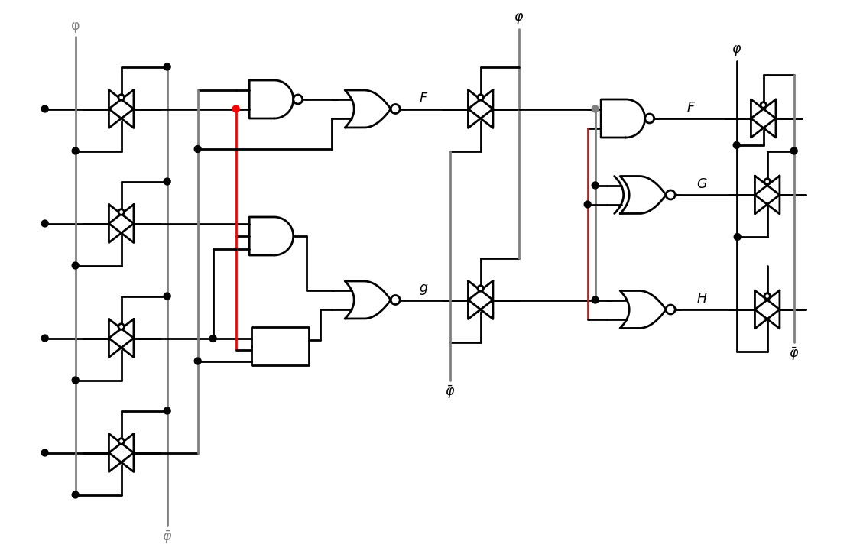

9.3 Figure 2.67 Data synchronization using transmission gates
import schemdraw
import schemdraw.elements as elm
import matplotlib.pyplot as plt
from schemdraw import dsp
from schemdraw import logic
with schemdraw.Drawing(unit=2) as d:
d += ( F1 := dsp.Box(w=3, h=4).anchor('W').fill('white').label('$Bloke 1$'))
d += ( F2 := dsp.Box(w=3, h=4).anchor('W').fill('white').label('$Bloke 2$').at((5,0)))
d += ( F3 := dsp.Box(w=3, h=4).anchor('W').fill('white').label('$Bloke 3$').at((10,0)))
d += (l1 :=elm.Line().left(d.unit*1).at((0,1.5)).dot())
d += (l2 :=elm.Line().left(d.unit*1).at((0,.75)).dot())
d += (l3 :=elm.Line().left(d.unit*1).at((0,0)).dot())
d += (l4 :=elm.Line().left(d.unit*1).at((0,-.75)).dot())
d += (l5 :=elm.Line().right(d.unit*1).at((3,1.5)))
d += (l6 :=elm.Line().right(d.unit*1).at((3,.75)))
d += (l7 :=elm.Line().right(d.unit*1).at((3,0)))
d += (l8 :=elm.Line().right(d.unit*1).at((3,-.75)))
d += (l9 :=elm.Line().right(d.unit*1).at((8,1.5)))
d += (l10 :=elm.Line().right(d.unit*1).at((8,.75)))
d += (l11 :=elm.Line().right(d.unit*1).at((8,0)))
d += (l12 :=elm.Line().right(d.unit*1).at((8,-.75)))
d += (l13 :=elm.Line().right(d.unit*1).at((13,1.5)).dot())
d += (l14 :=elm.Line().right(d.unit*1).at((13,.75)).dot())
d += (l15 :=elm.Line().right(d.unit*1).at((13,0)).dot())
d += (l16 :=elm.Line().right(d.unit*1).at((13,-.75)).dot())
d += (l17 :=elm.Line().up(d.unit*2.5).at((-1,-2)).linestyle('--').label('$φ$','right',color='black'))
d += (l18 :=elm.Line().up(d.unit*2.5).at((4,-2)).linestyle('--').label(r'$\bar{φ}$','right',color='black'))
d += (l19 :=elm.Line().up(d.unit*2.5).at((9,-2)).linestyle('--').label('$φ$','right',color='black'))
d += (l20 :=elm.Line().up(d.unit*2.5).at((14,-2)).linestyle('--').label(r'$\bar{φ}$','right',color='black'))
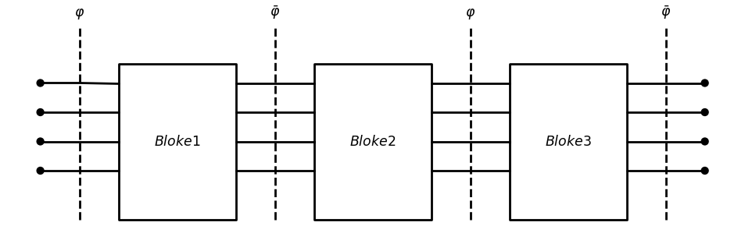

9.4 Figure 2.68 Block-level system timing diagram
says that a clock of 0 = 1 allows inputs into logic block 1. The output transferred to logic block 2 when the clock changes to 0 = 0 andso: this scheme, data moves through a logic block every half cycle. Sine logic blocks are arbitrary, it can be used as the basis for buildint complex logic chains. It also allows us to synchronize the operation: formed on each bit of an n-bit binary word. A synchronized word adder is illustrated in Figure 2.69(a). The: words $an_{1}$...a0 and $bn−i$...b0 are controlled by the 0-clock plane, wit sum Sn-p.-Sg is transferred to the output when 0 = 0. Every bitina is transmitted from one point to another at the same time, which; us to track the data flow through the system. This is extended toa scale with the ALU (arithmetic and logic unit) example in Figure2t Inputs A and B are “gated” into the ALU by the φ -plane control: thef word Out is transferred to the next stage when $\overset{‾}{φ}$ = 1 , i.e., φ = 0 This trates the power of using clocked data transfer in VLSI design. Clocked transmission gates synchronize the flow of signals, but lines themselves cannot store the values for times longer than $thold$ is very small. A storage element such as a latch is needed to obtain
import schemdraw
import schemdraw.elements as elm
import matplotlib.pyplot as plt
from schemdraw import dsp
from schemdraw import logic
with schemdraw.Drawing(unit=2) as d:
d += ( F1 := dsp.Box(w=2, h=6).anchor('W').fill('white').label('n-bit\n word \n adder').label('\n(a) Clocked adder','bottom',color='black'))
d += (l1 :=elm.Line().left(d.unit*1).at((0,2.9)).dot().label('$a_0$','left',color='black'))
d += (l2 :=elm.Line().left(d.unit*1).at((0,2.5)).dot().label('$a_1$','left',color='black'))
d += elm.DotDotDot().theta(90).at((-1.5,.8))
d += (l3 :=elm.Line().left(d.unit*1).at((0,1)).dot().label('$an-{1}$','left',color='black'))
d += (l4 :=elm.Line().left(d.unit*1).at((0,0)).dot().label('$b_0$','left',color='black'))
d += (l5 :=elm.Line().left(d.unit*1).at((0,-.5)).dot().label('$b_1$','left',color='black'))
d += elm.DotDotDot().theta(90).at((-1.5,-2.2))
d += (l6 :=elm.Line().left(d.unit*1).at((0,-2.5)).dot().label('$bn-{1}$','left',color='black'))
d += (l7 :=elm.Line().right(d.unit*1).at((2,.5)).dot().label('$s_0$','right',color='black'))
d += (l8 :=elm.Line().right(d.unit*1).at((2,-2.5)).dot().label('$Sn-{1}$','right',color='black'))
d += (l9 :=elm.Line().right(d.unit*1).at((2,0)).dot().label('$s_1$','right',color='black'))
d += elm.DotDotDot().theta(90).at((3.5,-2.2))
d += (l10 :=elm.Line().up(d.unit*3.5).at((-1,-3)).linestyle('--').label('$φ$','right',color='black'))
d += (l11 :=elm.Line().up(d.unit*3.5).at((3.25,-3)).linestyle('--').label(r'$\bar{φ}$','right',color='black'))
l12 = d.add(elm.DataBusLine().right().length(4).color('black').label('n','top').label('A','left').at((12,0)))
l22 = d.add(elm.Line().up().length(1.5).color('black'))
l32 = d.add(elm.Line().down().length(1.5).color('black').at(l12.end))
l42 = d.add(elm.Line().up().length(4).color('black').at((22,-5)).label('ALU','top'))
l52 = d.add(elm.Line().up().length(4).color('black').endpoints(l22.end,l42.end))
l62 = d.add(elm.DataBusLine().right().length(4).color('black').label('n','top').label('B','left').at((12,-6)))
l72 = d.add(elm.Line().up().length(1.5).color('black'))
l82 = d.add(elm.Line().down().length(1.5).color('black').at(l62.end))
l92 = d.add(elm.Line().up().length(4).color('black').endpoints(l82.end,l42.start))
l102 = d.add(elm.Line().up().length(0.2).color('white').at((20,-3)))
l112 = d.add(elm.Line().up().length(4).color('black').endpoints(l72.end,l102.start))
l122 = d.add(elm.Line().up().length(4).color('black').endpoints(l32.end,l102.start))
l132 = d.add(elm.DataBusLine().right().length(4).color('black').label('n','top').at((22,-3)).label('OUT','right'))
d += (l120 :=elm.Line().up(d.unit*5.5).at((13,-7)).linestyle('--').label('$φ$','right',color='black'))
d += (l121 :=elm.Line().up(d.unit*3.5).at((25.25,-5)).linestyle('--').label(r'$\bar{φ}$','right',color='black'))
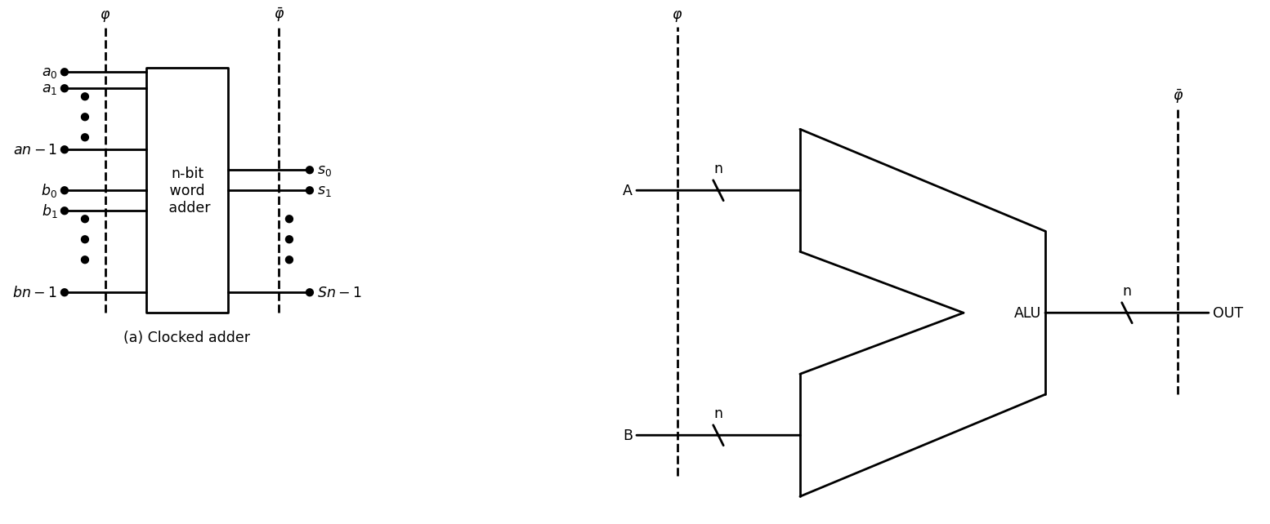

9.5 Figure 2.69 Control o f binary words using clocking planes
import schemdraw
import schemdraw.elements as elm
import matplotlib.pyplot as plt
from schemdraw import dsp
from schemdraw import logic
with schemdraw.Drawing(unit=2) as d:
Nor1= d.add(logic.Nor().right())
Nor2= d.add(logic.Nor().right().at((0,-3)).label('(a) Logic diagram','bottom',color='black'))
d += (l1 :=elm.Line().left(d.unit*.5).at((0,0.25)).dot().label('$S$','left',color='black'))
d += (l2 :=elm.Line().left(d.unit*.5).at((0,-3.25)).dot().label('$R$','left',color='black'))
d += (l3 :=elm.Line().right(d.unit*1).at((1.9,0)).dot().label(r'$\bar{Q}$','right',color='black'))
d += (l4 :=elm.Line().right(d.unit*1).at((1.9,-3)).dot().label('$Q$','right',color='black'))
d += (l5 :=elm.Line().up(d.unit*.3).at((0,-2.72)))
d += (l6 :=elm.Line().down(d.unit*.3).at((0,-.28)))
d += (l7 :=elm.Line().right(d.unit*.03).at((3,0)).color('black'))
d += (l8 :=elm.Line().right(d.unit*.03).at((3,-3)).color('black'))
d += (l9 :=elm.Line().right(d.unit*.03).endpoints(l5.end,l7.end).color('black'))
d += (l10 :=elm.Line().right(d.unit*.03).endpoints(l6.end,l8.end).color('black'))
d += (M1 := elm.PFet2().anchor('gate').theta(90).at((10,1)))
d += (l11 :=elm.Line().right(d.unit*2).at(M1.source).color('black').label('$VDD$','top',color='black'))
d += (M2 := elm.PFet2().anchor('source').theta(270).at(l11.end).reverse())
d += (M3 := elm.PFet2().anchor('source').theta(270).at(M1.drain).reverse())
d += (M4 := elm.PFet2().anchor('source').theta(90).at(M2.drain))
d += (M5 := elm.AnalogNFet(offset_gate = False).anchor('drain').theta(0).at(M3.drain))
d += (M6 := elm.AnalogNFet(offset_gate = False).anchor('drain').theta(0).at(M4.drain).reverse())
d += (l12 :=elm.Line().down(d.unit*.92).at(M3.gate))
d += (l13 :=elm.Line().left(d.unit*.22))
d += (l14 :=elm.Line().down(d.unit*.92).at(M4.gate))
d += (l15 :=elm.Line().right(d.unit*.22))
d += (l16 :=elm.Line().left(d.unit*.92).at(M5.drain).idot().dot().label(r'$\bar{Q}$','left',color='black'))
d += (M7 := elm.AnalogNFet(offset_gate = False).anchor('drain').theta(0).at(l16.end).reverse())
d += (l17 :=elm.Line().right(d.unit*.22).endpoints(M7.source,M5.source))
d += (l18 :=elm.Line().right(d.unit*.92).at(M6.drain).idot().dot().label('$Q$','right',color='black'))
d += (M8 := elm.AnalogNFet(offset_gate = False).anchor('drain').theta(0).at(l18.end))
d += (l19 :=elm.Line().right(d.unit*.22).endpoints(M8.source,M6.source))
d += elm.Ground().at(M7.source).label(' (b) CMOS Circuit ','bottom')
d += elm.Ground().at(M8.source)
d += (l20 :=elm.Line().left(d.unit*.5).at(M7.gate).label('$S$','left',color='black').dot())
d += (l21 :=elm.Line().up(d.unit*1.92))
d += (l22 :=elm.Line().right(d.unit*1.2))
d += (l23 :=elm.Line().right(d.unit*.5).at(M8.gate).label('$R$','right',color='black').dot())
d += (l24 :=elm.Line().up(d.unit*1.92))
d += (l25 :=elm.Line().left(d.unit*1.2))
d += (l26 :=elm.Line().left(d.unit*1.3).dot().at(l18.start))
d += (l27 :=elm.Line().left(d.unit*1.3).dot().at((14,-1.8)).color('black'))
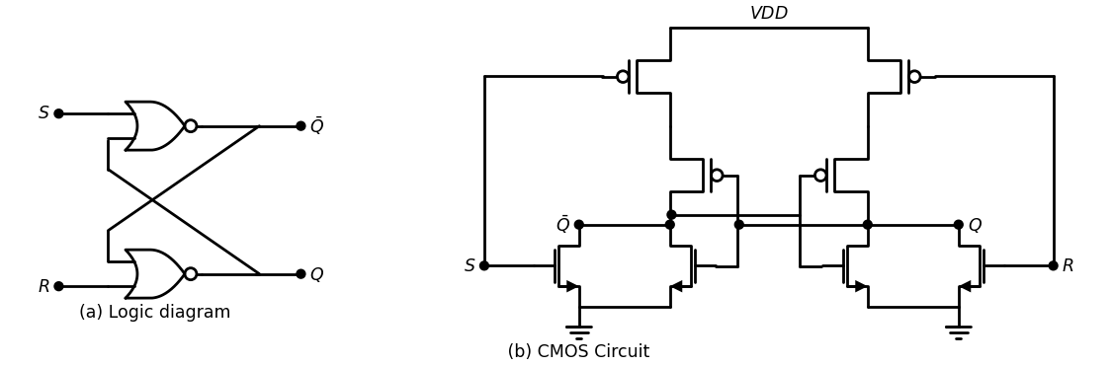
import matplotlib.pyplot as plt
import numpy as np
from matplotlib import rcParams
import PySpice.Logging.Logging as Logging
from PySpice.Probe.Plot import plot
from PySpice.Spice.Library import SpiceLibrary
from PySpice.Spice.Netlist import Circuit
from PySpice.Unit import *
logger = Logging.setup_logging()
circuit = Circuit('Pulse Sources ')
circuit.model('2N7000', 'NMOS', L=0.18E-6, W=.5E-6,LAMBDA = 0.1 ,Kp=0.007, Vto=.1)
circuit.model('2N7100', 'PMOS', L=0.18E-6, W=4E-6,LAMBDA = 0.1 ,Kp=0.007, Vto=-.1)
pulse1 = circuit.PulseVoltageSource('V1', 'S', circuit.gnd, initial_value=1.8@u_V, pulsed_value=0@u_V,delay_time=1@u_ns,rise_time=.01@u_ns,fall_time=.01@u_ns, pulse_width=10@u_ns, period=30@u_ns)
pulse2 = circuit.PulseVoltageSource('V2', 'R', circuit.gnd, initial_value=0@u_V, pulsed_value=1.8@u_V,delay_time=2.5@u_ns,rise_time=1@u_ps,fall_time=1@u_ps,pulse_width=10@u_ns, period=30@u_ns)
circuit.V(1, '1', circuit.gnd, 1.8@u_V)
circuit.MOSFET(1, '2', 'S', '1','1', model='2N7100')
circuit.MOSFET(2, 'Q_bar', 'Q', '2','1', model='2N7100')
circuit.MOSFET(3, 'Q_bar', 'S', circuit.gnd,circuit.gnd, model='2N7000')
circuit.MOSFET(4, 'Q_bar', 'Q', circuit.gnd,circuit.gnd, model='2N7000')
#NOR2
circuit.MOSFET(5, '3', 'R', '1','1', model='2N7100')
circuit.MOSFET(6, 'Q', 'Q_bar', '3','1', model='2N7100')
circuit.MOSFET(7, 'Q', 'R', circuit.gnd,circuit.gnd, model='2N7000')
circuit.MOSFET(8, 'Q', 'Q_bar', circuit.gnd,circuit.gnd, model='2N7000')
simulator = circuit.simulator(temperature=25, nominal_temperature=25)
analysis = simulator.transient(step_time=1@u_ns, end_time=40@u_ns)
fig, (ax1, ax2, ax3,ax4) = plt.subplots(4, 1, figsize=(10, 6), sharex=True)
ax1.plot(analysis.time, analysis['S'], 'blue', linewidth=2, label='S')
ax1.set_xlabel('Time [s]', color='black', weight='black', fontsize=10)
ax1.set_ylabel('S ', color='black', weight='black', fontsize=10)
ax2.plot(analysis.time, analysis['R'], 'red', linewidth=2, label='R')
ax2.set_xlabel('Time [s]', color='black', weight='black', fontsize=10)
ax2.set_ylabel('R ', color='black', weight='black', fontsize=10)
ax3.plot(analysis.time, analysis['Q'], 'green', linewidth=2, label='Q')
ax3.set_xlabel('Time [s]', color='black', weight='black', fontsize=10)
ax3.set_ylabel('Q ', color='black', weight='black', fontsize=10)
ax4.plot(analysis.time, analysis['Q_bar'], 'Chocolate', linewidth=2, label='Q_bar')
ax4.set_xlabel('Time [s]', color='black', weight='black', fontsize=10)
ax4.set_ylabel('Q_bar ', color='black', weight='black', fontsize=10)
plt.tight_layout()
plt.show()
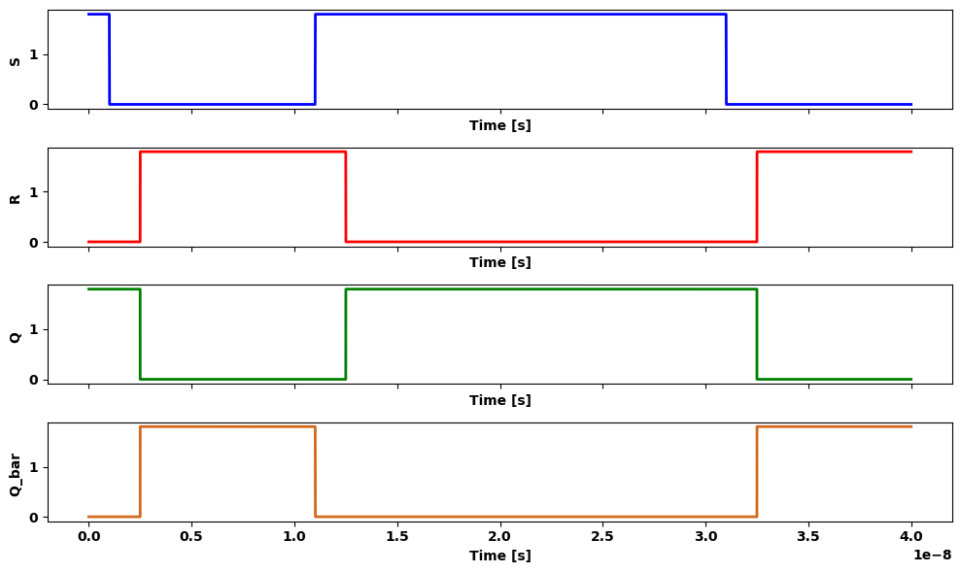

9.6 Figure 2.70 SR Lathc
term storage o f a data bit. Figure 2.70(a) shows the logic diagram for a simple N O R-based S R -latch . T h e C M O S circuit in Figure 2.7 0 (b ) is obtained by wiring two NOR2 gates together. Clock control can be added to the circuit by inserting AND gates at the inputs to arrive at the modified logic diagram in Figure 2.71(a). This only allows changes in the inputs when 0 = 1. A compact CMOS circuit can be obtained by observing that two identical CMOS AO I circuits can be used to create the circuit in Figure 2.71(b). Designing a CM OS circuit using a logic diagram as a starting point thus becom es a straightforward process. This makes CMOS easy to adapt to. The challenge arises in m aking the circuits as fast and as compact as possible.
import schemdraw
import schemdraw.elements as elm
import matplotlib.pyplot as plt
from schemdraw import dsp
from schemdraw import logic
with schemdraw.Drawing(unit=2) as d:
Nor1= d.add(logic.Nor().right())
Nor2= d.add(logic.Nor().right().at((0,-3)).label('(a) Logic diagram','bottom',color='black'))
d += (l1 :=elm.Line().left(d.unit*.5).at((0,0.25)))
d += (l2 :=elm.Line().left(d.unit*.5).at((0,-3.25)))
d += (l3 :=elm.Line().right(d.unit*1).at((1.9,0)).dot().label(r'$\bar{Q}$','right',color='black'))
d += (l4 :=elm.Line().right(d.unit*1).at((1.9,-3)).dot().label('$Q$','right',color='black'))
d += (l5 :=elm.Line().up(d.unit*.3).at((0,-2.72)))
d += (l6 :=elm.Line().down(d.unit*.3).at((0,-.28)))
d += (l7 :=elm.Line().right(d.unit*.03).at((3,0)).color('black'))
d += (l8 :=elm.Line().right(d.unit*.03).at((3,-3)).color('black'))
d += (l9 :=elm.Line().right(d.unit*.03).endpoints(l5.end,l7.end).color('black'))
d += (l10 :=elm.Line().right(d.unit*.03).endpoints(l6.end,l8.end).color('black'))
And1= d.add(logic.And().right().at((-2.7,0.25)).label('$S$','left',color='black'))
And2= d.add(logic.And().right().at((-2.7,-3.25)).label('$R$','left',color='black'))
d += (l11 :=elm.Line().down(d.unit*1.5).at((-2.7,0)))
d += (l12 :=elm.Line().left(d.unit*.53).at((-2.7,-1.5)).dot().label('$φ$','left',color='black'))
d += (M1 := elm.PFet2().anchor('gate').theta(90).at((10,1)))
d += (l11 :=elm.Line().right(d.unit*2).at(M1.source).color('black').label('$VDD$','top',color='black'))
d += (M2 := elm.PFet2().anchor('source').theta(270).at(l11.end).reverse())
d += (M3 := elm.PFet2().anchor('source').theta(270).at(M1.drain).reverse())
d += (M4 := elm.PFet2().anchor('source').theta(90).at(M2.drain))
d += (M5 := elm.AnalogNFet(offset_gate = False).anchor('drain').theta(0).at(M3.drain))
d += (M6 := elm.AnalogNFet(offset_gate = False).anchor('drain').theta(0).at(M4.drain).reverse())
d += (l12 :=elm.Line().down(d.unit*.92).at(M3.gate))
d += (l13 :=elm.Line().left(d.unit*.22))
d += (l14 :=elm.Line().down(d.unit*.92).at(M4.gate))
d += (l15 :=elm.Line().right(d.unit*.22))
d += (l16 :=elm.Line().left(d.unit*.92).at(M5.drain).idot().dot().label(r'$\bar{Q}$','left',color='black'))
d += (M7 := elm.AnalogNFet(offset_gate = False).anchor('drain').theta(0).at(l16.end).reverse())
d += (l18 :=elm.Line().right(d.unit*.92).at(M6.drain).idot().dot().label('$Q$','right',color='black'))
d += (M8 := elm.AnalogNFet(offset_gate = False).anchor('drain').theta(0).at(l18.end))
#d += (l19 :=elm.Line().right(d.unit*.22).endpoints(M8.source,M6.source))
d += elm.Ground().at(M10.source).label(' (b) CMOS Circuit ','bottom')
d += elm.Ground().at(M11.source)
d += (l20 :=elm.Line().left(d.unit*.5).at(M7.gate).label('$S$','left',color='black').dot())
d += (l21 :=elm.Line().up(d.unit*1.92))
d += (l22 :=elm.Line().right(d.unit*1.2))
d += (l23 :=elm.Line().right(d.unit*.5).at(M8.gate).label('$R$','right',color='black').dot())
d += (l24 :=elm.Line().up(d.unit*1.92))
d += (l25 :=elm.Line().left(d.unit*1.2))
d += (l26 :=elm.Line().left(d.unit*1.3).dot().at(l18.start))
d += (l27 :=elm.Line().left(d.unit*1.3).dot().at((14,-1.8)).color('black'))
d += (M9 := elm.PFet2().anchor('gate').theta(90).at((5.5,1)))
d += (l28 :=elm.Line().right(d.unit*2.3).at(M9.source))
d += (M10 := elm.AnalogNFet(offset_gate = False).anchor('drain').theta(0).at(M7.source).reverse())
d += (l29 :=elm.Line().down(d.unit*0.9).at(M5.source))
d += (l30 :=elm.Line().left(d.unit*0.9))
d += (l31 :=elm.Line().left(d.unit*1.8).at(M10.gate).label('$φ$','left',color='black').dot())
d += (l32 :=elm.Line().down(d.unit*2.75).at(M9.gate))
d += (l32 :=elm.Line().right(d.unit*2.25).at(M9.drain).dot())
d += (M11 := elm.AnalogNFet(offset_gate = False).anchor('drain').theta(0).at(M8.source))
d += (l33 :=elm.Line().down(d.unit*0.9).at(M6.source))
d += (l34 :=elm.Line().right(d.unit*0.9))
d += (l35 :=elm.Line().right(d.unit*1.8).at(M11.gate).label('$φ$','right',color='black').dot())
d += (M12 := elm.PFet2().anchor('source').theta(270).at((20,2)).reverse())
d += (l36 :=elm.Line().left(d.unit*2.3).at(M12.source))
d += (l37 :=elm.Line().left(d.unit*2.3).at(M12.drain).dot())
d += (l38 :=elm.Line().down(d.unit*2.75).at(M12.gate).dot())
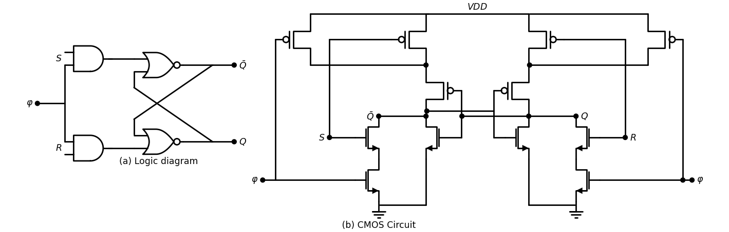

9.7 Figure 2.71 Clocked SR latch

10 2.7 Further Reading
[1] Ken Martin, Digital Integrated Circuit Design, Oxford University Press, New York, 2000.
[2] Michael John Sebastian Smith, Application Specific Integrated Cir cuits. Addison-Wesley, Reading, MA, 1997.
[3] John P. Uyemura, A First Course in Digital System s Design, Brooks-Cole Publishers, Monterey, CA, 2000
[4] John P. Uyemura, CMOS Logic C ircuit D esign. Kluwer Acat Publishers, Norwell, MA, 1999.
[5] M. Michael Vai, VLSI Design. CRC Press, Boca Raton, FL, 2001.
[6] Neil H. E. Weste and Kamran Eshraghian, Principles of CMOS Design. 2nd ed.. Addison-Wesley, Reading, MA, 1993.
[7] Wayne Wolf, Modern VLSI Design, 2nd ed., Prentice-Hall PTR, Um Saddle River, NJ, 1998.

11 2.8 Problems
[2.1] Suppose that VDD = 5 V and VTrl = 0.7 V. Find the output voltage Volt of the nFET in Figure P2.1 for the following input voltage values
(a) Vin =2 V; (b) Vin = 4.5 V; (c) Vin= 3.5 V; (d) Vin = 0.7 V.
import schemdraw
import schemdraw.elements as elm
import matplotlib.pyplot as plt
from schemdraw import dsp
from schemdraw import logic
with schemdraw.Drawing(unit=2) as d:
d += (M1 := elm.PFet2().anchor('gate').theta(0).label('$VDD$','top',color='black'))
d += (l1 :=elm.Line().down(d.unit*0.005).at((-1,-3)).dot().label('$-$','right',color='black'))
d += elm.Ground().at((-1,-3)).label('$Figure P2.1$','bottom',color='black')
d += (l2 :=elm.Line().down(d.unit*0.005).at((1,-3)).dot().label('$-$','right',color='black'))
d += elm.Ground().at((1,-3))
d += (l3 :=elm.Line().down(d.unit*0.005).at((-1,-1.35)).dot().label('+\n Vin','left',color='black'))
d += (l4 :=elm.Line().down(d.unit*0.005).at((1,-1.35)).dot().label('+\n Vout','left',color='black'))
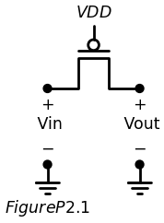
[2.2] Consider the two-FET chain in Figure P2.2. The power supply is to a value of VDD = 3.3 V and the nFET threshold voltage is Vpn=0.5v Find the output voltage VDD at the right side of the chain for the follow values of Vin: (a) Vin = 2.9 V; (b) Vin = 3.0 V; (c) Vin = 1.4 V; (d) Vin= 3.1v
import schemdraw
import schemdraw.elements as elm
import matplotlib.pyplot as plt
from schemdraw import dsp
from schemdraw import logic
with schemdraw.Drawing(unit=2) as d:
d += (M1 := elm.PFet2().anchor('gate').theta(0).label('$VDD$','top',color='black'))
d += (M2 := elm.PFet2().anchor('source').theta(0).label('$VDD$','top',color='black').at(M1.drain))
d += (l1 :=elm.Line().down(d.unit*0.005).at((-3,-1.35)).dot().label('+\n Vin','left',color='black'))
d += (l2 :=elm.Line().down(d.unit*0.005).at((1,-1.35)).dot().label('+\n Vout','left',color='black'))
d += elm.Ground().at((-3,-3)).label('$Figure P2.2$','bottom',color='black')
d += (l3 :=elm.Line().down(d.unit*0.005).at((-3,-3)).dot().label('$-$','right',color='black'))
d += elm.Ground().at((1,-3))
d += (l4 :=elm.Line().down(d.unit*0.005).at((1,-3)).dot().label('$-$','right',color='black'))
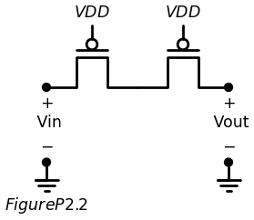
[2.3] The output of an nFET is used to drive the gate of another nFET shown in Figure P2.3. Assume that VD D = 3.3 V and V ^ = 0.60 V. M output voltage Vo u t when the input voltages are at the following valu^.
(a) Va = 3.3 V and Vb = 3.3 V; (b) Va = 0.5 V and Vb = 3.0 V; (c) Va= 2V and Vb = 2.5V ; (d) Va = 3.3 V and Vb = 1.8 V.
[2.4] Design a NAND3 gate using an 8:1 MUX.
[2.5] Design a NOR3 gate using an 8:1 MUX as a basis
import schemdraw
import schemdraw.elements as elm
import matplotlib.pyplot as plt
from schemdraw import dsp
from schemdraw import logic
with schemdraw.Drawing(unit=2) as d:
d += (M1 := elm.PFet2().anchor('gate').theta(0).label('$VDD$','top',color='black'))
d += (l1 :=elm.Line().right(d.unit*0.8).at(M1.source))
d += (l2 :=elm.Line().down(d.unit*0.3))
d += (M2 := elm.PFet2().anchor('gate').theta(0))
d += (l3 :=elm.Line().down(d.unit*0.005).at((-1,-1.35)).dot().label('+\n Va','left',color='black'))
d += elm.Ground().at((-1,-3)).label('$Figure P2.3$','bottom',color='black')
d += (l4 :=elm.Line().down(d.unit*0.005).at((-1,-3)).dot().label('$-$','right',color='black'))
d += (l5 :=elm.Line().down(d.unit*0.005).at((1.6,-3.3)).dot().label('+\n Vb','left',color='black'))
d += elm.Ground().at((1.6,-5))
d += (l6 :=elm.Line().down(d.unit*0.005).at((1.6,-5)).dot().label('$-$','right',color='black'))
d += (l7 :=elm.Line().down(d.unit*0.005).at((3.6,-3.3)).dot().label('+\n Vout','left',color='black'))
d += elm.Ground().at((3.6,-5))
d += (l8 :=elm.Line().down(d.unit*0.005).at((3.6,-5)).dot().label('$-$','right',color='black'))
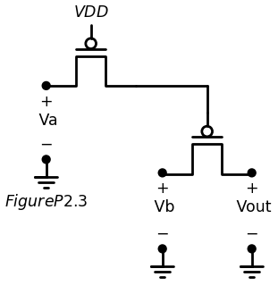
[2.6] Consider the 2-input XOR function a⊕b.
(a) Design an XOR gate using a 4:1 MUX.
(b) Modify the circuit in (a) to produce a 2-input XNOR.
(c) A full adder accepts inputs a, b, and c and calculates the sumbit
$s=a⊕b⊕c$ $\left(2.85\right)$
Use your MUX-based gates to design a circuit with this output.
[2.7] Design a CMOS logic gate for the function
f = $\bar{( a b + a c + b d)} $ $\left(2.86\right)$
using the smallest number of transistors.
[2.8] Design a CMOS circuit for the OAI expression
h = $\overset{‾}{\left(a+b\right)•\left(a+c\right).\left(b+d\right)}$ $\left(2.87\right)$
Use the smallest number of transistors in your design.
[2.9] Construct the CMOS logic gate for the function
g =$\overset{‾}{x\left(y+z\right)+y}$ (2.88)
Start with the minimum-transistor nFET network, and then apply bubble pushing to find the pFET wiring.
[2.10] Design a CMOS logic gate circuit th at implements
F = $\overset{‾}{a+bc+abc}$ $\left(2.89\right)$
using series - parallel logic. The objective is to minimize the transistor count.
[2.11] Consider the logic described for F.
(a) Construct the nFET array using the logic diagram.
(b) Apply bubble pushing to obtian the pFET logic. Then construct the pFET array using the rules.
import schemdraw
import schemdraw.elements as elm
import matplotlib.pyplot as plt
from schemdraw import dsp
from schemdraw import logic
with schemdraw.Drawing(unit=2) as d:
And= d.add(logic.And().right())
d += (l1 :=elm.Line().left(d.unit*0.1).at((0,0.25)).label('$a$','left',color='black').dot())
d += (l2 :=elm.Line().left(d.unit*0.1).at((0,-.25)).label('$b$','left',color='black').dot())
Or= d.add(logic.Or().right().at((0,-3)).label('$Figure P2.4$','bottom',color='black'))
d += (l3 :=elm.Line().left(d.unit*0.1).at((0,-2.75)).label('$c$','left',color='black').dot())
d += (l4 :=elm.Line().left(d.unit*0.1).at((0,-3.25)).label('$d$','left',color='black').dot())
Nor= d.add(logic.Nor().right().at((4,-1.5)).label('$F$','right',color='black'))
d += (l5 :=elm.Line().right(d.unit*0.5).at((1.8,0)))
d += (l6 :=elm.Line().down(d.unit*0.62))
d += (l7 :=elm.Line().right(d.unit*.6))
d += (l8 :=elm.Line().right(d.unit*0.5).at((1.8,-3)))
d += (l9:=elm.Line().up(d.unit*0.62))
d += (l10 :=elm.Line().right(d.unit*.6))
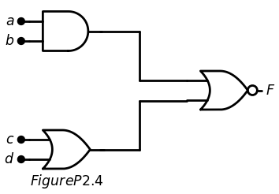
[2.12] An AOAI logic gate is described by the schematic in Figure P2.5
(a) Construct the nFET array using the logic diagram.
(b) Apply bubble pushing to obtain the pFET logic. Use the d i y construct the pFET array using the pFET rules.
import schemdraw
import schemdraw.elements as elm
import matplotlib.pyplot as plt
from schemdraw import dsp
from schemdraw import logic
with schemdraw.Drawing(unit=2) as d:
Or= d.add(logic.Or().right())
d += (l1 :=elm.Line().left(d.unit*0.1).at((0,0.25)).label('$a$','left',color='black').dot())
d += (l2 :=elm.Line().left(d.unit*0.1).at((0,-.25)).label('$b$','left',color='black').dot())
Or= d.add(logic.Or().right().at((0,-3)).label('$Figure P2.5$','bottom',color='black'))
d += (l3 :=elm.Line().left(d.unit*0.7).at((0,-2.75)))
d += (l4 :=elm.Line().left(d.unit*0.1).at((0,-3.25)).label('$e$','left',color='black').dot())
Nand= d.add(logic.Nand().right().at((4,-1.5)).label('$G$','right',color='black'))
d += (l5 :=elm.Line().right(d.unit*0.5).at((1.8,0)))
d += (l6 :=elm.Line().down(d.unit*0.62))
d += (l7 :=elm.Line().right(d.unit*.6))
d += (l8 :=elm.Line().right(d.unit*0.5).at((1.8,-3)))
d += (l9:=elm.Line().up(d.unit*0.62))
d += (l10 :=elm.Line().right(d.unit*.6))
And= d.add(logic.And().right().at((-3,-2.75)))
d += (l11 :=elm.Line().left(d.unit*0.1).at((-3,-2.5)).label('$c$','left',color='black').dot())
d += (l12 :=elm.Line().left(d.unit*0.1).at((-3,-3)).label('$d$','left',color='black').dot())
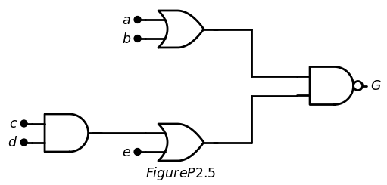
[2.13] A pFET logic array is shown in Figure P2.6. Construct the Logic diagram using the pFET logic equations. Then construct the nFET circuit
import schemdraw
import schemdraw.elements as elm
import matplotlib.pyplot as plt
from schemdraw import dsp
from schemdraw import logic
with schemdraw.Drawing(unit=2) as d:
d += (M1 := elm.PFet2().anchor('gate').theta(90).label('$x$','top',color='black'))
d += (M2 := elm.PFet2().anchor('source').theta(90).at(M1.drain).label('$y$','top',color='black'))
d += (M3 := elm.PFet2().anchor('source').theta(90).at(M2.drain).label('$z$','top',color='black'))
d += elm.Vdd().at(M1.source).label('$V{DD}$','top',color='black')
d += (M4 := elm.PFet2().anchor('source').theta(270).at((3,-3)).reverse().label('$W$','bottom',color='black'))
d += (l1 :=elm.Line().right(d.unit*1.2).dot().at(M3.drain).label('$h$','right',color='black').label('$Figure P2.6$','bottom',color='black'))
d += (l2 :=elm.Line().up(d.unit*1).at(M4.source))
d += (l3 :=elm.Line().left(d.unit*0.82).dot())
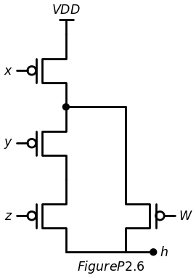
import matplotlib.pyplot as plt
import numpy as np
from matplotlib import rcParams
import PySpice.Logging.Logging as Logging
from PySpice.Probe.Plot import plot
from PySpice.Spice.Library import SpiceLibrary
from PySpice.Spice.Netlist import Circuit
from PySpice.Unit import *
logger = Logging.setup_logging()
circuit = Circuit('Pulse Sources ')
circuit.model('2N7000', 'NMOS', L=0.18E-6, W=.3E-6,LAMBDA = 0.1 ,Kp=0.007, Vto=.4)
circuit.model('2N7100', 'PMOS', L=0.18E-6, W=4E-6,LAMBDA = 0.1 ,Kp=0.007, Vto=-.4)
pulse1 = circuit.PulseVoltageSource('V1', 'X', circuit.gnd, initial_value=1.8@u_V, pulsed_value=0@u_V,delay_time=1@u_ns,rise_time=.01@u_ns,fall_time=.01@u_ns, pulse_width=20@u_ns, period=30@u_ns)
pulse2 = circuit.PulseVoltageSource('V2', 'Y', circuit.gnd, initial_value=0@u_V, pulsed_value=1.8@u_V,delay_time=2.5@u_ns,rise_time=1@u_ps,fall_time=1@u_ps,pulse_width=10@u_ns, period=30@u_ns)
pulse3 = circuit.PulseVoltageSource('V3', 'Z', circuit.gnd, initial_value=0@u_V, pulsed_value=1.8@u_V,delay_time=1.5@u_ns,rise_time=1@u_ps,fall_time=1@u_ps,pulse_width=10@u_ns, period=30@u_ns)
pulse4 = circuit.PulseVoltageSource('V4', 'W', circuit.gnd, initial_value=0@u_V, pulsed_value=1.8@u_V,delay_time=1.5@u_ns,rise_time=1@u_ps,fall_time=1@u_ps,pulse_width=15@u_ns, period=30@u_ns)
circuit.V(1, '1', circuit.gnd, 1.8@u_V)
circuit.MOSFET(1, '2', 'X', '1','1', model='2N7100')
circuit.MOSFET(2, '3', 'Y', '2','1', model='2N7100')
circuit.MOSFET(3, 'H', 'Z', '3','1', model='2N7100')
circuit.MOSFET(4, 'H', 'W', '2','1', model='2N7100')
circuit.C(1, 'H',circuit.gnd , 2@u_pF)
simulator = circuit.simulator(temperature=25, nominal_temperature=25)
analysis = simulator.transient(step_time=1@u_ns, end_time=40@u_ns)
fig, (ax1, ax2, ax3,ax4,ax5) = plt.subplots(5, 1, figsize=(10, 6), sharex=True)
ax1.plot(analysis.time, analysis['X'], 'blue', linewidth=2, label='X')
ax1.set_xlabel('Time [s]', color='black', weight='black', fontsize=10)
ax1.set_ylabel('X ', color='black', weight='black', fontsize=10)
ax2.plot(analysis.time, analysis['Y'], 'red', linewidth=2, label='Y')
ax2.set_xlabel('Time [s]', color='black', weight='black', fontsize=10)
ax2.set_ylabel('Y ', color='black', weight='black', fontsize=10)
ax3.plot(analysis.time, analysis['Z'], 'green', linewidth=2, label='Z')
ax3.set_xlabel('Time [s]', color='black', weight='black', fontsize=10)
ax3.set_ylabel('Z ', color='black', weight='black', fontsize=10)
ax4.plot(analysis.time, analysis['W'], 'red', linewidth=2, label='W')
ax4.set_xlabel('Time [s]', color='black', weight='black', fontsize=10)
ax4.set_ylabel('W ', color='black', weight='black', fontsize=10)
ax5.plot(analysis.time, analysis['H'], 'green', linewidth=2, label='H')
ax5.set_xlabel('Time [s]', color='black', weight='black', fontsize=10)
ax5.set_ylabel('H ', color='black', weight='black', fontsize=10)
plt.tight_layout()
plt.show()
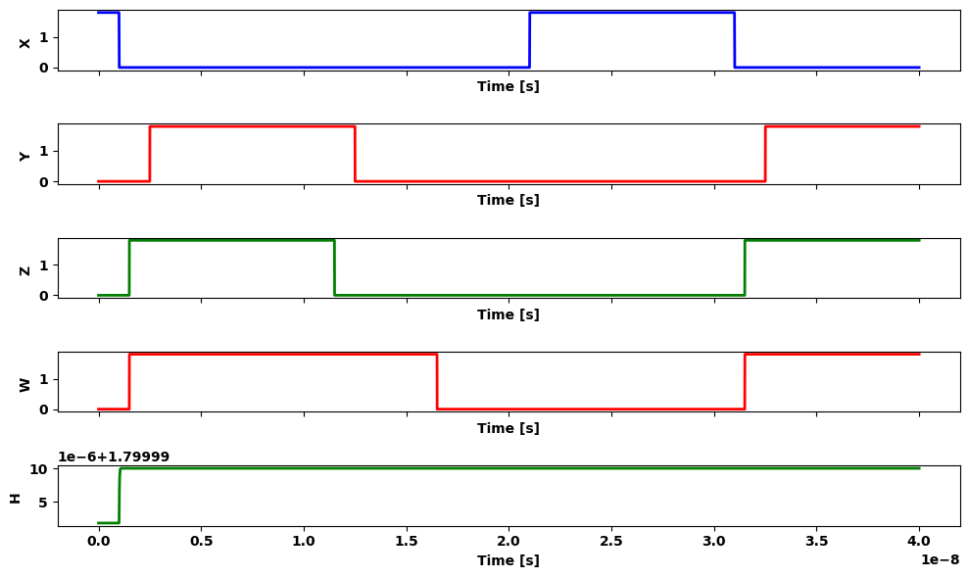
[2.14] Design the 4:1 multiplexor circuit that implements the function equation (2.80) by using TG switches.
[2.15] Use an AOI22 gate to design a 2:1 MUX. Inverters are permittee your design.
[2.16] Design a 4:1 MUX using three 2:1 TG multiplexors.
[2.17] A CPU clock has a frequency 2.1 GHz. W hat is the period 1?
[2. 18 ] Suppose that the hold time for a TG is given as tt o I d = 120 miB is the smallest clock frequency that can be used toclo the data flow using a scheme such as that shown in Figure 2.67?

