Table of Contents

Chapter Two

0.1 Electrical Conduction and Diodes

1 2.1 Introduction
Electrical conduction processes govern the basic properties of many electronic devices. Wacuum, gas, or semiconductor diodes are important examples because they are in common use and because they form the basis for describing the behavior of transistors, triodes, pentodes, thyratrons, and other devices.
Circuit models for electronic devices can be based entirely on measured electrical properties as typified by the average characteristic curves provided by manufacturers. However, without some knowledge of the theory of operation one might conclude that drastic differences exist between different types of devices. In terms of conduction processes, we can recognize similarities that unify and simplify the subject. At best, measurement of the external terminal behavior of a device can tell us only “what” happens, whereas the conduction processes help to explain “why” it happens.
The following discussion of conduction processes is aimed primarily at establishing the plausibility of the theoretical forms for the currentversus-voltage curves of vacuum, gas, and semiconductor diodes. The operation of a few other devices is also described. The results obtained for the diodes’ are extrapolated :to transistors, triodes, pentodes and thyratrons in Chaptérs 5, 6, and 7.

2 2.2 Atomic Particles
For our purposes it will suffice to consider the nucleus of an atom as a single entity with a net positive electrical charge and a particular atomic weight. The remainder of the atom consists of electrons, each bearing a negative charge and orbiting around the nucleus.
The orbital electrons can be considered to be arranged systematically in successive layers or shells. The ones nearest the nucleus are more tightly bound to the nucleus by the force of attraction between oppositely charged particles than are the more remote electrons. The total number of orbital electrons is just sufficient to neutralize the positive charge on the nucleus, so that atoms normally display no net charge.
The similarity of the chemical properties of various elements, which results in the familiar periodic table, is related to the electron arrange- ment around the nucleus. The shell nearest the nucleus can contain no more than two electrons, whereas successive layers may contain eight or more. The outermost shell contains the valence electrons which govern the nature of chemical reactions. These valence electrons also play a large part in determining electrical behavior and crystalline structure. The metallic elements tend to have one, two, or three valence elec- trons, and nonmetals have five, six, or seven. Filled valence shells correspond to the inert gases, such as helium, argon, neon, and xenon. Half-filled valence shells characterize a class of elements known as semi- conductors (e.g. carbon, silicon, germanium). Although mechanically brittle rather than ductile, these elements have a metallic appearance. As we shall see in the discussion of conductivity, the semiconductors are centered somewhere between the metals that are good electrical conductors and the nonmetals which tend to be good insulators.

3 2.3 Electrical Conduction in Metals
An electric field applied to a conducting material produces a slow, steady drift of electrons which accounts for the conduction current. Conduction current is defined as the rate at which charge passes through a given cross section of a conductor (amperes equal coulombs per second). Although this current results from the motion of many elec- trons, we shall neglect statistical fluctuations in the numbers of electrons and in their velocities so that current is like a smooth fluid flow*.
*The fluid-flow analogy is not valid for very small currents, because in this case the fluctuations due to the particle nature of the current cannot be neglected.
Copper, the most commonly used conducting material, has two valence electrons per atom. The atoms of copper are so densely packed that valence electrons are readily interchanged by the atoms and are free to
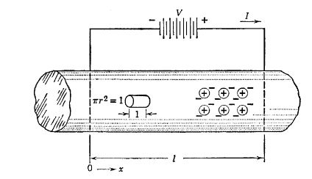
-e= charge on electron = 1.6×${10}^{−19}$ coulombe
E=$\frac{−V}{L}$= electron field (volte/meter)
v=drift velocity (meter/sec)
M=$v/E$ = mobility ($Meter^{2}$/volt sec)
n=no.of electrons/$Meter^{3}$
J= -nev = current density (amperes/$meter^{2}$)
σ=$ \frac {J}{E}$ = Mne = conductivity (mhos/meter)
I=J A = current (amperes)
I=σAE = $\frac{σAV}{L}$
I=GV where G=$ \frac {σA}{L}$= conductance (mhos)
V=RI , where R=$\frac{1}{G}$ = resistance (ohms)
R= \frac {ρ.L}{A}, where ρ= $\frac{1}{σ}$= resistivity
ρ= 1.72×${10}^{−6}$ ohm-cm for copper

3.1 Fig.2.1 conduction in a metel
move when a force is applied. Current is proportional to the number of electrons involved, their mobility or freedom of motion, and the magni- tude of the applied force. The mobility is defined as the drift velocity per unit of applied electric field. (See Fig. 2.1.)
The fluctuations of current due to thermal agitation of the charged particles can be heard as a hissing sound in the output of a high-gain audio amplifier or radio receiver. Asa result, such thermal fluctuations of current (or voltage) are called “noise.”
The drift velocity of the electrons in a metal represents an equilibrium condition analogous to the terminal velocity of a body falling in the gravitational field. In vacuum, the force of gravity produces constant acceleration; in air, a falling body attains a terminal velocity determined by the force of gravity and by friction forces, Similarly, in vacuum, the force on an electron due to an electric field produces constant acceleration since there are no restraining forces. In a metal, the moving electrons collide with the atoms and lose some of the kinetic energy gained from the electric field. The collisions increase the thermal energy of the atoms and thus produce the familiar heating effect due to an electric current. The drift velocity represents an equilibrium between the kinetic energy gained from the applied field and that lost in collisions.
Mobility corresponds roughly to the reciprocal of viscous friction in a mechanical system. The force on an electron is the product of the electronic charge e and the electric field strength FE. Thus, the force equals (e/M)v, whereas in mechanics the corresponding term is fdx/dt or fv, where f is the coefficient of viscous friction.

4 Conduction in a semiconductor
The elements called semiconductors have four valence electrons. Silicon or germanium are good examples. They are normally in crystal- line form with each valence electron shared by two atoms. As indicated in Fig. 2.2, the atoms are arranged along the diagonals and centers of cubes. Each bond in this crystal lattice consists of two valence electrons shared by two atoms. The planar diagram in Fig. 2.2 is convenient for visualization of valence bonds. In Fig. 2.3(a) each link represents a single valence electron shared by two atoms. The circles each represent the nucleus of a germanium atom plus the orbital electrons other than valence electrons. A particular valence electron may be assumed to spend half time with each of two atoms. On the average each atom sees eight half-time electrons, which satisfies the valence requirements for four electrons. Compared with the situation that exists in a metal, the valence electrons are relatively tightly bound.
At room temperatures (say 300°K), the thermal vibrations of the atoms shake loose a few electrons. The number depends upon the purity of the crystal and other factors as well as the temperature. In a pure material, such as germanium (ealled an intrinsic semiconductor), the number of valence electrons free of the atomic bonds at any given time is apt to be one in every 10° to one in 10? of the total number of valence electrons. These free electrons, except for the fact that they are less numerous, behave somewhat like the free electrons in a metal. They have a definite mobility, and under the influence of an applied field they produce a conduction current. The conductivity of an intrinsic semiconductor can be expected to be much less than that of a metal because of the small number of free electrons available.
import numpy as np
import matplotlib.pyplot as plt
from mpl_toolkits.mplot3d import Axes3D
def draw_sphere(ax, center, radius=0.1, color='gray'):
u = np.linspace(0, 2 * np.pi, 20)
v = np.linspace(0, np.pi, 10)
x = center[0] + radius * np.outer(np.cos(u), np.sin(v))
y = center[1] + radius * np.outer(np.sin(u), np.sin(v))
z = center[2] + radius * np.outer(np.ones_like(u), np.cos(v))
ax.plot_surface(x, y, z, color=color, edgecolor='k', alpha=0.8)
fig = plt.figure(figsize=(10, 10))
ax = fig.add_subplot(111, projection='3d')
ax.set_box_aspect([1,1,1])
# Top layer atoms (slab plane)
top_layer = np.array([[x, y, 3] for x in range(4) for y in range(4)])
for p in top_layer:
draw_sphere(ax, p, radius=0.15, color='lightgray')
# "Bond" stubs on each atom (visual effect)
for dx, dy in [(1,0),(0,1),(-1,0),(0,-1)]:
p2 = p + 0.3 * np.array([dx, dy, 0])
ax.plot([p[0], p2[0]], [p[1], p2[1]], [p[2], p2[2]], color='black')
# Lattice points for the lower diamond/covalent structure
lower = np.array([
[0, 0, 0], [1, 0, 1], [2, 0, 0], [3, 0, 1],
[0, 1, 1], [1, 1, 2], [2, 1, 1], [3, 1, 2],
[0, 2, 0], [1, 2, 1], [2, 2, 0], [3, 2, 1],
[1, 3, 1], [2, 3, 0], [3, 3, 1]
])
for p in lower:
draw_sphere(ax, p, radius=0.15, color='silver')
# Draw bonds in the lower structure
connections = [
(0, 1), (1, 2), (2, 3),
(0, 4), (1, 5), (2, 6), (3, 7),
(4, 5), (5, 6), (6, 7),
(4, 8), (5, 9), (6, 10), (7, 11),
(8, 9), (9, 10), (10, 11),
(9, 12), (10, 13), (11, 14)
]
for i, j in connections:
p1, p2 = lower[i], lower[j]
ax.plot([p1[0], p2[0]], [p1[1], p2[1]], [p1[2], p2[2]], color='black', lw=2)
# Dashed lines for the cube (optional, for clarity)
cube = np.array([[0, 0, 0], [3, 0, 0], [3, 3, 0], [0, 3, 0], [0, 0, 0]])
ax.plot(cube[:,0], cube[:,1], cube[:,2], color='k', linestyle='dashed')
ax.set_axis_off()
plt.show()
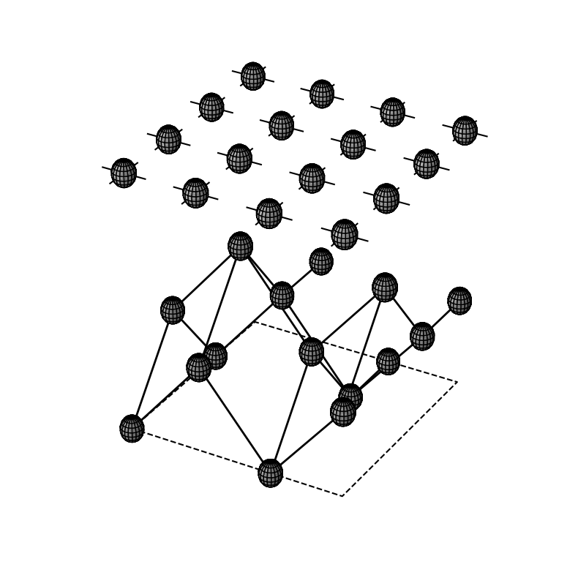
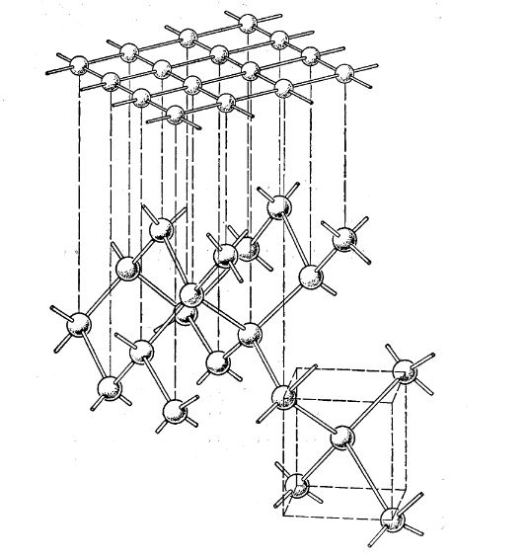

4.1 Fig. 2.2. Semiconductor crystal structure.
A free electron wandering through the semiconductor crystal is very likely to be recaptured by any other atom which happens to have a missing valence electron. In fact, when an electron is jarred loose from its atomic bond, it leaves a vacancy in the crystal structure. This vacancy in the crystal lattice is very aptly called a “hole.” The atom from which the electron has departed is effectively ionized (net positive
charge equal to +e), but since the total number of such ionized atoms equals the total number of free electrons, the material displays no
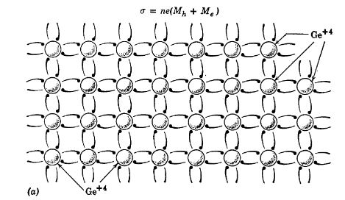
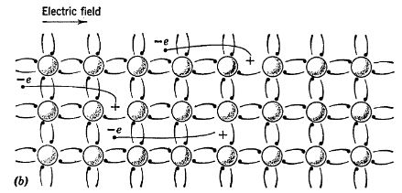
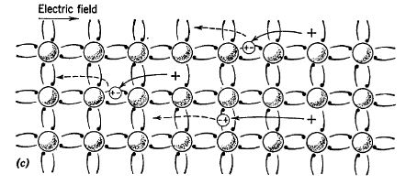

4.2 Fig. 2.3. Conduction in an intrinsic semiconductor.
charge in the macroscopic sense. Nevertheless, in the course of the endless thermal jostlings, the ionized atom seeks to acquire from a neighbor an electron to replace the missing one. Whenever such a transfer takes place, the electron vacancy or hole has effectively moved from one atom to another. Thus, the positive charge associated with an ionized atom may be transferred from one atom to another in the lattice. Since the atoms themselves do not migrate through the material, it is convenient to associate a positive charge with the hole.
Designating the hole as the equivalent of a positively charged particle provides a physical model that agrees quite well with experimental observations. Holes display a mobility differing from that of free electrons, but like electrons, they contribute a component to the conduc- tion current. In an intrinsic semiconductor, the number of holes and their total charge equal the number and total charge of the free electrons; hence, the fractions of the conduction current contributed by the elec- trons and by the holes are proportional to the mobilities in an intrinsic semiconductor. The sketches in Fig. 2.3(6) and (c) indicate the forma- tion, migration, and recombination of electrons and holes. An applied electric field E is assumed to be directed from left to right. Under the influence of the applied field, the electrons move to the left and the holes to the right. Since they are oppositely charged, the electron current and hole current add to produce the total conduction current.
The recapture of an electron by a vacancy in the crystal lattice amounts to the recombination of an electron with a hole. The breaking of a bond represents the creation of a free electron (— e) and a hole (+e). The normal life span of the free charges is of the order of a millisecond in germanium. This lifetime is sufficient to make semiconductors interesting and important materials.
From a practical standpoint the conductivity of an intrinsic semi- conductor like germanium is too low to be very useful. Therefore, in normal use controlled amounts of impurities are injected to provide additional conduction electrons (n-type) or additional holes (p-type).

5 2.5 n-Type and p-Type Semiconductors
Since free electrons and holes exist in equal numbers in an intrinsic semiconductor, the charge carriers added by an impurity cause either the holes or the electrons to predominate. Thus, in n-type semiconduc- tors, electrons are the majority carriers and holes are in the minority; in p-type the reverse is true.
The n-type material is produced by adding a carefully controlled minute quantity (e.g., one part in 10°) of a “donor” impurity such as arsenic to the intrinsic semiconductor. The arsenic atoms merely
replace occasional germanium atoms in the crystal lattice. As indicated in Fig. 2.4(a) they produce an excess of free electrons, since arsenic has five valence electrons. The number of free electrons “donated” by the
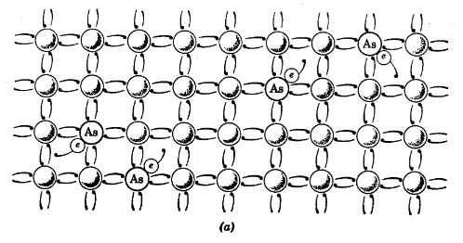
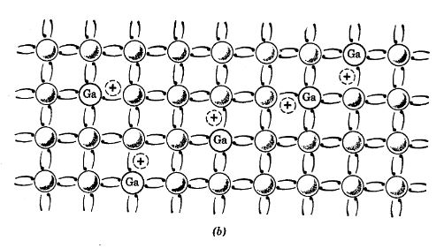

5.1 Fig. 2.4. Conduction in (a) n-type and (6) p-type semiconductors.
arsenic far exceeds the number of electron-hole pairs formed; hence, the conductivity due to the majority carrier (electrons in this case) far exceeds that of the intrinsic material.
The p-type semiconductor is formed by adding an “acceptor” impurity like gallium to an intrinsic semiconductor. The acceptor has only three valence electrons, and when it replaces the germanium in the crystal lattice, it leaves a hole as indicated in Fig. 2.4(b). Thus, the holes predominate and the conductivity increase is mainly due to this charge carrier which in actuality is a shortage of electrons.

6 2.6 Semiconductor Junction
Various methods are used to bring about the close proximity of p-type and n-type materials necessary to create a p-n junction. The so-called grown junction is actually a single crystal with a donor impurity on one side of the junction and an acceptor impurity on the other. The transi- tion occurs in a very small distance (of the order of 0.001 millimeters).
import matplotlib.pyplot as plt
from matplotlib import rcParams
import PySpice.Logging.Logging as Logging
logger = Logging.setup_logging()
from PySpice.Probe.Plot import plot
from PySpice.Spice.Netlist import Circuit
from PySpice.Unit import *
fig, axs = plt.subplots(1, 2, figsize=(10, 10))
circuit = Circuit('Transitional characteristic1')
circuit.model('BAV21','D' ,IS = .1@u_mA ,BV = 293.10@u_V, IBV = 0.001293@u_A , RS = 1@u_Ohm )
Vi = circuit.V('i', '1', circuit.gnd, 0@u_V)
circuit.R(1, '1', '2', 1@u_kOhm)
circuit.R(2, '3', '4', 10@u_Ohm)
circuit.D(1, '2','3', model = 'BAV21')
circuit.V(1, '4', circuit.gnd, 2@u_V)
circuit.D(2, '5', '2', model = 'BAV21')
circuit.V(2, circuit.gnd, '6', 2@u_V)
circuit.R(3, '5', '6', 10@u_Ohm)
simulator = circuit.simulator(temperature=25, nominal_temperature=25)
analysis = simulator.dc(Vi=slice(-5, 5, .1))
axs[0].plot(analysis['1'], analysis['2'],'black',linewidth=5)
axs[0].axhline(0, color='black', linewidth=1)
axs[0].axvline(0, color='black', linewidth=1)
axs[0].text(-2, 2.3, 'p-type', ha='center', va='center')
axs[0].text(2, 2.3, 'n-type', ha='center', va='center')
axs[0].text(-4.3, 2.3, '(a)', ha='center', va='center')
axs[0].plot([-4, 4], [2.5, 2.5], color='black', linestyle='-', label='Membership = 1')
axs[0].plot([-4, 4], [2.2, 2.2], color='black', linestyle='-', label='Membership = 1')
axs[0].plot([-4, -4], [2.19, 2.5], color='black', linestyle='-', label='Membership = 1')
axs[0].plot([4, 4], [2.19, 2.5], color='black', linestyle='-', label='Membership = 1')
axs[0].text(0.2, 2, 'φ', ha='center', va='center')
axs[0].text(-2, 0.1, '(b)', ha='center', va='center')
axs[0].text(5, 0.06, 'x', ha='center', va='center')
# **Subplot (1, 2): PNG Sample File**
img_sample = mpimg.imread('images/fig2-5.jpg') # Load the PNG file
axs[1].imshow(img_sample)
axs[1].axis('off') # Hide axes for image display
axs[1].set_title('Original')
Text(0.5, 1.0, 'Original')
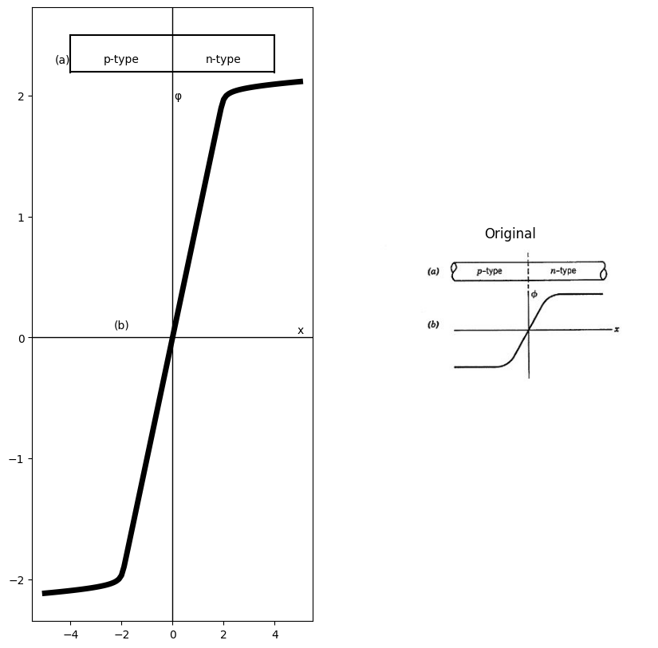

6.1 Fig. 2.5. Potential diagram of a semiconductor p-n junction.
The sketch in Fig. 2.5(a) shows a p-n junction. Each type of semi- conductor material is electrically neutral, but the p-type contains an excess of holes, and the n-type contains free electrons. Consequently, by thinking of the excess holes or electrons as a gas or cloud of particles free to move, it is natural to expect some holes to diffuse from the p-type to the n-type and some electrons to diffuse the other way.
The holes moving to the right represent positive charge and leave the left side of the junction slightly negative. Similarly, electrons diffusing to the left add negative charge there. The loss of electrons from the right half further raises the potential of the right side of the junction. Thus, the diffusion of both holes and electrons results in an additive effect illustrated by the potential diagram in Fig. 2.5(b). The potential difference developed across the junction by the diffusion of particles tends to oppose the diffusion. The higher the potential difference, the smaller the number of particles that have sufficient energy to migrate across the potential barrier. An equilibrium value is reached when the force due to the potential barrier equals the diffusion force. Now note what happens to the few hole-electron pairs formed by thermal agita- tion. If a pair is formed in the n-type material just to the right of the
junction, the potential difference provides a force of attraction for the hole; hence, it moves to the left. Similarly, for a pair formed on the left, the electron is pulled to the right. These directions of motion are oppo- site to those involved in the diffusion process. When equilibrium occurs, the net value of the electron migration and the net value of the hole migration are zero across the junction. The disappearance of holes and free electrons through recombination can be considered qualita- tively as a reduction in the number of pairs formed.
The value of the equilibrium potential difference for a germanium diode is a fraction of a volt. This is a measure of the energy required to move a hole from left to right or an electron from right to left.

7 2.7 Junction Diode
The form of the current-versus-voltage curve for a semiconductor junction diode can be deduced from the principles just discussed. Suppose the voltage source in Fig. 2.6 is adjustable over a suitable range of values of either polarity. The desired diode curve is obtained by measuring the value of current 7 for specific values of applied voltage v.
For positive values the source voltage opposes the p-n junction poten- tial. Lowering the potential barrier by this means permits more holes to migrate from left to right and more electrons from right to left. The additive effects of the hole and electron motions constitute the current 7. For small values of v the effective potential barrier is lowered only slightly; hence, only a few carriers get through. ‘These are the ones having maximum thermal energy. For larger values of the source voltage more carriers can overcome the junction potential. Since the statistical distribution of the energies of holes or electrons is exponential, * more and more charges migrate across the junction as the barrier is lowered and we may therefore expect current 7 to increase exponentially with an increase in the positive value of ».| The exponential relation should hold over a fair range of values of current and voltage. For large values of these variables the heating effect of the current will modify the behavior. Also, the ohmic resistance of the semiconductor material in the diode body (away from the junction) will modify the curve of tvs. v toward a more nearly linear resistive curve.
For slightly negative values of v the source effectively aids the junction potential in retarding diffusion of the majority carriers provided by the impurity content. However, this reverse voltage aids minority carriers
- At any particular temperature the number of particles that have a specific energy decreases exponentially with increasing values of energy.
- The constant Vo = kT/e is of the order of 0.025 volts for germanium at room temperature,
created by the formation of hole-electron pairs. For a pair created in the p-type material the electron migrates to the right. The particles that remain in the p-type or n-type material are the same as those provided by the impurities. The polarity of the applied potential pulls majority
import matplotlib.pyplot as plt
from matplotlib import rcParams
import matplotlib.image as mpimg
import numpy as np
from schemdraw import dsp
import schemdraw
import schemdraw.elements as e
import PySpice.Logging.Logging as Logging
logger = Logging.setup_logging()
from PySpice.Probe.Plot import plot
from PySpice.Spice.Netlist import Circuit
from PySpice.Unit import *
fig, axs = plt.subplots(3, 2, figsize=(15, 15))
d = schemdraw.Drawing()
d += ( T := dsp.Box(w=1.5, h=.5).anchor('W').fill('white').label('p'))
d += ( T := dsp.Box(w=1.5, h=.5).anchor('W').fill('white').label('n').at((1.5,0)))
l1 = d.add(e.Line().left().length(1).at((0,0)))
l2 = d.add(e.Line().up().length(2))
V = d.add(e.SourceV(l=3).right().label('$V$').reverse().length(5))
l3 = d.add(e.Line().down().length(2))
l2 = d.add(e.Line().left().length(1))
d.save('Drawings/2-6a.jpg') # Save the drawing to a PNG file
img = mpimg.imread('Drawings/2-6a.jpg')
axs[0,0].imshow(img)
axs[0,0].axis('off') # Hide axes for image display
axs[0,0].set_title('Circuit Diagram (developed)')
circuit = Circuit('Transitional characteristic1')
circuit.model('BAV21','D' ,IS = .1@u_mA ,BV = 293.10@u_V, IBV = 0.001293@u_A , RS = 1@u_Ohm )
Vi = circuit.V('i', '1', circuit.gnd, 0@u_V)
circuit.R(1, '1', '2', 1@u_kOhm)
circuit.R(2, '3', '4', 10@u_Ohm)
circuit.D(1, '2','3', model = 'BAV21')
circuit.V(1, '4', circuit.gnd, 2@u_V)
circuit.D(2, '5', '2', model = 'BAV21')
circuit.V(2, circuit.gnd, '6', 2@u_V)
circuit.R(3, '5', '6', 10@u_Ohm)
simulator = circuit.simulator(temperature=25, nominal_temperature=25)
analysis = simulator.dc(Vi=slice(-5, 5, .1))
axs[0,1].plot(analysis['1'], analysis['2'],'black',linewidth=5)
axs[0,1].axhline(0, color='black', linewidth=1)
axs[0,1].axvline(0, color='black', linewidth=1)
circuit = Circuit('Transitional characteristic1')
circuit.model('BAV21','D' ,IS = 1@u_mA ,BV = 293.10@u_V, IBV = 0.001293@u_A , RS = 100@u_Ohm )
Vi = circuit.V('i', '1', circuit.gnd, 0@u_V)
circuit.R(1, '1', '2', 8@u_kOhm)
circuit.R(2, '3', '4', 1@u_kOhm)
circuit.D(1, '2','3', model = 'BAV21')
circuit.V(1, '4', circuit.gnd, 4@u_V)
circuit.D(2, '5', '2', model = 'BAV21')
circuit.V(2, circuit.gnd, '6', 4@u_V)
circuit.R(3, '5', '6', 1@u_Ohm)
simulator = circuit.simulator(temperature=25, nominal_temperature=25)
analysis = simulator.dc(Vi=slice(-5, 5, .1))
axs[0,1].plot(analysis['1'], analysis['2'],'black',linewidth=5,linestyle='--')
axs[0,1].axhline(0, color='black', linewidth=1)
axs[0,1].axvline(0, color='black', linewidth=1)
circuit = Circuit('Transitional characteristic1')
circuit.model('BAV21','D' ,IS = 1@u_mA ,BV = 293.10@u_V, IBV = 0.001293@u_A , RS = 100@u_Ohm )
Vi = circuit.V('i', '1', circuit.gnd, 0@u_V)
circuit.R(1, '1', '2', 8@u_kOhm)
circuit.R(2, '3', '4', 1@u_Ohm)
circuit.D(1, '2','3', model = 'BAV21')
circuit.V(1, '4', circuit.gnd, 1.5@u_V)
circuit.D(2, '5', '2', model = 'BAV21')
circuit.V(2, circuit.gnd, '6', 1.5@u_V)
circuit.R(3, '5', '6', 1@u_Ohm)
simulator = circuit.simulator(temperature=25, nominal_temperature=25)
analysis = simulator.dc(Vi=slice(-5, 5, .1))
axs[0,1].plot(analysis['1'], analysis['2'],'black',linewidth=5,linestyle='--')
axs[0,1].axhline(0, color='black', linewidth=1)
axs[0,1].axvline(0, color='black', linewidth=1)
axs[0,1].text(4, 1, 'forward bias', ha='center', va='center')
axs[0,1].text(4, 2.5, 'Zero bias', ha='center', va='center')
axs[0,1].text(4, 3.2, 'Reverse bias', ha='center', va='center')
d = schemdraw.Drawing()
D2 = d.add(e.Diode(fill=True).right().label(['+' , '$V$' , '-'], ofst=.8 , fontsize = 16))
ss1 = d.add(e.Source().right().at(D2.start))
d += e.lines.CurrentLabelInline().at(D2).right().label('$i$').color('black')
d.save('Drawings/2-6b.jpg') # Save the drawing to a PNG file
img = mpimg.imread('Drawings/2-6b.jpg')
axs[1,0].imshow(img)
axs[1,0].axis('off') # Hide axes for image display
axs[1,0].set_title('Circuit Diagram (developed)')
circuit = Circuit('v-i curve')
circuit.model('BAV21','D' ,IS = 100@u_uA , N = 1.906 ,BV = 110@u_V, IBV = 0.0001@u_V, VJ = 20@u_V ,CJO = 7.048E-13 ,RS = 20@u_Ohm ,TT = 3.48E-9)
Vi = circuit.V('i', '1', circuit.gnd, 0@u_V)
circuit.R(1, '2', '3', 1@u_Ohm)
circuit.D(1,'2' ,'1', model = 'BAV21')
circuit.V(1, circuit.gnd,'3', 1@u_V)
circuit.R(2, '1', '4', 1@u_Ohm)
circuit.D(2,'4',circuit.gnd , model = 'BAV21')
circuit.I(1, circuit.gnd,'4', 200@u_uA)
circuit.V(2,'6', circuit.gnd, 2@u_V)
circuit.R(3, '5', '6', 1@u_Ohm)
circuit.D(3,'1','5' , model = 'BAV21')
simulator = circuit.simulator(temperature=25, nominal_temperature=25)
analysis = simulator.dc(Vi=slice(-2,8, 0.1))
axs[1,1].plot(analysis['1'], u_mA(-analysis.Vi),'black',linewidth=2,linestyle='-')
axs[1,1].set_xlim(-4, 4)
axs[1,1].set_ylim(-4, 4)
axs[1,1].set_xlabel('V [V]')
axs[1,1].set_ylabel('I [mA]')
axs[1,1].text(.1, -0.2, '$-Io$', ha='center', va='center', fontsize=12)
axs[1,1].text(-1, 0.2, '$-Vz$', ha='center', va='center', fontsize=12)
axs[1,1].axhline(0, color='black', linewidth=1 )
axs[1,1].axvline(0, color='black', linewidth=1)
# **Subplot (1, 2): PNG Sample File**
img_sample = mpimg.imread('images/fig2-6a.jpg') # Load the PNG file
axs[2,0].imshow(img_sample)
axs[2,0].axis('off') # Hide axes for image display
axs[2,0].set_title('Original')
# **Subplot (1, 2): PNG Sample File**
img_sample = mpimg.imread('images/fig2-6b.jpg') # Load the PNG file
axs[2,1].imshow(img_sample)
axs[2,1].axis('off') # Hide axes for image display
axs[2,1].set_title('Original')
Text(0.5, 1.0, 'Original')
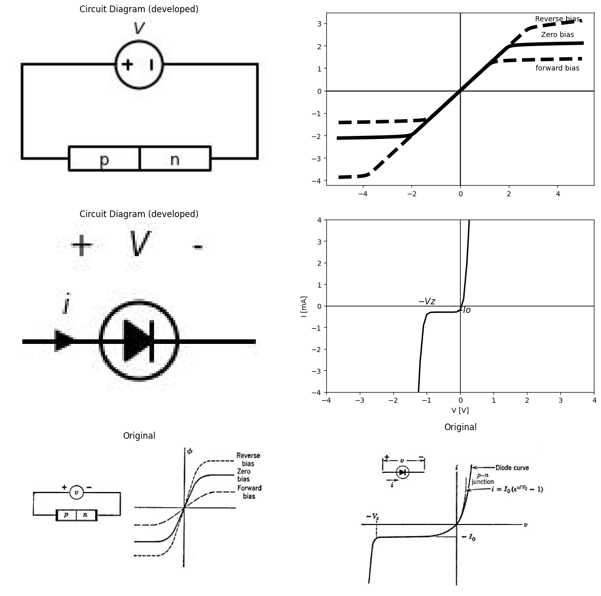

7.1 Fig. 2.6. Current versus voltage curve for a p-n junction diode.
carriers away from the junction and tends to prevent their diffusing across the junction. Thus, the current carried across the junction de- pends entirely on the thermally-created pairs of carriers and not on the applied voltage. After the voltage is a few tenths of a volt negative, the current approaches a small constant value (—Jo). The magnitude of Jo is likely to be only a few microamperes and increases with temperature, but for a fixed temperature the current is virtually independent of voltage from a few tenths of a volt negative to a few volts or a few tens of volts negative,
As the voltage is made more negative, the electric field acting on the charged particles increases correspondingly. For some value of v, say —Vz, a large increase in current occurs. This increase results from the fact that the high value of electric field accelerates the minority carriers proportionately more. The kinetic energy thus acquired by the holes or electrons can be imparted to atoms in the crystal lattice by collision. Increasing the energy of an atom in this fashion may cause it to break an electron bond and thus free another hole-electron pair. At the voltage —Vz, this process, which is called the avalanche effect, becomes cumula- tive, and a very large change in current occurs for very little increase in negative voltage. The breakdown voltage — Vz, is an important param- eter in many applications of junction diodes.
import matplotlib.pyplot as plt
from matplotlib import rcParams
import matplotlib.image as mpimg
import numpy as np
from schemdraw import dsp
import schemdraw
import schemdraw.elements as e
import PySpice.Logging.Logging as Logging
logger = Logging.setup_logging()
from PySpice.Probe.Plot import plot
from PySpice.Spice.Netlist import Circuit
from PySpice.Unit import *
fig, axs = plt.subplots(2, 2, figsize=(15, 15))
img_sample = mpimg.imread('images/fig2-7a.jpg') # Load the PNG file
axs[0,0].imshow(img_sample)
axs[0,0].axis('off') # Hide axes for image display
axs[0,0].set_title('Original')
d = schemdraw.Drawing()
D2 = d.add(e.Diode(fill=True).right().label(['+' , '$V$' , '-'], ofst=.8 , fontsize = 16))
ss1 = d.add(e.Source().right().at(D2.start))
d += e.lines.CurrentLabelInline().at(D2).right().label('$i$').color('black')
d.save('Drawings/2-7-b.jpg') # Save the drawing to a PNG file
img = mpimg.imread('Drawings/2-7-b.jpg')
axs[0,1].imshow(img)
axs[0,1].axis('off') # Hide axes for image display
axs[0,1].set_title('Circuit Diagram (developed)')
circuit = Circuit('v-i curve')
circuit.model('BAV21','D' ,IS = 300@u_uA , N = 1.906 ,BV = 8100@u_V, IBV = 0.0001@u_V, VJ = 20@u_V ,CJO = 7.048E-13 ,RS = 150@u_Ohm ,TT = 3.48E-9)
Vi = circuit.V('i', '1', circuit.gnd, 0@u_V)
circuit.R(1, '1', '2', 0@u_Ohm)
circuit.D(1, '2',circuit.gnd , model = 'BAV21')
simulator = circuit.simulator(temperature=25, nominal_temperature=25)
analysis = simulator.dc(Vi=slice(-1,8, 0.1))
axs[1,0].plot(analysis['1'], u_mA(-analysis.Vi),'black',linewidth=2)
axs[1,0].set_xlim(-2, 4)
axs[1,0].set_ylim(-2, 2)
axs[1,0].set_xlabel('V [V]')
axs[1,0].set_ylabel('I [mA]')
axs[1,0].axhline(0, color='black', linewidth=1 )
axs[1,0].axvline(0, color='black', linewidth=1)
img_sample = mpimg.imread('images/fig2-7.jpg') # Load the PNG file
axs[1,1].imshow(img_sample)
axs[1,1].axis('off') # Hide axes for image display
axs[1,1].set_title('Original')
Text(0.5, 1.0, 'Original')
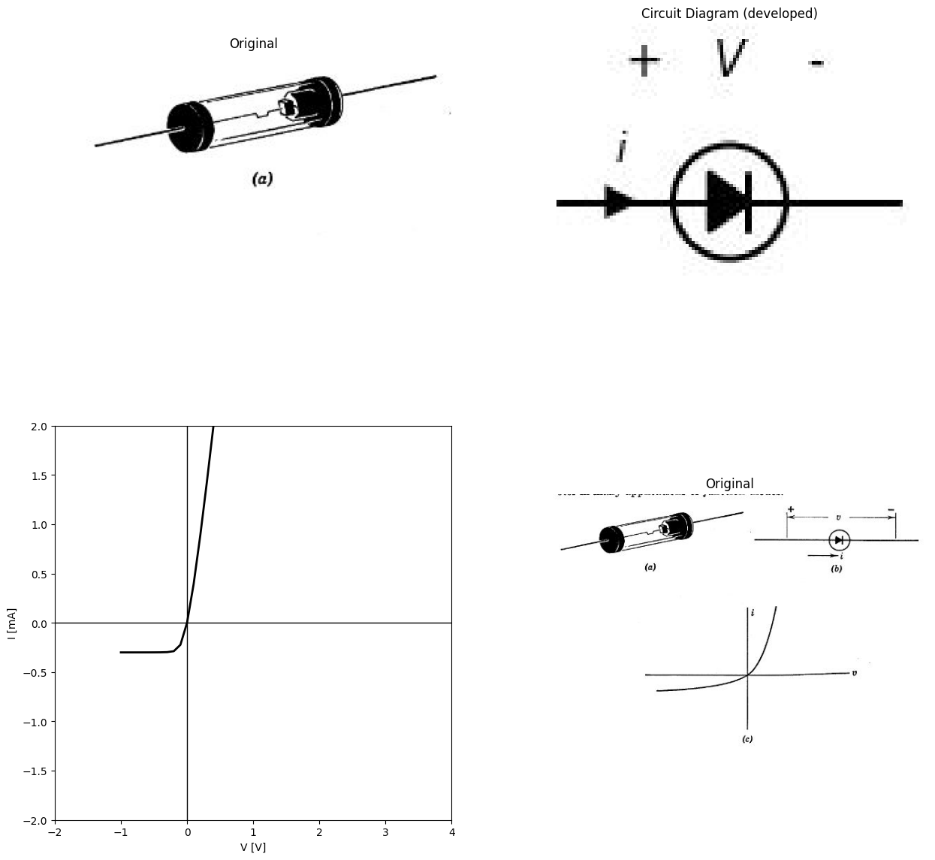

7.2 Fig. 2.7. Point-contact diode. (a) Sketch; (6) Symbol; (c) 7 vs. v curve.

8 2.8 Point-Contact Diode
The point-contact rectifier consists of a semiconductor on which the tip of a fine wire rests as shown in Fig. 2.7(a). The curve of current versus voltage shown in Fig. 2.7(c) is qualitatively similar to that of the junction diode. However, for a given positive voltage, the point- contact conducts less current than the junction diode. Also, for a given reverse voltage the point-contact conducts somewhat more current. Furthermore, as negative voltage increases, the reverse current tends to
increase rather than remaining nearly constant. The sharp break in the junction diode curve at —Vz does not occur in point-contact diodes, since heating of the sharp point occurs at much lower voltages and causes a gradual increase in the conductance in the negative direction.
import matplotlib.pyplot as plt
from matplotlib import rcParams
import matplotlib.image as mpimg
import numpy as np
from schemdraw import dsp
import schemdraw
import schemdraw.elements as e
import PySpice.Logging.Logging as Logging
logger = Logging.setup_logging()
from PySpice.Probe.Plot import plot
from PySpice.Spice.Netlist import Circuit
from PySpice.Unit import *
fig, axs = plt.subplots(1, 3, figsize=(15, 15))
img_sample = mpimg.imread('images/fig2-8a.jpg') # Load the PNG file
axs[0].imshow(img_sample)
axs[0].axis('off') # Hide axes for image display
axs[0].set_title('Original')
v = np.linspace(-3, 3, 400)
i_neg = 0.4 * (v[v < 0] + 1.5)**3 + 0.2 # Dashed, negative-voltage part (nonlinear cubic)
axs[1].axhline(0, color='black', lw=1)
axs[1].axvline(0, color='black', lw=1)
axs[1].plot(v[v < 0], i_neg, 'k-') # Dashed segment
img_sample = mpimg.imread('images/fig2-8b.jpg') # Load the PNG file
axs[2].imshow(img_sample)
axs[2].axis('off') # Hide axes for image display
axs[2].set_title('Original')
Text(0.5, 1.0, 'Original')
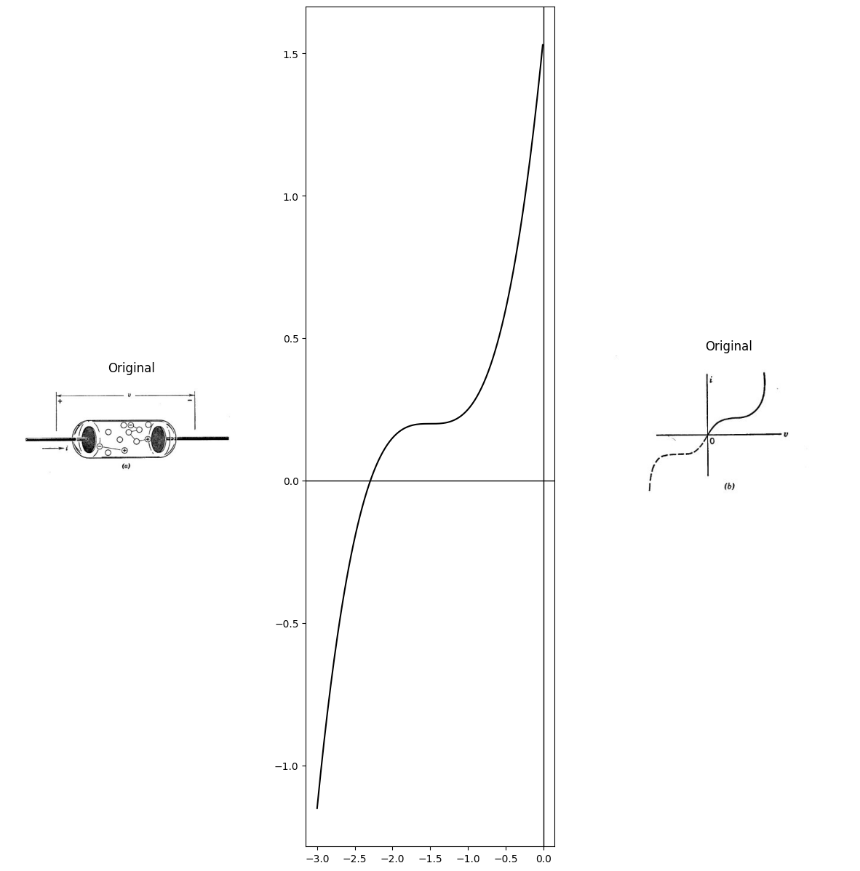

8.1 Fig. 2.8. Properties of a gas discharge. (a) Gas-filled diode; (b) Current versus voltage curve.

9 2.9 Conduction in Gases
Whereas in metals the atoms are so closely packed that the orbits of valence electrons overlap, the atoms in a gas can usually be considered as isolated particles. When pressures and temperatures begin to approach those for which the gas becomes a liquid, this simplifying assumption no longer applies. However, gas diodes contain gas or vapor atrelatively low pressures for which the assumption applies fairly well.
The sketch shown in Fig. 2.8 illustrates a simple electron tube. Assume the sealed glass tube contains a gas at low pressure. For example, let the gas be one of the inert elements, such as argon or neon. The elec- tric field, —v/d, owing to an applied voltage v, should have no particular effect on the gas, since the atoms are electrically neutral. The atoms move in random fashion because they have thermal energy. As they move about, the atoms occasionally collide with each other. Some of these collisions may cause one or both of the colliding atoms to ionize; that is, one or more valence electrons receives sufficient energy from the collision to escape from the atom. ‘Thus, ionization results in the creation of one or more free electrons and a positively charged ion.
In the absence of an applied field, the free electrons and ions move about in the gas and eventually recombine. The total number of charged carriers in the tube will depend on the gas temperature, the pressure, and the amount of high-energy radiation present. Cosmic rays or gamma rays passing through the tube may leave a trail of ionized atoms and free electrons. With a voltage » applied to the electrodes, the electrons tend to move toward the positive electrode. Since the mass of the ion is many times greater than that of the electron, the force imparts a high acceleration to the electron but a relatively small one to the ion.
The electron accelerates until it collides with an atom or ion (or the left electrode). The probability that the electron will cause an ionizing collision depends mainly on the pressure. If the pressure is extremely low, there are few atoms in the tube, and the chances of hitting any of them are small. Nevertheless, for a given applied voltage the electron accelerates freely for a longer time (on the average) ; hence, if a hit occurs the probability of ionization is high. If the pressure is too great, the electron collides with atoms so frequently that the probability of ionizing one is negligibly small. Since the electron is so light compared with an atom, it is deflected in random manner by each collision. Thus, the acceleration due to the applied field is lost at each collision (on the average). Between extremes of pressure a value exists for which the probability of ionization by collision is a maximum.
Now let us consider the form of the current versus voltage curve likely to be obtained for a simple tube similar to the one shown in Fig. 2.8. The rate of formation and of recombination of the free charges in the tube establishes the equilibrium number present. For voltage equal to zero the current is zero. As voltage is increased from zero, some elec- trons are accelerated through the tube and a small current is observed. A further increase of voltage begins to provide sufficient electron energy to ionize a few atoms. This increases the number of free charges present and permits a somewhat greater number of electrons to cross the tube. Average velocity also increases. The current is the product of the number of electrons, the electronic charge, and the velocity. Thus, the current should increase more rapidly than linearly with increasing volt- age, because both the number and the velocity of electrons increase with the applied voltage. A continued increase of the applied voltage increases the kinetic energy of the free electrons. A certain minimum of energy must always be inparted to a bound electron to free it and ionize the atom. However, with sufficient energy available, the ejected electron may have sufficient energy to ionize another atom by collision without first gaining energy from the applied field. Under these conditions the process is regenera- tive, and the result is glow discharge (a form of electrical arc). The available current increases tremendously with no increase in voltage. In fact, once the discharge has been started the voltage drop across the tube diminishes below the value required to initiate the discharge.
From the symmetry of the electrodes in the gas-filled tube sketched in Fig. 2.8(a), it is obvious that reversal of the polarity of » will result in a similar curve with the direction of current reversed. Thus, although this tube has a highly nonlinear 7 vs. v curve, the curve is bidirectional.

10 2.10 Electron Emission from Metals
The large numbers of free electrons in a metal give the metal its high conductivity. Although free to migrate within the metal, these electrons are restrained from leaving the metal by the potential barrier known _as the work function. For most metals the work function has a value of a
few electron volts. An electron volt is 1.6 X 10$​^{\left(−19\right)}$ joules. The electronic charge is 1.6 X ${10}^{−}19$ coulombs, hence the work function W in electron volts corresponds numerically to the voltage v. The several methods for supplying the necessary energy for electron emission con- stitute an important aspect of electronic-device behavior. For emission to take place, it is always necessary to supply the difference between the required escape energy (work function) and the energy already possessed by the electron. .
Figure 2.9(a) shows the binding force holding an electron to a metal as a function of the distance from the surface. The surface is assumed to be at 2 = 0 with the metal to the left and free space to the right of the origin. When the electron is at point A, it is embedded in the metal and (on the average) feels no net force. At point B the metallic atoms are all to the left of the electron in question; hence, there is a net binding force tending to hold the electron to the metal. Right at the surface, the force on the electron is due primarily to positive charges on atoms nearest the electron. In going outward from B to C, the force inereases somewhat. Although the increased distance diminishes the force due to immediately adjacent charges, the influence of positive charges over a greater part of the surface tends to increase the total force. The distances from A to B and B to C are small multiples of atomic dimensions.
import matplotlib.pyplot as plt
from matplotlib import rcParams
import matplotlib.image as mpimg
import numpy as np
from schemdraw import dsp
import schemdraw
import schemdraw.elements as e
import PySpice.Logging.Logging as Logging
logger = Logging.setup_logging()
from PySpice.Probe.Plot import plot
from PySpice.Spice.Netlist import Circuit
from PySpice.Unit import *
fig, axs = plt.subplots(1, 4, figsize=(15, 15))
x=[-0.133627986,0.075380228,0.32639296,0.507367423,0.702497085,0.91122865,1.105897232,1.272439845,1.438890243,1.563336122,1.659656033,1.769854496,
1.977018384,2.115342814,2.379219718,2.573703867,2.768280232,3.018831883,3.436848311,3.72940448,4.078120369,4.413049922,4.776105443,5.292931622]
Energy=[-0.055613008,0.087829426,0.209139951,0.375037051,0.495056548,0.707799522,0.943319918,1.22439516,1.528570582,1.854877912,2.226740088,2.622025201,
3.227471232,3.577201499,3.976036939,4.257757695,4.516378271,4.753189695,5.040074563,5.254754079,5.401424083,5.50157097,5.556163012,5.591205201]
# Plot
axs[0].plot(x,Energy,
markerfacecolor='b',color='black', markersize=2)
axs[0].text(4, 4, 'total energy \n\n required for \n\n electron escope', ha='center', va='center')
#axs[0].title('Number of iterations carried out by the RSIN algorithm ', fontsize=14)
axs[0].axhline(0, color='black')
axs[0].axvline(0, color='black')
x=[-0.897911425,-0.694329465,-0.559113167,-0.424370316,-0.312352893,-0.223155588,-0.088791494,-0.011051592,0.089034981,0.177853529,0.267145524,
0.345264183,0.42366691,0.524795065,0.649216784,0.785474664,0.899575251,1.025511998,1.117739361,1.186862538,1.302762222,1.453128804,1.603211319,
1.798460623,2.062454346,2.302491681,2.679070963,3.066255445,3.543962882,3.930484539,4.21464708]
force=[-1.023185348,-0.82534787,-0.589760932,-0.256959662,0.07546285,0.426949472,0.837522207,1.208262316,1.657152648,2.086410735,2.418454491,
2.711423135,2.94606318,3.181081983,3.299822345,3.321537754,3.226217208,3.03387171,2.76318661,2.569894219,2.105159213,1.563220879,1.079611143,
0.65508752,0.115042971,-0.172623074,-0.496902308,-0.665449233,-0.754709665,-0.787156526,-0.801864928]
# Plot
axs[1].plot(x,force,
markerfacecolor='b',color='black', markersize=2)
axs[1].text(-.5, -.2, 'A', ha='center', va='center')
axs[1].text(-.1, 1.2, 'B', ha='center', va='center')
axs[1].text(.5, 3.3, 'C', ha='center', va='center')
axs[1].axhline(0, color='black')
axs[1].axvline(0, color='black')
img_sample = mpimg.imread('images/fig2-9a.jpg') # Load the PNG file
axs[2].imshow(img_sample)
axs[2].axis('off') # Hide axes for image display
axs[2].set_title('Original')
img_sample = mpimg.imread('images/fig2-9b.jpg') # Load the PNG file
axs[3].imshow(img_sample)
axs[3].axis('off') # Hide axes for image display
axs[3].set_title('Original')
Text(0.5, 1.0, 'Original')
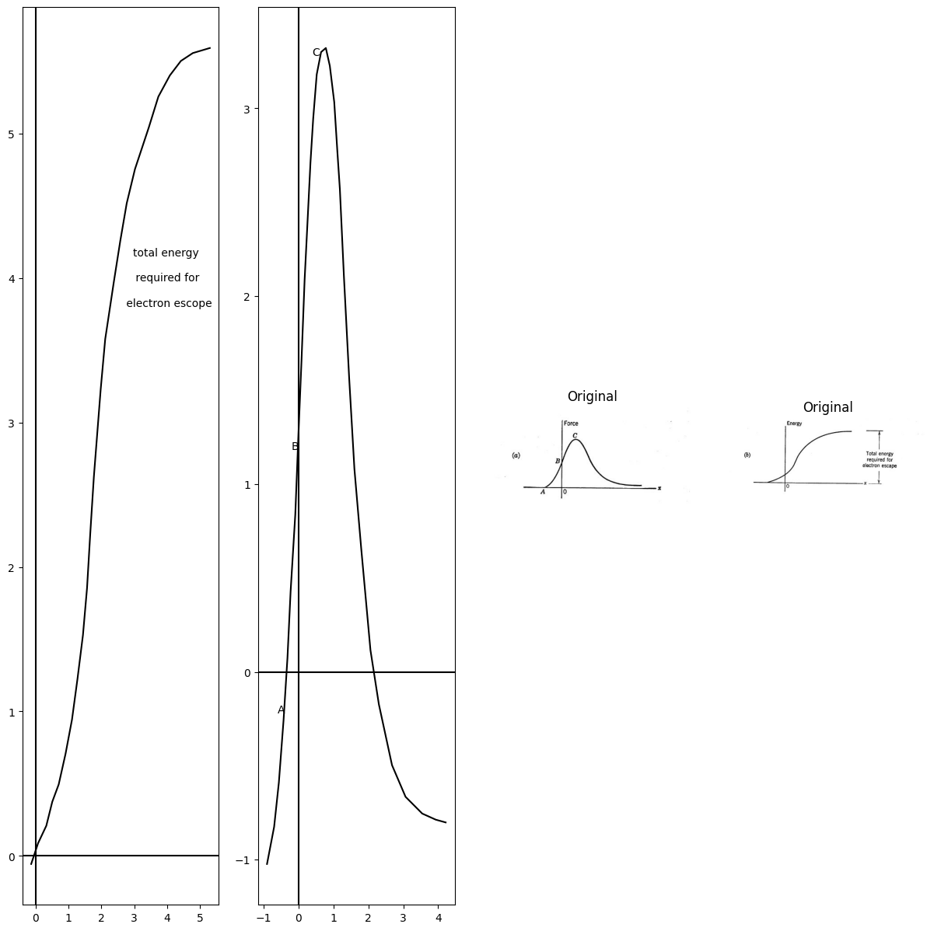

10.1 Fig. 2.9. Force and energy involved in electron emission.
The sketch of Fig. 2.9(a) shows the applied force required to hold an electron in equilibrium at any value of z. The total energy required to remove an electron from the metal is therefore the area under the curve. The integral of the force curve is sketched in Fig, 2.9(). More precisely, the work function is defined as the difference of two energies (W, — Wo) where W, is the kinetic energy associated with the x component of electron motion (normal to the surface). The energy Wo is the maximum value of energy (associated with the z component of electron motion) at a temperature of 0°K.

11 2.11 Field Emission
Since free electrons are bound to a metal by electrical forces, let us consider electrical force as a means of releasing them from the metal. Emission of electrons as a result of an electrical force is called field emission, since the force on an electron is the product of charge and elec- tric field intensity. The field intensity required is of the order of ${10}^{10}$ volts per meter. In order to obtain such large field intensities with nominal voltages between electrodes, special geometry is required. As an example, consider the cylindrical electrode structure shown in Fig. 2.10(a). With a voltage applied between the two cylinders, the electric field intensity is given by the expression in Fig. 2.10(b). Since there is circular symmetry, the lines of force are radial and the intensity varies inversely with r for 7; $r_{1}<r<r_{2}$. This expression applies only if
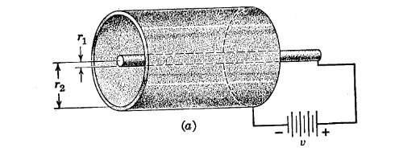
(b) $E_{r}=\frac{v}{rln\frac{r_{2}}{r_{1}}}for*r_{1}<r<r_{2}$

11.1 Fig. 2.10. Field emission from a cold cathode.
the space between the electrode is evacuated or contains no charged particles. For v = 100 volts, r1 = 0.01 cm and r2 = 1 cm, r2/r1 = 100, In r2/r1 = 4.6, and the maximum field intensity (which occurs for r = r1) is approximately 2 X 10° volts per meter. This value is still far from that required for field emission. The inclusion of a fine, sharp-pointed wire or annular dise extending radially inward from the outer cylinder (cathode) can bring the field intensity up high enough for field emission. The so-called cold-cathode, gas-discharge voltage regulators use such an electrode structure. The high field intensity at the sharp point or edge causes electrons to be emitted to initiate the glow discharge. When the interelectrode space is filled with ionized atoms and free electrons, the field is radically modified, and the simple expression for electric field intensity no longer applies.

12 2.12 Thermionic Emission
The type of electron source most commonly used in vacuum tubes or gas-filled tubes is the heated cathode. The temperature of the emitting material is raised until a suitable number of the free electrons have thermal energies comparable to or exceeding the work function. Under these conditions an electron leaves the cathode with a kinetic energy that depends on the amount by which its thermal energy exceeds the work function. Most of the electrons emerge from the hot cathode with a velocity corresponding to energies from zero to a few electron volts. Electrons are thus released whether or not an external field is applied. This means of releasing electrons is called thermionic emission.
The cathode may be a filament of tungsten or thoriated tungsten wire heated to a temperature of 1500°K or more by passing an electric current through it. Indirectly heated cathodes are more efficient in terms of thermionic current available per watt of heating power. This type of cathode consists of a filament or heater surrounded by a small cylindrical sleeve of nickel or similar metal. The outer surface of the sleeve is coated with a material like barium oxide, strontium oxide, calcium oxide, or a mixture of oxides, which are better emitters than tungsten or thori- ated tungsten because they have lower work functions.
The efficiency of various cathode materials is a critical function of the detailed processing of the material. As a result, considerable variations occur even with the same type of material. The following empirical equation gives the form of the temperature dependence of thermionic current density.
J = $AT^{2}$ .$e^{b}/T$ amperes/unit area (2.1) In this equation b is the work function in temperature units,* $T$ is temperature in degrees Kelvin, and A is an empirical constant. The thermionic emission equation indicates that a saturation value of emis- sion current exists for a specific value of cathode temperature.

13 2.13 Temperature-Limited Emission in a Vacuum Diode
The effect of temperature-limited emission on the behavior of a vacuum diode is illustrated by Fig. 2.11 where (a) shows the complete symbol} for a vacuum diode, and (6) shows the i vs. v curves for various values of 7. These are established by adjusting the voltage E applied to the heater. The currents J,, Z2, and J3 are the product of cathode area and the corresponding current densities given by Eq. 2.1. Normal
- $b=eφ/k$, where e is electronic charge (1.6 × ${10}^{−}19$ coulombs), ¢ is voltage equivalent of work function, and k is Boltzmann’s constant (1.38 × ${10}^{−}23$ joules per degree Kelvin).
t+ The more commonly used symbol (Fig. 2.11(c)] shows only the anode and cathode. The heater and its power source are usually omitted, since it is assumed that the heater will be operated at rated voltage. The term diode is obviously & misnomer unless the heater and cathode are considered as a single electrode.
diode operation does not include temperature-limited operation, since other design ratings, such as anode power dissipation, are usually exceeded long before saturation is reached.
import matplotlib.pyplot as plt
from matplotlib import rcParams
import matplotlib.image as mpimg
import numpy as np
from schemdraw import dsp
import schemdraw
import schemdraw.elements as e
import PySpice.Logging.Logging as Logging
logger = Logging.setup_logging()
from PySpice.Probe.Plot import plot
from PySpice.Spice.Netlist import Circuit
from PySpice.Unit import *
fig, axs = plt.subplots(2, 2, figsize=(15, 15))
d = schemdraw.Drawing()
ss1 = d.add(e.Source().up().length(1))
l1 = d.add(e.Line().right().length(.5).at((-.25,.7)))
l2 = d.add(e.Line().right().length(.5).at((-.25,.3)))
l3 = d.add(e.Line().down().length(.1))
l4 = d.add(e.Line().down().length(2).at(l2.start).dot(open=True))
l5 = d.add(e.Line().up().length(2).at((-.05,.7)).dot(open=True))
l6 = d.add(e.Line().right().length(1).at((-2,2.8)))
l7 = d.add(e.Line().right().length(1).at((-2,-1.6)))
d += e.Arrow().down().at((-1.8, -.7)).length(0.95).color('black').label('-', ofst=-0.5 )
d += e.Arrow().up().at((-1.8, 1.8)).length(0.95).label('$v$', 'right', ofst=-1.6).color('black').label('+', ofst=-0.5 )
d += e.Arrow().down().at((0.5, 3)).length(0.75).label('$i$', 'top', ofst=-0.5).color('black')
l8 = d.add(e.Line().right().length(.005).at((-.03,.20)).color('black'))
l9 = d.add(e.Line().right().length(.005).at((.11,.008)).color('black'))
l10 = d.add(e.Line().right().length(.005).at((-.11,.008)).color('black'))
l11 = d.add(e.Line().right().length(.005).endpoints(l10.end,l8.end).color('black'))
l12 = d.add(e.Line().right().length(.005).endpoints(l8.end,l9.end).color('black'))
l13 = d.add(e.Line().down().length(1.3).at(l10.end))
l14 = d.add(e.Line().down().length(.5).at(l9.end))
l15 = d.add(e.Line().right().length(2))
l16 = d.add(e.Line().down().length(.7))
d += e.Battery().left().label('$E$','bottom' ).length(2.1).reverse()
d.save('Drawings/2-11a.jpg') # Save the drawing to a PNG file
img = mpimg.imread('Drawings/2-11a.jpg')
axs[0,0].imshow(img)
axs[0,0].axis('off') # Hide axes for image display
axs[0,0].set_title('Circuit Diagram (developed)')
circuit = Circuit('Transitional characteristic1')
circuit.model('BAV21','D' ,IS = .1@u_mA ,BV = 293.10@u_V, IBV = 0.001293@u_A , RS = 1@u_Ohm )
Vi = circuit.V('i', '1', circuit.gnd, 0@u_V)
circuit.R(1, '1', '2', 1@u_kOhm)
circuit.R(2, '3', '4', 10@u_Ohm)
circuit.D(1, '2','3', model = 'BAV21')
circuit.V(1, '4', circuit.gnd, 2@u_V)
circuit.D(2, '5', '2', model = 'BAV21')
circuit.V(2, circuit.gnd, '6', 2@u_V)
circuit.R(3, '5', '6', 10@u_Ohm)
simulator = circuit.simulator(temperature=25, nominal_temperature=25)
analysis = simulator.dc(Vi=slice(0, 5, .1))
axs[0,1].plot(analysis['1'], analysis['2'],'black',linewidth=5)
axs[0,1].axhline(0, color='black', linewidth=1)
axs[0,1].axvline(0, color='black', linewidth=1)
circuit = Circuit('Transitional characteristic1')
circuit.model('BAV21','D' ,IS = 1@u_mA ,BV = 293.10@u_V, IBV = 0.001293@u_A , RS = 100@u_Ohm )
Vi = circuit.V('i', '1', circuit.gnd, 0@u_V)
circuit.R(1, '1', '2', 8@u_kOhm)
circuit.R(2, '3', '4', 1@u_kOhm)
circuit.D(1, '2','3', model = 'BAV21')
circuit.V(1, '4', circuit.gnd, 4@u_V)
circuit.D(2, '5', '2', model = 'BAV21')
circuit.V(2, circuit.gnd, '6', 4@u_V)
circuit.R(3, '5', '6', 1@u_Ohm)
simulator = circuit.simulator(temperature=25, nominal_temperature=25)
analysis = simulator.dc(Vi=slice(0, 5, .1))
axs[0,1].plot(analysis['1'], analysis['2'],'black',linewidth=5,linestyle='-')
axs[0,1].axhline(0, color='black', linewidth=1)
axs[0,1].axvline(0, color='black', linewidth=1)
circuit = Circuit('Transitional characteristic1')
circuit.model('BAV21','D' ,IS = 1@u_mA ,BV = 293.10@u_V, IBV = 0.001293@u_A , RS = 100@u_Ohm )
Vi = circuit.V('i', '1', circuit.gnd, 0@u_V)
circuit.R(1, '1', '2', 8@u_kOhm)
circuit.R(2, '3', '4', 1@u_Ohm)
circuit.D(1, '2','3', model = 'BAV21')
circuit.V(1, '4', circuit.gnd, 1.5@u_V)
circuit.D(2, '5', '2', model = 'BAV21')
circuit.V(2, circuit.gnd, '6', 1.5@u_V)
circuit.R(3, '5', '6', 1@u_Ohm)
simulator = circuit.simulator(temperature=25, nominal_temperature=25)
analysis = simulator.dc(Vi=slice(0, 5, .1))
axs[0,1].plot(analysis['1'], analysis['2'],'black',linewidth=5,linestyle='-')
axs[0,1].axhline(0, color='black', linewidth=1)
axs[0,1].axvline(0, color='black', linewidth=1)
axs[0,1].text(4, 1.5, 'T1', ha='center', va='center')
axs[0,1].text(4, 2.3, 'T2', ha='center', va='center')
axs[0,1].text(4, 3.2, 'T3', ha='center', va='center')
d = schemdraw.Drawing()
ss1 = d.add(e.Source().up().length(1))
l1 = d.add(e.Line().right().length(.5).at((-.25,.7)))
l2 = d.add(e.Line().right().length(.5).at((-.25,.3)))
l3 = d.add(e.Line().down().length(.1))
l4 = d.add(e.Line().down().length(2).at(l2.start).dot(open=True))
l5 = d.add(e.Line().up().length(2).at((-.05,.7)).dot(open=True))
l6 = d.add(e.Line().right().length(1).at((-2,2.8)))
l7 = d.add(e.Line().right().length(1).at((-2,-1.6)))
d += e.Arrow().down().at((-1.8, -.7)).length(0.95).color('black').label('-', ofst=-0.5 )
d += e.Arrow().up().at((-1.8, 1.8)).length(0.95).label('$v$', 'right', ofst=-1.6).color('black').label('+', ofst=-0.5 )
d += e.Arrow().down().at((0.5, 3)).length(0.75).label('$i$', 'top', ofst=-0.5).color('black')
d.save('Drawings/2-11b.jpg') # Save the drawing to a PNG file
img = mpimg.imread('Drawings/2-11b.jpg')
axs[1,0].imshow(img)
axs[1,0].axis('off') # Hide axes for image display
axs[1,0].set_title('Circuit Diagram (developed)')
img_sample = mpimg.imread('images/fig2-11.jpg') # Load the PNG file
axs[1,1].imshow(img_sample)
axs[1,1].axis('off') # Hide axes for image display
axs[1,1].set_title('Original')
Text(0.5, 1.0, 'Original')
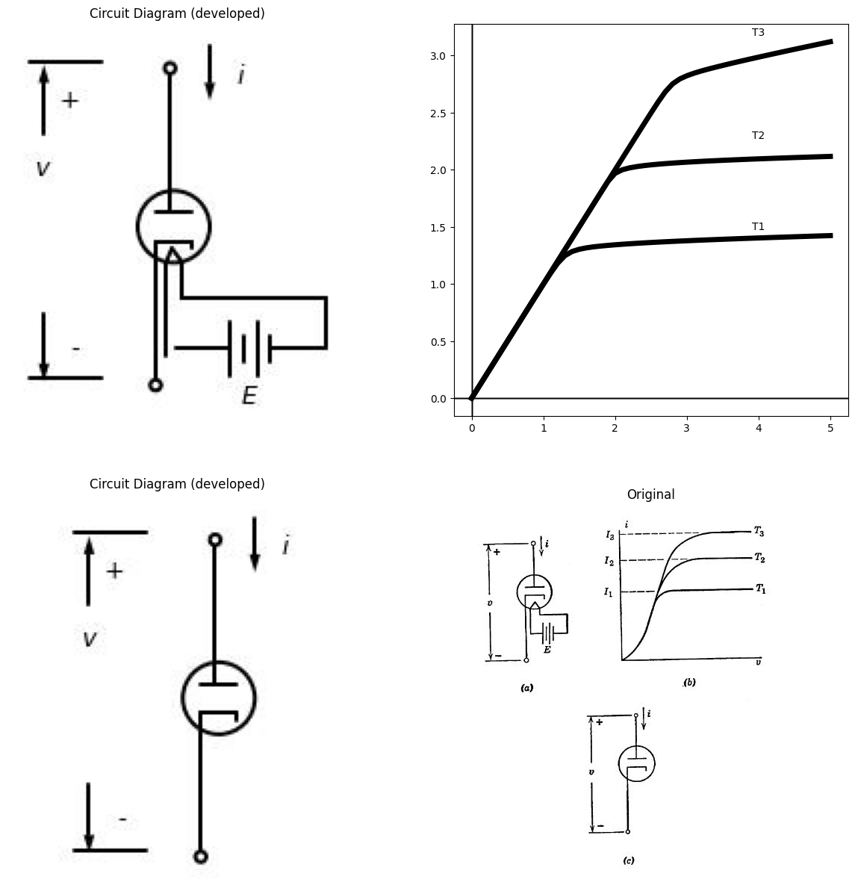

13.1 Fig. 2.11. Temperature-limited emission in a vacuum diode.
A vacuum diode designed to operate in the saturation region may be considered as a control valve with heater temperature as the control parameter. Since thermal time constants are large, the response to changes in 7 (effected by adjusting heater power source E) for such a device is too sluggish to compete with other available control valves, such as triodes or transistors.

14 2.14 Vacuum Diode
The electrode structure of a typical vacuum diode is shown in Fig. 2.12. With the cathode cold, the electrodes constitute a small capaci-
tance (a few micromicrofarads). The capacitive properties of the diode need be considered only for high-frequency operation. With the cathode heated, the diode is primarily a nonlinear conductance even for anode currents considerably less than the saturation value. This nonlinearity is the result of a cloud of electrons (called space charge) that accumu- lates near the cathode. The presence of this cloud of negative charges depresses the po- tential near the cathode to the same value as the cathode potential or even slightly below. The potential near the cathode depends to a great extent on initial velocities of electrons. For example, suppose both the cathode and the anode are connected to the same potential (say, zero). If we postulate an ideal cathode,
- namely one that brings all electrons just to the energy required to leave the cathode, electrons will emerge with zero energy or zero velocity, hence none will actually leave. The potential will then remain zero throughout the interelec- trode space. If this ideal cathode is heated further, all electrons will emerge with a finite initial velocity and some will reach the anode. However, the presence of electrons between the diode. and tends to retard electrons. From the region of negative potential, some electrons will be accelerated toward the anode while others will be returned toward the cathode.
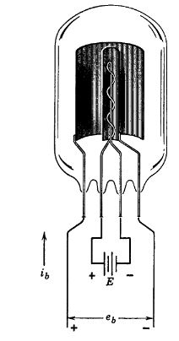

14.1 Fig. 2.12. Typical vacume diode
An actual cathode produces a distribution of initial velocities, since the electrons in the metal have an exponential distribution of energies. Again the space charge will depress the potential below cathode po- tential, but a small anode current will exist even with anode voltage zero. If we make the anode voltage negative with respect to cathode, this small current will decrease exponentially with the negative volt- age. This small exponential tail in the negative-voltage region can usually be neglected, so that for most engineering purposes we can as- sume the anode current to be zero for zero anode voltage.
As the anode voltage is raised to positive values the potential minimum is raised slightly. Thus more electrons tend to reach the anode and fewer electrons remain in the space-charge cloud.
import matplotlib.pyplot as plt
from matplotlib import rcParams
import matplotlib.image as mpimg
import numpy as np
from schemdraw import dsp
import schemdraw
import schemdraw.elements as e
import PySpice.Logging.Logging as Logging
logger = Logging.setup_logging()
from PySpice.Probe.Plot import plot
from PySpice.Spice.Netlist import Circuit
from PySpice.Unit import *
fig, axs = plt.subplots(3, 2, figsize=(15, 15))
d = schemdraw.Drawing()
E1 = d.add( e.Battery().left().label('$e_b$','bottom' ).length(3))
l1 = d.add(e.Line().up().length(2).label('$x=0$', 'top', ofst=.5))
l2 = d.add(e.Line().up().length(2).at(E1.start).label('$x=x_b$', 'top', ofst=-1.5))
l3 = d.add(e.Line().up().length(1))
l4 = d.add(e.Line().right().length(.001).at((1.5,3.3)))
l5 = d.add(e.Line().right().length(.001).at((1.5,2.3)))
l6 = d.add(e.Line().right().length(1).endpoints(l3.end,l4.end).label('$Anode$', 'top', ofst=.5))
l7 = d.add(e.Line().down().length(.001).endpoints(l2.end,l5.end))
l8 = d.add(e.Line().down().length(.001).endpoints(l6.end,l7.end))
l9 = d.add(e.Line().up().length(1).at(l1.end))
l10 = d.add(e.Line().right().length(.001).at((-1.5,3.3)))
l11 = d.add(e.Line().right().length(.001).at((-1.5,2.3)))
l12 = d.add(e.Line().right().length(1).endpoints(l9.end,l10.end))
l13 = d.add(e.Line().down().length(.001).endpoints(l1.end,l11.end).label('$Cathode$', 'top', ofst=1.5))
l14 = d.add(e.Line().down().length(.001).endpoints(l12.end,l13.end))
d.save('Drawings/2-13.jpg') # Save the drawing to a PNG file
img = mpimg.imread('Drawings/2-13.jpg')
axs[0,0].imshow(img)
axs[0,0].axis('off') # Hide axes for image display
axs[0,0].set_title('Circuit Diagram (developed)')
I = np.linspace(0, 10, 100)
R1 = 1
R2 = 2
Rs = R1+R2
V1 = R1 * I
V2 = R2 * I
Vs = Rs * I
axs[0,1].plot(I, V1, color='black', linestyle='--')
axs[0,1].annotate('', xy=(10, R1 * 10), xytext=(10, 0),
arrowprops=dict(arrowstyle='->', color='black', lw=1.5))
axs[0,1].text(10, -0.2, '$x_b$', ha='center', va='center', fontsize=12)
axs[0,1].text(10, 10.2, '$e_b$', ha='center', va='center', fontsize=12)
axs[0,1].axhline(0, color='black', linewidth=2)
axs[0,1].axvline(0, color='black', linewidth=2)
x=[-1.831844179,-1.57675081,-1.183292372,-0.789144865,-0.296001103,0.198061419,0.594046443,1.38739463,1.984128442,2.402898684,2.7219836,3.082504536,
3.38316834,3.725497852,3.967452971,4.25061442,4.594322071,4.838114707,5.042308841,5.306360107,5.51124331,5.653513104]
force=[-0.73847532,-0.974045065,-1.234742862,-1.425844684,-1.618324643,-1.718009969,-1.723522521,-1.595355674,-1.3252406,-1.029446218,-0.801869674,
-0.389255116,-0.022210993,0.553069803,0.990536785,1.589843122,2.304315869,2.92737212,3.550979627,4.220157567,4.913361049,5.282610194]
# Plot
axs[1,0].plot(x,force,
markerfacecolor='b',color='black', markersize=2)
axs[1,0].text(-1.8, 5.3, 'φ', ha='center', va='center')
axs[1,0].text(-1.95, -.8, '0', ha='center', va='center')
axs[1,0].text(5.7, 5.8, 'eb', ha='center', va='center')
axs[1,0].text(5.7, -.3, 'xb', ha='center', va='center')
axs[1,0].plot([-1.8, -1.8], [-1.3, 5],'black', linewidth=2,linestyle='-')
axs[1,0].plot([5.7, 5.7], [0, 5.7],'black', linewidth=2,linestyle='-')
axs[1,0].annotate('', xy=(-1.8, 4), xytext=(-1, 4), arrowprops=dict(arrowstyle='->'))
axs[1,0].annotate('', xy=(-1, 2), xytext=(-1.8, 2), arrowprops=dict(arrowstyle='->'))
axs[1,0].annotate('', xy=(1.5, 3), xytext=(.5, 3), arrowprops=dict(arrowstyle='->'))
axs[1,0].text(1, 2.7, 'jb=ρV', ha='center', va='center')
axs[1,0].text(-1, 1.7, '$j_0=ρ+V$', ha='center', va='center')
axs[1,0].text(-1, 3.7, '$j_0-J_b=ρ-V$', ha='center', va='center')
axs[1,0].axhline(0, color='black')
axs[1,0].axvline(0, color='black', linestyle='--')
x=[-0.432104115,0.018755513,0.596431501,0.940050448,1.22958481,1.502328964,1.811439006,2.26717321,2.597251667,2.948066418,3.135002553,3.269014717,
3.330991473,5.269680135,6.239024466]
force=[0.340051995,0.528187431,0.822441621,1.055067238,1.266840501,1.586589499,1.948971697,2.589630306,3.231913774,4.13254979,4.819787685,
5.593916838,6.347425759,6.322356509,6.309821885]
# Plot
axs[1,1].plot(x,force,
markerfacecolor='b',color='black', markersize=2, linewidth=2)
x1=[-2.621640024,-2.118552792,-1.651599325,-1.022856347,-0.465452407,0.290571177,0.88573374,1.285062132,1.865291469,2.267405333,2.725692886,
3.022887297,3.230327602,3.323331425,3.649463797,3.9748998,4.407576484,5.054038161,6.203122824]
force1=[0.411468408,0.448066418,0.463579951,0.498553102,0.577552189,0.761741539,1.012666161,1.416985191,1.948275328,2.611179028,3.488873586,
4.411754693,5.335796413,5.636317915,5.9122731,6.123582117,6.290400953,6.303593259,6.31028613]
# Plot
axs[1,1].plot(x1,force1,
markerfacecolor='b',color='black', markersize=2,linestyle='--')
axs[1,1].text(5, 2, 'saturation region', ha='center', va='center')
axs[1,1].text(1.5,5, 'Space-charge\n Limited region', ha='center', va='center')
axs[1,1].text(-1.5,5, 'Cutt off\n region', ha='center', va='center')
axs[1,1].plot([3.3, 3.3], [0, 5.5],'black', linewidth=2,linestyle='--')
axs[1,1].axhline(0, color='black')
axs[1,1].axvline(0, color='black', linestyle='-')
img = mpimg.imread('images/fig2-13a.jpg')
axs[2,0].imshow(img)
axs[2,0].axis('off') # Hide axes for image display
axs[2,0].set_title('Circuit Diagram (developed)')
img_sample = mpimg.imread('images/fig2-13b.jpg') # Load the PNG file
axs[2,1].imshow(img_sample)
axs[2,1].axis('off') # Hide axes for image display
axs[2,1].set_title('Original')
Text(0.5, 1.0, 'Original')
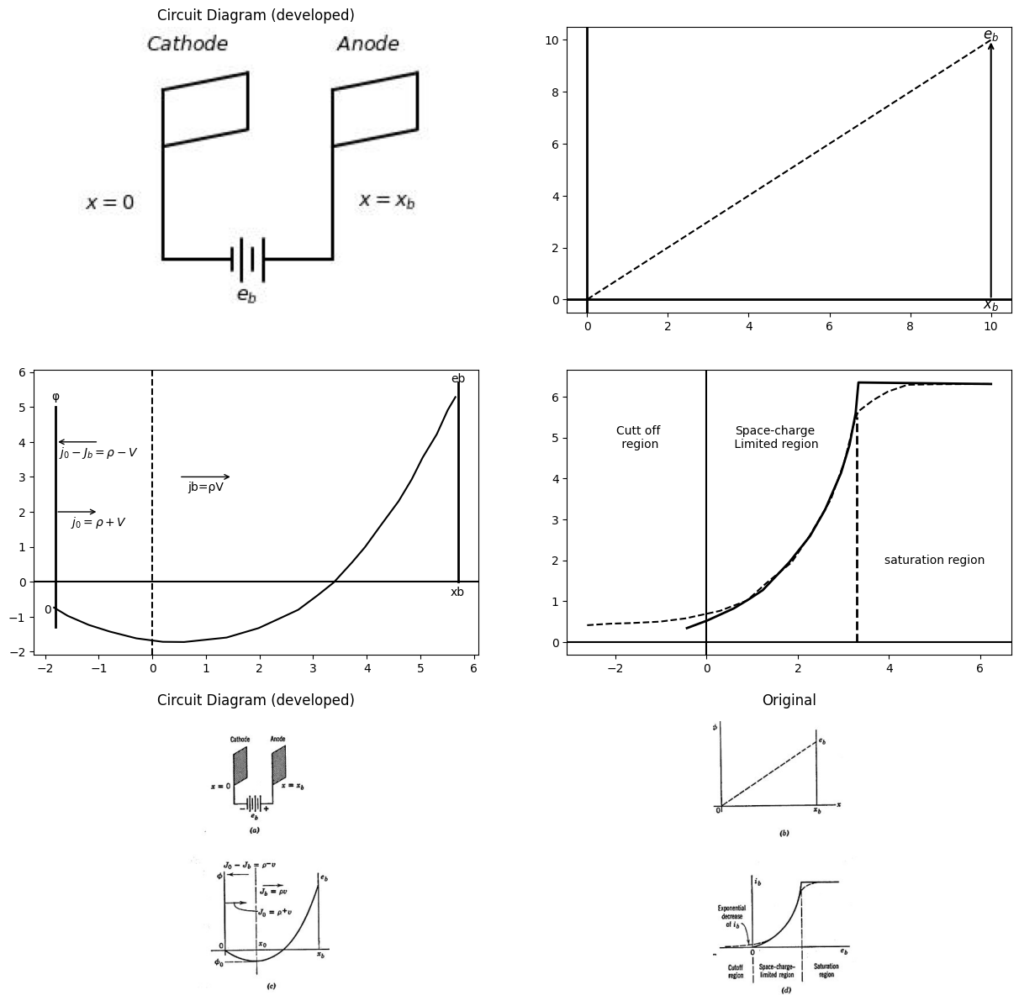

14.2 Fig. 2.13. Parallel-plane diode.

15 2.15 The Parallel-Plane Diode
In normal operation the current versus voltage curve for a vacuum diode is quite closely approximated by an expression of the form $i_{b}$ = $Ke_{b}^{3}/2$. The quantity K, called the perveance, depends upon electrode geometry, but the functional relation between e and 2, may be shown to be independent of geometry. Thus, the $i_{b}$ vs. $e_{b}$, relation for current limited by space charge in a vacuum tube is usually called the three- halves power law.
A quantitative derivation of the behavior of a vacuum diode is simpli- fied by choosing a parallel-plane electrode structure.” As indicated by Fig. 2.13(a), we shall consider the conduction per unit area between parallel plates of infinite extent. This implies no fringing of fields; that is, no variations except as a function of z. For a given anode voltage $e_{b}$, the potential distribution between electrodes is therefore linear in the absence of electrons (cold cathode) and the electric field intensity (slope of the potential curve) is a constant. We shall also assume that for any given temperature, the cathode emits electrons at a constant rate in a direction normal to the cathode plane and that all electrons have the same initial kinetic energy.
With the cathode emitting copious quantities of electrons, the poten- tial distribution between the cathode (x = 0) and the anode (x = x) takes on the form shown in Fig. 2.13(c). The electron cloud depresses the curve below the straight line that exists under cold-cathode condi- tions. Assuming the general form of the curve to be reasonable, we shall calculate the mathematical expression for the curve from electron behav- ior in the interelectrode space.
Electrons leave the cathode with an initial velocity vp. Assuming each electron acts independently, we can neglect the loss of energy by collision with other electrons. A change in kinetic energy must therefore appear as a change in the potential energy e¢, where ¢ is the electronic charge and φ is the electric potential. Thus, at any distance x from the cathode:
$e_{φ}=\frac{m}{2}\left(v^{2}−V_{o}^{2}\right)$ $\left(2.2\right)$
where m is electron mass and » is velocity. The initial kinetic energy
$eφ_{0}=\frac{mv_{0}^{2}}{2}$ $\left(2.3\right)$
so that Eq. 2.2 can be expressed as follows:
$\frac{mv^{2}}{2}=e\left(φ+φ_{0}\right)$ $\left(2.4\right)$
Differentiating Eq. 2.2 or 2.4 with respect to x and remembering that $v=dx/dt$ yields:
$e\frac{d_{φ}}{d_{x}}=mv\frac{d_{v}}{d_{x}}=m\frac{d_{v}}{d_{t}}$ $\left(2.5\right)$
The first term is the force acting on the electron (product of charge and electric field). The last term is the product of mass and accelera- tion.
As an electron leaves the cathode, it encounters a retarding electric field. If the depth of the potential minimum is just equal to ¢o, as shown in Fig. 2.13(c), the electron comes to rest at 2. This is a point of un- stable equilibrium, and the electron either falls back to the cathode or begins the longer fall to the anode. (Remember that electrons “fall” up a potential hill because of the negative charge.) Our problem is to calculate the fractional number of emitted electrons that reach the anode.
The total electron current passing through unit area of any plane for which x is constant is measured by the charge crossing the plane in unit time. To the right of zo the current density J, is pv, where p is the local space-charge density per unit volume. Both pandv vary with z, but continuity of current demands that their product be independent of z when the flow is in equilibrium.
To the left of xo, current can be considered to consist of two com- ponents, as indicated by Fig. 2.13(c). The emission current density Jo is ptv, and the returned current density $\left(Jo—Jb\right)$ is pv». Equation 2.4 shows that for a given z, the velocities are the same for electrons traveling in either direction. This is physically reasonable, since the acceleration from 2%» back to the cathode is due to the same potential curve as the deceleration from cathode to zp. Thus, the total space- charge density at any point on the left of zo is related to the current densities by the equation:
$2\left(Jo—Jb\right)=\left(ρ^{+}+ρ^{−}\right).v$ $\left(2.6\right)$
The relation between the potential curve and the space charge that generates it is provided by Poisson’s equation, which in one dimension reduces to:
$\frac{d_{φ}^{2}}{d_{x}^{2}}$= $−\frac{ρ}{e_{o}}$ $\left(2.7\right)$
since both ¢ and p are independent of y and z. In this equation, p is the total space-charge density at any point, and $e_{o}$ is the permittivity of free space. Relation $J_{b}=pv$ (independent of x) together with Eqs. 2.4 and 2.7, after elimination of p and v, yields
$\frac{d_{φ}^{2}}{d_{x}^{2}}=\frac{J_{b}}{e_{o}}.\sqrt{\frac{m}{2e}}{\left(φ−φ_{o}\right)}^{−}\frac{1}{2}$ $\left(2.8\right)$
Solution of this equation subject to the boundary conditions:
$φ=−φo,\frac{d_{φ}}{d_{x}}=0$ at $x=x_{o}$
$φ=e_{b}$ at $x=x_b $ $\left(2.9\right)$
yields the result:
$J_{b}=A\frac{{\left(e_{b}+φ_{o}\right)}^{3}/2}{{\left(x_{b}−x_{o}\right)}^{2}}$ $\left(2.10\right)$
where
$A= \frac {4e_o}{9}\sqrt {\frac {2e}{m}}=2.34×10^-6 in MKS units $ $\left(2.11\right)$
A= = V 2e/m = 2.34 x 10-* in MKS units (2.11) The result given by Eq. 2.10, which applies to the right of zo, shows a three-halves power dependence on voltage and an inverse square de- pendence on distance. This is consistent with the dimensions of Eq. 2.8. In fact, by dimensional analysis it can be shown that a three-halves power law holds for any electrode geometry as we shall see in Art. 2.16. For the region to the left of 29, the same method is used. The total space charge $\left(ρ^{+}+ρ^{−}\right)$ is used in Poisson’s equation together with the boundary condition $φ=0atx=0$. The conditions φ = —φo and dφ/dx = 0 at x = xo also apply. The latter insure continuity of poten- tial and electric field at 2. Using these factors to modify Eq. 2.10 yields the following result:
$2J_{o}−J_{b}=A\frac{φo^{3}/2}{x_{o}^{2}}$ $\left(2.12\right)$
Equations 2.10 and 2.12 frame the problem. Given emission current Jo and emission energy φo, plate voltage e, and electrode spacing xb, find current density Jb, and the position of the minimum $ x_o$. Practical considerations lead to a few simplifying assumptions, At normal operating temperatures ¢ for an oxide coated cathode is usually a few electron volts. The plate voltage required to saturate a typical diode may be several hundred volts. At saturation $J_{b},=J_{o}$; hence, Eqs. 2.10 and 2.12 become
$ J_o=A \frac {(e_b +φ_o)^3/2}{(x_b - x_o)^2}=A \frac{φ_o^3/2}{x_o^2}$ $\left(2.13\right)$
Since eb>>φo it follows that $x_{o}<<x_{b}$. For example, if eb = 100φo, then xo is approximately xb,/30. When eb; is slightly negative, Jb = 0; hence, Eq. 2.12 yields:
$2J_o=A \frac{φ_o^3/2}{x_o^2} $ $\left(2.14\right)$
Comparison with Eq. 2.13 shows that x9 is roughly one-third smaller at cutoff (Jb = 0) than at saturation (Jb = Jo). If the maximum value of xo is xb/30, then ${\left(x_{b},—x_{o}\right)}^{2}$ varies only about two per cent over the entire range of operation from cutoff to saturation. Ignoring this small variation in $x_{o}$, the space-charge-limited diode law becomes:
$i_{b}=k{\left(e_{b}+φ_{o}\right)}^{3}/2,fore_{b}≥0$ $\left(2.15\right)$
where K and $φ_{o}$ are constants. The curve is sketched in Fig. 2.13(d). This relation, called the Child—Langmuir law or three-halves power law, agrees closely with experimental tube curves over a wide range of positive voltages. Empirically determined values of $φ_{o}$ run from less than a volt to a few volts. Considered as an empirical constant,$φ_{o}$ accounts for contact-potential difference as well as initial velocities.
Actually, because of the exponential distribution of emission velocities, the plate current does not cut off abruptly as shown in Fig. 2.13(d). Instead, 2, remains slightly positive and decreases exponentially as e, is made negative; hence, the cutoff region should more realistically be called the exponential region.
An experimental curve also shows a gradual transition from space- charge limit to saturation limit as indicated by the dotted line in Fig. 2.13(d). This is due to the distribution of initial velocity, and to non- uniformities in the cathode temperature, the cathode potential, and the interelectrode spacing.

16 2.16 Generalized Three-Halves Power Law
The parallel-plane electrode structure considered in the previous article is not as common in vacuum diodes as is the concentric cylinder structure. Anodes with rectangular or elliptical cross sections are also used with cylindrical cathodes. Nevertheless, except for the value of the constant multiplier, the three-halves power law applies for any electrode geometry. For concentric cylinders the law may be derived with but slightly more difficulty than for the parallel-plane case. For other geome- tries the derivation is analytically very difficult, if not impossible. The assumptions that are helpful in demonstrating plausibility of the three- halves power law for a diode with arbitrary electrode cross sections are no more restrictive than those made for the parallel-plane structure. ..
Two physical effects govern the behavior of the charged particles moving in an electric field, once the potential distribution and the current have reached equilibrium. These are as follows:
(a) Charge distribution determines the potential. This means that if the position of all charges in space is known, the potential at any point. can be calculated by superposition of the potential due to each charge.
(b) Potential distribution determines charge motion. This means. that if the potential is known everywhere, the motion of charges can be calculated, assuming zero velocity at the point of origin. This effect. may be expressed as $φ_{e}=\frac{1}{2}mv^{2}$, where φ is potential, $φ$ is electronic charge, m is electron mass, and v is electron vélocity:
Now consider a diode with arbitrary electrode structure. For conven- ience, take the cathode potential as reference and let it be zero. Let a voltage eb, be applied to the anode relative to the cathode and allow current to reach an equilibrium value. In accordance with (b), velocity
is proportional to the square root of potential (v ~ \sqrt{φ}) at any point in the interelectrode space. In accordance with (a), doubling charge den- sity $ρ$ everywhere doubles φ everywhere (φ ~ ρ). Under equilibrium conditions there must be continuity of current across any equipotential surface. In particular, the anode is an equipotential surface, and the anode current must be proportional to the charge density (p) times the velocity (v) at the anode. Since $ρv φ\sqrt{φ}$, we have $i_{b} e^{3}/2$. The generality of this result is of considerable importance, since it establishes the idealized behavior of any vacuum diode* over a fairly wide range of current and voltage values, namely from the cutoff or exponential region to the saturation region. Thus, the three-halves power law unifies the interpretation of measured vacuum tube curves.

17 2.17. Gas-Filled Thermionic Diode
The discussion of conduction in a gas indicated that a discharge could be established between two electrodes as shown in Fig. 2.8. A few stray electrons, producing ionization by collision, initiate a discharge that can sustain itself. If one of the electrodes is a hot cathode, the large number of thermionic electrons thus made available will modify the properties of the discharge tube. With parallel-plane electrodes (both cold) the curve of current versus voltage is symmetrical for positive or negative v and z. With a hot cathode, a preferred direction of conduction exists, and the discharge tube becomes a rectifier somewhat analogous to the vacuum diode. Gas-filled diodes usually contain one of the inert gases, such as argon or neon. The gas pressure within the tube is made low compared with atmospheric pressure in order to make the breakdown voltage low. Sometimes a drop of liquid mercury is included. In this case the mercury vapor provides the atoms which are to be ionized.
Suppose electrons are emitted from the cathode and attracted toward the anode of a parallel-plane structure by a positive value of eb. As the electrons accelerate, they ionize gas molecules by collision, releasing additional electrons and positive ions. ‘The electrons, having high mobility, are swept rapidly toward the anode. The positive ions, being
- It can also be extended to multi-electrode tubes.
much larger and heavier, tend to move slowly toward the cathode. As indicated by Fig. 2.14, the presence of positive ions in the interelectrode space tends to raise the potential curve.
import matplotlib.pyplot as plt
from matplotlib import rcParams
import matplotlib.image as mpimg
import numpy as np
from schemdraw import dsp
import schemdraw
import schemdraw.elements as e
import PySpice.Logging.Logging as Logging
logger = Logging.setup_logging()
from PySpice.Probe.Plot import plot
from PySpice.Spice.Netlist import Circuit
from PySpice.Unit import *
fig, axs = plt.subplots(2, 3, figsize=(15, 15))
d = schemdraw.Drawing()
ss1 = d.add(e.Source().up().length(1))
l1 = d.add(e.Line().right().length(.5).at((-.25,.7)))
l2 = d.add(e.Line().right().length(.5).at((-.25,.3)))
l3 = d.add(e.Line().down().length(.1))
l4 = d.add(e.Line().down().length(2).at(l2.start))
l5 = d.add(e.Line().up().length(2).at((-.05,.7)))
l6 = d.add(e.Line().right().length(1).at((-2,2.8)))
l7 = d.add(e.Line().right().length(1).at((-2,-1.6)))
d += e.Arrow().down().at((-1.8, -.7)).length(0.95).color('black').label('-', ofst=-0.5 )
d += e.Arrow().up().at((-1.8, 1.8)).length(0.95).label('$e_b$', 'right', ofst=-1.6).color('black').label('+', ofst=-0.5 )
d += e.Arrow().down().at((-.3, 3)).length(0.75).label('$i$', 'top').color('black')
l8 = d.add(e.Line().right().length(2).at((0,2.7)))
R1 = d.add(e.Resistor().down().length(2).label('$R$', 'top'))
d += e.Battery().down().label('$E$','top' ).length(2.4)
l8 = d.add(e.Line().left().length(2.2))
d.save('Drawings/2-14.jpg') # Save the drawing to a PNG file
img = mpimg.imread('Drawings/2-14.jpg')
axs[0,0].imshow(img)
axs[0,0].axis('off') # Hide axes for image display
axs[0,0].set_title('Circuit Diagram (developed)')
circuit = Circuit('Transitional characteristic1')
circuit.model('BAV21','D' ,IS = .1@u_uA ,BV = 293.10@u_V, IBV = 0.001293@u_A , RS = .10@u_Ohm )
Vi = circuit.V('i', '1', circuit.gnd, 0@u_V)
circuit.R(1, '1', '2', 100@u_kOhm)
circuit.R(2, '3', '4', .100@u_Ohm)
circuit.D(1, '2','3', model = 'BAV21')
circuit.V(1, '4', circuit.gnd, 2@u_V)
circuit.D(2, '5', '2', model = 'BAV21')
circuit.V(2, circuit.gnd, '6', 2@u_V)
circuit.R(3, '5', '6', 100@u_Ohm)
simulator = circuit.simulator(temperature=25, nominal_temperature=25)
analysis = simulator.dc(Vi=slice(0, 5, .1))
axs[0,1].plot(analysis['1'], analysis['2'],'black',linewidth=5)
axs[0,1].axhline(0, color='black', linewidth=1)
axs[0,1].axvline(0, color='black', linewidth=1)
axs[0,1].plot([5, 5], [0, 3],'black', linewidth=2,linestyle='-')
axs[0,1].plot([5, 0], [2.2, 0],'black', linewidth=2,linestyle='--')
axs[0,1].text(5, -0.2, '$x_b$', ha='center', va='center', fontsize=12)
axs[0,1].text(5.1, 2.5, '$e_b$', ha='center', va='center', fontsize=12)
eb1 = [0,0,0,0,0.06676074,1.67616104,2.993670838,3.958124631,4.174810466,4.274268723,4.27539231,4.139146982,3.963118351,3.630578212,3.337072318,
2.985764115,2.635954028,2.423762541,2.407741023,2.432751237,2.537078371,2.680314907,2.925381717]
ib1 = [0,0,0,0,0,0.116913578,0.336591862,0.634989332,0.72882587,0.918814218,1.090416597,1.282039254,1.397666571,1.609718082,1.783363346,2.129019566,
2.703478958,3.296051935,3.849129125,4.668870965,5.602469622,6.4785951,7.906980615]
axs[0,2].plot(eb1, ib1, 'black',linestyle='-')
axs[0,2].axhline(0, color='black',linewidth=2, ls='-')
axs[0,2].axvline(0, color='black',linewidth=2, ls='-')
img_sample = mpimg.imread('images/fig2-14a.jpg') # Load the PNG file
axs[1,0].imshow(img_sample)
axs[1,0].axis('off') # Hide axes for image display
axs[1,0].set_title('Original')
img_sample = mpimg.imread('images/fig2-14b.jpg') # Load the PNG file
axs[1,1].imshow(img_sample)
axs[1,1].axis('off') # Hide axes for image display
axs[1,1].set_title('Original')
img_sample = mpimg.imread('images/fig2-14c.jpg') # Load the PNG file
axs[1,2].imshow(img_sample)
axs[1,2].axis('off') # Hide axes for image display
axs[1,2].set_title('Original')
Text(0.5, 1.0, 'Original')
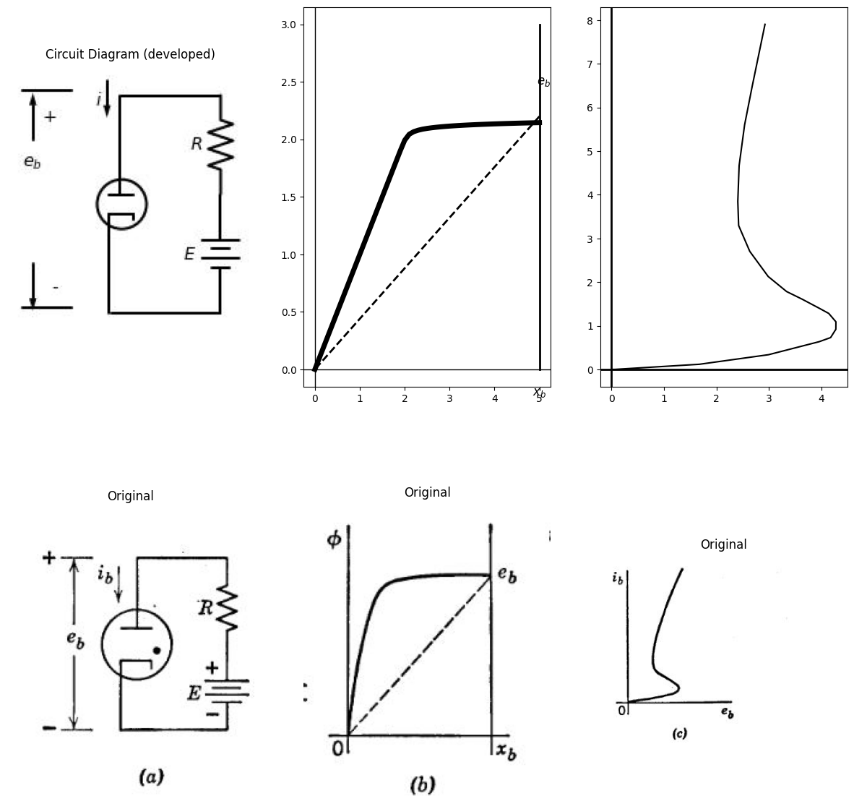

17.1 Fig. 2.14. Thermionic gas diode.
The symbol for a gas diode is shown in Fig. 2.14(a), and the expected form of the potential curve is shown in (b). The current versus voltage curve is shown in (c). The form of this curve differs from that of the cold-cathode discharge. Since there is a large quantity of electrons available from the thermionic cathode, the low-current conduction region shown in Fig. 2.8(b) does not exist here. Note, however, from Fig. 2.14(c) that once the discharge is initiated, the current will tend to become excessively large if a fixed voltage is applied. However, if the current is controlled, the voltage adjusts itself to the appropriate
value. The simple circuit of Fig. 2.14(a) might be used to determine the iy VS. €y curve experimentally, provided that EZ and R are adjustable. The resistance R limits the current to values safe for the diode.
The form of the potential curve shown in Fig. 2.14(b) shows a high field intensity near the cathode. ‘This field accelerates the electrons almost to final velocity (corresponding to e,); hence, ionization of gas molecules starts near the cathode. Over the majority of the space between electrodes, the potential variation is small. This means small field intensity and, hence, electrons tend to proceed at almost constant velocity. Meanwhile, positive ions in this region, being subject to low
field intensity and having low mobility, drift slowly toward the cathode.
This portion of the interelectrode space is called the plasma region. Here, under equilibrium conditions, ions and electrons are formed by collision and some may be lost by recombination. Near the cathode, the high field intensity accelerates emission electrons toward the plasma and then to the anode; concurrently, positive ions are accelerated toward
the cathode, where they recombine with electrons. The plasma is highly conducting because of both the positive ions and the electrons, which tend to cancel each other insofar as space charge is concerned, however the ion and electron currents are additive. Once the plasma has been established, the potential curve varies only slightly with the magnitude of the current.
The large conduction current possible in a gas diode with very low voltage drop makes the device a very efficient rectifier in comparison with a vacuum diode., The highly conducting plasma effectively places the anode very close to the cathode. This helps to account for the low anode voltage required to sustain a large current.

18 2.18 Excitation by Collision
The conduction in a gas-filled tube is called a glow discharge because of the characteristic light given off. For neon the color is a deep red, for argon violet, and for mercury vapor a greenish blue. The light is emitted by the conducting gas following excitation of the atoms by collision with fast-moving electrons. Excitation involves an increase in the energy of an electron. The electron then loses that energy by emitting it in the form of electromagnetic radiation.
According to quantum theory, the electrons associated with an atom can assume only a finite number of distinct values of energy. Only one electron at a time can assume a specific state. The lower energy states belong to the inner shells of electrons, and, in general, electrons seek the lowest energy states. Valence electrons have the highest energies and, hence, require the least additional energy for escape. Ionization nor- mally occurs by removal of a valence electron. However, suppose a high-speed electron gives up enough energy in colliding with an atom to raise the energy of one of the electrons in an inner shell sufficiently to eject it from the atom. This leaves a vacancy in one of the low-energy states, and the atom or molecule is said to be excited as well as ionized. One of the high-energy electrons will then fall to the low-energy state, and the decrease in electron energy will result in the emission of a quantum of light (photon). The low-energy electron need not be completely ejected from the atom for excitation to occur. Its energy could be raised from the normal level to a higher level within the atom. Upon losing that energy, a photon is emitted. The frequency of the light emitted is determined by the product of the energy difference between the two states involved and a natural constant known as Planck’s constant, $h=6.63X{10}^{−}34$ joule sec.

19 2.19 Photoelectric Emission
Photoelectric emission is the converse of excitation by collision. When an electron collides with an atom, giving up some or all of its energy, the result may be ionization, or excitation which then results in photon radiation. The converse applies to the situation in which photons of light impinge on the atoms of a material such as cesium, calcium, or aluminum. If the quantum of energy hy for light having a frequency » imparts sufficient energy to an electron to overcome the work function of the material, photoelectric emission occurs. For most materials the photoelectric work function is nearly equal (but not identical) to the thermionic work function.
The materials mentioned above are good photoelectric emitters and are used as the cathode structure in a vacuum or gas-filled tube together with an anode to form a diode. The anode is connected to a positive potential relative to the cathode and thus attracts the emitted electrons. Photoelectric diodes (vacuum or gas-filled) may be compared in a general way to thermionic diodes. With light of constant intensity and frequency distribution impinging on a photoelectric diode, the current versus voltage curve is roughly similar to that of a thermionic diode with constant cathode temperature. However, constant cathode heating power (and therefore temperature) represents the normal mode of operation for thermionic diodes, whereas photoelectric diodes are more often used under conditions of varying light intensity and frequency.
The sketch shown in Fig. 2.15(a) indicates the electrode geometry used in a common type of vacuum phototube. The cathode is part of a cylinder and the anode a wire placed before it. Light impinging on the cathode releases electrons which are attracted to the anode if the latter has a positive potential with respect to the cathode. Photoelectric emission from typical cathode materials yields electron currents of the order of microamperes (thermionic emission from an oxide-coated cathode may yield currents of many milliamperes or even amperes). The successively higher values of saturation current in Fig. 2.15(d) correspond to increasing levels of light intensity. Specific values of current for a given light intensity depend upon the light frequency or wavelength, since the metals used as photoelectric cathodes show a definite peak in sensitivity. The peak for cesium occurs at a light wave- length of about 5400 angstroms, whereas sodium and potassium show peaks at about 4200 and 4400 angstroms, respectively.
The symbol for a vacuum phototube is shown in Fig. 2.15(b). Ifa dot
is placed within the circle, the resulting symbol represents a gas-filled tube [Fig. 2.15(c)]. Anode curves for a gas-filled tube are much like those for a vacuum phototube until gas breakdown occurs. Then the available current increases rapidly with voltage [Fig. 2.15(e)]. In fact,
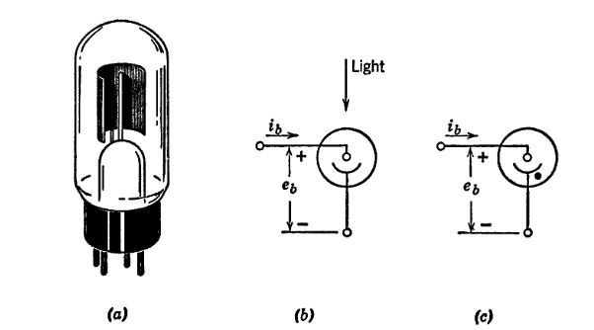
import matplotlib.pyplot as plt
from matplotlib import rcParams
import matplotlib.image as mpimg
import numpy as np
from schemdraw import dsp
import schemdraw
import schemdraw.elements as elm
import PySpice.Logging.Logging as Logging
logger = Logging.setup_logging()
from PySpice.Probe.Plot import plot
from PySpice.Spice.Netlist import Circuit
from PySpice.Unit import *
# Create the figure and subplots
fig, axs = plt.subplots(1, 2, figsize=(15,15))
rcParams['font.weight'] = 'bold'
circuit = Circuit('NMOS')
circuit.model('2N7000', 'NMOS', L=100E-6, W=200E-6, Kp=0.13, Vto=40.475)
Vgate = circuit.V('gate','gate',circuit.gnd, 0@u_V)
circuit.R(2, 'drain', '2',0.001@u_Ohm)
Vi = circuit.V('i', '2', circuit.gnd, 1000@u_V)
circuit.MOSFET(1, 'drain', 'gate', circuit.gnd,circuit.gnd, model='2N7000')
for gate_voltage in np.arange(20, 80, 10):
gate_voltage = gate_voltage@u_V
Vgate.dc_value = gate_voltage
simulator = circuit.simulator(temperature=25, nominal_temperature=25)
analysis = simulator.dc(Vi=slice(0, 80, 1))
axs[0].plot(analysis['drain'], u_mA(-analysis.Vi),linewidth=5, color='black')
axs[0].axvline(x=0, color='black')
axs[0].set_title('Characteristic $I_D-V_{DS}$ for different values of $V_{GS}$')
axs[0].set_xlabel('$V_{DS} [V]$')
axs[0].set_ylabel('$I_D [uA]$')
Vth = 1.0 # ولتاژ آستانه (V)
kn = 5 # پارامتر هدایت (mA/V^2)
VDS_breakdown = 5 # ولتاژ شکست (V)
# ولتاژهای درین-سورس
VDS = np.linspace(0, 5.1, 600)
# ولتاژهای مختلف گیت-سورس برای رسم
VGS_values = [1.2, 1.5,1.8, 2.0]
for VGS in VGS_values:
IDS = np.zeros_like(VDS)
linear_region = VDS < (VGS - Vth)
IDS[linear_region] = kn * ((VGS - Vth) * VDS[linear_region] - 0.5 * VDS[linear_region] ** 2)
IDS[IDS < 0] = 0
saturation_region = VDS >= (VGS - Vth)
IDS[saturation_region] = 0.5 * kn * (VGS - Vth) ** 2
# اثر شکست (Breakdown)
IDS[VDS > VDS_breakdown] *= 5
axs[1].plot(VDS, IDS, label=f"VGS = {VGS} V",linewidth=3, color='black')
axs[1].set_title('Characteristic $I_D-V_{DS}$ for different values of $V_{GS}$')
axs[1].set_xlabel('$V_{DS} [V]$')
axs[1].set_ylabel('$I_D [uA]$')
Text(0, 0.5, '$I_D [uA]$')
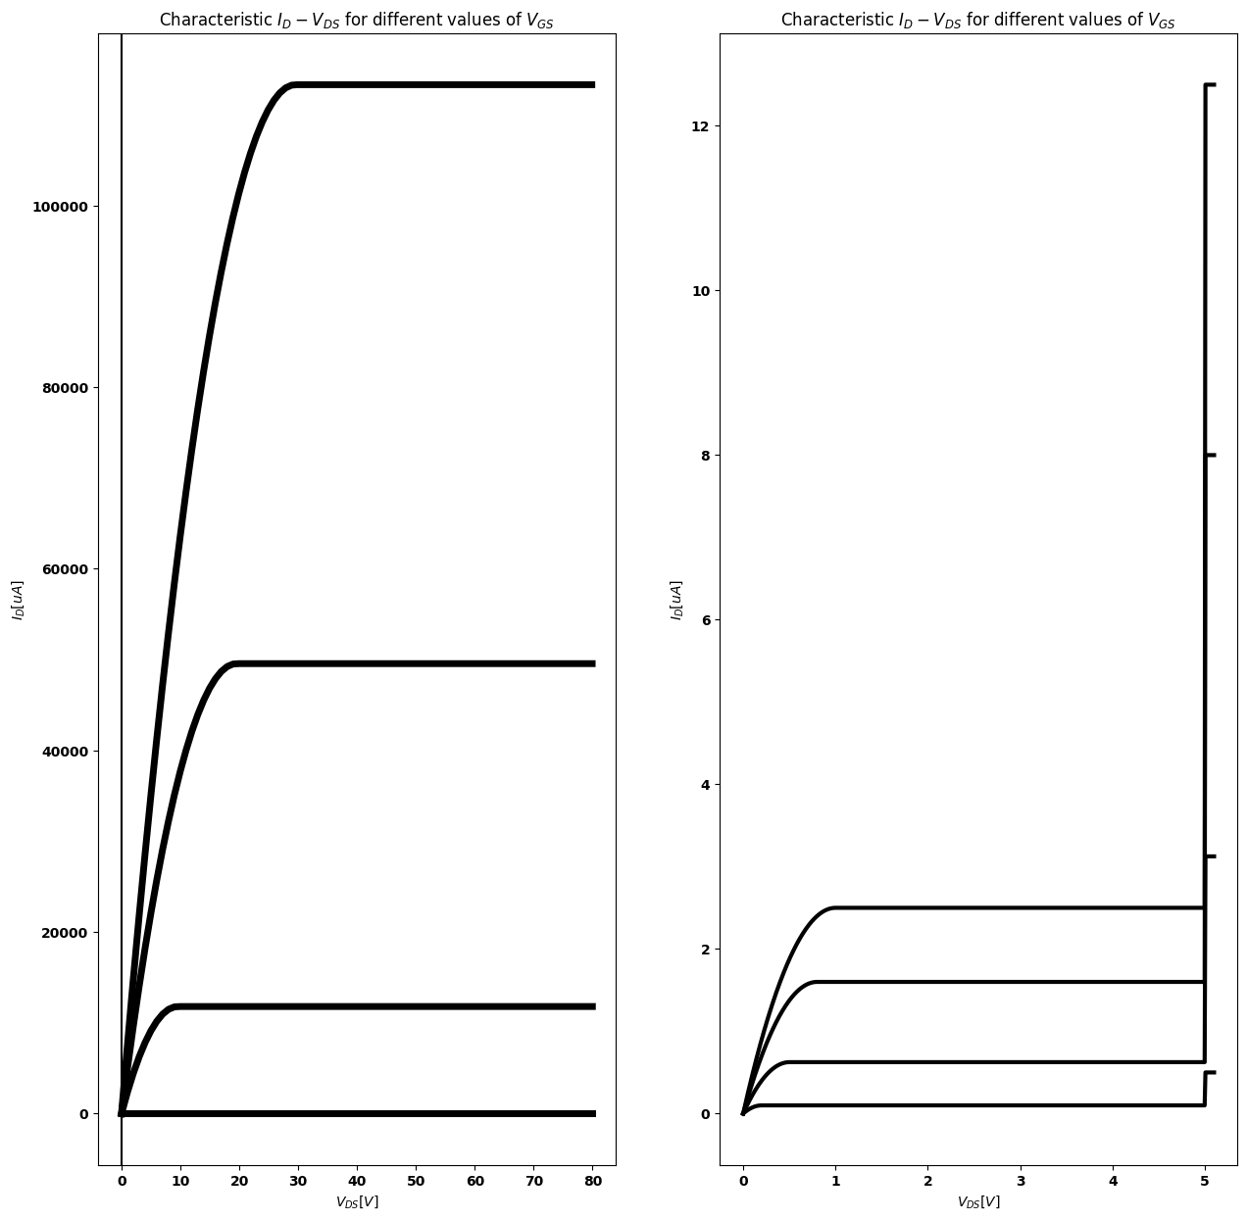

19.1 Fig. 2.15. Properties of phototubes. (a) Phototube; (b) Symbol for phototube;(c) Symbol for gas-filled phototube; (d) Anode curves for vacuum phototube;(e) Anode curves for gas-filled phototube.
as in the case of gas-filled thermionic diode, a series resistance is necessary to limit the current to reasonable values. The gas-filled tubes are useful in operating relays which then execute a function, such as door-opening, under control of a light signal.
When it is desirable or necessary to increase the current output from
a vacuum phototube, a device called a secondary emission multiplier is sometimes used.

20 2.20 Secondary Emission
Electrons can be ejected from a metal, glass, or other material under bombardment by electrons. Thus, an electron impinging on a metal may impart sufficient energy to atoms near the surface to eject one or more electrons. This process, called secondary emission, often plays an important part in vacuum tube operation. For example, a secondary
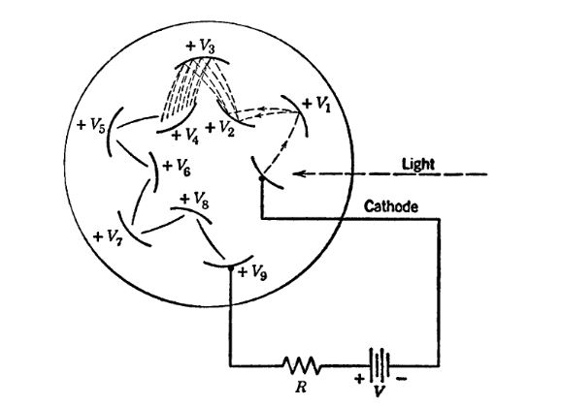

20.1 Fig.2.16. Secondary-emission multiplier.
emission multiplier associated with a vacuum phototube is shown in Fig. 2.16. The cathode and the anode form a diode and the other electrodes, going counterclockwise from cathode to anode, are con- nected to successively higher voltages (usually by means of a resistive voltage-divider). An electron emitted from the cathode is attracted to the first electrode where it may release one or more secondary elec- trons. The higher potential of the next electrode attracts these second- aries. If each electron releases r secondaries and there are n electrodes on the way from cathode to anode, the anode current will be r” times the photoelectrically-emitted current. The secondary emission ratio r usually falls in the range of two or three secondary electrons per primary electron.
In many vacuum tube applications secondary emission is undesirable rather than useful. If bombardment of an anode or other electrode in a tube results in the release of secondary electrons, the characteristics of the tube may be seriously affected. This point will be discussed further in Chapter 7 in connection with multi-electrode tubes.

21 SUPPLEMENTARY READING
L. B, Arguimbau, R. B. Adler, Vacuum Tube Circuits and Transistors, John Wiley and Sons, New York, 1956.
H. Bruining, Physics and Applications of Secondary Electron Emission, McGraw-Hill, New York, 1954.
W. G. Dow, Fundamentals of Engineering Electronics, John Wiley and Sons, New York, 1952.
D. V. Geppert, Basic Electron Tubes, McGraw-Hill, New York, 1951.
T. 8. Gray, Applied Electronics, 2nd edition, John Wiley and Sons, New York, 1954.
Willis W. Harman, Fundamentals of Electronic Motion, McGraw-Hill, New York, 1953,
L. P. Hunter, editor, Handbook of Semiconductor Electronics, McGraw-Hill, New York,
R. D. Middlebrook, An Introduction to Junction Transistor Theory, John Wiley and Sons, New York, 1957.
Karl R. Spangenberg, Fundamentals of Electron Devices, McGraw-Hill, New York,
Robert L. Sproull, Modern Physics: A Textbook for Engineers, John Wiley and Sons, New York, 1956,
Aldert van der Ziel, Solid State Physical Electronics, Prentice-Hall, New Jersey, 1957. V. K, Zworykin and G. A. Morton, Television: The Electronics of Image Transmission in Color and Monochrome, 2nd edition, John Wiley and Sons, New York, 1954.

22 PROBLEMS
2.1. Give a brief qualitative description of the mechanism of electrical conduction in a metal.
2.2. What basic processes govern electrical conduction in an intrinsic semi- conductor like silicon or germanium?
2.3. What is the effect of adding a small amount of a donor impurity like arsenic to an intrinsic semiconductor? Of an acceptor impurity like indium or gallium?
2.4. What physical processes influence the equilibrium value of the potential barrier at a p-n junction with no external fields applied?
2.5. Make a qualitative sketch of charge distribution, electric field and potential variations in the vicinity of a p-n junction.
2.6. (a) Sketch the curve of current versus applied voltage for a p-n junction and give a qualitative physical explanation of the form of the curve.
(6) Sketch another curve of current versus voltage for the same p-n junction at a higher equilibrium temperature. 2.7. (a2) How much d-c current flows in a short-circuited semiconductor junction diode when the entire circuit is in thermal equilibrium at room tem- perature? Explain.
(6) With reverse voltage applied, a p-n junction diode conducts a small, nearly constant reverse current. Explain.
(c) With forward voltage applied, a p-n junction diode conducts a relatively large forward current which increases exponentially with applied voltage. Explain.
2.8. Sketch the general form of the current versus voltage curve for a cold- cathode gas diode.
2.9, Describe the operation of a hot-cathode gas-filled diode.
2.10. For a vacuum diode, sketch curves of current versus anode voltage for various values of cathode temperature.
2.11. For a vacuum diode, sketch curves of current versus temperature for various values of anode voltage.
2.12. Explain the effects of space-charge limitation and temperature limita- tion of current in a vacuum diode.
2.13. State the basic principles involved in establishing the plausibility of the generalized three-halves power law for vacuum diodes.
2.14. For a parallel-plane vacuum diode with cathode grounded and anode at +, sketch the cold-cathode potential distribution, electric field, and charge distribution. Assume the anode and cathode each have an area A and are separated a distance d (neglect fringing).
2.15. Modify the curves of Problem 2.14 to include the effects of a sheet of charge midway between cathode and anode.
import matplotlib.pyplot as plt
from matplotlib import rcParams
import matplotlib.image as mpimg
import numpy as np
import PySpice.Logging.Logging as Logging
logger = Logging.setup_logging()
from PySpice.Probe.Plot import plot
from PySpice.Spice.Netlist import Circuit
from PySpice.Unit import *
rcParams['font.weight'] = 'bold'
fig, axs = plt.subplots(1, 2, figsize=(10, 10))
# Create subplots
circuit = Circuit('Diode')
circuit.model('BAV21','D' ,IS =100@u_nA , N = 1.906 ,BV = 110@u_V, IBV = 0.0001@u_V, VJ = 0.7@u_V ,CJO = 7.048E-13 ,RS = 2@u_kOhm ,TT = 3.48E-9)
Vth = circuit.V('th', '1', circuit.gnd, 0@u_V)
circuit.D(1, '1',circuit.gnd , model = 'BAV21')
circuit.I(1, '1',circuit.gnd, 10@u_mA )
simulator = circuit.simulator(temperature=25, nominal_temperature=25)
analysis = simulator.dc(Vth=slice(-100, 100, 0.1))
axs[0].plot(analysis['1'],u_mA(-analysis.Vth), 'black', linewidth=3)
axs[0].set_title('V-I Curve for D2')
axs[0].set_xlim(-100, 100)
axs[0].set_xlabel('I [A]')
axs[0].set_ylabel('V [V]')
axs[0].set_ylim(-100, 100)
axs[0].axhline(0, color='black', linewidth=1)
axs[0].axvline(0, color='black', linewidth=1)
# **Subplot (1, 2): PNG Sample File**
img_sample = mpimg.imread('images/p2.1.jpg') # Load the PNG file
axs[1].imshow(img_sample)
axs[1].axis('off') # Hide axes for image display
axs[1].set_title('Original')
Text(0.5, 1.0, 'Original')
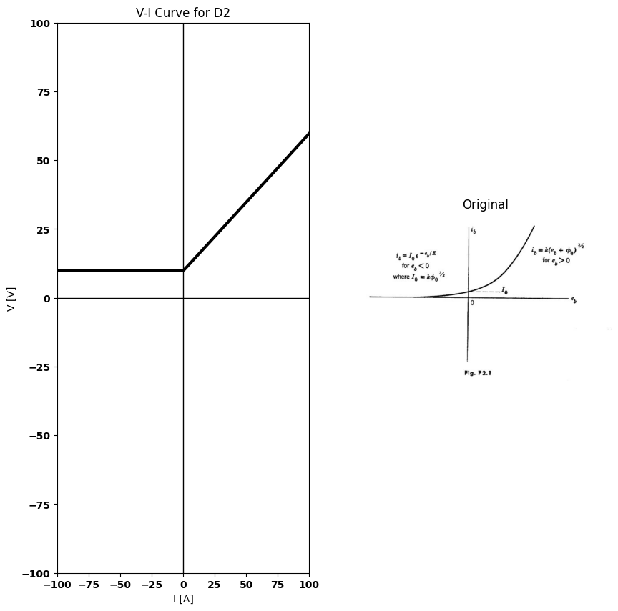

22.1 Fig.p.2.1
2.16. Measurements on the plate-to-cathode circuit of a vacuum diode yield results that are closely approximated by the curve in Fig. P2:1.
(a) What are possible. reasons for I≠ 0?
(b) What is the significance of the product et, in the first quadrant?
(c) What is the significance of the product —ési, in the second quadrant? 2.17. The voltage-current relation for a particular diode is given by
$i=\frac{e^{3}/2}{1000}$ amperes
In the vicinity of the operating point (Zo, J) this relation may be expanded in the power series
$i=c_{o}E_{o}+c_{1}\left(e−E_{o}\right)+c_{2}{\left(e−E_{o}\right)}^{2}+...c_{n}{\left(e−E_{o}\right)}^{n}$
Evaluate the coefficients co, c1, and ce at the operating point 7) = 1 ampere.
2.18. (a) Show that for a three-halves power law curve (i, = Ke,3*), which closely approximates the t, versus ¢, curve of a high-vacuum diode, the slope of the curve at any point is just three-halves times the slope of a chord drawn from the origin to that point.
(b) If % = 10 ma when e, = 100 vy, what is the incremental resistance de,/di, of the diode at i, = 10 ma?
(c) Show that the incremental resistance along a three-halves power 1 versus é, curve varies inversely as the cube root of the current.
2.19, Two parallel plates, spaced 1 cm apart, are connected in series with a current-indicating device and a battery of voltage V = 200 volts, as shown in Fig. P2.2. The area of each plate is A cm?. At ¢ = 0, an electron is intro- duced at a small hole in the left-hand plate with zero initial velocity. Plot, as a function of time, the current which flows through the indicating device. Show that the energy acquired by the electron in its flight between plates is equal to the energy delivered by the battery. The polarity of the battery is reversed so that the left-hand plate is made
import matplotlib.pyplot as plt
from matplotlib import rcParams
import matplotlib.image as mpimg
import numpy as np
from schemdraw import dsp
import schemdraw
import schemdraw.elements as e
import PySpice.Logging.Logging as Logging
logger = Logging.setup_logging()
from PySpice.Probe.Plot import plot
from PySpice.Spice.Netlist import Circuit
from PySpice.Unit import *
fig, axs = plt.subplots(1, 2, figsize=(15, 15))
d = schemdraw.Drawing()
I1 = d.add(e.MeterI().right().length(2).label('$ma$','top').label('$Fig.p2.2$','bottom'))
E = d.add(e.Battery().right().length(2).reverse().label('$200$','bottom'))
l1 = d.add(e.Line().right().length(1))
l2 = d.add(e.Line().up().length(2))
l3 = d.add(e.Line().left().length(1.5).dot())
l4 = d.add(e.Line().up().length(2).at((3.45,1.8)).linewidth(4))
l5 = d.add(e.Line().left().length(1).at(I1.start))
l6 = d.add(e.Line().up().length(2))
l7 = d.add(e.Line().right().length(1.5).dot())
l8 = d.add(e.Line().up().length(2).at((0.55,1.8)).linewidth(4))
d += e.Arrow().right().length(.75).linewidth(0.6).color('black'). at((-.2,3)).label('$Electron$','left')
l9 = d.add(e.Line().right().length(0.0001).dot(). at((.8,3)))
d += e.Arrow().right().length(.75).linewidth(0.6).color('black')
d += e.Arrow().right().length(.75).linewidth(0.6).color('black'). at((2.6,3.7)).label('$1 cm$','left')
d += e.Arrow().left().length(.75).linewidth(0.6).color('black'). at((1.3,3.7))
d.save('Drawings/p2-2.jpg') # Save the drawing to a PNG file
img = mpimg.imread('Drawings/p2-2.jpg')
axs[0].imshow(img)
axs[0].axis('off') # Hide axes for image display
axs[0].set_title('Circuit Diagram (developed)')
# **Subplot (1, 2): PNG Sample File**
img_sample = mpimg.imread('images/p2-2.jpg') # Load the PNG file
axs[1].imshow(img_sample)
axs[1].axis('off') # Hide axes for image display
axs[1].set_title('Original')
Text(0.5, 1.0, 'Original')
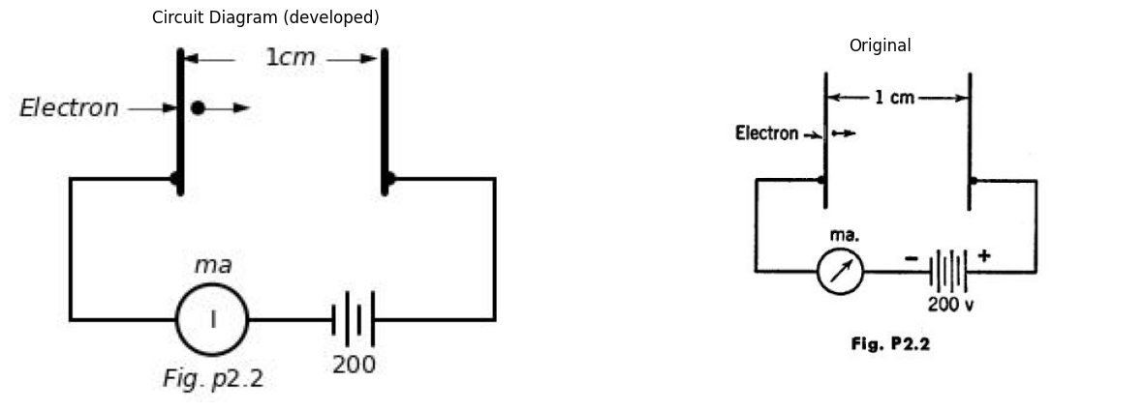

22.2 fig.p.2.2
positive. At $t = 0 $an electron is injected through the hole with an x-directed initial velocity corresponding to an energy of 200 electron volts. Plot the current-time relation. Show that the energy lost by the electron is equal to the energy delivered to the battery.
Field fringing effects at the plate edges and in the vicinity of the hole may be neglected.
2.20. (a) Assuming that the cathode of a high-vacuum diode is a limitless source of zero-velocity electrons, what happens to the electric field at the cathode, to the electron velocity at a given point, and to the space-charge density at a given point when the plate-to-cathode voltage is doubled? (b) Sketch log i vs. loge for a high-vacuum diode. What portion or portions of the curve are straight, and why?
(c) Repeat part (b) with log e, replaced by ep.
2.21. An idealized parallel-plane diode consists of a pair of semi-infinite plates spaced 8 mm apart. With the plate 100 volts positive with respect to the cathode, the current flow is space-charge limited. Under this condition, and neglecting initial velocities and contact potential, find the velocity attained by an electron which has reached a point 1 mm distant from the cathode.
2.22. A particular germanium junction diode conducts 0.1 ma of current in the reverse direction when a few volts of reverse voltage are applied. The incremental resistance of the diode, measured at the origin of the 7 vs. » diode curve, is found to be 200 ohms. What are the values of the constants J» and Vo in the theoretical junction law $i=I_{o}\left(e^{\frac{v}{V_{o}}}—1\right)?$
import matplotlib.pyplot as plt
from matplotlib import rcParams
import matplotlib.image as mpimg
import numpy as np
from schemdraw import dsp
import schemdraw
import schemdraw.elements as e
import PySpice.Logging.Logging as Logging
logger = Logging.setup_logging()
from PySpice.Probe.Plot import plot
from PySpice.Spice.Netlist import Circuit
from PySpice.Unit import *
fig, axs = plt.subplots(1, 2, figsize=(15, 15))
d = schemdraw.Drawing()
D1 = d.add(e.Diode(fill=True).right())
ss1 = d.add(e.Source().right().at(D1.start))
D2 = d.add(e.Diode(fill=True).right().reverse())
ss2 = d.add(e.Source().right().at(D2.start))
D3 = d.add(e.Diode(fill=True).right().at((10,0)))
ss3 = d.add(e.Source().right().at(D3.start))
l1 = d.add(e.Line().down().length(1))
l2 = d.add(e.Line().down().length(1))
D4 = d.add(e.Diode(fill=True).left())
ss4 = d.add(e.Source().left().at(D4.start))
l3 = d.add(e.Line().up().length(1))
l4 = d.add(e.Line().up().length(1))
l5 = d.add(e.Line().right().length(1).dot().at(l1.end))
l6 = d.add(e.Line().left().length(1).dot().at(l3.end))
d.save('Drawings/p2-3.jpg') # Save the drawing to a PNG file
img = mpimg.imread('Drawings/p2-3.jpg')
axs[0].imshow(img)
axs[0].axis('off') # Hide axes for image display
axs[0].set_title('Circuit Diagram (developed)')
# **Subplot (1, 2): PNG Sample File**
img_sample = mpimg.imread('images/p2-3.jpg') # Load the PNG file
axs[1].imshow(img_sample)
axs[1].axis('off') # Hide axes for image display
axs[1].set_title('Original')
Text(0.5, 1.0, 'Original')
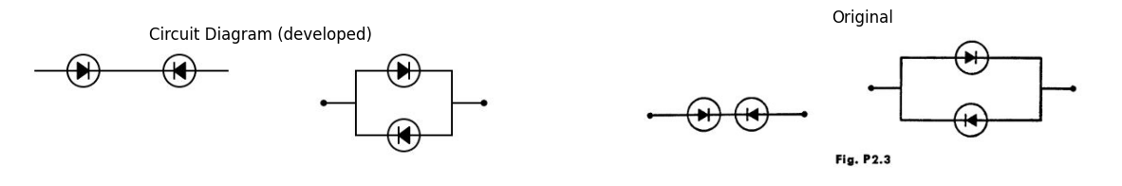

22.3 fig.p.2.3
2.23, Sketch the current versus voltage characteristic for two identical junction diodes, each characteristic given by $i=I_{o}\left(e^{\frac{v}{V_{o}}}—1\right)$, connected in
(a) series and (6) parallel as in Fig. P2.3.
2.24. The voltage-ampere relationship of a germanium diode may be de- scribed by the following equation:
$i=I_{o}\left(e^{\frac{qv}{KT}}—1\right)$
At room temperature $kT/q = 0.025 $volt. Typical values for the constant J and the reverse voltage at which avalanche breakdown takes place are $50 × 10^-6 $amperes and —80 volts, respectively. The maximum average power which can be dissipated by such a device without internal damage due to heating is typically 0.1 watt.
(a) Determine the maximum average forward current rating of the device.
(b) Determine the voltage v at which the forward current rating is reached.

