Table of Contents

CHAPTER THREE
Resistive Diode Circuits

1 3.1 Introduction
Resistive diode circuits include diodes, linear resistances, and sources, but no energy-storage elements. Although actual devices include small capacitances and inductances (for example the capacitance between electrodes in a vacuum diode), we shall represent diodes as nonlinear resistances in this chapter. By setting aside the consideration of the small energy-storage elements for the time being, we are in effect confining our attention to situations in which the currents and voltages are either in static equilibrium or they are varying so slowly that their time derivatives can be neglected. Circuit equilibrium equations are therefore algebraic rather than differential.
Since interelectrode and other stray capacitances, as well as wiring inductances, are very small in actual circuits, the resistive approximation fits many practical situations quite well. Both the circuit functions and the methods of analysis examined here will apply to circuits involving electronic devices other than diodes and to situations in which energy-storage elements must be included to describe circuit behavior satisfactorily. In fact, resistive circuit analysis forms the base upon which to build the analysis of circuits containing energy-storage elements.

2 3.2 Graphical Analysis of Linear Resistance Networks
Graphical analysis is seldom used for linear resistive circuits because quantitative results are more readily obtained by algebraic methods. However, a graphical solution may be the most convenient when the terminal relations for a device are available in graphical form and not
import matplotlib.pyplot as plt
import numpy as np
import schemdraw
import schemdraw.elements as elm
import matplotlib.image as mpimg
# Create the figure and subplots
fig, axs = plt.subplots(3, 2, figsize=(12, 12))
# **Subplot (1, 1): Schemdraw Circuit Diagram**
d = schemdraw.Drawing()
d += elm.Dot(open=True)
d += elm.Line().up().length(2)
d += elm.Line().right().length(1)
d += ( R1 := elm.Resistor().right().label('$R1$' , 'top'))
d += elm.Line().right().length(1)
d.push()
d += elm.Arrow().right().length(1).color('black').label('i', loc='top', color='black'). at((0.5,2.2))
d.pop()
d += elm.Dot(open=True)
d.push()
d += elm.Line().down().length(1).color('gray'). at((5,1.7)).linestyle('-')
d.pop()
d += elm.Line().right().length(1)
d += ( R2 := elm.Resistor().right().label('$R2$' , 'top'))
d += elm.Line().right().length(1)
d += elm.Line().down().length(2)
d += elm.Dot(open=True)
d += elm.Arrow().left().length(4).label(r'-', loc='start').at((9.7,0)).color('black')
d += elm.Arrow().right().length(4).label(r'+', loc='start').at((0.3,0)).color('black')
d += elm.Arrow().right().length(1).at((4.5, 0.3)).color('white').label('$V$', loc='bottom', color='black')
d += elm.Arrow().right().length(1.7).at((3.2, 1.3)).color('black')
d += elm.Arrow().right().length(1).at((2, 1.5)).color('white').label('$V1$', loc='bottom', color='black')
d += elm.Arrow().left().length(1.7).at((1.8, 1.3)).color('black')
d += elm.Arrow().right().length(1.7).at((8.2, 1.3)).color('black')
d += elm.Arrow().right().length(1).at((7, 1.5)).color('white').label('$V2$', loc='bottom', color='black')
d += elm.Arrow().left().length(1.7).at((7, 1.3)).color('black')
d.save('images-books/circuit_diagram.png') # Save the drawing to a PNG file
# Load the saved PNG file into the subplot
img = mpimg.imread('images-books/circuit_diagram.png')
axs[0, 0].imshow(img)
axs[0, 0].axis('off') # Hide axes for image display
axs[0, 0].set_title('Circuit Diagram (developed)')
# **Subplot (1, 2): PNG Sample File**
img_sample = mpimg.imread('images-books/1-.png') # Load the PNG file
axs[0, 1].imshow(img_sample)
axs[0, 1].axis('off') # Hide axes for image display
axs[0, 1].set_title('Original')
# **Subplot (2, 1): First Matplotlib Chart (Sine Wave)**
I = np.linspace(-2, 10, 100)
R1 = 1
R2 = 2
Rs = R1+R2
V1 = R1 * I
V2 = R2 * I
Vs = Rs * I
axs[1, 0].plot(I, V1, color='black', linestyle='-')
axs[1, 0].set_ylabel('V1', labelpad=20, loc='top', rotation=0)
axs[1, 0].text(10, 8, 'R1', fontsize=12, ha='center', va='center', color='black')
axs[1, 0].annotate('', xy=(2, R1 * 2), xytext=(2, 0),
arrowprops=dict(arrowstyle='->', color='black', lw=1.5))
axs[1, 0].annotate('', xy=(4, R1 * 4), xytext=(4, 0),
arrowprops=dict(arrowstyle='->', color='black', lw=1.5))
axs[1,0].axhline(0, color='black', linewidth=2)
axs[1,0].axvline(0, color='black', linewidth=2)
# **Subplot (2, 2): Second Matplotlib Chart (Cosine Wave)**
axs[1, 1].plot(I, V2, color='black', linestyle='-')
axs[1, 1].set_ylabel('V2', labelpad=20, loc='top', rotation=0)
axs[1, 1].text(10, 8, 'R2', fontsize=12, ha='center', va='center', color='black')
axs[1, 1].annotate('', xy=(2, R2 * 2), xytext=(2, 0),
arrowprops=dict(arrowstyle='->', color='black', lw=1.5))
axs[1, 1].annotate('', xy=(4, R2 * 4), xytext=(4, 0),
arrowprops=dict(arrowstyle='->', color='black', lw=1.5))
axs[1,1].axhline(0, color='black', linewidth=2)
axs[1,1].axvline(0, color='black', linewidth=2)
#y_cos = np.cos(x) # Sample data for cosine wave
axs[2,0].plot(I, Vs, color='black', linestyle='-')
axs[2,0].plot(I, I, color='black', linestyle='-' , lw=0.5)
axs[2,0].set_ylabel('Vs', labelpad=20, loc='top', rotation=0)
axs[2,0].text(10, 8, 'Rs', fontsize=12, ha='center', va='center', color='black')
axs[2,0].annotate('', xy=(1, Rs * 1), xytext=(1, 1),
arrowprops=dict(arrowstyle='->', color='black', lw=1.5))
axs[2,0].annotate('', xy=(2, Rs * 2), xytext=(2, 2),
arrowprops=dict(arrowstyle='->', color='black', lw=1.5))
axs[2,0].annotate('', xy=(1, 1), xytext=(1, 0),
arrowprops=dict(arrowstyle='->', color='black', lw=0.5))
axs[2,0].annotate('', xy=(2, 2), xytext=(2, 0),
arrowprops=dict(arrowstyle='->', color='black', lw=0.5))
axs[2,0].axhline(0, color='black', linewidth=2)
axs[2,0].axvline(0, color='black', linewidth=2)
#
#ax_big = fig.add_subplot(gs[:, 1])
axs[2,1].plot(I, V1, color='black', linestyle='--')
axs[2,1].plot(I, V2, color='black', linestyle='--')
axs[2,1].plot(I, Vs, color='black', linestyle='-')
axs[2,1].axhline(0, color='black', lw=0.5)
axs[2,1].axvline(0, color='black', lw=0.5)
axs[2,1].set_ylabel('V', labelpad=20, loc='top', rotation=0)
axs[2,1].text(3.5, 9, 'Rs', fontsize=12, ha='center', va='center', color='black')
axs[2,1].text(5, 6, 'R1', fontsize=12, ha='center', va='center', color='black')
axs[2,1].text(5, 9, 'R2', fontsize=12, ha='center', va='center', color='black')
a0=3
a1=R1 * a0
a2=R2 * a0
a3=Rs * a0
axs[2,1].plot([0, a0], [a1, a1], color='black', linestyle='--', label='Membership = 0.9')
axs[2,1].plot([0, a0], [a2,a2], color='black', linestyle='--', label='Membership = 0.8')
axs[2,1].plot([0, a0], [a3, a3], color='black', linestyle='--', label='Membership = 0.8')
axs[2,1].plot([a0, a0], [0, a3], color='black', linestyle='--', label='Membership = 0.8')
axs[2,1].annotate('I', (a0, 0), textcoords="offset points", xytext=(0,-10), ha='center', color='black')
axs[2,1].annotate('IR1', (0, a1), textcoords="offset points", xytext=(-10,0), ha='right', color='black')
axs[2,1].annotate('IR2', (0, a2), textcoords="offset points", xytext=(-10,0), ha='right', color='black')
axs[2,1].annotate('IRs', (0, a3), textcoords="offset points", xytext=(-10,0), ha='right', color='black')
axes = [axs[1,0], axs[1,1], axs[2,0],axs[2,1]]
for axs[2,1] in axes:
axs[2,1].spines['top'].set_color('none')
axs[2,1].spines['right'].set_color('none')
axs[2,1].spines['left'].set_position('zero')
axs[2,1].spines['bottom'].set_position('zero')
axs[2,1].xaxis.set_ticks_position('bottom')
axs[2,1].yaxis.set_ticks_position('left')
axs[2,1].tick_params(axis='both', which='both', length=0)
axs[2,1].set_xticks([])
axs[2,1].set_yticks([])
axs[2,1].set_xlabel('i', labelpad=20, loc='right')
axs[2,1].set_aspect('equal', adjustable='box')
axs[2,1].set_xlim([-2, 10])
axs[2,1].set_ylim([-2, 10])
axs[2,1].axhline(0, color='black', linewidth=2)
axs[2,1].axvline(0, color='black', linewidth=2)
plt.tight_layout()
plt.show()
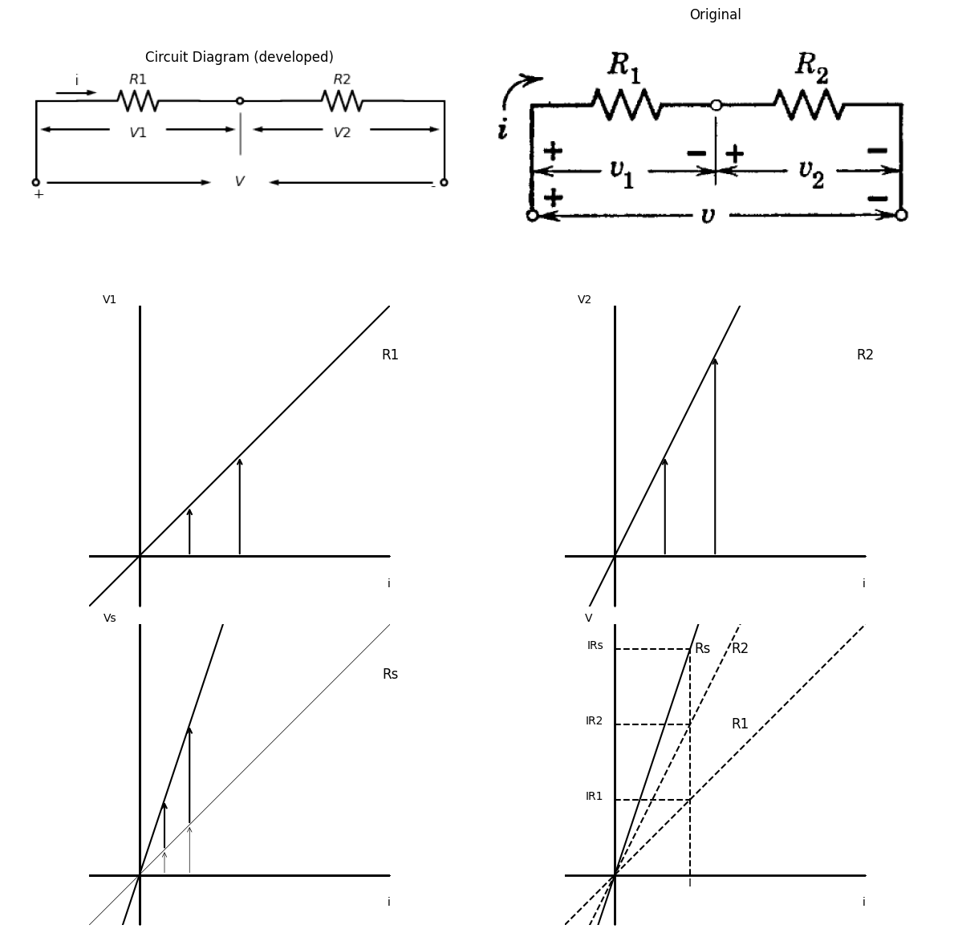
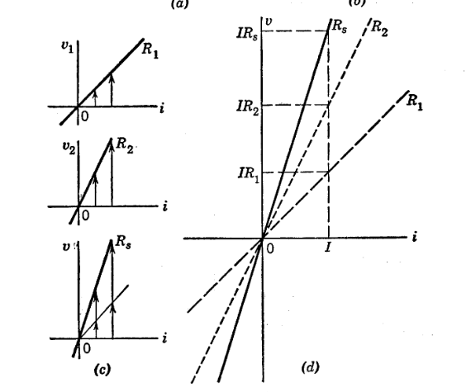
import ipywidgets as widgets
from ipywidgets import interact
import matplotlib.pyplot as plt
from matplotlib import rcParams
import PySpice.Logging.Logging as Logging
logger = Logging.setup_logging()
from PySpice.Probe.Plot import plot
from PySpice.Spice.Netlist import Circuit
from PySpice.Unit import *
rcParams['font.weight'] = 'bold'
figure = plt.figure(figsize=(15, 10))
#@interact(Mode1=(True) , Mode2=(True), Mode3=(True))
@interact(R=widgets.IntSlider(min=1, max=5, step=1, value=2))
def response(R=2@u_Ohm):
rcParams['font.weight'] = 'bold'
figure, ax1, = plt.subplots(figsize=(15, 5))
circuit = Circuit('v-i curve')
Vi = circuit.V('i', '1', circuit.gnd, 1@u_V)
circuit.R(1, '1', circuit.gnd, R@u_Ohm)
simulator = circuit.simulator(temperature=25, nominal_temperature=25)
analysis = simulator.dc(Vi=slice(-5, 5, 0.1))
ax1.plot(u_A(-analysis.Vi), analysis['1'], 'black', linewidth=2,linestyle='-' )
ax1.set_xlabel('i [ma]')
ax1.set_ylabel('V [v]')
plt.axhline(0, color='black', linewidth=1)
plt.axvline(0, color='black', linewidth=1)
plt.tight_layout()
plt.show()
<Figure size 1500x1000 with 0 Axes>
{"model_id":"1cc21b3fb4874323b1d5ef8630d43f9d","version_major":2,"version_minor":0}

2.0.0.1 Fig. 3.1. Resistances in series
$$v=v1+v2$$
$$v=i\left(R1+R2\right)$$
$$v=iRs$$
$$\left(b\right)$$

2.1
readily expressible as a simple function. If nonlinear curves are ap- proximated to permit an analytic solution, a qualitative graphical solution may be helpful in making the approximations and interpreting the results. A graphical sketch is an aid to understanding the operation of a nonlinear device. A few graphical solutions of linear circuits will serve to introduce the techniques that also apply to nonlinear circuits. Figure 3.1 shows the graphical method of combining resistances in series. The circuit is shown in $\left(a\right)$, and the pertinent equations are given in $\left(b\right)$. The three sketches in $\left(c\right)$ represent resistances $R_{1}$ and $R_{2}$

2.2
as well as the sum Rs Voltage drops across $R_{1}$ and $R_{2}$ for any particular value of current are added to obtain the voltage drop across $R_{S}$ for that current, as shown in $\left(d\right)$. The same procedure can be extended to the summation of any number of resistances in series.
import matplotlib.pyplot as plt
from matplotlib import rcParams
import matplotlib.image as mpimg
import numpy as np
import schemdraw
import schemdraw.elements as e
import PySpice.Logging.Logging as Logging
logger = Logging.setup_logging()
from PySpice.Probe.Plot import plot
from PySpice.Spice.Netlist import Circuit
from PySpice.Unit import *
# Create the figure and subplots
fig, axs = plt.subplots(5, 2, figsize=(15, 15))
d = schemdraw.Drawing()
R1 = d.add(e.Resistor().right().label(' $R_1=1/G1$'))
d += e.lines.CurrentLabelInline().at(R1).right().label('$i_1$').color('black')
line_down1 = d.add(e.Line().down().at(R1.end))
l1 = d.add(e.Line().right().at(line_down1.center))
R2 = d.add(e.Resistor().left().at((R1.end[0], R1.end[1] - 3)).label(' $R_2=1/G2$'))
d += e.lines.CurrentLabelInline().at(R2).right().label('$i_2$').color('black')
line_down2 = d.add(e.Line().down().at(R1.start))
l2 = d.add(e.Line().left().at(line_down2.center))
d.add(e.Line().down().at(R1.start))
d.add(e.Line().down().at(l1.end))
d.add(e.Line().down().at(l2.end))
d += e.lines.CurrentLabelInline().at(l2).right().label('$i$').color('black')
d += e.Gap().down().label('⟵ + $v$ - ⟶',
fontsize = 16).color('black').at((1.5,-3))
d.save('images-books/circuit_diagram2.png') # Save the drawing to a PNG file
# Load the saved PNG file into the subplot
img = mpimg.imread('images-books/circuit_diagram2.png')
axs[0, 0].imshow(img)
axs[0, 0].axis('off') # Hide axes for image display
axs[0, 0].set_title('Circuit Diagram (developed)')
# **Subplot (1, 2): PNG Sample File**
img_sample = mpimg.imread('images-books/3-2a.png') # Load the PNG file
axs[0,1].imshow(img_sample)
axs[0,1].axis('off') # Hide axes for image display
axs[0,1].set_title('Original')
#
circuit = Circuit('v-i curve')
Vi = circuit.V('i', '1', circuit.gnd, 0@u_V)
circuit.R(1 ,'1', circuit.gnd, 1@u_Ohm )
simulator = circuit.simulator(temperature=25, nominal_temperature=25)
analysis = simulator.dc(Vi=slice(-5, 5, 0.1))
axs[1,0].plot(analysis['1'], u_A(-analysis.Vi),'black',linewidth=2)
axs[1,0].set_title('I-V Analysis (Ngspice Simulation via Pyspice)')
axs[1,0].set_ylabel('V [V]')
axs[1,0].set_xlabel('I [A]')
axs[1,0].text( 4, 4.545, 'G1', ha='center', va='center')
axs[1,0].text( 0.2, -0.2, '0', ha='center', va='center')
axs[1,0].axhline(0, color='black', linewidth=2)
axs[1,0].axvline(0, color='black', linewidth=2)
axs[1,0].annotate('', xy=(2, 2), xytext=(0, 2), arrowprops=dict(arrowstyle='->'))
axs[1,0].annotate('', xy=(4, 4), xytext=(0, 4), arrowprops=dict(arrowstyle='->'))
# **Subplot (1, 2): PNG Sample File**
img_sample = mpimg.imread('images-books/3-2b.png') # Load the PNG file
axs[1,1].imshow(img_sample)
axs[1,1].axis('off') # Hide axes for image display
axs[1,1].set_title('Original')
#2
circuit = Circuit('v-i curve')
Vi = circuit.V('i', '1', circuit.gnd, 0@u_V)
circuit.R(1 ,'1', circuit.gnd, 0.3@u_Ohm )
simulator = circuit.simulator(temperature=25, nominal_temperature=25)
analysis = simulator.dc(Vi=slice(-5, 5, 0.1))
axs[2,0].plot(analysis['1'], u_A(-analysis.Vi),'black',linewidth=2)
axs[2,0].axhline(0, color='black', linewidth=1)
axs[2,0].axvline(0, color='black', linewidth=1)
axs[2,0].set_title('I-V Analysis (Ngspice Simulation via Pyspice)')
axs[2,0].set_xlim(-5, 5)
axs[2,0].set_ylim(-8, 8)
axs[2,0].set_ylabel('V [V]')
axs[2,0].set_xlabel('I [A]')
axs[2,0].text( 2.6, 7, 'G2', ha='center', va='center')
axs[2,0].annotate('', xy=(0.7, 2), xytext=(0, 2), arrowprops=dict(arrowstyle='->'))
axs[2,0].annotate('', xy=(1.3, 4), xytext=(0, 4), arrowprops=dict(arrowstyle='->'))
# **Subplot (1, 2): PNG Sample File**
img_sample = mpimg.imread('images-books/3-2c.png') # Load the PNG file
axs[2,1].imshow(img_sample)
axs[2,1].axis('off') # Hide axes for image display
axs[2,1].set_title('Original')
#3
circuit = Circuit('v-i curve')
Vi = circuit.V('i', '1', circuit.gnd, 0@u_V)
circuit.R(1 ,'1', circuit.gnd, 1.3@u_Ohm )
simulator = circuit.simulator(temperature=25, nominal_temperature=25)
analysis = simulator.dc(Vi=slice(-2, 5, 0.1))
axs[3,0].plot(analysis['1'], u_A(-analysis.Vi),'black',linewidth=2)
circuit = Circuit('v-i curve1')
Vt = circuit.V('t', '1', circuit.gnd, 0@u_V)
circuit.R(2 ,'1', circuit.gnd, 0.8@u_Ohm )
simulator = circuit.simulator(temperature=25, nominal_temperature=25)
analysis = simulator.dc(Vt=slice(0, 5, 0.1))
axs[3,0].plot(analysis['1'], u_A(-analysis.Vt),'black',linestyle='--',linewidth=2)
axs[3,0].annotate('', xy=(0.8, 1), xytext=(0, 1), arrowprops=dict(arrowstyle='->'))
axs[3,0].annotate('', xy=(2.4, 3), xytext=(0, 3), arrowprops=dict(arrowstyle='->'))
axs[3,0].annotate('', xy=(1.3, 1), xytext=(0, 1), arrowprops=dict(arrowstyle='->'))
axs[3,0].annotate('', xy=(3.9, 3), xytext=(0, 3), arrowprops=dict(arrowstyle='->'))
axs[3,0].axhline(0, color='black', linewidth=2)
axs[3,0].axvline(0, color='black', linewidth=2)
axs[3,0].set_title('I-V Analysis (Ngspice Simulation via Pyspice)')
axs[3,0].set_ylabel('V [V]')
axs[3,0].set_xlabel('I [A]')
axs[3,0].text( 4, 2.9, 'Gp', ha='center', va='center')
axs[3,0].text( 0.2, -0.2, '0', ha='center', va='center')
# **Subplot (1, 2): PNG Sample File**
img_sample = mpimg.imread('images-books/3-2d.png') # Load the PNG file
axs[3,1].imshow(img_sample)
axs[3,1].axis('off') # Hide axes for image display
axs[3,1].set_title('Original')
#4
circuit = Circuit('v-i curve')
Vth = circuit.V('th', '1', circuit.gnd, 0@u_V)
circuit.R(1 ,'1', circuit.gnd, 0.7@u_Ohm )
simulator = circuit.simulator(temperature=25, nominal_temperature=25)
analysis = simulator.dc(Vth=slice(-5, 5, 0.1))
axs[4,0].plot(analysis['1'], u_A(-analysis.Vth),'black',linewidth=2)
circuit = Circuit('v-i curve1')
Vt = circuit.V('t', '1', circuit.gnd, 0@u_V)
circuit.R(2 ,'1', circuit.gnd, 0.2@u_Ohm )
simulator = circuit.simulator(temperature=25, nominal_temperature=25)
analysis = simulator.dc(Vt=slice(-5, 5, 0.1))
axs[4,0].plot(analysis['1'], u_A(-analysis.Vt),'black',linestyle='--',linewidth=2)
circuit = Circuit('v-i curve2')
Vp = circuit.V('p', '1', circuit.gnd, 0@u_V)
circuit.R(2 ,'1', circuit.gnd,0.4@u_Ohm )
simulator = circuit.simulator(temperature=25, nominal_temperature=25)
analysis = simulator.dc(Vp=slice(-5, 5, 0.1))
axs[4,0].plot(analysis['1'], u_A(-analysis.Vp),'black',linestyle='-.',linewidth=2)
axs[4,0].text(3, 8.2, 'G1', ha='center', va='center')
axs[4,0].text( 1.6, 9.5, 'G2', ha='center', va='center')
axs[4,0].text( 4, 6.8, 'Gp=G1+G2', ha='center', va='center')
axs[4,0].text( 4.4, 4, 'Rp=R1*R2/R1+R2', ha='center', va='center')
axs[4,0].set_title('I-V Analysis (Ngspice via Pyspice Simulation)')
axs[4,0].annotate('', xy=(4.2, 6), xytext=(0, 6), arrowprops=dict(arrowstyle='->'))
axs[4,0].annotate('', xy=(1.1, 6.1), xytext=(1.1, 0), arrowprops=dict(arrowstyle='->'))
axs[4,0].annotate('', xy=(2.3, 6), xytext=(2.3, 0), arrowprops=dict(arrowstyle='->'))
axs[4,0].annotate('', xy=(4.1, 6), xytext=(4.1, 0), arrowprops=dict(arrowstyle='->'))
axs[4,0].text(-0.1, 6, 'V', ha='center', va='center')
axs[4,0].text(1.3, -0.6, 'VG2', ha='center', va='center')
axs[4,0].text(2.3, -0.6, 'VG1', ha='center', va='center')
axs[4,0].text(4.2, -0.5, 'VGp', ha='center', va='center')
axs[4,0].axhline(0, color='black', linewidth=2)
axs[4,0].axvline(0, color='black', linewidth=2)
axs[4,0].set_xlim(-5, 5)
axs[4,0].set_ylim(-8, 10)
axs[4,0].set_ylabel('V [V]')
axs[4,0].set_xlabel('I [A]')
# **Subplot (1, 2): PNG Sample File**
img_sample = mpimg.imread('images-books/3-2e.png') # Load the PNG file
axs[4,1].imshow(img_sample)
axs[4,1].axis('off') # Hide axes for image display
axs[4,1].set_title('Original')
# Show the combined plots
plt.tight_layout()
plt.show()
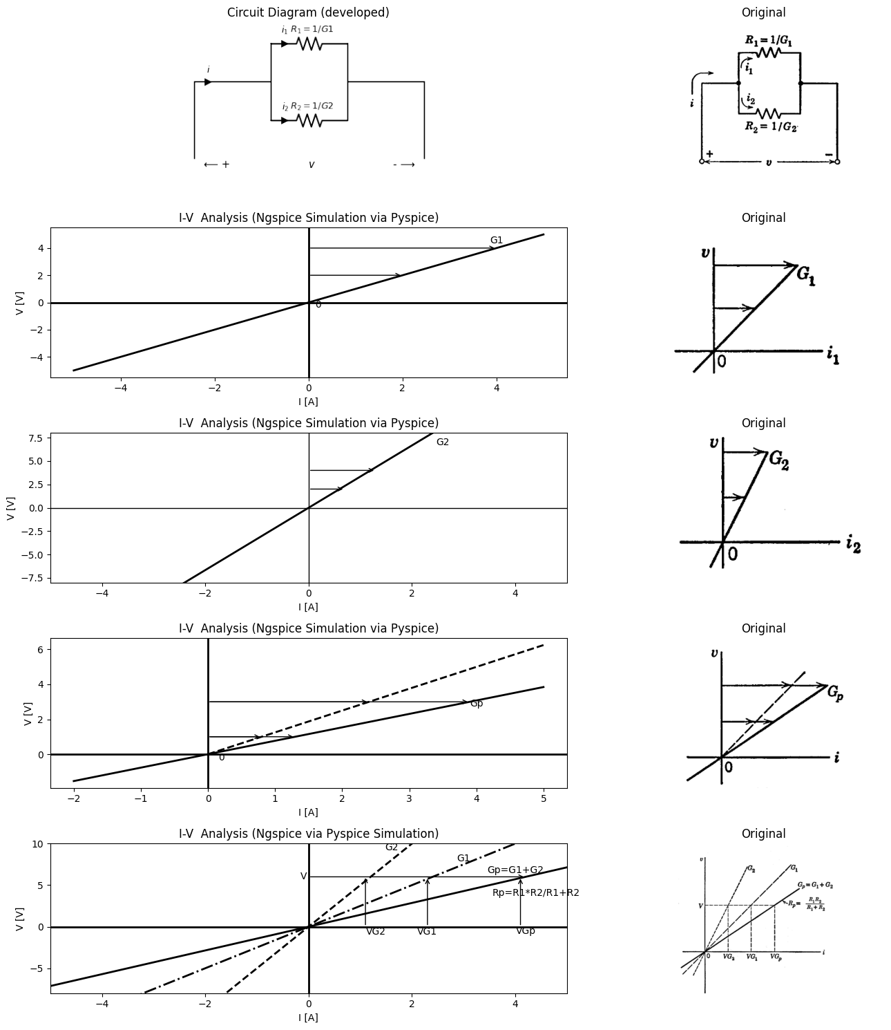
$$i=i_{1}+i_{2}$$
$$i=v\left(G_{1}+G_{2}\right)$$
$$i=vG_{P}$$
$$i=v/R_{P}$$
$$\left(b\right)$$

2.2.0.1 Fig. 3.2. Resistances in parallel.
Figure 3.2 presents the dual problem of combining resistances in parallel. Here the voltage across the resistances is common, and the equivalent resistance of the parallel combination is obtained graphically by summing currents. Expressing the resistances $ R_1 $ and $ R_2 $ as the conductances $G_1= 1/R_1 $ and $G_{2}=1/R_{2}$ puts the equations in the same form as those for the series circuit. This is a consequence of the duality
principle. In fact, by applying this principle to the series-resistance problem given in Fig. 3.1, the solution for the parallel-resistance problem of Fig. 3.2 is immediately known. Using these methods, the total
import schemdraw
import schemdraw.elements as e
import schemdraw as schem
import matplotlib.pyplot as plt
import matplotlib.image as mpimg
import numpy as np
# Create the figure and subplots
fig, axs = plt.subplots(2, 2, figsize=(12, 12))
d = schemdraw.Drawing()
d += elm.SourceV().left().label('V', 'bottom')
d += elm.Line().left().length(3)
d += elm.Line().up().length(4)
d.push()
d += elm.Arrow().right().at((-5.2, 4.3)).length(0.75).label('$i$', 'top').color('black')
d.pop()
d += elm.Line().right().length(2).dot()
d.push()
d += elm.Line().up().length(1.5)
d.push()
d += elm.Arrow().up().at((-3.7, 4.5)).length(0.75).label('$i_1$', 'bottom').color('black')
d.pop()
d += (R1 := elm.Resistor().right().label('$R_1=1/G_1$', 'top'))
d += elm.Line().down().length(1.5)
d.pop()
d += elm.Line().down().length(1.5)
d.push()
d += elm.Arrow().down().at((-3.7, 3.5)).length(0.75).label('$i_2$', loc='bottom').color('black')
d.pop()
d += (R2 := elm.Resistor().right().label('$R_2=1/G_2$', 'bottom'))
d += elm.Line().up().length(1.5).dot()
d += elm.Line().right().length(0.8).dot(open=True )
d.push()
d += (R3 := elm.Resistor().right().label('$R_3$', 'top'))
d += elm.Line().down().length(4)
d += elm.Line().left().length(3)
d += elm.Arrow().right().length(2.3).at((-2.6, 1.3)).color('black')
d += elm.Arrow().right().length(0.2).at((-3.2, 1.5)).color('white').label('$V_p$', loc='bottom', color='black')
d += elm.Arrow().left().length(2.3).at((-3.6, 1.3)).color('black')
d += elm.Arrow().right().length(1.2).at((1.6, 1.3)).color('black')
d += elm.Arrow().right().length(0.2).at((1.3, 1.5)).color('white').label('$V_{R3}$', loc='bottom', color='black')
d += elm.Arrow().left().length(1.2).at((1, 1.3)).color('black')
d += elm.Line().down().length(2.6).at((-0.2,3.8)).color('gray').linestyle('--')
d.pop()
d.save('./Drawings/fig3-3.png')
d.save('./Drawings/fig3-3.svg')
# Load the saved PNG file into the subplot
img = mpimg.imread('./Drawings/fig3-3.png')
axs[0,0].imshow(img)
axs[0,0].axis('off') # Hide axes for image display
axs[0,0].set_title('Circuit Diagram (developed)')
# **Subplot (1, 2): PNG Sample File**
img_sample = mpimg.imread('images-books/3-3.png') # Load the PNG file
axs[0,1].imshow(img_sample)
axs[0,1].axis('off') # Hide axes for image display
axs[0,1].set_title('Original')
d.save('./Drawings/fig3-3.png')
d.save('./Drawings/fig3-3.svg')
d.save('./Drawings/fig3-3.jpg')
#
circuit = Circuit('v-i curve')
Vth = circuit.V('th', '1', circuit.gnd, 0@u_V)
circuit.R(1 ,'1', circuit.gnd, 1.5@u_Ohm )
simulator = circuit.simulator(temperature=25, nominal_temperature=25)
analysis = simulator.dc(Vth=slice(-5, 5, 0.1))
axs[1,0].plot(analysis['1'], u_A(-analysis.Vth),'black',linestyle='--',linewidth=2)
circuit = Circuit('v-i curve2')
Vt = circuit.V('t', '1', circuit.gnd, 0@u_V)
circuit.R(2 ,'1', circuit.gnd, 1@u_Ohm )
simulator = circuit.simulator(temperature=25, nominal_temperature=25)
analysis = simulator.dc(Vt=slice(-5, 5, 0.1))
axs[1,0].plot(analysis['1'], u_A(-analysis.Vt),'black',linestyle='-',linewidth=2)
circuit = Circuit('v-i curve3')
Vp = circuit.V('p', '1', circuit.gnd, 0@u_V)
circuit.R(2 ,'1', circuit.gnd, 5@u_Ohm )
simulator = circuit.simulator(temperature=25, nominal_temperature=25)
analysis = simulator.dc(Vp=slice(-5, 5, 0.1))
axs[1,0].plot(analysis['1'], u_A(-analysis.Vp),'black',linestyle='--',linewidth=2)
circuit = Circuit('v-i curve4')
Vs = circuit.V('s', '1', circuit.gnd, 0@u_V)
circuit.R(3 ,'1', circuit.gnd, 0.5@u_Ohm )
simulator = circuit.simulator(temperature=25, nominal_temperature=25)
analysis = simulator.dc(Vs=slice(-5, 5, 0.1))
axs[1,0].plot(analysis['1'], u_A(-analysis.Vs),'black',linestyle='--',linewidth=2)
circuit = Circuit('v-i curve5')
Vm = circuit.V('m', '1', circuit.gnd, 0@u_V)
circuit.R(4 ,'1', circuit.gnd, 0.75@u_Ohm )
simulator = circuit.simulator(temperature=25, nominal_temperature=25)
analysis = simulator.dc(Vm=slice(-5, 5, 0.1))
axs[1,0].plot(analysis['1'], u_A(-analysis.Vm),'black',linestyle='-.',linewidth=2)
axs[1,0].axhline(0, color='black', linewidth=2)
axs[1,0].axvline(0, color='black', linewidth=2)
axs[1,0].text(3., 4.4, 'G1', ha='center', va='center')
axs[1,0].text( 2, 4.5, 'G2', ha='center', va='center')
axs[1,0].text( 4, 3.3, 'Gp=G1+G2', ha='center', va='center')
axs[1,0].text( 4, 4.4, 'RT', ha='center', va='center')
axs[1,0].text( 4.4, 0.6, 'R3', ha='center', va='center')
axs[1,0].annotate('', xy=(4.1, 2.7), xytext=(0, 2.8), arrowprops=dict(arrowstyle='->'))
axs[1,0].annotate('', xy=(1.4, 2.8), xytext=(1.4, 0), arrowprops=dict(arrowstyle='->'))
axs[1,0].annotate('', xy=(2, 2.7), xytext=(2, 0), arrowprops=dict(arrowstyle='->'))
axs[1,0].annotate('', xy=(4, 2.7), xytext=(4, 0), arrowprops=dict(arrowstyle='->'))
axs[1,0].annotate('', xy=(4, 1), xytext=(4, 0), arrowprops=dict(arrowstyle='->'))
axs[1,0].text(-0.1, 2.8, 'V', ha='center', va='center')
axs[1,0].text(1.3, -0.6, 'VG2', ha='center', va='center')
axs[1,0].text(2.2, -0.6, 'VG1', ha='center', va='center')
axs[1,0].text(4., -0.5, 'VGp', ha='center', va='center')
axs[1,0].set_title('I-V Analysis (Ngspice Simulation via Pyspice)')
axs[1,0].set_xlim(-5, 5)
axs[1,0].set_ylim(-5, 5)
axs[1,0].set_ylabel('V [V]')
axs[1,0].set_xlabel('I [A]')
img_sample = mpimg.imread('images-books/3-3b.png') # Load the PNG file
axs[1,1].imshow(img_sample)
axs[1,1].axis('off') # Hide axes for image display
axs[1,1].set_title('Original')
# Show the combined plots
plt.tight_layout()
plt.show()
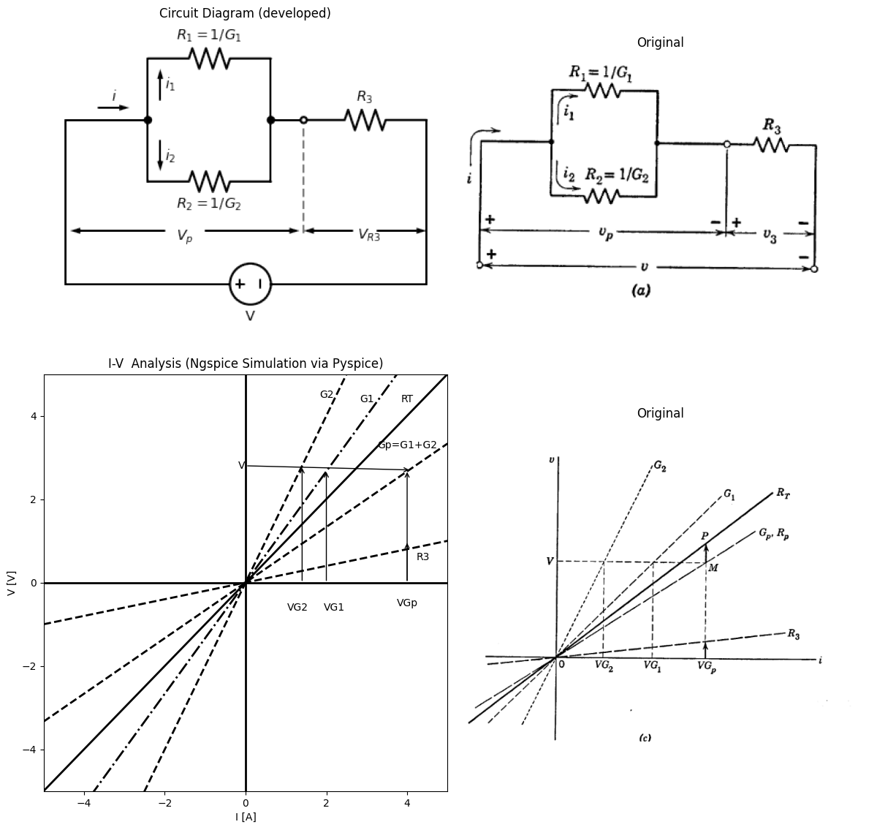
$$v=v_{p}+v_{3}$$
$$v=i\left(R_{p}+R_{3}\right)$$
$$v=iR_{T}$$
$$\left(b\right)$$

2.2.0.2 Fig. 3.3.series-parallel combination
resistance $R_{T}$ for a series-parallel combination of resistances is deter- mined graphically in Fig. 3.3. The foregoing examples illustrate several important points. A straight line through the origin of a voltage versus current plane represents a
linear resistance $R$ or a conductance $G=1/R$. Thus, data given either as resistance or conductance may be plotted equally well, and no con- version from one to the other is necessary. Any number of resistances or conductances can be combined in series and parallel, and the resultant
import schemdraw
import schemdraw.elements as e
import ipywidgets as widgets
from ipywidgets import interact
#@interact(Mode1=(True) , Mode2=(True), Mode3=(True))
@interact(E=widgets.IntSlider(min=-40, max=40, step=1, value=2))
def response(Ev=2):
with schemdraw.Drawing() as d:
R = d.add(e.Resistor().right().label('$R=1/G$'))
d += e.lines.CurrentLabelInline().at(R).right().label('$i_1$').color('black')
if (Ev > 0):
E = d.add(e.Battery().right().at(R.end).label(f'$+\quad E= {Ev}\quad-$'))
line_down1 = d.add(e.Line().down().at(E.end).dot(open=True))
elif (Ev < 0):
E = d.add(e.Battery().right().reverse().at(R.end).label(f'$-\quad E= {Ev}\quad+$'))
line_down1 = d.add(e.Line().down().at(E.end).dot(open=True))
else:
line_left1 = d.add(e.Line().right().at(R.end).dot(open=True))
line_down1 = d.add(e.Line().down().at(line_left1.end).dot(open=True))
line_down2 = d.add(e.Line().down().at(R.start).dot(open=True))
d += e.Gap().down().label('⟵ + $v$ - ⟶',
fontsize = 16).color('black').at((3,-1))
d += e.Gap().down().label('$ v=iR+E $ ',fontsize = 12).color('black').at((3,-2))
d.draw()
{"model_id":"644121f5570a45dd9b4be044c900e31a","version_major":2,"version_minor":0}
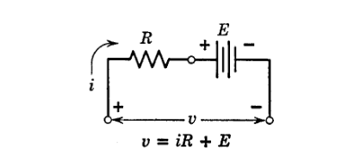
$$v=iR+E$$
$$\left(a\right)$$
import ipywidgets as widgets
from ipywidgets import interact
import matplotlib.pyplot as plt
from matplotlib import rcParams
import PySpice.Logging.Logging as Logging
logger = Logging.setup_logging()
from PySpice.Probe.Plot import plot
from PySpice.Spice.Netlist import Circuit
from PySpice.Unit import *
rcParams['font.weight'] = 'bold'
figure = plt.figure(figsize=(15, 10))
#@interact(Mode1=(True) , Mode2=(True), Mode3=(True))
@interact(E=widgets.IntSlider(min=-40, max=40, step=1, value=40))
def response(E=40):
circuit = Circuit('Resistance and voltage')
Vth = circuit.V('th', '1', circuit.gnd, 0@u_V)
circuit.R(1, '1', '2', 2@u_Ohm)
circuit.V('fixed', '2', '3', E@u_V)
circuit.R(2, '3', circuit.gnd, 0@u_Ohm)
simulator = circuit.simulator(temperature=25, nominal_temperature=25)
analysis = simulator.dc(Vth=slice(-800, 800, 0.1))
I = (analysis['1'] - analysis['2']) / 2
# Plot for R1
plt.plot(I, analysis['1'], 'black', linewidth=3 )
plt.plot(I, (analysis['1'] - analysis['2']), 'black', linewidth=2,linestyle='--' , label='R')
plt.annotate('', xy=(20, 40), xytext=(20, 0), arrowprops=dict(arrowstyle='->'))
plt.annotate('', xy=(15, 70), xytext=(15, 40), arrowprops=dict(arrowstyle='<->'))
plt.annotate('', xy=(-20, 40), xytext=(40, 40), arrowprops=dict(arrowstyle='-'))
plt.text(0.1, E, 'E', ha='center', va='center')
plt.legend(loc='best' , fontsize=16)
plt.text(2, E-2, 'E', ha='center', va='center')
if( E > 0):
plt.text(-E/2, -2, '-E/R', ha='center', va='center')
else:
plt.text(-E/2, 2, 'E/R', ha='center', va='center')
plt.text(E/2 + 2, 78, 'V=iR+E', ha='center', va='center')
plt.text(40, 78, 'R', ha='center', va='center')
plt.xlim([-80, 80])
plt.xlabel('I [A]')
plt.ylabel('V [V]')
plt.ylim([-80, 80])
#x=0 و y=0
plt.axhline(0, color='black', linewidth=1)
plt.axvline(0, color='black', linewidth=1)
plt.tight_layout()
plt.show()
figure.savefig('./Drawings/fig16.svg')
<Figure size 1500x1000 with 0 Axes>
{"model_id":"fb896e83c8d547af89521ea8d3ee9a41","version_major":2,"version_minor":0}
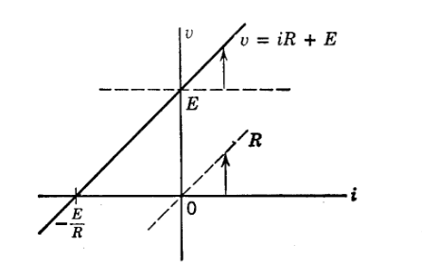
import schemdraw
import schemdraw.elements as e
import schemdraw as schem
import matplotlib.pyplot as plt
import matplotlib.image as mpimg
import numpy as np
# Create the figure and subplots
fig, axs = plt.subplots(2, 2, figsize=(12, 12))
d = schemdraw.Drawing()
R = d.add(e.Resistor().right().label('$R=1/G$'))
d += e.lines.CurrentLabelInline().at(R).right().label('$i_1$').color('black')
line_down1 = d.add(e.Line().down().at(R.end))
l1 = d.add(e.Line().right().at(line_down1.center))
I = d.add(e.SourceI().left().at((R.end[0], R.end[1] - 3)).label('$I$'))
line_down2 = d.add(e.Line().down().at(R.start))
l2 = d.add(e.Line().left().at(line_down2.center))
d += e.lines.CurrentLabelInline().at(l2).right().label('$i$').color('black')
d.add(e.Line().down().at(R.start))
d.add(e.Line().down().at(l1.end))
d.add(e.Line().down().at(l2.end))
d += e.Gap().down().label('⟵ + $v$ - ⟶',
fontsize = 16).color('black').at((1.5,-2.5))
d.draw()
d.save('./Drawings/fig3-4b.png')
d.save('./Drawings/fig3-4b.svg')
# Load the saved PNG file into the subplot
img = mpimg.imread('./Drawings/fig3-4b.png')
axs[0,0].imshow(img)
axs[0,0].axis('off') # Hide axes for image display
axs[0,0].set_title('Circuit Diagram (developed)')
# **Subplot (1, 2): PNG Sample File**
img_sample = mpimg.imread('images-books/3-4c.png') # Load the PNG file
axs[0,1].imshow(img_sample)
axs[0,1].axis('off') # Hide axes for image display
axs[0,1].set_title('Original')
#
circuit = Circuit('Resistance and voltage')
Vth = circuit.V('th', '1', circuit.gnd, 0@u_V)
circuit.R(1, '1', '2', 2@u_Ohm)
circuit.V('fixed', '2', '3', 40@u_V)
circuit.R(2, '3', circuit.gnd, 0@u_Ohm)
simulator = circuit.simulator(temperature=25, nominal_temperature=25)
analysis = simulator.dc(Vth=slice(-800, 800, 0.1))
I = (analysis['1'] - analysis['2']) / 2
# Plot for R1
axs[1,0].plot(I, analysis['1'], 'black', linewidth=3 )
axs[1,0].plot(I, analysis['1'], 'black', linewidth=3 , label='$V-IR=ir$')
axs[1,0].plot(I, (analysis['1'] - analysis['2']), 'black', linewidth=1 ,linestyle='--', label='R')
axs[1,0].annotate('', xy=(20, 40), xytext=(20, 0), arrowprops=dict(arrowstyle='->'))
axs[1,0].annotate('', xy=(15, 70), xytext=(15, 40), arrowprops=dict(arrowstyle='->'))
axs[1,0].annotate('', xy=(-20, 40), xytext=(40, 40), arrowprops=dict(arrowstyle='-'))
axs[1,0].annotate('', xy=(-20, -30), xytext=(-20, 30), arrowprops=dict(arrowstyle='-'))
axs[1,0].annotate('', xy=(-10, 20), xytext=(-20, 20), arrowprops=dict(arrowstyle='->'))
axs[1,0].annotate('', xy=(10, 20), xytext=(0, 20), arrowprops=dict(arrowstyle='->'))
axs[1,0].text(0.1, 40, 'E', ha='center', va='center')
axs[1,0].legend(loc='best' , fontsize=16)
axs[1,0].text(23.2, 78, 'V-IR=ir', ha='center', va='center')
axs[1,0].text(23.2, 75, 'i=V/R-I', ha='center', va='center')
axs[1,0].text(40, 75, 'R', ha='center', va='center')
axs[1,0].text(2.2, 37, 'IR', ha='center', va='center')
axs[1,0].text(-18, -2.2, '-I', ha='center', va='center')
axs[1,0].set_xlim(-80, 80)
axs[1,0].set_ylim(-80,80)
axs[1,0].set_ylabel('V [V]')
axs[1,0].set_xlabel('I [A]')
axs[1,0].axhline(0, color='black', linewidth=1)
axs[1,0].axvline(0, color='black', linewidth=1)
img_sample = mpimg.imread('images-books/3-4d.png') # Load the PNG file
axs[1,1].imshow(img_sample)
axs[1,1].axis('off') # Hide axes for image display
axs[1,1].set_title('Original')
# Show the combined plots
plt.tight_layout()
plt.show()
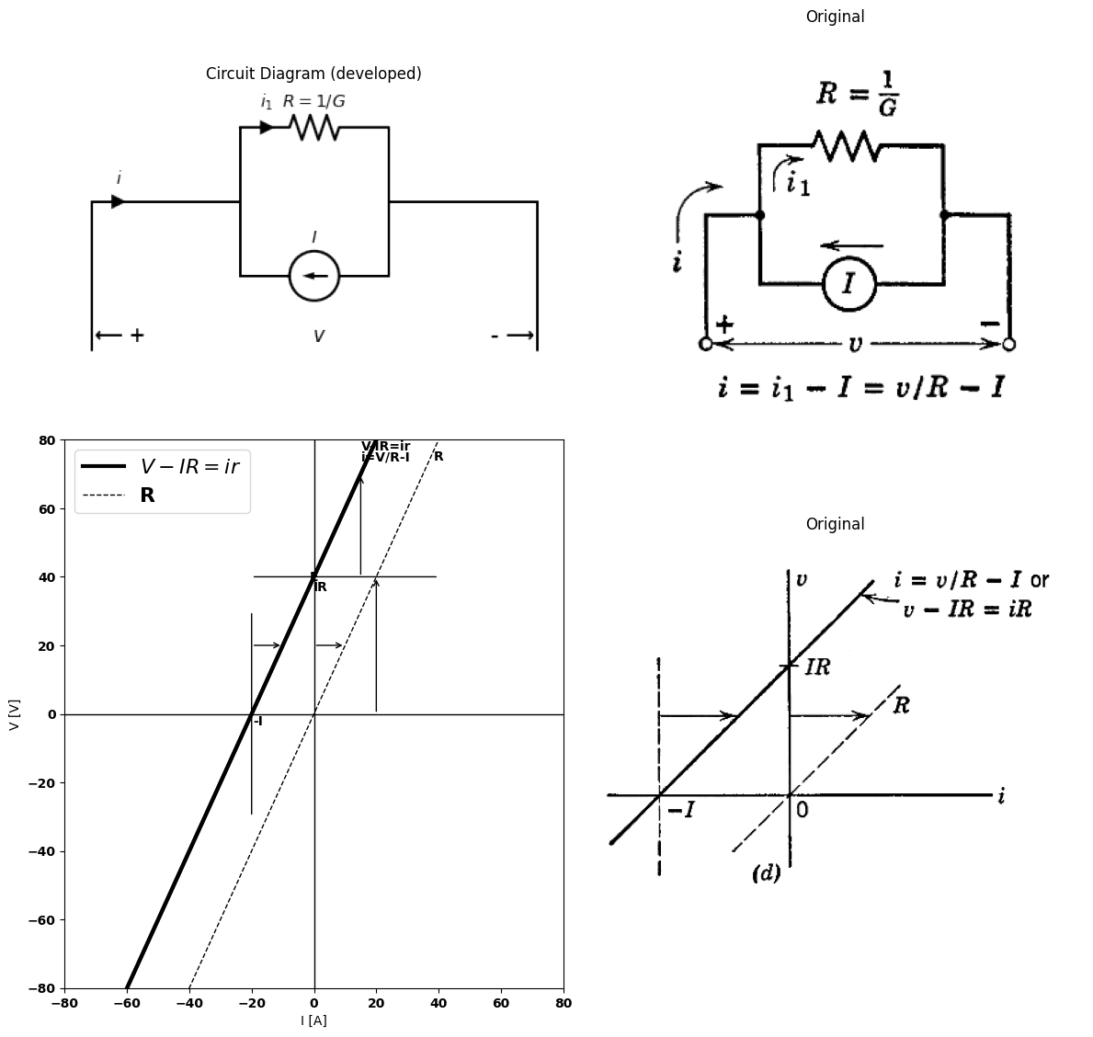
import schemdraw
import schemdraw.elements as e
import schemdraw as schem
import matplotlib.pyplot as plt
import matplotlib.image as mpimg
from schemdraw import dsp
import numpy as np
# Create the figure and subplots
fig, axs = plt.subplots(2, 2, figsize=(12, 12))
d = schemdraw.Drawing()
line_Right1 = d.add(e.Line().right())
d += e.lines.CurrentLabelInline().at(line_Right1).right().label('$i$').color('BLACK')
d += ( T := dsp.Box(w=3, h=3).anchor('W').fill('white').label('Resistances\n and\n batteries'))
line_Right2 = d.add(e.Line().right().at(T.E))
line_down1 = d.add(e.Line().down().at(line_Right1.start).dot(open=True))
line_down2 = d.add(e.Line().down().at(line_Right2.end).dot(open=True))
d += e.Gap().down().label('⟵ + $v$ - ⟶',
fontsize = 16).color('BLACK').at((4.5,-1))
d.draw()
d.save('./Drawings/fig3-4e.png')
d.save('./Drawings/fig3-4e.svg')
# Load the saved PNG file into the subplot
img = mpimg.imread('./Drawings/fig3-4e.png')
axs[0,0].imshow(img)
axs[0,0].axis('off') # Hide axes for image display
axs[0,0].set_title('Circuit Diagram (developed)')
# **Subplot (1, 2): PNG Sample File**
img_sample = mpimg.imread('images-books/3-4e.png') # Load the PNG file
axs[0,1].imshow(img_sample)
axs[0,1].axis('off') # Hide axes for image display
axs[0,1].set_title('Original')
#
circuit = Circuit('Resistance and voltage')
Vth = circuit.V('th', '1', circuit.gnd, 0@u_V)
circuit.R(1, '1', '2', 120@u_Ohm)
circuit.V('fixed', '2', '3', 40@u_V)
circuit.R(2, '3', circuit.gnd, 0@u_Ohm)
simulator = circuit.simulator(temperature=25, nominal_temperature=25)
analysis = simulator.dc(Vth=slice(-800, 800, 0.1))
I = (analysis['1'] - analysis['2']) / 1
# Plot for R1
axs[1,0].plot(I, analysis['1'], 'black', linewidth=3 , label='RO=Eoc/Isc')
axs[1,0].text(0.1, 40, 'E', ha='center', va='center')
axs[1,0].legend(loc='best' , fontsize=16)
axs[1,0].text(-20, -0.6, '$-Isc$', ha='center', va='center')
axs[1,0].text(-38, -2, 'Isc', ha='center', va='center')
axs[1,0].text(3, 40, '$Eoc$', ha='center', va='center')
axs[1,0].text(20, 60, 'RO=Eoc/Isc', ha='center', va='center')
axs[1,0].text(0, 40, '0', ha='center', va='center')
axs[1,0].text(-40, 0, '0', ha='center', va='center')
axs[1,0].set_xlim(-80, 80)
axs[1,0].set_ylim(-80,80)
axs[1,0].set_ylabel('V [V]')
axs[1,0].set_xlabel('I [A]')
axs[1,0].axhline(0, color='black', linewidth=1)
axs[1,0].axvline(0, color='black', linewidth=1)
img_sample = mpimg.imread('images-books/3-4f.png') # Load the PNG file
axs[1,1].imshow(img_sample)
axs[1,1].axis('off') # Hide axes for image display
axs[1,1].set_title('Original')
plt.tight_layout()
plt.show()
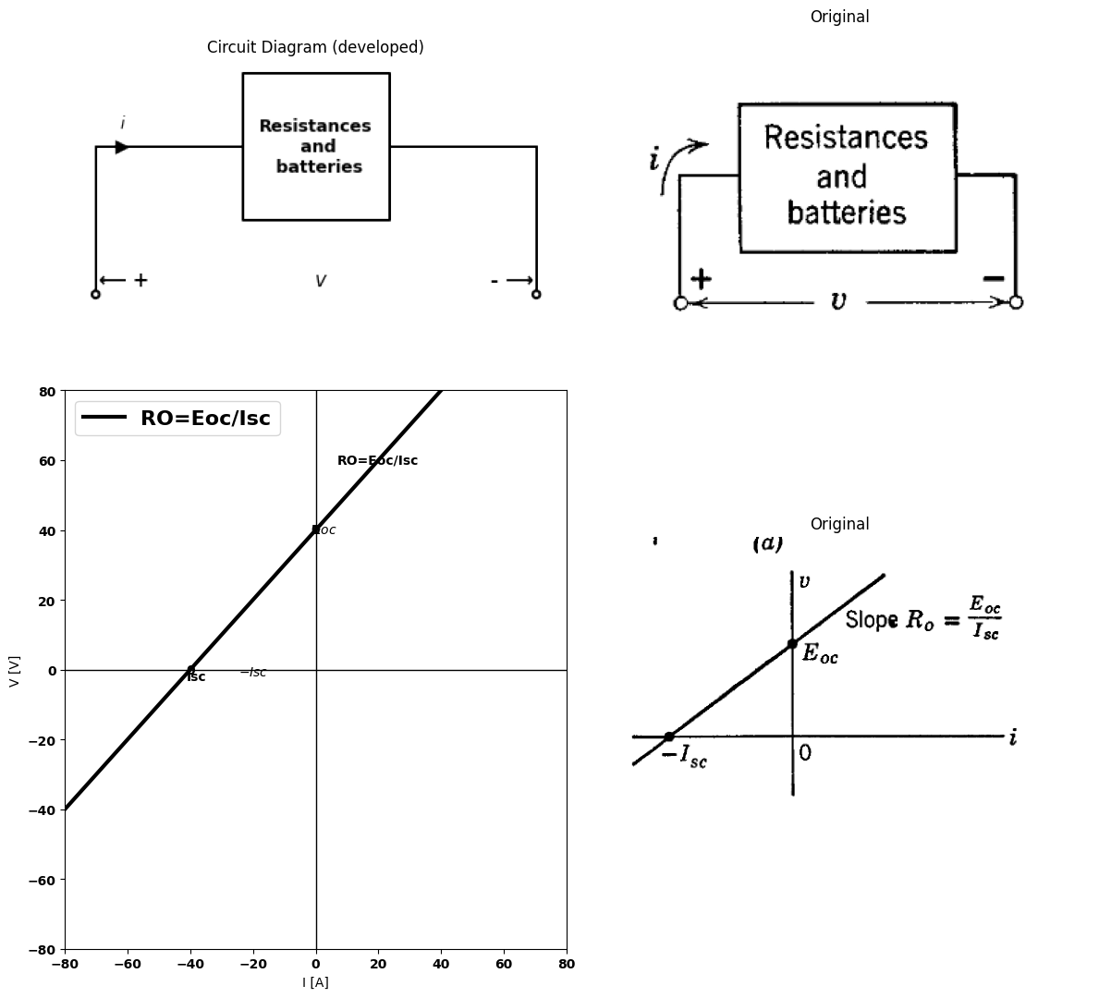

2.2.0.3 Fig. 3.4. Resistance and voltage or current source. Circuits $\left(a\right)$ and $\left(c\right)$ are equivalent if the resistances are equal and if $I=E/R$
plot will still be a line through the origin with a slope equal to the total resistance.
The graphical effect of including a source as part of a resistive circuit amounts to a translation of coordinates or, alternatively, a translation of the resistive line so that it does not pass through the origin. Since an ideal voltage source is independent of current, it appears as a line of zero slope, thus placing in evidence the fact that it has no internal resistance.
Similarly, a current source appears as a line of constant current for all voltages.
Consider the series combination of a resistance and battery shown in Fig. 3.4$\left(a\right)$. The resistance $R$ might, of course, represent the composite effect of any number of resistances, in accordance with the results above. In the graphical representation of this circuit shown in Fig. 3.4$\left(b\right)$, the line has a slope $R$, a voltage intercept $E$, and a current intercept - $E/R$.
Referring to Fig. 3.4$\left(c\right)$ and $\left(d\right)$, we see that a current source in parallel with a resistance has the same graphical appearance as a voltage source in series with a resistance. If the source values are related by $E=IR$, and a common value of resistance is chosen, the circuits $\left(a\right)$ and $\left(c\right)$ are equivalent, and the plots in $\left(b\right)$ and $\left(d\right)$ are identical. Thus, we have pictorial evidence of the equivalence of voltage source with series resistance and current source with parallel resistance. Conversely, for an arbitrary straight line in a voltage versus current plane, the slope and intercepts determine the values for the parameters in the voltage- source or current-source representation of the line. Thus, the circuits in Fig. 3.4$\left(a\right)$ and $\left(c\right)$ are general circuit models for any straight line in a $v$ vs. $i$ plane. If the intercept is zero, the circuit model contains no source, and the line represents only a resistance.
Note specifically that the voltage intercept corresponds to zero current and is therefore the open-circuit voltage, whereas the current intercept corresponds to zero voltage and hence is short-circuit current. Thus we see that $resistance$ $between$ $a$ $pair$ $of$ $terminals$ in a network is the $ratio$ $of$ $the$ $open−circuit$ $voltage$ $to$ $the$ $short−circuit$ $current$ ($with$ $proper$ $sign$). Furthermore, it is evident from these facts that the behavior of an arbitrary resistive network is completely described at a pair of terminals by this resistance and either the voltage or the current source.
Note that the $v$ vs. $i$ plot of a positive resistance will have a positive slope only if current and voltage reference directions are appropriately chosen. Negative slope does not necessarily imply negative resistance.$*$
As a more general example, consider the circuit shown in Fig. 3.5. To relate the graphical interpretation to the algebraic relations, the lines in the $v$ vs. $i$ plane are numbered to correspond to the algebraic equations. The solution may be summarized as follows:
$\left(a\right)$ Plot lines $\left(1\right)$ and $\left(2\right)$ with appropriate slopes and intercepts. $\left(b\right)$ Choose convenient points (like A and B) and sum currents of $\left(1\right)$ and $(2) $to obtain line $\left(3\right)$.
$*$ Negative resistance is a useful concept in electronic circuit analysis. In contrast to positive resistance, which dissipates power, negative resistance is a convenient way to represent certain types of power sources. Further discussion is deferred until Chapter 9.
import schemdraw
import schemdraw.elements as e
import schemdraw as schem
import matplotlib.pyplot as plt
import matplotlib.image as mpimg
import numpy as np
# Create the figure and subplots
fig, axs = plt.subplots(2, 2, figsize=(12, 12))
d = schemdraw.Drawing()
d += elm.SourceV().left().label('V', 'bottom')
d += elm.Line().left().length(4)
d += elm.Line().up().length(5)
d.push()
d += elm.Arrow().right().at((-6.2, 5.3)).length(0.75).label('$i$', 'top').color('black')
d.pop()
d += elm.Line().right().length(2).dot()
d.push()
d += elm.Line().up().length(1.5)
d.push()
d += elm.Arrow().up().at((-4.7, 5.5)).length(0.75).label('$i_1$', 'bottom').color('black')
d.pop()
d += (R1 := elm.Resistor().right().label('$R_1=1/G_1$', 'top'))
d += elm.Battery().label('$E_1$', 'top') # ایجاد نماد باتری با برچسب 'Battery'
d += elm.Line().down().length(1.5)
d.pop()
d += elm.Line().down().length(1.5)
d.push()
d += elm.Arrow().down().at((-4.7, 4.5)).length(0.75).label('$i_2$', loc='bottom').color('black')
d.pop()
d += (R2 := elm.Resistor().right().label('$R_2=1/G_2$', 'bottom')).dot()
d.push()
d += (R3 := elm.Resistor().right().label('$R_3$', 'top'))
d += elm.Line().up().length(1.5).dot()
d += (R4 := elm.Resistor().right().label('$R_4$', 'top'))
d += elm.Line().down().length(5)
d += elm.Line().left().length(4)
d += elm.Arrow().right().length(3.3).at((-2.4, 1.3)).color('black')
d += elm.Arrow().right().length(0.2).at((-3.0, 1.5)).color('white').label('$V_P$', loc='bottom', color='black')
d += elm.Arrow().left().length(3.3).at((-3.6, 1.3)).color('black')
d += elm.Arrow().right().length(1.2).at((2.8, 1.3)).color('black')
d += elm.Arrow().right().length(0.2).at((2.4, 1.5)).color('white').label('$V_{R4}$', loc='bottom', color='black')
d += elm.Arrow().left().length(1.2).at((2.3, 1.3)).color('black')
d += elm.Line().down().length(0.7).at((1.0,1.7)).color('gray').linestyle('-')
d.pop()
d.pop()
d += elm.Line().down().length(1.5)
d += elm.SourceI().right().label('I', 'top')
d += elm.Line().up().length(1.5).dot()
d.save('./Drawings/fig3-5.jpg')
d.save('./Drawings/fig3-5.svg')
# Load the saved PNG file into the subplot
img = mpimg.imread('./Drawings/fig3-5.jpg')
axs[0,0].imshow(img)
axs[0,0].axis('off') # Hide axes for image display
axs[0,0].set_title('Circuit Diagram (developed)')
# **Subplot (1, 2): PNG Sample File**
img_sample = mpimg.imread('images-books/3-5a.png') # Load the PNG file
axs[0,1].imshow(img_sample)
axs[0,1].axis('off') # Hide axes for image display
axs[0,1].set_title('Original')
# Show the combined plots
circuit = Circuit('v-i curve')
Vth = circuit.V('th', '1', circuit.gnd, 0@u_V)
circuit.R(1 ,'1', circuit.gnd, 1.5@u_Ohm )
simulator = circuit.simulator(temperature=25, nominal_temperature=25)
analysis = simulator.dc(Vth=slice(-800, 800, 0.1))
axs[1,0].plot(analysis['1'], u_A(-analysis.Vth),'black',linestyle='--',linewidth=1)
#
circuit = Circuit('Resistance and voltage')
Vth = circuit.V('th', '1', circuit.gnd, 0@u_V)
circuit.R(1, '1', '2', 3@u_Ohm)
circuit.V('fixed', '2', '3', 40@u_V)
circuit.R(2, '3', circuit.gnd,2@u_Ohm)
simulator = circuit.simulator(temperature=25, nominal_temperature=25)
analysis = simulator.dc(Vth=slice(-800, 800, 0.1))
I = (analysis['1'] - analysis['2']) / 2
# Plot for R1
axs[1,0].plot(I, analysis['1'], 'black', linewidth=2 )
#plt.plot(I, (analysis['1'] - analysis['2']), 'black', linewidth=2,linestyle='-.' , label='R')
#
circuit = Circuit('Resistance and voltage')
Vth = circuit.V('th', '1', circuit.gnd, 0@u_V)
circuit.R(1, '1', '2', 8@u_kOhm)
circuit.V('fixed', '2', '3', -30@u_V)
circuit.R(2, '3', circuit.gnd, 0@u_Ohm)
simulator = circuit.simulator(temperature=25, nominal_temperature=25)
analysis = simulator.dc(Vth=slice(-800, 800, 0.1))
I = (analysis['1'] - analysis['2']) / 2
# Plot for R1
axs[1,0].plot(I, analysis['1'], 'black', linewidth=1,linestyle='-.' )
##
circuit = Circuit('Resistance and voltage')
Vth = circuit.V('th', '1', circuit.gnd, 0@u_V)
circuit.R(1, '1', '2', 100@u_Ohm)
circuit.V('fixed', '2', '3', 40@u_V)
circuit.R(2, '3', circuit.gnd,1@u_Ohm)
simulator = circuit.simulator(temperature=25, nominal_temperature=25)
analysis = simulator.dc(Vth=slice(-800, 800, 0.1))
I = (analysis['1'] - analysis['2']) / 2
# Plot for R1
axs[1,0].plot(I, analysis['1'], 'black', linewidth=1,linestyle='-.' )
##
circuit = Circuit('Resistance and voltage')
Vth = circuit.V('th', '1', circuit.gnd, 0@u_V)
circuit.R(1, '1', '2', 2@u_Ohm)
circuit.V('fixed', '2', '3', 70@u_V)
circuit.R(2, '3', circuit.gnd, 1@u_Ohm)
simulator = circuit.simulator(temperature=25, nominal_temperature=25)
analysis = simulator.dc(Vth=slice(-800, 800, 0.1))
I = (analysis['1'] - analysis['2']) / 1
# Plot for R1
axs[1,0].plot(I, analysis['1'], 'black', linewidth=1,linestyle='--' , label='RO=Eoc/Isc')
axs[1,0].text(-3, 70, 'E1', ha='center', va='center')
axs[1,0].text(-4, 40, 'Eoc', ha='center', va='center')
axs[1,0].text(-7, 3, 'Isc', ha='center', va='center')
axs[1,0].text(5, 85, '(1)', ha='center', va='center')
axs[1,0].text(35, 45, '(2)', ha='center', va='center')
axs[1,0].text(15, 60, '(3)', ha='center', va='center')
axs[1,0].text(40, 20, '(4)', ha='center', va='center')
axs[1,0].text(3, 65, '(5)', ha='center', va='center')
axs[1,0].text(-25, 50, '{vp vs i1\n slope R1', ha='center', va='center')
axs[1,0].text(60, 25, '{v4 vs i \n slope R4', ha='center', va='center')
axs[1,0].text(70, 65, '{vp vs.i \n slope R1(R1+R3/(R1+R2+R3))', ha='center', va='center')
axs[1,0].text(3, 65, '(5)', ha='center', va='center')
axs[1,0].text(-82,-60, 'B', ha='center', va='center')
axs[1,0].axhline(0, color='black', linewidth=2)
axs[1,0].axvline(0, color='black', linewidth=2)
axs[1,0].set_title('I-V Analysis (Ngspice Simulation via Pyspice)')
axs[1,0].set_xlim(-100, 80)
axs[1,0].set_ylim(-80,80)
axs[1,0].set_ylabel('V [V]')
axs[1,0].set_xlabel('I [A]')
axs[1,0].axhline(0, color='black', linewidth=1)
axs[1,0].axvline(0, color='black', linewidth=1)
img_sample = mpimg.imread('images-books/3-5b.png') # Load the PNG file
axs[1,1].imshow(img_sample)
axs[1,1].axis('off') # Hide axes for image display
axs[1,1].set_title('Original')
plt.tight_layout()
plt.show()
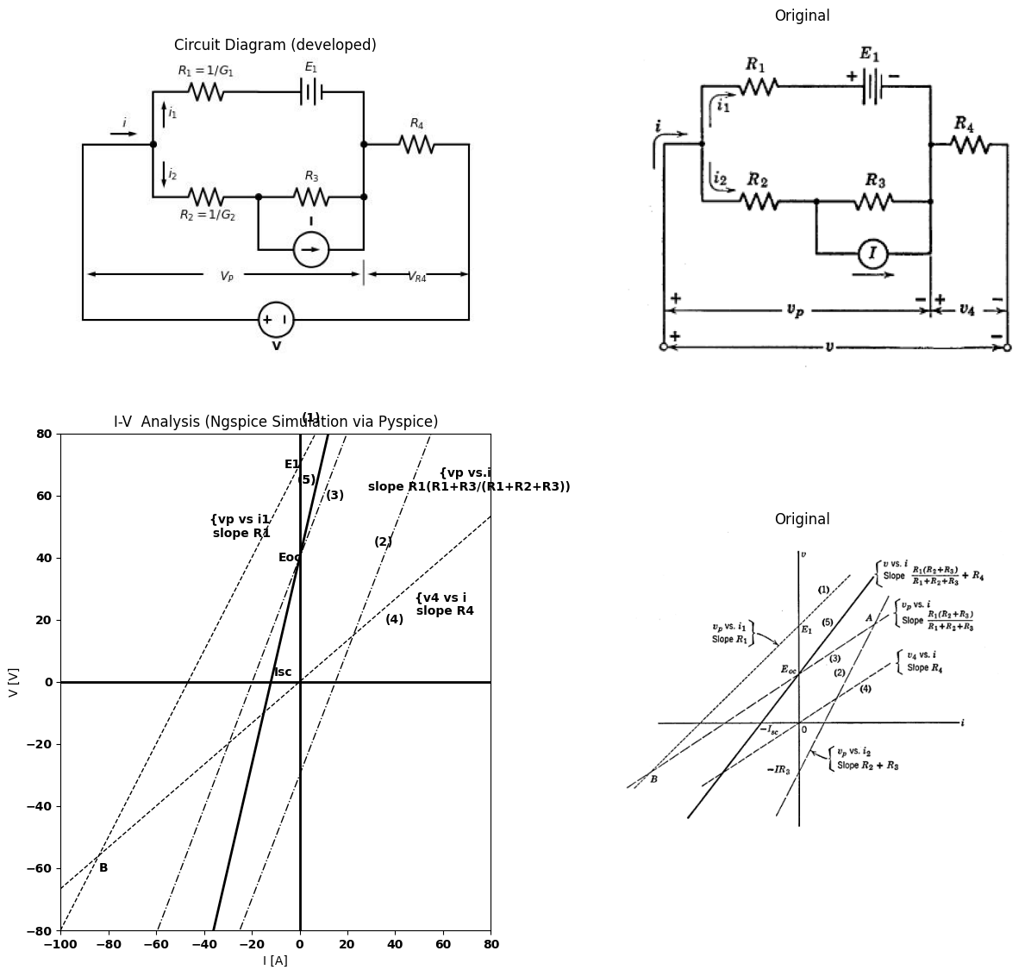
$$\left(1\right)v_{p}=i_{1}R_{1}+E_{1}$$
$$\left(2\right)V_{p}=i_{2}R_{2}+\left(i_{2}−I\right)R_{3}$$
$$=\left(R_{2}+R_{3}\right)−IR_{3}$$
$$\left(3\right)i=i_{1}+i_{2}−−>\left(v_{p}Vs.i\right)$$
$$\left(4\right)v_{4}=iR_{4}$$
$$\left(5\right)v=v_{p}+v_{4}$$
Fig. 3.5. multiple resistances and sources
$\left(c\right)$ Plot line $\left(4\right)$. $\left(d\right)$ Choose convenient points (like $E_{o}c$ and $−I_{s}c$) and sum voltages of $\left(3\right)$ and $\left(4\right)$ to obtain line $\left(5\right)$. Comparison of Figs. 3.4$\left(b\right)$ and $\left(d\right)$ and 3.5 shows that the circuit of Fig. 3.5 is equivalent to a voltage source $E_{o}c$ in series with a resistance $R_{o}$, or a current source $I_{s}c$ in parallel with $R_{o}$, where $R_{o}$ equals $E_{o}c/I_{s}c$.
The generalization of this concept is illustrated in Fig. 3.4$\left(e\right)$ and $\left(f\right)$. Regardless of circuit complexity, we can always reduce any number of resistances, batteries, and current sources to the same simple form of voltage versus current relation at a pair of terminals. Figures 3.4$\left(b\right)$, $\left(d\right)$, and$ (f)$ are identical in form, and hence they illustrate the Thevenin equivalent circuit concept. The graphical approach to resistive circuits. has enabled us to deduce this result without stating or attempting to prove Thevenin's theorem. Furthermore, the graphical approach. emphasizes the fact that this simple terminal representation for any resistive circuit is a direct consequence of linearity. The addition of currents or voltages specified by nonlinear relations does not lead to such generality. import schemdraw
import schemdraw
import schemdraw.elements as elm
import schemdraw as schem
import matplotlib.pyplot as plt
import matplotlib.image as mpimg
import numpy as np
# Create the figure and subplots
fig, axs = plt.subplots(1, 2, figsize=(12, 12))
d = schemdraw.Drawing()
d += elm.Line().right(d.unit*.1).idot()
d += (Line:= elm.Line().reverse().dot())
d.push()
d += (R1:= elm.Resistor().down().dot(open=True).label('$R1$' , 'bot'))
d += (N := elm.Diode().dot())
d += elm.Line().tox(R1.start)
d += ( L3 := elm.Line().left(d.unit*1.1).dot())
d += elm.Gap().toy(R1.start).label( '$v$')
d.pop()
d += elm.Arrow().up().length(1.5).linewidth(0.6).color('black').label('+',loc='end', color='black',ofst=-0.2). at((-.1,-1.6))
d += elm.Arrow().down().length(1.5).linewidth(0.6).color('black').label(r'_', loc='end', color='black',ofst=(-.5, 0.2)). at((-.1,-4.5))
d += e.Arrow().right().at((1.6, .5)).length(0.75).label('$i$').color('black')
d += elm.Line().right().length(1).at((2.3,-3)).color('black').linestyle('-')
d += elm.Arrow().up().linewidth(0.6).length(4).linewidth(0.6).linewidth(0.6).color('white').label('$VR1$', loc='start', color='black',ofst=0.3). at((2.8,-1.5))
d += elm.Arrow().up().length(.5).linewidth(0.6).color('black').label('+',loc='end', color='black',ofst=-0.2). at((2.5,-.6))
d += elm.Arrow().down().length(.5).linewidth(0.6).color('black').label(r'_', loc='end', color='black',ofst=(-.5, 0.2)). at((2.5,-2.5))
d += elm.Arrow().up().linewidth(0.6).length(4).linewidth(0.6).linewidth(0.6).color('white').label('$eb$', loc='start', color='black',ofst=0.3). at((2.8,-4.5))
d += elm.Arrow().up().length(.5).linewidth(0.6).color('black').label('+',loc='end', color='black',ofst=-0.2). at((2.5,-3.6))
d += elm.Arrow().down().length(.5).linewidth(0.6).color('black').label(r'_', loc='end', color='black',ofst=(-.5, 0.2)). at((2.5,-5.5))
d.save('./Drawings/fig3-6.jpg')
d.save('./Drawings/fig3-6.svg')
# Load the saved PNG file into the subplot
img = mpimg.imread('./Drawings/fig3-6.jpg')
axs[0].imshow(img)
axs[0].axis('off') # Hide axes for image display
axs[0].set_title('Circuit Diagram (developed)')
# **Subplot (1, 2): PNG Sample File**
img_sample = mpimg.imread('images-books/3-6a.png') # Load the PNG file
axs[1].imshow(img_sample)
axs[1].axis('off') # Hide axes for image display
axs[1].set_title('Original')
# Show the combined plots
Text(0.5, 1.0, 'Original')
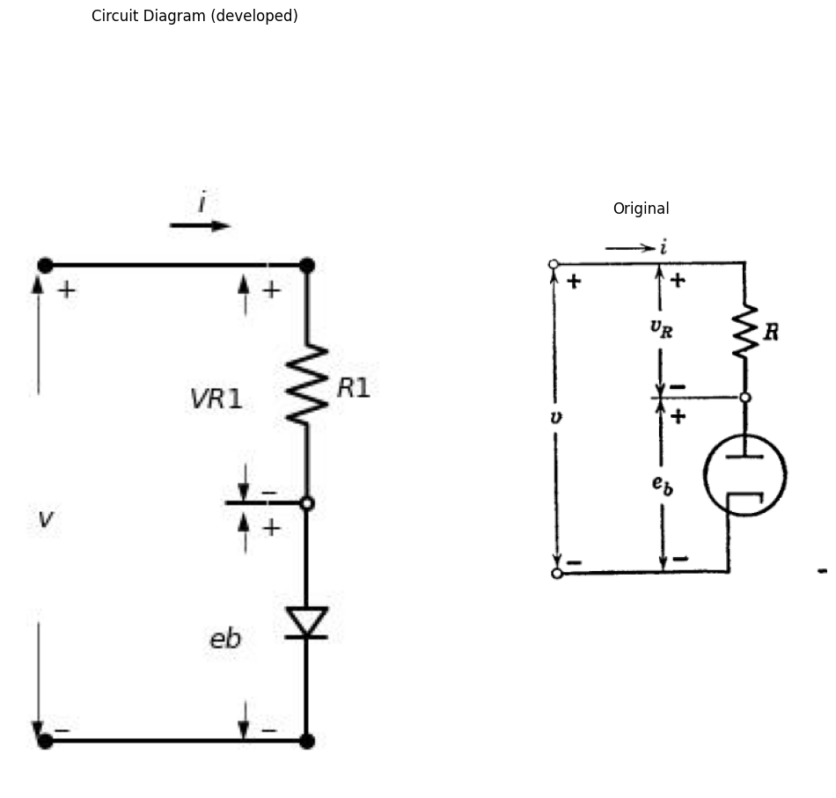
import matplotlib.pyplot as plt
from matplotlib import rcParams
import PySpice.Logging.Logging as Logging
import ipywidgets as widgets
from ipywidgets import interact
logger = Logging.setup_logging()
from PySpice.Probe.Plot import plot
from PySpice.Spice.Netlist import Circuit
from PySpice.Unit import *
#@interact(Mode1=(True) , Mode2=(True), Mode3=(True))
@interact(T=widgets.IntSlider(min=-40, max=125, step=1, value=27), R=widgets.IntSlider(min=0.1, max=1, step=0.1, value=0.3))
def response(T=27, R=0.3):
rcParams['font.weight'] = 'bold'
figure, ax1 = plt.subplots(figsize=(10, 5))
circuit = Circuit('v-i curve')
circuit.model('BAV21','D' ,IS = 14.5@u_nA , N = 1.906 ,BV = 110@u_V, IBV = 0.0001@u_V, VJ = .7@u_V ,CJO = 7.048E-13 ,RS = 14@u_Ohm ,TT = 3.48E-9)
Vi = circuit.V('i', '1', circuit.gnd, 5@u_V)
circuit.R(1, '1', '2', R@u_Ohm)
circuit.D(1, '2',circuit.gnd , model = 'BAV21')
simulator = circuit.simulator(temperature=T, nominal_temperature=25)
analysis = simulator.dc(Vi=slice(0, 15, 0.1))
ax1.plot(analysis['2'], u_mA(-analysis.Vi),'black',linewidth=2)
circuit = Circuit('v-i curve1')
circuit.model('BAV21','D' ,IS = 14.5@u_nA , N = 1.906 ,BV = 1000@u_V, IBV = 0.0001@u_V, VJ = .8@u_V ,CJO = 7.048E-13 ,RS = 100@u_Ohm ,TT = 3.48E-9)
Vi = circuit.V('i', '1', circuit.gnd, 5@u_V)
circuit.R(1, '1', '2', R@u_Ohm)
circuit.D(1, '2',circuit.gnd , model = 'BAV21')
simulator = circuit.simulator(temperature=T, nominal_temperature=25)
analysis = simulator.dc(Vi=slice(0, 15, 0.1))
ax1.plot(analysis['2'], u_mA(-analysis.Vi),'black',linestyle='-.',linewidth=2)
circuit = Circuit('thev')
Vi = circuit.V('i', '1', circuit.gnd, 0@u_V)
circuit.R(1 ,'1', circuit.gnd, 0.05@u_Ohm )
simulator = circuit.simulator(temperature=T, nominal_temperature=25)
analysis = simulator.dc(Vi=slice(-2, 3, 0.1))
ax1.plot(analysis['1'], u_A(-analysis.Vi),'black',linestyle='--',linewidth=2)
ax1.legend(('I-V diode curve','diode equation'), loc=(.8,.8))
ax1.set_title('Load Line Analysis (Ngspice Simulation via Pyspice)')
plt.annotate('', xy=(0.2, 4), xytext=(0, 4), arrowprops=dict(arrowstyle='->'))
plt.annotate('', xy=(0.1, 2), xytext=(0, 2), arrowprops=dict(arrowstyle='->'))
plt.annotate('', xy=(0.3, 6), xytext=(0, 6), arrowprops=dict(arrowstyle='->'))
plt.annotate('', xy=(1, 4), xytext=(1, 0), arrowprops=dict(arrowstyle='->'))
plt.annotate('', xy=(1.25, 6), xytext=(1.25, 0), arrowprops=dict(arrowstyle='->'))
plt.annotate('', xy=(0.8, 2), xytext=(0.8, 0), arrowprops=dict(arrowstyle='->'))
plt.annotate('', xy=(0.65, 4), xytext=(1, 0), arrowprops=dict(arrowstyle='->'))
plt.annotate('', xy=(0.7, 6), xytext=(1.25, 0), arrowprops=dict(arrowstyle='->'))
plt.annotate('', xy=(0.6, 2), xytext=(0.8, 0), arrowprops=dict(arrowstyle='->'))
plt.annotate('', xy=(1.4, 7.5), xytext=(1.55, 7.5), arrowprops=dict(arrowstyle='->'))
plt.annotate('', xy=(1.28, 6), xytext=(0.7, 6), arrowprops=dict(arrowstyle='->'))
plt.annotate('', xy=(1, 4), xytext=(0.65, 4), arrowprops=dict(arrowstyle='->'))
plt.annotate('', xy=(0.8, 2), xytext=(0.62, 2), arrowprops=dict(arrowstyle='->'))
ax1.text(0.55, 2, 'A', ha='center', va='center')
ax1.text(0.6, 4, 'B', ha='center', va='center')
ax1.text(0.65, 6, 'C', ha='center', va='center')
ax1.text(0.2, 7.5, 'vR=i*R', ha='center', va='center')
ax1.text(0.65, 7.5, 'i=f(eb)', ha='center', va='center')
ax1.text(1.75, 7.5, 'v=i*R+eb', ha='center', va='center')
ax1.set_xlim(-1, 3)
ax1.set_ylim(-2, 8)
ax1.set_xlabel('V [V]')
ax1.set_ylabel('I [mA]')
plt.axhline(0, color='black', linewidth=2)
plt.axvline(0, color='black', linewidth=2)
plt.tight_layout()
plt.show()
figure.savefig('./Drawings/fig8.svg')
ig = plt.figure(figsize=(5, 3))
img = plt.imread('./images-books/3-6b.png')
plt.imshow(img)
plt.axis('off')
plt.title('\nReference image from the book:', fontsize=8, pad=10,loc='left')
plt.show()
{"model_id":"14f109179b204a6abbbc23bb86c03642","version_major":2,"version_minor":0}
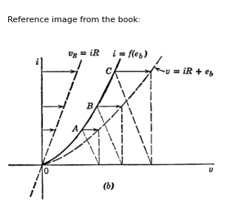
Fig. 3.6. Diode and series resistance## 3.3 Graphical Solution of Nonlinear Circuits.

3 3.3 Graphical Solution of Nonlinear Circuits
Having solved the general linear resistive circuit problem, let us analyze some elementary nonlinear circuits. A diode in series with resistance R, as shown in Fig. 3.6$\left(a\right)$, is a nonlinear circuit analogous to the combination of linear resistances in series. The construction in Fig. 3.6$\left(b\right)$ illustrates the summation of voltage drops for specific values of current. A number of points must be plotted to obtain the new curve, since the result is not a straight line. This construction is only useful when a particular resistance $R$ is to be associated with a particular diode; another curve must be plotted when either the diode or the resistor is changed. Since such plots may require a fair number of points, it is desirable to seek a simpler procedure. Restricting a problem to finding a specific solution, i.e., the equilibrium current and voltage
at one operating point, removes the need for replotting. A succession of such operating points would form a functional relation between two variables (like $i$ and $v$ at a pair of terminals).
import schemdraw
import schemdraw.elements as e
import schemdraw as schem
import matplotlib.pyplot as plt
import matplotlib.image as mpimg
import numpy as np
# Create the figure and subplots
fig, axs = plt.subplots(4, 2, figsize=(12, 12))
d = schemdraw.Drawing()
d += elm.Line().right(d.unit*.1).idot()
d += (Line:= elm.Line().reverse().dot())
d.push()
d += (R1:= elm.Resistor().down().label('$R$' , 'bot').label(['+','$eR$','-'], loc='top'))
d += (N := elm.Diode().label('$D$' , 'bot').label(['+','$eb$','-'], loc='top').dot())
d += elm.Line().tox(R1.start)
d += ( L3 := elm.Line().left(d.unit*1.1).dot())
d += elm.Battery().toy(R1.start).reverse().label(['-', '$E$', '+'])
d += elm.CurrentLabel(top=True, ofst=.8).at(N).label('$i_b$').down()
d.pop()
d.save('./Drawings/fig3-7.jpg')
d.save('./Drawings/fig3-7.svg')
# Load the saved PNG file into the subplot
img = mpimg.imread('./Drawings/fig3-7.jpg')
axs[0,0].imshow(img)
axs[0,0].axis('off') # Hide axes for image display
axs[0,0].set_title('Circuit Diagram (developed)')
# **Subplot (1, 2): PNG Sample File**
img_sample = mpimg.imread('images-books/3-7a.png') # Load the PNG file
axs[0,1].imshow(img_sample)
axs[0,1].axis('off') # Hide axes for image display
axs[0,1].set_title('Original')
d.save('./Drawings/fig3-7a.png')
d.save('./Drawings/fig3-7a.svg')
#1
circuit = Circuit('v-i curve')
circuit.model('BAV21','D' ,IS = 14.5@u_nA , N = 1.906 ,BV = 110@u_V, IBV = 0.0001@u_V, VJ = .8@u_V ,CJO = 7.048E-13 ,RS = 100@u_Ohm ,TT = 3.48E-9)
Vi = circuit.V('i', '1', circuit.gnd, 10@u_V)
circuit.R(1, '1', '2', .5@u_kOhm)
circuit.D(1, '2',circuit.gnd , model = 'BAV21')
simulator = circuit.simulator(temperature=25, nominal_temperature=25)
analysis = simulator.dc(Vi=slice(0, 25, 0.1))
axs[1,0].plot(analysis['2'], u_mA(-analysis.Vi),'black',linewidth=3)
circuit = Circuit('thev')
Vth = circuit.V('th', '1', circuit.gnd, 0@u_V)
circuit.R(1 ,'1', '2', 0.5@u_kOhm )
circuit.V(2, '2', circuit.gnd, 2.5@u_V)
simulator = circuit.simulator(temperature=25, nominal_temperature=25)
analysis = simulator.dc(Vth=slice(0, 25, 0.1))
axs[1,0].plot(analysis['1'],u_mA(analysis.Vth),'gray',linewidth=1.5)
axs[1,0].legend(('I-V diode curve','diode equation'), loc=(.8,.8))
axs[1,0].annotate('', xy=(0.9, 3.2), xytext=(0, 3.2), arrowprops=dict(arrowstyle='->'))
axs[1,0].annotate('', xy=(0.9, 3.2), xytext=(0.9,0 ), arrowprops=dict(arrowstyle='->'))
axs[1,0].set_title('Load Line Analysis (Ngspice Simulation via Pyspice)')
axs[1,0].text(3, 0.2, 'E', ha='center', va='center')
axs[1,0].text(-0.2, 4, 'E/R', ha='center', va='center')
axs[1,0].text(0.1, 2.6, 'Ib', ha='center', va='center')
axs[1,0].text(1.2, 4, 'ib=f(eb)', ha='center', va='center')
axs[1,0].text(2, 2, 'i=(E-eb)/R', ha='center', va='center')
axs[1,0].set_xlim(0, 6)
axs[1,0].set_ylim(0,6)
axs[1,0].set_ylabel('eb [V]')
axs[1,0].set_xlabel('I [A]')
axs[1,0].axhline(0, color='black', linewidth=1)
axs[1,0].axvline(0, color='black', linewidth=1)
img_sample = mpimg.imread('images-books/3-7b.png') # Load the PNG file
axs[1,1].imshow(img_sample)
axs[1,1].axis('off') # Hide axes for image display
axs[1,1].set_title('Original')
#3
circuit = Circuit('v-i curve')
circuit.model('BAV21','D' ,IS = 14.5@u_nA , N = 1.906 ,BV = 110@u_V, IBV = 0.0001@u_V, VJ = .8@u_V ,CJO = 7.048E-13 ,RS = 100@u_Ohm ,TT = 3.48E-9)
Vi = circuit.V('i', '1', circuit.gnd, 10@u_V)
circuit.R(1, '1', '2', 1@u_kOhm)
circuit.D(1, '2',circuit.gnd , model = 'BAV21')
simulator = circuit.simulator(temperature=25, nominal_temperature=25)
analysis = simulator.dc(Vi=slice(0, 25, 0.1))
axs[2,0].plot(analysis['2'], u_mA(-analysis.Vi),'black',linewidth=3)
circuit = Circuit('thev')
Vth = circuit.V('th', '1', circuit.gnd, 0@u_V)
circuit.R(1 ,'1', '2', 0.5@u_kOhm )
circuit.V(2, '2', circuit.gnd, 3@u_V)
simulator = circuit.simulator(temperature=25, nominal_temperature=25)
analysis = simulator.dc(Vth=slice(0, 25, 0.1))
axs[2,0].plot(analysis['1'],u_mA(analysis.Vth),'black',linewidth=1.5)
circuit = Circuit('thev1')
Vth = circuit.V('th', '1', circuit.gnd, 0@u_V)
circuit.R(1 ,'1', '2', 0.5@u_kOhm )
circuit.V(2, '2', circuit.gnd, 2@u_V)
simulator = circuit.simulator(temperature=25, nominal_temperature=25)
analysis = simulator.dc(Vth=slice(0, 25, 0.1))
axs[2,0].plot(analysis['1'],u_mA(analysis.Vth),'black',linewidth=1.5)
circuit = Circuit('thev2')
Vth = circuit.V('th', '1', circuit.gnd, 0@u_V)
circuit.R(1 ,'1', '2', 0.5@u_kOhm )
circuit.V(2, '2', circuit.gnd, 1@u_V)
simulator = circuit.simulator(temperature=25, nominal_temperature=25)
analysis = simulator.dc(Vth=slice(0, 25, 0.1))
axs[2,0].plot(analysis['1'],u_mA(analysis.Vth),'black',linewidth=1.5)
axs[2,0].legend(('I-V diode curve','diode equation'), loc=(.8,.8))
axs[2,0].annotate('', xy=(2, 2.2), xytext=(2,2.8 ), arrowprops=dict(arrowstyle='->'))
axs[2,0].set_title('Load Line Analysis (Ngspice Simulation via Pyspice)')
axs[2,0].text(1.3, 4.8, 'ib=f(eb)', ha='center', va='center')
axs[2,0].text(2, 2.8, 'i=(E3-eb)/R', ha='center', va='center')
axs[2,0].annotate('', xy=(0.65, 0.8), xytext=(0,0.8 ), arrowprops=dict(arrowstyle='->'))
axs[2,0].annotate('', xy=(0.83, 2.4), xytext=(0,2.4 ), arrowprops=dict(arrowstyle='->'))
axs[2,0].annotate('', xy=(1, 4), xytext=(0,4 ), arrowprops=dict(arrowstyle='->'))
axs[2,0].text(0.7, 4.8, 'R', ha='center', va='center')
axs[2,0].text(0.7, 2.9, 'R', ha='center', va='center')
axs[2,0].text(0.5, 1.2, 'R', ha='center', va='center')
axs[2,0].text(.1, 0.9, 'I1', ha='center', va='center')
axs[2,0].text(.1, 2.5, 'I2', ha='center', va='center')
axs[2,0].text(.1, 4.2, 'I3', ha='center', va='center')
axs[2,0].set_xlim(0, 6)
axs[2,0].set_ylim(0,6)
axs[2,0].set_ylabel('eb [V]')
axs[2,0].set_xlabel('I [mA]')
axs[2,0].axhline(0, color='black', linewidth=1)
axs[2,0].axvline(0, color='black', linewidth=1)
img_sample = mpimg.imread('images-books/3-7c.png') # Load the PNG file
axs[2,1].imshow(img_sample)
axs[2,1].axis('off') # Hide axes for image display
axs[2,1].set_title('Original')
#4
circuit = Circuit('v-i curve')
circuit.model('BAV21','D' ,IS = 14.5@u_nA , N = 1.906 ,BV = 110@u_V, IBV = 0.0001@u_V, VJ = .8@u_V ,CJO = 7.048E-13 ,RS = 100@u_Ohm ,TT = 3.48E-9)
Vi = circuit.V('i', '1', circuit.gnd, 10@u_V)
circuit.R(1, '1', '2', 1@u_kOhm)
circuit.D(1, '2',circuit.gnd , model = 'BAV21')
simulator = circuit.simulator(temperature=25, nominal_temperature=25)
analysis = simulator.dc(Vi=slice(0, 25, 0.1))
axs[3,0].plot(analysis['2'], u_mA(-analysis.Vi),'black',linewidth=3)
circuit = Circuit('thev')
Vth = circuit.V('th', '1', circuit.gnd, 0@u_V)
circuit.R(1 ,'1', '2', 0.5@u_kOhm )
circuit.V(2, '2', circuit.gnd, 3@u_V)
simulator = circuit.simulator(temperature=25, nominal_temperature=25)
analysis = simulator.dc(Vth=slice(0, 25, 0.1))
axs[3,0].plot(analysis['1'],u_mA(analysis.Vth),'black',linewidth=1.5)
circuit = Circuit('thev1')
Vth = circuit.V('th', '1', circuit.gnd, 0@u_V)
circuit.R(1 ,'1', '2', 0.75@u_kOhm )
circuit.V(2, '2', circuit.gnd, 3@u_V)
simulator = circuit.simulator(temperature=25, nominal_temperature=25)
analysis = simulator.dc(Vth=slice(0, 25, 0.1))
axs[3,0].plot(analysis['1'],u_mA(analysis.Vth),'black',linewidth=1.5)
circuit = Circuit('thev2')
Vth = circuit.V('th', '1', circuit.gnd, 0@u_V)
circuit.R(1 ,'1', '2', 1@u_kOhm )
circuit.V(2, '2', circuit.gnd, 3@u_V)
simulator = circuit.simulator(temperature=25, nominal_temperature=25)
analysis = simulator.dc(Vth=slice(0, 25, 0.1))
axs[3,0].plot(analysis['1'],u_mA(analysis.Vth),'black',linewidth=1.5)
circuit = Circuit('thev3')
Vth = circuit.V('th', '1', circuit.gnd, 0@u_V)
circuit.R(1 ,'1', '2', 1.5@u_kOhm )
circuit.V(2, '2', circuit.gnd, 3@u_V)
simulator = circuit.simulator(temperature=25, nominal_temperature=25)
analysis = simulator.dc(Vth=slice(0, 25, 0.1))
axs[3,0].plot(analysis['1'],u_mA(analysis.Vth),'black',linewidth=1.5)
axs[3,0].legend(('I-V diode curve','diode equation'), loc=(.8,.8))
axs[3,0].annotate('', xy=(2, 2.2), xytext=(2,2.8 ), arrowprops=dict(arrowstyle='->'))
axs[3,0].set_title('Load Line Analysis (Ngspice Simulation via Pyspice)')
axs[3,0].text(1.3, 4.8, 'ib=f(eb)', ha='center', va='center')
axs[3,0].text(1.9, 2.8, 'i=(E3-eb)/R1', ha='center', va='center')
axs[3,0].text(0.5, 4.8, 'R1', ha='center', va='center')
axs[3,0].text(0.5, 3.5, 'R2', ha='center', va='center')
axs[3,0].text(0.5, 2.8, 'R3', ha='center', va='center')
axs[3,0].text(0.5, 2, 'R4', ha='center', va='center')
axs[3,0].set_xlim(0, 6)
axs[3,0].set_ylim(0,6)
axs[3,0].set_ylabel('eb [V]')
axs[3,0].set_xlabel('I [mA]')
axs[3,0].axhline(0, color='black', linewidth=1)
axs[3,0].axvline(0, color='black', linewidth=1)
img_sample = mpimg.imread('images-books/3-7d.png') # Load the PNG file
axs[3,1].imshow(img_sample)
axs[3,1].axis('off') # Hide axes for image display
axs[3,1].set_title('Original')
# Show the combined plots
plt.tight_layout()
plt.show()
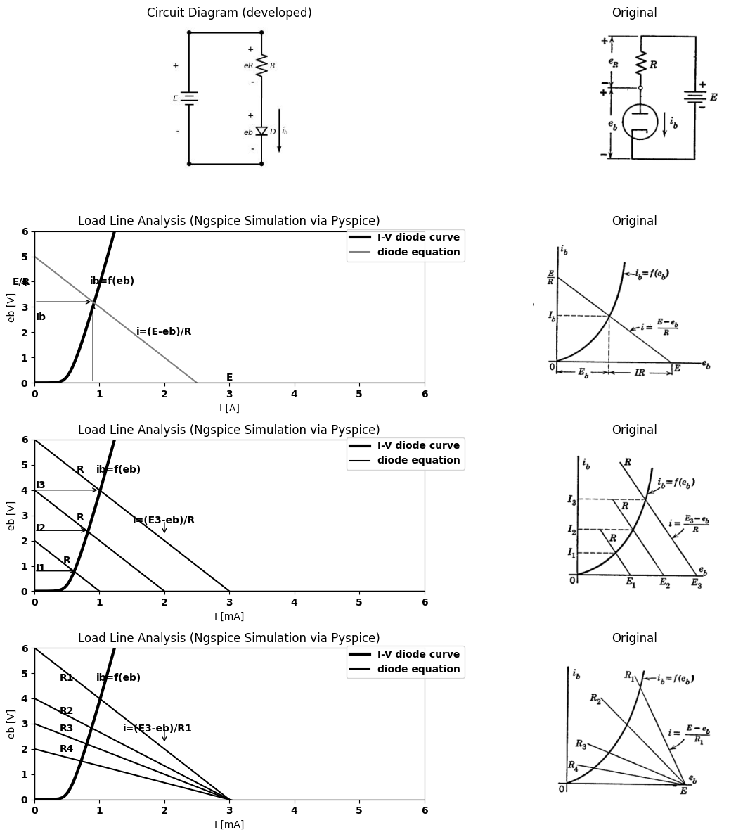
import ipywidgets as widgets
from ipywidgets import interact
import matplotlib.pyplot as plt
from matplotlib import rcParams
import PySpice.Logging.Logging as Logging
logger = Logging.setup_logging()
from PySpice.Probe.Plot import plot
from PySpice.Spice.Netlist import Circuit
from PySpice.Unit import *
rcParams['font.weight'] = 'bold'
figure = plt.figure(figsize=(15, 10))
#@interact(Mode1=(True) , Mode2=(True), Mode3=(True))
@interact(R=widgets.IntSlider(min=0.5, max=5, step=0.5, value=1.5))
def response(R=1.5@u_kOhm):
rcParams['font.weight'] = 'bold'
figure, ax1, = plt.subplots(figsize=(15, 5))
circuit = Circuit('thev3')
Vth = circuit.V('th', '1', circuit.gnd, 0@u_V)
circuit.R(1 ,'1', '2', R@u_kOhm )
circuit.V(2, '2', circuit.gnd, 3@u_V)
simulator = circuit.simulator(temperature=25, nominal_temperature=25)
analysis = simulator.dc(Vth=slice(0, 25, 0.1))
ax1.plot(analysis['1'],u_mA(analysis.Vth),'black',linewidth=1.5)
circuit = Circuit('v-i curve')
circuit.model('BAV21','D' ,IS = 14.5@u_nA , N = 1.906 ,BV = 110@u_V, IBV = 0.0001@u_V, VJ = .8@u_V ,CJO = 7.048E-13 ,RS = 100@u_Ohm ,TT = 3.48E-9)
Vi = circuit.V('i', '1', circuit.gnd, 10@u_V)
circuit.R(1, '1', '2', 1@u_kOhm)
circuit.D(1, '2',circuit.gnd , model = 'BAV21')
simulator = circuit.simulator(temperature=25, nominal_temperature=25)
analysis = simulator.dc(Vi=slice(0, 25, 0.1))
ax1.plot(analysis['2'], u_mA(-analysis.Vi),'black',linewidth=3)
ax1.set_xlim(0, 6)
ax1.set_ylim(0,6)
ax1.set_ylabel('eb [V]')
ax1.set_xlabel('I [mA]')
ax1.axhline(0, color='black', linewidth=1)
ax1.axvline(0, color='black', linewidth=1)
<Figure size 1500x1000 with 0 Axes>
{"model_id":"8634315856784254b0e215bca8c1a551","version_major":2,"version_minor":0}

4 Fig.3.7.Diode operating point.
The diode circuit of Fig. 3.7$\left(a\right)$ has a specific voltage $E$ applied, supplying power to the circuit. The source $E$ and the resistance $R$, often called the load resistance, provide a linear constraint that aids in solving the problem. This constraint or “load line,” as plotted in Fig. 3.7$\left(b\right)$, represents the relation $ i = (E−e_b)/R $ and amounts to plotting the resistive line as a voltage drop subtracted from supply voltage $E$. The effects of varying the supply voltage for a fixed value of load resistance and varying the load resistance for a fixed value of supply voltage are illustrated by Fig. 3.7$\left(c\right)$ and $\left(d\right)$, respectively. Having solved the “simplest one-diode problem,” the previous results
obtained for linear resistances and sources tell us that we have also solved the most general one-diode problem. As indicated by Fig. 3.8, the load line may actually be representative of an arbitrary network of resistances and batteries. Graphical or algebraic reduction of the network to a single resistance and source permits solution of the operating-point problem. Once the current and voltage are specified at the diode terminals, any other current or voltage within the network can be determined.
import schemdraw
import schemdraw.elements as e
import schemdraw as schem
import matplotlib.pyplot as plt
import matplotlib.image as mpimg
from schemdraw import dsp
import numpy as np
# Create the figure and subplots
fig, axs = plt.subplots(1, 2, figsize=(12, 12))
d = schemdraw.Drawing()
D1 = d.add(e.Diode().down())
l1 = d.add(e.Line().right().at(D1.start).dot(open = True))
d += e.lines.CurrentLabelInline().at(l1).left().label('$i_b$').color('black')
l2 = d.add(e.Line().right().at(D1.end).dot(open = True))
d += e.Gap().up()
d += e.Arrow().up().linewidth(0.6).length(4).linewidth(0.6).linewidth(0.6).color('white').label('$V1$', loc='start', color='black',ofst=0.3). at((3.5,-1.5))
d += e.Arrow().up().length(.5).linewidth(0.6).color('black').label('+',loc='end', color='black',ofst=.5). at((3.,-.6))
d += e.Arrow().down().length(.5).linewidth(0.6).color('black').label(r'_', loc='end', color='black',ofst=(-.5, -0.5)). at((3.,-2.5))
d.move(5,1.5)
d += ( T := dsp.Box(w=4, h=4).anchor('W').fill('white').label('Linear\n resistances\n and\n batteries'))
center_x, center_y = T.center
line_Right1 = d.add(e.Line().left().at((center_x-2, center_y + 1.65)).length(1))
d += e.lines.CurrentLabelInline().at(line_Right1.start).right().label('$i$').color('black')
line_Right2 = d.add(e.Line().left().at((center_x-2, center_y - 1.65)).length(1))
d += e.Gap().up().color('black')
d += e.Arrow().up().linewidth(0.6).length(4).linewidth(0.6).linewidth(0.6).color('white').label('$e$', loc='start', color='black',ofst=0.3). at((7.5,-1.5))
d += e.Arrow().up().length(.5).linewidth(0.6).color('black').label('+',loc='end', color='black',ofst=-.2). at((7,-.6))
d += e.Arrow().down().length(.5).linewidth(0.6).color('black').label(r'_', loc='end', color='black',ofst=(-.5, 0.2)). at((7,-2.5))
d.move(6,4)
l01 = d.add(e.Line().down().length(1.5))
D1 = d.add(e.Diode().down())
l02 = d.add(e.Line().down().at(D1.end).length(1.5))
l1 = d.add(e.Line().right().at(l01.start))
d += e.Gap().down().length(6).color('black').at((2,0))
l2 = d.add(e.Line().right().at(l02.end))
d += e.Gap().up().label([] , fontsize = 16).color('black')
d += ( T := dsp.Box(w=6, h=8).anchor('W').linestyle('--'))
l3 = d.add(e.Line().right().at(l1.end))
d += e.lines.CurrentLabelInline().at(l1.start).left().label('$i_b=-i$').color('black')
l4 = d.add(e.Line().right().at(l2.end))
R = d.add(e.Resistor().down().at(l3.end).label('$R0$'))
Eoc = d.add(e.Battery().down().at(R.end).label('$E_{oc}$'))
d += e.Arrow().up().linewidth(0.6).length(4).linewidth(0.6).linewidth(0.6).color('white').label('$e_b$', loc='start', color='black',ofst=0.3). at((15.5,-1.5))
d += e.Arrow().up().length(1.5).linewidth(0.6).color('black').label('+',loc='end', color='black',ofst=-.2). at((15,-0.5))
d += e.Arrow().down().length(1.5).linewidth(0.6).color('black').label(r'_', loc='end', color='black',ofst=(-.5, 0.2)). at((15,-3.5))
d.save('./Drawings/fig3-8.jpg')
d.save('./Drawings/fig3-8.svg')
# Load the saved PNG file into the subplot
img = mpimg.imread('./Drawings/fig3-8.jpg')
axs[0].imshow(img)
axs[0].axis('off') # Hide axes for image display
axs[0].set_title('Circuit Diagram (developed)')
# **Subplot (1, 2): PNG Sample File**
img_sample = mpimg.imread('images-books/3-8a.png') # Load the PNG file
axs[1].imshow(img_sample)
axs[1].axis('off') # Hide axes for image display
axs[1].set_title('Original')
d.save('./Drawings/fig3-8a.png')
d.save('./Drawings/fig3-8a.svg')
#1
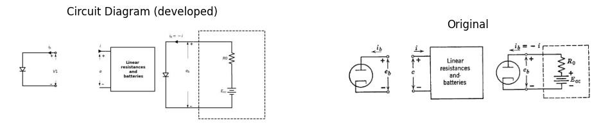
import schemdraw
import schemdraw.elements as e
import schemdraw as schem
import matplotlib.pyplot as plt
import matplotlib.image as mpimg
import numpy as np
# Create the figure and subplots
fig, axs = plt.subplots(3, 2, figsize=(12, 12))
#diode curve
circuit = Circuit('v-i curve')
circuit.model('BAV21','D' ,IS = 14.5@u_nA , N = 1.906 ,BV = 110@u_V, IBV = 0.0001@u_V, VJ = .8@u_V ,CJO = 7.048E-13 ,RS = 100@u_Ohm ,TT = 3.48E-9)
Vi = circuit.V('i', '1', circuit.gnd, 10@u_V)
circuit.R(1, '1', '2', 100@u_Ohm)
circuit.D(1, '2',circuit.gnd , model = 'BAV21')
simulator = circuit.simulator(temperature=25, nominal_temperature=25)
analysis = simulator.dc(Vi=slice(0, 25, 0.1))
axs[0,0].plot(analysis['1'], u_mA(-analysis.Vi),'black',linewidth=3)
# linear circute
circuit = Circuit('thev')
Vi= circuit.V('i', '1', circuit.gnd, 0@u_V)
circuit.R(1 ,'1', '2', 0.75@u_kOhm )
circuit.V(2, '2', circuit.gnd, 3@u_V)
simulator = circuit.simulator(temperature=25, nominal_temperature=25)
analysis = simulator.dc(Vi=slice(0, 25, 0.1))
# diode and resistor
circuit = Circuit('v-i curve')
circuit.model('BAV21','D' ,IS = 14.5@u_nA , N = 1.906 ,BV = 110@u_V, IBV = 0.0001@u_V, VJ = .8@u_V ,CJO = 7.048E-13 ,RS = 100@u_Ohm ,TT = 3.48E-9)
Vi = circuit.V('i', '1', circuit.gnd, 10@u_V)
circuit.R(1, '1', '2', 100@u_Ohm)
circuit.D(1, '2',circuit.gnd , model = 'BAV21')
simulator = circuit.simulator(temperature=25, nominal_temperature=25)
analysis = simulator.dc(Vi=slice(0, 25, 0.1))
axs[1,0].plot(analysis['1'], u_mA(-analysis.Vi),'black',linewidth=3)
circuit = Circuit('thev')
Vi = circuit.V('i', '1', circuit.gnd, 0@u_V)
circuit.R(1 ,'1', '2', 0.75@u_kOhm )
circuit.V(2, '2', circuit.gnd, 3@u_V)
simulator = circuit.simulator(temperature=25, nominal_temperature=25)
analysis = simulator.dc(Vi=slice(0, 25, 0.1))
axs[2,0].plot(analysis['1'],u_mA(analysis.Vi),'gray',linewidth=1.5)
# Plot for G1
axs[0,0].set_title('V-I Curve for Diode')
axs[0,0].set_xlim(0, 5)
axs[0,0].set_xlabel('eb [A]')
axs[0,0].set_ylabel('ib [V]')
axs[0,0].set_ylim(0, 5)
axs[0,0].text(1, 4, 'ib=f(eb)', ha='center', va='center')
# **Subplot (1, 2): PNG Sample File**
img_sample = mpimg.imread('images-books/3-8b.png') # Load the PNG file
axs[0,1].imshow(img_sample)
axs[0,1].axis('off') # Hide axes for image display
axs[0,1].set_title('Original')
axs[1,0].plot(analysis['1'],u_mA(analysis.Vi),'black',linewidth=1.5)
axs[1,0].set_title('V-I Curve resistor')
axs[1,0].set_xlim(-1, 5)
axs[1,0].set_xlabel('e [A]')
axs[1,0].set_ylabel('i [V]')
axs[1,0].set_ylim(-1, 5)
axs[1,0].text(2, 2.5, 'ib=(Eoc-e)/Ro', ha='center', va='center')
axs[1,0].text(3, -0.7, 'e=(Eoc+iRo)\n or ib=(Eoc-e)/Ro', ha='center', va='center')
axs[1,0].text(3, 0.2, 'Eoc', ha='center', va='center')
axs[1,0].text(-0.3, 4, 'Eoc/Ro', ha='center', va='center')
axs[1,0].annotate('', xy=(2.5, -0.5), xytext=(3.5,0.5 ), arrowprops=dict(arrowstyle='-'))
axs[1,0].axhline(0, color='black', linewidth=1)
axs[1,0].axvline(0, color='black', linewidth=1)
axs[1,0].annotate('', xy=(3, -0.3), xytext=(3,0 ), arrowprops=dict(arrowstyle='->'))
# **Subplot (1, 2): PNG Sample File**
img_sample = mpimg.imread('images-books/3-8d.png') # Load the PNG file
axs[1,1].imshow(img_sample)
axs[1,1].axis('off') # Hide axes for image display
axs[1,1].set_title('Original')
axs[2,0].set_title('V-I Curve for Gp ')
axs[2,0].set_xlim(-1, 5)
axs[2,0].set_xlabel('eb [A]')
axs[2,0].set_ylabel('ib [V]')
axs[2,0].set_ylim(-1, 5)
axs[2,0].annotate('', xy=(3, -0.4), xytext=(3,0 ), arrowprops=dict(arrowstyle='->'))
axs[2,0].axhline(0, color='black', linewidth=2)
axs[2,0].axvline(0, color='black', linewidth=2)
axs[2,0].text(-0.3, 4, 'Eoc/Ro', ha='center', va='center')
axs[2,0].text(3, -0.5, 'Eoc', ha='center', va='center')
axs[2,0].text(1.8, 4, 'ib=f(eb)', ha='center', va='center')
axs[2,0].text(0.5, 4.5, 'ib=-i', ha='center', va='center')
axs[2,0].text(2.5, 1.5, '-i= (Eoc-eb)/Ro', ha='center', va='center')
# **Subplot (1, 2): PNG Sample File**
img_sample = mpimg.imread('images-books/3-8c.png') # Load the PNG file
axs[2,1].imshow(img_sample)
axs[2,1].axis('off') # Hide axes for image display
axs[2,1].set_title('Original')
plt.tight_layout()
plt.show()
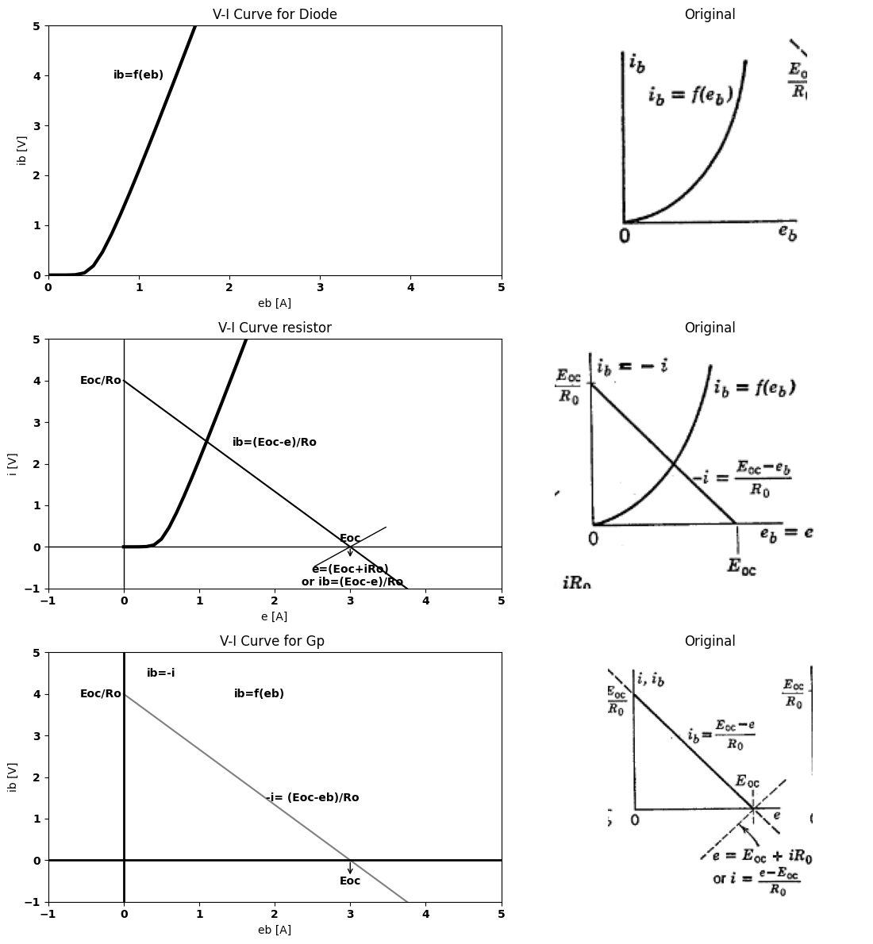
Fig. 3.8. General one-diode circuit
Only a few relatively simple circuits with two diodes can be analyzed graphically. Obviously, any number of identical diodes in series or in parallel poses no greater problem than a single diode, since the voltage scale or the current scale of the diode curve can be multiplied by the number of diodes.
As shown in Fig. 3.9$\left(a\right)$, two different diodes in series present a more difficult problem, since the composite curve for the two $\left(b\right)$ must be plotted point-by-point. The same circuit connected to a resistive load $R$ and supply voltage $E$ is shown in $\left(c\right)$. The operating-point problem for this case could be solved by using the composite curve $i=f\left(v\right)$ from Fig. 3.9$\left(b\right)$ and plotting the load line $i=\left(E−v\right)/R$, just as was done for a single diode.
Graphical solution of the general two-diode circuit requires a number
of construction lines to carry out a double cut-and-try process in order to establish a pair of operating points for the two diodes. The solution is seldom necessary, since most two-diode circuits use identical diodes and usually exhibit symmetry, which can be exploited to simplify the
import schemdraw
import schemdraw.elements as e
import schemdraw as schem
import matplotlib.pyplot as plt
import matplotlib.image as mpimg
from schemdraw import dsp
import numpy as np
# Create the figure and subplots
fig, axs = plt.subplots(2, 2, figsize=(12, 12))
d = schemdraw.Drawing()
l1 = d.add(e.Line().left())
d += e.lines.CurrentLabelInline().at((-1.3,0)).left().label('$i$').color('black')
D1 = d.add(e.Diode().down().at(l1.end).dot(open= True))
D2 = d.add(e.Diode().down())
l2 = d.add(e.Line().right())
d += e.Gap().down().length(3).label(['+',' ',' ','$e_{b1}$',' ',' ','-'] , fontsize = 16).color('black').at((-2,0))
d += e.Gap().down().length(3).label(['+',' ',' ','$e_{b2}$',' ',' ','-'] , fontsize = 16).color('black').at((-2,-3))
d += e.Gap().down().length(6).color('black').at((0,0))
d += e.Arrow().up().linewidth(0.6).length(4).linewidth(0.6).linewidth(0.6).color('white').label('$e_b$', loc='start', color='black',ofst=0.3). at((.5,-2.5))
d += e.Arrow().up().length(1.5).linewidth(0.6).color('black').label('+',loc='end', color='black',ofst=.5). at((-0.1,-1.5))
d += e.Arrow().down().length(1.5).linewidth(0.6).color('black').label(r'_', loc='end', color='black',ofst=(-.5, -0.5)). at((-0.1,-4.5))
d += e.Line().right().length(1).color('black'). at((-3,-3)).linestyle('-')
d.save('./Drawings/fig3-9a.jpg')
d.save('./Drawings/fig3-9a.svg')
# Load the saved PNG file into the subplot
img = mpimg.imread('./Drawings/fig3-9a.jpg')
axs[0,0].imshow(img)
axs[0,0].axis('off') # Hide axes for image display
axs[0,0].set_title('Circuit Diagram (developed)')
# **Subplot (1, 2): PNG Sample File**
img_sample = mpimg.imread('images-books/3-9a.png') # Load the PNG file
axs[0,1].imshow(img_sample)
axs[0,1].axis('off') # Hide axes for image display
axs[0,1].set_title('Original')
d.save('./Drawings/fig3-9a.png')
d.save('./Drawings/fig3-9a.svg')
#
circuit = Circuit('v-i curve')
circuit.model('BAV21','D' ,IS = 14.5@u_nA , N = 1.906 ,BV = 110@u_V, IBV = 0.0001@u_V, VJ = .8@u_V ,CJO = 7.048E-13 ,RS = 100@u_Ohm ,TT = 3.48E-9)
Vi = circuit.V('i', '1', circuit.gnd, 10@u_V)
circuit.R(1, '1', '2', 1@u_kOhm)
circuit.D(1, '2',circuit.gnd , model = 'BAV21')
simulator = circuit.simulator(temperature=25, nominal_temperature=25)
analysis = simulator.dc(Vi=slice(0, 25, 0.1))
axs[1,0].plot(analysis['2'], u_mA(-analysis.Vi),'black',linestyle='--',linewidth=2)
circuit = Circuit('v-i curve1')
circuit.model('BAV21','D' ,IS = 14.5@u_nA , N = 1.906 ,BV = 110@u_V, IBV = 0.0001@u_V, VJ = .5@u_V ,CJO = 7.048E-13 ,RS = 10@u_Ohm ,TT = 3.48E-9)
Vi = circuit.V('i', '1', circuit.gnd, 10@u_V)
circuit.R(1, '1', '2', 1@u_Ohm)
circuit.D(1, '2',circuit.gnd , model = 'BAV21')
simulator = circuit.simulator(temperature=25, nominal_temperature=25)
analysis = simulator.dc(Vi=slice(0, 25, 0.1))
axs[1,0].plot(analysis['2'], u_mA(-analysis.Vi),'black',linestyle='--',linewidth=1)
circuit = Circuit('v-i curve2')
circuit.model('BAV21','D' ,IS = 14.5@u_nA , N = 1.906 ,BV = 110@u_V, IBV = 0.0001@u_V, VJ = .5@u_V ,CJO = 7.048E-13 ,RS = 0.2@u_kOhm ,TT = 3.48E-9)
Vi = circuit.V('i', '1', circuit.gnd, 10@u_V)
circuit.R(1, '1', '2', 1@u_Ohm)
circuit.D(1, '2',circuit.gnd , model = 'BAV21')
simulator = circuit.simulator(temperature=25, nominal_temperature=25)
analysis = simulator.dc(Vi=slice(0, 25, 0.1))
axs[1,0].plot(analysis['2'], u_mA(-analysis.Vi),'black',linewidth=2)
axs[1,0].set_title('diode curve')
axs[1,0].text(0.5, 2.65, 'i=f2(e2)', ha='center', va='center')
axs[1,0].text(0.75, 2.65, 'i=f1(e1)', ha='center', va='center')
axs[1,0].text(1.25, 2.65, 'i=f(v)', ha='center', va='center')
axs[1,0].text(1.25, 2, 'v=eb1+eb2', ha='center', va='center')
axs[1,0].annotate('', xy=(0.55, 0.75), xytext=(0,0.75 ), arrowprops=dict(arrowstyle='->'))
axs[1,0].annotate('', xy=(0.6, 1.5), xytext=(0,1.5 ), arrowprops=dict(arrowstyle='->'))
axs[1,0].annotate('', xy=(0.7, 0.75), xytext=(0.6,0.75 ), arrowprops=dict(arrowstyle='->'))
axs[1,0].annotate('', xy=(0.9, 1.5), xytext=(0.7,1.5 ), arrowprops=dict(arrowstyle='->'))
axs[1,0].set_xlim(0, 2)
axs[1,0].set_ylim(0, 3)
axs[1,0].set_xlabel('v [V]')
axs[1,0].set_ylabel('i [A]')
# **Subplot (1, 2): PNG Sample File**
img_sample = mpimg.imread('images-books/3-9b.png') # Load the PNG file
axs[1,1].imshow(img_sample)
axs[1,1].axis('off') # Hide axes for image display
axs[1,1].set_title('Original')
plt.tight_layout()
plt.show()
figure.savefig('./Drawings/fig3-9b.svg')
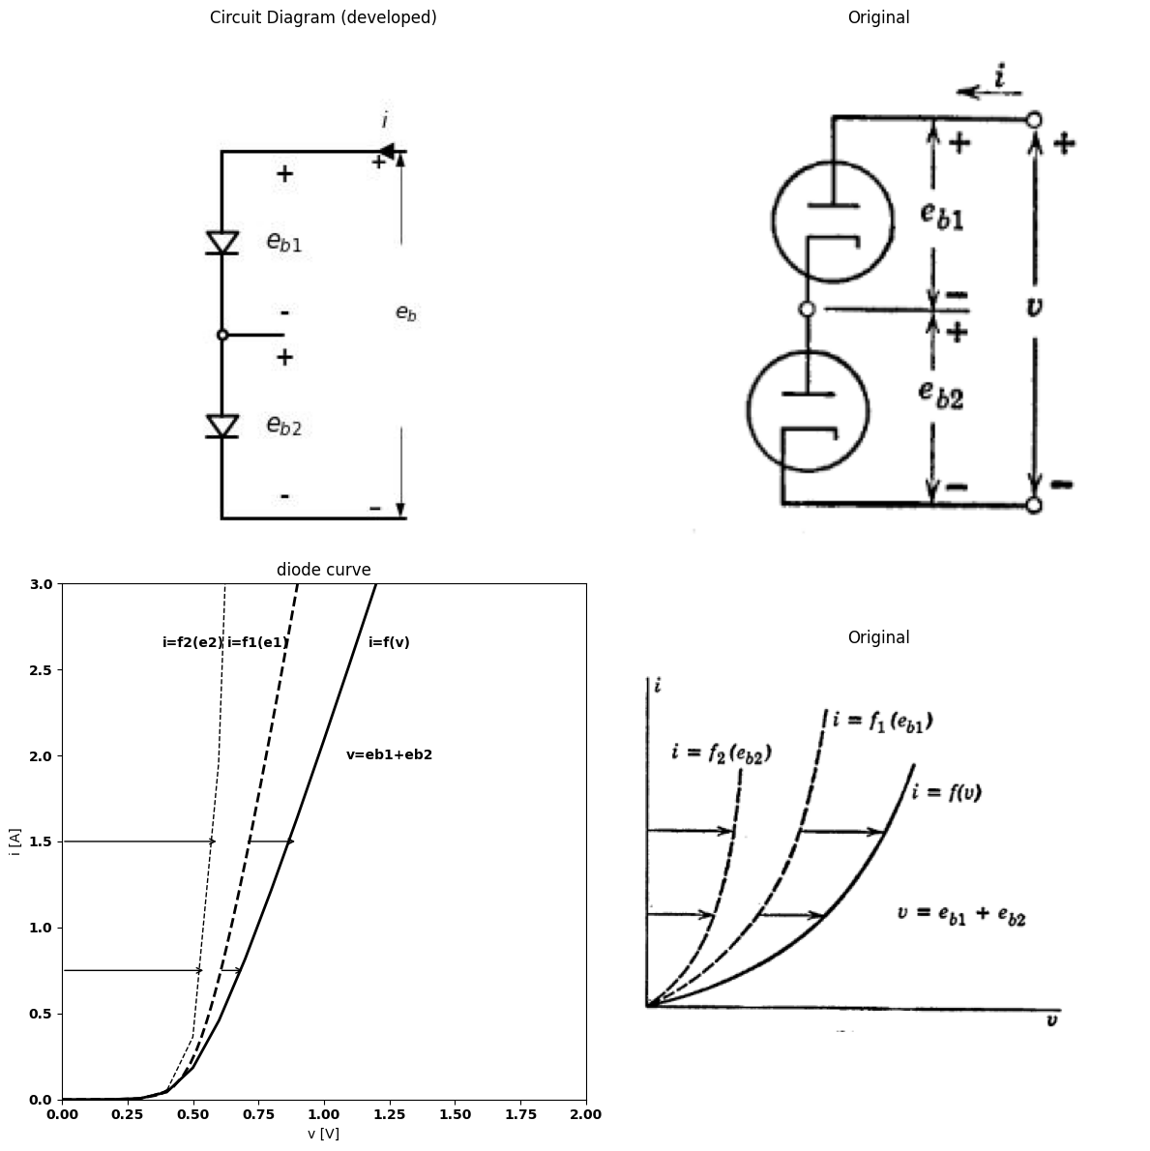
import matplotlib.pyplot as plt
from matplotlib import rcParams
import matplotlib.image as mpimg
import numpy as np
import PySpice.Logging.Logging as Logging
logger = Logging.setup_logging()
from PySpice.Probe.Plot import plot
from PySpice.Spice.Netlist import Circuit
from PySpice.Unit import *
# Create the figure and subplots
fig, axs = plt.subplots(2, 2, figsize=(12, 12))
d = schemdraw.Drawing()
l1 = d.add(e.Line().left())
d += e.lines.CurrentLabelInline().at((-1.3,0)).left().label('$i$').color('black')
D1 = d.add(e.Diode().down().dot(open=True).at(l1.end))
D2 = d.add(e.Diode().down())
l2 = d.add(e.Line().right())
d += e.Gap().down().length(3).label(['+',' ',' ','$e_{b1}$',' ',' ','-'] , fontsize = 16).color('black').at((-2,0))
d += e.Gap().down().length(3).label(['+',' ',' ','$e_{b2}$',' ',' ','-'] , fontsize = 16).color('black').at((-2,-3))
d += e.Gap().down().length(6).label(['+',' ',' ',' ',' ',' ','$v$',' ',' ',' ',' ',' ','-'] , fontsize = 16).color('black').at((-4,0))
d += e.Line().right().length(1).color('black'). at((-3,-3)).linestyle('-')
d += e.Line().right().length(1).color('black').dot(open=True). at((-4,-.001)).linestyle('-')
d += e.Line().right().length(1).color('black').dot(open=True). at((-4,-5.95)).linestyle('-')
R = d.add(e.Resistor().down().at(l1.start).label('R'))
E = d.add(e.Battery().down().at(R.end).label('$E_{oc}$'))
d.save('./Drawings/fig3-9c.jpg')
d.save('./Drawings/fig3-9c.svg')
# Load the saved PNG file into the subplot
img = mpimg.imread('./Drawings/fig3-9a.jpg')
axs[0,0].imshow(img)
axs[0,0].axis('off') # Hide axes for image display
axs[0,0].set_title('Circuit Diagram (developed)')
# **Subplot (1, 2): PNG Sample File**
img_sample = mpimg.imread('images-books/3-9c.png') # Load the PNG file
axs[0,1].imshow(img_sample)
axs[0,1].axis('off') # Hide axes for image display
axs[0,1].set_title('Original')
d.save('./Drawings/fig3-9c.png')
d.save('./Drawings/fig3-9c.svg')
#
circuit = Circuit('v-i curve')
circuit.model('BAV21','D' ,IS = 14.5@u_nA , N = 1.906 ,BV = 110@u_V, IBV = 0.0001@u_V, VJ = .8@u_V ,CJO = 7.048E-13 ,RS = 200@u_Ohm ,TT = 3.48E-9)
Vi = circuit.V('i', '1', circuit.gnd, 10@u_V)
circuit.R(1, '1', '2', 1@u_kOhm)
circuit.D(1, '2',circuit.gnd , model = 'BAV21')
simulator = circuit.simulator(temperature=25, nominal_temperature=25)
analysis = simulator.dc(Vi=slice(0, 25, 0.1))
axs[1,0].plot(analysis['2'], u_mA(-analysis.Vi),'black',linewidth=3)
circuit = Circuit('thev')
Vth = circuit.V('th', '1', circuit.gnd, 0@u_V)
circuit.R(1 ,'1', '2', 0.75@u_kOhm )
circuit.V(2, '2', circuit.gnd, 3@u_V)
simulator = circuit.simulator(temperature=25, nominal_temperature=25)
analysis = simulator.dc(Vth=slice(0, 25, 0.1))
axs[1,0].plot(analysis['1'],u_mA(analysis.Vth),'gray',linewidth=1.5)
axs[1,0].legend(('I-V diode curve','diode equation'), loc=(.8,.8))
axs[1,0].set_title('Operating Point Analysis (Ngspice Simulation via Pyspice)')
axs[1,0].text(.5, 3.65, 'R', ha='center', va='center')
axs[1,0].text(1.75, 4.2, 'i=f(v)', ha='center', va='center')
axs[1,0].text(1.6, 2.9, 'operating point', ha='center', va='center')
axs[1,0].text(1.09, 2.52, 'o', ha='center', va='center')
axs[1,0].text(3, 0, 'o', ha='center', va='center')
axs[1,0].text(3, .2, 'E', ha='center', va='center')
axs[1,0].annotate('', xy=(1.1, 2.5), xytext=(1.5,2.8 ), arrowprops=dict(arrowstyle='->'))
axs[1,0].set_xlim(0, 5)
axs[1,0].set_ylim(0, 5)
axs[1,0].set_xlabel('eb [V]')
axs[1,0].set_ylabel('ib [mA]')
# **Subplot (1, 2): PNG Sample File**
img_sample = mpimg.imread('images-books/3-9d.png') # Load the PNG file
axs[1,1].imshow(img_sample)
axs[1,1].axis('off') # Hide axes for image display
axs[1,1].set_title('Original')
plt.tight_layout()
plt.show()
d.save('./Drawings/fig3-9d1.png')
plt.tight_layout()
plt.show()
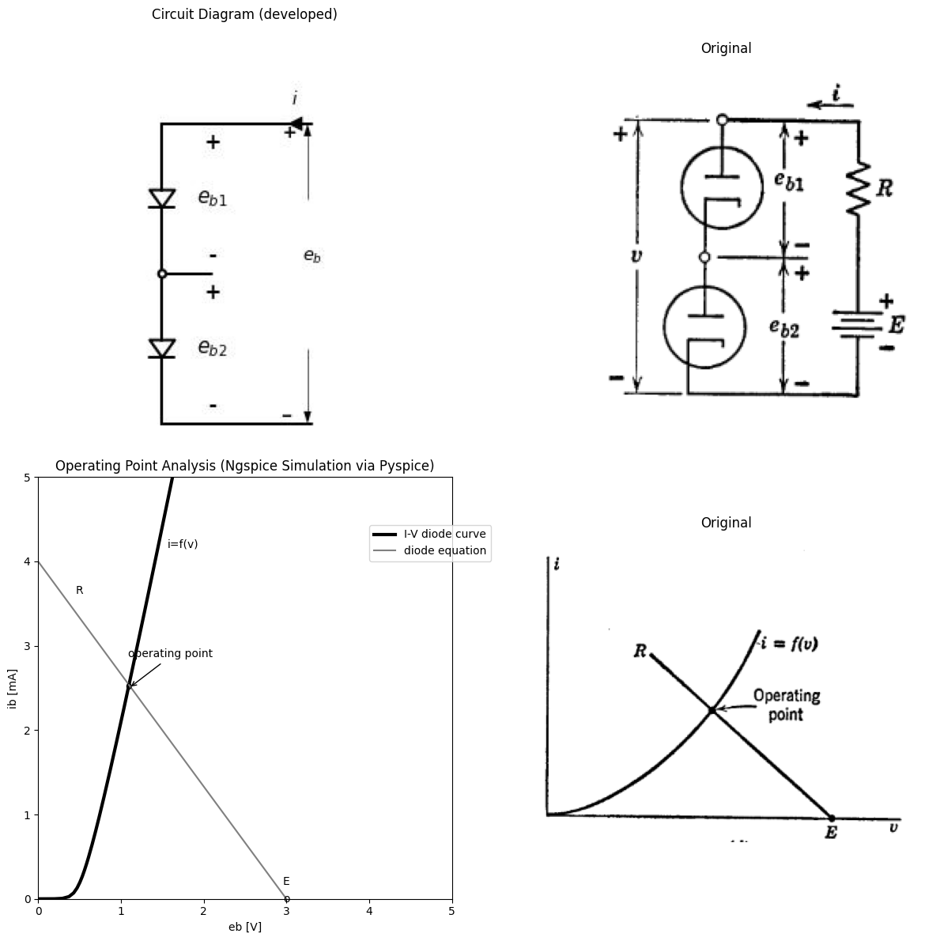
<Figure size 640x480 with 0 Axes>
Fig. 3.9. Diodes in series.
analysis.Circuits containing more than two diodes (or any other type of nonlinear device) are so cumbersome to handle that simplifying approximations become essential.
The essence of the general two-diode problem is shown in Fig. 3.10. Note the simplicity with which any three-terminal linear circuit can be represented. The circuit shown in Fig. 3.10$\left(b\right)$ is only one of many
possible models for a three-terminal network. With three terminals, there are two separate conditions that can be specified, say $i_{1}$ and $i_{2}$. Each of these currents should be a linear function of the voltages $e_{1}$ and $e_{2}$ The model and the equations given in Fig. 3.10 satisfy these conditions.
import schemdraw
import schemdraw.elements as e
import schemdraw as schem
import matplotlib.pyplot as plt
import matplotlib.image as mpimg
from schemdraw import dsp
import numpy as np
# Create the figure and subplots
fig, axs = plt.subplots(1, 2, figsize=(12, 12))
d = schemdraw.Drawing()
D1 = d.add(e.Diode().down())
l1 = d.add(e.Line().right().at(D1.start))
d += e.lines.CurrentLabelInline().at(l1).left().label('$i_{b1}$').color('black')
l2 = d.add(e.Line().right().at(D1.end))
d += e.Gap().up().label(['-' , '$e_{b1}$' , '+'] , fontsize = 16).color('black')
#d.push()
d.move(3, -1)
d += ( T := dsp.Box(w=4, h=3).anchor('W').fill('white').label('Resistances\n and\n batteries'))
center_x, center_y = T.center
line_Right1 = d.add(e.Line().left().at((center_x-2, center_y + 1)).length(1))
d += e.lines.CurrentLabelInline().at(line_Right1.start).right().label('$i_1$').color('black')
line_Right2 = d.add(e.Line().right().at((center_x+2, center_y + 1)).length(1))
d += e.lines.CurrentLabelInline().at(line_Right2.start).left().label('$i_2$').color('black')
line_Right3 = d.add(e.Line().down().at((center_x, center_y - 1.5)).length(0.5))
d += e.Gap().up().label(['-',' ',' ',' ' , '$e_1$' ,' ',' ',' ', '+'] , fontsize = 16).color('black').at((5,-3))
d += e.Gap().up().label(['-',' ',' ',' ' , '$e_2$' ,' ',' ',' ', '+'] , fontsize = 16).color('black').at((11,-3))
line_Right4 = d.add(e.Line().right().at(line_Right3.end))
line_Right5 = d.add(e.Line().left().at(line_Right3.end))
d += e.Ground().at(line_Right3.end)
d.move(8, 3)
D3 = d.add(e.Diode().down())
l21 = d.add(e.Line().left().at(D3.start))
d += e.lines.CurrentLabelInline().at(l21).right().label('$i_{b2}$').color('black')
l31 = d.add(e.Line().left().at(D3.end))
d += e.Gap().up().label(['-' , '$e_{b2}$' , '+'] , fontsize = 16).color('black')
d.save('./Drawings/fig3-10a.jpg')
d.save('./Drawings/fig3-10a.svg')
# Load the saved PNG file into the subplot
img = mpimg.imread('./Drawings/fig3-10a.jpg')
axs[0].imshow(img)
axs[0].axis('off') # Hide axes for image display
axs[0].set_title('Circuit Diagram (developed)')
# **Subplot (1, 2): PNG Sample File**
img_sample = mpimg.imread('images-books/3-10a.png') # Load the PNG file
axs[1].imshow(img_sample)
axs[1].axis('off') # Hide axes for image display
axs[1].set_title('Original')
d.save('./Drawings/fig3-10a.png')
d.save('./Drawings/fig3-10a.svg')
#
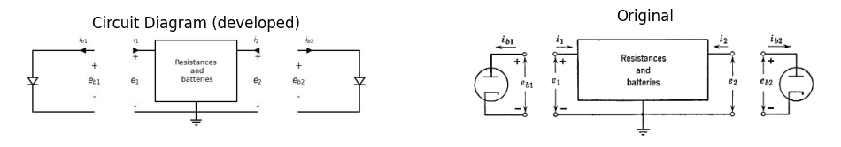
import schemdraw
import schemdraw.elements as e
import schemdraw as schem
import matplotlib.pyplot as plt
import matplotlib.image as mpimg
from schemdraw import dsp
import numpy as np
# Create the figure and subplots
fig, axs = plt.subplots(1, 2, figsize=(12, 12))
d = schemdraw.Drawing()
l1 = d.add(e.Line().right().length(1.4))
d += ( T := dsp.Box(w=12, h=5).anchor('W').linestyle('--'))
E1 = d.add(e.Battery().right().at(l1.end).label('+$E_{1(oc)}$-'))
R1 = d.add(e.Resistor().right().at(E1.end).label('R1'))
R2 = d.add(e.Resistor().right().at(R1.end).label('R2'))
Rm = d.add(e.Resistor().down().at(R1.end).label('Rm'))
E2 = d.add(e.Battery().right().at(R2.end).reverse().label('-$E_{2(oc)}$+'))
d += e.Gap().up().label(['-',' ',' ',' ' , '$e_1$' ,' ',' ',' ', '+'] , fontsize = 16).color('black').at((0,-3))
d += e.Gap().up().label(['-',' ',' ',' ' , '$e_2$' ,' ',' ',' ', '+'] , fontsize = 16).color('black').at((14.5,-3))
l11 = d.add(e.Line().right().at(E2.end).length(1.4))
l2 = d.add(e.Line().right().at(Rm.end).length(7.4))
l3 = d.add(e.Line().left().at(Rm.end).length(7.4))
d += e.Ground().at(Rm.end).label('$e_1-E_{1(oc)} = i_1(R_1+R_m)+i_2R_m$\n\n $e_2-E_{2(oc)} = i_1R_m+i_2(R_2+R_m) $', ofst=-3)
d += e.lines.CurrentLabelInline().at(E1.start).right().label('$i_1$').color('black')
d += e.lines.CurrentLabelInline().at(E2.end).left().label('$i_2$').color('black')
d.save('./Drawings/fig3-10b.jpg')
d.save('./Drawings/fig3-10b.svg')
# Load the saved PNG file into the subplot
img = mpimg.imread('./Drawings/fig3-10b.jpg')
axs[0].imshow(img)
axs[0].axis('off') # Hide axes for image display
axs[0].set_title('Circuit Diagram (developed)')
# **Subplot (1, 2): PNG Sample File**
img_sample = mpimg.imread('images-books/3-10b.png') # Load the PNG file
axs[1].imshow(img_sample)
axs[1].axis('off') # Hide axes for image display
axs[1].set_title('Original')
d.save('./Drawings/fig3-10b.png')
d.save('./Drawings/fig3-10b.svg')
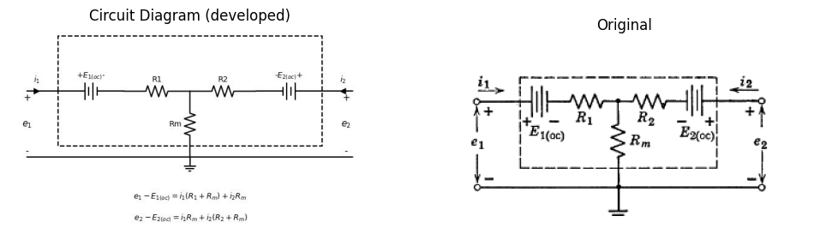
Fig. 3.10. General two_diode circuit.
If values of $ i_1 $ and $ i_2 $ are assumed, $ e_1 $ and $ e_2 $ are determined; but with the diodes connected, $ i_1 = -i_{b1} $ and $ i_2 = -i_{b2} $ , and these values determine $ e_{b1} $ and $ e_{b2} $. There is little likelihood of finding the right values of the currents to make $ e_1 = e_{b1} $ and $ e_2 = e_{b2} $ without repeatedly assuming values for the currents. The cut-and-try process can be organized by means of graphical constructions.
Continued pursuit of such procedures is unwarranted, particularly since one need only contemplate a circuit with three or more diodes to stimulate a search for a simpler method. We can conclude that graphical analysis is most useful for the solution of resistive circuits containing
a single nonlinear element and an arbitrary number of resistances and batteries.

5 3.4 Algebraic Solution of Diode Circuit Problems
An algebraic expression for the $ i_b $ vs. $ e_b $ relationship of a diode can be obtained either by deriving it from physical laws as outlined in Chapter 2, or by approximating either experimental data or average characteristics with an appropriate function.
Algebraic determination of an operating point may be carried out by analogy to the graphical solution shown in Fig. 3.8$\left(a\right)$ and $\left(b\right)$. If the diode characteristic is specified by an equation such as $ i = K e^{3/2} $, this expression for current may be equated to the expression $ i = {(E - e_b)}/R $ given by the load line. The solution of this equation yields $ E_b $, the value of $ e_b $ at the operating point.
or exponential expressions, such as those describing semiconductor diodes, the solution of problems involving two or more diodes may result in transcendental equations that require graphical or cut-and-try solutions. However, in many cases the algebraic solution is direct and less time-consuming than a graphical construction.
The problem becomes more difficult if the circuit includes energy-storage elements since differential equations are then necessary to express circuit equilibrium conditions. Except for a few special cases, nonlinear differential equations cannot be solved by analytic methods.

6 3.5 The Ideal Rectifier as a Diode Model
The desirability of applying the powerful analytical tools of linear circuit theory to nonlinear problems provides the motivation for approximating nonlinear curves by straight-line segments; that is, by piecewise linear approximations. One additional type of circuit element, the ideal rectifier, enables us to represent a nonlinearcurve in this manner with any desired degree of accuracy. Surprisingly enough, we shall see that a two-segment approximation often provides results of acceptable accuracy. By making piecewise linear approximations to nonlinear curves, a nonlinear problem is reduced to two or more connected linear problems for which solutions can be obtained by means of linear circuit theory.
The ideal rectifier is the basic piecewise linear circuit element. It is a resistive element in the sense that there is no energy-storage associated with it. As shown in Fig. 3.11$\left(a\right)$, this element develops no voltage drop
for current in the forward direction (zero resistance) and permits no current for reverse voltages (infinite resistance). In contrast with the linear circuit elements $R$, $L$, $C$, $E$, and $I$, the ideal rectifier has no numerical value associated with it, only a preferred direction of con_
import schemdraw
import schemdraw.elements as e
import schemdraw as schem
import matplotlib.pyplot as plt
import matplotlib.image as mpimg
from schemdraw import dsp
import numpy as np
# Create the figure and subplots
fig, axs = plt.subplots(1, 2, figsize=(12, 12))
d = schemdraw.Drawing()
d.push()
D1 = d.add(e.Diode(fill=True).down())
d += e.lines.CurrentLabelInline().at(D1).down().label('$i$').color('black')
d += e.Gap().up().label(['-' , '$v$' , '+'], ofst=-0.8 , fontsize = 16).color('black')
d.move(6, 0)
D2 = d.add(e.Diode(fill=True).down())
ss1 = d.add(e.Source().down().at(D2.start))
d += e.lines.CurrentLabelInline().at(D2).down().label('$i_b$').color('black')
d += e.Gap().up().label(['-' , '$e_b$' , '+'], ofst=-1.2 , fontsize = 16).color('black')
d.pop()
d.move(0, -8)
l1 = d.add(e.Line().right())
D3 = d.add(e.Diode(fill=True).up())
d.push()
d += e.Gap().down().label(['+' , '$e_2=-v$' , '-'], ofst=1.2 , fontsize = 15).color('black')
d.pop()
R1 = d.add(e.Resistor().left().label('$R$'))
d += e.Gap().down().label(['+' , '$e_1$' , '-'] , fontsize = 16).color('black')
d.move(6, 0)
l2 = d.add(e.Line().right())
D4 = d.add(e.Diode(fill=True).up())
ss2 = d.add(e.Source().up().at(D4.start))
d.push()
d += e.lines.CurrentLabelInline().at(D4).up().label('$i_b$').color('black')
d += e.Gap().down().label(['+' , ' $e_2=-e_b$' , '-'], ofst=1.2 , fontsize = 15).color('black')
d.pop()
R2 = d.add(e.Resistor().left().label('$R$'))
d += e.Gap().down().label(['+' , '$e_1$' , '-'] , fontsize = 16).color('black')
d.save('./Drawings/fig3-11a.jpg')
d.save('./Drawings/fig3-11a.svg')
# Load the saved PNG file into the subplot
img = mpimg.imread('./Drawings/fig3-11a.jpg')
axs[0].imshow(img)
axs[0].axis('off') # Hide axes for image display
axs[0].set_title('Circuit Diagram (developed)')
# **Subplot (1, 2): PNG Sample File**
img_sample = mpimg.imread('images-books/3-11a.png') # Load the PNG file
axs[1].imshow(img_sample)
axs[1].axis('off') # Hide axes for image display
axs[1].set_title('Original')
d.save('./Drawings/fig3-11a.png')
d.save('./Drawings/fig3-11a.svg')
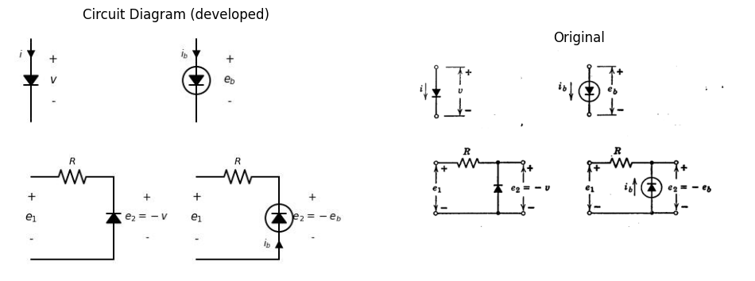
import matplotlib.pyplot as plt
from matplotlib import rcParams
import matplotlib.image as mpimg
import numpy as np
import PySpice.Logging.Logging as Logging
logger = Logging.setup_logging()
from PySpice.Probe.Plot import plot
from PySpice.Spice.Netlist import Circuit
from PySpice.Unit import *
rcParams['font.weight'] = 'bold'
fig, axs = plt.subplots(4, 2, figsize=(10, 10))
# Create subplots
circuit = Circuit('Diode')
circuit.model('BAV21','D' ,IS =10@u_mA , N = 1.906 ,BV = 110@u_V, IBV = 0.0001@u_V, VJ = 0.7@u_V ,CJO = 7.048E-13 ,RS = 800@u_Ohm ,TT = 3.48E-9)
Vth = circuit.V('th', '1', circuit.gnd, 0@u_V)
circuit.D(1, '1',circuit.gnd , model = 'BAV21')
simulator = circuit.simulator(temperature=25, nominal_temperature=25)
analysis = simulator.dc(Vth=slice(-100, 100, 0.1))
axs[0,0].plot(analysis['1'],u_mA(-analysis.Vth), 'black', linewidth=3)
# circuit 2
circuit = Circuit('Diode2')
circuit.model('BAV21','D' ,IS = 40@u_uA , N = 1.906 ,BV = 110@u_V, IBV = 0.0001@u_V, VJ = 0.1@u_mV ,CJO = 7.048E-13 ,RS = 0.01@u_Ohm ,TT = 3.48E-9)
Vth = circuit.V('th', '1', circuit.gnd, 0@u_V)
circuit.D(1, '1', circuit.gnd , model = 'BAV21')
simulator = circuit.simulator(temperature=25, nominal_temperature=25)
analysis = simulator.dc(Vth=slice(-100, 100, 0.1))
axs[1,0].plot(analysis['1'],u_mA(-analysis.Vth), 'black', linewidth=3)
# circuit 3
circuit = Circuit('Diode2')
circuit.model('BAV21','D' ,IS = 40@u_uA , N = 1.906 ,BV = 110@u_V, IBV = 0.0001@u_V, VJ = 0.1@u_mV ,CJO = 7.048E-13 ,RS = 1@u_kOhm ,TT = 3.48E-9)
Vth = circuit.V('th', '1', circuit.gnd, 0@u_V)
circuit.D(1, '2', circuit.gnd , model = 'BAV21')
circuit.R(1, '1', '2', 600@u_Ohm)
simulator = circuit.simulator(temperature=25, nominal_temperature=25)
analysis = simulator.dc(Vth=slice(-100, 100, 0.1))
axs[2,0].plot(analysis['1'],u_mA(-analysis.Vth), 'black', linewidth=3)
# circuit4
circuit = Circuit('v-i curve1')
circuit.model('BAV21','D' ,IS =10@u_mA , N = 1.906 ,BV = 110@u_V, IBV = 0.0001@u_V, VJ = 0.7@u_V ,CJO = 7.048E-13 ,RS = 1000@u_Ohm ,TT = 3.48E-9)
Vth = circuit.V('th', '1', circuit.gnd, 0@u_V)
circuit.R(1, '1','2', 10@u_Ohm)
circuit.D(1, '2',circuit.gnd , model = 'BAV21')
simulator = circuit.simulator(temperature=25, nominal_temperature=25)
analysis = simulator.dc(Vth=slice(-100, 100, 0.1))
axs[3,0].plot(analysis['1'],u_mA(-analysis.Vth), 'black', linewidth=3)
circuit = Circuit('thev')
Vi = circuit.V('i', '1', circuit.gnd, 0@u_V)
circuit.R(1 ,'1', circuit.gnd, 0.5@u_Ohm )
simulator = circuit.simulator(temperature=25, nominal_temperature=25)
analysis = simulator.dc(Vi=slice(-100, 100, 0.1))
axs[3,0].plot(analysis['1'], u_A(-analysis.Vi),'black',linestyle='--',linewidth=2)
#analyze
axs[1,0].set_title('V-I Curve for D1')
axs[1,0].text(53, 50, '$ib=f(eb)$', ha='center', va='center')
axs[1,0].text(20, 25, '$o$', ha='center', va='center')
axs[1,0].text(25, 25, '$B$', ha='center', va='center')
axs[1,0].text(-25, -10, '$o$', ha='center', va='center')
axs[1,0].text(-25, -14, '$A$', ha='center', va='center')
axs[1,0].set_xlim(-100, 100)
axs[1,0].set_xlabel('I [A]')
axs[1,0].set_ylabel('V [V]')
axs[1,0].set_ylim(-100, 100)
axs[1,0].axhline(0, color='black', linewidth=1)
axs[1,0].axvline(0, color='black', linewidth=1)
axs[0,0].set_title('V-I Curve for D2')
axs[0,0].set_xlim(-100, 100)
axs[0,0].set_xlabel('I [A]')
axs[0,0].set_ylabel('V [V]')
axs[0,0].set_ylim(-100, 100)
axs[0,0].axhline(0, color='black', linewidth=1)
axs[0,0].axvline(0, color='black', linewidth=1)
axs[2,0].set_xlim(-100, 100)
axs[2,0].set_xlabel('e1 [V]')
axs[2,0].set_ylabel('e2 [V]')
axs[2,0].set_ylim(-100, 100)
axs[2,0].text(50, 50, '$slope$', ha='center', va='center')
axs[2,0].text(50, 57, '$+1$', ha='center', va='center')
axs[2,0].text(-50, 50, '$(e)$', ha='center', va='center')
axs[2,0].text(-35, -25, '$For e1<0 , e2=0$', ha='center', va='center')
axs[2,0].text(-35, -35, '$For e1>0 , e2=e1 $', ha='center', va='center')
axs[2,0].axhline(0, color='black', linewidth=1)
axs[2,0].axvline(0, color='black', linewidth=1)
axs[3,0].annotate('', xy=(-50, -100), xytext=(-50,-8 ), arrowprops=dict(arrowstyle='<->'))
axs[3,0].annotate('', xy=(-50, 0), xytext=(-50,20 ), arrowprops=dict(arrowstyle='->'))
axs[3,0].annotate('', xy=(50, 50), xytext=(50,0 ), arrowprops=dict(arrowstyle='<->'))
axs[3,0].annotate('', xy=(50, 50), xytext=(50,65 ), arrowprops=dict(arrowstyle='->'))
axs[3,0].set_xlim(-100, 100)
axs[3,0].set_xlabel('e1 [V]')
axs[3,0].set_ylabel('e2 [V]')
axs[3,0].set_ylim(-100, 100)
axs[3,0].text(50, 50, '$o$', ha='center', va='center')
axs[3,0].text(53, 41.5, '$A$', ha='center', va='center')
axs[3,0].text(-50, -10, '$o$', ha='center', va='center')
axs[3,0].text(-45, -15, '$B$', ha='center', va='center')
axs[3,0].text(75, 85, '$slope 1$', ha='center', va='center')
axs[3,0].text(80, 50, '$e2=e1+Rib$', ha='center', va='center')
axs[3,0].text(-55, -25, '$Rib$', ha='center', va='center')
axs[3,0].text(-50, 20, '$eb$', ha='center', va='center')
axs[3,0].text(55, 25, '$-eb$', ha='center', va='center')
axs[3,0].text(50, 99, '$-Rib$', ha='center', va='center')
axs[3,0].text(50, -25, '$e2=e1+Rib$', ha='center', va='center')
axs[3,0].text(55, -30, '$=e1+Rf(eb)$', ha='center', va='center')
axs[3,0].axhline(0, color='black', linewidth=1)
axs[3,0].axvline(0, color='black', linewidth=1)
# **Subplot (1, 2): PNG Sample File**
img_sample = mpimg.imread('images-books/3-11c.png') # Load the PNG file
axs[0,1].imshow(img_sample)
axs[0,1].axis('off') # Hide axes for image display
axs[0,1].set_title('Original')
# **Subplot (1, 2): PNG Sample File**
img_sample = mpimg.imread('images-books/3-11b.png') # Load the PNG file
axs[1,1].imshow(img_sample)
axs[1,1].axis('off') # Hide axes for image display
axs[1,1].set_title('Original')
# **Subplot (1, 2): PNG Sample File**
img_sample = mpimg.imread('images-books/3-11d.png') # Load the PNG file
axs[2,1].imshow(img_sample)
axs[2,1].axis('off') # Hide axes for image display
axs[2,1].set_title('Original')
# **Subplot (1, 2): PNG Sample File**
img_sample = mpimg.imread('images-books/3-11e.png') # Load the PNG file
axs[3,1].imshow(img_sample)
axs[3,1].axis('off') # Hide axes for image display
axs[3,1].set_title('Original')
plt.tight_layout()
plt.show()
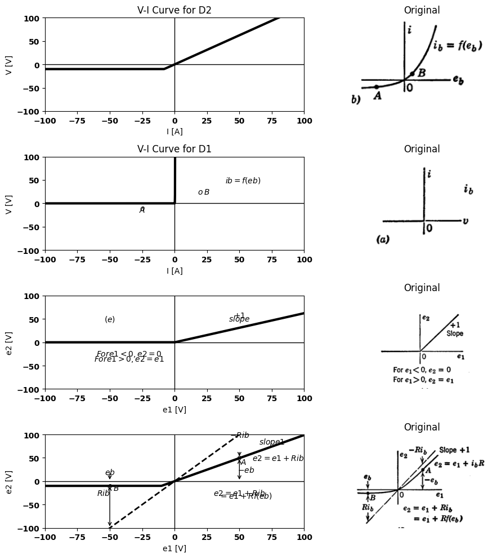
import matplotlib.pyplot as plt
from matplotlib import rcParams
import matplotlib.image as mpimg
import numpy as np
import PySpice.Logging.Logging as Logging
logger = Logging.setup_logging()
from PySpice.Probe.Plot import plot
from PySpice.Spice.Netlist import Circuit
from PySpice.Unit import *
rcParams['font.weight'] = 'bold'
fig, axs = plt.subplots(2, 2, figsize=(10, 10))
#fig1
circuit = Circuit('inpu')
circuit.model('BAV21','D' ,IS = 10@u_mA ,BV = 293.10@u_V, IBV = 0.001293@u_A , RS =0.01@u_Ohm )
circuit.SinusoidalVoltageSource(1, '1', circuit.gnd, amplitude=10@u_V)
circuit.D(1, '1','2', model = 'BAV21')
circuit.R(1, '2',circuit.gnd, 1@u_Ohm)
simulator = circuit.simulator(temperature=25, nominal_temperature=25)
analysis = simulator.transient(step_time=0.001@u_ms, end_time=0.1@u_s)
axs[0,0].plot(-analysis.branches[('v1')],'black',linewidth=5)
axs[0,0].plot(analysis['1'],'black',linestyle='--',linewidth=5)
#2
circuit = Circuit('inpu')
circuit.model('BAV21','D' ,IS = -10@u_mA ,BV = 293.10@u_V, IBV = 0.001293@u_A , RS =0.2@u_Ohm )
circuit.SinusoidalVoltageSource(1, '1', circuit.gnd, amplitude=10@u_V)
circuit.D(1, '2',circuit.gnd, model = 'BAV21')
circuit.R(1, '1','2', 1@u_Ohm)
simulator = circuit.simulator(temperature=25, nominal_temperature=25)
analysis = simulator.transient(step_time=0.001@u_ms, end_time=0.1@u_s)
axs[1,0].plot(-analysis.branches[('v1')],'black',linewidth=5)
axs[1,0].plot(analysis['1'],'black',linestyle='--',linewidth=5)
axs[1,0].axvline(x=0, color='black')
axs[1,0].set_title('Input Voltage')
axs[1,0].grid()
axs[1,0].set_xlabel('T [mS]')
axs[1,0].set_ylabel('$V_i [V]$')
axs[1,0].axvline(x=0, color='black')
axs[1,0].set_title('Current of Half-wave rectifier')
axs[1,0].grid()
axs[1,0].set_xlabel('T [mS]')
axs[1,0].set_ylabel('e [V]')
axs[1,0].text(16000, 10, '$e2$', ha='center', va='center')
axs[1,0].text(24000, -5, '$e1= E1sinwt$', ha='center', va='center')
axs[1,0].axhline(0, color='black', linewidth=1)
axs[1,0].axvline(0, color='black', linewidth=1)
axs[0,0].axvline(x=0, color='black')
axs[0,0].set_title('Input Voltage')
axs[0,0].grid()
axs[0,0].set_xlabel('T [mS]')
axs[0,0].set_ylabel('$V_i [V]$')
axs[0,0].axvline(x=0, color='black')
axs[0,0].set_title('Current of Half-wave rectifier')
axs[0,0].annotate('', xy=(8000, 10), xytext=(16000,10 ), arrowprops=dict(arrowstyle='->'))
axs[0,0].annotate('', xy=(16000, 0), xytext=(16000,9 ), arrowprops=dict(arrowstyle='->'))
axs[0,0].annotate('', xy=(20000, -3), xytext=(24000,-8 ), arrowprops=dict(arrowstyle='->'))
axs[0,0].annotate('', xy=(22000, 12), xytext=(24000,-8 ), arrowprops=dict(arrowstyle='->'))
axs[0,0].grid()
axs[0,0].set_xlabel('T [mS]')
axs[0,0].set_ylabel('e [V]')
axs[0,0].text(16000, 10, '$e2$', ha='center', va='center')
axs[0,0].text(24000, -10, '$e1= E1sinwt$', ha='center', va='center')
axs[0,0].axhline(0, color='black', linewidth=1)
axs[0,0].axvline(0, color='black', linewidth=1)
# **Subplot (1, 2): PNG Sample File**
img_sample = mpimg.imread('images-books/3-11g.png') # Load the PNG file
axs[0,1].imshow(img_sample)
axs[0,1].axis('off') # Hide axes for image display
axs[0,1].set_title('Original')
# **Subplot (1, 2): PNG Sample File**
img_sample = mpimg.imread('images-books/3-11h.png') # Load the PNG file
axs[1,1].imshow(img_sample)
axs[1,1].axis('off') # Hide axes for image display
axs[1,1].set_title('Original')
plt.tight_layout()
plt.show()
figure.savefig('./Drawings/fig34.svg')
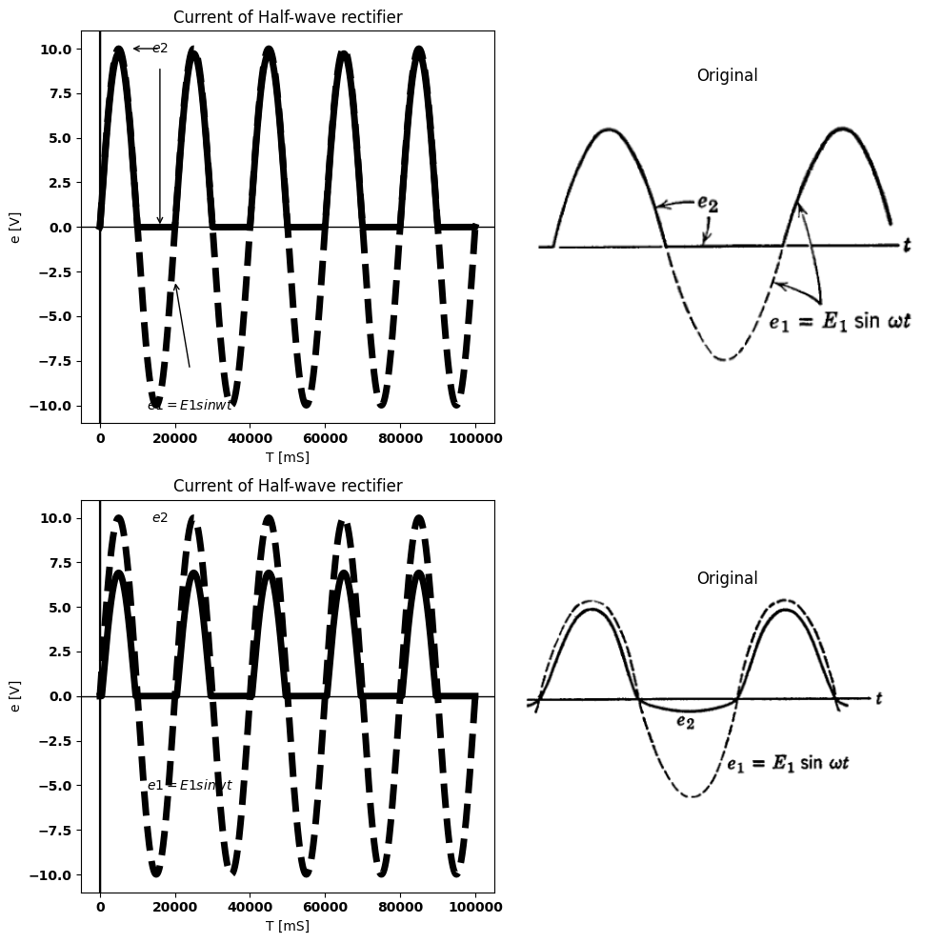
Fig. 3.11. Comparison of ideal rectifier and typical diode in a simple clipping circuit.
duction. Note also that the ideal rectifier is lossless since the product of $v$ and $i$ is zero for all possible values of $v$ and $i$.
Since the ideal rectifier is an idealization of a physical diode, it is interesting to see how well it approximates such a diode in a typical
circuit. An arbitrary diode curve $i_{b}=f\left(e_{b}\right)$ is shown in Fig. 3.11$\left(b\right)$. Two simple rectifier circuits are shown, using in $\left(c\right)$ an ideal rectifier and in $\left(d\right)$ an actual diode. The circuits reproduce the positive portions of the input voltage waveform but do not pass the negative portions to the output so that the output is unidirectional or "rectified." This circuit is also the basic prototype of amplitude wave-shaping circuits. It is called a diode clipper, since it removes or clips a portion of the input waveform.
The plots of $e_{2}$ vs. $e_{1}$ shown in Fig. 3.11$\left(e\right)$ and $\left(f\right)$, called transfer curves, present graphically the instantaneous relation between output and input voltages. The slope at any point ($\left(\frac{Δe_{2}}{Δe_{1}}\right)$ is called the transfer ratio or gain, in this case a voltage ratio that cannot exceed unity. The sketches exaggerate the difference between the transfer curve for the circuit with the ideal rectifier and that of the circuit with an actual diode. In the high-conduction region ($e_{1}<0$), if the voltage drop across $R$ is very large compared with the drop across the diode, the percentage error is small. For $e_{1}$ greater than $0$, the error is again small if $e_{b}≫R_{ib}$. These are contradictory conditions on $R$, but an intermediate value of $R$ can usually be found to satisfy the conditions reasonably well over a fair range of values for $e_{1}$ and $e_{2}$. The close correspondence between these transfer curves is quite surprising in view of the fact that the diode curve and the ideal rectifier curve differ considerably. The rectifying or wave-shaping action of the two circuits, Fig. 3.11$\left(g\right)$ and $\left(h\right)$, also shows great similarity

7 3.6 Piecewise-Linear Models for Vacuum Diodes
Curves for vacuum diodes closely follow the three-halves power law (see Fig. 3.12), except at low voltages, where contact potential difference and the initial velocity of electrons become important. The geometry of this curve illustrates the considerations involved in approximating a nonlinear curve. Suppose the range of voltage over which the diode is to be operated includes negative values and extends to point $P$ for positive values. For a particular point, such as $P$, let the voltage and current be designated as $E_{b}$ and $I_{b}$, respectively.
The line $OP$ through the origin determines a quantity $r_{b}$ , called the total plate resistance. A tangent drawn through $P$ defines the quantity $r_{p}$ , called the incremental plate resistance. As indicated in Fig. 3.12,
the value of $r_{p}$ determined at any point on a three-halves power curve is $\frac{2r_{b}}{3}$. The tangent-line intercept $E_{0}$ occurs at the value $\frac{E_{b}}{3}$. Note that the curve lies between the $r_{b}$ line and the $r_{p}$ line for $0 < e_b < E_b$. The tangent line $r_{p}$ always lies below the curve, whereas the chord $r_{b}$ crosses the curve at point $P$.
import schemdraw
import schemdraw.elements as e
import schemdraw as schem
import matplotlib.pyplot as plt
import matplotlib.image as mpimg
import numpy as np
# Create the figure and subplots
fig, axs = plt.subplots(2, 2, figsize=(12, 12))
d = schemdraw.Drawing()
D1 = d.add(e.Diode().down())
l1 = d.add(e.Line().right().at(D1.start))
d += e.lines.CurrentLabelInline().at(l1).left().label('$i_b$').color('black')
l2 = d.add(e.Line().right().at(D1.end))
d += e.Gap().up().label(['-' , '$e_b$' , '+'] , fontsize = 16).color('black')
d.save('./Drawings/fig3-12.png')
d.save('./Drawings/fig3-12.svg')
# Load the saved PNG file into the subplot
img = mpimg.imread('./Drawings/fig3-12.png')
axs[0,0].imshow(img)
axs[0,0].axis('off') # Hide axes for image display
axs[0,0].set_title('Circuit Diagram (developed)')
# **Subplot (1, 2): PNG Sample File**
img_sample = mpimg.imread('images-books/3-12a.png') # Load the PNG file
axs[0,1].imshow(img_sample)
axs[0,1].axis('off') # Hide axes for image display
axs[0,1].set_title('Original')
#
circuit = Circuit('v-i curve')
circuit.model('BAV21','D' ,IS = 8.5@u_uA , N = 1.906 ,BV = 110@u_V, IBV = 0.0001@u_V, VJ = 0.1@u_V ,CJO = 7.048E-13 ,RS = 84@u_Ohm ,TT = 3.48E-9)
Vi = circuit.V('i', '1', circuit.gnd, 5@u_V)
circuit.R(1, '1', '2', 0.3@u_Ohm)
circuit.D(1, '2',circuit.gnd , model = 'BAV21')
simulator = circuit.simulator(temperature=25, nominal_temperature=25)
analysis = simulator.dc(Vi=slice(0, 15, 0.1))
axs[1,0].plot(analysis['2'], u_mA(-analysis.Vi),'black',linewidth=2)
circuit = Circuit('thev')
Vi = circuit.V('i', '1', circuit.gnd, 0@u_V)
circuit.R(1 ,'1', circuit.gnd, .13@u_Ohm )
simulator = circuit.simulator(temperature=25, nominal_temperature=25)
analysis = simulator.dc(Vi=slice(-2, 1, 0.1))
axs[1,0].plot(analysis['1'], u_A(-analysis.Vi),'black',linestyle='--',linewidth=2)
# curve 2
circuit = Circuit('thev')
Vi = circuit.V('i', '1', circuit.gnd, 0@u_V)
circuit.R(1 ,'1', '2', .075@u_Ohm )
circuit.V('fixed', '2', circuit.gnd, 0.4@u_V)
simulator = circuit.simulator(temperature=25, nominal_temperature=25)
analysis = simulator.dc(Vi=slice(-2, 3, 0.1))
axs[1,0].plot(analysis['1'], u_A(-analysis.Vi),'black',linestyle='-.',linewidth=2)
axs[1,0].legend(('I-V diode curve','diode equation'), loc=(.8,.8))
axs[1,0].set_title('Load Line Analysis (Ngspice Simulation via Pyspice)')
axs[1,0].annotate('', xy=(0.97, 7), xytext=(0,7 ), arrowprops=dict(arrowstyle='->'))
axs[1,0].annotate('', xy=(0.92, 7), xytext=(0.92,0 ), arrowprops=dict(arrowstyle='->'))
axs[1,0].annotate('', xy=(0.75, 5.8), xytext=(0.5,5.8 ), arrowprops=dict(arrowstyle='->'))
axs[1,0].annotate('', xy=(0.65, 4), xytext=(0.42,4 ), arrowprops=dict(arrowstyle='->'))
axs[1,0].annotate('', xy=(0.7, 4.5), xytext=(0.85,3 ), arrowprops=dict(arrowstyle='->'))
axs[1,0].text(1, -0.3, 'Eb', ha='center', va='center')
axs[1,0].text(-0.1, 7, 'ib', ha='center', va='center')
axs[1,0].text(1, 7, 'P', ha='center', va='center')
axs[1,0].text(0.2, 6, 'Total Plate', ha='center', va='center')
axs[1,0].text(0.2, 5.5, 'Resistance rb=Eb/ib', ha='center', va='center')
axs[1,0].text(0.2, 4, 'ib=Keb^(3/2)', ha='center', va='center')
axs[1,0].text(1, 2.5, 'incremantal\n Plate resistance\n rp=deb/dib', ha='center', va='center')
axs[1,0].set_xlim(-1, 3)
axs[1,0].set_ylim(-2, 8)
axs[1,0].set_xlabel('eb [V]')
axs[1,0].set_ylabel('ib [mA]')
axs[1,0].axhline(0, color='black', linewidth=2)
axs[1,0].axvline(0, color='black', linewidth=2)
# **Subplot (1, 2): PNG Sample File**
img_sample = mpimg.imread('images-books/3-12b.png') # Load the PNG file
axs[1,1].imshow(img_sample)
axs[1,1].axis('off') # Hide axes for image display
axs[1,1].set_title('Original')
plt.tight_layout()
plt.show()
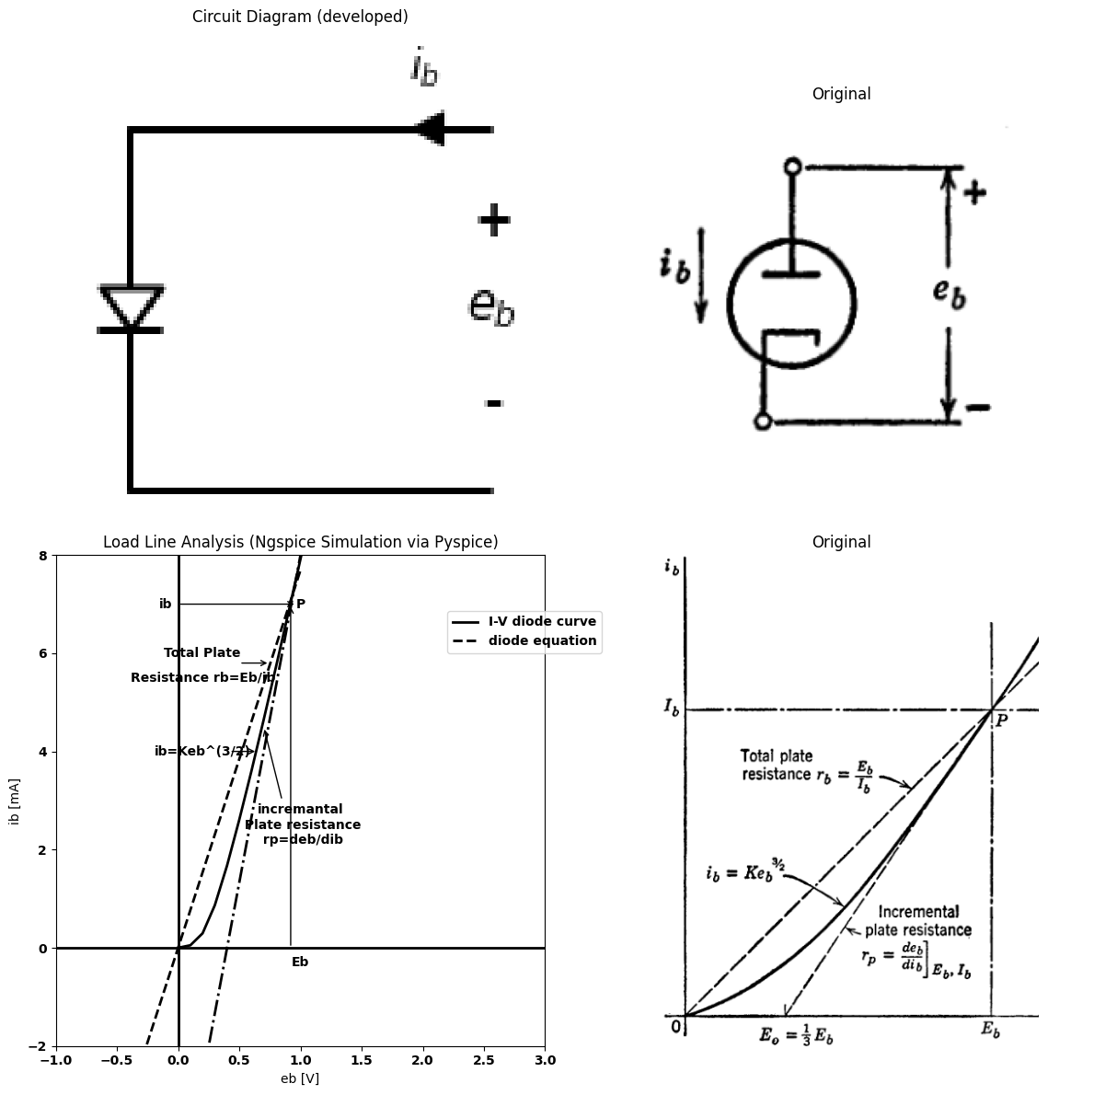
$$ib=keb$$
$$foreb>0$$
$$ib=0$$
$$foreb<0$$

7.1 (1) $$r_{p}=\left(\frac{E_{b}}{i_{b}}\right)=\left(\frac{1}{Keb^{\frac{2}{3}}}\right)$$

7.2 (2) $$r_{p}=\left(\frac{deb}{dib}\right)=\left(\frac{2}{3K}\right)×{\left(\frac{ib}{K}\right)}^{\frac{−1}{3}}=\frac{2}{3Keb^{\frac{1}{2}}}=\frac{2}{3}r_{b}$$

7.3 (3) $$E_{o}=E_{b}−rp_{I}b=\frac{1}{3}E_{b}$$
Fig. 3.12. Geometrical properties of three-halves power curve for vacuum diode.
The equation for the tangent line represents the first two terms of the Taylor series expansion of the diode curve about point $P$. Expanding $i_{b}=Ke_{b}^{3/2}$ at point $P$ yields a constant term and a linear term. Expressed in terms of the coordinates of point $P$, this becomes $ i_b = -\frac{I_b}{2} + \frac{3I_b e_b}{2E_b}$. This tangent line may be considered to be a linear approximation to the diode curve. The corresponding circuit model is either a battery of value $E_{0}=\frac{E_{b}}{3}$ in series with a resistance $r_{p}=\frac{2E_{b}}{3I_{b}}$ or a current source of magnitude $\frac{I_{b}}{2}$ in parallel with the
resistance.
The tangent line approximates $i_{b}$ reasonably well near $P$. In fact, it yields current values within 0.015$I_{b}$ of the actual diode curve
import matplotlib.pyplot as plt
import numpy as np
import schemdraw
import schemdraw.elements as e
import matplotlib.image as mpimg
# Create the figure and subplots
fig, axs = plt.subplots(5, 2, figsize=(12, 12))
# **Subplot (1, 1): Schemdraw Circuit Diagram**
d = schemdraw.Drawing()
d.push()
D1 = d.add(e.Diode(fill=True).down())
d += e.lines.CurrentLabelInline().at(D1).down().label('$i_b$').color('black')
R1 = d.add(e.Resistor().down().label('$r_p=2/3.E_b/I_b$', ofst=-3))
E1 = d.add(e.Battery().down().label(['+ ','$E_o=1/3.E_b$','- '], ofst=-3))
d.pop()
d += e.Gap().down().length(9).label(['\u2191','+',' ',' ',' ',' ',' ',' ','$e_b$'
,' ',' ',' ',' ',' ',' ','-','\u2193'], ofst=-1 , fontsize = 16).color('black')
d.move(5,9)
d.push()
D2 = d.add(e.Diode(fill=True).down())
d += e.lines.CurrentLabelInline().at(D2).down().label('$i_b$').color('black')
R2 = d.add(e.Resistor().down().label('$0/9.E_b/I_b$', ofst=-2.3))
E1 = d.add(e.Battery().down().label(['+ ','$0/14E_b$','- '], ofst=-2.3))
d.pop()
d += e.Gap().down().length(9).label(['\u2191','+',' ',' ',' ',' ',' ',' ','$e_b$'
,' ',' ',' ',' ',' ',' ','-','\u2193'], ofst=-1 , fontsize = 16).color('black')
d.move(5,9)
d.push()
D3 = d.add(e.Diode(fill=True).down())
d += e.lines.CurrentLabelInline().at(D3).down().label('$i_b$').color('black')
R3 = d.add(e.Resistor().down().label('$r_b=E_b/I_b$', ofst=-2.3))
d.pop()
d += e.Gap().down().length(6).label(['\u2191','+',' ',' ',' ',' ','$e_b$'
,' ',' ',' ',' ','-','\u2193'], ofst=-1 , fontsize = 16).color('black')
d.move(5,6)
d.push()
D4 = d.add(e.Diode(fill=True).down())
d += e.lines.CurrentLabelInline().at(D4).down().label('$i_b$').color('black')
R4 = d.add(e.Resistor().down().label('$r_b=1.1E_b/I_b$', ofst=-3))
d.pop()
d += e.Gap().down().length(6).label(['\u2191','+',' ',' ',' ',' ','$e_b$'
,' ',' ',' ',' ','-','\u2193'], ofst=-1 , fontsize = 16).color('black')
d.save('./Drawings/fig3-13.jpg')
d.save('./Drawings/fig3-13.svg')
# Load the saved PNG file into the subplot
img = mpimg.imread('./Drawings/fig3-13.jpg')
axs[0,0].imshow(img)
axs[0,0].axis('off') # Hide axes for image display
axs[0,0].set_title('Circuit Diagram (developed)')
# **Subplot (1, 2): PNG Sample File**
img_sample = mpimg.imread('images-books/3-13.png') # Load the PNG file
axs[0,1].imshow(img_sample)
axs[0,1].axis('off') # Hide axes for image display
axs[0,1].set_title('Original')
#
circuit = Circuit('v-i curve')
circuit.model('BAV21','D' ,IS = 100@u_uA , N = 1.906 ,BV = 110@u_V, IBV = 0.0001@u_V, VJ = 0.7@u_V ,CJO = 7.048E-13 ,RS = 24@u_Ohm ,TT = 3.48E-9)
Vi = circuit.V('i', '1', circuit.gnd, 0@u_V)
circuit.R(1, '1', '2', 80@u_Ohm)
circuit.D(1, '2',circuit.gnd , model = 'BAV21')
simulator = circuit.simulator(temperature=25, nominal_temperature=25)
analysis = simulator.dc(Vi=slice(0, 50, 0.1))
axs[1,0].plot(analysis['1'], u_mA(-analysis.Vi),'black',linestyle='--',linewidth=2)
# resistance
circuit = Circuit('thev')
Vi = circuit.V('i', '1', circuit.gnd, 0@u_V)
circuit.R(1 ,'1', '2', 0.1@u_Ohm )
circuit.V(1, '2',circuit.gnd, 0.25@u_V)
simulator = circuit.simulator(temperature=25, nominal_temperature=25)
analysis = simulator.dc(Vi=slice(0.25, 10, 0.1))
axs[1,0].plot(analysis['1'], u_A(-analysis.Vi),'black',linestyle='-',linewidth=2)
axs[1,0].set_title('Load Line Analysis')
axs[1,0].annotate('', xy=(0.97, 7), xytext=(0,7 ), arrowprops=dict(arrowstyle='->'))
axs[1,0].annotate('', xy=(0.92, 7), xytext=(0.92,0 ), arrowprops=dict(arrowstyle='->'))
axs[1,0].annotate('', xy=(0.65, 4), xytext=(0.42,4 ), arrowprops=dict(arrowstyle='->'))
axs[1,0].annotate('', xy=(0.7, 4.5), xytext=(0.85,3 ), arrowprops=dict(arrowstyle='->'))
axs[1,0].text(0.88, -0.3, 'Eb', ha='center', va='center')
axs[1,0].text(-0.1, 7, 'Ib', ha='center', va='center')
axs[1,0].text(1, 7, 'P', ha='center', va='center')
axs[1,0].text(0.2, 4, 'ib=Keb^(3/2)', ha='center', va='center')
axs[1,0].text(1, 3, 'rp=2/3rb', ha='center', va='center')
axs[1,0].text(2, 4, 'Within 0.015 Ib for \n 0.8Eb<eb<1.2Eb \n maximum error\n 0.18Ib ateb=Eb/3', ha='center', va='center')
axs[1,0].set_xlim(-1, 3)
axs[1,0].set_ylim(-2, 8)
axs[1,0].set_xlabel('eb [V]')
axs[1,0].set_ylabel('ib [mA]')
axs[1,0].axhline(0, color='black', linewidth=3)
axs[1,0].axvline(0, color='black', linewidth=3)
# **Subplot (1, 2): PNG Sample File**
img_sample = mpimg.imread('images-books/3-13a.png') # Load the PNG file
axs[1,1].imshow(img_sample)
axs[1,1].axis('off') # Hide axes for image display
axs[1,1].set_title('Original')
#
circuit = Circuit('v-i curve')
circuit.model('BAV21','D' ,IS = 10@u_uA , N = 1.906 ,BV = 110@u_V, IBV = 0.0001@u_V, VJ = 0.7@u_V ,CJO = 7.048E-13 ,RS = 40@u_Ohm ,TT = 3.48E-9)
Vi = circuit.V('i', '1', circuit.gnd, 0@u_V)
circuit.R(1, '1', '2', 70@u_Ohm)
circuit.D(1, '2',circuit.gnd , model = 'BAV21')
simulator = circuit.simulator(temperature=25, nominal_temperature=25)
analysis = simulator.dc(Vi=slice(0, 50, 0.1))
axs[2,0].plot(analysis['1'], u_mA(-analysis.Vi),'black',linestyle='--',linewidth=2)
# resistance
circuit = Circuit('thev')
Vi = circuit.V('i', '1', circuit.gnd, 0@u_V)
circuit.R(1 ,'1', '2', 0.155@u_Ohm )
circuit.V(1, '2',circuit.gnd, 0.12@u_V)
simulator = circuit.simulator(temperature=25, nominal_temperature=25)
analysis = simulator.dc(Vi=slice(0.12, 10, 0.1))
axs[2,0].plot(analysis['1'], u_A(-analysis.Vi),'black',linestyle='-',linewidth=2)
axs[2,0].set_title('Load Line Analysis')
axs[2,0].annotate('', xy=(0.95, 5.2), xytext=(0,5.2), arrowprops=dict(arrowstyle='->'))
axs[2,0].annotate('', xy=(0.92,5.4), xytext=(0.92,0 ), arrowprops=dict(arrowstyle='->'))
axs[2,0].annotate('', xy=(0.76, 4), xytext=(0.52,4 ), arrowprops=dict(arrowstyle='->'))
axs[2,0].text(0.92, -0.3, 'Eb', ha='center', va='center')
axs[2,0].text(-0.1, 5.3, 'Ib', ha='center', va='center')
axs[2,0].text(1.1, 5.3, '0.95Ib', ha='center', va='center')
axs[2,0].text(0.4, 4, '0.9rb', ha='center', va='center')
axs[2,0].text(.2, -0.3, '0.14Eb', ha='center', va='center')
axs[2,0].text(2, 4, 'Within +0.05 Ib \nfor eb<eb<Eb ', ha='center', va='center')
axs[2,0].set_xlim(-1, 3)
axs[2,0].set_ylim(-2, 8)
axs[2,0].set_xlabel('eb [V]')
axs[2,0].set_ylabel('ib [mA]')
axs[2,0].axhline(0, color='black', linewidth=3)
axs[2,0].axvline(0, color='black', linewidth=3)
plt.axhline(0, color='black', linewidth=3)
plt.axvline(0, color='black', linewidth=3)
# **Subplot (1, 2): PNG Sample File**
img_sample = mpimg.imread('images-books/3-13b.png') # Load the PNG file
axs[2,1].imshow(img_sample)
axs[2,1].axis('off') # Hide axes for image display
axs[2,1].set_title('Original')
#3
circuit = Circuit('v-i curve')
circuit.model('BAV21','D' ,IS = 10@u_uA , N = 1.906 ,BV = 110@u_V, IBV = 0.0001@u_V, VJ = 0.7@u_V ,CJO = 7.048E-13 ,RS = 40@u_Ohm ,TT = 3.48E-9)
Vi = circuit.V('i', '1', circuit.gnd, 0@u_V)
circuit.R(1, '1', '2', 70@u_Ohm)
circuit.D(1, '2',circuit.gnd , model = 'BAV21')
simulator = circuit.simulator(temperature=25, nominal_temperature=25)
analysis = simulator.dc(Vi=slice(0, 50, 0.1))
axs[3,0].plot(analysis['1'], u_mA(-analysis.Vi),'black',linestyle='--',linewidth=2)
# resistance
circuit = Circuit('thev')
Vi = circuit.V('i', '1', circuit.gnd, 0@u_V)
circuit.R(1 ,'1', '2', 0.155@u_Ohm )
circuit.V(1, '2',circuit.gnd, 0.@u_V)
simulator = circuit.simulator(temperature=25, nominal_temperature=25)
analysis = simulator.dc(Vi=slice(0, 10, 0.1))
axs[3,0].plot(analysis['1'], u_A(-analysis.Vi),'black',linestyle='-',linewidth=2)
axs[3,0].set_title('Load Line Analysis')
axs[3,0].annotate('', xy=(1.1, 7), xytext=(0,7), arrowprops=dict(arrowstyle='->'))
axs[3,0].annotate('', xy=(1.09,7.1), xytext=(1.09,0 ), arrowprops=dict(arrowstyle='->'))
axs[3,0].text(1.1, -0.3, 'Eb', ha='center', va='center')
axs[3,0].text(-0.1, 7, 'Ib', ha='center', va='center')
axs[3,0].text(1.15, 7, 'Ib', ha='center', va='center')
axs[3,0].text(0.4, 4, 'rb', ha='center', va='center')
axs[3,0].text(2, 4, 'Within +0.15 for \n eb<1.25Eb ', ha='center', va='center')
axs[3,0].set_xlim(-1, 3)
axs[3,0].set_ylim(-2, 8)
axs[3,0].set_xlabel('eb [V]')
axs[3,0].set_ylabel('ib [mA]')
axs[3,0].axhline(0, color='black', linewidth=3)
axs[3,0].axvline(0, color='black', linewidth=3)
# **Subplot (1, 2): PNG Sample File**
img_sample = mpimg.imread('images-books/3-13c.png') # Load the PNG file
axs[3,1].imshow(img_sample)
axs[3,1].axis('off') # Hide axes for image display
axs[3,1].set_title('Original')
#4
circuit = Circuit('v-i curve')
circuit.model('BAV21','D' ,IS = 10@u_uA , N = 1.906 ,BV = 110@u_V, IBV = 0.0001@u_V, VJ = 0.7@u_V ,CJO = 7.048E-13 ,RS = 40@u_Ohm ,TT = 3.48E-9)
Vi = circuit.V('i', '1', circuit.gnd, 0@u_V)
circuit.R(1, '1', '2', 70@u_Ohm)
circuit.D(1, '2',circuit.gnd , model = 'BAV21')
simulator = circuit.simulator(temperature=25, nominal_temperature=25)
analysis = simulator.dc(Vi=slice(0, 50, 0.1))
axs[4,0].plot(analysis['1'], u_mA(-analysis.Vi),'black',linestyle='--',linewidth=2)
# resistance
circuit = Circuit('thev')
Vi = circuit.V('i', '1', circuit.gnd, 0@u_V)
circuit.R(1 ,'1', '2', 0.1705@u_Ohm )
circuit.V(1, '2',circuit.gnd, 0.@u_V)
simulator = circuit.simulator(temperature=25, nominal_temperature=25)
analysis = simulator.dc(Vi=slice(0, 10, 0.1))
axs[4,0].plot(analysis['1'], u_A(-analysis.Vi),'black',linestyle='-',linewidth=2)
axs[4,0].set_title('Load Line Analysis')
axs[4,0].annotate('', xy=(1.1, 7), xytext=(0,7), arrowprops=dict(arrowstyle='->'))
axs[4,0].annotate('', xy=(1.09,7.1), xytext=(1.09,0 ), arrowprops=dict(arrowstyle='->'))
axs[4,0].text(1.1, -0.3, 'Eb', ha='center', va='center')
axs[4,0].text(-0.1, 7, 'Ib', ha='center', va='center')
axs[4,0].text(1.2, 6, '0.9Ib', ha='center', va='center')
axs[4,0].text(0.4, 4, 'rb', ha='center', va='center')
axs[4,0].text(2, 4, 'Within +0.1 for \n eb<Eb ', ha='center', va='center')
axs[4,0].set_xlim(-1, 3)
axs[4,0].set_ylim(-2, 8)
axs[4,0].set_xlabel('eb [V]')
axs[4,0].set_ylabel('ib [mA]')
axs[4,0].axhline(0, color='black', linewidth=3)
axs[4,0].axvline(0, color='black', linewidth=3)
# **Subplot (1, 2): PNG Sample File**
img_sample = mpimg.imread('images-books/3-13d.png') # Load the PNG file
axs[4,1].imshow(img_sample)
axs[4,1].axis('off') # Hide axes for image display
axs[4,1].set_title('Original')
Text(0.5, 1.0, 'Original')
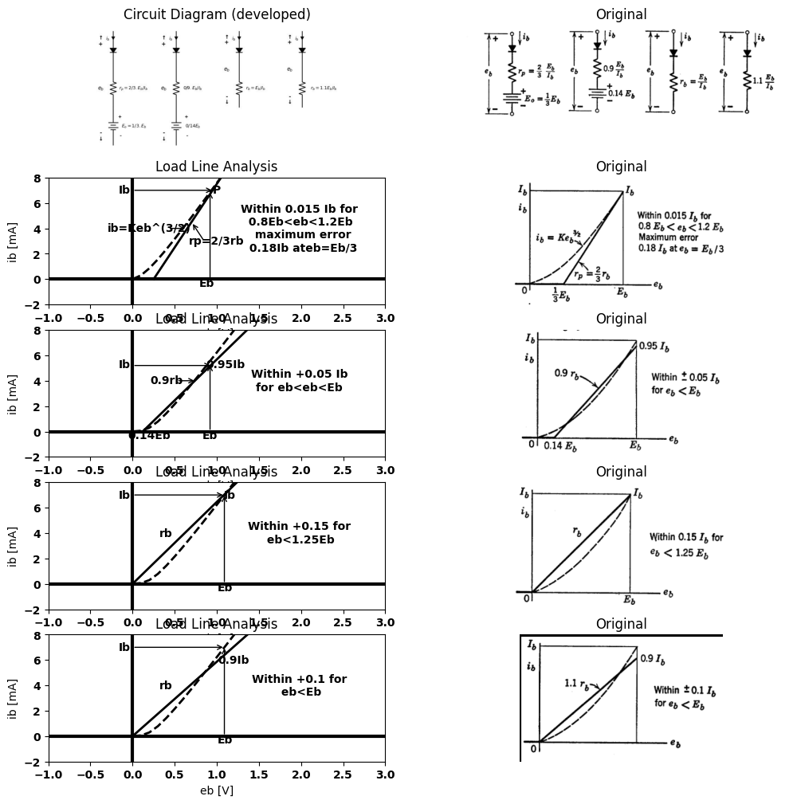
Fig. 3.13 Piecewise-linear models for vacuum diodes.
for $0.8E_b < e_b < 1.2E_b$.Theadditionofanidealrectifiertothismodelyieldsthepiecewise−linearmodelshowninFig.3.13$(a)$.
A better fit over the specified range $e_{b}<E_{b}$ is obtained by changing circuit parameters as shown in Fig. 3.13(b). Obtaining such a straight-
line fit to a nonlinear curve can best be done by eye. Minimizing by calculus the difference between a nonlinear curve and the equation of a
import matplotlib.pyplot as plt
import numpy as np
import schemdraw
import schemdraw.elements as e
import matplotlib.image as mpimg
# Create the figure and subplots
fig, axs = plt.subplots(3, 2, figsize=(12, 12))
# **Subplot (1, 1): Schemdraw Circuit Diagram**
d = schemdraw.Drawing()
d.push()
D1 = d.add(e.Diode(fill=True).down())
R2 = d.add(e.Resistor().down().label('$R_2$', ofst=-1))
E1 = d.add(e.Battery().down().label(['+ ','$E_2$','- '], ofst=-1.2))
l1 = d.add(e.Line().left())
d.pop()
d.push()
l2 = d.add(e.Line().left())
D2 = d.add(e.Diode(fill=True).down())
R1 = d.add(e.Resistor().down().label('$R_1$', ofst=-1))
l3 = d.add(e.Line().down())
l4 = d.add(e.Line().left((d.unit/2)).at(l3.end).label('$ R_1=R_a$\n\n $R_2=R_aR_b/R_a-R_b $', ofst=-1.4))
l5 = d.add(e.Line().left((d.unit/2)).at(D2.start))
d += e.lines.CurrentLabelInline().at(l5.start).right().label('$i_b$').color('black')
d.pop()
d += e.Gap().down().length(9).label(['\u2191','+',' ',' ',' ',' ',' ','$e_b$'
,' ',' ',' ',' ',' ','-','\u2193'], ofst=-5 , fontsize = 16).color('black')
d.move(8,9)
d.push()
D3 = d.add(e.Diode(fill=True).down())
R3 = d.add(e.Resistor().down().label('$R_2$', ofst=-1))
E2 = d.add(e.Battery().down().label(['+ ','$E_2$','- '], ofst=-1.2))
l6 = d.add(e.Line().left())
d.pop()
d.push()
l7 = d.add(e.Line().left())
D4 = d.add(e.Diode(fill=True).down())
R4 = d.add(e.Resistor().down().label('$R_1$', ofst=-1))
l8 = d.add(e.Line().down())
l9 = d.add(e.Line().left((d.unit/2)).at(l8.end).label('$ G_1=G_a$\n\n $ G_2=G_b-G_a $\n\n $ G3=G_c-G_b-G_a $', ofst=-2.2))
l10 = d.add(e.Line().left((d.unit/2)).at(D4.start))
d += e.lines.CurrentLabelInline().at(l10.start).right().label('$i_b$').color('black')
d.pop()
d += e.Gap().down().length(9).label(['\u2191','+',' ',' ',' ',' ',' ','$e_b$'
,' ',' ',' ',' ',' ','-','\u2193'], ofst=-5 , fontsize = 16).color('black')
l11 = d.add(e.Line().right().at(D3.start))
D5 = d.add(e.Diode(fill=True).down())
R5 = d.add(e.Resistor().down().label('$R_3$', ofst=-1))
E3 = d.add(e.Battery().down().label(['+ ','$E_3$','- '], ofst=-1.2))
l12 = d.add(e.Line().left())
d.save('./Drawings/fig3-14.jpg')
d.save('./Drawings/fig3-14.svg')
# Load the saved PNG file into the subplot
img = mpimg.imread('./Drawings/fig3-14.jpg')
axs[0,0].imshow(img)
axs[0,0].axis('off') # Hide axes for image display
axs[0,0].set_title('Circuit Diagram (developed)')
# **Subplot (1, 2): PNG Sample File**
img_sample = mpimg.imread('images-books/3-14.png') # Load the PNG file
axs[0,1].imshow(img_sample)
axs[0,1].axis('off') # Hide axes for image display
axs[0,1].set_title('Original')
#1
circuit = Circuit('v-i curve')
circuit.model('BAV21','D' ,IS = 10@u_uA , N = 1.906 ,BV = 110@u_V, IBV = 0.0001@u_V, VJ = 0.7@u_V ,CJO = 7.048E-13 ,RS = 1@u_Ohm ,TT = 3.48E-9)
Vi = circuit.V('i', '1', circuit.gnd, 0@u_V)
circuit.R(1, '2', circuit.gnd, 350@u_Ohm)
circuit.D(1, '1','2' , model = 'BAV21')
simulator = circuit.simulator(temperature=25, nominal_temperature=25)
analysis = simulator.dc(Vi=slice(0, 1, 0.1))
axs[1,0].plot(analysis['1'], u_mA(-analysis.Vi),'black',linestyle='-',linewidth=2)
circuit = Circuit('thev')
circuit.model('BAV21','D' ,IS = 10@u_uA , N = 1.906 ,BV = 110@u_V, IBV = 0.0001@u_V, VJ = 0.7@u_V ,CJO = 7.048E-13 ,RS = 1@u_Ohm ,TT = 3.48E-9)
Vi = circuit.V('i', '1', circuit.gnd, 0@u_V)
circuit.R(2, '2', circuit.gnd, 240@u_Ohm)
circuit.D(2, '1','2' , model = 'BAV21')
circuit.R(1, '2', '3', 200@u_Ohm)
circuit.D(3, '1','2' , model = 'BAV21')
circuit.V(1, '3',circuit.gnd ,1@u_V)
simulator = circuit.simulator(temperature=25, nominal_temperature=25)
analysis = simulator.dc(Vi=slice(1, 3, 0.1))
axs[1,0].plot(analysis['1'], u_mA(-analysis.Vi),'black',linestyle='-',linewidth=2)
#2
circuit = Circuit('v-i curve')
circuit.model('BAV21','D' ,IS = 14.5@u_nA , N = 1.906 ,BV = 110@u_V, IBV = 0.0001@u_V, VJ = .7@u_V ,CJO = 7.048E-13 ,RS = 150@u_Ohm ,TT = 3.48E-9)
Vi = circuit.V('i', '1', circuit.gnd, 10@u_V)
circuit.R(1, '1', '2', 1@u_Ohm)
circuit.D(1, '2',circuit.gnd , model = 'BAV21')
simulator = circuit.simulator(temperature=25, nominal_temperature=25)
analysis = simulator.dc(Vi=slice(0, 25, 0.1))
axs[1,0].plot(analysis['2'], u_mA(-analysis.Vi),'black',linestyle='--',linewidth=3)
axs[1,0].annotate('', xy=(1.6, 6), xytext=(0,6), arrowprops=dict(arrowstyle='->'))
axs[1,0].annotate('', xy=(1.5, 6), xytext=(1.5,0), arrowprops=dict(arrowstyle='->'))
axs[1,0].annotate('', xy=(1.2, 4), xytext=(1.8,4), arrowprops=dict(arrowstyle='->'))
axs[1,0].annotate('', xy=(1.2, 4), xytext=(1,4), arrowprops=dict(arrowstyle='->'))
axs[1,0].set_title('Load Line Analysis')
axs[1,0].text(0.4, 2, 'Ra=R1', ha='center', va='center')
axs[1,0].text(1, -0.4, 'E2', ha='center', va='center')
axs[1,0].text(2, 4, 'ib=Keb', ha='center', va='center')
axs[1,0].text(0.5, 4, 'Rb=R1R2/(R1+R2)', ha='center', va='center')
axs[1,0].text(1.5, -0.4, 'Eb', ha='center', va='center')
axs[1,0].text(-0.1, 6, 'ib', ha='center', va='center')
axs[1,0].set_xlim(-1, 8)
axs[1,0].set_ylim(-2, 8)
axs[1,0].set_xlabel('V [V]')
axs[1,0].set_ylabel('I [mA]')
axs[1,0].axhline(0, color='black', linewidth=1)
axs[1,0].axvline(0, color='black', linewidth=1)
# **Subplot (1, 2): PNG Sample File**
img_sample = mpimg.imread('images-books/3-14a.png') # Load the PNG file
axs[1,1].imshow(img_sample)
axs[1,1].axis('off') # Hide axes for image display
axs[1,1].set_title('Original')
#
circuit = Circuit('v-i curve')
circuit.model('BAV21','D' ,IS = 10@u_uA , N = 1.906 ,BV = 110@u_V, IBV = 0.0001@u_V, VJ = 0.7@u_V ,CJO = 7.048E-13 ,RS = 1@u_Ohm ,TT = 3.48E-9)
Vi = circuit.V('i', '1', circuit.gnd, 0@u_V)
circuit.R(1, '2', circuit.gnd, 350@u_Ohm)
circuit.D(1, '1','2' , model = 'BAV21')
simulator = circuit.simulator(temperature=25, nominal_temperature=25)
analysis = simulator.dc(Vi=slice(0, 1, 0.1))
axs[2,0].plot(analysis['1'], u_mA(-analysis.Vi),'black',linestyle='-',linewidth=2)
circuit = Circuit('thev')
circuit.model('BAV21','D' ,IS = 10@u_uA , N = 1.906 ,BV = 110@u_V, IBV = 0.0001@u_V, VJ = 0.7@u_V ,CJO = 7.048E-13 ,RS = 1@u_Ohm ,TT = 3.48E-9)
Vi = circuit.V('i', '1', circuit.gnd, 0@u_V)
circuit.R(2, '2', circuit.gnd, 230@u_Ohm)
circuit.D(2, '1','2' , model = 'BAV21')
circuit.R(1, '2', '3', 200@u_Ohm)
circuit.D(3, '1','2' , model = 'BAV21')
circuit.V(1, '3',circuit.gnd ,1@u_V)
simulator = circuit.simulator(temperature=25, nominal_temperature=25)
analysis = simulator.dc(Vi=slice(1, 1.3, 0.1))
axs[2,0].plot(analysis['1'], u_mA(-analysis.Vi),'black',linestyle='-',linewidth=2)
#2
circuit = Circuit('thev')
circuit.model('BAV21','D' ,IS = 10@u_uA , N = 1.906 ,BV = 110@u_V, IBV = 0.0001@u_V, VJ = 0.7@u_V ,CJO = 7.048E-13 ,RS =120@u_Ohm ,TT = 3.48E-9)
Vi = circuit.V('i', '1', circuit.gnd, 0@u_V)
circuit.R(2, '2', circuit.gnd, 130@u_Ohm)
circuit.D(2, '1','2' , model = 'BAV21')
circuit.R(1, '2', '3', 210@u_Ohm)
circuit.D(3, '1','2' , model = 'BAV21')
circuit.V(1, '3',circuit.gnd ,1@u_V)
simulator = circuit.simulator(temperature=25, nominal_temperature=25)
analysis = simulator.dc(Vi=slice(1.3, 2.6, 0.1))
axs[2,0].plot(analysis['1'], u_mA(-analysis.Vi),'black',linestyle='-',linewidth=2)
#3
circuit = Circuit('v-i curve')
circuit.model('BAV21','D' ,IS = 14.5@u_nA , N = 1.906 ,BV = 110@u_V, IBV = 0.0001@u_V, VJ = .7@u_V ,CJO = 7.048E-13 ,RS = 140@u_Ohm ,TT = 3.48E-9)
Vi = circuit.V('i', '1', circuit.gnd, 10@u_V)
circuit.R(1, '1', '2', 1@u_Ohm)
circuit.D(1, '2',circuit.gnd , model = 'BAV21')
simulator = circuit.simulator(temperature=25, nominal_temperature=25)
analysis = simulator.dc(Vi=slice(0, 25, 0.1))
axs[2,0].plot(analysis['2'], u_mA(-analysis.Vi),'black',linestyle='--',linewidth=3)
axs[2,0].annotate('', xy=(1, 2.2), xytext=(1,0), arrowprops=dict(arrowstyle='->'))
axs[2,0].annotate('', xy=(1.3, 4.5), xytext=(1.3,0), arrowprops=dict(arrowstyle='->'))
axs[2,0].annotate('', xy=(1.7, 7.5), xytext=(1.7,0), arrowprops=dict(arrowstyle='->'))
axs[2,0].annotate('', xy=(1.7, 7.3), xytext=(0,7.3), arrowprops=dict(arrowstyle='->'))
axs[2,0].text(1, -0.4, 'E2', ha='center', va='center')
axs[2,0].text(1.3, -0.4, 'E3', ha='center', va='center')
axs[2,0].text(1.7, -.4, 'Eb', ha='center', va='center')
axs[2,0].set_title('Load Line Analysis')
axs[2,0].text(0.3, 1, 'Ra=R1', ha='center', va='center')
axs[2,0].text(.7, 3.4, 'Rb=R1||R2', ha='center', va='center')
axs[2,0].text(1.2, 6.4, 'Rc=R1||R2||R3', ha='center', va='center')
axs[2,0].text(-.1, 7.2, 'ib', ha='center', va='center')
axs[2,0].text(1.5, 4, 'ib=Keb', ha='center', va='center')
axs[2,0].set_xlim(-1, 5)
axs[2,0].set_ylim(-2, 8)
axs[2,0].set_xlabel('V [V]')
axs[2,0].set_ylabel('I [mA]')
axs[2,0].axhline(0, color='black', linewidth=1)
axs[2,0].axvline(0, color='black', linewidth=1)
# **Subplot (1, 2): PNG Sample File**
img_sample = mpimg.imread('images-books/3-14b.png') # Load the PNG file
axs[2,1].imshow(img_sample)
axs[2,1].axis('off') # Hide axes for image display
axs[2,1].set_title('Original')
plt.tight_layout()
plt.show()
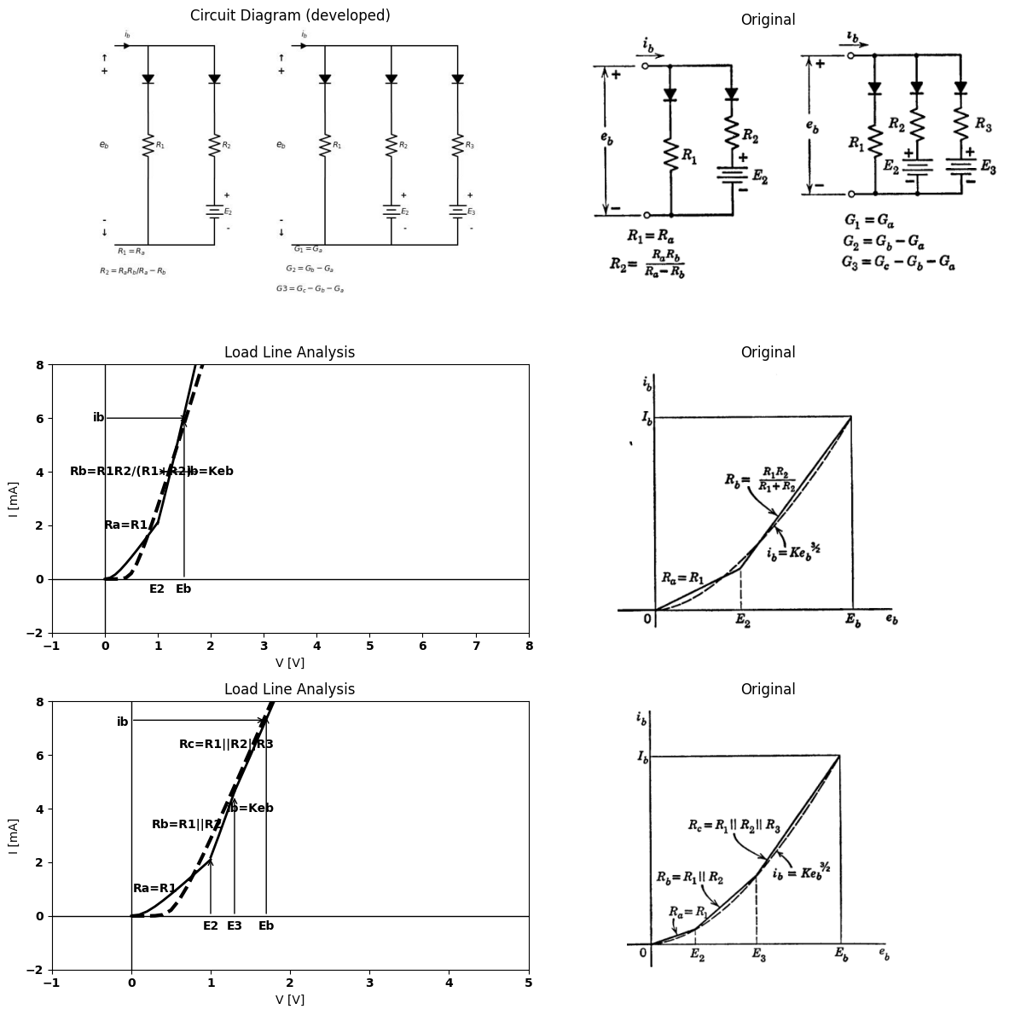
Fig. 3.14. Multiple-segment approximations.
straight line, with floating values for the intercept and slope, can be time-consuming.
A simpler circuit model results from the use of in conjunction with an ideal rectifier. As shown in Fig. 3.13$\left(c\right)$, the errors for this model are somewhat larger than those of the previous two. Again, a better fit
may be obtained for the same circuit configuration by modifying the parameters to the values shown in Fig. 3.13$\left(d\right)$.
The approximation to the vacuum diode obtained with any of these models is much better than that obtained with only an ideal rectifier. When one of these models is used to analyze the clipper circuit described in Article 3.5, the results obtained can hardly be distinguished from those obtained with the actual nonlinear curve. In fact, for almost any application of a vacuum diode, these models will yield adequately accurate results for the resistive-circuit problem. Nevertheless, if the need should arise, the concept can be extended to yield even better approximations. The circuit models and corresponding curves shown in Fig. 3.14 illustrate this point. Any number of segments can be produced by paralleling additional circuit branches made up of battery, resistance, and ideal rectifier in series. The relations between the resistive slopes of the piecewise-linear curve and the resistances or conductances used in the circuit model are indicated in the figure.
Each parallel branch in the circuit models shown in Fig. 3.14 includes a "back-biased" ideal rectifier. The applied voltage must exceed the reverse bias voltage in a branch in order for conduction to take place in that branch. Thus, as the applied voltage is increased, successive branches of the circuit conduct.
The models used thus far approximate $i$ vs. $v$ curves that are concave upward; that is, conductance increases as applied voltage increases.
However, some vs. curves have concave downward regions; for example, the more complete vacuum-diode curve shown in Fig. 3.15$\left(a\right)$. Since the conductance decreases with increasing voltage in the saturation region, a new form of circuit is required to add a resistance in series when the voltage or current has increased to a given level. This effect can be achieved by using a "forward-biased" ideal rectifier. As indicated in Fig. 3.15$\left(b\right)$, the rectifier must be so directed that the applied current eventually overcomes the current due to the forward bias. When the ideal rectifier is conducting, the voltage drop across its terminals is zero. When the applied current equals the bias current, the total current through the ideal rectifier is zero. This is the break point at which the rectifier becomes an open circuit, and current then passes through the resistance. An alternate form of this model is shown in Fig. 3.15$\left(c\right)$. The complete vacuum-diode model is shown in $\left(d\right)$.

8 3.7 Piecewise-Linear Models for Semiconductor Diodes
he semiconductor diode has a current versus voltage curve that differs in functional form from that of the vacuum diode. However,
aside from the fact that reverse current may have to be considered, the problem of devising a circuit model is similar to that already solved for the vacuum diode.
import matplotlib.pyplot as plt
import numpy as np
import schemdraw
import schemdraw.elements as e
import matplotlib.image as mpimg
# Create the figure and subplots
fig, axs = plt.subplots(5, 2, figsize=(12, 12))
# **Subplot (1, 1): Schemdraw Circuit Diagram**
d = schemdraw.Drawing()
d.push()
D1 = d.add(e.Diode().down())
d += e.lines.CurrentLabelInline().at(D1).down().label('$i_b$').color('black')
d += e.Gap().up().label(['-' , '$e_b$' , '+'], ofst = 1 , fontsize = 16).color('black')
d.move(2,-1.5)
l1 = d.add(e.Line().right())
d += e.lines.CurrentLabelInline().right().label('$i$').color('black')
l2 = d.add(e.Line().up((d.unit/2)))
R1 = d.add(e.Resistor().right().label('+ v -\n\n\n$R$', ofst=-1))
l3 = d.add(e.Line().down((d.unit/2)))
D2 = d.add(e.Diode(fill=True).left())
l4 = d.add(e.Line().down((d.unit/2)))
I = d.add(e.SourceI().right().label('$I$'))
l5 = d.add(e.Line().up((d.unit/2)))
l6 = d.add(e.Line().right())
d.pop()
d.move(0,-6)
d.push()
l7 = d.add(e.Line().right())
d += e.lines.CurrentLabelInline().right().label('$i$').color('black')
l8 = d.add(e.Line().down((d.unit/2)))
R2 = d.add(e.Resistor().right().label('$R$', ofst=-1))
E1 = d.add(e.Battery().right().reverse().label('- $E$ +'))
l9 = d.add(e.Line().up((d.unit/2)))
l10 = d.add(e.Line().left((d.unit/2)))
D3 = d.add(e.Diode(fill=True).left())
l11 = d.add(e.Line().left((d.unit/2)).at(D3.end))
d += e.Gap().right().length(6).label(['+ $v$ -'], ofst = 1 ,
fontsize = 16).color('black')
d += e.Line().right().at(l10.start)
d.pop()
d.move(0,-5)
d.push()
l17 = d.add(e.Line().right((d.unit/2)))
d += e.lines.CurrentLabelInline().right().label('$i$').color('black')
l18 = d.add(e.Line().down((d.unit/2)))
R12 = d.add(e.Resistor().right().label('$R_3$', ofst=-1))
E2 = d.add(e.Battery().right().reverse().label('- $E_3$ +'))
l19 = d.add(e.Line().up((d.unit/2)))
l20 = d.add(e.Line().left((d.unit/2)))
D13 = d.add(e.Diode(fill=True).left())
l21 = d.add(e.Line().left((d.unit/2)).at(D13.end))
d += e.Line().right(d.unit/2).at(l20.start)
D14 = d.add(e.Diode(fill=True).down())
d += e.Line().down(d.unit/2)
R13 = d.add(e.Resistor().down().label('$R_1$', ofst=0.4))
d += e.Line().down(d.unit/2)
l= d.add(e.Line().right(d.unit/2))
E3 = d.add(e.Battery().up().reverse().label(['-', '$E_2$','+'], ofst=-1.5))
R14 = d.add(e.Resistor().up().label('$R_2$', ofst=-1.5))
D15 = d.add(e.Diode(fill=True).up().reverse())
d += e.Line().left(d.unit/2)
d += e.Line().left(d.unit*3.5).at(l.end)
d += e.Gap().up().length(9).label(['-',' ',' ',' ',' ',' ','$e_b$',' ',' ',' ',' ',' ','+'], ofst = 1 ,
fontsize = 16).color('black')
d.save('./Drawings/fig3-15.jpg')
d.save('./Drawings/fig3-15.svg')
# Load the saved PNG file into the subplot
img = mpimg.imread('./Drawings/fig3-15.jpg')
axs[0,0].imshow(img)
axs[0,0].axis('off') # Hide axes for image display
axs[0,0].set_title('Circuit Diagram (developed)')
# **Subplot (1, 2): PNG Sample File**
img_sample = mpimg.imread('images-books/3-15.png') # Load the PNG file
axs[0,1].imshow(img_sample)
axs[0,1].axis('off') # Hide axes for image display
axs[0,1].set_title('Original')
#
def f(x):
return -1.05*x**3 + 3.9*x**2 + 3*x
x = np.linspace(0, 10, 400)
y = f(x)
s=f(2.9)
y2=np.where(x < 2.9, y,s)
axs[1,0].plot(x, y2,'black')
axs[1,0].set_title('V-I')
axs[1,0].set_xlim(-5, 8)
axs[1,0].set_xlabel('V [V]')
axs[1,0].set_ylabel('I [mA]')
axs[1,0].set_ylim(-5, 20)
axs[1,0].set_title('Diode Current-Voltage Characteristic')
axs[1,0].axhline(0, color='black', linewidth=2 )
axs[1,0].axvline(0, color='black', linewidth=2)
# **Subplot (1, 2): PNG Sample File**
img_sample = mpimg.imread('images-books/3-15a.png') # Load the PNG file
axs[1,1].imshow(img_sample)
axs[1,1].axis('off') # Hide axes for image display
axs[1,1].set_title('Original')
#
circuit = Circuit('Diode')
circuit.model('BAV21','D' ,IS = 4@u_nA , N = 1.906 ,BV = 110@u_V, IBV = 0.0001@u_V, VJ = 0.7@u_V ,CJO = 7.048E-13 ,RS = 1@u_kOhm ,TT = 3.48E-9)
Vth = circuit.V('th', '1', circuit.gnd, 0@u_V)
circuit.D(1, circuit.gnd,'1' , model = 'BAV21')
circuit.R(1, '1',circuit.gnd , 10@u_kOhm)
circuit.I(1, '1',circuit.gnd , 60@u_mA)
simulator = circuit.simulator(temperature=25, nominal_temperature=25)
analysis = simulator.dc(Vth=slice(0, 100, 0.1))
# Plot for R1
axs[2,0].plot(analysis['1'],u_mA(-analysis.Vth), 'black', linewidth=2)
axs[2,0].set_title('V-I Curve for D')
axs[2,0].set_xlim(-100, 100)
axs[2,0].set_xlabel('V [V]')
axs[2,0].set_ylabel('I [mA]')
axs[2,0].set_ylim(-100, 100)
axs[2,0].axhline(0, color='black', linewidth=1)
axs[2,0].axvline(0, color='black', linewidth=1)
axs[2,0].annotate('+I', xy=(0, 0), xytext=(-12, 80),
textcoords='offset points', ha='center', color='black', fontsize=12, fontweight='medium')
axs[2,0].annotate('R', xy=(10, 0), xytext=(50,55),
textcoords='offset points', ha='center', color='black', fontsize=12, fontweight='medium')
# **Subplot (1, 2): PNG Sample File**
img_sample = mpimg.imread('images-books/3-15b.png') # Load the PNG file
axs[2,1].imshow(img_sample)
axs[2,1].axis('off') # Hide axes for image display
axs[2,1].set_title('Original')
#
circuit = Circuit('Diode')
circuit.model('BAV21','D' ,IS = 400@u_uA , N = 1.906 ,BV = 110@u_V, IBV = 0.0001@u_V, VJ = 0.7@u_V ,CJO = 7.048E-13 ,RS = 10@u_Ohm ,TT = 3.48E-9)
Vth = circuit.V('th', '1', circuit.gnd, 0@u_V)
circuit.D(1, '2','1' , model = 'BAV21')
circuit.V(1, '2',circuit.gnd , 0.01@u_V)
circuit.I(1, '1','2' , 60@u_mA)
simulator = circuit.simulator(temperature=25, nominal_temperature=25)
analysis = simulator.dc(Vth=slice(0, 100, 0.1))
# Plot for R1
axs[3,0].plot(analysis['1'],u_mA(-analysis.Vth), 'black', linewidth=2)
axs[3,0].set_title('V-I Curve for D')
axs[3,0].set_xlim(-50, 100)
axs[3,0].set_xlabel('V [V]')
axs[3,0].set_ylabel('I [mA]')
axs[3,0].set_ylim(-50, 100)
axs[3,0].axhline(0, color='black', linewidth=1)
axs[3,0].axvline(0, color='black', linewidth=1)
axs[3,0].annotate('E/R', xy=(0, 0), xytext=(-12, 110),
textcoords='offset points', ha='center', color='black', fontsize=12, fontweight='medium')
axs[3,0].annotate('R', xy=(10, 0), xytext=(50, 60),
textcoords='offset points', ha='center', color='black', fontsize=12, fontweight='medium')
#
eb = np.linspace(0, 15, 100)
ib = np.zeros_like(eb)
E2=2
E3=3
r1=1.5
rb=4
rc=0.13
for i in range(len(eb)):
if eb[i] <= E2:
ib[i] = r1*eb[i]
elif eb[i] <= E3:
ib[i] = r1 * E2 + rb * (eb[i] - E2)
else:
ib[i] = r1 * E2 + rb * (E3 - E2) + rc * (eb[i] - E3)
axs[4,0].plot(eb, ib,'black', linewidth=2)
y1 = 1.3*eb**(3/2)
m1=3
m2=6
y11=1.3*m1**(3/2)
y = np.where(eb < m1, y1,np.where(eb < m2, y11+0.01*y1,y11+0.01*(1.3*m2**(3/2))))
axs[4,0].plot(eb, y,'black', linewidth=2, linestyle='--')
axs[4,0].grid()
axs[4,0].set_xlabel('eb (V)')
axs[4,0].set_ylabel('ib (mA)')
axs[4,0].set_title('Diode Current-Voltage Characteristic')
#axs[1].axis('off')
axs[4,0].set_xlim(0, 5)
axs[4,0].set_ylim(0, 10)
# **Subplot (1, 2): PNG Sample File**
img_sample = mpimg.imread('images-books/3-15c.png') # Load the PNG file
axs[3,1].imshow(img_sample)
axs[3,1].axis('off') # Hide axes for image display
axs[3,1].set_title('Original')
# **Subplot (1, 2): PNG Sample File**
img_sample = mpimg.imread('images-books/3-15d.png') # Load the PNG file
axs[4,1].imshow(img_sample)
axs[4,1].axis('off') # Hide axes for image display
axs[4,1].set_title('Original')
Text(0.5, 1.0, 'Original')
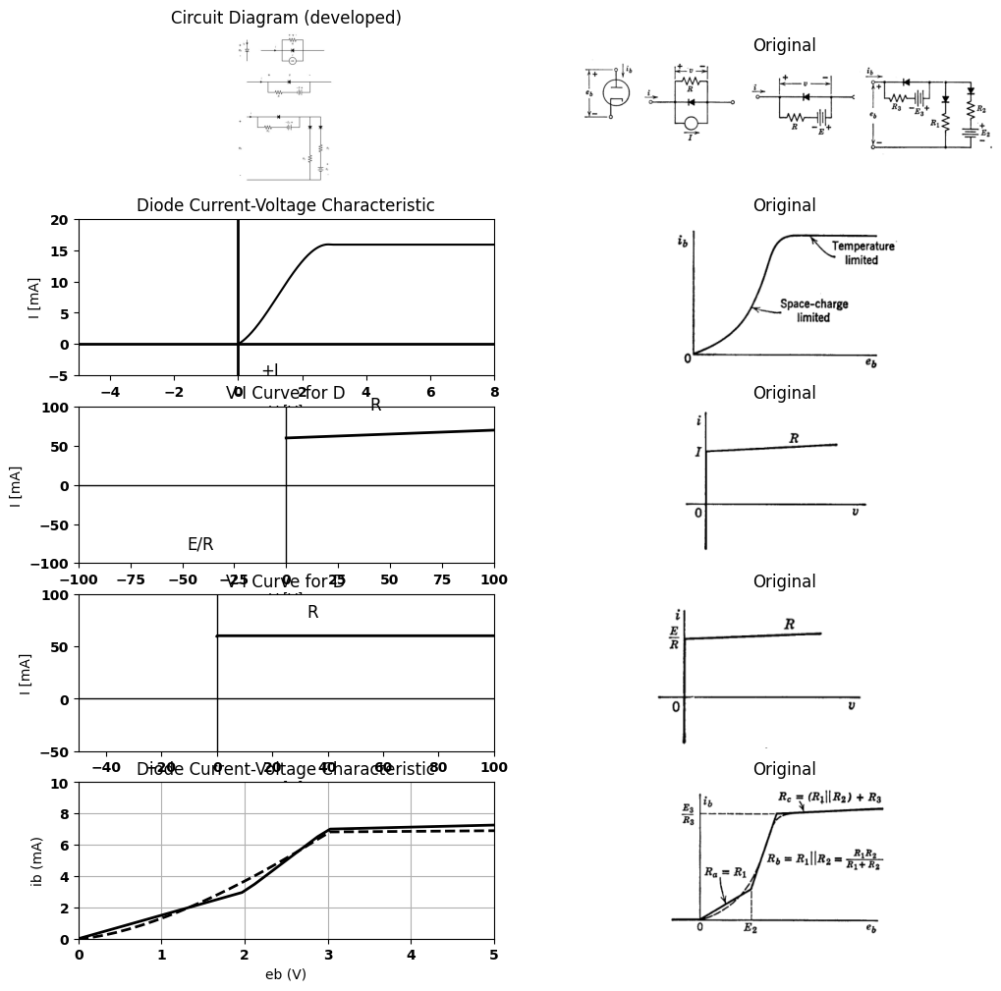
Fig. 3.15. Representing temperature saturation in a vacuum diode.
aside from the fact that reverse current may have to be considered, the problem of devising a circuit model is similar to that already solved for the vacuum diode.
The curve of current versus voltage for a semiconductor junction alone is exponential. The effective forward resistance may be as low as a few ohms and is ordinarily not more than a few hundred ohms, whereas the reverse resistance is likely to be hundreds of kilohms or even a few
megohms for reverse voltages up to the value required to produce reverse-voltage breakdown.
The sketch in Fig. 3.16$\left(a\right)$ is a typical semiconductor-diode curve. The magnitude of the reverse current has been exaggerated in order to
import matplotlib.pyplot as plt
import numpy as np
import schemdraw
import schemdraw.elements as e
import matplotlib.image as mpimg
# Create the figure and subplots
fig, axs = plt.subplots(2, 2, figsize=(12, 12))
# **Subplot (1, 1): Schemdraw Circuit Diagram**
d = schemdraw.Drawing()
d.push()
l1 = d.add(e.Line().up().length(0.002).dot(open=True))
D1 = d.add(e.Diode(fill=True).down().dot(open=True))
ss1 = d.add(e.Source().down().at(D1.start))
d += e.Gap().up().label(['-', '$v$', '+'], ofst=-1.7, fontsize=16).color('black')
d += e.Line().right().length(1.5).at((0, 0)).color('black')
d += e.Line().right().length(1.5).at((0, -3)).color('black')
d += e.Arrow().down().length(0.7).color('black').label('i', loc='top', color='black').at((-0.22, 0.1))
d += e.Arrow().down().length(0.5).at((1.7, -2.5)).color('black')
d += e.Arrow().up().length(0.5).at((1.7, -0.5)).color('black')
d.move(6, 0)
d.save('./Drawings/fig3-16.jpg')
d.save('./Drawings/fig3-16.svg')
# Load the saved PNG file into the subplot
img = mpimg.imread('./Drawings/fig3-16.jpg')
axs[0,0].imshow(img)
axs[0,0].axis('off') # Hide axes for image display
axs[0,0].set_title('Circuit Diagram (developed)')
# **Subplot (1, 2): PNG Sample File**
img_sample = mpimg.imread('images-books/3-16a.png') # Load the PNG file
axs[0,1].imshow(img_sample)
axs[0,1].axis('off') # Hide axes for image display
axs[0,1].set_title('Original')
#
circuit = Circuit('v-i curve')
circuit.model('BAV21','D' ,IS = 300@u_uA , N = 1.906 ,BV = 8100@u_V, IBV = 0.0001@u_V, VJ = 20@u_V ,CJO = 7.048E-13 ,RS = 150@u_Ohm ,TT = 3.48E-9)
Vi = circuit.V('i', '1', circuit.gnd, 0@u_V)
circuit.R(1, '1', '2', 0@u_Ohm)
circuit.D(1, '2',circuit.gnd , model = 'BAV21')
simulator = circuit.simulator(temperature=25, nominal_temperature=25)
analysis = simulator.dc(Vi=slice(-1,8, 0.1))
axs[1,0].plot(analysis['1'], u_mA(-analysis.Vi),'black',linewidth=2)
axs[1,0].set_xlim(-2, 4)
axs[1,0].set_ylim(-2, 2)
axs[1,0].set_xlabel('V [V]')
axs[1,0].set_ylabel('I [mA]')
axs[1,0].text(2, 1.5, 'i=Io(e^(v/vD)-1)\n Where Vo=KT/e \n Vo=0.026 vlot at \n room Temprature\n 300(k)', ha='center', va='center', fontsize=12)
axs[1,0].text(-1.1, -0.3, '$-Io$', ha='center', va='center', fontsize=12)
axs[1,0].axhline(0, color='black', linewidth=1 )
axs[1,0].axvline(0, color='black', linewidth=1)
# **Subplot (1, 2): PNG Sample File**
img_sample = mpimg.imread('images-books/3-16b.png') # Load the PNG file
axs[1,1].imshow(img_sample)
axs[1,1].axis('off') # Hide axes for image display
axs[1,1].set_title('Original')
Text(0.5, 1.0, 'Original')
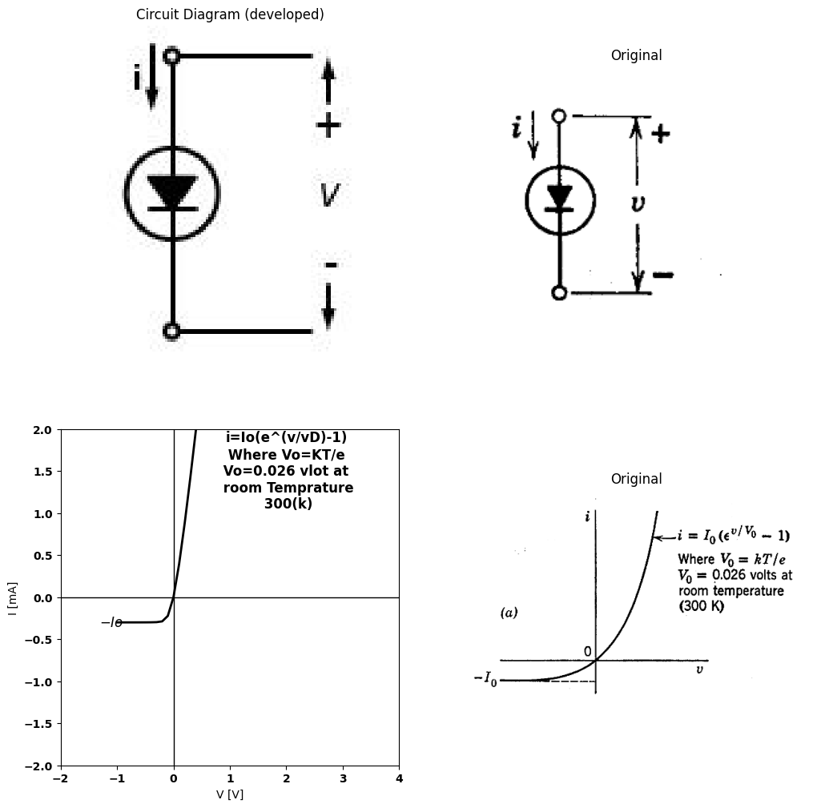
$$k=Boltzmannconstant$$
$$=1.38*{10}^{−}23joule/°k$$
$$T=degresKelvin$$
$$e=electroniccharge$$
$$=1.6*{10}^{−}19coulomb$$
import matplotlib.pyplot as plt
import numpy as np
import schemdraw
import schemdraw.elements as e
import matplotlib.image as mpimg
# Create the figure and subplots
fig, axs = plt.subplots(2, 2, figsize=(12, 12))
# **Subplot (1, 1): Schemdraw Circuit Diagram**
d = schemdraw.Drawing()
l1 = d.add(e.Line().up().length(0.5).dot(open=True))
d.push()
l2 = d.add(e.Line().down().length(0.5).dot())
D1 = d.add(e.Diode(fill= True).down().at(l1.start))
R2 = d.add(e.Resistor().down().label([ '$rf$'], ofst=-1.3).dot(open=True))
d += e.Line().right().length(2).dot().at(l1.start)
R1 = d.add(e.Resistor().down().label(['$rr-rf$'], ofst=-1.8).dot())
d += e.Line().left().length(2).dot()
d.pop()
d += e.Arrow().down().length(0.7).linewidth(0.6).color('black').label('i', loc='top', color='black',ofst=-0.3). at((0.3,1))
d += e.Arrow().up().length(4).linewidth(0.6).color('white').label('$V$', loc='start', color='black',ofst=0.3). at((-0.4,-2.5))
d += e.Arrow().up().length(2.5).linewidth(0.6).color('black').label('+',loc='end', color='black',ofst=-0.2). at((-0.7,-2))
d += e.Line().left().length(0.8).linewidth(0.6).at(l1.end).color('black')
d += e.Arrow().down().length(2.5).linewidth(0.6).color('black').label(r'_', loc='end', color='black',ofst=(-.5, 0.3)). at((-0.7,-3.5))
d += e.Line().left().length(0.8).linewidth(0.6).at(R2.end).color('black')
d.move(7,6)
l1 = d.add(e.Line().up().length(0.5).dot(open=True))
d.push()
l2 = d.add(e.Line().down().length(0.5).dot())
D1 = d.add(e.Diode(fill= True).down().at(l1.start))
R2 = d.add(e.Resistor().down().label([ '$gf-gr$'], ofst=-1.9).dot(open=True))
d += e.Line().right().length(2).dot().at(l1.start)
R1 = d.add(e.Resistor().down().label(['$gr$'], ofst=-1))
d += e.Line().down().length(2.5)
d += e.Line().left().length(2)
d.pop()
d += e.Arrow().down().length(0.7).linewidth(0.6).color('black').label('i', loc='top', color='black',ofst=-.3). at((6.9,1))
d += e.Arrow().up().length(4).linewidth(0.6).color('white').label('$V$', loc='start', color='black',ofst=-5.3). at((0.4,-2.5))
d += e.Arrow().up().length(2.5).linewidth(.6).color('black').label('+',loc='end', color='black',ofst=-.1). at((5.7,-2))
d += e.Line().left().length(.8).linewidth(0.6).at(l1.end).color('black')
d += e.Arrow().down().length(2.5).linewidth(.6).color('black').label(r'_', loc='end', color='black',ofst=(-.5, .2)). at((5.7,-3.5))
d += e.Line().left().length(.8).linewidth(0.8).at(R2.end).color('black')
d.move(7,6)
l1 = d.add(e.Line().right().length(1.3).dot())
d.push()
l2 = d.add(e.Line().right().length(1.5).dot())
D1 = d.add(e.Diode(fill= True).down().at(l1.end).length(2.7))
R1 = d.add(e.Resistor().down().label([ '$rf$'], ofst=-1).length(3.26).dot())
D = d.add(e.Diode(fill= True).down().reverse().at(l2.end))
R2 = d.add(e.Resistor().down().label([ '$rr$'], ofst=-1.).dot())
d += e.Line().left().length(2.8)
d.pop()
d += e.Arrow().right().length(.7).linewidth(.6).color('black').label('i', loc='top', color='black',ofst=.2). at((12.9,0.6))
d += e.Arrow().up().length(4).linewidth(0.6).color('white').label('$V$', loc='start', color='black',ofst=-12.3). at((0.4,-2.6))
d += e.Arrow().up().length(2.2).linewidth(.6).color('black').label('+',loc='end', color='black',ofst=-.1). at((12.5,-2.3))
d += e.Arrow().down().length(2.5).linewidth(.6).color('black').label(r'_', loc='end', color='black',ofst=(-.5, .2)). at((12.5,-3.5))
d.save('./Drawings/fig3-16c.jpg')
d.save('./Drawings/fig3-16c.svg')
# Load the saved PNG file into the subplot
img = mpimg.imread('./Drawings/fig3-16c.jpg')
axs[0,0].imshow(img)
axs[0,0].axis('off') # Hide axes for image display
axs[0,0].set_title('Circuit Diagram (developed)')
# **Subplot (1, 2): PNG Sample File**
img_sample = mpimg.imread('images-books/3-16c.png') # Load the PNG file
axs[0,1].imshow(img_sample)
axs[0,1].axis('off') # Hide axes for image display
axs[0,1].set_title('Original')
#
circuit = Circuit('Diode')
circuit.model('LED','D' ,IS = 1.2@u_mA , N = 2.906 ,BV = 410@u_V, IBV = 0.0001@u_V, VJ = .7@u_V ,CJO = 7.048E-13 ,RS = 500@u_Ohm ,TT = 3.48E-9)
Vi = circuit.V('i', '1', circuit.gnd, 5@u_V)
circuit.D(1, '1',circuit.gnd , model = 'LED')
simulator = circuit.simulator(temperature=25, nominal_temperature=25)
analysis = simulator.dc(Vi=slice(-5, 30, 0.1))
axs[1,0].plot(analysis['1'],u_mA(-analysis.Vi), 'black',linestyle='--', linewidth=1.5)
circuit = Circuit('Diode2')
circuit.model('BAV21','D' ,IS = 50@u_uA , N = 2.906 ,BV = 410@u_V, IBV = 0.0001@u_V, VJ = .7@u_V ,CJO = 7.048E-13 ,RS = 250@u_Ohm ,TT = 3.48E-9)
Vi = circuit.V('i', '1', circuit.gnd, 5@u_V)
circuit.D(1, '2',circuit.gnd , model = 'BAV21')
circuit.R(1, '1','2' ,150@u_Ohm)
circuit.D(2,'3','1', model = 'BAV21')
circuit.R(2, '3',circuit.gnd ,3@u_kOhm)
simulator = circuit.simulator(temperature=25, nominal_temperature=25)
analysis = simulator.dc(Vi=slice(-5, 30, 0.1))
axs[1,0].plot(analysis['1'],u_mA(-analysis.Vi), 'black',linestyle='-', linewidth=1.5)
# Plot for R1
axs[1,0].set_title('V-I Curve D')
axs[1,0].set_xlim(-5, 6.5)
axs[1,0].set_xlabel('V [V]')
axs[1,0].set_ylabel('I [mA]')
axs[1,0].set_ylim(-5, 5)
axs[1,0].text(1.8, 4.5, '$rf$', ha='center', va='center', fontsize=12)
axs[1,0].text(-2, 2, '$(b)$', ha='center', va='center', fontsize=12)
axs[1,0].text(-2, -0.24, '$rr $', ha='center', va='center', fontsize=12)
axs[1,0].axhline(0, color='black', linewidth=2 )
axs[1,0].axvline(0, color='black', linewidth=2)
# **Subplot (1, 2): PNG Sample File**
img_sample = mpimg.imread('images-books/3-16d.png') # Load the PNG file
axs[1,1].imshow(img_sample)
axs[1,1].axis('off') # Hide axes for image display
axs[1,1].set_title('Original')
Text(0.5, 1.0, 'Original')
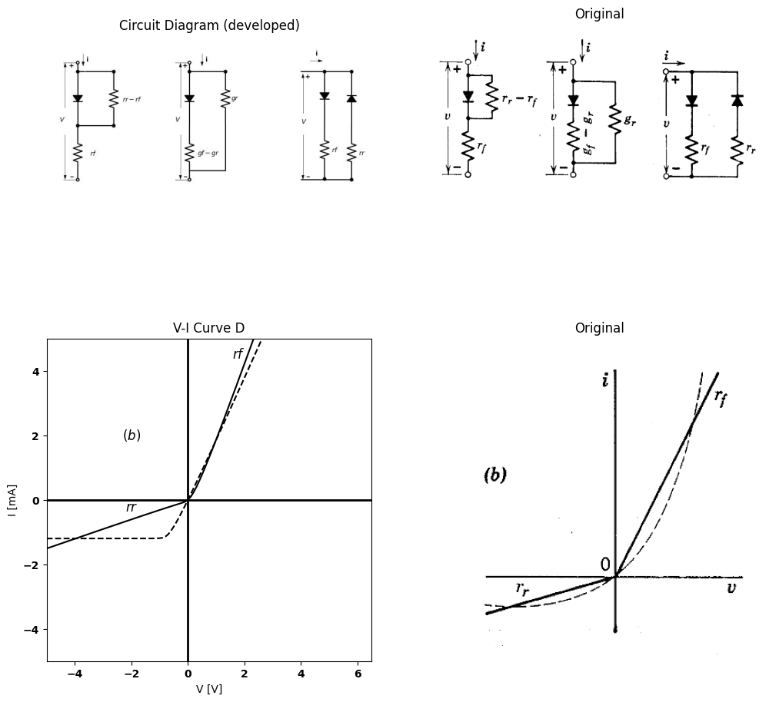
import matplotlib.pyplot as plt
import numpy as np
import schemdraw
import schemdraw.elements as e
import matplotlib.image as mpimg
# Create the figure and subplots
fig, axs = plt.subplots(1, 2, figsize=(12, 12))
# **Subplot (1, 1): Schemdraw Circuit Diagram**
d = schemdraw.Drawing()
d.push()
l1 = d.add(e.Line().up().length(0.002).dot(open=True))
D1 = d.add(e.Diode(fill=True).down().dot(open=True))
ss1 = d.add(e.Source().down().at(D1.start))
d += e.Gap().up().label(['-', '$v$', '+'], ofst=-1.7, fontsize=16).color('black')
d += e.Line().right().length(1.5).at((0, 0)).color('black')
d += e.Line().right().length(1.5).at((0, -3)).color('black')
d += e.Arrow().down().length(0.7).color('black').label('i', loc='top', color='black').at((-0.22, 0.1))
d += e.Arrow().down().length(0.5).at((1.7, -2.5)).color('black')
d += e.Arrow().up().length(0.5).at((1.7, -0.5)).color('black')
d.save('./Drawings/fig3-16e1.jpg')
d.save('./Drawings/fig3-16e1.svg')
# Load the saved PNG file into the subplot
img = mpimg.imread('./Drawings/fig3-16e1.jpg')
axs[0].imshow(img)
axs[0].axis('off') # Hide axes for image display
axs[0].set_title('Circuit Diagram (developed)')
# **Subplot (1, 2): PNG Sample File**
img_sample = mpimg.imread('images-books/3-16e.png') # Load the PNG file
axs[1].imshow(img_sample)
axs[1].axis('off') # Hide axes for image display
axs[1].set_title('Original')
Text(0.5, 1.0, 'Original')
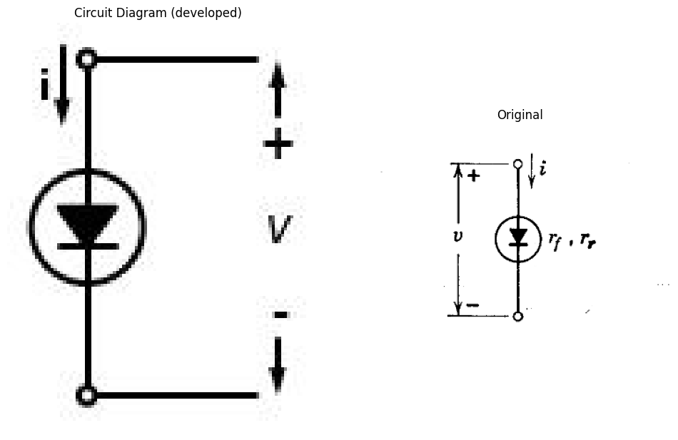
Fig. 3.16. Approximating semiconductor diodes with forward and reverse resistances.
clarify the drawings.An approximation to the curve based on two resistive lines is shown in Fig. 3.16$\left(b\right)$. A number of alternative forms are possible for this circuit model. The models shown with a single ideal rectifier are equally convenient. Since reverse resistance $r_{r}$ is much larger than forward resistance $r_{f}$, the two resistances (or conductances) in the model are very nearly those corresponding to the graphical slopes.
If the ratio of $r_{r}$ to $r_{f}$ is not sufficient to justify the simplifying approximation $r_{r}−r_{f}≈r_{f}$ or $g_{f}−g_{r}≈g_{f}$, the graphical slopes can be placed in evidence by introducing another ideal rectifier as shown. Since no sources are included in this two-rectifier model, the break point for
import matplotlib.pyplot as plt
import numpy as np
import schemdraw
import schemdraw.elements as e
import matplotlib.image as mpimg
# Create the figure and subplots
fig, axs = plt.subplots(2, 2, figsize=(12, 12))
# **Subplot (1, 1): Schemdraw Circuit Diagram**
d = schemdraw.Drawing()
l1 = d.add(e.Line().up().length(0.5).dot(open=True))
d.push()
l2 = d.add(e.Line().down().length(0.5))
R1 = d.add(e.Resistor().down().at(l1.start).label(['$r$'], ofst=-.8))
D1 = d.add(e.Diode(fill= True).down().dot(open=True))
d += e.Line().right().length(2).dot().at(D1.start)
I = d.add(e.SourceI().down().label('$Io$').dot())
d += e.Line().left().length(2).dot()
l3 = d.add(e.Line().down().length(0.5).dot(open=True))
d.pop()
d += e.Arrow().down().length(0.7).linewidth(0.6).color('black').label('i', loc='top', color='black',ofst=-.3). at((.7,0.7))
d += e.Arrow().up().length(4).linewidth(0.6).color('white').label('$V$', loc='start', color='black',ofst=0.3). at((-0.4,-2.7))
d += e.Arrow().up().length(2.5).linewidth(0.6).color('black').label('+',loc='end', color='black',ofst=-0.2). at((-0.7,-2))
d += e.Line().left().length(0.8).linewidth(0.6).at(l1.end).color('black')
d += e.Arrow().down().length(2.5).linewidth(0.6).color('black').label(r'_', loc='end', color='black',ofst=(-.5, 0.4)). at((-0.7,-3.9))
d += e.Line().left().length(0.8).linewidth(0.7).at(l3.end).color('black')
d += e.Arrow().up().length(.8).linewidth(0.6).color('black'). at((2.8,-5))
d.pop()
d.move(7,4.5)
l1 = d.add(e.Line().right().length(1.6))
l4 = d.add(e.Line().left().length(1.6).dot(open=True))
R1 = d.add(e.Resistor().down().at(l1.end).label(['$r$'], ofst=-.8))
D1 = d.add(e.Diode(fill= True).down())
l6 = d.add(e.Line().down().length(2))
d += e.Line().right().length(2).dot().at(D1.start)
I = d.add(e.SourceI().down().label('$I$'))
l2 = d.add(e.Line().down().length(2))
d += e.Line().right().length(6).dot().at(R1.start)
D2 = d.add(e.Diode(fill= True).down().dot())
R1 = d.add(e.Resistor().down().at(D2.end).label(['$r=(ro*ra)/(ro-ra)$'], ofst=-3.9))
E1 = d.add(e.Battery().down().length(2).label(['+', '$V1$', '-'], ofst=-1.3).dot())
l3 = d.add(e.Line().left().length(7.8).dot(open=True))
d += e.Arrow().right().length(0.7).linewidth(0.6).color('black').label('i', loc='top', color='black',ofst=.1). at((10.,.7))
d += e.Arrow().up().length(4).linewidth(0.6).color('white').label('$V$', loc='start', color='black',ofst=0.3). at((10.4,-3.5))
d += e.Arrow().up().length(2.5).linewidth(0.6).color('black').label('+',loc='end', color='black',ofst=-0.2). at((10,-2.2))
d += e.Line().left().length(0.8).linewidth(0.6).at(l1.end).color('black')
d += e.Arrow().down().length(2.5).linewidth(0.6).color('black').label(r'_', loc='end', color='black',ofst=(-.5, 0.6)). at((10,-5.2))
d.pop()
d.save('./Drawings/fig3-17a.jpg')
d.save('./Drawings/fig3-17a.svg')
# Load the saved PNG file into the subplot
img = mpimg.imread('./Drawings/fig3-17a.jpg')
axs[0,0].imshow(img)
axs[0,0].axis('off') # Hide axes for image display
axs[0,0].set_title('Circuit Diagram (developed)')
# **Subplot (1, 2): PNG Sample File**
img_sample = mpimg.imread('images-books/3-17a.png') # Load the PNG file
axs[0,1].imshow(img_sample)
axs[0,1].axis('off') # Hide axes for image display
axs[0,1].set_title('Original')
#
circuit = Circuit('v-i curve')
circuit.model('BAV21','D' ,IS = 100@u_uA , N = 1.906 ,BV = 110@u_V, IBV = 0.0001@u_V, VJ = 20@u_V ,CJO = 7.048E-13 ,RS = 20@u_Ohm ,TT = 3.48E-9)
Vi = circuit.V('i', '1', circuit.gnd, 0@u_V)
circuit.R(1, '1', '2', .1@u_Ohm)
circuit.D(1, '2',circuit.gnd , model = 'BAV21')
circuit.I(1, circuit.gnd,'2', 200@u_uA)
simulator = circuit.simulator(temperature=25, nominal_temperature=25)
analysis = simulator.dc(Vi=slice(-2,8, 0.075))
axs[1,0].plot(analysis['1'], u_mA(-analysis.Vi),'black',linewidth=2,linestyle='--')
circuit = Circuit('v-i curve')
Vi = circuit.V('i', '1', circuit.gnd, 0@u_V)
circuit.R(1, '1', circuit.gnd, .12@u_kOhm)
simulator = circuit.simulator(temperature=25, nominal_temperature=25)
analysis = simulator.dc(Vi=slice(-0.03,8, 0.1))
axs[1,0].plot(analysis['1'], u_mA(-analysis.Vi),'black',linewidth=2,linestyle='-')
circuit = Circuit('v-i curve3')
Vi = circuit.V('i', '1', circuit.gnd, 0@u_V)
circuit.R(1, '1', circuit.gnd, -55@u_kOhm)
circuit.I(1, circuit.gnd, '1', 250@u_uA)
simulator = circuit.simulator(temperature=25, nominal_temperature=25)
analysis = simulator.dc(Vi=slice(-2,.0005, 0.1))
axs[1,0].plot(analysis['1'], u_mA(-analysis.Vi),'black',linewidth=2,linestyle='-')
axs[1,0].set_xlim(-2, 4)
axs[1,0].set_ylim(-1, 2)
axs[1,0].set_xlabel('V [V]')
axs[1,0].set_ylabel('I [mA]')
axs[1,0].text(0.3, 1.5, 'r', ha='center', va='center', fontsize=12)
axs[1,0].text(.1, -0.2, '$-Io$', ha='center', va='center', fontsize=12)
axs[1,0].axhline(0, color='black', linewidth=1 )
axs[1,0].axvline(0, color='black', linewidth=1)
# **Subplot (1, 2): PNG Sample File**
img_sample = mpimg.imread('images-books/3-17b.png') # Load the PNG file
axs[1,1].imshow(img_sample)
axs[1,1].axis('off') # Hide axes for image display
axs[1,1].set_title('Original')
plt.tight_layout()
plt.show()
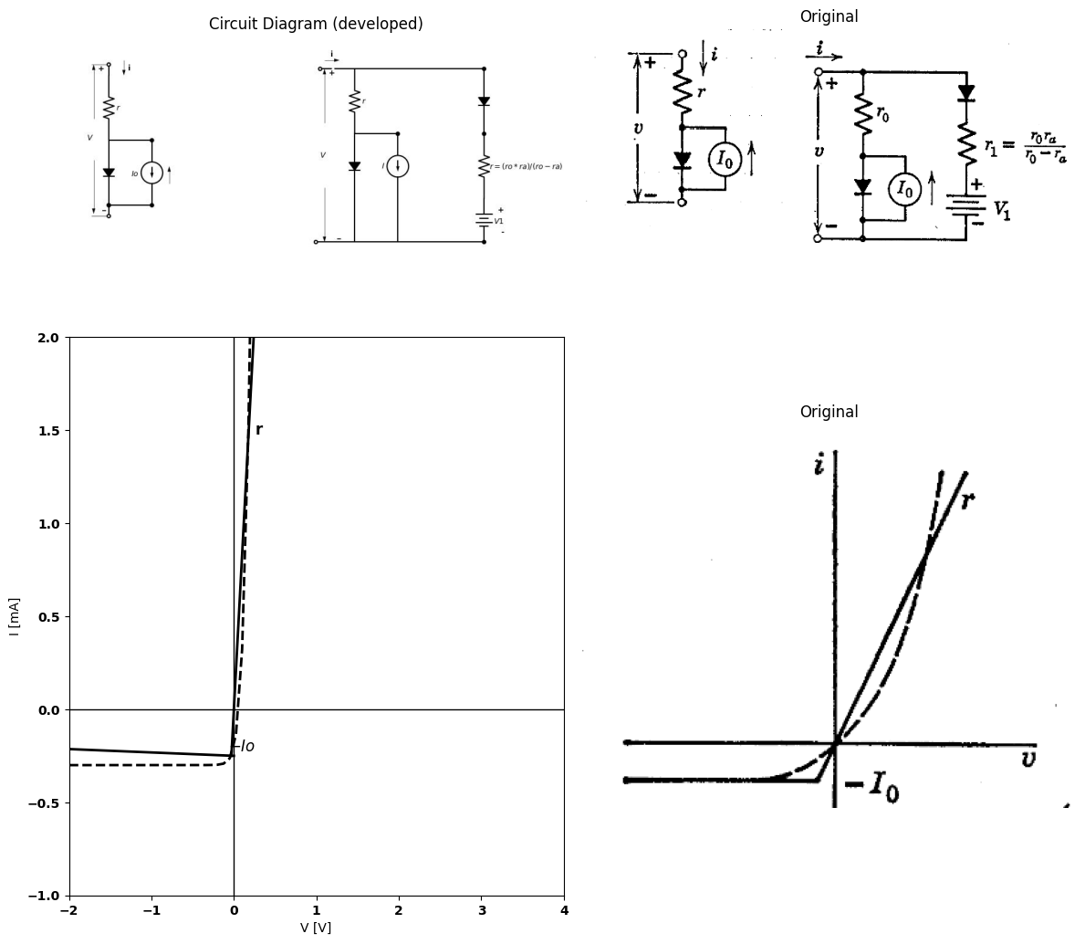
import matplotlib.pyplot as plt
import numpy as np
import schemdraw
import schemdraw.elements as e
import matplotlib.image as mpimg
# Create the figure and subplots
fig, axs = plt.subplots(1, 2, figsize=(12, 12))
# **Subplot (1, 1): Schemdraw Circuit Diagram**
d = schemdraw.Drawing()
l1 = d.add(e.Line().right().length(1.6).dot())
d.push()
l3 = d.add(e.Line().left().length(1.6).dot(open=True))
D1 = d.add(e.Diode(fill= True).down().at(l1.end).reverse())
R1 = d.add(e.Resistor().down().label([ '$rz$'], ofst=-1).length(3.26).dot())
E1 = d.add(e.Battery().down().reverse().label(['-', '$Vz$', '+'], ofst=-1.3).dot())
l2 = d.add(e.Line().left().length(1.6).dot(open=True))
l4 = d.add(e.Line().right().length(2.2).dot().at(l1.end))
d.push()
l6 = d.add(e.Line().down().length(0.5))
R2 = d.add(e.Resistor().down().at(l6.start).label(['$r$'], ofst=-.8))
D2 = d.add(e.Diode(fill= True).down().dot(open=True))
d += e.Line().right().length(2).dot().at(D2.start)
I = d.add(e.SourceI().down().reverse().label('$Io$').dot())
d += e.Line().left().length(2).dot()
l7 = d.add(e.Line().down().length(3.3))
l8 = d.add(e.Line().left().length(2.2))
l9 = d.add(e.Line().right().length(4.2).at(R2.start).dot())
D3 = d.add(e.Diode(fill= True).down().dot())
R3 = d.add(e.Resistor().down().at(D3.end).label(['$r1$'], ofst=-1.3))
E2 = d.add(e.Battery().down().label(['+', '$V1$', '-'], ofst=-1.3))
l10 = d.add(e.Line().down().length(.3))
l11 = d.add(e.Line().left().length(4.3))
d.pop()
d += e.Arrow().right().length(0.7).linewidth(0.6).color('black').label('i', loc='top', color='black',ofst=.2). at((.6,0.5))
d += e.Arrow().up().length(4).linewidth(0.6).color('white').label('$V$', loc='start', color='black',ofst=1.3). at((1.7,-4.8))
d += e.Arrow().up().length(2.5).linewidth(0.6).color('black').label('+',loc='end', color='black',ofst=-0.2). at((0.2,-2.5))
d += e.Line().left().length(0.8).linewidth(0.6).at(l1.end).color('black')
d += e.Arrow().up().length(.8).linewidth(0.6).color('black'). at((6.5,-5))
d += e.Arrow().down().length(2.5).linewidth(0.6).color('black').label(r'_', loc='end', color='black',ofst=(-.5, 0.4)). at((0.2,-6.7))
d.save('./Drawings/fig3-17c.jpg')
d.save('./Drawings/fig3-17c.svg')
# Load the saved PNG file into the subplot
img = mpimg.imread('./Drawings/fig3-17c.jpg')
axs[0].imshow(img)
axs[0].axis('off') # Hide axes for image display
axs[0].set_title('Circuit Diagram (developed)')
# **Subplot (1, 2): PNG Sample File**
img_sample = mpimg.imread('images-books/3-17c.png') # Load the PNG file
axs[1].imshow(img_sample)
axs[1].axis('off') # Hide axes for image display
axs[1].set_title('Original')
Text(0.5, 1.0, 'Original')
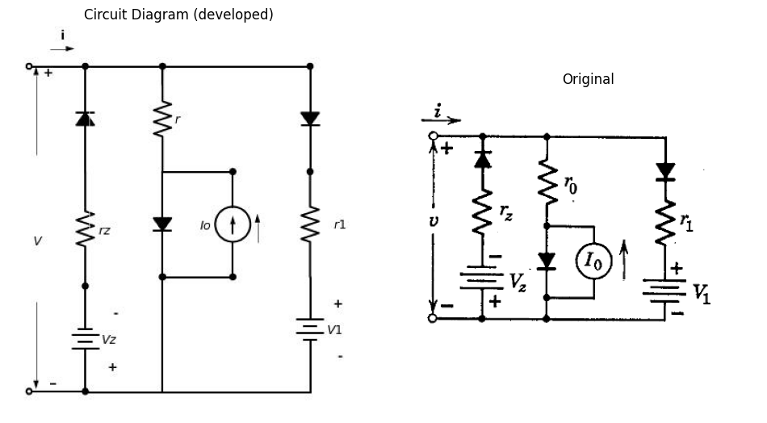
import matplotlib.pyplot as plt
from matplotlib import rcParams
import matplotlib.image as mpimg
import numpy as np
import PySpice.Logging.Logging as Logging
logger = Logging.setup_logging()
from PySpice.Probe.Plot import plot
from PySpice.Spice.Netlist import Circuit
from PySpice.Unit import *
rcParams['font.weight'] = 'bold'
fig, axs = plt.subplots(1, 2, figsize=(10, 10))
circuit = Circuit('v-i curve')
circuit.model('BAV21','D' ,IS = 100@u_uA , N = 1.906 ,BV = 110@u_V, IBV = 0.0001@u_V, VJ = 20@u_V ,CJO = 7.048E-13 ,RS = 20@u_Ohm ,TT = 3.48E-9)
Vi = circuit.V('i', '1', circuit.gnd, 0@u_V)
circuit.R(1, '2', '3', 1@u_Ohm)
circuit.D(1,'2' ,'1', model = 'BAV21')
circuit.V(1, circuit.gnd,'3', 1@u_V)
circuit.R(2, '1', '4', 1@u_Ohm)
circuit.D(2,'4',circuit.gnd , model = 'BAV21')
circuit.I(1, circuit.gnd,'4', 200@u_uA)
circuit.V(2,'6', circuit.gnd, 2@u_V)
circuit.R(3, '5', '6', 1@u_Ohm)
circuit.D(3,'1','5' , model = 'BAV21')
simulator = circuit.simulator(temperature=25, nominal_temperature=25)
analysis = simulator.dc(Vi=slice(-2,8, 0.1))
axs[0].plot(analysis['1'], u_mA(-analysis.Vi),'black',linewidth=2,linestyle='--')
axs[0].set_xlim(-4, 4)
axs[0].set_ylim(-4, 4)
axs[0].set_xlabel('V [V]')
axs[0].set_ylabel('I [mA]')
axs[0].text(.1, -0.2, '$-Io$', ha='center', va='center', fontsize=12)
axs[0].text(-1, 0.2, '$-Vz$', ha='center', va='center', fontsize=12)
axs[0].axhline(0, color='black', linewidth=1 )
axs[0].axvline(0, color='black', linewidth=1)
# **Subplot (1, 2): PNG Sample File**
img_sample = mpimg.imread('images-books/3-17d.png') # Load the PNG file
axs[1].imshow(img_sample)
axs[1].axis('off') # Hide axes for image display
axs[1].set_title('Original')
plt.tight_layout()
plt.show()
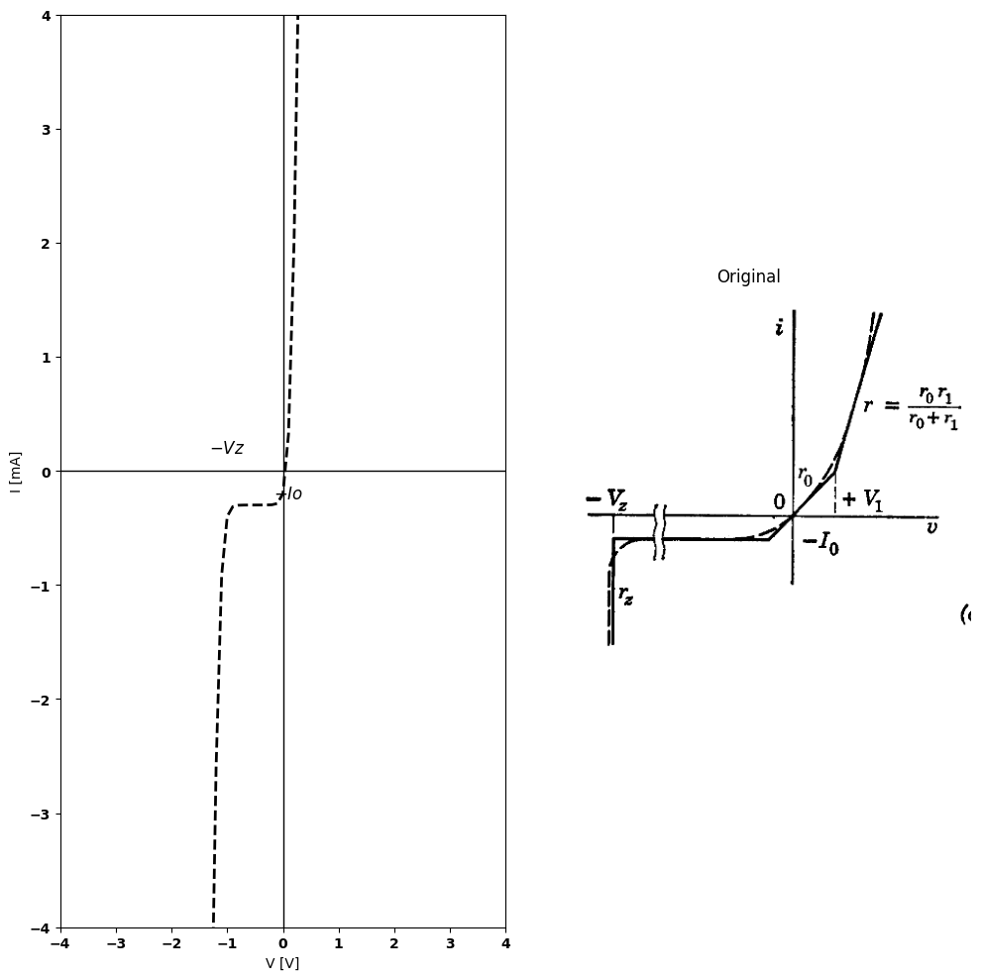
Fig. 3.17. Additional semiconductor diode models.
each of the diodes occurs at $i=0$, $v=0$ (one opening and the other closing).
The model with two ideal rectifiers is more complicated, but if it clarifies the resulting circuit problem, its use is justified. When circuit complexity increases, caution should be exercised in choosing models containing extraneous ideal rectifiers, as each rectifier may create additional circuit states.
It will usually be more convenient to designate a two-segment resistive approximation by the simple symbol shown in Fig. 3.16(c). Circuit equations for this approximation can be written as though the element were a resistance $r$ with specific values $r_{r}$ or $r_{f}$, depending upon the polarity of voltage $v$ or current $i$.
If the reverse current of a semiconductor diode is critical to the behavior of a particular circuit, a better representation is obtained by the model shown in Fig. 3.17(a). For negative voltages, $v<\left(−I_{or}\right)$, the ideal rectifier is open, and the model represents the constant-current line ($−I_{0}$). For $v>\left(−I_{or}\right)$, the diode closes, and the diode is represented by the small resistance $r$. An additional segment can be added to improve the approximation over a wider range of $v$ and $i$ by a parallel branch, as shown in Fig. 3.17(b). The effect of reverse-voltage breakdown can be included by a circuit that holds the voltage nearly constant at the appropriate value (say $−25$ volts) for a particular diode. A circuit model that suffices is shown in Fig. 3.17(c). There are no extraneous ideal rectifiers in this model, since each one corresponds to a different break point in the $i$ vs. $v$ curve. Nevertheless, it is apparent that this is an elaboration of the model that only represent the resistive behavior of a single circuit element, the semiconductor diode.
As familiarity with the subject develops, it is seldom necessary to draw the complete circuit model, for any particular value of $v$ or $i$, we are concerned only with the relation between $v$ and $i$, and in piecewise linear models this is always a straight line. Thus, if we keep track of the segment of the curve on which the diode is operating at any given time, the maximum complexity of the relation is $i=aw+b$. Correspondingly, the circuit model for any one segment reduces to (at most) a resistance and a source (current or voltage). A series of single-segment models is shown in Fig. 3.18 for the same circuit model shown in Fig. 3.17$\left(c\right)$. The slopes and intercepts for the linear segments correspond to those on the complete $i$ vs. $v$ curve, but do not necessarily correspond to the sources or resistances in the complete model. Note, for example, $V_{1}$ and $V_{1}′$.

9 3.8 Piecewise-Linear Models for Gas-Filled Diodes
The curve of $i_{b}$ vs. $e_{b}$ for a gas-filled thermionic diode is shown qualitatively in Fig. 3.19$\left(a\right)$, together with the usual symbol for a gas-filled tube. The dot within the circle distinguishes the gas-filled tube from the corresponding type of vacuum tube (diode, in this case). Conduction in the tube is very small until $e_{b}$ reaches the value $E_{m}$. At this
import matplotlib.pyplot as plt
import numpy as np
import schemdraw
import schemdraw.elements as e
import matplotlib.image as mpimg
# Create the figure and subplots
fig, axs = plt.subplots(1, 2, figsize=(12, 12))
# **Subplot (1, 1): Schemdraw Circuit Diagram**
d = schemdraw.Drawing()
l1 = d.add(e.Line().right().length(1.6).dot())
d.push()
l3 = d.add(e.Line().left().length(1.6).dot(open=True))
D1 = d.add(e.Diode(fill= True).down().at(l1.end).reverse())
R1 = d.add(e.Resistor().down().label([ '$rz$'], ofst=-1).length(3.26).dot())
E1 = d.add(e.Battery().down().reverse().label(['-', '$Vz$', '+'], ofst=-1.3).dot())
l2 = d.add(e.Line().left().length(1.6).dot(open=True))
l4 = d.add(e.Line().right().length(2.2).dot().at(l1.end))
d.push()
l6 = d.add(e.Line().down().length(0.5))
R2 = d.add(e.Resistor().down().at(l6.start).label(['$r$'], ofst=-.8))
D2 = d.add(e.Diode(fill= True).down().dot(open=True))
d += e.Line().right().length(2).dot().at(D2.start)
I = d.add(e.SourceI().down().reverse().label('$Io$').dot())
d += e.Line().left().length(2).dot()
l7 = d.add(e.Line().down().length(3.3))
l8 = d.add(e.Line().left().length(2.2))
l9 = d.add(e.Line().right().length(4.2).at(R2.start).dot())
D3 = d.add(e.Diode(fill= True).down().dot())
R3 = d.add(e.Resistor().down().at(D3.end).label(['$r1$'], ofst=-1.3))
E2 = d.add(e.Battery().down().label(['+', '$V1$', '-'], ofst=-1.3))
l10 = d.add(e.Line().down().length(.3))
l11 = d.add(e.Line().left().length(4.3))
d.pop()
d += e.Arrow().right().length(0.7).linewidth(0.6).color('black').label('i', loc='top', color='black',ofst=.2). at((.6,0.5))
d += e.Arrow().up().length(4).linewidth(0.6).color('white').label('$V$', loc='start', color='black',ofst=1.3). at((1.7,-4.8))
d += e.Arrow().up().length(2.5).linewidth(0.6).color('black').label('+',loc='end', color='black',ofst=-0.2). at((0.2,-2.5))
d += e.Line().left().length(0.8).linewidth(0.6).at(l1.end).color('black')
d += e.Arrow().up().length(.8).linewidth(0.6).color('black'). at((6.5,-5))
d += e.Arrow().down().length(2.5).linewidth(0.6).color('black').label(r'_', loc='end', color='black',ofst=(-.5, 0.4)). at((0.2,-6.7))
d.save('./Drawings/fig3-17c.jpg')
d.save('./Drawings/fig3-17c.svg')
# Load the saved PNG file into the subplot
img = mpimg.imread('./Drawings/fig3-17c.jpg')
axs[0].imshow(img)
axs[0].axis('off') # Hide axes for image display
axs[0].set_title('Circuit Diagram (developed)')
# **Subplot (1, 2): PNG Sample File**
img_sample = mpimg.imread('images-books/3-17c.png') # Load the PNG file
axs[1].imshow(img_sample)
axs[1].axis('off') # Hide axes for image display
axs[1].set_title('Original')
Text(0.5, 1.0, 'Original')
import matplotlib.pyplot as plt
from matplotlib import rcParams
import matplotlib.image as mpimg
import numpy as np
import PySpice.Logging.Logging as Logging
logger = Logging.setup_logging()
from PySpice.Probe.Plot import plot
from PySpice.Spice.Netlist import Circuit
from PySpice.Unit import *
rcParams['font.weight'] = 'bold'
fig, axs = plt.subplots(1, 2, figsize=(10, 10))
circuit = Circuit('v-i curve')
circuit.model('BAV21','D' ,IS = 100@u_uA , N = 1.906 ,BV = 110@u_V, IBV = 0.0001@u_V, VJ = 20@u_V ,CJO = 7.048E-13 ,RS = 20@u_Ohm ,TT = 3.48E-9)
Vi = circuit.V('i', '1', circuit.gnd, 0@u_V)
circuit.R(1, '2', '3', 1@u_Ohm)
circuit.D(1,'2' ,'1', model = 'BAV21')
circuit.V(1, circuit.gnd,'3', 1@u_V)
circuit.R(2, '1', '4', 1@u_Ohm)
circuit.D(2,'4',circuit.gnd , model = 'BAV21')
circuit.I(1, circuit.gnd,'4', 200@u_uA)
circuit.V(2,'6', circuit.gnd, 2@u_V)
circuit.R(3, '5', '6', 1@u_Ohm)
circuit.D(3,'1','5' , model = 'BAV21')
simulator = circuit.simulator(temperature=25, nominal_temperature=25)
analysis = simulator.dc(Vi=slice(-2,8, 0.1))
axs[0].plot(analysis['1'], u_mA(-analysis.Vi),'black',linewidth=2,linestyle='--')
axs[0].set_xlim(-4, 4)
axs[0].set_ylim(-4, 4)
axs[0].set_xlabel('V [V]')
axs[0].set_ylabel('I [mA]')
axs[0].text(.1, -0.2, '$-Io$', ha='center', va='center', fontsize=12)
axs[0].text(-1, 0.2, '$-Vz$', ha='center', va='center', fontsize=12)
axs[0].axhline(0, color='black', linewidth=1 )
axs[0].axvline(0, color='black', linewidth=1)
# **Subplot (1, 2): PNG Sample File**
img_sample = mpimg.imread('images-books/3-17d.png') # Load the PNG file
axs[1].imshow(img_sample)
axs[1].axis('off') # Hide axes for image display
axs[1].set_title('Original')
plt.tight_layout()
plt.show()
import matplotlib.pyplot as plt
import numpy as np
import schemdraw
import schemdraw.elements as e
import matplotlib.image as mpimg
# Create the figure and subplots
fig, axs = plt.subplots(1, 2, figsize=(12, 12))
# **Subplot (1, 1): Schemdraw Circuit Diagram**
d = schemdraw.Drawing()
d.push()
d += e.Dot(open=True)
E = d.add(e.Battery().up().label(['+', '$V_z$','-'], ofst=-1.2, fontsize = 16))
d += e.Dot(open=True)
d += e.lines.CurrentLabelInline().at(E).down().label('$i$').color('black')
d += e.Gap().down().label(['+','','' , '$v$','','', '-'], ofst = -1.2 , fontsize = 16).color('black')
d += e.Line().left().length(1).at((-0.2,0)).color('black').linestyle('-')
d += e.Line().left().length(1).at((-0.2,3)).color('black').linestyle('-')
d.move(5,-3)
d += e.Dot(open=True)
I = d.add(e.SourceI().up().label([ '$I_0$'], ofst=-1.4, fontsize = 16))
d += e.Dot(open=True)
d += e.lines.CurrentLabelInline().at(I).down().label('$i$').color('black')
d += e.Gap().down().label(['+','','' , '$v$','','', '-'], ofst = -1.2 , fontsize = 16).color('black')
d += e.Line().left().length(1).at((3.6,0)).color('black').linestyle('-')
d += e.Line().left().length(1).at((3.6,3)).color('black').linestyle('-')
d.move(5,-3)
d += e.Dot(open=True)
R= d.add(e.Resistor().up().label([ '$r_o$'], ofst=-1, fontsize = 16))
d += e.Dot(open=True)
d += e.lines.CurrentLabelInline().at(R).down().label('$i$').color('black')
d += e.Gap().down().label(['+','','' , '$v$','','', '-'], ofst = -1.2 , fontsize = 16).color('black')
d += e.Line().left().length(1).at((7.4,0)).color('black').linestyle('-')
d += e.Line().left().length(1).at((7.4,3)).color('black').linestyle('-')
d.pop()
d.move(11,3)
d.push()
d += e.Dot(open=True)
R= d.add(e.Resistor().down().label([ '$r_a=(r0.r1)/r0+r1$'], ofst=-4.5, fontsize = 16))
d.push()
E = d.add(e.Battery().down().label(['+', '$V=V1(1-(r_a/r_o))$','-'], ofst=-4.5, fontsize = 16))
d += e.Dot(open=True)
d += e.lines.CurrentLabelInline().at(R).down().label('$i$').color('black')
d += e.Arrow().up().length(2.7).at((9.8,0)).color('black').label('+', loc='left', color='black',ofst=-3)
d += e.Arrow().up().length(4).linewidth(0.6).color('white').label('$V$', loc='start', color='black',ofst=1.4). at((11.3,-.1))
d += e.Arrow().down().length(2.5).at((9.8,-0.5)).color('black')
d += e.Line().left().length(1).at((10.8,-3)).color('black').linestyle('-')
d += e.Line().left().length(1).at((10.8,3)).color('black').linestyle('-')
d.save('./Drawings/fig3-18.jpg')
d.save('./Drawings/fig3-18.svg')
# Load the saved PNG file into the subplot
img = mpimg.imread('./Drawings/fig3-18.jpg')
axs[0].imshow(img)
axs[0].axis('off') # Hide axes for image display
axs[0].set_title('Circuit Diagram (developed)')
# **Subplot (1, 2): PNG Sample File**
img_sample = mpimg.imread('images-books/3-18.png') # Load the PNG file
axs[1].imshow(img_sample)
axs[1].axis('off') # Hide axes for image display
axs[1].set_title('Original')
Text(0.5, 1.0, 'Original')
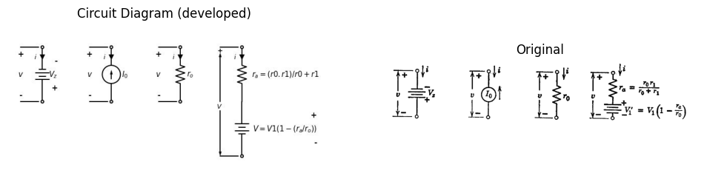
import matplotlib.pyplot as plt
from matplotlib import rcParams
import matplotlib.image as mpimg
import numpy as np
import PySpice.Logging.Logging as Logging
logger = Logging.setup_logging()
from PySpice.Probe.Plot import plot
from PySpice.Spice.Netlist import Circuit
from PySpice.Unit import *
rcParams['font.weight'] = 'bold'
#figure, ax1 = plt.subplots(figsize=(8, 8))
# Create the figure and subplots
fig, axs = plt.subplots(4, 2, figsize=(10, 10))
# Create subplots
circuit = Circuit('v-i curve')
Vi = circuit.V('i', '1', circuit.gnd, 0@u_V)
circuit.R(1 ,'1', circuit.gnd, 1@u_Ohm )
simulator = circuit.simulator(temperature=25, nominal_temperature=25)
analysis = simulator.dc(Vi=slice(-5, 5, 0.1))
axs[0,0].plot(analysis['1'], u_A(-analysis.Vi),'black',linewidth=2)
# circuit 2
circuit = Circuit('v-i curve')
Vi = circuit.V('i', '1', circuit.gnd, 0@u_V)
circuit.R(1 ,'1', '2',0.4@u_Ohm )
circuit.V(1 ,'2', circuit.gnd, 1.5@u_V )
simulator = circuit.simulator(temperature=25, nominal_temperature=25)
analysis = simulator.dc(Vi=slice(-5, 5, 0.1))
axs[1,0].plot(analysis['1'], u_A(-analysis.Vi),'black',linewidth=2)
# circuit 3
circuit = Circuit('v-i curve')
Vi = circuit.V('i', '1', circuit.gnd, 0@u_V)
circuit.I(1 ,'1', circuit.gnd, -2@u_A )
simulator = circuit.simulator(temperature=25, nominal_temperature=25)
analysis = simulator.dc(Vi=slice(-5, 5, 0.1))
axs[2,0].plot(analysis['1'], u_A(-analysis.Vi),'black',linewidth=2)
# circuit4
circuit = Circuit('v-i curve')
Vi = circuit.V('i', '1', circuit.gnd, 0@u_V)
circuit.R(2 ,'1', '2', 0.001@u_Ohm )
circuit.V(1 ,'2', circuit.gnd, -2@u_V )
simulator = circuit.simulator(temperature=25, nominal_temperature=25)
analysis = simulator.dc(Vi=slice(-5, 5, 0.1))
axs[3,0].plot(analysis['1'], u_A(-analysis.Vi),'black',linewidth=2)
#analyze
axs[1,0].set_title('V-I Curve1')
axs[1,0].set_xlim(-5, 5)
axs[1,0].set_xlabel('I [A]')
axs[1,0].set_ylabel('V [V]')
axs[1,0].set_ylim(-5, 5)
axs[1,0].axhline(0, color='black', linewidth=1)
axs[1,0].axvline(0, color='black', linewidth=1)
axs[1,0].text( 3.7, 3.545, 'ra', ha='center', va='center')
axs[1,0].text( 0.1, -0.15, '0', ha='center', va='center')
axs[1,0].text( -2, -4, 'i=(v-v10/ra', ha='center', va='center')
axs[0,0].set_title('V-I Curve2')
axs[2,0].set_title('V-I Curve3')
axs[3,0].set_title('V-I Curve4')
axs[0,0].set_xlim(-5, 5)
axs[0,0].set_xlabel('I [A]')
axs[0,0].set_ylabel('V [V]')
axs[0,0].set_ylim(-5, 5)
axs[0,0].axhline(0, color='black', linewidth=1)
axs[0,0].axvline(0, color='black', linewidth=1)
axs[0,0].text( 4.5, 3.545, 'ro', ha='center', va='center')
axs[0,0].text( 0.1, -0.15, '0', ha='center', va='center')
axs[0,0].text( -2, -4, 'i=v/ro', ha='center', va='center')
axs[2,0].set_xlim(-5, 5)
axs[2,0].set_xlabel('i [A]')
axs[2,0].set_ylabel('v [V]')
axs[2,0].set_ylim(-5, 5)
axs[2,0].axhline(0, color='black', linewidth=1)
axs[2,0].axvline(0, color='black', linewidth=1)
axs[2,0].text( 0.1, -0.15, '0', ha='center', va='center')
axs[2,0].text( -2.5, -1.8, '-Io', ha='center', va='center')
axs[2,0].text( -2.5, -3.8, 'i=-Io', ha='center', va='center')
axs[3,0].set_xlim(-5, 5)
axs[3,0].set_xlabel('i [A]')
axs[3,0].set_ylabel('V [V]')
axs[3,0].set_ylim(-5, 5)
axs[3,0].axhline(0, color='black', linewidth=1)
axs[3,0].axvline(0, color='black', linewidth=1)
axs[3,0].text( 0.1, -0.15, '0', ha='center', va='center')
axs[3,0].text( -1.5, -4.2, 'v=-Vz', ha='center', va='center')
axs[3,0].text( -.2, 4.2, 'A', ha='center', va='center')
axs[2,0].text( -.2, 4.2, 'B', ha='center', va='center')
axs[0,0].text( -.2, 4.2, 'C', ha='center', va='center')
axs[1,0].text( -.2, 4.2, 'D', ha='center', va='center')
# **Subplot (1, 2): PNG Sample File**
img_sample = mpimg.imread('images-books/3-18b.png') # Load the PNG file
axs[0,1].imshow(img_sample)
axs[0,1].axis('off') # Hide axes for image display
axs[0,1].set_title('Original')
img_sample = mpimg.imread('images-books/3-18a.png') # Load the PNG file
axs[1,1].imshow(img_sample)
axs[1,1].axis('off') # Hide axes for image display
axs[1,1].set_title('Original')
img_sample = mpimg.imread('images-books/3-18c.png') # Load the PNG file
axs[2,1].imshow(img_sample)
axs[2,1].axis('off') # Hide axes for image display
axs[2,1].set_title('Original')
img_sample = mpimg.imread('images-books/3-18d.png') # Load the PNG file
axs[3,1].imshow(img_sample)
axs[3,1].axis('off') # Hide axes for image display
axs[3,1].set_title('Original')
plt.tight_layout()
plt.show()
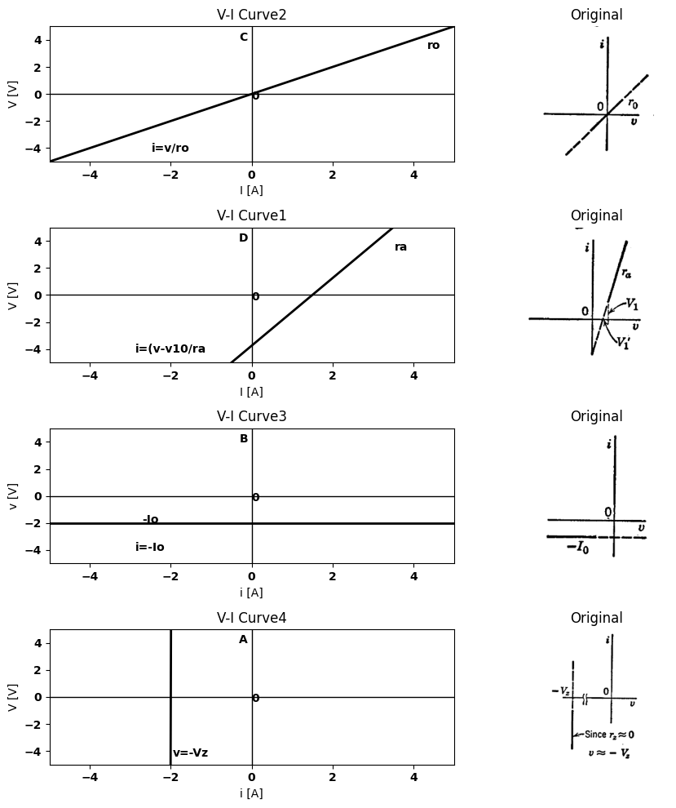
Fig. 3.18 Linear representation of segments of piecewise-linear curve.
point, the molecules of the gas become completely ionized and form a plasma. The plasma consists of a nearly field-free region in which the charges of the electrons are essentially neutralized by positive-ion charge. Conduction is sustained for a wide range of currents with an almost constant voltage drop across the tube. The voltage $E$ may be substantially less than $E_{m}$ . In the conduction state, the curve is fairly well approximated by the simple model shown in Fig. 3.19$\left(b\right)$. The onset of conduction may be represented by a resistance in series with an ideal rectifier. This model is good up to voltage , as indicated by the line of slope in Fig. 3.19$\left(c\right)$. When the two simple models are combined, as indicated in Fig. 3.19$\left(c\right)$, the curve is as shown by
the solid line. It is therefore preferable to use each of these parallel branches as a separate model. The resistance applies prior to ionization, and the voltage source $E$ applies after ionization.
The transition from one model to the other is left indeterminate by this use of two separate models. It is apparent that a piecewise-linear It is apparent that a piecewise-linear
import matplotlib.pyplot as plt
import numpy as np
import schemdraw
import schemdraw.elements as e
import matplotlib.image as mpimg
# Create the figure and subplots
fig, axs = plt.subplots(1, 2, figsize=(12, 12))
# **Subplot (1, 1): Schemdraw Circuit Diagram**
d = schemdraw.Drawing()
d.push()
d += e.Dot(open=True)
D = d.add(e.Diode().down().label(['+', '$e_b$','-'], ofst=-1.2, fontsize = 16))
d += e.Dot(open=True)
d += e.lines.CurrentLabelInline().at(D).down().label('$i_b$').color('black')
d += e.Gap().up().label(['-','','' , '$v$','','', '+'], ofst = 1.2 , fontsize = 16).color('black')
d += e.Line().left().length(1).at((-0.2,0)).color('black').linestyle('-')
d += e.Line().left().length(1).at((-0.2,-3)).color('black').linestyle('-')
d.pop()
d.move(5,0)
d.push()
d += e.Dot(open=True)
D= d.add(e.Diode(fill=True).down().label([ '+', '$e_b$','-'], ofst=-1.2, fontsize = 16))
d.push()
E = d.add(e.Battery().down().label(['+', '$E$','-'], ofst=-1.2, fontsize = 16))
d += e.Dot()
d += e.lines.CurrentLabelInline().at(D).down().label('$i_b$').color('black')
d += e.Arrow().up().length(2.8).at((3.8,-3)).color('black').label('$V$', loc='left', color='black')
d += e.Arrow().down().length(2.5).at((3.8,-3.5)).color('black')
d += e.Line().left().length(1).at((4.8,-6)).color('black').linestyle('-')
d += e.Line().left().length(1).at((4.8,0)).color('black').linestyle('-')
d.pop()
d.move(5,3)
d.push()
d += e.Dot(open=True)
l1 = d.add(e.Line().right())
d += e.Dot()
D1 = d.add(e.Diode(fill=True).down())
r = d.add(e.Resistor().down().label('$r$', ofst=-1))
d += e.Dot()
l2 = d.add(e.Line().left())
d += e.Dot(open=True)
d.pop()
d += e.Gap().down().length(6).label(['\u2191','+','','','','$e_b$','','','','-','\u2193'], ofst=0 , fontsize = 16).color('black')
d.move(3,6)
d.push()
l3 = d.add(e.Line().right())
D2 = d.add(e.Diode(fill=True).down())
E = d.add(e.Battery().down().label(['+', '$E$','-'], ofst=-1.2, fontsize = 16))
l4 = d.add(e.Line().left())
d.pop()
cc
Text(0.5, 1.0, 'Original')
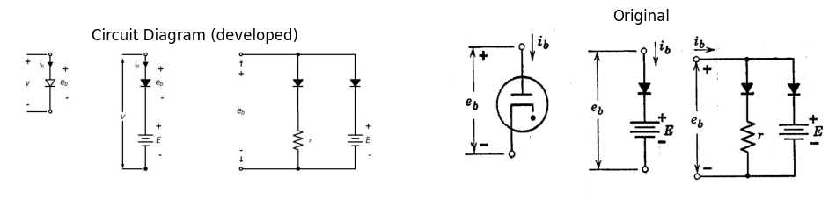
import matplotlib.pyplot as plt
import numpy as np
import schemdraw
import schemdraw.elements as elm
import matplotlib.image as mpimg
# Create the figure and subplots
fig, axs = plt.subplots(1, 2, figsize=(12, 12))
eb1 = [0,
0,
0,
0,
0.06676074,
1.67616104,
2.993670838,
3.958124631,
4.174810466,
4.274268723,
4.27539231,
4.139146982,
3.963118351,
3.630578212,
3.337072318,
2.985764115,
2.635954028,
2.423762541,
2.407741023,
2.432751237,
2.537078371,
2.680314907,
2.925381717
]
ib1 = [0,
0,
0,
0,
0,
0.116913578,
0.336591862,
0.634989332,
0.72882587,
0.918814218,
1.090416597,
1.282039254,
1.397666571,
1.609718082,
1.783363346,
2.129019566,
2.703478958,
3.296051935,
3.849129125,
4.668870965,
5.602469622,
6.4785951,
7.906980615
]
axs[0].plot(eb1, ib1, 'black',linestyle='-')
axs[0].axhline(0, color='black',linewidth=2, ls='-')
axs[0].axvline(0, color='black',linewidth=2, ls='-')
axs[0].annotate('', xy=(4.2,1), xytext=(4.2, 0), arrowprops=dict(arrowstyle='->'))
axs[0].set_xlim(-2, 9)
axs[0].set_xlabel('i [A]')
axs[0].set_ylabel('V [V]')
axs[0].set_ylim(-2, 9)
axs[0].text(4,-.8, 'Em', fontsize=10)
axs[0].text(2.4,-.8, 'E', fontsize=10)
axs[0].axhline(0, color='black', linewidth=2)
axs[0].axvline(0, color='black', linewidth=2)
# **Subplot (1, 2): PNG Sample File**
img_sample = mpimg.imread('images-books/3-19a.png') # Load the PNG file
axs[1].imshow(img_sample)
axs[1].axis('off') # Hide axes for image display
axs[1].set_title('Original')
plt.tight_layout()
plt.show()
figure.savefig('./Drawings/fig44-4.svg')
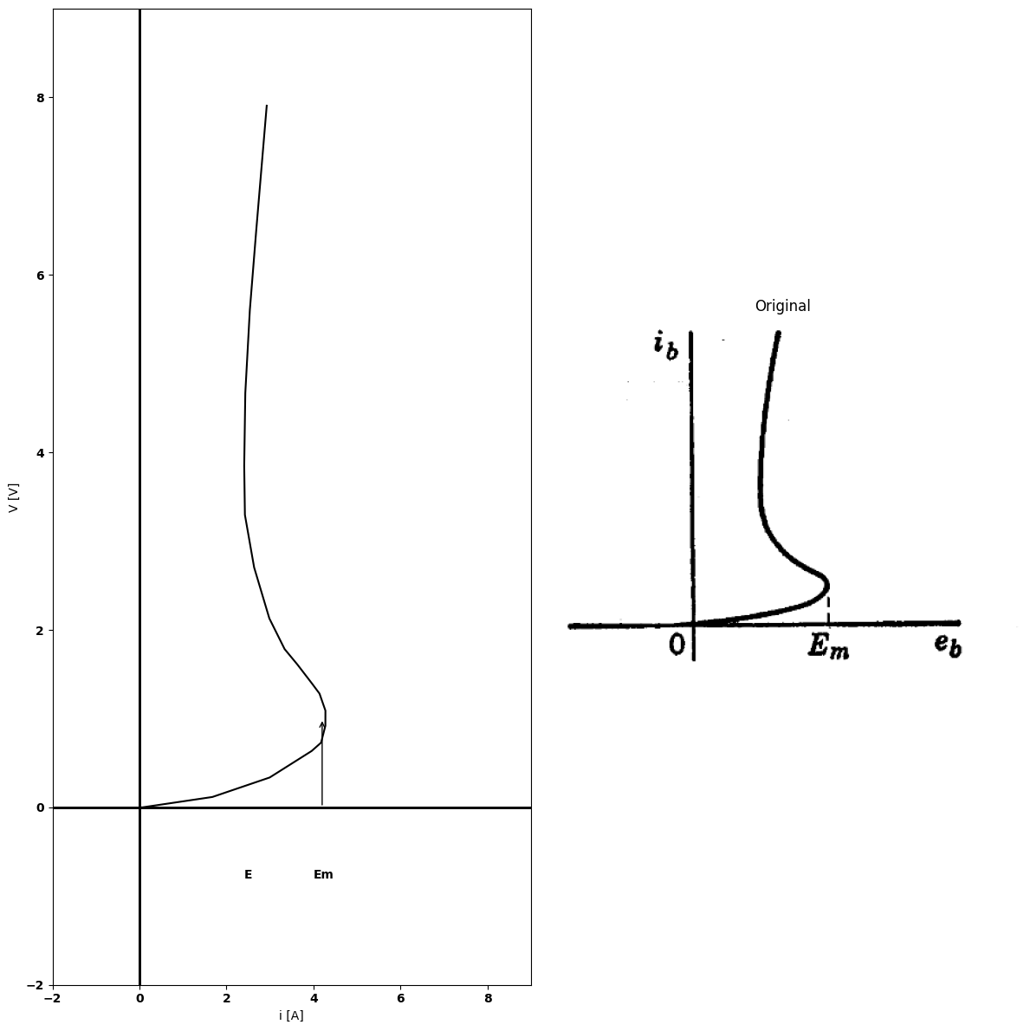
import matplotlib.pyplot as plt
import numpy as np
import schemdraw
import schemdraw.elements as elm
import matplotlib.image as mpimg
# Create the figure and subplots
fig, axs = plt.subplots(1, 2, figsize=(12, 12))
eb1 = [0,
0,
0,
0,
0.06676074,
1.67616104,
2.993670838,
3.958124631,
4.174810466,
4.274268723,
4.27539231,
4.139146982,
3.963118351,
3.630578212,
3.337072318,
2.985764115,
2.635954028,
2.423762541,
2.407741023,
2.432751237,
2.537078371,
2.680314907,
2.925381717
]
ib1 = [0,
0,
0,
0,
0,
0.116913578,
0.336591862,
0.634989332,
0.72882587,
0.918814218,
1.090416597,
1.282039254,
1.397666571,
1.609718082,
1.783363346,
2.129019566,
2.703478958,
3.296051935,
3.849129125,
4.668870965,
5.602469622,
6.4785951,
7.906980615
]
eb2 =[2.5, 2.5, 2.5, 2.5 ,2.5 ,2.5 ,2.5 ,2.5 ,2.5]
ib2 = [0 , 1 , 2 , 3, 4 ,5 ,6 ,7 ,8 ]
#
axs[0].plot(eb1, ib1, 'black',linestyle='--')
axs[0].plot(eb2, ib2, 'black')
axs[0].axhline(0, color='black',linewidth=2, ls='-')
axs[0].axvline(0, color='black',linewidth=2, ls='-')
axs[0].annotate('', xy=(4.2,1), xytext=(4.2, 0), arrowprops=dict(arrowstyle='->'))
axs[0].set_xlim(-2, 9)
axs[0].set_xlabel('i [A]')
axs[0].set_ylabel('V [V]')
axs[0].set_ylim(-2, 9)
axs[0].text(4,-.8, 'Em', fontsize=10)
axs[0].text(2.4,-.8, 'E', fontsize=10)
#
axs[0].axhline(0, color='black', linewidth=2)
axs[0].axvline(0, color='black', linewidth=2)
# **Subplot (1, 2): PNG Sample File**
img_sample = mpimg.imread('images-books/3-19b.png') # Load the PNG file
axs[1].imshow(img_sample)
axs[1].axis('off') # Hide axes for image display
axs[1].set_title('Original')
plt.tight_layout()
plt.show()
figure.savefig('./Drawings/fig44-4.svg')
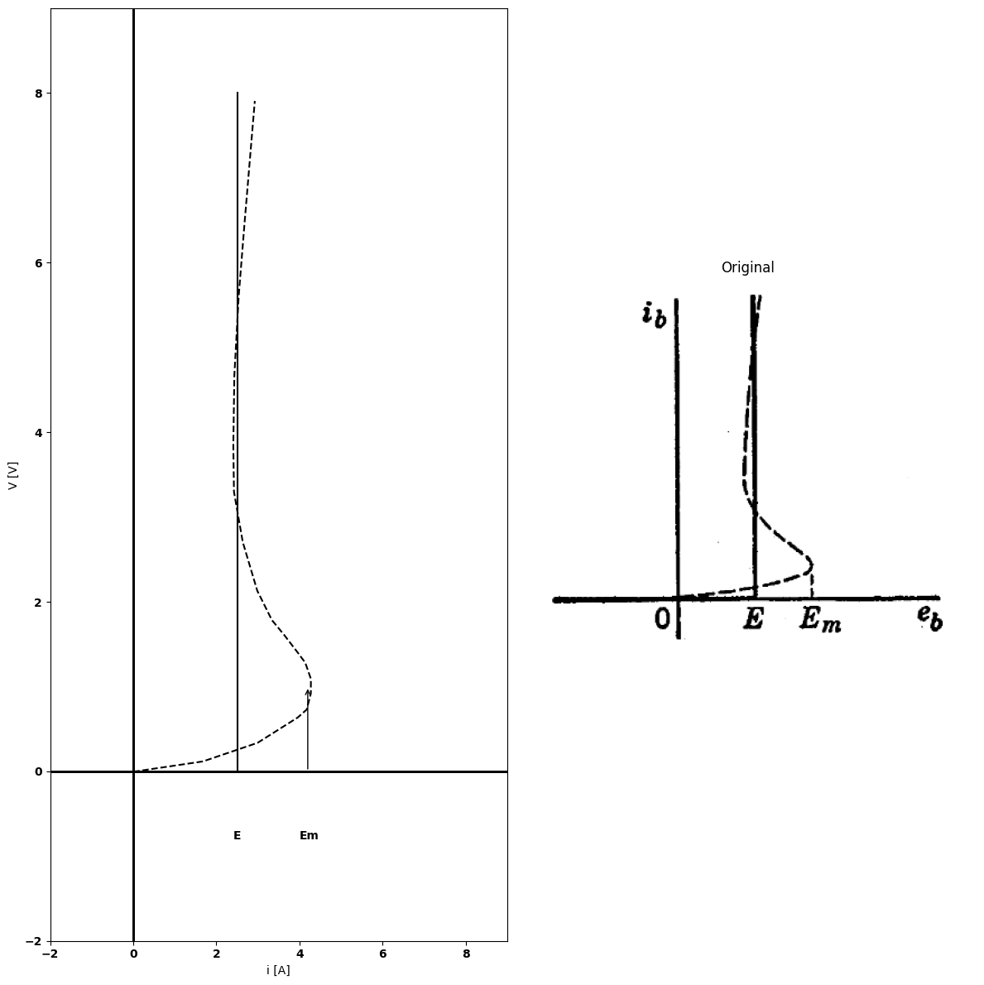
import matplotlib.pyplot as plt
import numpy as np
import schemdraw
import schemdraw.elements as elm
import matplotlib.image as mpimg
# Create the figure and subplots
fig, axs = plt.subplots(1, 2, figsize=(12, 12))
eb1 = [0,
0,
0,
0,
0.06676074,
1.67616104,
2.993670838,
3.958124631,
4.174810466,
4.274268723,
4.27539231,
4.139146982,
3.963118351,
3.630578212,
3.337072318,
2.985764115,
2.635954028,
2.423762541,
2.407741023,
2.432751237,
2.537078371,
2.680314907,
2.925381717
]
ib1 = [0,
0,
0,
0,
0,
0.116913578,
0.336591862,
0.634989332,
0.72882587,
0.918814218,
1.090416597,
1.282039254,
1.397666571,
1.609718082,
1.783363346,
2.129019566,
2.703478958,
3.296051935,
3.849129125,
4.668870965,
5.602469622,
6.4785951,
7.906980615
]
eb2 =[0,0,2.35396257,2.388706844,2.383876089]
ib2 = [0,0,0.54950679,4.145539153,8.145556044 ]
eb3 =[0,2.353590974,4.358539964,6.014931424,7.801939058]
ib3 = [0,0.511046551,1.023267009,1.459783123,1.915073306 ]
axs[0].plot(eb1, ib1, 'black',linestyle='--')
axs[0].plot(eb2, ib2, 'black',linestyle='-')
axs[0].plot(eb3, ib3, 'black',linestyle='-.')
axs[0].axhline(0, color='black',linewidth=2, ls='-')
axs[0].axvline(0, color='black',linewidth=2, ls='-')
axs[0].annotate('', xy=(4.2,1), xytext=(4.2, 0), arrowprops=dict(arrowstyle='->'))
axs[0].set_xlim(-2, 9)
axs[0].set_xlabel('i [A]')
axs[0].set_ylabel('V [V]')
axs[0].set_ylim(-2, 9)
axs[0].text(4,-.8, 'Em', fontsize=10)
axs[0].axhline(0, color='black', linewidth=2)
axs[0].axvline(0, color='black', linewidth=2)
# **Subplot (1, 2): PNG Sample File**
img_sample = mpimg.imread('images-books/3-19c.png') # Load the PNG file
axs[1].imshow(img_sample)
axs[1].axis('off') # Hide axes for image display
axs[1].set_title('Original')
plt.tight_layout()
plt.show()
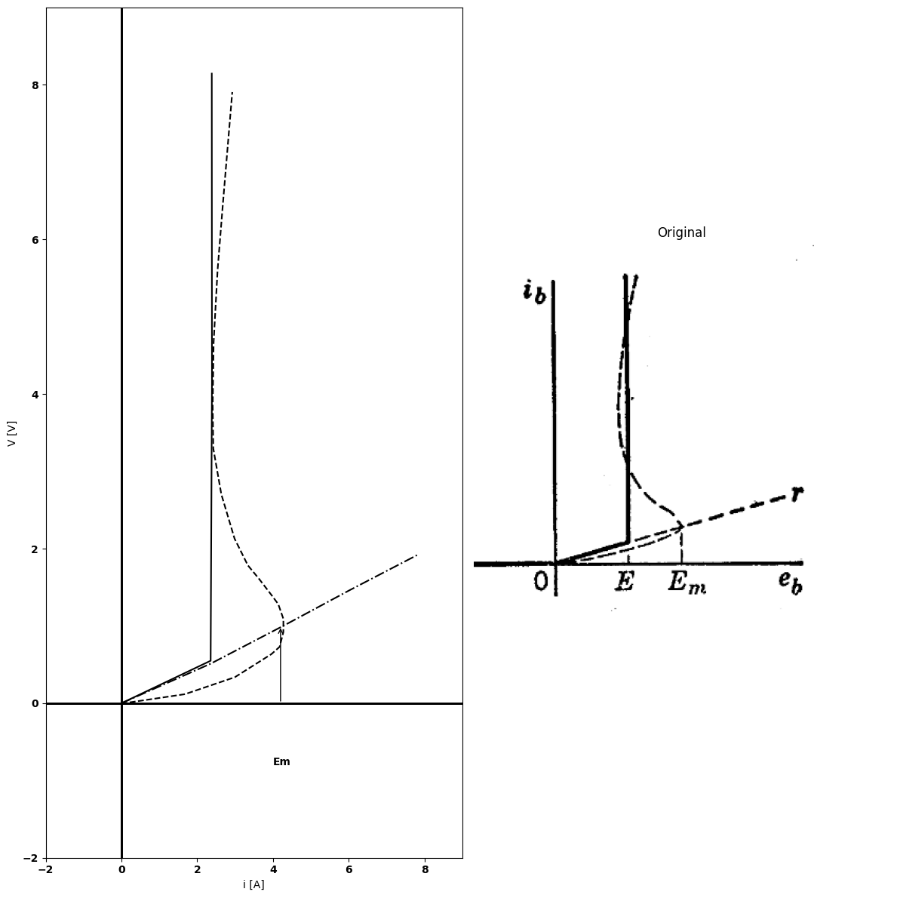
Fig. 3.19. Piecewise-linear models for gas-filled diodes.
approximation made to follow the curve more closely must consist of resistance $$ for $0<e_{b}<E_{m}$ . Then a line of negative slope is required in order to return to the vertical line at $e_{b}=E$ . This negative slope implies the necessity for an element corresponding to negative resistance. A discussion of negative resistance and its properties is deferred until Chapter 9.
import matplotlib.pyplot as plt
import numpy as np
import schemdraw
import schemdraw.elements as elm
import matplotlib.image as mpimg
# Create the figure and subplots
fig, axs = plt.subplots(2, 2, figsize=(12, 12))
# **Subplot (1, 1): Schemdraw Circuit Diagram**
d = schemdraw.Drawing()
l1 = d.add(e.Line().up().length(0.5).dot(open=True))
d.push()
l2 = d.add(e.Line().down().length(0.5).dot())
D1 = d.add(e.Diode(fill=True).down().at(l1.start))
R = d.add(e.Resistor().down().label('$r$', ofst=-1))
E1 = d.add(e.Battery().down().label(['+', '$E$', '-'], ofst=-1.3).dot(open=True))
d.pop()
d += e.Arrow().up().linewidth(0.6).length(4).linewidth(0.6).linewidth(0.6).color('white').label('$V$', loc='start', color='black',ofst=0.3). at((-0.4,-2.5))
d += e.Arrow().down().length(0.7).linewidth(0.6).color('black').label('i', loc='top', color='black',ofst=-0.3). at((0.3,1))
d += e.Arrow().up().length(2.5).linewidth(0.6).color('black').label('+',loc='end', color='black',ofst=0.4). at((-0.7,-2))
d += e.Line().left().length(0.8).linewidth(0.6).at(l1.end).color('gray')
d += e.Arrow().down().length(2.5).linewidth(0.6).color('black').label(r'_', loc='end', color='black',ofst=(-.5, -0.3)). at((-0.7,-6.5))
d += e.Line().left().length(0.8).linewidth(0.6).at(E1.end).color('gray')
d.save('./Drawings/fig20.jpg')
d.save('./Drawings/fig20.svg')
# Load the saved PNG file into the subplot
img = mpimg.imread('./Drawings/fig20.jpg')
axs[0,0].imshow(img)
axs[0,0].axis('off') # Hide axes for image display
axs[0,0].set_title('Circuit Diagram (developed)')
# **Subplot (1, 2): PNG Sample File**
img_sample = mpimg.imread('images-books/20a.png') # Load the PNG file
axs[0,1].imshow(img_sample)
axs[0,1].axis('off') # Hide axes for image display
axs[0,1].set_title('Original')
circuit = Circuit('Diode')
circuit.model('BAV21','D' ,IS = 4@u_nA , N = 1.906 ,BV = 110@u_V, IBV = 0.0001@u_V, VJ = 0.7@u_V ,CJO = 7.048E-13 ,RS = 0.01@u_Ohm ,TT = 3.48E-9)
Vth = circuit.V('th', '1', circuit.gnd, 0@u_V)
circuit.D(1, '1','2' , model = 'BAV21')
circuit.V(1, '3',circuit.gnd , 20@u_V)
circuit.R(1, '2','3' , 300@u_Ohm)
simulator = circuit.simulator(temperature=25, nominal_temperature=25)
analysis = simulator.dc(Vth=slice(-100, 100, 0.1))
# Plot for R1
axs[1,0].plot(analysis['1'],u_mA(-analysis.Vth), 'black', linewidth=2)
axs[1,0].set_title('V-I Curve for D')
axs[1,0].set_xlim(-60, 100)
axs[1,0].set_xlabel('V [V]')
axs[1,0].set_ylabel('I [mA]')
axs[1,0].set_ylim(-60, 100)
axs[1,0].axhline(0, color='black', linewidth=1)
axs[1,0].axvline(0, color='black', linewidth=1)
axs[1,0].annotate('+E', xy=(20, 0), xytext=(12, -14),
textcoords='offset points', ha='center', color='black', fontsize=12, fontweight='medium')
axs[1,0].text(50, 60, '$r$', ha='center', va='center', fontsize=12)
axs[1,0].plot([20, 20], [-4, 4], color='black', linewidth=1)
axs[1,0].text(-70, -40, '$R_1$', ha='center', va='center', fontsize=12)
# **Subplot (1, 2): PNG Sample File**
img_sample = mpimg.imread('images-books/20a1.png') # Load the PNG file
axs[1,1].imshow(img_sample)
axs[1,1].axis('off') # Hide axes for image display
axs[1,1].set_title('Original')
plt.tight_layout()
plt.show()
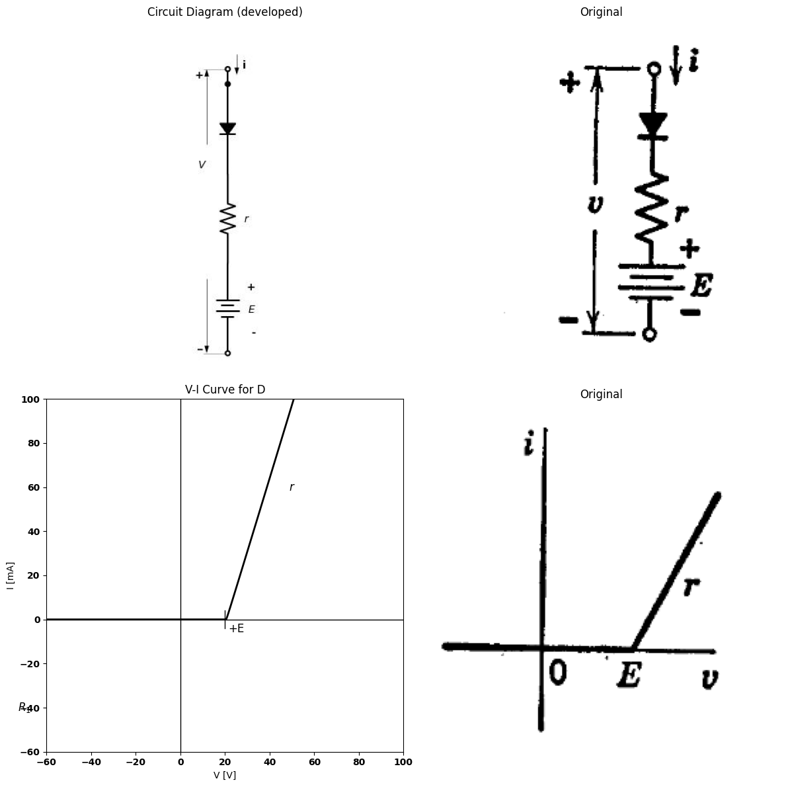
import ipywidgets as widgets
from ipywidgets import interact
import matplotlib.pyplot as plt
from matplotlib import rcParams
import PySpice.Logging.Logging as Logging
logger = Logging.setup_logging()
from PySpice.Probe.Plot import plot
from PySpice.Spice.Netlist import Circuit
from PySpice.Unit import *
rcParams['font.weight'] = 'bold'
figure = plt.figure(figsize=(15, 10))
#@interact(Mode1=(True) , Mode2=(True), Mode3=(True))
@interact(E=widgets.IntSlider(min=-20, max=20, step=5, value=20))
def response(E=20):
circuit = Circuit('Resistance and voltage')
circuit = Circuit('Diode')
circuit.model('BAV21','D' ,IS = 4@u_nA , N = 1.906 ,BV = 110@u_V, IBV = 0.0001@u_V, VJ = 0.7@u_V ,CJO = 7.048E-13 ,RS = 0.01@u_Ohm ,TT = 3.48E-9)
Vth = circuit.V('th', '1', circuit.gnd, 0@u_V)
circuit.D(1, '1','2' , model = 'BAV21')
circuit.V(1, '3',circuit.gnd , E@u_V)
circuit.R(1, '2','3' , 300@u_Ohm)
simulator = circuit.simulator(temperature=25, nominal_temperature=25)
analysis = simulator.dc(Vth=slice(-100, 100, 0.1))
# Plot for R1
plt.plot(analysis['1'],u_mA(-analysis.Vth), 'black', linewidth=2)
#plt.set_title('V-I Curve for D')
#plt.set_xlim(-60, 100)
#plt.set_xlabel('V [V]')
#plt.set_ylabel('I [mA]')
#plt.set_ylim(-60, 100)
plt.axhline(0, color='black', linewidth=1)
plt.axvline(0, color='black', linewidth=1)
plt.annotate('-E', xy=(-20, 0), xytext=(12, -14),
textcoords='offset points', ha='center', color='black', fontsize=12, fontweight='medium')
plt.text(50, 60, '$r$', ha='center', va='center', fontsize=12)
plt.plot([20, 20], [-4, 4], color='black', linewidth=1)
plt.text(-70, -40, '$R_1$', ha='center', va='center', fontsize=12)
plt.tight_layout()
plt.show()
<Figure size 1500x1000 with 0 Axes>
{"model_id":"4e46a7b584654c3183d26a8b415561d3","version_major":2,"version_minor":0}
import ipywidgets as widgets
from ipywidgets import *
import schemdraw
import schemdraw.elements as elm
@interact(Mode1=(True) , Mode2=(True), Mode3=(True))
def response(Mode1=True , Mode2=True, Mode3=(True)):
with schemdraw.Drawing() as d:
if (Mode1):
d += elm.Dot(open=True)
d += elm.Line().down().length(0.2)
d += elm.Diode(fill=True).down().label('$D$')
d += elm.Resistor().down().label('$r$','top')
d += elm.Battery().label('$E$', 'top').down().dot(open=True)
d += elm.Line().right().length(1.4).at((-2.1,0.0)).color('black').linestyle('--')
d += elm.Line().right().length(1.4).at((-2.1,-9.2)).color('black').linestyle('--')
d += elm.Arrow().down().length(4.0).at((-1.9, -5.2)).color('black')
d += elm.Arrow().up().length(0.2).at((-2.3, -4.7)).color('white').label('$V$', loc='bottom', color='black')
d += elm.Arrow().up().length(4.0).at((-1.9, -4)).color('black')
#d += elm.Label('$+$').at((-2.1,-0.4)).color('red')
# d += elm.Label('_').at((-2.1,-8.8)).color('red')
d += elm.Arrow().down().length(0.7).at((-0.4, -0.5)).color('black').label('$i$')
if (Mode2):
d += elm.Dot(open=True).at((6,-1))
d += elm.Line().down().length(1.2)
d += elm.Diode(fill=True).up().label('$D$').at((6,-5))
d += elm.Line().down().length(1.2).at((6,-5)).dot(open=True)
d += elm.Resistor().down().label('$r$','top').at((4,-2))
d += elm.Line().right().length(4)
d += elm.SourceI(reverse=True).up().label('I', 'top')
d += elm.Line().left().length(4)
d += elm.Line().right().length(2.4).at((2.7,-1.0)).color('black').linestyle('--')
d += elm.Line().right().length(2.4).at((2.7,-6.2)).color('black').linestyle('--')
d += elm.Arrow().down().length(2.0).at((2.9, -4.2)).color('black')
d += elm.Arrow().up().length(0.2).at((2.5, -3.7)).color('white').label('$V$', loc='bottom', color='black')
d += elm.Arrow().up().length(2.0).at((2.9, -3)).color('black')
d += elm.Arrow().down().length(0.7).at((5.7, -1.2)).color('black').label('$i$')
#d += elm.Label('$+$').at((2.5,-1.5)).color('red')
# d += elm.Label('_').at((2.5,-5.7)).color('red')
if (Mode3):
d += elm.Dot().at((14,0))
d += elm.Line().down().length(0.2)
d += elm.Diode(fill=True).down().label('$D$')
d += elm.Resistor().down().label('$R_1$','top')
d += elm.Battery().label('$E_1$', 'top').down()
d += elm.Line().right().length(1).at((11.9,0.0)).color('black').linestyle('--')
d += elm.Line().right().length(1).at((11.9,-9.2)).color('black').linestyle('--')
d += elm.Arrow().down().length(4.0).at((12.1, -5.2)).color('black')
d += elm.Arrow().up().length(0.2).at((11.7, -4.7)).color('white').label('$V$', loc='bottom', color='black')
d += elm.Arrow().up().length(4.0).at((12.1, -4)).color('black')
#d += elm.Label('+').at((11.9,-0.4)).color('red')
#d += elm.Label('_').at((11.9,-8.8)).color('red')
d += elm.Arrow().down().length(0.7).at((14.2, -0.5)).color('black').label('$i_1$','bottom')
d += elm.Line().down().length(0.2).at((16.9,0))
d += elm.Diode(fill=True).down().label('$D$')
d += elm.Resistor().down().label('$R_2$','top')
d += elm.Battery().label('$E_2$', 'top').down()
d += elm.Line().left().length(2.9).dot()
d += elm.Line().left().length(0.8).dot(open=True)
d += elm.Line().left().length(3.7).dot(open=True).at((16.9,0))
d += elm.Arrow().down().length(0.7).at((17.1, -0.5)).color('black').label('$i_2$','bottom')
d += elm.Arrow().right().length(0.7).at((13.0, -0.2)).color('black').label('$i$', 'bottom')
fig = plt.figure(figsize=(5, 3))
img = plt.imread('./images-books/3-20c.png')
plt.imshow(img)
plt.axis('off')
plt.title('\nReference image from the book:', fontsize=8, pad=10,loc='left')
plt.show()
{"model_id":"8037cf45c3e349be98608da488d762e5","version_major":2,"version_minor":0}
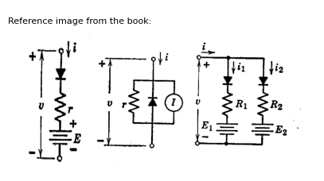
import matplotlib.pyplot as plt
from matplotlib import rcParams
import matplotlib.image as mpimg
import numpy as np
import PySpice.Logging.Logging as Logging
logger = Logging.setup_logging()
from PySpice.Probe.Plot import plot
from PySpice.Spice.Netlist import Circuit
from PySpice.Unit import *
rcParams['font.weight'] = 'bold'
fig, axs = plt.subplots(3, 2, figsize=(10, 10))
circuit = Circuit('Diode')
circuit.model('BAV21','D' ,IS = 4@u_nA , N = 1.906 ,BV = 110@u_V, IBV = 0.0001@u_V, VJ = 0.7@u_V ,CJO = 7.048E-13 ,RS = 0.01@u_Ohm ,TT = 3.48E-9)
Vth = circuit.V('th', '1', circuit.gnd, 0@u_V)
circuit.D(1, circuit.gnd,'1' , model = 'BAV21')
circuit.I(1, '1',circuit.gnd , 40@u_mA)
circuit.R(1, '1',circuit.gnd , 1800@u_Ohm)
simulator = circuit.simulator(temperature=25, nominal_temperature=25)
analysis = simulator.dc(Vth=slice(-100, 100, 0.1))
# Plot for R1
axs[0,0].plot(analysis['1'],u_mA(-analysis.Vth), 'black', linewidth=2)
axs[0,0].set_title('V-I Curve for D')
axs[0,0].set_xlim(-60, 100)
axs[0,0].set_xlabel('V [V]')
axs[0,0].set_ylabel('I [mA]')
axs[0,0].set_ylim(-60, 100)
axs[0,0].axhline(0, color='black', linewidth=1)
axs[0,0].axvline(0, color='black', linewidth=1)
axs[0,0].text(40, 80, '$r$', ha='center', va='center', fontsize=12)
axs[0,0].text(-70, -40, '$R_1$', ha='center', va='center', fontsize=12)
axs[0,0].text(-5, 40, '$I$', ha='center', va='center', fontsize=12)
#
circuit = Circuit('Diode')
circuit.model('BAV21','D' ,IS = 4@u_nA , N = 1.906 ,BV = 110@u_V, IBV = 0.0001@u_V, VJ = 0.7@u_V ,CJO = 7.048E-13 ,RS = 0.01@u_Ohm ,TT = 3.48E-9)
Vth = circuit.V('th', '1', circuit.gnd, 0@u_V)
circuit.D(1, '1' ,'2', model = 'BAV21')
circuit.V(1, '3',circuit.gnd , 10@u_V)
circuit.R(1, '2','3' , 800@u_Ohm)
circuit.D(2, '1' ,'4', model = 'BAV21')
circuit.V(2, '5',circuit.gnd , 20@u_V)
circuit.R(2, '4','5' , 1200@u_Ohm)
simulator = circuit.simulator(temperature=25, nominal_temperature=25)
analysis = simulator.dc(Vth=slice(-100, 100, 0.1))
axs[1,0].plot(analysis['1'],u_mA(-analysis.Vth), 'black', linewidth=2)
axs[1,0].plot(analysis['2'],u_mA(-analysis.Vth), 'black', linewidth=2)
circuit = Circuit('Diode2')
Vth = circuit.V('th', '1', circuit.gnd, 0@u_V)
circuit.R(3, '1', '2' , 800@u_Ohm)
circuit.V(1, '2',circuit.gnd , 10@u_V)
circuit.R(4, '1', '3' ,288@u_kOhm)
circuit.V(2, '3',circuit.gnd , 20@u_V)
simulator = circuit.simulator(temperature=25, nominal_temperature=25)
analysis = simulator.dc(Vth=slice(20, 100, 0.1))
axs[1,0].plot(analysis['1'],u_mA(-analysis.Vth), 'black', linestyle='--',linewidth=2)
axs[1,0].set_title('V-I Curve for D')
axs[1,0].text(10, -8, '$ٍٍE1$', ha='center', va='center', fontsize=12)
axs[1,0].text(23, -8, '$ٍٍE2$', ha='center', va='center', fontsize=12)
axs[1,0].set_xlim(-60, 100)
axs[1,0].set_xlabel('V [V]')
axs[1,0].set_ylabel('I [mA]')
axs[1,0].set_ylim(-60, 100)
axs[1,0].axhline(0, color='black', linewidth=1)
axs[1,0].axvline(0, color='black', linewidth=1)
#
circuit = Circuit('Diode')
circuit.model('BAV21','D' ,IS = 4000@u_uA , N = 1.906 ,BV = 110@u_V, IBV = 0.0001@u_V, VJ = 0.7@u_V ,CJO = 7.048E-13 ,RS = 0.01@u_Ohm ,TT = 3.48E-9)
Vth = circuit.V('th', '1', circuit.gnd, 0@u_V)
circuit.D(1, '2' ,'1', model = 'BAV21')
circuit.I(1, '1','2' , 20@u_mA)
circuit.R(1, '1','2' ,800@u_Ohm)
circuit.D(2, circuit.gnd ,'2', model = 'BAV21')
circuit.I(2, '2',circuit.gnd , 50@u_mA)
circuit.R(2, '2',circuit.gnd , .8@u_kOhm)
simulator = circuit.simulator(temperature=25, nominal_temperature=25)
analysis = simulator.dc(Vth=slice(-100, 100, 0.1))
axs[2,0].plot(analysis['1'],u_mA(-analysis.Vth), 'black', linewidth=2)
#ax.plot(analysis['2'],u_mA(-analysis.Vth), 'black', linewidth=2)
circuit = Circuit('Diode2')
circuit.model('BAV21','D' ,IS = 4000@u_uA , N = 1.906 ,BV = 110@u_V, IBV = 0.0001@u_V, VJ = 0.7@u_V ,CJO = 7.048E-13 ,RS = 0.01@u_Ohm ,TT = 3.48E-9)
Vth = circuit.V('th', '1', circuit.gnd, 0@u_V)
circuit.D(1, circuit.gnd ,'1', model = 'BAV21')
circuit.I(1, '1',circuit.gnd , 20@u_mA)
circuit.R(1, '1',circuit.gnd ,800@u_Ohm)
simulator = circuit.simulator(temperature=25, nominal_temperature=25)
analysis = simulator.dc(Vth=slice(-100, 100, 0.1))
axs[2,0].plot(analysis['1'],u_mA(-analysis.Vth), 'black', linewidth=2,linestyle='--')
axs[2,0].plot(analysis['1'],u_mA(-analysis.Vth), 'black', linestyle='--',linewidth=2)
axs[2,0].set_title('V-I Curve for D')
axs[2,0].text(-3, 20, '$I_1$', ha='center', va='center', fontsize=12)
axs[2,0].text(-3, 55, '$I_2$', ha='center', va='center', fontsize=12)
axs[2,0].text(10, 62, '$V_2$', ha='center', va='center', fontsize=12)
axs[2,0].text(70, 95, '$V_2$', ha='center', va='center', fontsize=12)
axs[2,0].set_xlim(-60, 100)
axs[2,0].set_xlabel('V [V]')
axs[2,0].set_ylabel('I [mA]')
axs[2,0].set_ylim(-60, 100)
axs[2,0].axhline(0, color='black', linewidth=1)
axs[2,0].axvline(0, color='black', linewidth=1)
axs[2,0].annotate('', xy=(23,55), xytext=(0, 55), arrowprops=dict(arrowstyle='->'))
axs[2,0].annotate('', xy=(70,80), xytext=(45, 80), arrowprops=dict(arrowstyle='->'))
# **Subplot (1, 2): PNG Sample File**
img_sample = mpimg.imread('images-books/20b.png') # Load the PNG file
axs[0,1].imshow(img_sample)
axs[0,1].axis('off') # Hide axes for image display
axs[0,1].set_title('Original')
# **Subplot (1, 2): PNG Sample File**
img_sample = mpimg.imread('images-books/20c.png') # Load the PNG file
axs[1,1].imshow(img_sample)
axs[1,1].axis('off') # Hide axes for image display
axs[1,1].set_title('Original')
# **Subplot (1, 2): PNG Sample File**
img_sample = mpimg.imread('images-books/20d.png') # Load the PNG file
axs[2,1].imshow(img_sample)
axs[2,1].axis('off') # Hide axes for image display
axs[2,1].set_title('Original')
plt.tight_layout()
plt.show()
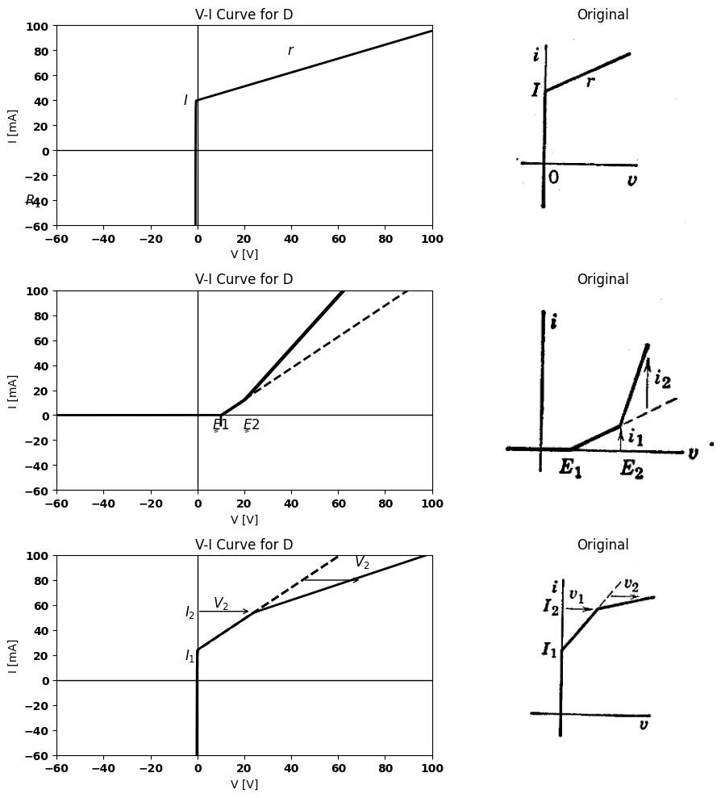
import schemdraw
import schemdraw.elements as elm
import schemdraw as schem
import matplotlib.pyplot as plt
import matplotlib.image as mpimg
import numpy as np
# Create the figure and subplots
fig, axs = plt.subplots(1, 2, figsize=(12, 12))
d = schemdraw.Drawing()
d += elm.Dot(open=True)
d += elm.Line().right().length(1.5)
d += elm.Diode(fill=True).left().label('$D$').at((4.5,0))
d += elm.Line().up().length(2)
d += elm.SourceI().right().label('I', 'top')
d += elm.Line().down().length(2)
d.push()
d += elm.Line().down().length(2)
d += elm.Resistor().left().label('$R_1$','top')
d += elm.Line().up().length(2)
d.pop()
d += elm.Line().right().length(1)
d += elm.Diode(fill=True).left().label('$D$').at((8.5,0))
d += elm.Line().up().length(2)
d += elm.SourceI().right().label('I', 'top')
d += elm.Line().down().length(2)
d.push()
d += elm.Line().down().length(2)
d += elm.Resistor().left().label('$R_2$','top')
d += elm.Line().up().length(2)
d.pop()
d += elm.Line().right().length(1)
d += elm.Line().down().length(3.5)
d += elm.Line().left().length(9.5).dot(open=True)
d += elm.Arrow().down().length(1.3).at((-0.1, -2.1)).color('black')
d += elm.Arrow().up().length(0.2).at((-0.6, -1.9)).color('white').label('$V$', loc='bottom', color='black')
d += elm.Arrow().up().length(1.3).at((-0.1, -1.5)).color('black')
d += elm.Arrow().right().length(0.7).at((0.3, 0.3)).color('black').label('$i$','top')
d += elm.Gap().label(['+', '$v_1$', '-']).color('black').at((1.6,-2.6))
d += elm.Gap().label(['+', '$v_2$', '-']).color('black').at((5.6,-2.6))
d.save('./Drawings/fig20e.jpg')
d.save('./Drawings/fig20e.svg')
# Load the saved PNG file into the subplot
img = mpimg.imread('./Drawings/fig20e.jpg')
axs[0].imshow(img)
axs[0].axis('off') # Hide axes for image display
axs[0].set_title('Circuit Diagram (developed)')
# **Subplot (1, 2): PNG Sample File**
img_sample = mpimg.imread('images-books/20e.png') # Load the PNG file
axs[1].imshow(img_sample)
axs[1].axis('off') # Hide axes for image display
axs[1].set_title('Original')
Text(0.5, 1.0, 'Original')
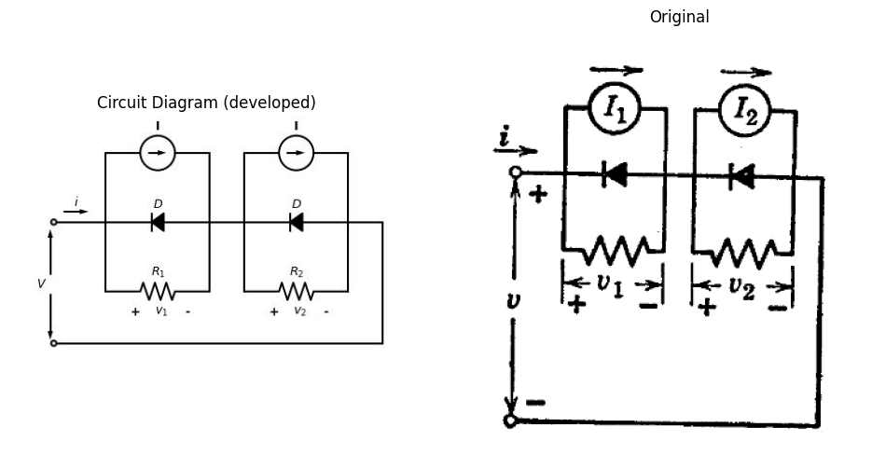
import matplotlib.pyplot as plt
from matplotlib import rcParams
import matplotlib.image as mpimg
import numpy as np
import PySpice.Logging.Logging as Logging
logger = Logging.setup_logging()
from PySpice.Probe.Plot import plot
from PySpice.Spice.Netlist import Circuit
from PySpice.Unit import *
rcParams['font.weight'] = 'bold'
#figure, ax1 = plt.subplots(figsize=(8, 8))
# Create the figure and subplots
fig, axs = plt.subplots(1, 2, figsize=(10, 10))
circuit = Circuit('Diode')
circuit.model('BAV21','D' ,IS = 40@u_uA , N = 1.906 ,BV = 110@u_V, IBV = 0.0001@u_V, VJ = 0.7@u_V ,CJO = 7.048E-13 ,RS = 0.01@u_Ohm ,TT = 3.48E-9)
Vth = circuit.V('th', '1', circuit.gnd, 0@u_V)
circuit.D(1, '2' ,'1', model = 'BAV21')
circuit.I(1, '1','2' , 20@u_mA)
circuit.R(1, '1','2' ,1000@u_Ohm)
circuit.D(2, '3' ,'2', model = 'BAV21')
circuit.I(2, '2','3' , 50@u_mA)
circuit.R(2, '2','3' , 2000@u_Ohm)
circuit.D(3, '3' ,'4', model = 'BAV21')
circuit.V(3, '5',circuit.gnd , 10@u_V)
circuit.R(3, '4','5' , 1800@u_Ohm)
circuit.D(4, '3' ,'6', model = 'BAV21')
circuit.V(4, '7',circuit.gnd , 20@u_V)
circuit.R(4, '6','7' , 1500@u_Ohm)
circuit.D(5, '3' ,'8', model = 'BAV21')
circuit.R(5, '8',circuit.gnd , 2000@u_Ohm)
circuit.D(6, '1' ,'9', model = 'BAV21')
circuit.V(6, '10',circuit.gnd , 50@u_V)
circuit.R(6, '9','10' , 1500@u_Ohm)
simulator = circuit.simulator(temperature=25, nominal_temperature=25)
analysis = simulator.dc(Vth=slice(-100, 100, 0.1))
axs[0].plot(analysis['1'],u_mA(-analysis.Vth), 'black', linewidth=2)
circuit = Circuit('Diode2')
circuit.model('BAV21','D' ,IS = 40@u_uA , N = 1.906 ,BV = 110@u_V, IBV = 0.0001@u_V, VJ = 0.7@u_V ,CJO = 7.048E-13 ,RS = 0.01@u_kOhm ,TT = 3.48E-9)
Vth = circuit.V('th', '1', circuit.gnd, 0@u_V)
circuit.D(1, '1' ,'2', model = 'BAV21')
circuit.V(1, '3',circuit.gnd , .8@u_V)
circuit.R(1, '2','3' ,1500@u_Ohm)
simulator = circuit.simulator(temperature=25, nominal_temperature=25)
analysis = simulator.dc(Vth=slice(0, 25, 0.1))
axs[0].plot(analysis['1'],u_mA(-analysis.Vth), 'black', linewidth=2,linestyle='--')
axs[0].plot(analysis['1'],u_mA(-analysis.Vth), 'black', linestyle='--',linewidth=2)
axs[0].set_title('V-I Curve for D')
axs[0].text(80, -6, '$E_5$', ha='center', va='center', fontsize=12)
axs[0].text(-3, 40, '$I_3$', ha='center', va='center', fontsize=12)
axs[0].text(-3, 60, '$I_4$', ha='center', va='center', fontsize=12)
axs[0].text(10, -6, '$E_1$', ha='center', va='center', fontsize=12)
axs[0].text(20, -6, '$E_2$', ha='center', va='center', fontsize=12)
axs[0].text(5, 8, '$R_o$', ha='center', va='center', fontsize=12)
axs[0].text(10, 15, '$R_a$', ha='center', va='center', fontsize=12)
axs[0].text(38, 35, '$R_b$', ha='center', va='center', fontsize=12)
axs[0].text(50, 55, '$R_c$', ha='center', va='center', fontsize=12)
axs[0].text(85, 65, '$R_d$', ha='center', va='center', fontsize=12)
axs[0].set_xlim(-60, 100)
axs[0].set_xlabel('V [V]')
axs[0].set_ylabel('I [mA]')
axs[0].set_ylim(-60, 100)
axs[0].axhline(0, color='black', linewidth=1)
axs[0].axvline(0, color='black', linewidth=1)
axs[0].annotate('', xy=(70,60), xytext=(0, 60), arrowprops=dict(arrowstyle='->'))
axs[0].annotate('', xy=(55,40), xytext=(0, 40), arrowprops=dict(arrowstyle='->'))
axs[0].annotate('', xy=(10,8), xytext=(10, 0), arrowprops=dict(arrowstyle='->'))
axs[0].annotate('', xy=(20,20), xytext=(20, 0), arrowprops=dict(arrowstyle='->'))
# **Subplot (1, 2): PNG Sample File**
img_sample = mpimg.imread('images-books/20h.png') # Load the PNG file
axs[1].imshow(img_sample)
axs[1].axis('off') # Hide axes for image display
axs[1].set_title('Original')
plt.tight_layout()
plt.show()
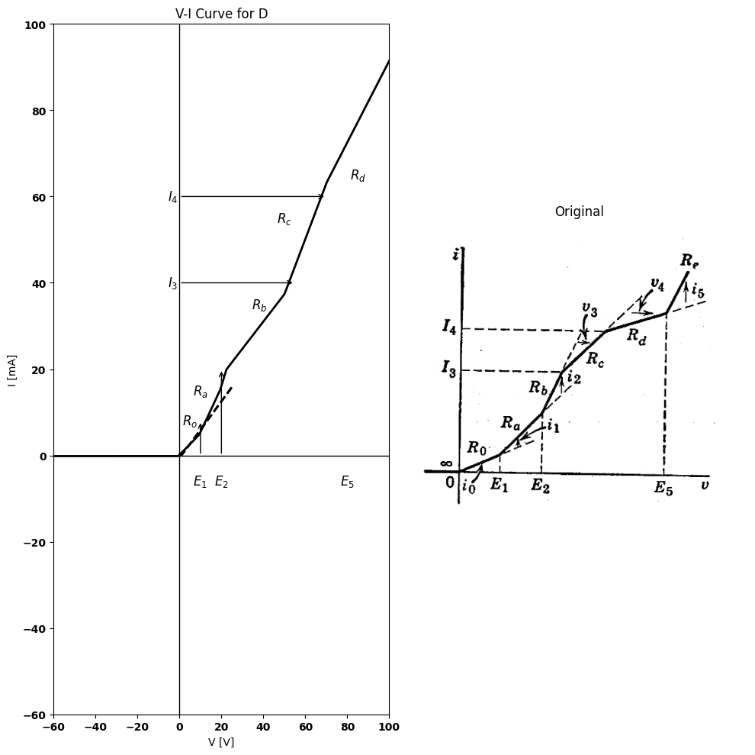
Fig. 3.20. piecewise-linear model for arbitrary nonlinear resstances.

10 3.9 Piecewise-Linear Model for Arbitrary Nonlinear Resistance
The basic ideas presented thus far can be extended to the representation of an arbitrary nonlinear resistance or conductance, provided we restrict ourselves to positive slopes or allow the use of negative resistance in the models.
The simple circuits shown in Fig. 3.20 $\left(a\right)$ and $\left(b\right)$ yield concave-up
and concave-down breaks, respectively, on a plot of current versus voltage. $A$ combination of such sections can be used for a succession of increasing or decreasing conductance segments, as shown in Fig. 3.20 $\left(c\right)$ and $\left(d\right)$.
Representation of an "arbitrary" curve is shown in Fig. 3.20 $\left(e\right)$. The procedure followed here simply amounts to grouping together. those segments that form concave-up regions of the curve. Similarly, concave-down regions are grouped together. Models of the successive "up" and "down" regions are then put together in series and parallel as required. The form of the resulting model is the familiar ladder network with "up" and "down" regions represented by shunt and series ladder network elements, respectively.
Suppose the sequence of segments in Fig. 3.20 $\left(e\right)$ represents the piece- wise-linear approximation to some general resistive curve $i=f\left(v\right)$. As $v$ increases from zero, the first segment of slope $G_{0}1/R_{0}$ is represented directly by the shunt branch on the right end of the model. The second segment has conductance $G_{a}$; hence conductance$ G_1 = G_a – G_0$ must be added in parallel, beginning at$ v = E_1.$ The same considerations apply to the next segment, where $G_{2}=G_{b}−G_{a}$ must be added, beginning at $v=E_{2}.$
At current $I3$, the slope decreases; hence series resistance must be added. It is apparent from the graph that $R_{c}>R_{b}$ ; hence $R_3 $ is positive. The relations between circuit elements and slopes on the graph are tabulated in Fig. 3.20$\left(e\right)$.
The sequence of diode operation for increasing v proceeds from right to left in the circuit model. Designating the diodes by the subscripts of the associated resistances, $D_0 $closes as $v$ goes from negative to positive values. $D_{1}$ closes for$ v = E_1 $,andD2closesfor$ v = E_2.$ Then, D3 opens when reaches the value corresponding to $i=I_{3}$ , and $D_{4}$ opens when$ i = I_4.$ Finally, $D_{5}$ closes when $v=E_{5}.$
A few pertinent comments are in order about the basic shunt and series elements used in this ladder-network development of the arbitrary $i=f\left(v\right)$ curve. The form of the shunt element shown in Fig. 3.20 $\left(a\right)$ is convenient because it places the voltage coordinate of the break point in evidence. Also, since currents are added for shunt elements, it is convenient to have the break point at $i=0$ so that no contribution of current from this element exists to the left of the break point. Similarly, the series element shown in $\left(b\right)$ of the same figure places the current coordinate of the break point in evidence, and contributes no voltage drop to the left of the break point.
The variations of the basic forms shown in Fig. 3.21 serve to emphasize the important point that reference directions for $v$ and $i$ are part of the
import ipywidgets as widgets
from ipywidgets import interact
import schemdraw
import schemdraw.elements as elm
@interact(Diode_Orientation=['Forward', 'Reverse'], Battery_Orientation=['Forward', 'Reverse']
,Diode_Orientation2=['Forward', 'Reverse'],SourceI_Orientation=['Forward', 'Reverse'])
def response(Diode_Orientation='Forward', Battery_Orientation='Forward',Diode_Orientation2='Forward',SourceI_Orientation='Forward'):
with schemdraw.Drawing() as d:
# First Circuit
d += elm.Line().right().length(0.5)
if Diode_Orientation == 'Forward':
d += elm.Diode(fill=True).down().label('$D$')
else:
d += elm.Diode(fill=True, reverse=True).down().label('$D$')
d += elm.Resistor().down().label('$R$', 'top')
d += elm.Battery().label('$E$', 'top').down()
d += elm.Line().left().length(0.5)
d += elm.Line().right().length(1.1).at((-2.1, 0.0)).color('gray').linestyle('--')
d += elm.Line().right().length(1.1).at((-2.1, -9.0)).color('gray').linestyle('--')
d += elm.Arrow().down().length(4.0).at((-1.9, -5.0)).color('black')
d += elm.Arrow().up().length(0.2).at((-2.2, -4.7)).color('white').label('$V$', loc='bottom', color='black')
d += elm.Arrow().up().length(4.0).at((-1.9, -4)).color('black')
#d += elm.Label('+').at((-2.1, -0.4)).color('red')
#d += elm.Label('_').at((-2.1, -8.8)).color('red')
d += elm.Arrow().down().length(0.7).at((0.2, -0.4)).color('black').label('$i$')
#d += elm.Label('(a,b)').at((-0.8, -9.8))
# Second Circuit
d += elm.Line().right().length(0.5).at((4,0))
d += elm.Diode(fill=True).down().label('$D$')
d += elm.Resistor().down().label('$R$', 'top')
if Battery_Orientation == 'Forward':
d += elm.Battery().down().label('$E$')
else:
d += elm.Battery(reverse=True).down().label('$E$')
d += elm.Line().left().length(0.5)
d += elm.Line().right().length(1.1).at((4-2.1, 0)).color('gray').linestyle('--')
d += elm.Line().right().length(1.1).at((4-2.1, -9)).color('gray').linestyle('--')
d += elm.Arrow().down().length(4.0).at((4-1.9, -5)).color('black')
d += elm.Arrow().up().length(0.2).at((1.6, -4.7)).color('white').label('$V$', loc='bottom', color='black')
d += elm.Arrow().up().length(4.0).at((4-1.9, -4)).color('black')
#d += elm.Label('+').at((4-2.1, -0.4)).color('red')
#d += elm.Label('_').at((4-2.1, -8.8)).color('red')
d += elm.Arrow().down().length(0.7).at((5-0.8, -0.4)).color('black').label('$i$')
#d += elm.Label('(c,d)').at((3.4, -9.8))
# Third Circuit
d += elm.Dot(open=True).at((10,-1))
d += elm.Line().down().length(1.2)
if Diode_Orientation2 == 'Forward':
d += elm.Diode(fill=True).down().label('$D$')
else:
d += elm.Diode(fill=True, reverse=True).down().label('$D$')
d += elm.Line().down().length(1.2).at((10,-5)).dot(open=True)
d += elm.Resistor().down().label('$R$','top').at((8,-2))
d += elm.Line().right().length(4)
d += elm.SourceI().up().label('I', 'top')
d += elm.Line().left().length(4)
d += elm.Line().right().length(2.4).at((6.7,-1.0)).color('gray').linestyle('--')
d += elm.Line().right().length(2.4).at((6.7,-6.2)).color('gray').linestyle('--')
d += elm.Arrow().down().length(2.0).at((6.9, -4.2)).color('black')
d += elm.Arrow().up().length(0.2).at((6.5, -3.7)).color('white').label('$V$', loc='bottom', color='black')
d += elm.Arrow().up().length(2.0).at((6.9, -3)).color('black')
d += elm.Arrow().down().length(0.7).at((9.7, -1.2)).color('black').label('$I$')
# Fourth Circuit
d += elm.Dot(open=True).at((17,-1))
d += elm.Line().down().length(1.2)
d += elm.Diode(fill=True).up().label('$D$').at((17,-5))
d += elm.Line().down().length(1.2).at((17,-5)).dot(open=True)
d += elm.Resistor().down().label('$R$','top').at((15,-2))
d += elm.Line().right().length(4)
if SourceI_Orientation == 'Forward':
d += elm.SourceI().up().label('$I$')
else:
d += elm.SourceI(reverse=True).up().label('$I$')
d += elm.Line().left().length(4)
d += elm.Line().right().length(2.4).at((13.7,-1.0)).color('black').linestyle('--')
d += elm.Line().right().length(2.4).at((13.7,-6.2)).color('black').linestyle('--')
d += elm.Arrow().down().length(2.0).at((13.9, -4.2)).color('black')
d += elm.Arrow().up().length(0.2).at((13.5, -3.7)).color('white').label('$V$', loc='bottom', color='black')
d += elm.Arrow().up().length(2.0).at((13.9, -3)).color('black')
d += elm.Arrow().down().length(0.7).at((16.7, -1.2)).color('black').label('$I$')
fig = plt.figure(figsize=(5, 3))
img = plt.imread('./images-books/3-21.png')
plt.imshow(img)
plt.axis('off')
plt.title('\nReference image from the book:', fontsize=8, pad=10,loc='left')
plt.show()
{"model_id":"a252a40142674dfda7dbd1bbb68b008f","version_major":2,"version_minor":0}
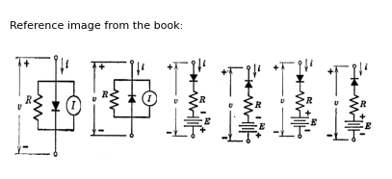
import matplotlib.pyplot as plt
from matplotlib import rcParams
import matplotlib.image as mpimg
import numpy as np
import PySpice.Logging.Logging as Logging
logger = Logging.setup_logging()
from PySpice.Probe.Plot import plot
from PySpice.Spice.Netlist import Circuit
from PySpice.Unit import *
rcParams['font.weight'] = 'bold'
fig, axs = plt.subplots(4, 2, figsize=(10, 10))
# Create subplots
circuit = Circuit('v-i curve')
circuit.model('BAV21','D' ,IS = 1000@u_nA , N = 1.906 ,BV = 110@u_V, IBV = 0.0001@u_V, VJ = 0.7@u_V ,CJO = 7.048E-13 ,RS = 0.01@u_kOhm ,TT = 3.48E-9)
Vth = circuit.V('th', '1', circuit.gnd, 0@u_V)
circuit.D(1, '1','2' , model = 'BAV21')
circuit.V(1, '3',circuit.gnd , 15@u_V)
circuit.R(1, '2','3' , 1@u_kOhm)
simulator = circuit.simulator(temperature=25, nominal_temperature=25)
analysis = simulator.dc(Vth=slice(-40, 100, 0.1))
axs[0,0].plot(analysis['1'],u_mA(-analysis.Vth), 'black', linewidth=2)
# circuit 2
circuit = Circuit('v-i curve')
circuit.model('BAV21','D' ,IS = 1000@u_nA , N = 1.906 ,BV = 110@u_V, IBV = 0.0001@u_V, VJ = 0.7@u_V ,CJO = 7.048E-13 ,RS = 0.01@u_kOhm ,TT = 3.48E-9)
Vth = circuit.V('th', '1', circuit.gnd, 0@u_V)
circuit.D(1, '2','1' , model = 'BAV21')
circuit.V(1, '3',circuit.gnd , 15@u_V)
circuit.R(1, '2','3' , 1@u_kOhm)
simulator = circuit.simulator(temperature=25, nominal_temperature=25)
analysis = simulator.dc(Vth=slice(-40, 100, 0.1))
axs[1,0].plot(analysis['1'],u_mA(-analysis.Vth), 'black', linewidth=2)
# circuit 3
circuit = Circuit('v-i curve')
circuit.model('BAV21','D' ,IS = 1000@u_nA , N = 1.906 ,BV = 110@u_V, IBV = 0.0001@u_V, VJ = 0.7@u_V ,CJO = 7.048E-13 ,RS = 0.01@u_kOhm ,TT = 3.48E-9)
Vth = circuit.V('th', '1', circuit.gnd, 0@u_V)
circuit.D(1, '1','2' , model = 'BAV21')
circuit.V(1,circuit.gnd ,'3', 15@u_V)
circuit.R(1, '2','3' , 1@u_kOhm)
simulator = circuit.simulator(temperature=25, nominal_temperature=25)
analysis = simulator.dc(Vth=slice(-40, 100, 0.1))
axs[2,0].plot(analysis['1'],u_mA(-analysis.Vth), 'black', linewidth=2)
# circuit4
circuit = Circuit('v-i curve')
circuit.model('BAV21','D' ,IS = 1000@u_nA , N = 1.906 ,BV = 110@u_V, IBV = 0.0001@u_V, VJ = 0.7@u_V ,CJO = 7.048E-13 ,RS = 0.01@u_kOhm ,TT = 3.48E-9)
Vth = circuit.V('th', '1', circuit.gnd, 0@u_V)
circuit.D(1, '2','1' , model = 'BAV21')
circuit.V(1,circuit.gnd ,'3', 15@u_V)
circuit.R(1, '2','3' , 1@u_kOhm)
simulator = circuit.simulator(temperature=25, nominal_temperature=25)
analysis = simulator.dc(Vth=slice(-100, 40, 0.1))
axs[3,0].plot(analysis['1'],u_mA(-analysis.Vth), 'black', linewidth=2)
axs[1,0].annotate('-E', xy=(15, 0), xytext=(0, 14),
textcoords='offset points', ha='center', color='black', fontsize=12, fontweight='medium')
axs[1,0].set_title('V-I Curve1')
axs[1,0].set_xlim(-40, 80)
axs[1,0].set_xlabel('I [A]')
axs[1,0].set_ylabel('V [V]')
axs[1,0].set_ylim(-100, 100)
axs[1,0].axhline(0, color='black', linewidth=1)
axs[1,0].axvline(0, color='black', linewidth=1)
axs[0,0].set_title('V-I Curve2')
axs[2,0].set_title('V-I Curve3')
axs[3,0].set_title('V-I Curve4')
axs[0,0].set_xlim(-40, 80)
axs[0,0].set_xlabel('I [A]')
axs[0,0].set_ylabel('V [V]')
axs[0,0].set_ylim(-100, 100)
axs[0,0].annotate('+E', xy=(15, 0), xytext=(0, 14),
textcoords='offset points', ha='center', color='black', fontsize=12, fontweight='medium')
axs[0,0].axhline(0, color='black', linewidth=1)
axs[0,0].axvline(0, color='black', linewidth=1)
axs[2,0].set_xlim(-40, 80)
axs[2,0].set_xlabel('i [A]')
axs[2,0].set_ylabel('v [V]')
axs[2,0].set_ylim(-100, 100)
axs[2,0].axhline(0, color='black', linewidth=1)
axs[2,0].axvline(0, color='black', linewidth=1)
axs[2,0].annotate('-E', xy=(-15, 0), xytext=(0, -14),
textcoords='offset points', ha='center', color='black', fontsize=12, fontweight='medium')
axs[3,0].set_xlim(-100, 40)
axs[3,0].set_xlabel('i [A]')
axs[3,0].set_ylabel('V [V]')
axs[3,0].set_ylim(-100, 100)
axs[3,0].axhline(0, color='black', linewidth=1)
axs[3,0].axvline(0, color='black', linewidth=1)
axs[3,0].annotate('-E', xy=(-15, 0), xytext=(0, -14),
textcoords='offset points', ha='center', color='black', fontsize=12, fontweight='medium')
img_sample = mpimg.imread('images-books/21a.png') # Load the PNG file
axs[0,1].imshow(img_sample)
axs[0,1].axis('off') # Hide axes for image display
axs[0,1].set_title('Original')
img_sample = mpimg.imread('images-books/21b.png') # Load the PNG file
axs[1,1].imshow(img_sample)
axs[1,1].axis('off') # Hide axes for image display
axs[1,1].set_title('Original')
img_sample = mpimg.imread('images-books/21c.png') # Load the PNG file
axs[2,1].imshow(img_sample)
axs[2,1].axis('off') # Hide axes for image display
axs[2,1].set_title('Original')
img_sample = mpimg.imread('images-books/21d.png') # Load the PNG file
axs[3,1].imshow(img_sample)
axs[3,1].axis('off') # Hide axes for image display
axs[3,1].set_title('Original')
plt.tight_layout()
plt.show()
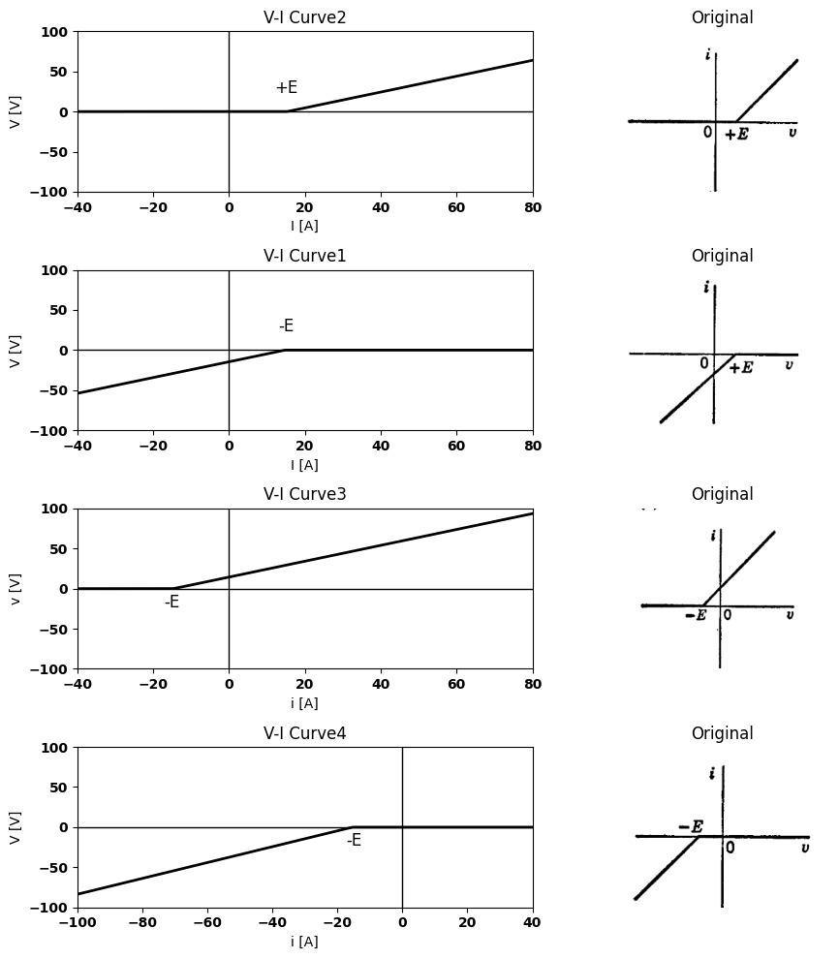
import ipywidgets as widgets
from ipywidgets import interact
import matplotlib.pyplot as plt
from matplotlib import rcParams
import PySpice.Logging.Logging as Logging
logger = Logging.setup_logging()
from PySpice.Probe.Plot import plot
from PySpice.Spice.Netlist import Circuit
from PySpice.Unit import *
rcParams['font.weight'] = 'bold'
figure = plt.figure(figsize=(15, 10))
#@interact(Mode1=(True) , Mode2=(True), Mode3=(True))
@interact(E=widgets.IntSlider(min=-20, max=20, step=5, value=20))
def response(E=20):
circuit = Circuit('Resistance and voltage')
circuit = Circuit('Diode')
circuit.model('BAV21','D' ,IS = 4@u_nA , N = 1.906 ,BV = 110@u_V, IBV = 0.0001@u_V, VJ = 0.7@u_V ,CJO = 7.048E-13 ,RS = 0.01@u_Ohm ,TT = 3.48E-9)
Vth = circuit.V('th', '1', circuit.gnd, 0@u_V)
circuit.D(1, '2','1' , model = 'BAV21')
circuit.V(1, '3',circuit.gnd , E@u_V)
circuit.R(1, '2','3' , 300@u_Ohm)
simulator = circuit.simulator(temperature=25, nominal_temperature=25)
analysis = simulator.dc(Vth=slice(-100, 100, 0.1))
# Plot for R1
plt.plot(analysis['1'],u_mA(-analysis.Vth), 'black', linewidth=2)
#plt.set_title('V-I Curve for D')
#plt.set_xlim(-60, 100)
#plt.set_xlabel('V [V]')
#plt.set_ylabel('I [mA]')
#plt.set_ylim(-60, 100)
plt.axhline(0, color='black', linewidth=1)
plt.axvline(0, color='black', linewidth=1)
plt.annotate('-E', xy=(-20, 0), xytext=(12, -14),
textcoords='offset points', ha='center', color='black', fontsize=12, fontweight='medium')
plt.text(50, 60, '$r$', ha='center', va='center', fontsize=12)
plt.plot([20, 20], [-4, 4], color='black', linewidth=1)
plt.text(-70, -40, '$R_1$', ha='center', va='center', fontsize=12)
plt.tight_layout()
plt.show()
<Figure size 1500x1000 with 0 Axes>
{"model_id":"8ba246f72c1544f8b51a79d331bf67d6","version_major":2,"version_minor":0}
import ipywidgets as widgets
from ipywidgets import interact
import matplotlib.pyplot as plt
from matplotlib import rcParams
import PySpice.Logging.Logging as Logging
logger = Logging.setup_logging()
from PySpice.Probe.Plot import plot
from PySpice.Spice.Netlist import Circuit
from PySpice.Unit import *
rcParams['font.weight'] = 'bold'
figure = plt.figure(figsize=(15, 10))
#@interact(Mode1=(True) , Mode2=(True), Mode3=(True))
@interact(E=widgets.IntSlider(min=-20, max=20, step=5, value=20))
def response(E=20):
circuit = Circuit('Resistance and voltage')
circuit = Circuit('Diode')
circuit.model('BAV21','D' ,IS = 4@u_nA , N = 1.906 ,BV = 110@u_V, IBV = 0.0001@u_V, VJ = 0.7@u_V ,CJO = 7.048E-13 ,RS = 0.01@u_Ohm ,TT = 3.48E-9)
Vth = circuit.V('th', '1', circuit.gnd, 0@u_V)
circuit.D(1, '1','2' , model = 'BAV21')
circuit.V(1, '3',circuit.gnd , E@u_V)
circuit.R(1, '2','3' , 300@u_Ohm)
simulator = circuit.simulator(temperature=25, nominal_temperature=25)
analysis = simulator.dc(Vth=slice(-100, 100, 0.1))
# Plot for R1
plt.plot(analysis['1'],u_mA(-analysis.Vth), 'black', linewidth=2)
#plt.set_title('V-I Curve for D')
#plt.set_xlim(-60, 100)
#plt.set_xlabel('V [V]')
#plt.set_ylabel('I [mA]')
#plt.set_ylim(-60, 100)
plt.axhline(0, color='black', linewidth=1)
plt.axvline(0, color='black', linewidth=1)
plt.annotate('-E', xy=(-20, 0), xytext=(12, -14),
textcoords='offset points', ha='center', color='black', fontsize=12, fontweight='medium')
plt.text(50, 60, '$r$', ha='center', va='center', fontsize=12)
plt.plot([20, 20], [-4, 4], color='black', linewidth=1)
plt.text(-70, -40, '$R_1$', ha='center', va='center', fontsize=12)
plt.tight_layout()
plt.show()
<Figure size 1500x1000 with 0 Axes>
{"model_id":"499e444b8d9c4327931e51363a3fe265","version_major":2,"version_minor":0}
import matplotlib.pyplot as plt
from matplotlib import rcParams
import matplotlib.image as mpimg
import numpy as np
import PySpice.Logging.Logging as Logging
logger = Logging.setup_logging()
from PySpice.Probe.Plot import plot
from PySpice.Spice.Netlist import Circuit
from PySpice.Unit import *
rcParams['font.weight'] = 'bold'
fig, axs = plt.subplots(4, 2, figsize=(10, 10))
# Create subplots
circuit = Circuit('v-i curve')
circuit.model('BAV21','D' ,IS = 1000@u_nA , N = 1.906 ,BV = 110@u_V, IBV = 0.0001@u_V, VJ = 0.7@u_V ,CJO = 7.048E-13 ,RS = 0.0001@u_kOhm ,TT = 3.48E-9)
Vth = circuit.V('th', '1', circuit.gnd, 0@u_V)
circuit.D(1, '1',circuit.gnd , model = 'BAV21')
circuit.I(1,circuit.gnd ,'1', 10@u_mA)
circuit.R(1, '1',circuit.gnd , 1@u_kOhm)
simulator = circuit.simulator(temperature=25, nominal_temperature=25)
analysis = simulator.dc(Vth=slice(-40, 100, 0.1))
axs[0,0].plot(analysis['1'],u_mA(-analysis.Vth), 'black', linewidth=2)
# circuit 2
circuit = Circuit('v-i curve')
circuit.model('BAV21','D' ,IS = 1000@u_nA , N = 1.906 ,BV = 110@u_V, IBV = 0.0001@u_V, VJ = 0.7@u_V ,CJO = 7.048E-13 ,RS = 0.0001@u_kOhm ,TT = 3.48E-9)
Vth = circuit.V('th', '1', circuit.gnd, 0@u_V)
circuit.D(1, circuit.gnd,'1' , model = 'BAV21')
circuit.I(1,circuit.gnd ,'1', 20@u_mA)
circuit.R(1, '1',circuit.gnd , 1@u_kOhm)
simulator = circuit.simulator(temperature=25, nominal_temperature=25)
analysis = simulator.dc(Vth=slice(-40, 100, 0.1))
axs[1,0].plot(analysis['1'],u_mA(-analysis.Vth), 'black', linewidth=2)
# circuit 3
circuit = Circuit('v-i curve')
circuit.model('BAV21','D' ,IS = 1000@u_nA , N = 1.906 ,BV = 110@u_V, IBV = 0.0001@u_V, VJ = 0.7@u_V ,CJO = 7.048E-13 ,RS = 0.0001@u_kOhm ,TT = 3.48E-9)
Vth = circuit.V('th', '1', circuit.gnd, 0@u_V)
circuit.D(1, '1',circuit.gnd , model = 'BAV21')
circuit.I(1,'1',circuit.gnd , 20@u_mA)
circuit.R(1, '1',circuit.gnd , 1@u_kOhm)
simulator = circuit.simulator(temperature=25, nominal_temperature=25)
analysis = simulator.dc(Vth=slice(-40, 100, 0.1))
axs[2,0].plot(analysis['1'],u_mA(-analysis.Vth), 'black', linewidth=2)
# circuit4
circuit = Circuit('v-i curve')
circuit.model('BAV21','D' ,IS = 30@u_mA , N = 1.906 ,BV = 110@u_V, IBV = 0.0001@u_V, VJ = 0.7@u_V ,CJO = 7.048E-13 ,RS = 0.0001@u_kOhm ,TT = 3.48E-9)
Vth = circuit.V('th', '1', circuit.gnd, 0@u_V)
circuit.D(1, circuit.gnd ,'1', model = 'BAV21')
circuit.I(1,'1',circuit.gnd , 10@u_mA)
circuit.R(1, '1',circuit.gnd , 1@u_kOhm)
simulator = circuit.simulator(temperature=25, nominal_temperature=25)
analysis = simulator.dc(Vth=slice(-100, 100, 0.1))
axs[3,0].plot(analysis['1'],u_mA(-analysis.Vth), 'black', linewidth=2)
axs[1,0].annotate('-I', xy=(-3, 0), xytext=(0, -25),
textcoords='offset points', ha='center', color='black', fontsize=12, fontweight='medium')
axs[1,0].set_title('V-I Curve1')
axs[1,0].set_xlim(-40, 80)
axs[1,0].set_xlabel('I [A]')
axs[1,0].set_ylabel('V [V]')
axs[1,0].set_ylim(-100, 100)
axs[1,0].axhline(0, color='black', linewidth=1)
axs[1,0].axvline(0, color='black', linewidth=1)
axs[0,0].set_title('V-I Curve2')
axs[2,0].set_title('V-I Curve3')
axs[3,0].set_title('V-I Curve4')
axs[0,0].set_xlim(-40, 80)
axs[0,0].set_xlabel('I [A]')
axs[0,0].set_ylabel('V [V]')
axs[0,0].set_ylim(-100, 100)
axs[0,0].annotate('+I', xy=(3, 0), xytext=(0, -14),
textcoords='offset points', ha='center', color='black', fontsize=12, fontweight='medium')
axs[0,0].axhline(0, color='black', linewidth=1)
axs[0,0].axvline(0, color='black', linewidth=1)
axs[2,0].set_xlim(-40, 80)
axs[2,0].set_xlabel('i [A]')
axs[2,0].set_ylabel('v [V]')
axs[2,0].set_ylim(-100, 100)
axs[2,0].axhline(0, color='black', linewidth=1)
axs[2,0].axvline(0, color='black', linewidth=1)
axs[2,0].annotate('+I', xy=(3, 0), xytext=(0, 25),
textcoords='offset points', ha='center', color='black', fontsize=12, fontweight='medium')
axs[3,0].set_xlim(-40, 100)
axs[3,0].set_xlabel('i [A]')
axs[3,0].set_ylabel('V [V]')
axs[3,0].set_ylim(-100, 100)
axs[3,0].axhline(0, color='black', linewidth=1)
axs[3,0].axvline(0, color='black', linewidth=1)
axs[3,0].annotate('+I', xy=(-3, 0), xytext=(0, 40),
textcoords='offset points', ha='center', color='black', fontsize=12, fontweight='medium')
img_sample = mpimg.imread('images-books/21e.png') # Load the PNG file
axs[0,1].imshow(img_sample)
axs[0,1].axis('off') # Hide axes for image display
axs[0,1].set_title('Original')
img_sample = mpimg.imread('images-books/21f.png') # Load the PNG file
axs[1,1].imshow(img_sample)
axs[1,1].axis('off') # Hide axes for image display
axs[1,1].set_title('Original')
img_sample = mpimg.imread('images-books/21g.png') # Load the PNG file
axs[2,1].imshow(img_sample)
axs[2,1].axis('off') # Hide axes for image display
axs[2,1].set_title('Original')
img_sample = mpimg.imread('images-books/21h.png') # Load the PNG file
axs[3,1].imshow(img_sample)
axs[3,1].axis('off') # Hide axes for image display
axs[3,1].set_title('Original')
plt.tight_layout()
plt.show()
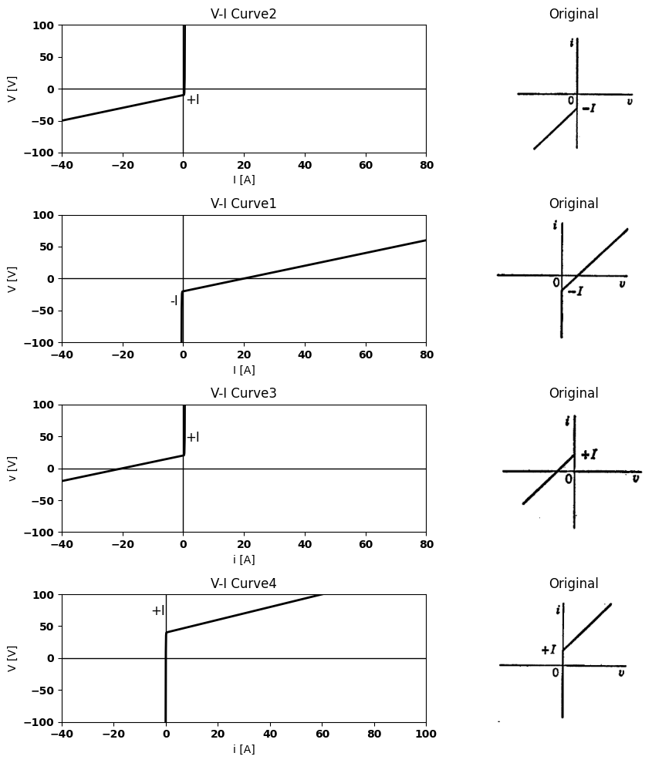
Fig. 3.21. Variations of basic resistive diode circuit forms.
circuit model.The series $E$ and $r$ forms shown in $\left(a\right)$, $\left(b\right)$, $\left(c\right)$, and $\left(d\right)$ yield a break point on the $i=0$ axis. The shunt $I$ and $r$ forms shown in $\left(e\right)$, $\left(f\right)$, $\left(g\right)$, and $\left(h\right)$ yield a break point on the $v=0$ axis. The position of the nonzero coordinate of the break point in each case depends only on the magnitude and polarization of $E$ or $I$. The fact that the break joins two segments that are concave up or concave down depends only on the direction in which the diode is oriented relative to the assigned reference directions.
Circuits of the basic forms can be combined to yield a break point with both $v$ and $i$ nonzero. Examples of such forms are shown in Fig. 3.22. In the circuits shown in $\left(a\right)$ through $\left(f\right)$, the sources are
import schemdraw
import schemdraw.elements as e
import schemdraw as schem
import matplotlib.pyplot as plt
import matplotlib.image as mpimg
import numpy as np
# Create the figure and subplots
fig, axs = plt.subplots(2, 2, figsize=(12, 12))
d = schemdraw.Drawing()
l1 = d.add(e.Line().up().length(0.5).dot(open=True))
d.push()
l2 = d.add(e.Line().down().length(0.5).dot())
D1 = d.add(e.Diode(fill=True).down().at(l1.start))
E1 = d.add(e.Battery().down().label(['+', '$E$', '-'], ofst=-1.3).dot(open=True))
d += e.Line().right().length(2).at(l1.start)
I = d.add(e.SourceI().down().label('$I$'))
d += e.Line().left().length(2).dot()
d.pop()
d += e.Arrow().up().linewidth(0.6).length(4).linewidth(0.6).linewidth(0.6).color('white').label('$V$', loc='start', color='black',ofst=0.3). at((-0.4,-2.5))
d += e.Arrow().down().length(0.7).linewidth(0.6).color('black').label('i', loc='top', color='black',ofst=-0.3). at((0.3,1))
d += e.Arrow().up().length(2.5).linewidth(0.6).color('black').label('+',loc='end', color='black',ofst=0.4). at((-0.7,-2))
d += e.Line().left().length(0.8).linewidth(0.6).at(l1.end).color('gray')
d += e.Arrow().down().length(2.5).linewidth(0.6).color('black').label(r'_', loc='end', color='black',ofst=(-0.5, -0.3)). at((-0.7,-3.5))
d += e.Line().left().length(0.8).linewidth(0.6).at(E1.end).color('gray')
d.save('./Drawings/fig22a.jpg')
d.save('./Drawings/fig22a.svg')
# Load the saved PNG file into the subplot
img = mpimg.imread('./Drawings/fig22a.jpg')
axs[0,0].imshow(img)
axs[0,0].axis('off') # Hide axes for image display
axs[0,0].set_title('Circuit Diagram (developed)')
# **Subplot (1, 2): PNG Sample File**
img_sample = mpimg.imread('images-books/22a.png') # Load the PNG file
axs[0,1].imshow(img_sample)
axs[0,1].axis('off') # Hide axes for image display
axs[0,1].set_title('Original')
#
circuit = Circuit('Diode')
circuit.model('BAV21','D' ,IS = 4@u_nA , N = 1.906 ,BV = 110@u_V, IBV = 0.0001@u_V, VJ = 0.7@u_V ,CJO = 7.048E-13 ,RS = 0.01@u_Ohm ,TT = 3.48E-9)
Vth = circuit.V('th', '1', circuit.gnd, 0@u_V)
circuit.D(1, '1','2' , model = 'BAV21')
circuit.V(1, '2',circuit.gnd , 10@u_V)
circuit.I(1, '1','2' , 10@u_mA)
simulator = circuit.simulator(temperature=25, nominal_temperature=25)
analysis = simulator.dc(Vth=slice(-100, 100, 0.1))
# Plot for R1
axs[1,0].plot(analysis['1'],u_mA(-analysis.Vth), 'black', linewidth=2)
axs[1,0].set_title('V-I Curve for D')
axs[1,0].set_xlim(-100, 100)
axs[1,0].set_xlabel('V [V]')
axs[1,0].set_ylabel('I [mA]')
axs[1,0].set_ylim(-100, 100)
axs[1,0].axhline(0, color='black', linewidth=1)
axs[1,0].axvline(0, color='black', linewidth=1)
axs[1,0].annotate('+I', xy=(0, 0), xytext=(-12, 20),
textcoords='offset points', ha='center', color='black', fontsize=12, fontweight='medium')
axs[1,0].annotate('+E', xy=(10, 0), xytext=(0, -14),
textcoords='offset points', ha='center', color='black', fontsize=12, fontweight='medium')
axs[1,0].plot([10, 10], [-2, 2], color='black', linewidth=1)
img_sample = mpimg.imread('images-books/22a1.png') # Load the PNG file
axs[1,1].imshow(img_sample)
axs[1,1].axis('off') # Hide axes for image display
axs[1,1].set_title('Original')
plt.tight_layout()
plt.show()
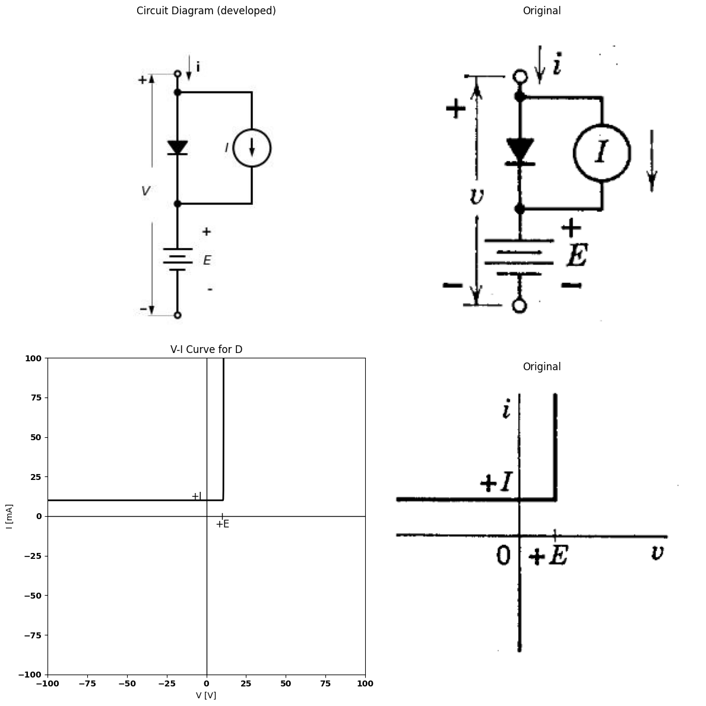
import schemdraw
import schemdraw.elements as e
import schemdraw as schem
import matplotlib.pyplot as plt
import matplotlib.image as mpimg
import numpy as np
# Create the figure and subplots
fig, axs = plt.subplots(2, 2, figsize=(12, 12))
d = schemdraw.Drawing()
l1 = d.add(e.Line().up().length(0.5).dot(open=True))
d.push()
l2 = d.add(e.Line().down().length(0.5).dot())
D1 = d.add(e.Diode(fill=True).down().reverse().at(l1.start))
E1 = d.add(e.Battery().down().label(['+', '$E$', '-'], ofst=-1.3).dot(open=True))
d += e.Line().right().length(2).at(l1.start)
I = d.add(e.SourceI().down().label('$I$'))
d += e.Line().left().length(2).dot()
d.pop()
d += e.Arrow().up().linewidth(0.6).length(4).linewidth(0.6).linewidth(0.6).color('white').label('$V$', loc='start', color='black',ofst=0.3). at((-0.4,-2.5))
d += e.Arrow().down().length(0.7).linewidth(0.6).color('black').label('i', loc='top', color='black',ofst=-0.3). at((0.3,1))
d += e.Arrow().up().length(2.5).linewidth(0.6).color('black').label('+',loc='end', color='black',ofst=0.4). at((-0.7,-2))
d += e.Line().left().length(0.8).linewidth(0.6).at(l1.end).color('gray')
d += e.Arrow().down().length(2.5).linewidth(0.6).color('black').label(r'_', loc='end', color='black',ofst=(-0.5, -0.3)). at((-0.7,-3.5))
d += e.Line().left().length(0.8).linewidth(0.6).at(E1.end).color('gray')
d.save('./Drawings/fig22b.jpg')
d.save('./Drawings/fig22b.svg')
# Load the saved PNG file into the subplot
img = mpimg.imread('./Drawings/fig22b.jpg')
axs[0,0].imshow(img)
axs[0,0].axis('off') # Hide axes for image display
axs[0,0].set_title('Circuit Diagram (developed)')
# **Subplot (1, 2): PNG Sample File**
img_sample = mpimg.imread('images-books/22b.png') # Load the PNG file
axs[0,1].imshow(img_sample)
axs[0,1].axis('off') # Hide axes for image display
axs[0,1].set_title('Original')
#
circuit = Circuit('Diode')
circuit.model('BAV21','D' ,IS = 4@u_nA , N = 1.906 ,BV = 110@u_V, IBV = 0.0001@u_V, VJ = 0.7@u_V ,CJO = 7.048E-13 ,RS = 0.01@u_Ohm ,TT = 3.48E-9)
Vth = circuit.V('th', '1', circuit.gnd, 0@u_V)
circuit.D(1, '2','1' , model = 'BAV21')
circuit.V(1, '2',circuit.gnd , 10@u_V)
circuit.I(1, '1','2' , 10@u_mA)
simulator = circuit.simulator(temperature=25, nominal_temperature=25)
analysis = simulator.dc(Vth=slice(-100, 100, 0.1))
# Plot for R1
axs[1,0].plot(analysis['1'],u_mA(-analysis.Vth), 'black', linewidth=2)
axs[1,0].set_title('V-I Curve for D')
axs[1,0].set_xlim(-100, 100)
axs[1,0].set_xlabel('V [V]')
axs[1,0].set_ylabel('I [mA]')
axs[1,0].set_ylim(-100, 100)
axs[1,0].axhline(0, color='black', linewidth=1)
axs[1,0].axvline(0, color='black', linewidth=1)
axs[1,0].annotate('+I', xy=(0, 0), xytext=(-12, 10),
textcoords='offset points', ha='center', color='black', fontsize=12, fontweight='medium')
axs[1,0].annotate('+E', xy=(10, 0), xytext=(12, -14),
textcoords='offset points', ha='center', color='black', fontsize=12, fontweight='medium')
axs[1,0].plot([-2, 2], [10, 10], color='black', linewidth=1)
img_sample = mpimg.imread('images-books/22b1.png') # Load the PNG file
axs[1,1].imshow(img_sample)
axs[1,1].axis('off') # Hide axes for image display
axs[1,1].set_title('Original')
plt.tight_layout()
plt.show()
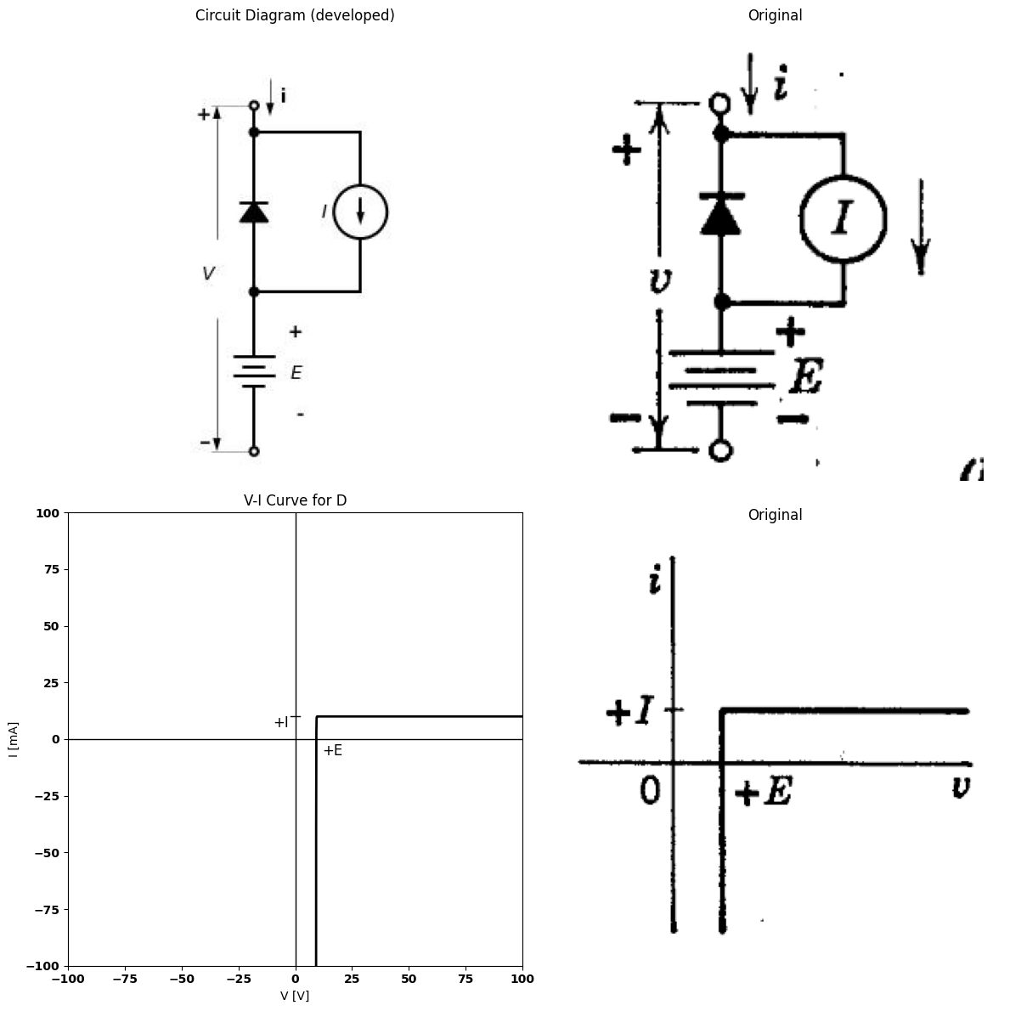
import schemdraw
import schemdraw.elements as e
import schemdraw as schem
import matplotlib.pyplot as plt
import matplotlib.image as mpimg
import numpy as np
# Create the figure and subplots
fig, axs = plt.subplots(2, 2, figsize=(12, 12))
d = schemdraw.Drawing()
l1 = d.add(e.Line().up().length(0.5).dot(open=True))
d.push()
l2 = d.add(e.Line().down().length(0.5).dot())
D1 = d.add(e.Diode(fill=True).down().at(l1.start))
E1 = d.add(e.Battery().down().label(['+', '$E$', '-'], ofst=-1.3).dot(open=True))
d += e.Line().right().length(2).dot().at(l1.start)
I = d.add(e.SourceI().down().label('$I$').dot())
d += e.Line().left().length(2).dot()
d.pop()
d += e.Arrow().down().length(0.7).linewidth(0.6).color('black').label('i', loc='top', color='black',ofst=-0.3). at((0.3,1))
d += e.Arrow().up().length(4).linewidth(0.6).color('white').label('$V$', loc='start', color='black',ofst=0.3). at((-0.4,-2.5))
d += e.Arrow().up().length(2.5).linewidth(0.6).color('black').label('+',loc='end', color='black',ofst=0.4). at((-0.7,-2))
d += e.Line().left().length(0.8).linewidth(0.6).at(l1.end).color('gray')
d += e.Arrow().down().length(2.5).linewidth(0.6).color('black').label(r'_', loc='end', color='black',ofst=(-0.5, -0.3)). at((-0.7,-3.5))
d += e.Line().left().length(0.8).linewidth(0.6).at(E1.end).color('gray')
d += e.Line().right().length(2).at(I.start)
d += e.Line().right().length(2).at(I.end)
R1 = d.add(e.Resistor().up().label('$R_1$',ofst=-1))
d.save('./Drawings/fig22c.jpg')
d.save('./Drawings/fig22c.svg')
# Load the saved PNG file into the subplot
img = mpimg.imread('./Drawings/fig22c.jpg')
axs[0,0].imshow(img)
axs[0,0].axis('off') # Hide axes for image display
axs[0,0].set_title('Circuit Diagram (developed)')
# **Subplot (1, 2): PNG Sample File**
img_sample = mpimg.imread('images-books/22c.png') # Load the PNG file
axs[0,1].imshow(img_sample)
axs[0,1].axis('off') # Hide axes for image display
axs[0,1].set_title('Original')
#
circuit = Circuit('Diode')
circuit.model('BAV21','D' ,IS = 4@u_nA , N = 1.906 ,BV = 110@u_V, IBV = 0.0001@u_V, VJ = 0.7@u_V ,CJO = 7.048E-13 ,RS = 0.01@u_Ohm ,TT = 3.48E-9)
Vth = circuit.V('th', '1', circuit.gnd, 0@u_V)
circuit.D(1, '1','2' , model = 'BAV21')
circuit.V(1, '2',circuit.gnd , 10@u_V)
circuit.I(1, '1','2' , 10@u_mA)
circuit.R(1, '1','2' , 2000@u_Ohm)
simulator = circuit.simulator(temperature=25, nominal_temperature=25)
analysis = simulator.dc(Vth=slice(-100, 100, 0.1))
# Plot for R1
axs[1,0].plot(analysis['1'],u_mA(-analysis.Vth), 'black', linewidth=2)
axs[1,0].set_title('V-I Curve for D')
axs[1,0].set_xlim(-100, 100)
axs[1,0].set_xlabel('V [V]')
axs[1,0].set_ylabel('I [mA]')
axs[1,0].set_ylim(-100, 100)
axs[1,0].axhline(0, color='black', linewidth=1)
axs[1,0].axvline(0, color='black', linewidth=1)
axs[1,0].annotate('+I', xy=(0, 0), xytext=(-12, 10),
textcoords='offset points', ha='center', color='black', fontsize=12, fontweight='medium')
axs[1,0].annotate('+E', xy=(10, 0), xytext=(12, -14),
textcoords='offset points', ha='center', color='black', fontsize=12, fontweight='medium')
axs[1,0].plot([-2, 2], [10, 10], color='black', linewidth=1)
axs[1,0].plot([10, 10], [-2, 2], color='black', linewidth=1)
axs[1,0].text(-70, -40, '$R_1$', ha='center', va='center', fontsize=12)
img_sample = mpimg.imread('images-books/22c1.png') # Load the PNG file
axs[1,1].imshow(img_sample)
axs[1,1].axis('off') # Hide axes for image display
axs[1,1].set_title('Original')
plt.tight_layout()
plt.show()
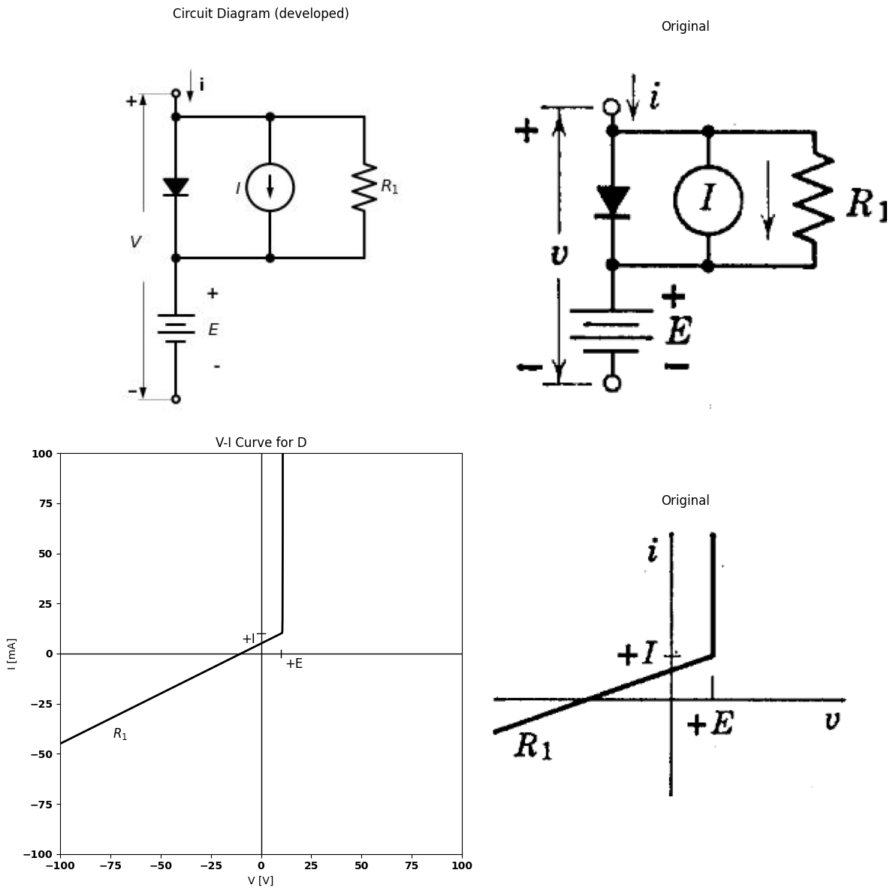
import schemdraw
import schemdraw.elements as e
import schemdraw as schem
import matplotlib.pyplot as plt
import matplotlib.image as mpimg
import numpy as np
# Create the figure and subplots
fig, axs = plt.subplots(2, 2, figsize=(12, 12))
d = schemdraw.Drawing()
l1 = d.add(e.Line().up().length(0.5).dot(open=True))
d.push()
l2 = d.add(e.Line().down().length(0.5).dot())
D1 = d.add(e.Diode(fill=True).down().reverse().at(l1.start))
E1 = d.add(e.Battery().down().label(['+', '$E$', '-'], ofst=-1.3).dot(open=True))
d += e.Line().right().length(2).dot().at(l1.start)
I = d.add(e.SourceI().down().label('$I$').dot())
d += e.Line().left().length(2).dot()
d.pop()
d += e.Arrow().down().length(0.7).linewidth(0.6).color('black').label('i', loc='top', color='black',ofst=-0.3). at((0.3,1))
d += e.Arrow().up().length(4).linewidth(0.6).color('white').label('$V$', loc='start', color='black',ofst=0.3). at((-0.4,-2.5))
d += e.Arrow().up().length(2.5).linewidth(0.6).color('black').label('+',loc='end', color='black',ofst=0.4). at((-0.7,-2))
d += e.Line().left().length(0.8).linewidth(0.6).at(l1.end).color('gray')
d += e.Arrow().down().length(2.5).linewidth(0.6).color('black').label(r'_', loc='end', color='black',ofst=(-0.5, -0.3)). at((-0.7,-3.5))
d += e.Line().left().length(0.8).linewidth(0.6).at(E1.end).color('gray')
d += e.Line().right().length(2).at(I.start)
d += e.Line().right().length(2).at(I.end)
R1 = d.add(e.Resistor().up().label('$R_1$',ofst=-1))
d.save('./Drawings/fig22d.jpg')
d.save('./Drawings/fig22d.svg')
# Load the saved PNG file into the subplot
img = mpimg.imread('./Drawings/fig22d.jpg')
axs[0,0].imshow(img)
axs[0,0].axis('off') # Hide axes for image display
axs[0,0].set_title('Circuit Diagram (developed)')
# **Subplot (1, 2): PNG Sample File**
img_sample = mpimg.imread('images-books/22d.png') # Load the PNG file
axs[0,1].imshow(img_sample)
axs[0,1].axis('off') # Hide axes for image display
axs[0,1].set_title('Original')
#
circuit = Circuit('Diode')
circuit.model('BAV21','D' ,IS = 4@u_nA , N = 1.906 ,BV = 110@u_V, IBV = 0.0001@u_V, VJ = 0.7@u_V ,CJO = 7.048E-13 ,RS = 0.01@u_Ohm ,TT = 3.48E-9)
Vth = circuit.V('th', '1', circuit.gnd, 0@u_V)
circuit.D(1, '2','1' , model = 'BAV21')
circuit.V(1, '2',circuit.gnd , 10@u_V)
circuit.I(1, '1','2' , 10@u_mA)
circuit.R(1, '1','2' , 2000@u_Ohm)
simulator = circuit.simulator(temperature=25, nominal_temperature=25)
analysis = simulator.dc(Vth=slice(-100, 100, 0.1))
# Plot for R1
axs[1,0].plot(analysis['1'],u_mA(-analysis.Vth), 'black', linewidth=2)
axs[1,0].set_title('V-I Curve for D')
axs[1,0].set_xlim(-100, 100)
axs[1,0].set_xlabel('V [V]')
axs[1,0].set_ylabel('I [mA]')
axs[1,0].set_ylim(-100, 100)
axs[1,0].axhline(0, color='black', linewidth=1)
axs[1,0].axvline(0, color='black', linewidth=1)
axs[1,0].annotate('+I', xy=(0, 0), xytext=(-12, 10),
textcoords='offset points', ha='center', color='black', fontsize=12, fontweight='medium')
axs[1,0].annotate('+E', xy=(10, 0), xytext=(12, -14),
textcoords='offset points', ha='center', color='black', fontsize=12, fontweight='medium')
axs[1,0].plot([-2, 2], [10, 10], color='black', linewidth=1)
axs[1,0].text(70, 50, '$R_1$', ha='center', va='center', fontsize=12)
img_sample = mpimg.imread('images-books/22d1.png') # Load the PNG file
axs[1,1].imshow(img_sample)
axs[1,1].axis('off') # Hide axes for image display
axs[1,1].set_title('Original')
plt.tight_layout()
plt.show()
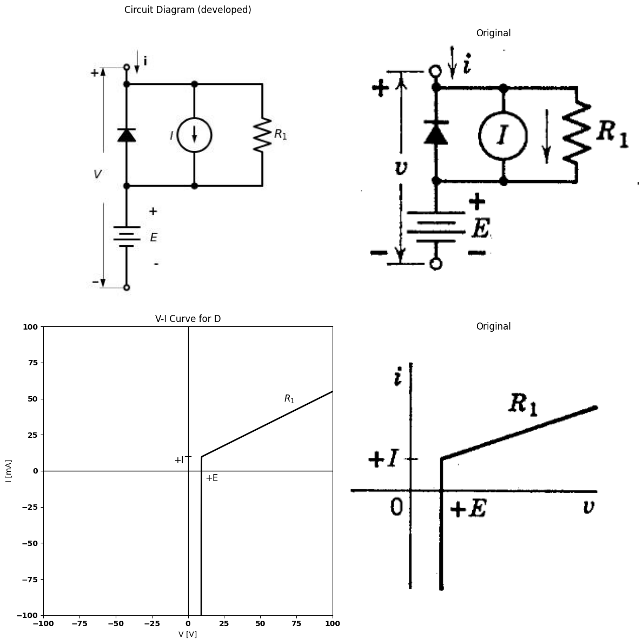
import schemdraw
import schemdraw.elements as e
import schemdraw as schem
import matplotlib.pyplot as plt
import matplotlib.image as mpimg
import numpy as np
# Create the figure and subplots
fig, axs = plt.subplots(2, 2, figsize=(12, 12))
d = schemdraw.Drawing()
l1 = d.add(e.Line().up().length(0.5).dot(open=True))
d.push()
l2 = d.add(e.Line().down().length(0.5).dot())
D1 = d.add(e.Diode(fill=True).down().at(l1.start))
R2 = d.add(e.Resistor().down().length(2).label('$R_2$',ofst=-1))
E1 = d.add(e.Battery().down().length(2).label(['+', '$E$', '-'], ofst=-1.3).dot(open=True))
d += e.Line().right().length(2).dot().at(l1.start)
I = d.add(e.SourceI().down().label('$I$').dot())
d += e.Line().left().length(2).dot()
d.pop()
d += e.Arrow().down().length(0.7).linewidth(0.6).color('black').label('i', loc='top', color='black',ofst=-0.3). at((0.3,1))
d += e.Arrow().up().length(4.5).linewidth(0.6).color('white').label('$V$', loc='start', color='black',ofst=0.3). at((-0.4,-3))
d += e.Arrow().up().length(3).linewidth(0.6).color('black').label('+',loc='end', color='black',ofst=0.4). at((-0.7,-2.5))
d += e.Line().left().length(0.8).linewidth(0.6).at(l1.end).color('gray')
d += e.Arrow().down().length(3).linewidth(0.6).color('black').label(r'_', loc='end', color='black',ofst=(-0.5, -0.3)). at((-0.7,-4))
d += e.Line().left().length(0.8).linewidth(0.6).at(E1.end).color('gray')
d += e.Line().right().length(2).at(I.start)
d += e.Line().right().length(2).at(I.end)
R1 = d.add(e.Resistor().up().label('$R_1$',ofst=-1))
d.save('./Drawings/fig22e.jpg')
d.save('./Drawings/fig22e.svg')
# Load the saved PNG file into the subplot
img = mpimg.imread('./Drawings/fig22e.jpg')
axs[0,0].imshow(img)
axs[0,0].axis('off') # Hide axes for image display
axs[0,0].set_title('Circuit Diagram (developed)')
# **Subplot (1, 2): PNG Sample File**
img_sample = mpimg.imread('images-books/22e.png') # Load the PNG file
axs[0,1].imshow(img_sample)
axs[0,1].axis('off') # Hide axes for image display
axs[0,1].set_title('Original')
#
circuit = Circuit('Diode')
circuit.model('BAV21','D' ,IS = 4@u_nA , N = 1.906 ,BV = 110@u_V, IBV = 0.0001@u_V, VJ = 0.7@u_V ,CJO = 7.048E-13 ,RS = 0.01@u_Ohm ,TT = 3.48E-9)
Vth = circuit.V('th', '1', circuit.gnd, 0@u_V)
circuit.D(1, '1','2' , model = 'BAV21')
circuit.V(1, '3',circuit.gnd , 10@u_V)
circuit.I(1, '1','2' , 10@u_mA)
circuit.R(1, '1','2' , 2000@u_Ohm)
circuit.R(2, '2','3' , 1000@u_Ohm)
simulator = circuit.simulator(temperature=25, nominal_temperature=25)
analysis = simulator.dc(Vth=slice(-100, 100, 0.1))
# Plot for R1
axs[1,0].plot(analysis['1'],u_mA(-analysis.Vth), 'black', linewidth=2)
axs[1,0].set_title('V-I Curve for D')
axs[1,0].set_xlim(-100, 100)
axs[1,0].set_xlabel('V [V]')
axs[1,0].set_ylabel('I [mA]')
axs[1,0].set_ylim(-100, 100)
axs[1,0].axhline(0, color='black', linewidth=1)
axs[1,0].axvline(0, color='black', linewidth=1)
axs[1,0].annotate('+I', xy=(0, 0), xytext=(-12, 10),
textcoords='offset points', ha='center', color='black', fontsize=12, fontweight='medium')
axs[1,0].annotate('+$E+IR_2$', xy=(20, 0), xytext=(15, -16),
textcoords='offset points', ha='center', color='black', fontsize=12, fontweight='medium')
axs[1,0].plot([-2, 2], [10, 10], color='black', linewidth=1)
axs[1,0].plot([20, 20], [-2, 2], color='black', linewidth=1)
axs[1,0].text(-70, -30, '$R_1+R_2$', ha='center', va='center', fontsize=12)
axs[1,0].text(70, 48, '$R_2$', ha='center', va='center', fontsize=12)
img_sample = mpimg.imread('images-books/22e1.png') # Load the PNG file
axs[1,1].imshow(img_sample)
axs[1,1].axis('off') # Hide axes for image display
axs[1,1].set_title('Original')
plt.tight_layout()
plt.show()
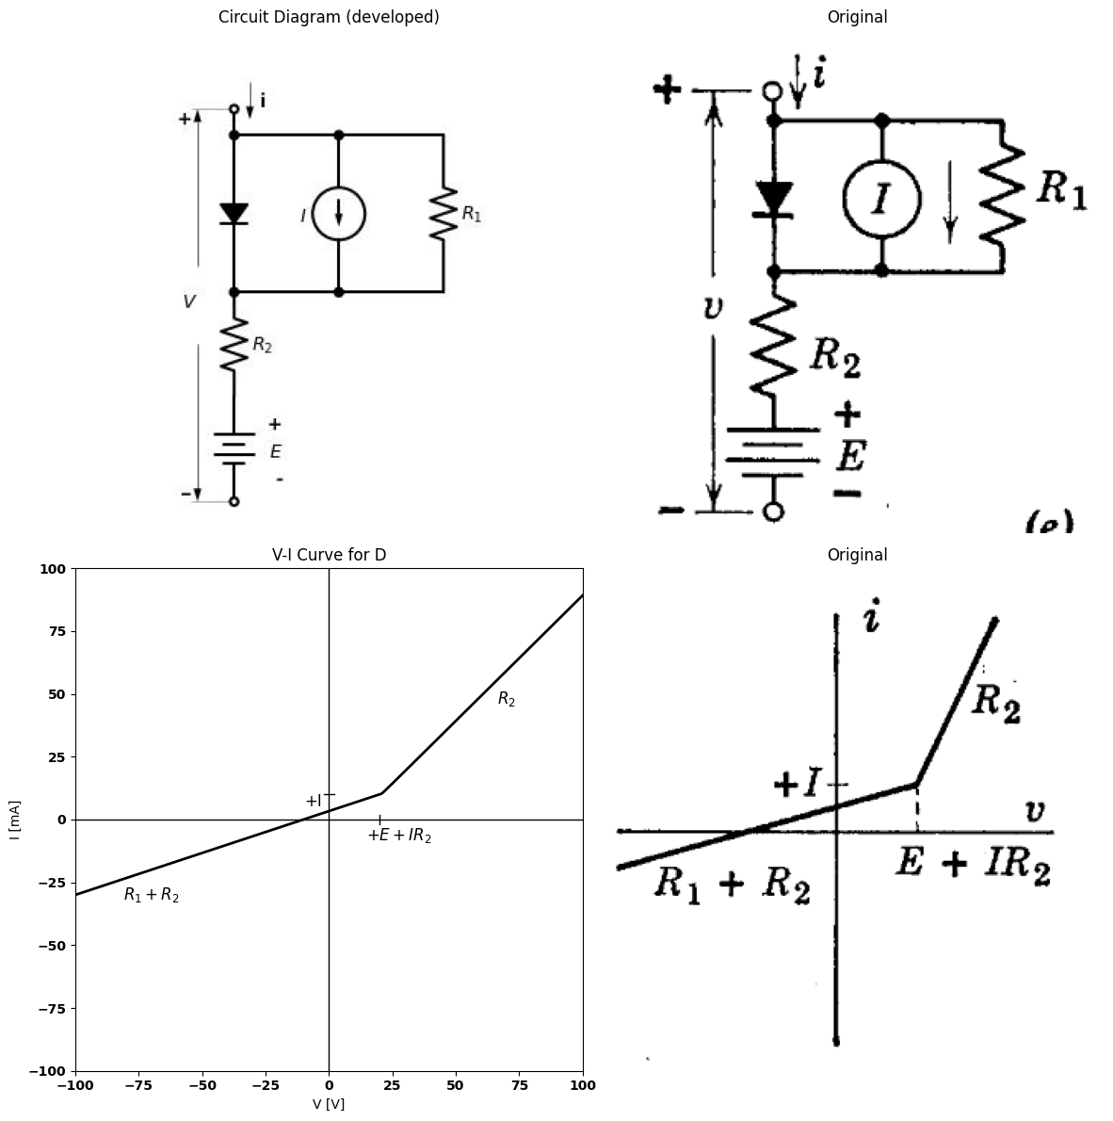
import schemdraw
import schemdraw.elements as e
import schemdraw as schem
import matplotlib.pyplot as plt
import matplotlib.image as mpimg
import numpy as np
# Create the figure and subplots
fig, axs = plt.subplots(2, 2, figsize=(12, 12))
d = schemdraw.Drawing()
l1 = d.add(e.Line().up().length(0.5).dot(open=True))
d.push()
l2 = d.add(e.Line().down().length(0.5).dot())
D1 = d.add(e.Diode(fill=True).down().reverse().at(l1.start))
R2 = d.add(e.Resistor().down().length(2).label('$R_2$',ofst=-1))
E1 = d.add(e.Battery().down().length(2).label(['+', '$E$', '-'], ofst=-1.3).dot(open=True))
d += e.Line().right().length(2).dot().at(l1.start)
I = d.add(e.SourceI().down().label('$I$').dot())
d += e.Line().left().length(2).dot()
d.pop()
d += e.Arrow().down().length(0.7).linewidth(0.6).color('black').label('i', loc='top', color='black',ofst=-0.3). at((0.3,1))
d += e.Arrow().up().length(4.5).linewidth(0.6).color('white').label('$V$', loc='start', color='black',ofst=0.3). at((-0.4,-3))
d += e.Arrow().up().length(3).linewidth(0.6).color('black').label('+',loc='end', color='black',ofst=0.4). at((-0.7,-2.5))
d += e.Line().left().length(0.8).linewidth(0.6).at(l1.end).color('gray')
d += e.Arrow().down().length(3).linewidth(0.6).color('black').label(r'_', loc='end', color='black',ofst=(-0.5, -0.3)). at((-0.7,-4))
d += e.Line().left().length(0.8).linewidth(0.6).at(E1.end).color('gray')
d += e.Line().right().length(2).at(I.start)
d += e.Line().right().length(2).at(I.end)
R1 = d.add(e.Resistor().up().label('$R_1$',ofst=-1))
d.save('./Drawings/fig22f.jpg')
d.save('./Drawings/fig22f.svg')
# Load the saved PNG file into the subplot
img = mpimg.imread('./Drawings/fig22f.jpg')
axs[0,0].imshow(img)
axs[0,0].axis('off') # Hide axes for image display
axs[0,0].set_title('Circuit Diagram (developed)')
# **Subplot (1, 2): PNG Sample File**
img_sample = mpimg.imread('images-books/22f.png') # Load the PNG file
axs[0,1].imshow(img_sample)
axs[0,1].axis('off') # Hide axes for image display
axs[0,1].set_title('Original')
#
circuit = Circuit('Diode')
circuit.model('BAV21','D' ,IS = 4@u_nA , N = 1.906 ,BV = 110@u_V, IBV = 0.0001@u_V, VJ = 0.7@u_V ,CJO = 7.048E-13 ,RS = 0.01@u_Ohm ,TT = 3.48E-9)
Vth = circuit.V('th', '1', circuit.gnd, 0@u_V)
circuit.D(1, '2','1' , model = 'BAV21')
circuit.V(1, '3',circuit.gnd , 10@u_V)
circuit.I(1, '1','2' , 10@u_mA)
circuit.R(1, '1','2' , 2000@u_Ohm)
circuit.R(2, '2','3' , 1000@u_Ohm)
simulator = circuit.simulator(temperature=25, nominal_temperature=25)
analysis = simulator.dc(Vth=slice(-100, 100, 0.1))
# Plot for R1
axs[1,0].plot(analysis['1'],u_mA(-analysis.Vth), 'black', linewidth=2)
axs[1,0].set_title('V-I Curve for D')
axs[1,0].set_xlim(-100, 100)
axs[1,0].set_xlabel('V [V]')
axs[1,0].set_ylabel('I [mA]')
axs[1,0].set_ylim(-100, 100)
axs[1,0].axhline(0, color='black', linewidth=1)
axs[1,0].axvline(0, color='black', linewidth=1)
axs[1,0].annotate('+I', xy=(0, 0), xytext=(-12, 10),
textcoords='offset points', ha='center', color='black', fontsize=12, fontweight='medium')
axs[1,0].annotate('+$E+IR_2$', xy=(20, 0), xytext=(15, -16),
textcoords='offset points', ha='center', color='black', fontsize=12, fontweight='medium')
axs[1,0].plot([-2, 2], [10, 10], color='black', linewidth=1)
axs[1,0].plot([20, 20], [-2, 2], color='black', linewidth=1)
axs[1,0].text(-70, -65, '$R_2$', ha='center', va='center', fontsize=12)
axs[1,0].text(70, 40, '$R_1+R_2$', ha='center', va='center', fontsize=12)
img_sample = mpimg.imread('images-books/22f1.png') # Load the PNG file
axs[1,1].imshow(img_sample)
axs[1,1].axis('off') # Hide axes for image display
axs[1,1].set_title('Original')
plt.tight_layout()
plt.show()
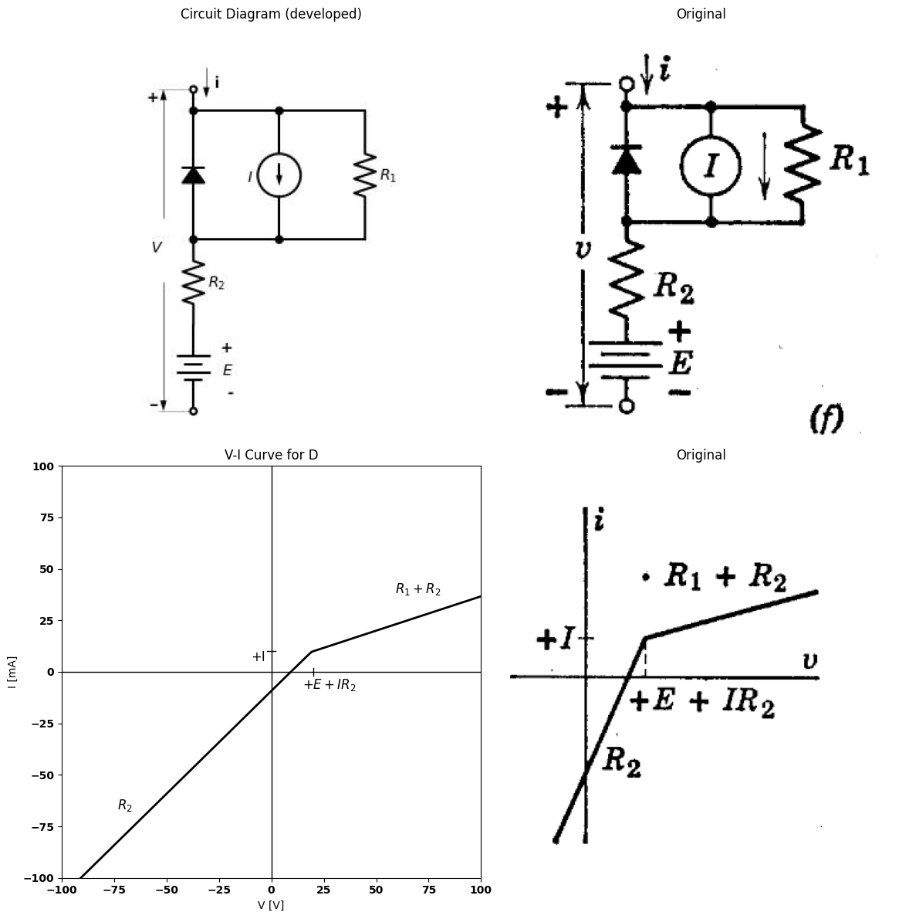
import schemdraw
import schemdraw.elements as e
import schemdraw as schem
import matplotlib.pyplot as plt
import matplotlib.image as mpimg
import numpy as np
# Create the figure and subplots
fig, axs = plt.subplots(1, 2, figsize=(12, 12))
d = schemdraw.Drawing()
l1 = d.add(e.Line().right().length(1.4))
l4 = d.add(e.Line().left().length(1.4).dot(open=True))
E1 = d.add(e.Battery().right().at(l1.end).label('+$E_1$-',ofst=-1.3))
R1 = d.add(e.Resistor().right().at(E1.end).label('R1').dot())
R2 = d.add(e.Resistor().right().at(R1.end).label('R2'))
R3 = d.add(e.Resistor().down().at(R1.end).label('R3').dot())
E2 = d.add(e.Battery().right().at(R2.end).reverse().label('-$E_2$+',ofst=-1.3))
l2 = d.add(e.Line().right().at(R3.end).length(6))
l3 = d.add(e.Line().left().at(R3.end).length(7.4).dot(open=True))
D1 = d.add(e.Diode(fill=True).down().at(E2.end))
d += e.Arrow().right().linewidth(0.6).length(0.7).at(l1.start).color('black').label('i', loc='top', color='black',ofst=0.2). at((-0.3,0.3))
d += e.Arrow().up().length(1).linewidth(0.6).color('white').label('$V$', loc='start', color='black',ofst=0.3). at((-0.3,-1.4))
d += e.Arrow().up().length(0.8).linewidth(0.6).color('black').label('+',loc='end', color='black',ofst=0.4). at((-0.7,-0.9))
d += e.Arrow().down().length(0.8).linewidth(0.6).color('black').label(r'_', loc='end', color='black',ofst=(-0.3,-0.5)). at((-0.7,-2.2))
d.save('./Drawings/fig22g.jpg')
d.save('./Drawings/fig22g.svg')
# Load the saved PNG file into the subplot
img = mpimg.imread('./Drawings/fig22g.jpg')
axs[0].imshow(img)
axs[0].axis('off') # Hide axes for image display
axs[0].set_title('Circuit Diagram (developed)')
# **Subplot (1, 2): PNG Sample File**
img_sample = mpimg.imread('images-books/22g.png') # Load the PNG file
axs[1].imshow(img_sample)
axs[1].axis('off') # Hide axes for image display
axs[1].set_title('Original')
C:\MLPack\PortablePython-3.10.5x64\App\Python\lib\site-packages\schemdraw\elements\elements.py:147: UserWarning: Duplicate `at` parameter in element: `Point(0.0,0.0)` changed to `Point(-0.3,0.3)`.
warnings.warn("Duplicate `at` parameter in element: "
Text(0.5, 1.0, 'Original')
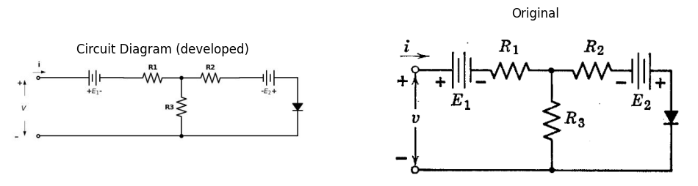
import schemdraw
import schemdraw.elements as e
import schemdraw as schem
import matplotlib.pyplot as plt
import matplotlib.image as mpimg
import numpy as np
# Create the figure and subplots
fig, axs = plt.subplots(1, 2, figsize=(12, 12))
d = schemdraw.Drawing()
l1 = d.add(e.Line().right().length(1.4))
l4 = d.add(e.Line().left().length(1.4).dot(open=True))
E1 = d.add(e.Battery().right().at(l1.end).label('+$E_1$-',ofst=-1.3))
R1 = d.add(e.Resistor().right().at(E1.end).label('R1').dot())
R2 = d.add(e.Resistor().right().at(R1.end).label('R2'))
R3 = d.add(e.Resistor().down().at(R1.end).label('R3').dot())
E2 = d.add(e.Battery().right().at(R2.end).reverse().label('-$E_2$+',ofst=-1.3))
l2 = d.add(e.Line().right().at(R3.end).length(6))
l3 = d.add(e.Line().left().at(R3.end).length(7.4).dot(open=True))
D1 = d.add(e.Diode(fill=True).down().reverse().at(E2.end))
d += e.Arrow().right().linewidth(0.6).length(0.7).at(l1.start).color('black').label('i', loc='top', color='black',ofst=0.2). at((0.3,0.3))
d += e.Arrow().up().length(1).linewidth(0.6).color('white').label('$V$', loc='start', color='black',ofst=0.3). at((0.6,-1.4))
d += e.Arrow().up().length(0.8).linewidth(0.6).color('black').label('+',loc='end', color='black',ofst=0.4). at((0.2,-0.9))
d += e.Arrow().down().length(0.8).linewidth(0.6).color('black').label(r'_', loc='end', color='black',ofst=(-0.6,-0.4)). at((0.2,-2.2))
d.save('./Drawings/fig22h.jpg')
d.save('./Drawings/fig22h.svg')
# Load the saved PNG file into the subplot
img = mpimg.imread('./Drawings/fig22h.jpg')
axs[0].imshow(img)
axs[0].axis('off') # Hide axes for image display
axs[0].set_title('Circuit Diagram (developed)')
# **Subplot (1, 2): PNG Sample File**
img_sample = mpimg.imread('images-books/22h.png') # Load the PNG file
axs[1].imshow(img_sample)
axs[1].axis('off') # Hide axes for image display
axs[1].set_title('Original')
C:\MLPack\PortablePython-3.10.5x64\App\Python\lib\site-packages\schemdraw\elements\elements.py:147: UserWarning: Duplicate `at` parameter in element: `Point(0.0,0.0)` changed to `Point(0.3,0.3)`.
warnings.warn("Duplicate `at` parameter in element: "
Text(0.5, 1.0, 'Original')
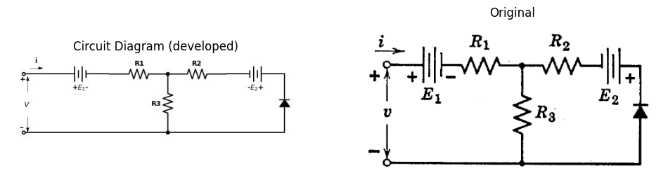
Fig. 3.22. Circuits with nonzero break-point coordinates.
polarized to position the break point in the first quadrant.By appropriate choice of polarities for $E$ and $I$ the breaks can be placed in the second, third, or fourth quadrants. The circuits shown in $\left(g\right)$ and $\left(h\right)$ are general forms that permit positioning of break coordinates and control of slopes.
More formal synthesis procedures can be used to realize a general nonlinear curve with resistive-diode circuits.* However, a remarkable degree of generality can be achieved using only the few simple ideas discussed thus far.
*T. E. Stern, Piecewise-Linear Network Theory, Technical Report No. 315, Research Laboratory of Electronics, M.I.T., June 15, 1956.

11 3.10 Analysis of Piecewise-Linear Circuits
Devising piecewise-linear circuits to approximate specified curves of voltage versus current, as illustrated by the several preceding articles, is an elementary form of synthesis or design. The analysis problem applies to a circuit that already exists and may require determination of voltage and current at a pair of terminals (driving-point problem), or the voltage or current response at one pair of terminals due to a voltage or current applied at another pair of terminals (transfer problem). For example, the response at the output of a circuit to a sinusoidal or square-wave input may be desired.
In the following articles, the principal methods of analyzing nonlinear resistive diode circuits will be used to derive piecewise-linear curves for a few simple circuits. These methods are based either on the determi- nation of slopes and intercepts for each state or of coordinates for the break points between states.

11.1 3.11 The Method of Assumed Diode States
The method of assumed diode states is based on the fact that over any linear segment of a piecewise-linear curve, each diode in the corresponding circuit remains in a specific state, either on or off. Circuits are analyzed by assuming all possible combinations of states of the ideal rectifiers and finding the corresponding linear relation of $i$ vs. $v$ for each combination. In Fig. 3.23$\left(a\right)$ the assumed states and the constraints on variables imposed by these assumptions are listed next to the circuit diagram. The linear relation for $ivs.v$ in each assumed state is calculated from the simplified circuits shown in $\left(b\right)$ and sketched as a dotted line in $\left(c\right)$. The desired curve must consist of portions of these linear relations. Determination of the appropriate portions of the lines requires consideration of what is happening in the circuit. This is best accomplished by deducing circuit behavior while mentally varying $v$ (or $i$) from large negative to large positive values.
To begin, let us consider values of $v$ much more negative than $—E$. This condition would make $D_{1}$ nonconducting $\left(i=0\right)$; therefore, it corresponds to state I or II. When $D_{1}$ is off, the input is disconnected from the remainder of the circuit, and $D_{2}$ is held on by the current $E/R2$ supplied from source $E$. Thus, state I can never actually exist and the circuit must be in state $II$ when v is less than zero. Diode $D_{1}$ will switch from off to on when $v=0 $(since $v_{i}=v−v_{2}$). At that
point, current $i=0;$ hence, there is no possible effect on $D_{2}$. Thus,$ D_2$ remains closed, and the circuit proceeds to state $IV$ as $v$ crosses zero. Now as $ v$ increases, the current $i$ will increase; and since $i$ passes through
import schemdraw
import schemdraw.elements as e
import schemdraw as schem
import matplotlib.pyplot as plt
import matplotlib.image as mpimg
import numpy as np
# Create the figure and subplots
fig, axs = plt.subplots(1, 2, figsize=(12, 12))
d = schemdraw.Drawing()
l1 = d.add(e.Line().right().length(1.4))
l4 = d.add(e.Line().left().length(1.4).dot(open=True))
D1 = d.add(e.Diode(fill=True).right().at(l1.end).label('+$v_1$-\n\n\n$D_1$',ofst=-1))
R1 = d.add(e.Resistor().right().at(D1.end).label('R1').dot())
R2 = d.add(e.Resistor().right().at(R1.end).label('R2'))
D2 = d.add(e.Diode(fill=True).reverse().down().at(R1.end).label('$D_2$').dot())
l2 = d.add(e.Line().right().at(D2.end).length(3))
l3 = d.add(e.Line().left().at(D2.end).length(7.4).dot(open=True))
E = d.add(e.Battery().down().reverse().at(R2.end).label(['-','$E$','+'],ofst=0.2))
d += e.Arrow().right().linewidth(0.6).length(0.7).color('black').label('i', loc='top', color='black',ofst=0.2). at((-0.3,0.3))
d += e.Arrow().up().length(1).linewidth(0.6).color('white').label('$V$', loc='start', color='black',ofst=0.3). at((0.3,-1.4))
d += e.Arrow().up().length(0.8).linewidth(0.6).color('black').label('+',loc='end', color='black',ofst=0.4). at((-0.1,-0.9))
d += e.Arrow().down().length(0.8).linewidth(0.6).color('black').label(r'_', loc='end', color='black',ofst=(-0.3,-0.5)). at((-0.1,-2.2))
d += e.Arrow().up().linewidth(0.6).length(0.7).color('black').label('$i_2$', loc='top', color='black',ofst=-0.4). at((7.6,-0.8))
d += e.Gap().down().label('-\n$v_2$\n+',fontsize = 16).color('black').at((8,0.7))
d += e.Gap().down().label(' $D_1$ $D_2$ ',fontsize = 12).color('black').at((12,1))
d += e.Gap().down().label('\u2160 $off$ $off$ (i=0,$i_2$=0)',fontsize = 12).color('black').at((12.8,0.5))
d += e.Gap().down().label('\u2161 $off$ $on$ (i=0,$v_2$=0)',fontsize = 12).color('black').at((12.8,0))
d += e.Gap().down().label(' \u2162 $on$ $off$ ($v_1$=0,$i_2$=0)$',fontsize = 12).color('black').at((13.9,-0.5))
d += e.Gap().down().label(' \u2163 $on$ $on$ ($v_1$=0,$v_2$=0)',fontsize = 12).color('black').at((12.9,-1))
d.save('./Drawings/fig23a.jpg')
d.save('./Drawings/fig23a.svg')
# Load the saved PNG file into the subplot
img = mpimg.imread('./Drawings/fig23a.jpg')
axs[0].imshow(img)
axs[0].axis('off') # Hide axes for image display
axs[0].set_title('Circuit Diagram (developed)')
# **Subplot (1, 2): PNG Sample File**
img_sample = mpimg.imread('images-books/23a.png') # Load the PNG file
axs[1].imshow(img_sample)
axs[1].axis('off') # Hide axes for image display
axs[1].set_title('Original')
Text(0.5, 1.0, 'Original')
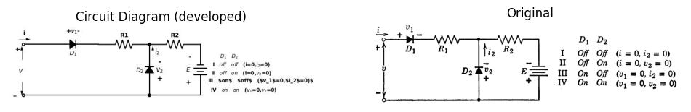
import schemdraw
import schemdraw.elements as e
import schemdraw as schem
import matplotlib.pyplot as plt
import matplotlib.image as mpimg
import numpy as np
# Create the figure and subplots
fig, axs = plt.subplots(1, 2, figsize=(12, 12))
d = schemdraw.Drawing()
l3 = d.add(e.Line().down().color('white'))
l1 = d.add(e.Line().left().length(1).dot(open=True))
d.push()
d += e.Gap().right().label('\u2160', ofst=((-1,4.5)) , fontsize = 16)
d.pop()
d += e.Gap().right().label('i=0', ofst=((-1,-1)) , fontsize = 16)
d.pop()
l4 = d.add(e.Line().left().length(1).at(l3.start).dot(open=True))
d += e.Arrow().right().linewidth(0.6).length(0.7).color('black').label('i', loc='top', color='black',ofst=0.2). at((-1.3,0.3))
d += e.Arrow().up().length(1).linewidth(0.6).color('white').label('$V$', loc='start', color='black',ofst=0.3). at((-0.7,-1.4))
d += e.Arrow().up().length(0.8).linewidth(0.6).color('black').label('+',loc='end', color='black',ofst=0.4). at((-1.1,-0.9))
d += e.Arrow().down().length(0.8).linewidth(0.6).color('black').label(r'_', loc='end', color='black',ofst=(-0.3,-0.3)). at((-1.1,-2.2))
a=4
l3 = d.add(e.Line().down().color('white').at((a,0)))
l1 = d.add(e.Line().left().length(1).dot(open=True))
d.push()
d += e.Gap().right().label('\u2161', ofst=((-1,4.5)) , fontsize = 16)
d.pop()
d += e.Gap().right().label('i=0', ofst=((-1,-1)) , fontsize = 16)
d.pop()
l4 = d.add(e.Line().left().length(1).at(l3.start).dot(open=True))
d += e.Arrow().right().linewidth(0.6).length(0.7).color('black').label('i', loc='top', color='black',ofst=0.2). at((a-1.3,0.3))
d += e.Arrow().up().length(1).linewidth(0.6).color('white').label('$V$', loc='start', color='black',ofst=0.3). at((a-0.7,-1.4))
d += e.Arrow().up().length(0.8).linewidth(0.6).color('black').label('+',loc='end', color='black',ofst=0.4). at((a-1.1,-0.9))
d += e.Arrow().down().length(0.8).linewidth(0.6).color('black').label(r'_', loc='end', color='black',ofst=(-0.3,-0.3)). at((a-1.1,-2.2))
a=8
l3 = d.add(e.Line().down().color('white').at((a,0)))
l1 = d.add(e.Line().left().length(1).dot(open=True))
d.push()
d += e.Gap().right().label('\u2162', ofst=((2,4.5)) , fontsize = 15)
d += e.Gap().right().label('$i = (v + E)/(R_1 + R_2)$', ofst=((-1,-1)) , fontsize = 15)
d.pop()
l4 = d.add(e.Line().left().length(1).at(l3.start).dot(open=True))
d += e.Arrow().right().linewidth(0.6).length(0.7).color('black').label('i', loc='top', color='black',ofst=0.2). at((a-1.3,0.3))
d += e.Arrow().up().length(1).linewidth(0.6).color('white').label('$V$', loc='start', color='black',ofst=0.3). at((a-0.7,-1.4))
d += e.Arrow().up().length(0.8).linewidth(0.6).color('black').label('+',loc='end', color='black',ofst=0.4). at((a-1.1,-0.9))
d += e.Arrow().down().length(0.8).linewidth(0.6).color('black').label(r'_', loc='end', color='black',ofst=(-0.3,-0.3)). at((a-1.1,-2.2))
R1 = d.add(e.Resistor().right().at(l4.start).label('R1').dot())
R2 = d.add(e.Resistor().right().label('R2'))
E = d.add(e.Battery().down().reverse().label(['-','$E$','+'],ofst=0.2))
l5 = d.add(e.Line().left().length(6))
a=18
l3 = d.add(e.Line().down().color('white').at((a,0)))
l1 = d.add(e.Line().left().length(1).dot(open=True))
d.push()
d += e.Gap().right().label('\u2163', ofst=((0,4.5)) , fontsize = 16)
d.pop()
d += e.Gap().right().label('$i$ = $v$/$R_1$', ofst=((0,-1)) , fontsize = 16)
d.pop()
l4 = d.add(e.Line().left().length(1).at(l3.start).dot(open=True))
d += e.Arrow().right().linewidth(0.6).length(0.7).color('black').label('i', loc='top', color='black',ofst=0.2). at((a-1.3,0.3))
d += e.Arrow().up().length(1).linewidth(0.6).color('white').label('$V$', loc='start', color='black',ofst=0.3). at((a-0.7,-1.4))
d += e.Arrow().up().length(0.8).linewidth(0.6).color('black').label('+',loc='end', color='black',ofst=0.4). at((a-1.1,-0.9))
d += e.Arrow().down().length(0.8).linewidth(0.6).color('black').label(r'_', loc='end', color='black',ofst=(-0.3,-0.3)). at((a-1.1,-2.2))
R1 = d.add(e.Resistor().right().at(l4.start).label('R1'))
l4 = d.add(e.Line().down())
l4 = d.add(e.Line().left().length(3))
d.save('./Drawings/fig23b.jpg')
d.save('./Drawings/fig23b.svg')
# Load the saved PNG file into the subplot
img = mpimg.imread('./Drawings/fig23b.jpg')
axs[0].imshow(img)
axs[0].axis('off') # Hide axes for image display
axs[0].set_title('Circuit Diagram (developed)')
# **Subplot (1, 2): PNG Sample File**
img_sample = mpimg.imread('images-books/23b.png') # Load the PNG file
axs[1].imshow(img_sample)
axs[1].axis('off') # Hide axes for image display
axs[1].set_title('Original')
Text(0.5, 1.0, 'Original')
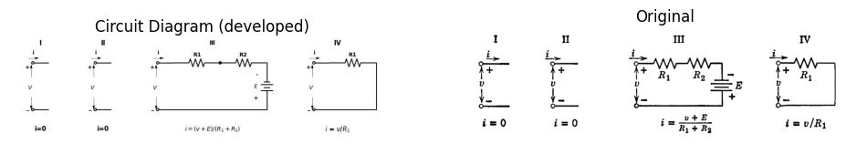
import matplotlib.pyplot as plt
from matplotlib import rcParams
import matplotlib.image as mpimg
import numpy as np
import PySpice.Logging.Logging as Logging
logger = Logging.setup_logging()
from PySpice.Probe.Plot import plot
from PySpice.Spice.Netlist import Circuit
from PySpice.Unit import *
rcParams['font.weight'] = 'bold'
#figure, ax1 = plt.subplots(figsize=(8, 8))
# Create the figure and subplots
fig, axs = plt.subplots(1, 2, figsize=(10, 10))
circuit = Circuit('t3')
circuit.model('BAV21','D' ,IS = 4@u_nA , N = 1.906 ,BV = 110@u_V, IBV = 0.0001@u_V, VJ = 0.7@u_V ,CJO = 7.048E-13 ,RS = 0.01@u_Ohm ,TT = 3.48E-9)
Vth1 = circuit.V('th1', '1', circuit.gnd, 0@u_V)
circuit.D(1, '1','2' , model = 'BAV21')
circuit.R(1, '2','3' , 0.6@u_Ohm)
circuit.D(2, circuit.gnd,'3' , model = 'BAV21')
circuit.V(1, circuit.gnd ,'4' , 30@u_V)
circuit.R(2, '3','4', 0.7@u_Ohm)
simulator = circuit.simulator(temperature=25, nominal_temperature=25)
analysis = simulator.dc(Vth1=slice(-150, 150, 0.1))
axs[0].plot(analysis['1'],u_A(-analysis.Vth1),'black', linewidth=3)
#III
circuit = Circuit('t3')
Vth1 = circuit.V('th1', '1', circuit.gnd, 0@u_V)
circuit.R(2, '1','2', 1.3@u_Ohm)
circuit.V(1, circuit.gnd ,'2' , 30@u_V)
simulator = circuit.simulator(temperature=25, nominal_temperature=25)
analysis = simulator.dc(Vth1=slice(-150, 150, 0.1))
axs[0].plot(analysis['1'],u_A(-analysis.Vth1),'black', linewidth=2,linestyle='--')
R1=0.7
R2=0.6
E=30
#Iv
circuit = Circuit('t3')
Vth1 = circuit.V('th1', '1', circuit.gnd, 0@u_V)
circuit.R(2, '1',circuit.gnd, 0.6@u_Ohm)
simulator = circuit.simulator(temperature=25, nominal_temperature=25)
analysis = simulator.dc(Vth1=slice(-150, 80, 0.1))
axs[0].plot(analysis['1'],u_A(-analysis.Vth1),'black', linewidth=2,linestyle='-.')
axs[0].set_title('V-I Curve for D')
axs[0].set_xlim(-80, 120)
axs[0].set_xlabel('V [V]')
axs[0].set_ylabel('I [A]')
axs[0].set_ylim(-60, 120)
axs[0].axhline(0, color='black', linewidth=1)
axs[0].axvline(0, color='black', linewidth=1)
axs[0].annotate('E/$R_2$', xy=(0, 0), xytext=(-14, E/R2), ha='center', color='black', fontsize=12, fontweight='medium')
axs[0].annotate('E$R_1$/$R_2$', xy=(0, 0), xytext=(((E*R1)/R2),-13), ha='center', color='black', fontsize=12, fontweight='medium')
axs[0].plot([-2, 2], [E/R2, E/R2], color='black', linewidth=1)
axs[0].plot([(E*R1)/R2, (E*R1)/R2], [-2, 2], color='black', linewidth=1)
axs[0].text(70, 66, '\u2162', ha='center', va='center', fontsize=10)
axs[0].text(50, 95, '\u2163', ha='center', va='center', fontsize=10)
axs[0].text(90, 4, '\u2193 \u2161 and \u2162', ha='center', va='center', fontsize=10)
img_sample = mpimg.imread('images-books/23c.png') # Load the PNG file
axs[1].imshow(img_sample)
axs[1].axis('off') # Hide axes for image display
axs[1].set_title('Original')
plt.tight_layout()
plt.show()
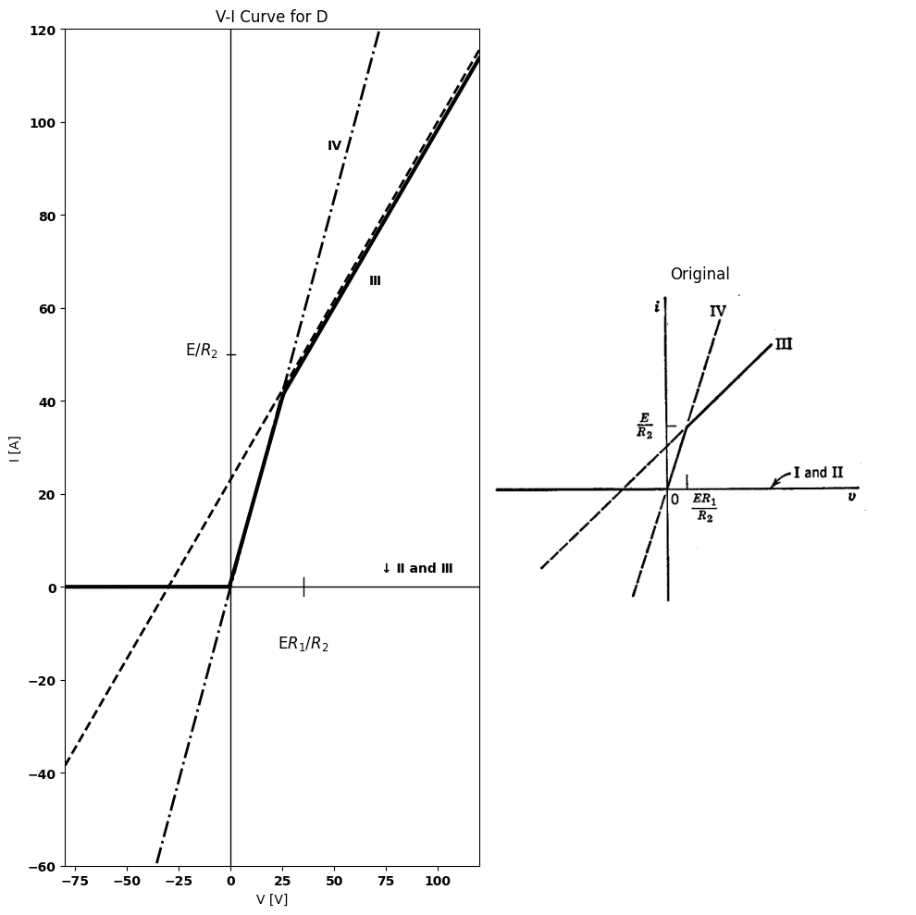
Fig. 3.23. Linear analysis based on assumed diode states.
$D2$ in a direction opposite to that of the bias current, the net current $i$ is diminished. When $i=E/R2$, the current $i2 $is zero, and $D2$ opens, putting the circuit into state $III$. Thus, as we vary $v$ from large negative
values to large positive values, we proceed from state $II$ to state$ IV$,andthentostate$ III$.Ifseveraldiodesareinvolvedinacircuit,theorderofoccurrenceofthevariousstatesmaybeindefiniteunlessnumericalvaluesarespecifiedfortheresistancesandbatteries.Withnumericalvaluesknown,lettheinputvariable($v$ or $i$) be increased from negative values to positive ones. Now suppose a given circuit is in a particular state with several diodes $on$ and several $off$. To determine which state occurs next as the input variable ($v$ or $i$) is increased, consider the negative voltage across each diode that is $off$ and the positive current through each diode that is $on$. The first one of these quantities to reach zero determines the next state. Note when a diode is $on$ that the positive current tells us how much it is conducting while the fact that the voltage is zero tells us only that the diode is $on$. Similarly, when a diode is $off$, the negative voltage tells us how far the diode is biased away from the break point, whereas the fact that the current is zero tells us only that the diode is $off$. The method just outlined has a distinct shortcoming. It grows The method just outlined has a distinct shortcoming. cumbersome very rapidly as circuit complexity increases. With three ideal diodes, there are eight combinations of $on$ and $off$, and four diodes lead to sixteen combinations. In general, $n$ diodes have $2^{n}$ combinations of $on$ and $off$. Thus, even though preliminary reasoning eliminates some of the possible states, the problem mushrooms rapidly.

12 3.12 The Break-Point Method
The second approach is called the break-point method. It is based on the fact that a circuit containing only linear or piecewise-linear elements such as batteries, resistances, and ideal rectifiers-must yield driving-point and transfer curves that are piecewise linear. The coordinates of the break points specify the character of the entire curve except for each of the end segments, which must be determined by the outermost break point and a resistive slope. Two adjacent break points (in terms of the independent variable) specify the state line joining the break points. Thus each break point joins two states, so that a circuit with $n$ states has $n−1$ break points.
The usefulness of the method stems from the fact that both the current and the voltage for a particular ideal rectifier are constrained to zero at the break point of that rectifier. These two constraints when applied to the circuit reduce an $n$-diode circuit to one containing only $\left(n−1\right)$ diodes.
Let us illustrate the break-point method with the same circuit used
in the previous section. At the break point of $D_{1},v_{1}=i=0$. since $R_{1}$ carries no current, the right-hand loop of the circuit behaves as though $R_{1}$ were removed. Thus $D_{2}$ conducts a current $i_{2}=E/R_{2}$ with voltage
import schemdraw
import schemdraw.elements as e
import schemdraw as schem
import matplotlib.pyplot as plt
import matplotlib.image as mpimg
import numpy as np
# Create the figure and subplots
fig, axs = plt.subplots(1, 2, figsize=(12, 12))
d = schemdraw.Drawing()
l1 = d.add(e.Line().right().length(1.4))
l4 = d.add(e.Line().left().length(1.4).dot(open=True))
D1 = d.add(e.Diode().right().at(l1.end).label('+ $V_1$ -',ofst=0.2))
R1 = d.add(e.Resistor().right().at(D1.end).label('R1').dot())
D1 = d.add(e.Diode().down().reverse().at(R1.end).label(['+', '$v2$', '-'], ofst=-1.3))
R2 = d.add(e.Resistor().right().at(R1.end).label('R2'))
E2 = d.add(e.Battery().down().at(R2.end).reverse().label(['-', '$E$', '+'], ofst=-1.3))
l2 = d.add(e.Line().left().at(E2.end).length(10.45).dot(open=True))
d += e.Arrow().up().length(1).linewidth(0.6).color('white').label('$V$', loc='start', color='black',ofst=0.3). at((-0.3,-1.4))
d += e.Arrow().up().length(0.8).linewidth(0.6).color('black').label('+',loc='end', color='black',ofst=0.4). at((-0.7,-0.9))
d += e.Arrow().down().length(0.8).linewidth(0.6).color('black').label(r'_', loc='end', color='black',ofst=(-0.3,-0.5)). at((-0.7,-2.2))
d += e.Arrow().right().linewidth(0.6).length(0.8).color('black').label('i1', loc='top', color='black',ofst=0.1). at((-0.4,0.4))
d += e.Arrow().up().linewidth(0.6).length(0.8).color('black').label('i2', loc='top', color='black',ofst=0.1). at((7.9,-1.4))
d.save('./Drawings/fig24a.jpg')
d.save('./Drawings/fig24a.svg')
# Load the saved PNG file into the subplot
img = mpimg.imread('./Drawings/fig24a.jpg')
axs[0].imshow(img)
axs[0].axis('off') # Hide axes for image display
axs[0].set_title('Circuit Diagram (developed)')
# **Subplot (1, 2): PNG Sample File**
img_sample = mpimg.imread('images-books/24a.png') # Load the PNG file
axs[1].imshow(img_sample)
axs[1].axis('off') # Hide axes for image display
axs[1].set_title('Original')
# Show the combined plots
plt.tight_layout()
plt.show()
d.save('./Drawings/fig24a.png')
d.save('./Drawings/fig24a.svg')
d.save('./Drawings/fig24a.jpg')
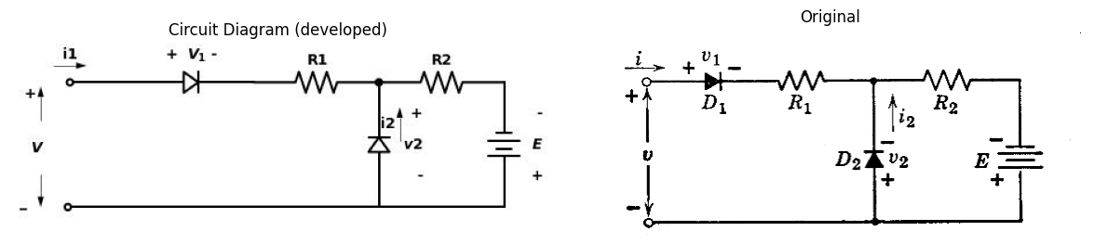
import matplotlib.pyplot as plt
import numpy as np
import schemdraw
import schemdraw.elements as elm
import matplotlib.image as mpimg
# Create the figure and subplots
fig, axs = plt.subplots(1, 2, figsize=(10, 10))
circuit = Circuit('t3')
circuit.model('BAV21','D' ,IS = 4@u_nA , N = 1.906 ,BV = 110@u_V, IBV = 0.0001@u_V, VJ = 0.7@u_V ,CJO = 7.048E-13 ,RS = 0.01@u_Ohm ,TT = 3.48E-9)
Vth1 = circuit.V('th1', '1', circuit.gnd, 0@u_V)
circuit.D(1, '1','2' , model = 'BAV21')
circuit.R(1, '2','3' , 0.6@u_Ohm)
circuit.D(2, circuit.gnd,'3' , model = 'BAV21')
circuit.V(1, circuit.gnd ,'4' , 30@u_V)
circuit.R(2, '3','4', 0.7@u_Ohm)
simulator = circuit.simulator(temperature=25, nominal_temperature=25)
analysis = simulator.dc(Vth1=slice(-150, 150, 0.1))
axs[0].plot(analysis['1'],u_A(-analysis.Vth1),'black', linewidth=3)
R1=0.7
R2=0.6
E=30
axs[0].text(-25, 16, 'Break point1', ha='center', va='center', fontsize=10)
axs[0].text(-25, 70, 'Break point2', ha='center', va='center', fontsize=10)
axs[0].text(0, 0, '0', ha='center', va='center', fontsize=10)
axs[0].text(25, 40, '0', ha='center', va='center', fontsize=10)
axs[0].text(100, 110, 'R1+R2', ha='center', va='center', fontsize=10)
axs[0].text(110,80, 'Δ_i', ha='center', va='center', fontsize=10)
axs[0].text(75, 55, 'Δ_v', ha='center', va='center', fontsize=10)
axs[0].text(-50, -5, 'i=0', ha='center', va='center', fontsize=10)
axs[0].set_title('V-I Curve for D')
axs[0].set_xlim(-80, 120)
axs[0].set_xlabel('V [V]')
axs[0].set_ylabel('I [A]')
axs[0].set_ylim(-60, 120)
axs[0].annotate('', xy=(50,60), xytext=(0,72 ), arrowprops=dict(arrowstyle='->'))
axs[0].annotate('', xy=(0,0), xytext=(-17,13 ), arrowprops=dict(arrowstyle='->'))
axs[0].annotate('', xy=(100,60), xytext=(50,60 ), arrowprops=dict(arrowstyle='-'))
axs[0].annotate('', xy=(100,100), xytext=(100,60 ), arrowprops=dict(arrowstyle='-'))
axs[0].axhline(0, color='black', linewidth=1)
axs[0].axvline(0, color='black', linewidth=1)
axs[0].annotate('E/$R_2$', xy=(0, 0), xytext=(-14, E/R2), ha='center', color='black', fontsize=12, fontweight='medium')
axs[0].annotate('E$R_1$/$R_2$', xy=(0, 0), xytext=(((E*R1)/R2),-13), ha='center', color='black', fontsize=12, fontweight='medium')
axs[0].plot([-2, 2], [E/R2, E/R2], color='black', linewidth=1)
axs[0].plot([(E*R1)/R2, (E*R1)/R2], [-2, 2], color='black', linewidth=1)
img_sample = mpimg.imread('images-books/24b.png') # Load the PNG file
axs[1].imshow(img_sample)
axs[1].axis('off') # Hide axes for image display
axs[1].set_title('Original')
plt.tight_layout()
plt.show()
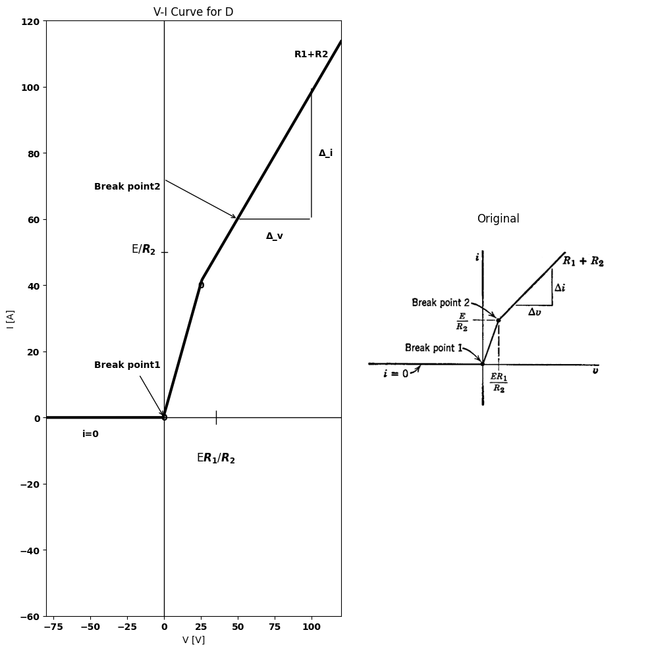
import schemdraw
import schemdraw.elements as e
import schemdraw as schem
import matplotlib.pyplot as plt
import matplotlib.image as mpimg
import numpy as np
# Create the figure and subplots
fig, axs = plt.subplots(1, 2, figsize=(12, 12))
d = schemdraw.Drawing()
l1 = d.add(e.Line().left().length(1.2).dot(open=True))
R1 = d.add(e.Switch().right().at(l1.end).label('v1=0\n i=0'))
l2 = d.add(e.Line().right().length(0.6))
l3 = d.add(e.Line().down().length(3))
R1 = d.add(e.Resistor().right().at(l3.start).label('R2').dot())
E1 = d.add(e.Battery().down().at(R1.end).reverse().label(['-', '$E$', '+'], ofst=-1.3))
l2 = d.add(e.Line().left().at(E1.end).length(6.7).dot(open=True))
d += e.Arrow().up().length(1).linewidth(0.6).color('white').label('$V$', loc='start', color='black',ofst=0.3). at((-1.,-1.3))
d += e.Arrow().up().length(0.8).linewidth(0.6).color('black').label('+',loc='end', color='black',ofst=0.4). at((-1.2,-0.9))
d += e.Arrow().down().length(0.8).linewidth(0.6).color('black').label(r'_', loc='end', color='black',ofst=(-0.4,-0.3)). at((-1.25,-2.))
d.move(10,3)
l3 = d.add(e.Line().left().length(0.8).dot(open=True))
R3 = d.add(e.Resistor().right().at(l3.end).label('R1').dot())
l4 = d.add(e.Line().down().length(0.8))
R4 = d.add(e.Resistor().right().at(l4.start).label('R2').dot())
E1 = d.add(e.Battery().down().at(R4.end).reverse().label(['-', '$E$', '+'], ofst=-1.3))
l5 = d.add(e.Line().left().length(3).label('v2=0\n i2=0'))
l6 = d.add(e.Line().up().length(.7))
l7 = d.add(e.Line().left().at(l6.start).length(2.9).dot(open=True))
d += e.Arrow().up().length(1).linewidth(0.6).color('white').label('$V$', loc='start', color='black',ofst=0.3). at((8.5,-1.0))
d += e.Arrow().up().length(0.8).linewidth(0.6).color('black').label('+',loc='end', color='black',ofst=0.4). at((8.0,-0.7))
d += e.Arrow().down().length(0.8).linewidth(0.6).color('black').label(r'_', loc='end', color='black',ofst=(-0.8,-0.3)). at((8.05,-1.7))
d.save('./Drawings/fig24c1.jpg')
d.save('./Drawings/fig24c1.svg')
# Load the saved PNG file into the subplot
img = mpimg.imread('./Drawings/fig24c1.jpg')
axs[0].imshow(img)
axs[0].axis('off') # Hide axes for image display
axs[0].set_title('Circuit Diagram (developed)')
# **Subplot (1, 2): PNG Sample File**
img_sample = mpimg.imread('images-books/24c1.png') # Load the PNG file
axs[1].imshow(img_sample)
axs[1].axis('off') # Hide axes for image display
axs[1].set_title('Original')
# Show the combined plots
plt.tight_layout()
plt.show()
d.save('./Drawings/fig24c1.png')
d.save('./Drawings/fig24c1.svg')
d.save('./Drawings/fig24c1.jpg')
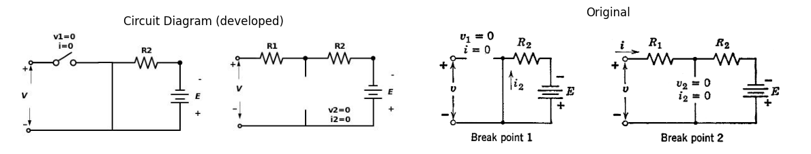
Fig3.24. Break-point method of analysis.
$V_{2}=0$. Now, since both $v_{1}$ and $v_{2}=0$, the input voltage is zero, and the first break point is thus established at the origin where $v=i=0$. The break point of $D_{2}$ corresponds to $v_{2}=i_{2}=0$. The current in $R_{2}$ must then be $E/R_{2}$; and since $i_{2}=0$, current i entering the circuit must also be $E/R_{2}$, and the first diode must be closed. Now, since $V_{1}=v_{2}=0$, we have $v=iR_{1}=ER_{1}/R_{2}$ for the voltage coordinate
import schemdraw
import schemdraw.elements as e
import schemdraw as schem
import matplotlib.pyplot as plt
import matplotlib.image as mpimg
import numpy as np
# Create the figure and subplots
fig, axs = plt.subplots(1, 2, figsize=(12, 12))
d = schemdraw.Drawing()
l1 = d.add(e.Line().right().length(0.5))
R1 = d.add(e.Resistor().right().label([ '$R1$'], ofst=0.2).length(3).dot())
D1 = d.add(e.Diode(fill=True).down())
E1 = d.add(e.Battery().down().label(['+', '$E1$', '-'], ofst=-1.3))
l2 = d.add(e.Line().right().length(2).at(D1.start))
D2 = d.add(e.Diode(fill=True).down().at(l2.end).reverse())
E2 = d.add(e.Battery().down().reverse().label(['-', '$E2$', '+'], ofst=-1.3))
l3 = d.add(e.Line().right().length(2).at(D2.start))
l4 = d.add(e.Line().down().length(1.))
R2 = d.add(e.Resistor().down().label([ '$R2$'], ofst=0.2).length(4))
l5 = d.add(e.Line().down().length(1.))
l6 = d.add(e.Line().left().length(7.5))
l7 = d.add(e.Line().up().length(1.8))
V1 = d.add(e.SourceV().up().label(['-', '$e1$', '+'], ofst=.2))
l8 = d.add(e.Line().up().length(1.2))
d += e.Arrow().down().length(2.5).linewidth(0.6).color('black').label(r'_', loc='end', color='black',ofst=(-.5, 0.4)). at((8.2,-3.5))
d += e.Arrow().up().length(2.5).linewidth(0.6).color('black').label('+',loc='end', color='black',ofst=-0.3). at((8.2,-2.5))
d += e.Arrow().up().length(4).linewidth(0.6).color('white').label('$e2$', loc='start', color='black',ofst=1.3). at((9.7,-2.8))
d += e.Line().right().length(1).at((7.8,0)).color('black').linestyle('-')
d += e.Line().right().length(1).at((7.8,-6)).color('black').linestyle('-')
d.move(2,6)
l9 = d.add(e.Line().right().length(0.5))
R3 = d.add(e.Resistor().right().label([ '$R1$'], ofst=0.2).length(3).dot())
l10 = d.add(e.Line().down().length(1.5))
R4 = d.add(e.Resistor().down().label([ '$R2$'], ofst=0.2).length(3))
l10 = d.add(e.Line().down().length(1.5))
l11 = d.add(e.Line().right().length(2).at(R3.end))
D3 = d.add(e.Diode(fill=True).down())
E3 = d.add(e.Battery().down().label(['+', '$E1$', '-'], ofst=-1.3))
l12 = d.add(e.Line().right().length(2).at(D3.start))
D4 = d.add(e.Diode(fill=True).down().at(l12.end).reverse())
E4 = d.add(e.Battery().down().reverse().label(['-', '$E2$', '+'], ofst=-1.3))
l13 = d.add(e.Line().left().length(7.5).at(E4.end))
l14 = d.add(e.Line().up().length(1.4).at(l13.end))
V1 = d.add(e.SourceV().up().label(['-', '$e1$', '+'], ofst=.2))
l15 = d.add(e.Line().up().length(1.6))
d += e.Arrow().down().length(2.5).linewidth(0.6).color('black').label(r'_', loc='end', color='black',ofst=(-.5, 0.4)). at((20.2,-3.5))
d += e.Arrow().up().length(2.5).linewidth(0.6).color('black').label('+',loc='end', color='black',ofst=-0.3). at((20.2,-2.5))
d += e.Arrow().up().length(4).linewidth(0.6).color('white').label('$e2$', loc='start', color='black',ofst=1.3). at((21.7,-2.8))
d += e.Line().right().length(2).at((18.8,0)).color('black').linestyle('-')
d += e.Line().right().length(2).at((18.8,-6)).color('black').linestyle('-')
d.save('./Drawings/fig25c1.jpg')
d.save('./Drawings/fig25c1.svg')
# Load the saved PNG file into the subplot
img = mpimg.imread('./Drawings/fig25c1.jpg')
axs[0].imshow(img)
axs[0].axis('off') # Hide axes for image display
axs[0].set_title('Circuit Diagram (developed)')
# **Subplot (1, 2): PNG Sample File**
img_sample = mpimg.imread('images-books/25c1.png') # Load the PNG file
axs[1].imshow(img_sample)
axs[1].axis('off') # Hide axes for image display
axs[1].set_title('Original')
# Show the combined plots
plt.tight_layout()
plt.show()
d.save('./Drawings/fig25c1.png')
d.save('./Drawings/fig25c1.svg')
d.save('./Drawings/fig25c1.jpg')
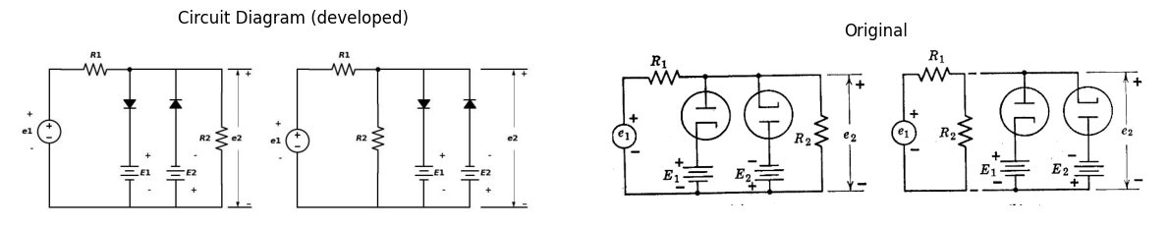
import schemdraw
import schemdraw.elements as e
import schemdraw as schem
import matplotlib.pyplot as plt
import matplotlib.image as mpimg
import numpy as np
# Create the figure and subplots
fig, axs = plt.subplots(1, 2, figsize=(12, 12))
d = schemdraw.Drawing()
l1 = d.add(e.Line().right().length(1))
R1 = d.add(e.Resistor().right().label([ R'$\frac{R1R2}{R1+R2}$'], ofst=0.2).length(3).dot())
D1 = d.add(e.Diode(fill=True).down())
R2 = d.add(e.Resistor().down().label([ '$r1$'], ofst=0.2).length(3).dot())
E1 = d.add(e.Battery().down().label(['+', '$E1$', '-'], ofst=-1.3))
l2 = d.add(e.Line().right().length(2.5).at(R1.end))
D2 = d.add(e.Diode(fill=True).down().reverse())
R3 = d.add(e.Resistor().down().label([ '$r2$'], ofst=0.2).length(3).dot())
E2 = d.add(e.Battery().down().label(['-', '$E2$', '+'], ofst=-1.3).reverse())
l3 = d.add(e.Line().left().length(6.5))
l4 = d.add(e.Line().up().length(3.5))
V1 = d.add(e.SourceV().up().label(['-', '$e1$', '+'], ofst=-1.8))
l4 = d.add(e.Line().up().length(2.5))
d += e.Arrow().down().length(4).linewidth(0.6).color('black').label(r'_', loc='end', color='black',ofst=(-.7, .4)). at((8.2,-5))
d += e.Arrow().up().length(3.5).linewidth(0.6).color('black').label('+',loc='end', color='black',ofst=-0.3). at((8.2,-3.5))
d += e.Arrow().up().length(4).linewidth(0.6).color('white').label('$e2$', loc='start', color='black',ofst=1.3). at((9.7,-4.))
d += e.Arrow().up().length(4).linewidth(0.6).color('white').label('$es=e1R2/(R1+R2)$', loc='start', color='black',ofst=1.3). at((.7,-4.))
d += e.Line().right().length(1).at((7.8,0)).color('black').linestyle('-')
d += e.Line().right().length(1).at((7.8,-9)).color('black').linestyle('-')
d.save('./Drawings/fig25c.jpg')
d.save('./Drawings/fig25c.svg')
# Load the saved PNG file into the subplot
img = mpimg.imread('./Drawings/fig25c.jpg')
axs[0].imshow(img)
axs[0].axis('off') # Hide axes for image display
axs[0].set_title('Circuit Diagram (developed)')
# **Subplot (1, 2): PNG Sample File**
img_sample = mpimg.imread('images-books/25c.png') # Load the PNG file
axs[1].imshow(img_sample)
axs[1].axis('off') # Hide axes for image display
axs[1].set_title('Original')
# Show the combined plots
plt.tight_layout()
plt.show()
d.save('./Drawings/fig25c.png')
d.save('./Drawings/fig25c.svg')
d.save('./Drawings/fig25c.jpg')
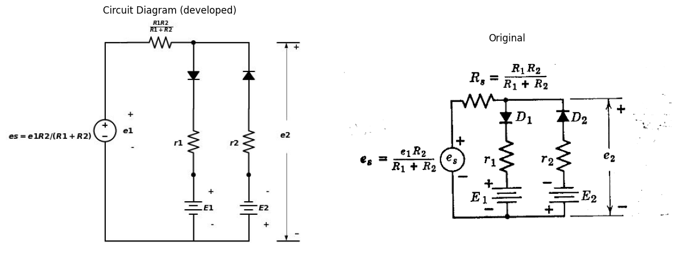
import matplotlib.pyplot as plt
import numpy as np
import schemdraw
import schemdraw.elements as elm
import matplotlib.image as mpimg
# Create the figure and subplots
fig, axs = plt.subplots(1, 2, figsize=(10, 10))
circuit = Circuit('Transitional characteristic1')
circuit.model('BAV21','D' ,IS = 1@u_mA ,BV = 293.10@u_V, IBV = 0.001293@u_A , RS = 10@u_Ohm )
Vi = circuit.V('i', '1', circuit.gnd, 0@u_V)
circuit.R(1, '1', '2', 500@u_Ohm)
circuit.D(1, '2','3', model = 'BAV21')
circuit.V(1, '3', circuit.gnd, 40@u_V)
circuit.D(2, '4', '2', model = 'BAV21')
circuit.V(2, circuit.gnd, '4', 40@u_V)
circuit.R(3, '2', circuit.gnd, 500@u_Ohm)
simulator = circuit.simulator(temperature=25, nominal_temperature=25)
analysis = simulator.dc(Vi=slice(-100, 100, .01))
axs[0].plot(analysis['1'], analysis['2'],'black',linewidth=5)
#ax1.annotate('', xy=(13,12), xytext=(14,-14 ), arrowprops=dict(arrowstyle='->'))
circuit = Circuit('Transitional characteristic1')
Vi = circuit.V('i', '1', circuit.gnd, 0@u_V)
circuit.R(1, '1', '2', 0@u_Ohm)
circuit.R(2, '2', circuit.gnd, 100@u_Ohm)
simulator = circuit.simulator(temperature=25, nominal_temperature=25)
analysis = simulator.dc(Vi=slice(-100, 100, .01))
axs[0].plot(analysis['1'], analysis['2'],'black',linewidth=3,linestyle ='--')
#plt.plot([-40, 0], [-40, -40], color='black', linestyle='--', label='Membership = 1')
circuit = Circuit('Transitional characteristic1')
Vi = circuit.V('i', '1', circuit.gnd, 0@u_V)
circuit.R(1, '1', '2', 1000@u_Ohm)
circuit.R(2, '2', circuit.gnd, 1000@u_Ohm)
simulator = circuit.simulator(temperature=25, nominal_temperature=25)
analysis = simulator.dc(Vi=slice(-40, 100, .01))
axs[0].plot(analysis['1'], analysis['2'],'black',linewidth=3,linestyle ='-.')
axs[0].axhline(0, color='black', linewidth=1)
axs[0].axvline(0, color='black', linewidth=1)
axs[0].grid()
axs[0].annotate('', xy=(-80, -40), xytext=(0, -40), arrowprops=dict(arrowstyle='->'))
axs[0].annotate('', xy=(80, 40), xytext=(0, 40), arrowprops=dict(arrowstyle='->'))
axs[0].annotate('', xy=(75, 40), xytext=(75, 0), arrowprops=dict(arrowstyle='->'))
axs[0].annotate('', xy=(-75, -40), xytext=(-75, 0), arrowprops=dict(arrowstyle='->'))
axs[0].annotate('', xy=(25, 10), xytext=(25, -10), arrowprops=dict(arrowstyle='->'))
axs[0].set_ylim(-100, 100)
axs[0].set_xlabel('e1 [V]')
axs[0].set_ylabel('e2 [V]')
axs[0].text( 75, 80, '$e2=e1$', ha='center', va='center')
axs[0].text( -78, -95, '$(r2/(r2+Rs)*(R2(R1+R2)))$', ha='center', va='center')
axs[0].text( 100, 55, '$e2=es$', ha='center', va='center')
axs[0].text( -.9, 40, '$E1$', ha='center', va='center')
axs[0].text( 1.8, -40, '$-E2$', ha='center', va='center')
axs[0].text( -75, 5.5, '$-E2(R1+R2)/R2$', ha='center', va='center')
axs[0].text( 78, -6, '$E2(R1+R2)/R2$', ha='center', va='center')
axs[0].text( 25, -15, '$slopeR2/(R1+R2)$', ha='center', va='center')
axs[0].text( -80, -25, '$slope$', ha='center', va='center')
img_sample = mpimg.imread('images-books/25d.png') # Load the PNG file
axs[1].imshow(img_sample)
axs[1].axis('off') # Hide axes for image display
axs[1].set_title('Original')
plt.tight_layout()
plt.show()
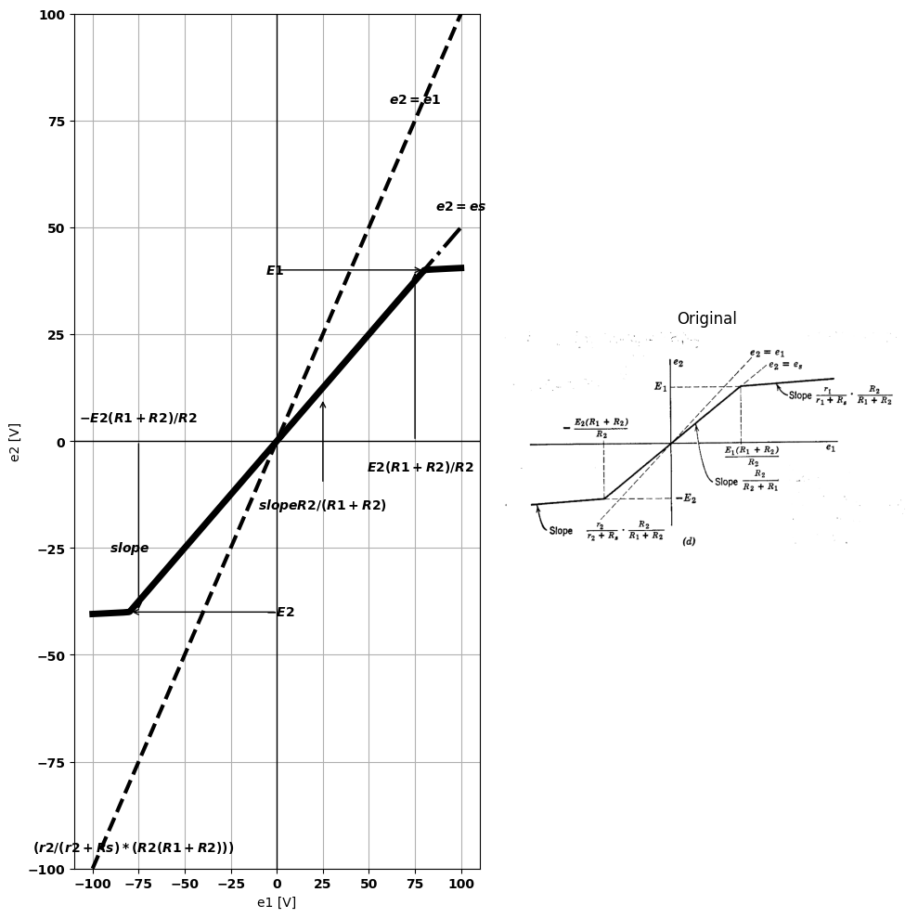
Fig. 3.25. Transfer curve for limiter
of the break point, as shown in Fig. 3.24 $\left(b\right)$.The circuit that determine the break-point coordinates are shown in point $1$ the first diode is open, and $i=0$.The curve therefore proceeds to the left along the horizontal axis. To the right of break point $2$ the first diode $D_{1}$ is closed, and the second diode $D_{2}$ is open, so that $\left(\frac{\Delta v}{\Delta i}\right) = R_1 + R_2 $. Between the two break points the circuit is linear, so the curve must be a straight line joining points $1$ and $2$.
Let us now illustrate the determination of a transfer curve by the break-point method. The circuit shown in Fig. 3.25$\left(a\right)$ is called a double-ended clipper or limiter. Before proceeding with the analysis, let us simplify the linear portion of the circuit, redrawn in $\left(b\right)$ to emphasize the separation of the linear and nonlinear parts. From the terminals at which $e_{2}$ is to be obtained, the source $e_{1}$, its internal resistance $R_{1}$, and the load resistance $R_{2}$ may be replaced by a new source voltage with a new internal resistance $R_{s}$, as shown in $\left(c\right)$. The voltage $e_{s}$, is the open-circuit effect of $e_{1}$, considering the two shunt-diode circuits as loads external to the linear circuit. The resistance $R_{s}$ is the apparent resistance between the output terminals.
For the circuit of Fig. 3.25$\left(c\right)$ each vacuum diode has been approxi- mated by an ideal rectifier in series with a small resistance. The break point for ideal diode $D_{1}$ occurs at $e_{2}+E_{1}$. At this point, $D_{2}$ must obviously be off; hence, $e_{2}=e_{s}=E_{1}$ and $e_{1}=E_{1}\left(R_{1}+R_{2}\right)/R_{2}$. For $e_{2}$ greater than $+E_{1}$, $D_{1}$ is $on$, $D_{2}$ is $off$, and the slope $\left(\frac{Δe_{2}}{Δe_{s}}\right)=r_{1}/\left(R_{s}+r_{1}\right)$. The break point for $D_{2}$ occurs at $−E_{2}$, and at this point $D_{1}$ is $off$; hence, $e_{2}=e_{s}=−E_{2}$ and $e_{1}=−E_{2}\left(R_{1}+R_{2}\right)/R_{2}$. For $e_{2}$ more negative than $−E_{2}$, diode $D_{2}$ is $on$, and slope $\left(\frac{Δe_{2}}{Δe_{s}}\right)=r_{2}/\left(R_{2}+r_{s}\right)$. The slope of the line joining the two break points can always be calculated from the break-point coordinates, but in this case the circuit is so simple (both diodes are $off$) that the value can be found by inspection.

12.1 3.13 Simple Multidiode Circuits
When a diode circuit contains no internal batteries or current sources, all break points occur at the origin. The analysis problem then becomes. relatively simple, even when more than two ideal diodes are present. For illustration, consider the three full-wave rectifier circuits shown in Fig. 3.26. These circuits are so named because both positive and negative values of the input voltage $e_{1}$ produce a positive output voltage $e_{2}$. If a sinusoidal waveform of voltage is applied at $e_{1}$, the output $e_{2}$ consists of adjacent half-sinusoids of the same polarity.
Inspection of Fig. 3.26 indicates that the transfer curve for all three circuits should have even symmetry, that is, $ƒ\left(−e_{1}\right)=f\left(+e_{1}\right)$. The circuits shown in $\left(a\right)$, $\left(b\right)$, and $\left(c\right)$ have successively greater transfer slopes, as indicated by the corresponding curves of $e_{2}$ vs. $e_{1}$. However, the slope of the transfer curve is not the only basis for judging the relative merits of the three circuits. The input resistance $R_{i}n=e_{1}/i_{1}$ lies between $R_{1}$ and $2R_{1}$ for circuit $\left(a\right)$ and between $R_{1}/2$ and $R_{1}$ for
circuit $\left(b\right)$. Hence more power must be supplied to circuit $\left(b\right)$ for the same input voltage $e_{1}$. Circuit $\left(c\right)$ provides maximum transfer slope
import schemdraw
import schemdraw.elements as e
import schemdraw as schem
import matplotlib.pyplot as plt
import matplotlib.image as mpimg
import numpy as np
# Create the figure and subplots
fig, axs = plt.subplots(1, 2, figsize=(12, 12))
d = schemdraw.Drawing()
e1 = d.add(e.SourceV().up().label(['-','$e_1$','+']))
l1 = d.add(e.Line().up().length(1))
l2 = d.add(e.Line().right().length(3).dot())
R1 = d.add(e.Resistor().down().label('R1').dot())
R2 = d.add(e.Resistor().down().at(R1.end).label('R1'))
l3 = d.add(e.Line().left().length(3))
l4 = d.add(e.Line().up().length(2))
d += e.lines.CurrentLabelInline().at(l2).right().label('$i1$').color('black')
d.move(3, 4)
l5 = d.add(e.Line().right().length(5))
D1 = d.add(e.Diode(fill=True).down().dot())
D2 = d.add(e.Diode(fill=True).down().reverse())
l5 = d.add(e.Line().left().length(5).dot())
d.move(5, 3)
l5 = d.add(e.Line().left().length(1).dot(open=True))
R2 = d.add(e.Resistor().left().label('R2').dot(open=True).label('-''<-----' '$e_2$' '----->''+' ,'bottom'))
l6 = d.add(e.Line().left().length(1))
d += e.Line().down().length(1).at((4,0.8)).color('black').linestyle('--')
d += e.Line().down().length(1).at((7,0.8)).color('black').linestyle('--')
d += e.Arrow().right().at((2.4,-2.4)).color('white').label('(a)', loc='bottom', color='black')
d.save('./Drawings/fig26a.jpg')
d.save('./Drawings/fig26a.svg')
# Load the saved PNG file into the subplot
img = mpimg.imread('./Drawings/fig26a.jpg')
axs[0].imshow(img)
axs[0].axis('off') # Hide axes for image display
axs[0].set_title('Circuit Diagram (developed)')
# **Subplot (1, 2): PNG Sample File**
img_sample = mpimg.imread('images-books/26a.png') # Load the PNG file
axs[1].imshow(img_sample)
axs[1].axis('off') # Hide axes for image display
axs[1].set_title('Original')
# Show the combined plots
plt.tight_layout()
plt.show()
d.save('./Drawings/fig26a.png')
d.save('./Drawings/fig26a.svg')
d.save('./Drawings/fig26a.jpg')
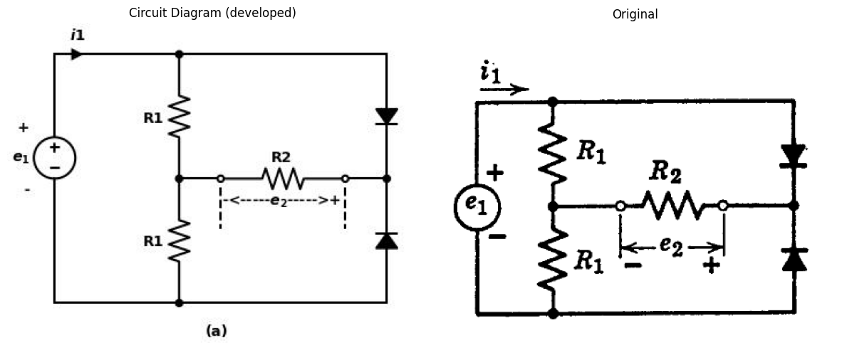
import matplotlib.pyplot as plt
import numpy as np
import schemdraw
import schemdraw.elements as elm
import matplotlib.image as mpimg
from PySpice.Spice.Netlist import Circuit
# Create the figure and subplots
fig, axs = plt.subplots(1, 2, figsize=(10, 10))
k = 1
phi_0 = 1
E = 1
# محدوده برای eb
eb_neg = np.linspace(-1, 0, 200)
eb_pos = np.linspace(0, 1, 200)
I_0 = k * phi_0**(1.5) # مقدار ثابت I0
ib_neg = I_0 * np.exp(-eb_neg / E)
ib_pos = k * (eb_pos + phi_0)**(1.5)
eb = np.concatenate((eb_neg, eb_pos))
ib = np.concatenate((ib_neg, ib_pos))
axs[0].plot(eb, ib, label='$i_b$ در مقابل $e_b$', color='black')
axs[0].axhline(y=I_0, color='grey', linestyle='-', label='$I_0$')
axs[0].axhline(y=0, color='black', linewidth=0.5)
axs[0].axvline(x=0, color='black', linewidth=0.5)
axs[0].text(0.05, 1.5, r'$slope \frac{R2}{R1+2R2}<1/2$', fontsize=12)
img_sample = mpimg.imread('images-books/26a1.png') # Load the PNG file
axs[1].imshow(img_sample)
axs[1].axis('off') # Hide axes for image display
axs[1].set_title('Original')
# Show the combined plots
#d.save('./Drawings/fig26a1.png')
#d.save('./Drawings/fig26a1.svg')
#plt.tight_layout()
#plt.show()
Text(0.5, 1.0, 'Original')
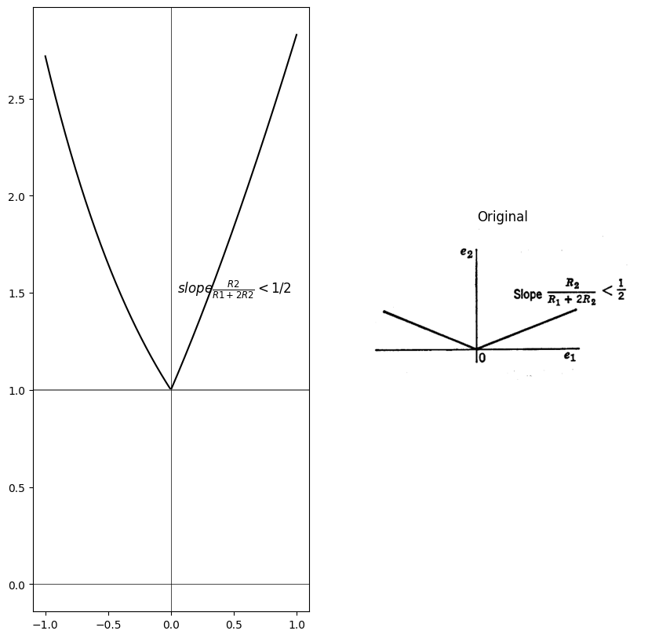
import schemdraw
import schemdraw.elements as e
import schemdraw as schem
import matplotlib.pyplot as plt
import matplotlib.image as mpimg
import numpy as np
# Create the figure and subplots
fig, axs = plt.subplots(1, 2, figsize=(12, 12))
d = schemdraw.Drawing()
e1 = d.add(e.SourceV().up().label(['-','$e_1$','+']))
l1 = d.add(e.Line().up().length(1))
l2 = d.add(e.Line().right().length(3).dot())
D2 = d.add(e.Diode(fill=True).down().reverse().dot())
R2 = d.add(e.Resistor().down().label('R1'))
l3 = d.add(e.Line().left().length(3))
l4 = d.add(e.Line().up().length(2))
d += e.lines.CurrentLabelInline().at(l2).right().label('$i1$').color('black')
d.move(3, 4)
l5 = d.add(e.Line().right().length(5))
D1 = d.add(e.Diode(fill=True).down().dot())
R2 = d.add(e.Resistor().down().label('R1'))
l5 = d.add(e.Line().left().length(5).dot())
d.move(5, 3)
l5 = d.add(e.Line().left().length(1).dot(open=True))
R2 = d.add(e.Resistor().left().label('R2').dot(open=True).label('-''<-----' '$e_2$' '----->''+' ,'bottom'))
l6 = d.add(e.Line().left().length(1))
d += e.Line().down().length(1).at((4,0.8)).color('black').linestyle('--')
d += e.Line().down().length(1).at((7,0.8)).color('black').linestyle('--')
d += e.Arrow().right().at((2.4,-2.4)).color('white').label('(b)', loc='bottom', color='black')
d.save('./Drawings/fig26b.jpg')
d.save('./Drawings/fig26b.svg')
# Load the saved PNG file into the subplot
img = mpimg.imread('./Drawings/fig26b.jpg')
axs[0].imshow(img)
axs[0].axis('off') # Hide axes for image display
axs[0].set_title('Circuit Diagram (developed)')
# **Subplot (1, 2): PNG Sample File**
img_sample = mpimg.imread('images-books/26b.png') # Load the PNG file
axs[1].imshow(img_sample)
axs[1].axis('off') # Hide axes for image display
axs[1].set_title('Original')
# Show the combined plots
plt.tight_layout()
plt.show()
d.save('./Drawings/fig26b.png')
d.save('./Drawings/fig26b.svg')
d.save('./Drawings/fig26b.jpg')
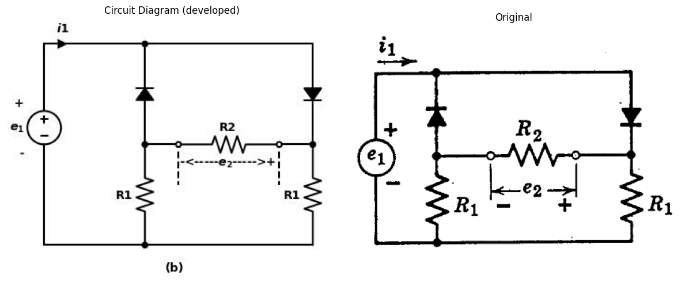
import matplotlib.pyplot as plt
import numpy as np
import schemdraw
import schemdraw.elements as elm
import matplotlib.image as mpimg
# Create the figure and subplots
fig, axs = plt.subplots(1, 2, figsize=(10, 10))
circuit = Circuit('Transitional characteristic1')
circuit.model('BAV21','D' ,IS = 100@u_nA ,BV = 293.10@u_V, IBV = 0.001293@u_A , RS = 1@u_Ohm )
Vi = circuit.V('i', '1', circuit.gnd, 0@u_V)
circuit.R(1, '1', '2', 30@u_Ohm)
circuit.R(2, '2', circuit.gnd, 70@u_Ohm)
circuit.D(1, '1','3', model = 'BAV21')
circuit.R(3, '2', '3', -15@u_Ohm)
circuit.D(2, circuit.gnd,'3', model = 'BAV21')
simulator = circuit.simulator(temperature=25, nominal_temperature=25)
analysis = simulator.dc(Vi=slice(-100, 100, .01))
axs[0].plot(analysis['1'], analysis['2'],'black',linewidth=3,linestyle ='-')
axs[0].text( 40, 40, '$Slope R2/(R1+2R2)<1$', ha='center', va='center')
axs[0].axhline(0, color='black', linewidth=1)
axs[0].axvline(0, color='black', linewidth=1)
axs[0].set_ylim(-100, 100)
axs[0].set_xlabel('e1 [V]')
axs[0].set_ylabel('e2 [V]')
figure.savefig('./Drawings/fig26b1.jpg')
figure.savefig('./Drawings/fig26b1.svg')
img_sample = mpimg.imread('images-books/26b1.png') # Load the PNG file
axs[1].imshow(img_sample)
axs[1].axis('off') # Hide axes for image display
axs[1].set_title('Original')
# Show the combined plots
d.save('./Drawings/fig26b1.png')
d.save('./Drawings/fig26b1.svg')
plt.tight_layout()
plt.show()
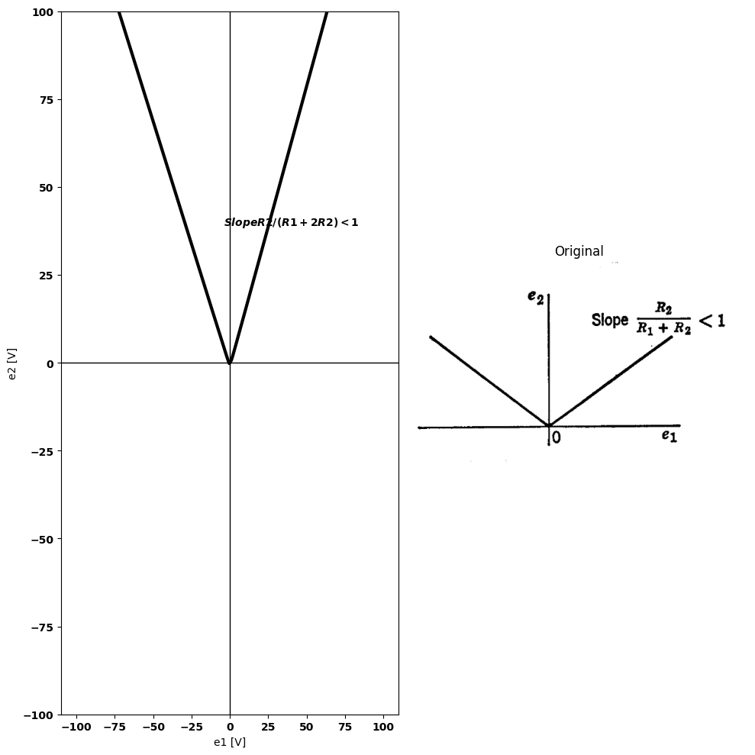
import schemdraw
import schemdraw.elements as e
import schemdraw as schem
import matplotlib.pyplot as plt
import matplotlib.image as mpimg
import numpy as np
# Create the figure and subplots
fig, axs = plt.subplots(1, 2, figsize=(12, 12))
d = schemdraw.Drawing()
e1 = d.add(e.SourceV().up().label(['-','$e_1$','+']))
l1 = d.add(e.Line().up().length(1))
l2 = d.add(e.Line().right().length(3).dot())
D2 = d.add(e.Diode(fill=True).down().reverse().dot())
D1 = d.add(e.Diode(fill=True).down())
l3 = d.add(e.Line().left().length(3))
l4 = d.add(e.Line().up().length(2))
d += e.lines.CurrentLabelInline().at(l2).right().label('$i1$').color('black')
d.move(3, 4)
l5 = d.add(e.Line().right().length(5))
D1 = d.add(e.Diode(fill=True).down().dot())
D2 = d.add(e.Diode(fill=True).down().reverse())
l5 = d.add(e.Line().left().length(5).dot())
d.move(5, 3)
l5 = d.add(e.Line().left().length(1).dot(open=True))
R2 = d.add(e.Resistor().left().label('R2').dot(open=True).label('-''<-----' '$e_2$' '----->''+' ,'bottom'))
l6 = d.add(e.Line().left().length(1))
d += e.Line().down().length(1).at((4,0.8)).color('black').linestyle('--')
d += e.Line().down().length(1).at((7,0.8)).color('black').linestyle('--')
d += e.Arrow().right().at((2.4,-2.4)).color('white').label('(c)', loc='bottom', color='black')
d.save('./Drawings/fig3-26c.jpg')
d.save('./Drawings/fig3-26c.svg')
# Load the saved PNG file into the subplot
img = mpimg.imread('./Drawings/fig3-26c.jpg')
axs[0].imshow(img)
axs[0].axis('off') # Hide axes for image display
axs[0].set_title('Circuit Diagram (developed)')
# **Subplot (1, 2): PNG Sample File**
img_sample = mpimg.imread('images-books/3-26c.png') # Load the PNG file
axs[1].imshow(img_sample)
axs[1].axis('off') # Hide axes for image display
axs[1].set_title('Original')
# Show the combined plots
plt.tight_layout()
plt.show()
d.save('./Drawings/fig3-26c.png')
d.save('./Drawings/fig3-26c.svg')
d.save('./Drawings/fig3-26c.jpg')
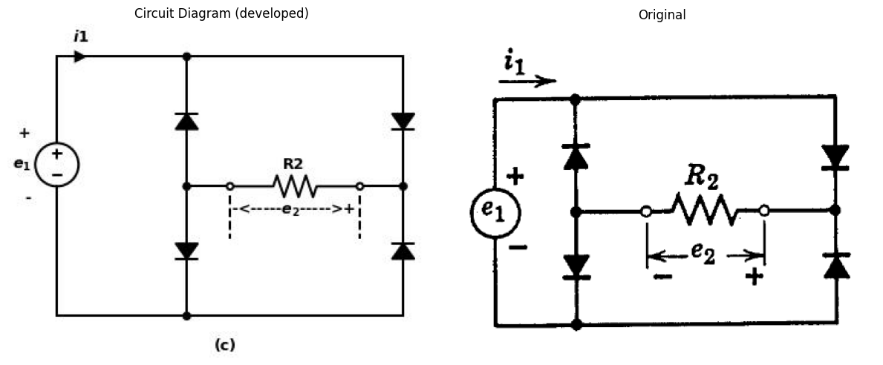
import matplotlib.pyplot as plt
import numpy as np
import schemdraw
import schemdraw.elements as elm
import matplotlib.image as mpimg
# Create the figure and subplots
fig, axs = plt.subplots(1, 2, figsize=(10, 10))
circuit = Circuit('Transitional characteristic1')
circuit.model('BAV21','D' ,IS = 100@u_nA ,BV = 293.10@u_V, IBV = 0.001293@u_A , RS = .1@u_Ohm )
Vi = circuit.V('i', '1', circuit.gnd, 0@u_V)
circuit.R(1, '1', '2', 50@u_Ohm)
circuit.R(2, '2', circuit.gnd, 200@u_Ohm)
circuit.D(1, '1','3', model = 'BAV21')
circuit.R(3, '2', '3', -25@u_Ohm)
circuit.D(2, circuit.gnd,'3', model = 'BAV21')
simulator = circuit.simulator(temperature=25, nominal_temperature=25)
analysis = simulator.dc(Vi=slice(-100, 100, .01))
axs[0].plot(analysis['1'], analysis['2'],'black',linewidth=3,linestyle ='-')
axs[0].text( 20, 70, '$Slope 1$', ha='center', va='center')
axs[0].axhline(0, color='black', linewidth=1)
axs[0].axvline(0, color='black', linewidth=1)
axs[0].set_ylim(-100, 100)
axs[0].set_xlabel('e1 [V]')
axs[0].set_ylabel('e2 [V]')
figure.savefig('./Drawings/fig3-26c1.jpg')
figure.savefig('./Drawings/fig3-26c1.svg')
img_sample = mpimg.imread('images-books/3-26c1.png') # Load the PNG file
axs[1].imshow(img_sample)
axs[1].axis('off') # Hide axes for image display
axs[1].set_title('Original')
# Show the combined plots
d.save('./Drawings/fig3-26c1.png')
d.save('./Drawings/fig3-26c1.svg')
plt.tight_layout()
plt.show()
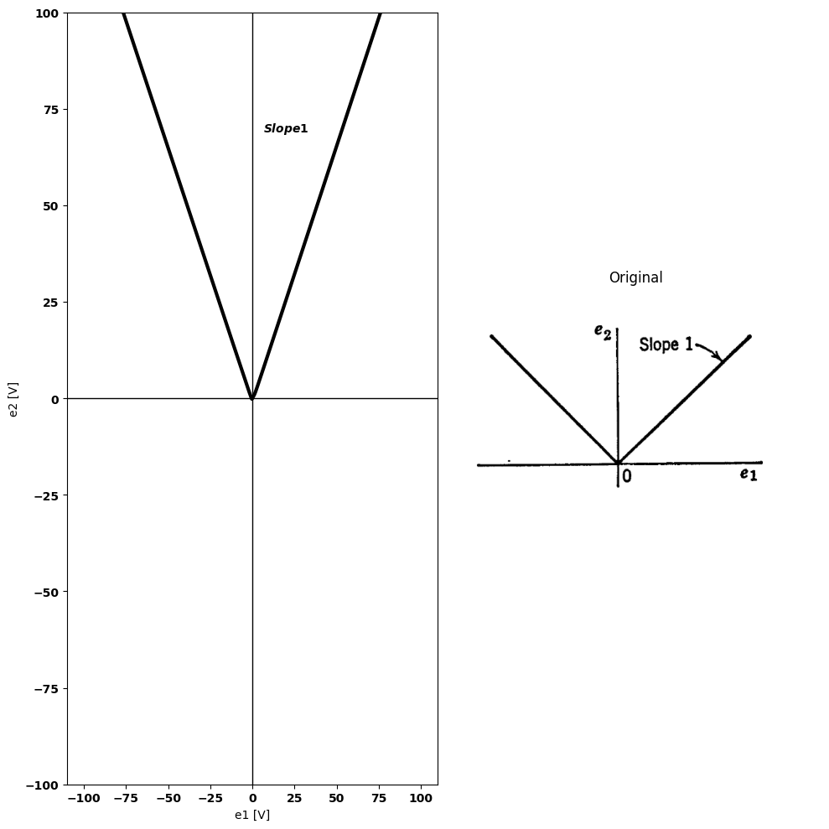
import matplotlib.pyplot as plt
from matplotlib import rcParams
import PySpice.Logging.Logging as Logging
logger = Logging.setup_logging()
from PySpice.Doc.ExampleTools import find_libraries
from PySpice.Probe.Plot import plot
from PySpice.Spice.Library import SpiceLibrary
from PySpice.Spice.Netlist import Circuit
from PySpice.Unit import *
rcParams['font.weight'] = 'bold'
circuit = Circuit('Full-wave rectifier')
circuit.model('BAV21','D' ,IS = 1@u_mA ,BV = 293.10@u_V, IBV = 0.001293@u_A , RS = 0.001@u_Ohm)
circuit.SinusoidalVoltageSource(1, '1', '2', amplitude=20@u_V)
circuit.D(1, circuit.gnd,'1', model = 'BAV21')
circuit.D(2, circuit.gnd,'2', model = 'BAV21')
circuit.D(3, '1','o', model = 'BAV21')
circuit.D(4, '2','o', model = 'BAV21')
circuit.R(1, 'o',circuit.gnd, 1@u_Ohm)
figure, ax1 = plt.subplots(figsize=(15, 5))
simulator = circuit.simulator(temperature=25, nominal_temperature=25)
analysis = simulator.transient(step_time=0.1@u_ms, end_time=0.08@u_s)
ax1.plot(analysis['1']-analysis['2'],'black',linewidth=5)
plt.axhline(0, color='black',linewidth=1, ls='-')
plt.axvline(0, color='black',linewidth=1, ls='-')
figure, ax1 = plt.subplots(figsize=(15, 5))
simulator = circuit.simulator(temperature=25, nominal_temperature=25)
analysis = simulator.transient(step_time=0.1@u_ms, end_time=0.08@u_s)
ax1.plot(analysis['o'],'black',linewidth=5)
plt.axhline(0, color='black',linewidth=1, ls='-')
plt.axvline(0, color='black',linewidth=1, ls='-')
ax1.set_title('Input-Output Voltage')
ax1.set_xlabel('T [mS]')
ax1.set_ylabel('e2 [V]')
fig = plt.figure(figsize=(5, 3))
img = plt.imread('images-books/3-26d.png')
plt.imshow(img)
plt.axis('off')
plt.title('\nReference image from the book:', fontsize=8, pad=10,loc='left')
plt.show()
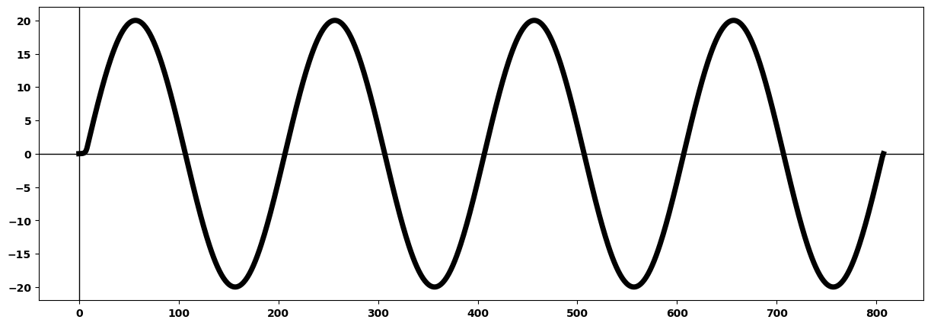
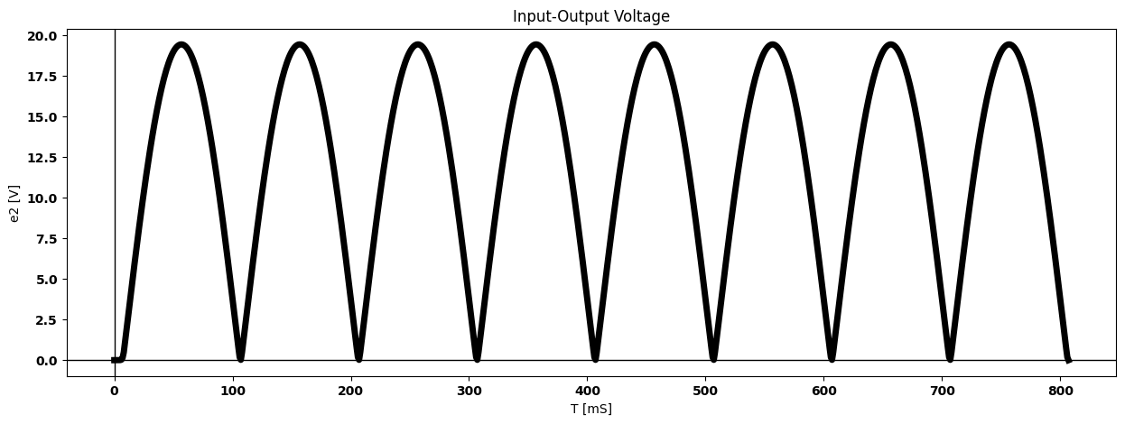
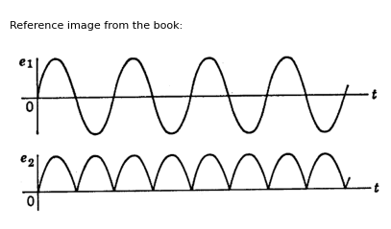
Fig. 3.26. Full-wave rectifier circuits.
(unity) and an arbitrary input resistance $R_{i}n=R_{2}$, at the cost of two additional diodes.
Waveforms of input and corresponding output are shown in Fig. 3.26 $\left(d\right)$ for the circuit of $\left(c\right)$. The output for circuit $\left(a\right)$ or $\left(b\right)$ would be similar in form but with smaller amplitude. The full-wave rectifier
import schemdraw
import schemdraw.elements as e
import schemdraw as schem
import matplotlib.pyplot as plt
import matplotlib.image as mpimg
import numpy as np
# Create the figure and subplots
fig, axs = plt.subplots(1, 2, figsize=(12, 12))
d = schemdraw.Drawing()
e1 = d.add(e.SourceV().up().label(['-','$e_1$','+']))
l1 = d.add(e.Line().up().length(6))
l2 = d.add(e.Line().right().length(5))
D1 = d.add(e.Diode(fill=True).right().reverse().label('D1'))
l3 = d.add(e.Line().down().length(1.5).dot())
D2 = d.add(e.Diode(fill=True).left().label('D2'))
l4 = d.add(e.Line().left().length(3))
l5 = d.add(e.Line().down().length(4.5))
e2 = d.add(e.SourceV().down().reverse().label(['+','$e_2$','-']).dot())
l6 = d.add(e.Line().left().length(2))
l7 = d.add(e.Line().right().length(4))
e3 = d.add(e.SourceV().up().label(['-','$e_3$','+']))
l8 = d.add(e.Line().up().length(3))
l9 = d.add(e.Line().right().length(1))
D3 = d.add(e.Diode(fill=True).right().reverse().label('D3').dot())
l10 = d.add(e.Line().up().length(1.5))
R = d.add(e.Resistor().down().at(D3.end).label('R'))
E = d.add(e.Battery().down().label(['+', '$E$', '-'], ofst=-1.3).dot())
l11 = d.add(e.Line().left().length(4))
l12 = d.add(e.Line().right().length(3).at(E.end).dot(open=True))
l13 = d.add(e.Line().right().length(3).at(D3.end).dot(open=True))
d += e.Arrow().up().length(1).linewidth(0.6).color('white').label('$e_0$', loc='start', color='black',ofst=0.3). at((11.5,3))
d += e.Arrow().up().length(0.8).linewidth(0.6).color('black').label('+',loc='end', color='black',ofst=0.4). at((11,4.6))
d += e.Arrow().down().length(0.8).linewidth(0.6).color('black').label(r'_', loc='end', color='black',ofst=(-0.3,-0.5)). at((11,1.3))
d += e.Arrow().right().at((3.4,-0.4)).color('white').label('(a)', loc='bottom', color='black')
d.save('./Drawings/fig3-27a.jpg')
d.save('./Drawings/fig3-27a.svg')
# Load the saved PNG file into the subplot
img = mpimg.imread('./Drawings/fig3-27a.jpg')
axs[0].imshow(img)
axs[0].axis('off') # Hide axes for image display
axs[0].set_title('Circuit Diagram (developed)')
# **Subplot (1, 2): PNG Sample File**
img_sample = mpimg.imread('images-books/3-27a.png') # Load the PNG file
axs[1].imshow(img_sample)
axs[1].axis('off') # Hide axes for image display
axs[1].set_title('Original')
# Show the combined plots
plt.tight_layout()
plt.show()
d.save('./Drawings/fig3-27a.png')
d.save('./Drawings/fig3-27a.svg')
d.save('./Drawings/fig3-27a.jpg')
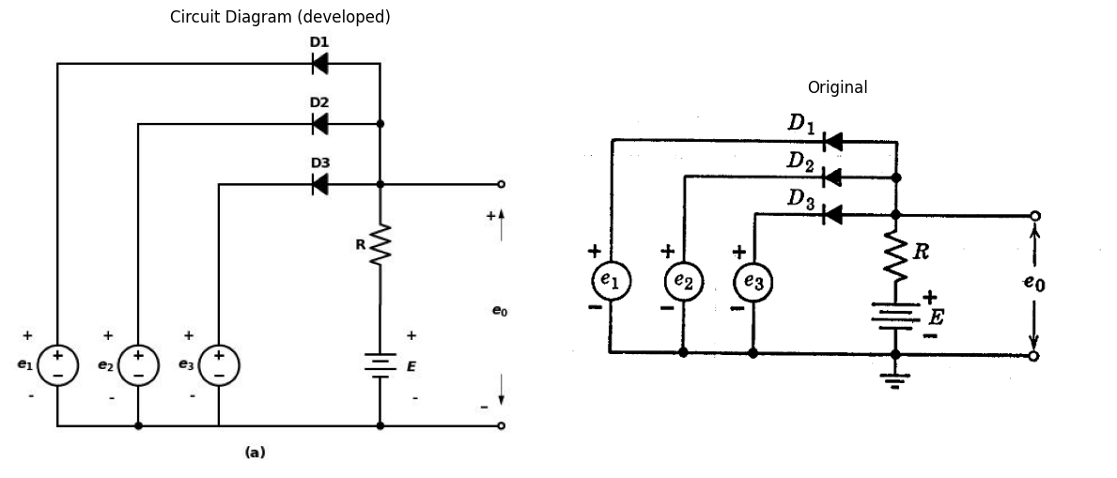
import matplotlib.pyplot as plt
import numpy as np
from matplotlib import rcParams
import PySpice.Logging.Logging as Logging
from PySpice.Probe.Plot import plot
from PySpice.Spice.Library import SpiceLibrary
from PySpice.Spice.Netlist import Circuit
from PySpice.Unit import *
logger = Logging.setup_logging()
#define circuits
circuit = Circuit('Pulse Sources and Diodes')
circuit.model('BAV21','D' ,IS = 100@u_uA ,BV = 293.10@u_V, IBV = 0.001293@u_A , RS = 0.001@u_Ohm)
# pulse sourse
pulse1 = circuit.PulseVoltageSource('V1', '1', circuit.gnd, initial_value=0@u_V, pulsed_value=2@u_V, pulse_width=1@u_ms, period=5@u_ms)
pulse2 = circuit.PulseVoltageSource('V2', '2', circuit.gnd, initial_value=0@u_V, pulsed_value=2@u_V, pulse_width=2@u_ms, period=10@u_ms)
pulse3 = circuit.PulseVoltageSource('V3', '3', circuit.gnd, initial_value=0@u_V, pulsed_value=2@u_V ,pulse_width=0.5@u_ms, period=10@u_ms)
#pulse2 = circuit.PulseVoltageSource
circuit.D(1, 'N1', '1', model='BAV21')
circuit.D(2, 'N1', '2', model='BAV21')
circuit.D(3, 'N1', '3', model='BAV21')
circuit.R(1, 'N1', '4', 10@u_Ohm)
circuit.V(1, '4', circuit.gnd, 2@u_V)
#simulation
simulator = circuit.simulator(temperature=25, nominal_temperature=25)
analysis = simulator.transient(step_time=1@u_us, end_time=20@u_ms)
# plot
fig, (ax1, ax2, ax3, ax4) = plt.subplots(4, 1, figsize=(10, 6), sharex=True)
ax1.plot(analysis.time, analysis['1'], 'black', linewidth=2, label='e 1')
ax1.set_ylabel('e1 [V]', color='black', weight='black', fontsize=10)
ax1.text(0.0062,1.8, '$---E$', fontsize=10)
ax2.text(0.0025,1.8, '$---E$', fontsize=10)
ax3.text(0.012,1.8, '$---E$', fontsize=10)
ax4.text(0.0122,1.8, '$---E$', fontsize=10)
ax1.legend()
ax2.plot(analysis.time, analysis['2'], 'black', linewidth=2, label='e 2')
ax2.set_ylabel('e2 [V]', color='black', weight='black', fontsize=10)
ax2.legend()
ax3.plot(analysis.time, analysis['3'], 'black', linewidth=2, label='e 3')
ax3.set_ylabel('e3 [V]', color='black', weight='black', fontsize=10)
ax3.legend()
ax4.plot(analysis.time, analysis['N1'], 'black', linewidth=2, label='Vo')
ax4.set_xlabel('Time [s]', color='black', weight='black', fontsize=10)
ax4.set_ylabel('eo [V]', color='black', weight='black', fontsize=10)
ax4.legend()
fig = plt.figure(figsize=(5, 3))
img = plt.imread('images-books/3-27b.png')
plt.imshow(img)
plt.axis('off')
plt.title('\nReference image from the book:', fontsize=8, pad=10,loc='left')
plt.show()
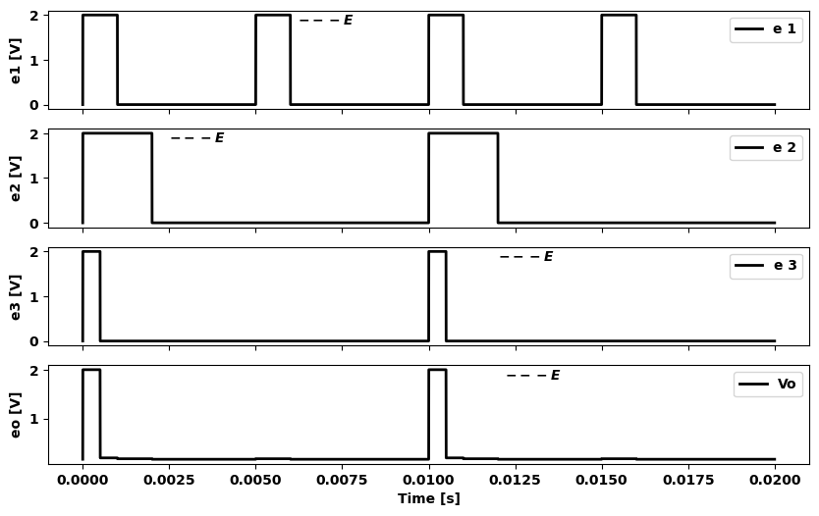
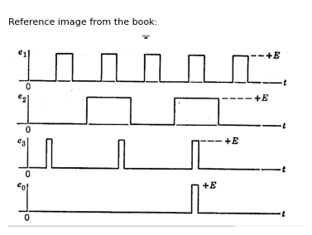
import matplotlib.pyplot as plt
import numpy as np
from matplotlib import rcParams
import PySpice.Logging.Logging as Logging
from PySpice.Probe.Plot import plot
from PySpice.Spice.Library import SpiceLibrary
from PySpice.Spice.Netlist import Circuit
from PySpice.Unit import *
logger = Logging.setup_logging()
circuit = Circuit('Pulse Sources and Diodes')
circuit.model('BAV21','D' ,IS = 100@u_uA ,BV = 293.10@u_V, IBV = 0.001293@u_A , RS = 0.001@u_Ohm)
pulse1 = circuit.PulseVoltageSource('V1', '1', circuit.gnd, initial_value=0@u_V, pulsed_value=2@u_V, pulse_width=1@u_ms, period=4@u_ms)
circuit.SinusoidalVoltageSource('V2', '2', circuit.gnd, amplitude=2@u_V, offset=2@u_V)
circuit.D(1, 'N1', '1', model='BAV21')
circuit.D(2, 'N1', '2', model='BAV21')
circuit.R(1, 'N1', '3', 10@u_Ohm)
circuit.V(1, '3', circuit.gnd, 2@u_V)
simulator = circuit.simulator(temperature=25, nominal_temperature=25)
analysis = simulator.transient(step_time=1@u_us, end_time=30@u_ms)
fig, (ax1, ax2, ax3) = plt.subplots(3, 1, figsize=(10, 6), sharex=True)
ax1.plot(analysis.time, analysis['1'], 'black', linewidth=2, label='e 1')
ax1.set_ylabel('e1 [V]', color='black', weight='black', fontsize=10)
ax1.legend()
ax2.plot(analysis.time, analysis['2'], 'black', linewidth=2, label='e 2')
ax2.set_ylabel('e2 [V]', color='black', weight='black', fontsize=10)
ax2.legend()
ax3.plot(analysis.time, analysis['N1'], 'black', linewidth=2, label='Vo')
ax3.set_xlabel('Time [s]', color='black', weight='black', fontsize=10)
ax3.set_ylabel('eo [V]', color='black', weight='black', fontsize=10)
ax3.legend()
fig = plt.figure(figsize=(5, 3))
img = plt.imread('images-books/3-27c.png')
plt.imshow(img)
plt.axis('off')
plt.title('\nReference image from the book:', fontsize=8, pad=10,loc='left')
plt.show()
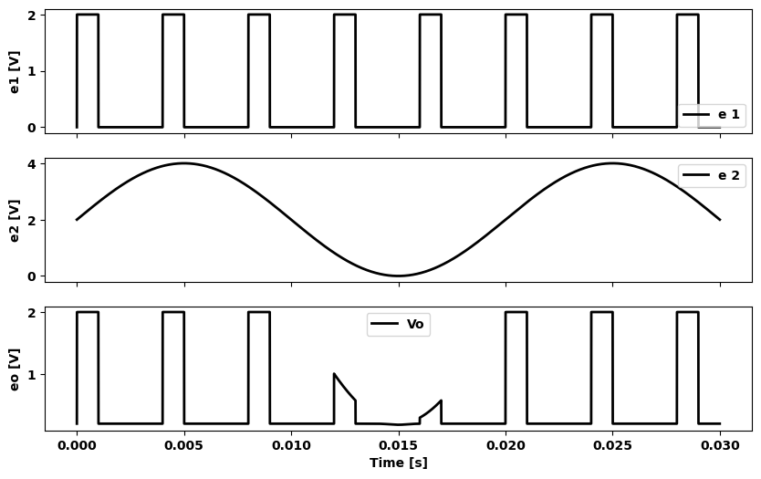
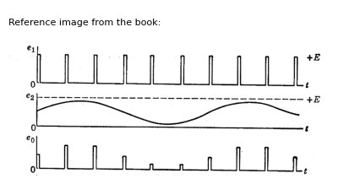
Fig. 3.27. Diode gate circuit (AND circuit)
circuits described here, or variations thereof, find many applications in electronic systems.
Another class of resistive diode circuits, called gate circuits, are used to permit or prevent the passage of electrical signals. Switching circuits
of all kinds and digital computers, in particular, use gate circuits to perform a variety of operations.
The gate circuit shown in Fig. 3.27 $\left(a\right)$ is called an AND circuit because it requires coincidence of signals at $e_{1},e_{2}$, and $е_{3}$ to produce an output. Examination of the circuit shows that in the absence of inputs all diodes conduct (and the output voltage is zero) if the diodes
import schemdraw
import schemdraw.elements as e
import schemdraw as schem
import matplotlib.pyplot as plt
import matplotlib.image as mpimg
import numpy as np
# Create the figure and subplots
fig, axs = plt.subplots(1, 2, figsize=(12, 12))
d = schemdraw.Drawing()
e1 = d.add(e.SourceV().up().label(['-','$e_1$','+']))
l1 = d.add(e.Line().up().length(6))
l2 = d.add(e.Line().right().length(5))
D1 = d.add(e.Diode(fill=True).right().label('D1'))
l3 = d.add(e.Line().down().length(1.5).dot())
D2 = d.add(e.Diode(fill=True).left().reverse().label('D2'))
l4 = d.add(e.Line().left().length(3))
l5 = d.add(e.Line().down().length(4.5))
e2 = d.add(e.SourceV().down().reverse().label(['+','$e_2$','-']).dot())
l6 = d.add(e.Line().left().length(2))
l7 = d.add(e.Line().right().length(4))
e3 = d.add(e.SourceV().up().label(['-','$e_3$','+']))
l8 = d.add(e.Line().up().length(3))
l9 = d.add(e.Line().right().length(1))
D3 = d.add(e.Diode(fill=True).right().label('D3').dot())
l10 = d.add(e.Line().up().length(1.5))
R = d.add(e.Resistor().down().at(D3.end).label('R'))
E = d.add(e.Battery().down().label(['+', '$E$', '-'], ofst=-1.3).dot())
l11 = d.add(e.Line().left().length(4))
l12 = d.add(e.Line().right().length(3).at(E.end).dot(open=True))
l13 = d.add(e.Line().right().length(3).at(D3.end).dot(open=True))
d += e.Arrow().up().length(1).linewidth(0.6).color('white').label('$e_0$', loc='start', color='black',ofst=0.3). at((11.5,3))
d += e.Arrow().up().length(0.8).linewidth(0.6).color('black').label('+',loc='end', color='black',ofst=0.4). at((11,4.6))
d += e.Arrow().down().length(0.8).linewidth(0.6).color('black').label(r'_', loc='end', color='black',ofst=(-0.3,-0.5)). at((11,1.3))
d += e.Arrow().right().at((3.4,-0.4)).color('white').label('(a)', loc='bottom', color='black')
d.save('./Drawings/fig3-28a.jpg')
d.save('./Drawings/fig3-28a.svg')
# Load the saved PNG file into the subplot
img = mpimg.imread('./Drawings/fig3-28a.jpg')
axs[0].imshow(img)
axs[0].axis('off') # Hide axes for image display
axs[0].set_title('Circuit Diagram (developed)')
# **Subplot (1, 2): PNG Sample File**
img_sample = mpimg.imread('images-books/3-28a.png') # Load the PNG file
axs[1].imshow(img_sample)
axs[1].axis('off') # Hide axes for image display
axs[1].set_title('Original')
# Show the combined plots
plt.tight_layout()
plt.show()
d.save('./Drawings/fig3-28a.png')
d.save('./Drawings/fig3-28a.svg')
d.save('./Drawings/fig3-28a.jpg')
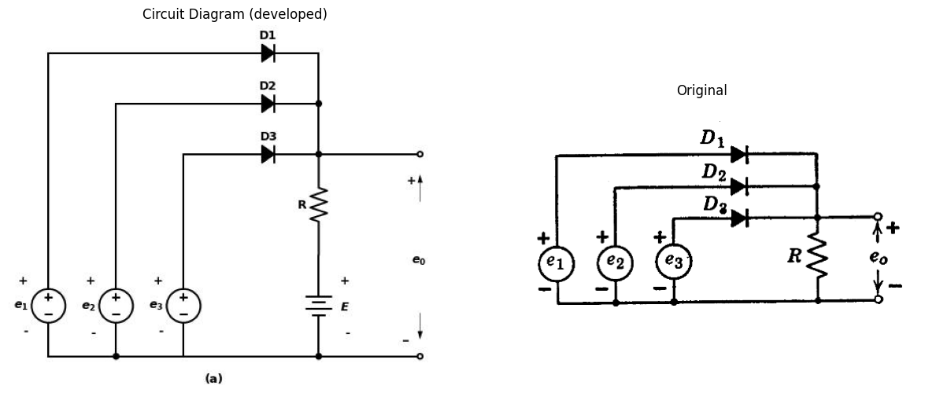
import matplotlib.pyplot as plt
import numpy as np
from matplotlib import rcParams
import PySpice.Logging.Logging as Logging
from PySpice.Probe.Plot import plot
from PySpice.Spice.Library import SpiceLibrary
from PySpice.Spice.Netlist import Circuit
from PySpice.Unit import *
logger = Logging.setup_logging()
#define circuits
circuit = Circuit('Pulse Sources and Diodes')
circuit.model('D', 'D', IS=4@u_nA, N=1.906, BV=110@u_V, IBV=0.0001@u_V, VJ=0.7@u_V, CJO=7.048E-13, RS=0.01@u_Ohm, TT=3.48E-9)
# pulse sourse
pulse1 = circuit.PulseVoltageSource('V1', '1', circuit.gnd, initial_value=0@u_V, pulsed_value=2@u_V, pulse_width=2@u_ms, period=10@u_ms)
pulse2 = circuit.PulseVoltageSource('V2', '2', circuit.gnd, initial_value=0@u_V, pulsed_value=1.5@u_V, pulse_width=0.5@u_ms, period=2@u_ms)
pulse3 = circuit.PulseVoltageSource('V3', '3', circuit.gnd, initial_value=0@u_V, pulsed_value=1.3@u_V, pulse_width=7@u_ms, period=10@u_ms)
circuit.D(1, '1', 'N1', model='D')
circuit.D(2, '2', 'N1', model='D')
circuit.D(3, '3', 'N1', model='D')
circuit.R(1, 'N1', circuit.gnd, 1@u_Ohm)
#simulation
simulator = circuit.simulator(temperature=25, nominal_temperature=25)
analysis = simulator.transient(step_time=1@u_us, end_time=20@u_ms)
# plot
fig, (ax1, ax2, ax3, ax4) = plt.subplots(4, 1, figsize=(10, 6), sharex=True)
ax1.plot(analysis.time, analysis['1'], 'black', linewidth=2, label='e 1')
ax1.set_ylabel('e1 [V]', color='black', weight='black', fontsize=10)
ax1.legend()
ax2.plot(analysis.time, analysis['2'], 'black', linewidth=2, label='e 2')
ax2.set_ylabel('e2 [V]', color='black', weight='black', fontsize=10)
ax2.legend()
ax3.plot(analysis.time, analysis['3'], 'black', linewidth=2, label='e 3')
ax3.set_ylabel('e3 [V]', color='black', weight='black', fontsize=10)
ax3.legend()
ax4.plot(analysis.time, analysis['N1'], 'black', linewidth=2, label='Vo')
ax4.set_xlabel('Time [s]', color='black', weight='black', fontsize=10)
ax4.set_ylabel('eo [V]', color='black', weight='black', fontsize=10)
ax4.legend()
fig = plt.figure(figsize=(5, 3))
img = plt.imread('images-books/3-28b.png')
plt.imshow(img)
plt.axis('off')
plt.title('\nReference image from the book:', fontsize=8, pad=10,loc='left')
plt.show()
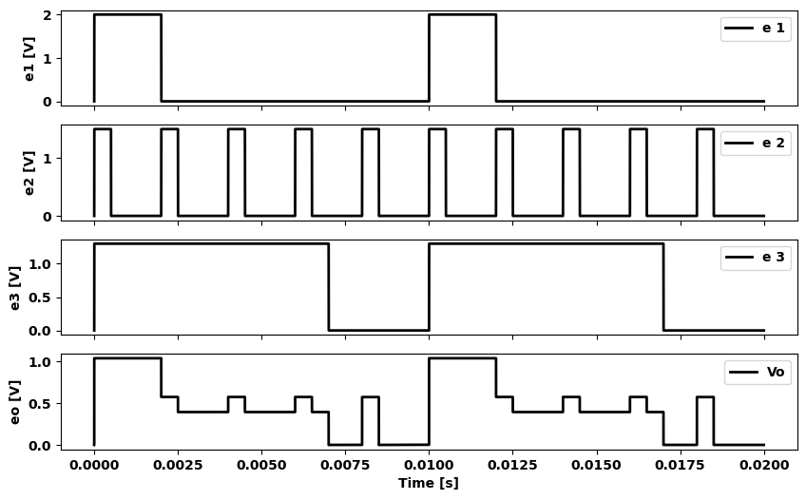
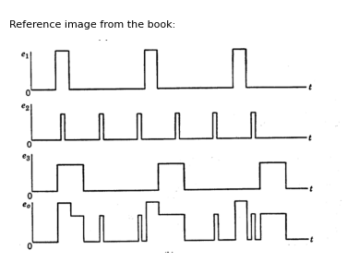
Fig. 3.28. Diode gate circuit (OR circuit)
and sources are assumed to be ideal (zero resistance). A positive pulse from any one or two of the sources simply turns off the corresponding diodes, but $e_{0}$ remains zero. Thus, e₁ and e2 raise the cathodes of their diodes to a positive value, while the anodes are held at zero by the conduction of $D_{3}$. If a positive voltage is present at all three inputs, an output voltage occurs. This action of the circuit is illustrated in Fig. 3.27$\left(b\right)$ for input voltages consisting of rectangular pulses. The output-pulse duration corresponds to the "overlap" of the input pulses.
If the input signals are unequal but less than $E$, the output voltage will have an amplitude very nearly equal to the amplitude of the smallest input signal. Thus the circuit is a basic form of pulse amplitude modulator, as indicated in $\left(c\right)$. Alternatively, it may be called a sampling circuit, since each rectangular pulse, in effect, samples the instantaneous value of the sine wave. Only two inputs are necessary in this case; hence we may assume that source $e_{3}$ and diode $D_{3}$ have been disconnected from resistor $R$. The maximum positive value of the voltage $e_{2}$ should be slightly less than the peak pulse height; otherwise the pulse height will partially determine the output amplitude. Either of the circuit functions illustrated in Fig. 3.27$\left(b\right)$ and $\left(c\right)$ can be carried out with negative voltages by reversing the polarity of source $E$ and reversing the diodes
Another type of gate circuit, often called an OR circuit, is shown in Fig. 3.28$\left(a\right)$. In this case, an input voltage at $e_{1},e_{2}$, or $e_{3}$ will produce a corresponding output voltage. The circuit therefore performs the function of combining signals from various sources. As indicated in Fig. 3.28$\left(b\right)$, the output amplitude will be dictated by the maximum input amplitude, in the event that several inputs occur simultaneously, because the largest input amplitude biases the remaining diodes in the reverse direction.

13 3.14 Stepwise Approximation
The circuit models devised for piecewise-linear approximations of nonlinear curves use resistances, ideal rectifiers, voltage sources, and current sources. If we eliminate resistances from this list of elements, the circuit models that can be devised result in stepwise approximations.
The ideal rectifier is actually a stepwise approximation to an actual diode rather than a piecewise-linear approximation, for neither segment of its $i$ vs. $v$ curve is really resistive. In the conducting direction, the ideal rectifier is a short circuit, which can be interpreted as a special case of voltage source $\left(E=0\right)$. In the reverse direction we have infinite resistance, which can be interpreted as a special case of current source $\left(I=0\right)$. Thus, the ideal rectifier can be considered to have a bit of the character of ideal sources. In fact, connected in series with a voltage source or in parallel with a current source it merely makes the ideal linear sources unidirectional.
The stepwise representation of a smooth curve, as shown in Fig. 3.29$\left(a\right)$, may seem to be a rather gross approximation. Actually it can provide a very good average fit to the nonlinear curve. Since the area
under a stepwise approximation increases in a series of linear ramps, as shown in Fig. 3.29 $\left(b\right)$, we observe that the integral of a stepwise approxi- mation leads to a piecewise-linear curve. A circuit model for the stepwise approximation is shown in $\left(c\right)$.
import matplotlib.pyplot as plt
import numpy as np
import schemdraw
import schemdraw.elements as elm
import matplotlib.image as mpimg
# Create the figure and subplots
fig, axs = plt.subplots(1, 2, figsize=(10, 10))
circuit = Circuit('Transitional characteristic1')
circuit.model('BAV21','D' ,IS = 100@u_uA ,BV = 293.10@u_V, IBV = 0.001293@u_A , RS = 1@u_Ohm )
Vi = circuit.V('i', '1', circuit.gnd, 0@u_V)
circuit.D(1, '2','1', model = 'BAV21')
circuit.I(1, '1', '2', 20@u_mA)
circuit.D(2, '2', '3', model = 'BAV21')
circuit.V(1, '3', circuit.gnd, 20@u_V)
circuit.D(13, '4','1', model = 'BAV21')
circuit.I(2, '1', '4', 30@u_mA)
circuit.D(4, '4', '5', model = 'BAV21')
circuit.V(2, '5', circuit.gnd, 30@u_V)
circuit.D(5, '6','1', model = 'BAV21')
circuit.I(3, '1', '6', 30@u_mA)
circuit.D(6, '6', '7', model = 'BAV21')
circuit.V(3, '7', circuit.gnd, 40@u_V)
circuit.D(7, '8','1', model = 'BAV21')
circuit.I(4, '1', '8', 10@u_mA)
circuit.D(8, '8', circuit.gnd, model = 'BAV21')
simulator = circuit.simulator(temperature=25, nominal_temperature=25)
analysis = simulator.dc(Vi=slice(-10, 60, .01))
axs[0].plot(analysis['1'],u_mA(-analysis.Vi),'black',linewidth=3)
# 2
circuit = Circuit('v-i curve')
circuit.model('BAV21','D' ,IS = 1.45@u_nA , N = 1.906 ,BV = 110@u_V, IBV = 0.0001@u_V, VJ = .7@u_V ,CJO = 7.048E-13 ,RS = 600@u_Ohm ,TT = 3.48E-9)
Vi = circuit.V('i', '1', circuit.gnd, 10@u_V)
circuit.R(1, '1', '2', 200@u_Ohm)
circuit.D(1, '2',circuit.gnd , model = 'BAV21')
simulator = circuit.simulator(temperature=25, nominal_temperature=25)
analysis = simulator.dc(Vi=slice(0, 100, 0.1))
axs[0].plot(analysis['2'], u_mA(-analysis.Vi),'black',linewidth=3)
axs[0].axhline(0, color='black', linewidth=1)
axs[0].axvline(0, color='black', linewidth=1)
axs[0].annotate('', xy=(60, 90), xytext=(60, 0), arrowprops=dict(arrowstyle='->'))
axs[0].annotate('', xy=(30, 60), xytext=(0, 60), arrowprops=dict(arrowstyle='->'))
axs[0].annotate('', xy=(40, 90), xytext=(0, 90), arrowprops=dict(arrowstyle='->'))
axs[0].annotate('', xy=(30, 30), xytext=(0, 30), arrowprops=dict(arrowstyle='->'))
axs[0].annotate('', xy=(40, 60), xytext=(40, 0), arrowprops=dict(arrowstyle='->'))
axs[0].annotate('', xy=(20, 10), xytext=(20, 0), arrowprops=dict(arrowstyle='->'))
axs[0].set_xlim(-10, 100)
axs[0].set_ylim(-10, 100)
axs[0].set_xlabel('v [V]')
axs[0].set_ylabel('i [mA]')
axs[0].text( -2, 10, 'I1', ha='center', va='center')
axs[0].text( -2, 30, 'I2', ha='center', va='center')
axs[0].text( -2, 60, 'I3', ha='center', va='center')
axs[0].text( -2, 90, 'I4', ha='center', va='center')
axs[0].text( 20, -3, 'E1', ha='center', va='center')
axs[0].text( 40, -3, 'E2', ha='center', va='center')
axs[0].text( 60, -3, 'E3', ha='center', va='center')
axs[0].text( 65, 98, 'i=f(v)', ha='center', va='center')
figure.savefig('./Drawings/fig3-29a.jpg')
figure.savefig('./Drawings/fig3-29a.svg')
img_sample = mpimg.imread('images-books/3-29a.png') # Load the PNG file
axs[1].imshow(img_sample)
axs[1].axis('off') # Hide axes for image display
axs[1].set_title('Original')
#Show the combined plots
d.save('./Drawings/fig3-29a.png')
d.save('./Drawings/fig3-29a.svg')
plt.tight_layout()
plt.show()
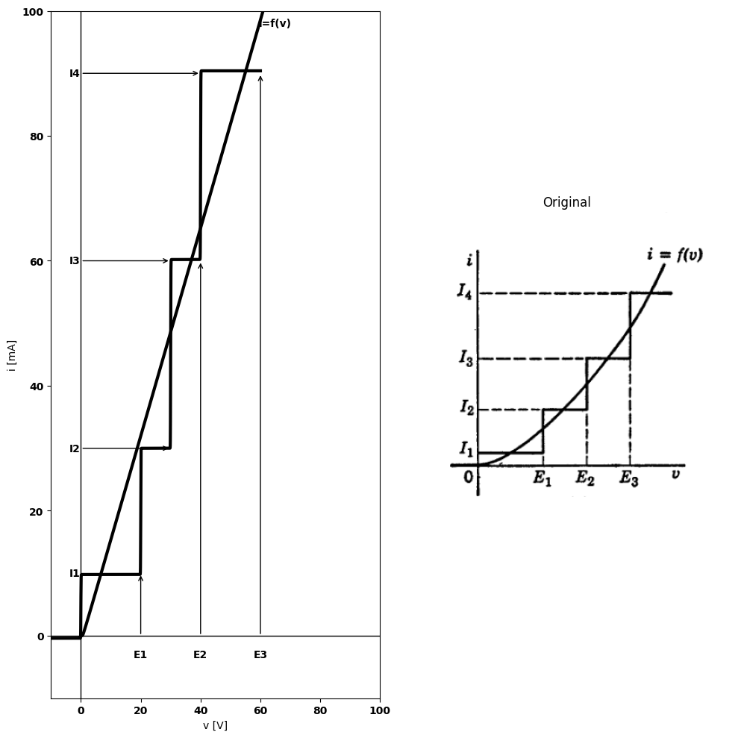
import schemdraw
import schemdraw.elements as e
import schemdraw as schem
import matplotlib.pyplot as plt
import matplotlib.image as mpimg
import numpy as np
# Create the figure and subplots
fig, axs = plt.subplots(1, 2, figsize=(12, 12))
d = schemdraw.Drawing()
d += elm.Arrow().down().length(4.5).at((12.1, 1.6)).color('black')
d += elm.Arrow().up().length(0.2).at((11.7, 1.9)).color('white').label('$V$', loc='bottom', color='black')
d += elm.Arrow().up().length(4.5).at((12.1, 2.4)).color('black')
d += elm.Dot(open=True)
d += elm.Line().right().length(20)
d += elm.Line().down().length(1).dot()
d.push()
d += elm.Diode(fill=True).down().label('$D$').reverse()
d += elm.Diode(fill=True).down().label('$D$')
d.pop()
d += elm.Line().left().length(2)
d += elm.SourceI().down().label('$I_1$')
d += elm.Line().right().length(2).dot()
d += elm.Line().down().length(6)
d += elm.Line().left().length(5).dot()
d.push()
d += elm.Battery().up().label('$E_1$').reverse()
d += elm.Diode(fill=True).up().label('$D$').reverse()
d += elm.Diode(fill=True).up().label('$D$').dot()
d.push()
d += elm.Line().up().length(1)
d.pop()
d += elm.Line().left().length(2)
d += elm.SourceI().down().label('$I_2-{I_1}$')
d += elm.Line().right().length(2).dot()
d.pop()
d += elm.Line().left().length(5).dot()
d.push()
d += elm.Battery().up().label('$E_2$').reverse()
d += elm.Diode(fill=True).up().label('$D$').reverse()
d += elm.Diode(fill=True).up().label('$D$').dot()
d.push()
d += elm.Line().up().length(1)
d.pop()
d += elm.Line().left().length(2)
d += elm.SourceI().down().label('$I_3-{I_2}$')
d += elm.Line().right().length(2).dot()
d.pop()
d += elm.Line().left().length(5).dot()
d.push()
d += elm.Battery().up().label('$E_3$').reverse()
d += elm.Diode(fill=True).up().label('$D$').reverse()
d += elm.Diode(fill=True).up().label('$D$').dot()
d.push()
d += elm.Line().up().length(1)
d.pop()
d += elm.Line().left().length(2)
d += elm.SourceI().down().label('$I_4-{I_3}$')
d += elm.Line().right().length(2).dot()
d.pop()
d += elm.Line().left().length(5).dot(open=True)
d += elm.Arrow().right().length(0.7).at((12.3, 7.3)).color('black').label('$i$','top')
d.save('./Drawings/fig3-29c.jpg')
d.save('./Drawings/fig3-29c.svg')
# Load the saved PNG file into the subplot
img = mpimg.imread('./Drawings/fig3-29c.jpg')
axs[0].imshow(img)
axs[0].axis('off') # Hide axes for image display
axs[0].set_title('Circuit Diagram (developed)')
# **Subplot (1, 2): PNG Sample File**
img_sample = mpimg.imread('images-books/3-29c.png') # Load the PNG file
axs[1].imshow(img_sample)
axs[1].axis('off') # Hide axes for image display
axs[1].set_title('Original')
# Show the combined plots
plt.tight_layout()
plt.show()
d.save('./Drawings/fig3-29c.png')
d.save('./Drawings/fig3-29c.svg')
d.save('./Drawings/fig3-29c.jpg')
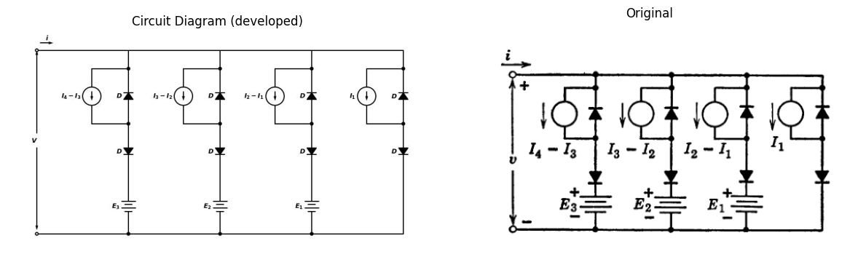
import matplotlib.pyplot as plt
import numpy as np
import schemdraw
import schemdraw.elements as elm
import matplotlib.image as mpimg
# Create the figure and subplots
fig, axs = plt.subplots(1, 2, figsize=(10, 10))
circuit = Circuit('v-i curve')
circuit.model('BAV21','D' ,IS = 10@u_uA , N = 1.906 ,BV = 110@u_V, IBV = 0.0001@u_V, VJ = 0.7@u_V ,CJO = 7.048E-13 ,RS = 1@u_Ohm ,TT = 3.48E-9)
Vi = circuit.V('i', '1', circuit.gnd, 0@u_V)
circuit.R(1, '2', circuit.gnd, 350@u_Ohm)
circuit.D(1, '1','2' , model = 'BAV21')
simulator = circuit.simulator(temperature=25, nominal_temperature=25)
analysis = simulator.dc(Vi=slice(0, 1, 0.1))
axs[0].plot(analysis['1'], u_mA(-analysis.Vi),'black',linestyle='-',linewidth=2)
circuit = Circuit('thev')
circuit.model('BAV21','D' ,IS = 10@u_uA , N = 1.906 ,BV = 110@u_V, IBV = 0.0001@u_V, VJ = 0.7@u_V ,CJO = 7.048E-13 ,RS = 1@u_Ohm ,TT = 3.48E-9)
Vi = circuit.V('i', '1', circuit.gnd, 0@u_V)
circuit.R(2, '2', circuit.gnd, 230@u_Ohm)
circuit.D(2, '1','2' , model = 'BAV21')
circuit.R(1, '2', '3', 190@u_Ohm)
circuit.D(3, '1','2' , model = 'BAV21')
circuit.V(1, '3',circuit.gnd ,1@u_V)
simulator = circuit.simulator(temperature=25, nominal_temperature=25)
analysis = simulator.dc(Vi=slice(1, 1.3, 0.1))
axs[0].plot(analysis['1'], u_mA(-analysis.Vi),'black',linestyle='-',linewidth=2)
#2
circuit = Circuit('thev')
circuit.model('BAV21','D' ,IS = 10@u_uA , N = 1.906 ,BV = 110@u_V, IBV = 0.0001@u_V, VJ = 0.7@u_V ,CJO = 7.048E-13 ,RS =.0000001@u_Ohm ,TT = 3.48E-9)
Vi = circuit.V('i', '1', circuit.gnd, 0@u_V)
circuit.R(2, '2', circuit.gnd, 230@u_Ohm)
circuit.D(2, '1','2' , model = 'BAV21')
circuit.R(1, '2', '3', 200@u_Ohm)
circuit.D(3, '1','2' , model = 'BAV21')
circuit.V(1, '3',circuit.gnd ,1@u_V)
simulator = circuit.simulator(temperature=25, nominal_temperature=25)
analysis = simulator.dc(Vi=slice(1.3, 2.6, 0.1))
axs[0].plot(analysis['1'], u_mA(-analysis.Vi),'black',linestyle='-',linewidth=2)
#3
axs[0].annotate('', xy=(1.3, 2), xytext=(1.3,0), arrowprops=dict(arrowstyle='->'))
axs[0].annotate('', xy=(1.3, 4.8), xytext=(1.3,2), arrowprops=dict(arrowstyle='->'))
axs[0].annotate('', xy=(1.8, 2), xytext=(1,2), arrowprops=dict(arrowstyle='-'))
axs[0].set_title('Load Line Analysis')
axs[0].text(1.8, 1, '∫_0^E1 I1dv', ha='center', va='center')
axs[0].text(1.8, 4, '∫_E1^E2 Idv', ha='center', va='center')
axs[0].set_xlim(-1, 5)
axs[0].set_ylim(-2, 8)
axs[0].set_xlabel('V [V]')
axs[0].set_ylabel('I [mA]')
axs[0].axhline(0, color='black', linewidth=1)
axs[0].axvline(0, color='black', linewidth=1)
figure.savefig('./Drawings/fig3-29b.jpg')
figure.savefig('./Drawings/fig3-29b.svg')
img_sample = mpimg.imread('images-books/3-29b.png') # Load the PNG file
axs[1].imshow(img_sample)
axs[1].axis('off') # Hide axes for image display
axs[1].set_title('Original')
# Show the combined plots
d.save('./Drawings/fig3-29b.png')
d.save('./Drawings/3-29b.svg')
plt.tight_layout()
plt.show()
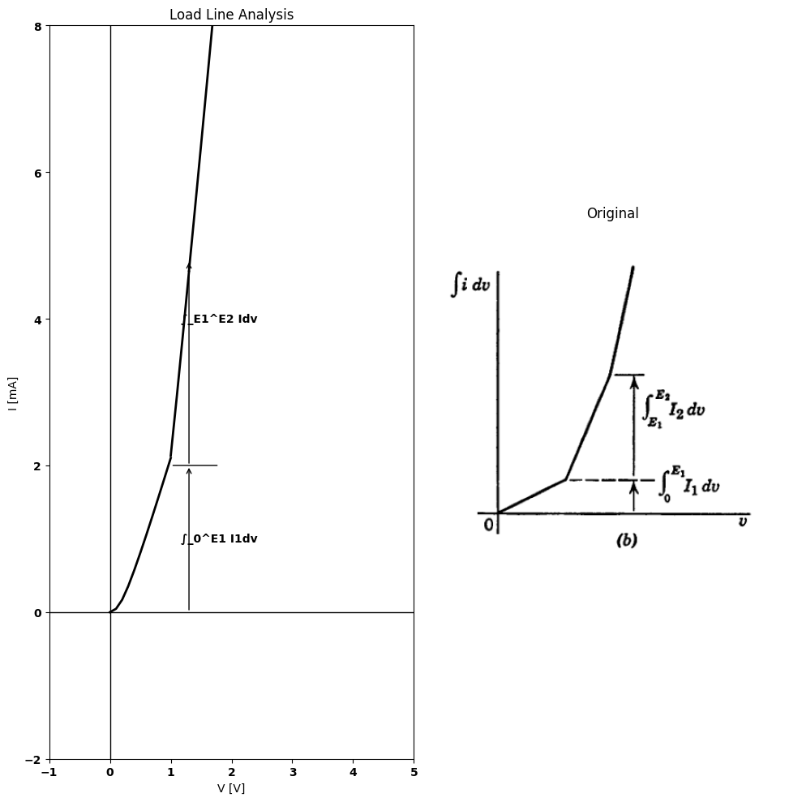
Fig. 3.29. Stepwise approximation

14 3.15 Parabolic Approximation
square-law curve can obviously be used to approximate some portion of a general nonlinear curve. As shown in Fig. 3.30$\left(a\right)$, the parabola $i=K_{2}e^{2}$ fits the vacuum-diode curve $i_{b}$=$K_{1}$ $e_{b}$ $​^{3}/^{2}$ about as well as the linear resistance $r_{b}$ over a given range of values. A somewhat better fit is obtained over the range of voltage and current indicated, by shifting the curve upward, as in $\left(b\right)$, to place some of the parabola above and some below the vacuum-diode curve. By inspection of this curve we see that a reduction in the constant, accompanied by a shift to the
import numpy as np
import matplotlib.pyplot as plt
eb = np.linspace(0, 5, 100)
rb = 1
Ib = eb[99]
K1 = Ib/eb[99]**(3/2)
K2 = Ib/eb[99]**2
rb = 1
ib_a = K1 * eb**(3/2) #fig1
i_a = eb / (rb)
i2_a = K2 * eb**2
ib_b = K1 * eb**(3/2) #fig2
i_b = 1.1 * K2 * eb**2
ib_c = K1 * eb**(3/2) #fig3
i_c = 0.9 * K2 * (eb + 0.1 * eb)**2
fig, axs = plt.subplots(2, 2, figsize=(10, 10))
axs[0,0].plot(eb, i_a, color='black', linestyle='--')
axs[0,0].plot(eb, ib_a, color='black')
axs[0,0].plot(eb, i2_a, color='black', linestyle='-.')
axs[0,0].set_title('(a)')
axs[0,0].set_xlabel(r'$e_b$', loc='right')
axs[0,0].set_ylabel(r'$i_b$',rotation=0,loc='top')
axs[0,0].annotate('i = $e/r_b$', xy=(2, 2), xytext=(1.5, 2.8),
arrowprops=dict(facecolor='black', arrowstyle='->'),
fontsize=12, color='black')
axs[0,0].annotate(r'$i_b$ = $K_1 e_b^{3/2}$', xy=(2.3, 1.6),
xytext=(2.7, 1),
arrowprops=dict(facecolor='black', arrowstyle='->'),
fontsize=12, color='black')
axs[0,0].annotate(r'$i$ = $K_2 e_b^2$', xy=(1.5, K2 * 1.5**2),
xytext=(2, 0.6),
arrowprops=dict(facecolor='black', arrowstyle='->'),
fontsize=12, color='black')
axs[1,0].plot(eb, i_a, color='black', linestyle='--')
axs[1,0].plot(eb, ib_b, label=r'$i_b = K_1 e_b^{3/2}$', color='black')
axs[1,0].plot(eb, i_b, label=r'$i = 1.1 K_2 e_b^2$', color='black', linestyle='-.')
axs[1,0].set_title('(b)')
axs[1,0].set_xlabel(r'$e_b$', loc='right')
axs[1,0].set_ylabel(r'$i_b$',rotation=0,loc='top')
axs[1,0].annotate(r'$i_b$ = $K_1 e_b^{3/2}$', xy=(2.3, 1.6),
xytext=(0.8, 2.4),
arrowprops=dict(facecolor='black', arrowstyle='->'),
fontsize=12, color='black')
axs[1,0].annotate(r'$i$ = $1.1 K_2 e^2$', xy=(2.6, 1.5),
xytext=(2.2, 0.6),
arrowprops=dict(facecolor='black', arrowstyle='->'),
fontsize=12, color='black')
axs[1,0].text(3.5, 5.6, '$1.1I_b$', fontsize=10, ha='right', color='black')
axs[1,0].text(-0.1, 5, '$I_b$', fontsize=10, ha='right', color='black')
axs[1,0].text(5.1, -0.2, '$E_b$', fontsize=10, ha='right', color='black')
axs[1,1].plot(eb, i_a, color='black', linestyle='--')
axs[1,1].plot(eb, ib_c, color='black')
axs[1,1].plot(eb, i_c, label=r'$i = 0.9 K_2 (e_b + 0.1 e_b)^2$', color='black', linestyle='-.')
axs[1,1].set_title('(c)')
axs[1,1].set_xlabel(r'$e_b$', loc='right')
axs[1,1].set_ylabel(r'$i_b$',rotation=0,loc='top')
axs[1,1].annotate(r'$i_b$ = $K_1 e_b^{3/2}$', xy=(2.3, 1.6),
xytext=(0.8, 2.4),
arrowprops=dict(facecolor='black', arrowstyle='->'),
fontsize=12, color='black')
axs[1,1].annotate(r'$i$ = $1.1 K_2 e^2$', xy=(2.6, 1.5),
xytext=(2.2, 0.6),
arrowprops=dict(facecolor='black', arrowstyle='->'),
fontsize=12, color='black')
axs[1,1].text(3.5, 5.6, '$1.09I_b$', fontsize=10, ha='right', color='black')
axs[1,1].text(-0.1, 5, '$I_b$', fontsize=10, ha='right', color='black')
axs[1,1].text(5.1, -0.2, '$E_b$', fontsize=10, ha='right', color='black')
axs[0,1].text(0.2, 2.5, r'$ r_b = {E_b}{I_b}$', fontsize=12, color='black', ha='center')
axs[0,1].text(0.2, 2, r'$ K_1 = {I_b}{E_b^{3/2}}$', fontsize=12, color='black', ha='center')
axs[0,1].text(0.2, 1.5, r'$ K_2 = {I_b}{E_b^2}$', fontsize=12, color='black', ha='center')
a=[axs[0,0],axs[0,1],axs[1,0],axs[1,1]]
for i in a:
i.spines['top'].set_visible(False)
i.spines['right'].set_visible(False)
i.set_ylim(0, 6)
i.set_xlim(0, 6)
i.set_xticks([])
i.set_yticks([])
if i == axs[1, 0] or i == axs[1, 1]:
i.plot([0, 5], [5, 5], color='gray', linestyle='dashed')
i.plot([5, 5], [5.6, 0], color='gray', linestyle='dashed')
i.plot([5, 3.6], [5.6, 5.6], color='gray', linestyle='dashed')
axs[0,0].plot([0, 5], [5, 5], color='gray', linestyle='dashed')
axs[0,0].plot([5, 5], [5, 0], color='gray', linestyle='dashed')
axs[0,1].axis('off')
plt.tight_layout()
plt.show()
fig = plt.figure(figsize=(6, 6))
img = plt.imread('images-books/3-30-1.png')
plt.imshow(img)
plt.axis('off')
plt.title('\nReference image from the book:', fontsize=8, pad=10,loc='left')
plt.show()
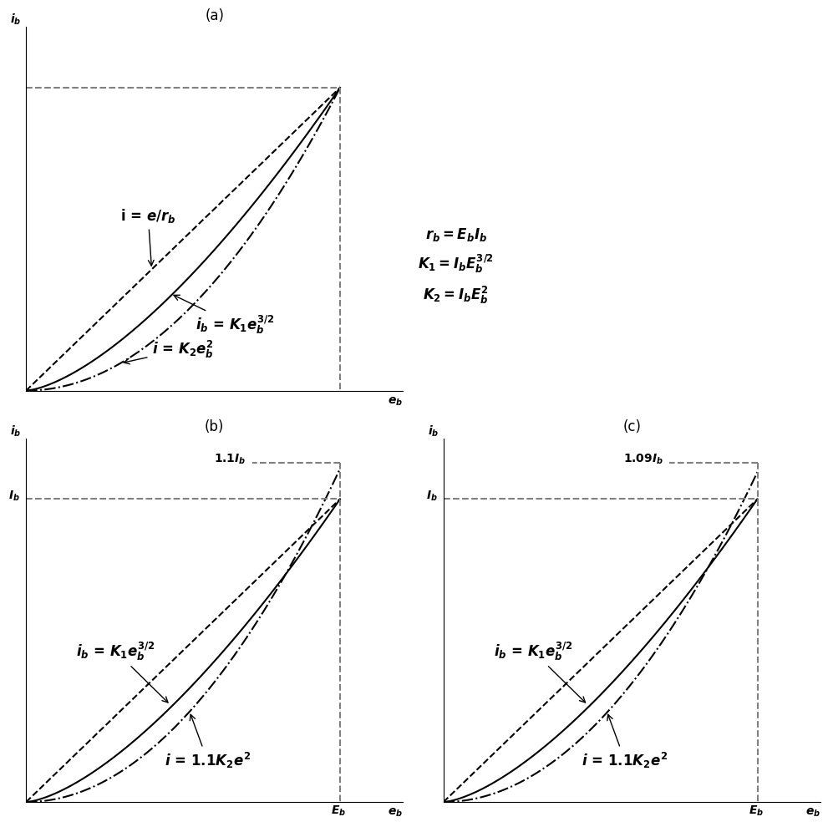
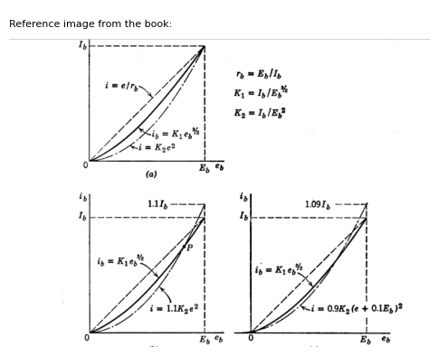
Fig. 3.30. Parabolic approximations to $3/2$-power curve.
left, should provide an even better fit, as shown in $\left(c\right)$. This curve matches the diode curve very well over the range of values indicated.
If a nonlinear curve of $i$ vs. $e$ were approximated by several parabolic segments (concave up and down), the derivative curve $di/de$ vs. $e$ would be piecewise-linear, provided the slopes of the parabolic segments match at their junctions. If the slopes did not match, the curve of $di/de$ vs. $e$ would contain steps.
The square-law relation $i=Ke^{2}$ is often used in analyzing detector circuits, mixer circuits, and the like. See Art. 4.14.

15 3.16 A Simple Electrical Transient
Thus far in this chapter we have examined some of the properties of resistive-diode circuits. We have considered methods of approximating
the current versus voltage curves of various types of diodes or of an arbitrary nonlinear resistance. In this article we shall consider a circuit with one energy-storage element to show that functions of time or frequency also can be approximated to good advantage. Usually the resulting simplification of the analysis problem justifies the use of such approximations.
Let us consider the most elementary example possible. Suppose a capacitor $C$ has been charged to a voltage $E_{b}=Q/C$. Let us determine. the waveforms $e\left(t\right)$ and $i\left(t\right)$ resulting when the capacitor is discharged through various resistive circuits, both linear and nonlinear.
The circuit, equations, and waveforms shown in Fig. 3.31 $\left(a\right)$ illustrate the familiar linear circuit problem. The solution of the linear differen- tial equation is a decaying exponential characterized by the time con- stant $ τ = ᎡᏟ $ .
Now suppose the capacitor $C$ is to be discharged through a vacuum diode described by a three-halves power curve, as indicated in Fig. 3.31$\left(b\right)$. The simple nonlinear differential equation, when solved, shows. that the voltage and current no longer vary exponentially with time, but rather, in an inverse square manner. The solution for $v\left(t\right)$ is given analytically and graphically in $\left(b\right)$. If now the diode is approximated by $r_{b}$, the solution has the same form as in $\left(a\right)$. This exponential waveform is shown as a dashed line in the waveform plot of Fig. 3.31 $\left(b\right)$. Since the $r$ approximation lies entirely above the three-halves power curve, and since $i=−Cde/dt$, the discharge by the vacuum diode actually proceeds more slowly than the exponential determined by the $г_{b}$ approximation. It is apparent that the exponential waveform can be matched to the inverse square expression more closely by using a closer approximation to the diode curve than that given by the $r_{b}$ line.
In Fig. 3.31 $\left(c\right)$ the waveform $v\left(t\right)$ is plotted for a square-law curve of $i$ vs. $v$. Again the expression for $v\left(t\right)$ is readily obtained by separation of variables and integration of the simple expression. The exponential discharge produced by an $г_{b}$ approximation is shown for comparison. Since the square-law curve of $i$ vs. $v$ lies farther below the r line than does the three-halves power law, the discharge proceeds more slowly in this case than in $\left(b\right)$.
For each of the examples given in $\left(a\right)$, $\left(b\right)$, and $\left(c\right)$, the waveform of current $i\left(t\right)$ can be obtained from $v\left(t\right)$ by substitution in the appropriate $i$ vs. $v$ equation, or by differentiation, since $i=−Cdv/dt$. Let us now consider the waveforms that result from a two-segment piecewise linear approximation for a diode curve, as shown in Fig. 3.32$\left(a\right)$ (a three-halves power curve is assumed for convenience). Each segment of this piecewise-linear approximation yields an exponen-
import schemdraw
import schemdraw.elements as e
import schemdraw as schem
import matplotlib.pyplot as plt
import matplotlib.image as mpimg
import numpy as np
# Create the figure and subplots
fig, axs = plt.subplots(1, 2, figsize=(12, 12))
d = schemdraw.Drawing()
S1 = d.add(e.Switch().left().flip().label('$closes at$\n$t=0$',ofst=(1.4,0.2)))
C1 = d.add(e.Capacitor().down().label(['+','$C$ $E_b$','- '],ofst=-1))
R1 = d.add(e.Resistor().down().at(S1.start).label('$R$'))
l1 = d.add(e.Line().left())
d += e.Line().right().length(0.8).linewidth(0.6).at(S1.start).color('gray')
d += e.Line().right().length(0.8).linewidth(0.6).at(R1.end).color('gray')
d += e.Arrow().right().linewidth(0.6).length(0.6).color('black').label('$i$', loc='top', color='black',ofst=0.2). at((-1,0.3))
d += e.Arrow().up().length(1).linewidth(0.6).color('white').label('$V$', loc='start', color='black',ofst=0.3). at((1.2,-1.4))
d += e.Arrow().up().length(0.8).linewidth(0.6).color('black').label('+',loc='end', color='black',ofst=-0.1). at((0.8,-0.9))
d += e.Arrow().down().length(0.8).linewidth(0.6).color('black').label(r'_', loc='end', color='black',ofst=(-0.4,0.2)). at((0.8,-2.2))
d += e.Arrow().length(0.4).at((-2, 0.5)).theta(-110)
d.save('./Drawings/fig322-11.jpg')
d.save('./Drawings/fig322-11.svg')
# Load the saved PNG file into the subplot
img = mpimg.imread('./Drawings/fig322-11.jpg')
axs[0].imshow(img)
axs[0].axis('off') # Hide axes for image display
axs[0].set_title('Circuit Diagram (developed)')
# **Subplot (1, 2): PNG Sample File**
img_sample = mpimg.imread('images-books/close.png') # Load the PNG file
axs[1].imshow(img_sample)
axs[1].axis('off') # Hide axes for image display
axs[1].set_title('Original')
# Show the combined plots
plt.tight_layout()
plt.show()
d.save('./Drawings/fig322-11.png')
d.save('./Drawings/fig322-1.svg')
d.save('./Drawings/fig322-1.jpg')
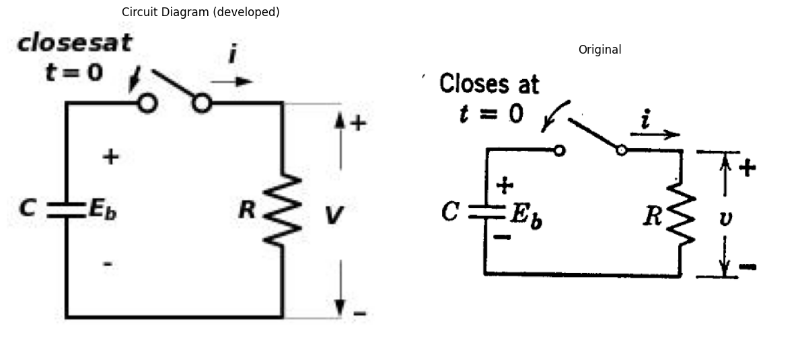
import schemdraw
import schemdraw.elements as e
import schemdraw as schem
import matplotlib.pyplot as plt
import matplotlib.image as mpimg
import numpy as np
# Create the figure and subplots
fig, axs = plt.subplots(1, 2, figsize=(12, 12))
d = schemdraw.Drawing()
S1 = d.add(e.Switch().left().flip().label('$t=0$',ofst=(1.4,0.2)))
C1 = d.add(e.Capacitor().down().label(['+','$C$ $E_b$','- '],ofst=-1))
D1 = d.add(e.Diode().down().at(S1.start))
l1 = d.add(e.Line().left())
d += e.Line().right().length(1.6).linewidth(0.6).at(S1.start).color('gray')
d += e.Line().right().length(1.6).linewidth(0.6).at(R1.end).color('gray')
d += e.Arrow().right().linewidth(0.6).length(0.6).color('black').label('$i$', loc='top', color='black',ofst=0.2). at((-1,0.3))
d += e.Arrow().up().length(1).linewidth(0.6).color('white').label('$V$', loc='start', color='black',ofst=0.3). at((1.9,-1.4))
d += e.Arrow().up().length(0.8).linewidth(0.6).color('black').label('+',loc='end', color='black',ofst=-0.1). at((1.5,-0.9))
d += e.Arrow().down().length(0.8).linewidth(0.6).color('black').label(r'_', loc='end', color='black',ofst=(-0.4,0.2)). at((1.5,-2.2))
d += e.Arrow().length(0.4).at((-2, 0.5)).theta(-110)
d.save('./Drawings/fig31-11.jpg')
d.save('./Drawings/fig31-11.svg')
# Load the saved PNG file into the subplot
img = mpimg.imread('./Drawings/fig31-11.jpg')
axs[0].imshow(img)
axs[0].axis('off') # Hide axes for image display
axs[0].set_title('Circuit Diagram (developed)')
# **Subplot (1, 2): PNG Sample File**
img_sample = mpimg.imread('images-books/c=0.png') # Load the PNG file
axs[1].imshow(img_sample)
axs[1].axis('off') # Hide axes for image display
axs[1].set_title('Original')
# Show the combined plots
plt.tight_layout()
plt.show()
d.save('./Drawings/fig31-11.png')
d.save('./Drawings/fig31-1.svg')
d.save('./Drawings/fig31-1.jpg')
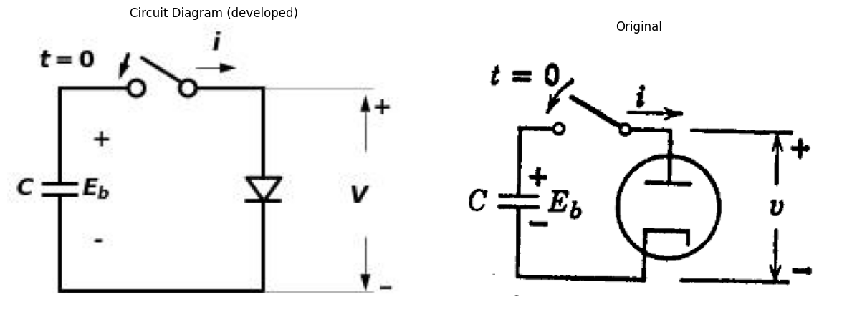
import numpy as np
import matplotlib.pyplot as plt
fig, axs = plt.subplots(3, 2, figsize=(16, 12))
# 1
Eb = 1
RC = 1
t = np.linspace(0, 5, 100)
x1 = np.array([0, 1])
y1 = np.array([1, 0])
x2 = np.array([1, 2])
y2 = np.array([0.36, 0])
x3 = np.array([2, 3])
y3 = np.array([0.135, 0])
v = Eb * np.exp(-t / RC)
E1 = 0.35
x = np.linspace(0, 0.7, 100)
axs[0,0].plot(x, x, color='black', linestyle='-', label=r'$i$=$f(v)$')
axs[0,0].set_xlim(0, 2.1)
axs[0,0].set_ylim(0, 1.1)
axs[0,0].set_xlabel('v', fontsize=12, loc='right')
axs[0,0].set_ylabel('i' ,rotation=0, loc='top', fontsize=10)
axs[0,1].plot(t, v / Eb, color='black', linewidth=2, label=r'$v$=$E_be^{-t/RC}$')
axs[0,1].plot(x1, y1, color='black')
axs[0,1].plot(x2, y2, color='black')
axs[0,1].plot(x3, y3, color='black')
axs[0,1].plot([1, 1], [0, 0.36], color='gray', linestyle='--')
axs[0,1].plot([2, 2], [0, 0.14], color='gray', linestyle='--')
axs[0,1].text(1.1, 0.37, r' ___$E_1/E_b$', fontsize=10, color='gray', ha='center')
axs[0,1].text(4, 1, r'$i = \frac{v}{R} = -C \frac{dv}{dt}\quad \{ \text{at } t = 0, \: v = E_b \}$', fontsize=10, va='center', ha='right', color='black')
axs[0,1].text(1.7, 0.8, r'$v = E_b e^{-t/(RC)}$', fontsize=10)
axs[0,1].annotate(r'$Slope:-1$', xy=(0.6, 0.4),
xytext=(1, 0.5),
arrowprops=dict(facecolor='black', arrowstyle='->'),
fontsize=9, color='black')
axs[0,1].annotate(r'$e^{-t/RC}$', xy=(1.7, 0.2),
xytext=(1.9, 0.3),
arrowprops=dict(facecolor='black', arrowstyle='->'),
fontsize=9, color='black')
axs[0,1].annotate('$Slope$:\n$-E_1/E_b$', xy=(1.5, 0.17),
xytext=(0.03, 0.2),
arrowprops=dict(facecolor='black', arrowstyle='->'),
fontsize=8, color='black')
axs[0,1].set_xlabel('$t/RC$', loc='right', fontsize=10)
axs[0,1].set_ylabel(r'$v/E_b$', rotation=0, loc='top', fontsize=10)
axs[0,1].set_xlim(0, 5)
axs[0,1].set_ylim(0, 1.1)
# 2
Ib = 1
k = Ib/Eb**(3/2)
rb = Eb/Ib
RC = 1
t = np.linspace(0, 5, 100)
v = Eb * np.exp(-t / RC)
x = np.linspace(0, 1, 100)
axs[1,0].plot(x, x, color='black', linestyle='--', label=r'$r_b$=$E_b/I_b$' )
axs[1,0].plot(x, k*x**(3/2), color='black', label=r'$r_b$=$E_b/I_b$' )
axs[1,0].set_xlim(0, 2)
axs[1,0].set_ylim(0, 1.1)
axs[1,0].set_xlabel('v', loc='right', fontsize=10)
axs[1,0].set_ylabel('i', rotation=0, loc='top', fontsize=10)
axs[1,1].plot(t, v / Eb, color='black', linewidth=2, linestyle='--', label=r'$\frac{v}{E_b} = e^{-t/(RC)}$')
axs[1,1].plot(t, 1 / (1 + t / (RC * Eb)), color='black', linewidth=2, label=r'$\frac{v}{E_b} = \frac{1}{(2 + \frac{t}{r_bC})^2}$')
axs[1,1].set_xlabel(r'$t/RC$', loc='right', fontsize=10)
axs[1,1].set_ylabel(r'$\frac{v}{E_b}$', rotation=0, loc='top', fontsize=10)
axs[1,1].set_xlim(0, 5)
axs[1,1].set_ylim(0, 1.1)
# 3
k = Ib/Eb**2
rb = Eb/Ib
RC = 1
t = np.linspace(0, 5, 100)
v = Eb * np.exp(-t / RC)
x = np.linspace(0, 1, 100)
axs[2,0].plot(x, x, color='black', linestyle='--', label=r'$r_b$=$E_b/I_b$' )
axs[2,0].plot(x, k*x**2, color='black', label=r'$i$=$kv^2$' )
axs[2,0].set_xlim(0, 2)
axs[2,0].set_ylim(0, 1.1)
axs[2,0].set_xlabel('v', loc='right', fontsize=10)
axs[2,0].set_ylabel('i', rotation=0, loc='top', fontsize=10)
axs[2,1].plot(t, v / Eb, color='black', linewidth=2, linestyle='--', label=r'$\frac{v}{E_b} = e^{-t/(RC)}$')
axs[2,1].plot(t, 1 / (1 + t / (RC * Eb)), color='black', linewidth=2, label=r'$\frac{v}{E_b} = \frac{1}{1 + \frac{t}{r_bC}}$')
axs[2,1].set_xlabel(r'$t/RC$', loc='right', fontsize=10)
axs[2,1].set_ylabel(r'$\frac{v}{E_b}$', rotation=0, loc='top', fontsize=10)
axs[2,1].set_xlim(0, 5)
axs[2,1].set_ylim(0, 1.1)
a=[axs[0,0],axs[0,1],axs[1,0],axs[1,1],axs[2,0],axs[2,1]]
for i in a:
i.spines['top'].set_visible(False)
i.spines['right'].set_visible(False)
i.legend()
i.axhline(0, color='black', linewidth=0.5, linestyle='--')
i.axvline(0, color='black', linewidth=0.5, linestyle='--')
plt.show()
fig = plt.figure(figsize=(8, 4))
img = plt.imread('./images-books/3-31.png')
plt.imshow(img)
plt.axis('off')
plt.title('\nReference image from the book:', fontsize=8, pad=10,loc='left')
plt.show()
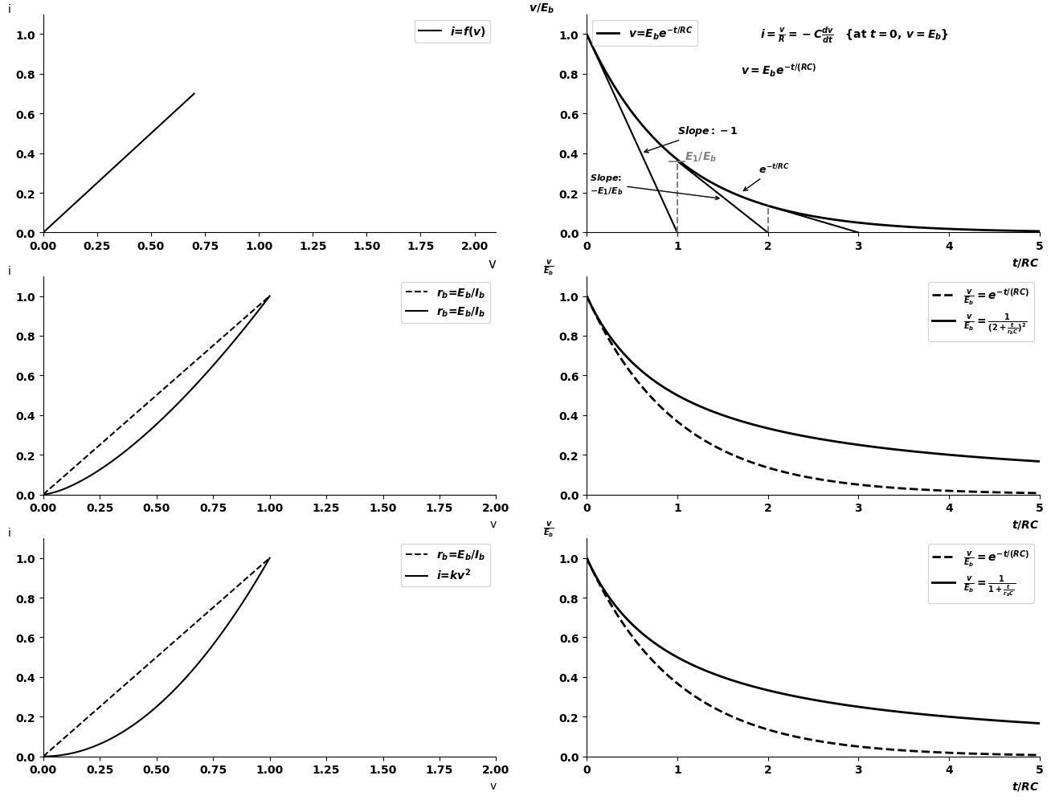
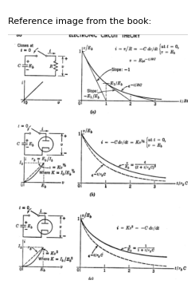
Fig. 3.31. Discharge of capacitor by linear and nonelinear resistances.
tial curve. The time constant and final value are different for each exponential; but since $i$ is continuous at the break point, the slope of the voltage waveform $\left(dv/dt\right)$ is also continuous at the transition from
one exponential to the other. The slope of the approximation wave- form of current, see Fig. 3.32$\left(b\right)$, is not continuous at the break point.
Note that the approximations match the true waveforms quite closely. Since most of the applications of electronic circuits involve time-varying
import numpy as np
import matplotlib.pyplot as plt
eb = np.linspace(0, 5, 100)
rb = 1
Ib = eb[99]
K1 = Ib/eb[99]**(3/2)
K2 = Ib/eb[99]**2
rb = 1
ib_a = K1 * eb**(3/2) #fig1
i_a = eb / (rb)
i2_a = K2 * eb**2
ib_b = K1 * eb**(3/2) #fig2
i_b = 1.1 * K2 * eb**2
ib_c = K1 * eb**(3/2) #fig3
i_c = 0.9 * K2 * (eb + 0.1 * eb)**2
fig, axs = plt.subplots(2, 2, figsize=(10, 10))
axs[0,0].plot(eb, i_a, color='black', linestyle='--')
axs[0,0].plot(eb, ib_a, color='black')
axs[0,0].plot(eb, i2_a, color='black', linestyle='-.')
axs[0,0].set_title('(a)')
axs[0,0].set_xlabel(r'$e_b$', loc='right')
axs[0,0].set_ylabel(r'$i_b$',rotation=0,loc='top')
axs[0,0].annotate('i = $e/r_b$', xy=(2, 2), xytext=(1.5, 2.8),
arrowprops=dict(facecolor='black', arrowstyle='->'),
fontsize=12, color='black')
axs[0,0].annotate(r'$i_b$ = $K_1 e_b^{3/2}$', xy=(2.3, 1.6),
xytext=(2.7, 1),
arrowprops=dict(facecolor='black', arrowstyle='->'),
fontsize=12, color='black')
axs[0,0].annotate(r'$i$ = $K_2 e_b^2$', xy=(1.5, K2 * 1.5**2),
xytext=(2, 0.6),
arrowprops=dict(facecolor='black', arrowstyle='->'),
fontsize=12, color='black')
axs[1,0].plot(eb, i_a, color='black', linestyle='--')
axs[1,0].plot(eb, ib_b, label=r'$i_b = K_1 e_b^{3/2}$', color='black')
axs[1,0].plot(eb, i_b, label=r'$i = 1.1 K_2 e_b^2$', color='black', linestyle='-.')
axs[1,0].set_title('(b)')
axs[1,0].set_xlabel(r'$e_b$', loc='right')
axs[1,0].set_ylabel(r'$i_b$',rotation=0,loc='top')
axs[1,0].annotate(r'$i_b$ = $K_1 e_b^{3/2}$', xy=(2.3, 1.6),
xytext=(0.8, 2.4),
arrowprops=dict(facecolor='black', arrowstyle='->'),
fontsize=12, color='black')
axs[1,0].annotate(r'$i$ = $1.1 K_2 e^2$', xy=(2.6, 1.5),
xytext=(2.2, 0.6),
arrowprops=dict(facecolor='black', arrowstyle='->'),
fontsize=12, color='black')
axs[1,0].text(3.5, 5.6, '$1.1I_b$', fontsize=10, ha='right', color='black')
axs[1,0].text(-0.1, 5, '$I_b$', fontsize=10, ha='right', color='black')
axs[1,0].text(5.1, -0.2, '$E_b$', fontsize=10, ha='right', color='black')
axs[1,1].plot(eb, i_a, color='black', linestyle='--')
axs[1,1].plot(eb, ib_c, color='black')
axs[1,1].plot(eb, i_c, label=r'$i = 0.9 K_2 (e_b + 0.1 e_b)^2$', color='black', linestyle='-.')
axs[1,1].set_title('(c)')
axs[1,1].set_xlabel(r'$e_b$', loc='right')
axs[1,1].set_ylabel(r'$i_b$',rotation=0,loc='top')
axs[1,1].annotate(r'$i_b$ = $K_1 e_b^{3/2}$', xy=(2.3, 1.6),
xytext=(0.8, 2.4),
arrowprops=dict(facecolor='black', arrowstyle='->'),
fontsize=12, color='black')
axs[1,1].annotate(r'$i$ = $1.1 K_2 e^2$', xy=(2.6, 1.5),
xytext=(2.2, 0.6),
arrowprops=dict(facecolor='black', arrowstyle='->'),
fontsize=12, color='black')
axs[1,1].text(3.5, 5.6, '$1.09I_b$', fontsize=10, ha='right', color='black')
axs[1,1].text(-0.1, 5, '$I_b$', fontsize=10, ha='right', color='black')
axs[1,1].text(5.1, -0.2, '$E_b$', fontsize=10, ha='right', color='black')
axs[0,1].text(0.2, 2.5, r'$ r_b = {E_b}{I_b}$', fontsize=12, color='black', ha='center')
axs[0,1].text(0.2, 2, r'$ K_1 = {I_b}{E_b^{3/2}}$', fontsize=12, color='black', ha='center')
axs[0,1].text(0.2, 1.5, r'$ K_2 = {I_b}{E_b^2}$', fontsize=12, color='black', ha='center')
a=[axs[0,0],axs[0,1],axs[1,0],axs[1,1]]
for i in a:
i.spines['top'].set_visible(False)
i.spines['right'].set_visible(False)
i.set_ylim(0, 6)
i.set_xlim(0, 6)
i.set_xticks([])
i.set_yticks([])
if i == axs[1, 0] or i == axs[1, 1]:
i.plot([0, 5], [5, 5], color='gray', linestyle='dashed')
i.plot([5, 5], [5.6, 0], color='gray', linestyle='dashed')
i.plot([5, 3.6], [5.6, 5.6], color='gray', linestyle='dashed')
axs[0,0].plot([0, 5], [5, 5], color='gray', linestyle='dashed')
axs[0,0].plot([5, 5], [5, 0], color='gray', linestyle='dashed')
axs[0,1].axis('off')
plt.tight_layout()
plt.show()
fig.savefig('./Drawings/3-32-1.svg')
fig.savefig('./Drawings/3-32-1.jpg')
fig = plt.figure(figsize=(5, 3))
img = plt.imread('./images-books/3-32-1.png')
plt.imshow(img)
plt.axis('off')
plt.title('\noriginal', fontsize=8, pad=10,loc='left')
plt.show()
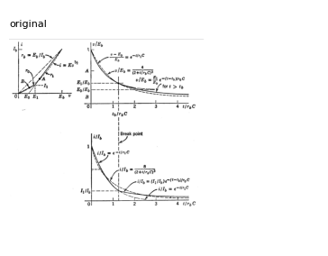
Fig. 3.32. Use of a piecewise-linear approximation for calculating capacitor discharge.
voltages and currents in circuits containing inductance or capacitance or both, it is encouraging to find that simple representations of nonlinear $i$ vs. $v$ curves yield adequate approximations to time-varying behavior

16 3.17 Solution of Transient Problem Using Stepwise Diode Approximation
If a nonlinear element exerts a major influence on the current or voltage, a simple one- or two-segment piecewise-linear approximation may be judged inadequate. However, the piecewise-linear model.
loses some of its convenience if more than one or two break points occur within the range of expected current or voltage variation. such cases the stepwise approximation for $i$ vs. $v$ is often useful.
Let the diode curve in Fig. 3.33 be approximated by a stepwise curve. The diode curve could be any function $i=f\left(v\right)$; but in order to have the true solution available for comparison, assume $i:Kv^{3}$ .The true
import schemdraw
import schemdraw.elements as e
import schemdraw as schem
import matplotlib.pyplot as plt
import matplotlib.image as mpimg
import numpy as np
# Create the figure and subplots
fig, axs = plt.subplots(1, 2, figsize=(12, 12))
d = schemdraw.Drawing()
l3 = d.add(e.Line().up().color('white'))
l1 = d.add(e.Line().left().length(1).dot(open=True))
D1 = d.add(e.Diode(fill=True).down().at(l1.start))
R1 = d.add(e.Resistor().down().label('$ro$',ofst=-1.2))
l1 = d.add(e.Line().down().length(3).dot())
l2 = d.add(e.Line().right().length(2).at(D1.start).dot())
D2 = d.add(e.Diode(fill=True).down())
R2 = d.add(e.Resistor().down().label('$ror1/(ro-r1)$',ofst=-3.2))
E1 = d.add(e.Battery().down().label('$E_1$',ofst=-1.2))
l1 = d.add(e.Line().left().length(3).dot(open=True))
d += e.Arrow().up().length(1).linewidth(0.6).color('white').label('$V$', loc='start', color='black',ofst=0.3). at((-.9,-1.4))
d += e.Arrow().up().length(1.8).linewidth(0.6).color('black').label('+',loc='end', color='black',ofst=-0.1). at((-1.2,1))
d += e.Arrow().down().length(1.8).linewidth(0.6).color('black').label(r'_', loc='end', color='black',ofst=(-0.4,0.2)). at((-1.2,-4.))
d.save('./Drawings/fig3-32.jpg')
d.save('./Drawings/fig3-32.svg')
# Load the saved PNG file into the subplot
img = mpimg.imread('./Drawings/fig3-32.jpg')
axs[0].imshow(img)
axs[0].axis('off') # Hide axes for image display
axs[0].set_title('Circuit Diagram (developed)')
# **Subplot (1, 2): PNG Sample File**
img_sample = mpimg.imread('images-books/3-32.png') # Load the PNG file
axs[1].imshow(img_sample)
axs[1].axis('off') # Hide axes for image display
axs[1].set_title('Original')
# Show the combined plots
plt.tight_layout()
plt.show()
d.save('./Drawings/fig3-32.png')
d.save('./Drawings/fig3-32.svg')
d.save('./Drawings/fig3-32.jpg')
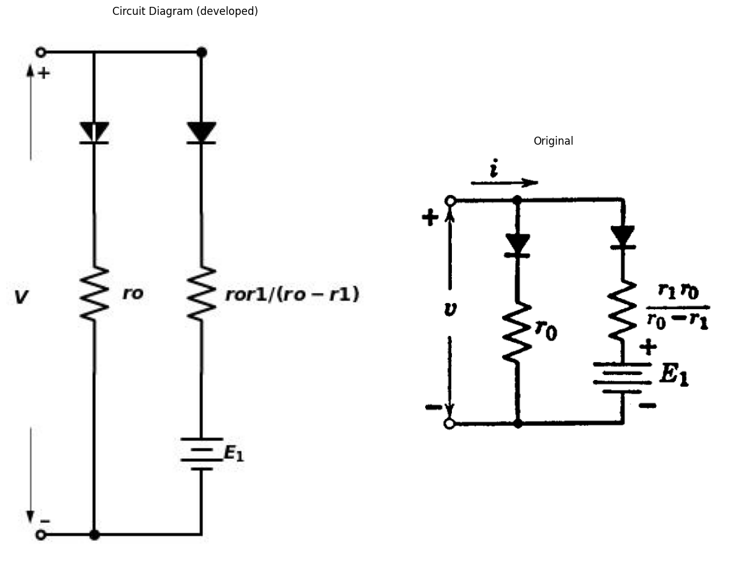
import matplotlib.pyplot as plt
from matplotlib import rcParams
import PySpice.Logging.Logging as Logging
logger = Logging.setup_logging()
from PySpice.Spice.Netlist import Circuit
from PySpice.Unit import *
import numpy as np
fig, axs = plt.subplots(2, 2, figsize=(10, 10))
t = np.linspace(0,10,100)
r0=3
rb=1
c = 0.5
x = t/(rb*c)
tA = 0.1
tB = 0.3
tC = 0.8
tD = 1.6
tE = 3.6
Eb = 4
Ib = Eb/rb
K = 0.5
y0 = 4/((2+x)**2)
y1 =np.where(x < tA, ((((4/((2+tA)**2)))-1)/tA)*x+1,np.where(x < tB, ((4/((2+tA)**2)-(4/((2+tB)**2)))/(tA-tB))*(x-tA)+((4/(2+tA)**2)),
np.where(x < tC, ((4/((2+tB)**2)-(4/((2+tC)**2)))/(tB-tC))*(x-tB)+((4/(2+tB)**2)),
np.where(x < tD, ((4/((2+tC)**2)-(4/((2+tD)**2)))/(tC-tD))*(x-tC)+((4/(2+tC)**2)),
np.where(x < tE, ((4/((2+tD)**2)-(4/((2+tE)**2)))/(tD-tE))*(x-tD)+((4/(2+tD)**2)),((4/((2+tE)**2)-(4/((2+5)**2)))/(tE-5))*(x-tE)+((4/(2+tE)**2)))))))
axs[0,1].plot(x, y1, color='black', label=r'$slope$')
axs[0,1].plot(x, y0, color='black', linestyle='--', label=r'$v/E_b$=$4/(2+t/r_bc)^2$')
axs[0,1].set_ylim(0, 1.1)
axs[0,1].set_xlim(0, 5)
axs[0,1].set_xlabel(r'$t/r_bc$', loc='right')
axs[0,1].set_ylabel(r'$v/E_b$',rotation=0,loc='top')
x = np.linspace(0,1,20)
v = x*Eb
i = K*v**(3/2)
y1 = i/Ib
y2 = rb*x
XE = 0.1
XD = 0.3
XC = 0.5
XB = 0.7
XA = 0.9
y3 =np.where(x > XA,(K/Ib)*(Eb)**(3/2) ,np.where(x > XB,(K/Ib)*(0.8*Eb)**(3/2) ,
np.where(x > XC,(K/Ib)*(0.6*Eb)**(3/2) ,np.where(x > XD,(K/Ib)*(0.4*Eb)**(3/2) ,
np.where(x > XE,(K/Ib)*(0.2*Eb)**(3/2) ,(K/Ib)*(0.05*Eb)**(3/2))))))
axs[1,0].plot(x, y1, color='black', label=r'$i=Kv^{3/2}$')
axs[1,0].plot(x, y2, color='black', linestyle='--', label=r'$r_b$=$E_b/I_b$')
axs[1,0].step(x, y3, color='black', label=r'$slope$')
a=[axs[0,0],axs[0,1],axs[1,0],axs[1,1]]
axs[1,0].set_ylim(0, 1.1)
axs[1,0].set_xlim(0, 1)
axs[1,0].set_xlabel(r'$v/E_b$', loc='right')
axs[1,0].set_ylabel(r'$i/I_b$',rotation=0,loc='top')
XE = 3.8
XD = 1.8
XC = 0.8
XB = 0.4
XA = 0.15
Xt = t/rb*c
y4 = 8/(2+Xt)**3
y5 =np.where(Xt > XE,0.026,np.where(Xt > XD,0.1,
np.where(Xt > XC,0.3,np.where(Xt > XB,0.5,
np.where(Xt > XA,0.8,1)))))
axs[1,1].plot(Xt, y4, color='black',linestyle='--', label=r'$i/I_b$=$8/(2+t/r_bc)^3$')
axs[1,1].step(Xt, y5, color='black', label=r'$slope$')
axs[1,1].set_ylim(0, 1.1)
axs[1,1].set_xlim(0, 5)
axs[1,1].set_xlabel(r'$t/r_bC$', loc='right')
axs[1,1].set_ylabel(r'$i/I_b$',rotation=0,loc='top')
a=[axs[0,1],axs[1,0],axs[1,1]]
for i in a:
i.spines['top'].set_visible(False)
i.spines['right'].set_visible(False)
i.set_xticks([])
i.set_yticks([])
i.legend()
axs[0,0].axis('off')
fig = plt.figure(figsize=(5, 3))
img = plt.imread('images-books/3-33.png')
plt.imshow(img)
plt.axis('off')
plt.title('\nReference image from the book:', fontsize=8, pad=10,loc='left')
plt.show()
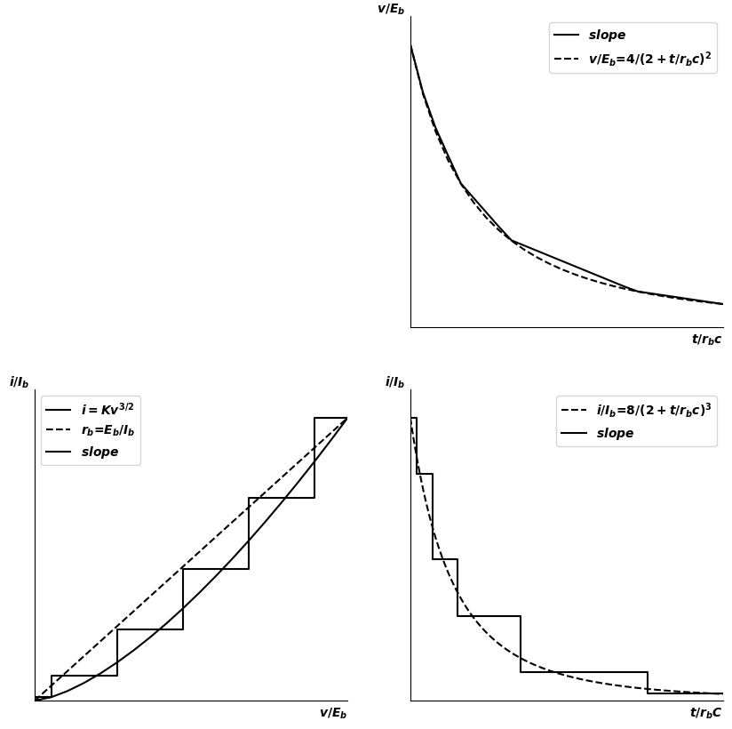
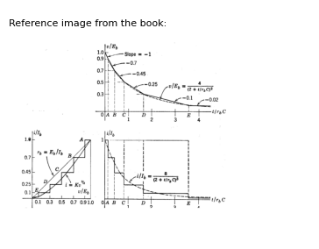
Fig. 3.33. Stepsise diode approximations to obtain piecewise-linear waveform approximations.
waveforms $v\left(t\right)$ and $i\left(t\right)$ for the capacitor discharge are shown by the dashed lines. The waveforms resulting from the stepwise approximation are shown by the solid line. Since $i=−Cdv/dt$, the waveform $v\left(t\right)$ is piecewise-linear, whereas $i\left(t\right)$ is a stepwise curve.
In the example shown in Fig. 3.33, the stepwise curve was literally drawn to "look right." Despite this seemingly haphazard approach to the approximation problem, the resulting piecewise-linear waveform of $v\left(t\right)$ is almost everywhere within 10 per cent of the true curve derived from the three-halves power law. The waveform of $v\left(t\right)$ may be drawn very rapidly by beginning at $t=0$, and drawing a line from the initial value of voltage to the value at break point A, with slope determined by the current.
The example shown in Fig. 3.33 includes many more segments than are required for making a reasonably good approximation. The sketches in Fig. 3.34 show the results obtained with smaller numbers of segments.
import matplotlib.pyplot as plt
from matplotlib import rcParams
import numpy as np
fig, axs = plt.subplots(2, 2, figsize=(10, 10))
t = np.linspace(0,10,100)
r0=3
rb=1
c = 0.5
x = t/(rb*c)
tA = 1
tB = 3
Eb = 4
Ib = Eb/rb
K = 0.5
y0 = 4/((2+x)**2)
y1 =np.where(x < tA, ((((4/((2+tA)**2)))-1)/tA)*x+1,np.where(x < tB,
((4/((2+tA)**2)-(4/((2+tB)**2)))/(tA-tB))*(x-tA)+((4/(2+tA)**2)),((4/((2+tB)**2)-(4/((2+5)**2)))/(tB-5))*(x-tB)+((4/(2+tB)**2))))
axs[0,1].plot(x, y1, color='black', label=r'$v/E_b$=$4/(2+t/r_bc)^2$')
axs[0,1].plot(x, y0, color='black', linestyle='--',dashes=(10,3), label=r'$slope$')
axs[0,1].set_ylim(0, 1.1)
axs[0,1].set_xlim(0, 5)
axs[0,1].set_xlabel(r'$t/r_bc$', loc='right')
axs[0,1].set_ylabel(r'$v/E_b$',rotation=0,loc='top')
x = np.linspace(0,1.01,100)
v = x*Eb
i = K*v**(3/2)
y1 = i/Ib
y2 = rb*x
XB = 0.12
XA = 0.4
y3 =np.where(x > 1,1,np.where(x > XA,0.6,np.where(x > XB,0.14,0.02)))
axs[0,0].plot(x, y1, color='black', label=r'$i=Kv^{3/2}$')
axs[0,0].plot(x, y2, color='black', label=r'$r_b$=$E_b/I_b$')
axs[0,0].step(x, y3, color='black', label=r'$slope$')
axs[0,0].set_ylim(0, 1.1)
axs[0,0].set_xlim(0, 1.1)
axs[0,0].set_xlabel(r'$v/E_b$', loc='right')
axs[0,0].set_ylabel(r'$i/I_b$',rotation=0,loc='top')
XA = 0.4
y3 =np.where(x > 1,1,np.where(x > XA,0.5,0.05))
axs[1,0].plot(x, y1, color='black', label=r'$i=Kv^{3/2}$')
axs[1,0].plot(x, y2, color='black', label=r'$r_b$=$E_b/I_b$')
axs[1,0].step(x, y3, color='black', label=r'$slope$')
axs[1,0].set_ylim(0, 1.1)
axs[1,0].set_xlim(0, 1.1)
axs[1,0].set_xlabel(r'$v/E_b$', loc='right')
axs[1,0].set_ylabel(r'$i/I_b$',rotation=0,loc='top')
x = t/(rb*c)
y0 = 4/((2+x)**2)
tA = 1.5
yA = 0.31
y1 =np.where(x < tA, (((yA-1)/tA)*x)+1,(((yA-0.091)/(tA-4.6))*(x-4.6))+0.091)
axs[1,1].plot(x, y1, color='black', label=r'$slope$')
axs[1,1].plot(x, y0, color='black', linestyle='--',dashes=(10,3), label=r'$v/E_b$=$4/(2+t/r_bc)^2$')
axs[1,1].set_ylim(0, 1.1)
axs[1,1].set_xlim(0, 5)
axs[1,1].set_xlabel(r'$t/r_bc$', loc='right')
axs[1,1].set_ylabel(r'$v/E_b$',rotation=0,loc='top')
a=[axs[0,1],axs[1,0],axs[1,1]]
for i in a:
i.spines['top'].set_visible(False)
i.spines['right'].set_visible(False)
i.set_xticks([])
i.set_yticks([])
i.legend()
fig = plt.figure(figsize=(5, 3))
img = plt.imread('images-books/3-34.png')
plt.imshow(img)
plt.axis('off')
plt.title('\nReference image from the book:', fontsize=8, pad=10,loc='left')
plt.show()
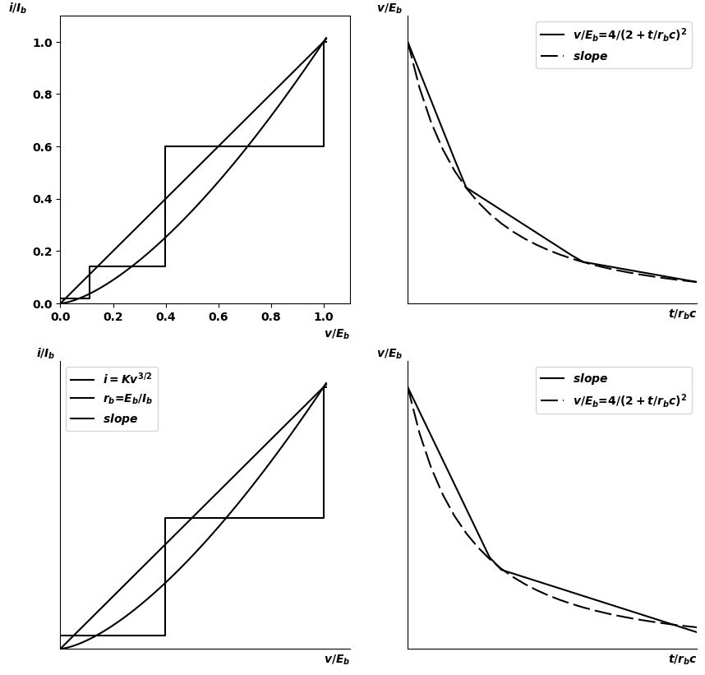
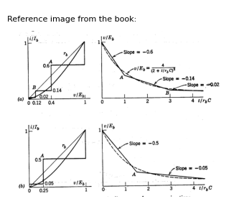
Fig. 3.34. Simple piecewise-linear waveform approximations.

17 3.18 Approximations for the Exponential Curve
The current and voltage transients of linear or piecewise-linear circuits are exponential in character. Since such transients will occur repeatedly in the analysis of electronic circuits, the properties of exponential wave- forms, and a few simple approximations to them are important.
The function with which we shall most often be concerned is the form $e^{−}x$ as shown in Fig. 3.35(a). In this expression, $x=τ/r$. The constant $r$ is merely a normalizing factor for the time scale. An exponential curve is completely determined when the initial and final values are known, together with the time constant. At each point on the curve, the slope is proportional to the magnitude (relative to the final value); that is, the slope at any specific value $E_{1}$ is $−E_{1}/τ$. The area under the curve is finite and equal to the product of the initial value and the time con- stant. Mathematically, the value of the exponential approaches zero. as time approaches infinity. For engineering purposes, however, the
exponential has reached completion after an elapsed time corresponding to several time constants. For example, when $τ/r=5$, the value of the exponential is 0.6 per cent of the initial value at $t=0$.
The first term of the series expansion of the exponential makes a convenient approximation to the initial part of the exponential curve.
import matplotlib.pyplot as plt
from matplotlib import rcParams
import numpy as np
fig, axs = plt.subplots(4, 1, figsize=(10, 10))
x = np.linspace(0,10,100)
y1 = np.exp(-x)
y2 = 1-x
axs[0].set_ylabel(r'$y$',rotation=0,loc='top')
axs[0].plot(x, y1, color='black', label=r'$e^{-x}$')
axs[0].plot(x, y2, color='black', label=r'$1-x$')
y2 = 1-(x/2)
y3 = 1-np.exp(-x)
axs[1].plot(x, y1, color='black', label=r'$e^{-x}$')
axs[1].plot(x, y2, color='black', label=r'$1-x/2$')
axs[1].plot(x, y3, color='black', linestyle='--',dashes=(8,3), label=r'$slope$')
y4 = (1-x/2)/(1+x/2)
axs[2].plot(x, y1, color='black', label=r'$e^{-x}$')
axs[2].plot(x, y4, color='black', linestyle='--',dashes=(8,3), label=r'$(1-x/2)/(1+x/2)$')
a=[axs[0],axs[1],axs[2]]
for i in a:
i.spines['top'].set_visible(False)
i.spines['right'].set_visible(False)
i.set_xticks([0,1,2,3,4,5])
i.set_yticks([0,0.2,0.4,0.6,0.8,1.0])
i.legend()
i.set_ylim(0, 1.1)
i.set_xlim(0, 5.1)
i.set_xlabel(r'$x$', loc='right')
img_sample = mpimg.imread('images-books/3-35-1.png') # Load the PNG file
axs[3].imshow(img_sample)
axs[3].axis('off') # Hide axes for image display
axs[3].set_title('Original')
# Show the combined plots
plt.tight_layout()
plt.show()
plt.tight_layout()
plt.show()
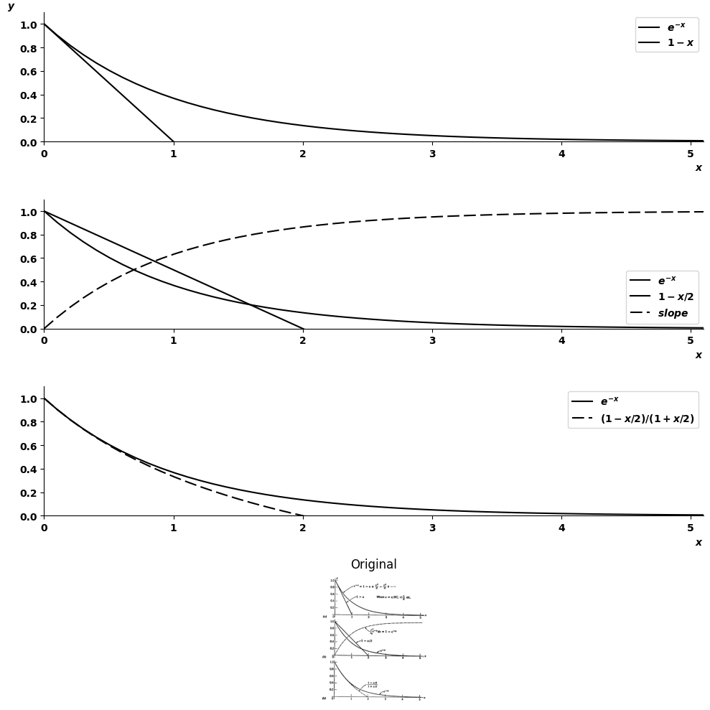
<Figure size 640x480 with 0 Axes>
Fig. 3.35. Approximating exponential curves.
When $x$ is small, the higher-order terms $x^{2},x^{3}$, etc. may be neglected. This approximation is shown in Fig. 3.35$\left(a\right)$. The area under the exponential of $\left(a\right)$ is unity, whereas the area under the triangle representing the approximation in $\left(a\right)$ is only ½. Hence, if a linear approximation is desired to match total area instead of initial slope, the line must reach zero at $x=2$, as shown in Fig. 3.35$\left(b\right)$.
The approximation given in Fig. 3.35$\left(c\right)$ matches initial slope but not total area. It follows the true curve more closely than either of the other approximations. Higher-order approximations may be justified in some special cases, but since the exponential itself is fairly convenient to manipulate, one either uses simple approximations or the function itself.

18 SUPPLEMENTARY READING
B. Chance, Waveforms, McGraw-Hill, New York, 1948.
T. S. Gray, Applied Electronics, 2nd edition, John Wiley and Sons, New York, 1954.
E. A. Guillemin, Introductory Circuit Theory, John Wiley and Sons, New York, 1953.
J. Millman and H. Taub, Pulse and Digital Circuits, McGraw-Hill, New York, 1956.

19 PROBLEMS
$3.1$. Find the Thevenin equivalent of each of the circuits in Figs. P3.1-P3.4. Note that the two-terminal circuits can be simplified to a single resistor and single source, whereas the three-terminal circuits require two sources and three resistors.
import schemdraw
import schemdraw.elements as e
import schemdraw as schem
import matplotlib.pyplot as plt
import matplotlib.image as mpimg
import numpy as np
# Create the figure and subplots
fig, axs = plt.subplots(1, 2, figsize=(12, 12))
d = schemdraw.Drawing()
l1 = d.add(e.Line().right().length(1.4))
l2 = d.add(e.Line().left().length(3.4).dot(open=True))
R1 = d.add(e.Resistor().down().at(l1.end).label('1',ofst=-1.).dot())
R2 = d.add(e.Resistor().down().at(R1.end).label('1',ofst=-1.).dot())
R3 = d.add(e.Resistor().down().label('1',ofst=-1.).dot())
l3 = d.add(e.Line().left().at(R3.end).length(3.4).dot(open=True))
E1 = d.add(e.BatteryCell().down().at((-0.9, -5.3)).length(0.75).label('$1$',ofst=-1.2))
l4 = d.add(e.Line().up().at(E1.start).length(2.3).dot())
l5 = d.add(e.Line().right().at(l4.end).length(2.2))
l5 = d.add(e.Line().down().at(E1.end).length(2.95).dot())
l6 = d.add(e.Line().right().at(l1.end).length(3.4).dot())
E2 = d.add(e.BatteryCell().down().at((4.8, -2.3)).length(0.75).label('$1$',ofst=-1.2))
l6 = d.add(e.Line().up().at(E2.start).length(2.35))
l7 = d.add(e.Line().down().at(E2.end).length(2.95))
l8 = d.add(e.Line().left().at(l7.end).length(3.45))
I1 = d.add(e.SourceI().down().at((4.8, -7.2)).length(0.75).label('$1$',ofst=-1.5))
l9 = d.add(e.Line().down().at(I1.end).length(.8))
l7 = d.add(e.Line().left().at(l9.end).length(3.4))
l7 = d.add(e.Line().up().at(I1.start).length(1.2).dot())
d += e.Arrow().right().at((-1.7, .5)).length(0.75).label('$i_2$').color('black')
d += e.Arrow().up().linewidth(0.6).length(4).linewidth(0.6).linewidth(0.6).color('white').label('$V$', loc='start', color='black',ofst=0.3). at((-1.6,-4.5))
d += e.Arrow().up().length(2.5).linewidth(0.6).color('black').label('+',loc='end', color='black',ofst=-0.2). at((-2,-2.6))
d += e.Arrow().down().length(2.5).linewidth(0.6).color('black').label(r'_', loc='end', color='black',ofst=(-.5, 0.2)). at((-2,-6.5))
d.move(10,9)
l10 = d.add(e.Line().right().length(1.4))
l11 = d.add(e.Line().left().length(2.4).dot(open=True))
l12 = d.add(e.Line().down().at(l10.end).length(2.4))
R4 = d.add(e.Resistor().down().at(l12.end).label('1',ofst=-1.))
l12 = d.add(e.Line().down().at(R4.end).length(3.6))
l12 = d.add(e.Line().left().length(2.4).dot(open=True))
l13 = d.add(e.Line().right().at(l10.end).length(3.4))
R5 = d.add(e.Resistor().down().at(l13.end).label('1',ofst=-1.).dot())
R6 = d.add(e.Resistor().down().at(R5.end).label('1',ofst=-1.).dot())
E3 = d.add(e.BatteryCell().down().at((12.8, -6.1)).length(1.75).label('$1$',ofst=-1.2))
l14 = d.add(e.Line().down().at(E3.end).length(1.15))
l15 = d.add(e.Line().left().at(l14.end).length(3.5))
l16 = d.add(e.Line().right().at(l13.end).length(3))
R7 = d.add(e.Resistor().down().at(l16.end).label('1',ofst=-1.).dot())
R8 = d.add(e.Resistor().down().at(R7.end).label('1',ofst=-1.).dot())
R9 = d.add(e.Resistor().down().at(R8.end).label('1',ofst=-1.).dot())
l17 = d.add(e.Line().left().at(R9.end).length(3))
R10 = d.add(e.Resistor().right().at(R5.end).label('1',ofst=-1.).dot())
E4 = d.add(e.BatteryCell().right().at((13.5, -2.1)).length(1.75).label('$1$',ofst=.2))
l17 = d.add(e.Line().right().at(E4.end).length(.55).dot())
l17 = d.add(e.Line().left().at(E4.start).length(.69).dot())
R11 = d.add(e.Resistor().right().at(R7.start).label('1',ofst=0.2).dot())
I2 = d.add(e.SourceI().up().at((18.8, -2.7)).length(2.75).label('$1$',ofst=-1.5))
l17 = d.add(e.Line().down().at(I2.start).length(.69).dot())
E5 = d.add(e.BatteryCell().down().at((18.8, -3.5)).length(1.75).label('$1$',ofst=-1.2))
I3 = d.add(e.SourceI().up().at((18.8, -9)).length(2.98).label('$1$',ofst=-1.5))
R11 = d.add(e.Resistor().left().at(I3.start).label('1',ofst=0.2).dot())
l17 = d.add(e.Line().down().at(E5.end).length(1))
l17 = d.add(e.Line().left().at(I3.end).length(6))
d += e.Arrow().right().at((7, .5)).length(0.75).label('$i_2$').color('black')
d += e.Arrow().up().linewidth(0.6).length(4).linewidth(0.6).linewidth(0.6).color('white').label('$V$', loc='start', color='black',ofst=0.3). at((7.6,-4.5))
d += e.Arrow().up().length(2.5).linewidth(0.6).color('black').label('+',loc='end', color='black',ofst=-0.2). at((7,-2.6))
d += e.Arrow().down().length(2.5).linewidth(0.6).color('black').label(r'_', loc='end', color='black',ofst=(-.5, 0.2)). at((7,-6.5))
d.save('./Drawings/fig1.jpg')
d.save('./Drawings/fig1.svg')
# Load the saved PNG file into the subplot
img = mpimg.imread('./Drawings/fig1.jpg')
axs[0].imshow(img)
axs[0].axis('off') # Hide axes for image display
axs[0].set_title('Circuit Diagram (developed)')
# **Subplot (1, 2): PNG Sample File**
img_sample = mpimg.imread('images-books/p3-1.png') # Load the PNG file
axs[1].imshow(img_sample)
axs[1].axis('off') # Hide axes for image display
axs[1].set_title('Original')
# Show the combined plots
plt.tight_layout()
plt.show()
d.save('./Drawings/fig1.png')
d.save('./Drawings/fig1.svg')
d.save('./Drawings/fig1.jpg')
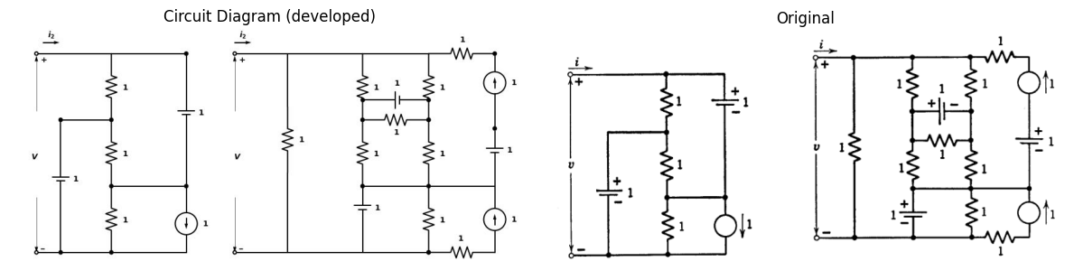
$3.2$. Reciprocity for a two-terminal-pair network can be expressed as a relation between two sets of measurements ($A$ and $B$) performed on the same network (Fig. P3.5). If the networks are reciprocal, the following determinants must be equal.
$[V_1^A , I_1^A ] = [V_2^A , I_2^4 ] $
$[V_1^B, I_1^B ] = [ V_2^B , I_2^B ] $
import schemdraw
import schemdraw.elements as e
import schemdraw as schem
import matplotlib.pyplot as plt
import matplotlib.image as mpimg
import numpy as np
# Create the figure and subplots
fig, axs = plt.subplots(1, 2, figsize=(12, 12))
d = schemdraw.Drawing()
l1 = d.add(e.Line().right().length(1.4).dot())
l2 = d.add(e.Line().left().length(2).dot(open=True))
R1 = d.add(e.Resistor().down().at(l1.end).label('1',ofst=0.1).dot())
l2 = d.add(e.Line().left().length(2).dot(open=True))
E1 = d.add(e.BatteryCell().right().at((2.4, .0001)).length(1.75).label('$1$',ofst=.2))
l2 = d.add(e.Line().right().at(R1.start).length(1))
R2 = d.add(e.Resistor().down().at(E1.end).label('1',ofst=0.1).dot())
R3 = d.add(e.Resistor().left().at(R2.end).label('1',ofst=0.1))
R4 = d.add(e.Resistor().down().at(R2.end).label('1',ofst=0.1).dot())
E2 = d.add(e.BatteryCell().right().at((2.4, -6.0001)).length(1.75).label('$1$',ofst=.2))
l3 = d.add(e.Line().left().at(E2.start).length(1).dot())
R5 = d.add(e.Resistor().up().at(l3.end).label('1',ofst=0.1))
l4 = d.add(e.Line().left().at(l3.end).length(2).dot(open=True))
d += e.Arrow().right().at((-.1, .5)).length(0.75).label('$i_1$').color('black')
d += e.Arrow().up().linewidth(0.6).length(4).linewidth(0.6).linewidth(0.6).color('white').label('$V1$', loc='start', color='black',ofst=0.3). at((-.1,-1.5))
d += e.Arrow().up().length(.5).linewidth(0.6).color('black').label('+',loc='end', color='black',ofst=-0.2). at((-.6,-.6))
d += e.Arrow().down().length(.5).linewidth(0.6).color('black').label(r'_', loc='end', color='black',ofst=(-.5, 0.2)). at((-.6,-2.4))
d += e.Arrow().right().at((-.1, -6.5)).length(0.75).label('$i_2$').color('black')
d += e.Arrow().up().linewidth(0.6).length(4).linewidth(0.6).linewidth(0.6).color('white').label('$V2$', loc='start', color='black',ofst=0.3). at((.1,-4.5))
d += e.Arrow().up().length(.5).linewidth(0.6).color('black').label('_',loc='end', color='black',ofst=-0.2). at((-.6,-3.6))
d += e.Arrow().down().length(.5).linewidth(0.6).color('black').label(r'+', loc='end', color='black',ofst=(-.5, 0.2)). at((-.6,-5.4))
d.move(8,6)
l5 = d.add(e.Line().right().length(1.4))
l6 = d.add(e.Line().left().length(2.4).dot(open=True))
R6 = d.add(e.Resistor().down().at(l5.end).label('1',ofst=.1).dot())
E3 = d.add(e.BatteryCell().down().at((8.8, -3)).length(0.75).label('$2$',ofst=.2))
l7 = d.add(e.Line().left().length(2.4).dot(open=True))
R7 = d.add(e.Resistor().down().at(l7.start).label('3',ofst=.1).dot())
E4 = d.add(e.BatteryCell().down().at((8.8, -6.8)).length(0.75).label('$1$',ofst=.2))
l7 = d.add(e.Line().left().length(2.4).dot(open=True))
l8 = d.add(e.Line().right().at(R6.start).length(2.4).dot())
I3 = d.add(e.SourceI().up().at((11.2, -3)).length(2.98).label('$3$',ofst=-1.3))
l7 = d.add(e.Line().down().at(I3.start).length(.75).dot())
l7 = d.add(e.Line().left().length(2.4).dot())
I4 = d.add(e.SourceI().up().at((11.2, -6.80)).length(2.98).label('$3$',ofst=-1.3))
l7 = d.add(e.Line().down().at(I4.start).length(0.75).dot())
l7 = d.add(e.Line().left().length(2.4).dot())
l9 = d.add(e.Line().right().at(l8.end).length(2.4).dot())
R8 = d.add(e.Resistor().down().at(l9.end).label('2',ofst=.1).dot())
E5 = d.add(e.BatteryCell().down().at((13.6, -3)).length(3.75).label('$1$',ofst=.2))
l9 = d.add(e.Line().down().at(E5.end).length(0.8).dot())
l9 = d.add(e.Line().left().length(2.4).dot())
l10 = d.add(e.Line().right().length(1.6).at(R8.start).dot())
l9 = d.add(e.Line().down().length(2))
I5 = d.add(e.SourceI().up().at((15.2, -4.80)).length(2.98).label('$1$',ofst=-1.3))
l9 = d.add(e.Line().down().at(I5.start).length(2.75))
l9 = d.add(e.Line().left().length(2.8))
d += e.Arrow().right().at((6.9, .5)).length(0.75).label('$i_1$').color('black')
d += e.Arrow().right().at((6.9, -8)).length(0.75).label('$i_2$').color('black')
d += e.Arrow().up().linewidth(0.6).length(4).linewidth(0.6).linewidth(0.6).color('white').label('$V1$', loc='start', color='black',ofst=0.3). at((7,-1.5))
d += e.Arrow().up().length(.5).linewidth(0.6).color('black').label('+',loc='end', color='black',ofst=-0.2). at((6.4,-.6))
d += e.Arrow().down().length(.5).linewidth(0.6).color('black').label(r'_', loc='end', color='black',ofst=(-.5, 0.2)). at((6.4,-3.))
d += e.Arrow().up().linewidth(0.6).length(4).linewidth(0.6).linewidth(0.6).color('white').label('$V2$', loc='start', color='black',ofst=0.3). at((7,-5.5))
d += e.Arrow().up().length(.5).linewidth(0.6).color('black').label('_',loc='end', color='black',ofst=-0.2). at((6.4,-4.3))
d += e.Arrow().down().length(.5).linewidth(0.6).color('black').label(r'+', loc='end', color='black',ofst=(-.5, 0.2)). at((6.4,-7))
d.move(-1,-4)
d += ( T := dsp.Box(w=4, h=4).anchor('W').fill('white').label('Reciprocal\n network'))
center_x, center_y = T.center
line_Right1 = d.add(e.Line().left().at((center_x-2, center_y + 1.65)).length(1))
d += e.Arrow().right().at((4.1, -9.5)).length(0.75).label('$i_1$').color('black')
line_Right2 = d.add(e.Line().left().at((center_x-2, center_y - 1.65)).length(1))
d += e.Gap().up().label(['-' , '$V_1$' , '+'] , fontsize = 16).color('black')
#
line_Right1 = d.add(e.Line().left().at((center_x--3., center_y + 1.6)).length(1))
d += e.Arrow().left().at((10.9, -9.5)).length(0.75).label('$i_2$').color('black')
line_Right2 = d.add(e.Line().left().at((center_x--3, center_y - 1.65)).length(1))
d += e.Gap().up().label(['-' , '$V_2$' , '+'] , fontsize = 16). at((10.4,-13)).color('black')
d.save('./Drawings/fig3.jpg')
d.save('./Drawings/fig3.svg')
# Load the saved PNG file into the subplot
img = mpimg.imread('./Drawings/fig3.jpg')
axs[0].imshow(img)
axs[0].axis('off') # Hide axes for image display
axs[0].set_title('Circuit Diagram (developed)')
# **Subplot (1, 2): PNG Sample File**
img_sample = mpimg.imread('images-books/p3-3.png') # Load the PNG file
axs[1].imshow(img_sample)
axs[1].axis('off') # Hide axes for image display
axs[1].set_title('Original')
# Show the combined plots
plt.tight_layout()
plt.show()
d.save('./Drawings/fig3.png')
d.save('./Drawings/fig3.svg')
d.save('./Drawings/fig3.jpg')
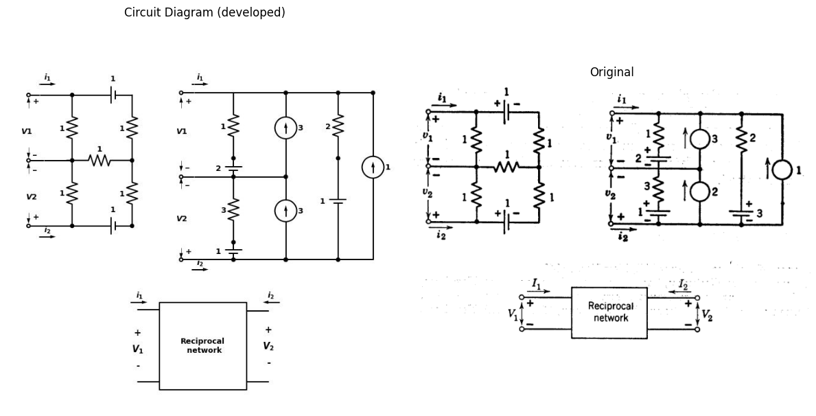
This equation implies that
$I_{2}/V_{1}=I_{2}/V_{2}$ and $V_2/I_1 = V_1/I_2 $
Thus any purely resistive, reciprocal two-terminal-pair network can be simpli- fied to three resistors in a "$T$" or "$π$" configuration, as in Figs. P3.6 and P3.7
import schemdraw
import schemdraw.elements as e
import schemdraw as schem
import matplotlib.pyplot as plt
import matplotlib.image as mpimg
import numpy as np
# Create the figure and subplots
fig, axs = plt.subplots(1, 2, figsize=(12, 12))
d = schemdraw.Drawing()
l1 = d.add(e.Line().left().length(1.4).dot(open=True))
R1 = d.add(e.Resistor().right().at(l1.start).dot())
R2 = d.add(e.Resistor().down().dot())
R3 = d.add(e.Resistor().right().at(R1.end))
l1 = d.add(e.Line().right().length(1).dot(open=True))
l2 = d.add(e.Line().right().at(R2.end).length(4).dot(open=True))
l2 = d.add(e.Line().left().at(R2.end).length(4.36).dot(open=True))
d += e.Arrow().right().at((-.9, .5)).length(0.75).label('$i_1$').color('black')
d += e.Arrow().left().at((6.9, .5)).length(0.75).label('$i_2$').color('black')
d += e.Arrow().up().linewidth(0.6).length(4).linewidth(0.6).linewidth(0.6).color('white').label('$V1$', loc='start', color='black',ofst=0.3). at((-1,-1.5))
d += e.Arrow().up().length(.5).linewidth(0.6).color('black').label('+',loc='end', color='black',ofst=-0.2). at((-1.4,-.6))
d += e.Arrow().down().length(.5).linewidth(0.6).color('black').label(r'_', loc='end', color='black',ofst=(-.5, 0.2)). at((-1.4,-2.5))
d += e.Arrow().up().linewidth(0.6).length(4).linewidth(0.6).linewidth(0.6).color('white').label('$V2$', loc='start', color='black',ofst=0.3). at((7.5,-1.5))
d += e.Arrow().up().length(.5).linewidth(0.6).color('black').label('+',loc='end', color='black',ofst=-0.2). at((7,-.6))
d += e.Arrow().down().length(.5).linewidth(0.6).color('black').label(r'_', loc='end', color='black',ofst=(-.5, 0.2)). at((7,-2.5))
d.move(5,3)
l3 = d.add(e.Line().left().length(1.4).dot(open=True))
R4 = d.add(e.Resistor().right().at(l3.start).dot())
R5 = d.add(e.Resistor().down().dot())
R6 = d.add(e.Resistor().right().at(R5.start))
l3 = d.add(e.Line().right().length(2).dot(open=True))
R7 = d.add(e.Resistor().down().at(R6.end))
l3 = d.add(e.Line().left().length(7.5).dot(open=True))
l3 = d.add(e.Line().right().length(2).at(R7.end).dot(open=True))
d += e.Arrow().right().at((11, .5)).length(0.75).label('$i_1$').color('black')
d += e.Arrow().left().at((19.9, .5)).length(0.75).label('$i_2$').color('black')
d += e.Arrow().up().linewidth(0.6).length(4).linewidth(0.6).linewidth(0.6).color('white').label('$V1$', loc='start', color='black',ofst=0.3). at((11,-1.5))
d += e.Arrow().up().length(.5).linewidth(0.6).color('black').label('+',loc='end', color='black',ofst=-0.2). at((10.5,-.6))
d += e.Arrow().down().length(.5).linewidth(0.6).color('black').label(r'_', loc='end', color='black',ofst=(-.5, 0.2)). at((10.5,-2.5))
d += e.Arrow().up().linewidth(0.6).length(4).linewidth(0.6).linewidth(0.6).color('white').label('$V2$', loc='start', color='black',ofst=0.3). at((20.8,-1.5))
d += e.Arrow().up().length(.5).linewidth(0.6).color('black').label('+',loc='end', color='black',ofst=-0.2). at((20,-.6))
d += e.Arrow().down().length(.5).linewidth(0.6).color('black').label(r'_', loc='end', color='black',ofst=(-.5, 0.2)). at((20,-2.5))
d.move(-12,-2.5)
l4 = d.add(e.Line().left().length(2).dot(open=True))
R4 = d.add(e.Resistor().right().at(l4.start).label('1',ofst=.1))
l3 = d.add(e.Line().right().length(2).dot(open=True))
R5 = d.add(e.Resistor().right().at((8.2, -9.5)).label('1',ofst=.1))
R6 = d.add(e.Resistor().right().endpoints(l3.end, R5.start).label('1',ofst=.1))
l3 = d.add(e.Line().right().length(2).at(R5.end).dot(open=True))
l13 = d.add(e.Line().left().length(2.2).at(R5.start).dot(open=True))
l14 = d.add(e.Line().right().length(0.5).at(R6.end))
R7 = d.add(e.Resistor().right().endpoints(R5.end, l4.end).label('1',ofst=.1))
d += e.Arrow().right().at((6, -5)).length(0.75).label('$i_1$').color('black')
d += e.Arrow().left().at((13,-5)).length(0.75).label('$i_2$').color('black')
d += e.Arrow().up().linewidth(0.6).length(4).linewidth(0.6).linewidth(0.6).color('white').label('$V1$', loc='start', color='black',ofst=0.3). at((6.5,-7))
d += e.Arrow().up().length(1).linewidth(0.6).color('black').label('+',loc='end', color='black',ofst=-0.2). at((5.9,-6.5))
d += e.Arrow().down().length(1).linewidth(0.6).color('black').label(r'_', loc='end', color='black',ofst=(-.5, 0.2)). at((5.9,-8.5))
d += e.Arrow().up().linewidth(0.6).length(4).linewidth(0.6).linewidth(0.6).color('white').label('$V2$', loc='start', color='black',ofst=0.3). at((13.5,-7.5))
d += e.Arrow().up().length(1).linewidth(0.6).color('black').label('+',loc='end', color='black',ofst=0.4). at((13,-6.5))
d += e.Arrow().down().length(1).linewidth(0.6).color('black').label(r'_', loc='end', color='black',ofst=(-0.6, -0.3)). at((13.2,-8.5))
d.save('./Drawings/fig6.jpg')
d.save('./Drawings/fig6.svg')
# Load the saved PNG file into the subplot
img = mpimg.imread('./Drawings/fig6.jpg')
axs[0].imshow(img)
axs[0].axis('off') # Hide axes for image display
axs[0].set_title('Circuit Diagram (developed)')
# **Subplot (1, 2): PNG Sample File**
img_sample = mpimg.imread('images-books/p3-6.png') # Load the PNG file
axs[1].imshow(img_sample)
axs[1].axis('off') # Hide axes for image display
axs[1].set_title('Original')
# Show the combined plots
plt.tight_layout()
plt.show()
d.save('./Drawings/fig6.png')
d.save('./Drawings/fig6.svg')
d.save('./Drawings/fig6.jpg')
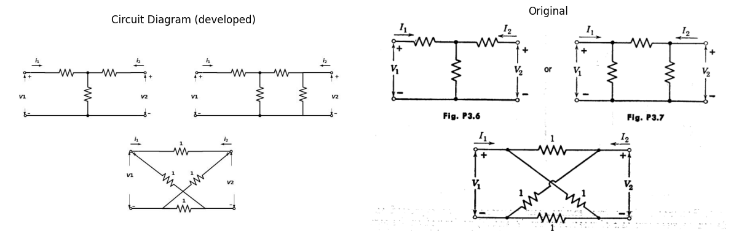
Using reciprocity, simplify the networks in Figs. P3.8, P3.9, and P3.10 to a $T$ and $π$ equivalent. Can you suggest how the above determinant expression
import schemdraw
import schemdraw.elements as e
import schemdraw as schem
import matplotlib.pyplot as plt
import matplotlib.image as mpimg
import numpy as np
# Create the figure and subplots
fig, axs = plt.subplots(1, 2, figsize=(12, 12))
d = schemdraw.Drawing()
l1 = d.add(e.Line().left().length(1.4).dot(open=True))
R1 = d.add(e.Resistor().right().at(l1.start).label('1',ofst=.1).dot())
R2 = d.add(e.Resistor().down().dot().label('1',ofst=.1))
R3 = d.add(e.Resistor().right().at(R1.end).label('1',ofst=.1).dot())
R4 = d.add(e.Resistor().down().dot().label('1',ofst=.1))
R5 = d.add(e.Resistor().right().at(R3.end).label('1',ofst=.1).dot())
R6 = d.add(e.Resistor().down().dot().label('1',ofst=.1))
R7 = d.add(e.Resistor().right().at(R5.end).label('1',ofst=.1).dot(open=True))
R8 = d.add(e.Resistor().right().at(R6.end).label('1',ofst=-1).dot(open=True))
R9 = d.add(e.Resistor().right().at(R4.end).label('1',ofst=-1).dot())
R10 = d.add(e.Resistor().right().at(R2.end).label('1',ofst=-1).dot())
R11 = d.add(e.Resistor().left().at(R2.end).label('1',ofst=-1))
l1 = d.add(e.Line().left().length(1.4).dot(open=True))
d += e.Arrow().right().at((-.9, .5)).length(0.75).label('$i_1$').color('black')
d += e.Arrow().left().at((12, .5)).length(0.75).label('$i_2$').color('black')
d += e.Arrow().up().linewidth(0.6).length(4).linewidth(0.6).linewidth(0.6).color('white').label('$V1$', loc='start', color='black',ofst=0.3). at((-1,-1.5))
d += e.Arrow().up().length(.5).linewidth(0.6).color('black').label('+',loc='end', color='black',ofst=-0.2). at((-1.4,-.6))
d += e.Arrow().down().length(.5).linewidth(0.6).color('black').label(r'_', loc='end', color='black',ofst=(-.5, 0.2)). at((-1.4,-2.5))
d += e.Arrow().up().linewidth(0.6).length(4).linewidth(0.6).linewidth(0.6).color('white').label('$V2$', loc='start', color='black',ofst=0.3). at((12.5,-1.5))
d += e.Arrow().up().length(.5).linewidth(0.6).color('black').label('+',loc='end', color='black',ofst=0.5). at((12,-.6))
d += e.Arrow().down().length(.5).linewidth(0.6).color('black').label(r'_', loc='end', color='black',ofst=(-.5, -0.5)). at((12,-2.5))
d.move(-12,-2.5)
l2 = d.add(e.Line().left().length(2).at((8, -5.5)).dot(open=True))
R4 = d.add(e.Resistor().right().at((8, -5.5)).label('1',ofst=.1))
l3 = d.add(e.Line().right().length(2).dot(open=True))
R5 = d.add(e.Resistor().right().at((8.2, -9.5)).label('1',ofst=.1))
R6 = d.add(e.Resistor().right().endpoints(l3.end, R5.start).label('2',ofst=.1))
l3 = d.add(e.Line().right().length(2).at(R5.end).dot(open=True))
l3 = d.add(e.Line().left().length(2.2).at(R5.start).dot(open=True))
#l4 = d.add(e.Line().right().length(0.5).at(R6.end))
#l3 = d.add(e.Line().down().length(2).at(l4.end).dot())
#l3 = d.add(e.Line().up().length(2).at(R6.start).dot())
R7 = d.add(e.Resistor().right().endpoints(R5.end, l2.end).label('2',ofst=.1))
#l3 = d.add(e.Line().up().length(1).at(R7.end).dot())
#l5 = d.add(e.Line().left().length(1).at(R7.start))
#l3 = d.add(e.Line().down().length(3).at(l5.end).dot())
d += e.Arrow().right().at((6, -5)).length(0.75).label('$i_1$').color('black')
d += e.Arrow().left().at((13,-5)).length(0.75).label('$i_2$').color('black')
d += e.Arrow().up().linewidth(0.6).length(4).linewidth(0.6).linewidth(0.6).color('white').label('$V1$', loc='start', color='black',ofst=0.3). at((6.5,-7))
d += e.Arrow().up().length(1).linewidth(0.6).color('black').label('+',loc='end', color='black',ofst=-0.2). at((5.9,-6.5))
d += e.Arrow().down().length(1).linewidth(0.6).color('black').label(r'_', loc='end', color='black',ofst=(-.5, 0.2)). at((5.9,-8.5))
d += e.Arrow().up().linewidth(0.6).length(4).linewidth(0.6).linewidth(0.6).color('white').label('$V2$', loc='start', color='black',ofst=0.3). at((13.5,-7.5))
d += e.Arrow().up().length(1).linewidth(0.6).color('black').label('+',loc='end', color='black',ofst=0.4). at((13,-6.5))
d += e.Arrow().down().length(1).linewidth(0.6).color('black').label(r'_', loc='end', color='black',ofst=(-0.6, -0.3)). at((13.2,-8.5))
d.save('./Drawings/fig9.jpg')
d.save('./Drawings/fig9.svg')
# Load the saved PNG file into the subplot
img = mpimg.imread('./Drawings/fig9.jpg')
axs[0].imshow(img)
axs[0].axis('off') # Hide axes for image display
axs[0].set_title('Circuit Diagram (developed)')
# **Subplot (1, 2): PNG Sample File**
img_sample = mpimg.imread('images-books/p3-9.png') # Load the PNG file
axs[1].imshow(img_sample)
axs[1].axis('off') # Hide axes for image display
axs[1].set_title('Original')
# Show the combined plots
plt.tight_layout()
plt.show()
d.save('./Drawings/fig9.png')
d.save('./Drawings/fig9.svg')
d.save('./Drawings/fig9.jpg')
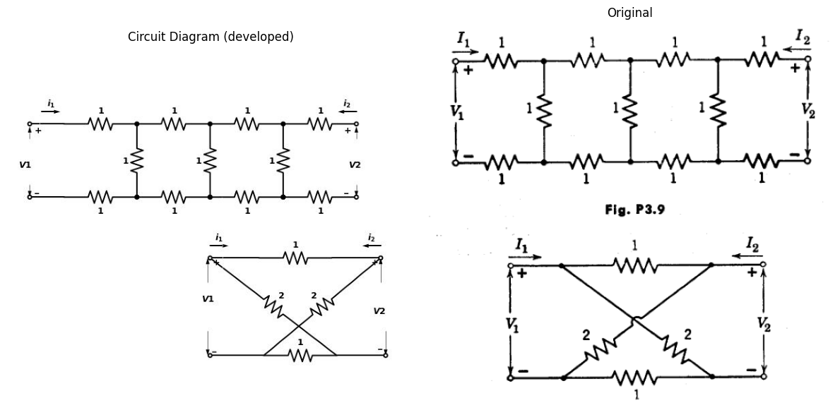
Fig. P3.9
Fig. P3.10
of reciprocity might be proved for a purely resistive circuit using basic con- siderations (i.e., Ohm's law, conservation of energy, Kirchhoff's law, etc.)?
$3.3$. How many basically different circuits can be designed using a single battery, resistor, and ideal diode? Draw the circuits and sketch their asso- ciated $e−i$ characteristics. Some of the possible circuits are redundant, in- determinant, or merely special cases of another circuit.
$3.4$. $\left(a\right)$ What is meant by the dual of a two-terminal linear circuit element? $\left(b\right)$ What is the dual of an ideal rectifier?
import schemdraw
import schemdraw.elements as e
import schemdraw as schem
import matplotlib.pyplot as plt
import matplotlib.image as mpimg
import numpy as np
# Create the figure and subplots
fig, axs = plt.subplots(1, 2, figsize=(12, 12))
d = schemdraw.Drawing()
l1 = d.add(e.Line().right().length(1.4).dot())
l2 = d.add(e.Line().left().length(2).dot(open=True))
D1= d.add(e.Diode().down().at(l2.start).dot())
l2 = d.add(e.Line().left().length(2).dot(open=True))
d += e.Arrow().right().at((-.6, .5)).length(0.75).label('$i_b$').color('black')
d += e.Arrow().up().linewidth(0.6).length(4).linewidth(0.6).linewidth(0.6).color('white').label('$eb$', loc='start', color='black',ofst=0.3). at((-.5,-1.5))
d += e.Arrow().up().length(.5).linewidth(0.6).color('black').label('+',loc='end', color='black',ofst=0.5). at((-.6,-.6))
d += e.Arrow().down().length(.5).linewidth(0.6).color('black').label(r'_', loc='end', color='black',ofst=(-.5, -.5)). at((-.6,-2.5))
d.save('./Drawings/fig11.jpg')
d.save('./Drawings/fig11.svg')
# Load the saved PNG file into the subplot
img = mpimg.imread('./Drawings/fig11.jpg')
axs[0].imshow(img)
axs[0].axis('off') # Hide axes for image display
axs[0].set_title('Circuit Diagram (developed)')
# **Subplot (1, 2): PNG Sample File**
img_sample = mpimg.imread('images-books/p3-11.png') # Load the PNG file
axs[1].imshow(img_sample)
axs[1].axis('off') # Hide axes for image display
axs[1].set_title('Original')
# Show the combined plots
plt.tight_layout()
plt.show()
d.save('./Drawings/fig11.png')
d.save('./Drawings/fig11.svg')
d.save('./Drawings/fig11.jpg')
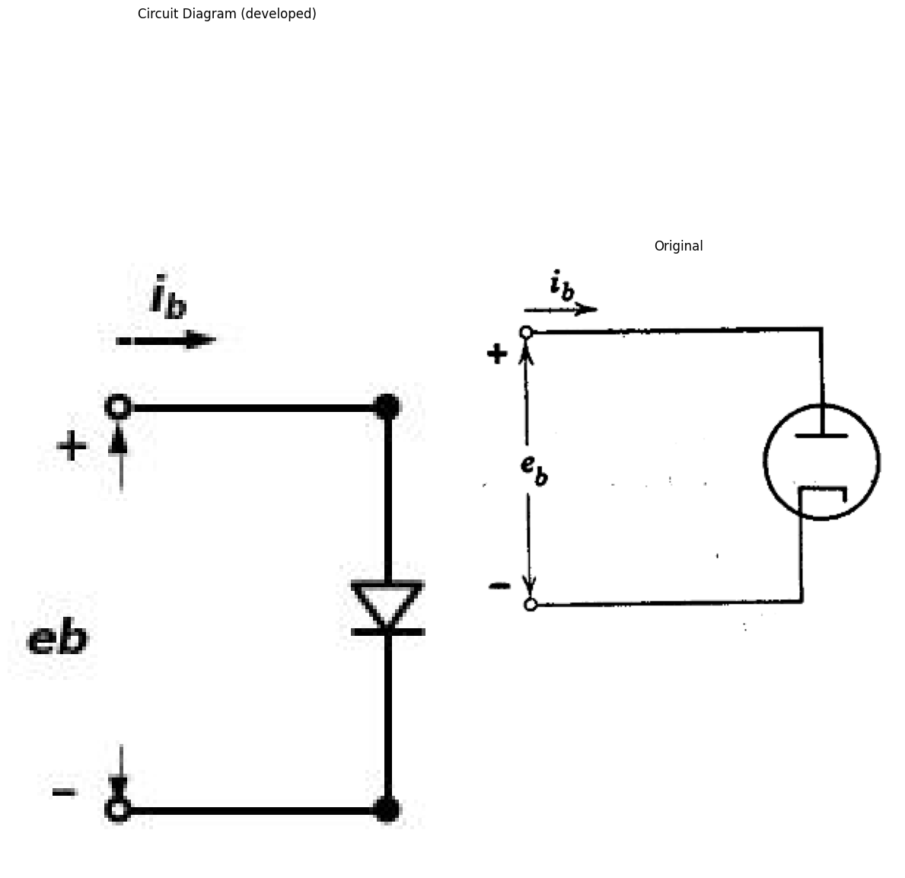
Fig. P3.11
import matplotlib.pyplot as plt
import numpy as np
import schemdraw
import schemdraw.elements as elm
import matplotlib.image as mpimg
# Create the figure and subplots
fig, axs = plt.subplots(1, 2, figsize=(10, 10))
circuit = Circuit('v-i curve')
circuit.model('BAV21','D' ,IS = 150@u_nA , N = 1.906 ,BV = 110@u_V, IBV = 0.0001@u_V, VJ = .8@u_V ,CJO = 7.048E-13 ,RS = 500@u_Ohm ,TT = 3.48E-9)
Vi = circuit.V('i', '1', circuit.gnd, 10@u_V)
circuit.R(1, '1', '2', .5@u_kOhm)
circuit.D(1, '2',circuit.gnd , model = 'BAV21')
simulator = circuit.simulator(temperature=25, nominal_temperature=25)
analysis = simulator.dc(Vi=slice(0, 5, 0.1))
axs[0].plot(analysis['2'], u_mA(-analysis.Vi),'black',linewidth=3)
axs[0].legend(('I-V diode curve','diode equation'), loc=(.8,.8))
axs[0].annotate('', xy=(2.5, 4), xytext=(0, 4), arrowprops=dict(arrowstyle='->'))
axs[0].annotate('', xy=(2.5, 4), xytext=(2.5,0 ), arrowprops=dict(arrowstyle='->'))
axs[0].set_title('Load Line Analysis (Ngspice Simulation via Pyspice)')
axs[0].text(3, 4, 'Ib~eb^3/2', ha='center', va='center')
axs[0].set_xlim(0, 5)
axs[0].set_ylim(0, 5)
axs[0].set_xlabel('eb [V]')
axs[0].set_ylabel('ib [mA]')
img_sample = mpimg.imread('images-books/p3-12.png') # Load the PNG file
axs[1].imshow(img_sample)
axs[1].axis('off') # Hide axes for image display
axs[1].set_title('Original')
# Show the combined plots
d.save('./Drawings/fig12.png')
d.save('./Drawings/fig12.svg')
plt.tight_layout()
plt.show()
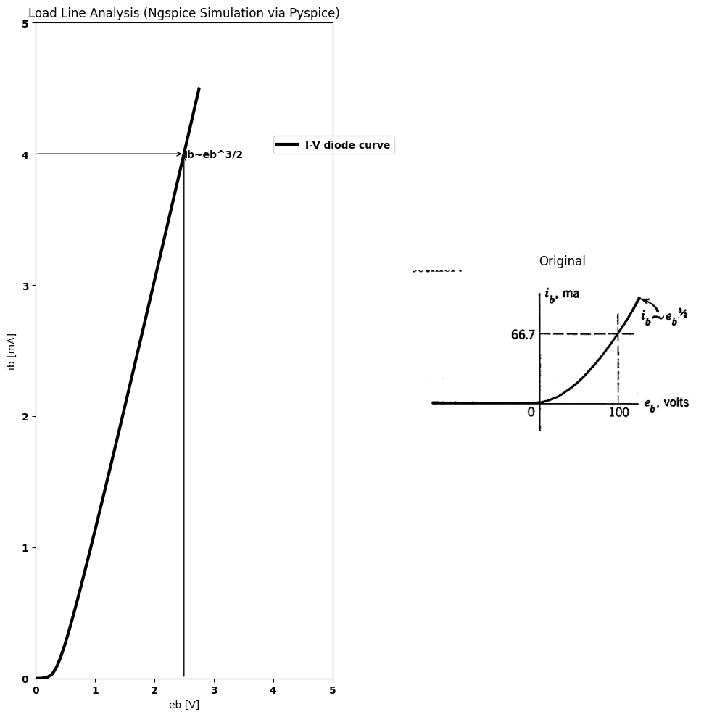
Fig. P3.12
$3.5$. A vacuum diode, Fig. P3.11, has the characteristic shown in Fig. P3.12. Determine suitable values of $R$ and $E$ to represent the diode by the circuit of Fig. P3.13, so that the approximation to the actual characteristic is very good in the neighborhood of $е_{b}$ = 100 volts. (The ideal rectifier in Fig. P3.13 has the characteristic shown by Fig. P3.14.)
$3.6$. $\left(a\right)$ Plot $e_{2}$ against $e_{1}$ for the circuit of Fig. P3.15, in which the diode characteristic is that of Fig. P3.12. Cover the range -100 < $e_{1}$ < +200. Also plot $e_{2}$ versus $e_{1}$ for Fig. P3.16.
import schemdraw
import schemdraw.elements as e
import schemdraw as schem
import matplotlib.pyplot as plt
import matplotlib.image as mpimg
import numpy as np
# Create the figure and subplots
fig, axs = plt.subplots(1, 2, figsize=(12, 12))
d = schemdraw.Drawing()
l1 = d.add(e.Line().right().length(1.4))
l2 = d.add(e.Line().left().length(2).dot(open=True))
R1 = d.add(e.Resistor().right().at(l2.start).label('R',ofst=-1))
E3 = d.add(e.Battery().right().at(R1.end).length(2).label('$E$',ofst=-1.2))
D1= d.add(e.Diode(fill=True).down().dot())
l2 = d.add(e.Line().left().length(7).dot(open=True))
d += e.Arrow().right().at((-.6, .5)).length(0.75).label('$i_b$').color('black')
d += e.Arrow().up().linewidth(0.6).length(4).linewidth(0.6).linewidth(0.6).color('white').label('$eb$', loc='start', color='black',ofst=0.3). at((-.5,-1.5))
d += e.Arrow().up().length(.5).linewidth(0.6).color('black').label('+',loc='end', color='black',ofst=0.5). at((-.6,-.6))
d += e.Arrow().down().length(.5).linewidth(0.6).color('black').label(r'_', loc='end', color='black',ofst=(-.5, -.5)). at((-.6,-2.5))
d += e.Arrow().down().at((5.6,-.85)).length(0.75).label('$i$').color('black')
d += e.Arrow().up().linewidth(0.6).length(4).linewidth(0.6).linewidth(0.6).color('white').label('$e$', loc='start', color='black',ofst=0.3). at((7.5,-1.5))
d += e.Arrow().up().length(.5).linewidth(0.6).color('black').label('+',loc='end', color='black',ofst=0.5). at((7.6,-.6))
d += e.Arrow().down().length(.5).linewidth(0.6).color('black').label(r'_', loc='end', color='black',ofst=(-.5, -.5)). at((7.6,-2.5))
d += e.Line().right().length(1).color('black'). at((7.,.1)).linestyle('-')
d += e.Line().right().length(1).color('black'). at((7.,-3.1)).linestyle('-')
d.save('./Drawings/fig13.jpg')
d.save('./Drawings/fig13.svg')
# Load the saved PNG file into the subplot
img = mpimg.imread('./Drawings/fig13.jpg')
axs[0].imshow(img)
axs[0].axis('off') # Hide axes for image display
axs[0].set_title('Circuit Diagram (developed)')
# **Subplot (1, 2): PNG Sample File**
img_sample = mpimg.imread('images-books/p3-13.png') # Load the PNG file
axs[1].imshow(img_sample)
axs[1].axis('off') # Hide axes for image display
axs[1].set_title('Original')
# Show the combined plots
plt.tight_layout()
plt.show()
d.save('./Drawings/fig13.png')
d.save('./Drawings/fig13.svg')
d.save('./Drawings/fig13.jpg')
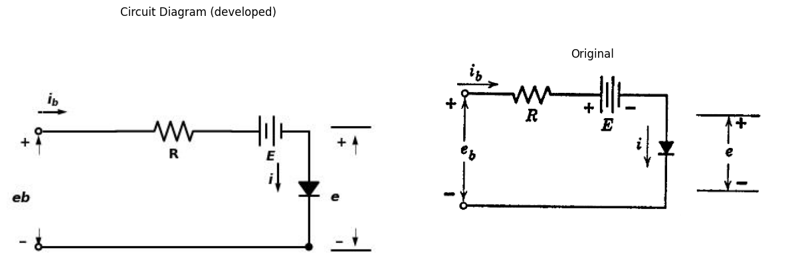
import matplotlib.pyplot as plt
import numpy as np
import schemdraw
import schemdraw.elements as elm
import matplotlib.image as mpimg
# Create the figure and subplots
fig, axs = plt.subplots(1, 2, figsize=(10, 10))
circuit = Circuit('Diode')
circuit.model('BAV21','D' ,IS = 4@u_nA , N = 1.906 ,BV = 110@u_V, IBV = 0.0001@u_V, VJ = 0.7@u_V ,CJO = 7.048E-13 ,RS = 0.01@u_Ohm ,TT = 3.48E-9)
Vth = circuit.V('th', '1', circuit.gnd, 0@u_V)
circuit.R(1, '1','2' , 2@u_Ohm)
circuit.V(1, '2','3', 0.5@u_V)
circuit.D(1, '3',circuit.gnd , model = 'BAV21')
simulator = circuit.simulator(temperature=25, nominal_temperature=25)
analysis = simulator.dc(Vth=slice(-200, 200, 0.1))
# Plot for R1
axs[0].plot(analysis['1'],u_mA(-analysis.Vth), 'black', linewidth=2)
axs[0].set_title('V-I Curve for D')
axs[0].grid(linewidth=0.5)
axs[0].set_xlim(-100, 100)
axs[0].set_xlabel('e')
axs[0].set_ylabel('i')
axs[0].set_ylim(-20, 100)
axs[0].axhline(0, color='black', linewidth=1)
axs[0].axvline(0, color='black', linewidth=1)
img_sample = mpimg.imread('images-books/p3-14.png') # Load the PNG file
axs[1].imshow(img_sample)
axs[1].axis('off') # Hide axes for image display
axs[1].set_title('Original')
# Show the combined plots
#d.save('./Drawings/fig12-1.png')
#d.save('./Drawings/fig12-1.svg')
plt.tight_layout()
plt.show()
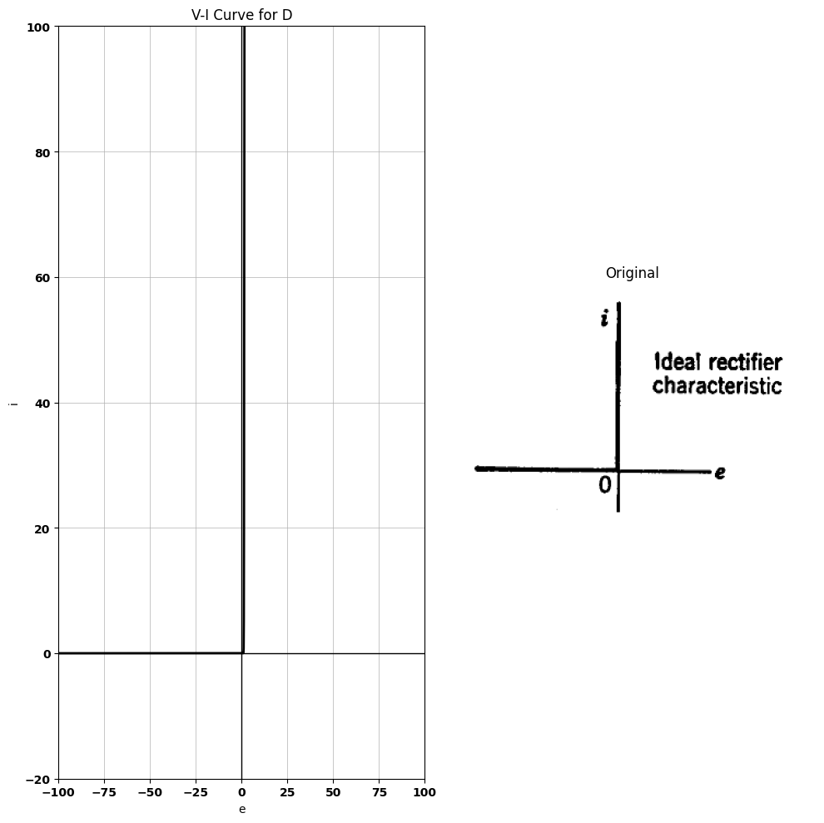
Fig. P3.14
$\left(b\right)$ How serious is the error in the $e_{2}$ vs. $e_{1}$ characteristic due to replacement of the diode by an ideal rectifier? How would the error be affected by a change in the load resistance from 10kΩ to some smaller value? some smaller value?
import schemdraw
import schemdraw.elements as e
import schemdraw as schem
import matplotlib.pyplot as plt
import matplotlib.image as mpimg
import numpy as np
# Create the figure and subplots
fig, axs = plt.subplots(1, 2, figsize=(12, 12))
d = schemdraw.Drawing()
l1 = d.add(e.Line().right().length(1.4))
l2 = d.add(e.Line().left().length(2.1).dot())
D1= d.add(e.Diode().at(l1.end).right().dot())
R1 = d.add(e.Resistor().down().at(D1.end).label('10kΩ ',ofst=0.3))
l2 = d.add(e.Line().left().length(5.1).dot())
E = d.add(e.SourceV().up().at((-.7, -3)).length(3).label('$e1$',ofst=.2))
l2 = d.add(e.Line().right().length(2.1).at(R1.start).dot(open=True))
l2 = d.add(e.Line().right().length(2.1).at(R1.end).dot(open=True))
d += e.Arrow().up().linewidth(0.6).length(4).linewidth(0.6).linewidth(0.6).color('white').label('$e2$', loc='start', color='black',ofst=0.3). at((7,-1.5))
d += e.Arrow().up().length(.5).linewidth(0.6).color('black').label('+',loc='end', color='black',ofst=0.5). at((6.5,-.6))
d += e.Arrow().down().length(.5).linewidth(0.6).color('black').label(r'_', loc='end', color='black',ofst=(-.5, -.5)). at((6.5,-2.5))
d.save('./Drawings/fig15.jpg')
d.save('./Drawings/fig15.svg')
# Load the saved PNG file into the subplot
img = mpimg.imread('./Drawings/fig15.jpg')
axs[0].imshow(img)
axs[0].axis('off') # Hide axes for image display
axs[0].set_title('Circuit Diagram (developed)')
# **Subplot (1, 2): PNG Sample File**
img_sample = mpimg.imread('images-books/p3-15.png') # Load the PNG file
axs[1].imshow(img_sample)
axs[1].axis('off') # Hide axes for image display
axs[1].set_title('Original')
# Show the combined plots
plt.tight_layout()
plt.show()
d.save('./Drawings/fig15.png')
d.save('./Drawings/fig15.svg')
d.save('./Drawings/fig15.jpg')
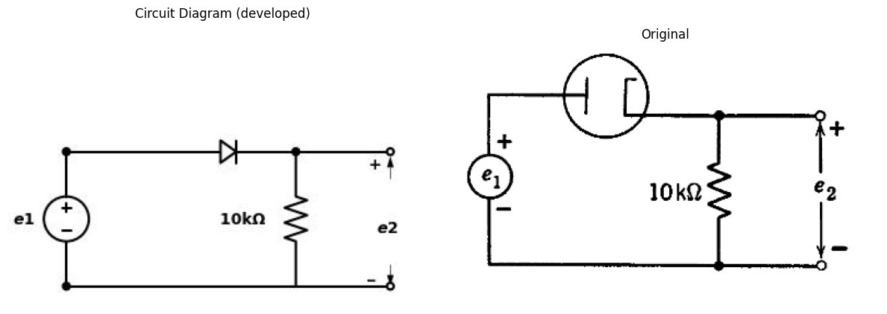
Fig. P3.15
import schemdraw
import schemdraw.elements as e
import schemdraw as schem
import matplotlib.pyplot as plt
import matplotlib.image as mpimg
import numpy as np
# Create the figure and subplots
fig, axs = plt.subplots(1, 2, figsize=(12, 12))
d = schemdraw.Drawing()
l1 = d.add(e.Line().right().length(1.4))
l2 = d.add(e.Line().left().length(2.1).dot())
D1= d.add(e.Diode(fill=True).at(l1.end).right().dot())
R1 = d.add(e.Resistor().down().at(D1.end).label('10kΩ ',ofst=0.3))
l2 = d.add(e.Line().left().length(5.1).dot())
E = d.add(e.SourceV().up().at((-.7, -3)).length(3).label('$e1$',ofst=.2))
l2 = d.add(e.Line().right().length(2.1).at(R1.start).dot(open=True))
l2 = d.add(e.Line().right().length(2.1).at(R1.end).dot(open=True))
d += e.Arrow().up().linewidth(0.6).length(4).linewidth(0.6).linewidth(0.6).color('white').label('$e2$', loc='start', color='black',ofst=0.3). at((7,-1.5))
d += e.Arrow().up().length(.5).linewidth(0.6).color('black').label('+',loc='end', color='black',ofst=0.5). at((6.5,-.6))
d += e.Arrow().down().length(.5).linewidth(0.6).color('black').label(r'_', loc='end', color='black',ofst=(-.5, -.5)). at((6.5,-2.5))
d.save('./Drawings/fig16.jpg')
d.save('./Drawings/fig16.svg')
# Load the saved PNG file into the subplot
img = mpimg.imread('./Drawings/fig16.jpg')
axs[0].imshow(img)
axs[0].axis('off') # Hide axes for image display
axs[0].set_title('Circuit Diagram (developed)')
# **Subplot (1, 2): PNG Sample File**
img_sample = mpimg.imread('images-books/p3-16.png') # Load the PNG file
axs[1].imshow(img_sample)
axs[1].axis('off') # Hide axes for image display
axs[1].set_title('Original')
# Show the combined plots
plt.tight_layout()
plt.show()
d.save('./Drawings/fig16.png')
d.save('./Drawings/fig16.svg')
d.save('./Drawings/fig16.jpg')
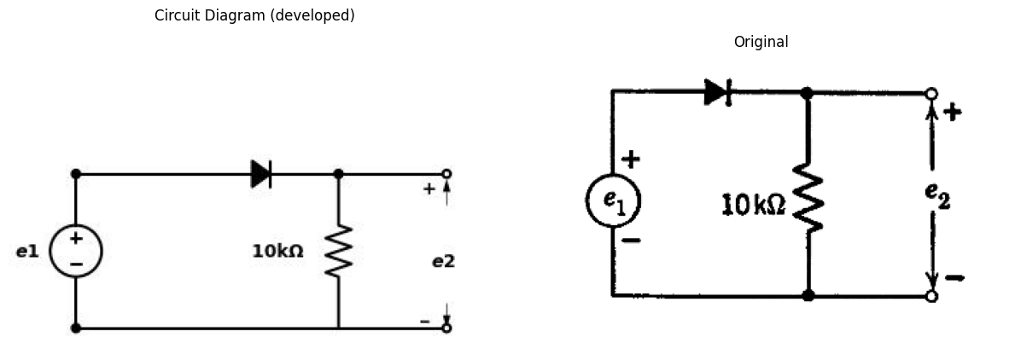
$3.7$. A high-vacuum diode curve is closely approximated by the function $i_{b}$=$K$ $e_{b}$ $​^{3}/^{2}$. It is known that $i_{b}$ = 100 ma (milliamperes) when $e_{b}$ = 20 volts.
$\left(a\right)$ Determine $K$ and specify its dimensions.
$\left(b\right)$ Plot $i_{b}$ vs. $e_{b}$ over the range from 0 to 20 volts.
$\left(c\right)$ It is desired to approximate the actual diode by a model consisting of an ideal rectifier in series with a resistance $R$. By adjusting a straightedge on the plot of part $\left(b\right)$, find the value of $R$ which makes the maximum magnitude of error in $i_{b}$ a minimum in the region of interest lying between 0 and 20 volts. The error referred to is $i_{b}$ (diode) minus $i_{b}$ (model) at any given $e_{b}$.
$\left(d\right)$ What is the maximum magnitude of error, expressed as a percentage of the maximum diode current in the region of interest?
$3.8$. The diode of Problem 3.7 is connected in series with a resistance $R_{L}$, and a voltage $V_{1}$ is applied across the combination. Let $V_{2}$ be the resulting voltage across $R_{L}$.
import schemdraw
import schemdraw.elements as e
import schemdraw as schem
import matplotlib.pyplot as plt
import matplotlib.image as mpimg
import numpy as np
# Create the figure and subplots
fig, axs = plt.subplots(1, 2, figsize=(12, 12))
d = schemdraw.Drawing()
d.push()
D1= d.add(e.Diode().up().label('$D_1$', ofst=0.3).reverse())
d += e.Line().right().dot()
R = d.add(e.Resistor().right().label('$10k$', ofst=0.1))
E = d.add(e.Battery().down().label(['+', '$200V$', '-'], ofst=.2))
l1 =d.add(e.Line().left().dot())
d += e.Line().left()
D2= d.add(e.Diode().up().at(l1.end).label('$D_2$', ofst=0.3).reverse())
d.save('./Drawings/fig17.jpg')
d.save('./Drawings/fig17.svg')
# Load the saved PNG file into the subplot
img = mpimg.imread('./Drawings/fig17.jpg')
axs[0].imshow(img)
axs[0].axis('off') # Hide axes for image display
axs[0].set_title('Circuit Diagram (developed)')
# **Subplot (1, 2): PNG Sample File**
img_sample = mpimg.imread('images-books/p3-17.png') # Load the PNG file
axs[1].imshow(img_sample)
axs[1].axis('off') # Hide axes for image display
axs[1].set_title('Original')
# Show the combined plots
plt.tight_layout()
plt.show()
d.save('./Drawings/fig17.png')
d.save('./Drawings/fig17.svg')
d.save('./Drawings/fig17.jpg')
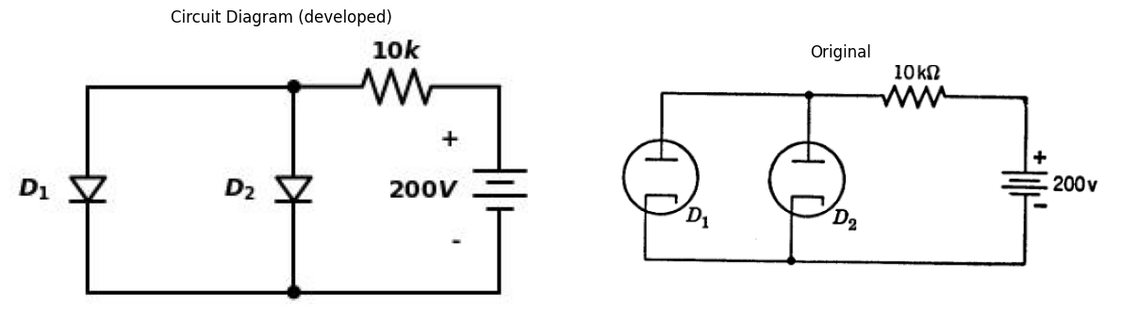
Fig. P3.17
$\left(a\right)$ Plot $V_{2}$ vs. $V_{1}$ for $R_{L}$ = 4800 ohms over the range of $V_{1}$ from 0 to 500 volts.
$\left(b\right)$ Repeat part $\left(a\right)$ with the diode replaced by its approximate model as in Problem 3.7 $\left(c\right)$.
$\left(c\right)$ Does the approximation introduce an appreciable error? Explain.
$3.9$. Find the operating point for each diode in the circuit shown in Fig. P3.17. The characteristics for $D_{1}$ and $D_{2}$ are plotted in Figs. P3.18 and P3.19
import matplotlib.pyplot as plt
from matplotlib import rcParams
import numpy as np
fig, axs = plt.subplots(1, 2, figsize=(8, 5))
x = np.linspace(0,180,500)
k1 = 0.022
k2 = 0.012
y1 = k1*(x**(3/2))
y2 = k2*(x**(3/2))
axs[0].plot(x, y1, color='black', label=r'$e^{-x}$')
axs[1].plot(x, y2, color='black', label=r'$1-x$')
axs[0].set_ylabel(r'$i_b, in$ mA',rotation=0,loc='top')
axs[1].set_ylabel(r'$i_b, in$ mA',rotation=0,loc='top')
a=[axs[0],axs[1]]
for i in a:
i.set_xticks([0,25,50,75,100,125,150,175])
i.set_yticks([0,2.5,5,7.5,10,12.5,15,17.5,20,22.5,25])
i.legend()
i.set_ylim(0, 25)
i.set_xlim(0, 175)
i.set_xlabel(r'$e_b, in$ volts', loc='right')
i.grid()
i.tick_params(axis='x', labelsize=10)
i.tick_params(axis='y', labelsize=10)
plt.tight_layout()
plt.show()
fig = plt.figure(figsize=(5, 3))
img = plt.imread('images-books/p3-18.png')
plt.imshow(img)
plt.axis('off')
plt.title('\nReference image from the book:', fontsize=8, pad=10,loc='left')
plt.show()
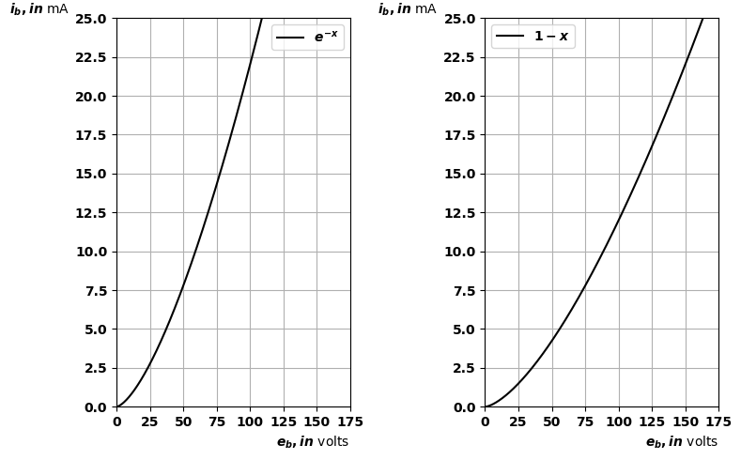
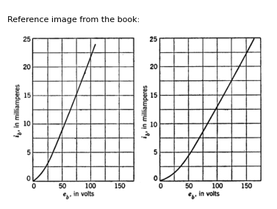
$3.10$. If $y=x$ $​^{3}/^{2}$, the linear approximation $y$=0.9$x$ is correct at $x$=0 roughly 0.1 too high at $x$=1/3 , correct at about $x$=2/3, and 0.1 too low at $x$=1. If a space-charge-limited (i.e., operating somewhere between cut-off and saturation) high-vacuum diode draws 10 ma at 100 volts, what size linear resistor might you use as an approximate model of the diode over the region between 0 and 10 ma?
3.11. A voltage $e_{1}coswt$ is applied to the circuit of Fig. P3.20, and a voltage $e_{2}$ is measured at the output. The load resistance $R$ is adjustable.
import schemdraw
import schemdraw.elements as e
import schemdraw as schem
import matplotlib.pyplot as plt
import matplotlib.image as mpimg
import numpy as np
# Create the figure and subplots
fig, axs = plt.subplots(1, 2, figsize=(12, 12))
d = schemdraw.Drawing()
d.push()
d.push()
d += e.Dot(open=True)
l1 =d.add(e.Line().right().dot())
d += e.Line().up().length(0.8)
R1 = d.add(e.Resistor().right().label('$r_r - r_f$', ofst=0.1))
d += e.Line().down().length(0.8).dot()
R2 = d.add(e.Resistor().right().dot().label('$r_f$', ofst=0.1))
d += e.Line().down().length(0.8).at(l1.end)
D = d.add(e.Diode(fill=True).right())
d += e.Line().up().length(0.8)
R3 = d.add(e.ResistorVar().down().at(R2.end).label('$R$', ofst=0.1))
d += e.Ground().at(R3.end)
l2 =d.add(e.Line().right().at(R2.end).dot(open=True))
d += e.Gap().up().label([ '$e_1$'] ,fontsize = 16).color('black').at((0,-2))
d += e.Gap().up().label(['$e_2$' ] ,fontsize = 16).color('black').at((12,-2))
d += e.Arrow().right().at((2.5,-3.5)).color('white').label('P3.20', loc='bottom', color='black')
d.save('./Drawings/fig20.jpg')
d.save('./Drawings/fig20.svg')
# Load the saved PNG file into the subplot
img = mpimg.imread('./Drawings/fig20.jpg')
axs[0].imshow(img)
axs[0].axis('off') # Hide axes for image display
axs[0].set_title('Circuit Diagram (developed)')
# **Subplot (1, 2): PNG Sample File**
img_sample = mpimg.imread('images-books/p3-20.png') # Load the PNG file
axs[1].imshow(img_sample)
axs[1].axis('off') # Hide axes for image display
axs[1].set_title('Original')
# Show the combined plots
plt.tight_layout()
plt.show()
d.save('./Drawings/fig20.png')
d.save('./Drawings/fig20.svg')
d.save('./Drawings/fig20.jpg')
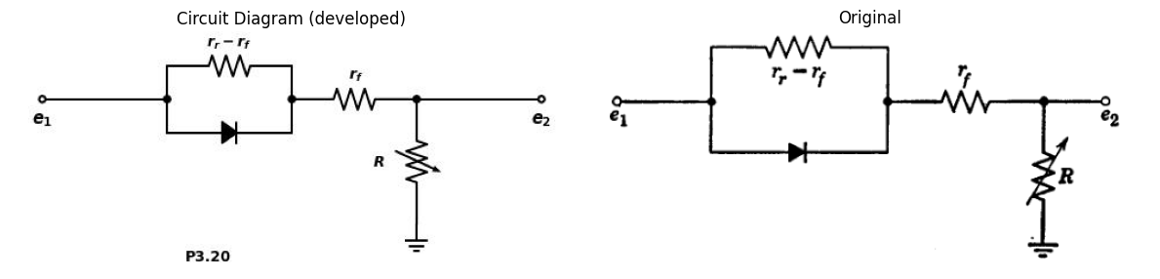
In terms of the forward and reverse diode resistances, $r_{f}$, and $r_{r}$, find the value of the load resistance $R$ which gives the largest d-c component of output
voltage. What is the d-c value in terms of $E_{1}$, $r_{r}$, and $r_{ƒ}$? ($e_{1}$ and $e_{2}$ are voltages measured with respect to ground.)
import schemdraw
import schemdraw.elements as e
import schemdraw as schem
import matplotlib.pyplot as plt
import matplotlib.image as mpimg
import numpy as np
# Create the figure and subplots
fig, axs = plt.subplots(1, 2, figsize=(12, 12))
d = schemdraw.Drawing()
d.push()
E = d.add(e.Battery().down().label(['+', '$40V$', '-'], ofst=.2))
d += elm.Line().right().dot()
R1 = d.add(e.Resistor().right().at(E.start).dot().label('$300$', ofst=0.3))
D = d.add(e.Diode().right().dot())
R2 = d.add(e.Resistor().down().dot().label('$R$', ofst=0.3))
d += elm.Line().left()
d += elm.Line().right().at(R2.end).dot(open=True)
d += elm.Line().right().at(D.end).dot(open=True)
R3 = d.add(e.Resistor().down().at(R1.end).label('$200$', ofst=0.3))
d += e.Gap().up().label([ '-','','','','$e_0$','','','','+' ] ,fontsize = 16).color('black').at((9,-3))
d += elm.Arrow().right().length(1).label('$i_b=K.e_b*(3/2)$', loc='top').color('black'). at((3.5,0.5))
d += elm.Arrow().left().length(0.5).at((9,-2)).color('black').down()
d += elm.Arrow().right().length(0.5).at((9,-1)).color('black').up()
d += elm.Arrow().right().at((3.5,-3.5)).color('white').label('P3.21', loc='bottom', color='black')
d += elm.Arrow().right().length(1).at((3.9, -0.5)).color('white').label('+''<----''$e_b$''----->''-', loc='bottom', color='black')
d.push()
d.move(6,-1)
d += ( T := dsp.Box(w=4, h=4).anchor('W').fill('white').label('Block\n Box'))
center_x, center_y = T.center
line_Right1 = d.add(e.Line().right().at((center_x+2, center_y + 1.65)).length(2))
d += elm.Dot(open=True)
S = d.add(e.Switch().right())
C = d.add(e.Capacitor().down().label(['+', '$V_c$', '-'], ofst=.2))
d += elm.Line().left().length(3)
line_Right2 = d.add(e.Line().right().at((center_x+2, center_y - 1.38)).length(2))
d += elm.Dot(open=True)
d += elm.Arrow().right().at((13.5,-3.8)).color('white').label('P3.22', loc='bottom', color='black')
d.save('./Drawings/fig21.jpg')
d.save('./Drawings/fig21.svg')
# Load the saved PNG file into the subplot
img = mpimg.imread('./Drawings/fig21.jpg')
axs[0].imshow(img)
axs[0].axis('off') # Hide axes for image display
axs[0].set_title('Circuit Diagram (developed)')
# **Subplot (1, 2): PNG Sample File**
img_sample = mpimg.imread('images-books/p3-21.png') # Load the PNG file
axs[1].imshow(img_sample)
axs[1].axis('off') # Hide axes for image display
axs[1].set_title('Original')
# Show the combined plots
plt.tight_layout()
plt.show()
d.save('./Drawings/fig21.png')
d.save('./Drawings/fig21.svg')
d.save('./Drawings/fig21.jpg')
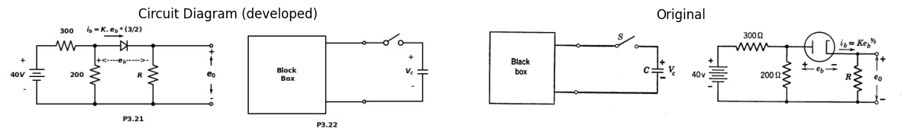
$3.12$. The high-vacuum diode shown in Fig. P3.21 is assumed to obey the three-halves power law ($i_{b}$= $Kе_{b}$ $​^{1}.$ $​^{5}$) and $i_{b}$ =50 ma when $e_{b}$ = 20 volts. Compute $e_{o}$ as a function of $R$.
3.13. A one-farad capacitor charged to 2 volts is suddenly connected to the terminals of a black box (Fig. P3.22). The capacitor voltage decreases lin-
import schemdraw
import schemdraw.elements as e
import schemdraw as schem
import matplotlib.pyplot as plt
import matplotlib.image as mpimg
import numpy as np
# Create the figure and subplots
fig, axs = plt.subplots(1, 2, figsize=(12, 12))
d = schemdraw.Drawing()
d.push()
V1 = d.add(e.SourceV().up().label(['-', '$e_1$', '+'], ofst=.2))
d += elm.Line().up().length(1)
R1 = d.add(e.Resistor().right().dot().label('$R_1$', ofst=0.3))
d += elm.Line().down().length(1.5).dot()
R2 = d.add(e.Resistor().down().dot().label('$R_g$', ofst=-1))
d += elm.Line().down().length(1.5).dot()
d += elm.Line().left()
d += elm.Line().up().length(2)
d += elm.Line().right().at(R1.end).length(4)
D1 = d.add(e.Diode(fill=True).down())
E = d.add(e.Battery().down().label(['+', '$E_o$', '-'], ofst=.2))
d += elm.Line().left().length(4)
d += elm.Arrow().right().length(1).label('$i_1$', loc='top').color('black'). at((0.5,3.2))
d += elm.Line().right().at(R2.start).length(2)
I = d.add(e.SourceI().down().label([ '$I_0$'], ofst=-1.4, fontsize = 16))
d += elm.Line().left().length(2)
d += elm.Line().left().length(1.5)
D2 = d.add(e.Diode(fill=True).up())
d += elm.Line().right().length(1.5)
d += elm.Arrow().right().at((1.5,-2.5)).color('white').label('P3.23', loc='bottom', color='black')
d.push()
d.move(6,2)
V2 = d.add(e.SourceV().up().label(['-', '$e_1$', '+'], ofst=.2))
D3 = d.add(e.Diode(fill=True).right().dot())
R3 = d.add(e.Resistor().down().dot().label('$R$', ofst=-1))
d += elm.Line().left()
d += elm.Line().right().at(R3.end).dot(open=True)
d += elm.Line().right().at(R3.start).dot(open=True)
d += e.Gap().up().label([ '-','','','','$e_2$','','','','+' ] ,fontsize = 16).color('black').at((16.5,-0.6))
d += e.Arrow().left().length(0.5).at((16.5,0.5)).color('black').down()
d += e.Arrow().right().length(0.5).at((16.5,1.5)).color('black').up()
d += elm.Arrow().right().at((12,-2.5)).color('white').label('P3.24', loc='bottom', color='black')
d.save('./Drawings/fig23.jpg')
d.save('./Drawings/fig23.svg')
# Load the saved PNG file into the subplot
img = mpimg.imread('./Drawings/fig23.jpg')
axs[0].imshow(img)
axs[0].axis('off') # Hide axes for image display
axs[0].set_title('Circuit Diagram (developed)')
# **Subplot (1, 2): PNG Sample File**
img_sample = mpimg.imread('images-books/p3-23.png') # Load the PNG file
axs[1].imshow(img_sample)
axs[1].axis('off') # Hide axes for image display
axs[1].set_title('Original')
# Show the combined plots
plt.tight_layout()
plt.show()
d.save('./Drawings/fig23.png')
d.save('./Drawings/fig23.svg')
d.save('./Drawings/fig23.jpg')
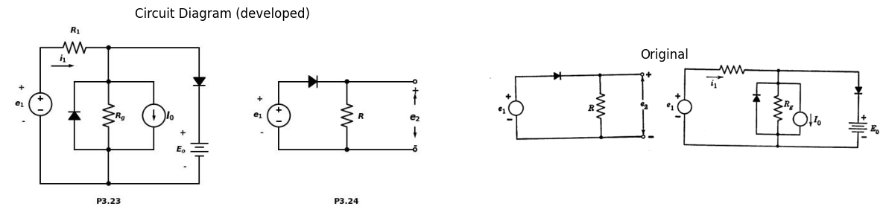
early (not exponentially) to 1 volt in 1 second, after which it continues ex- ponentially toward zero, with no discontinuity in either the voltage or its time derivative. Using sources, resistances, and ideal diodes, synthesize a possible circuit for the black box.
$3.14$. Plot the driving-point curve ($e_{1}$ vs. $i_{1}$) for the circuit of Fig. P3.23. Indicate slopes and break points.
$3.15$. Draw the transfer relations between the variables indicated in Figs. P3.24 through P3.28.
$3.16$. Sketch the responses of the ideal circuits shown in Figs. P3.29 and P3.30.
import schemdraw
import schemdraw.elements as e
import schemdraw as schem
import matplotlib.pyplot as plt
import matplotlib.image as mpimg
import numpy as np
# Create the figure and subplots
fig, axs = plt.subplots(1, 2, figsize=(12, 12))
d = schemdraw.Drawing()
d.push()
I= d.add(e.SourceI().up().label([ '$i_1$'], ofst=.2))
d += elm.Line().right().dot()
d += elm.Line().right().dot()
R1 = d.add(e.Resistor().down().dot().label('$R$', ofst=-1))
d += elm.Line().left().dot()
D1 = d.add(e.Diode(fill=True).up())
d += elm.Line().left().at(D1.start)
d += elm.Line().right().at(R1.end).dot(open=True)
d += elm.Line().right().at(R1.start).dot(open=True)
d += elm.Gap().up().label([ '-','','','','$e_2$','','','','+' ] ,fontsize = 16).color('black').at((9,0))
d += elm.Arrow().left().length(0.5).at((9,1)).color('black').down()
d += elm.Arrow().right().length(0.5).at((9,2)).color('black').up()
d += elm.Arrow().right().at((1.5,-2.5)).color('white').label('P3.25', loc='bottom', color='black')
d.push()
d.move(7,2.5)
V2 = d.add(e.SourceV().up().label([ '$e_1$'], ofst=.2))
D3 = d.add(e.Diode(fill=True).right().dot())
R3 = d.add(e.Resistor().down().dot().label('$R$', ofst=-1))
d += elm.Line().left()
d += elm.Line().right().at(R3.end).dot(open=True)
d += elm.Line().right().at(R3.start).dot(open=True)
d += elm.Gap().up().label([ '-','','','','$e_2$','','','','+' ] ,fontsize = 16).color('black').at((17.5,-0.1))
d += elm.Arrow().left().length(0.5).at((17.5,0.8)).color('black').down()
d += elm.Arrow().right().length(0.5).at((17.5,1.8)).color('black').up()
d += elm.Arrow().right().at((12,-2.5)).color('white').label('P3.26', loc='bottom', color='black')
d.save('./Drawings/fig24.jpg')
d.save('./Drawings/fig4.svg')
# Load the saved PNG file into the subplot
img = mpimg.imread('./Drawings/fig24.jpg')
axs[0].imshow(img)
axs[0].axis('off') # Hide axes for image display
axs[0].set_title('Circuit Diagram (developed)')
# **Subplot (1, 2): PNG Sample File**
img_sample = mpimg.imread('images-books/p3-24.png') # Load the PNG file
axs[1].imshow(img_sample)
axs[1].axis('off') # Hide axes for image display
axs[1].set_title('Original')
# Show the combined plots
plt.tight_layout()
plt.show()
d.save('./Drawings/fig24.png')
d.save('./Drawings/fig24.svg')
d.save('./Drawings/fig24.jpg')
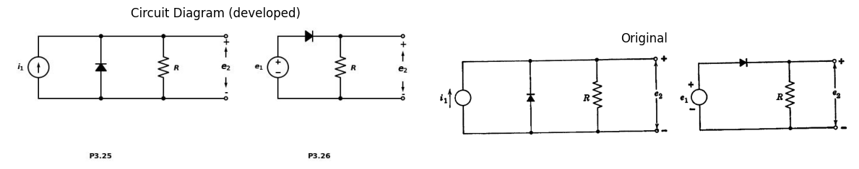
import schemdraw
import schemdraw.elements as e
import schemdraw as schem
import matplotlib.pyplot as plt
import matplotlib.image as mpimg
import numpy as np
# Create the figure and subplots
fig, axs = plt.subplots(1, 2, figsize=(12, 12))
d = schemdraw.Drawing()
E1 = d.add(e.SourceV().up().label(['-', '$e_1$', '+'], ofst=0.5).length(4))
R1 = d.add(e.Resistor().right().length(3).label('$R$'))
D1 = d.add(e.Diode(fill=True).down().length(4).reverse())
l1 = d.add(e.Line().right().length(2).at(D1.start))
E2 = d.add(e.BatteryCell().down().length(2).label(['+', '$E$', '-'], ofst=.2).at(l1.end))
R2 = d.add(e.Resistor().down().length(2).label('$R$'))
l1 = d.add(e.Line().left().length(5))
l1 = d.add(e.Line().right().length(2).dot(open=True).at(R2.end))
l1 = d.add(e.Line().right().length(2).dot(open=True).at(E2.start))
d += e.Arrow().up().length(4.5).linewidth(0.6).color('white').label('$e_2$', loc='start', color='black',ofst=0.3). at((7.5,2))
d += e.Arrow().up().length(1).color('black').label('+',loc='end', color='black',ofst=-0.3). at((7,3))
d += e.Arrow().down().length(1.1).linewidth(2).color('black').label(r'_', loc='end', color='black',ofst=(-0.5, 0.3)). at((7,1.))
d.save('./Drawings/fig27.jpg')
d.save('./Drawings/fig27.svg')
# Load the saved PNG file into the subplot
img = mpimg.imread('./Drawings/fig27.jpg')
axs[0].imshow(img)
axs[0].axis('off') # Hide axes for image display
axs[0].set_title('Circuit Diagram (developed)')
# **Subplot (1, 2): PNG Sample File**
img_sample = mpimg.imread('images-books/p3-27.png') # Load the PNG file
axs[1].imshow(img_sample)
axs[1].axis('off') # Hide axes for image display
axs[1].set_title('Original')
# Show the combined plots
plt.tight_layout()
plt.show()
d.save('./Drawings/fig27.png')
d.save('./Drawings/fig27.svg')
d.save('./Drawings/fig27.jpg')
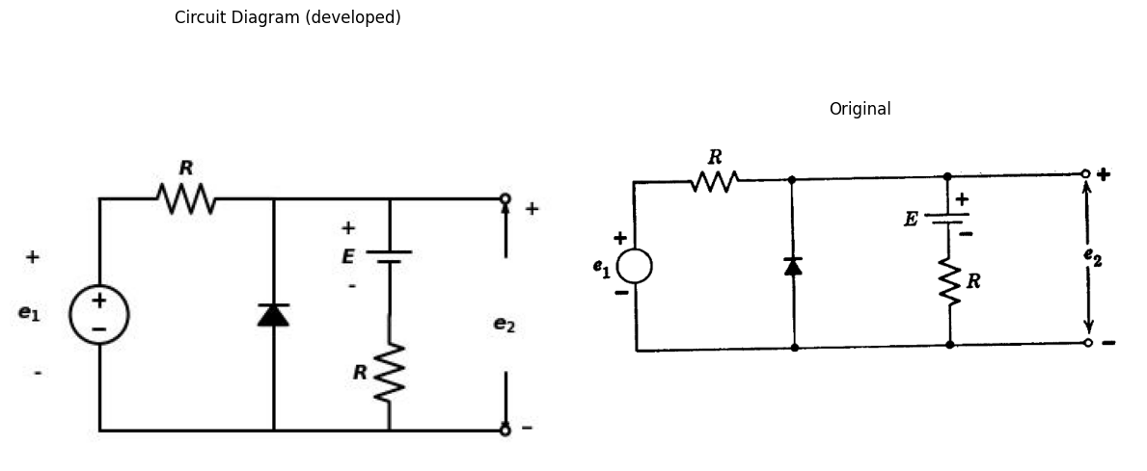
import schemdraw
import schemdraw.elements as e
import schemdraw as schem
import matplotlib.pyplot as plt
import matplotlib.image as mpimg
import numpy as np
# Create the figure and subplots
fig, axs = plt.subplots(1, 2, figsize=(12, 12))
d = schemdraw.Drawing()
I = d.add(e.SourceI().up().label('$i1$').length(4).dot())
R1 = d.add(e.Resistor().right().length(3).label('$R$'))
D1 = d.add(e.Diode(fill=True).down().length(4).reverse())
l1 = d.add(e.Line().right().length(2).at(D1.start))
E2 = d.add(e.BatteryCell().down().length(2).label(['+', '$E$', '-'], ofst=.2).at(l1.end))
R2 = d.add(e.Resistor().down().length(2).label('$R$'))
l1 = d.add(e.Line().left().length(5))
l1 = d.add(e.Line().right().length(2).dot(open=True).at(R2.end))
l1 = d.add(e.Line().right().length(2).dot(open=True).at(E2.start))
d += e.Arrow().up().length(4.5).linewidth(0.6).color('white').label('$e_2$', loc='start', color='black',ofst=0.3). at((7.5,2))
d += e.Arrow().up().length(1).color('black').label('+',loc='end', color='black',ofst=-0.3). at((7,3))
d += e.Arrow().down().length(1.1).linewidth(2).color('black').label(r'_', loc='end', color='black',ofst=(-0.5, 0.3)). at((7,1.))
d.save('./Drawings/fig28.jpg')
d.save('./Drawings/fig28.svg')
# Load the saved PNG file into the subplot
img = mpimg.imread('./Drawings/fig28.jpg')
axs[0].imshow(img)
axs[0].axis('off') # Hide axes for image display
axs[0].set_title('Circuit Diagram (developed)')
# **Subplot (1, 2): PNG Sample File**
img_sample = mpimg.imread('images-books/p3-28.png') # Load the PNG file
axs[1].imshow(img_sample)
axs[1].axis('off') # Hide axes for image display
axs[1].set_title('Original')
# Show the combined plots
plt.tight_layout()
plt.show()
d.save('./Drawings/fig28.png')
d.save('./Drawings/fig28.svg')
d.save('./Drawings/fig28.jpg')
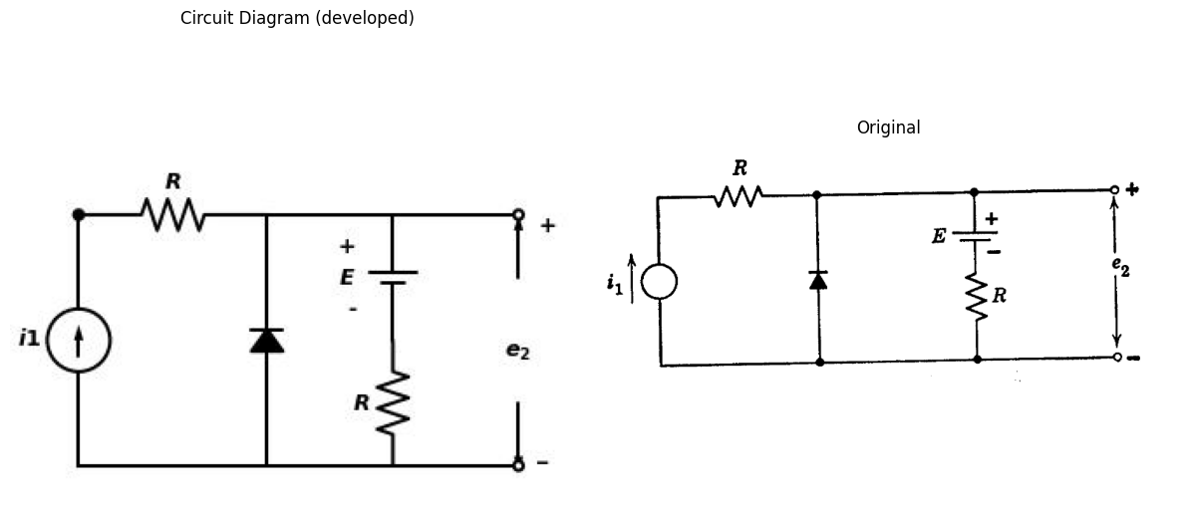
import schemdraw
import schemdraw.elements as e
import schemdraw as schem
import matplotlib.pyplot as plt
import matplotlib.image as mpimg
import numpy as np
# Create the figure and subplots
fig, axs = plt.subplots(1, 2, figsize=(12, 12))
d = schemdraw.Drawing()
E1 = d.add(e.SourceV().up().label(['-', '$e_1$', '+'], ofst=0.5))
R1 = d.add(e.Resistor().right().length(3))
D1 = d.add(e.Diode(fill=True).down().length(1))
E2 = d.add(e.BatteryCell().down().length(2).label(['+', '$1_ Volts$', '-'], ofst=.2))
l1 = d.add(e.Line().left().length(3))
l2 = d.add(e.Line().right().length(2).at(D1.start))
R2 = d.add(e.Resistor().down().length(3))
l4 = d.add(e.Line().left().length(2))
l5 = d.add(e.Line().right().length(2).dot(open=True).at(R2.end))
l5 = d.add(e.Line().right().length(2).dot(open=True).at(R2.start))
d += e.Arrow().up().length(4.5).linewidth(0.6).color('white').label('$e_2$', loc='start', color='black',ofst=0.3). at((7.5,1.5))
d += e.Arrow().up().length(1).color('black').label('+',loc='end', color='black',ofst=-0.3). at((7,2))
d += e.Arrow().down().length(1.1).linewidth(2).color('black').label(r'_', loc='end', color='black',ofst=(-0.5, 0.3)). at((7,1.))
d.save('./Drawings/fig29-1.jpg')
d.save('./Drawings/fig29-1.svg')
# Load the saved PNG file into the subplot
img = mpimg.imread('./Drawings/fig29-1.jpg')
axs[0].imshow(img)
axs[0].axis('off') # Hide axes for image display
axs[0].set_title('Circuit Diagram (developed)')
# **Subplot (1, 2): PNG Sample File**
img_sample = mpimg.imread('images-books/p3-29-1.png') # Load the PNG file
axs[1].imshow(img_sample)
axs[1].axis('off') # Hide axes for image display
axs[1].set_title('Original')
# Show the combined plots
plt.tight_layout()
plt.show()
d.save('./Drawings/fig29-1.png')
d.save('./Drawings/fig29-1.svg')
d.save('./Drawings/fig29-1.jpg')
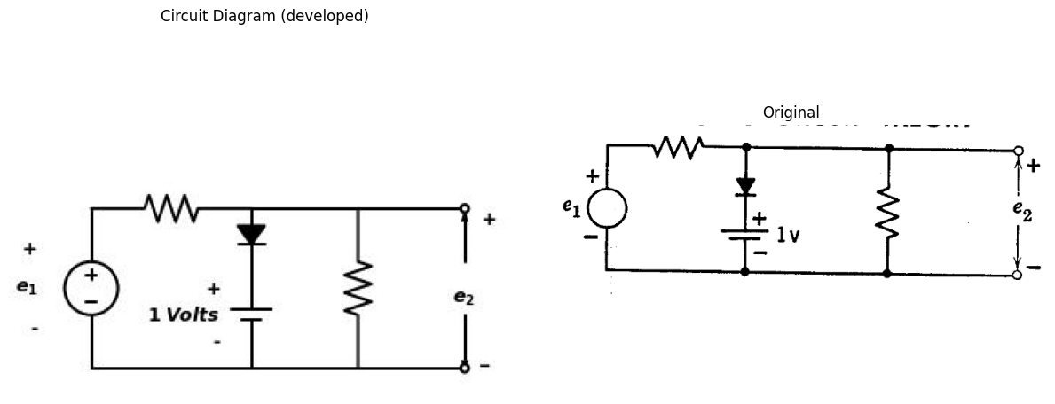
import matplotlib.pyplot as plt
import numpy as np
import schemdraw
import schemdraw.elements as elm
import matplotlib.image as mpimg
# Create the figure and subplots
fig, axs = plt.subplots(1, 2, figsize=(12, 12))
x = np.array([0, 1, 2, 3, 4, 5, 6, 7])
y = np.array([3, 0, 2, 0, 3, 0, 2, 0])
axs[0].step(x, y, where='post', color='black', label=' ')
axs[0].grid(linewidth=0.5)
axs[0].set_xlim(-1, 8)
axs[0].set_xlabel('t', loc='right')
axs[0].set_ylabel('$e_1$',rotation=0,loc='top')
axs[0].set_ylim(-1, 4)
axs[0].axhline(0, color='black', linewidth=1.5)
axs[0].axvline(0, color='black', linewidth=1.5)
img_sample = mpimg.imread('images-books/p3-29.png') # Load the PNG file
axs[1].imshow(img_sample)
axs[1].axis('off') # Hide axes for image display
axs[1].set_title('Original')
# Show the combined plots
plt.tight_layout()
plt.show()
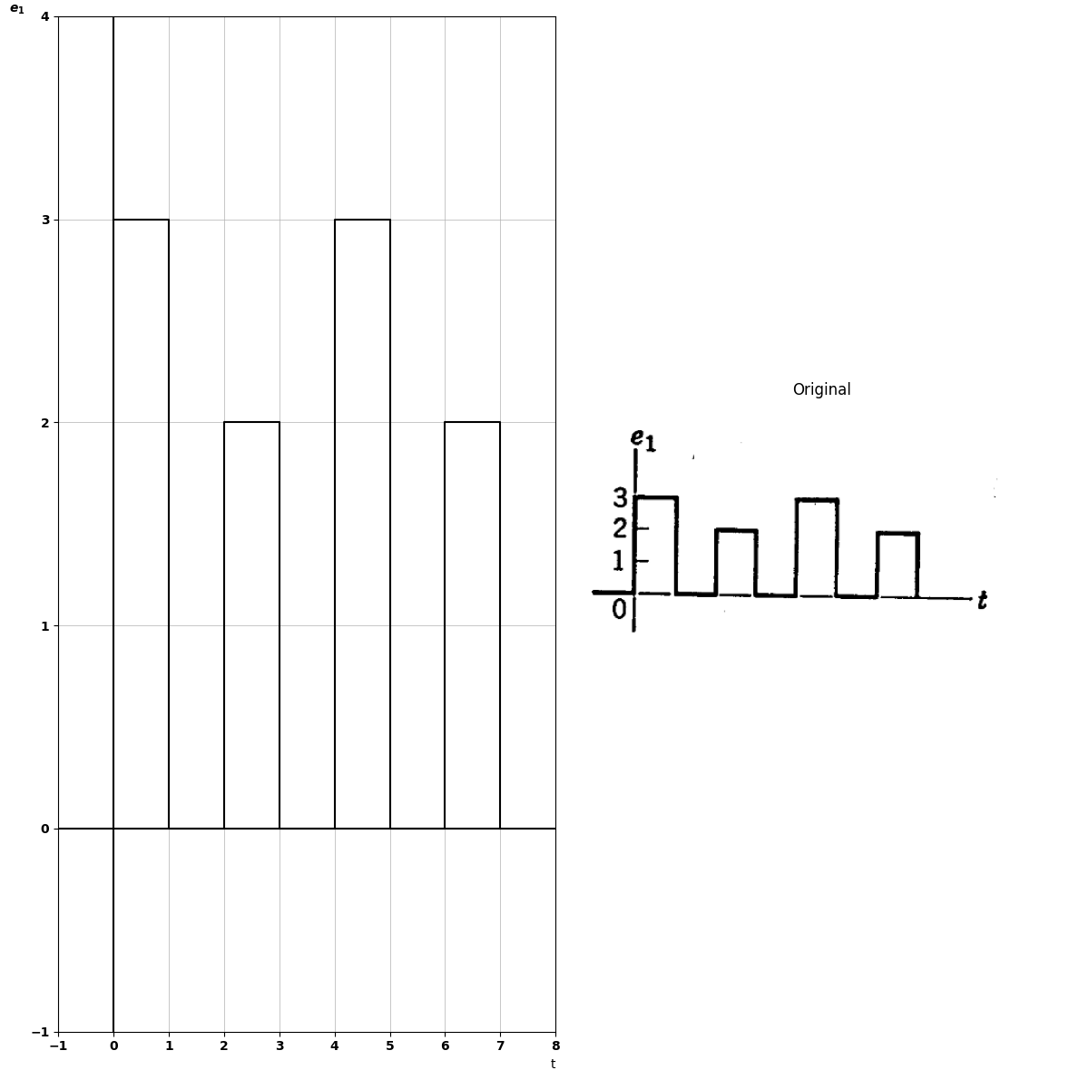
import schemdraw
import schemdraw.elements as e
import schemdraw as schem
import matplotlib.pyplot as plt
import matplotlib.image as mpimg
import numpy as np
# Create the figure and subplots
fig, axs = plt.subplots(1, 2, figsize=(12, 12))
d = schemdraw.Drawing()
E1 = d.add(e.SourceV().up().label(['-', '$e_1$', '+'], ofst=0.5))
D1 = d.add(e.Diode(fill=True).right())
E2 = d.add(e.BatteryCell().right().label(['+', '$2_ Volts$', '-'], ofst=.2))
R1 = d.add(e.Resistor().down().length(3))
l1 = d.add(e.Line().left().length(6))
l2 = d.add(e.Line().right().length(2).dot(open=True).at(R1.end))
l3 = d.add(e.Line().right().length(2).dot(open=True).at(R1.start))
d += e.Arrow().up().length(4.5).linewidth(0.6).color('white').label('$e_2$', loc='start', color='black',ofst=0.3). at((8.5,1.5))
d += e.Arrow().up().length(1).color('black').label('+',loc='end', color='black',ofst=-0.3). at((8,2))
d += e.Arrow().down().length(1.1).linewidth(2).color('black').label(r'_', loc='end', color='black',ofst=(-0.5, 0.3)). at((8,1.))
d.save('./Drawings/fig30-1.jpg')
d.save('./Drawings/fig30-1.svg')
# Load the saved PNG file into the subplot
img = mpimg.imread('./Drawings/fig30-1.jpg')
axs[0].imshow(img)
axs[0].axis('off') # Hide axes for image display
axs[0].set_title('Circuit Diagram (developed)')
# **Subplot (1, 2): PNG Sample File**
img_sample = mpimg.imread('images-books/p3-30-1.png') # Load the PNG file
axs[1].imshow(img_sample)
axs[1].axis('off') # Hide axes for image display
axs[1].set_title('Original')
# Show the combined plots
plt.tight_layout()
plt.show()
d.save('./Drawings/fig30-1.png')
d.save('./Drawings/fig30-1.svg')
d.save('./Drawings/fig30-1.jpg')
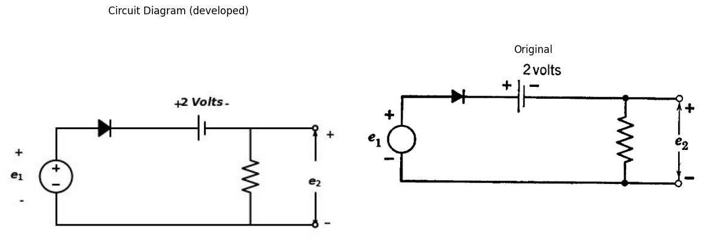
import matplotlib.pyplot as plt
import numpy as np
import schemdraw
import schemdraw.elements as elm
import matplotlib.image as mpimg
# Create the figure and subplots
fig, axs = plt.subplots(1, 2, figsize=(12, 12))
x = np.array([0, 1, 2, 3, 4, 5, 6, 7, 8, 9])
y = np.array([3, 0, 1, 0, 3, 0, 1, 0, 3, 0])
axs[0].step(x, y, where='post', color='black', label=' ')
axs[0].set_xlim(-1, 10)
axs[0].set_xlabel('t', loc='right')
axs[0].set_ylabel('$e_1$',rotation=0,loc='top')
axs[0].set_ylim(-1, 4)
axs[0].axhline(0, color='black', linewidth=1.5)
axs[0].axvline(0, color='black', linewidth=1.5)
img_sample = mpimg.imread('images-books/p3-30.png') # Load the PNG file
axs[1].imshow(img_sample)
axs[1].axis('off') # Hide axes for image display
axs[1].set_title('Original')
# Show the combined plots
plt.tight_layout()
plt.show()
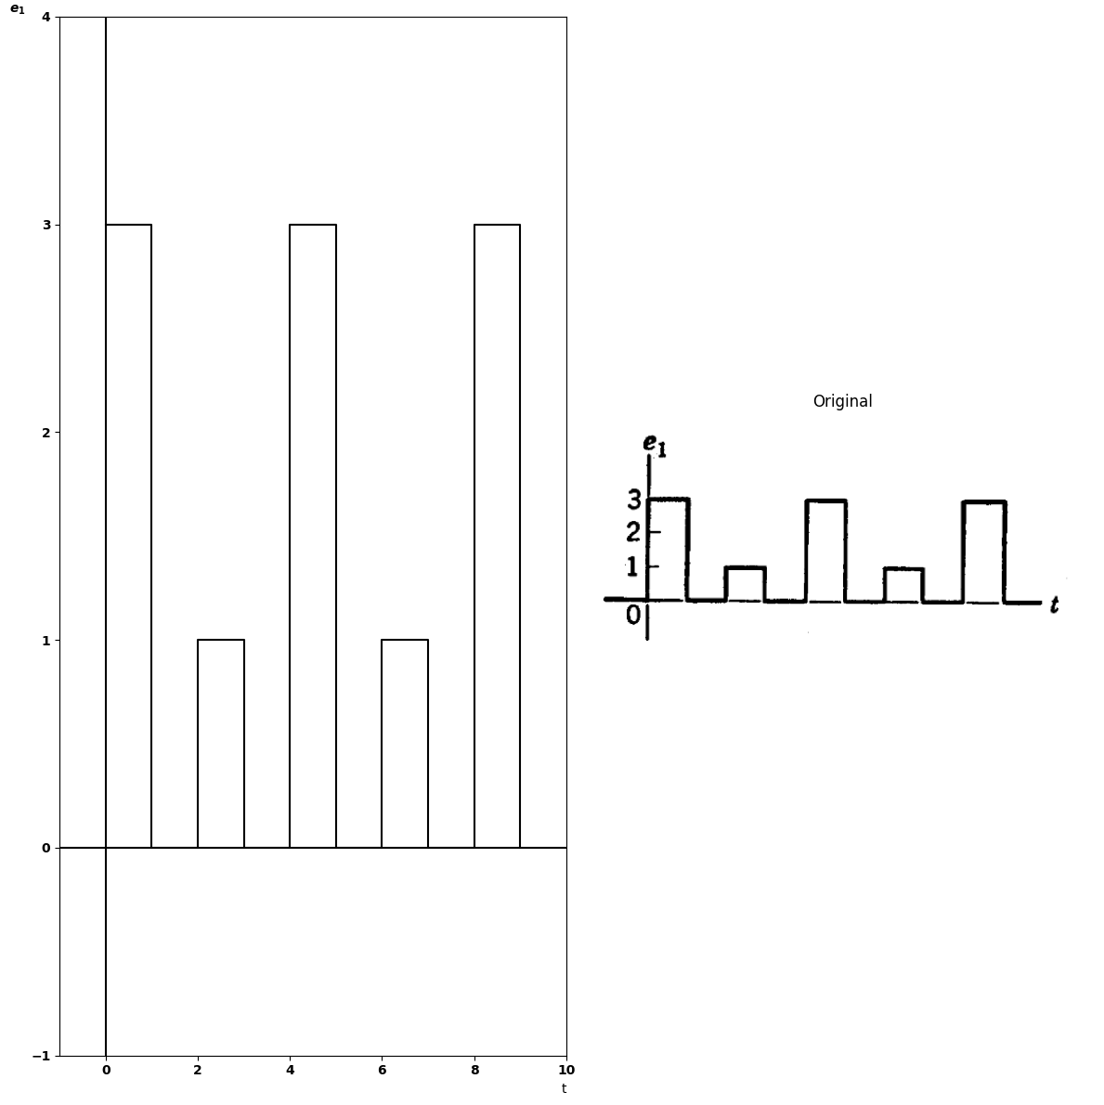
$3.17$. Sketch the e vs. i characteristic of the circuits shown in Figs. P3.31- P3.34.
import schemdraw
import schemdraw.elements as elm
import schemdraw as schem
import matplotlib.pyplot as plt
import matplotlib.image as mpimg
import numpy as np
# Create the figure and subplots
fig, axs = plt.subplots(1, 2, figsize=(12, 12))
d = schemdraw.Drawing()
d += elm.Dot(open=True)
d += elm.Diode(fill=True).right().label('$D$')
d.push()
d += elm.Resistor().right().label('$R$','top')
d +=elm.BatteryCell().down().label('V', loc='bottom').reverse()
d += elm.Line().left().length(6).dot(open=True)
d.pop()
d += elm.Diode(fill=True).down().label('$D$').reverse()
d += elm.Line().right().length(.7).at((-1.1,0.0)).color('black').linestyle('--')
d += elm.Line().right().length(.7).at((-1.1,-3.0)).color('black').linestyle('--')
d += elm.Arrow().down().length(1.0).at((-0.9, -1.9)).color('black')
d += elm.Arrow().up().length(0.2).at((-1.3, -1.7)).color('white').label('$e$', loc='bottom', color='black')
d += elm.Arrow().up().length(1.0).at((-0.9, -1)).color('black')
d += elm.Arrow().right().length(0.7).at((0.2, -0.2)).color('black').label('$i$',loc='bottom')
d.save('./Drawings/fig32.jpg')
d.save('./Drawings/fig32.svg')
# Load the saved PNG file into the subplot
img = mpimg.imread('./Drawings/fig32.jpg')
axs[0].imshow(img)
axs[0].axis('off') # Hide axes for image display
axs[0].set_title('Circuit Diagram (developed)')
# **Subplot (1, 2): PNG Sample File**
img_sample = mpimg.imread('images-books/p3-32.png') # Load the PNG file
axs[1].imshow(img_sample)
axs[1].axis('off') # Hide axes for image display
axs[1].set_title('Original')
# Show the combined plots
plt.tight_layout()
plt.show()
d.save('./Drawings/fig32.png')
d.save('./Drawings/fig32.svg')
d.save('./Drawings/fig32.jpg')
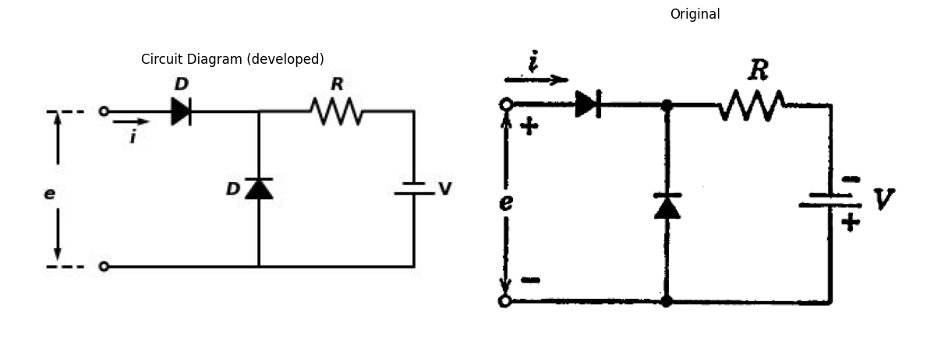
import schemdraw
import schemdraw.elements as elm
import schemdraw as schem
import matplotlib.pyplot as plt
import matplotlib.image as mpimg
import numpy as np
# Create the figure and subplots
fig, axs = plt.subplots(1, 2, figsize=(12, 12))
d = schemdraw.Drawing()
d += elm.Dot(open=True)
d += elm.Line().right().length(1)
d.push()
d += elm.Line().down().length(3)
d += elm.Resistor().down().label('$R_0$','top')
d +=elm.SourceV().down().label('V_0', loc='bottom').reverse()
d += elm.Line().left().length(1).dot(open=True)
d += elm.Line().right().length(1.4).at((-2.1,0.0)).color('gray').linestyle('--')
d += elm.Line().right().length(1.4).at((-2.1,-9.2)).color('gray').linestyle('--')
d += elm.Arrow().down().length(4.0).at((-1.9, -5.2)).color('black')
d += elm.Arrow().up().length(0.2).at((-2.3, -4.7)).color('white').label('$e$', loc='bottom', color='black')
d += elm.Arrow().up().length(4.0).at((-1.9, -4)).color('black')
d += elm.Arrow().right().length(0.7).at((0.2, -0.2)).color('black').label('$i$',loc='bottom')
d.pop()
d += elm.Line().right().length(3)
d.push()
d += elm.Diode(fill=True).down().label('$D$')
d += elm.Resistor().down().label('$R_1$','top')
d +=elm.SourceV().down().label('V_1', loc='bottom').reverse()
d += elm.Line().left().length(3)
d.pop()
d += elm.Line().right().length(3)
d.push()
d += elm.Diode(fill=True).down().label('$D$')
d += elm.Resistor().down().label('$R_2$','top')
d +=elm.SourceV().down().label('V_2', loc='bottom').reverse()
d += elm.Line().left().length(3)
d.pop()
d += elm.Line().right().length(.2)
d += elm.Line().right().length(3).linestyle('--')
d += elm.Line().right().length(.2)
d += elm.Diode(fill=True).down().label('$D$')
d += elm.Resistor().down().label('$R_n$','top')
d +=elm.SourceV().down().label('V_n', loc='bottom').reverse()
d += elm.Line().left().length(.2)
d += elm.Line().left().length(3).linestyle('--')
d += elm.Line().left().length(.2)
d.save('./Drawings/fig33.jpg')
d.save('./Drawings/fig33.svg')
# Load the saved PNG file into the subplot
img = mpimg.imread('./Drawings/fig33.jpg')
axs[0].imshow(img)
axs[0].axis('off') # Hide axes for image display
axs[0].set_title('Circuit Diagram (developed)')
# **Subplot (1, 2): PNG Sample File**
img_sample = mpimg.imread('images-books/p3-33.png') # Load the PNG file
axs[1].imshow(img_sample)
axs[1].axis('off') # Hide axes for image display
axs[1].set_title('Original')
# Show the combined plots
plt.tight_layout()
plt.show()
d.save('./Drawings/fig33.png')
d.save('./Drawings/fig33.svg')
d.save('./Drawings/fig33.jpg')
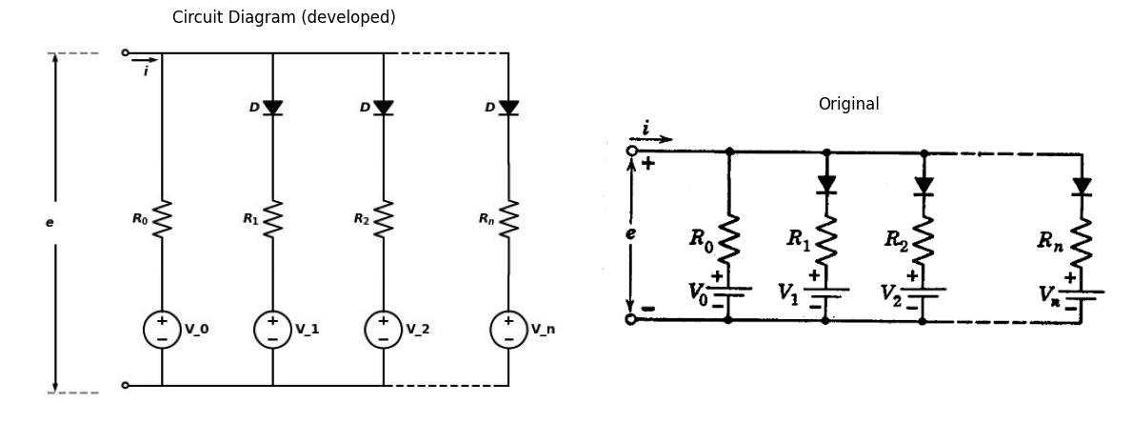
import schemdraw
import schemdraw.elements as elm
import schemdraw as schem
import matplotlib.pyplot as plt
import matplotlib.image as mpimg
import numpy as np
# Create the figure and subplots
fig, axs = plt.subplots(1, 2, figsize=(12, 12))
d = schemdraw.Drawing()
d += elm.Dot(open=True)
d += elm.Line().right().length(1.5)
d += elm.Resistor().right().label('$G_1$','top')
d += elm.Line().up().length(2)
d += elm.SourceI().left().label('I', 'top')
d += elm.Line().down().length(4)
#d.push()
d += elm.Diode(fill=True).right().label('$D$')
d += elm.Line().up().length(2)
d += elm.Line().right().length(1)
d += elm.Resistor().right().label('$G_1$','top')
d += elm.Line().up().length(2)
d += elm.SourceI().left().label('I', 'top')
d += elm.Line().down().length(4)
#d.push()
d += elm.Diode(fill=True).right().label('$D$')
d += elm.Line().up().length(2)
d += elm.Line().right().length(1)
d += elm.Line().right().length(3).linestyle('--')
d += elm.Line().right().length(1)
d += elm.Line().down().length(6)
d += elm.Line().left().length(1)
d += elm.Line().left().length(3).linestyle('--')
d += elm.Line().left().length(1)
d += elm.Resistor().left().label('$G_0$','top')
d += elm.Line().up().length(2)
d += elm.SourceI().right().label('I', 'top')
d += elm.Line().down().length(4)
d += elm.Diode(fill=True).left().label('$D$')
d += elm.Line().up().length(2)
d += elm.Line().left().length(1)
d += elm.Resistor().left().label('$G_n$','top')
d.push()
d += elm.Line().up().length(2)
d += elm.SourceI().right().label('I', 'top')
d += elm.Line().down().length(2)
d.pop()
d += elm.Line().left().length(1.5).dot(open=True)
d += elm.Arrow().down().length(2.5).at((-0.1, -3.4)).color('black')
d += elm.Arrow().up().length(0.2).at((-0.6, -3.1)).color('white').label('$V$', loc='bottom', color='black')
d += elm.Arrow().up().length(2.5).at((-0.1, -2.5)).color('black')
d += elm.Arrow().right().length(0.7).at((0.3, 0.3)).color('black').label('$i$','top')
#d += elm.Label('+').at((0.3,-0.4)).color('red')
#d += elm.Label('_').at((0.3,-5.7)).color('red')
d.save('./Drawings/fig34.jpg')
d.save('./Drawings/fig34.svg')
# Load the saved PNG file into the subplot
img = mpimg.imread('./Drawings/fig34.jpg')
axs[0].imshow(img)
axs[0].axis('off') # Hide axes for image display
axs[0].set_title('Circuit Diagram (developed)')
# **Subplot (1, 2): PNG Sample File**
img_sample = mpimg.imread('images-books/p3-34.png') # Load the PNG file
axs[1].imshow(img_sample)
axs[1].axis('off') # Hide axes for image display
axs[1].set_title('Original')
# Show the combined plots
plt.tight_layout()
plt.show()
d.save('./Drawings/fig34.png')
d.save('./Drawings/fig34.svg')
d.save('./Drawings/fig34.jpg')
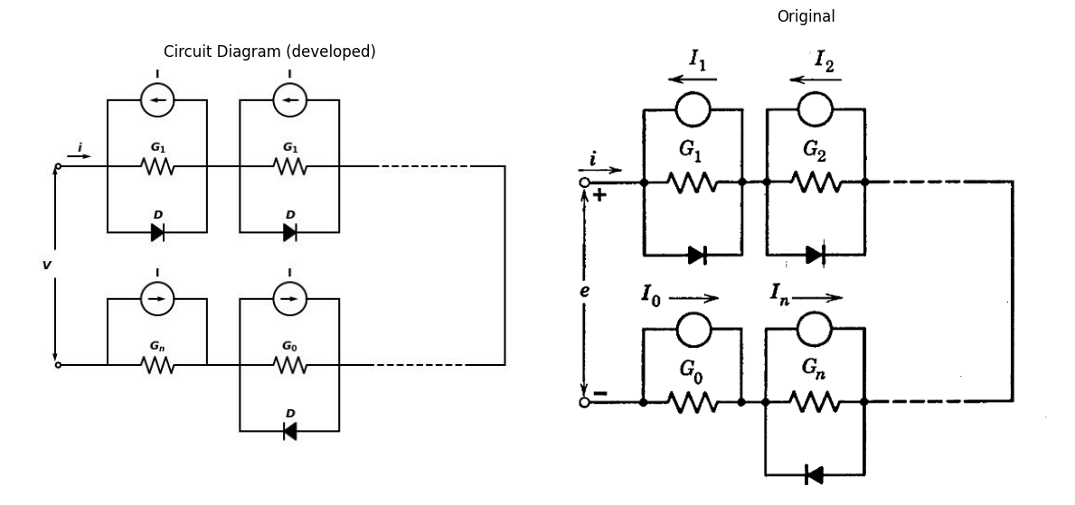
$3.18$. Sketch $v_{2}$ vs. $v_{1}$ for the circuit shown in Fig. P3.35.
import schemdraw
import schemdraw.elements as elm
import schemdraw as schem
import matplotlib.pyplot as plt
import matplotlib.image as mpimg
import numpy as np
# Create the figure and subplots
fig, axs = plt.subplots(1, 2, figsize=(12, 12))
d = schemdraw.Drawing()
d +=elm.SourceV().up().label('$V_1$', loc='top')
d += elm.Line().up().length(1.1)
d += elm.Line().right().length(1).dot()
d += elm.Line().up().length(1)
d += elm.Diode(fill=True).right().label('$D$')
d += elm.Battery().label('$V$', 'top').right()
d += elm.Line().down().length(1).dot()
d.push()
d += elm.Line().down().length(1)
d += elm.Battery().label('$V$', 'top').left()
d += elm.Diode(fill=True).left().label('$D$')
d += elm.Line().up().length(1)
d.pop()
d += elm.Line().right().length(1)
d += elm.Line().down().length(1)
d += elm.Resistor().down().label('$R_0$','top')
d += elm.Line().down().length(0.1)
d += elm.Line().left().length(8)
d.save('./Drawings/fig35.jpg')
d.save('./Drawings/fig35.svg')
# Load the saved PNG file into the subplot
img = mpimg.imread('./Drawings/fig35.jpg')
axs[0].imshow(img)
axs[0].axis('off') # Hide axes for image display
axs[0].set_title('Circuit Diagram (developed)')
# **Subplot (1, 2): PNG Sample File**
img_sample = mpimg.imread('images-books/p3-35.png') # Load the PNG file
axs[1].imshow(img_sample)
axs[1].axis('off') # Hide axes for image display
axs[1].set_title('Original')
# Show the combined plots
plt.tight_layout()
plt.show()
d.save('./Drawings/fig35.png')
d.save('./Drawings/fig35.svg')
d.save('./Drawings/fig35.jpg')
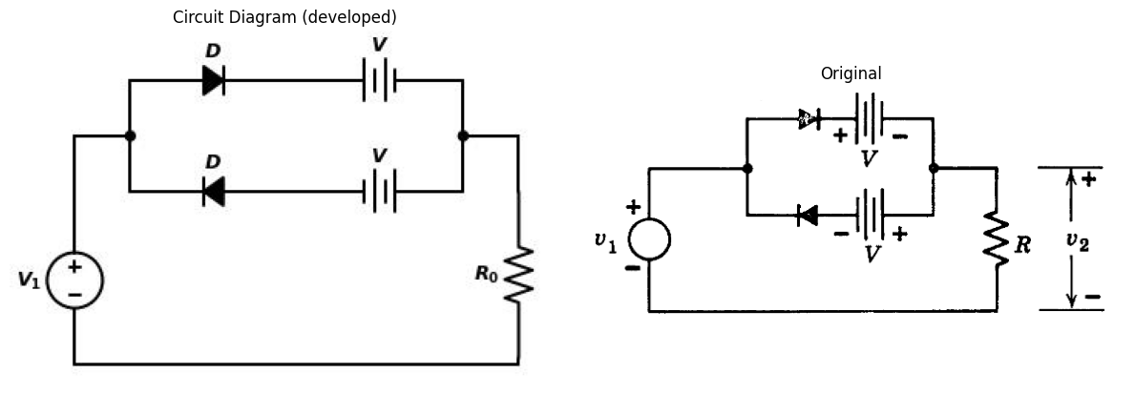
$3.19$. Sketch and dimension the driving-point curve ($v$ vs. $i$) for each of the circuits shown in Figs. P3.36-P3.38.
import schemdraw
import schemdraw.elements as elm
import schemdraw as schem
import matplotlib.pyplot as plt
import matplotlib.image as mpimg
import numpy as np
# Create the figure and subplots
fig, axs = plt.subplots(1, 2, figsize=(12, 12))
d = schemdraw.Drawing()
d += elm.Dot(open=True)
d += elm.Line().right().length(0.5)
d += elm.Resistor().right().label('$R_1$','top')
d += elm.Diode(fill=True).right().label('$D$')
d += elm.Battery().label('$V_1$', 'top').right().reverse()
d += elm.Line().down().length(1).dot()
d.push()
d += elm.Resistor().down().label('$R_2$','top')
d += elm.Battery().label('$V_2$', 'top').down()
d += elm.Line().left().length(9.5).dot(open=True)
d.pop()
d += elm.Line().left().length(2.5)
d += elm.Line().down().length(1.5)
d += elm.Diode(fill=True).down().label('$D$')
d += elm.Line().down().length(1.5).dot()
d += elm.Arrow().down().length(2.7).at((-0.1, -4.2)).color('black')
d += elm.Arrow().up().length(0.2).at((-0.6, -3.5)).color('white').label('$V$', loc='bottom', color='black')
d += elm.Arrow().up().length(2.7).at((-0.1, -2.8)).color('black')
d += elm.Arrow().right().length(0.7).at((0.3, 0.3)).color('black').label('$i$','top')
d.save('./Drawings/fig36.jpg')
d.save('./Drawings/fig36.svg')
# Load the saved PNG file into the subplot
img = mpimg.imread('./Drawings/fig36.jpg')
axs[0].imshow(img)
axs[0].axis('off') # Hide axes for image display
axs[0].set_title('Circuit Diagram (developed)')
# **Subplot (1, 2): PNG Sample File**
img_sample = mpimg.imread('images-books/p3-36.png') # Load the PNG file
axs[1].imshow(img_sample)
axs[1].axis('off') # Hide axes for image display
axs[1].set_title('Original')
# Show the combined plots
plt.tight_layout()
plt.show()
d.save('./Drawings/fig36.png')
d.save('./Drawings/fig36.svg')
d.save('./Drawings/fig36.jpg')
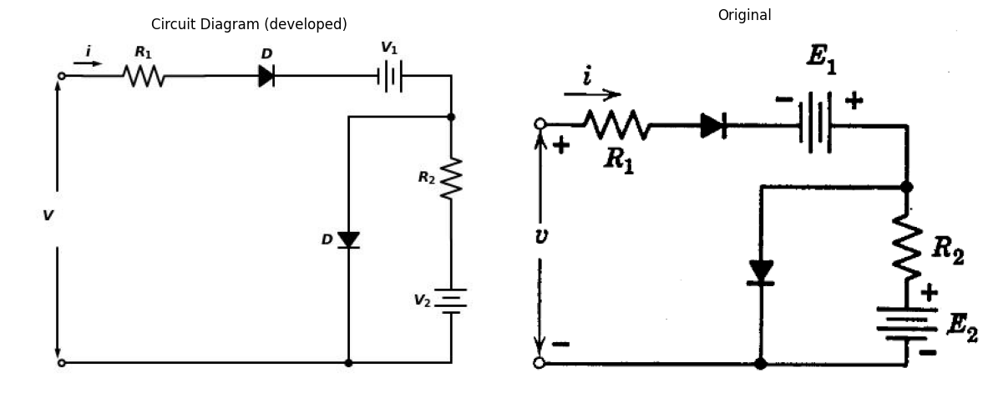
import schemdraw
import schemdraw.elements as elm
import schemdraw as schem
import matplotlib.pyplot as plt
import matplotlib.image as mpimg
import numpy as np
# Create the figure and subplots
fig, axs = plt.subplots(1, 2, figsize=(12, 12))
d = schemdraw.Drawing()
d += elm.Dot(open=True)
d += elm.Line().right().length(1)
d.push()
d += elm.Diode(fill=True).down().label('$D$')
d += elm.Resistor().down().label('$R_1$','top')
d += elm.Battery().label('$E_1$', 'top').down()
d += elm.Line().left().length(1).dot(open=True)
d += elm.Line().right().length(1.4).at((-2.1,0.0)).color('black').linestyle('--')
d += elm.Line().right().length(1.4).at((-2.1,-9.2)).color('black').linestyle('--')
d += elm.Arrow().down().length(4.0).at((-1.9, -5.2)).color('black')
d += elm.Arrow().up().length(0.2).at((-2.3, -4.7)).color('white').label('$V$', loc='bottom', color='black')
d += elm.Arrow().up().length(4.0).at((-1.9, -4)).color('black')
d += elm.Arrow().right().length(0.7).at((0.2, -0.2)).color('black').label('$i$',loc='bottom')
d.pop()
d += elm.Line().right().length(2)
d += elm.Diode(fill=True).down().label('$D$')
d += elm.Resistor().down().label('$R_2$','top')
d += elm.Battery().label('$E_2$', 'top').down()
d += elm.Line().left().length(2)
d.save('./Drawings/fig37.jpg')
d.save('./Drawings/fig37.svg')
# Load the saved PNG file into the subplot
img = mpimg.imread('./Drawings/fig37.jpg')
axs[0].imshow(img)
axs[0].axis('off') # Hide axes for image display
axs[0].set_title('Circuit Diagram (developed)')
# **Subplot (1, 2): PNG Sample File**
img_sample = mpimg.imread('images-books/p3-37.png') # Load the PNG file
axs[1].imshow(img_sample)
axs[1].axis('off') # Hide axes for image display
axs[1].set_title('Original')
# Show the combined plots
plt.tight_layout()
plt.show()
d.save('./Drawings/fig37.png')
d.save('./Drawings/fig37.svg')
d.save('./Drawings/fig37.jpg')
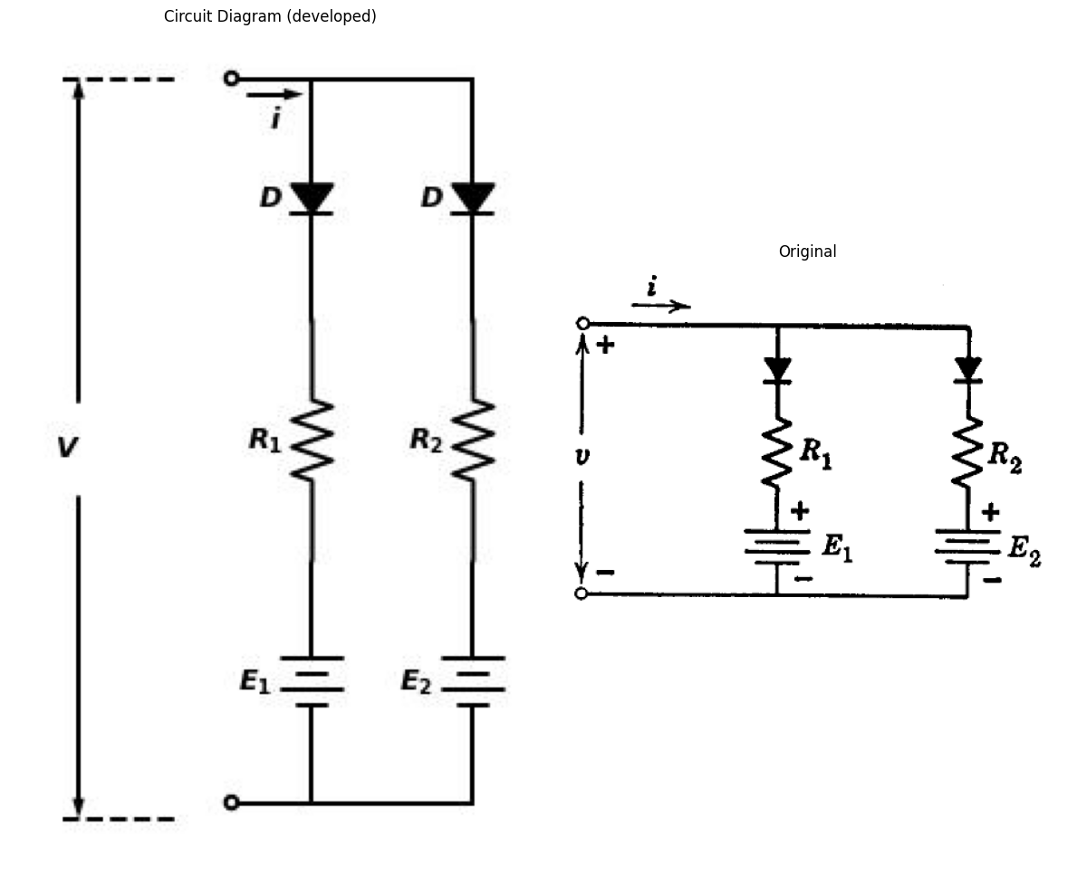
$3.20$. Plot $v$ vs. $i$ for the circuit shown in Fig. P3.39, showing slopes and the dimensions of break points.
$3.21$. Sketch the graphs of $e$ vs. $i$ for the circuits shown in Figs. P3.40–P3.43. All components are ideal.
$3.22$. Plot the $e$ vs. $i$ graph for the circuit shown in Fig. P3.44.
import schemdraw
import schemdraw.elements as elm
import schemdraw as schem
import matplotlib.pyplot as plt
import matplotlib.image as mpimg
import numpy as np
# Create the figure and subplots
fig, axs = plt.subplots(1, 2, figsize=(12, 12))
d = schemdraw.Drawing()
d += elm.Dot(open=True)
d += elm.Line().right().length(1.5)
d += elm.Resistor().right().label('$R_1$','top')
d += elm.Diode(fill=True).right().label('$D$')
d += elm.Line().right().length(2.5)
d += elm.Line().down().length(1).dot()
d.push()
d += elm.Resistor().down().label('$R_2$','top')
d += elm.Battery().label('$E_2$', 'top').down()
d += elm.Line().left().length(8.5).dot()
d += elm.Battery().label('$E_1$', 'top').up()
d += elm.Diode(fill=True).up().label('$D$')
d += elm.Line().up().length(1)
d.pop()
d += elm.Line().left().length(2.5)
d += elm.Line().down().length(1.5)
d += elm.Diode(fill=True).down().label('$D$')
d += elm.Line().down().length(1.5).dot()
d += elm.Line().left().length(1.5).dot(open=True).at((1.5,-7))
d += elm.Arrow().down().length(2.7).at((-0.1, -4.2)).color('black')
d += elm.Arrow().up().length(0.2).at((-0.6, -3.5)).color('white').label('$V$', loc='bottom', color='black')
d += elm.Arrow().up().length(2.7).at((-0.1, -2.8)).color('black')
d += elm.Arrow().right().length(0.7).at((0.3, 0.3)).color('black').label('$i$','top')
d.save('./Drawings/fig38.jpg')
d.save('./Drawings/fig38.svg')
# Load the saved PNG file into the subplot
img = mpimg.imread('./Drawings/fig38.jpg')
axs[0].imshow(img)
axs[0].axis('off') # Hide axes for image display
axs[0].set_title('Circuit Diagram (developed)')
# **Subplot (1, 2): PNG Sample File**
img_sample = mpimg.imread('images-books/p3-38.png') # Load the PNG file
axs[1].imshow(img_sample)
axs[1].axis('off') # Hide axes for image display
axs[1].set_title('Original')
# Show the combined plots
plt.tight_layout()
plt.show()
d.save('./Drawings/fig38.png')
d.save('./Drawings/fig38.svg')
d.save('./Drawings/fig38.jpg')
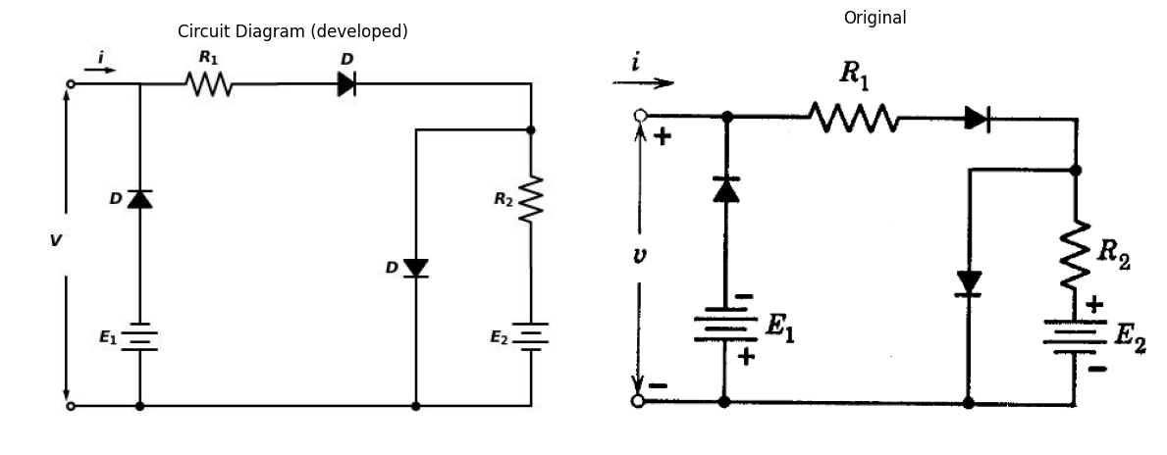
Fig. P3.38
import schemdraw
import schemdraw.elements as elm
import schemdraw as schem
import matplotlib.pyplot as plt
import matplotlib.image as mpimg
import numpy as np
# Create the figure and subplots
fig, axs = plt.subplots(1, 2, figsize=(12, 12))
d = schemdraw.Drawing()
d += elm.Dot(open=True)
d += elm.Line().right().length(1.5).dot()
d += elm.Diode(fill=True).right().label('$D$')
d += elm.Line().up().length(1.5)
d += elm.Resistor().left().label('$1 KΩ$','top')
d += elm.Line().down().length(3)
d += elm.SourceI().right().label('1 mA', 'bottom')
d += elm.Line().up().length(1.5).dot()
d += elm.Line().right().length(1.5)
d += elm.Line().down().length(5)
d += elm.Line().left().length(1.5).dot()
d += elm.Line().up().length(1)
d += elm.SourceI().left().label('3 mA', 'top')
d += elm.Line().down().length(1).dot()
d.push()
d += elm.Line().down().length(1)
d += elm.Diode(fill=True).right().label('$D$')
d += elm.Line().up().length(1)
d.pop()
d += elm.Line().left().length(1.5).dot(open=True)
d += elm.Arrow().down().length(1.7).at((-0.1, -3.2)).color('black')
d += elm.Arrow().up().length(0.2).at((-0.6, -2.7)).color('white').label('$V$', loc='bottom', color='black')
d += elm.Arrow().up().length(1.7).at((-0.1, -1.8)).color('black')
d += elm.Arrow().right().length(0.7).at((0.3, 0.3)).color('black').label('$i$','top')
d.save('./Drawings/fig39.jpg')
d.save('./Drawings/fig39.svg')
# Load the saved PNG file into the subplot
img = mpimg.imread('./Drawings/fig39.jpg')
axs[0].imshow(img)
axs[0].axis('off') # Hide axes for image display
axs[0].set_title('Circuit Diagram (developed)')
# **Subplot (1, 2): PNG Sample File**
img_sample = mpimg.imread('images-books/p3-39.png') # Load the PNG file
axs[1].imshow(img_sample)
axs[1].axis('off') # Hide axes for image display
axs[1].set_title('Original')
# Show the combined plots
plt.tight_layout()
plt.show()
d.save('./Drawings/fig39.png')
d.save('./Drawings/fig39.svg')
d.save('./Drawings/fig39.jpg')
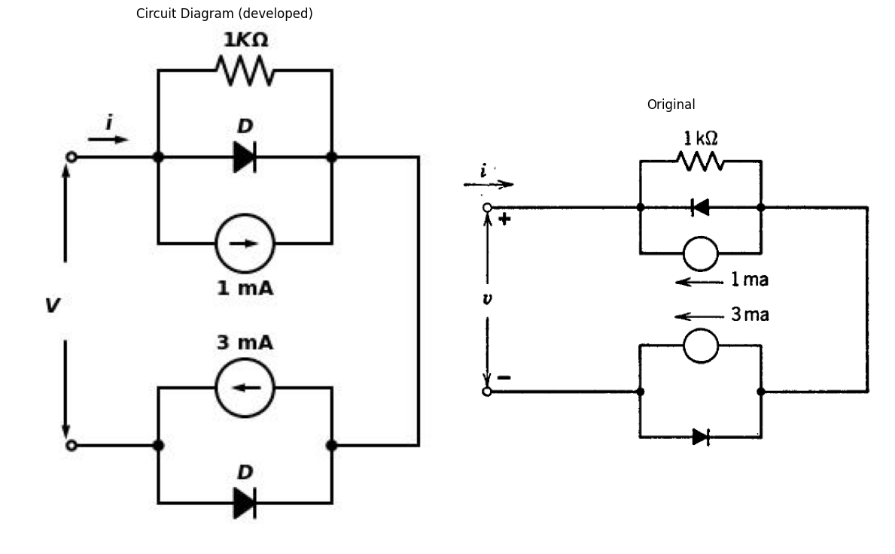
Fig. P3.39
import schemdraw
import schemdraw.elements as elm
import schemdraw as schem
import matplotlib.pyplot as plt
import matplotlib.image as mpimg
import numpy as np
# Create the figure and subplots
fig, axs = plt.subplots(1, 2, figsize=(12, 12))
d = schemdraw.Drawing()
d += elm.Dot(open=True)
d += elm.Line().right().length(5.5)
d += elm.Diode(fill=True).down().label('$D$').reverse()
d += elm.Diode(fill=True).down().label('$D$')
d += elm.Line().left().length(3).dot()
d += elm.SourceI().up().label('I', 'bottom')
d.push()
d += elm.Line().right().length(3).dot()
d.pop()
d += elm.SourceI().up().label('I', 'bottom').reverse()
d += elm.Line().left().length(2.5).at((2.5,-6)).dot(open=True)
d += elm.Arrow().down().length(2.1).at((-0.1, -3.8)).color('black')
d += elm.Arrow().up().length(0.2).at((-0.6, -3.1)).color('white').label('$V$', loc='bottom', color='black')
d += elm.Arrow().up().length(2.1).at((-0.1, -2.2)).color('black')
d += elm.Arrow().right().length(0.7).at((0.3, 0.3)).color('black').label('$i$','top')
d.save('./Drawings/fig40.jpg')
d.save('./Drawings/fig40.svg')
# Load the saved PNG file into the subplot
img = mpimg.imread('./Drawings/fig40.jpg')
axs[0].imshow(img)
axs[0].axis('off') # Hide axes for image display
axs[0].set_title('Circuit Diagram (developed)')
# **Subplot (1, 2): PNG Sample File**
img_sample = mpimg.imread('images-books/p3-40.png') # Load the PNG file
axs[1].imshow(img_sample)
axs[1].axis('off') # Hide axes for image display
axs[1].set_title('Original')
# Show the combined plots
plt.tight_layout()
plt.show()
d.save('./Drawings/fig40.png')
d.save('./Drawings/fig40.svg')
d.save('./Drawings/fig40.jpg')
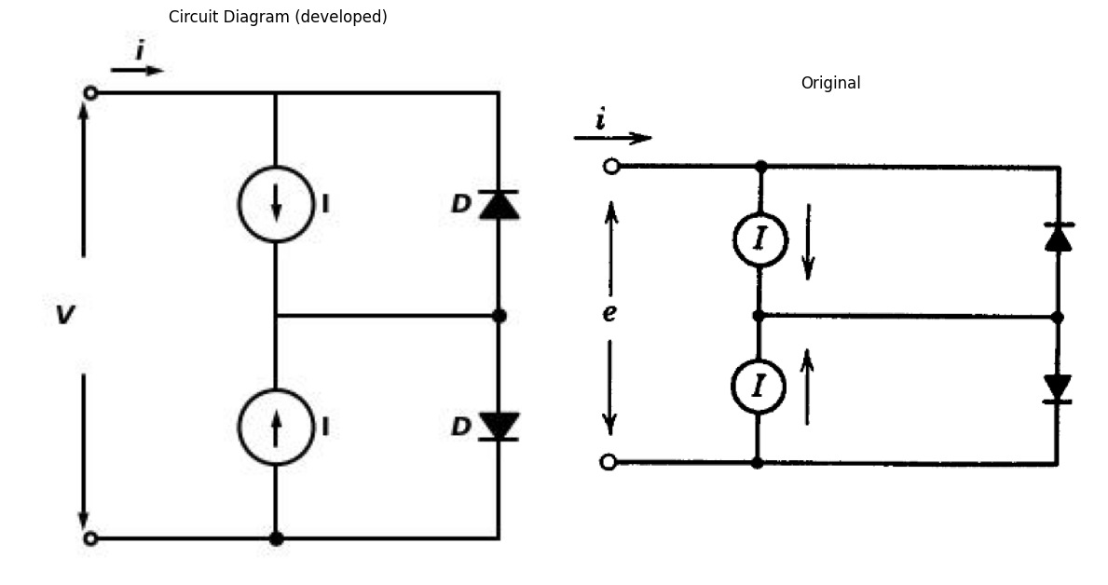
import schemdraw
import schemdraw.elements as elm
import schemdraw as schem
import matplotlib.pyplot as plt
import matplotlib.image as mpimg
import numpy as np
# Create the figure and subplots
fig, axs = plt.subplots(1, 2, figsize=(12, 12))
d = schemdraw.Drawing()
d += elm.Dot(open=True)
d += elm.Line().right().length(5.5)
d += elm.Diode(fill=True).down().label('$D$').reverse()
d += elm.Diode(fill=True).down().label('$D$')
d += elm.Line().left().length(3).dot()
d += elm.Diode(fill=True).up().label('$D$')
d.push()
d += elm.SourceI().right().label('I', 'bottom')
d.pop()
d += elm.Diode(fill=True).up().label('$D$').reverse()
d += elm.Line().left().length(2.5).at((2.5,-6)).dot(open=True)
d += elm.Arrow().down().length(2.1).at((-0.1, -3.8)).color('black')
d += elm.Arrow().up().length(0.2).at((-0.6, -3.1)).color('white').label('$e$', loc='bottom', color='black')
d += elm.Arrow().up().length(2.1).at((-0.1, -2.2)).color('black')
d += elm.Arrow().right().length(0.7).at((0.3, 0.3)).color('black').label('$i$','top')
#d += elm.Label('+').at((0.3,-0.4)).color('red')
#d += elm.Label('_').at((0.3,-5.7)).color('red')
d.save('./Drawings/fig41.jpg')
d.save('./Drawings/fig41.svg')
# Load the saved PNG file into the subplot
img = mpimg.imread('./Drawings/fig41.jpg')
axs[0].imshow(img)
axs[0].axis('off') # Hide axes for image display
axs[0].set_title('Circuit Diagram (developed)')
# **Subplot (1, 2): PNG Sample File**
img_sample = mpimg.imread('images-books/p3-41.png') # Load the PNG file
axs[1].imshow(img_sample)
axs[1].axis('off') # Hide axes for image display
axs[1].set_title('Original')
# Show the combined plots
plt.tight_layout()
plt.show()
d.save('./Drawings/fig41.png')
d.save('./Drawings/fig41.svg')
d.save('./Drawings/fig41.jpg')
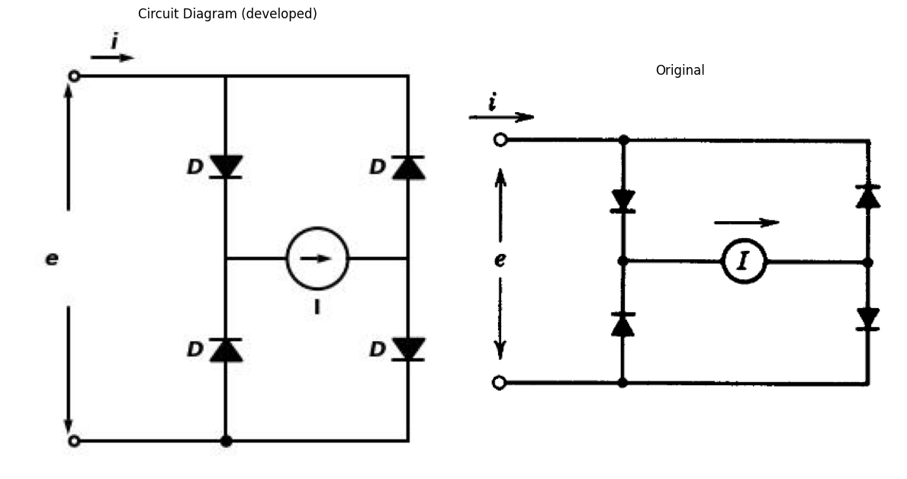
import schemdraw
import schemdraw.elements as elm
import schemdraw as schem
import matplotlib.pyplot as plt
import matplotlib.image as mpimg
import numpy as np
# Create the figure and subplots
fig, axs = plt.subplots(1, 2, figsize=(12, 12))
d = schemdraw.Drawing()
d += elm.Dot(open=True)
d += elm.Line().right().length(5.5)
d += elm.Diode(fill=True).down().label('$D$')
d += elm.Diode(fill=True).down().label('$D$').reverse()
d += elm.Line().left().length(3).dot()
d += elm.Diode(fill=True).up().label('$D$').reverse()
d.push()
d += elm.Battery().label('$E$', 'top').right().reverse()
d.pop()
d += elm.Diode(fill=True).up().label('$D$')
d += elm.Line().left().length(2.5).at((2.5,-6)).dot(open=True)
d += elm.Arrow().down().length(2.1).at((-0.1, -3.8)).color('black')
d += elm.Arrow().up().length(0.2).at((-0.6, -3.1)).color('white').label('$V$', loc='bottom', color='black')
d += elm.Arrow().up().length(2.1).at((-0.1, -2.2)).color('black')
d += elm.Arrow().right().length(0.7).at((0.3, 0.3)).color('black').label('$i$','top')
#d += elm.Label('+').at((0.3,-0.4)).color('red')
#d += elm.Label('_').at((0.3,-5.7)).color('red')
d.save('./Drawings/fig42.jpg')
d.save('./Drawings/fig42.svg')
# Load the saved PNG file into the subplot
img = mpimg.imread('./Drawings/fig42.jpg')
axs[0].imshow(img)
axs[0].axis('off') # Hide axes for image display
axs[0].set_title('Circuit Diagram (developed)')
# **Subplot (1, 2): PNG Sample File**
img_sample = mpimg.imread('images-books/p3-42.png') # Load the PNG file
axs[1].imshow(img_sample)
axs[1].axis('off') # Hide axes for image display
axs[1].set_title('Original')
# Show the combined plots
plt.tight_layout()
plt.show()
d.save('./Drawings/fig42.png')
d.save('./Drawings/fig42.svg')
d.save('./Drawings/fig42.jpg')
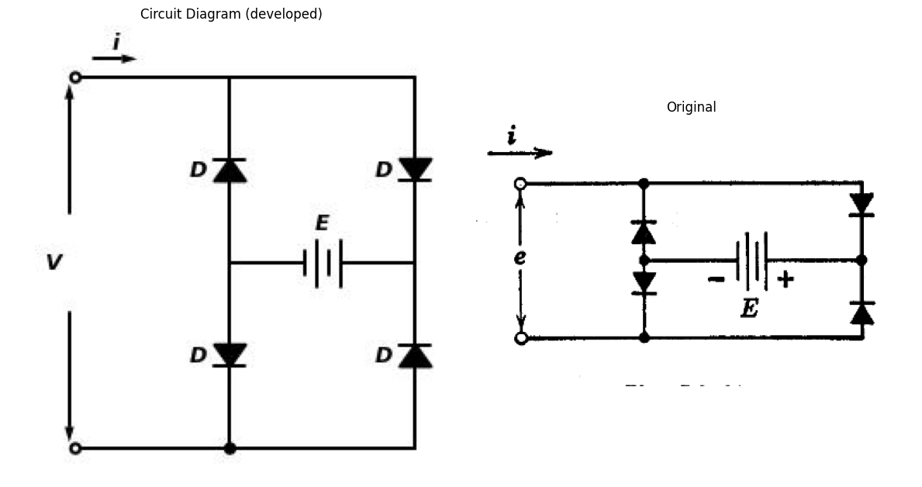
import schemdraw
import schemdraw.elements as elm
import schemdraw as schem
import matplotlib.pyplot as plt
import matplotlib.image as mpimg
import numpy as np
# Create the figure and subplots
fig, axs = plt.subplots(1, 2, figsize=(12, 12))
d = schemdraw.Drawing()
d += elm.Dot(open=True)
d += elm.Line().right().length(5.5)
d += elm.Diode(fill=True).down().label('$D$').reverse()
d += elm.Battery().label('$E$', 'top').down().reverse()
d += elm.Line().left().length(3).dot()
d += elm.Battery().label('$E$', 'top').up().reverse()
d += elm.Diode(fill=True).up().label('$D$').reverse()
d += elm.Line().left().length(2.5).at((2.5,-6)).dot(open=True)
d += elm.Arrow().down().length(2.1).at((-0.1, -3.8)).color('black')
d += elm.Arrow().up().length(0.2).at((-0.6, -3.1)).color('white').label('$e$', loc='bottom', color='black')
d += elm.Arrow().up().length(2.1).at((-0.1, -2.2)).color('black')
d += elm.Arrow().right().length(0.7).at((0.3, 0.3)).color('black').label('$i$','top')
#d += elm.Label('+').at((0.3,-0.4)).color('red')
#d += elm.Label('_').at((0.3,-5.7)).color('red')
d.save('./Drawings/fig43.jpg')
d.save('./Drawings/fig43.svg')
# Load the saved PNG file into the subplot
img = mpimg.imread('./Drawings/fig43.jpg')
axs[0].imshow(img)
axs[0].axis('off') # Hide axes for image display
axs[0].set_title('Circuit Diagram (developed)')
# **Subplot (1, 2): PNG Sample File**
img_sample = mpimg.imread('images-books/p3-43.png') # Load the PNG file
axs[1].imshow(img_sample)
axs[1].axis('off') # Hide axes for image display
axs[1].set_title('Original')
# Show the combined plots
plt.tight_layout()
plt.show()
d.save('./Drawings/fig43.png')
d.save('./Drawings/fig43.svg')
d.save('./Drawings/fig43.jpg')
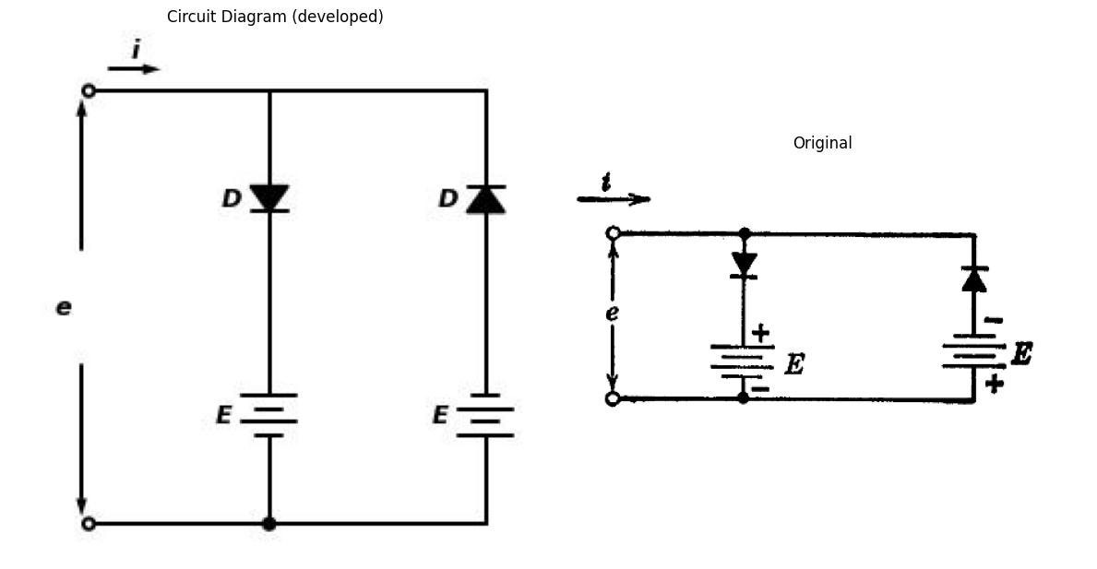
Fig. P3.43
import schemdraw
import schemdraw.elements as elm
import schemdraw as schem
import matplotlib.pyplot as plt
import matplotlib.image as mpimg
import numpy as np
# Create the figure and subplots
fig, axs = plt.subplots(1, 2, figsize=(12, 12))
d = schemdraw.Drawing()
d += elm.Dot(open=True)
d += elm.Line().right().length(2.5)
d += elm.Resistor().right().label('$1 Ω$','top')
d.push()
d += elm.Line().right().length(2.5)
d += elm.Resistor().down().label('$1 Ω$','top')
d += elm.Diode(fill=True).down().label('$D$')
d +=elm.SourceV().down().label('3 V', loc='bottom').reverse()
d += elm.Line().left().length(2.5)
d.pop()
d += elm.Line().down().length(1.5)
d += elm.Resistor().down().label('$2 Ω$','bottom')
d += elm.Battery().label('$6 V$', 'bottom').down()
d += elm.Line().down().length(1.5)
d += elm.Line().left().length(3.5)
d += elm.Line().up().length(1.5)
d += elm.Resistor().up().label('$2 Ω$','top').dot()
d.push()
d += elm.Resistor().up().label('$1 Ω$','top')
d += elm.Line().up().length(1.5)
d.pop()
d += elm.Line().right().length(1.5)
d += elm.SourceI().down().label('1 A', 'bottom')
d += elm.Line().down().length(1.5)
d += elm.Line().left().length(3.6).dot(open=True)
d += elm.Arrow().down().length(3.7).at((-0.1, -5.2)).color('black')
d += elm.Arrow().up().length(0.2).at((-0.6, -4.6)).color('white').label('$V$', loc='bottom', color='black')
d += elm.Arrow().up().length(3.7).at((-0.1, -3.8)).color('black')
d += elm.Arrow().right().length(0.7).at((0.3, 0.3)).color('black').label('$i$','top')
#d += elm.Label('+').at((0.3,-0.4)).color('black')
#d += elm.Label('_').at((0.3,-8.7)).color('black')
d.save('./Drawings/fig44.jpg')
d.save('./Drawings/fig44.svg')
# Load the saved PNG file into the subplot
img = mpimg.imread('./Drawings/fig44.jpg')
axs[0].imshow(img)
axs[0].axis('off') # Hide axes for image display
axs[0].set_title('Circuit Diagram (developed)')
# **Subplot (1, 2): PNG Sample File**
img_sample = mpimg.imread('images-books/p3-44.png') # Load the PNG file
axs[1].imshow(img_sample)
axs[1].axis('off') # Hide axes for image display
axs[1].set_title('Original')
# Show the combined plots
plt.tight_layout()
plt.show()
d.save('./Drawings/fig44.png')
d.save('./Drawings/fig44.svg')
d.save('./Drawings/fig44.jpg')
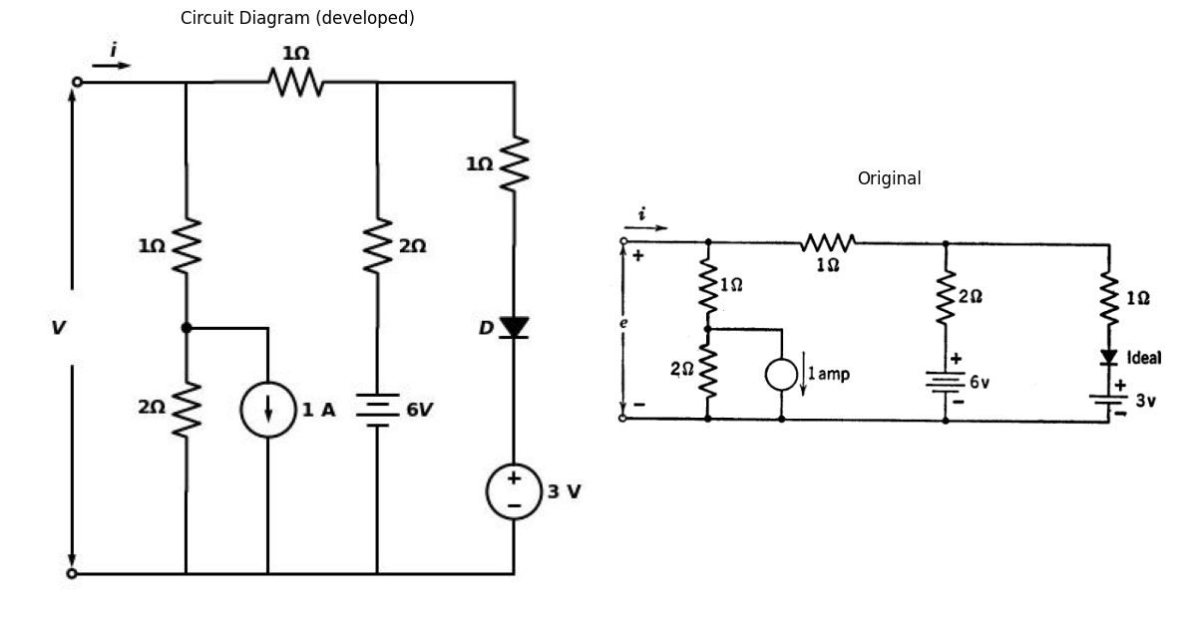
Fig. P3.44
$3.23$. In the circuit shown in Fig. P3.45, $C$ is initially charged to the voltage $E$ as shown. At time $t$=0 the switch $S$ is closed. Sketch $e\left(t\right)$ for the three cases: $R$ = 0; 0 < $R$ < $E/I$; and $R>E/I$.
import schemdraw
import schemdraw.elements as elm
import schemdraw as schem
import matplotlib.pyplot as plt
import matplotlib.image as mpimg
import numpy as np
# Create the figure and subplots
fig, axs = plt.subplots(1, 2, figsize=(12, 12))
d = schemdraw.Drawing()
d += elm.Line().right().length(1)
d += elm.Resistor().right().label('$R$','top')
d += elm.Switch(action=open).label('$S$','top')
d += elm.Line().right().length(.5)
d.push()
d += elm.Line().right().length(1.5)
d += elm.Diode(fill=True).down().label('$D$')
d += elm.Line().left().length(9)
d += elm.Capacitor().label('C').up().label([ '-','$ E $','+' ], loc='bottom', color='black')
d.pop()
d += elm.SourceI().down().label('I', 'top')
d += elm.Arrow().down().length(.7).at((1.2, -2.2)).color('black')
d += elm.Arrow().up().length(0.2).at((1, -1.6)).color('white').label('$e_t$', loc='bottom', color='black')
d += elm.Arrow().up().length(.7).at((1.2, -0.8)).color('black')
d.save('./Drawings/fig45.jpg')
d.save('./Drawings/fig45.svg')
# Load the saved PNG file into the subplot
img = mpimg.imread('./Drawings/fig45.jpg')
axs[0].imshow(img)
axs[0].axis('off') # Hide axes for image display
axs[0].set_title('Circuit Diagram (developed)')
# **Subplot (1, 2): PNG Sample File**
img_sample = mpimg.imread('images-books/p3-45.png') # Load the PNG file
axs[1].imshow(img_sample)
axs[1].axis('off') # Hide axes for image display
axs[1].set_title('Original')
# Show the combined plots
plt.tight_layout()
plt.show()
d.save('./Drawings/fig45.png')
d.save('./Drawings/fig45.svg')
d.save('./Drawings/fig45.jpg')
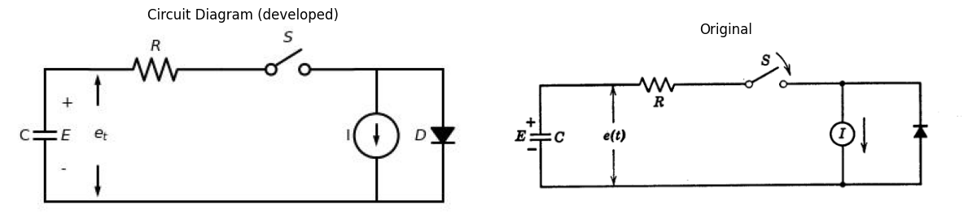
$3.24$. $\left(a\right)$ Synthesize a piecewise-linear circuit for the vacuum diode with the current-voltage characteristic (Fig. P3.46): $i$ = 10^-3 $e^{3}/^{2}$ with the approxi- mation tangent to the curve at the points $e$ = 0; 1v; 2v (for $e$ < 0, $i4 = 0). (Two break points.)
import matplotlib.pyplot as plt
import numpy as np
import schemdraw
import schemdraw.elements as elm
import matplotlib.image as mpimg
# Create the figure and subplots
fig, axs = plt.subplots(1, 2, figsize=(12, 12))
x = np.linspace(0, 3, 50)
y1 = x ** (3/2)
axs[0].plot(x, y1, color='black', label=r'i=$10^{-3}e^{3/2}$')
dy1_dx = (3/2) * x**(1/2)
tangent_points = [1, 2]
for point in tangent_points:
y_value = point ** (3/2)
slope = (3/2) * point**(1/2)
x_tangent = np.linspace(point - 1, point + 1, 50)
y_tangent = slope * (x_tangent - point) + y_value
axs[0].plot(x_tangent, y_tangent, linestyle='--', color='black', label=f'Tangent at x={point}')
axs[0].set_xlim(-1, 4)
axs[0].set_xlabel('e, volts', loc='right')
axs[0].set_ylabel('$10^3i,$ amps', rotation=0, loc='top')
axs[0].plot([0,1], [1,1], color='black', linestyle='--', label='Membership = 1')
axs[0].plot([1,1], [0,1], color='black', linestyle='--', label='Membership = 1')
axs[0].plot([2,2], [0,2], color='black', linestyle='--', label='Membership = 2')
axs[0].set_ylim(-1, 4)
axs[0].axhline(0, color='black', linewidth=1.5)
axs[0].axvline(0, color='black', linewidth=1.5)
img_sample = mpimg.imread('images-books/p3-46.png') # Load the PNG file
axs[1].imshow(img_sample)
axs[1].axis('off') # Hide axes for image display
axs[1].set_title('Original')
# Show the combined plots
plt.tight_layout()
plt.show()
plt.tight_layout()
plt.show()
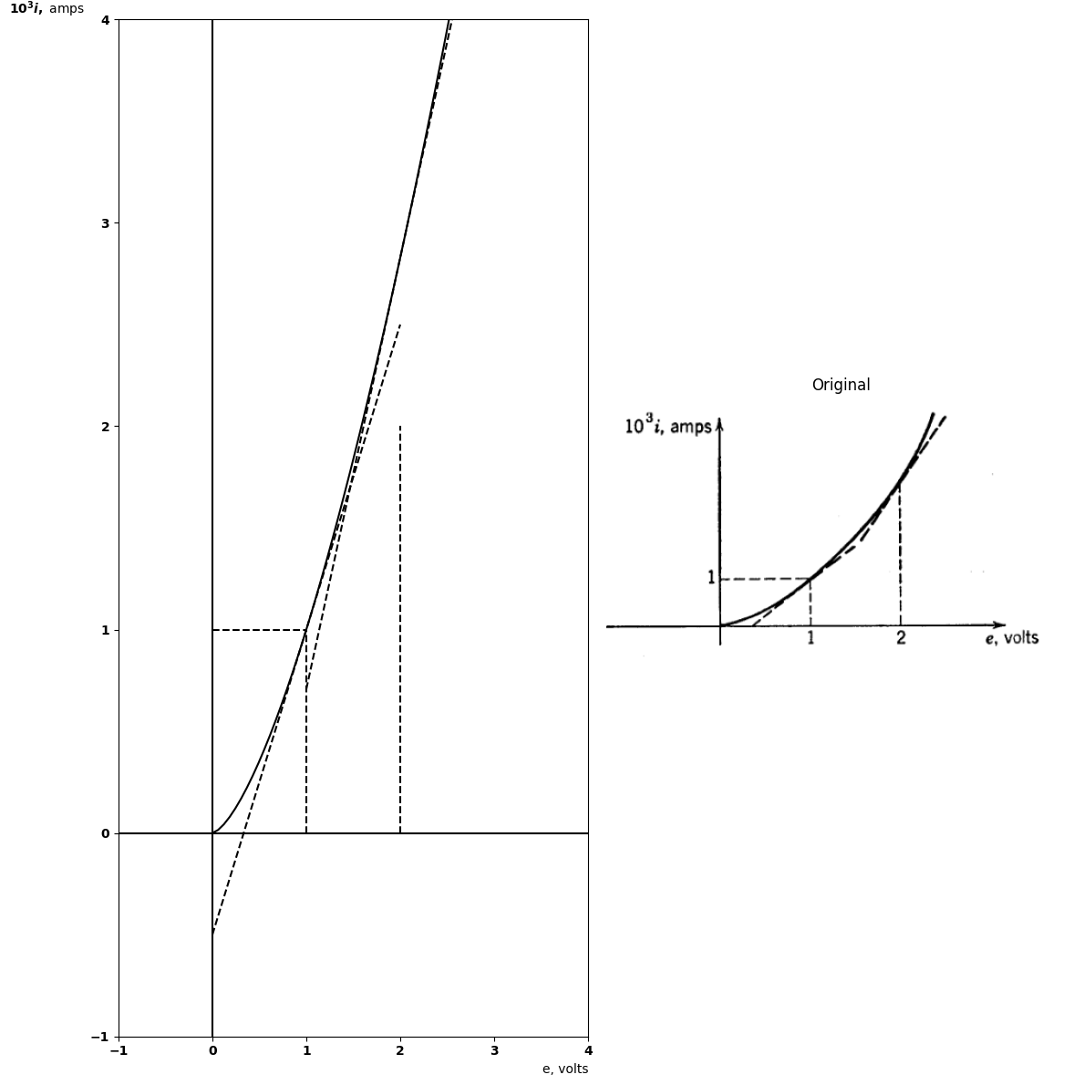
<Figure size 640x480 with 0 Axes>
Fig. P3.46
$\left(b\right)$ Using the circuit model found in part $\left(a\right)$ for the diode in the circuit shown in Fig. P3.47, find the voltage transfer characteristic, $e_{2}$ vs. $e_{1}$.
import schemdraw
import schemdraw.elements as elm
import schemdraw as schem
import matplotlib.pyplot as plt
import matplotlib.image as mpimg
import numpy as np
# Create the figure and subplots
fig, axs = plt.subplots(1, 2, figsize=(12, 12))
d = schemdraw.Drawing()
d += elm.Dot(open=True)
d += elm.Line().right().length(1)
d += elm.Resistor().right().label('$R=1KΩ$','top')
d.push()
d += elm.Line().right().length(1.5).dot(open=True)
d.pop()
d += elm.Diode(fill=True).down().label('$D$')
d.push()
d += elm.Line().right().length(1.5).dot(open=True)
d.pop()
d += elm.Line().left().length(4).dot(open=True)
d += elm.Arrow().down().length(.7).at((0.1, -2.2)).color('black')
d += elm.Arrow().up().length(0.2).at((-.4, -1.6)).color('white').label('$e_1$', loc='bottom', color='black')
d += elm.Arrow().up().length(.7).at((0.1, -0.8)).color('black')
d += elm.Arrow().down().length(.7).at((5+0.4, -2.2)).color('black')
d += elm.Arrow().up().length(0.2).at((5-.1, -1.6)).color('white').label('$e_2$', loc='bottom', color='black')
d += elm.Arrow().up().length(.7).at((5+0.4, -0.8)).color('black')
d.save('./Drawings/fig47.jpg')
d.save('./Drawings/fig47.svg')
# Load the saved PNG file into the subplot
img = mpimg.imread('./Drawings/fig47.jpg')
axs[0].imshow(img)
axs[0].axis('off') # Hide axes for image display
axs[0].set_title('Circuit Diagram (developed)')
# **Subplot (1, 2): PNG Sample File**
img_sample = mpimg.imread('images-books/p47.png') # Load the PNG file
axs[1].imshow(img_sample)
axs[1].axis('off') # Hide axes for image display
axs[1].set_title('Original')
# Show the combined plots
plt.tight_layout()
plt.show()
d.save('./Drawings/fig47.png')
d.save('./Drawings/fig47.svg')
d.save('./Drawings/fig47.jpg')
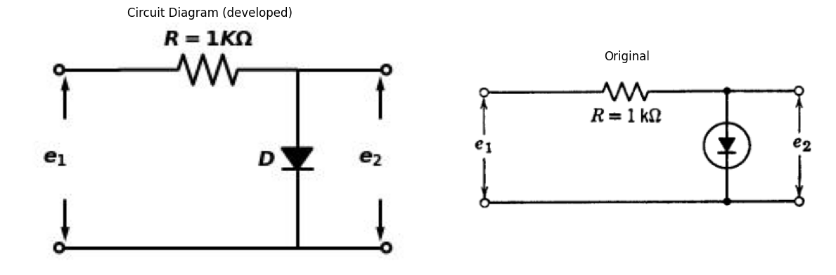
Fig. P3.47
$3.25$. The resistive-diode circuit shown in Fig. P3.48 has three ideal diodes, two of which have no influence on the driving point characteristic. Redraw the circuit with only one diode, and sketch $i$ vs. $e$, Fig. P3.48
import schemdraw
import schemdraw.elements as elm
import schemdraw as schem
import matplotlib.pyplot as plt
import matplotlib.image as mpimg
import numpy as np
# Create the figure and subplots
fig, axs = plt.subplots(1, 2, figsize=(12, 12))
d = schemdraw.Drawing()
d.push()
d += elm.Dot(open=True)
E1 = d.add(elm.Battery().right().label(['+', '$6$','-'], ofst=0.2).dot())
d += elm.lines.CurrentLabelInline().at(E1).right().label('$i$').color('black')
l1 = d.add(elm.Line().right())
E2 = d.add(elm.Battery().right().reverse().label(['-', '$5$','+'], ofst=0.2))
l2 = d.add(elm.Line().right().dot())
l3 = d.add(elm.Line().right().length(1.5).dot())
l4 = d.add(elm.Line().right().length(1.5))
I1 = d.add(elm.SourceI().down().reverse().label('$2A$', ofst=-1.5))
l5 = d.add(elm.Line().down().length(1.5))
l6 = d.add(elm.Line().left().length(1.5).dot())
l7 = d.add(elm.Line().left().length(5.5).dot())
l8 = d.add(elm.Line().left().length(8).dot(open=True))
l9 = d.add(elm.Line().down().at(E1.end).length(1.5))
D1 = d.add(elm.Diode(fill=True).right())
l10 = d.add(elm.Line().right().length(1.5))
l11 = d.add(elm.Line().right().length(1.5))
D2 = d.add(elm.Diode(fill=True).reverse().right())
l12 = d.add(elm.Line().up().length(1.5))
D3 = d.add(elm.Diode(fill=True).up().at(l6.end))
l13 = d.add(elm.Line().up().length(1.5))
R1 = d.add(elm.Resistor().up().at(l7.end).label('$R=3$', ofst=-1.5).dot())
d += elm.Gap().up().label([ '-','$ e$','+' ] ,fontsize = 16).color('black').at((0,-3.8))
d += elm.Arrow().length(1.2).at((0,-3.2)).color('black').down()
d += elm.Arrow().length(1.2).at((0,-1.3)).color('black').up()
d.save('./Drawings/fig48.jpg')
d.save('./Drawings/fig48.svg')
# Load the saved PNG file into the subplot
img = mpimg.imread('./Drawings/fig48.jpg')
axs[0].imshow(img)
axs[0].axis('off') # Hide axes for image display
axs[0].set_title('Circuit Diagram (developed)')
# **Subplot (1, 2): PNG Sample File**
img_sample = mpimg.imread('images-books/p48.png') # Load the PNG file
axs[1].imshow(img_sample)
axs[1].axis('off') # Hide axes for image display
axs[1].set_title('Original')
# Show the combined plots
plt.tight_layout()
plt.show()
d.save('./Drawings/fig48.png')
d.save('./Drawings/fig48.svg')
d.save('./Drawings/fig48.jpg')
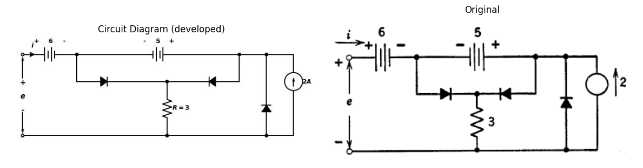
Fig. P3.48
$3.25$. Sketch and dimension $e_{2}$ vs. $e_{1}$ curves for the circuits shown in Figs. P3.49-P3.52. In each case $e−1$ is the applied voltage, $e_{2}$ is the measured output voltage, and $R_{o}$ is several times larger than $R$.
import schemdraw
import schemdraw.elements as e
import schemdraw as schem
import matplotlib.pyplot as plt
import matplotlib.image as mpimg
import numpy as np
# Create the figure and subplots
fig, axs = plt.subplots(1, 2, figsize=(12, 12))
d = schemdraw.Drawing()
d.push()
d += elm.Dot(open=True)
R1 = d.add(elm.Resistor().right().label('$R$', ofst=-1).dot())
l1 = d.add(elm.Line().right().dot())
l2 = d.add(elm.Line().right().dot(open=True))
R2 = d.add(elm.Resistor().down().at(l1.end).label('$R_o$', ofst=-1))
l3 = d.add(elm.Line().left().dot())
D1 = d.add(elm.Diode(fill=True).up())
d += elm.Ground().at(l3.end)
d += elm.Gap().up().label([ '$ e_1$' ] ,fontsize = 16).color('black').at((0,-2))
d += elm.Gap().up().label([ '$ e_2$' ] ,fontsize = 16).color('black').at((9,-2))
d.pop()
d.move(12,2.5)
d.push()
d += elm.Dot(open=True)
l4 = d.add(elm.Line().right().length(1.5).dot())
l5 = d.add(elm.Line().right())
D2 = d.add(elm.Diode(fill=True).down().dot())
D3 = d.add(elm.Diode(fill=True).reverse().down())
l6 = d.add(elm.Line().left().dot())
R3 = d.add(elm.Resistor().up().label('$R$', ofst=-1).dot())
R4 = d.add(elm.Resistor().up().label('$R$', ofst=-1))
R5 = d.add(elm.Resistor().right().at(R3.end).label('$R_o$', ofst=-1).label('-''<--' '$e_2$' '-->''+' ,'top',color='black'))
d += elm.Ground().at(l6.end)
d += elm.Gap().up().label([ '$ e_1$' ] ,fontsize = 16).color('black').at((11.5,1))
d += elm.Line().down().length(0.8).at((14,0.5)).color('black').linestyle('-')
d += elm.Line().down().length(0.8).at((16,0.5)).color('black').linestyle('-')
d.save('./Drawings/fig50.jpg')
d.save('./Drawings/fig50.svg')
# Load the saved PNG file into the subplot
img = mpimg.imread('./Drawings/fig50.jpg')
axs[0].imshow(img)
axs[0].axis('off') # Hide axes for image display
axs[0].set_title('Circuit Diagram (developed)')
# **Subplot (1, 2): PNG Sample File**
img_sample = mpimg.imread('images-books/p50.png') # Load the PNG file
axs[1].imshow(img_sample)
axs[1].axis('off') # Hide axes for image display
axs[1].set_title('Original')
# Show the combined plots
plt.tight_layout()
plt.show()
d.save('./Drawings/fig50.png')
d.save('./Drawings/fig50.svg')
d.save('./Drawings/fig50.jpg')
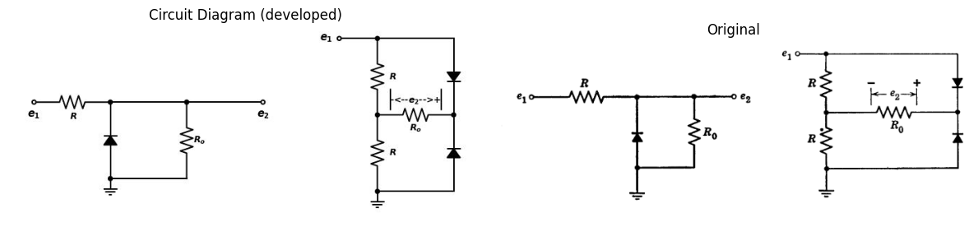
import schemdraw
import schemdraw.elements as e
import schemdraw as schem
import matplotlib.pyplot as plt
import matplotlib.image as mpimg
import numpy as np
# Create the figure and subplots
fig, axs = plt.subplots(1, 2, figsize=(12, 12))
d = schemdraw.Drawing()
d += elm.Dot(open=True)
l1 = d.add(elm.Line().right().length(1.5).dot())
l2 = d.add(elm.Line().right())
D1 = d.add(elm.Diode(fill=True).down().dot())
R1 = d.add(elm.Resistor().down().label('$R$', ofst=-1))
l3 = d.add(elm.Line().left().dot())
R2 = d.add(elm.Resistor().up().label('$R$', ofst=-1).dot())
D2 = d.add(elm.Diode(fill=True).up())
R3 = d.add(elm.Resistor().right().at(R2.end).label('$R_o$', ofst=-1).label('-''<--' '$e_2$' '-->''+' ,'top',color='black'))
d += elm.Ground().at(l3.end)
d += elm.Gap().up().label([ '$ e_1$' ] ,fontsize = 16).color('black').at((-0.5,-1.5))
d += elm.Line().down().length(0.8).at((2,-2)).color('black').linestyle('-')
d += elm.Line().down().length(0.8).at((4,-2)).color('black').linestyle('-')
d.pop()
d.move(5,2.8)
d.push()
d += elm.Dot(open=True)
l4 = d.add(elm.Line().right().length(1.5).dot())
l5 = d.add(elm.Line().right())
D2 = d.add(elm.Diode(fill=True).down().dot())
D3 = d.add(elm.Diode(fill=True).down().reverse())
l6 = d.add(elm.Line().left().dot())
D4 = d.add(elm.Diode(fill=True).up().dot().reverse())
D5 = d.add(elm.Diode(fill=True).up())
R5 = d.add(elm.Resistor().right().at(D4.end).label('$R_o$', ofst=-1).label('-''<--' '$e_2$' '-->''+' ,'top',color='black'))
d += elm.Ground().at(l6.end)
d += elm.Gap().up().label([ '$ e_1$' ] ,fontsize = 16).color('black').at((8.5,-1.5))
d += elm.Line().down().length(0.8).at((11,-2)).color('black').linestyle('-')
d += elm.Line().down().length(0.8).at((13,-2)).color('black').linestyle('-')
d.save('./Drawings/fig52.jpg')
d.save('./Drawings/fig52.svg')
# Load the saved PNG file into the subplot
img = mpimg.imread('./Drawings/fig52.jpg')
axs[0].imshow(img)
axs[0].axis('off') # Hide axes for image display
axs[0].set_title('Circuit Diagram (developed)')
# **Subplot (1, 2): PNG Sample File**
img_sample = mpimg.imread('images-books/52.png') # Load the PNG file
axs[1].imshow(img_sample)
axs[1].axis('off') # Hide axes for image display
axs[1].set_title('Original')
# Show the combined plots
plt.tight_layout()
plt.show()
d.save('./Drawings/fig52.png')
d.save('./Drawings/fig52.svg')
d.save('./Drawings/fig52.jpg')
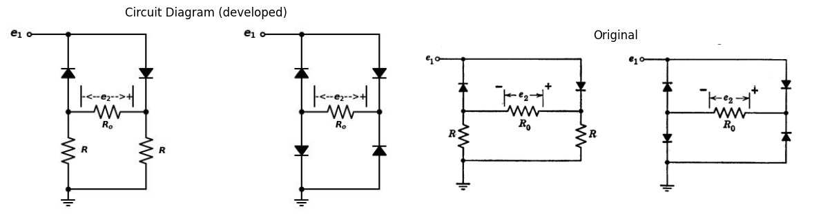
Fig. P3.49 Fig. P3.50 Fig. P3.51 Fig. P3.52
$3.27$. Find the piecewise-linear $e_{2}$ vs. $e_{1}$ characteristic of the circuit shown in Fig. P3.53.
import schemdraw
import schemdraw.elements as e
import schemdraw as schem
import matplotlib.pyplot as plt
import matplotlib.image as mpimg
import numpy as np
# Create the figure and subplots
fig, axs = plt.subplots(1, 2, figsize=(12, 12))
d = schemdraw.Drawing()
d += elm.Dot(open=True)
l1 = d.add(elm.Line().right().dot())
l2 = d.add(elm.Line().right().dot())
R1 = d.add(elm.Resistor().right().label('$R=10$', ofst=-1).dot())
l3 = d.add(elm.Line().right().dot())
l4 = d.add(elm.Line().right().dot())
l5 = d.add(elm.Line().right().dot(open=True))
R2 = d.add(elm.Resistor().down().label('$R=10$', ofst=-1.7).at(l4.end))
D1 = d.add(elm.Diode(fill=True).down())
E1 = d.add(elm.Battery().down().label(['+', '$10V$','-'], ofst=-1.8).dot())
l6 = d.add(elm.Line().right().dot(open=True))
l7 = d.add(elm.Line().left().at(E1.end).dot())
l8 = d.add(elm.Line().up())
R3 = d.add(elm.Resistor().up().label('$R=10$', ofst=-1.7))
l9 = d.add(elm.Line().up())
l10 = d.add(elm.Line().left().at(l7.end).length(9).dot())
l11 = d.add(elm.Line().up())
D2 = d.add(elm.Diode(fill=True).up())
l12 = d.add(elm.Line().up())
l13 = d.add(elm.Line().left().at(l10.end).dot(open=True))
l14 = d.add(elm.Line().up().at(l2.end).length(1.5))
I1 = d.add(elm.SourceI().right().label('$i=1/2$', ofst=0.1))
l15 = d.add(elm.Line().down())
D3 = d.add(elm.Diode(fill=True).left())
l16 = d.add(elm.Line().up().length(1.5))
d += elm.Gap().up().label([ '-','$ e_1 $','+' ] ,fontsize = 16).color('black').at((0,-6))
d += elm.Arrow().length(3.3).at((0,-5.4)).color('black').down()
d += elm.Arrow().length(3.3).at((0,-3.4)).color('black').up()
d += elm.Gap().up().label([ '-','$ e_2 $','+' ] ,fontsize = 16).color('black').at((18,-6))
d += elm.Arrow().length(3.3).at((18,-5.4)).color('black').down()
d += elm.Arrow().length(3.3).at((18,-3.4)).color('black').up()
d.save('./Drawings/fig53.jpg')
d.save('./Drawings/fig53.svg')
# Load the saved PNG file into the subplot
img = mpimg.imread('./Drawings/fig53.jpg')
axs[0].imshow(img)
axs[0].axis('off') # Hide axes for image display
axs[0].set_title('Circuit Diagram (developed)')
# **Subplot (1, 2): PNG Sample File**
img_sample = mpimg.imread('images-books/p53.png') # Load the PNG file
axs[1].imshow(img_sample)
axs[1].axis('off') # Hide axes for image display
axs[1].set_title('Original')
# Show the combined plots
plt.tight_layout()
plt.show()
d.save('./Drawings/fig53.png')
d.save('./Drawings/fig53.svg')
d.save('./Drawings/fig53.jpg')
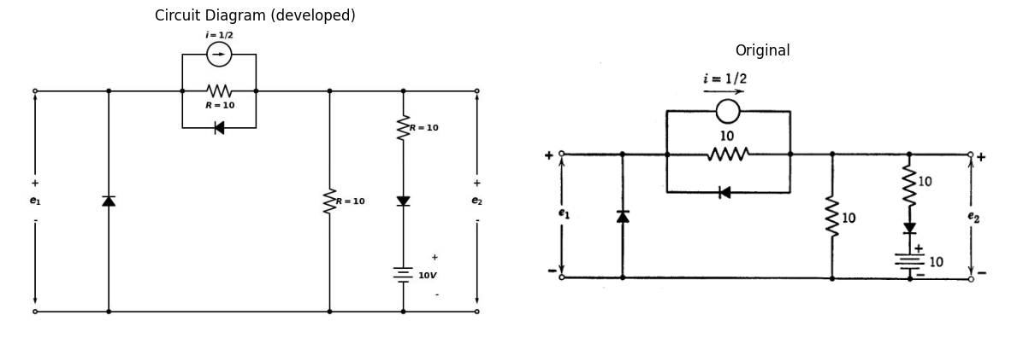
$3.28$. $\left(a\right)$ Find $i$ vs. $e$ for the circuit in Fig. P3.54. Give values of all slopes and break points. $\left(b\right)$ Assuming $V_{2}$| < |$V_{1}$| repeat $\left(a\right)$ with $V_{2}$ reversed.
import schemdraw
import schemdraw.elements as e
import schemdraw as schem
import matplotlib.pyplot as plt
import matplotlib.image as mpimg
import numpy as np
# Create the figure and subplots
fig, axs = plt.subplots(1, 2, figsize=(12, 12))
d = schemdraw.Drawing()
d += elm.Dot(open=True)
l1 = d.add(elm.Line().right().dot())
d += elm.lines.CurrentLabelInline().at(l1).right().label('$i$').color('black')
D1 = d.add(elm.Diode(fill=True).right().dot())
l2 = d.add(elm.Line().right())
R1 = d.add(elm.Resistor().down().label('$R_2$', ofst=-1))
D2 = d.add(elm.Diode(fill=True).down())
E1 = d.add(elm.Battery().down().label(['+', '$V_1$','-'], ofst=0.2))
l3 = d.add(elm.Line().left().dot())
l4 = d.add(elm.Line().left().dot())
l5 = d.add(elm.Line().left().dot(open=True))
l6 = d.add(elm.Line().up().at(l3.end))
R2 = d.add(elm.Resistor().up().label('$R_1$', ofst=-1))
l7 = d.add(elm.Line().up())
E2 = d.add(elm.Battery().up().at(l4.end).label(['+', '$V_2$','-'], ofst=0.2))
R3 = d.add(elm.Resistor().up().label('$R_3$', ofst=-1))
D3 = d.add(elm.Diode(fill=True).up())
d += elm.Gap().up().label([ '-','$ e$','+' ] ,fontsize = 16).color('black').at((0,-6))
d += elm.Arrow().length(3.3).at((0,-5.4)).color('black').down()
d += elm.Arrow().length(3.3).at((0,-3.4)).color('black').up()
d.save('./Drawings/fig54.jpg')
d.save('./Drawings/fig54.svg')
# Load the saved PNG file into the subplot
img = mpimg.imread('./Drawings/fig54.jpg')
axs[0].imshow(img)
axs[0].axis('off') # Hide axes for image display
axs[0].set_title('Circuit Diagram (developed)')
# **Subplot (1, 2): PNG Sample File**
img_sample = mpimg.imread('images-books/p54.png') # Load the PNG file
axs[1].imshow(img_sample)
axs[1].axis('off') # Hide axes for image display
axs[1].set_title('Original')
# Show the combined plots
plt.tight_layout()
plt.show()
d.save('./Drawings/fig54.png')
d.save('./Drawings/fig54.svg')
d.save('./Drawings/fig54.jpg')
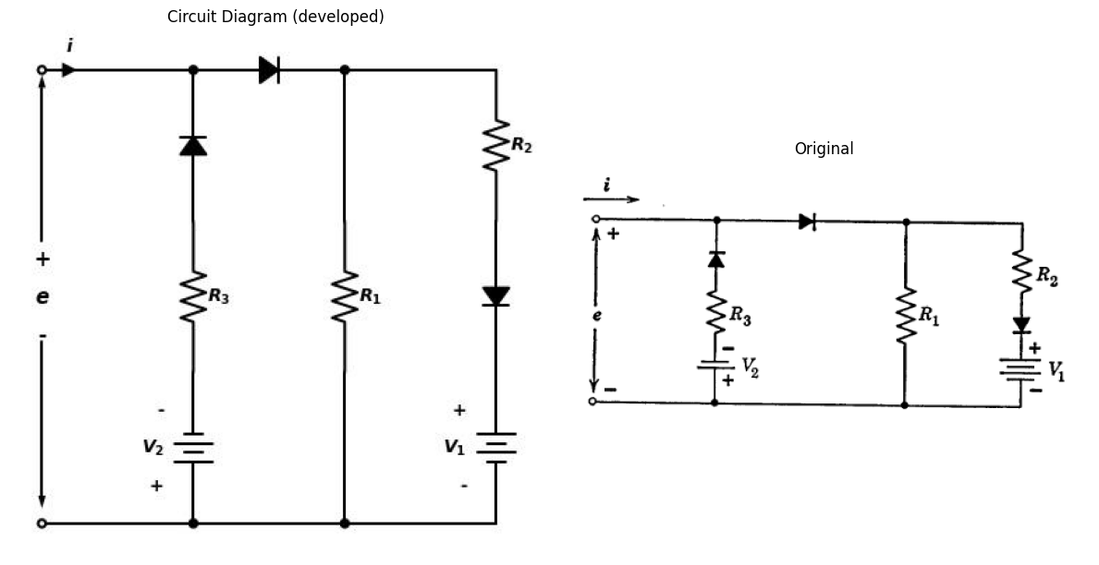
$3.29$. Both rectifiers in the circuit shown in Fig. P3.55 may be considered ideal. Find $i$ as a function of $v$, and sketch the result.
import schemdraw
import schemdraw.elements as e
import schemdraw as schem
import matplotlib.pyplot as plt
import matplotlib.image as mpimg
import numpy as np
# Create the figure and subplots
fig, axs = plt.subplots(1, 2, figsize=(12, 12))
d = schemdraw.Drawing()
d += e.Dot(open=True)
l1 = d.add(elm.Line().right().dot())
d += e.lines.CurrentLabelInline().at(l1).right().label('$i$').color('black')
D1 = d.add(e.Diode(fill=True).reverse().right().label(['-', '$V_1$','+'], ofst=-1, color='black'))
R1 = d.add(e.Resistor().right().label('$R_1$', ofst=-1).dot())
d += e.lines.CurrentLabelInline().at(R1).left().label('$i_1$').color('black')
l2 = d.add(e.Line().right())
D2 = d.add(e.Diode(fill=True).down().label(['+', '$V_2$','-'], ofst=-1, color='black').label('E=20\nR1=10KΩ\nR2=30kΩ\nR3=40kΩ ', ofst=-5))
d += e.lines.CurrentLabelInline().at(D2).down().label('$i_2$').color('black')
R2 = d.add(e.Resistor().down().label('$R_2$', ofst=-1))
l3 = d.add(e.Line().left().length(12).dot(open=True))
l4 = d.add(e.Line().up().length(1.5).at(l1.end))
E1 = d.add(e.Battery().right().reverse().label(['-', '$E$','+'], ofst=0.2))
R3 = d.add(e.Resistor().right().label('$R_3$', ofst=0.2))
l5 = d.add(e.Line().down().length(1.5))
d += e.Gap().up().label([ '-','$ v $','+' ] ,fontsize = 16).color('black').at((0,-4.6))
d += e.Arrow().length(1.9).at((0,-4)).color('black').down()
d += e.Arrow().length(1.9).at((0,-2)).color('black').up()
d.save('./Drawings/fig5115.jpg')
d.save('./Drawings/fig5115.svg')
# Load the saved PNG file into the subplot
img = mpimg.imread('./Drawings/fig5115.jpg')
axs[0].imshow(img)
axs[0].axis('off') # Hide axes for image display
axs[0].set_title('Circuit Diagram (developed)')
# **Subplot (1, 2): PNG Sample File**
img_sample = mpimg.imread('images-books/p55.png') # Load the PNG file
axs[1].imshow(img_sample)
axs[1].axis('off') # Hide axes for image display
axs[1].set_title('Original')
# Show the combined plots
plt.tight_layout()
plt.show()
d.save('./Drawings/fig515.png')
d.save('./Drawings/fig515.svg')
d.save('./Drawings/fig515.jpg')
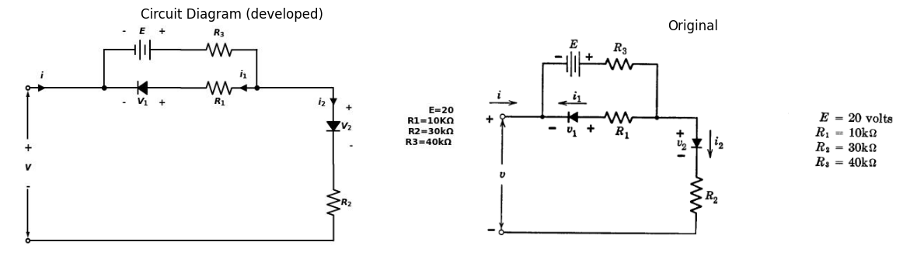
$3.30$. Sketch and dimension the current versus voltage curve of the circuit shown in Fig. P3.56.
import schemdraw
import schemdraw.elements as elm
import schemdraw as schem
import matplotlib.pyplot as plt
import matplotlib.image as mpimg
import numpy as np
# Create the figure and subplots
fig, axs = plt.subplots(1, 2, figsize=(12, 12))
d = schemdraw.Drawing()
d += elm.Dot(open=True)
D1 = d.add(elm.Diode(fill=True).right())
d += elm.lines.CurrentLabelInline().at(D1).right().label('$i$').color('black')
R1 = d.add(elm.Resistor().right().label('$R_1$', ofst=-1).dot())
l1 = d.add(elm.Line().right())
R2 = d.add(elm.Resistor().down().label('$R_2$', ofst=-1))
E1 = d.add(elm.Battery().down().reverse().label(['-', '$V$','+'], ofst=-1.1))
l2 = d.add(elm.Line().left().dot())
l3 = d.add(elm.Line().left().length(6).dot(open=True))
l4 = d.add(elm.Line().up().length(1.5).at(l2.end))
D2 = d.add(elm.Diode(fill=True).up())
l5 = d.add(elm.Line().up().length(1.5))
d += elm.Gap().up().label([ '-','$ v $','+' ] ,fontsize = 16).color('black').at((0,-4.6))
d += elm.Arrow().length(1.9).at((0,-4)).color('black').down()
d += elm.Arrow().length(1.9).at((0,-2)).color('black').up()
d.save('./Drawings/fig526.png')
d.save('./Drawings/fig526.svg')
# Load the saved PNG file into the subplot
img = mpimg.imread('./Drawings/fig526.png')
axs[0].imshow(img)
axs[0].axis('off') # Hide axes for image display
axs[0].set_title('Circuit Diagram (developed)')
# **Subplot (1, 2): PNG Sample File**
img_sample = mpimg.imread('images-books/p56.png') # Load the PNG file
axs[1].imshow(img_sample)
axs[1].axis('off') # Hide axes for image display
axs[1].set_title('Original')
# Show the combined plots
plt.tight_layout()
plt.show()
d.save('./Drawings/fig516.png')
d.save('./Drawings/fig516.svg')
d.save('./Drawings/fig516.jpg')
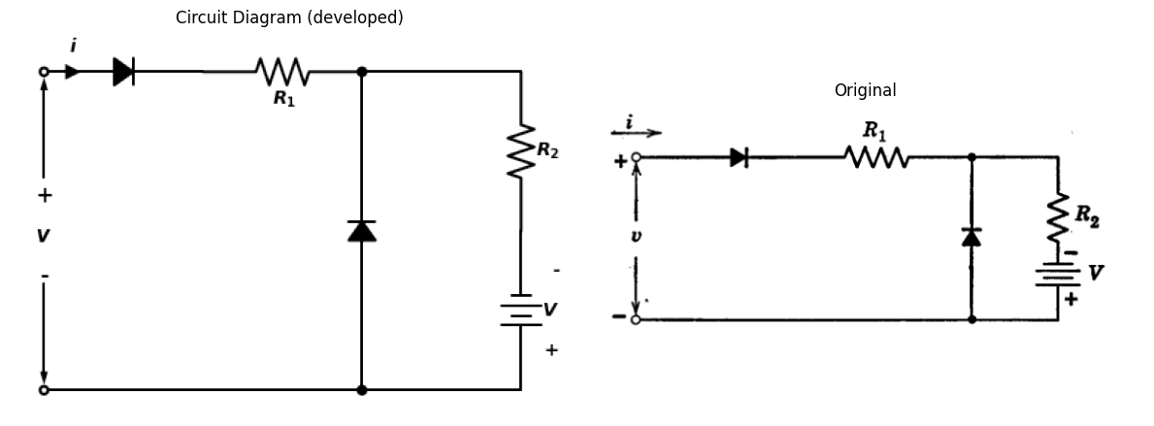
$3.31$. The general form of the current-voltage characteristics of semiconductor diodes may be represented by a variety of piecewise-linear curves. A number of such curves are shown with numerical values chosen for convenience (Figs. P3.57-P3.59). Draw the piecewise-linear circuits corre- sponding to each of the above characteristics. Give numerical values for all resistances, and for any voltage or current sources which may be used.
import matplotlib.pyplot as plt
import numpy as np
import schemdraw
import schemdraw.elements as elm
import matplotlib.image as mpimg
# Create the figure and subplots
fig, axs = plt.subplots(1, 2, figsize=(12, 12))
x = np.linspace(-11, 11, 400)
y = np.where(x < 0, (0.2) * x, x)
axs[0].plot(x, y, linewidth=1.5,color='black', label=' ')
#axs[0].title(' ')
#axs[0].xlim(-10,10)
#axs[0].ylim(-10,10)
axs[0].axhline(0, color='black', linewidth=1)
axs[0].axvline(0, color='black', linewidth=1)
axs[0].axis('on')
axs[0].text(-9,0.5,'-10')
axs[0].text(-1.6,-2.5,'-0.01')
axs[0].plot([0,-9], [-1.8,-1.8], linewidth=0.5,color='gray', linestyle='--',dashes=(10,3))
axs[0].plot([-9,-9], [0,-1.8], linewidth=0.5,color='gray', linestyle='--',dashes=(10,3))
axs[0].text(3,-.8,'1')
axs[0].text(-0.8,3,'1')
axs[0].plot([0,3], [3,3], linewidth=1,color='black', linestyle='--',dashes=(10,3))
axs[0].plot([3,3], [0,3], linewidth=1,color='black', linestyle='--',dashes=(10,3))
axs[0].set_title('Circuit Diagram (developed)')
img_sample = mpimg.imread('images-books/p57.png') # Load the PNG file
axs[1].imshow(img_sample)
axs[1].axis('off') # Hide axes for image display
axs[1].set_title('Original')
# Show the combined plots
plt.tight_layout()
plt.show()
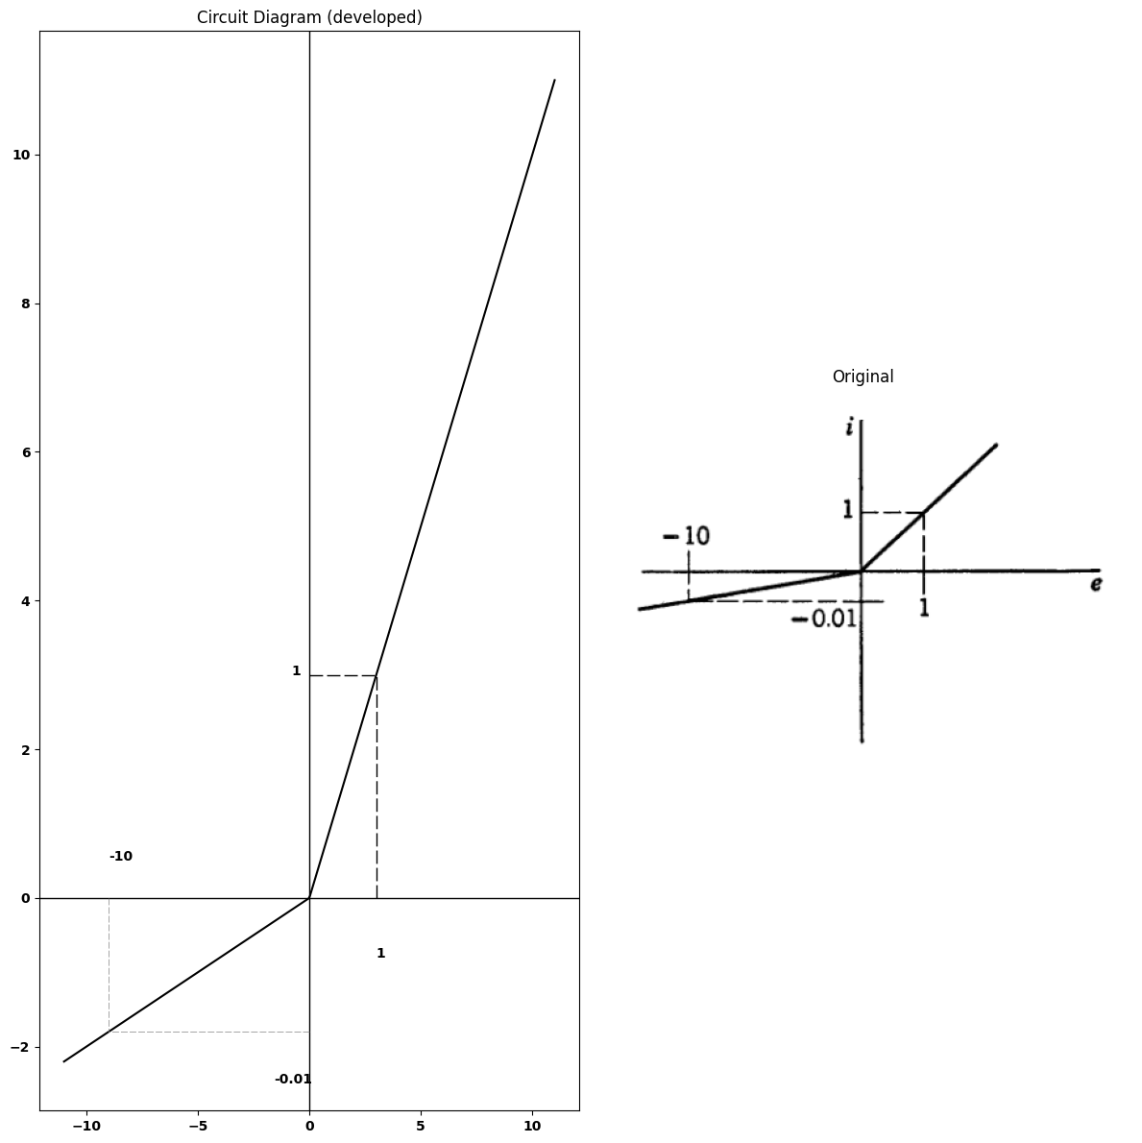
import matplotlib.pyplot as plt
import numpy as np
import schemdraw
import schemdraw.elements as elm
import matplotlib.image as mpimg
# Create the figure and subplots
fig, axs = plt.subplots(1, 2, figsize=(12, 12))
x = np.linspace(-11, 11, 400)
#y = np.where(x < 0, 0.001 * x, x)
y = np.where(x < -2, 10 * -0.2, x)
axs[0].plot(x, y, linewidth=1.5,color='black', label=' ')
#axs[0].title(' ')
axs[0].text(11,-.2,'e')
axs[0].text(-0.8,10,'i')
axs[0].axhline(0, color='black', linewidth=1)
axs[0].axvline(0, color='black', linewidth=1)
axs[0].axis('on')
axs[0].text(3,-.8,'1')
axs[0].text(-0.8,3,'1')
axs[0].plot([0,3], [3,3], linewidth=1,color='black', linestyle='--',dashes=(10,3))
axs[0].plot([3,3], [0,3], linewidth=1,color='black', linestyle='--',dashes=(10,3))
axs[0].text(-1.6,-2.5,'-0.01')
axs[0].plot([0.4,-0.4], [-1.8,-1.8], linewidth=0.5,color='black')
axs[0].set_title('Circuit Diagram (developed)')
img_sample = mpimg.imread('images-books/p58.png') # Load the PNG file
axs[1].imshow(img_sample)
axs[1].axis('off') # Hide axes for image display
axs[1].set_title('Original')
# Show the combined plots
plt.tight_layout()
plt.show()
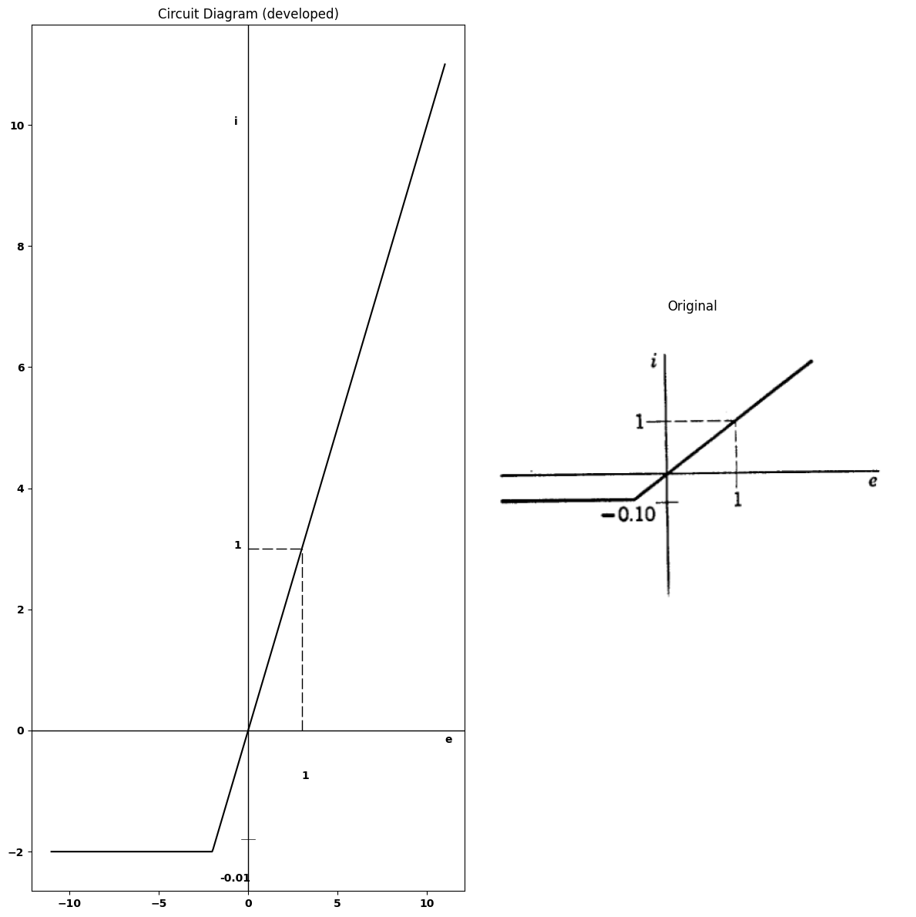
import matplotlib.pyplot as plt
import numpy as np
import schemdraw
import schemdraw.elements as elm
import matplotlib.image as mpimg
# Create the figure and subplots
fig, axs = plt.subplots(1, 2, figsize=(12, 12))
x = np.linspace(-11, 11, 400)
y = np.where(x < -9, -9, np.where(x < 0, 0, x))
axs[0].plot(x, y, linewidth=1.5,color='black', label=' ')
axs[0].axhline(0, color='black', linewidth=1)
axs[0].axvline(0, color='black', linewidth=1)
axs[0].axis('on')
axs[0].text(-9,0.5,'-10')
axs[0].text(3,-.8,'1')
axs[0].text(-0.8,3,'1')
axs[0].plot([0,3], [3,3], linewidth=1,color='black', linestyle='--',dashes=(10,3))
axs[0].plot([3,3], [0,3], linewidth=1,color='black', linestyle='--',dashes=(10,3))
axs[0].set_title('Circuit Diagram (developed)')
img_sample = mpimg.imread('images-books/p59.png') # Load the PNG file
axs[1].imshow(img_sample)
axs[1].axis('off') # Hide axes for image display
axs[1].set_title('Original')
# Show the combined plots
plt.tight_layout()
plt.show()
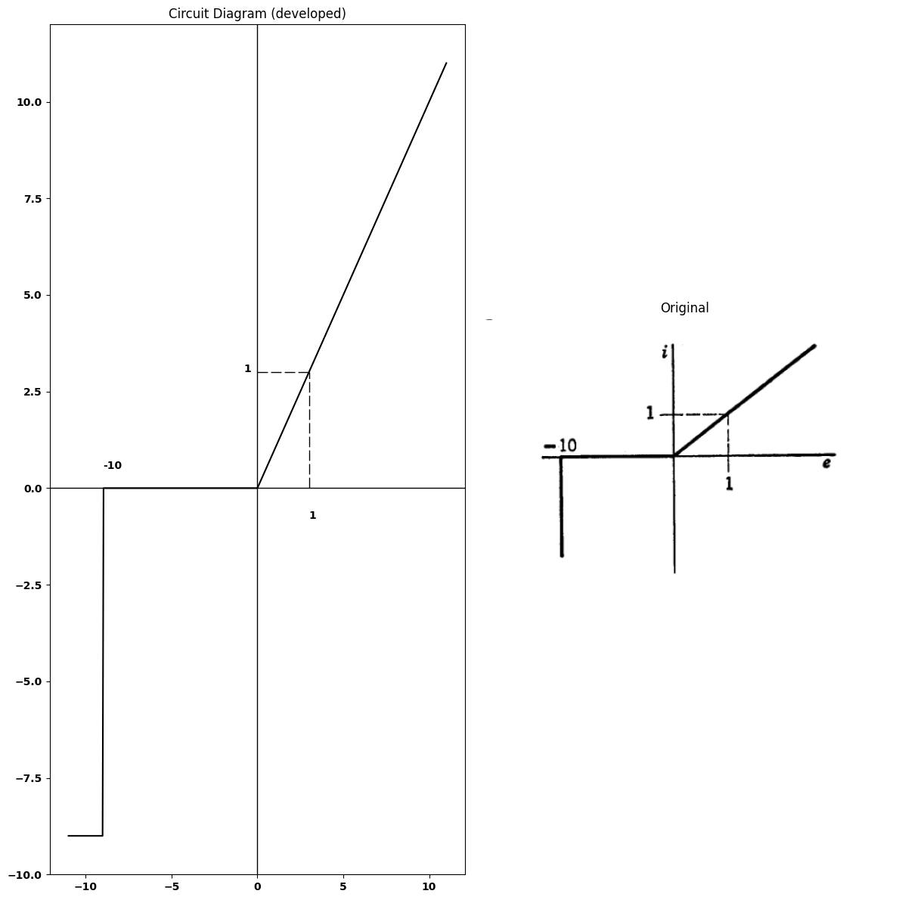
$3.32$. Determine the $e$ vs. $i$ characteristic of the circuit shown in Fig. P3.60.
import schemdraw
import schemdraw.elements as e
import schemdraw as schem
import matplotlib.pyplot as plt
import matplotlib.image as mpimg
import numpy as np
# Create the figure and subplots
fig, axs = plt.subplots(1, 2, figsize=(12, 12))
d = schemdraw.Drawing()
l1 = d.add(e.Line().down().length(5).dot(open=True))
D1 = d.add(e.Diode(fill=True).right().at(l1.start))
E1 = d.add(e.BatteryCell().right().label(['+', '$10$', '-'], ofst=.2).dot())
l2 = d.add(e.Line().down().length(2).dot())
I = d.add(e.SourceI().left().label('$8$').length(6).dot())
D2 = d.add(e.Diode(fill=True).right().at(l2.start).reverse())
E1 = d.add(e.BatteryCell().right().label(['+', '$6$', '-'], ofst=.2).dot().reverse())
l3 = d.add(e.Line().down().length(2).dot())
I2 = d.add(e.SourceI().left().label('$2$').length(6).dot().reverse())
l4 = d.add(e.Line().down().length(3).dot(open=True).at(I2.start))
d += e.Arrow().up().length(0.7).linewidth(0.6).color('black').label('i', loc='top', color='black',ofst=0.1). at((-.5,-4.5))
d += e.Arrow().up().length(4.5).linewidth(0.6).color('white').label('$e$', loc='start', color='black',ofst=0.3). at((6.5,-4.8))
d += e.Arrow().left().length(5).color('black').label('+',loc='end', color='black',ofst=-0.3). at((5,-5))
d += e.Arrow().right().length(5).linewidth(2).color('black').label(r'_', loc='end', color='black',ofst=(-0.5, 0.5)). at((7,-5))
d.move(2, 1)
l5 = d.add(e.Line().down().length(1).dot(open=True))
R1 = d.add(e.Resistor().up().length(1.5).label('$2$',ofst=-1).at(l5.start))
D3 = d.add(e.Diode(fill=True).up().at(R1.end).length(1.5))
E3 = d.add(e.BatteryCell().right().label(['+', '$1$', '-'], ofst=.2))
D4 = d.add(e.Diode(fill=True).right().at(E3.end).reverse())
R1 = d.add(e.Resistor().right().length(1.5).label('$2$',ofst=-1).at(D4.end))
l5 = d.add(e.Line().up().length(2).dot().at(D3.end))
E4 = d.add(e.BatteryCell().right().label(['+', '$1$', '-'], ofst=.2).reverse())
D5 = d.add(e.Diode(fill=True).right().at(E4.end))
R2 = d.add(e.Resistor().right().length(1.5).label('$2$',ofst=-1).at(D5.end))
l6 = d.add(e.Line().down().length(6).dot(open=True))
d += e.Arrow().up().length(0.7).linewidth(0.6).color('black').label('i', loc='top', color='black',ofst=0.1). at((13.5,-4.5))
d += e.Arrow().up().length(4.5).linewidth(0.6).color('white').label('$e$', loc='start', color='black',ofst=0.3). at((18.5,-4.8))
d += e.Arrow().left().length(3).color('black').label('+',loc='end', color='black',ofst=-0.3). at((17,-5))
d += e.Arrow().right().length(3).linewidth(2).color('black').label(r'_', loc='end', color='black',ofst=(-0.5, 0.5)). at((18.5,-5))
d.save('./Drawings/fig32.png')
d.save('./Drawings/fig32.svg')
# Load the saved PNG file into the subplot
img = mpimg.imread('./Drawings/fig32.png')
axs[0].imshow(img)
axs[0].axis('off') # Hide axes for image display
axs[0].set_title('Circuit Diagram (developed)')
# **Subplot (1, 2): PNG Sample File**
img_sample = mpimg.imread('images-books/p60.png') # Load the PNG file
axs[1].imshow(img_sample)
axs[1].axis('off') # Hide axes for image display
axs[1].set_title('Original')
# Show the combined plots
plt.tight_layout()
plt.show()
d.save('./Drawings/fig31.png')
d.save('./Drawings/fig31.svg')
d.save('./Drawings/fig31.jpg')
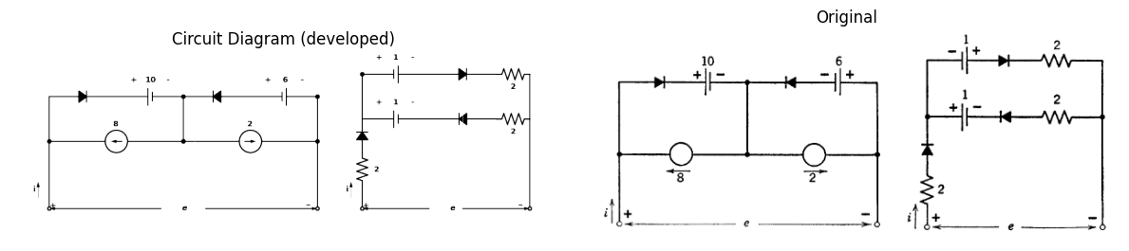
$3.33$. Determine the $e$ vs. $i$ characteristic of the circuit shown in Fig. P3.61.
$3.34$. Plot the $v$ vs. $i$ characteristic of the circuit shown in Fig.P3.62 (there are three break points).
$3.35$. The scheme of Fig. P3.63 is used in a function generator to obtain low frequency, low distortion sine waves. Design a four-diode, four-break point, piecewise-linear network which will give a reasonable approximation to a sine
import schemdraw
import schemdraw.elements as e
import schemdraw as schem
import matplotlib.pyplot as plt
import matplotlib.image as mpimg
import numpy as np
# Create the figure and subplots
fig, axs = plt.subplots(1, 2, figsize=(12, 12))
d = schemdraw.Drawing()
l1 = d.add(e.Line().left().length(5).dot(open=True))
D1 = d.add(e.Diode(fill=True).left().at((.1,-3)))
E1 = d.add(e.BatteryCell().right().at(D1.start).label(['+', '$E$', '-'], ofst=-1.1))
R1 = d.add(e.Resistor().right().endpoints(l1.start, D1.end).label('R',ofst=.1))
R2 = d.add(e.Resistor().right().endpoints(l1.start, E1.end).label('R',ofst=.1))
l2 = d.add(e.Line().left().length(5).dot(open=True).at((-0.1,-6)))
R3 = d.add(e.Resistor().right().endpoints(R1.end, l2.start).label('R',ofst=-1))
D2 = d.add(e.Diode(fill=True).right().endpoints(E1.end, l2.start))
#l2 = d.add(e.Line().left().length(5).dot(open=True).at((-0.1,-6)))
d += e.Arrow().right().length(0.7).linewidth(0.6).color('black').label('i', loc='top', color='black',ofst=0.1). at((-4.5,0.5))
d += e.Arrow().down().length(2.5).linewidth(2).color('black').label(r'_', loc='end', color='black',ofst=(-0.5, -0.3)). at((-5,-3.5))
d += e.Arrow().up().length(2.5).color('black').label('+',loc='end', color='black',ofst=0.4). at((-5,-2.5))
d += e.Arrow().up().length(4.5).linewidth(0.6).color('white').label('$V$', loc='start', color='black',ofst=0.3). at((-4.5,-3))
d.save('./Drawings/fig2666.png')
d.save('./Drawings/fig2666.svg')
# Load the saved PNG file into the subplot
img = mpimg.imread('./Drawings/fig2666.png')
axs[0].imshow(img)
axs[0].axis('off') # Hide axes for image display
axs[0].set_title('Circuit Diagram (developed)')
# **Subplot (1, 2): PNG Sample File**
img_sample = mpimg.imread('images-books/p3-62.png') # Load the PNG file
axs[1].imshow(img_sample)
axs[1].axis('off') # Hide axes for image display
axs[1].set_title('Original')
# Show the combined plots
plt.tight_layout()
plt.show()
d.save('./Drawings/fig41.png')
d.save('./Drawings/fig41.svg')
d.save('./Drawings/fig41.jpg')
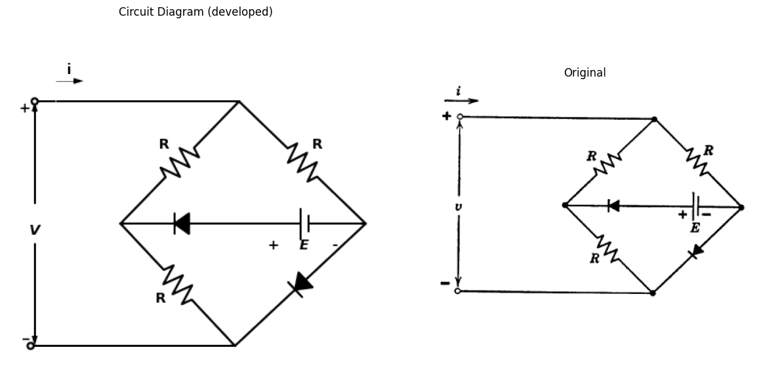
import schemdraw
import schemdraw.elements as e
from schemdraw import dsp
with schemdraw.Drawing() as d:
# Create the figure and subplots
fig, axs = plt.subplots(2, 2, figsize=(12, 12))
d = schemdraw.Drawing()
d += ( T := dsp.Box(w=4, h=4).anchor('W').fill('white').label('Nonlinear\n network'))
center_x, center_y = T.center
line_Right1 = d.add(e.Line().left().at((center_x-2, center_y + 1.65)).length(1).dot(open=True))
d += e.Arrow().right().at((-1.1, 2)).length(0.75).label('$i_1$').color('black')
line_Right2 = d.add(e.Line().left().at((center_x-2, center_y - 1.65)).length(1).dot(open=True))
d += e.Gap().up().label(['-' , '$V_1$' , '+'] , fontsize = 16).color('black')
line_Right1 = d.add(e.Line().left().at((center_x--3., center_y + 1.6)).length(1))
d += e.Arrow().up().length(0.7).at((-1, 1)).color('black')
d += e.Arrow().down().length(0.7).at((-1, -1)).color('black')
d += e.Arrow().up().length(0.7).at((5, 0.95)).color('black')
d += e.Arrow().down().length(0.7).at((5, -1)).color('black')
line_Right2 = d.add(e.Line().left().at((center_x--3, center_y - 1.65)).length(1))
d += e.Gap().up().label(['-' , '$V_2$' , '+'] , fontsize = 16). at((5,-1.5)).color('black')
d.save('images-books/circuit_diagram.png') # Save the drawing to a PNG file
#d.save('./Drawings/fig15.jpg')
#d.save('./Drawings/fig15.svg')
# Load the saved PNG file into the subplot
img = mpimg.imread('images-books/circuit_diagram.png')
axs[0, 0].imshow(img)
axs[0, 0].axis('off') # Hide axes for image display
axs[0, 0].set_title('Circuit Diagram (developed)')
# **Subplot (1, 2): PNG Sample File**
img_sample = mpimg.imread('images-books/p3-63.png') # Load the PNG file
axs[0, 1].imshow(img_sample)
axs[0, 1].axis('off') # Hide axes for image display
axs[0, 1].set_title('Original')
# **Subplot (2, 2): Second Matplotlib Chart (Cosine Wave)**
triangular_wave = 2 * np.abs(2 * (t * 2 - np.floor(t * 2 + 0.5))) - 1 # Sample data for cosine wave
axs[1, 1].plot(t, triangular_wave, label='Cosine Wave', color='black')
axs[1, 1].set_title('Vin')
axs[1, 1].set_xlabel('time')
axs[1, 1].set_ylabel('V(v)')
#axs[1, 1].grid(True)
axs[1, 1].legend()
# **Subplot (2, 1): First Matplotlib Chart (Sine Wave)**
x = np.linspace(0, 10, 100)
y_sin = np.sin(x) # Sample data for sine wave
axs[1, 0].plot(x, y_sin, label='Sine Wave', color='black')
axs[1, 0].set_title('Vout')
axs[1, 0].set_xlabel('time')
axs[1, 0].set_ylabel('V(v)')
axs[1, 0].axhline(0, color='black', linewidth=2)
axs[1, 0].axvline(0, color='black', linewidth=2)
#axs[1, 0].grid(True)
axs[1, 0].legend()
# Show the combined plots
plt.axhline(0, color='black', linewidth=2)
plt.axvline(0, color='black', linewidth=2)
plt.tight_layout()
plt.show()
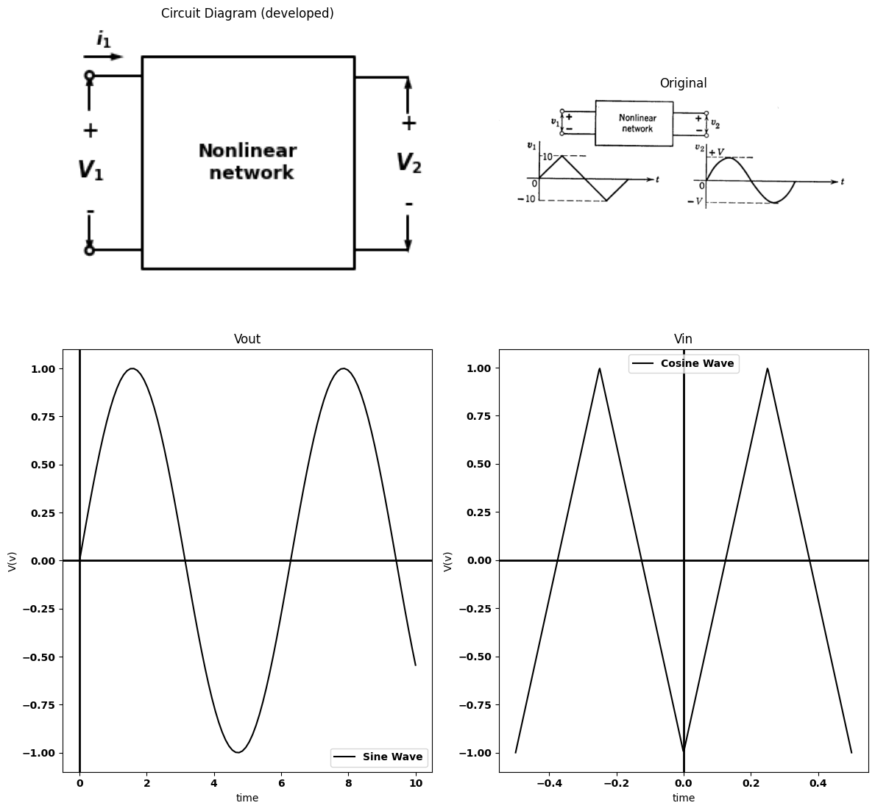
wave for $v_{2}$. $V$ should be on the order of 5 volts. The characteristic of the network should look somewhat like Fig. P3.64.
import matplotlib.pyplot as plt
import numpy as np
import schemdraw
import schemdraw.elements as elm
import matplotlib.image as mpimg
# Create the figure and subplots
fig, axs = plt.subplots(1, 2, figsize=(12, 12))
t = np.linspace(-0.5, 0.5, 500) # time
sine_wave = np.sin(2 * np.pi * 0.5 * t) # frequncy 5 hirtz
axs[0].plot(t, sine_wave , linewidth=2,color='black')
axs[0].axhline(0, color='black', linewidth=2)
axs[0].axvline(0, color='black', linewidth=2)
img_sample = mpimg.imread('images-books/p3-64.png') # Load the PNG file
axs[1].imshow(img_sample)
axs[1].axis('off') # Hide axes for image display
axs[1].set_title('Original')
# Show the combined plots
plt.tight_layout()
plt.show()
plt.tight_layout()
plt.show()
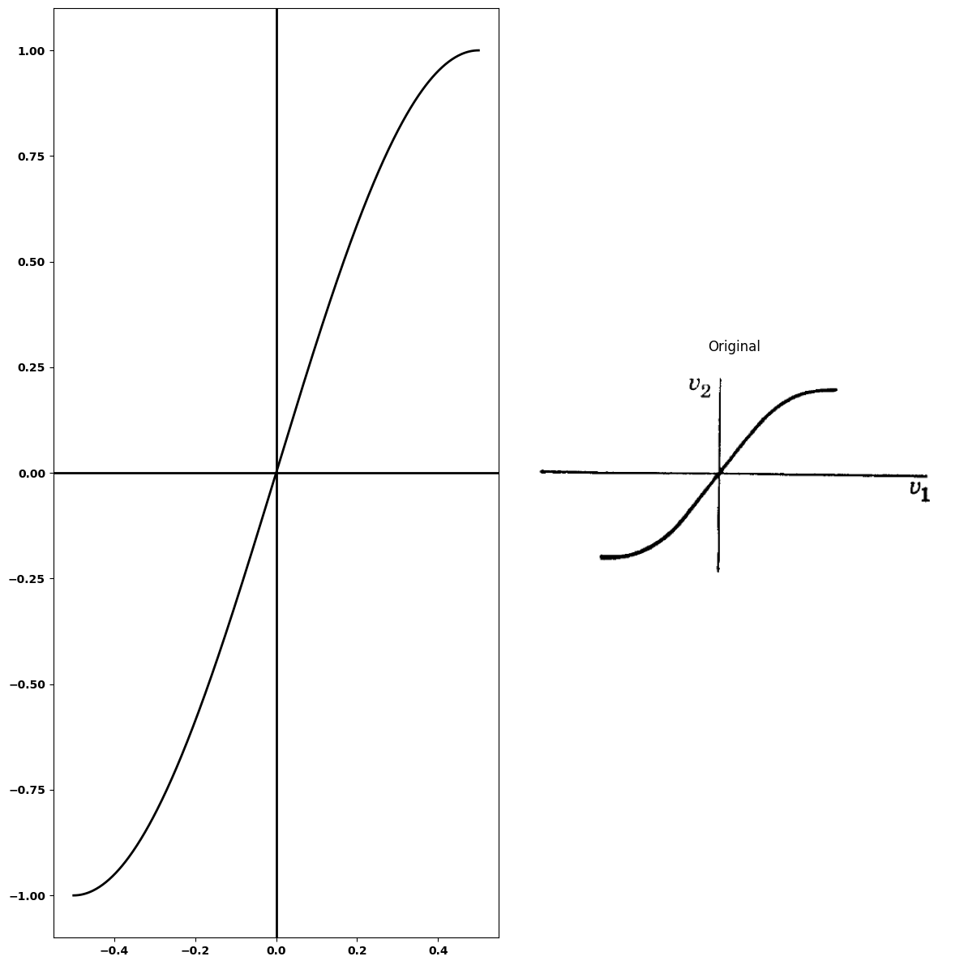
<Figure size 640x480 with 0 Axes>
$3.36$. Two nonlinear functions $y_{ı}=f_{1}\left(x_{1}\right)$ and $y_{2}=f_{2}\left(x_{2}\right)$ below:
x1 | 0 | 1 | 2 | 3 | 4 | 6 | 8 | 10
y1 | 0 | 2 | 3.5 | 4.5 | 5.25 | 6 | 6.25 | 6.5
x2 | 0 | 2 | 4 | 6 | 7 | 8 | 9
y2 | 1 | 2 | 3.5 | 5.5 | 8 | 10 | 11
Make a graphical simultaneous solution of these equations for the conditions that
$x_{1}$ = $y_{2}$ ; $x_1 $+ $x_{2}$ = 10
Find the values of $x_{1}$ and $x_{2}$.
$3.37$. If in Problem 3.36 $x_{1}$ and $x_{2}$ are currents in two circuit elements, $Y_{1}$ and $y_{2}$ are the voltages across them, and $f_{1}\left(x_{1}\right)$ and $f_{2}\left(x_{2}\right)$ are their volt- ampere characteristics, drawn an equivalent electric circuit. 3.38. If in Problem
$3.38$. If in Problem 3.36 $x_{1}$ and $x_{2}$ are the elongations of two springs, $y_{1}$ and $y_{2}$ are the spring forces, and $f_{1}\left(x_{1}\right)$ and $f2\left(x2\right)$ are the nonlinear force characteristics of the springs, draw an equivalent mechanical system.
$3.39$. A type of nonlinear resistor has a volt-ampere characteristic given approximately by $i=Kv^{4}$. For a certain resistor
$i$ = 1.0 amp for $v$ = 100 volts.
This resistor is to be used in a circuit where the operating range will be about 1.0±0.5 amp.
$\left(a\right)$ Find a linear incremental model at the 1.0±amp operating point.
$\left(b\right)$ Find the percent error in voltage across the resistor at the two extremes of the current range if the linear model of $\left(a\right)$ is used.
$\left(c\right)$ Find a linear model which would have zero error at the two extremes. Also find the corresponding per cent error at $i$ 1.00 amp.
$\left(d\right)$ The nonlinear resistor is now connected in series with a 100-ohm linear resistor and a 200-volt battery. Find the current.
$\left(e\right)$ A sinusoidal voltage $e$ = 25 sin wt is now applied in series with the cir- cuit of $\left(d\right)$. Use an incremental model to find the a-c component of current.
$3.40$. Plot $i$ vs. $v$ for the circuit shown in Fig. P3.65
import schemdraw
import schemdraw.elements as e
import schemdraw as schem
import matplotlib.pyplot as plt
import matplotlib.image as mpimg
import numpy as np
# Create the figure and subplots
#fig, axs = plt.subplots(1, 2, figsize=(12, 12))
d = schemdraw.Drawing()
fig, axs = plt.subplots(1, 2, figsize=(12, 12))
l1 = d.add(e.Line().left().length(3).dot(open=True))
D1 = d.add(e.Diode(fill=True).down().at(l1.start))
D2 = d.add(e.Diode(fill=True).down().reverse())
l2 = d.add(e.Line().left().length(3).dot(open=True))
l3 = d.add(e.Line().right().length(6).at(D1.start))
E1 = d.add(e.Battery().right().at(D2.start).label(['+', '$V$', '-'], ofst=.1))
R1 = d.add(e.Resistor().right().label('$R_1$',ofst=-1))
D3 = d.add(e.Diode(fill=True).up())
D4 = d.add(e.Diode(fill=True).down().at(D3.start))
l4 = d.add(e.Line().left().length(6).label('$fig.p3.65 $', ofst=-1))
d += e.Arrow().right().length(0.7).linewidth(0.6).color('black').label('i', loc='top', color='black',ofst=0.1). at((-2.3,.5))
d += e.Arrow().up().length(4.5).linewidth(0.6).color('white').label('$v$', loc='start', color='black',ofst=0.3). at((-2.5,-3))
d += e.Arrow().up().length(2).color('black').label('+',loc='end', color='black',ofst=-0.2). at((-3,-2))
d += e.Arrow().down().length(2).linewidth(2).color('black').label(r'_', loc='end', color='black',ofst=(-0.5, 0.3)). at((-3,-4))
d.move(13, 6)
l5 = d.add(e.Line().left().length(1.5).dot(open=True))
D5 = d.add(e.Diode(fill=True).down().reverse().at(l5.start))
l6 = d.add(e.Line().left().length(1.5).dot(open=True))
l7 = d.add(e.Line().right().length(1.5).at(D5.end))
l8 = d.add(e.Line().right().length(1.5).at(D5.start))
R2 = d.add(e.Resistor().down().label('$R_1$',ofst=-1))
D6 = d.add(e.Diode(fill=True).right().at(R2.start))
R3 = d.add(e.Resistor().down().label('$R_2$',ofst=-1))
l8 = d.add(e.Line().left().length(3).at(R3.end).label('$fig.p3.66 $', ofst=-2))
l9 = d.add(e.Line().right().length(2).at(R3.end))
l10 = d.add(e.Line().right().length(2).at(R3.start))
I = d.add(e.SourceI().up().label('$I_1$').at(l9.end))
d += e.Arrow().right().length(0.7).linewidth(0.6).color('black').label('i', loc='top', color='black',ofst=0.1). at((8.6,.5))
d += e.Arrow().up().length(1).color('black').label('+',loc='end', color='black',ofst=-0.2). at((8.5,-1))
d += e.Arrow().down().length(1).linewidth(2).color('black').label(r'_', loc='end', color='black',ofst=(-0.5, 0.3)). at((8.5,-2))
d += e.Arrow().up().length(4.5).linewidth(0.6).color('white').label('$e$', loc='start', color='black',ofst=0.3). at((8.9,-1.5))
d.save('./Drawings/fig222-3.png')
d.save('./Drawings/fig222-3.svg')
# Load the saved PNG file into the subplot
img = mpimg.imread('./Drawings/fig222-3.png')
axs[0].imshow(img)
axs[0].axis('off') # Hide axes for image display
axs[0].set_title('Circuit Diagram (developed)')
# **Subplot (1, 2): PNG Sample File**
img_sample = mpimg.imread('images-books/65.png') # Load the PNG file
axs[1].imshow(img_sample)
axs[1].axis('off') # Hide axes for image display
axs[1].set_title('Original')
# Show the combined plots
plt.tight_layout()
plt.show()
d.save('./Drawings/fig133.png')
d.save('./Drawings/fig133.svg')
d.save('./Drawings/fig133.jpg')
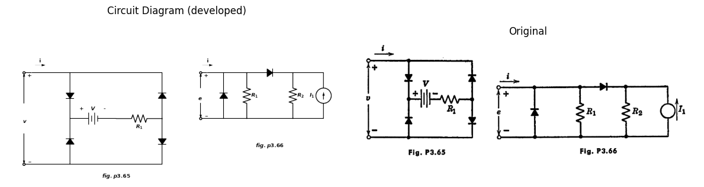
$3.41$. Find the $i$ vs. $e$ curve for the circuit shown in Fig. P3.66.
$\left(a\right)$ by assumed state method;
$\left(b\right)$ by break-point method.
$3.42$. It is desired to construct a diode limiter circuit which clips any input waveform in such a way that the magnitude of the voltage of the output waveform never exceeds ±2 volts. The idealized transfer curve for this device is shown in Fig. P3.67.
Synthesize this curve using ideal diodes and linear elements. What modification of the transfer curve would result if vacuum diodes were used in place of the ideal diodes?
$3.43$. Devise one or more circuit models to represent the piecewise-linear driving-point curves shown in Figs. P3.68-P3.73. Use ideal rectifiers, resistances, batteries, and (if necessary) current sources.
import matplotlib.pyplot as plt
from matplotlib import rcParams
import PySpice.Logging.Logging as Logging
logger = Logging.setup_logging()
from PySpice.Probe.Plot import plot
from PySpice.Spice.Netlist import Circuit
from PySpice.Unit import *
fig, axs = plt.subplots(1, 2, figsize=(10, 10))
circuit = Circuit('Transitional characteristic1')
circuit.model('BAV21','D' ,IS = .1@u_mA ,BV = 293.10@u_V, IBV = 0.001293@u_A , RS = 1@u_Ohm )
Vi = circuit.V('i', '1', circuit.gnd, 0@u_V)
circuit.R(1, '1', '2', 1@u_kOhm)
circuit.R(2, '3', '4', 10@u_Ohm)
circuit.D(1, '2','3', model = 'BAV21')
circuit.V(1, '4', circuit.gnd, 2@u_V)
circuit.D(2, '5', '2', model = 'BAV21')
circuit.V(2, circuit.gnd, '6', 2@u_V)
circuit.R(3, '5', '6', 10@u_Ohm)
simulator = circuit.simulator(temperature=25, nominal_temperature=25)
analysis = simulator.dc(Vi=slice(-5, 5, .1))
axs[0].plot(analysis['1'], analysis['2'],'black',linewidth=5)
axs[0].axhline(0, color='black', linewidth=1)
axs[0].axvline(0, color='black', linewidth=1)
axs[0].plot([0, 2], [2, 2], color='black', linestyle='--', label='Membership = 1')
axs[0].plot([-2, 0], [-2,-2], color='black', linestyle='--', label='Membership = 1')
axs[0].plot([2, 2], [0, 2], color='black', linestyle='--', label='Membership = 1')
axs[0].plot([-2, -2], [-2, 0], color='black', linestyle='--', label='Membership = 1')
axs[0].text(2, -0.2, '2', ha='center', va='center')
axs[0].text(-0.1, 2, '2', ha='center', va='center')
axs[0].text(0.1, -2, '-2', ha='center', va='center')
axs[0].text(-2, 0.1, '-2', ha='center', va='center')
axs[0].text(-0.2, 2.3, 'e2', ha='center', va='center')
axs[0].text(5.4, -0.06, 'e1', ha='center', va='center')
#plt.tight_layout()
#plt.show()
#d.save('./Drawings/fig1.jpg')
#d.save('./Drawings/fig1.svg')
img_sample = mpimg.imread('images-books/p3-67.png') # Load the PNG file
axs[1].imshow(img_sample)
axs[1].axis('off') # Hide axes for image display
axs[1].set_title('Original')
Text(0.5, 1.0, 'Original')
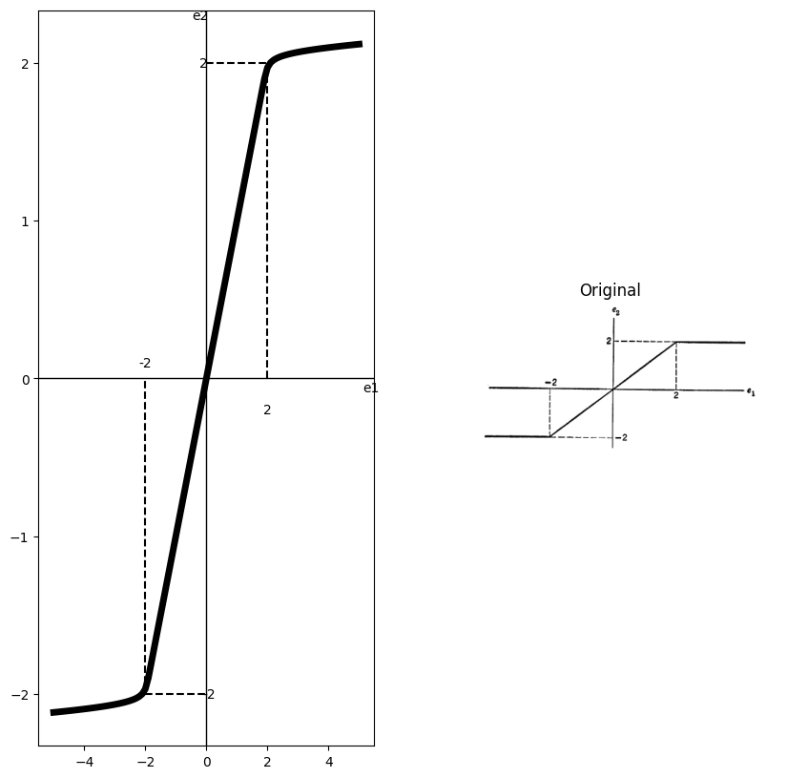
import matplotlib.pyplot as plt
from matplotlib import rcParams
import PySpice.Logging.Logging as Logging
logger = Logging.setup_logging()
from PySpice.Probe.Plot import plot
from PySpice.Spice.Netlist import Circuit
from PySpice.Unit import *
rcParams['font.weight'] = 'bold'
fig, axs = plt.subplots(1, 2, figsize=(10, 10))
circuit = Circuit('t3')
circuit.model('BAV21','D' ,IS = 40@u_nA , N = 1.906 ,BV = 110@u_V, IBV = 0.0001@u_V, VJ = 0.7@u_V ,CJO = 7.048E-13 ,RS = 0.001@u_Ohm ,TT = 3.48E-9)
Vth1 = circuit.V('th1', '1', circuit.gnd, 0@u_V)
circuit.D(1, '1','2' , model = 'BAV21')
circuit.R(1, '2','3' , 0.4@u_Ohm)
circuit.D(2, circuit.gnd,'3' , model = 'BAV21')
circuit.V(1, circuit.gnd ,'4' ,50@u_V)
circuit.R(2, '3','4', 1@u_Ohm)
simulator = circuit.simulator(temperature=25, nominal_temperature=25)
analysis = simulator.dc(Vth1=slice(-150, 150, 0.1))
axs[0].plot(analysis['1'],u_A(-analysis.Vth1),'black', linewidth=3)
axs[0].set_title('V-I Curve for D')
axs[0].set_xlim(-80, 120)
axs[0].set_xlabel('I [A]')
axs[0].set_ylabel('V [v]')
axs[0].plot([22,22], [50,0], color='black', linestyle='--', label='Membership = 1')
axs[0].plot([75, 75], [80,0], color='black', linestyle='--', label='Membership = 1')
axs[0].plot([18,0], [50,50], color='black', linestyle='--', label='Membership = 1')
axs[0].plot([75,0], [80,80], color='black', linestyle='--', label='Membership = 1')
axs[0].text(20, -5, '$I_1$', ha='center', va='center')
axs[0].text(75, -5, '$I_2$', ha='center', va='center')
axs[0].text(-5, 50, '$V_1$', ha='center', va='center')
axs[0].text(-5, 90, '$V_2$', ha='center', va='center')
axs[0].set_ylim(-60, 120)
axs[0].axhline(0, color='black', linewidth=1)
axs[0].axvline(0, color='black', linewidth=1)
axs[0].text(0, -95, 'Fig. P3.68', ha='center', va='center', fontsize=12)
#figure.savefig('./Drawings/fig25-2.png')
#figure.savefig('./Drawings/fig25-2.svg')
# **Subplot (1, 2): PNG Sample File**
img_sample = mpimg.imread('images-books/p3-68.png') # Load the PNG file
axs[1].imshow(img_sample)
axs[1].axis('off') # Hide axes for image display
axs[1].set_title('Original')
# Show the combined plots
#d.save('./Drawings/fig12-1.png')
#d.save('./Drawings/fig12-1.svg')
plt.tight_layout()
plt.show()
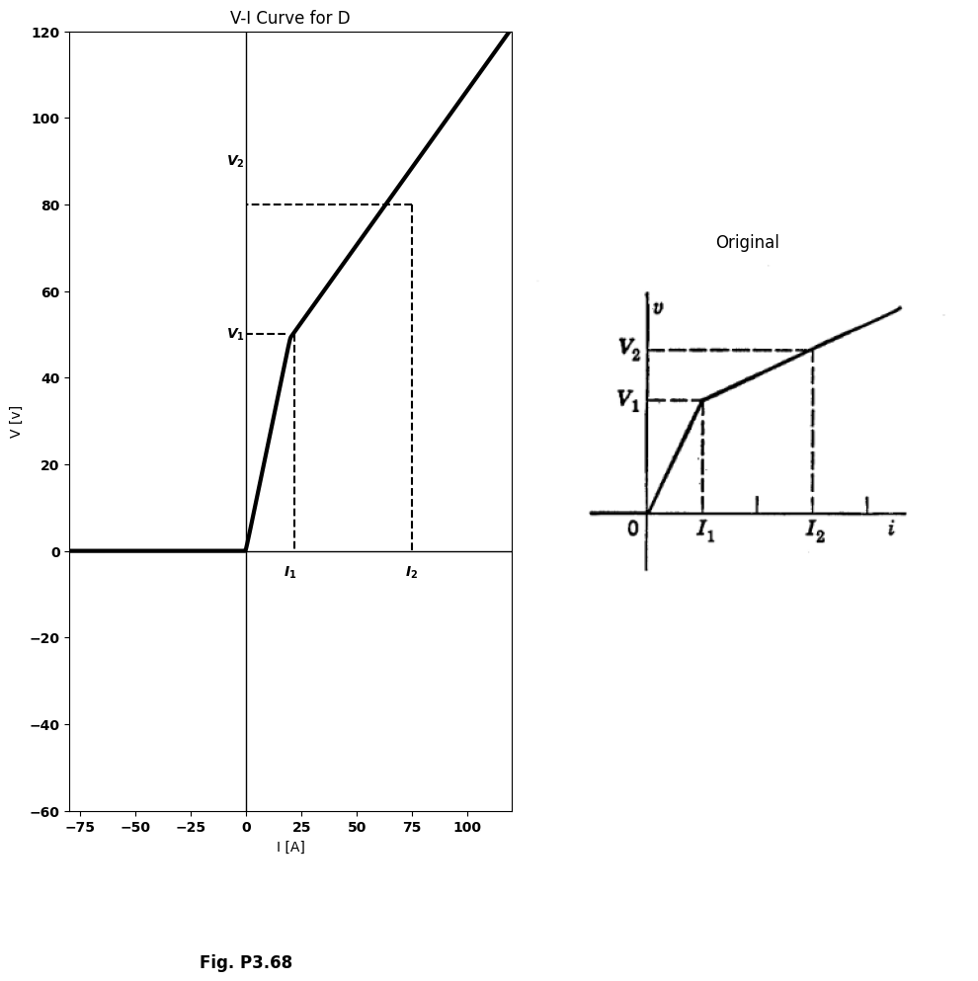
import matplotlib.pyplot as plt
from matplotlib import rcParams
import PySpice.Logging.Logging as Logging
logger = Logging.setup_logging()
from PySpice.Probe.Plot import plot
from PySpice.Spice.Netlist import Circuit
from PySpice.Unit import *
rcParams['font.weight'] = 'bold'
fig, axs = plt.subplots(1, 2, figsize=(10, 10))
circuit = Circuit('Diode')
circuit.model('BAV21','D' ,IS = 4@u_nA , N = 1.906 ,BV = 110@u_V, IBV = 0.0001@u_V, VJ = 0.7@u_V ,CJO = 7.048E-13 ,RS = 0.01@u_Ohm ,TT = 3.48E-9)
Vth = circuit.V('th', '1', circuit.gnd, 0@u_V)
circuit.D(1, '1' ,'2', model = 'BAV21')
circuit.V(1, '3',circuit.gnd , 0@u_V)
circuit.R(1, '2','3' , 1200@u_Ohm)
circuit.D(2, '1' ,'4', model = 'BAV21')
circuit.V(2, '5',circuit.gnd , 50@u_V)
circuit.R(2, '4','5' , 1000@u_Ohm)
simulator = circuit.simulator(temperature=25, nominal_temperature=25)
analysis = simulator.dc(Vth=slice(-100, 100, 0.1))
axs[0].plot(analysis['1'],u_mA(-analysis.Vth), 'black', linewidth=2)
axs[0].set_title('V-I Curve for D')
axs[0].set_xlim(-60, 100)
axs[0].set_xlabel('I [I]')
axs[0].set_ylabel('V [v]')
axs[0].set_ylim(-60, 100)
axs[0].axhline(0, color='black', linewidth=1)
axs[0].axvline(0, color='black', linewidth=1)
axs[0].plot([50,50], [40,0], color='black', linestyle='--', label='Membership = 1')
axs[0].plot([75,75], [84,0], color='black', linestyle='--', label='Membership = 1')
axs[0].plot([0,50], [40,40], color='black', linestyle='--', label='Membership = 1')
axs[0].plot([0,75], [83,83], color='black', linestyle='--', label='Membership = 1')
axs[0].text(50, -5, '$I_1$', ha='center', va='center')
axs[0].text(75, -5, '$I_2$', ha='center', va='center')
axs[0].text(-5, 40, '$V_1$', ha='center', va='center')
axs[0].text(-5, 85, '$V_2$', ha='center', va='center')
axs[0].text(10, -90, 'Fig. P3.69', ha='center', va='center', fontsize=12)
figure.savefig('./Drawings/fig24-1.jpg')
figure.savefig('./Drawings/fig24-1.svg')
# **Subplot (1, 2): PNG Sample File**
img_sample = mpimg.imread('images-books/p3-69.png') # Load the PNG file
axs[1].imshow(img_sample)
axs[1].axis('off') # Hide axes for image display
axs[1].set_title('Original')
# Show the combined plots
plt.tight_layout()
plt.show()
d.save('./Drawings/fig11-1.png')
d.save('./Drawings/fig11-1.svg')
plt.tight_layout()
plt.show()
plt.tight_layout()
plt.show()
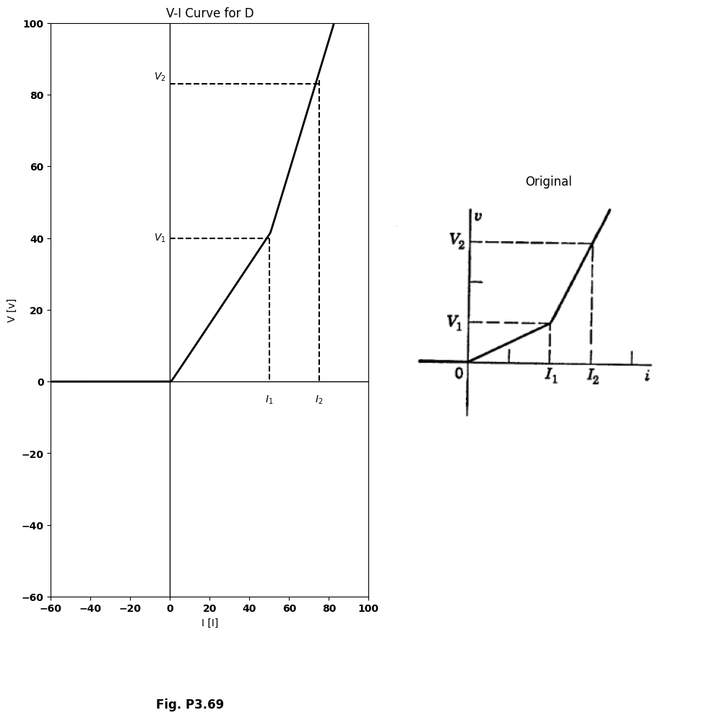
<Figure size 640x480 with 0 Axes>
<Figure size 640x480 with 0 Axes>
import matplotlib.pyplot as plt
from matplotlib import rcParams
import PySpice.Logging.Logging as Logging
logger = Logging.setup_logging()
from PySpice.Probe.Plot import plot
from PySpice.Spice.Netlist import Circuit
from PySpice.Unit import *
rcParams['font.weight'] = 'bold'
fig, axs = plt.subplots(1, 2, figsize=(10, 10))
circuit = Circuit('Diode')
circuit.model('BAV21','D' ,IS = 4@u_nA , N = 1.906 ,BV = 110@u_V, IBV = 0.0001@u_V, VJ = 0.7@u_V ,CJO = 7.048E-13 ,RS = 0.01@u_Ohm ,TT = 3.48E-9)
Vth = circuit.V('th', '1', circuit.gnd, 0@u_V)
circuit.D(1, '1','2' , model = 'BAV21')
circuit.V(1, '3',circuit.gnd , 45@u_V)
circuit.R(1, '2','3' , 1@u_kOhm)
simulator = circuit.simulator(temperature=25, nominal_temperature=25)
analysis = simulator.dc(Vth=slice(-40, 100, 0.1))
axs[0].plot(analysis['1'],u_mA(-analysis.Vth), 'black', linewidth=2)
# circuit4
circuit = Circuit('v-i curve')
circuit.model('BAV21','D' ,IS = 1000@u_nA , N = 1.906 ,BV = 110@u_V, IBV = 0.0001@u_V, VJ = 0.7@u_V ,CJO = 7.048E-13 ,RS = 0.01@u_kOhm ,TT = 3.48E-9)
Vth = circuit.V('th', '1', circuit.gnd, 0@u_V)
circuit.D(1, '2','1' , model = 'BAV21')
circuit.V(1,circuit.gnd ,'3', 45@u_V)
circuit.R(1, '2','3' , 1@u_kOhm)
simulator = circuit.simulator(temperature=25, nominal_temperature=25)
analysis = simulator.dc(Vth=slice(-100, 40, 0.1))
axs[0].plot(analysis['1'],u_mA(-analysis.Vth), 'black', linewidth=2)
axs[0].set_title('V-I Curve for D')
axs[0].set_xlim(-100, 120)
axs[0].set_xlabel('I [I]')
axs[0].set_ylabel('V [v]')
axs[0].set_ylim(-100, 100)
axs[0].axhline(0, color='black', linewidth=1)
axs[0].axvline(0, color='black', linewidth=1)
axs[0].annotate('+I', xy=(45, 0), xytext=(0, 8),
textcoords='offset points', ha='center', color='black', fontsize=12, fontweight='medium')
axs[0].annotate('-I', xy=(-45, 0), xytext=(0, 8),
textcoords='offset points', ha='center', color='black', fontsize=12, fontweight='medium')
axs[0].text(100, 15, 'Slope:R', ha='center', va='center')
axs[0].text(-50, -25, 'Slope:R', ha='center', va='center')
axs[0].annotate('', xy=(70,25), xytext=(80,15 ), arrowprops=dict(arrowstyle='->'))
axs[0].annotate('', xy=(-60,-10), xytext=(-38,-23), arrowprops=dict(arrowstyle='->'))
#ax.text(00, -135, 'Fig. P3.70', ha='center', va='center', fontsize=12)
figure.savefig('./Drawings/fig23-1.jpg')
figure.savefig('./Drawings/fig23-1.svg')
# **Subplot (1, 2): PNG Sample File**
img_sample = mpimg.imread('images-books/p3-70.png') # Load the PNG file
axs[1].imshow(img_sample)
axs[1].axis('off') # Hide axes for image display
axs[1].set_title('Original')
# Show the combined plots
plt.tight_layout()
plt.show()
d.save('./Drawings/fig10-1.png')
d.save('./Drawings/fig10-1.svg')
plt.tight_layout()
plt.show()
plt.tight_layout()
plt.show()
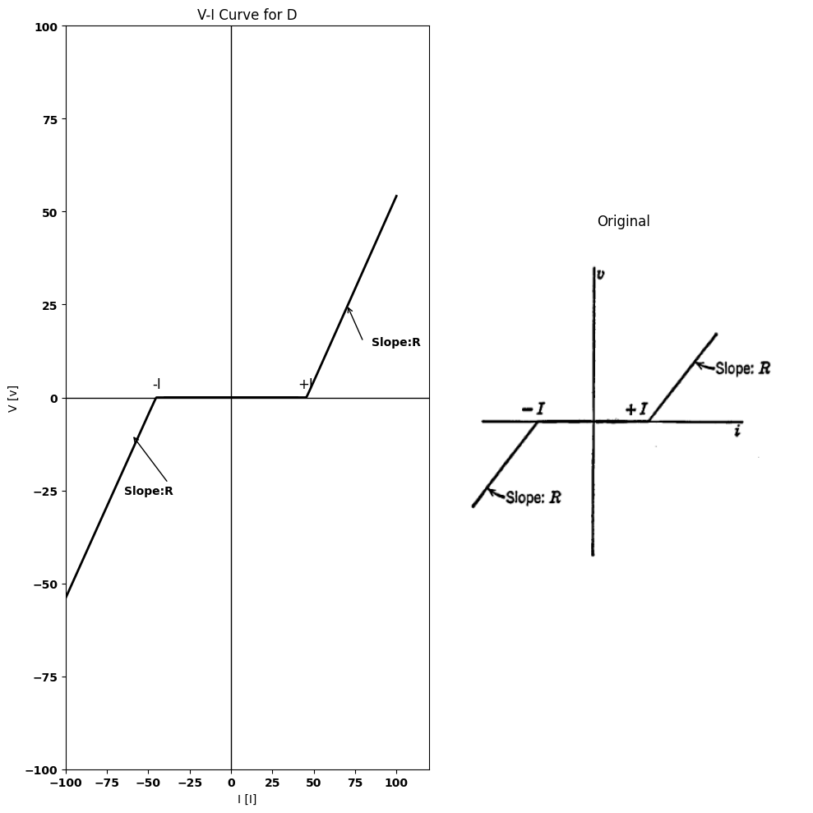
<Figure size 640x480 with 0 Axes>
<Figure size 640x480 with 0 Axes>
import matplotlib.pyplot as plt
from matplotlib import rcParams
import PySpice.Logging.Logging as Logging
logger = Logging.setup_logging()
from PySpice.Probe.Plot import plot
from PySpice.Spice.Netlist import Circuit
from PySpice.Unit import *
rcParams['font.weight'] = 'bold'
fig, axs = plt.subplots(1, 2, figsize=(10, 10))
circuit = Circuit('v-i curve')
circuit.model('BAV21','D' ,IS = 1000@u_nA , N = 1.906 ,BV = 110@u_V, IBV = 0.0001@u_V, VJ = 0.7@u_V ,CJO = 7.048E-13 ,RS = 0.0001@u_kOhm ,TT = 3.48E-9)
Vth = circuit.V('th', '1', circuit.gnd, 0@u_V)
circuit.D(1, '1',circuit.gnd , model = 'BAV21')
circuit.I(1,circuit.gnd ,'1', 40@u_mA)
circuit.R(1, '1',circuit.gnd , 1@u_kOhm)
simulator = circuit.simulator(temperature=25, nominal_temperature=25)
analysis = simulator.dc(Vth=slice(-100, 0.1, 0.1))
axs[0].plot(analysis['1'],u_mA(-analysis.Vth), 'black', linewidth=2)
# circuit4
circuit = Circuit('v-i curve')
circuit.model('BAV21','D' ,IS = 30@u_mA , N = 1.906 ,BV = 110@u_V, IBV = 0.0001@u_V, VJ = 0.7@u_V ,CJO = 7.048E-13 ,RS = 0.0001@u_kOhm ,TT = 3.48E-9)
Vth = circuit.V('th', '1', circuit.gnd, 0@u_V)
circuit.D(1, circuit.gnd ,'1', model = 'BAV21')
circuit.I(1,'1',circuit.gnd , 10@u_mA)
circuit.R(1, '1',circuit.gnd , 1@u_kOhm)
simulator = circuit.simulator(temperature=25, nominal_temperature=25)
analysis = simulator.dc(Vth=slice(-.0545, 100, 0.1))
axs[0].plot(analysis['1'],u_mA(-analysis.Vth), 'black', linewidth=2)
axs[0].set_title('V-I Curve for D')
axs[0].set_xlim(-100, 120)
axs[0].set_xlabel('I [I]')
axs[0].set_ylabel('V [v]')
axs[0].set_ylim(-100, 100)
axs[0].axhline(0, color='black', linewidth=1)
axs[0].axvline(0, color='black', linewidth=1)
axs[0].annotate('+V', xy=(0, 40), xytext=(-10, 8),
textcoords='offset points', ha='center', color='black', fontsize=12, fontweight='medium')
axs[0].annotate('-V', xy=(0, -40), xytext=(8, -10),
textcoords='offset points', ha='center', color='black', fontsize=12, fontweight='medium')
axs[0].text(75, 70, 'Slope:R', ha='center', va='center')
axs[0].text(-50, -50, 'Slope:R', ha='center', va='center')
axs[0].annotate('', xy=(50,85), xytext=(80,75 ), arrowprops=dict(arrowstyle='->'))
axs[0].annotate('', xy=(-23,-65), xytext=(-50,-55), arrowprops=dict(arrowstyle='->'))
#axs[0].text(0, -135, 'Fig. P3.71', ha='center', va='center', fontsize=12)
figure.savefig('./Drawings/fig22-1.jpg')
figure.savefig('./Drawings/fig22-1.svg')
# **Subplot (1, 2): PNG Sample File**
img_sample = mpimg.imread('images-books/p3-71.png') # Load the PNG file
axs[1].imshow(img_sample)
axs[1].axis('off') # Hide axes for image display
axs[1].set_title('Original')
# Show the combined plots
plt.tight_layout()
plt.show()
d.save('./Drawings/fig9-1.png')
d.save('./Drawings/fig9-1.svg')
plt.tight_layout()
plt.show()
plt.tight_layout()
plt.show()
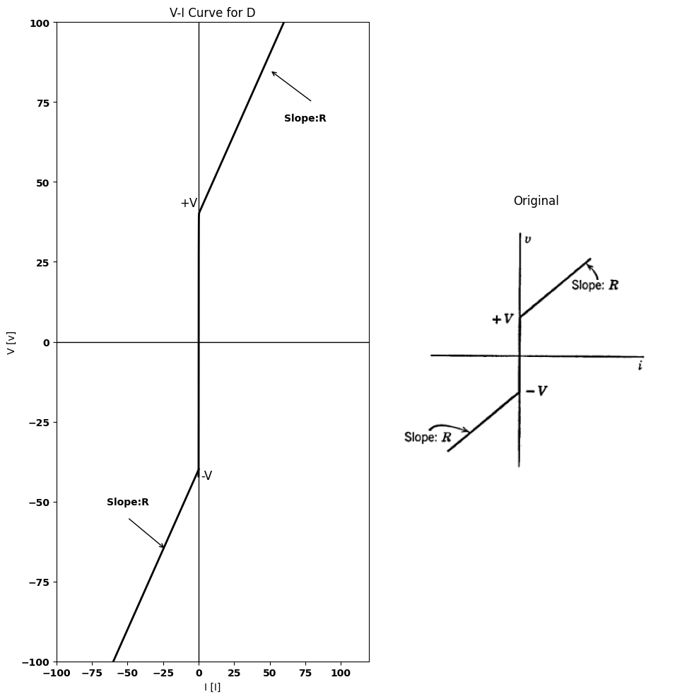
<Figure size 640x480 with 0 Axes>
<Figure size 640x480 with 0 Axes>
import matplotlib.pyplot as plt
from matplotlib import rcParams
import PySpice.Logging.Logging as Logging
logger = Logging.setup_logging()
from PySpice.Probe.Plot import plot
from PySpice.Spice.Netlist import Circuit
from PySpice.Unit import *
rcParams['font.weight'] = 'bold'
fig, axs = plt.subplots(1, 2, figsize=(10, 10))
circuit = Circuit('Transitional characteristic1')
circuit.model('BAV21','D' ,IS = 1@u_uA ,BV = 293.10@u_V, IBV = 0.001293@u_A , RS = 10@u_Ohm )
Vi = circuit.V('i', '1', circuit.gnd, 0@u_V)
circuit.D(1, '2','1', model = 'BAV21')
circuit.I(1, '1', '2', 1@u_mA)
circuit.D(2, '2', '3', model = 'BAV21')
circuit.V(1, '3', circuit.gnd,1@u_V)
circuit.D(13, '4','1', model = 'BAV21')
circuit.I(2, '1', '4', 1@u_mA)
circuit.D(4, '4', '5', model = 'BAV21')
circuit.V(2, '5', circuit.gnd, 2@u_V)
circuit.D(5, '6','1', model = 'BAV21')
circuit.I(3, '1', '6', 2@u_mA)
simulator = circuit.simulator(temperature=25, nominal_temperature=25)
analysis = simulator.dc(Vi=slice(0, 4, .01))
axs[0].plot(analysis['1'],u_mA(-analysis.Vi),'black',linewidth=3)
circuit = Circuit('Transitional characteristic1')
circuit.model('BAV21','D' ,IS = 1@u_uA ,BV = 293.10@u_V, IBV = 0.001293@u_A , RS = 10@u_Ohm )
Vi = circuit.V('i', '1', circuit.gnd, 0@u_V)
circuit.D(1, '2','1', model = 'BAV21')
circuit.I(1, '1', '2', -1@u_mA)
circuit.D(2, '2', '3', model = 'BAV21')
circuit.V(1, '3', circuit.gnd,0@u_V)
circuit.D(13, '4','1', model = 'BAV21')
circuit.I(2, '1', '4', -1@u_mA)
circuit.D(4, '4', '5', model = 'BAV21')
circuit.V(2, '5', circuit.gnd, -1@u_V)
circuit.D(5, '6','1', model = 'BAV21')
#circuit.I(3, '1', '6', -1@u_mA)
simulator = circuit.simulator(temperature=25, nominal_temperature=25)
analysis = simulator.dc(Vi=slice(-4, 0, .01))
axs[0].plot(analysis['1'],u_mA(-analysis.Vi),'black',linewidth=3)
axs[0].axhline(0, color='black', linewidth=1)
axs[0].axvline(0, color='black', linewidth=1)
axs[0].plot([0, 0], [-0.5, 0], color='black', linewidth=3)
axs[0].annotate('-1', xy=(0.1, -1), xytext=(-0.5, -1),
textcoords='offset points', ha='center', color='black', fontsize=12, fontweight='medium')
axs[0].annotate('-2', xy=(0.1, -2), xytext=(-0.5, -2),
textcoords='offset points', ha='center', color='black', fontsize=12, fontweight='medium')
axs[0].annotate('1', xy=(-0.1, 1), xytext=(-0.5, 1),
textcoords='offset points', ha='center', color='black', fontsize=12, fontweight='medium')
axs[0].annotate('2', xy=(-0.1, 2), xytext=(-0.5, 2),
textcoords='offset points', ha='center', color='black', fontsize=12, fontweight='medium')
axs[0].plot([2, 2], [0, .2], color='black', linewidth=1)
axs[0].plot([0.1,0], [2,2], color='black', linewidth=1)
axs[0].plot([0.1,0], [1,1], color='black', linewidth=1)
axs[0].set_xlim(-4, 4)
axs[0].set_ylim(-3, 3)
axs[0].set_xlabel('v [V]')
axs[0].set_ylabel('i [mA]')
figure.savefig('./Drawings/fig21-1.jpg')
figure.savefig('./Drawings/fig21-1.svg')
# **Subplot (1, 2): PNG Sample File**
img_sample = mpimg.imread('images-books/p3-72.png') # Load the PNG file
axs[1].imshow(img_sample)
axs[1].axis('off') # Hide axes for image display
axs[1].set_title('Original')
# Show the combined plots
plt.tight_layout()
plt.show()
d.save('./Drawings/fig8-1.png')
d.save('./Drawings/fig8-1.svg')
plt.tight_layout()
plt.show()
plt.tight_layout()
plt.show()
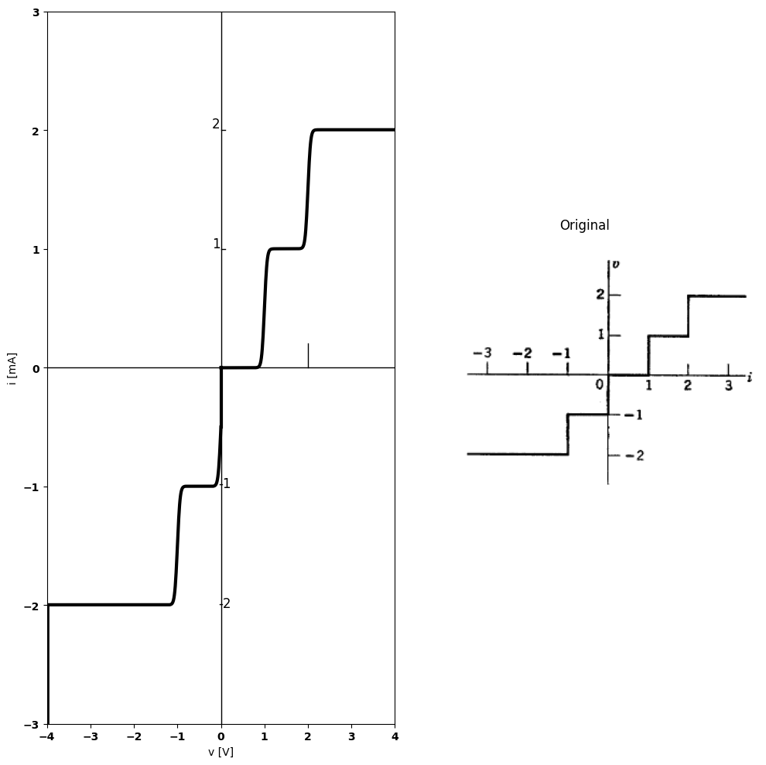
<Figure size 640x480 with 0 Axes>
<Figure size 640x480 with 0 Axes>
import matplotlib.pyplot as plt
from matplotlib import rcParams
import PySpice.Logging.Logging as Logging
logger = Logging.setup_logging()
from PySpice.Probe.Plot import plot
from PySpice.Spice.Netlist import Circuit
from PySpice.Unit import *
rcParams['font.weight'] = 'bold'
fig, axs = plt.subplots(1, 2, figsize=(10, 10))
circuit = Circuit('Transitional characteristic1')
circuit.model('BAV21','D' ,IS = .1@u_mA ,BV = 293.10@u_V, IBV = 0.001293@u_A , RS = .1@u_Ohm )
Vi = circuit.V('i', '1', circuit.gnd, 0@u_V)
circuit.R(1, '1', '2', 10@u_kOhm)
circuit.R(2, '3', '4', 100@u_Ohm)
circuit.D(1, '2','3', model = 'BAV21')
circuit.V(1, '4', circuit.gnd, 1@u_V)
circuit.D(2, '5', '2', model = 'BAV21')
circuit.V(2, circuit.gnd, '6', 1@u_V)
circuit.R(3, '5', '6', 100@u_Ohm)
simulator = circuit.simulator(temperature=25, nominal_temperature=25)
analysis = simulator.dc(Vi=slice(-2, 2, .1))
axs[0].plot(analysis['1'], analysis['2'],'black',linewidth=5)
axs[0].axhline(0, color='black', linewidth=1)
axs[0].axvline(0, color='black', linewidth=1)
axs[0].plot([-2,-2], [-1, -3], color='black', linewidth=4)
axs[0].plot([2,2], [1, 3], color='black', linewidth=4)
axs[0].text(0, -4, 'Fig. P3.73', ha='center', va='center', fontsize=12)
#ax.plot([20, 20], [-2, 2], color='black', linewidth=1)
axs[0].set_xlim(-3, 3)
axs[0].set_ylim(-3, 3)
figure.savefig('./Drawings/fig20-1.jpg')
figure.savefig('./Drawings/fig20-1.svg')
# **Subplot (1, 2): PNG Sample File**
img_sample = mpimg.imread('images-books/p3-73.png') # Load the PNG file
axs[1].imshow(img_sample)
axs[1].axis('off') # Hide axes for image display
axs[1].set_title('Original')
# Show the combined plots
plt.tight_layout()
plt.show()
d.save('./Drawings/fig7-1.png')
d.save('./Drawings/fig7-1.svg')
plt.tight_layout()
plt.show()
plt.tight_layout()
plt.show()
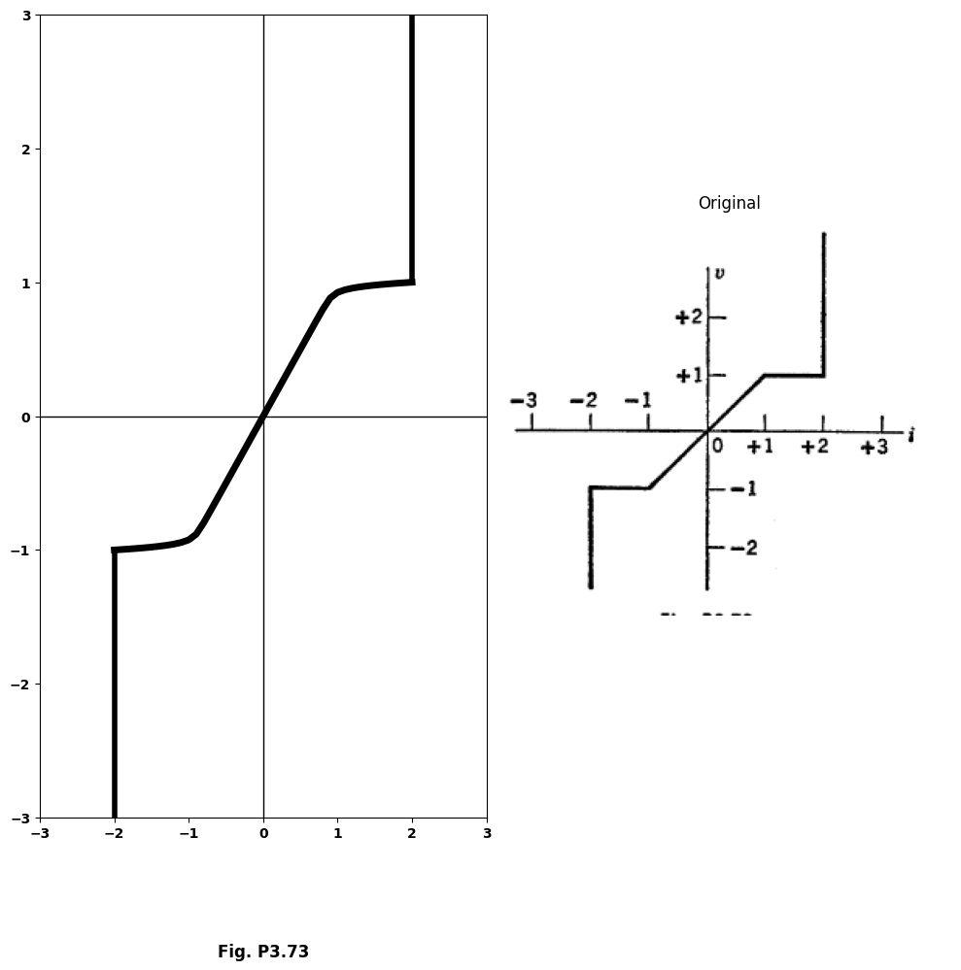
<Figure size 640x480 with 0 Axes>
<Figure size 640x480 with 0 Axes>
$3.44$. Using ideal rectifiers, resistors, voltage sources, and (if needed) current sources, design a circuit whose input $i$ vs. $v$ is as shown in Fig. P3.74.
import matplotlib.pyplot as plt
from matplotlib import rcParams
import PySpice.Logging.Logging as Logging
logger = Logging.setup_logging()
from PySpice.Probe.Plot import plot
from PySpice.Spice.Netlist import Circuit
from PySpice.Unit import *
rcParams['font.weight'] = 'bold'
fig, axs = plt.subplots(1, 2, figsize=(10, 10))
circuit = Circuit('Diode')
circuit.model('BAV21','D' ,IS = 4@u_nA , N = 1.906 ,BV = 110@u_V, IBV = 0.0001@u_V, VJ = 0.7@u_V ,CJO = 7.048E-13 ,RS = 0.01@u_Ohm ,TT = 3.48E-9)
Vth = circuit.V('th', '1', circuit.gnd, 0@u_V)
circuit.D(1, '1' ,'2', model = 'BAV21')
circuit.V(1, '3',circuit.gnd , 0@u_V)
circuit.R(1, '2','3' , 3200@u_Ohm)
circuit.D(2, '1' ,'4', model = 'BAV21')
circuit.V(2, '5',circuit.gnd , 70@u_V)
circuit.R(2, '4','5' , 100@u_Ohm)
simulator = circuit.simulator(temperature=25, nominal_temperature=25)
analysis = simulator.dc(Vth=slice(0, 76, 0.1))
axs[0].plot(analysis['1'],u_mA(-analysis.Vth), 'black', linewidth=2)
circuit = Circuit('Diode2')
circuit.model('BAV21','D' ,IS = 4@u_nA , N = 1.906 ,BV = 110@u_V, IBV = 0.0001@u_V, VJ = 0.7@u_V ,CJO = 7.048E-13 ,RS = 0.01@u_Ohm ,TT = 3.48E-9)
Vth = circuit.V('th', '6', circuit.gnd, 0@u_V)
circuit.D(3, '7' ,'6', model = 'BAV21')
circuit.V(3, '8',circuit.gnd , 0@u_V)
circuit.R(3, '7','8' , 3200@u_Ohm)
circuit.D(4, '9' ,'6', model = 'BAV21')
circuit.V(4, '10',circuit.gnd ,-70@u_V)
circuit.R(4, '9','10' , 100@u_Ohm)
simulator = circuit.simulator(temperature=25, nominal_temperature=25)
analysis = simulator.dc(Vth=slice(-76,0, 0.1))
axs[0].plot(analysis['6'],u_mA(-analysis.Vth), 'black', linewidth=2)
axs[0].set_title('V-I Curve for D')
axs[0].set_xlim(-150, 150)
axs[0].set_ylabel('I [I]')
axs[0].set_xlabel('V [v]')
axs[0].set_ylim(-150, 150)
axs[0].axhline(0, color='black', linewidth=1)
axs[0].axvline(0, color='black', linewidth=1)
axs[0].plot([-114, 115], [-110, 110], color='black', linestyle='--', linewidth=2)
axs[0].plot([-113, -75], [-110, -74], color='black', linewidth=2)
axs[0].plot([116, 77], [110, 75], color='black', linewidth=2)
axs[0].text(0, -200, 'Fig. P3.74', ha='center', va='center', fontsize=12)
figure.savefig('./Drawings/fig19-1.jpg')
figure.savefig('./Drawings/fig19-1.svg')
# **Subplot (1, 2): PNG Sample File**
img_sample = mpimg.imread('images-books/p3-74.png') # Load the PNG file
axs[1].imshow(img_sample)
axs[1].axis('off') # Hide axes for image display
axs[1].set_title('Original')
# Show the combined plots
plt.tight_layout()
plt.show()
d.save('./Drawings/fig6-1.png')
d.save('./Drawings/fig6-1.svg')
plt.tight_layout()
plt.show()
plt.tight_layout()
plt.show()
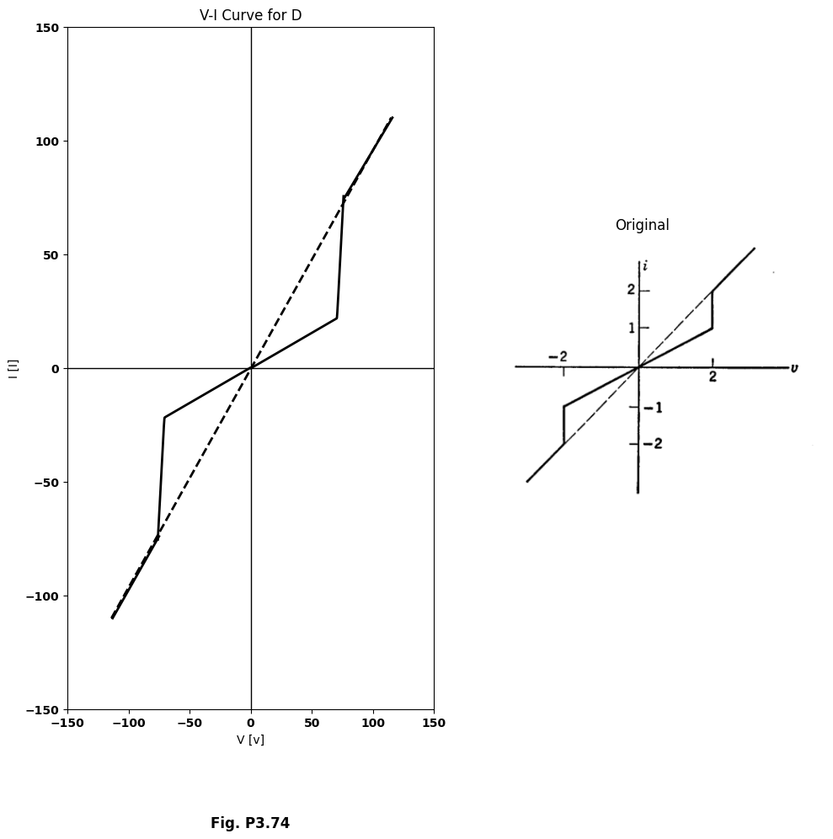
<Figure size 640x480 with 0 Axes>
<Figure size 640x480 with 0 Axes>
import matplotlib.pyplot as plt
from matplotlib import rcParams
import PySpice.Logging.Logging as Logging
logger = Logging.setup_logging()
from PySpice.Probe.Plot import plot
from PySpice.Spice.Netlist import Circuit
from PySpice.Unit import *
rcParams['font.weight'] = 'bold'
fig, axs = plt.subplots(1, 2, figsize=(10, 10))
circuit = Circuit('Diode')
circuit.model('BAV21','D' ,IS = 4@u_nA , N = 1.906 ,BV = 110@u_V, IBV = 0.0001@u_V, VJ = 0.7@u_V ,CJO = 7.048E-13 ,RS = 0.01@u_kOhm ,TT = 3.48E-9)
Vth = circuit.V('th', '1', circuit.gnd, 0@u_V)
circuit.D(1, '2','1' , model = 'BAV21')
circuit.V(1, '3',circuit.gnd , 50@u_V)
#circuit.I(1, '2','1' , 25@u_mA)
circuit.R(1, '2','3' , 1000@u_Ohm)
simulator = circuit.simulator(temperature=25, nominal_temperature=25)
analysis = simulator.dc(Vth=slice(0, 100, 0.1))
# Plot for R1
axs[0].plot(analysis['1'],u_mA(-analysis.Vth), 'black', linewidth=2)
axs[0].set_title('V-I Curve for D')
axs[0].set_xlim(-100, 100)
axs[0].set_xlabel('V [V]')
axs[0].set_ylabel('I [mA]')
axs[0].set_ylim(-80, 100)
axs[0].axhline(0, color='black', linewidth=1)
axs[0].axvline(0, color='black', linewidth=1)
axs[0].annotate('-I', xy=(0, 0), xytext=(-12, -75),
textcoords='offset points', ha='center', color='black', fontsize=12, fontweight='medium')
axs[0].annotate('V', xy=(10, 0), xytext=(50, 8),
textcoords='offset points', ha='center', color='black', fontsize=12, fontweight='medium')
axs[0].plot([0, 0], [-49,-100], color='black', linewidth=2)
axs[0].text(0, -140, 'Fig. P3.75', ha='center', va='center', fontsize=12)
figure.savefig('./Drawings/fig18-1.jpg')
figure.savefig('./Drawings/fig18-1.svg')
# **Subplot (1, 2): PNG Sample File**
img_sample = mpimg.imread('images-books/p3-75.png') # Load the PNG file
axs[1].imshow(img_sample)
axs[1].axis('off') # Hide axes for image display
axs[1].set_title('Original')
# Show the combined plots
plt.tight_layout()
plt.show()
d.save('./Drawings/fig6-1.png')
d.save('./Drawings/fig6-1.svg')
plt.tight_layout()
plt.show()
plt.tight_layout()
plt.show()
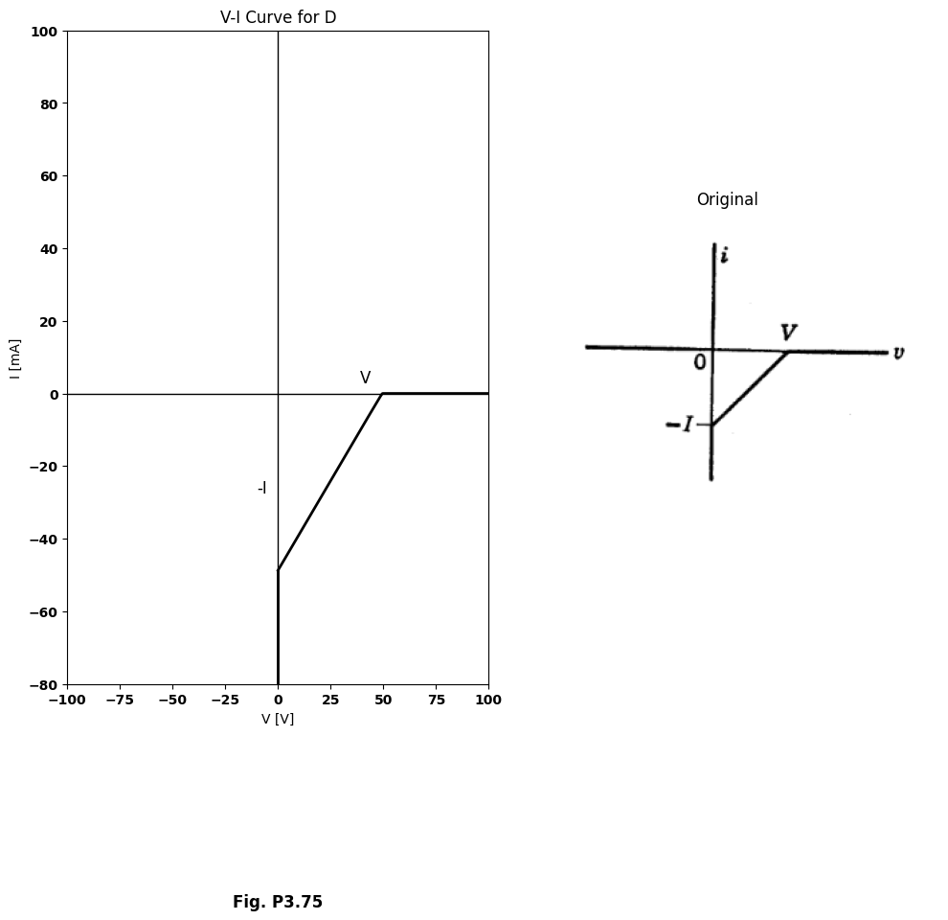
<Figure size 640x480 with 0 Axes>
<Figure size 640x480 with 0 Axes>
$3.45$. Using ideal rectifiers, positive resistances, and batteries, design circuits to give the $i$ vs. $v$ curves shown in Figs. P3.75-P3.77. Curve of Fig. P3.77
import matplotlib.pyplot as plt
import numpy as np
import schemdraw
import schemdraw.elements as elm
import matplotlib.image as mpimg
rcParams['font.weight'] = 'bold'
fig, axs = plt.subplots(1, 2, figsize=(10, 10))
circuit = Circuit('t3')
circuit.model('BAV21','D' ,IS = 4@u_nA , N = 1.906 ,BV = 110@u_V, IBV = 0.0001@u_V, VJ = 0.7@u_V ,CJO = 7.048E-13 ,RS = 0.01@u_Ohm ,TT = 3.48E-9)
Vth1 = circuit.V('th1', '1', circuit.gnd, 0@u_V)
circuit.D(1, '1','2' , model = 'BAV21')
circuit.R(1, '2','3' , 1@u_Ohm)
circuit.D(2, circuit.gnd,'3' , model = 'BAV21')
circuit.V(1, circuit.gnd ,'4' , 50@u_V)
circuit.R(2, '3','4', 1.2@u_Ohm)
simulator = circuit.simulator(temperature=25, nominal_temperature=25)
analysis = simulator.dc(Vth1=slice(-150, 150, 0.1))
axs[0].plot(analysis['1'],u_A(-analysis.Vth1),'black', linewidth=3)
axs[0].set_title('V-I Curve for D')
axs[0].set_xlim(-80, 120)
axs[0].set_xlabel('V [V]')
axs[0].set_ylabel('I [I]')
axs[0].set_ylim(-60, 120)
axs[0].axhline(0, color='black', linewidth=1)
axs[0].axvline(0, color='black', linewidth=1)
axs[0].text(15, 25, '$R_1$', ha='center', va='center', fontsize=12)
axs[0].text(110, 60, '$R_2$', ha='center', va='center', fontsize=12)
axs[0].text(40, -5, '$V$', ha='center', va='center', fontsize=12)
axs[0].plot([40, 40], [41, 0], color='black', linestyle='--', label='Membership = 1')
#axs[0].text(10, -95, 'Fig. P3.76', ha='center', va='center', fontsize=12)
#figure.savefig('./Drawings/fig17-2.jpg')
#figure.savefig('./Drawings/fig17-2.svg')
# **Subplot (1, 2): PNG Sample File**
img_sample = mpimg.imread('images-books/p3.76.png') # Load the PNG file
axs[1].imshow(img_sample)
axs[1].axis('off') # Hide axes for image display
axs[1].set_title('Original')
# Show the combined plots
plt.tight_layout()
plt.show()
#d.save('./Drawings/fig5-1.png')
#d.save('./Drawings/fig5-1.svg')
plt.tight_layout()
plt.show()
plt.tight_layout()
plt.show()
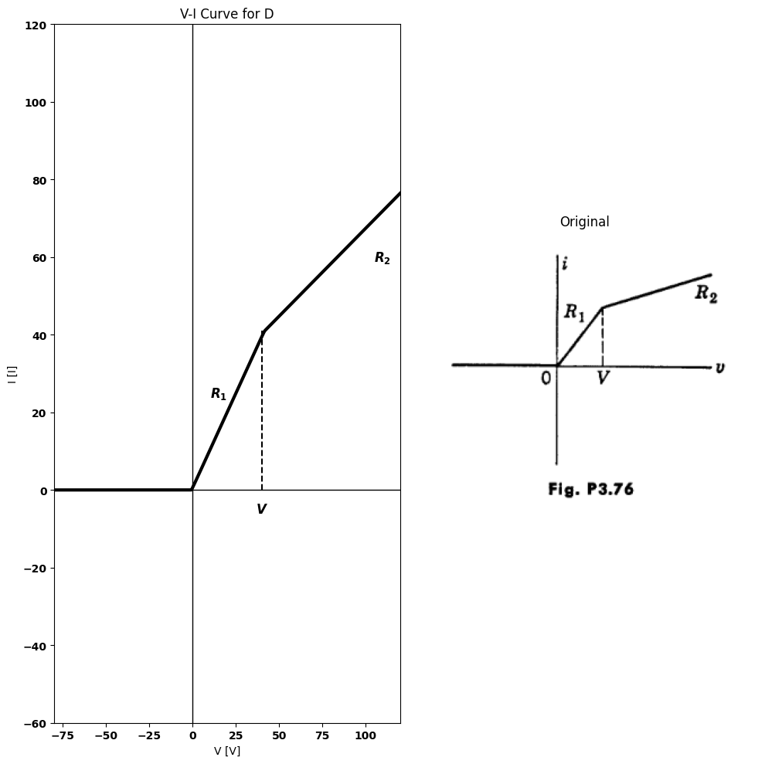
<Figure size 640x480 with 0 Axes>
<Figure size 640x480 with 0 Axes>
import matplotlib.pyplot as plt
from matplotlib import rcParams
import PySpice.Logging.Logging as Logging
logger = Logging.setup_logging()
from PySpice.Probe.Plot import plot
from PySpice.Spice.Netlist import Circuit
from PySpice.Unit import *
rcParams['font.weight'] = 'bold'
fig, axs = plt.subplots(1, 2, figsize=(10, 10))
circuit = Circuit('Diode')
circuit.model('BAV21','D' ,IS = 4@u_nA , N = 1.906 ,BV = 110@u_V, IBV = 0.0001@u_V, VJ = 0.7@u_V ,CJO = 7.048E-13 ,RS = 0.01@u_Ohm ,TT = 3.48E-9)
Vth = circuit.V('th', '1', circuit.gnd, 0@u_V)
circuit.D(1, '1' ,'2', model = 'BAV21')
circuit.V(1, '3',circuit.gnd , 0@u_V)
circuit.R(1, '2','3' , 1200@u_Ohm)
circuit.D(2, '1' ,'4', model = 'BAV21')
circuit.V(2, '5',circuit.gnd , 50@u_V)
circuit.R(2, '4','5' , 1000@u_Ohm)
simulator = circuit.simulator(temperature=25, nominal_temperature=25)
analysis = simulator.dc(Vth=slice(0, 100, 0.1))
axs[0].plot(analysis['1'],u_mA(-analysis.Vth), 'black', linewidth=2)
circuit = Circuit('Diode2')
circuit.model('BAV21','D' ,IS = 4@u_nA , N = 1.906 ,BV = 110@u_V, IBV = 0.0001@u_V, VJ = 0.7@u_V ,CJO = 7.048E-13 ,RS = 0.01@u_Ohm ,TT = 3.48E-9)
Vth = circuit.V('th', '6', circuit.gnd, 0@u_V)
circuit.D(3, '7' ,'6', model = 'BAV21')
circuit.V(3, '8',circuit.gnd , 0@u_V)
circuit.R(3, '7','8' , 4500@u_Ohm)
circuit.D(4, '9' ,'6', model = 'BAV21')
circuit.V(4, '10',circuit.gnd ,-50@u_V)
circuit.R(4, '9','10' , 1000@u_Ohm)
simulator = circuit.simulator(temperature=25, nominal_temperature=25)
analysis = simulator.dc(Vth=slice(-100,0, 0.1))
axs[0].plot(analysis['6'],u_mA(-analysis.Vth), 'black', linewidth=2)
axs[0].set_title('V-I Curve for D')
axs[0].set_xlim(-150, 100)
axs[0].set_xlabel('I [I]')
axs[0].set_ylabel('V [v]')
axs[0].set_ylim(-150, 100)
axs[0].axhline(0, color='black', linewidth=1)
axs[0].axvline(0, color='black', linewidth=1)
axs[0].annotate('V', xy=(0, -10), xytext=(50, 0),
textcoords='offset points', ha='center', color='black', fontsize=12, fontweight='medium')
axs[0].annotate('-V', xy=(0, 10), xytext=(-55, 0),
textcoords='offset points', ha='center', color='black', fontsize=12, fontweight='medium')
axs[0].plot([52, 52], [42, 0], color='black', linestyle='--', label='Membership = 1')
axs[0].plot([-52, -52], [-10, 0], color='black', linestyle='--', label='Membership = 1')
axs[0].text(80, 15, '$2/3Ω$', ha='center', va='center', fontsize=12)
axs[0].text(90, 75, '$1/2Ω$', ha='center', va='center', fontsize=12)
axs[0].text(-25, -20, '$2Ω$', ha='center', va='center', fontsize=12)
axs[0].text(-100, -48, '$3/2Ω$', ha='center', va='center', fontsize=12)
axs[0].annotate('', xy=(18,15), xytext=(70,15 ), arrowprops=dict(arrowstyle='->'))
axs[0].text(-30, -200, 'Fig. P3.77', ha='center', va='center', fontsize=12)
figure.savefig('./Drawings/fig16-1.jpg')
figure.savefig('./Drawings/fig16-1.svg')
# **Subplot (1, 2): PNG Sample File**
img_sample = mpimg.imread('images-books/p3-77.png') # Load the PNG file
axs[1].imshow(img_sample)
axs[1].axis('off') # Hide axes for image display
axs[1].set_title('Original')
# Show the combined plots
plt.tight_layout()
plt.show()
d.save('./Drawings/fig4-1.png')
d.save('./Drawings/fig4-1.svg')
plt.tight_layout()
plt.show()
plt.tight_layout()
plt.show()
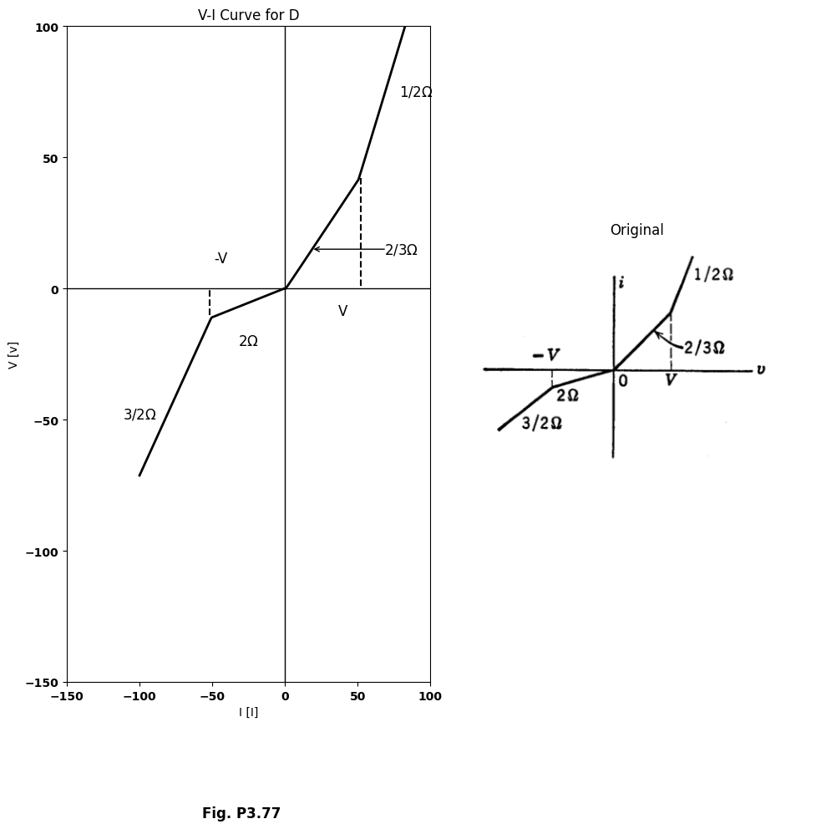
<Figure size 640x480 with 0 Axes>
<Figure size 640x480 with 0 Axes>
can be realized with only two ideal rectifiers in a bridge-type circuit, or with three ideal rectifiers.
$3.46$. Write a set of linear equations for the curves in Fig. P3.77 and specify the range of validity of each equation.
$3.47$. It is desired to design a piecewise-linear circuit that will approximate the characteristic $i=e^{2}$ over the range 0 < $e$ < 10 with a maximum current error of ±1 percent full scale, e.g., $i$ ($e^{2}±1$) for 0 < $e$ < 10. What is the smallest number of diodes needed and what circuit do you propose?
import matplotlib.pyplot as plt
from matplotlib import rcParams
import PySpice.Logging.Logging as Logging
logger = Logging.setup_logging()
from PySpice.Probe.Plot import plot
from PySpice.Spice.Netlist import Circuit
from PySpice.Unit import *
rcParams['font.weight'] = 'bold'
fig, axs = plt.subplots(1, 2, figsize=(10, 10))
circuit = Circuit('v-i curve')
circuit.model('BAV21','D' ,IS = 1000@u_nA , N = 1.906 ,BV = 110@u_V, IBV = 0.0001@u_V, VJ = 0.7@u_V ,CJO = 7.048E-13 ,RS = 0.0001@u_kOhm ,TT = 3.48E-9)
Vth = circuit.V('th', '1', circuit.gnd, 0@u_V)
circuit.D(1, '1',circuit.gnd , model = 'BAV21')
circuit.I(1,circuit.gnd ,'1', 40@u_mA)
circuit.R(1, '1',circuit.gnd , 1@u_kOhm)
simulator = circuit.simulator(temperature=25, nominal_temperature=25)
analysis = simulator.dc(Vth=slice(-100, 0.1, 0.1))
axs[0].plot(analysis['1'],u_mA(-analysis.Vth), 'black', linewidth=2)
# circuit4
circuit = Circuit('v-i curve')
circuit.model('BAV21','D' ,IS = 30@u_mA , N = 1.906 ,BV = 110@u_V, IBV = 0.0001@u_V, VJ = 0.7@u_V ,CJO = 7.048E-13 ,RS = 0.0001@u_kOhm ,TT = 3.48E-9)
Vth = circuit.V('th', '1', circuit.gnd, 0@u_V)
circuit.D(1, circuit.gnd ,'1', model = 'BAV21')
circuit.I(1,'1',circuit.gnd , 10@u_mA)
circuit.R(1, '1',circuit.gnd , 1@u_kOhm)
simulator = circuit.simulator(temperature=25, nominal_temperature=25)
analysis = simulator.dc(Vth=slice(-.0545, 100, 0.1))
axs[0].plot(analysis['1'],u_mA(-analysis.Vth), 'black', linewidth=2)
axs[0].set_title('V-I Curve for D')
axs[0].set_xlim(-100, 120)
axs[0].set_ylabel('I [I]')
axs[0].set_xlabel('V [v]')
axs[0].set_ylim(-100, 100)
axs[0].axhline(0, color='black', linewidth=1)
axs[0].axvline(0, color='black', linewidth=1)
axs[0].annotate('+I', xy=(0, 35), xytext=(-10, 8),
textcoords='offset points', ha='center', color='black', fontsize=12, fontweight='medium')
axs[0].annotate('-I', xy=(0, -40), xytext=(8, -10),
textcoords='offset points', ha='center', color='black', fontsize=12, fontweight='medium')
axs[0].text(75, 70, 'Slope:1/R', ha='center', va='center')
axs[0].text(-50, -50, 'Slope:1/R', ha='center', va='center')
axs[0].annotate('', xy=(50,85), xytext=(80,75 ), arrowprops=dict(arrowstyle='->'))
axs[0].annotate('', xy=(-23,-65), xytext=(-50,-55), arrowprops=dict(arrowstyle='->'))
axs[0].text(0, -138, 'Fig. P3.78', ha='center', va='center', fontsize=12)
figure.savefig('./Drawings/fig15-1.jpg')
figure.savefig('./Drawings/fig15-1.svg')
# **Subplot (1, 2): PNG Sample File**
img_sample = mpimg.imread('images-books/p3-78.png') # Load the PNG file
axs[1].imshow(img_sample)
axs[1].axis('off') # Hide axes for image display
axs[1].set_title('Original')
# Show the combined plots
plt.tight_layout()
plt.show()
d.save('./Drawings/fig3-1.png')
d.save('./Drawings/fig3-1.svg')
plt.tight_layout()
plt.show()
plt.tight_layout()
plt.show()
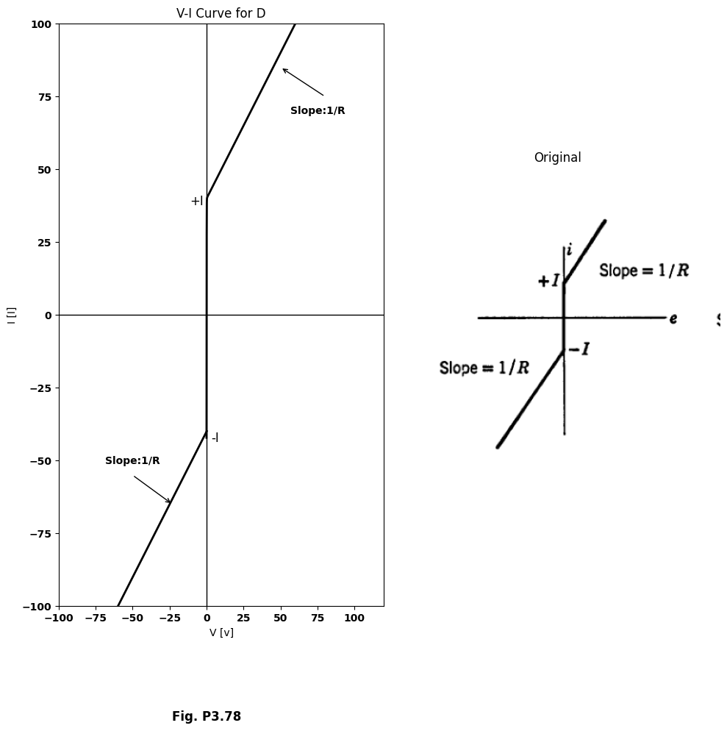
<Figure size 640x480 with 0 Axes>
<Figure size 640x480 with 0 Axes>
import matplotlib.pyplot as plt
from matplotlib import rcParams
import PySpice.Logging.Logging as Logging
logger = Logging.setup_logging()
from PySpice.Probe.Plot import plot
from PySpice.Spice.Netlist import Circuit
from PySpice.Unit import *
rcParams['font.weight'] = 'bold'
fig, axs = plt.subplots(1, 2, figsize=(10, 10))
circuit = Circuit('Diode')
circuit.model('BAV21','D' ,IS = 4@u_nA , N = 1.906 ,BV = 110@u_V, IBV = 0.0001@u_V, VJ = 0.7@u_V ,CJO = 7.048E-13 ,RS = 0.01@u_Ohm ,TT = 3.48E-9)
Vth = circuit.V('th', '1', circuit.gnd, 0@u_V)
circuit.D(1, '1','2' , model = 'BAV21')
circuit.V(1, '3',circuit.gnd , 45@u_V)
circuit.R(1, '2','3' , 1@u_kOhm)
simulator = circuit.simulator(temperature=25, nominal_temperature=25)
analysis = simulator.dc(Vth=slice(-40, 100, 0.1))
axs[0].plot(analysis['1'],u_mA(-analysis.Vth), 'black', linewidth=2)
# circuit4
circuit = Circuit('v-i curve')
circuit.model('BAV21','D' ,IS = 1000@u_nA , N = 1.906 ,BV = 110@u_V, IBV = 0.0001@u_V, VJ = 0.7@u_V ,CJO = 7.048E-13 ,RS = 0.01@u_kOhm ,TT = 3.48E-9)
Vth = circuit.V('th', '1', circuit.gnd, 0@u_V)
circuit.D(1, '2','1' , model = 'BAV21')
circuit.V(1,circuit.gnd ,'3', 45@u_V)
circuit.R(1, '2','3' , 1@u_kOhm)
simulator = circuit.simulator(temperature=25, nominal_temperature=25)
analysis = simulator.dc(Vth=slice(-100, 40, 0.1))
axs[0].plot(analysis['1'],u_mA(-analysis.Vth), 'black', linewidth=2)
axs[0].set_title('V-I Curve for D')
axs[0].set_xlim(-100, 120)
axs[0].set_ylabel('I [I]')
axs[0].set_xlabel('V [v]')
axs[0].set_ylim(-100, 100)
axs[0].axhline(0, color='black', linewidth=1)
axs[0].axvline(0, color='black', linewidth=1)
axs[0].annotate('+V', xy=(45, 0), xytext=(0, 8),
textcoords='offset points', ha='center', color='black', fontsize=12, fontweight='medium')
axs[0].annotate('-V', xy=(-45, 0), xytext=(0, 8),
textcoords='offset points', ha='center', color='black', fontsize=12, fontweight='medium')
axs[0].text(100, 15, '$Slope:1/R$', ha='center', va='center')
axs[0].text(-45, -25, '$Slope:1/R$', ha='center', va='center')
axs[0].annotate('', xy=(70,25), xytext=(80,15 ), arrowprops=dict(arrowstyle='->'))
axs[0].annotate('', xy=(-60,-10), xytext=(-38,-23), arrowprops=dict(arrowstyle='->'))
axs[0].plot([46, 46], [-6, 6], color='black', linewidth=1)
axs[0].plot([-46, -46], [-6, 6], color='black', linewidth=1)
axs[0].text(0, -140, 'Fig. P3.79', ha='center', va='center', fontsize=12)
figure.savefig('./Drawings/fig14-1.jpg')
figure.savefig('./Drawings/fig14-1.svg')
# **Subplot (1, 2): PNG Sample File**
img_sample = mpimg.imread('images-books/p-3.79.png') # Load the PNG file
axs[1].imshow(img_sample)
axs[1].axis('off') # Hide axes for image display
axs[1].set_title('Original')
# Show the combined plots
plt.tight_layout()
plt.show()
d.save('./Drawings/fig2-1.png')
d.save('./Drawings/fig2-1.svg')
plt.tight_layout()
plt.show()
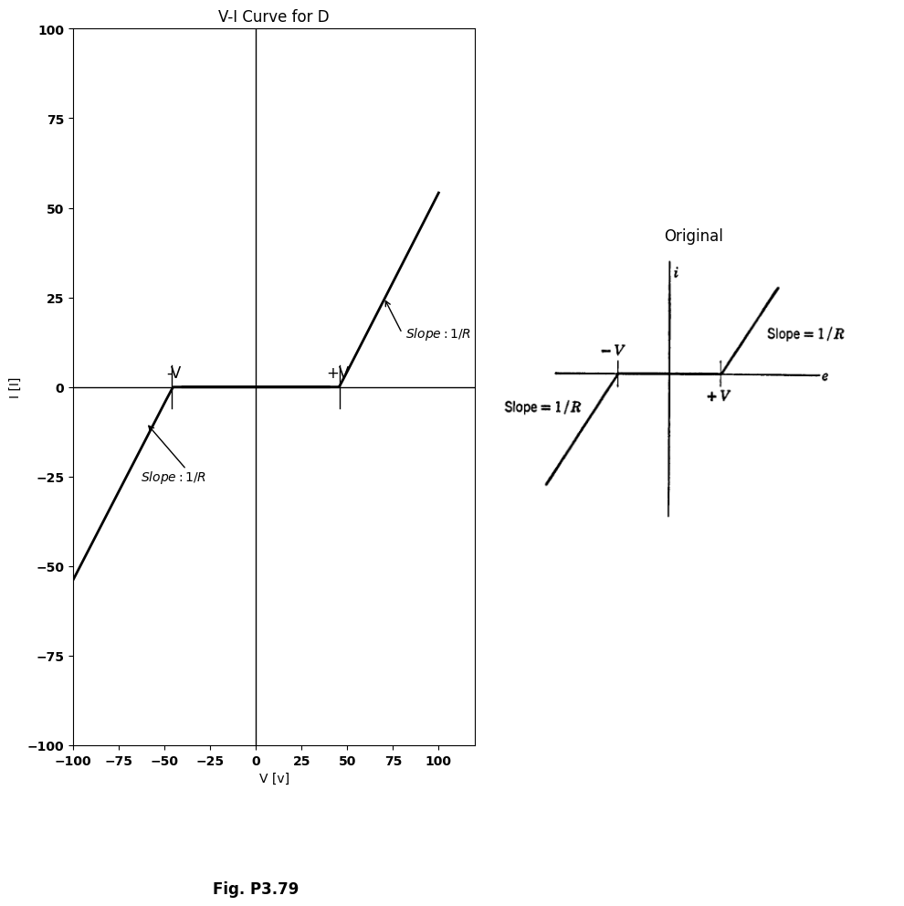
<Figure size 640x480 with 0 Axes>
$3.48$. $\left(a\right)$ Using linear circuit elements and ideal diodes, design circuits that will have the terminal volt-ampere relationships shown in Figs. P3.78 and P3.79.
$\left(b\right)$ Sketch the terminal volt-ampere relationship that will result if the two circuits devised in $\left(a\right)$ are connected in series.
$\left(c\right)$ Repeat $\left(b\right)$ for the circuits connected in parallel.
$3.49$. A gas diode is placed in series with a 100 kilohm resistance and the combination is connected to a variable voltage source. The voltage is slowly raised from zero. The circuit draws negligible current until the source voltage reaches 100 volts, at which time the current jumps to nearly 1 ma. The voltage is now slowly reduced, whence the current decreases slowly to the value 0.05 ma and then suddenly jumps back to zero. What information does this experiment give you about the $i$ vs. $e$ curve of the gas diode?
import matplotlib.pyplot as plt
from matplotlib import rcParams
import PySpice.Logging.Logging as Logging
logger = Logging.setup_logging()
from PySpice.Probe.Plot import plot
from PySpice.Spice.Netlist import Circuit
from PySpice.Unit import *
rcParams['font.weight'] = 'bold'
fig, axs = plt.subplots(1, 2, figsize=(10, 10))
circuit = Circuit('Diode')
circuit.model('BAV21','D' ,IS = 4@u_nA , N = 1.906 ,BV = 110@u_V, IBV = 0.0001@u_V, VJ = 0.7@u_V ,CJO = 7.048E-13 ,RS = 0.01@u_Ohm ,TT = 3.48E-9)
Vth = circuit.V('th', '1', circuit.gnd, 0@u_V)
circuit.D(1, '1' ,'2', model = 'BAV21')
circuit.V(1, '3',circuit.gnd , 0@u_V)
circuit.R(1, '2','3' , 2000@u_Ohm)
circuit.D(2, '1' ,'4', model = 'BAV21')
circuit.V(2, '5',circuit.gnd , 80@u_V)
circuit.R(2, '4','5' , 500@u_Ohm)
simulator = circuit.simulator(temperature=25, nominal_temperature=25)
analysis = simulator.dc(Vth=slice(0, 100, 0.1))
axs[0].plot(analysis['1'],u_mA(-analysis.Vth), 'black', linewidth=2)
#circuit2
circuit = Circuit('Diode')
circuit.model('BAV21','D' ,IS = 4@u_nA , N = 1.906 ,BV = 110@u_V, IBV = 0.0001@u_V, VJ = 0.7@u_V ,CJO = 7.048E-13 ,RS = 0.01@u_Ohm ,TT = 3.48E-9)
Vth = circuit.V('th', '6', circuit.gnd, 0@u_V)
circuit.D(1, '7' ,'6', model = 'BAV21')
circuit.V(1, '8',circuit.gnd , 0@u_V)
circuit.R(1, '7','8' , 2000@u_Ohm)
circuit.D(2, '6' ,'9', model = 'BAV21')
circuit.V(2, '10',circuit.gnd , 40@u_V)
circuit.R(2, '9','10' , 500@u_Ohm)
simulator = circuit.simulator(temperature=25, nominal_temperature=25)
analysis = simulator.dc(Vth=slice(-100, 0, 0.1))
axs[0].plot(analysis['6'],u_mA(-analysis.Vth), 'black', linewidth=2)
axs[0].set_title('Circuit Diagram (developed)')
axs[0].set_xlim(-120, 120)
axs[0].set_ylabel('I [I]')
axs[0].set_xlabel('V [v]')
axs[0].set_ylim(-120, 120)
axs[0].axhline(0, color='black', linewidth=1)
axs[0].axvline(0, color='black', linewidth=1)
axs[0].plot([0,80], [40,40], color='black', linestyle='--', label='Membership = 1')
axs[0].plot([81,81], [40,0], color='black', linestyle='--', label='Membership = 1')
axs[0].plot([0,-72], [-35,-35], color='black', linestyle='--', label='Membership = 1')
axs[0].plot([-70,-70], [-38,0], color='black', linestyle='--', label='Membership = 1')
axs[0].text(-75, 5, '-V', ha='center', va='center')
axs[0].text(85, -5, 'V', ha='center', va='center')
axs[0].text(-5, 40, 'I', ha='center', va='center')
axs[0].text(5, -35, '-I', ha='center', va='center')
axs[0].text(70, 60, 'Slope:G', ha='center', va='center')
axs[0].text(-100, -50, 'Slope:G', ha='center', va='center')
axs[0].text(100, -50, 'G>I/V', ha='center', va='center')
#axs[0].plt.tight_layout()
#plt.show()
figure.savefig('./Drawings/fig13-1.jpg')
figure.savefig('./Drawings/fig13-1.svg')
# **Subplot (1, 2): PNG Sample File**
img_sample = mpimg.imread('images-books/p3-80.png') # Load the PNG file
axs[1].imshow(img_sample)
axs[1].axis('off') # Hide axes for image display
axs[1].set_title('Original')
# Show the combined plots
plt.tight_layout()
plt.show()
d.save('./Drawings/fig2.png')
d.save('./Drawings/fig2.svg')
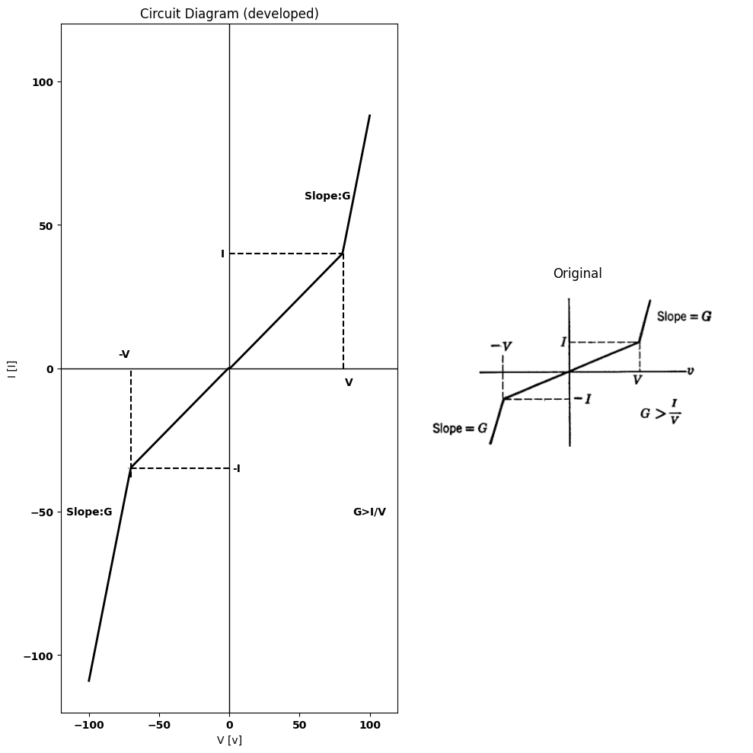
$3.50$. Using batteries, positive resistances, and ideal rectifiers, design a circuit to give the volt-ampere curve shown in Fig. P3.80.
$3.51$. Sketch and dimension $i_{1}$ vs. $e_{1}$ and $e_{2}$ vs. $e_{1}$ for the circuit shown in Fig. P3.81.
import schemdraw
import schemdraw.elements as e
import schemdraw as schem
import matplotlib.pyplot as plt
import matplotlib.image as mpimg
import numpy as np
# Create the figure and subplots
fig, axs = plt.subplots(1, 2, figsize=(12, 12))
d = schemdraw.Drawing()
E1 = d.add(e.SourceV().up().label(['-', '$e_1$', '+'], ofst=0.5))
l1 = d.add(e.Line().right().length(2))
D1 = d.add(e.Diode(fill=True).right().label('$D_1$',ofst=-1))
E1 = d.add(e.Battery().right().at(D1.end).label(['+', '$E1$', '-'], ofst=-1.3))
D2 = d.add(e.Diode(fill=True).down().at(E1.end).reverse().label('$D_m$',ofst=0.3))
l2 = d.add(e.Line().left().length(8))
l3 = d.add(e.Line().right().length(2).at(D2.start))
I = d.add(e.SourceI().down().label('$Im$'))
l4 = d.add(e.Line().left().length(2).at(I.end))
l5 = d.add(e.Line().right().length(0.5).at(I.start))
D3 = d.add(e.Diode(fill=True).right().label('$D_2$',ofst=-1))
E1 = d.add(e.Battery().right().at(D3.end).label(['+', '$E2$', '-'], ofst=-1.3))
R2 = d.add(e.Resistor().down().length(3).label('$R_2$',ofst=-1))
l5 = d.add(e.Line().left().length(6.5))
l6 = d.add(e.Line().up().length(2).at(R2.start))
l7 = d.add(e.Line().left().length(4))
D4 = d.add(e.Diode(fill=True).left().label('$D_0$',ofst=-1))
R3 = d.add(e.Resistor().left().length(3).label('$R_0$',ofst=-1))
l8 = d.add(e.Line().left().length(4))
l9 = d.add(e.Line().down().length(2).dot())
l10 = d.add(e.Line().right().length(2).dot(open=True).at(R2.start))
l11 = d.add(e.Line().right().length(2).dot(open=True).at(R2.end))
d += e.Arrow().right().length(0.7).linewidth(0.6).color('black').label('i', loc='top', color='black',ofst=0.1). at((.3,3.2))
d += e.Arrow().up().length(4.5).linewidth(0.6).color('white').label('$e_2$', loc='start', color='black',ofst=0.3). at((19,1.5))
d += e.Arrow().up().length(1.2).color('black').label('+',loc='end', color='black',ofst=-0.2). at((18.5,1.6))
d += e.Arrow().down().length(1.1).linewidth(2).color('black').label(r'_', loc='end', color='black',ofst=(-0.5, 0.3)). at((18.5,1.1))
R4 = d.add(e.Ground().right(). at((8.7,.02)))
d.save('./Drawings/fig2.png')
d.save('./Drawings/fig2.svg')
# Load the saved PNG file into the subplot
img = mpimg.imread('./Drawings/fig2.png')
axs[0].imshow(img)
axs[0].axis('off') # Hide axes for image display
axs[0].set_title('Circuit Diagram (developed)')
# **Subplot (1, 2): PNG Sample File**
img_sample = mpimg.imread('images-books/p3-81.png') # Load the PNG file
axs[1].imshow(img_sample)
axs[1].axis('off') # Hide axes for image display
axs[1].set_title('Original')
# Show the combined plots
plt.tight_layout()
plt.show()
d.save('./Drawings/fig1.png')
d.save('./Drawings/fig1.svg')
d.save('./Drawings/fig1.jpg')
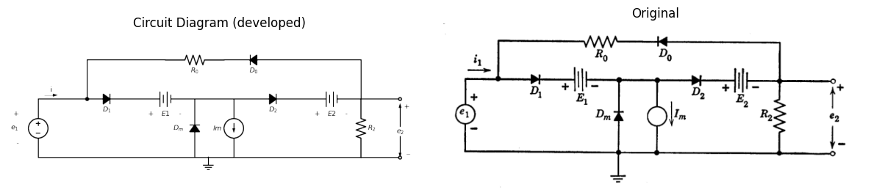
Fig. P3.81

