Table of Contents

0.0.1 CHAPTER Five

1 Transistor Models and Circuits

1.1 5.1 Introduction
In its most familiar form the transistor is a semiconductor triode. Like the semiconductor diode, it was first developed as a point-contact device. The point-contact transistor consists of a base of semiconductor material, say n-type germanium, on which two fine, pointed wires rest in close proximity. One of these is called the emitter, and the other is the collector. As shown in Fig. 5.1(a) the unit appears to be two point-contact diodes using the same base. The emitter and the collector are not identical, since the latter is treated by a process called "forming" to modify the base material near the collector.
The junction transistor, evolved several years after the point-contact transistor, can be described qualitatively as two junction diodes utilizing a common base. Junction transistors are made in a variety of ways. In one method a single crystal of germanium or other semiconductor is grown by applying a seed crystal to the top of a molten bath of the semiconductor material. Withdrawing the crystal at the proper rate results in cooling and crystallization. As the crystal is withdrawn, electron-donor or electron-acceptor impurities are added in carefully controlled amounts to form alternate layers of n-type and p-type semiconductors. The crystal is then cut into small slabs, and leads are attached by soldering. The result is a grown-junction transistor indicated in Fig. 5.1(b). The dimensions of the semiconductor slab are usually small fractions of an inch, and the thickness of the base layer is likely to be of the order of 0.001 inch. Locating the base layer and attaching the connecting lead to it requires precise fabrication techniques.
import matplotlib.pyplot as plt
import numpy as np
import schemdraw
from schemdraw import dsp
import schemdraw.elements as e
import matplotlib.image as mpimg
d = schemdraw.Drawing()
d += ( T := dsp.Box(w=5, h=2).anchor('W').label('$n-type$'))
mid_bottom = (2.5, -1.5)
l = d.add(e.Line().length(d.unit*0.3).at(mid_bottom).down().anchor('center').dot(open=True))
d += e.Arrow().right().linewidth(0.6).length(1.4).at(((1.5, -2))).color('white').label('$Base$', loc='end', color='black',ofst=0.2)
d += e.Arrow().length(1.5).at((1.7, 2.3)).label('$Emitter$', ofst=(-1.6,-1.1)).theta(-60)
d += e.Arrow().length(1.5).at((3.3, 2.3)).label('$Collector$', ofst=(-1.7,1.3)).theta(-120) ;
d.save('./Drawings5/5-1a.png')
d.save('./Drawings5/5-1a.svg')
fig, axs = plt.subplots(1, 2, figsize=(8, 4))
img = mpimg.imread('./Drawings5/5-1a.png')
axs[0].imshow(img)
axs[0].axis('off')
axs[0].set_title('Circuit Diagram (developed)')
img_sample = mpimg.imread('./images5/5-1a.png')
axs[1].imshow(img_sample)
axs[1].axis('off')
axs[1].set_title('Original')
plt.tight_layout()
plt.show()
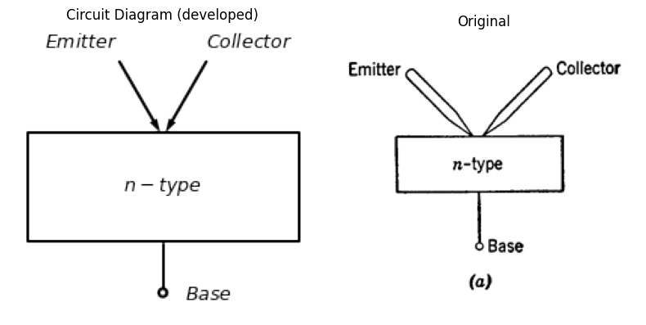
import matplotlib.pyplot as plt
import numpy as np
import schemdraw
from schemdraw import dsp
import schemdraw.elements as e
import matplotlib.image as mpimg
d = schemdraw.Drawing()
mid_bottom = (3.4, -1.5)
d += dsp.Line().length(d.unit*0.3).idot(open=True).label('$Emitter$', ofst=(-1.2,-0.2))
d += ( T1 := dsp.Box(w=2, h=2).anchor('W').label('n'))
d += ( T2 := dsp.Box(w=1, h=2).anchor('W').at(T1.E).label('p'))
d += ( T3 := dsp.Box(w=2, h=2).anchor('W').at(T2.E).label('n'))
d += dsp.Line().length(d.unit*0.3).at(T3.E).dot(open=True).label('$Collector$', ofst=(1.4,-0.25))
l = d.add(e.Line().length(d.unit*0.3).at(mid_bottom).down().anchor('center').dot(open=True))
d += e.Arrow().right().linewidth(0.6).length(1.4).at(((2.2, -2))).color('white').label('$Base$', loc='end', color='black',ofst=0.2)
d.draw()
d.save('./Drawings5/5-1b.png')
d.save('./Drawings5/5-1b.svg')
fig, axs = plt.subplots(1, 2, figsize=(8, 4))
img = mpimg.imread('./Drawings5/5-1b.png')
axs[0].imshow(img)
axs[0].axis('off')
axs[0].set_title('Circuit Diagram (developed)')
img_sample = mpimg.imread('./images5/5-1b.png')
axs[1].imshow(img_sample)
axs[1].axis('off')
axs[1].set_title('Original')
plt.tight_layout()
plt.show()
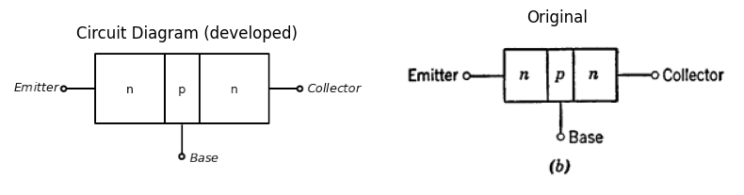
import matplotlib.pyplot as plt
import numpy as np
import schemdraw
from schemdraw import dsp
import schemdraw.elements as e
import matplotlib.image as mpimg
d = schemdraw.Drawing()
mid_bottom = (1.7, -1.95)
d += dsp.Line().length(d.unit*0.3).idot(open=True).label('$Emitter$', ofst=(-1.2,-0.2))
d += ( T1 := dsp.Box(w=0.25, h=0.6).anchor('W'))
d += ( T2 := dsp.Box(w=1, h=3).anchor('W').at(T1.E))
d += ( T3 := dsp.Box(w=0.25, h=2.1).anchor('W').at(T2.E))
d += dsp.Line().length(d.unit*0.3).at(T3.E).dot(open=True).label('$Collector$', ofst=(1.4,-0.25))
l = d.add(e.Line().length(d.unit*0.3).at(mid_bottom).down().anchor('center').dot(open=True))
d += e.Arrow().right().linewidth(0.6).length(1.4).at(((0.6, -2.5))).color('white').label('$Base$', loc='end', color='black',ofst=0.2)
d += e.Arrow().length(1.5).at((0.35, 1.6)).label('$Indium$', ofst=(-1.4,-1.1)).theta(-60)
d += e.Arrow().length(1.5).at((3.3, 2.3)).label('$Indium$', ofst=(-1.7,1.3)).theta(-120)
d += e.Arrow().length(1.5).at((0.35, -1.6)).label('Layer of\n p-type \n material', ofst=(-1.4,-0.1)).theta(60)
d += e.Arrow().length(1.5).at((3.3, -2.3)).label('Layer of\n p-type \n material', ofst=(-1.3,0.2)).theta(120)
d += e.Arrow().length(1.5).at((2.2, 2.8)).label('n-type \n germanium', ofst=(-1.7,1.3)).theta(-120)
d.draw()
d.save('./Drawings5/5-1c.png')
d.save('./Drawings5/5-1c.svg')
fig, axs = plt.subplots(1, 2, figsize=(8, 4))
img = mpimg.imread('./Drawings5/5-1c.png')
axs[0].imshow(img)
axs[0].axis('off')
axs[0].set_title('Circuit Diagram (developed)')
img_sample = mpimg.imread('./images5/5-1c.png') # Load the PNG file
axs[1].imshow(img_sample)
axs[1].axis('off')
axs[1].set_title('Original')
plt.tight_layout()
plt.show()
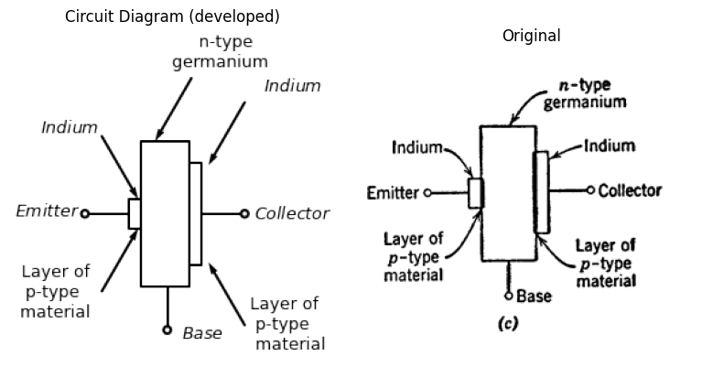
import matplotlib.pyplot as plt
import numpy as np
import schemdraw
from schemdraw import dsp
import schemdraw.elements as e
import matplotlib.image as mpimg
d = schemdraw.Drawing()
d += dsp.Line().length(d.unit*0.2).up().idot(open=True).label('$Base$', ofst=(-0.6,-0.9))
tr = d.add(e.BjtNpn(circle=True).up().flip().label('n-p-n', ofst=(-1.2,-1)))
d += dsp.Line().length(d.unit*0.3).dot(open=True).left().label('$Emitter$', ofst=(1.2,0.2)).at(tr.emitter)
d += dsp.Line().length(d.unit*0.3).dot(open=True).right().label('$Collector$', ofst=(1.4,-0.3)).at(tr.collector)
d.move(6, -1.5)
d += dsp.Line().length(d.unit*0.2).up().idot(open=True).label('$Base$', ofst=(-0.6,-0.9))
tr = d.add(e.BjtPnp(circle=True).up().label('p-n-p', ofst=(-1.2,-1)))
d += dsp.Line().length(d.unit*0.3).dot(open=True).left().label('$Emitter$', ofst=(1.2,0.2)).at(tr.emitter)
d += dsp.Line().length(d.unit*0.3).dot(open=True).right().label('$Collector$', ofst=(1.4,-0.3)).at(tr.collector)
d.draw()
d.save('./Drawings5/5-1dm.png')
d.save('./Drawings5/5-1dm.svg')
fig, axs = plt.subplots(2, 1, figsize=(8, 4))
img = mpimg.imread('./Drawings5/5-1dm.png')
axs[0].imshow(img)
axs[0].axis('off')
axs[0].set_title('Circuit Diagram (developed)')
img_sample = mpimg.imread('./images5/5-1dm.png') # Load the PNG file
axs[1].imshow(img_sample)
axs[1].axis('off')
axs[1].set_title('Original')
plt.tight_layout()
plt.show()
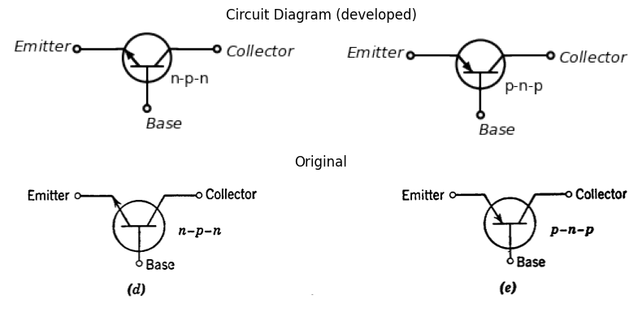
Fig. 5.1. Transistr configuration.
The alloy-junction transistor, Fig. 5.1(c), is made by placing small amounts of an acceptor like indium on opposite sides of a piece of n-type semiconductor, say n-type germanium. When the unit is heated to high temperatures, an alloy of the indium and germanium is formed on each side of the germanium. The result is the formation of p-type material on each side of the n-type and, hence, a p-n-p transistor. A p-type semiconductor material can be alloyed with a donor impurity such as arsenic to make n-p-n transistors. Figure 5.1(d) and (e) shows circuit symbols.
sistors, some of which result in substantially different kinds of units. The reader is referred to other books and to the literature for details, since the subject is already a broad one and continues to evolve as new techniques and new materials are exploited. A few references are listed at the end of the chapter.
The qualitative discussion of transistor behavior in the following article is based on the treatment of semiconductor diodes in Chapter 2 and will be limited to the junction transistor. The physics of the point-contact transistor is more involved, but it leads to a circuit model of the same type. This brief account is included as a means of relating the basic physical processes to the electrical behavior and to the circuit models.

1.2 5.2 Electrical Conduction in p-n-n-p Junction Transistors
In both p- and n-type semiconductor material, hole-electron pairs are created by thermal agitation. At equilibrium, just as many pairs disappear by recombination as are formed by thermal agitation. In p-type material, holes are the majority carriers and the free electrons that exist are called minority carriers, since they are outnumbered by the free holes provided by the acceptor impurity. In n-type material, electrons are the majority carriers and the holes are minority carriers, since the donor impurity provides a large number of free electrons. Diffusion of the majority carriers across a p-n junction (holes from p to n and electrons from n to p) establishes a potential barrier which eventually brings the diffusion process into equilibrium in the absence of applied fields.
When a small forward bias voltage is applied to a p-n junction (plus to minus from p to n), the potential barrier is effectively lowered, and a large current flows as the result of both kinds of majority carriers moving in opposite directions. The mobility of electrons differs from that of holes, and the number of holes and electrons may be unequal; hence, the contributions of the two types of majority carriers to the total conduction current are not necessarily equal. In fact, the operation of a transistor is based on current flow from only one type of majority carrier. For a p-n-p transistor, let us make the first junction (p-n) from emitter to base with the p-type material having more acceptor impurity content than the n-type has donor impurity. Then the forward current from emitter to base will consist largely of holes (+) going from emitter to base, rather than electrons (−) going from base to emitter. This is illustrated in Fig. 5.2(a).
Now recall that a reverse bias voltage on a p-n junction results in a small current caused by the minority carriers. This current reaches a saturation value that is temperature-dependent but remains constant over a fairly wide range of reverse voltages, as shown in Fig. 5.2(b).
import matplotlib.pyplot as plt
import numpy as np
import schemdraw
from schemdraw import dsp
import schemdraw.elements as e
import matplotlib.image as mpimg
d = schemdraw.Drawing()
mid_bottom = (3.7, 0.6)
d += dsp.Line().up().length(d.unit*0.7).idot(open=True)
d += dsp.Line().right().length(d.unit*0.4)
d += ( T1 := dsp.Box(w=2, h=2).anchor('W').label('p', ofst=(0,1.3)))
d += ( T2 := dsp.Box(w=1, h=2).anchor('W').at(T1.E).label('n', ofst=(0,1.3)))
l1 = d.add(e.Line().length(2).at(T2.NE).linestyle('--'))
l2 = d.add(e.Line().down().length(2).linestyle('--'))
l3 = d.add(e.Line().left().length(2).linestyle('--'))
l = d.add(e.Line().length(d.unit*0.35).at(mid_bottom).down().anchor('center').dot(open=True))
d += e.Arrow().left().linewidth(0.6).length(1.4).at((1.5, 0)).color('black').label('$+$', loc='end', color='black',ofst=-0.4)
d += e.Arrow().right().linewidth(0.6).length(1.4).at((2.2, 0)).color('black').label('$-$', loc='end', color='black',ofst=(-0.3,0.4))
d += e.Arrow().right().linewidth(0.6).length(1.4).at((0.45, -0.2)).color('white').label('$V_{eb}$', loc='end', color='black',ofst=(-0.3,0.4))
d += e.Arrow().right().linewidth(0.6).length(0.7).color('black').label('$i$', loc='top', color='black',ofst=0.2).at((0,2.3))
d += e.Arrow().right().linewidth(0.6).length(0.7).color('white').label('⊕ ⊕ ⊕\n ⊕ ⊕\n⊕ ⊕\n ⊕ ⊕', loc='top', fontsize=16, color='black',ofst=0.2).at((1.8,1))
d += e.Arrow().right().linewidth(0.6).length(0.7).color('black').at((2.9,2))
d += e.Arrow().right().linewidth(0.6).length(0.7).color('black').at((3,2.7))
d += e.Arrow().right().linewidth(0.6).length(0.7).color('black').at((3,1.6))
d.save('./Drawings5/5-2am.png')
d.save('./Drawings5/5-2am.svg')
fig, axs = plt.subplots(1, 2, figsize=(8, 4))
img = mpimg.imread('./Drawings5/5-2am.png')
axs[0].imshow(img)
axs[0].axis('off')
axs[0].set_title('Circuit Diagram (developed)')
img_sample = mpimg.imread('./images5/5-2am.png')
axs[1].imshow(img_sample)
axs[1].axis('off')
axs[1].set_title('Original')
plt.tight_layout()
plt.show()
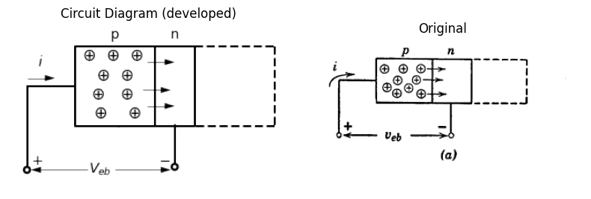
import matplotlib.pyplot as plt
import numpy as np
import schemdraw
from schemdraw import dsp
import schemdraw.elements as e
import matplotlib.image as mpimg
d = schemdraw.Drawing()
mid_bottom = (0.5, -1.5)
mid_bottom2 = (3, 0)
d += ( T1 := dsp.Box(w=1, h=2).anchor('W').label('n', ofst=(0,1.3)))
d += ( T2 := dsp.Box(w=2, h=2).anchor('W').at(T1.E).label('p', ofst=(0,1.3)))
l1 = d.add(e.Line().left().length(2).at(T1.NW).linestyle('--'))
l2 = d.add(e.Line().down().length(2).linestyle('--'))
l3 = d.add(e.Line().right().length(2).linestyle('--'))
l = d.add(e.Line().length(d.unit*0.35).at(mid_bottom).down().anchor('center').dot(open=True))
d += dsp.Line().right().length(d.unit*0.4).at(mid_bottom2)
d += dsp.Line().down().length(d.unit*0.65).dot(open=True)
d += e.Arrow().left().linewidth(0.6).length(1.4).at((1.9, -2)).color('black').label('$-$', loc='end', color='black',ofst=-0.4)
d += e.Arrow().right().linewidth(0.6).length(1.4).at((2.7, -2)).color('black').label('$+$', loc='end', color='black',ofst=(-0.3,0.4))
d += e.Arrow().right().linewidth(0.6).length(1.4).at((1, -2.2)).color('white').label('$V_{cb}$', loc='end', color='black',ofst=(-0.3,0.4))
d += e.Arrow().left().linewidth(0.6).length(0.7).color('black').label('$i$', loc='top', color='black',ofst=0.2).at((4.2,0.3))
d += e.Arrow().right().linewidth(0.6).length(0.7).color('white').label('⊕', loc='top', fontsize=16, color='black',ofst=0.2).at((-0.1,-0.5))
d += e.Arrow().right().linewidth(0.6).length(0.7).color('white').label('⊖', loc='top', fontsize=16, color='black',ofst=0.2).at((1.4,-0.5))
d += e.Arrow().right().linewidth(0.6).length(0.5).color('black').at((0.45,-0.1))
d += e.Arrow().left().linewidth(0.6).length(0.5).color('black').at((1.65,-0.1))
d.save('./Drawings5/5-2bm.png')
d.save('./Drawings5/5-2bm.svg')
fig, axs = plt.subplots(1, 2, figsize=(8, 4))
img = mpimg.imread('./Drawings5/5-2bm.png')
axs[0].imshow(img)
axs[0].axis('off')
axs[0].set_title('Circuit Diagram (developed)')
img_sample = mpimg.imread('./images5/5-2bm.png')
axs[1].imshow(img_sample)
axs[1].axis('off')
axs[1].set_title('Original')
plt.tight_layout()
plt.show()
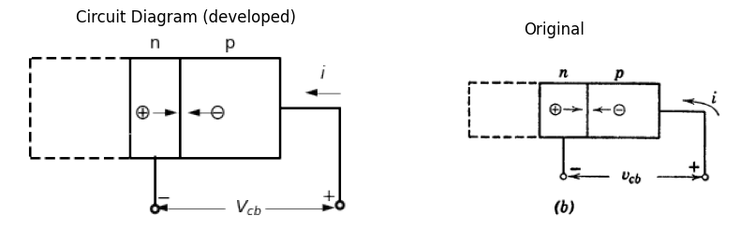
import matplotlib.pyplot as plt
import numpy as np
import schemdraw
from schemdraw import dsp
import schemdraw.elements as e
import matplotlib.image as mpimg
d = schemdraw.Drawing()
mid_bottom = (3.4, -1.5)
d += dsp.Line().length(d.unit*0.3).label('Emitter', loc='top', color='black',ofst=(0.6,-1.45))
d += ( T1 := dsp.Box(w=2, h=2).anchor('W').label('p', ofst=(0,1.3)))
d += ( T2 := dsp.Box(w=1, h=2).anchor('W').at(T1.E).label('n', ofst=(0,1.3)))
d += ( T3 := dsp.Box(w=2, h=2).anchor('W').at(T2.E).label('p', ofst=(0,1.3)))
d += dsp.Line().length(d.unit*0.3).at(T3.E).label('Collector', loc='top', color='black',ofst=(-0.5,-1.45))
d += dsp.Line().down().length(d.unit*0.65).dot(open=True)
d += dsp.Line().down().length(d.unit*0.65).at((0,0)).label('$Base$', ofst=(0.6,3)).dot(open=True)
l = d.add(e.Line().length(d.unit*0.3).at(mid_bottom).down().anchor('center').dot(open=True))
d += e.Arrow().left().linewidth(0.6).length(0.7).color('black').label('$i_c$', loc='top', color='black',ofst=0.2).at((6.8,0.3))
d += e.Arrow().right().linewidth(0.6).length(0.7).color('white').label('⊕ ⊕ ⊕ ⊕\n⊕ ⊕ ⊕ ⊕\n⊕ ⊕ ⊕ ⊕', loc='top', fontsize=16, color='black',ofst=0.2).at((1.5,-0.8))
d += e.Arrow().right().linewidth(0.6).length(0.7).color('white').label('⊕', loc='top', fontsize=16, color='black',ofst=0.2).at((3.2,0.2))
d += e.Arrow().right().linewidth(0.6).length(0.7).color('white').label('⊕', loc='top', fontsize=16, color='black',ofst=0.2).at((4,-0.3))
d += e.Arrow().right().linewidth(0.6).length(0.8).color('black').at((2.6,0.6))
d += e.Arrow().right().linewidth(0.6).length(1.2).color('black').at((2.6,0.8))
d += e.Arrow().right().linewidth(0.6).length(1.2).color('black').at((2.6,0.4))
d += e.Arrow().right().linewidth(0.6).length(1.6).color('black').at((2.6,0.1))
d += e.Arrow().linewidth(0.6).length(0.9).color('black').theta(-40).at((2.6,-0.1))
d += e.Arrow().left().linewidth(0.6).length(1.3).at((1.4, -2)).color('black').label('$+$', loc='end', color='black',ofst=-0.4)
d += e.Arrow().right().linewidth(0.6).length(1.3).at((2, -2)).color('black').label('$-$', loc='end', color='black',ofst=(-0.3,0.4))
d += e.Arrow().right().linewidth(0.6).length(1.4).at((0.3, -2.2)).color('white').label('$V_{eb}$', loc='end', color='black',ofst=(-0.3,0.4))
d += e.Arrow().right().linewidth(0.6).length(0.7).color('black').label('$i_e$', loc='top', color='black',ofst=0.2).at((0,0.3))
d += e.Arrow().left().linewidth(0.6).length(1.3).at((4.9, -2)).color('black').label('$-$', loc='end', color='black',ofst=-0.4)
d += e.Arrow().right().linewidth(0.6).length(1.3).at((5.5, -2)).color('black').label('$+$', loc='end', color='black',ofst=(-0.3,0.4))
d += e.Arrow().right().linewidth(0.6).length(1.4).at((3.8, -2.2)).color('white').label('$V_{cb}$', loc='end', color='black',ofst=(-0.3,0.4))
d += e.Arrow().up().linewidth(0.6).length(0.5).color('black').label('$i_b$', loc='top', color='black',ofst=-0.4).at((3.6,-1.6))
d.draw()
d.save('./Drawings5/5-2cm.png')
d.save('./Drawings5/5-2cm.svg')
fig, axs = plt.subplots(1, 2, figsize=(8, 4))
img = mpimg.imread('./Drawings5/5-2cm.png')
axs[0].imshow(img)
axs[0].axis('off')
axs[0].set_title('Circuit Diagram (developed)')
img_sample = mpimg.imread('./images5/5-2cm.png')
axs[1].imshow(img_sample)
axs[1].axis('off')
axs[1].set_title('Original')
plt.tight_layout()
plt.show()
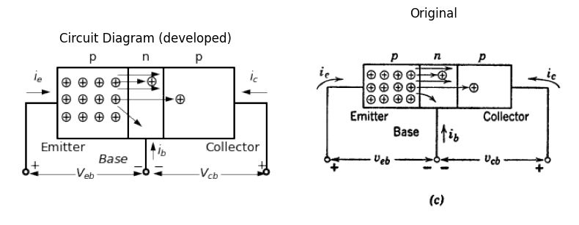
import matplotlib.pyplot as plt
import numpy as np
import matplotlib.image as mpimg
from matplotlib.gridspec import GridSpec
fig = plt.figure(figsize=(12, 9))
gs = GridSpec(3, 2, width_ratios=[1, 2])
ax1 = fig.add_subplot(gs[0, 0])
ax1.set_title('V-I Curve')
a=0.03
b=0.026
#y = np.exp(-x)
x1 = np.linspace(0, 5, 500)
y1=b*np.log((x1+a)/a)
ax1.plot(x1, y1, color='black', linewidth=3)
ax1.set_xlim([-0.5, 1.2])
ax1.set_ylim([-0.2,0.6])
ax2 = fig.add_subplot(gs[1, 0])
x2 = -np.linspace(-0.005, 5, 500)
y2 = -b * np.exp(-x2 /a)+b
ax2.plot(x2, y2, color='black', linewidth=3)
ax2.set_xlim([-0.5, 1.2])
ax2.set_ylim([-0.9,0.3])
ax3 = fig.add_subplot(gs[2, 0])
alpha = 0.4
x = -np.linspace(0, 5, 500)
x0 = -np.linspace(alpha, 5, 500)
x00 = -np.linspace(2*alpha, 5, 500)
y = -b * np.exp(-x / a)+b
y0 = -b * np.exp(-(x0 + alpha) / a) + b
y00 = -b * np.exp(-(x00 + 2*alpha) / a) + b
ax3.plot(x, y, color='black', linewidth=3)
ax3.plot(x0, y0, color='black', linewidth=3)
ax3.plot(x00, y00, color='black', linewidth=3)
x4 = np.linspace(0, 0.3, 500)
y4=b*np.log((x4+1*a)/(1*a))
x5 = np.linspace(-alpha, 0.3-alpha, 500)
y5=b*np.log(((x5+alpha)+(1*a))/(1*a))
x6 = np.linspace(-2*alpha, 0.3-(2*alpha), 500)
y6=b*np.log(((x6+2*alpha)+(1*a))/(1*a))
ax3.plot(x4, y4, color='black',linestyle='--')
ax3.plot(x5, y5, color='black',linestyle='--')
ax3.plot(x6, y6, color='black',linestyle='--')
ax3.set_xlim([-1.2, 0.5])
ax3.set_ylim([-0.9,0.3])
ax_big = fig.add_subplot(gs[:, 1])
ax_big.axis('off')
img_sample = mpimg.imread('./images5/5-2n.png')
ax_big.imshow(img_sample)
ax_big.set_title('Original')
axes = [ax1, ax2, ax3]
for ax in axes:
ax.spines['top'].set_color('none')
ax.spines['right'].set_color('none')
ax.spines['left'].set_position('zero')
ax.spines['bottom'].set_position('zero')
ax.spines['left'].set_linewidth(2)
ax.spines['bottom'].set_linewidth(2)
ax.xaxis.set_ticks_position('bottom')
ax.yaxis.set_ticks_position('left')
ax.tick_params(axis='both', which='both', length=0)
ax.set_xticks([])
ax.set_yticks([])
ax.set_xlabel('i', labelpad=3, loc='right')
ax.set_aspect('equal', adjustable='box')
plt.tight_layout()
plt.show()
plt.tight_layout()
plt.show()
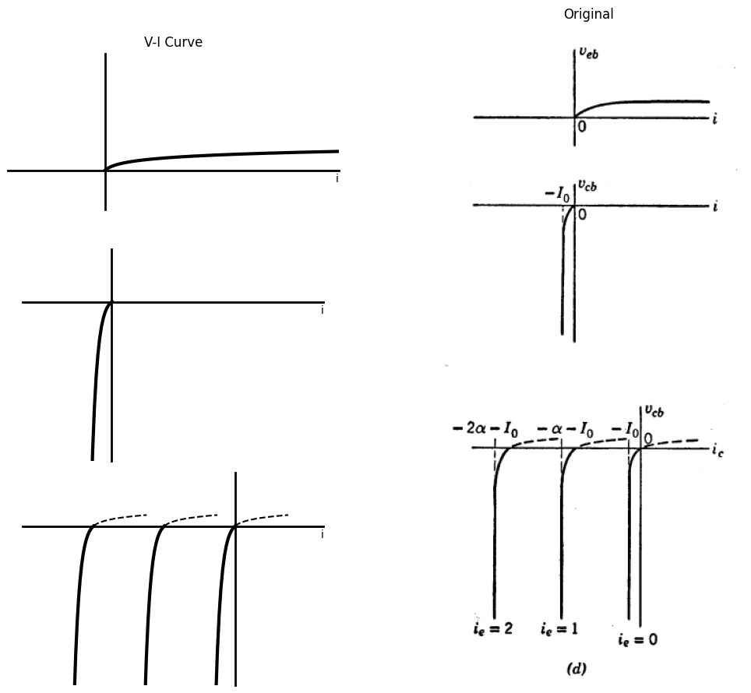
<Figure size 640x480 with 0 Axes>
Fig. 5.2. Injection of holes by the emitter in p-n-p type transistors. (a) Forward bias (Veb > 0); (b) Reverse bias (Veb < 0); (c) p-n-p transistor; (d) Collector curves (Vcb vs. ic).
Combining these two diodes to form a p-n-p transistor, as shown in Fig. 5.2(c), we find that the emitter injects holes into the base across the forward-biased p-n junction. Once across the junction, the holes diffuse through the base. Those that diffuse across to the n-p junction are then in a field of attraction caused by the reverse bias on that junction, and thus flow across to the collector, causing a large increase in collector current. In most junction transistors, 95 percent or more of the holes injected into the base from the emitter will reach the collector. The distance across the base is made very small, and in the alloy junction, the collector cross-section is often made larger than that of the emitter in order to enhance the collection of the majority carriers.
The sketch of Vcb vs. ic shown in Fig. 5.2(d) is typical of junction-transistor collector curves. If ie equals 0, the current -I0 is the same as for the diode shown in Fig. 5.2(b). When ie is greater than 0, we can envisage the majority-carrier injection as providing a current source of magnitude αie in the collector circuit, producing a change in current ic = -αie. This shifts the Vcb vs. -ic curve parallel to itself, as shown for a number of values of ie. For each value of ie, the curve of Vcb vs. ic is just like a diode curve with a shift controlled by ie.

1.3 5.3 Electrical Conduction in n-p-n Junction Transistor
In n-p-n transistors, electrons are the majority carriers; hence, a discussion of these units is like that for the p-n-p transistors provided all polarities are reversed and the roles of electrons and holes are interchanged. The possibility of exploiting either a positive or a negative charge carrier provides a great deal of flexibility in transistor circuit design.
Referring to Fig. 5.3 we see that the n-p-n unit can be envisioned as two n-p junctions, one from emitter to base and the other from collector to base. Reference directions for currents and voltages are the same as those in Fig. 5.2, so that veₑ in Fig. 5.3(a) must now be negative to cause the majority carriers (electrons) to migrate freely from emitter to base. Since conventional current (motion of positive charge) is opposite to electron current, the emitter current is negative in this case. To provide reverse bias for the collector junction, the voltage vcₑ in Fig. 5.3(b) must be positive so that electrons are attracted to the collector after diffusing through the base. Electrons emerging from the collector terminal constitute a current into the terminal; hence, ic is positive. The polarity changes are indicated by the curves of Fig. 5.3, which should be compared with the corresponding curves in Fig. 5.2.
Ability to deal with both p-n-p and n-p-n transistors is important in circuit design; but since the difference between them is really one of detail, no purpose is served by duplicate analyses of p-n-p and n-p-n transistor circuits. In the remainder of the chapter, we shall discuss circuit models and basic circuits for p-n-p transistors. The methods and results are readily transferred to n-p-n transistors.
import matplotlib.pyplot as plt
import numpy as np
import schemdraw
from schemdraw import dsp
import schemdraw.elements as e
import matplotlib.image as mpimg
d = schemdraw.Drawing()
mid_bottom = (3.7, 0.6)
d += dsp.Line().up().length(d.unit*0.7).idot(open=True)
d += dsp.Line().right().length(d.unit*0.4)
d += ( T1 := dsp.Box(w=2, h=2).anchor('W').label('n', ofst=(0,1.3)))
d += ( T2 := dsp.Box(w=1, h=2).anchor('W').at(T1.E).label('p', ofst=(0,1.3)))
l1 = d.add(e.Line().length(2).at(T2.NE).linestyle('--'))
l2 = d.add(e.Line().down().length(2).linestyle('--'))
l3 = d.add(e.Line().left().length(2).linestyle('--'))
l = d.add(e.Line().length(d.unit*0.35).at(mid_bottom).down().anchor('center').dot(open=True))
d += e.Arrow().left().linewidth(0.6).length(1.4).at((1.5, 0)).color('black').label('$+$', loc='end', color='black',ofst=-0.4)
d += e.Arrow().right().linewidth(0.6).length(1.4).at((2.2, 0)).color('black').label('$-$', loc='end', color='black',ofst=(-0.3,0.4))
d += e.Arrow().right().linewidth(0.6).length(1.4).at((0.45, -0.2)).color('white').label('$V_{eb}$', loc='end', color='black',ofst=(-0.3,0.4))
d += e.Arrow().right().linewidth(0.6).length(0.7).color('black').label('$i_e$', loc='top', color='black',ofst=0.2).at((0,2.3))
d += e.Arrow().right().linewidth(0.6).length(0.7).color('white').label('⊖ ⊖ ⊖ ⊖\n⊖ ⊖ ⊖\n⊖ ⊖ ⊖ ⊖', loc='top', fontsize=16, color='black',ofst=0.2).at((1.8,1.2))
d += e.Arrow().right().linewidth(0.6).length(0.7).color('black').at((2.9,2))
d += e.Arrow().right().linewidth(0.6).length(0.7).color('black').at((3,2.7))
d += e.Arrow().right().linewidth(0.6).length(0.7).color('black').at((3,1.6))
d.save('./Drawings5/5-3am.png')
d.save('./Drawings5/5-3am.svg')
fig, axs = plt.subplots(1, 2, figsize=(8, 4))
img = mpimg.imread('./Drawings5/5-3am.png')
axs[0].imshow(img)
axs[0].axis('off')
axs[0].set_title('Circuit Diagram (developed)')
img_sample = mpimg.imread('./images5/5-3am.png')
axs[1].imshow(img_sample)
axs[1].axis('off')
axs[1].set_title('Original')
plt.tight_layout()
plt.show()
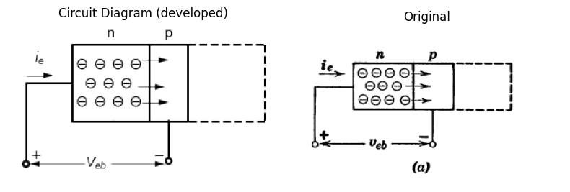
import matplotlib.pyplot as plt
import numpy as np
import schemdraw
from schemdraw import dsp
import schemdraw.elements as e
import matplotlib.image as mpimg
d = schemdraw.Drawing()
mid_bottom = (0.5, -1.5)
mid_bottom2 = (3, 0)
d += ( T1 := dsp.Box(w=1, h=2).anchor('W').label('p', ofst=(0,1.3)))
d += ( T2 := dsp.Box(w=2, h=2).anchor('W').at(T1.E).label('n', ofst=(0,1.3)))
l1 = d.add(e.Line().left().length(2).at(T1.NW).linestyle('--'))
l2 = d.add(e.Line().down().length(2).linestyle('--'))
l3 = d.add(e.Line().right().length(2).linestyle('--'))
l = d.add(e.Line().length(d.unit*0.35).at(mid_bottom).down().anchor('center').dot(open=True))
d += dsp.Line().right().length(d.unit*0.4).at(mid_bottom2)
d += dsp.Line().down().length(d.unit*0.65).dot(open=True)
d += e.Arrow().left().linewidth(0.6).length(1.4).at((1.9, -2)).color('black').label('$-$', loc='end', color='black',ofst=-0.4)
d += e.Arrow().right().linewidth(0.6).length(1.4).at((2.7, -2)).color('black').label('$+$', loc='end', color='black',ofst=(-0.3,0.4))
d += e.Arrow().right().linewidth(0.6).length(1.4).at((1, -2.2)).color('white').label('$V_{cb}$', loc='end', color='black',ofst=(-0.3,0.4))
d += e.Arrow().left().linewidth(0.6).length(0.7).color('black').label('$i_c$', loc='top', color='black',ofst=0.2).at((4.2,0.3))
d += e.Arrow().right().linewidth(0.6).length(0.7).color('white').label('⊖', loc='top', fontsize=16, color='black',ofst=0.2).at((-0.1,-0.5))
d += e.Arrow().right().linewidth(0.6).length(0.7).color('white').label('⊕', loc='top', fontsize=16, color='black',ofst=0.2).at((1.4,-0.5))
d += e.Arrow().right().linewidth(0.6).length(0.5).color('black').at((0.45,-0.1))
d += e.Arrow().left().linewidth(0.6).length(0.5).color('black').at((1.65,-0.1))
d.save('./Drawings5/5-3bm.png')
d.save('./Drawings5/5-3bm.svg')
fig, axs = plt.subplots(1, 2, figsize=(8, 4))
img = mpimg.imread('./Drawings5/5-3bm.png')
axs[0].imshow(img)
axs[0].axis('off')
axs[0].set_title('Circuit Diagram (developed)')
img_sample = mpimg.imread('./images5/5-3bm.png')
axs[1].imshow(img_sample)
axs[1].axis('off')
axs[1].set_title('Original')
plt.tight_layout()
plt.show()
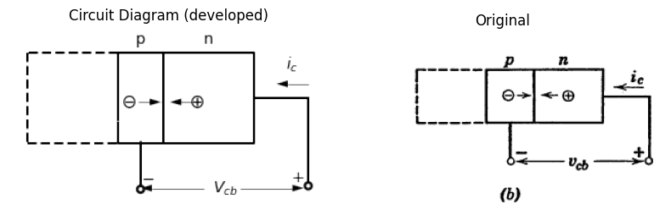
import matplotlib.pyplot as plt
import numpy as np
import schemdraw
from schemdraw import dsp
import schemdraw.elements as e
import matplotlib.image as mpimg
d = schemdraw.Drawing()
mid_bottom = (3.4, -1.7)
d += dsp.Line().length(d.unit*0.3).label('Emitter', loc='top', color='black',ofst=(0.6,-1.45))
d += ( T1 := dsp.Box(w=2, h=2).anchor('W').label('n', ofst=(0,1.3)))
d += ( T2 := dsp.Box(w=1, h=2).anchor('W').at(T1.E).label('p', ofst=(0,1.3)))
d += ( T3 := dsp.Box(w=2, h=2).anchor('W').at(T2.E).label('n', ofst=(0,1.3)))
d += dsp.Line().length(d.unit*0.3).at(T3.E).label('Collector', loc='top', color='black',ofst=(-0.5,-1.45))
d += dsp.Line().down().length(d.unit*0.8)
d += dsp.Line().down().length(d.unit*0.8).at((0,0)).label('$Base$', ofst=(0.6,3))
E1 = d.add(e.Battery().right().reverse().label('- +', ofst=(0,-0.8)))
d += dsp.Line().right().length(0.8)
E2 = d.add(e.Battery().right().reverse().label('- +',ofst=(0,-0.8)))
l = d.add(e.Line().length(d.unit*0.45).at(mid_bottom).down().anchor('center'))
d += e.Arrow().left().linewidth(0.6).length(0.7).color('black').label('$i_c$', loc='top', color='black',ofst=0.2).at((6.8,0.3))
d += e.Arrow().right().linewidth(0.6).length(0.7).color('white').label('⊖ ⊖ ⊖ ⊖\n⊖ ⊖ ⊖ ⊖\n⊖ ⊖ ⊖ ⊖', loc='top', fontsize=16, color='black',ofst=0.2).at((1.5,-0.8))
d += e.Arrow().right().linewidth(0.6).length(0.7).color('white').label('⊖', loc='top', fontsize=16, color='black',ofst=0.2).at((4,0))
d += e.Arrow().right().linewidth(0.6).length(0.7).color('white').label('⊖', loc='top', fontsize=16, color='black',ofst=0.2).at((3.2,-0.3))
d += e.Arrow().right().linewidth(0.6).length(1).color('black').at((2.6,0.7))
d += e.Arrow().right().linewidth(0.6).length(1.7).color('black').at((2.6,0.4))
d += e.Arrow().right().linewidth(0.6).length(0.9).color('black').at((2.6,0.1))
d += e.Arrow().right().linewidth(0.6).length(0.8).color('black').at((2.6,-0.2))
d += e.Arrow().right().linewidth(0.6).length(0.9).color('black').at((2.6,-0.5))
d += e.Arrow().linewidth(0.6).length(0.6).color('black').theta(60).at((2.9,-1.5))
d += e.Arrow().right().linewidth(0.6).length(1.4).at((0.3, -2.2)).color('white').label('$V_{eb}$', loc='end', color='black',ofst=(-0.35,-0.6))
d += e.Arrow().right().linewidth(0.6).length(0.7).color('black').label('$i_e$', loc='top', color='black',ofst=0.2).at((0,0.3))
d += e.Arrow().right().linewidth(0.6).length(1.4).at((3.8, -2.2)).color('white').label('$V_{cb}$', loc='end', color='black',ofst=(-0.26,-0.6))
d += e.Arrow().up().linewidth(0.6).length(0.5).color('black').label('$i_b$', loc='top', color='black',ofst=-0.4).at((3.6,-1.6))
d.draw()
d.save('./Drawings5/5-3cm.png')
d.save('./Drawings5/5-3cm.svg')
fig, axs = plt.subplots(1, 2, figsize=(8, 4))
img = mpimg.imread('./Drawings5/5-3cm.png')
axs[0].imshow(img)
axs[0].axis('off')
axs[0].set_title('Circuit Diagram (developed)')
img_sample = mpimg.imread('./images5/5-3cm.png')
axs[1].imshow(img_sample)
axs[1].axis('off')
axs[1].set_title('Original')
plt.tight_layout()
plt.show()
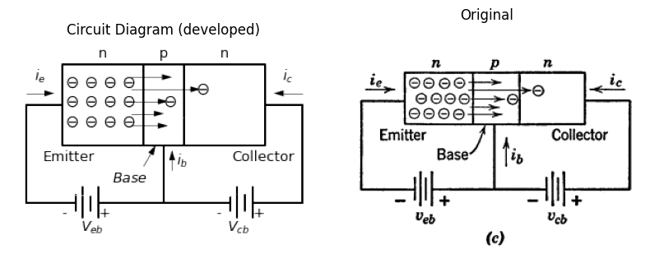
import matplotlib.pyplot as plt
import numpy as np
import matplotlib.image as mpimg
from matplotlib.gridspec import GridSpec
fig = plt.figure(figsize=(12, 9))
gs = GridSpec(3, 2, width_ratios=[1, 2])
ax1 = fig.add_subplot(gs[0, 0])
ax1.set_title('V-I Curve')
a=0.03
b=0.026
#y = np.exp(-x)
x1 = -np.linspace(0, 5, 500)
y1=-b*np.log((-x1+a)/a)
ax1.plot(x1, y1, color='black', linewidth=3)
ax1.set_xlim([-1, 1])
ax1.set_ylim([-0.6,0.6])
ax2 = fig.add_subplot(gs[1, 0])
x2 = np.linspace(-0.005, 5, 500)
y2 = b * np.exp(x2 /a)-b
ax2.plot(x2, y2, color='black', linewidth=3)
ax2.set_xlim([-1, 1])
ax2.set_ylim([-0.6,0.6])
ax3 = fig.add_subplot(gs[2, 0])
alpha = 0.4
x = np.linspace(0, 10, 500)
x0 = np.linspace(alpha, 10, 500)
x00 = np.linspace(2*alpha, 10, 500)
y = b * np.exp(x / a)-b
y0 = b * np.exp((x0 - alpha) / a) - b
y00 = b * np.exp((x00 - 2*alpha) / a) - b
ax3.plot(x, y, color='black', linewidth=3)
ax3.plot(x0, y0, color='black', linewidth=3)
ax3.plot(x00, y00, color='black', linewidth=3)
x00 = np.linspace(3*alpha, 10, 500)
y00 = b * np.exp((x00 - 3*alpha) / a) - b
ax3.plot(x00, y00, color='black', linewidth=3)
ax3.set_xlim([-0.2, 2])
ax3.set_ylim([-0.2,2])
ax_big = fig.add_subplot(gs[:, 1])
ax_big.axis('off')
img_sample = mpimg.imread('./images5/5-3n.png')
ax_big.imshow(img_sample)
ax_big.set_title('Original')
axes = [ax1, ax2, ax3]
for ax in axes:
ax.spines['top'].set_color('none')
ax.spines['right'].set_color('none')
ax.spines['left'].set_position('zero')
ax.spines['bottom'].set_position('zero')
ax.spines['left'].set_linewidth(2)
ax.spines['bottom'].set_linewidth(2)
ax.xaxis.set_ticks_position('bottom')
ax.yaxis.set_ticks_position('left')
ax.tick_params(axis='both', which='both', length=0)
ax.set_xticks([])
ax.set_yticks([])
ax.set_xlabel('i', labelpad=3, loc='right')
ax.set_aspect('equal', adjustable='box')
plt.tight_layout()
plt.show()
plt.tight_layout()
plt.show()
plt.savefig('./Drawings5/5-3n.jpg')
plt.savefig('./Drawings5/5-3n.svg')
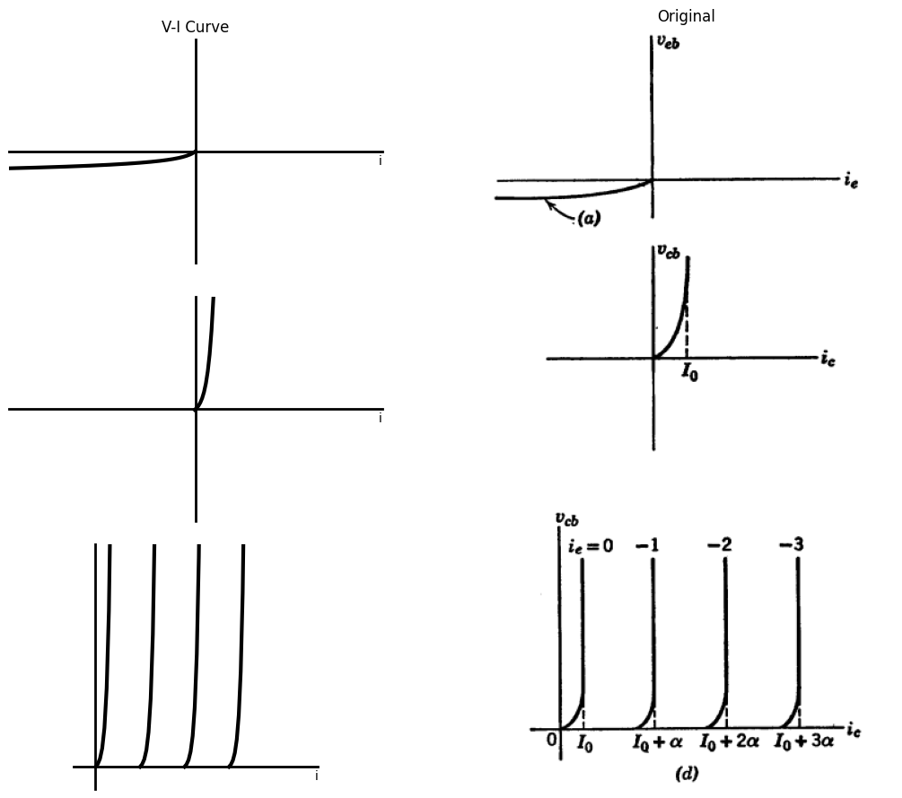
<Figure size 640x480 with 0 Axes>
<Figure size 640x480 with 0 Axes>
Fig. 5.3. Injection of Electrons by the emitter in n-p-n Type Junction Transistors .
(a) Forward bias $ (v_{eb} < 0) $; (b) Reverse bias $\left(v_{cb}>0\right)$; (c) n-p-n transistor; (d) Collector curves $( v_{cb} $ vs. $ i_c )$.

1.4 5.4 Variational Voltage Gain and Power Gain
The foregoing discussion indicated the basic structure of a transistor to be two diodes with a common element, namely the base. Furthermore, the curves relating collector current and collector-to-base voltage are merely diode curves biased or polarized by an amount depending on emitter current. Transistors are therefore transfer or control valves in contrast with diodes, which can be called self-operated valves. The property of a control valve that is of greatest interest is the capability for producing variational power amplification. The resistance $ r_e $ between emitter and base with forward bias applied is likely to be as low as 50 to 100 ohms. On the other hand, the resistance between collector and base when the output circuit is reverse biased may be as large as 1 megohm or more. Thus a series resistor $ R_c $ of a few kilohms (say, 10kΩ) could be inserted in the collector circuit, as in Fig. 5.4, without appreciably altering the current flow. In this example, the current gain might be 0.95. However, for a large ratio of $ R_c $ to $ R_{in} $, the variational voltage gain and the variational power gain are both considerably greater than unity, as can be seen from the expressions in Fig. 5.4.
import matplotlib.pyplot as plt
import numpy as np
import schemdraw
from schemdraw import dsp
import schemdraw.elements as e
import matplotlib.image as mpimg
d = schemdraw.Drawing()
mid_bottom = (3.4, -1.7)
d += dsp.Line().length(d.unit*0.3)
d += ( T1 := dsp.Box(w=2, h=2).anchor('W').label('p'))
d += ( T2 := dsp.Box(w=1, h=2).anchor('W').at(T1.E).label('n'))
d += ( T3 := dsp.Box(w=2, h=2).anchor('W').at(T2.E).label('p'))
d += dsp.Line().length(d.unit*0.3).at(T3.E)
d += dsp.Line().down().length(d.unit*0.01)
d += dsp.Line().down().length(d.unit*0.01).at((0,0))
R1 = d.add(e.Resistor(l=1.2).down().label('$R_e$', ofst=-1))
V = d.add(e.SourceV(l=1.2).reverse().down().label('$e_1$'))
E1 = d.add(e.Battery().right().label('+ -', ofst=(0,-0.8)))
d += dsp.Line().right().length(0.8)
E2 = d.add(e.Battery().right().label('+ -',ofst=(0,-0.8)))
R2 = d.add(e.Resistor(l=2.4).up().label('$R_c$', ofst=-1))
l = d.add(e.Line().length(d.unit*0.45).at(mid_bottom).down().anchor('center'))
d += e.Arrow().left().linewidth(0.6).length(0.7).color('black').label('$i_c$', loc='top', color='black',ofst=0.2).at((6.8,0.3))
d += e.Arrow().right().linewidth(0.6).length(1.4).at((0.3, -2.2)).color('white').label('$V_e$', loc='end', color='black',ofst=(-0.35,-0.6))
d += e.Arrow().right().linewidth(0.6).length(0.7).color('black').label('$i_e$', loc='top', color='black',ofst=0.2).at((0,0.3))
d += e.Arrow().right().linewidth(0.6).length(1.4).at((3.8, -2.2)).color('white').label('$V_c$', loc='end', color='black',ofst=(-0.26,-0.6))
d += e.Arrow().up().linewidth(0.6).length(0.5).color('black').label('$i_b$', loc='top', color='black',ofst=-0.4).at((3.6,-1.6))
d += e.Arrow().up().length(0.8).linewidth(0.6).color('black').label('+',loc='end', color='black',ofst=0.4). at((8.4,-0.8))
d += e.Arrow().down().length(0.8).linewidth(0.6).color('black').label(r'_', loc='end', color='black',ofst=(-0.3,-0.3)). at((8.4,-1.5))
d += e.Arrow().up().length(3).linewidth(0.6).color('white').label('$V_c$', loc='start', color='black',ofst=0.3). at((8.9,-1))
l3 = d.add(e.Line().right().length(1.4).color('white').at(R2.end))
l32 = d.add(e.Line().right().length(0.5))
l4 = d.add(e.Line().right().length(1.4).color('white').at(R2.start))
l42 = d.add(e.Line().right().length(0.5))
d.draw()
d.save('./Drawings5/5-4m.png')
d.save('./Drawings5/5-4m.svg')
fig, axs = plt.subplots(1, 2, figsize=(8, 4))
img = mpimg.imread('./Drawings5/5-4m.png')
axs[0].imshow(img)
axs[0].axis('off')
axs[0].set_title('Circuit Diagram (developed)')
img_sample = mpimg.imread('./images5/5-4m.png')
axs[1].imshow(img_sample)
axs[1].axis('off')
axs[1].set_title('Original')
plt.tight_layout()
plt.show()
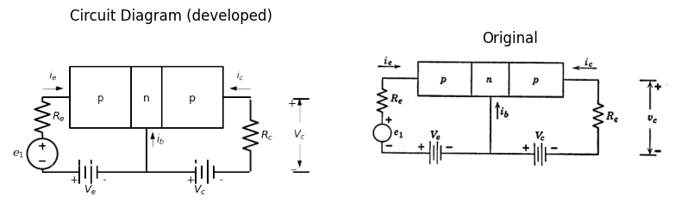
Variational current gain = $\alpha = -\frac{\Delta i_c}{\Delta i_e} $
Input resistance = $ R_{in} = \frac{\Delta e_1}{\Delta i_e} $
Variational voltage gain = $ \frac{\Delta V_c}{\Delta e_1} \approx \frac{R_c \alpha \Delta i_e}{R_{in} \Delta i_e} \approx \frac{\alpha R_c}{R_{in}} $
Variational power gain = $\frac{-\Delta v_c \Delta i_c}{\Delta e_1 \Delta i_e} \approx \frac{R_c \alpha^2 (\Delta i_e)^2}{R_{in} (\Delta i_e)^2} \approx \frac{\alpha^2 R_c}{R_{in}} $
Fig. 5.4 Variational gain.
Variational power amplification leads to the more useful functions performed by transistors or other control valves. Voltage or current amplification is often an important function, but the existence of one or both is really an incidental by-product of power amplification. After all, an ordinary linear transformer with a turns ratio of $ n $ (actually, slightly less) and a current ratio of $ 1/n $. If $ n $ is greater than 1, this corresponds to a voltage gain and current attenuation. If $ n $ is less than 1, the transformer has a current gain and voltage attenuation. In either case, the power gain $ (e_{2}i_{2}/e_{1}i_{1})$ from primary to secondary is less than unity and approaches unity only for an ideal transformer. The power amplification attributed to transistors (or other control valves, such as vacuum triodes and pentodes) must satisfy the conservation-of-energy principle. Power must be supplied to the transistor and its associated circuit by means of bias-voltage sources. The transistor (or any other control valve) merely permits a small source of power to control a large source of power. Thus, the input-to-output power gain exists in the variational sense but not in terms of total voltages and currents.

1.5 5.5 Ideal-Diode Model for p-n-p Junction Transistor
Let us postulate a simple circuit model to approximate the behavior of the p-n-p transistor discussed in Article 5.2. The model shown in
import matplotlib.pyplot as plt
import numpy as np
import schemdraw
from schemdraw import dsp
import schemdraw.elements as e
import matplotlib.image as mpimg
d = schemdraw.Drawing()
D1 = d.add(e.Diode(fill=True).right().label('$D_e$',ofst=-1).dot().idot(open=True))
l1 = d.add(e.Line().down().dot(open=True))
l2 = d.add(e.Line(l=0.6).right().at(l1.start))
D2 = d.add(e.Diode(l=1.5,fill=True).reverse().right().at(l2.end).label('$D_c$',ofst=-1).idot().dot())
l3 = d.add(e.Line(l=0.6).right().dot(open=True))
l4 = d.add(e.Line(l=1.3).up().at(D2.start))
I = d.add(e.SourceI(l=1.5).right().label('a$i_e+I_0$'))
l4 = d.add(e.Line(l=1.3).down())
d += e.Gap().right().label('Emitter',fontsize = 12).color('black').at((-2.2,0.1))
d += e.Gap().right().label('Collector',fontsize = 12).color('black').at((5,0.1))
d += e.Gap().right().label('Base',fontsize = 12).color('black').at((1.6,-3.2))
d += e.Arrow().left().linewidth(0.6).length(0.7).color('black').label('$i_c$', loc='top', color='black',ofst=0.2).at((6,0.3))
d += e.Arrow().right().linewidth(0.6).length(0.7).color('black').label('$i_e$', loc='top', color='black',ofst=0.2).at((0,0.3))
d += e.Arrow().up().linewidth(0.6).length(0.7).color('black').label('$i_b$', loc='top', color='black',ofst=-0.4).at((3.2,-1.9))
d += e.Arrow().length(1.5).at((4.8, -1.6)).label('+', ofst=(0.7,-0.4)).theta(60)
d += e.Arrow().length(1.5).at((4.3, -2.2)).label('-', ofst=(0.7,0.4)).theta(-150)
d += e.Arrow().length(1.5).at((1.6, -2.2)).label('-', ofst=(0.7,-0.4)).theta(-30)
d += e.Arrow().length(1.5).at((1, -1.5)).label('+', ofst=(0.7,0.4)).theta(120)
d += e.Gap().right().label('$v_{eb}$',fontsize = 12).color('black').at((-0.4,-1.8))
d += e.Gap().right().label('$v_{cb}$',fontsize = 12).color('black').at((3.2,-1.8))
d.draw()
d.save('./Drawings5/5-5m.png')
d.save('./Drawings5/5-5m.svg')
fig, axs = plt.subplots(1, 2, figsize=(8, 4))
img = mpimg.imread('./Drawings5/5-5m.png')
axs[0].imshow(img)
axs[0].axis('off')
axs[0].set_title('Circuit Diagram (developed)')
img_sample = mpimg.imread('./images5/5-5m.png')
axs[1].imshow(img_sample)
axs[1].axis('off')
axs[1].set_title('Original')
plt.tight_layout()
plt.show()
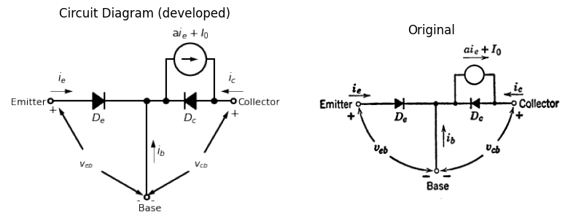
import matplotlib.pyplot as plt
import numpy as np
import matplotlib.image as mpimg
from matplotlib.gridspec import GridSpec
import matplotlib.pyplot as plt
fig = plt.figure(figsize=(10, 10))
gs = GridSpec(2, 2, width_ratios=[1, 1])
ax0 = fig.add_subplot(gs[0, 0])
def custom_function(x,a):
return np.where(x < a, -50, 0)
a1 = 0
x1 = np.linspace(-20, 20, 500)
y1 = custom_function(x1,a1)
ax0.plot(x1, y1, 'black', linewidth=3.5)
ax0.set_title('V-I Curve')
ax0.set_ylabel('$v_{eb}=f_1(i_e,i_c)$', labelpad=3, loc='top')
ax0.set_xlim(-5, 10)
ax0.set_ylim(-10, 5)
ax0.set_xlabel('$i_e$', labelpad=3, loc='right')
plt.axhline(0, color='black', linewidth=1)
plt.axvline(0, color='black', linewidth=1)
ax1 = fig.add_subplot(gs[0, 1])
a2 = -0.5
x2 = np.linspace(-20, 20, 500)
y2 = custom_function(x2,a2)
ax1.plot(x2, y2, 'black', linewidth=3)
a3 = -3
y3 = custom_function(x2,a3)
ax1.plot(x2, y3, 'black', linewidth=3)
a4 = -5.5
y4 = custom_function(x2,a4)
ax1.plot(x2, y4, 'black', linewidth=3)
a5 = -8
y5 = custom_function(x2,a5)
ax1.plot(x2, y5, 'black', linewidth=3)
ax1.set_xlim(-10, 5)
ax1.set_ylim(-10, 5)
ax1.set_xlabel('$i_c$', labelpad=3, loc='right')
ax1.set_ylabel('$v_{cb}=f_2(i_e,i_c)$', labelpad=3, loc='top')
ax1.set_title('V-I Curve')
ax2 = fig.add_subplot(gs[1, :])
img_sample = mpimg.imread('./images5/5-5n.png')
ax2.imshow(img_sample)
ax2.set_title('Original')
ax2.axis('off')
axes = [ax0, ax1]
for a in axes:
a.spines['top'].set_color('none')
a.spines['right'].set_color('none')
a.spines['left'].set_position('zero')
a.spines['bottom'].set_position('zero')
a.spines['left'].set_linewidth(2)
a.spines['bottom'].set_linewidth(2)
a.xaxis.set_ticks_position('bottom')
a.yaxis.set_ticks_position('left')
a.tick_params(axis='both', which='both', length=0)
a.set_xticks([])
a.set_yticks([])
a.set_aspect('equal', adjustable='box')
plt.tight_layout()
plt.show()
plt.tight_layout()
plt.show()
plt.savefig('./Drawings5/5-5n.jpg')
plt.savefig('./Drawings5/5-5n.svg')
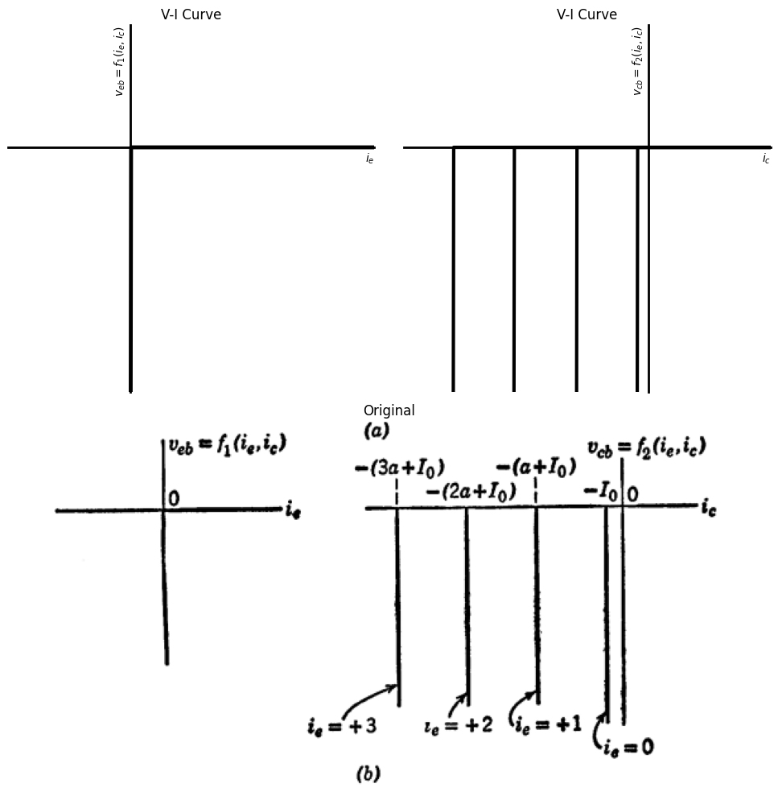
<Figure size 640x480 with 0 Axes>
<Figure size 640x480 with 0 Axes>
Note: Since $i_e + i_b + i_c $ = 0, we have the following relations for $ D_e $ closed and $ D_c $ open:
$ i_c = -I_0 - ai_e, \quad \frac{\Delta i_c}{\Delta i_e} = -a$
$ i_b = I_0 - (1 - a)i_e, \quad \frac{\Delta i_e}{\Delta i_b} = -\frac{1}{(1 - a)}$
$ i_c = \frac{(-I_0 + ai_b)}{(1 - a)}, \quad \frac{\Delta i_c}{\Delta i_b} = \frac{a}{(1 - a)}$
Fig. 5.5 Ideal-diode model for p-n-p junction transistor.
Fig. 5.5(a), based on the physical structure of the p-n-p junction transistor, contains two ideal diodes, one from emitter to base and one from collector to base. The dependent current source $ai_{e}$ accounts for the influence of the emitter current on the collector current. The constant $\alpha $ is chosen to match the variational current gain $ \left( \frac{\partial i_c}{\partial i_e} \text{ for } v_{cb} \text{ constant} \right) $ of the transistor being represented by the model. The model has a constant current of magnitude $ I_0 $ to represent the small reverse current in the collector diode.
import matplotlib.pyplot as plt
import numpy as np
import schemdraw
from schemdraw import dsp
import schemdraw.elements as e
import matplotlib.image as mpimg
d = schemdraw.Drawing()
D1 = d.add(e.Diode(fill=True).reverse().right().label('$D_e$',ofst=-1).dot().idot(open=True))
l1 = d.add(e.Line().down().dot(open=True))
l2 = d.add(e.Line(l=0.6).right().at(l1.start))
D2 = d.add(e.Diode(l=1.5,fill=True).right().at(l2.end).label('$D_c$',ofst=-1).idot().dot())
l3 = d.add(e.Line(l=0.6).right().dot(open=True))
l4 = d.add(e.Line(l=1.3).up().at(D2.start))
I = d.add(e.SourceI(l=1.5).right().label('a$i_e-I_0$'))
l4 = d.add(e.Line(l=1.3).down())
d += e.Gap().right().label('Emitter',fontsize = 12).color('black').at((-2.2,0.1))
d += e.Gap().right().label('Collector',fontsize = 12).color('black').at((5,0.1))
d += e.Gap().right().label('Base',fontsize = 12).color('black').at((1.6,-3.2))
d += e.Arrow().left().linewidth(0.6).length(0.7).color('black').label('$i_c$', loc='top', color='black',ofst=0.2).at((6,0.3))
d += e.Arrow().right().linewidth(0.6).length(0.7).color('black').label('$i_e$', loc='top', color='black',ofst=0.2).at((0,0.3))
d += e.Arrow().up().linewidth(0.6).length(0.7).color('black').label('$i_b$', loc='top', color='black',ofst=-0.4).at((3.2,-1.9))
d += e.Arrow().length(1.5).at((4.8, -1.6)).label('+', ofst=(0.7,-0.4)).theta(60)
d += e.Arrow().length(1.5).at((4.3, -2.2)).label('-', ofst=(0.7,0.4)).theta(-150)
d += e.Arrow().length(1.5).at((1.6, -2.2)).label('-', ofst=(0.7,-0.4)).theta(-30)
d += e.Arrow().length(1.5).at((1, -1.5)).label('+', ofst=(0.7,0.4)).theta(120)
d += e.Gap().right().label('$v_{eb}$',fontsize = 12).color('black').at((-0.4,-1.8))
d += e.Gap().right().label('$v_{cb}$',fontsize = 12).color('black').at((3.2,-1.8))
d.draw()
d.save('./Drawings5/5-6m.png')
d.save('./Drawings5/5-6m.svg')
fig, axs = plt.subplots(1, 2, figsize=(8, 4))
img = mpimg.imread('./Drawings5/5-6m.png')
axs[0].imshow(img)
axs[0].axis('off')
axs[0].set_title('Circuit Diagram (developed)')
img_sample = mpimg.imread('./images5/5-6m.png')
axs[1].imshow(img_sample)
axs[1].axis('off')
axs[1].set_title('Original')
plt.tight_layout()
plt.show()
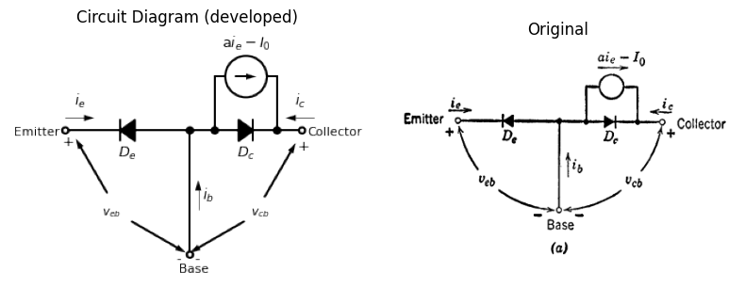
import matplotlib.pyplot as plt
import numpy as np
import matplotlib.image as mpimg
from matplotlib.gridspec import GridSpec
import matplotlib.pyplot as plt
fig = plt.figure(figsize=(10, 10))
gs = GridSpec(2, 2, width_ratios=[1, 1])
ax0 = fig.add_subplot(gs[0, 0])
def custom_function(x,a):
return np.where(x > a, 50, 0)
a1 = 0
x1 = np.linspace(-20, 20, 500)
y1 = custom_function(x1,a1)
ax0.plot(x1, y1, 'black', linewidth=3)
ax0.set_title('V-I Curve')
ax0.set_ylabel('$v_{eb}=f_1(i_e,i_c)$', labelpad=3, loc='top')
ax0.set_xlim(-10, 5)
ax0.set_ylim(-5, 10)
ax0.set_xlabel('$i_c$', labelpad=3, loc='right')
plt.axhline(0, color='black', linewidth=1)
plt.axvline(0, color='black', linewidth=1)
ax1 = fig.add_subplot(gs[0, 1])
a2 = 0.5
x2 = np.linspace(-20, 20, 500)
y2 = custom_function(x2,a2)
ax1.plot(x2, y2, 'black', linewidth=3)
a3 = 3
y3 = custom_function(x2,a3)
ax1.plot(x2, y3, 'black', linewidth=3)
a4 = 5.5
y4 = custom_function(x2,a4)
ax1.plot(x2, y4, 'black', linewidth=3)
a5 = 8
y5 = custom_function(x2,a5)
ax1.plot(x2, y5, 'black', linewidth=3)
ax1.set_xlim(-5, 10)
ax1.set_ylim(-5, 10)
ax1.set_xlabel('$i_e$', labelpad=3, loc='right')
ax1.set_ylabel('$v_{cb}=f_2(i_e,i_c)$', labelpad=3, loc='top')
ax1.set_title('V-I Curve')
ax2 = fig.add_subplot(gs[1, :])
img_sample = mpimg.imread('./images5/5-6n.png')
ax2.imshow(img_sample)
ax2.set_title('Original')
ax2.axis('off')
axes = [ax0, ax1]
for a in axes:
a.spines['top'].set_color('none')
a.spines['right'].set_color('none')
a.spines['left'].set_position('zero')
a.spines['bottom'].set_position('zero')
a.spines['left'].set_linewidth(2)
a.spines['bottom'].set_linewidth(2)
a.xaxis.set_ticks_position('bottom')
a.yaxis.set_ticks_position('left')
a.tick_params(axis='both', which='both', length=0)
a.set_xticks([])
a.set_yticks([])
a.set_aspect('equal', adjustable='box')
plt.tight_layout()
plt.show()
plt.tight_layout()
plt.show()
plt.savefig('./Drawings5/5-6n.jpg')
plt.savefig('./Drawings5/5-6n.svg')
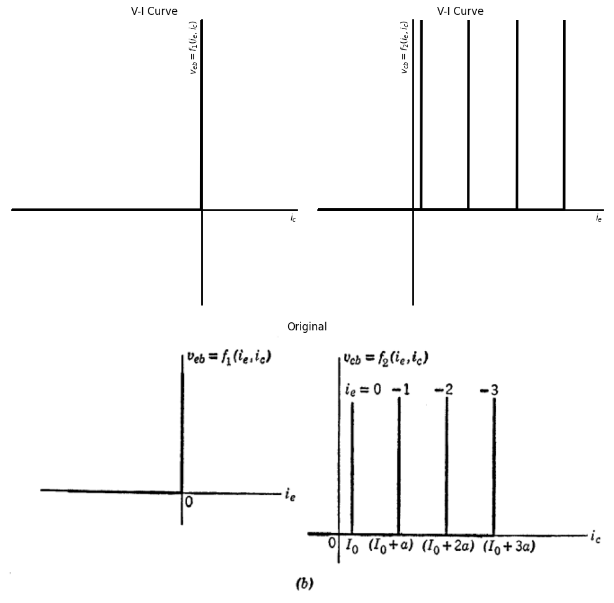
<Figure size 640x480 with 0 Axes>
<Figure size 640x480 with 0 Axes>
Note: Since $i_e + i_b + i_c $ = 0, we have the following relations for for $ D_e $ closed and $ D_c $ open: $ i_c = +I_0 - ai_e, \quad \frac{\Delta i_c}{\Delta i_e} = -a$
$ i_b = -I_0 - (1 - a)i_e, \quad \frac{\Delta i_e}{\Delta i_b} = -\frac{1}{(1 - a)}$
$ i_c = \frac{(+I_0 + ai_b)}{(1 - a)}, \quad \frac{\Delta i_c}{\Delta i_b} = \frac{a}{(1 - a)}$
Fig. 5.6 Ideal-diode model for p-n-p junction transistor.
The constant current $ I_0 $ will be omitted from the dependent generator for the sake of simplicity in some of the following articles. The piecewise-linear curves shown in Fig. 5.5(b), readily derived from the model by diode break-point analysis, are remarkably similar to typical transistor collector curves, such as those shown in Appendix A.
The normal operating state of the transistor occurs when the emitter diode $ D_e $ is closed and the collector diode $ D_c $ is open. This state represents a region called the amplification region on the $ v_{cb} $ vs. $ i_c $ plane, which for this model is the entire third quadrant to the left of $−I_{0}(i_{c}<−I_{0}$, $ v_{cb} < 0) $. If $ D_e $ is opened, the transistor is said to be cut off, and in this simple model the cut-off region degenerates to the line $ i_e = 0 $. Similarly, the saturation state, when $ D_c $ is closed, is here represented by the $ v_{cb} = 0 $ axis. The corresponding ideal-diode model of an n-p-n transistor, and its curves, are shown in Fig. 5.6.
import matplotlib.pyplot as plt
import numpy as np
import schemdraw
from schemdraw import dsp
import schemdraw.elements as e
import matplotlib.image as mpimg
d = schemdraw.Drawing()
l0 = d.add(e.Line(l=0.6).right().idot(open=True))
D1 = d.add(e.Diode(l=1.5,fill=True).right().label('$D_e$',ofst=-1).dot().idot())
l00 = d.add(e.Line(l=0.6).right().dot())
l01 = d.add(e.Line(l=1.3).up().at(l00.start))
I0 = d.add(e.SourceI(l=1.5).left().label("$a'i_c$"))
l02 = d.add(e.Line(l=1.3).down())
l1 = d.add(e.Line().down().dot(open=True).at(l00.end))
l2 = d.add(e.Line(l=0.6).right().at(l1.start))
D2 = d.add(e.Diode(l=1.5,fill=True).reverse().right().at(l2.end).label('$D_c$',ofst=-1).idot().dot())
l3 = d.add(e.Line(l=0.6).right().dot(open=True))
l4 = d.add(e.Line(l=1.3).up().at(D2.start))
I = d.add(e.SourceI(l=1.5).right().label('a$i_e$'))
l5 = d.add(e.Line(l=1.3).down())
d += e.Gap().right().label('Emitter',fontsize = 12).color('black').at((-2.2,0.1))
d += e.Gap().right().label('Collector',fontsize = 12).color('black').at((5,0.1))
d += e.Gap().right().label('Base',fontsize = 12).color('black').at((1.2,-3.2))
d += e.Arrow().left().linewidth(0.6).length(0.7).color('black').label('$i_c$', loc='top', color='black',ofst=0.2).at((5.6,0.3))
d += e.Arrow().right().linewidth(0.6).length(0.7).color('black').label('$i_e$', loc='top', color='black',ofst=0.2).at((-0.6,0.3))
d += e.Arrow().up().linewidth(0.6).length(0.7).color('black').label('$i_b$', loc='top', color='black',ofst=-0.4).at((3,-1.9))
d += e.Arrow().length(1.5).at((4.8, -1.6)).label('+', ofst=(0.7,-0.4)).theta(60)
d += e.Arrow().length(1.5).at((4.3, -2.2)).label('-', ofst=(0.7,0.4)).theta(-150)
d += e.Arrow().length(1.5).at((1.2, -2.2)).label('-', ofst=(0.7,-0.4)).theta(-30)
d += e.Arrow().length(1.5).at((0.8, -1.5)).label('+', ofst=(0.7,0.4)).theta(120)
d += e.Gap().right().label('$v_{eb}$',fontsize = 12).color('black').at((-0.4,-1.7))
d += e.Gap().right().label('$v_{cb}$',fontsize = 12).color('black').at((3.2,-1.8))
d.draw()
d.save('./Drawings5/5-7m.png')
d.save('./Drawings5/5-7m.svg')
fig, axs = plt.subplots(1, 2, figsize=(8, 4))
img = mpimg.imread('./Drawings5/5-7m.png')
axs[0].imshow(img)
axs[0].axis('off')
axs[0].set_title('Circuit Diagram (developed)')
img_sample = mpimg.imread('./images5/5-7m.png')
axs[1].imshow(img_sample)
axs[1].axis('off')
axs[1].set_title('Original')
plt.tight_layout()
plt.show()
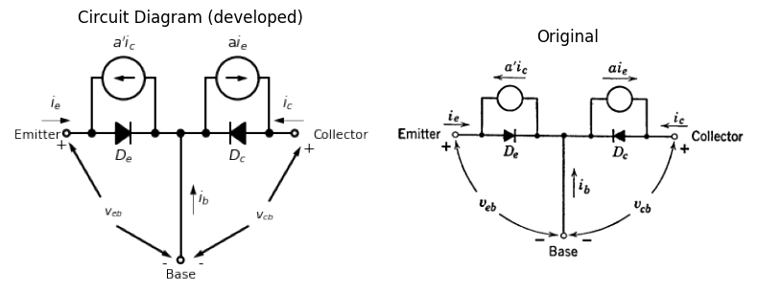
import matplotlib.pyplot as plt
import numpy as np
import matplotlib.image as mpimg
from matplotlib.gridspec import GridSpec
import matplotlib.pyplot as plt
fig = plt.figure(figsize=(10, 10))
gs = GridSpec(2, 2, width_ratios=[1, 1])
ax0 = fig.add_subplot(gs[0, 0])
def custom_function(x,a,b):
return np.where(x < a, b, 0)
a1 = 0
b1 = -50
x1 = np.linspace(-20, 9, 500)
y1 = custom_function(x1,a1,b1)
ax0.plot(x1, y1, 'black', linewidth=3)
a1 = -1
b1 = -9
x1 = np.linspace(a1-0.001, 9, 500)
y1 = custom_function(x1,a1,b1)
ax0.plot(x1, y1, 'black', linewidth=3)
a1 = -2
b1 = -8
x1 = np.linspace(a1-0.001, 9, 500)
y1 = custom_function(x1,a1,b1)
ax0.plot(x1, y1, 'black', linewidth=3)
a1 = -3
b1 = -7
x1 = np.linspace(a1-0.001, 9, 500)
y1 = custom_function(x1,a1,b1)
ax0.plot(x1, y1, 'black', linewidth=3)
a1 = -4
b1 = -4
x1 = np.linspace(b1, 9, 500)
y1 = custom_function(x1,a1,b1)
ax0.plot(x1, y1, 'black', linewidth=3)
ax0.plot([-4, -4], [-1, 0], color='black', linewidth=3)
ax0.set_title('V-I Curve')
ax0.set_ylabel('$v_{eb}$', labelpad=3, loc='top')
ax0.set_xlim(-5, 10)
ax0.set_ylim(-10, 5)
ax0.set_xlabel('$i_e$', labelpad=3, loc='right')
plt.axhline(0, color='black', linewidth=1)
plt.axvline(0, color='black', linewidth=1)
ax1 = fig.add_subplot(gs[0, 1])
a2 = 0
b2 = -50
x2 = np.linspace(-20, 20, 500)
y2 = custom_function(x2,a2,b2)
ax1.plot(x2, y2, 'black', linewidth=3)
a2 = -3
y2 = custom_function(x2,a2,b2)
ax1.plot(x2, y2, 'black', linewidth=3)
a2 = -6
y2 = custom_function(x2,a2,b2)
ax1.plot(x2, y2, 'black', linewidth=3)
a2 = -9
y2 = custom_function(x2,a2,b2)
ax1.plot(x2, y2, 'black', linewidth=3)
ax1.set_xlim(-10, 5)
ax1.set_ylim(-10, 5)
ax1.set_xlabel('$i_c$', labelpad=3, loc='right')
ax1.set_ylabel('$v_{cb}$', labelpad=3, loc='top')
ax1.set_title('V-I Curve')
ax2 = fig.add_subplot(gs[1, :])
img_sample = mpimg.imread('./images5/5-7n.png')
ax2.imshow(img_sample)
ax2.set_title('Original')
ax2.axis('off')
axes = [ax0, ax1]
for a in axes:
a.spines['top'].set_color('none')
a.spines['right'].set_color('none')
a.spines['left'].set_position('zero')
a.spines['bottom'].set_position('zero')
a.spines['left'].set_linewidth(2)
a.spines['bottom'].set_linewidth(2)
a.xaxis.set_ticks_position('bottom')
a.yaxis.set_ticks_position('left')
a.tick_params(axis='both', which='both', length=0)
a.set_xticks([])
a.set_yticks([])
a.set_aspect('equal', adjustable='box')
plt.tight_layout()
plt.show()
plt.tight_layout()
plt.show()
plt.savefig('./Drawings5/5-7n.jpg')
plt.savefig('./Drawings5/5-7n.svg')
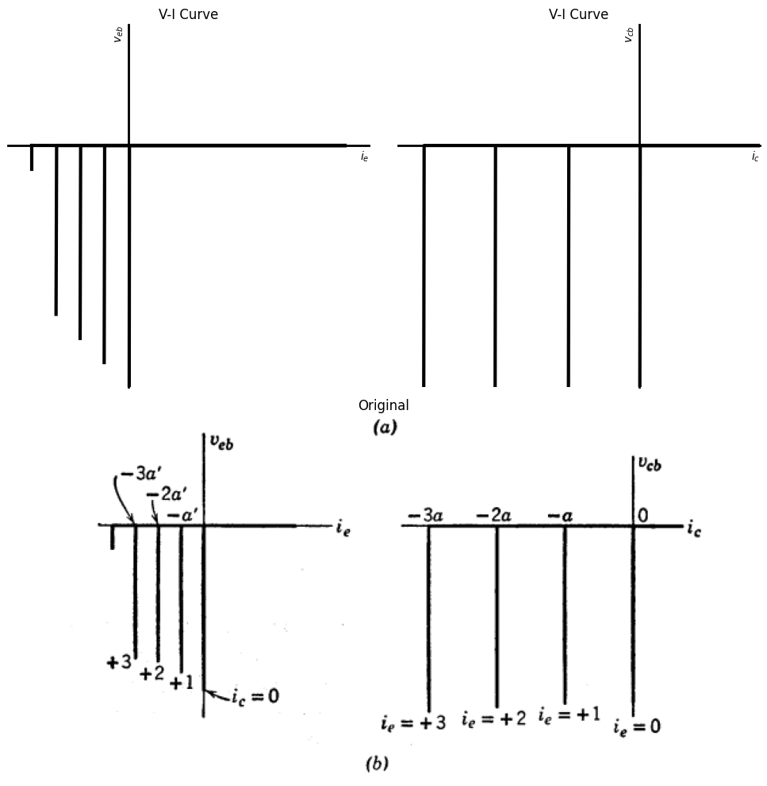
<Figure size 640x480 with 0 Axes>
<Figure size 640x480 with 0 Axes>
Fig. 5.7 Ideal-Diode Model with two dependent generators (neglecting reverse diode current $I_{e}$).
These ideal-diode models provide a convenient way of remembering the ideal current gains between various terminal pairs when the transistor is operating in the normal amplification state (emitter diode closed and collector diode open). As indicated in Fig. 5.5(c) and Fig. 5.6(c), the relations between the various currents lead directly to expressions for variational current gain. When resistive parameters are included in the circuit model, the current gains are smaller, but the ideal values given here provide limits for checking the more involved expressions.
Thus far, we have considered positive emitter currents that cause holes to diffuse through the base to the collector. The physical structure of the transistor suggests the possibility of interchanging the roles of emitter and collector by sending the hole current through the device in the opposite direction. If emitter and collector are made identical, as they are in a “symmetrical” transistor, the emitter and collector can be interchanged at will. Most transistors, however, are designed to have a much smaller current gain when emitter and collector are interchanged. Whether the transistor is symmetrical or not, it is apparent that the model shown in Fig. 5.7(a) is more general than the previous ones, since it includes the effect of collector current on the emitter current. The corresponding curves are shown in Fig. 5.7(b). A model of this type is useful when the voltages or currents applied to the device are likely to have large amplitudes of arbitrary polarity.

1.6 5.6 Ideal-Diode Model for Common Emitter Connection
In the models of Figs. 5.5, 5.6, and 5.7, the voltages are referred to the base. The plots can be expressed in functional notation as $ v_{eb} = f_1(i_e, i_c) $ and $ v_{cb} = f_2(i_e, i_c) $, a convenient representation for transistor circuits in which the base is the terminal common to input and output. However, in many transistor circuits, the emitter is the common terminal. Although the curves in the previous figures contain all the required information and thus can still be used for this "common emitter" connection, it may be more instructive to present the data in another form, namely base-to-emitter voltage versus base current and collector-to-emitter voltage versus collector current. These curves are shown in Fig. 5.8(b). It is desirable to redraw the model to the form shown in Fig. 5.8(a) to emphasize the fact that the base current $ i_b $ is now the control parameter. To calculate the current gain, the ratio of collector current to base current, assume that the emitter current is 1 mA. Then if $ D_e $ is open and $ D_e $ closed (forward gain or amplification region) the collector current is ( -a , ma ), and, by summing currents at the common node, the base current must be ( - (1 - a) , ma ). Thus the current gain for the common emitter connection is $ \frac{a}{(1 - a)} $, which for $ a $ close to unity can be a large number. For example, if $ a = 0.98 $, the current gain is 49.
The transistor states, as defined in the previous article, are located on the $ v_{ce} $ versus $ i_e $ plane as follows:
Forward gain or amplification Third quadrant
Saturation $v_{ce} = 0 $ line
Cutoff $ i_b = 0 $ line, $ v_{ce} < 0 $
The figure shows a set of lines (dotted in the first quadrant), which have not appeared in previous curves. These lines represent the region where the reverse-current generator ( a' i_c ) comes into play.
import matplotlib.pyplot as plt
import numpy as np
import schemdraw
from schemdraw import dsp
import schemdraw.elements as e
import matplotlib.image as mpimg
d = schemdraw.Drawing()
l0 = d.add(e.Line().right().idot(open=True).dot())
l01 = d.add(e.Line(l=1.1).right().dot())
D1 = d.add(e.Diode(l=1.5,fill=True).reverse().right().label('$D_c$',ofst=-1).dot())
l02 = d.add(e.Line(l=1.1).right().dot(open=True))
l1 = d.add(e.Line(l=1.3).up().at(D1.start))
I0 = d.add(e.SourceI(l=1.5).right().label("$ai_e$"))
l2 = d.add(e.Line(l=1.3).down())
l3 = d.add(e.Line(l=1.1).down().at(l0.end))
D2 = d.add(e.Diode(l=1.5,fill=True).reverse().down().label('$D_e$',ofst=-1))
l4 = d.add(e.Line(l=1.1).down().dot(open=True))
l5 = d.add(e.Line(l=1).left().at(l4.start).linestyle('--'))
l6 = d.add(e.Line(l=1).left().at(D2.start).linestyle('--'))
I0 = d.add(e.SourceI(l=1.5).down().label("$a'i_c$").linestyle('--'))
d += e.Gap().right().label('Base',fontsize = 12).color('black').at((-2.2,0.1))
d += e.Gap().right().label('Collector',fontsize = 12).color('black').at((6.1,0.1))
d += e.Gap().right().label('Emitter',fontsize = 12).color('black').at((1.4,-4))
d += e.Arrow().left().linewidth(0.6).length(0.7).color('black').label('$i_c$', loc='top', color='black',ofst=0.2).at((7,0.3))
d += e.Arrow().right().linewidth(0.6).length(0.7).color('black').label('$i_b$', loc='top', color='black',ofst=0.2).at((-0.3,0.3))
d += e.Arrow().up().linewidth(0.6).length(0.7).color('black').label('$i_e$', loc='top', color='black',ofst=-0.4).at((3.3,-3))
d += e.Arrow().length(1.7).at((5.7, -1.6)).label('+', ofst=(0.7,-0.4)).theta(60)
d += e.Arrow().length(1.7).at((4.6, -3)).label('-', ofst=(0.7,0.4)).theta(-150)
d += e.Arrow().length(1.7).at((1.4, -3)).label('-', ofst=(0.7,-0.4)).theta(-30)
d += e.Arrow().length(1.7).at((0.6, -1.7)).label('+', ofst=(0.7,0.4)).theta(110)
d += e.Gap().right().label('$v_{be}$',fontsize = 12).color('black').at((-0.8,-2.4))
d += e.Gap().right().label('$v_{ce}$',fontsize = 12).color('black').at((3.9,-2))
d.draw()
d.save('./Drawings5/5-8m.png')
d.save('./Drawings5/5-8m.svg')
fig, axs = plt.subplots(1, 2, figsize=(8, 4))
img = mpimg.imread('./Drawings5/5-8m.png')
axs[0].imshow(img)
axs[0].axis('off')
axs[0].set_title('Circuit Diagram (developed)')
img_sample = mpimg.imread('./images5/5-8m.png')
axs[1].imshow(img_sample)
axs[1].axis('off')
axs[1].set_title('Original')
plt.tight_layout()
plt.show()
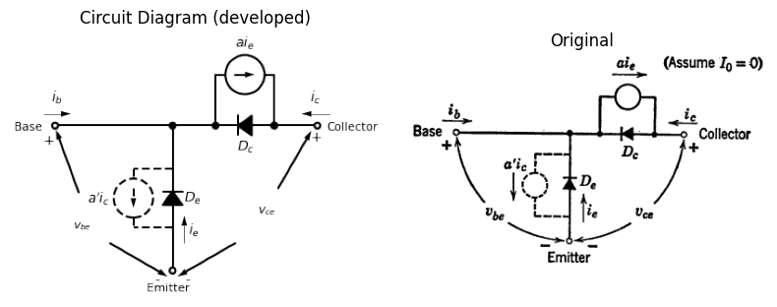
import matplotlib.pyplot as plt ################################################
import numpy as np
import matplotlib.image as mpimg
from matplotlib.gridspec import GridSpec
import matplotlib.pyplot as plt
fig = plt.figure(figsize=(10, 10))
gs = GridSpec(2, 2, width_ratios=[1, 1])
ax0 = fig.add_subplot(gs[0, 0])
def custom_function(x,a,b):
return np.where(x > a, b, 0)
a1 = 0
b1 = 50
x1 = np.linspace(-20, 20, 500)
y1 = custom_function(x1,a1,b1)
ax0.plot(x1, y1, 'black', linewidth=3)
ax0.plot([-1, -1], [0, 4], color='black', linewidth=2, linestyle='--')
ax0.plot([-2, -2], [0, 3.5], color='black', linewidth=2, linestyle='--')
ax0.plot([-3, -3], [0, 3], color='black', linewidth=2, linestyle='--')
ax0.plot(x1, y1, 'black', linewidth=3)
ax0.set_title('V-I Curve')
ax0.set_ylabel('$v_{be}$', labelpad=3, loc='top')
ax0.set_xlim(-5, 10)
ax0.set_ylim(-10, 5)
ax0.set_xlabel('$i_b$', labelpad=3, loc='right')
plt.axhline(0, color='black', linewidth=1)
plt.axvline(0, color='black', linewidth=1)
ax1 = fig.add_subplot(gs[0, 1])
a2 = 0
b2 = -50
x2 = np.linspace(-20, 20, 500)
y2 = custom_function(x2,a2,b2)
ax1.plot(x2, y2, 'black', linewidth=3)
a2 = -3
y2 = custom_function(x2,a2,b2)
ax1.plot(x2, y2, 'black', linewidth=3)
a2 = -6
y2 = custom_function(x2,a2,b2)
ax1.plot(x2, y2, 'black', linewidth=3)
a2 = -9
y2 = custom_function(x2,a2,b2)
ax1.plot(x2, y2, 'black', linewidth=3)
ax1.plot([1, 1], [0, 4], color='black', linewidth=2, linestyle='--')
ax1.plot([2, 2], [0, 4], color='black', linewidth=2, linestyle='--')
ax1.plot([3, 3], [0, 4], color='black', linewidth=2, linestyle='--')
ax1.set_xlim(-10, 5)
ax1.set_ylim(-10, 5)
ax1.set_xlabel('$i_c$', labelpad=3, loc='right')
ax1.set_ylabel('$v_{ce}$', labelpad=3, loc='top')
ax1.set_title('V-I Curve')
ax2 = fig.add_subplot(gs[1, :])
img_sample = mpimg.imread('./images5/5-8n.png')
ax2.imshow(img_sample)
ax2.set_title('Original')
ax2.axis('off')
axes = [ax0, ax1]
for a in axes:
a.spines['top'].set_color('none')
a.spines['right'].set_color('none')
a.spines['left'].set_position('zero')
a.spines['bottom'].set_position('zero')
a.spines['left'].set_linewidth(2)
a.spines['bottom'].set_linewidth(2)
a.xaxis.set_ticks_position('bottom')
a.yaxis.set_ticks_position('left')
a.tick_params(axis='both', which='both', length=0)
a.set_xticks([])
a.set_yticks([])
a.set_aspect('equal', adjustable='box')
plt.tight_layout()
plt.show()
plt.tight_layout()
plt.show()
plt.savefig('./Drawings5/5-8n.jpg')
plt.savefig('./Drawings5/5-8n.svg')
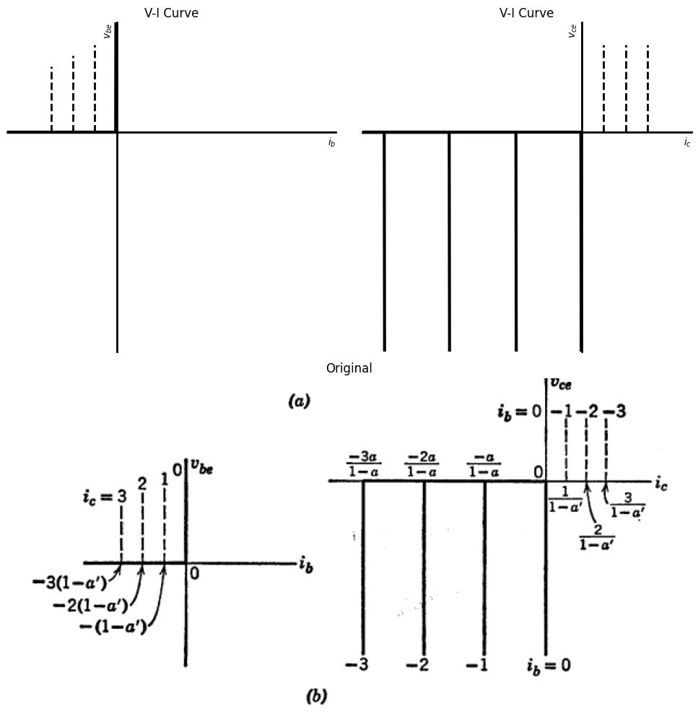
<Figure size 640x480 with 0 Axes>
<Figure size 640x480 with 0 Axes>
Fig. 5.8 Simple ideal-diode model for common emitter connection of p-n-p junction transistors (neglecting reverse current $ I_0 $).

1.7 5.7 Effect of a Coupling Resistance in the Transistor Model
Making better resistive approximations to the junctions in a transistor tends to improve the accuracy of the model. Thus, we might replace each ideal diode by the exponential approximation to a junction diode as in Chapter 2. There are many cases in which an exponential diode model is useful. However, the linear-circuit methods are so powerful that we shall emphasize piecewise-linear models in order to use linear circuit theory in each diode state. For examining general circuit behavior, the accuracy will be adequate with a two-segment piecewise-linear approximation to the junctions. Resistive approximations for the diodes give the corresponding curves finite and nonzero slopes as might be expected by analogy to the diode models discussed in Chapter 3.
However, before including resistive diodes, let us consider first the effect of base resistance alone. In the simple common-base transistor model, a current in the emitter circuit can influence the collector circuit only by means of the dependent current generator.
import matplotlib.pyplot as plt
import numpy as np
import schemdraw
from schemdraw import dsp
import schemdraw.elements as e
import matplotlib.image as mpimg
d = schemdraw.Drawing()
l0 = d.add(e.Line(l=0.6).right().idot(open=True))
D1 = d.add(e.Diode(l=1.5,fill=True).right().dot().idot())
l00 = d.add(e.Line(l=0.6).right().dot())
l01 = d.add(e.Line(l=1.3).up().at(l00.start))
I0 = d.add(e.SourceI(l=1.5).left().label("$a'i_c$"))
l02 = d.add(e.Line(l=1.3).down())
R1 = d.add(e.Resistor().down().dot(open=True).at(l00.end).label('$r_b$',ofst=-1))
l2 = d.add(e.Line(l=0.6).right().at(R1.start))
D2 = d.add(e.Diode(l=1.5,fill=True).reverse().right().at(l2.end).idot().dot())
l3 = d.add(e.Line(l=0.6).right().dot(open=True))
l4 = d.add(e.Line(l=1.3).up().at(D2.start))
I = d.add(e.SourceI(l=1.5).right().label('a$i_e$'))
l5 = d.add(e.Line(l=1.3).down())
d += e.Gap().right().color('black').at((-2.2,0.1))
d += e.Gap().right().color('black').at((5,0.1))
d += e.Gap().right().color('black').at((1.2,-3.2))
d += e.Arrow().left().linewidth(0.6).length(0.7).color('black').label('$i_c$', loc='top', color='black',ofst=0.2).at((5.6,0.3))
d += e.Arrow().right().linewidth(0.6).length(0.7).color('black').label('$i_e$', loc='top', color='black',ofst=0.2).at((-0.6,0.3))
d += e.Arrow().up().linewidth(0.6).length(0.7).color('black').label('$i_b$', loc='top', color='black',ofst=0.1).at((2.1,-1.9))
d += e.Arrow().length(1.5).at((4.8, -1.6)).label('+', ofst=(0.7,-0.4)).theta(60)
d += e.Arrow().length(1.5).at((4.3, -2.2)).label('-', ofst=(0.7,0.4)).theta(-150)
d += e.Arrow().length(1.5).at((1.2, -2.2)).label('-', ofst=(0.7,-0.4)).theta(-30)
d += e.Arrow().length(1.5).at((0.8, -1.5)).label('+', ofst=(0.7,0.4)).theta(120)
d += e.Gap().right().label('$v_{eb}$',fontsize = 12).color('black').at((-0.4,-1.7))
d += e.Gap().right().label('$v_{cb}$',fontsize = 12).color('black').at((3.2,-1.8))
d += e.Arrow().left().length(2.6).color('white').label('$v_{ce}$',loc='start',color='black',ofst=0).at((2.7,2.7))
d += e.Arrow().left().length(2.5).color('black').label('+',loc='end',color='black',ofst=-0.4).at((1.9,2.5))
d += e.Arrow().right().length(2.5).color('black').label('-',loc='end',color='black',ofst=(-0.2,0.4)).at((3.1,2.5))
d.draw()
d.save('./Drawings5/5-9m.png')
d.save('./Drawings5/5-9m.svg')
fig, axs = plt.subplots(1, 2, figsize=(8, 4))
img = mpimg.imread('./Drawings5/5-9m.png')
axs[0].imshow(img)
axs[0].axis('off')
axs[0].set_title('Circuit Diagram (developed)')
img_sample = mpimg.imread('./images5/5-9m.png')
axs[1].imshow(img_sample)
axs[1].axis('off')
axs[1].set_title('Original')
plt.tight_layout()
plt.show()
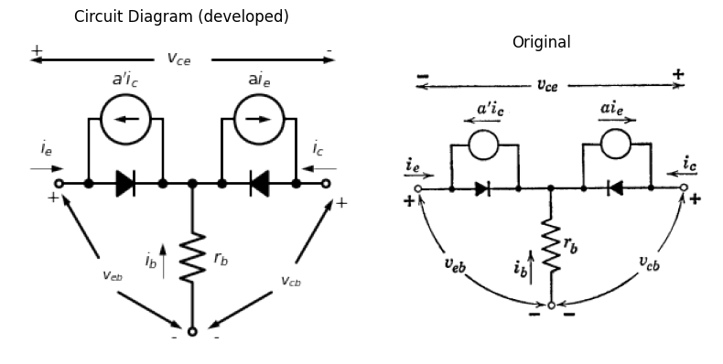
import matplotlib.pyplot as plt
import numpy as np
import matplotlib.image as mpimg
from matplotlib.gridspec import GridSpec
import matplotlib.pyplot as plt
fig = plt.figure(figsize=(12, 12))
gs = GridSpec(2, 2, width_ratios=[1, 1])
ax0 = fig.add_subplot(gs[0, 0])
ax0.plot([-5, 0], [0.7, 0], color='black', linewidth=1, linestyle='--')
ax0.plot([0, 0], [-8, 0], color='black', linewidth=3)
ax0.plot([-1, -1], [-7, 0.14], color='black', linewidth=2.5)
ax0.plot([-2, -2], [-6, 0.28], color='black', linewidth=2.5)
ax0.plot([-3, -3], [-5, 0.42], color='black', linewidth=2.5)
ax0.plot([-4, -4], [-4, 0.56], color='black', linewidth=2.5)
ax0.plot([0, 5], [0, 1.1], color='black', linewidth=2.5)
ax0.plot([-1, 3.36], [0.14, 1.1], color='black', linewidth=2.5)
ax0.plot([-2, 1.73], [0.28, 1.1], color='black', linewidth=2.5)
ax0.plot([-3, 0.09], [0.42, 1.1], color='black', linewidth=2.5)
ax0.plot([-4, -1.55], [0.56, 1.1], color='black', linewidth=2.5)
ax0.set_title('V-I Analysis (Ngspice Simulation via Pyspice)')
ax0.set_ylabel('$v_{eb}$', labelpad=3, loc='top')
ax0.set_xlim(-5, 8)
ax0.set_ylim(-10, 4)
ax0.set_xlabel('$i_e$', labelpad=3, loc='right')
ax0.set_title('V-I Curve')
plt.axhline(0, color='black', linewidth=1)
plt.axvline(0, color='black', linewidth=1)
ax1 = fig.add_subplot(gs[0, 1])
ax1.plot([-9, 0], [1.26, 0], color='black', linewidth=1, linestyle='--')
ax1.plot([0, 0], [-6, 0], color='black', linewidth=3)
ax1.plot([-3, -3], [-6, 0.42], color='black', linewidth=2.5)
ax1.plot([-6, -6], [-5, 0.84], color='black', linewidth=2.5)
ax1.plot([-9, -9], [-4, 1.26], color='black', linewidth=2.5)
ax1.plot([0, 5], [0, 0.6], color='black', linewidth=2.5)
ax1.plot([-3, 4], [0.42, 1.26], color='black', linewidth=2.5)
ax1.plot([-6, 3], [0.84, 1.92], color='black', linewidth=2.5)
ax1.plot([-9, -1], [1.26, 2.12], color='black', linewidth=2.5)
ax1.set_xlim(-9.5, 5)
ax1.set_ylim(-8, 4)
ax1.set_xlabel('$i_e$', labelpad=3, loc='right')
ax1.set_ylabel('$v_{cb}$', labelpad=3, loc='top')
ax1.set_title('V-I Curve')
ax2 = fig.add_subplot(gs[1, :])
img_sample = mpimg.imread('./images5/5-9n.png')
ax2.imshow(img_sample)
ax2.set_title('Original')
ax2.axis('off')
axes = [ax0, ax1]
for a in axes:
a.spines['top'].set_color('none')
a.spines['right'].set_color('none')
a.spines['left'].set_position('zero')
a.spines['bottom'].set_position('zero')
a.spines['left'].set_linewidth(2)
a.spines['bottom'].set_linewidth(2)
a.xaxis.set_ticks_position('bottom')
a.yaxis.set_ticks_position('left')
a.tick_params(axis='both', which='both', length=0)
a.set_xticks([])
a.set_yticks([])
a.set_aspect('equal', adjustable='box')
plt.tight_layout()
plt.show()
plt.tight_layout()
plt.show()
plt.savefig('./Drawings5/5-9n.jpg')
plt.savefig('./Drawings5/5-9n.svg')
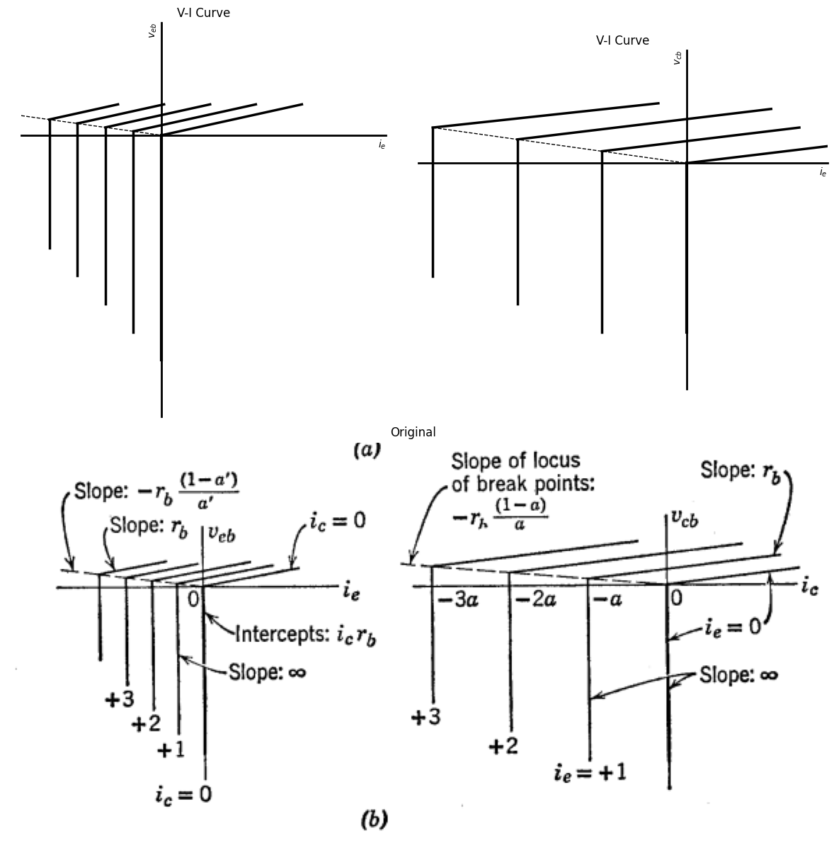
<Figure size 640x480 with 0 Axes>
<Figure size 640x480 with 0 Axes>
Fig. 5.9 Transistor model with ideal diodes and base resistance.
In an actual transistor, the ohmic resistance of the base material, which typically ranges from 50 to 100 ohms for most transistors, causes a resistive coupling effect between the two circuits. Including a base resistance in the ideal-diode model, as shown in Fig. 5.9(a), leads to the curves in Fig. 5.9(b) for the common-base connection. The collector curves are a reasonable approximation to the collector curves for an actual transistor.
If the polarizing voltages together with the applied signal do not drive the transistor into all of the diode states, it is well to use the less complete form for the model. Thus, if collector current is never likely to assume positive values in a given application, the $ a' i_e $ generator can be omitted since for negative values of $ i_c $, the $ a' i_c $ generator is shorted by the ideal diode. Another way of saying this is that the two current generators $ a' i_e $ and $ a' i_c $ can usually be considered one at a time. If both $ i_e $ and $ i_c $ are positive, we simply have two diodes using the same base, and the dependent generators are both shorted by the ideal diodes in the model.
import matplotlib.pyplot as plt
import numpy as np
import schemdraw
from schemdraw import dsp
import schemdraw.elements as e
import matplotlib.image as mpimg
d = schemdraw.Drawing()
l0 = d.add(e.Line(l=3.5).right().idot(open=True).dot())
l01 = d.add(e.Line(l=1.1).right().dot())
D1 = d.add(e.Diode(l=1.5,fill=True).reverse().right().dot())
l02 = d.add(e.Line(l=1.1).right().dot(open=True))
l1 = d.add(e.Line(l=1.3).up().at(D1.start))
I0 = d.add(e.SourceI(l=1.5).right().label("$ai_e=(-a/(1-a))i_b$"))
l2 = d.add(e.Line(l=1.3).down())
l3 = d.add(e.Line(l=1.1).down().at(l0.end))
D2 = d.add(e.Diode(l=1,fill=True).reverse().down().label('$D_e$',ofst=-1))
R1 = d.add(e.Resistor(l=1.5).down().label('$r_ef$',ofst=-1.2))
l4 = d.add(e.Line(l=1.1).down().dot(open=True))
l5 = d.add(e.Line(l=1).left().at(l4.start).linestyle('--'))
l6 = d.add(e.Line(l=1).left().at(D2.start).linestyle('--'))
I0 = d.add(e.SourceI(l=2.4).down().label("$a'i_c$").linestyle('--'))
#d += e.Gap().right().at((-2.2,0.1))
#d += e.Gap().right().color('black').at((6.1,0.1))
#d += e.Gap().right().color('black').at((1.4,-4))
d += e.Arrow().length(2).at((6.3, -1.9)).label('+', ofst=(0.7,-0.4)).theta(60)
d += e.Arrow().length(2).at((5.2, -3.5)).label('-', ofst=(0.7,0.4)).theta(-150)
d += e.Arrow().length(2).at((1.8, -3.5)).label('-', ofst=(0.7,-0.4)).theta(-30)
d += e.Arrow().length(2).at((0.7, -1.9)).label('+', ofst=(0.7,0.4)).theta(110)
d += e.Gap().right().label('$v_{be}$',fontsize = 12).color('black').at((-0.8,-2.8))
d += e.Gap().right().label('$v_{ce}$',fontsize = 12).color('black').at((4.6,-2.5))
d += e.Arrow().left().linewidth(0.6).length(0.7).color('black').label('$i_c$', loc='top', color='black',ofst=0.2).at((7,0.3))
d += e.Arrow().right().linewidth(0.6).length(0.7).color('black').label('$i_b=-(1-a)i_e$', loc='top', color='black',ofst=0.2).at((-0.3,0.3))
d += e.Arrow().up().linewidth(0.6).length(0.7).color('black').label('$i_e$', loc='top', color='black',ofst=-0.4).at((3.8,-3.9))
d.draw()
d.save('./Drawings5/5-10m.png')
d.save('./Drawings5/5-10m.svg')
fig, axs = plt.subplots(1, 2, figsize=(8, 4))
img = mpimg.imread('./Drawings5/5-10m.png')
axs[0].imshow(img)
axs[0].axis('off')
axs[0].set_title('Circuit Diagram (developed)')
img_sample = mpimg.imread('./images5/5-10m.png')
axs[1].imshow(img_sample)
axs[1].axis('off')
axs[1].set_title('Original')
plt.tight_layout()
plt.show()
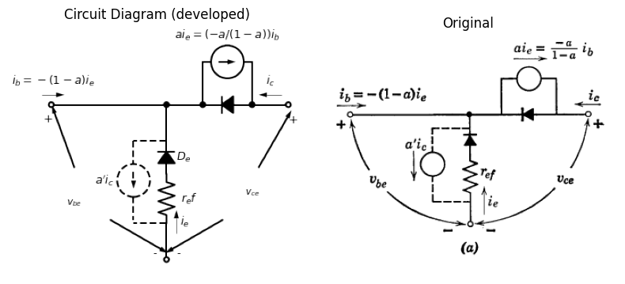
import matplotlib.pyplot as plt
import numpy as np
import matplotlib.image as mpimg
from matplotlib.gridspec import GridSpec
import matplotlib.pyplot as plt
fig = plt.figure(figsize=(10, 10))
gs = GridSpec(2, 2, width_ratios=[1, 1])
ax0 = fig.add_subplot(gs[0, 0])
#ax0.plot([-5, 0], [0.7, 0], color='black', linewidth=1, linestyle='--')
ax0.plot([-1, -1], [0, 4], color='black', linewidth=2, linestyle='--')
ax0.plot([-2, -2], [0, 4], color='black', linewidth=2, linestyle='--')
ax0.plot([-3, -3], [0, 4], color='black', linewidth=2, linestyle='--')
ax0.plot([1.6, 1.6], [0, 4], color='black', linewidth=2)
ax0.plot([3.2, 3.2], [0, 4], color='black', linewidth=2)
ax0.plot([-3.5, 3.2], [-2, 0], color='black', linewidth=2)
ax0.plot([-3.7, 1.6], [-1.59, 0], color='black', linewidth=2)
ax0.plot([-6, 0], [-1.8, 0], color='black', linewidth=2)
ax0.set_title('V-I Curve')
ax0.set_ylabel('$v_{be}$', labelpad=3, loc='top')
ax0.set_xlim(-6, 10)
ax0.set_ylim(-10, 5)
ax0.set_xlabel('$i_b$', labelpad=3, loc='right')
plt.axhline(0, color='black', linewidth=1)
plt.axvline(0, color='black', linewidth=1)
ax1 = fig.add_subplot(gs[0, 1])
ax1.plot([1, 1], [0, 4], color='black', linewidth=2, linestyle='--')
ax1.plot([2, 2], [0, 3.5], color='black', linewidth=2, linestyle='--')
ax1.plot([3, 3], [0, 3], color='black', linewidth=2, linestyle='--')
ax1.plot([-10, 0], [-2, 0], color='black', linewidth=2, linestyle='--')
ax1.plot([0, 0], [-9, 0], color='black', linewidth=3)
ax1.plot([-3, -3], [-9, -0.6], color='black', linewidth=2)
ax1.plot([-6, -6], [-9, -1.2], color='black', linewidth=2)
ax1.plot([-9, -9], [-9, -1.8], color='black', linewidth=2)
ax1.plot([-3, 1], [-0.6, 0], color='black', linewidth=2)
ax1.plot([-6, 2], [-1.2, 0], color='black', linewidth=2)
ax1.plot([-9, 3], [-1.8, 0], color='black', linewidth=2)
ax1.set_xlim(-10, 5)
ax1.set_ylim(-10, 5)
ax1.set_xlabel('$i_c$', labelpad=3, loc='right')
ax1.set_ylabel('$v_{ce}$', labelpad=3, loc='top')
ax1.set_title('V-I Curve')
ax2 = fig.add_subplot(gs[1, :])
img_sample = mpimg.imread('./images5/5-10n.png')
ax2.imshow(img_sample)
ax2.set_title('Original')
ax2.axis('off')
axes = [ax0, ax1]
for a in axes:
a.spines['top'].set_color('none')
a.spines['right'].set_color('none')
a.spines['left'].set_position('zero')
a.spines['bottom'].set_position('zero')
a.spines['left'].set_linewidth(2)
a.spines['bottom'].set_linewidth(2)
a.xaxis.set_ticks_position('bottom')
a.yaxis.set_ticks_position('left')
a.tick_params(axis='both', which='both', length=0)
a.set_xticks([])
a.set_yticks([])
a.set_aspect('equal', adjustable='box')
plt.tight_layout()
plt.show()
plt.tight_layout()
plt.show()
plt.savefig('./Drawings5/5-10n.jpg')
plt.savefig('./Drawings5/5-10n.svg')
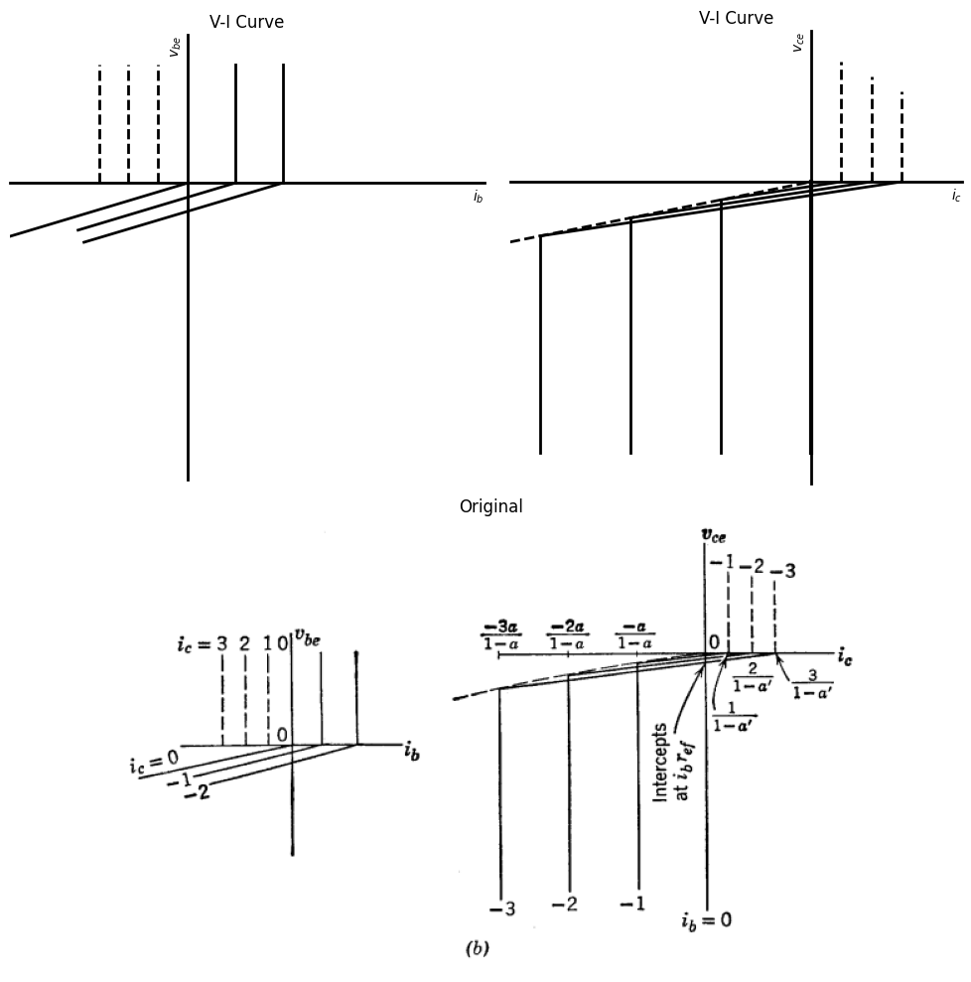
<Figure size 640x480 with 0 Axes>
<Figure size 640x480 with 0 Axes>
Fig. 5.10 Model for common-emitter connection with nonzero emitter-diode forward resistance.
Resistive coupling between the input and output circuits in the common-emitter connection is caused by the resistance of the emitter diode. For simplicity, let us add to the ideal diode model only a forward resistance $ r_{ef} $ in the emitter diode, as shown in Fig. 5.10(a). The corresponding input and output curves are shown in (b).

1.8 5.8 Piecewise-Linear Resistive Model
import matplotlib.pyplot as plt
import numpy as np
import schemdraw
from schemdraw import dsp
import schemdraw.elements as e
import matplotlib.image as mpimg
d = schemdraw.Drawing()
l0 = d.add(e.Line(l=0.6).right().idot(open=True))
D1 = d.add(e.Diode(l=1.5,fill=True).right().dot().idot().label("$D_e$",ofst=-1.2))
ci1 = d.add(e.Source(l=1.5).right().at(D1.start))
l00 = d.add(e.Line(l=0.6).right().dot())
l01 = d.add(e.Line(l=1.3).up().at(l00.start))
I0 = d.add(e.SourceI(l=1.5).left().label("$a'i_c$"))
l02 = d.add(e.Line(l=1.3).down())
R1 = d.add(e.Resistor().down().dot(open=True).at(l00.end).label('$r_b$',ofst=-1))
l2 = d.add(e.Line(l=0.6).right().at(R1.start))
D2 = d.add(e.Diode(l=1.5,fill=True).reverse().right().at(l2.end).idot().dot().label("$D_c$",ofst=-1.2))
ci2 = d.add(e.Source(l=1.5).right().at(D2.start))
l3 = d.add(e.Line(l=0.6).right().dot(open=True))
l4 = d.add(e.Line(l=1.3).up().at(D2.start))
I = d.add(e.SourceI(l=1.5).right().label('a$i_e$'))
l5 = d.add(e.Line(l=1.3).down())
d += e.Gap().right().color('black').at((-2.2,0.1))
d += e.Gap().right().color('black').at((5,0.1))
d += e.Gap().right().color('black').at((1.2,-3.2))
d += e.Arrow().left().linewidth(0.6).length(0.7).color('black').label('$i_c$', loc='top', color='black',ofst=0.2).at((5.6,0.3))
d += e.Arrow().right().linewidth(0.6).length(0.7).color('black').label('$i_e$', loc='top', color='black',ofst=0.2).at((-0.6,0.3))
d += e.Arrow().up().linewidth(0.6).length(0.7).color('black').label('$i_b$', loc='top', color='black',ofst=0.1).at((2.1,-1.9))
d += e.Arrow().length(1.5).at((4.8, -1.6)).label('+', ofst=(0.7,-0.4)).theta(60)
d += e.Arrow().length(1.5).at((4.3, -2.2)).label('-', ofst=(0.7,0.4)).theta(-150)
d += e.Arrow().length(1.5).at((1.2, -2.2)).label('-', ofst=(0.7,-0.4)).theta(-30)
d += e.Arrow().length(1.5).at((0.8, -1.5)).label('+', ofst=(0.7,0.4)).theta(120)
d += e.Gap().right().label('$v_{eb}$',fontsize = 12).color('black').at((-0.4,-1.7))
d += e.Gap().right().label('$v_{cb}$',fontsize = 12).color('black').at((3.2,-1.8))
d.draw()
d.save('./Drawings5/5-11m.png')
d.save('./Drawings5/5-11m.svg')
fig, axs = plt.subplots(1, 2, figsize=(8, 4))
img = mpimg.imread('./Drawings5/5-11m.png')
axs[0].imshow(img)
axs[0].axis('off')
axs[0].set_title('Circuit Diagram (developed)')
img_sample = mpimg.imread('./images5/5-11m.png')
axs[1].imshow(img_sample)
axs[1].axis('off')
axs[1].set_title('Original')
plt.tight_layout()
plt.show()
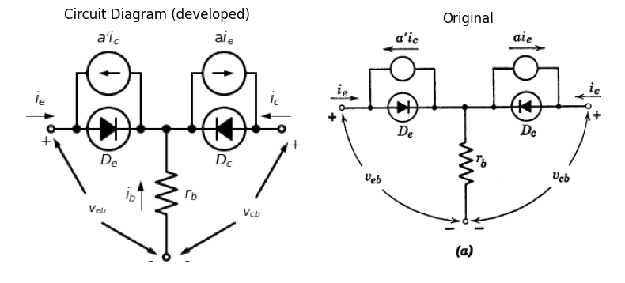
import matplotlib.pyplot as plt
import numpy as np
import schemdraw
from schemdraw import dsp
import schemdraw.elements as e
import matplotlib.image as mpimg
d = schemdraw.Drawing()
l1 = d.add(e.Line(l=0.6).down().idot(open=True))
D1 = d.add(e.Diode(l=1.5,fill=True).down())
ci1 = d.add(e.Source(l=1.5).down().at(D1.start))
l2 = d.add(e.Line(l=0.6).down().at(D1.end).dot(open=True))
d += e.Arrow().down().linewidth(0.6).length(0.7).color('black').label('$i$', loc='top', color='black',ofst=-0.3).at((0.5,-0.3))
l3 = d.add(e.Line(l=0.7).left().at(l1.start).color('white'))
l31 = d.add(e.Line(l=0.5).left().linewidth(0.6))
l4 = d.add(e.Line(l=0.7).left().at(l2.end).color('white'))
l41 = d.add(e.Line(l=0.5).left().linewidth(0.6))
d += e.Arrow().up().length(1).linewidth(0.6).color('white').label('$V$', loc='start', color='black',ofst=0.3). at((-0.4,-1.4))
d += e.Arrow().up().length(0.8).linewidth(0.6).color('black').label('+',loc='end', color='black',ofst=0.4). at((-0.9,-0.8))
d += e.Arrow().down().length(0.8).linewidth(0.6).color('black').label(r'_', loc='end', color='black',ofst=(-0.3,-0.5)). at((-0.9,-2))
d.draw()
d.save('./Drawings5/5-11bm.png')
d.save('./Drawings5/5-11bm.svg')
fig, axs = plt.subplots(1, 2, figsize=(8, 4))
img = mpimg.imread('./Drawings5/5-11bm.png')
axs[0].imshow(img)
axs[0].axis('off')
axs[0].set_title('Circuit Diagram (developed)')
img_sample = mpimg.imread('./images5/5-11bm.png')
axs[1].imshow(img_sample)
axs[1].axis('off')
axs[1].set_title('Original')
plt.tight_layout()
plt.show()
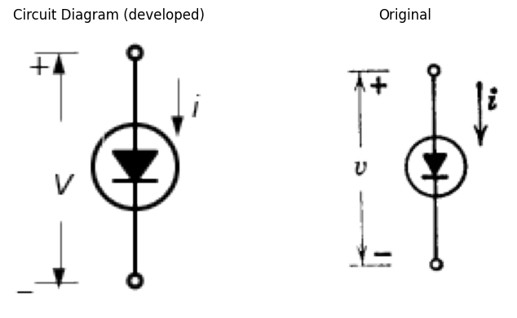
import matplotlib.pyplot as plt
import numpy as np
import matplotlib.image as mpimg
from matplotlib.gridspec import GridSpec
import matplotlib.pyplot as plt
fig = plt.figure(figsize=(10, 10))
gs = GridSpec(2, 2, width_ratios=[1, 1])
ax0 = fig.add_subplot(gs[0, 0])
ax0.plot([0, 10], [0, 3], color='black', linewidth=3)
ax0.plot([-2, 0], [-10, 0], color='black', linewidth=3)
ax0.set_title('V-I Curve')
ax0.set_ylabel('$v$', labelpad=3, loc='top')
ax0.set_xlim(-6, 9)
ax0.set_ylim(-10, 5)
ax0.set_xlabel('$i$', labelpad=3, loc='right')
plt.axhline(0, color='black', linewidth=1)
plt.axvline(0, color='black', linewidth=1)
ax1 = fig.add_subplot(gs[0, 1])
ax1.plot([0, 10], [0, 2.5], color='black', linewidth=3)
ax1.plot([-1.5, 0], [-10, 0], color='black', linewidth=3)
ax1.set_xlim(-6, 9)
ax1.set_ylim(-10, 5)
ax1.set_xlabel('$i$', labelpad=3, loc='right')
ax1.set_ylabel('$v$', labelpad=3, loc='top')
ax1.set_title('V-I Curve')
ax2 = fig.add_subplot(gs[1, :])
img_sample = mpimg.imread('./images5/5-11n.png')
ax2.imshow(img_sample)
ax2.set_title('Original')
ax2.axis('off')
axes = [ax0, ax1]
for a in axes:
a.spines['top'].set_color('none')
a.spines['right'].set_color('none')
a.spines['left'].set_position('zero')
a.spines['bottom'].set_position('zero')
a.spines['left'].set_linewidth(2)
a.spines['bottom'].set_linewidth(2)
a.xaxis.set_ticks_position('bottom')
a.yaxis.set_ticks_position('left')
a.tick_params(axis='both', which='both', length=0)
a.set_xticks([])
a.set_yticks([])
a.set_aspect('equal', adjustable='box')
plt.tight_layout()
plt.show()
plt.tight_layout()
plt.show()
plt.savefig('./Drawings5/5-11n.jpg')
plt.savefig('./Drawings5/5-11n.svg')
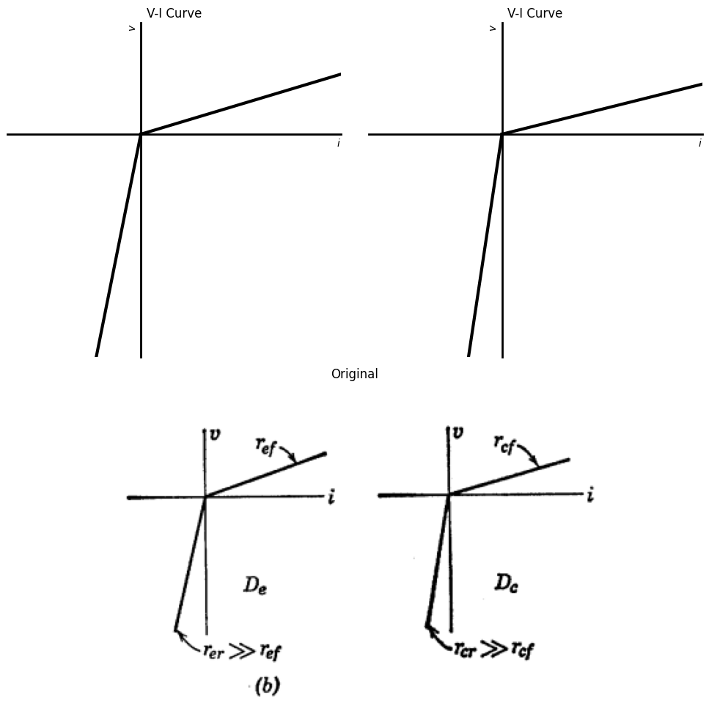
<Figure size 640x480 with 0 Axes>
<Figure size 640x480 with 0 Axes>
import matplotlib.pyplot as plt
import numpy as np
import schemdraw
from schemdraw import dsp
import schemdraw.elements as e
import matplotlib.image as mpimg
d = schemdraw.Drawing()
l0 = d.add(e.Line(l=1).right().idot(open=True))
D1 = d.add(e.Diode(l=1.5,fill=True).right().idot())
R1 = d.add(e.Resistor(l=1.5).right().dot().label('$r_{ef}$',ofst=-1)).dot()
l1 = d.add(e.Line(l=1.3).up())
I0 = d.add(e.SourceI().left().label("$a'i_c$"))
l2 = d.add(e.Line(l=1.3).down())
l3 = d.add(e.Line(l=1.3).down())
R2 = d.add(e.Resistor().right().label("$r_{er}$"))
l4 = d.add(e.Line(l=1.3).up())
l5 = d.add(e.Line(l=1.4).right().dot())
l6 = d.add(e.Line(l=0.4).down().at(l5.center).idot())
R3 = d.add(e.Resistor().down().label("$r_b$"))
l7 = d.add(e.Line(l=0.4).down().dot(open=True))
#l8 = d.add(e.Line(l=0.6).right().at(l5.end).dot())
D2 = d.add(e.Diode(l=1.5,fill=True).reverse().right().at(l5.end).idot())
R4 = d.add(e.Resistor(l=1.5).right().reverse().label('$r_{cf}$',ofst=-1)).dot()
l9 = d.add(e.Line(l=1.3).up())
I1 = d.add(e.SourceI().left().reverse().label("$ai_e$"))
l10 = d.add(e.Line(l=1.3).down())
l11 = d.add(e.Line(l=1.3).down())
R5 = d.add(e.Resistor().right().label("$r_{cr}$"))
l12 = d.add(e.Line(l=1.3).up())
l0 = d.add(e.Line(l=1).right().idot().dot(open=True))
d += e.Arrow().left().linewidth(0.6).length(0.7).color('black').label('$i_c$', loc='top', color='black',ofst=0.2).at((9.6,0.3))
d += e.Arrow().right().linewidth(0.6).length(0.7).color('black').label('$i_e$', loc='top', color='black',ofst=0.2).at((-0.1,0.3))
d += e.Arrow().length(2.5).at((7.9, -2.1)).label('+', ofst=(0.7,-0.5)).theta(50)
d += e.Arrow().length(2.5).at((7, -2.7)).label('-', ofst=(0.7,0.4)).theta(-150)
d += e.Gap().right().label('$v_{eb}$',fontsize = 12).color('black').at((0.6,-2.4))
d += e.Gap().right().label('$v_{cb}$',fontsize = 12).color('black').at((6,-2.3))
d += e.Arrow().length(2.5).at((2.4, -3)).label('-', ofst=(0.7,-0.4)).theta(-20)
d += e.Arrow().length(2.5).at((1.4, -2.2)).label('+', ofst=(0.7,0.4)).theta(125)
d.save('./Drawings5/5-11cm.png')
d.save('./Drawings5/5-11cm.svg')
fig, axs = plt.subplots(1, 2, figsize=(8, 4))
img = mpimg.imread('./Drawings5/5-11cm.png')
axs[0].imshow(img)
axs[0].axis('off')
axs[0].set_title('Circuit Diagram (developed)')
img_sample = mpimg.imread('./images5/5-11cm.png')
axs[1].imshow(img_sample)
axs[1].axis('off')
axs[1].set_title('Original')
plt.tight_layout()
plt.show()
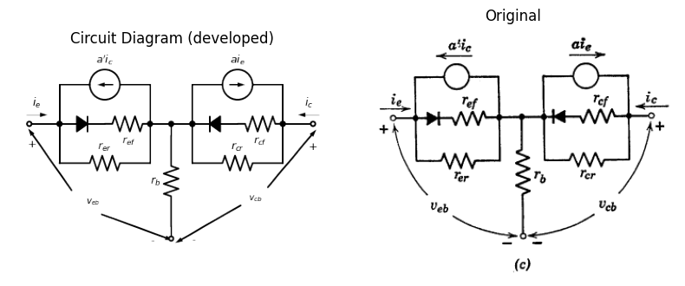
Fig. 5.11 Transistor Model Using Piecewise-Linear Resistive Diodes
Fig. 5.11(a). The piecewise-linear diodes $ D_e $ and $ D_c $ are specified by forward and reverse resistances, as indicated in Fig. 5.11(b). Typical values of forward resistances are 50 to 200 ohms, whereas reverse resistances are of the order of a megohm. The numerous parameters available in this model afford more than enough flexibility to approximate a set of transistor curves very well. In fact, the complete model shown in Fig. 5.11(c) is more involved than necessary for most circuit analysis or design problems.
############################ttttttttt
import matplotlib.pyplot as plt
import numpy as np
import schemdraw
from schemdraw import dsp
import schemdraw.elements as e
import matplotlib.image as mpimg
d = schemdraw.Drawing()
l0 = d.add(e.Line(l=1).right().idot(open=True))
D1 = d.add(e.Diode(l=1.5,fill=True).right().label('$D_e$',ofst=-1))
R1 = d.add(e.Resistor(l=1.5).right().dot().dot().label('$r_{ef}$',ofst=-1))
l5 = d.add(e.Line(l=1.4).right().dot())
l6 = d.add(e.Line(l=0.4).down().at(l5.center).idot())
R3 = d.add(e.Resistor().down().label("$r_b$"))
l7 = d.add(e.Line(l=0.4).down().dot(open=True))
#l8 = d.add(e.Line(l=0.6).right().at(l5.end).dot())
D2 = d.add(e.Diode(l=1.5,fill=True).reverse().right().at(l5.end).label('$D_c$',ofst=-1).dot().idot())
#R4 = d.add(e.Resistor(l=1.5).right().reverse().label('$r_{cf}$',ofst=-1)).dot()
l9 = d.add(e.Line(l=1.3).up())
I1 = d.add(e.SourceI(l=1.5).left().reverse().label("$ai_e$"))
l10 = d.add(e.Line(l=1.3).down())
l11 = d.add(e.Line(l=1.3).down())
R5 = d.add(e.Resistor(l=1.5).right().label("$r_{cr}$",ofst=-1))
l12 = d.add(e.Line(l=1.3).up())
l0 = d.add(e.Line(l=1).right().idot().dot(open=True))
d += e.Arrow().left().linewidth(0.6).length(0.7).color('black').label('$i_c$', loc='top', color='black',ofst=0.2).at((9.6,0.3))
d += e.Arrow().right().linewidth(0.6).length(0.7).color('black').label('$i_e$', loc='top', color='black',ofst=0.2).at((-0.1,0.3))
d += e.Arrow().length(2.2).at((7.5, -2.1)).label('+', ofst=(0.7,-0.5)).theta(70)
d += e.Arrow().length(2.5).at((7, -2.7)).label('-', ofst=(0.7,0.4)).theta(-150)
d += e.Gap().right().label('$v_{eb}$',fontsize = 12).color('black').at((0.6,-2.4))
d += e.Gap().right().label('$v_{cb}$',fontsize = 12).color('black').at((6,-2.3))
d += e.Arrow().length(2.5).at((2.4, -3)).label('-', ofst=(0.7,-0.4)).theta(-20)
d += e.Arrow().length(2.5).at((1.4, -2.2)).label('+', ofst=(0.7,0.4)).theta(125)
d.save('./Drawings5/5-12.png')
d.save('./Drawings5/5-12.svg')
fig, axs = plt.subplots(1, 2, figsize=(8, 4))
img = mpimg.imread('./Drawings5/5-12.png')
axs[0].imshow(img)
axs[0].axis('off')
axs[0].set_title('Circuit Diagram (developed)')
img_sample = mpimg.imread('./images5/5-12.png')
axs[1].imshow(img_sample)
axs[1].axis('off')
axs[1].set_title('Original')
plt.tight_layout()
plt.show()
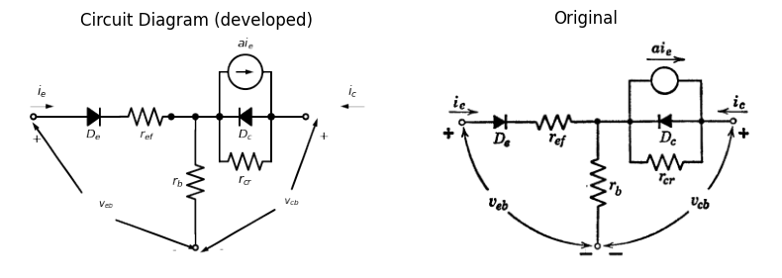
import matplotlib.pyplot as plt
import numpy as np
import schemdraw
from schemdraw import dsp
import schemdraw.elements as e
import matplotlib.image as mpimg
d = schemdraw.Drawing()
l0 = d.add(e.Line(l=1.3).right().idot(open=True))
D1 = d.add(e.Diode(l=1.5,fill=True).right().dot().idot())
l1 = d.add(e.Line(l=1.3).up())
I0 = d.add(e.SourceI(l=1.5).left().label("$a'i_c$"))
l2 = d.add(e.Line(l=1.3).down())
l3 = d.add(e.Line(l=1.3).down())
R2 = d.add(e.Resistor(l=1.5).right().label("$r_{er}$"))
l4 = d.add(e.Line(l=1.3).up())
l5 = d.add(e.Line(l=2.2).right())
l6 = d.add(e.Line(l=0.4).down().at(l5.center).idot())
R3 = d.add(e.Resistor().down().label("$r_b$"))
l7 = d.add(e.Line(l=0.4).down().dot(open=True))
#l8 = d.add(e.Line(l=0.6).right().at(l5.end).dot())
D2 = d.add(e.Diode(l=1.3,fill=True).reverse().right().at(l5.end))
R4 = d.add(e.Resistor(l=1.5).right().reverse().label('$r_{cf}$',ofst=-1))
l0 = d.add(e.Line(l=1).right().dot(open=True))
d += e.Arrow().left().linewidth(0.6).length(0.7).color('black').label('$i_c$', loc='top', color='black',ofst=0.2).at((9.2,0.3))
d += e.Arrow().right().linewidth(0.6).length(0.7).color('black').label('$i_e$', loc='top', color='black',ofst=0.2).at((-0.1,0.3))
d += e.Arrow().length(2.5).at((7.5, -2.1)).label('+', ofst=(0.7,-0.5)).theta(50)
d += e.Arrow().length(2.5).at((6.6, -2.7)).label('-', ofst=(0.7,0.4)).theta(-150)
d += e.Gap().right().label('$v_{eb}$',fontsize = 12).color('black').at((0,-2.3))
d += e.Gap().right().label('$v_{cb}$',fontsize = 12).color('black').at((5.6,-2.3))
d += e.Arrow().length(2.1).at((1.8, -3)).label('-', ofst=(0.7,-0.4)).theta(-20)
d += e.Arrow().length(2.1).at((0.9, -1.9)).label('+', ofst=(0.7,0.4)).theta(115)
d.save('./Drawings5/5-12b.png')
d.save('./Drawings5/5-12b.svg')
fig, axs = plt.subplots(1, 2, figsize=(8, 4))
img = mpimg.imread('./Drawings5/5-12b.png')
axs[0].imshow(img)
axs[0].axis('off')
axs[0].set_title('Circuit Diagram (developed)')
img_sample = mpimg.imread('./images5/5-12b.png')
axs[1].imshow(img_sample)
axs[1].axis('off')
axs[1].set_title('Original')
plt.tight_layout()
plt.show()
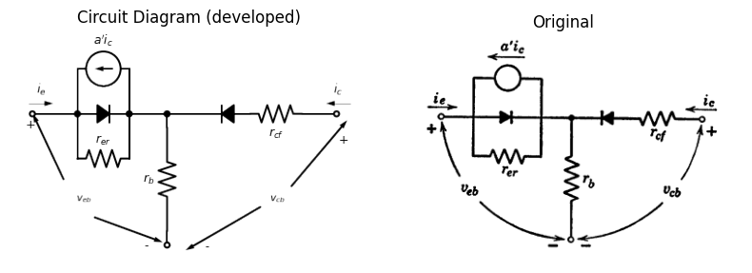
Fig. 5.12 Simplified Piecewise-Linear Resistive Model
The analytical complexity encountered with the general model can be reduced by using a model in which the emitter and the collector diodes are made semi-ideal. As shown in Fig. 5.12(a), only forward emitter resistance and reverse collector resistance are included. To solve a given circuit problem, one should choose the simplest possible model that will give the required accuracy. Often the best approach is to solve the problem first with the ideal-diode model and then add appropriate resistances to the model and refine the solution. Similarly, the model with the $ a' i_e $ generator alone is convenient if collector current is always negative, but if $ i_c $ is positive at any time, the $ a' i_e $ generator must also be included.
import matplotlib.pyplot as plt
import numpy as np
import schemdraw
from schemdraw import dsp
import schemdraw.elements as e
import matplotlib.image as mpimg
d = schemdraw.Drawing()
d += dsp.Line().length(d.unit*0.2).up().idot(open=True)
tr = d.add(e.BjtPnp(circle=True).up())
d += dsp.Line().length(d.unit*0.3).dot(open=True).left().at(tr.emitter)
d += dsp.Line().length(d.unit*0.3).dot(open=True).right().at(tr.collector)
d += e.Arrow().length(0.6).at((1.3, 0.7)).theta(60)
d += e.Arrow().length(0.6).at((0.7, 0.1)).theta(-150)
d += e.Gap().right().label('$v_{cb}$',fontsize = 12).color('black').at((-0.5,0.5))
d += e.Gap().right().label('$v_{eb}$',fontsize = 12).color('black').at((-2.6,0.5))
d += e.Arrow().length(0.6).at((-0.7, 0)).theta(-20)
d += e.Arrow().length(0.6).at((-1.3, 0.6)).theta(115)
d += e.Arrow().left().linewidth(0.6).length(0.7).color('black').label('$i_c$', loc='top', color='black',ofst=0.2).at((1.8,1.6))
d += e.Arrow().right().linewidth(0.6).length(0.7).color('black').label('$i_e$', loc='top', color='black',ofst=0.2).at((-1.9,1.6))
d.draw()
d.save('./Drawings5/5-13m.png')
d.save('./Drawings5/5-13m.svg')
fig, axs = plt.subplots(1, 2, figsize=(6, 3))
img = mpimg.imread('./Drawings5/5-13m.png')
axs[0].imshow(img)
axs[0].axis('off')
axs[0].set_title('Circuit Diagram (developed)')
img_sample = mpimg.imread('./images5/5-13m.png') # Load the PNG file
axs[1].imshow(img_sample)
axs[1].axis('off')
axs[1].set_title('Original')
plt.tight_layout()
plt.show()
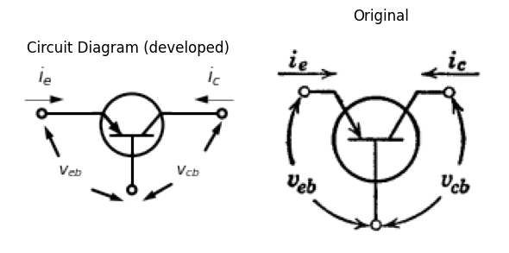
import matplotlib.pyplot as plt
import numpy as np
import matplotlib.image as mpimg
from matplotlib.gridspec import GridSpec
fig = plt.figure(figsize=(6, 9))
gs = GridSpec(3, 2, width_ratios=[1, 1])
ax0 = fig.add_subplot(gs[0, 0])
x2 = -np.linspace(0, 7, 500)
a1 = 0.02
b1 = 0.1
y2 = -b1 * np.exp(-x0 /a1)+b1
ax0.plot(x2, y2, color='black', linewidth=1)
y2 = -b1 * np.exp(-(x2+0.8) /a1)+b1
ax0.plot(x2, y2, color='black', linewidth=1)
y2 = -b1 * np.exp(-(x2+1.8) /a1)+b1
ax0.plot(x2, y2, color='black', linewidth=1)
y2 = -b1 * np.exp(-(x2+2.8) /a1)+b1
ax0.plot(x2, y2, color='black', linewidth=1)
y2 = -b1 * np.exp(-(x2+3.8) /a1)+b1
ax0.plot(x2, y2, color='black', linewidth=1)
ax0.set_title('V-I Curve')
ax0.set_ylabel('$v_{cb}$', labelpad=3, loc='top')
ax0.set_xlim(-4, 1)
ax0.set_ylim(-4, 1)
ax0.set_xlabel('$i_c$', labelpad=3, loc='right')
ax0.axhline(0, color='black', linewidth=1)
ax0.axvline(0, color='black', linewidth=1)
ax0.set_xticks(np.arange(-4, 1, 1))
ax0.set_yticks(np.arange(-40, 10, 10))
ax0.grid(True)
ax1 = fig.add_subplot(gs[0, 1])
x21 = -np.linspace(-4.3, 0.3, 500)
y21 = -0.012*(x21-5)**2+0.3
ax1.plot(x21, y21, color='black', linewidth=1, linestyle='--')
x21 = -np.linspace(-4, 0.1, 500)
y21 = -0.012*(x21-5)**2+0.27
ax1.plot(x21, y21, color='black', linewidth=1, linestyle='--')
x21 = -np.linspace(-4.1, -0.1, 500)
y21 = -0.012*(x21-5)**2+0.24
ax1.plot(x21, y21, color='black', linewidth=1, linestyle='--')
x21 = -np.linspace(-4.2, -0.5, 500)
y21 = -0.012*(x21-5)**2+0.21
ax1.plot(x21, y21, color='black', linewidth=1, linestyle='--')
x21 = -np.linspace(-4.3, -0.8, 500)
y21 = -0.012*(x21-5)**2+0.18
ax1.plot(x21, y21, color='black', linewidth=1, linestyle='--')
ax1.set_xlim(-1, 5)
ax1.set_ylim(-0.2, 0.4)
ax1.set_xlabel('$i_e$', labelpad=3, loc='right')
ax1.set_ylabel('$v_{eb}$', labelpad=3, loc='top')
ax1.set_title('V-I Curve')
ax1.grid(True)
ax1.set_xticks(np.arange(-1, 5, 1))
ax1.set_yticks(np.arange(-0.2, 0.4, 0.1))
ax2 = fig.add_subplot(gs[1, 0])
x2 = -np.linspace(0, 7, 500)
a1 = 0.04
b1 = 0.001
y2 = -b1 * np.exp(-x0 /a1)+b1
ax2.plot(x2, y2, color='black', linewidth=1)
y2 = -b1 * np.exp(-(x2+0.7) /a1)+b1+0.04
ax2.plot(x2, y2, color='black', linewidth=1)
y2 = -b1 * np.exp(-(x2+1.7) /a1)+b1+0.07
ax2.plot(x2, y2, color='black', linewidth=1)
y2 = -b1 * np.exp(-(x2+2.7) /a1)+b1+0.1
ax2.plot(x2, y2, color='black', linewidth=1)
y2 = -b1 * np.exp(-(x2+3.7) /a1)+b1+0.13
ax2.plot(x2, y2, color='black', linewidth=1)
ax2.set_xlim(-4.1, 1)
ax2.set_ylim(-0.4, 0.2)
ax2.set_xlabel('$i_e$', labelpad=3, loc='right')
ax2.set_ylabel('$v_{eb}$', labelpad=3, loc='top')
ax2.set_title('V-I Curve')
ax2.grid(True)
ax2.set_xticks(np.arange(-4, 1, 1))
ax2.set_yticks(np.arange(-0.6, 0.2, 0.2))
ax3 = fig.add_subplot(gs[1, 1])
x2 = -np.linspace(-10, 10, 1000)
a1 = 0.1
b1 = 0.16
y2 = -b1 * np.exp(-x2 /a1)+b1
ax3.plot(x2, y2, color='black', linewidth=1)
y2 = -b1 * np.exp(-x2 /a1)+b1-0.02
ax3.plot(x2, y2, color='black', linewidth=1)
ax3.set_xlim(-0.03, 0.5)
ax3.set_ylim(-0.2, 0.3)
ax3.set_xlabel('$i_e$', labelpad=3, loc='right')
ax3.set_ylabel('$v_{eb}$', labelpad=3, loc='top')
ax3.set_title('V-I Curve')
ax3.grid(True)
ax3.set_xticks(np.arange(-0.03, 0.5, 0.1))
ax3.set_yticks(np.arange(-0.2, 0.3, 0.1))
ax4 = fig.add_subplot(gs[2, :])
img_sample = mpimg.imread('./images5/5-13n.png')
ax4.imshow(img_sample)
ax4.set_title('Original')
ax4.axis('off')
axes = [ax0, ax1, ax2, ax3]
for a in axes:
a.spines['top'].set_color('none')
a.spines['right'].set_color('none')
a.spines['left'].set_position('zero')
a.spines['bottom'].set_position('zero')
a.spines['left'].set_linewidth(1)
a.spines['bottom'].set_linewidth(1)
a.xaxis.set_ticks_position('bottom')
a.yaxis.set_ticks_position('left')
a.tick_params(axis='both', which='both', length=5)
a.grid(True)
#a.set_xticks(np.arange(-6, 10, 2))
#a.set_yticks(np.arange(-10, 6, 2))
plt.tight_layout()
plt.show()
plt.savefig('./Drawings5/5-13n.jpg')
plt.savefig('./Drawings5/5-13n.svg')
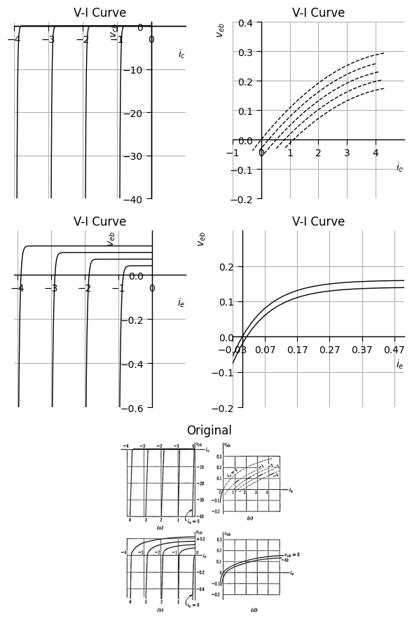
<Figure size 640x480 with 0 Axes>
Fig. 5.13 Typical Curves for a p-n-p Junction Transistor for Common-Base Connection
##5.9 Approximating Transistor Curves Typical measured curves specifying the “static” or resistive terminal behavior of a p-n-p junction transistor are shown in Fig. 5.13. This is only one of a number of forms in which a manufacturer may present average characteristics. The family of collector curves shown in Fig. 5.13(a) is repeated in (b) with an expanded voltage scale to emphasize the exponential character of the curves for small values of collector voltage is apparent. From the expanded scale, it is evident that each curve in the collector family resembles the curve for a semiconductor diode, with successive curves shifted along the current axis by an amount corresponding approximately to the majority-carrier injection provided by the emitter.
import matplotlib.pyplot as plt
import numpy as np
import matplotlib.image as mpimg
from matplotlib.gridspec import GridSpec
fig = plt.figure(figsize=(6, 9))
gs = GridSpec(3, 2, width_ratios=[1, 1])
ax0 = fig.add_subplot(gs[0, 0])
x2 = -np.linspace(0, 7, 500)
a1 = 0.02
b1 = 0.1
y2 = -b1 * np.exp(-x0 /a1)+b1
ax0.plot(x2, y2, color='black', linewidth=1)
y2 = -b1 * np.exp(-(x2+0.8) /a1)+b1
ax0.plot(x2, y2, color='black', linewidth=1)
y2 = -b1 * np.exp(-(x2+1.8) /a1)+b1
ax0.plot(x2, y2, color='black', linewidth=1)
y2 = -b1 * np.exp(-(x2+2.8) /a1)+b1
ax0.plot(x2, y2, color='black', linewidth=1)
y2 = -b1 * np.exp(-(x2+3.8) /a1)+b1
ax0.plot(x2, y2, color='black', linewidth=1)
ax0.set_title('V-I Curve')
ax0.set_ylabel('$v_{cb}$', labelpad=3, loc='top')
ax0.set_xlim(-4, 1)
ax0.set_ylim(-4, 1)
ax0.set_xlabel('$i_c$', labelpad=3, loc='right')
ax0.axhline(0, color='black', linewidth=1)
ax0.axvline(0, color='black', linewidth=1)
ax0.set_xticks(np.arange(-4, 1, 1))
ax0.set_yticks(np.arange(-40, 10, 10))
ax0.grid(True)
ax1 = fig.add_subplot(gs[0, 1])
ax1.plot([0,5], [-0.2,0.3], color='black', linewidth=1, linestyle='--',dashes=(8, 3))
ax1.plot([0,5], [-0.15,0.35], color='black', linewidth=1, linestyle='--',dashes=(8, 3))
ax1.plot([0,5], [-0.1,0.4], color='black', linewidth=1, linestyle='--',dashes=(8, 3))
ax1.plot([0,5], [-0.05,0.45], color='black', linewidth=1, linestyle='--',dashes=(8, 3))
ax1.plot([0,5], [0,0.5], color='black', linewidth=1, linestyle='--',dashes=(8, 3))
ax1.plot([0,5], [0,0.22], color='black', linewidth=1, linestyle='--',dashes=(10, 3))
ax1.plot([0,5], [0.03,0.25], color='black', linewidth=1, linestyle='--',dashes=(10, 3))
ax1.set_xlim(-1, 5)
ax1.set_ylim(-0.2, 0.3)
ax1.set_xlabel('$i_e$', labelpad=3, loc='right')
ax1.set_ylabel('$v_{eb}$', labelpad=3, loc='top')
ax1.set_title('V-I Curve')
ax1.grid(True)
ax1.set_xticks(np.arange(-1, 5, 1))
ax1.set_yticks(np.arange(-0.2, 0.3, 0.1))
ax2 = fig.add_subplot(gs[1, 0])
x2 = -np.linspace(0.08, 7, 500)
a1 = 0.04
b1 = 0.001
#y2 = -b1 * np.exp(-x0 /a1)+b1
#ax2.plot(x2, y2, color='black', linewidth=1)
ax2.plot([-0.1, 0], [-0.4, 0], color='black', linewidth=1)
x2 = -np.linspace(0.84, 7, 500)
y2 = -b1 * np.exp(-(x2+0.7) /a1)+b1+0.04
ax2.plot(x2, y2, color='black', linewidth=1)
x2 = -np.linspace(1.86, 7, 500)
y2 = -b1 * np.exp(-(x2+1.7) /a1)+b1+0.07
ax2.plot(x2, y2, color='black', linewidth=1)
x2 = -np.linspace(2.875, 7, 500)
y2 = -b1 * np.exp(-(x2+2.7) /a1)+b1+0.1
ax2.plot(x2, y2, color='black', linewidth=1)
x2 = -np.linspace(3.88, 7, 500)
y2 = -b1 * np.exp(-(x2+3.7) /a1)+b1+0.13
ax2.plot(x2, y2, color='black', linewidth=1)
ax2.plot([-5, 0], [0.04, 0], color='black', linewidth=1, linestyle='--')
ax2.plot([0, 1], [0, 0.02], color='black', linewidth=1)
ax2.plot([-0.84, 1], [0.01,0.06], color='black', linewidth=1)
ax2.plot([-1.86, 1], [0.02,0.1], color='black', linewidth=1)
ax2.plot([-2.87, 1], [0.027,0.14], color='black', linewidth=1)
ax2.plot([-3.88, 1], [0.037,0.18], color='black', linewidth=1)
ax2.set_xlim(-4.1, 1)
ax2.set_ylim(-0.4, 0.2)
ax2.set_xlabel('$i_e$', labelpad=3, loc='right')
ax2.set_ylabel('$v_{eb}$', labelpad=3, loc='top')
ax2.set_title('V-I Curve')
ax2.grid(True)
ax2.set_xticks(np.arange(-4, 1, 1))
ax2.set_yticks(np.arange(-0.4, 0.2, 0.2))
ax3 = fig.add_subplot(gs[1, 1])
ax3.plot([0,5], [0,0.25], color='black', linewidth=1)
ax3.plot([0,5], [-0.01,0.24], color='black', linewidth=1)
ax3.plot([0,5], [0.1,0.35], color='black', linewidth=1)
ax3.set_xlim(0, 5)
ax3.set_ylim(-0.2, 0.3)
ax3.set_xlabel('$i_e$', labelpad=3, loc='right')
ax3.set_ylabel('$v_{eb}$', labelpad=3, loc='top')
ax3.set_title('V-I Curve')
ax3.grid(True)
ax3.set_xticks(np.arange(0, 5, 1))
ax3.set_yticks(np.arange(-0.2, 0.3, 0.1))
ax4 = fig.add_subplot(gs[2, :])
img_sample = mpimg.imread('./images5/5-14n.png')
ax4.imshow(img_sample)
ax4.set_title('Original')
ax4.axis('off')
axes = [ax0, ax1, ax2, ax3]
for a in axes:
a.spines['top'].set_color('none')
a.spines['right'].set_color('none')
a.spines['left'].set_position('zero')
a.spines['bottom'].set_position('zero')
a.spines['left'].set_linewidth(1)
a.spines['bottom'].set_linewidth(1)
a.xaxis.set_ticks_position('bottom')
a.yaxis.set_ticks_position('left')
a.tick_params(axis='both', which='both', length=5)
a.grid(True)
#a.set_xticks(np.arange(-6, 10, 2))
#a.set_yticks(np.arange(-10, 6, 2))
plt.tight_layout()
plt.show()
plt.savefig('./Drawings5/5-14n.jpg')
plt.savefig('./Drawings5/5-14n.svg')
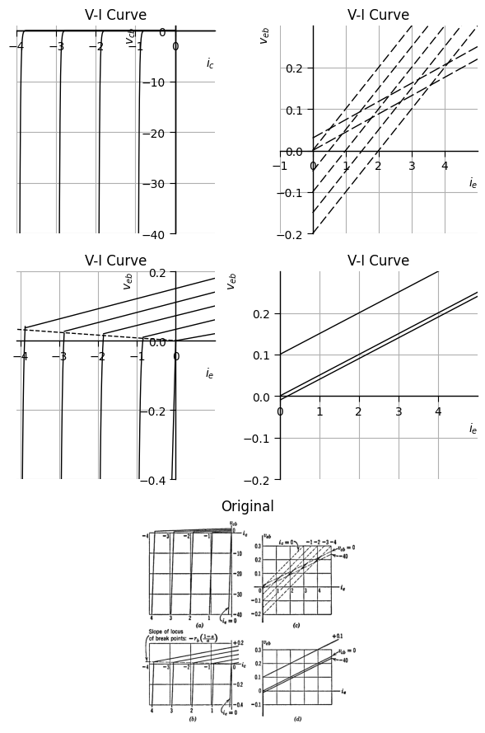
<Figure size 640x480 with 0 Axes>
Fig. 5.14 Approximate Curves for a p-n-p transistor using the model of Fig. 5.12, with $ r_{ef} = 50 $ ohms, $ r_b = 50 $ ohms, $ r_{cr} = 200 $ kΩ, $ \alpha = 0.95 $.
Since two voltages and two currents are needed to specify the terminal behavior of the transistor, another plot is necessary. Either the plot in Fig. 5.13(c) or that in (d) links the fourth variable ( v_{eb} ) to the other three. The graphical data can also be presented in a variety of forms, some of which will be introduced later.
Comparing the typical collector curves of Fig. 5.13(a) with those for the ideal diode model in Fig. 5.5(b), we see the possibility of reasonable quantitative agreement. The inclusion of base resistance in the ideal-diode model makes the collector family approximation somewhat better [compare curves in Fig. 5.13(b) and Fig. 5.9(b)].
The piecewise-linear curves in Fig. 5.14 are plotted for the model in Fig. 5.10 using the following values: $ r_{ef} = 50 $ ohms, $ r_b = 50 $ ohms, $ r_{er} = 200 $ kΩ, and $ \alpha = 0.95 $. The corresponding parts of Figs. 5.13 and 5.14 are seen to be in very close agreement except in the vicinity of break points.
import matplotlib.pyplot as plt
import numpy as np
import matplotlib.image as mpimg
from matplotlib.gridspec import GridSpec
fig = plt.figure(figsize=(6, 9))
gs = GridSpec(3, 2, width_ratios=[1, 1])
ax0 = fig.add_subplot(gs[0, :])
x2 = -np.linspace(0.08, 7, 500)
a1 = 0.04
b1 = 0.001
#y2 = -b1 * np.exp(-x0 /a1)+b1
#ax2.plot(x2, y2, color='black', linewidth=1)
ax0.plot([-0.1, 0], [-0.4, 0], color='black', linewidth=1)
x2 = -np.linspace(0.84, 7, 500)
y2 = -b1 * np.exp(-(x2+0.7) /a1)+b1+0.04
ax0.plot(x2, y2, color='black', linewidth=1)
x2 = -np.linspace(1.86, 7, 500)
y2 = -b1 * np.exp(-(x2+1.7) /a1)+b1+0.07
ax0.plot(x2, y2, color='black', linewidth=1)
x2 = -np.linspace(2.875, 7, 500)
y2 = -b1 * np.exp(-(x2+2.7) /a1)+b1+0.1
ax0.plot(x2, y2, color='black', linewidth=1)
x2 = -np.linspace(3.88, 7, 500)
y2 = -b1 * np.exp(-(x2+3.7) /a1)+b1+0.13
ax0.plot(x2, y2, color='black', linewidth=1)
ax0.plot([-5, 0], [0.04, 0], color='black', linewidth=1, linestyle='--')
ax0.plot([0, 1], [0, 0.02], color='black', linewidth=1)
ax0.plot([-0.84, 1], [0.01,0.06], color='black', linewidth=1)
ax0.plot([-1.86, 1], [0.02,0.1], color='black', linewidth=1)
ax0.plot([-2.87, 1], [0.027,0.14], color='black', linewidth=1)
ax0.plot([-3.88, 1], [0.037,0.18], color='black', linewidth=1)
ax0.set_xlim(-4.1, 1)
ax0.set_ylim(-0.4, 0.2)
ax0.set_xlabel('$i_e$', labelpad=3, loc='right')
ax0.set_ylabel('$v_{eb}$', labelpad=3, loc='top')
ax0.set_title('V-I Curve')
ax0.set_xticks(np.arange(-4, 1, 1))
ax0.set_yticks(np.arange(-0.4, 0.2, 0.2))
ax1 = fig.add_subplot(gs[1, 0])
ax1.plot([0,5], [-0.2,0.3], color='black', linewidth=1, linestyle='--',dashes=(8, 3))
#ax1.plot([0,5], [-0.15,0.35], color='black', linewidth=1, linestyle='--',dashes=(8, 3))
ax1.plot([0,5], [-0.1,0.4], color='black', linewidth=1, linestyle='--',dashes=(8, 3))
#ax1.plot([0,5], [-0.05,0.45], color='black', linewidth=1, linestyle='--',dashes=(8, 3))
ax1.plot([0,5], [0,0.5], color='black', linewidth=1, linestyle='--',dashes=(8, 3))
ax1.plot([0,5], [0,0.22], color='black', linewidth=1, linestyle='--',dashes=(10, 3))
ax1.plot([0,5], [-0.03,0.19], color='black', linewidth=1, linestyle='--',dashes=(10, 3))
ax1.set_xlim(-1, 5)
ax1.set_ylim(-0.2, 0.3)
ax1.set_xlabel('$i_e$', labelpad=3, loc='right')
ax1.set_ylabel('$v_{eb}$', labelpad=3, loc='top')
ax1.set_title('V-I Curve')
ax1.set_xticks(np.arange(-1, 5, 1))
ax1.set_yticks(np.arange(-0.2, 0.3, 0.1))
ax3 = fig.add_subplot(gs[1, 1])
ax3.plot([0,5], [0,0.25], color='black', linewidth=1)
ax3.plot([0,5], [-0.04,0.21], color='black', linewidth=1)
#ax3.plot([0,5], [0.1,0.35], color='black', linewidth=1)
ax3.set_xlim(0, 5)
ax3.set_ylim(-0.2, 0.3)
ax3.set_xlabel('$i_e$', labelpad=3, loc='right')
ax3.set_ylabel('$v_{eb}$', labelpad=3, loc='top')
ax3.set_title('V-I Curve')
ax3.set_xticks(np.arange(0, 5, 1))
ax3.set_yticks(np.arange(-0.2, 0.3, 0.1))
ax4 = fig.add_subplot(gs[2, :])
img_sample = mpimg.imread('./images5/5-15n.png')
ax4.imshow(img_sample)
ax4.set_title('Original')
ax4.axis('off')
axes = [ax0, ax1, ax2, ax3]
for a in axes:
a.spines['top'].set_color('none')
a.spines['right'].set_color('none')
a.spines['left'].set_position('zero')
a.spines['bottom'].set_position('zero')
a.spines['left'].set_linewidth(1)
a.spines['bottom'].set_linewidth(1)
a.xaxis.set_ticks_position('bottom')
a.yaxis.set_ticks_position('left')
a.tick_params(axis='both', which='both', length=5)
plt.tight_layout()
plt.show()
plt.savefig('./Drawings5/5-15n.jpg')
plt.savefig('./Drawings5/5-15n.svg')
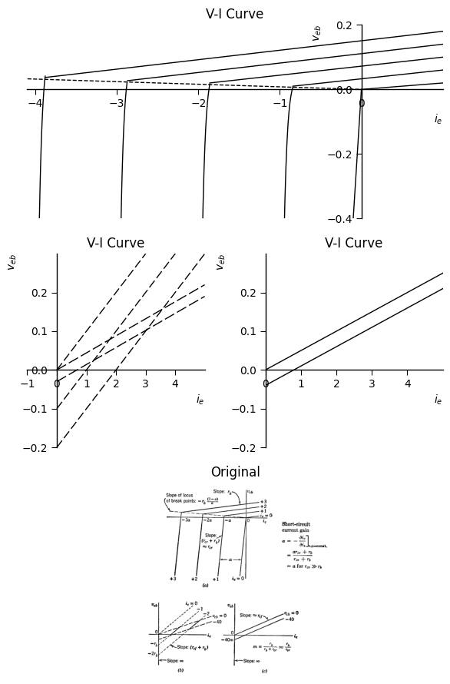
<Figure size 640x480 with 0 Axes>
Fig. 5.15 Slopes and Intercepts of Common-Base Curves for p-n-p Transistor, using the piecewise-linear model of Fig. 5.10. (a) $ v_{cb} $ vs. $ i_c $, parameter $ i_e $; (b) $ v_{eb} $ vs. $ i_e $, parameter $ i_c $; (c) $ v_{eb} $ vs. $ i_b $, parameter $ v_{cb} $.
This model then affords a fairly good approximation of the resistive behavior of a transistor. The heavy lines in Fig. 5.14(c) show the normal range of operation for the unit being described.
The curves of Fig. 5.14 were plotted from a break-point analysis of the model shown in Fig. 5.12(a). The curves are redrawn in Fig. 5.15, showing how to relate numerical values in order to show the general values of slopes and intercepts.
These plots show the effects of $ r_b, r_{ef}, r_{cr} $, and $ \alpha $, so that suitable values of these parameters can be chosen to approximate a set of actual curves.
An alternative method of analyzing circuits that contain models like those of Figs. 5.11 or 5.12 emphasizes the resistive character of the junction approximations. The model shown in Fig. 5.16(a) is purely resistive and, hence, applies in any one diode state when the appropriate values are used for $r_{e}$ and $ r_c $, namely, $ r_{ef} $ or $ r_{er} $ and $ r_{cf} $ and $ r_{cr} $.
import matplotlib.pyplot as plt
import numpy as np
import schemdraw
from schemdraw import dsp
import schemdraw.elements as e
import matplotlib.image as mpimg
d = schemdraw.Drawing()
l0 = d.add(e.Line(l=0.1).right().idot(open=True))
R0 = d.add(e.Resistor().right().dot().at(l0.end).label('$r_b$',ofst=-1))
R1 = d.add(e.Resistor().down().dot(open=True).at(R0.end).label('$r_e$',ofst=-1))
l2 = d.add(e.Line(l=0.8).right().at(R1.start))
R3 = d.add(e.Resistor(l=1.5).right().dot().idot().at(l2.end).label('$r_e$',ofst=-1))
l3 = d.add(e.Line(l=0.8).right().dot(open=True))
l4 = d.add(e.Line(l=1.3).up().at(R3.start))
I = d.add(e.SourceI(l=1.5).right().label('a$i_e$'))
l5 = d.add(e.Line(l=1.3).down())
d += e.Gap().right().color('black').at((-2.2,0.1))
d += e.Gap().right().color('black').at((5,0.1))
d += e.Gap().right().color('black').at((1.2,-3.2))
d += e.Arrow().left().linewidth(0.6).length(0.7).color('black').label('$i_c$', loc='top', color='black',ofst=0.2).at((6.5,0.3))
d += e.Arrow().right().linewidth(0.6).length(0.7).color('black').label('$i_e$', loc='top', color='black',ofst=0.2).at((-0.5,0.3))
d += e.Arrow().up().linewidth(0.6).length(0.7).color('black').label('$i_b$', loc='top', color='black',ofst=0.1).at((2.9,-2.8))
d += e.Arrow().length(1.5).at((5.3, -1.5)).label('+', ofst=(0.7,-0.4)).theta(60)
d += e.Arrow().length(1.5).at((4.6, -2.2)).label('-', ofst=(0.7,0.4)).theta(-150)
d += e.Arrow().length(1.5).at((1.7, -2.1)).label('-', ofst=(0.7,-0.4)).theta(-35)
d += e.Arrow().length(1.5).at((1, -1.5)).label('+', ofst=(0.7,0.4)).theta(120)
d += e.Gap().right().label('$v_{eb}$',fontsize = 12).color('black').at((-0.4,-1.7))
d += e.Gap().right().label('$v_{cb}$',fontsize = 12).color('black').at((3.4,-1.6))
d += e.Gap().right().label('$Note:$ \n\n $r_e$ = $r_{ef}$ or $r_{er}$\n $r_c$ = $r_cr$ or $r_{cf}$',fontsize = 12).color('black').at((5.9,-0.1))
d += e.Gap().right().label('$V_{eb}$ = $i_e(r_e+r_b)+i_cr_b$\n $V_{cb}$ = $i_c(r_b+ar_c)+i_c(r_b+r_b)$',fontsize = 12).color('black').at((1.5,-3.7))
d.draw()
d.save('./Drawings5/5-16.png')
d.save('./Drawings5/5-16.svg')
fig, axs = plt.subplots(1, 2, figsize=(8, 4))
img = mpimg.imread('./Drawings5/5-16.png')
axs[0].imshow(img)
axs[0].axis('off')
axs[0].set_title('Circuit Diagram (developed)')
img_sample = mpimg.imread('./images5/5-16.png')
axs[1].imshow(img_sample)
axs[1].axis('off')
axs[1].set_title('Original')
plt.tight_layout()
plt.show()
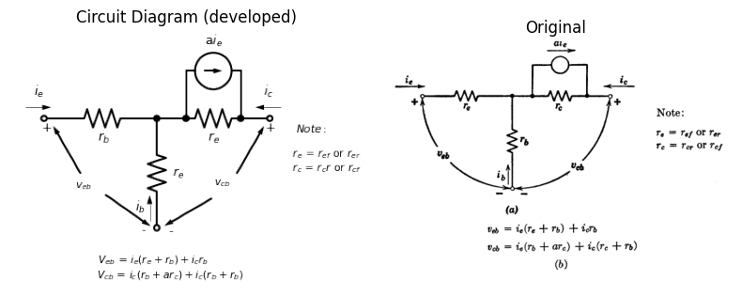
Fig. 5.16 Resistive Representation of Piecewise-Linear Model
A single current generator is shown in the interests of simplicity. The need for including $ a' i_e $ and removing $ a_i $ in state IV is no more difficult to remember than is the appropriate value to be used for each parameter. Actually, when the forward diode resistances are nonzero, omission of the second generator modifies the results somewhat. The resistive model of Fig. 5.16(a) is convenient to use because the same equations apply to all of the circuit states.
## 5.10 Total and Incremental Models
The voltages and currents on graphical plots describing an electronic device like a transistor are total quantities. Thus, such symbols as $i_{e}$ or $v_{cb}$ refer to the total instantaneous values of the variables. However, it is often possible to base an analysis on only the variational portions of the currents and voltages. Circuit models for calculating only variational currents and voltages are called incremental models or small-signal models.
Although the form of the model for any one state of a piecewise-linear approximation may be similar to that of an incremental model, the numerical values of the parameters may or may not be the same.
import matplotlib.pyplot as plt
import numpy as np
import schemdraw
from schemdraw import dsp
import schemdraw.elements as e
import matplotlib.image as mpimg
d = schemdraw.Drawing()
l1 = d.add(e.Line(l=0.6).down().idot(open=True))
D1 = d.add(e.Diode(l=1.5,fill=True).down())
ci1 = d.add(e.Source(l=1.5).down().at(D1.start))
l2 = d.add(e.Line(l=0.6).down().at(D1.end).dot(open=True))
d += e.Arrow().down().linewidth(0.6).length(0.7).color('black').label('$i$', loc='top', color='black',ofst=-0.3).at((0.4,0.3))
l3 = d.add(e.Line(l=0.2).left().at(l1.start).color('white'))
l31 = d.add(e.Line(l=1).left().linewidth(0.6))
l4 = d.add(e.Line(l=0.2).left().at(l2.end).color('white'))
l41 = d.add(e.Line(l=1).left().linewidth(0.6))
d += e.Arrow().up().length(1).linewidth(0.6).color('white').label('$V$', loc='start', color='black',ofst=0.3). at((-0.4,-1.4))
d += e.Arrow().up().length(0.8).linewidth(0.6).color('black').label('+',loc='end', color='black',ofst=0.4). at((-0.9,-0.8))
d += e.Arrow().down().length(0.8).linewidth(0.6).color('black').label(r'_', loc='end', color='black',ofst=(-0.3,-0.5)). at((-0.9,-2))
d.move(1, -2)
R0 = d.add(e.Resistor(l=2.8).down().idot(open=True).dot(open=True).label('$r$',ofst=-1))
d += e.Arrow().down().linewidth(0.6).length(0.7).color('black').label('$\Delta$ $i$', loc='top', color='black',ofst=-0.6).at((0.5,-4.6))
l7 = d.add(e.Line(l=0.2).left().at(R0.start).color('white'))
l71 = d.add(e.Line(l=1).left().linewidth(0.6))
l8 = d.add(e.Line(l=0.2).left().at(R0.end).color('white'))
l81 = d.add(e.Line(l=1).left().linewidth(0.6))
d += e.Arrow().up().length(1).linewidth(0.6).color('white').label('$\Delta$ $V$', loc='start', color='black',ofst=0.3). at((-0.3,-6.2))
d += e.Arrow().up().length(0.8).linewidth(0.6).color('black').label('+',loc='end', color='black',ofst=0.4). at((-0.8,-5.6))
d += e.Arrow().down().length(0.8).linewidth(0.6).color('black').label(r'_', loc='end', color='black',ofst=(-0.3,-0.5)). at((-0.8,-6.8))
d.move(1, -2)
R0 = d.add(e.Resistor(l=2.8).down().idot(open=True).label('$r$',ofst=-1))
E2 = d.add(e.Battery(l=1.6).down().label(['+', '$E_0$', '- '], ofst=-1.3).dot(open=True))
d += e.Arrow().down().linewidth(0.6).length(0.7).color('black').label('$i$', loc='top', color='black',ofst=-0.3).at((0.5,-9.3))
l7 = d.add(e.Line(l=0.2).left().at(R0.start).color('white'))
l71 = d.add(e.Line(l=1).left().linewidth(0.6))
l8 = d.add(e.Line(l=0.2).left().at(E2.end).color('white'))
l81 = d.add(e.Line(l=1).left().linewidth(0.6))
d += e.Arrow().up().length(1.5).linewidth(0.6).color('white').label('$V$', loc='start', color='black',ofst=0.3). at((-0.3,-11.9))
d += e.Arrow().up().length(1.3).linewidth(0.6).color('black').label('+',loc='end', color='black',ofst=0.4). at((-0.8,-10.9))
d += e.Arrow().down().length(1.3).linewidth(0.6).color('black').label(r'_', loc='end', color='black',ofst=(-0.3,-0.5)). at((-0.8,-12.7))
d.move(1, -2)
l1a = d.add(e.Line(l=0.6).down().idot(open=True))
D1a = d.add(e.Diode(l=1,fill=True).down())
l2a = d.add(e.Line(l=0.6).down().at(D1a.end))
R0 = d.add(e.Resistor(l=1).down().label('$r$',ofst=-1))
E2 = d.add(e.Battery(l=1.6).down().label(['+', '$E_0$', '- '], ofst=-1.3).dot(open=True))
d += e.Arrow().down().linewidth(0.6).length(0.7).color('black').label('$i$', loc='top', color='black',ofst=-0.3).at((0.5,-16))
l7 = d.add(e.Line(l=0.2).left().at(l1a.start).color('white'))
l71 = d.add(e.Line(l=1).left().linewidth(0.6))
l8 = d.add(e.Line(l=0.2).left().at(E2.end).color('white'))
l81 = d.add(e.Line(l=1).left().linewidth(0.6))
d += e.Arrow().up().length(2).linewidth(0.6).color('white').label('$V$', loc='start', color='black',ofst=0.3). at((-0.3,-18.2))
d += e.Arrow().up().length(1.8).linewidth(0.6).color('black').label('+',loc='end', color='black',ofst=0.4). at((-0.8,-17.8))
d += e.Arrow().down().length(1.8).linewidth(0.6).color('black').label(r'_', loc='end', color='black',ofst=(-0.3,-0.5)). at((-0.8,-18.9))
d += e.Gap().right().label('$v = f(i)$ \n$(V_a + \Delta v)$ = $f(I_a + \Delta i)$',fontsize = 12).color('black').at((1,-0.5))
d += e.Gap().right().label('$(v - V_a)$ = $r(i - I_a)$\n$\Delta v$ = $r\Delta i$',fontsize = 12).color('black').at((1,-5.5))
d += e.Gap().right().label('$v$ = $E_0$ + $ri$\n $V_a + \Delta v$ = $E_0$ + $r(I_a + \Delta i)$\nwhere $r$ = $\Delta v/\Delta i$\n and $E_0$ = $(V_a - rI_a)$',fontsize = 12).color('black').at((1.3,-10.5))
d += e.Gap().right().label('For \n $i>0$, $v$ = $E_0 + ri$\n $v<E_0$, $i = 0$',fontsize = 12).color('black').at((1,-17.5))
d.draw()
d.save('./Drawings5/5-17m.png')
d.save('./Drawings5/5-17m.svg')
fig, axs = plt.subplots(1, 2, figsize=(8, 10))
img = mpimg.imread('./Drawings5/5-17m.png')
axs[0].imshow(img)
axs[0].axis('off')
axs[0].set_title('Circuit Diagram (developed)')
img_sample = mpimg.imread('./images5/5-17m.png')
axs[1].imshow(img_sample)
axs[1].axis('off')
axs[1].set_title('Original')
plt.tight_layout()
plt.show()
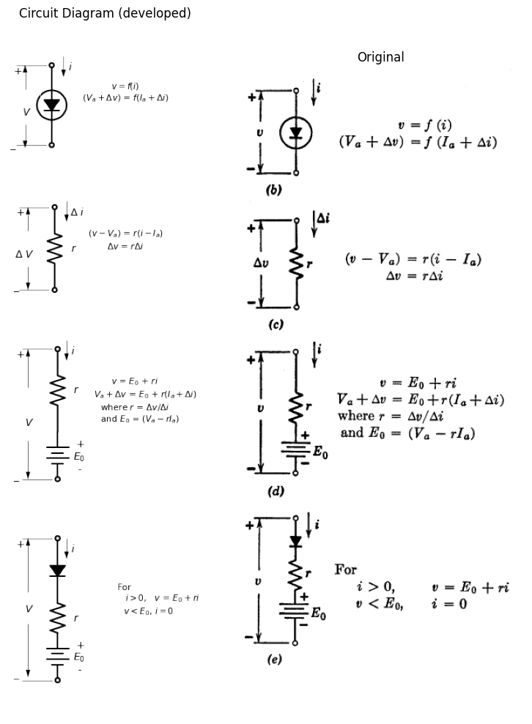
import matplotlib.pyplot as plt
import numpy as np
Ia = np.linspace(-2, 10, 400)
Va = 3*np.log(Ia+1.6)-1.1
fig, axs = plt.subplots(2, 1, figsize=(4, 8))
axs[0].plot(Ia, Va, label='E(V) Curve', color='black')
axs[0].plot([-3,10], [-1.2,9], color='black')
axs[0].spines['top'].set_color('none')
axs[0].spines['right'].set_color('none')
axs[0].spines['left'].set_position('zero')
axs[0].spines['bottom'].set_position('zero')
axs[0].spines['left'].set_linewidth(2)
axs[0].spines['bottom'].set_linewidth(2)
axs[0].xaxis.set_ticks_position('bottom')
axs[0].yaxis.set_ticks_position('left')
axs[0].tick_params(axis='both', which='both', length=0)
axs[0].set_xticks([])
axs[0].set_yticks([])
img_sample = mpimg.imread('./images5/5-17n.png')
axs[1].imshow(img_sample)
axs[1].set_title('Original')
axs[1].axis('off')
axs[1].spines['top'].set_visible(False)
axs[1].spines['right'].set_visible(False)
axs[1].spines['bottom'].set_visible(False)
axs[1].spines['left'].set_visible(False)
plt.show()
plt.savefig('./Drawings5/5-17.jpg')
plt.savefig('./Drawings5/5-17.svg')
C:\Users\Part LapTop\AppData\Local\Temp\ipykernel_1556\4054448608.py:4: RuntimeWarning: invalid value encountered in log
Va = 3*np.log(Ia+1.6)-1.1
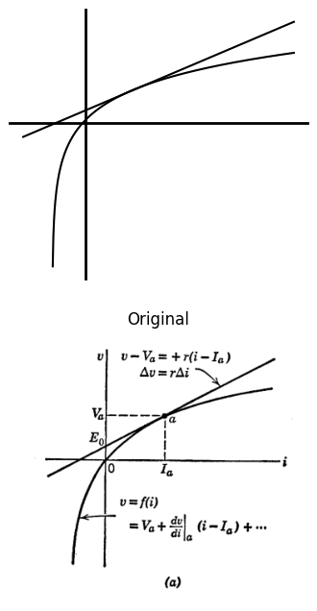
<Figure size 640x480 with 0 Axes>
Fig. 5.17. Total and incremental circuit models for a nonlinear function of one variable, $ v = f(i) $.
The major difference in the two models stems from the use of total quantities in one and variational quantities in the other.
The mathematical basis for the incremental model is the Taylor Series expansion for a nonlinear curve. The constant term fixes the "operating point" since this is the point about which the expansion is made. The first-order term gives the slope of the curve at the operating point and, hence, determines the change in current produced by a given change in voltage. The ratio $Δv/Δi$ is called the incremental resistance. For small signals the higher-order terms can be neglected.
The foregoing remarks are illustrated in Fig. 5.17. A nonlinear diode curve is shown in (a), together with the Taylor Series expansion about the point $a$ and the expression for the tangent. The diode symbol is shown in (b) with voltages and currents expressed as variations or increments around the operating point. The incremental model shown in (c) effectively amounts to a shift of coordinates from the origin to the quiescent point. Once the circuit is reduced to linear incremental form, the symbol $Δ$ has no significance, since the linear relation extends indefinitely.
The linear incremental relation between current and voltage effectively drops the fixed reference potential whereas a linear model based on total quantities preserves a unique origin of coordinates as indicated by Fig. 5.17 (d). A piecewise-linear model like that in (e) places in evidence the range of values of $v$ and $i$ for which a linear approximation applies.

1.9 5.11 Linear Incremental Models for Transistors
The terminal behavior of any three-terminal device is specified by two voltages and two currents. As shown in Fig. 5.18(a), the general function is usually separated into two functions for convenience in graphical or analytical manipulations. If each of the variables is expressed as a constant plus an increment, the constant values of the dependent independent variables determine the constant values of the dependent variables. This assumes the increments to be zero. The differentials of the equations relate the variational components as shown in Fig. 5.18(b). If the circuit is linear, the various partial derivatives are constants; that is, independent of the operating point set by the direct components of currents and voltages. These results are merely extensions of those given in Fig. 5.17 for the simpler function v = f(i).
For the linear incremental three-terminal circuit, there are many possible ways of specifying the relations between currents and voltages, but all involve four constant parameters. For the choice of variables used here there are six basic forms the equations can take as indicated in Fig. 5.19. All of these are related by simple linear transformations. As a matter of convenience, the symbol $ \Delta $ is omitted in Fig. 5.19, leaving the symbols for incremental voltages and currents the same as those used for total quantities. If both total and incremental values are involved in an analysis, primes or deltas or other distinguishing symbols must be used to avoid ambiguity.
import matplotlib.pyplot as plt
import numpy as np
import schemdraw
from schemdraw import dsp
import schemdraw.elements as e
import matplotlib.image as mpimg
d = schemdraw.Drawing()
d += dsp.Line().right().length(d.unit*0.4).idot(open=True)
d += ( T1 := dsp.Box(w=2, h=2).anchor('W').linestyle('--'))
d += dsp.Line().right().length(d.unit*0.4).at(T1.E).dot(open=True)
d += dsp.Line().down().length(d.unit*0.4).at(T1.S).dot(open=True)
d += e.Ground()
d += e.Arrow().right().linewidth(0.6).length(0.7).color('black').label('$i_1$', loc='top', color='black',ofst=-0.5).at((0.3,-0.2))
d += e.Arrow().left().linewidth(0.6).length(0.7).color('black').label('$i_2$', loc='top', color='black',ofst=-0.5).at((4.1,-0.2))
d += e.Arrow().up().linewidth(0.6).length(0.7).color('black').label('$i_3$', loc='top', color='black',ofst=-0.5).at((2.5,-1.9))
d += e.Arrow().length(1).at((1.1, -1.9)).label('-', ofst=(0.7,-0.4)).theta(-40)
d += e.Arrow().length(1).at((0.5, -1)).label('+', ofst=(0.7,0.4)).theta(120)
d += e.Gap().right().label('$v_1$',fontsize = 12).color('black').at((-0.7,-1.3))
d += e.Arrow().length(1).at((3.3, -1.9)).label('-', ofst=(0.5,0.4)).theta(-140)
d += e.Arrow().length(1).at((3.9, -1)).label('+', ofst=(0.5,-0.5)).theta(65)
d += e.Gap().right().label('$v_2$',fontsize = 12).color('black').at((2.3,-1.4))
d += e.Arrow().length(2).at((1.5, 1.5)).label('-', ofst=(0.5,0.4)).theta(-140)
d += e.Arrow().length(2).at((2.9, 1.5)).label('+', ofst=(0.7,-0.4)).theta(-40)
d += e.Gap().right().label('$v_3$',fontsize = 12).color('black').at((0.8,1.9))
d += e.Gap().right().label(' $f(v_1,v_2,i_1,i_2) = 0$ \nor\n $v_1 = f_1(i_1,i_2)$\n $v_2 = f_2(i_1,i_2)$',fontsize = 12).color('black').at((5,-0.5))
d.save('./Drawings5/5-18.png')
d.save('./Drawings5/5-18.svg')
fig, axs = plt.subplots(1, 2, figsize=(8, 4))
img = mpimg.imread('./Drawings5/5-18.png')
axs[0].imshow(img)
axs[0].axis('off')
axs[0].set_title('Circuit Diagram (developed)')
img_sample = mpimg.imread('./images5/5-18.png')
axs[1].imshow(img_sample)
axs[1].axis('off')
axs[1].set_title('Original')
plt.tight_layout()
plt.show()
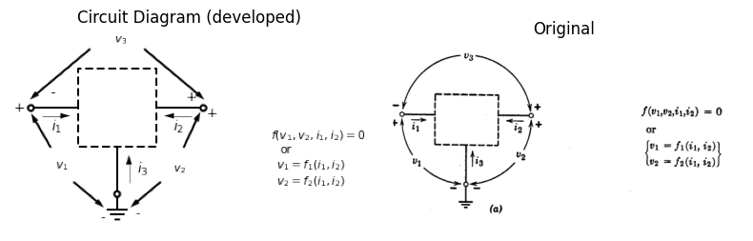
For
$
\begin{align}
v_1 & = V_1 + \Delta v_1 \ v_2 & = V_2 + \Delta v_2 \ i_1 & = I_1 + \Delta i_1 \ i_2 & = I_2 + \Delta i_2
\end{align}
$
,
$ \begin{align}
V_1 + \Delta v_1 & = f_1 \left( I_1 + \Delta i_1, ; I_2 + \Delta i_2 \right) \ V_2 + \Delta v_2 & = f_2 \left( I_1 + \Delta i_1, ; I_2 + \Delta i_2 \right)
\end{align}
$
Letting $ \Delta i_1 = \Delta i_2 = 0 $
so that $ \Delta v_1 = \Delta v_2 = 0 $
yields:
$
\begin{align}
V_1 & = f_1(I_1, I_2) \ V_2 & = f_2(I_1, I_2)
\end{align}
$
Incrementally,
$
\Delta v_1 = \frac{\partial f_1}{\partial i_1} \Delta i_1 + \frac{\partial f_1}{\partial i_2} \Delta i_2
$
$
\Delta v_2 = \frac{\partial f_2}{\partial i_1} \Delta i_1 + \frac{\partial f_2}{\partial i_2} \Delta i_2
$
Fig. 5.18. General equations for a three-terminal device.
The circuit models for the first two sets of equations in Fig. 5.19 involve driving-point resistances or conductances ((r_{11}, r_{22}, g_{11}, g_{22})) and transfer resistances or conductances $\left(r_{12},r_{21},g_{12},g_{21}\right)$. The remaining sets involve parameters in various other categories. For instance, the $h$ parameters involve a driving-point resistance $h_{11}$, reverse voltage gain $h_{21}$, and a driving-point conductance $h_{22}$. These linear circuit formulations are not restricted to resistances and conductances, but also apply to impedances and admittances. In Fig. 5.20 the resistive circuit of Fig. 5.16 is used as an incremental model of a transistor in the common-base connection. Since the model contains no d-c sources, the circuit and the equations are valid for either total or incremental calculations.
import matplotlib.pyplot as plt
import numpy as np
import schemdraw
from schemdraw import dsp
import schemdraw.elements as e
import matplotlib.image as mpimg
d = schemdraw.Drawing()
d += dsp.Line().right().length(d.unit*0.4).idot(open=True)
d += ( T1 := dsp.Box(w=3, h=2).anchor('W').linestyle('--').label('Linear'))
d += dsp.Line().right().length(d.unit*0.4).at(T1.E).dot(open=True)
d += dsp.Line().down().length(d.unit*0.4).at(T1.S).dot(open=True)
d += e.Arrow().right().linewidth(0.6).length(0.7).color('black').label('$i_1$', loc='top', color='black',ofst=0.1).at((0.1,0.2))
d += e.Arrow().left().linewidth(0.6).length(0.7).color('black').label('$i_2$', loc='top', color='black',ofst=0.1).at((5.3,0.2))
d.move(-1, -4)
l0 = d.add(e.Line(l=0.1).right().idot(open=True))
R0 = d.add(e.Resistor().right().label('$r_{11}$',ofst=0.2))
s1 = d.add(e.SourceV(l=1.9).down().reverse().label('$r_{12}i_2$',ofst=0.1))
l1 = d.add(e.Line(l=1).right().dot())
l2 = d.add(e.Line(l=1).right())
s2 = d.add(e.SourceV(l=1.9).up().label('$r_{21}i_1$',ofst=-1.9))
R1 = d.add(e.Resistor().right().label('$r_{22}$',ofst=0.2))
l3 = d.add(e.Line(l=0.1).right().dot(open=True))
l4 = d.add(e.Line(l=1.5).down().at(l1.end).dot(open=True))
d += e.Arrow().left().linewidth(0.6).length(0.7).color('black').label('$i_2$', loc='top', color='black',ofst=0.2).at((12.3,-3.5))
d += e.Arrow().right().linewidth(0.6).length(0.7).color('black').label('$i_1$', loc='top', color='black',ofst=0.2).at((3.2,-3.5))
a = (-2,-4)
d += e.Gap().right().label('$v_1 = r_{11}i_1 + r_{12}i_2$\n$v_2 = r_{21}i_1 + r_{22}i_2$',fontsize = 12).color('black').at((a))
d.move(3, -5)
l0 = d.add(e.Line(l=1.1).right().idot(open=True).dot())
R0 = d.add(e.Resistor(l=1.9).down().label('$g_{11}$',ofst=0.1))
l00 = d.add(e.Line(l=1.1).right().at(l0.end))
s01 = d.add(e.SourceI(l=1.9).down().label('$g_{12}v_2$',ofst=(-0.6,1.7)))
l01 = d.add(e.Line(l=1.1).left())
l02 = d.add(e.Line(l=1).right().dot().idot().at(l01.start))
l03 = d.add(e.Line(l=1).right().dot())
s02 = d.add(e.SourceI(l=1.9).up().reverse().label('$g_{21}v_1$',ofst=(-0.6,-0.4)))
l04 = d.add(e.Line(l=1.5).down().at(l03.start).dot(open=True))
l05 = d.add(e.Line(l=1.1).right().at(s02.start))
R00 = d.add(e.Resistor(l=1.9).up().label('$g_{22}$',ofst=-1.2).dot())
l06 = d.add(e.Line(l=1.1).right().at(s02.end))
l07 = d.add(e.Line(l=1.1).right().dot(open=True).at(R00.end))
d += e.Arrow().left().linewidth(0.6).length(0.7).color('black').label('$i_2$', loc='top', color='black',ofst=0.2).at((11.1,-8.7))
d += e.Arrow().right().linewidth(0.6).length(0.7).color('black').label('$i_1$', loc='top', color='black',ofst=0.2).at((3.4,-8.7))
a = (-2,-10)
d += e.Gap().right().label('$i_1 = g_{11}v_1 + g_{12}v_2$\n$i_2 = g_{21}v_1 + g_{22}v_2$',fontsize = 12).color('black').at((a))
a = (-2,-13)
d += e.Gap().right().label('$v_1 = h_{11}i_1 + h_{12}v_2$\n$i_2 = h_{21}i_1 + h_{22}v_2$',fontsize = 12).color('black').at((a))
a = (6,-13)
d += e.Gap().right().label('$v_2 = k_{11}v_1 + k_{12}i_2$\n$i_1 = k_{21}v_1 + k_{22}i_2$',fontsize = 12).color('black').at((a))
a = (-2,-15)
d += e.Gap().right().label('$v_1 = Av_2 - Bi_2$\n$i_1 = Cv_2 - Di_2$',fontsize = 12).color('black').at((a))
a = (6,-15)
d += e.Gap().right().label('$v_2 = Dv_1 - Bi_1$\n$i_2 = Cv_1 - Ai_1$',fontsize = 12).color('black').at((a))
"""
d += e.Arrow().length(1).at((1.1, -1.9)).label('-', ofst=(0.7,-0.4)).theta(-40)
d += e.Arrow().length(1).at((0.5, -1)).label('+', ofst=(0.7,0.4)).theta(120)
d += e.Gap().right().label('$v_1$',fontsize = 12).color('black').at((-0.7,-1.3))
d += e.Arrow().length(1).at((3.3, -1.9)).label('-', ofst=(0.5,0.4)).theta(-140)
d += e.Arrow().length(1).at((3.9, -1)).label('+', ofst=(0.5,-0.5)).theta(65)
d += e.Gap().right().label('$v_2$',fontsize = 12).color('black').at((2.3,-1.4))
"""
d.save('./Drawings5/5-19.png')
d.save('./Drawings5/5-19.svg')
fig, axs = plt.subplots(1, 2, figsize=(12, 18))
img = mpimg.imread('./Drawings5/5-19.png')
axs[0].imshow(img)
axs[0].axis('off')
axs[0].set_title('Circuit Diagram (developed) ')
img_sample = mpimg.imread('./images5/5-19.png')
axs[1].imshow(img_sample)
axs[1].axis('off')
axs[1].set_title('Original')
plt.tight_layout()
plt.show()
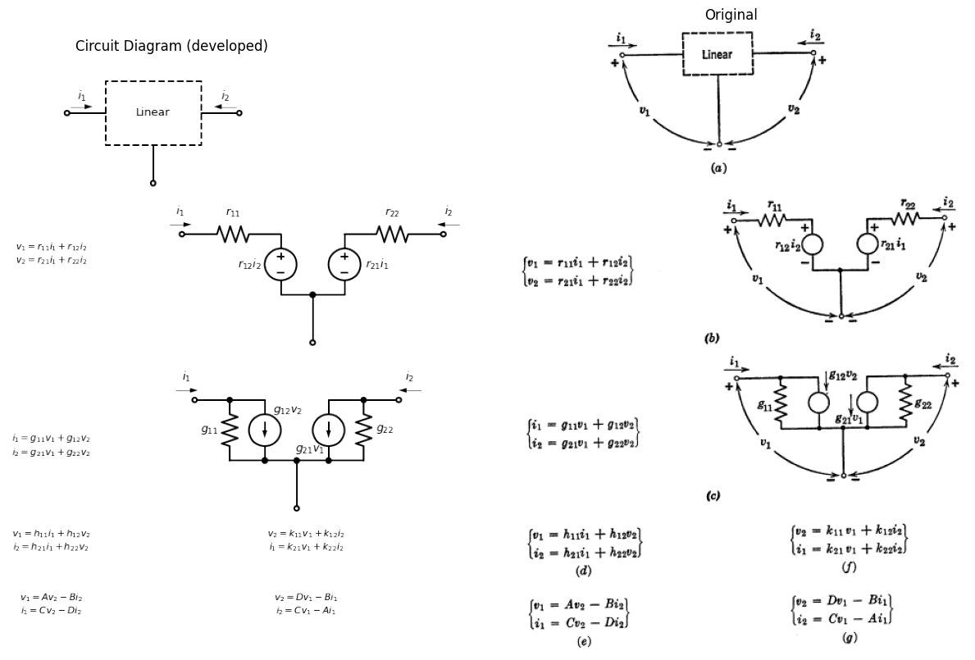
Fig. 5.19. Incremental models for a three-terminal device.
Identification of corresponding terms in the impedance formulation and in the $T$ circuit relates the generalized parameters $\left(r_{11},r_{12},r_{21},r_{22}\right)$ to the $T$ parameters $\left(r_{e},r_{b},r_{c},α\right)$.
Several formulations of the incremental model for the common-emitter connection are shown in Fig. 5.21 together with the corresponding equations. The circuit in (a) is the same as that of Fig. 5.20, but the equations involve the common-emitter variables $\left(v_{be},v_{ce},i_{b},i_{c}\right)$. The circuit and equations in (b) result when the dependent generator is specified in terms of base current. The model in (c) involves the so-called hybrid parameters or $h$ parameters. One current and one voltage $\left(i_{b}\text{ and }v_{ce}\right)$ are independent variables and the other current and voltage $\left(v_{be},i_{c}\right)$ are dependent variables.
import matplotlib.pyplot as plt
import numpy as np
import schemdraw
from schemdraw import dsp
import schemdraw.elements as e
import matplotlib.image as mpimg
d = schemdraw.Drawing()
l0 = d.add(e.Line(l=0.1).right().idot(open=True))
R0 = d.add(e.Resistor().right().label('$r_{11}$',ofst=0.2))
s1 = d.add(e.SourceV(l=1.9).down().reverse().label('$r_{12}i_2$',ofst=0.1))
l1 = d.add(e.Line(l=1).right().dot())
l2 = d.add(e.Line(l=1).right())
s2 = d.add(e.SourceV(l=1.9).up().label('$r_{21}i_1$',ofst=-1.9))
R1 = d.add(e.Resistor().right().label('$r_{22}$',ofst=0.2))
l3 = d.add(e.Line(l=0.1).right().dot(open=True))
l4 = d.add(e.Line(l=1.5).down().at(l1.end).dot(open=True))
d += e.Arrow().left().linewidth(0.6).length(0.7).color('black').label('$i_2$', loc='top', color='black',ofst=0.2).at((8.2,0.2))
d += e.Arrow().right().linewidth(0.6).length(0.7).color('black').label('$i_1$', loc='top', color='black',ofst=0.2).at((0,0.2))
d.move(9, -0.2)
l0 = d.add(e.Line(l=0.1).right().idot(open=True))
R0 = d.add(e.Resistor().right().dot().at(l0.end).label('$r_b$',ofst=-1))
R1 = d.add(e.Resistor().down().dot(open=True).at(R0.end).label('$r_e$',ofst=-1))
l2 = d.add(e.Line(l=0.8).right().at(R1.start))
R3 = d.add(e.Resistor(l=1.5).right().dot().idot().at(l2.end).label('$r_e$',ofst=-1))
l3 = d.add(e.Line(l=0.8).right().dot(open=True))
l4 = d.add(e.Line(l=1.3).up().at(R3.start))
I = d.add(e.SourceI(l=1.5).right().label('a$i_e$'))
l5 = d.add(e.Line(l=1.3).down())
d += e.Gap().right().color('black').at((-2.2,0.1))
d += e.Gap().right().color('black').at((5,0.1))
d += e.Gap().right().color('black').at((1.2,-3.2))
d += e.Arrow().left().linewidth(0.6).length(0.7).color('black').label('$i_c$', loc='top', color='black',ofst=0.2).at((16.3,0.3))
d += e.Arrow().right().linewidth(0.6).length(0.7).color('black').label('$i_e$', loc='top', color='black',ofst=0.2).at((9.4,0.3))
"""
d += e.Arrow().length(1.5).at((5.3, -1.5)).label('+', ofst=(0.7,-0.4)).theta(60)
d += e.Arrow().length(1.5).at((4.6, -2.2)).label('-', ofst=(0.7,0.4)).theta(-150)
d += e.Arrow().length(1.5).at((1.7, -2.1)).label('-', ofst=(0.7,-0.4)).theta(-35)
d += e.Arrow().length(1.5).at((1, -1.5)).label('+', ofst=(0.7,0.4)).theta(120)
d += e.Gap().right().label('$v_{eb}$',fontsize = 12).color('black').at((-0.4,-1.7))
d += e.Gap().right().label('$v_{cb}$',fontsize = 12).color('black').at((3.4,-1.6))
"""
d += e.Gap().right().label('$V_1$ = $r_{11}i_1+r_{12}i_2$\n $V_2$ = $r_{21}i_1+r_{22}i_2$',fontsize = 12).color('black').at((2.5,-3.8))
d += e.Gap().right().label('$V_{eb}$ = $i_e(r_e+r_b)+i_cr_b)$\n $V_{cb}$ = $i_e(r_b+ar_c)+i_c(r_c+r_b)$',fontsize = 12).color('black').at((11,-3.8))
d += e.Gap().right().label('$r_{11}$ = $i_e+r_b$\n$r_{12}$ = $r_b$\n$r_{21}=r_b+ar_c$\n$r_{22}=r_c+r_b$',fontsize = 12).color('black').at((2.5,-5))
d += e.Gap().right().label('$r_e$ = $r_{11}-r_{12}$\n$r_b$ = $r_{12}$\n$r_c=r_{22}-r_{12}$\n$a$ = $(r_{21}-r_{12})/(r_{22}-r_{12})$',fontsize = 12).color('black').at((11,-5))
d.save('./Drawings5/5-20.png')
d.save('./Drawings5/5-20.svg')
fig, axs = plt.subplots(1, 2, figsize=(15, 5))
img = mpimg.imread('./Drawings5/5-20.png')
axs[0].imshow(img)
axs[0].axis('off')
axs[0].set_title('Circuit Diagram (developed)')
img_sample = mpimg.imread('./images5/5-20.png')
axs[1].imshow(img_sample)
axs[1].axis('off')
axs[1].set_title('Original')
plt.tight_layout()
plt.show()
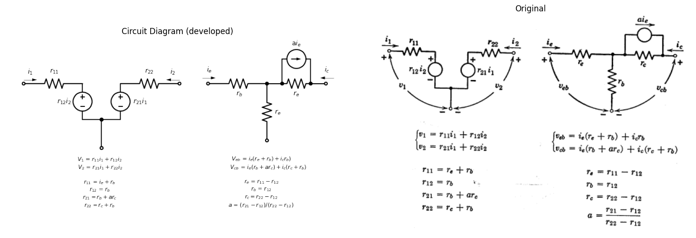
Fig. 5.20. Incremental models for a transistor in the common-base connection.
For typical numerical values $\left(r_{c}≫r_{e}\text{ or }r_{b}\right)$ the hybrid parameters are as follows:
$h_{11}≈r_{b}+r_{e}/\left(1−a\right)$
$h_{12}≈r_{e}/r_{d}$
$h_{21}=α_{cb}≈a/\left(1−a\right)$
$h_{22}=1/\left(r_{e}+r_{d}\right)$
The $h$ parameter formulation for the common-emitter connection is not as obviously related to the physical conduction processes in the transistor as is the common-base $T$ formulation involving $r_{e}$, $r_{b}$, $r_{c}$, and $α$. However, the $h$ parameters can be measured conveniently and accurately. The current gain is significant, but the other three constants are small and can often be neglected. For circuit design purposes, the $h$ parameters are very convenient. Each of the parameters in this formulation places in evidence a quantity significant in transistor amplifier circuits;
import matplotlib.pyplot as plt
import numpy as np
import schemdraw
from schemdraw import dsp
import schemdraw.elements as e
import matplotlib.image as mpimg
d = schemdraw.Drawing()
l0 = d.add(e.Line(l=0.1).right().idot(open=True))
R0 = d.add(e.Resistor().right().dot().at(l0.end).label('$r_b$',ofst=-1))
R1 = d.add(e.Resistor().down().dot(open=True).at(R0.end).label('$r_e$',ofst=-1))
l2 = d.add(e.Line(l=0.8).right().at(R1.start))
R3 = d.add(e.Resistor(l=1.5).right().dot().idot().at(l2.end).label('$r_c$',ofst=-1))
l3 = d.add(e.Line(l=0.8).right().dot(open=True))
l4 = d.add(e.Line(l=1.3).up().at(R3.start))
I = d.add(e.SourceI(l=1.5).right().label('a$i_e$'))
l5 = d.add(e.Line(l=1.3).down())
d += e.Gap().right().color('black').at((-2.2,0.1))
d += e.Gap().right().color('black').at((5,0.1))
d += e.Gap().right().color('black').at((1.2,-3.2))
d += e.Arrow().left().linewidth(0.6).length(0.7).color('black').label('$i_c$', loc='top', color='black',ofst=0.2).at((6.3,0.3))
d += e.Arrow().right().linewidth(0.6).length(0.7).color('black').label('$i_b$', loc='top', color='black',ofst=0.2).at((0.1,0.3))
d += e.Arrow().up().linewidth(0.6).length(0.7).color('black').label('$i_e$', loc='top', color='black',ofst=0.2).at((2.7,-2.7))
"""
d += e.Arrow().length(1.5).at((5.3, -1.5)).label('+', ofst=(0.7,-0.4)).theta(60)
d += e.Arrow().length(1.5).at((4.6, -2.2)).label('-', ofst=(0.7,0.4)).theta(-150)
d += e.Arrow().length(1.5).at((1.7, -2.1)).label('-', ofst=(0.7,-0.4)).theta(-35)
d += e.Arrow().length(1.5).at((1, -1.5)).label('+', ofst=(0.7,0.4)).theta(120)
d += e.Gap().right().label('$v_{eb}$',fontsize = 12).color('black').at((-0.4,-1.7))
d += e.Gap().right().label('$v_{cb}$',fontsize = 12).color('black').at((3.4,-1.6))
"""
d.save('./Drawings5/5-21a.png')
d.save('./Drawings5/5-21a.svg')
fig, axs = plt.subplots(1, 2, figsize=(15, 5))
img = mpimg.imread('./Drawings5/5-21a.png')
axs[0].imshow(img)
axs[0].axis('off')
axs[0].set_title('Circuit Diagram (developed)')
img_sample = mpimg.imread('./images5/5-21a.png')
axs[1].imshow(img_sample)
axs[1].axis('off')
axs[1].set_title('Original')
plt.tight_layout()
plt.show()
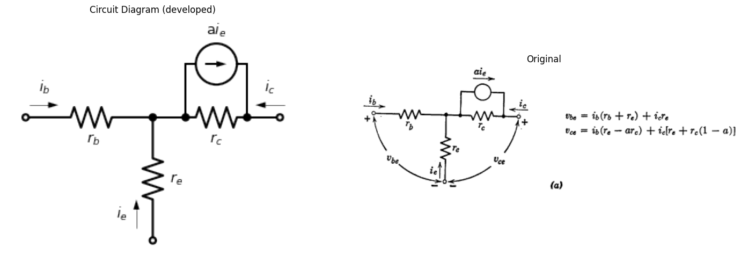
import matplotlib.pyplot as plt
import numpy as np
import schemdraw
from schemdraw import dsp
import schemdraw.elements as e
import matplotlib.image as mpimg
d = schemdraw.Drawing()
l0 = d.add(e.Line(l=0.1).right().idot(open=True))
R0 = d.add(e.Resistor().right().dot().at(l0.end).label('$r_b$',ofst=-1))
R1 = d.add(e.Resistor().down().dot(open=True).at(R0.end).label('$r_e$',ofst=-1))
l2 = d.add(e.Line(l=0.8).right().at(R1.start))
R3 = d.add(e.Resistor(l=1.5).right().dot().idot().at(l2.end).label('$r_d$',ofst=-1))
l3 = d.add(e.Line(l=0.8).right().dot(open=True))
l4 = d.add(e.Line(l=1.3).up().at(R3.start))
I = d.add(e.SourceI(l=1.5).right().label('-$a_{cb}i_b$'))
l5 = d.add(e.Line(l=1.3).down())
d += e.Gap().right().color('black').at((-2.2,0.1))
d += e.Gap().right().color('black').at((5,0.1))
d += e.Gap().right().color('black').at((1.2,-3.2))
d += e.Arrow().left().linewidth(0.6).length(0.7).color('black').label('$i_c$', loc='top', color='black',ofst=0.2).at((6.3,0.3))
d += e.Arrow().right().linewidth(0.6).length(0.7).color('black').label('$i_b$', loc='top', color='black',ofst=0.2).at((0.1,0.3))
a = (7,-0.1)
d += e.Gap().right().label('$v_{be} = i_b + (r_b + r_e) + i_cr_e$\n $v_{ce} = i_b(r_e - a_cbr_d) + i_c(r_e + r_d)$\n where $r_d = r_c(1-a)$ \n$a_{cb} = a/(1-a)$ ',fontsize = 12).color('black').at((a))
"""
d += e.Arrow().length(1.5).at((5.3, -1.5)).label('+', ofst=(0.7,-0.4)).theta(60)
d += e.Arrow().length(1.5).at((4.6, -2.2)).label('-', ofst=(0.7,0.4)).theta(-150)
d += e.Arrow().length(1.5).at((1.7, -2.1)).label('-', ofst=(0.7,-0.4)).theta(-35)
d += e.Arrow().length(1.5).at((1, -1.5)).label('+', ofst=(0.7,0.4)).theta(120)
d += e.Gap().right().label('$v_{eb}$',fontsize = 12).color('black').at((-0.4,-1.7))
d += e.Gap().right().label('$v_{cb}$',fontsize = 12).color('black').at((3.4,-1.6))
"""
d.save('./Drawings5/5-21b.png')
d.save('./Drawings5/5-21b.svg')
fig, axs = plt.subplots(1, 2, figsize=(15, 5))
img = mpimg.imread('./Drawings5/5-21b.png')
axs[0].imshow(img)
axs[0].axis('off')
axs[0].set_title('Circuit Diagram (developed)')
img_sample = mpimg.imread('./images5/5-21b.png')
axs[1].imshow(img_sample)
axs[1].axis('off')
axs[1].set_title('Original')
plt.tight_layout()
plt.show()
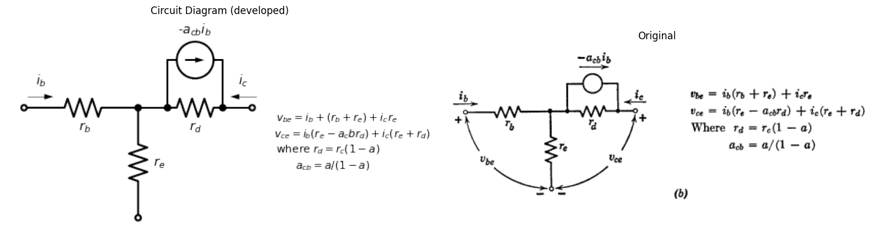
import matplotlib.pyplot as plt
import numpy as np
import schemdraw
from schemdraw import dsp
import schemdraw.elements as e
import matplotlib.image as mpimg
d = schemdraw.Drawing()
l0 = d.add(e.Line(l=1.1).right().idot(open=True))
R0 = d.add(e.Resistor(l=1.9).right().label('$h_{11}$',ofst=0.1))
s01 = d.add(e.SourceV(l=1.9).reverse().down().label('$h_{12}v_{ce}$',ofst=(0,-0.1)))
l02 = d.add(e.Line(l=1).right().dot().at(l01.start))
l03 = d.add(e.Line(l=1).right().dot())
s02 = d.add(e.SourceI(l=1.9).up().reverse().label('$h_{21}i_b$',ofst=(0,0)))
l04 = d.add(e.Line(l=1.5).down().at(l03.start).dot(open=True))
l05 = d.add(e.Line(l=1.1).right().at(s02.start))
R00 = d.add(e.Resistor(l=1.9).up().label('$h_{22}$',ofst=-1.2).dot())
l06 = d.add(e.Line(l=1.1).right().at(s02.end))
l07 = d.add(e.Line(l=1.1).right().dot(open=True).at(R00.end))
d += e.Arrow().left().linewidth(0.6).length(0.7).color('black').label('$i_c$', loc='top', color='black',ofst=0.2).at((7.6,0.3))
d += e.Arrow().right().linewidth(0.6).length(0.7).color('black').label('$i_b$', loc='top', color='black',ofst=0.2).at((-0.4,0.3))
a = (8,-0.7)
d += e.Gap().right().label(' $h_{11} = r_b + r_e/(1-a)$\n$h_{12} = r_e/r_d$ \n $h_{21} = a_{cb} = a/(1-a)$\n$h_{22} = 1/(r_e + r_d)$',fontsize = 12).color('black').at((a))
d.save('./Drawings5/5-21c.png')
d.save('./Drawings5/5-21c.svg')
fig, axs = plt.subplots(1, 2, figsize=(15, 5))
img = mpimg.imread('./Drawings5/5-21c.png')
axs[0].imshow(img)
axs[0].axis('off')
axs[0].set_title('Circuit Diagram (developed)')
img_sample = mpimg.imread('./images5/5-21c.png')
axs[1].imshow(img_sample)
axs[1].axis('off')
axs[1].set_title('Original')
plt.tight_layout()
plt.show()
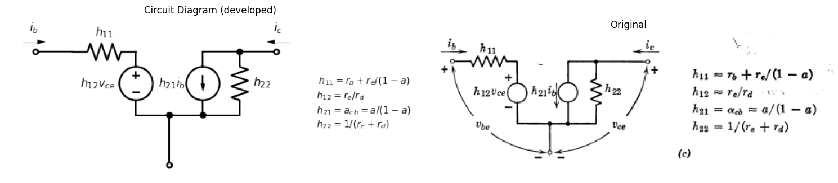
**Fig. 5.21**. Incremental models for a transistor in the common-emitter connection.
namely, an input impedance $\left(h_{11}=\frac{∂v_{be}}{∂i_{b}} \text{with} v_{ce} \text{fixed}\right)$, a reverse voltage gain $\left(h_{12}=\frac{∂v_{be}}{∂v_{ce}} \text{with} i_{b} \text{fixed}\right)$, a forward current gain $\left(h_{21}=\frac{∂i_{c}}{∂i_{b}} \text{with} v_{ce} \text{fixed}\right)$, and an output admittance $\left(h_{22}=\frac{∂i_{c}}{∂v_{ce}} \text{with} i_{b} \text{fixed}\right)$. Most manufacturers’ data on transistors are presented in these terms.
import matplotlib.pyplot as plt
import numpy as np
import schemdraw
from schemdraw import dsp
import schemdraw.elements as e
import matplotlib.image as mpimg
d = schemdraw.Drawing()
l = d.add(e.Line().length(0.5).up().idot(open=True).label('$b$'))
tr = d.add(e.BjtPnp(l=0.5,circle=True).up())
l0 = d.add(e.Line().length(0.3).dot(open=True).left().at(tr.emitter).label('$e$'))
l1 = d.add(e.Line().length(0.3).dot(open=True).right().at(tr.collector).label('$c$'))
l2 = d.add(e.Line().length(1).left().at(l0.end))
R0 = d.add(e.Resistor(l=1.9).down().label('$R_e$',ofst=0.1))
s01 = d.add(e.SourceV(l=1.9).reverse().down().label('$v_1$',ofst=(0,-0.1)))
E1 = d.add(e.Battery(l=2).right().label(['+ $V_e$ -'], ofst=-1.3).dot())
E2 = d.add(e.Battery(l=2).right().label(['+ $V_c$ -'], ofst=-1.3))
R1 = d.add(e.Resistor(l=3.8).up().label('$R_c$',ofst=0.1))
l3 = d.add(e.Line().length(1).left())
l4 = d.add(e.Line().length(3).down().at(l.end))
d += e.Ground()
d.move(-2, -3)
l5 = d.add(e.Line().length(1.5).right().dot(open=True).label('$e$', ofst=(0.7,0.1)))
R2 = d.add(e.Resistor(l=1.7).right().label('$r_e$',ofst=-0.9).dot())
R3 = d.add(e.Resistor().down().label('$r_b$',ofst=0.1).dot(open=True))
l6 = d.add(e.Line().right().idot(open=True).dot(open=True).label('$b$', ofst=(-1.2,0.1)))
E3 = d.add(e.Battery(l=2).right().label(['+ $V_c$ -'], ofst=-1.3))
R4 = d.add(e.Resistor().up().label('$R_c$',ofst=0.1))
l6 = d.add(e.Line(l=2).left().dot(open=True).label('$c$', ofst=(1.1,-0.2)))
l6 = d.add(e.Line(l=0.7).left().dot())
R5 = d.add(e.Resistor(l=1.7).left().label('$r_c$',ofst=-0.9).dot())
l7 = d.add(e.Line(l=0.7).left())
l8 = d.add(e.Line(l=1.1).up().at(R5.start))
I3 = d.add(e.SourceI(l=1.7).left().reverse().label('$ai_e$', ofst=0.1))
l8 = d.add(e.Line(l=1.1).down())
R6 = d.add(e.Resistor(l=1.5).down().at(l5.start).label(['$R_e$'], ofst=0.1))
s02 = d.add(e.SourceV(l=1.5).reverse().down().label('$v_1$',ofst=(0,-0.1)))
E4 = d.add(e.Battery(l=1.6).right().label(['+ $V_e$ -'], ofst=-1.3).dot(open=True))
l9 = d.add(e.Line(l=1.6).right())
d += e.Ground()
l10 = d.add(e.Line(l=0.2).right().color('white').at(R4.start))
l11 = d.add(e.Line(l=1.2).right())
l12 = d.add(e.Line(l=0.2).right().color('white').at(R4.end))
l13 = d.add(e.Line(l=1.2).right())
d += e.Arrow().left().linewidth(0.6).length(0.7).color('black').label('$i_c$', loc='top', color='black',ofst=0.2).at((6.4,-5.2))
d += e.Arrow().right().linewidth(0.6).length(0.7).color('black').label('$i_e$', loc='top', color='black',ofst=0.2).at((-1.9,-5.2))
d += e.Arrow().up().length(1.5).linewidth(0.6).color('white').label('$V_{eb}$', loc='start', color='black',ofst=0.3). at((0,-6.7))
d += e.Arrow().up().length(0.9).linewidth(0.6).color('black').label('+',loc='end', color='black',ofst=0.4). at((-0.5,-6.5))
d += e.Arrow().down().length(0.9).linewidth(0.6).color('black').label(r'_', loc='end', color='black',ofst=(-0.5,-0.3)). at((-0.5,-7.5))
d += e.Arrow().up().length(1.5).linewidth(0.6).color('white').label('$V_{cb}$', loc='start', color='black',ofst=0.3). at((4.7,-6.7))
d += e.Arrow().up().length(0.9).linewidth(0.6).color('black').label('+',loc='end', color='black',ofst=0.4). at((4.2,-6.5))
d += e.Arrow().down().length(0.9).linewidth(0.6).color('black').label(r'_', loc='end', color='black',ofst=(-0.5,-0.3)). at((4.2,-7.5))
d += e.Arrow().up().length(1.5).linewidth(0.6).color('white').label('$V_2$', loc='start', color='black',ofst=0.3). at((7.7,-6.7))
d += e.Arrow().up().length(0.9).linewidth(0.6).color('black').label('+',loc='end', color='black',ofst=0.4). at((7.2,-6.5))
d += e.Arrow().down().length(0.9).linewidth(0.6).color('black').label(r'_', loc='end', color='black',ofst=(-0.5,-0.3)). at((7.2,-7.5))
d.draw()
d.save('./Drawings5/5-22m.png')
d.save('./Drawings5/5-22m.svg')
fig, axs = plt.subplots(1, 2, figsize=(10, 8))
img = mpimg.imread('./Drawings5/5-22m.png')
axs[0].imshow(img)
axs[0].axis('off')
axs[0].set_title('Circuit Diagram (developed)')
img_sample = mpimg.imread('./images5/5-22m.png') # Load the PNG file
axs[1].imshow(img_sample)
axs[1].axis('off')
axs[1].set_title('Original')
plt.tight_layout()
plt.show()
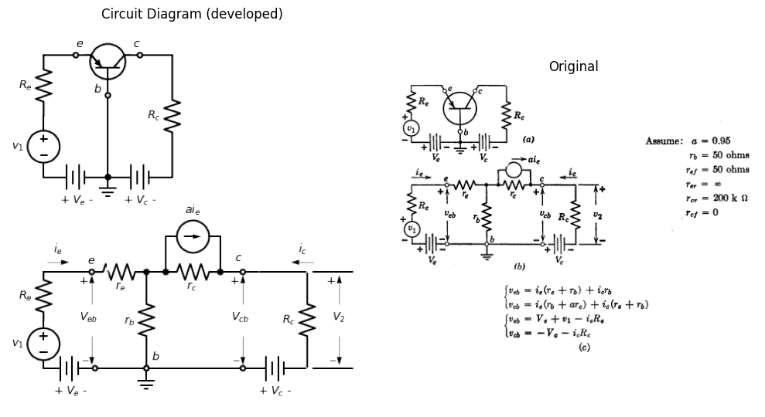
import matplotlib.pyplot as plt
import numpy as np
import matplotlib.image as mpimg
from matplotlib.gridspec import GridSpec
fig = plt.figure(figsize=(7, 6))
gs = GridSpec(2, 2, width_ratios=[1, 1])
ax0 = fig.add_subplot(gs[0, 0])
x2 = -np.linspace(0, 7, 500)
a1 = 0.02
b1 = 0.1
y2 = -b1 * np.exp(-x0 /a1)+b1
ax0.plot(x2, y2, color='black', linewidth=1)
y2 = -b1 * np.exp(-(x2+0.8) /a1)+b1
ax0.plot(x2, y2, color='black', linewidth=1)
y2 = -b1 * np.exp(-(x2+1.8) /a1)+b1
ax0.plot(x2, y2, color='black', linewidth=1)
y2 = -b1 * np.exp(-(x2+2.8) /a1)+b1
ax0.plot(x2, y2, color='black', linewidth=1)
y2 = -b1 * np.exp(-(x2+3.8) /a1)+b1
ax0.plot(x2, y2, color='black', linewidth=1)
ax0.plot([-5,0], [0,-26], color='black', linewidth=1)
ax0.set_title('V-I Curve')
ax0.set_ylabel('$v_{cb}$', labelpad=3, loc='top')
ax0.set_xlim(-5, 1)
ax0.set_ylim(-4, 1)
ax0.set_xlabel('$i_c$', labelpad=3, loc='right')
ax0.axhline(0, color='black', linewidth=1)
ax0.axvline(0, color='black', linewidth=1)
ax0.set_xticks(np.arange(-5, 1, 1))
ax0.set_yticks(np.arange(-40, 10, 10))
ax0.grid(True)
ax1 = fig.add_subplot(gs[0, 1])
ax1.plot([0,5], [-0.2,0.3], color='black', linewidth=1, linestyle='--',dashes=(8, 3))
ax1.plot([0,5], [-0.15,0.35], color='black', linewidth=1, linestyle='--',dashes=(8, 3))
ax1.plot([0,5], [-0.1,0.4], color='black', linewidth=1, linestyle='--',dashes=(8, 3))
ax1.plot([0,5], [-0.05,0.45], color='black', linewidth=1, linestyle='--',dashes=(8, 3))
ax1.plot([0,5], [0,0.5], color='black', linewidth=1, linestyle='--',dashes=(8, 3))
ax1.plot([0,5], [0,0.22], color='black', linewidth=1, linestyle='--',dashes=(10, 3))
ax1.plot([0,5], [0.03,0.25], color='black', linewidth=1, linestyle='--',dashes=(10, 3))
ax1.plot([0.2,3.2], [0.13,-0.17], color='black', linewidth=1, linestyle='--',dashes=(10, 3))
ax1.plot([0,4.5], [0.3,-0.14], color='black', linewidth=1)
ax1.plot([1.8,4.4], [0.28,0.01], color='black', linewidth=1, linestyle='--',dashes=(10, 3))
ax1.set_xlim(-1, 5)
ax1.set_ylim(-0.2, 0.3)
ax1.set_xlabel('$i_e$', labelpad=3, loc='right')
ax1.set_ylabel('$v_{eb}$', labelpad=3, loc='top')
ax1.set_title('V-I Curve')
ax1.grid(True)
ax1.set_xticks(np.arange(-1, 5, 1))
ax1.set_yticks(np.arange(-0.2, 0.3, 0.1))
ax4 = fig.add_subplot(gs[1, :])
img_sample = mpimg.imread('./images5/5-22n.png')
ax4.imshow(img_sample)
ax4.set_title('Original')
ax4.axis('off')
axes = [ax0, ax1]
for a in axes:
a.spines['top'].set_color('none')
a.spines['right'].set_color('none')
a.spines['left'].set_position('zero')
a.spines['bottom'].set_position('zero')
a.spines['left'].set_linewidth(1)
a.spines['bottom'].set_linewidth(1)
a.xaxis.set_ticks_position('bottom')
a.yaxis.set_ticks_position('left')
a.tick_params(axis='both', which='both', length=5)
a.grid(True)
plt.tight_layout()
plt.show()
plt.savefig('./Drawings5/5-22n.jpg')
plt.savefig('./Drawings5/5-22n.svg')
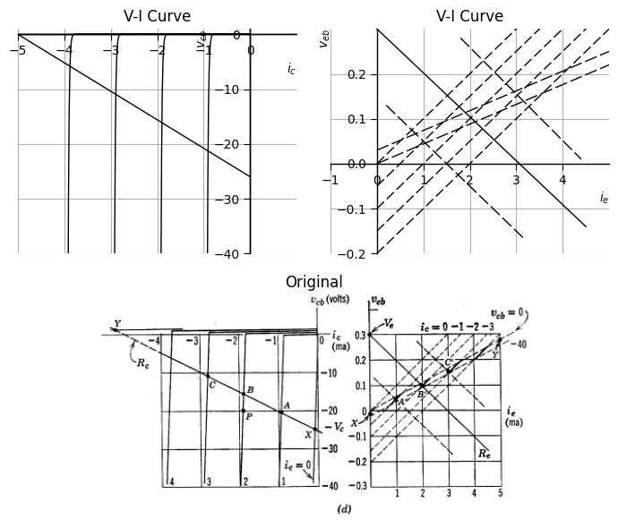
<Figure size 640x480 with 0 Axes>
Fig. 5.22. Determination of operating point in common-base circuit.

1.10 5.12 Determination of Operating Point in the Common-Base Circuit
A common-base resistive transistor circuit is shown in Fig. 5.22(a). The piecewise-linear model is shown in (b); and since this is a total model, the variables $v_{1}$, $v_{2}$, $v_{eb}$, $i_{e}$, etc., represent total quantities. The element values are the same as those assumed in Fig. 5.14. To determine the operating point of the transistor, we can write two equations pertaining to the input terminals. One expresses the constraint on terminal voltage and current imposed by the external circuit, and the other expresses the constraints imposed by the transistor. A similar pair of equations can be written for the output circuit. For the circuit in (b), the equations relating the terminal voltages to terminal currents in terms of the transistor parameters are:
$v_{eb}=i_{e}/\left(r_{e}+r_{b}\right)+i_{c}r_{b}$
$v_{cb}=i_{e}/\left(r_{b}+ar_{c}\right)+i_{c}\left(r_{c}+r_{b}\right)$
The equations relating the terminal voltages to currents in terms of the external circuit parameters are
$v_{eb}=V_{e}+v_{1}−i_{e}R_{e}$
$v_{cb}=−V_{c}−i_{c}R_{c}$
Equations 5.5, 5.6, 5.7, and 5.8 can be solved simultaneously to find the four coordinates of the operating point.
Operating points of actual transistor circuits are usually determined graphically using the nonlinear characteristic curves for the device, but to illustrate the procedure, we will perform the graphical construction on the piecewise-linear curves of Fig. 5.22(d), which correspond to the model in (b). The output load equation (Eq. 5.8) is plotted on the $V_{b}$ vs. $i_{c}$ plane, and the input load equation (Eq. 5.7) is plotted on the $v_{eb}$ vs. $i_{e}$ plane. The points $A′$, $B′$, and $C′$ on the input plane correspond to $A$, $B$, and $C$ on the output plane, so a line through $A′$, $B′$, and $C′$ corresponds to the output load line transferred to the input plane. An exact solution of the operating point problem requires finding the intersection in the input plane of the input load line with the transferred output load line. However, the transistor curves are so restricted in this plane that the operating point can be determined with reasonable accuracy from the input load line alone. A more significant simplification results when $V_{e}$ is of the order of $V_{c}$, and $R_{e}$ is much larger than $\left(r_{e}+r_{b}\right)$. On the scale shown, the input load equation will appear as a nearly vertical line on the input plane. In other words, $v_{eb}$, the drop across the transistor input terminals, can be neglected relative to $V_{e}$. Then the input load equation becomes
$V_{e}+v_{1}=i_{e}R_{e}$
and this equation, together with Eqs. 5.6 and 5.8, solved simultaneously or graphically on the output plane alone, determines the operating point.
With $ V_e, R_e, V_c, $ and $ R_c $ specified, the graphical or analytical solution for the quiescent operating point ($ v_1 = 0 $) is unique. As $ v_1 $ varies, the input load line actually translates parallel to itself, and the operating point moves along the output load line. This situation corresponds to the analysis of a specified circuit. The design or synthesis problem is not unique, since it is readily apparent that any number of lines can be passed through point $ B $ by varying $ V_c $ and $ R_c $ appropriately, and any number of lines can be passed through point $ B' $ by choosing different values of $ V_e $ and $ R_e $. In some instances, additional requirements on the circuit narrow the possible choice of values, but often there is still considerable freedom.
In the design of a transistor circuit, an operating point must be selected to suit the design conditions. To illustrate this kind of problem, suppose we have available a type of transistor specified by the curves given in Fig. 5.23 parts (a) and (c). The first set of curves are in terms of the variables most useful for the common-base circuit shown in (b), whereas the second set relates the variables pertinent to the common-emitter circuit shown in (d). Suppose we wish to develop a peak-to-peak a-c output of ten volts across resistance $ R_2 $ without distorting the input signal appreciably. For the common-base curves and circuit shown in Fig. 5.23(a) and (b) the entire range of design possibilities is readily envisioned.
First of all, we need a collector supply voltage $ V_c > 10 $ volts. We shall choose a value of 12 or more volts (say 15) to avoid the distortion that would be produced by the nonlinearity of the curves near $ v_{cb} = 0 $. The value of 2 kilohms for $ R_2 $ is the minimum that will produce the required output, assuming the maximum available emitter current is 6 mA. For this value of $ R_2 $, the operating point must be placed at $ P_1 $, where $ i_e = 3 $ mA. If the emitter and base resistances of the transistor can be neglected relative to $ R_1 $, we merely require the ratio $ \frac{V_e}{R_1} $ to be 3 ma.
For $ R_2 = 3.75 $ kilohms, the 10 volt peak-to-peak output is obtained with an emitter current variation of only about 3 mA. With the operating point set at $ P_2 $ (where $ i_e = 2 $ mA) we have $ i_e $ ranging from about 0.5 mA to produce the required output. The location of the operating point in this case is somewhat less critical since the portion of the load curve shown as a solid line can be shifted along the load line somewhat. The same is true for $ R_2 = 7.5 $ kilohms. In either of these cases the required values of $ R_1 $ and $ V_e $ can be determined as before.
The choice between possible values of $ R_2 $ is determined by gain and frequency-response requirements. With a larger value of $ R_2 $ the circuit has more voltage gain or power gain but over a smaller range of frequencies. With a small value of $ R_2 $, the gain is less but the frequency response is better.
import matplotlib.pyplot as plt
import numpy as np
import schemdraw
from schemdraw import dsp
import schemdraw.elements as e
import matplotlib.image as mpimg
d = schemdraw.Drawing()
l = d.add(e.Line().length(0.5).up())
tr = d.add(e.BjtPnp(l=0.5,circle=True).up())
l0 = d.add(e.Line().length(0.3).left().at(tr.emitter))
l1 = d.add(e.Line().length(0.3).right().at(tr.collector))
l2 = d.add(e.Line().length(0.3).left().at(l0.end))
R0 = d.add(e.Resistor(l=1.5).left().label('$R_1$',ofst=0.1))
s01 = d.add(e.SourceV(l=1.9).reverse().down().label('$v_1$',ofst=(0,-0.1)))
E1 = d.add(e.Battery(l=2).down().label(['+', '$V_e$', '- '], ofst=-1.3))
l03 = d.add(e.Line().length(2.8).right().dot())
l04 = d.add(e.Line().length(2.8).right())
E2 = d.add(e.Battery(l=2).up().label(['+','$V_c$','- '], ofst=-1.3))
R1 = d.add(e.Resistor(l=1.9).up().label('$R_2$',ofst=0.1))
l3 = d.add(e.Line().length(1.8).left())
l4 = d.add(e.Line().length(3).down().at(l.end))
d += e.Ground()
d.move(9,3)
tr = d.add(e.BjtPnp(l=0.5,circle=True).reverse().theta(-180))
l0 = d.add(e.Line().length(2.9).down().at(tr.emitter))
l1 = d.add(e.Line().length(2.8).right().at(tr.collector))
R0 = d.add(e.Resistor(l=2).left().label('$R_1$',ofst=0.1).at(tr.base))
s01 = d.add(e.SourceV(l=1.8).reverse().down().label('$v_1$',ofst=(0,-0.1)))
E1 = d.add(e.Battery(l=1.8).down().reverse().label(['- ', '$V_b$', '+'], ofst=-1.3))
l03 = d.add(e.Line().length(2.75).right().dot())
d += e.Ground()
l04 = d.add(e.Line().length(2.8).right())
E2 = d.add(e.Battery(l=2).up().label(['+','$V_c$','- '], ofst=-1.3))
R1 = d.add(e.Resistor(l=2.3).up().label('$R_2$',ofst=0.1))
d.draw()
d.save('./Drawings5/5-23bm.png')
d.save('./Drawings5/5-23bm.svg')
fig, axs = plt.subplots(1, 2, figsize=(15,7))
img = mpimg.imread('./Drawings5/5-23bm.png')
axs[0].imshow(img)
axs[0].set_xlim([0, img.shape[1]])
axs[0].set_ylim([img.shape[0], 0])
half_width = img.shape[1] / 2
axs[0].plot([half_width, img.shape[1]], [img.shape[0] / 4, 3 * img.shape[0] / 4], color='black', linewidth=3)
axs[0].plot([half_width, img.shape[1]], [3 * img.shape[0] / 4, img.shape[0] / 4], color='black', linewidth=3)
axs[0].axis('off')
axs[0].set_title('Circuit Diagram (developed)')
img_sample = mpimg.imread('./images5/5-23bm.png')
axs[1].imshow(img_sample)
axs[1].axis('off')
axs[1].set_title('Original')
plt.tight_layout()
plt.show()
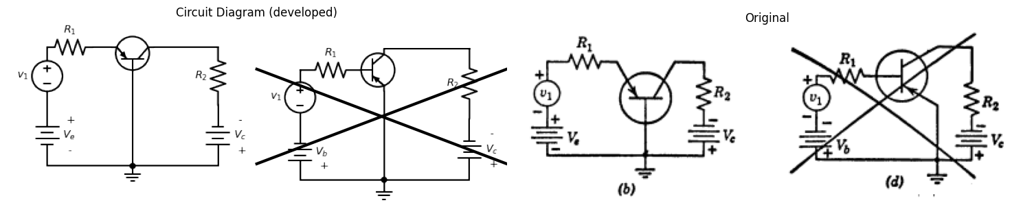
import matplotlib.pyplot as plt
import numpy as np
import schemdraw
from schemdraw import dsp
import schemdraw.elements as e
import matplotlib.image as mpimg
d = schemdraw.Drawing()
tr = d.add(e.BjtPnp(l=0.5,circle=True).reverse().theta(-180))
R1 = d.add(e.Resistor(l=2).down().label('$R_e$',ofst=0.1).at(tr.emitter).idot().dot())
R2 = d.add(e.Resistor(l=2).up().label('$R_2$',ofst=0.1).at(tr.collector).dot())
l03 = d.add(e.Line().length(1).left().at(tr.base))
R3 = d.add(e.Resistor(l=2.7).down().label('$R_n$',ofst=0.1).at(l03.end).idot().dot())
R4 = d.add(e.Resistor(l=2.7).up().label('$R_m$',ofst=0.1).at(l03.end))
l04 = d.add(e.Line().length(3.9).right())
l05 = d.add(e.Line().length(1.2).down())
E1 = d.add(e.Battery().down().reverse().label(['- ', '$V_c$', '+'], ofst=-1.3))
l06 = d.add(e.Line().length(1.2).down())
l07 = d.add(e.Line().length(3.9).left())
l08 = d.add(e.Line().length(0.9).right().at(R1.start))
c1 = d.add(e.Capacitor().length(2).down().label('$C_e$',ofst=-1))
c2 = d.add(e.Capacitor().length(1).left().label('$C$',ofst=-1).at(l03.end))
R5 = d.add(e.Resistor(l=1.4).left().label('$R_1$',ofst=0.1))
s01 = d.add(e.SourceV(l=2.7).reverse().down().label(['+', '$v_1$', '- '],ofst=(0,-0.1)))
l2 = d.add(e.Line().length(3).right())
d.draw()
d.save('./Drawings5/5-23em.png')
d.save('./Drawings5/5-23em.svg')
fig, axs = plt.subplots(1, 2, figsize=(15,7))
img = mpimg.imread('./Drawings5/5-23em.png')
axs[0].imshow(img)
axs[0].axis('off')
axs[0].set_title('Circuit Diagram (developed)')
img_sample = mpimg.imread('./images5/5-23em.png')
axs[1].imshow(img_sample)
axs[1].axis('off')
axs[1].set_title('Original')
plt.tight_layout()
plt.show()
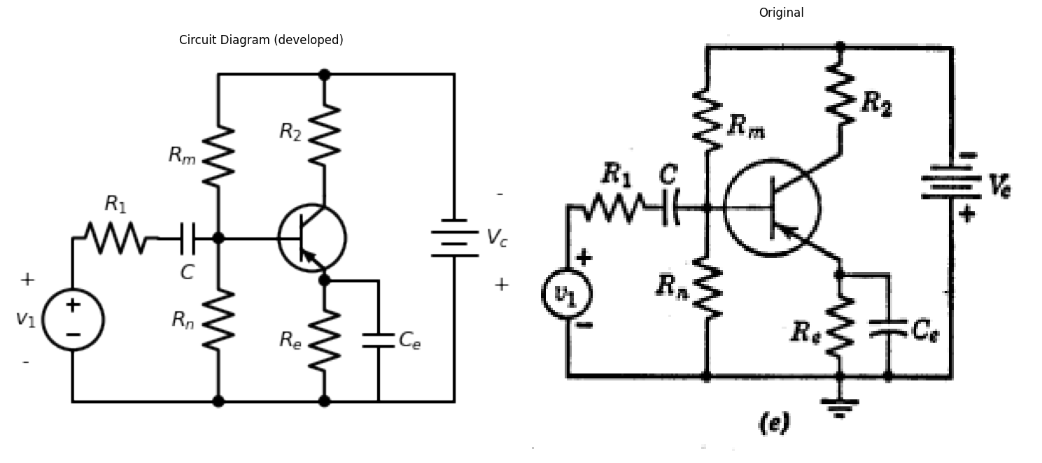
import matplotlib.pyplot as plt
import numpy as np
import schemdraw
from schemdraw import dsp
import schemdraw.elements as e
import matplotlib.image as mpimg
d = schemdraw.Drawing()
tr = d.add(e.BjtPnp(l=0.5,circle=True).reverse().theta(-180))
R0 = d.add(e.Resistor().down().label('$R_e$',ofst=0.1).at(tr.emitter).dot())
d += e.Ground()
l1 = d.add(e.Line().length(1.8).right().at(R0.end))
l1 = d.add(e.Line().length(2.7).left().at(R0.end))
R0 = d.add(e.Resistor(l=1.5).up().label('$R_2$',ofst=0.1).at(tr.collector))
l1 = d.add(e.Line().length(1.8).right())
l01 = d.add(e.Line().length(2.1).down())
E1 = d.add(e.Battery(l=1.8).down().reverse().label(['- ', '$V_c$', '+'], ofst=-1.3))
l02 = d.add(e.Line().length(2).down())
l02 = d.add(e.Line().length(1.9).left().at(tr.base))
R2 = d.add(e.Resistor(l=1.8).down().label('$R_mR_n/(R_m+R_n)$',ofst=0.1))
E2 = d.add(e.Battery(l=1.9).down().reverse().label(['- ', '$V_c$', '+'], ofst=-1.3))
d.move(13,2)
tr = d.add(e.BjtPnp(l=0.5,circle=True).reverse().theta(-180))
l1 = d.add(e.Line().length(1).down().at(tr.emitter))
d += e.Ground()
R0 = d.add(e.Resistor(l=1.5).up().label('$R_2$',ofst=0.1).at(tr.collector))
l1 = d.add(e.Line().length(1.8).right())
l01 = d.add(e.Line().length(4).down())
l02 = d.add(e.Line().length(2.2).left().at(tr.base))
R2 = d.add(e.Resistor(l=1.8).down().label('$R_mR_n/(R_m+R_n)$',ofst=-3.2))
l03 = d.add(e.Line().length(2.95).right().dot())
l04 = d.add(e.Line().length(1.8).right())
R3 = d.add(e.Resistor(l=1.8).left().label('$R_1$',ofst=0.2).idot().at(R2.start))
s01 = d.add(e.SourceV(l=1.8).reverse().down().label(['+', '$v_1$', '- '],ofst=(0,-0.1)))
l05 = d.add(e.Line().length(1.8).right())
d.draw()
d.save('./Drawings5/5-23fm.png')
d.save('./Drawings5/5-23fm.svg')
fig, axs = plt.subplots(1, 2, figsize=(15,7))
img = mpimg.imread('./Drawings5/5-23fm.png')
axs[0].imshow(img)
axs[0].axis('off')
axs[0].set_title('Circuit Diagram (developed)')
img_sample = mpimg.imread('./images5/5-23fm.png')
axs[1].imshow(img_sample)
axs[1].axis('off')
axs[1].set_title('Original')
plt.tight_layout()
plt.show()
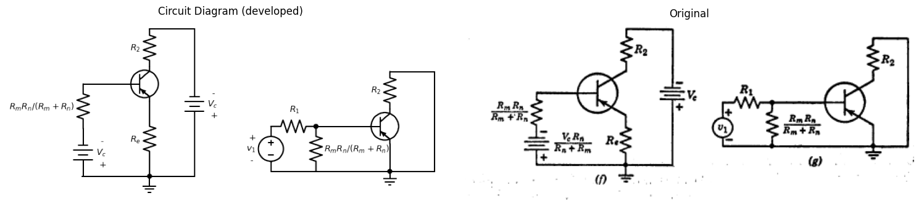
import matplotlib.pyplot as plt ###########################log
import numpy as np
import matplotlib.image as mpimg
from matplotlib.gridspec import GridSpec
"""
fig = plt.figure(figsize=(7, 6))
gs = GridSpec(2, 2, width_ratios=[1, 1])
ax0 = fig.add_subplot(gs[0, 0])
img_sample = mpimg.imread('./images5/5-23n.png')
ax4.imshow(img_sample)
ax4.set_title('Original')
plt.savefig('./Drawings5/5-23n.jpg')
plt.savefig('./Drawings5/5-23n.svg')
"""
"\nfig = plt.figure(figsize=(7, 6)) \ngs = GridSpec(2, 2, width_ratios=[1, 1]) \nax0 = fig.add_subplot(gs[0, 0]) \nimg_sample = mpimg.imread('./images5/5-23n.png') \nax4.imshow(img_sample) \nax4.set_title('Original')\nplt.savefig('./Drawings5/5-23n.jpg')\nplt.savefig('./Drawings5/5-23n.svg')\n"
Fig. 5.23. Stabilization of bias for transistor amplifiers.
Referring to the curves of Fig. 5.23, part (c), we might proceed with a circuit like that shown in (d) in a manner analogous to that described for the common-base circuit. However, the circuit shown in (d) is poor from a practical standpoint because it exhibits a tendency toward instability of the operating point. In the common-base circuit (a), the current $ I_0 $ passes primarily through the collector-base loop. For the circuit of (d), most of $ I_0 $ will be driven through the emitter-collector loop by the polarizing battery $ V_c $. The reverse current $ I_0 $ in a semiconductor junction is due to minority carriers. The number of such carriers available depends on the rate of hole-electron pair formation, which varies exponentially with temperature. Thus, any heating of the collector junction will increase $ I_0 $, which will further raise the temperature of the junction and increase $ I_0 $ still more. This may result in "thermal runaway." The result of collector junction heating may be a damaged transistor unless $ V_c $ and $ R_2 $ limit the current to a safe value. Even if the transistor is not damaged, an increase in $ I_0 $ shifts the entire set of collector characteristics so that the operating point is no longer properly located.
A circuit like that shown in Fig. 5.23 (e) can be used to avoid this unstable operation. In this circuit $ C $ and $ C_e $ are assumed to be so large that they have negligibly small impedances for the lowest signal frequency involved. They are, nevertheless, open circuits for d-c. Thus for signal frequencies, the incremental circuit reduces to a common-emitter circuit as shown in (g), but to represent the effects of the polarizing voltage and $ I_0 $ we have the circuit of (f). In (f) let the parallel combination of resistances in series with the base be designated $ R_b $ and let the equivalent battery be $ V_b $. Assuming $ R_b \gg r_b, , R_e \gg r_{ef}, $ and $ r_{cr} $ very large, we can write the equations:
$
V_b + R_b i_b = R_e i_e \tag{5.10}
$
and
$
i_b + i_e = ai_e + I_0 = -i_c \tag{5.11}
$
These can be solved to obtain the dependence of $ i_c $ on $ V_b $ and $ I_0 $ as follows:
$
-i_c = \frac{(R_b + R_e)I_0 + aV_b}{(1 - a)R_b + R_e} \tag{5.12}
$
For $ R_e = 0 $, we have $\frac{∂i_{c}}{∂I_{0}}=−\frac{1}{\left(1−a\right)}$, the situation that exists in the undesirable circuit of (d). With $ a $ very near unity (say 0.99) an increase of $ I_0 $ by an amount $ \Delta I_0 $ will cause a change of $ -100 \Delta I_0 $ in value of $ i_c $. The resulting increase in collector junction temperature may be sufficient to cause thermal runaway. With $ R_e \neq 0 $, we have the situation that exists in the circuit represented by (e) or (f) is as follows: If $ R_e $ equals $ R_b $, a change $ \Delta I_0 $ yields only a change of $ -2\Delta I_0 $ in collector current. This represents a fifty-fold reduction in the sensitivity of $ i_c $ to changes in $ I_0 $. The point is that $ R_e $ must not be too small relative to $ R_b $ in the circuit of Fig. 5.23(f).
import matplotlib.pyplot as plt
import numpy as np
import schemdraw
from schemdraw import dsp
import schemdraw.elements as e
import matplotlib.image as mpimg
d = schemdraw.Drawing()
l1 = d.add(e.Line(l=0.4).right())
l2 = d.add(e.Line(l=3).right())
l3 = d.add(e.Line(l=3).right())
l4 = d.add(e.Line(l=0.4).right())
l5 = d.add(e.Line(l=1.7).up().at(l1.start))
l6 = d.add(e.Line(l=6.8).right())
l7 = d.add(e.Line(l=1.7).down())
l8 = d.add(e.Line(l=0.6).down().at(l1.end).dot(open=True))
l9 = d.add(e.Line(l=0.6).down().at(l2.end).dot(open=True))
l9 = d.add(e.Line(l=0.6).down().at(l3.end).dot(open=True))
E2 = d.add(e.Battery().down().label(['+', '$E_1$', '- '], ofst=-1.3).at(l8.end))
R1 = d.add(e.Resistor(l=3).right().label('$R_1$',ofst=0.2).dot())
R2 = d.add(e.Resistor(l=3).right().label('$R_2$',ofst=0.2))
E3 = d.add(e.Battery().up().reverse().label(['- ', '$E_2$', '+'], ofst=-1.3))
R3 = d.add(e.Resistor(l=3).up().label('$R_3$',ofst=0.2).at(R1.end))
l10 = d.add(e.Line(l=1.5).right().linestyle('--'))
l10 = d.add(e.Line(l=0.7).down().linestyle('--'))
d += e.Ground()
d += e.Arrow().right().linewidth(0.6).length(4).at(((-2.5, 0.7))).color('white').label('Three-terminal device', loc='end', color='black',ofst=0.2)
d.draw()
d.save('./Drawings5/5-24.png')
d.save('./Drawings5/5-24.svg')
fig, axs = plt.subplots(1, 2, figsize=(7,7))
img = mpimg.imread('./Drawings5/5-24.png')
axs[0].imshow(img)
axs[0].axis('off')
axs[0].set_title('Circuit Diagram (developed)')
img_sample = mpimg.imread('./images5/5-24.png')
axs[1].imshow(img_sample)
axs[1].axis('off')
axs[1].set_title('Original')
plt.tight_layout()
plt.show()
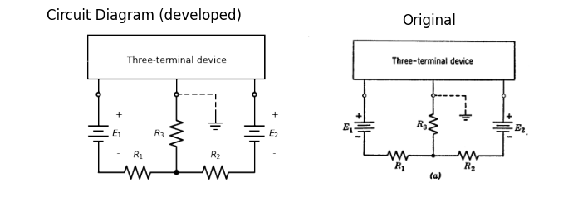
import matplotlib.pyplot as plt
import numpy as np
import schemdraw
from schemdraw import dsp
import schemdraw.elements as e
import matplotlib.image as mpimg
d = schemdraw.Drawing()
l0 = d.add(e.Line(l=1).down().idot(open=True))
E2 = d.add(e.Battery().down().label(['+', '$(E_1-E_3)$', '- '], ofst=0.3))
l00 = d.add(e.Line(l=0.6).down())
R1 = d.add(e.Resistor(l=3).right().label('$R_1$',ofst=0.2).dot())
R2 = d.add(e.Resistor(l=3).right().label('$R_2$',ofst=0.2))
l01 = d.add(e.Line(l=0.6).up())
E3 = d.add(e.Battery().up().reverse().label(['- ', '$(E_2-E_3)$', '+ '], ofst=-2.3))
l08 = d.add(e.Line(l=1).up().dot(open=True))
E3 = d.add(e.Battery(l=2.6).up().label(['+', '$E_3$', '- '], ofst=-1.3).at(R1.end))
R3 = d.add(e.Resistor(l=2.1).up().label('$R_3$',ofst=0.2).dot(open=True))
l10 = d.add(e.Line(l=1.5).right().linestyle('--'))
l10 = d.add(e.Line(l=0.7).down().linestyle('--'))
d += e.Ground()
d.draw()
d.save('./Drawings5/5-24b.png')
d.save('./Drawings5/5-24b.svg')
fig, axs = plt.subplots(1, 2, figsize=(7,14))
img = mpimg.imread('./Drawings5/5-24b.png')
axs[0].imshow(img)
axs[0].axis('off')
axs[0].set_title('Circuit Diagram (developed)')
img_sample = mpimg.imread('./images5/5-24b.png')
axs[1].imshow(img_sample)
axs[1].axis('off')
axs[1].set_title('Original')
plt.tight_layout()
plt.show()
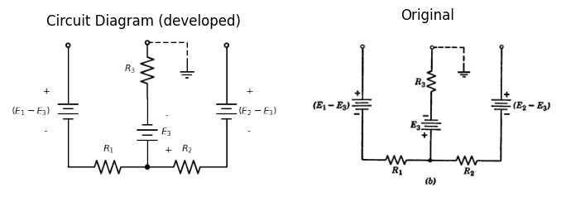
Fig. 5.24. General polarizing circuit.
Stability of the operating point is only one of many possible design considerations. The parameter values $ R_m, R_n, R_2, R_e $ in the circuit of Fig. 5.23(e) determine (1) the d-c stability of the operating point, (2) the location of the operating point, (3) the a-c operating path upon the transistor curves, (4) the current and voltage gains, and (5) the input and output impedances of the amplifier. The circuit design starts with a trial specification of items such as (1) through (5) above and proceeds toward suitable values of the circuit resistances, usually through a number of successive approximations. A straightforward analytical solution of the problem is convenient only for very simple circuit configurations. In any case, we must remember that individual transistor characteristics may deviate greatly from the published "average" curves, and that all circuit elements are likewise known only within certain tolerances.
The circuits used to provide d-c polarizing voltages or currents for transistors or vacuum tubes appear to take many different forms. They may make use of one or more sources and resistive voltage-dividers. However, for any three-terminal device all polarizing circuits are variations of the general form shown in Fig. 5.24(a).
import matplotlib.pyplot as plt
import numpy as np
import schemdraw
from schemdraw import dsp
import schemdraw.elements as e
import matplotlib.image as mpimg
d = schemdraw.Drawing()
l = d.add(e.Line().length(0.5).up())
tr = d.add(e.BjtPnp(l=0.5,circle=True).up())
l0 = d.add(e.Line().length(1.1).left().at(tr.emitter))
l1 = d.add(e.Line().length(1.1).right().at(tr.collector))
l2 = d.add(e.Line().length(2.3).down().dot().at(tr.base))
d += e.Ground()
l3 = d.add(e.Line().length(1.8).right().at(l2.end))
E2 = d.add(e.Battery(l=1.4).up().label(['+','$V_c$','- '], ofst=0.2))
R1 = d.add(e.Resistor(l=1.6).up().label('$R_c$',ofst=0.1))
l4 = d.add(e.Line().length(1.8).right().at(l2.end))
R2 = d.add(e.Resistor(l=1.6).down().label('$R_e$',ofst=0.1).at(l0.end).idot())
s01 = d.add(e.Battery(l=1.45).down().label(['+', '$V_e$', '- '], ofst=0.2))
l5 = d.add(e.Line().length(1.8).right())
c1 = d.add(e.Capacitor().length(2).left().label('$C$',ofst=0.1).at(R2.start))
R2 = d.add(e.Resistor(l=1.6).down().label('$R_1$',ofst=0.1))
V1 = d.add(e.Source(l=1.45).down().label('$v_1$', ofst=0.2))
l5 = d.add(e.Line().length(2).right())
d.draw()
d.save('./Drawings5/5-25.png')
d.save('./Drawings5/5-25.svg')
fig, axs = plt.subplots(1, 2, figsize=(7,14))
img = mpimg.imread('./Drawings5/5-25.png')
axs[0].imshow(img)
axs[0].axis('off')
axs[0].set_title('Circuit Diagram (developed)')
img_sample = mpimg.imread('./images5/5-25.png')
axs[1].imshow(img_sample)
axs[1].axis('off')
axs[1].set_title('Original')
plt.tight_layout()
plt.show()
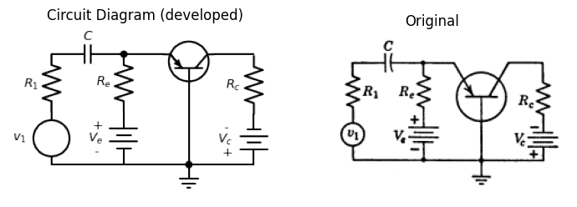
Fig. 5.25. Capacitive coupling of source.
The inclusion of a third battery as in (b) adds nothing significant, since an adjustment of the other two reduces the circuit to that shown in (a).
The use of capacitive coupling as shown in Fig. 5.23(e) permits separate determination of polarizing source and signal source requirements. In the circuit of Fig. 5.22(b), the d-c and signal currents must pass through the same resistance $ R_1 $, so that the polarizing and signal source requirements are interdependent. The circuit of Fig. 5.25 shows a method of "isolating" the d-c and signal currents in a common-base circuit.

1.11 5.13 Driving-Point and Transfer Curves for Common-Base Circuit
The succession of operating points between $ X $ and $ Y $ in the input plane of $ v_{eb} $ versus $ i_e $ of Fig. 5.22(d) defines the driving-point curve seen at the emitter-to-ground terminals. This curve is shown in Fig. 5.26(a). Since $ v_1 = v_{eb} - V_e + i_e R_e $, the corresponding curve of input voltage $ v_1 $ versus emitter current $ i_e $ can be obtained readily from the driving-point curve by shifting the intercept an amount $ V_e $ and increasing the slope by $ R_e $, as shown in (a).
The transfer curve $ v_2 $ vs. $ v_{eb} $ and $ v_2 $ vs. $ v_1 $ can be obtained by solving Eqs. 5.5, 5.6, 5.7, and 5.8 for $ i_c $ in terms of $ v_1 $ or $ v_{eb} $. Then since
$
v_2 = -i_c R_c \quad (5.13)
$
the curve can be plotted by using the appropriate values of $ r_e $ and $ r_c $ for each state. This procedure yields the equations for each segment of the curve.
import matplotlib.pyplot as plt
import numpy as np
import matplotlib.image as mpimg
from matplotlib.gridspec import GridSpec
fig = plt.figure(figsize=(8, 10))
gs = GridSpec(3, 2, width_ratios=[1, 1])
ax0 = fig.add_subplot(gs[0, 0])
x2 = -np.linspace(0, 6, 100)
ax0.plot([0,5], [-0.3,0.5], color='black', linewidth=2)
ax0.plot([0,5], [0,0.28], color='black', linewidth=1.5, linestyle='--',dashes=(8, 3))
ax0.set_title('V-I Curve')
ax0.set_ylabel('$v_1 or v_{eb}$', labelpad=3, loc='top')
ax0.set_xlim(0, 5.5)
ax0.set_ylim(-0.35, 0.35)
ax0.set_xlabel('$i_e$', labelpad=3, loc='right')
ax0.axhline(0, color='black', linewidth=1)
ax0.axvline(0, color='black', linewidth=1)
ax0.set_xticks(np.arange(0, 5.5, 1))
ax0.set_yticks(np.arange(-0.4, 0.35, 0.1))
ax0.grid(True)
ax1 = fig.add_subplot(gs[0, 1])
ax1.axis('off')
ax2 = fig.add_subplot(gs[1, 0])
ax2.plot([-0.4,-0.3], [0,0], color='black', linewidth=2)
ax2.plot([-0.3,0.4], [0,28], color='black', linewidth=2)
ax2.plot([0.4,0.6], [28,28], color='black', linewidth=2)
ax2.plot([-0.3,0], [0,0], color='black', linewidth=1.5, linestyle='--',dashes=(8, 3))
ax2.plot([0,0.28], [0,28], color='black', linewidth=1.5, linestyle='--',dashes=(8, 3))
ax2.plot([0.28,0.6], [28,28], color='black', linewidth=1.5, linestyle='--',dashes=(8, 3))
ax2.set_title('V-I Curve')
ax2.set_ylabel('$v_2 = -i_cR_c = V_c+v_{cb}$', labelpad=3, loc='top')
ax2.set_xlim(-0.4, 0.5)
ax2.set_ylim(-30, 50)
ax2.set_xlabel('$v_1 or v_{eb}$', labelpad=3, loc='right')
ax2.axhline(0, color='black', linewidth=0.5)
ax2.axvline(0, color='black', linewidth=0.5)
ax2.set_xticks(np.arange(-0.3, 0.5, 0.1))
ax2.set_yticks(np.arange(-30, 50, 10))
ax2.grid(True)
ax4 = fig.add_subplot(gs[2, :])
img_sample = mpimg.imread('./images5/5-26.png')
ax4.imshow(img_sample)
ax4.set_title('Original')
ax4.axis('off')
axes = [ax0, ax1,ax2 ]
for a in axes:
a.spines['top'].set_color('none')
a.spines['right'].set_color('none')
a.spines['left'].set_position('zero')
a.spines['bottom'].set_position('zero')
a.spines['left'].set_linewidth(1)
a.spines['bottom'].set_linewidth(1)
a.xaxis.set_ticks_position('bottom')
a.yaxis.set_ticks_position('left')
a.tick_params(axis='both', which='both', length=5)
a.grid(True)
plt.tight_layout()
plt.show()
plt.savefig('./Drawings5/5-26.jpg')
plt.savefig('./Drawings5/5-26.svg')
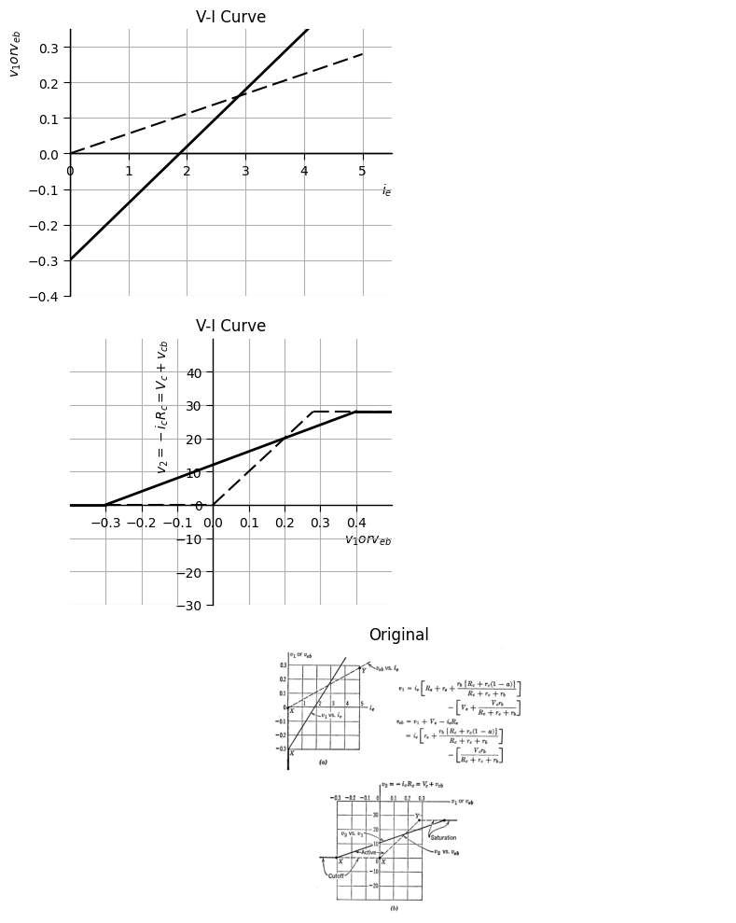
<Figure size 640x480 with 0 Axes>
Fig. 5.26. Driving point and transfer curves for the circuit of Fig. 5.22.
For the specific conditions illustrated in Fig. 5.22(d), graphical location of break points $ X $ and $ Y $ yields the transfer curves directly. At point $ X $ the emitter diode breaks, marking the transition between the cutoff and active or amplification region. At $ Y $ the collector diode breaks, marking the transition from active to saturation. The plot in Fig. 5.26(b) shows the resulting curves. The slopes are the voltage gains from the $ v_1 $ or $ v_{eb} $ terminals to the output terminals. The effect of resistance $ R_e $ is to reduce the gain $ \frac{dv_2}{dv_{eb}} $ relative to $ \frac{dv_2}{dv_1} $. For the numerical values used in the example, the reduction is approximately a factor of three.
Numerical values of the gains can be measured from the curves, and general gain expressions can be computed from the equations of Fig. 5.22(c). However, the incremental model is more convenient for gain calculations, since the constant terms do not enter the expressions.

1.12 5.14 Comparison of the Basic Transistor Circuits
Current gain, voltage gain, and power gain, as well as the input and output resistances of transistor circuits, are important in nearly all transistor applications. These properties of common-base, common-emitter, and common-collector circuits can be found by measuring the slopes of the appropriate transfer or driving-point curves as mentioned in Article 5.13. They can also be calculated by analysis of the appropriate incremental circuit; for example, the circuit in Fig. 5.20. However, the resulting expressions are usually cumbersome, and considerable simplification results when numerical values are substituted. Thus, rather than work out complicated exact expressions, it is more appropriate to calculate the approximate values of current gain, voltage gain, etc., using the ideal diode models to find approximate relative values of these quantities for the three basic transistor circuits in any one diode state. For example, consider the most interesting state, namely that for which amplification is obtained.
The values of the gains and resistances tabulated in Fig. 5.27 are based on the use of an ideal incremental model for the transistor in the active amplification region $(r_{e}=r_{b}=0$, $r_{c}=∞$, and $α=α)$. The quantities in the table can be obtained directly from the simple circuits that result from this model.
The relative values of the emitter, base and collector currents provide the key to the determination of the gains and resistances. Since the value of emitter-to-collector current gain is slightly less than unity for a junction transistor, the common-base circuit has a current gain less than unity, whereas the current gains of the other two circuits are large (approximately 20 for $α=0.95$). The voltage gain is nearly $R_{2}/R_{1}$ for the common-base circuit, considerably higher for the common-emitter circuit and slightly less than unity for the common-collector circuit. The latter is sometimes called an "emitter-follower," since the incremental changes in emitter voltage follow incremental changes in base voltage quite closely.
In terms of power gain, the common-emitter circuit is clearly superior to the common-base circuit. The power gain of the common-collector circuit also appears likely to be smaller than that of the common emitter, but the relative merits of the two depend on the ratio $R_{2}/R_{1}$. In fact, the common-collector circuit is most useful for coupling a high resistance source to a low resistance load $\left[R_{2}/R_{1}≪1\right]$, since the circuit has a relatively high input resistance and a low output resistance.
import matplotlib.pyplot as plt
import pandas as pd
import numpy as np
from PIL import Image
data = {
' ': ['Circuits', 'Current gain $\dfrac{i_2}{i_1}$', 'Voltage gain $\dfrac{v_2}{v_1}$', 'Power gain $\dfrac{-v_2 i_2}{v_1 i_1}$', 'Input resistance $\dfrac{v_1}{i_1}$', 'Output resistance $\dfrac{v_2}{i_0}$'],
'Common Base': [r' ', r'$-a$', r'$a \dfrac{R_2}{R_1}$', r'$a^2 \dfrac{R_2}{R_1}$', r'$R_1 + 0 = R_1$', r'$(R_2 \parallel \infty) = R_2$'],
'Common Emitter': [r' ', r'$\dfrac{a}{1 - a}$', r'$-\left(\dfrac{a}{1 - a}\right) \dfrac{R_2}{R_1}$', r'$\left(\dfrac{a}{1 - a}\right)^2 \dfrac{R_2}{R_1}$', r'$R_1 + 0 = R_1$', r'$(R_2 \parallel \infty) = R_2$'],
'Common Collector': [r' ', r'$-\left(\dfrac{1}{1 - a}\right)$', r'$\dfrac{R_2}{R_2 + R_1(1 - a)} \approx 1$', r'$\dfrac{1}{1 - a} \left(\dfrac{R_2}{R_2 + R_1(1 - a)}\right) \approx \dfrac{1}{1 - a}$', r'$R_1 + \dfrac{R_2}{1 - a}$', r'$R_2 \parallel (R_1(1 - a))$']
}
df = pd.DataFrame(data)
fig, ax = plt.subplots(figsize=(10, 10))
ax.axis('tight')
ax.axis('off')
table = ax.table(cellText=df.values, colLabels=df.columns, cellLoc='center', loc='center')
table.auto_set_font_size(False)
table.set_fontsize(16)
table.scale(3, 7)
plt.show()
plt.savefig('./Drawings5/5-27.png')
plt.savefig('./Drawings5/5-27.svg')
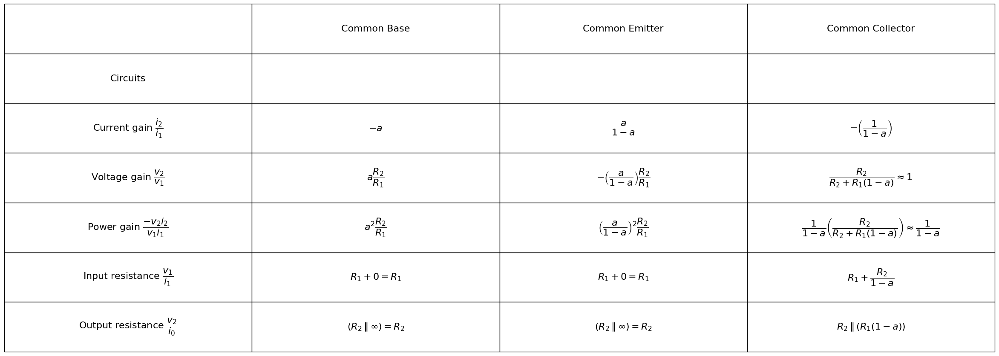
<Figure size 640x480 with 0 Axes>
Fig. 5.27. Comparison of basic circuits using an ideal transistor model $ (r_e = r_b = 0, , r_c = \infty) $.
Under these conditions, the power gain of the common-collector circuit becomes slightly larger than that of the common-emitter circuit.
The values given in Fig. 5.28 imply $R_{1}$ to be much greater than the input resistance contributed by the nonzero values of $r_{e}$ and $r_{b}$. Also, $R_{2}$ must be much less than the effective output resistance. For a more accurate comparison of the three circuits, the complete expressions, involving all the transistor parameters, should be used.
For n-p-n transistors, diode polarities and the corresponding bias voltage polarities must be reversed. From the standpoint of the circuit models, the only difference between point-contact and junction transistors is in numerical values; for example, with point-contact transistors we may have a short-circuit-current gain from emitter to collector greater than unity, so that values of $α$ are in the vicinity of 2 or 3. Also, the characteristic curves are such that diodes in the piecewise-linear circuit model are likely to have slightly larger forward resistances ($r_{ef}$ and $r_{cf}$ of the order of a few hundred ohms) and considerably smaller reverse resistances ($r_{e}$ and $r_{cr}$ of the order of 20 kilohms to 100 kilohms). In addition, the individual curves of the family $v_{cb}=f\left(i_{c},i_{e}\right)$ have greater variation in slope and spacing throughout the $v_{cb}$ vs. $i_{c}$ plane.
import matplotlib.pyplot as plt
import pandas as pd
import numpy as np
from PIL import Image
data = {
' ': ['Circuits', 'Current gain $\dfrac{i_2}{i_1}$', 'Voltage gain $\dfrac{v_2}{v_1}$', 'Power gain $\dfrac{-v_2 i_2}{v_1 i_1}$', 'Input resistance $\dfrac{v_1}{i_1}$', 'Output resistance $\dfrac{v_2}{i_0}$'],
'Common Base': [r' ', r'$-a$', r'$\dfrac{aR_2}{R_1 + R_b(1 - a)} $', r'$\dfrac{a^2R_2}{R_1 + R_b(1 - a)} $', r'$R_1 + R_b(1 - a)$', r'$(R_2 \parallel \infty) = R_2$'],
'Common Emitter': [r' ', r'$\dfrac{a}{1 - a}$', r'$\dfrac{-aR_2}{(1 - a)R_1 + R_e} $', r'$\dfrac{a^2R_2}{(1 - a)[(1 - a)R_1 + R_e]} $', r'$R_1 + \dfrac{R_e}{1 - a}$' , r'$(R_2 \parallel \infty) = R_2$'],
'Common Collector': [r' ', r'$-\left(\dfrac{1}{1 - a}\right)$', r'$\dfrac{R_2}{R_2 + R_1(1 - a)} \approx 1$', r'$\dfrac{R_2}{(1-a)[R_2 + R_1(1 - a)]} $', r'$R_1 + \dfrac{R_2}{1 - a}$', r'$R_2 \parallel (R_1(1 - a)) \approx {R_1(1 - a)}$']
}
df = pd.DataFrame(data)
fig, ax = plt.subplots(figsize=(10, 10))
ax.axis('tight')
ax.axis('off')
table = ax.table(cellText=df.values, colLabels=df.columns, cellLoc='center', loc='center')
table.auto_set_font_size(False)
table.set_fontsize(16)
table.scale(3, 7)
plt.show()
plt.savefig('./Drawings5/5-28.png')
plt.savefig('./Drawings5/5-28.svg')
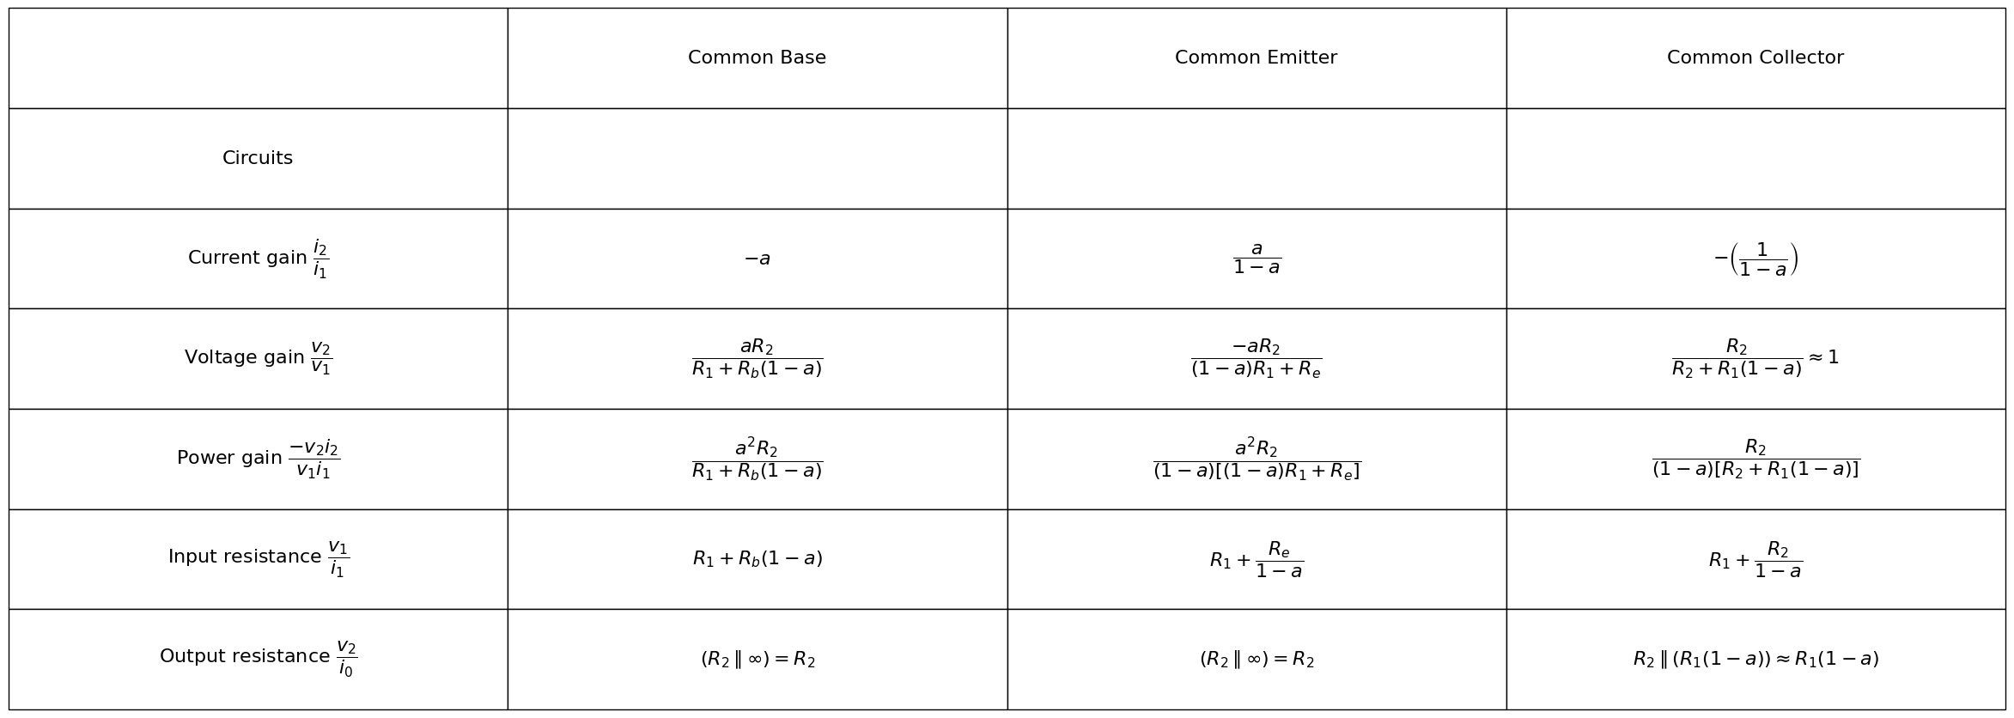
<Figure size 640x480 with 0 Axes>
Fig. 5.28. Effects of coupling resistance in the basic circuits $ (r_e = r_b = 0, , r_c = \infty) $.
The ideal-diode model, the piecewise-linear diode model, and the linear-incremental model have one very important feature in common. They all yield "linear" circuits and therefore linear differential equations when combined with energy-storage elements. To be sure, the diode models have multiple states and therefore will yield different linear equations for each state traversed during operation of the circuit.
Various resistive models can be devised for transistors in addition to those already discussed. As soon as we deviate from the use of linear segments to match the curves, we have many possible functions to consider. One that is often useful is based on the use of exponential diodes, and it is in keeping with the exponential relation between current and voltage in a semiconductor junction. Although exponential models (or other nonlinear models) may result in a better fit to the graphical curves or a better interpretation of the physical behavior of the transistor, they are usually less useful in circuit analysis and will not be pursued here. It is important to keep in mind the fact that no circuit model is the "right one" or the "best one" for all purposes. A model that is too general may be very cumbersome for analysis of circuit behavior. It is usually preferable to use the simplest model that adequately describes a device in a specific operational environment.
Thus far, no mention has been made of the effects of high-frequency variations of the currents and voltages applied to a transistor, nor has anything been said about the effects of temperature changes. Both of these materially influence transistor behavior.

1.13 5.15 High-Frequency Circuit Model
Resistive models are valid only for d-c or low-frequency operation. Modification of the models is necessary if they are to be used to determine circuit behavior at high frequencies. We shall here define high frequencies rather loosely as those for which the resistive models no longer represent the transistor adequately. Depending on the type of transistor involved and the circuit configuration, this may mean frequencies as low as tens of kilocycles per second, or as high as a few megacycles per second.
Semiconductor junctions exhibit an effective capacitance that influences transistor behavior when rapid variations of voltage or current occur. This capacitance depends upon the cross-sectional dimensions of the junction, the materials, the applied voltage, and other factors related to the method of fabrication. Typical values run from 10 to 100 μF. The incremental model shown in Fig. 5.29(a) includes such a capacitance $C_{c}$ in the collector circuit to represent the base-to-collector junction. For frequencies where the capacitive reactance is appreciably less than the collector resistance, $1/2πfC_{c}≪r_{c}$, the resistance can be omitted, as shown in (b). The corresponding capacitance across the emitter-to-base junction can usually be neglected if the emitter diode is closed, since this capacitor is shunted by the very small emitter resistance. The equations previously given for resistive models apply to the circuit in (a) if $r_{c}$ is replaced by complex impedance $z_{c}$, $i$ by $I$ and $v$ by $V$.
The presence of the capacitance at the collector junction can be visualized in terms of the charge and potential distributions. Diffusion of majority carriers across the base-to-collector junction builds up a potential difference, which is characteristic of a capacitance. The charge distribution, electric field and potential difference near the junction are shown in Fig. 5.30. The reverse bias applied for normal operation merely serves to charge this capacitance further. Conversely, the forward bias applied to the emitter-to-base junction results in a large conduction current that virtually swamps the capacitance effect.
import matplotlib.pyplot as plt
import numpy as np
import schemdraw
from schemdraw import dsp
import schemdraw.elements as e
import matplotlib.image as mpimg
d = schemdraw.Drawing()
l = d.add(e.Line().length(0.5).right().idot(open=True))
R1 = d.add(e.Resistor().right().label('$r_e$',ofst=0.1).dot())
l1 = d.add(e.Line().length(1.1).down())
R2 = d.add(e.Resistor().down().label('$r_b$',ofst=0.1).dot())
d += e.Ground()
l2 = d.add(e.Line().length(0.8).right().dot().at(R1.end))
R3 = d.add(e.Resistor().right().label('$r_c$',ofst=0.1).dot())
l3 = d.add(e.Line().length(1.3).right().dot(open=True))
l4 = d.add(e.Line().length(5.1).right().dot(open=True).at(R2.end))
l5 = d.add(e.Line().length(1.5).up().at(R3.end))
s01 = d.add(e.SourceI(l=3).reverse().left().label('$ai_e$',ofst=(0,-0.1)))
l5 = d.add(e.Line().length(1.5).down())
l6 = d.add(e.Line().length(1.5).down())
c1 = d.add(e.Capacitor().length(3).right().label('$C_e$',ofst=0.1))
l7 = d.add(e.Line().length(1.5).up())
l8 = d.add(e.Line().length(3.5).left().dot(open=True).at(R2.end))
d += e.Arrow().up().length(2).linewidth(0.6).color('white').label('$V_{eb}$', loc='start', color='black',ofst=0.3). at((0.4,-2))
d += e.Arrow().up().length(1.4).linewidth(0.6).color('black').label('+',loc='end', color='black',ofst=0.4). at((0,-1.6))
d += e.Arrow().down().length(1.4).linewidth(0.6).color('black').label(r'_', loc='end', color='black',ofst=(-0.3,-0.3)). at((0,-2.5))
d += e.Arrow().up().length(2).linewidth(0.6).color('white').label('$V_{cb}$', loc='start', color='black',ofst=0.3). at((9.2,-2))
d += e.Arrow().up().length(1.4).linewidth(0.6).color('black').label('+',loc='end', color='black',ofst=0.4). at((8.8,-1.6))
d += e.Arrow().down().length(1.4).linewidth(0.6).color('black').label(r'_', loc='end', color='black',ofst=(-0.3,-0.3)). at((8.8,-2.5))
d.move(-8,-6)
l = d.add(e.Line().length(0.5).right().idot(open=True))
R1 = d.add(e.Resistor().right().label('$r_e$',ofst=0.1).dot())
l1 = d.add(e.Line().length(1.1).down())
R2 = d.add(e.Resistor().down().label('$r_b$',ofst=0.1).dot())
d += e.Ground()
l2 = d.add(e.Line().length(0.8).right().dot().at(R1.end))
R3 = d.add(e.Resistor().right().label('$r_c$',ofst=0.1).dot())
l3 = d.add(e.Line().length(1.3).right().dot(open=True))
l4 = d.add(e.Line().length(5.1).right().dot(open=True).at(R2.end))
l5 = d.add(e.Line().length(1.5).up().at(R3.end))
s01 = d.add(e.SourceI(l=3).reverse().left().label('$ai_e$',ofst=(0,-0.1)))
l5 = d.add(e.Line().length(1.5).down())
l6 = d.add(e.Line().length(1.5).down())
c1 = d.add(e.Capacitor().length(3).right().label('$C_e$',ofst=0.1))
l7 = d.add(e.Line().length(1.5).up())
l8 = d.add(e.Line().length(3.5).left().dot(open=True).at(R2.end))
d += e.Arrow().up().length(2).linewidth(0.6).color('white').label('$V_{eb}$', loc='start', color='black',ofst=0.3). at((1.1,-12))
d += e.Arrow().up().length(1.4).linewidth(0.6).color('black').label('+',loc='end', color='black',ofst=0.4). at((0.7,-11.6))
d += e.Arrow().down().length(1.4).linewidth(0.6).color('black').label(r'_', loc='end', color='black',ofst=(-0.3,-0.3)). at((0.7,-12.5))
d += e.Arrow().up().length(2).linewidth(0.6).color('white').label('$V_{cb}$', loc='start', color='black',ofst=0.3). at((9.9,-12))
d += e.Arrow().up().length(1.4).linewidth(0.6).color('black').label('+',loc='end', color='black',ofst=0.4). at((9.5,-11.6))
d += e.Arrow().down().length(1.4).linewidth(0.6).color('black').label(r'_', loc='end', color='black',ofst=(-0.3,-0.3)). at((9.5,-12.5))
d.draw()
d.save('./Drawings5/5-29.png')
d.save('./Drawings5/5-29.svg')
fig, axs = plt.subplots(1, 2, figsize=(7,14))
img = mpimg.imread('./Drawings5/5-29.png')
axs[0].imshow(img)
axs[0].axis('off')
axs[0].set_title('Circuit Diagram (developed)')
img_sample = mpimg.imread('./images5/5-29.png')
axs[1].imshow(img_sample)
axs[1].axis('off')
axs[1].set_title('Original')
plt.tight_layout()
plt.show()
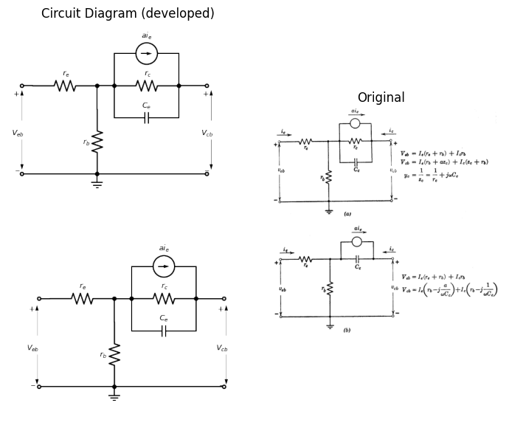
Fig. 5.29. Incremental model including collector capacitance.

1.14 5.16 Effect of Collector Capacitance on the Gain of the Grounded-Base Circuit
The collector capacitance tends to reduce the magnitude of the current gain of the transistor and also introduces a phase shift. Referring to the circuit of Fig. 5.29(a), it is evident that a load resistance $R_{c}$, connected between collector and ground, will receive almost the entire current $a_{i}e$ at zero frequency and a small fraction $i_{er_{b}}/\left(r_{b}+R_{c}\right)$ at infinite frequency where the capacitive reactance reaches zero.
A grounded-base circuit with collector capacitance in the transistor model is shown in Fig. 5.31(a), together with a vector diagram. The expression for complex current gain $I_{c}/I_{e}$ is given in (b), and the absolute magnitude $\left|\frac{I_{c}}{I_{e}}\right|$ is given in (c).
import matplotlib.pyplot as plt
import numpy as np
import schemdraw
from schemdraw import dsp
import schemdraw.elements as e
import matplotlib.image as mpimg
d = schemdraw.Drawing()
d += ( T1 := dsp.Box(w=4, h=3.5).anchor('W').label('p', ofst=(0,2.1)))
d += ( T2 := dsp.Box(w=4, h=3.5).anchor('W').at(T1.E).label('n', ofst=(0,2.1)))
d += ( T3 := dsp.Box(w=4, h=3.5).anchor('W').at(T2.E).label('p', ofst=(0,2.1)))
d += e.Arrow().right().linewidth(0.6).length(0.7).color('white').label('⊕\n⊕\n⊕\n⊕', loc='top', fontsize=27, color='black',ofst=0.2).at((7.1,-6.5))
d += e.Arrow().right().linewidth(0.6).length(0.7).color('white').label('⊖\n⊖\n⊖\n⊖', loc='top', fontsize=27, color='black',ofst=0.2).at((7.9,-6.5))
l = d.add(e.Line().length(3.5).at((7.85,-4.6)).down().anchor('center'))
d += e.Arrow().right().linewidth(0.6).length(0.7).color('white').label('⊖', loc='top', fontsize=24, color='black',ofst=0.2).at((7.1,0.7))
d += e.Arrow().right().linewidth(0.6).length(0.7).color('white').label('⊖', loc='top', fontsize=24, color='black',ofst=0.2).at((7.1,0.2))
d += e.Arrow().right().linewidth(0.6).length(0.7).color('white').label('⊖', loc='top', fontsize=24, color='black',ofst=0.2).at((7.1,-0.3))
d += e.Arrow().right().linewidth(0.6).length(0.7).color('white').label('⊕⊕', loc='top', fontsize=24, color='black',ofst=0.2).at((8.5,-1.8))
d += e.Arrow().right().linewidth(0.6).length(0.7).color('black').at((7.9,1.1))
d += e.Arrow().right().linewidth(0.6).length(0.7).color('black').at((7.9,0.7))
d += e.Arrow().right().linewidth(0.6).length(0.7).color('black').at((7.9,0.3))
d += e.Arrow().left().linewidth(0.6).length(0.7).color('black').at((8.4,-0.5))
d += e.Arrow().left().linewidth(0.6).length(0.7).color('black').at((8.4,-0.1))
d += e.Arrow().left().linewidth(0.6).length(0.7).color('black').at((8.4,-0.9))
"""
l = d.add(e.Line().length(d.unit*0.35).at(mid_bottom).down().anchor('center').dot(open=True))
d += e.Arrow().left().linewidth(0.6).length(1.4).at((1.5, 0)).color('black').label('$+$', loc='end', color='black',ofst=-0.4)
d += e.Arrow().right().linewidth(0.6).length(1.4).at((2.2, 0)).color('black').label('$-$', loc='end', color='black',ofst=(-0.3,0.4))
d += e.Arrow().right().linewidth(0.6).length(1.4).at((0.45, -0.2)).color('white').label('$V_{eb}$', loc='end', color='black',ofst=(-0.3,0.4))
d += e.Arrow().right().linewidth(0.6).length(0.7).color('black').label('$i$', loc='top', color='black',ofst=0.2).at((0,2.3))
d += e.Arrow().right().linewidth(0.6).length(0.7).color('black').at((2.9,2))
d += e.Arrow().right().linewidth(0.6).length(0.7).color('black').at((3,2.7))
d += e.Arrow().right().linewidth(0.6).length(0.7).color('black').at((3,1.6))
d += e.Arrow().right().linewidth(0.6).length(0.7).color('white').label('⊖', loc='top', fontsize=16, color='black',ofst=0.2).at((1.4,-0.5))
"""
d.save('./Drawings5/5-30m.png')
d.save('./Drawings5/5-30m.svg')
fig, axs = plt.subplots(1, 2, figsize=(8, 4))
img = mpimg.imread('./Drawings5/5-30m.png')
axs[0].imshow(img)
axs[0].axis('off')
axs[1].set_title('Circuit Diagram (developed)')
img_sample = mpimg.imread('./images5/5-30m.png')
axs[1].imshow(img_sample)
axs[1].axis('off')
axs[1].set_title('Original')
plt.tight_layout()
plt.show()
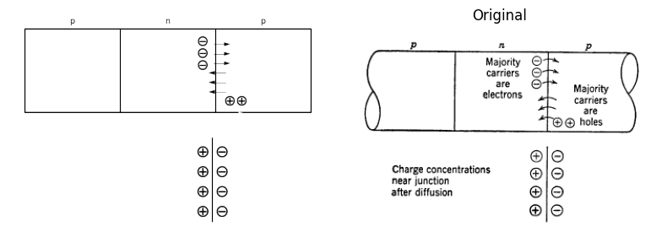
import matplotlib.pyplot as plt
import numpy as np
import matplotlib.image as mpimg
from matplotlib.gridspec import GridSpec
fig = plt.figure(figsize=(12, 9))
gs = GridSpec(3, 2, width_ratios=[1, 2])
ax1 = fig.add_subplot(gs[0, 0])
ax1.set_title('V-I Curve')
x1 = np.linspace(-5, 0, 500)
y1= 2**(x1+2)
x2 = -np.linspace(-5, 0, 500)
y2= -(1/2)**(x2-2)
ax1.plot(x1, y1, color='black', linewidth=3)
ax1.plot(x2, y2, color='black', linewidth=3)
ax1.set_xlim([-4, 7])
ax1.set_ylim([-5,5])
ax2 = fig.add_subplot(gs[1, 0])
x3 = np.linspace(-3.3,3.3, 500)
y3 = 1.5*np.cos(x3)+1.7
ax2.plot(x3, y3, color='black', linewidth=3)
ax2.set_xlim([-5, 5])
ax2.set_ylim([-1,6])
ax3 = fig.add_subplot(gs[2, 0])
x3 = np.linspace(-4,4, 500)
y3 = -1.5*np.sin(x3/2)
ax3.plot(x3, y3, color='black', linewidth=3)
ax3.set_xlim([-5, 5])
ax3.set_ylim([-3,3])
ax_big = fig.add_subplot(gs[:, 1])
ax_big.axis('off')
img_sample = mpimg.imread('./images5/5-30n.png')
ax_big.imshow(img_sample)
ax_big.set_title('Original')
axes = [ax1, ax2, ax3]
for ax in axes:
ax.spines['top'].set_color('none')
ax.spines['right'].set_color('none')
ax.spines['left'].set_position('zero')
ax.spines['bottom'].set_position('zero')
ax.spines['left'].set_linewidth(2)
ax.spines['bottom'].set_linewidth(2)
ax.xaxis.set_ticks_position('bottom')
ax.yaxis.set_ticks_position('left')
ax.tick_params(axis='both', which='both', length=0)
ax.set_xticks([])
ax.set_yticks([])
ax.set_xlabel('i', labelpad=3, loc='right')
ax.set_aspect('equal', adjustable='box')
plt.tight_layout()
plt.show()
plt.tight_layout()
plt.show()
plt.savefig('./Drawings5/5-30n.jpg')
plt.savefig('./Drawings5/5-30n.svg')
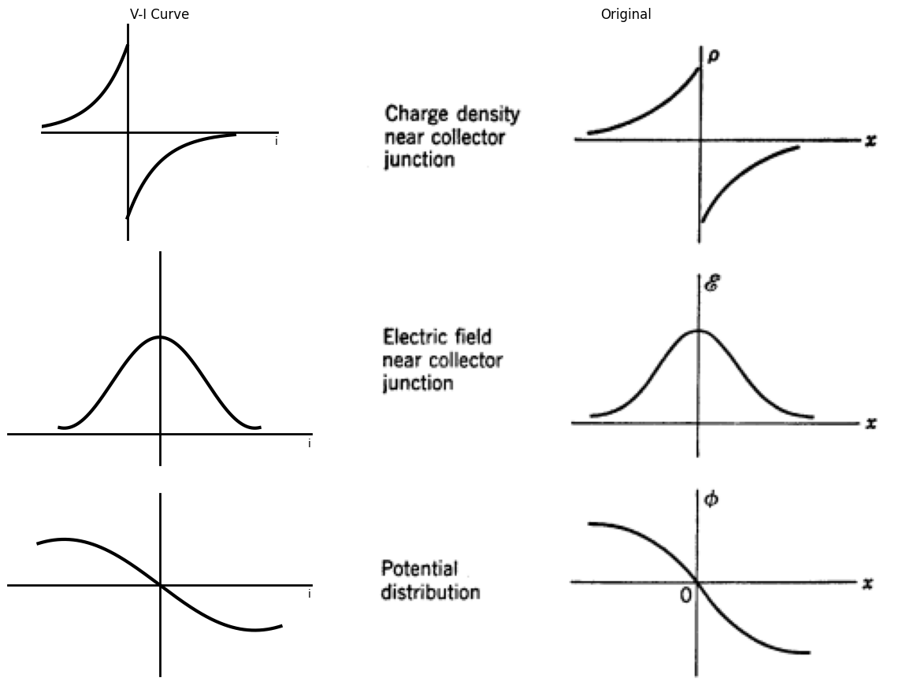
<Figure size 640x480 with 0 Axes>
<Figure size 640x480 with 0 Axes>
Fig. 5.30. Charge, electric field, and potential distribution near the collector junction of a p-n-p transistor.
The phase angle $θ$, representing the amount by which $I_{c}$ leads $I_{e}$, is given in (d). Sketches of $\left|\frac{I_{c}}{I_{e}}\right|$ vs. $ω$, and $θ$ vs. $ω$ are given in (e), using rectangular coordinates for the plots. The polar coordinate sketch in (f) indicates $\left|\frac{I_{c}}{I_{e}}\right|$ as the length of the radius vector, and the phase angle appears as the polar angle.
import matplotlib.pyplot as plt
import numpy as np
import schemdraw
from schemdraw import dsp
import schemdraw.elements as e
import matplotlib.image as mpimg
d = schemdraw.Drawing()
Re = d.add(e.Resistor().right().label('$R_e$',ofst=0.1).dot(open=True))
R1 = d.add(e.Resistor(l=3.5).right().label('$r_e$',ofst=0.1).dot())
R2 = d.add(e.Resistor().down().label('$r_b$',ofst=0.1).dot())
d += e.Ground()
c3 = d.add(e.Capacitor().right().label('$C_c$',ofst=0.1).at(R2.start).dot())
l5 = d.add(e.Line().length(1.5).up())
s01 = d.add(e.SourceI(l=3).reverse().left().label('$ai_e$',ofst=(0,-0.1)))
l6 = d.add(e.Line().length(1.5).down())
l8 = d.add(e.Line().length(1).right().at(l5.start).dot(open=True))
l9 = d.add(e.Line().length(1.5).right())
R3 = d.add(e.Resistor().down().label('$R_c$',ofst=0.1))
l10 = d.add(e.Line().length(1.5).left().dot(open=True))
l11 = d.add(e.Line().length(7.5).left().dot(open=True))
l12 = d.add(e.Line().left())
s02 = d.add(e.Source(l=3).reverse().up().label('$v_1$',ofst=(0,0.2)))
d += e.Arrow().up().length(1).linewidth(0.6).color('white').label('$V_{cb}$', loc='start', color='black',ofst=0.3). at((13.7,-1.2))
d += e.Arrow().up().length(1).linewidth(0.6).color('black').label('+',loc='end', color='black',ofst=0.4). at((13.3,-0.9))
d += e.Arrow().down().length(1).linewidth(0.6).color('black').label(r'_', loc='end', color='black',ofst=(-0.3,-0.3)). at((13.3,-1.8))
d.draw()
d.save('./Drawings5/5-31m.png')
d.save('./Drawings5/5-31m.svg')
fig, axs = plt.subplots(1, 2, figsize=(8,14))
img = mpimg.imread('./Drawings5/5-31m.png')
axs[0].imshow(img)
axs[0].axis('off')
axs[0].set_title('Circuit Diagram (developed)')
img_sample = mpimg.imread('./images5/5-31m.png')
axs[1].imshow(img_sample)
axs[1].axis('off')
axs[1].set_title('Original')
plt.tight_layout()
plt.show()
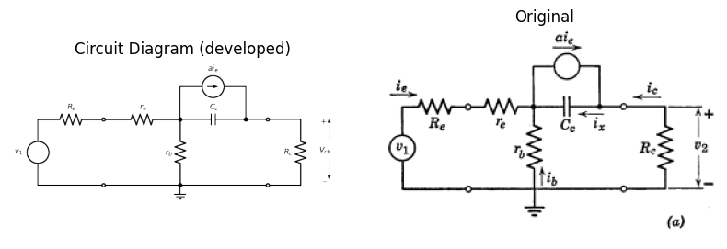
$$\frac{I_{c}}{I_{e}}=\frac{r_{b}+\frac{a}{jωC_{c}}}{r_{b}+R_{c}+\frac{1}{jωC_{c}}}=−\frac{\left[r_{b}\left(r_{b}+R_{c}\right)+\frac{a}{{\left(ωC_{c}\right)}^{2}}\right]−j\left[aR_{c}−\left(1−a\right)r_{b}\right]}{{\left(r_{b}+R_{c}\right)}^{2}+{\left(\frac{1}{ωC_{c}}\right)}^{2}}$$
(b)
$$\left|\frac{I_{c}}{I_{e}}\right|=\sqrt{\frac{r_{b}^{2}+{\left(\frac{a}{ωC_{c}}\right)}^{2}}{{\left(r_{b}+R_{c}\right)}^{2}+{\left(\frac{1}{ωC_{c}}\right)}^{2}}}=\sqrt{\frac{{\left(r_{b}ωC_{c}\right)}^{2}+a^{2}}{{\left(r_{b}+R_{c}\right)}^{2}{\left(ωC_{c}\right)}^{2}}+1}$$
(c)
$$tanθ=−\frac{\left[aR_{c}−\left(1−a\right)r_{b}\right]ωC_{c}}{\left[\left(ωC_{c}\right)r_{b}\left(r_{b}+R_{c}\right)+a\right]}≈−\frac{1}{\left(ωC_{c}r_{b}\right)/a+1/\left(ωC_{c}R_{c}\right)} \text{for} r_{b}≪R_{c}$$
import matplotlib.pyplot as plt
import numpy as np
import matplotlib.image as mpimg
from matplotlib.gridspec import GridSpec
fig = plt.figure(figsize=(12, 8))
gs = GridSpec(3, 2, width_ratios=[1, 1])
ax1 = fig.add_subplot(gs[0, 0])
ax1.set_title('V-I Curve')
x3 = np.linspace(-10,10, 500)
y3 = 1.5*np.cos(x3/2.5)+1.7
ax1.plot(x3, y3, color='black', linewidth=3)
ax1.set_xlim([-1, 8])
ax1.set_ylim([-1,5])
ax2 = fig.add_subplot(gs[0, 1])
x3 = np.linspace(-10,15, 500)
y3 = 1.6*np.cos((x3+0.6)/2)-1.6
ax2.plot(x3, y3, color='black', linewidth=3)
ax2.set_xlim([-1, 10])
ax2.set_ylim([-5,2])
ax3 = fig.add_subplot(gs[1, :])
ax3.set_xlim([-13, 4])
ax3.set_ylim([-3,7])
center_x = -6
radius = 5
theta = np.linspace(0, np.pi, 100)
x = center_x + radius * np.cos(theta)
y = radius * np.sin(theta)
ax3.plot(x, y, color='black')
ax3.annotate('', xy=(-6, 5), xytext=(0, 0),
arrowprops=dict(arrowstyle='->', color='black', lw=2))
ax_big = fig.add_subplot(gs[2,:])
ax_big.axis('off')
img_sample = mpimg.imread('./images5/5-31en.png')
ax_big.imshow(img_sample)
ax_big.set_title('Original')
axes = [ax1, ax2, ax3]
for ax in axes:
ax.spines['top'].set_color('none')
ax.spines['right'].set_color('none')
ax.spines['left'].set_position('zero')
ax.spines['bottom'].set_position('zero')
ax.spines['left'].set_linewidth(2)
ax.spines['bottom'].set_linewidth(2)
ax.xaxis.set_ticks_position('bottom')
ax.yaxis.set_ticks_position('left')
ax.tick_params(axis='both', which='both', length=0)
ax.set_xticks([])
ax.set_yticks([])
ax.set_xlabel(' ', labelpad=3, loc='right')
ax.set_aspect('equal', adjustable='box')
plt.tight_layout()
plt.show()
plt.tight_layout()
plt.show()
plt.savefig('./Drawings5/5-31en.jpg')
plt.savefig('./Drawings5/5-31en.svg')
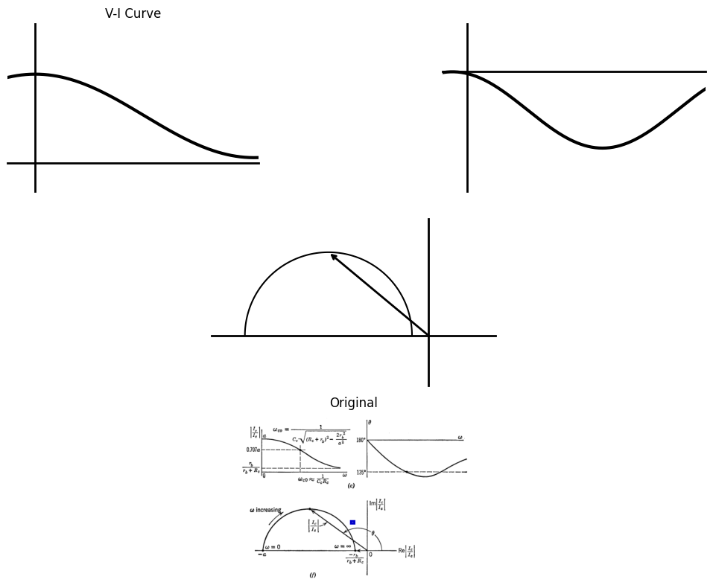
<Figure size 640x480 with 0 Axes>
<Figure size 640x480 with 0 Axes>
Fig. 5.31. Current gain versus frequency for grounded-base circuit.
This is drawn from a succession of vector diagrams for different frequencies; hence, $ω$ is a parameter along the curve. This polar plot is called a Nyquist diagram and is frequently used to describe transfer ratios.
The dependence of current gain on frequency, due to collector capacitance, can be determined in a similar manner for the common-emitter and common-collector circuits. The effective reactance is modified in these circuits by the current gain. Thus, in the common-emitter circuit, since $r_{a}=r_{c}\left(1−α\right)$, we have $C_{d}=C_{c}/\left(1−α\right)$.

1.15 5.17 Frequency Dependence of Current Gain
Another factor that influences the gain of transistor amplifiers at high frequencies is the frequency dependence of $α$, the short-circuit current gain of the transistor. This effect can be attributed in the p-n-p transistor to the time required for holes to diffuse through the base region. If the emitter current is varied incrementally at frequencies for which the period is comparable to the diffusion time, the collector current suffers a phase lag and a reduction in amplitude. The phase shift or time lag can be visualized as a delay in the effect of an increase (or decrease) of the hole current injected into the base. If the variation is sinusoidal, the peak (or any other reference point) in the waveform of $i_{e}$ has passed before the corresponding variation is transmitted through the base by diffusion. The reduction in the effective amplitude can be attributed to dispersion of transit times of the individual carriers because of the randomness of the hole motion. Thus, for good high-frequency performance, the base layer should be kept very thin to keep diffusion time low.
A power series in frequency can be used to approximate an experimental curve of short-circuit current gain versus frequency. For most purposes, the first two terms of the expansion suffice to give reasonable results. A circuit model with a frequency-dependent current generator, as shown in Fig. 5.32(a), yields an approximate representation of this effect. The quantity $a_{0}$ is the d-c or low-frequency value of $α$ and corresponds to the $α$ used in all previous circuit models. The frequency dependence can be included in all previous discussions by letting $α=\frac{a_{0}}{\left[1+j\left(ω/ω_{0}\right)\right]}$. The frequency $ω_{0}$ is the frequency for which $\left|α\right|=0.707 a_{0}$.
If the frequency-dependent model is used in a grounded-base circuit, as shown in Fig. 5.32, the basic expressions in (c) lead to the expression for current gain shown in (d). The expressions for the grounded-emitter and grounded-collector circuits can be modified in like manner by using the expression $\frac{a_{0}}{\left[1+j\left(ω/ω_{0}\right)\right]}$ for the parameter $α$. We recall from the discussion of semiconductor diodes in Chapter 2 that this reverse current is due to minority-carrier conduction that depends on the rate of formation of hole-electron pairs by thermal agitation. Once formed, such pairs exist (on the average) for a fraction of a millisecond before recombining. The number of charge carriers, and consequently the conductivity, increases exponentially with temperature. This effect places a definite temperature limitation on semiconductor devices (60 to 80°C for germanium and 120° to 150°C for silicon).
A plot of conductivity versus temperature for minority-carrier conduction can be expected to resemble the curve of $I_{C_{0}}$ vs. $T$. Correspondingly, resistivity, or a resistance such as $r_{cr}$, should diminish with temperature, as indicated by the typical curve of $r_{c}$ vs. $T$ in Fig. 5.34(b). Resistance due to majority-carrier conduction, such as $r_{ef}$ or $r_{b}$, tends to rise with temperature, as indicated in Fig. 5.34(c) and (d), because the resistivity of p-type or n-type semiconductor material generally tends to rise with temperature. This is true only up to the temperature for which the conduction of the intrinsic material becomes comparable to that of the donor or acceptor charge carriers. For still higher temperatures, the resistivity of such materials decreases, as does the resistivity of intrinsic semiconductor material.
import matplotlib.pyplot as plt
import numpy as np
import schemdraw
from schemdraw import dsp
import schemdraw.elements as e
import matplotlib.image as mpimg
d = schemdraw.Drawing()
l = d.add(e.Line().length(0.5).right().idot(open=True))
R1 = d.add(e.Resistor().right().label('$r_e$',ofst=0.1).dot())
l1 = d.add(e.Line().length(1.1).down())
R2 = d.add(e.Resistor().down().label('$r_b$',ofst=0.1).dot())
d += e.Ground()
l2 = d.add(e.Line().length(0.8).right().dot().at(R1.end))
R3 = d.add(e.Resistor().right().label('$r_c$',ofst=0.1).dot())
l3 = d.add(e.Line().length(1.3).right().dot(open=True))
l4 = d.add(e.Line().length(5.1).right().dot(open=True).at(R2.end))
l5 = d.add(e.Line().length(1.5).up().at(R3.end))
s01 = d.add(e.SourceI(l=3).reverse().left().label('$ai_e$',ofst=(0,-0.1)))
l5 = d.add(e.Line().length(1.5).down())
l8 = d.add(e.Line().length(3.5).left().dot(open=True).at(R2.end))
d += e.Arrow().up().length(2).linewidth(0.6).color('white').label('$V_{eb}$', loc='start', color='black',ofst=0.3). at((0.4,-2))
d += e.Arrow().up().length(1.4).linewidth(0.6).color('black').label('+',loc='end', color='black',ofst=0.4). at((0,-1.6))
d += e.Arrow().down().length(1.4).linewidth(0.6).color('black').label(r'_', loc='end', color='black',ofst=(-0.3,-0.3)). at((0,-2.5))
d += e.Arrow().up().length(2).linewidth(0.6).color('white').label('$V_{cb}$', loc='start', color='black',ofst=0.3). at((9.2,-2))
d += e.Arrow().up().length(1.4).linewidth(0.6).color('black').label('+',loc='end', color='black',ofst=0.4). at((8.8,-1.6))
d += e.Arrow().down().length(1.4).linewidth(0.6).color('black').label(r'_', loc='end', color='black',ofst=(-0.3,-0.3)). at((8.8,-2.5))
d.move(-6,-3)
tr = d.add(e.BjtPnp(l=0.5,circle=True).up())
l0 = d.add(e.Line().length(0.3).left().at(tr.emitter))
l1 = d.add(e.Line().length(0.3).right().at(tr.collector).dot(open=True))
R1 = d.add(e.Resistor(l=2).left().label('$r_e$',ofst=0.1).idot(open=True).at(l0.end))
l0 = d.add(e.Line().length(1).right().at(l1.end))
R2 = d.add(e.Resistor().down().label('$R_c$',ofst=0.1).at(l0.end))
l10 = d.add(e.Line().length(2).left().dot())
l11 = d.add(e.Line().length(3).left())
l9 = d.add(e.Line().length(0.3).down().at(tr.base).dot(open=True))
l10 = d.add(e.Line().length(2).down().dot())
s01 = d.add(e.Source(l=3).reverse().up().at(l11.end).label('$v_1$',ofst=(0,0.1)))
d.draw()
d.save('./Drawings5/5-32.png')
d.save('./Drawings5/5-32.svg')
fig, axs = plt.subplots(1, 2, figsize=(14,14))
img = mpimg.imread('./Drawings5/5-32.png')
axs[0].imshow(img)
axs[0].axis('off')
axs[0].set_title('Circuit Diagram (developed)')
img_sample = mpimg.imread('./images5/5-32.png')
axs[1].imshow(img_sample)
axs[1].axis('off')
axs[1].set_title('Original')
plt.tight_layout()
plt.show()
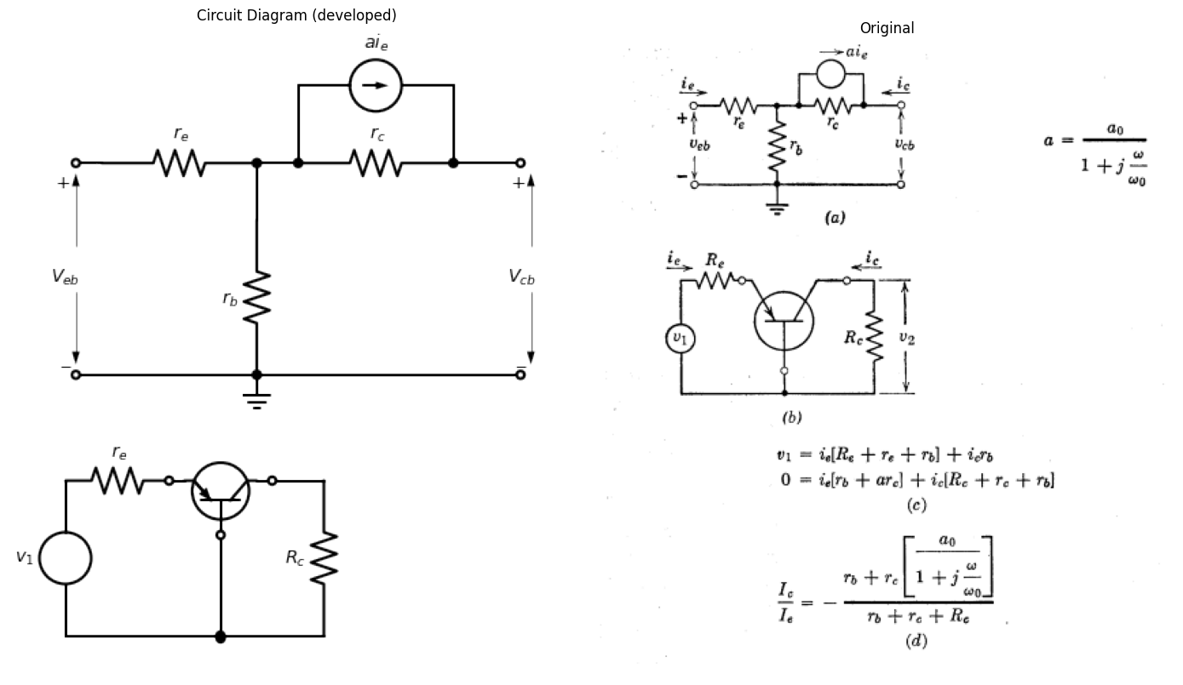
Fig. 5.32. Frequency dependence of current source.

1.16 5.18 Variation of Transistor Parameters
A piecewise-linear circuit model implies constancy of the parameters that specify the transistor throughout a given state of the diodes in the model. Actual transistor curves deviate from this idealization to some extent, and if the deviation is important the variation of parameters must be considered. Figure 5.33 gives an example of the parameter changes that may occur as a function of the operating point location in the amplification state. Such data are useful in circuit design. For instance, we may wish to choose an operating point in a region where a parameter variation is smallest; or we may wish to obtain maximum gain, or meet some other condition. The specific numerical values of the parameters at the appropriate point can then be used in the design calculations. In large-signal applications, the parameter variations are usually less important, and a piecewise-linear model can be based on average values of the parameters.
import matplotlib.pyplot as plt
import numpy as np
import matplotlib.image as mpimg
from matplotlib.gridspec import GridSpec
fig = plt.figure(figsize=(8, 12))
gs = GridSpec(3, 2, width_ratios=[1, 1])
ax0 = fig.add_subplot(gs[0, 0])
x = np.linspace(0, 2, 300)
#y=-0.0575*((x)**2)+0.36*(x)+0.46
y=-0.115*x**2+0.475*x+0.46
ax0.plot(x, y, color='black')
x1 = np.linspace(2, 5.4, 300)
y1=-0.025*(x1-2)**2+0.95
ax0.plot(x1, y1, color='black')
ax0.set_title('V-I Curve')
ax0.set_ylabel('a', labelpad=3, loc='top')
ax0.set_xlim(0, 6)
ax0.set_ylim(0, 1.4)
ax0.set_xlabel('$i_c, ma$', labelpad=3, loc='right')
ax0.axhline(0, color='black', linewidth=1)
ax0.axvline(0, color='black', linewidth=1)
ax0.set_yticks(np.arange(0, 1.4, 0.2))
ax0.grid(True)
ax1 = fig.add_subplot(gs[0, 1])
x = np.linspace(0, 6, 500)
y=1.2 * np.exp(-0.5 * (x - 1))
ax1.plot(x, y, color='black')
ax1.set_ylabel('$T_c,megohms$', labelpad=3, loc='top')
ax1.set_xlim(0, 6)
ax1.set_ylim(0, 1.4)
ax1.set_xlabel('$i_c, ma$', labelpad=3, loc='right')
ax1.axhline(0, color='black', linewidth=0.5)
ax1.axvline(0, color='black', linewidth=0.5)
ax1.set_yticks(np.arange(0, 1.4, 0.2))
ax1.grid(True)
ax2 = fig.add_subplot(gs[1, 0])
y=1.2*(70/1.4) * np.exp(-0.5 * ((x+0.08)*4 - 1))+0.1*(70/1.4)
ax2.plot(x, y, color='black')
ax2.set_ylabel('$r_e,$ ohms', labelpad=3, loc='top')
ax2.set_xlim(0, 6)
ax2.set_ylim(0, 70)
ax2.set_xlabel('$i_c, ma$', labelpad=3, loc='right')
ax2.axhline(0, color='black', linewidth=0.5)
ax2.axvline(0, color='black', linewidth=0.5)
ax2.set_yticks(np.arange(0,71,10))
ax2.grid(True)
ax3 = fig.add_subplot(gs[1, 1])
x = np.linspace(0.3, 6, 500)
y=(1.2*700/1.4) * np.exp(-0.5 * ((x+0.08)*4 - 1))+0.3*(700/1.4)
ax3.plot(x, y, color='black')
ax3.set_ylabel('$r_b,$ ohms', labelpad=3, loc='top')
ax3.set_xlim(0,6)
ax3.set_ylim(0, 700)
ax3.set_xlabel('$i_c, ma$', labelpad=3, loc='right')
ax3.axhline(0, color='black', linewidth=0.5)
ax3.axvline(0, color='black', linewidth=0.5)
ax3.set_yticks(np.arange(0,710,100))
ax3.grid(True)
ax4 = fig.add_subplot(gs[2, :])
img_sample = mpimg.imread('./images5/5-33.png')
ax4.imshow(img_sample)
ax4.set_title('Original')
ax4.axis('off')
axes = [ax0,ax1,ax2,ax3 ]
for a in axes:
a.spines['top'].set_color('none')
a.spines['right'].set_color('none')
a.spines['left'].set_position('zero')
a.spines['bottom'].set_position('zero')
a.spines['left'].set_linewidth(1)
a.spines['bottom'].set_linewidth(1)
a.xaxis.set_ticks_position('bottom')
a.yaxis.set_ticks_position('left')
a.tick_params(axis='both', which='both', length=5)
a.grid(True)
plt.tight_layout()
plt.show()
plt.savefig('./Drawings5/5-33.jpg')
plt.savefig('./Drawings5/5-33.svg')
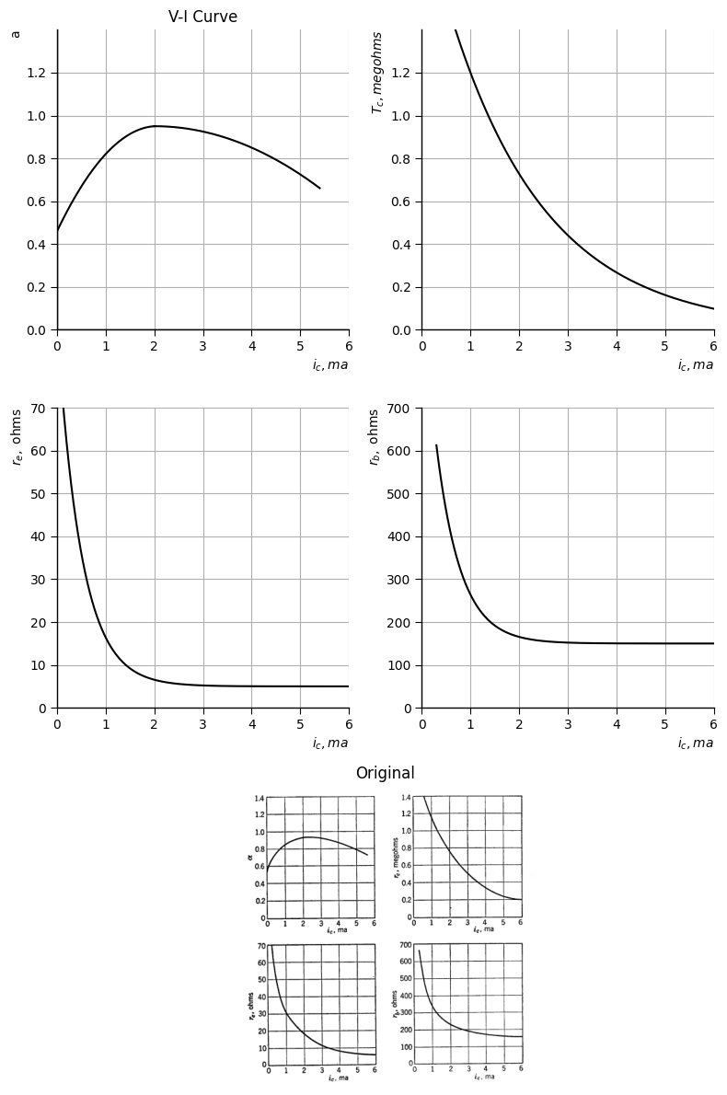
<Figure size 640x480 with 0 Axes>
Fig. 5.33. Typical variations of transistor parameters with collector current.
In either case, one of the design considerations is reduction of the effects of parameter variations.
The temperature dependence of transistor parameters poses another problem, since the environment in which a circuit is to be used may not be under the control of the circuit designer. The seriousness of temperature effects depends upon the semiconductor material and upon the fabrication process used by the transistor manufacturer. One critical effect of ambient temperature on transistor characteristics is a shift of the entire $v_{cb}$ vs. $i_{c}$ family, which results because the saturation current $I_{c}$ through the collector junction increases exponentially with temperature. This is the effect that was mentioned in connection with d-c polarization of the common-emitter circuit. A semilog plot of a typical variation with temperature of the reverse collector-junction current for zero emitter current is shown in Fig. 5.34(a).
import matplotlib.pyplot as plt
import numpy as np
import matplotlib.image as mpimg
from matplotlib.gridspec import GridSpec
fig = plt.figure(figsize=(8, 12))
gs = GridSpec(3, 2, width_ratios=[1, 1])
ax0 = fig.add_subplot(gs[0, 0])
x = np.linspace(-40, 90, 600)
y=(-1/1600)*((x/2-155)**2)-(1/10)*(x/2-155)
ax0.plot(x, y, color='black')
ax0.set_title('V-I Curve')
ax0.set_ylabel('$I_co,$ ma', labelpad=3, loc='top')
ax0.set_xlim(-40, 89)
ax0.set_ylim(0, 5)
ax0.set_xlabel('$T(C)$', labelpad=3, loc='right')
ax0.axhline(0, color='black', linewidth=1)
ax0.axvline(0, color='black', linewidth=1)
ax0.set_xticks(np.arange(-40, 85, 20))
ax0.set_yticks([0, 1, 2, 3, 4, 5])
ax0.set_yticklabels(['0','0.001', '0.01', '0.1', '1', ' '])
ax0.grid(True)
ax1 = fig.add_subplot(gs[0, 1])
y=(-1/1600)*((x/3-55)**2)-(1/10)*(x/3-55)-1
ax1.plot(x, y, color='black')
ax1.set_ylabel('$T_cr$', labelpad=3, loc='top')
ax1.set_xlim(-40, 85)
ax1.set_ylim(0, 5)
ax1.set_xlabel('$T(C)$', labelpad=3, loc='right')
ax1.axhline(0, color='black', linewidth=0.5)
ax1.axvline(0, color='black', linewidth=0.5)
ax1.set_xticks(np.arange(-40, 85, 20))
ax1.set_yticks([0, 1, 2, 3, 4, 5])
ax1.set_yticklabels(['0','10 k','100 k', '1 meg', '10 meg', ' '])
ax1.grid(True)
ax2 = fig.add_subplot(gs[1, 0])
y=(-1/1600)*((x/3-55)**2)-(1/10)*(x/3-55)-1
ax2.plot(x, -y+4, color='black')
ax2.set_ylabel('$T_b,$ ohms', labelpad=3, loc='top')
ax2.set_xlim(-40, 85)
ax2.set_ylim(0, 4)
ax2.set_xlabel('$T(C)$', labelpad=3, loc='right')
ax2.axhline(0, color='black', linewidth=0.5)
ax2.axvline(0, color='black', linewidth=0.5)
ax2.set_xticks(np.arange(-40, 85, 20))
ax2.set_yticks([0, 1, 2, 3, 4])
ax2.set_yticklabels(['0','10','100', '1000', ' '])
ax2.grid(True)
ax3 = fig.add_subplot(gs[1, 1])
y=(-1/1600)*((x/3-105)**2)-(1/10)*(x/3-105)-1.3
ax3.plot(x, y, color='black')
ax3.set_ylabel('$T_e,$ ohms', labelpad=3, loc='top')
ax3.set_xlim(-40, 85)
ax3.set_ylim(0, 4)
ax3.set_xlabel('$T(C)$', labelpad=3, loc='right')
ax3.axhline(0, color='black', linewidth=0.5)
ax3.axvline(0, color='black', linewidth=0.5)
ax3.set_xticks(np.arange(-40, 85, 20))
ax3.set_yticks([0, 1, 2, 3, 4])
ax3.set_yticklabels(['0','20','40', '80', ' '])
ax3.grid(True)
ax4 = fig.add_subplot(gs[2, :])
img_sample = mpimg.imread('./images5/5-34.png')
ax4.imshow(img_sample)
ax4.set_title('Original')
ax4.axis('off')
axes = [ax0,ax1,ax2,ax3 ]
for a in axes:
a.spines['top'].set_color('none')
a.spines['right'].set_color('none')
a.spines['left'].set_position('zero')
a.spines['bottom'].set_position('zero')
a.spines['left'].set_linewidth(1)
a.spines['bottom'].set_linewidth(1)
a.xaxis.set_ticks_position('bottom')
a.yaxis.set_ticks_position('left')
a.tick_params(axis='both', which='both', length=5)
a.grid(True)
plt.tight_layout()
plt.show()
plt.savefig('./Drawings5/5-34.jpg')
plt.savefig('./Drawings5/5-34.svg')
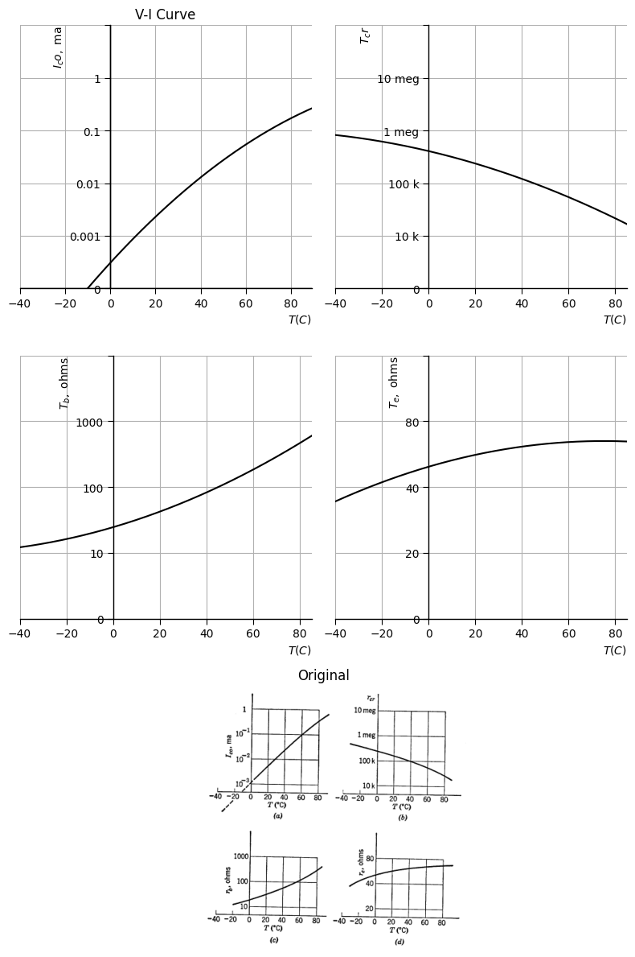
<Figure size 640x480 with 0 Axes>
Fig. 5.34. Effect of temperature on parameters of typical germanium junction transistors.
We recall from the discussion of semiconductor diodes in Chapter 2 that this reverse current is due to minority-carrier conduction that depends on the rate of formation of hole-electron pairs by thermal agitation. Once formed, such pairs exist (on the average) for a fraction of a millisecond before recombining. The number of charge carriers, and consequently the conductivity, increases exponentially with temperature. This effect places a definite temperature limitation on semiconductor devices (60 to 80°C for germanium and 120° to 150°C for silicon).
A plot of conductivity versus temperature for minority-carrier conduction can be expected to resemble the curve of $I_{C_{0}}$ vs. $T$. Correspondingly, resistivity, or a resistance such as $r_{cr}$, should diminish with temperature, as indicated by the typical curve of $r_{c}$ vs. $T$ in Fig. 5.34(b). Resistance due to majority-carrier conduction, such as $r_{ef}$ or $r_{b}$, tends to rise with temperature, as indicated in Fig. 5.34(c) and (d), because the resistivity of p-type or n-type semiconductor material generally tends to rise with temperature. This is true only up to the temperature for which the conduction of the intrinsic material becomes comparable to that of the donor or acceptor charge carriers. For still higher temperatures, the resistivity of such materials decreases, as does the resistivity of intrinsic semiconductor material.

1.17 5.19 Transistor Curves
In plotting transistor collector curves, we have used collector current as the independent variable, collector voltage as the dependent variable, and either emitter current or base current as the parameter. These choices are based on the fact that the transistor is a current-controlled device. The use of standard four-terminal circuit reference directions for currents and voltages results in third-quadrant curves for the p-n-p types and first-quadrant curves for the n-p-n types. These forms are the natural result of combining the physical behavior of transistors with circuit theory standards.
Transistor data supplied by most manufacturers usually places collector curves in the first quadrant by reversing reference directions (in effect) for p-n-p units. Furthermore, manufacturers’ data usually appear as a plot of current versus voltage, for ease of comparison with vacuum triode and pentode data.
Electronic circuit design may involve transistors, vacuum tubes, and other devices specified by manufacturers’ graphical data. The designer must be prepared to relate the data to his analysis or synthesis procedures. The transistor curves given in Appendix A for use in connection with some of the problems are patterned after typical manufacturers’ curves.

1.17.1 SUPPLEMENTARY READING
L. B. Argimbaau, R. B. Adler, Vacuum Tube Circuits and Transistors, John Wiley and Sons, New York, 1956. W. G. Dow, Fundamentals of Engineering Electronics, John Wiley and Sons, New York, 1952. E. A. Guillemin, Introductory Circuit Theory, John Wiley and Sons, New York, 1953. L. P. Hunter, editor, Handbook of Semiconductor Electronics, McGraw-Hill, New York, 1956. Lo, Endres, Zawels, et al., Transistor Electronics, Prentice-Hall, New Jersey, 1955. R. D. Middlebrook, An Introduction to Junction Transistor Theory, John Wiley and Sons, New York, 1957. Samuel Seely, Electronic Engineering, McGraw-Hill, New York, 1956. Shockley, Holes and Electrons in Semiconductors, Van Nostrand, New York, 1950. Karl R. Spangenberg, Fundamentals of Electron Devices, McGraw-Hill, New York, 1957. Robert L. Sproull, Modern Physics: A Textbook for Engineers, John Wiley and Sons, New York, 1956. Aldert van der Ziel, Solid State Physical Electronics, Prentice-Hall, New Jersey, 1957. Dewitt and Rossoff, Transistor Electronics, McGraw-Hill, New York, 1957.
PROBLEMS (See Appendix A for transistor curves)
5.1. The resistive-diode circuit of Fig. P5.1 contains two dependent sources.
(a) Find the breakpoints of the two diodes.
(b) Sketch and dimension $i_{1}$ vs. $e_{1}$
- (c) What is the incremental impedance, $\frac{Δe_{1}}{Δi_{1}}$, at $e_{1}=−3$ volts.
import matplotlib.pyplot as plt
import numpy as np
import schemdraw
from schemdraw import dsp
import schemdraw.elements as e
import matplotlib.image as mpimg
d = schemdraw.Drawing()
l = d.add(e.Line().length(2).right().dot())
l1 = d.add(e.Line().length(2).right().dot())
s01 = d.add(e.SourceV(l=4).down().reverse().label('$e_1$',ofst=(0,-0.1)).at(l.start))
s02 = d.add(e.SourceI(l=4).down().label('$0.5i_1$',ofst=(0,-0.1)).dot().at(l1.start))
R1 = d.add(e.Resistor(l=1.3).down().label('$r_e$',ofst=0.1).at(l1.end))
D1 = d.add(e.Diode(l=1.3,fill=True).down().label('$D_1$',ofst=0.1))
E1 = d.add(e.Battery(l=1.35).down().reverse().label(['- ', '$2 volts$', '+ '], ofst=-1.9).dot())
D2 = d.add(e.Diode(l=4,fill=True).right().reverse().label('$D_2$',ofst=0.1).at(l1.end))
s01 = d.add(e.Source(l=4).down().at(D2.end).label(['+','$2e_1$','-'],ofst=(0,-0.2)))
R2 = d.add(e.Resistor(l=4).left().label('$2kΩ$',ofst=0.1))
l4 = d.add(e.Line().length(4).left())
d.draw()
d.save('./Drawings5/p5-1.png')
d.save('./Drawings5/p5-1.svg')
fig, axs = plt.subplots(1, 2, figsize=(14,14))
img = mpimg.imread('./Drawings5/p5-1.png')
axs[0].imshow(img)
axs[0].axis('off')
axs[0].set_title('Circuit Diagram (developed)')
img_sample = mpimg.imread('./images5/p5-1.png')
axs[1].imshow(img_sample)
axs[1].axis('off')
axs[1].set_title('Original')
plt.tight_layout()
plt.show()
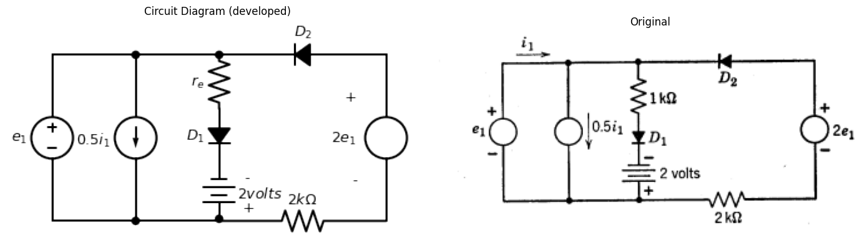
5.2. Using an ideal-diode transistor model in Fig. P5.2:
- (a) Sketch and dimension $e_{2}$ vs. $e_{1}$.
- (b) Sketch and dimension $i_{2}$ vs. $i_{1}$.
- (c) Determine the incremental voltage gain $\frac{Δe_{2}}{Δe_{1}}$ and the incremental current gain $\frac{Δi_{2}}{Δi_{1}}$ for the region of operation in which the emitter diode is closed and the collector diode is open.
import matplotlib.pyplot as plt
import numpy as np
import schemdraw
from schemdraw import dsp
import schemdraw.elements as e
import matplotlib.image as mpimg
d = schemdraw.Drawing()
tr = d.add(e.BjtPnp(l=0.5,circle=True).up())
l0 = d.add(e.Line().length(0.3).left().at(tr.emitter))
l1 = d.add(e.Line().length(0.3).right().at(tr.collector))
R1 = d.add(e.Resistor().left().label('$R_1$',ofst=0.1).at(l0.end))
l0 = d.add(e.Line().length(2).right().at(l1.end))
R2 = d.add(e.Resistor().down().label('$R_2$',ofst=0.1).at(l0.end))
l10 = d.add(e.Line().length(1).down().dot(open=True))
l9 = d.add(e.Line().length(2).down().at(tr.base).dot())
d += e.Ground()
l11 = d.add(e.Line().length(0.4).right().at(l9.end).color('white'))
l12 = d.add(e.Line().length(1.2).right())
l13 = d.add(e.Line().length(4).left().at(l9.end))
s01 = d.add(e.SourceV(l=2.75).up().label('$e_1$',ofst=(0,0.1)))
d.draw()
d.save('./Drawings5/p5-2.png')
d.save('./Drawings5/p5-2.svg')
fig, axs = plt.subplots(1, 2, figsize=(14,14))
img = mpimg.imread('./Drawings5/p5-2.png')
axs[0].imshow(img)
axs[0].axis('off')
axs[0].set_title('Circuit Diagram (developed)')
img_sample = mpimg.imread('./images5/p5-2.png')
axs[1].imshow(img_sample)
axs[1].axis('off')
axs[1].set_title('Original')
plt.tight_layout()
plt.show()
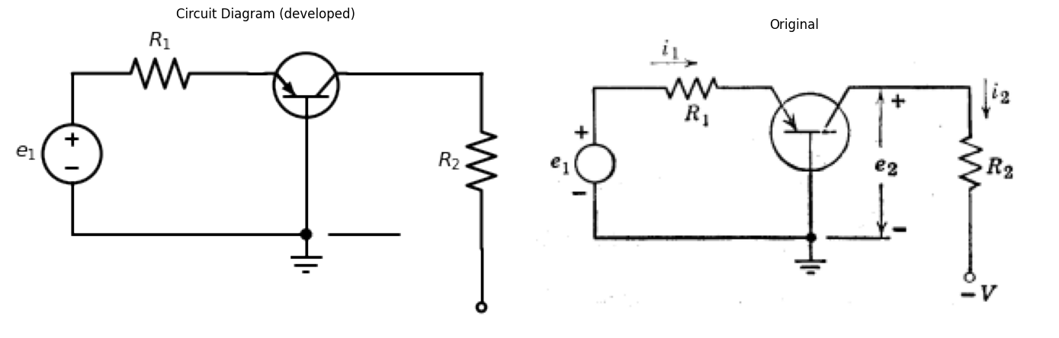
5.3. Repeat Problem 5.2 for the common-emitter connection (Fig. P5.3).
import matplotlib.pyplot as plt
import numpy as np
import schemdraw
from schemdraw import dsp
import schemdraw.elements as e
import matplotlib.image as mpimg
d = schemdraw.Drawing()
tr1 = d.add(e.BjtPnp(circle=True).theta(-360))
l1 = d.add(e.Line().length(1.1).up().at(tr1.emitter).label('$+V$',ofst=(0.9,-0.2)).dot(open=True))
l0 = d.add(e.Line(l=0.1).down().at(tr1.collector))
R1 = d.add(e.Resistor(l=2.6).down().label('$R_2$',ofst=0.1))
G = d.add(e.Ground())
R1 = d.add(e.Resistor(l=3.2).left().at(tr1.base).label('$R_1$',ofst=0.1))
V = d.add(e.SourceV(l=3.5).down().reverse().label('$e_1$', ofst=-1.5))
l0 = d.add(e.Line(l=3.95).right().dot())
d.draw()
d.save('./Drawings5/p5-3.png')
d.save('./Drawings5/p5-3.svg')
fig, axs = plt.subplots(1, 2, figsize=(15,7))
img = mpimg.imread('./Drawings5/p5-3.png')
axs[0].imshow(img)
axs[0].axis('off')
axs[0].set_title('Circuit Diagram (developed)')
img_sample = mpimg.imread('./images5/p5-3.png')
axs[1].imshow(img_sample)
axs[1].axis('off')
axs[1].set_title('Original')
plt.tight_layout()
plt.show()
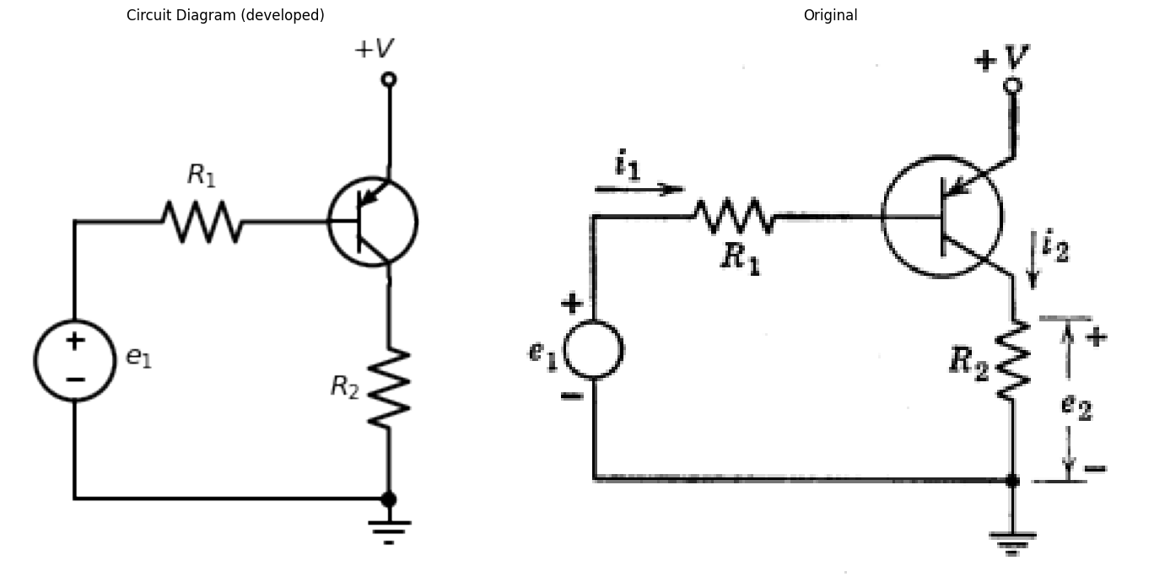
import matplotlib.pyplot as plt
import numpy as np
import schemdraw
from schemdraw import dsp
import schemdraw.elements as e
import matplotlib.image as mpimg
d = schemdraw.Drawing()
tr1 = d.add(e.BjtPnp(circle=True).reverse().theta(-180))
l1 = d.add(e.Line().length(1.4).right().at(tr1.collector))
R1 = d.add(e.Resistor(l=2.6).down().label('$R_2$',ofst=0.1))
l1 = d.add(e.Line().length(1.1).down().label('$-V$',ofst=(0.9,0.2)).dot(open=True))
l0 = d.add(e.Line(l=2).down().at(tr1.emitter))
G = d.add(e.Ground())
R1 = d.add(e.Resistor(l=3.2).left().at(tr1.base).label('$R_1$',ofst=0.1))
V = d.add(e.SourceV(l=2.5).down().reverse().label('$e_1$', ofst=-1.5))
l0 = d.add(e.Line(l=3.95).right().dot())
d.draw()
d.save('./Drawings5/p5-4.png')
d.save('./Drawings5/p5-4.svg')
fig, axs = plt.subplots(1, 2, figsize=(15,7))
img = mpimg.imread('./Drawings5/p5-4.png')
axs[0].imshow(img)
axs[0].axis('off')
axs[0].set_title('Circuit Diagram (developed)')
img_sample = mpimg.imread('./images5/p5-4.png')
axs[1].imshow(img_sample)
axs[1].axis('off')
axs[1].set_title('Original')
plt.tight_layout()
plt.show()
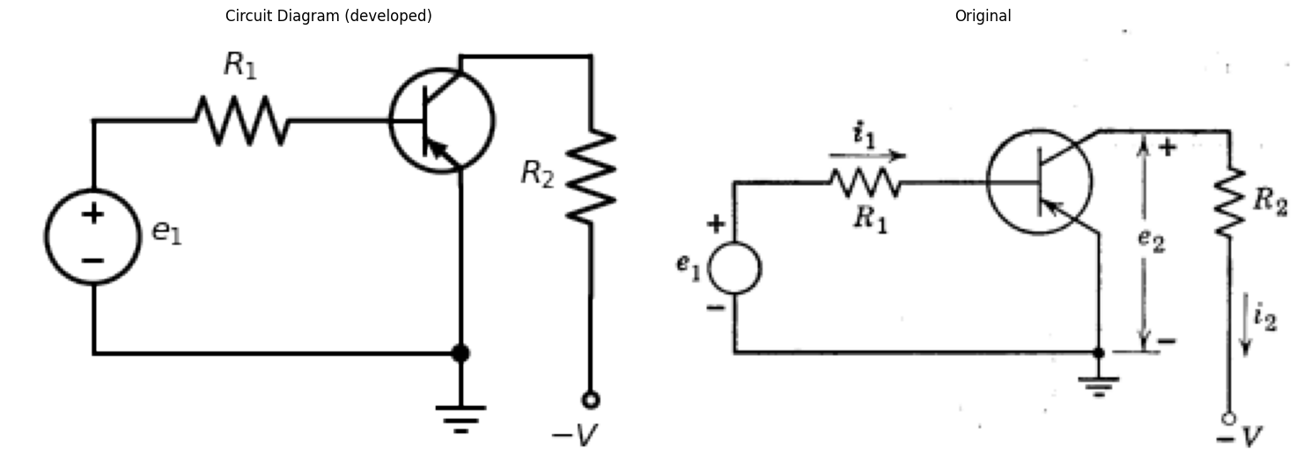
5.4. Repeat Problem 5.2 for the common-emitter connection shown in Fig. P5.4.
5.5. Repeat Problem 5.2 for the common-collector connection shown in Fig. P5.5.
import matplotlib.pyplot as plt
import numpy as np
import schemdraw
from schemdraw import dsp
import schemdraw.elements as e
import matplotlib.image as mpimg
d = schemdraw.Drawing()
tr1 = d.add(e.BjtPnp(circle=True).theta(-360))
R1 = d.add(e.Resistor(l=2.3).up().at(tr1.emitter))
l1 = d.add(e.Line().length(0.1).up().label('$+V$',ofst=(0.7,-0.2)).dot(open=True))
l0 = d.add(e.Line(l=1.5).down().at(tr1.collector))
G = d.add(e.Ground())
l2 = d.add(e.Line().length(0.2).left().at(tr1.base))
R1 = d.add(e.Resistor(l=3).left().label('$R_1$',ofst=0.1))
V = d.add(e.SourceV(l=2.1).down().reverse().label('$e_1$', ofst=-1.5))
l0 = d.add(e.Line(l=3.95).right().dot())
d.draw()
d.save('./Drawings5/p5-5.png')
d.save('./Drawings5/p5-5.svg')
fig, axs = plt.subplots(1, 2, figsize=(15,7))
img = mpimg.imread('./Drawings5/p5-5.png')
axs[0].imshow(img)
axs[0].axis('off')
axs[0].set_title('Circuit Diagram (developed)')
img_sample = mpimg.imread('./images5/p5-5.png')
axs[1].imshow(img_sample)
axs[1].axis('off')
axs[1].set_title('Original')
plt.tight_layout()
plt.show()
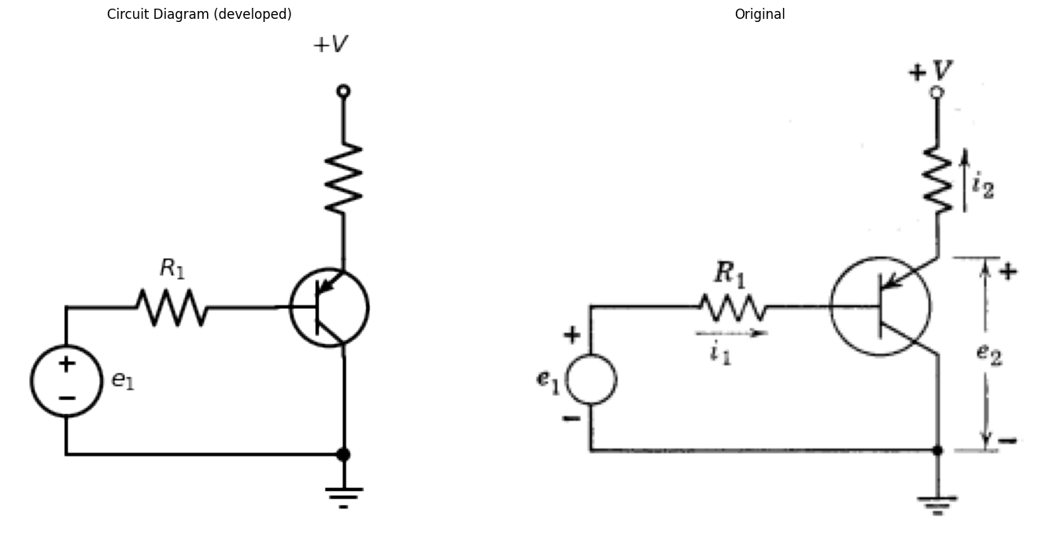
5.6. For the Type I transistor operated with the base common determine the least load resistance that may be used with a collector supply voltage of $−10$ volts without exceeding the rated collector dissipation of $4×{10}^{−3}$ watts when the emitter current may be any value in the range $0$ to $5$ ma.
5.7. From the Type I curves estimate the parameters $r_{ef}$, $r_{cr}$, $r_{b}$, and $α$ belonging to the piecewise-linear circuit model of Fig. 5.12(a).
5.8. For a transistor operated with the base common determine the variational power gain on the basis of these data:
(a) Model is the piecewise-linear one of Fig. 5.12(a) operated with the collector in the reverse region and the emitter in the forward region.
(b) $r_{ef}=50$ ohms, $r_{b}=50$ ohms, $r_{cr}=2×{10}^{5}$ ohms, $α=0.95$.
(c) Emitter source resistance = $100$ ohms, load resistance = $2000$ ohms.
5.9. For a transistor operated with the emitter common determine the variational power gain on the basis of the data of Problem 5.8.
5.10.
(a) Show that all possible transistor d-c polarizing circuits are equivalent to the circuit shown in Fig. P5.6.
(b) For the idealized transistor model in Fig. P5.7, how does $i_{e}$ depend on $V_{e}$, $V_{ce}$, and the minority-carrier current $I_{o}$.
(c) Find $\frac{Δi_{e}}{ΔI_{o}}$, and discuss the significance of the result in the design of a d-c polarizing network.
import matplotlib.pyplot as plt
import numpy as np
import schemdraw
from schemdraw import dsp
import schemdraw.elements as e
import matplotlib.image as mpimg
d = schemdraw.Drawing()
tr = d.add(e.BjtPnp(l=0.5,circle=True).up())
l0 = d.add(e.Line().length(1.3).left().at(tr.emitter))
l01 = d.add(e.Line().length(1).down().dot(open=True))
R0 = d.add(e.Resistor(l=2.2).down())
l1 = d.add(e.Line().length(1.3).right().at(tr.collector))
l02 = d.add(e.Line().length(1).down().dot(open=True))
R1 = d.add(e.Resistor(l=2.2).down())
l09 = d.add(e.Line().length(0.5).down().at(tr.base).dot(open=True))
R2 = d.add(e.Resistor(l=1.95).down().dot())
v00 = d.add(e.Battery(l=2).right().label('$V_e$',ofst=0.1).at(R0.end))
v01 = d.add(e.Battery(l=2).right().label('$V_c$',ofst=0.1))
d.draw()
d.save('./Drawings5/p5-6.png')
d.save('./Drawings5/p5-6.svg')
fig, axs = plt.subplots(1, 2, figsize=(14,14))
img = mpimg.imread('./Drawings5/p5-6.png')
axs[0].imshow(img)
axs[0].axis('off')
axs[0].set_title('Circuit Diagram (developed)')
img_sample = mpimg.imread('./images5/p5-6.png')
axs[1].imshow(img_sample)
axs[1].axis('off')
axs[1].set_title('Original')
plt.tight_layout()
plt.show()
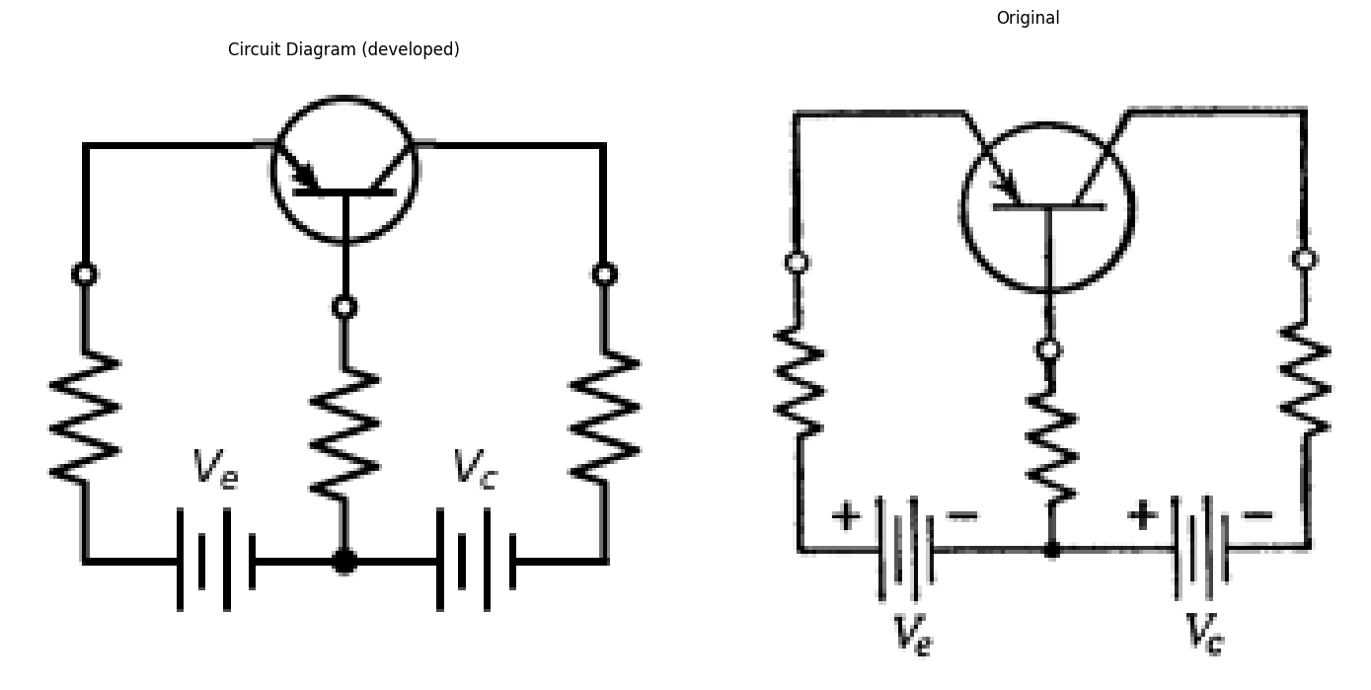
import matplotlib.pyplot as plt
import numpy as np
import schemdraw
from schemdraw import dsp
import schemdraw.elements as e
import matplotlib.image as mpimg
d = schemdraw.Drawing()
D1 = d.add(e.Diode(fill=True).right().dot())
l1 = d.add(e.Resistor().down().dot().label('$R_b$',ofst=0.1))
E1 = d.add(e.Battery().reverse().left().label(['-', '$V_e$', '+'], ofst=0.2))
E2 = d.add(e.Battery().right().label(['+', '$V_c$', '-'], ofst=0.2).at(E1.start))
R0 = d.add(e.Resistor().down().label('$R_e$',ofst=0.1).at(D1.start).idot().dot())
D2 = d.add(e.Diode(l=3,fill=True).reverse().right().at(D1.end).idot().dot())
R1 = d.add(e.Resistor().down().label('$R_c$',ofst=0.1))
l4 = d.add(e.Line(l=1.3).up().at(D2.start))
I = d.add(e.SourceI(l=3).right().label('a$i_e+]_0$'))
l5 = d.add(e.Line(l=1.3).down())
d += e.Arrow().right().linewidth(0.6).length(0.7).color('black').label('$i_e$', loc='top', color='black',ofst=0.2).at((-0.2,0.3))
d.draw()
d.save('./Drawings5/p5-7.png')
d.save('./Drawings5/p5-7.svg')
fig, axs = plt.subplots(1, 2, figsize=(8, 4))
img = mpimg.imread('./Drawings5/p5-7.png')
axs[0].imshow(img)
axs[0].axis('off')
axs[0].set_title('Circuit Diagram (developed)')
img_sample = mpimg.imread('./images5/p5-7.png')
axs[1].imshow(img_sample)
axs[1].axis('off')
axs[1].set_title('Original')
plt.tight_layout()
plt.show()
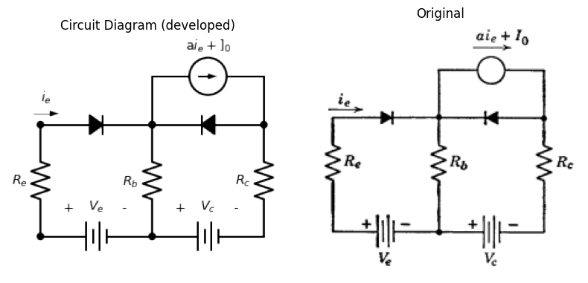
5.11. A common-base transistor circuit drives a load $R_{2}$ from a source with internal resistance $R_{1}$. For incremental voltages and currents, in the amplification region, the transistor model includes $r_{e}$, $r_{b}$, $r_{c}$, and $α$. Derive expressions for the following quantities in terms of $R_{1}$, $R_{2}$, $r_{e}$, $r_{b}$, $r_{c}$ and $α$:
(a) Current gain.
(b) Voltage gain.
(c) Power gain.
(d) Input resistance.
(e) Output resistance.
5.12. Repeat Problem 5.11 for a common-emitter circuit.
5.13. Repeat Problem 5.11 for a common-collector circuit.
import matplotlib.pyplot as plt
import numpy as np
import schemdraw
from schemdraw import dsp
import schemdraw.elements as e
import matplotlib.image as mpimg
d = schemdraw.Drawing()
tr = d.add(e.BjtPnp(l=0.5,circle=True).up())
l0 = d.add(e.Line().length(0.3).left().at(tr.emitter).dot(open=True))
l1 = d.add(e.Line().length(0.3).right().at(tr.collector).dot(open=True))
R1 = d.add(e.Resistor().left().label('$R_1$',ofst=0.1).at(l0.end))
l0 = d.add(e.Line().length(1).right().at(l1.end))
R2 = d.add(e.Resistor().right().label('$R_2$',ofst=0.1))
l10 = d.add(e.Battery().length(4).reverse().down().label('$V_c$',ofst=0.1))
l09 = d.add(e.Line().length(0.5).down().at(tr.base).dot(open=True))
l9 = d.add(e.Line().length(3.3).down().at(tr.base).dot())
l12 = d.add(e.Line().length(5).right().at(l9.end))
l13 = d.add(e.Line().length(4).left().at(l9.end))
v00 = d.add(e.Battery(l=2).reverse().up().label('$V_e$',ofst=0.1))
s01 = d.add(e.SourceV(l=2).up().label('$v_1$',ofst=(0,0.1)))
d.draw()
d.save('./Drawings5/p5-8.png')
d.save('./Drawings5/p5-8.svg')
fig, axs = plt.subplots(1, 2, figsize=(14,14))
img = mpimg.imread('./Drawings5/p5-8.png')
axs[0].imshow(img)
axs[0].axis('off')
axs[0].set_title('Circuit Diagram (developed)')
img_sample = mpimg.imread('./images5/p5-8.png')
axs[1].imshow(img_sample)
axs[1].axis('off')
axs[1].set_title('Original')
plt.tight_layout()
plt.show()
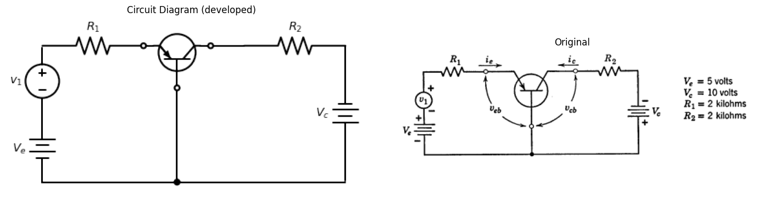
5.14. The p-n-p junction transistor in the common-base amplifier circuit shown in Fig. P5.8 can be approximated by an ideal-diode model in which the emitter-to-collector current gain is given by $α=0.95$. Neglect the reverse saturation current of the collector junction ($I_{o}$) and assume the current gain from collector to emitter is zero ($a′=0$).
(a) Sketch and dimension the following transistor curves based on the ideal-diode model:
- $v_{cb}$ vs. $i_{c}$ with $i_{e}$ as the parameter.
- $v_{eb}$ vs. $i_{e}$ with $i_{c}$ as the parameter.
(b) Find the values of $i_{e}$, $i_{c}$, $v_{cb}$, and $v_{eb}$ at the quiescent operating point of the circuit ($v_{1}=0$).
(c) Plot the driving-point curve, $v_{1}$ vs. $i_{e}$.
(d) Plot the transfer curves $v_{cb}$ vs. $v_{eb}$ and $v_{cb}$ vs. $v_{1}$.
import matplotlib.pyplot as plt
import numpy as np
import schemdraw
from schemdraw import dsp
import schemdraw.elements as e
import matplotlib.image as mpimg
d = schemdraw.Drawing()
tr1 = d.add(e.BjtPnp(circle=True).reverse().theta(180))
l1 = d.add(e.Line().length(2.5).right().at(tr1.collector).dot())
R00 = d.add(e.Resistor(l=2.7).down().label('$R_2$',ofst=0.1))
v00 = d.add(e.Battery(l=2.7).down().label('$V_c$',ofst=0.1).dot())
l00 = d.add(e.Line().length(1.5).left())
l01 = d.add(e.Line().length(1).right().at(l00.start).dot(open=True))
l02 = d.add(e.Line().length(1).right().at(l1.end).dot(open=True))
R0 = d.add(e.Resistor(l=2).down().label('$R_e$',ofst=0.1).at(tr1.emitter))
v0 = d.add(e.Battery(l=2).down().label('$V_e$',ofst=0.1))
G = d.add(e.Ground())
l2 = d.add(e.Resistor().length(2.5).left().at(tr1.base).label('$R_1$',ofst=0.1))
l3 = d.add(e.Line().length(0.7).down())
v1 = d.add(e.SourceV(l=4).reverse().down().label('$v_1$',ofst=0.1))
l4 = d.add(e.Line().length(3.2).right())
l00 = d.add(e.Line().length(0.3).right().at(R0.start).idot())
l01 = d.add(e.Line().length(0.7).right())
l03 = d.add(e.Line().length(1).right().dot().at(v0.end))
l02 = d.add(e.Line().length(0.7).up())
C1 = d.add(e.Capacitor(l=3.3).up().label('C',ofst=-1))
d += e.Arrow().up().length(1.9).linewidth(0.6).color('white').label('$v_2$', loc='start', color='black',ofst=0.3).at((3.1,-2.0))
d += e.Arrow().up().length(2).linewidth(0.6).color('black').label('',loc='end', color='black',ofst=0.4). at((2.7,-1.7))
d += e.Arrow().down().length(2).linewidth(0.6).color('black').label(r'', loc='end', color='black',ofst=(-0.3,-0.3)). at((2.7,-2.5))
d.draw()
d.save('./Drawings5/p5-9.png')
d.save('./Drawings5/p5-9.svg')
fig, axs = plt.subplots(1, 2, figsize=(15,7))
img = mpimg.imread('./Drawings5/p5-9.png')
axs[0].imshow(img)
axs[0].axis('off')
axs[0].set_title('Circuit Diagram (developed)')
img_sample = mpimg.imread('./images5/p5-9.png')
axs[1].imshow(img_sample)
axs[1].axis('off')
axs[1].set_title('Original')
plt.tight_layout()
plt.show()
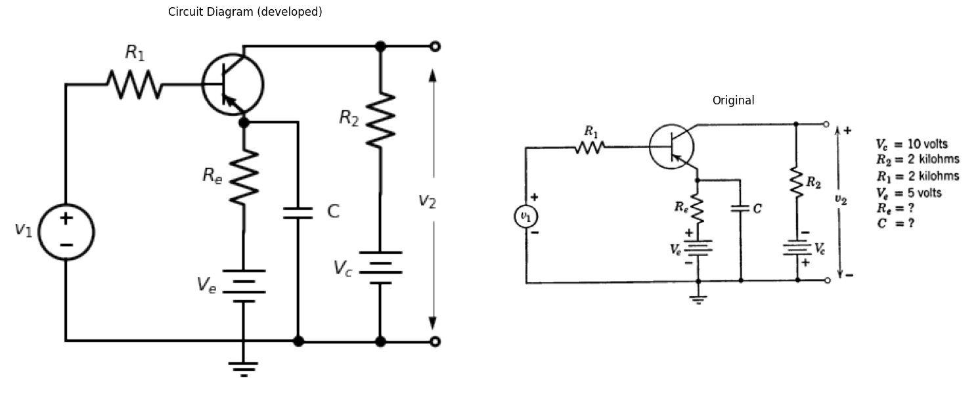
5.15. The transistor of Problem 5.14 is connected in the common-emitter circuit shown in Fig. P5.9.
(a) Determine the value of $R_{e}$ needed to make the emitter current ($i_{e}$) at the quiescent operating point ($v_{1}=0$) the same as in Problem 5.14.
(b) Plot the transfer curve $v_{2}$ vs. $v_{1}$, assuming $v_{e}$, $R_{e}$, and $C$ can be replaced by an appropriate battery.
(c) Determine the incremental voltage gain $\frac{Δv_{2}}{Δv_{1}}$ for the circuit assuming the increments in $v_{1}$ are small and the capacitance is very large.
(d) If $v_{1}=V_{1}sin\left(ωt\right)$, find the maximum value of $V_{1}$ that permits linear amplification for the quiescent conditions established in (a).
(e) For $ω_{1}={10}^{4}$ radians/sec, determine the approximate value of $C$ needed to hold the peak-to-peak variation of capacitor voltage to 2 percent of the average capacitor voltage.
import matplotlib.pyplot as plt
import numpy as np
import schemdraw
from schemdraw import dsp
import schemdraw.elements as e
import matplotlib.image as mpimg
d = schemdraw.Drawing()
D1 = d.add(e.Diode(fill=True).right().dot().idot(open=True))
l0 = d.add(e.Line().down().idot().dot())
l2 = d.add(e.Line(l=1).right().at(l0.start))
D2 = d.add(e.Diode(l=2.3,fill=True).reverse().right().idot().dot())
l4 = d.add(e.Line(l=1.3).up().at(D2.start))
I = d.add(e.SourceI(l=2.3).right().label('a$i_e$'))
l5 = d.add(e.Line(l=1.3).down())
l8 = d.add(e.Line(l=1.3).right().at(D2.end).dot(open=True))
l9 = d.add(e.Line(l=4.6).right().at(l0.end).dot(open=True))
l10 = d.add(e.Line(l=3).left().at(l0.end).dot(open=True))
d += e.Arrow().right().linewidth(0.6).length(0.7).color('black').label('$i_e$', loc='top', color='black',ofst=0.2).at((0.2,0.3))
d.draw()
d.save('./Drawings5/p5-10.png')
d.save('./Drawings5/p5-10.svg')
fig, axs = plt.subplots(1, 2, figsize=(8, 4))
img = mpimg.imread('./Drawings5/p5-10.png')
axs[0].imshow(img)
axs[0].axis('off')
axs[0].set_title('Circuit Diagram (developed)')
img_sample = mpimg.imread('./images5/p5-10.png')
axs[1].imshow(img_sample)
axs[1].axis('off')
axs[1].set_title('Original')
plt.tight_layout()
plt.show()
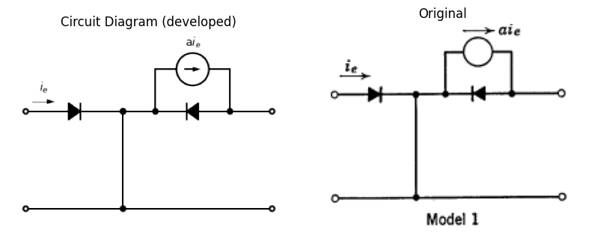
import matplotlib.pyplot as plt
import numpy as np
import schemdraw
from schemdraw import dsp
import schemdraw.elements as e
import matplotlib.image as mpimg
d = schemdraw.Drawing()
R0 = d.add(e.Resistor(l=2.2).right().label('$r_e$',ofst=0.1).idot(open=True))
D1 = d.add(e.Diode(l=2,fill=True).right().dot())
R0 = d.add(e.Resistor().down().label('$r_b$',ofst=0.1).idot().dot())
l2 = d.add(e.Line(l=0.8).right().at(R0.start))
D2 = d.add(e.Diode(l=2.3,fill=True).reverse().right().idot().dot())
l4 = d.add(e.Line(l=1.3).up().at(D2.start))
I = d.add(e.SourceI(l=2.3).right().label('a$i_e$'))
l5 = d.add(e.Line(l=1.3).down())
l6 = d.add(e.Line(l=1.3).down())
R1 = d.add(e.Resistor(l=2.3).left().label('$r_c$',ofst=0.1))
l7 = d.add(e.Line(l=1.3).up())
l8 = d.add(e.Line(l=1.3).right().at(D2.end).dot(open=True))
l9 = d.add(e.Line(l=4.3).right().at(R0.end).dot(open=True))
l10 = d.add(e.Line(l=4.3).left().at(R0.end).dot(open=True))
d += e.Arrow().right().linewidth(0.6).length(0.7).color('black').label('$i_e$', loc='top', color='black',ofst=0.2).at((1.6,0.3))
d.draw()
d.save('./Drawings5/p5-11.png')
d.save('./Drawings5/p5-11.svg')
fig, axs = plt.subplots(1, 2, figsize=(8, 4))
img = mpimg.imread('./Drawings5/p5-11.png')
axs[0].imshow(img)
axs[0].axis('off')
axs[0].set_title('Circuit Diagram (developed)')
img_sample = mpimg.imread('./images5/p5-11.png')
axs[1].imshow(img_sample)
axs[1].axis('off')
axs[1].set_title('Original')
plt.tight_layout()
plt.show()
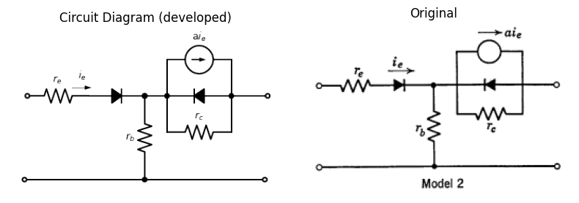
5.16. (a) From the information on the common-emitter characteristics of the Type II transistor, determine the values of $a$, $r_{c}$, and $r_{e}$ that you would use in each of the two models shown in Figs. P5.10 and P5.11 at an operating point $v_{ce}=−0.4$, $i_{b}=−0.6$ (with $r_{b}=100$ ohms from independent measurement).
(b) Using the circuit of Fig. P5.8, determine for which of the following calculations Model 1 (Fig. P5.10) can be used as a good approximation for the transistor rather than the more complete Model 2 (Fig. P5.11).
(1) Current gain $\frac{Δi_{c}}{Δi_{e}}$
(2) Voltage gain $\frac{Δv_{cb}}{Δv_{eb}}$, $Δv_{cb}/Δv_{1}$
(3) Input impedance $\frac{Δv_{eb}}{Δi_{e}}$
(4) Output impedance $\frac{Δv_{cb}}{Δi_{c}}$.
5.17. Repeat Problem 5.16(b) for the Type III n-p-n transistor.
import matplotlib.pyplot as plt
import numpy as np
import schemdraw
from schemdraw import dsp
import schemdraw.elements as e
import matplotlib.image as mpimg
d = schemdraw.Drawing()
tr1 = d.add(e.BjtPnp(circle=True).reverse().theta(180).label('$Type$ I',ofst=(-0.5,0)))
R1 = d.add(e.Resistor(l=2.3).up().label('$R_2$',ofst=0.1).at(tr1.collector))
l1 = d.add(e.Line().length(0.7).up().label('$V_c$',ofst=(1.0,-0.2)).dot(open=True))
l0 = d.add(e.Line(l=3.5).down().at(tr1.emitter))
G = d.add(e.Ground())
l2 = d.add(e.Line().length(2.2).left().at(tr1.base))
c = d.add(e.Capacitor(l=2.3).left())
R1 = d.add(e.Resistor(l=2.1).down().label('$R_1$',ofst=0.1))
V = d.add(e.SourceV(l=2.1).down().reverse().label('$V_1$', ofst=-1.5))
l0 = d.add(e.Line(l=5.25).right().dot())
R2 = d.add(e.Resistor(l=2.7).up().label('$R_b$',ofst=0.1).at(l2.center).idot())
l4 = d.add(e.Line().length(1.85).right().dot())
d.move(5,0)
l00 = d.add(e.Line().down().length(0.8).idot(open=True).dot())
D1 = d.add(e.Diode(fill=True).down().dot())
D2 = d.add(e.Diode(fill=True).down().reverse().dot(open=True))
l02 = d.add(e.Line().right().length(1.5).at(D2.start))
V = d.add(e.SourceI().up().label('$ai_e$', ofst=-1.7))
l02 = d.add(e.Line().left().length(1.5))
l03 = d.add(e.Line().left().length(1.8).at(D2.start).dot(open=True))
d.draw()
d.save('./Drawings5/p5-12.png')
d.save('./Drawings5/p5-12.svg')
fig, axs = plt.subplots(1, 2, figsize=(15,7))
img = mpimg.imread('./Drawings5/p5-12.png')
axs[0].imshow(img)
axs[0].axis('off')
axs[0].set_title('Circuit Diagram (developed)')
img_sample = mpimg.imread('./images5/p5-12.png')
axs[1].imshow(img_sample)
axs[1].axis('off')
axs[1].set_title('Original')
plt.tight_layout()
plt.show()
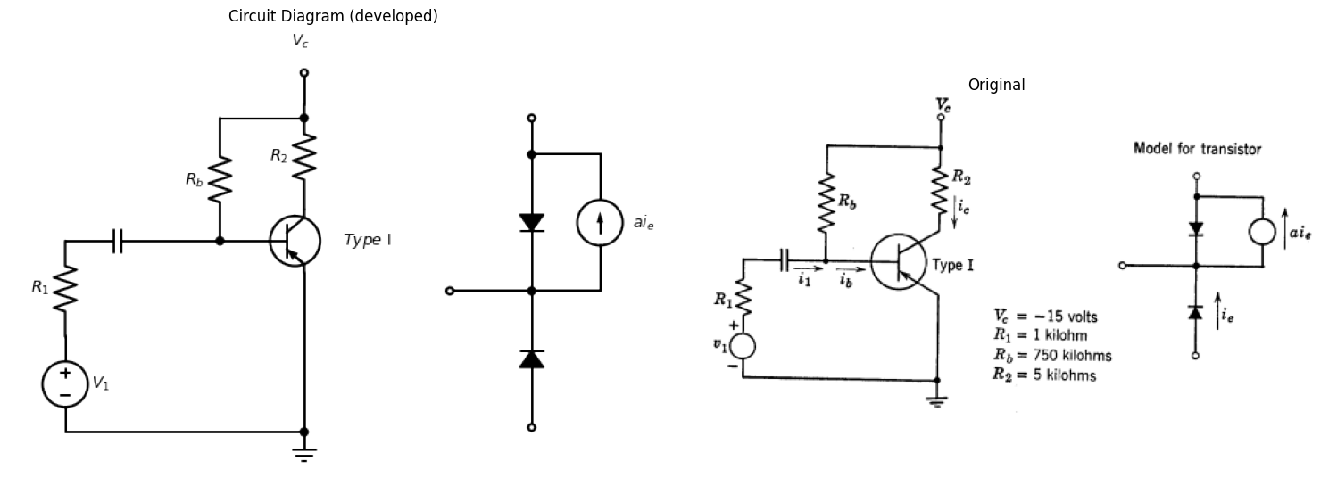
5.18. The circuit of Fig. P5.12 uses a Type I transistor in the common-emitter connection. The emitter bias is established by a base current $I_{b}$ obtained through $R_{b}$. Thus $V_{c}$ biases both the emitter and collector.
(a) Assuming that the base-to-emitter voltage is small compared to $V_{c}$, determine the quiescent collector voltage ($V_{ce}$) and collector current ($I_{c}$) from the characteristics of the common-emitter connection.
(b) Graphically determine the incremental current gain $\frac{Δi_{c}}{Δi_{1}}$. From this value of current gain, compute the value of $α$ to be used in the idealized model shown in Fig. P5.12.
import matplotlib.pyplot as plt
import numpy as np
import schemdraw
from schemdraw import dsp
import schemdraw.elements as e
import matplotlib.image as mpimg
d = schemdraw.Drawing()
D1 = d.add(e.Diode(fill=True).reverse().right().dot())
#l00 = d.add(e.Line(l=0.6).right().dot())
l1 = d.add(e.Line().down().dot())
E1 = d.add(e.BatteryCell().left().label(['+', '$V_e$', '-'], ofst=0.2))
E2 = d.add(e.Battery().right().label(['+', '$V_c$', '-'], ofst=0.2).at(E1.start))
R0 = d.add(e.Resistor().down().label('$R_e$',ofst=0.1).at(D1.start).idot().dot())
l2 = d.add(e.Line(l=0.6).right().at(l1.start))
D2 = d.add(e.Diode(l=1.5,fill=True).right().at(l2.end).idot().dot())
l3 = d.add(e.Line(l=0.9).right())
R1 = d.add(e.Resistor().down().label('$R_c$',ofst=0.1))
l4 = d.add(e.Line(l=1.3).up().at(D2.start))
I = d.add(e.SourceI(l=1.5).right().label('a$i_e$'))
l5 = d.add(e.Line(l=1.3).down())
l6 = d.add(e.Line().left().at(R0.start))
l7 = d.add(e.Line().left().at(R0.end))
I1 = d.add(e.SourceI().up().label('$i_1$'))
d += e.Arrow().left().linewidth(0.6).length(0.7).color('black').label('$i_2$', loc='top', color='black',ofst=0.2).at((5.9,0.3))
d += e.Arrow().right().linewidth(0.6).length(0.7).color('black').label('$i_e$', loc='top', color='black',ofst=0.2).at((-0.2,0.3))
d.draw()
d.save('./Drawings5/p5-13.png')
d.save('./Drawings5/p5-13.svg')
fig, axs = plt.subplots(1, 2, figsize=(8, 4))
img = mpimg.imread('./Drawings5/p5-13.png')
axs[0].imshow(img)
axs[0].axis('off')
axs[0].set_title('Circuit Diagram (developed)')
img_sample = mpimg.imread('./images5/p5-13.png')
axs[1].imshow(img_sample)
axs[1].axis('off')
axs[1].set_title('Original')
plt.tight_layout()
plt.show()
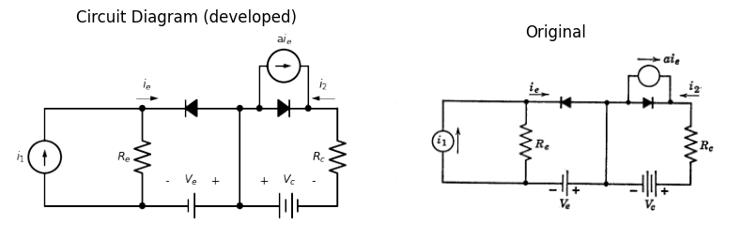
5.19. Using the ideal-diode transistor model shown in Fig. P5.13, obtain the $i_{2}$ vs. $i_{1}$ characteristic. Repeat for the grounded emitter and grounded collector connections.
5.20. A Type IV point-contact transistor is used in the circuit of Fig. P5.14.
(a) State the condition of the diodes in the normal operating region (open or closed).
(b) On the emitter characteristics ($v_{eb}$ vs. $i_{e}$) of the Type IV transistor, plot the input load line equation. Similarly, on the collector characteristics plot the output load line.
(c) Locate the quiescent operating point by transferring the load line on the collector characteristics onto the emitter characteristics. Also locate the operating point on the collector characteristics.
(d) Determine the small signal parameters ($r_{e}$, $r_{b}$, $r_{c}$, and $α$) at the operating point.
(e) Determine the small signal voltage gain $\frac{Δv_{cb}}{Δv_{eb}}$ at the operating point.
import matplotlib.pyplot as plt
import numpy as np
import schemdraw
from schemdraw import dsp
import schemdraw.elements as e
import matplotlib.image as mpimg
d = schemdraw.Drawing()
tr = d.add(e.BjtPnp(l=0.5,circle=True).up())
l0 = d.add(e.Line().length(0.3).left().at(tr.emitter))
l1 = d.add(e.Line().length(0.3).right().at(tr.collector))
l2 = d.add(e.Line().left().at(l0.end))
R1 = d.add(e.Resistor(l=1.6).down().label('$R_e$',ofst=0.1).at(l2.end))
E1 = d.add(e.BatteryCell(l=1.6).down().label(['+', '$V_e$', '-'], ofst=0.2))
l0 = d.add(e.Line().length(2).right().at(l1.end))
R2 = d.add(e.Resistor(l=1.6).down().label('$R_c$',ofst=0.1).at(l0.end))
E2 = d.add(e.Battery(l=1.6).down().reverse().label(['-', '$V_c$', '+'], ofst=0.2))
l9 = d.add(e.Line().length(2.45).down().at(tr.base).dot())
l12 = d.add(e.Line().length(7).right().at(E1.end))
d.draw()
d.save('./Drawings5/p5-14.png')
d.save('./Drawings5/p5-14.svg')
fig, axs = plt.subplots(1, 2, figsize=(14,14))
img = mpimg.imread('./Drawings5/p5-14.png')
axs[0].imshow(img)
axs[0].axis('off')
axs[0].set_title('Circuit Diagram (developed)')
img_sample = mpimg.imread('./images5/p5-14.png')
axs[1].imshow(img_sample)
axs[1].axis('off')
axs[1].set_title('Original')
plt.tight_layout()
plt.show()
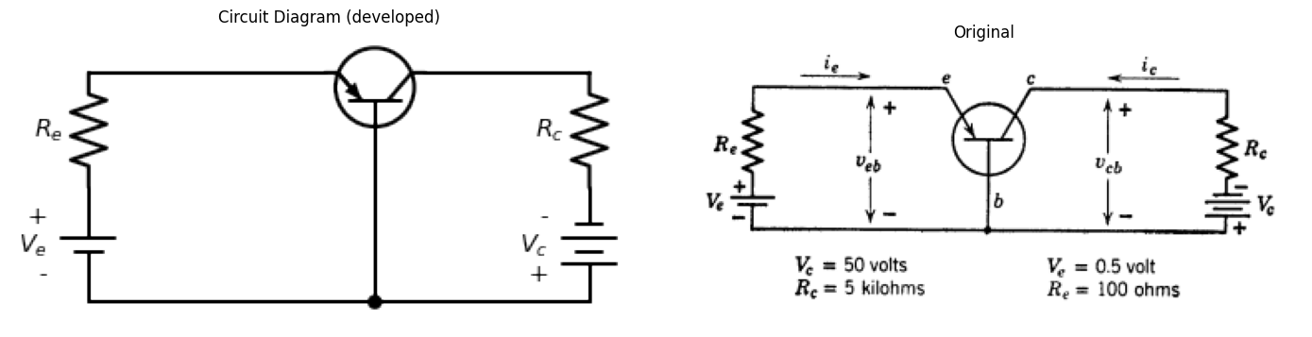
import matplotlib.pyplot as plt
import numpy as np
import schemdraw
from schemdraw import dsp
import schemdraw.elements as e
import matplotlib.image as mpimg
d = schemdraw.Drawing()
tr = d.add(e.BjtPnp(l=0.5,circle=True).up())
l0 = d.add(e.Line().length(1.5).left().at(tr.emitter))
l1 = d.add(e.Line().length(1.5).right().at(tr.collector))
R2 = d.add(e.Resistor().length(1.5).down().at(tr.base).label('$R_2$',ofst=0.1))
s = d.add(e.SourceSin(l=1.8).down().label(['+', '$e_2$', '- '],ofst=0.1))
l3 = d.add(e.Line().length(2.2).right().at(s.end))
E2 = d.add(e.Battery(l=1.4).up().label(['+','$V_3$','- '], ofst=0.2))
R1 = d.add(e.Resistor(l=2.6).up().label('$R_3$',ofst=0.1))
s = d.add(e.SourceSin(l=2.6).down().label(['+', '$e_1$', '- '],ofst=0.1).at(l0.end))
s01 = d.add(e.Battery(l=1.45).down().label(['+', '$V_1$', '- '], ofst=0.2))
l5 = d.add(e.Line().length(2.2).right())
d += e.Arrow().up().length(0.9).linewidth(0.6).color('white').label('$e_3$', loc='start', color='black',ofst=0.3).at((3.3,-0.5))
d += e.Arrow().up().length(0.4).linewidth(0.6).color('black').label('+',loc='end', color='black',ofst=0.4). at((2.9,-0.4))
d += e.Arrow().down().length(0.4).linewidth(0.6).color('black').label(r'_', loc='end', color='black',ofst=(-0.3,-0.3)). at((2.9,-0.9))
d.draw()
d.save('./Drawings5/p5-15.png')
d.save('./Drawings5/p5-15.svg')
fig, axs = plt.subplots(1, 2, figsize=(7,14))
img = mpimg.imread('./Drawings5/p5-15.png')
axs[0].imshow(img)
axs[0].axis('off')
axs[0].set_title('Circuit Diagram (developed)')
img_sample = mpimg.imread('./images5/p5-15.png')
axs[1].imshow(img_sample)
axs[1].axis('off')
axs[1].set_title('Original')
plt.tight_layout()
plt.show()
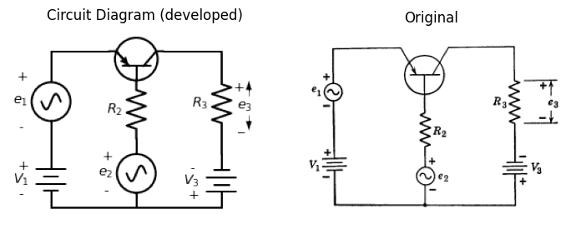
5.21. In the circuit of Fig. P5.15, assume the transistor has negligibly small forward emitter resistance and negligibly small reverse collector conductance.
(a) With $e_{1}$ and $e_{2}$ set equal to zero, sketch and dimension, in the $V_{1}$ plane, the boundaries of the region within which the transistor is operating in the usual amplification region (emitter conducting and collector non-conducting).
(b) For operation in such a region, find the a-c signal at $e_{3}$ when small a-c signals $e_{1}\left(t\right)$ and $e_{2}\left(t\right)$ are applied.
5.22. The variable resistance of Fig. P5.16, $R_{M}$ (a carbon button microphone) has a resistance of 400 ohms ± 10 percent ($R_{M}=R_{0}+Δr$). What would be a suitable value of $R_{1}$ for an operating point of 200 microamperes base current. Determine $v_{0}$ as a function of $Δr$. Use the data for the Type I transistor.
import matplotlib.pyplot as plt
import numpy as np
import schemdraw
from schemdraw import dsp
import schemdraw.elements as e
import matplotlib.image as mpimg
d = schemdraw.Drawing()
tr1 = d.add(e.BjtPnp(circle=True).theta(-360).label('$Type$ I',ofst=(0.5,0)))
l1 = d.add(e.Line().length(1).up().at(tr1.emitter).label('$+20v$',ofst=(0.9,-0.2)))
R0 = d.add(e.Resistor(l=3).down().label('$2000$ Ω',ofst=0.1).at(tr1.collector))
G = d.add(e.Ground())
l2 = d.add(e.Line().length(2.5).left().at(tr1.base))
l3 = d.add(e.Line().length(0.7).down())
R1 = d.add(e.ResistorVar(l=3).down().label('$R_M$',ofst=0.1))
R4 = d.add(e.Resistor().length(3.2).right().label('$R_1$',ofst=0.1))
l00 = d.add(e.Line().length(0.3).right().at(R0.start))
l01 = d.add(e.Line().length(1.5).right())
l02 = d.add(e.Line().length(0.3).right().at(R0.end))
l03 = d.add(e.Line().length(1.5).right())
d += e.Arrow().up().length(0.9).linewidth(0.6).color('white').label('$v_o$', loc='start', color='black',ofst=0.3).at((3.1,-2.1))
d += e.Arrow().up().length(1).linewidth(0.6).color('black').label('',loc='end', color='black',ofst=0.4). at((2.7,-1.8))
d += e.Arrow().down().length(1).linewidth(0.6).color('black').label(r'', loc='end', color='black',ofst=(-0.3,-0.3)). at((2.7,-2.6))
d.draw()
d.save('./Drawings5/p5-16.png')
d.save('./Drawings5/p5-16.svg')
fig, axs = plt.subplots(1, 2, figsize=(15,7))
img = mpimg.imread('./Drawings5/p5-16.png')
axs[0].imshow(img)
axs[0].axis('off')
axs[0].set_title('Circuit Diagram (developed)')
img_sample = mpimg.imread('./images5/p5-16.png')
axs[1].imshow(img_sample)
axs[1].axis('off')
axs[1].set_title('Original')
plt.tight_layout()
plt.show()
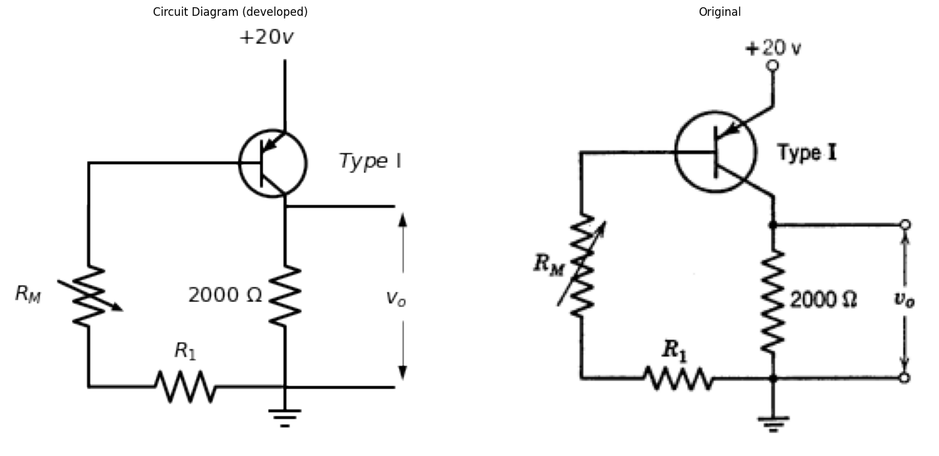
import matplotlib.pyplot as plt
import numpy as np
import schemdraw
from schemdraw import dsp
import schemdraw.elements as e
import matplotlib.image as mpimg
d = schemdraw.Drawing()
tr1 = d.add(e.BjtNpn(circle=True).reverse().theta(180).label('$n-p-n$',ofst=(-0.5,0)))
l1 = d.add(e.Line().length(1).up().at(tr1.emitter).label('$-V$',ofst=(0.9,-0.2)))
R0 = d.add(e.Resistor(l=1.5).down().label('$R_2$',ofst=0.1).at(tr1.collector))
s01 = d.add(e.SourceSin(l=1.5).down().label(['+','$V_2$','-'],ofst=(0,-0.2)).dot())
G = d.add(e.Ground())
l2 = d.add(e.Line().length(2.5).left().at(tr1.base))
l3 = d.add(e.Line().length(0.7).down())
R1 = d.add(e.Resistor(l=1.5).down().label('$R_1$',ofst=0.1))
s02 = d.add(e.SourceSin(l=1.5).down().label(['+','$V_1$','-'],ofst=(0,-0.2)))
l4 = d.add(e.Line().length(3.2).right())
l00 = d.add(e.Line().length(0.3).right().color('white').at(R0.start))
l01 = d.add(e.Line().length(1.5).right())
l02 = d.add(e.Line().length(0.3).right().color('white').at(s01.end))
l03 = d.add(e.Line().length(1.5).right())
l00 = d.add(e.Line().length(0.3).left().color('white').at(l3.start))
l01 = d.add(e.Line().length(1.5).left())
l02 = d.add(e.Line().length(0.3).left().color('white').at(s02.end))
l03 = d.add(e.Line().length(1.5).left())
d += e.Arrow().up().length(0.9).linewidth(0.6).color('white').label('$E_2$', loc='start', color='black',ofst=0.3).at((1.6,-2.1))
d += e.Arrow().up().length(1).linewidth(0.6).color('black').label('',loc='end', color='black',ofst=0.4). at((1.1,-1.8))
d += e.Arrow().down().length(1).linewidth(0.6).color('black').label(r'', loc='end', color='black',ofst=(-0.3,-0.3)). at((1.1,-2.6))
d += e.Arrow().up().length(1).linewidth(0.6).color('white').label('$E_1$', loc='start', color='black',ofst=0.3).at((-5.4,-1.7))
d += e.Arrow().up().length(1.3).linewidth(0.6).color('black').label('',loc='end', color='black',ofst=0.4). at((-5.8,-1.4))
d += e.Arrow().down().length(1.3).linewidth(0.6).color('black').label(r'', loc='end', color='black',ofst=(-3.3,-0.3)). at((-5.8,-2.2))
d.draw()
d.save('./Drawings5/p5-17.png')
d.save('./Drawings5/p5-17.svg')
fig, axs = plt.subplots(1, 2, figsize=(15,7))
img = mpimg.imread('./Drawings5/p5-17.png')
axs[0].imshow(img)
axs[0].axis('off')
axs[0].set_title('Circuit Diagram (developed)')
img_sample = mpimg.imread('./images5/p5-17.png')
axs[1].imshow(img_sample)
axs[1].axis('off')
axs[1].set_title('Original')
plt.tight_layout()
plt.show()
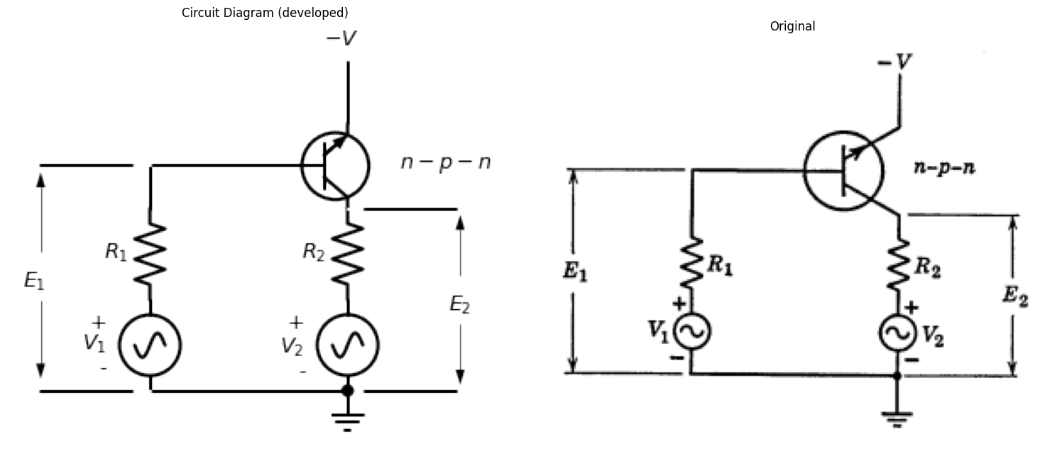
5.23. The circuit shown in Fig. P5.17 is used to measure the $h$-parameters of a transistor. Small a-c voltages of adjustable amplitudes $V_{1}$ and $V_{2}$ are applied as shown. The resulting a-c voltages $E_{1}$ and $E_{2}$ are measured with a high-impedance voltmeter. Assume that $R_{1}$ is much greater than $r_{b}+r_{e}/\left(1−α\right)$, and $R_{2}$ is much less than $r_{c}\left(1−α\right)$.
(a) Determine the $h$-parameters in terms of the external voltages and resistances.
(b) Determine $r_{e}$, $r_{b}$, $r_{c}$, and $α$.
import matplotlib.pyplot as plt
import numpy as np
import schemdraw
from schemdraw import dsp
import schemdraw.elements as e
import matplotlib.image as mpimg
d = schemdraw.Drawing()
tr1 = d.add(e.BjtPnp(circle=True).reverse().theta(180).label('$p-n-p$',ofst=(-0.5,0)))
l1 = d.add(e.Line().length(1.3).up().at(tr1.collector).dot())
l2 = d.add(e.Line().length(1).up().label('$-V_c$',ofst=(0.9,-0.2)).dot(open=True))
l3 = d.add(e.Line().length(4).left().at(l1.end))
s01 = d.add(e.SourceSin(l=2).down().label(['-','$e_1$','+'],ofst=(0,-0.2)))
R0 = d.add(e.Resistor(l=3.4).right().label('$R_1$',ofst=0.1))
R1 = d.add(e.Resistor(l=2.5).down().label('$R_2$',ofst=0.1).dot().idot().at(tr1.emitter))
G = d.add(e.Ground())
l8 = d.add(e.Line().length(1.5).right().at(R1.start).dot(open=True))
l9 = d.add(e.Line().length(1.5).right().at(R1.end).dot(open=True))
d += e.Arrow().up().length(0.9).linewidth(0.6).color('white').label('$e_2$', loc='start', color='black',ofst=0.3).at((1.6,-1.8))
d += e.Arrow().up().length(0.7).linewidth(0.6).color('black').label('+',loc='end', color='black',ofst=0.4). at((1.2,-1.5))
d += e.Arrow().down().length(0.7).linewidth(0.6).color('black').label(r'_', loc='end', color='black',ofst=(-0.3,-0.3)). at((1.2,-2.3))
d.draw()
d.save('./Drawings5/p5-18.png')
d.save('./Drawings5/p5-18.svg')
fig, axs = plt.subplots(1, 2, figsize=(15,7))
img = mpimg.imread('./Drawings5/p5-18.png')
axs[0].imshow(img)
axs[0].axis('off')
axs[0].set_title('Circuit Diagram (developed)')
img_sample = mpimg.imread('./images5/p5-18.png')
axs[1].imshow(img_sample)
axs[1].axis('off')
axs[1].set_title('Original')
plt.tight_layout()
plt.show()
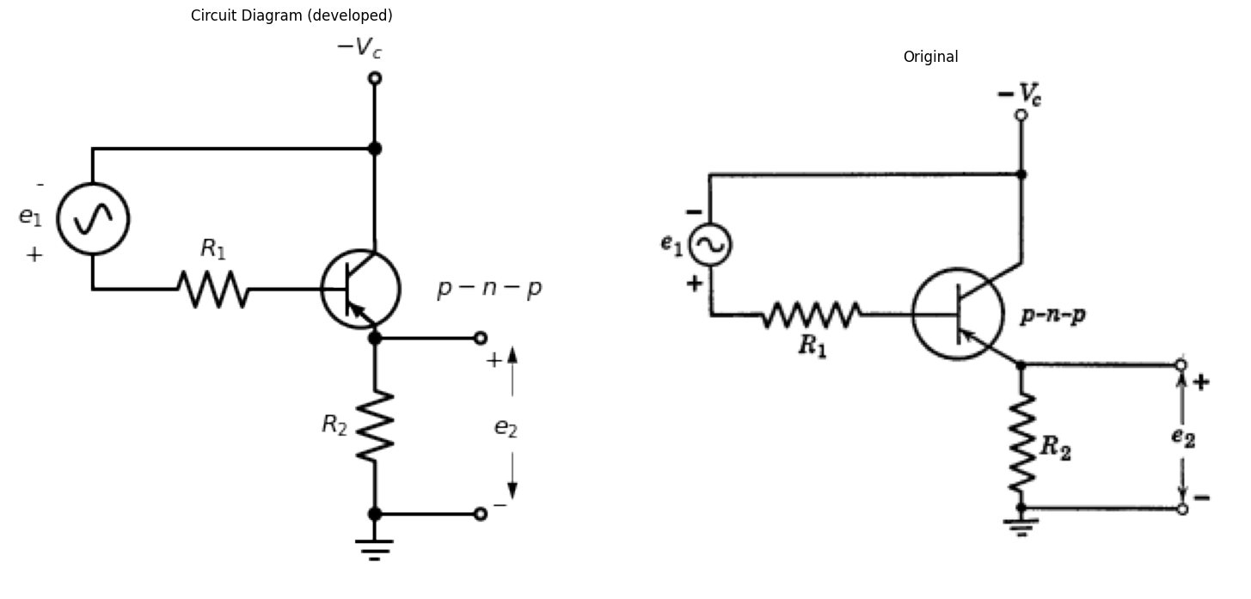
5.24. An emitter-follower circuit using a p-n-p junction transistor is shown in Fig. P5.18. The transistor is biased in the forward gain region and may be represented by the idealized linear incremental circuit model with $r_{e}=r_{b}=0$ and $r_{c}=∞$.
- (a) Find the incremental voltage gain, $\frac{Δe_{2}}{Δe_{1}}$.
- (b) Find the incremental input resistance facing the signal source, $e_{1}$.
- (c) Find the incremental output resistance facing the load resistance, $R_{2}$.
5.25. The circuit shown in Fig. P5.19 is used as the output stage of a transistor audio amplifier. Note that by combining p-n-p and n-p-n transistors, push-pull operation is obtained without the use of transformers. Assuming that in the transistor model $r_{e}=r_{b}=0$ and $r_{c}=∞$, $α=0.95$.
- (a) Plot and dimension the transfer curve $e_{2}$ vs. $e_{1}$.
- (b) Assuming $e_{1}=E_{1}sinωt$, plot $e_{2}$, $i_{1}$, and $i_{2}$ vs. time for $E_{1}<V_{c}$.
import matplotlib.pyplot as plt
import numpy as np
import schemdraw
from schemdraw import dsp
import schemdraw.elements as e
import matplotlib.image as mpimg
d = schemdraw.Drawing()
tr1 = d.add(e.BjtPnp(circle=True).reverse().theta(180).label('$p-n-p$',ofst=(2.2,-1.2)))
tr2 = d.add(e.BjtNpn(l=0.5,circle=True).reverse().theta(360).anchor('collector').at((2,0.7)).label('$n-p-n$',ofst=(0,1.2)))
l1 = d.add(e.Line().length(1).up().at(tr1.collector).label('$-V$',ofst=(0.9,-0.2)))
l2 = d.add(e.Line().length(1).up().at(tr2.collector).label('$+V$',ofst=(0.9,-0.2)))
l3 = d.add(e.Line().length(1.35).left().at(tr2.emitter).dot())
l4 = d.add(e.Line().length(1.35).left().at(l3.end))
l5 = d.add(e.Line().length(1.35).down().at(l3.end).dot())
R0 = d.add(e.Resistor(l=1.8).down().label('$R_L$',ofst=0.1).dot())
l6 = d.add(e.Line().length(0.5).down())
l7 = d.add(e.Line().length(6.1).left())
l8 = d.add(e.Line().length(1).right().at(R0.start).dot(open=True))
l9 = d.add(e.Line().length(1).right().at(R0.end).dot(open=True))
l10 = d.add(e.Line().length(1).right().at(tr2.base))
l11 = d.add(e.Line().length(1.5).down())
l12 = d.add(e.Line().length(6.2).left())
l13 = d.add(e.Line().length(1).left().at(tr1.base))
l14 = d.add(e.Line().length(1.5).down().dot())
R1 = d.add(e.Resistor().left().label('$R_g$',ofst=0.1))
s01 = d.add(e.SourceSin(l=3).down().label(['+','$e_1$','-'],ofst=(0,-0.1)))
G = d.add(e.Ground())
d += e.Arrow().up().length(0.7).linewidth(0.6).color('white').label('$e_2$', loc='start', color='black',ofst=0.3). at((2,-2.8))
d += e.Arrow().up().length(0.5).linewidth(0.6).color('black').label('+',loc='end', color='black',ofst=0.4). at((1.6,-2.6))
d += e.Arrow().down().length(0.5).linewidth(0.6).color('black').label(r'_', loc='end', color='black',ofst=(-0.3,-0.3)). at((1.6,-3.2))
d.draw()
d.save('./Drawings5/p5-19.png')
d.save('./Drawings5/p5-19.svg')
fig, axs = plt.subplots(1, 2, figsize=(15,7))
img = mpimg.imread('./Drawings5/p5-19.png')
axs[0].imshow(img)
axs[0].axis('off')
axs[0].set_title('Circuit Diagram (developed)')
img_sample = mpimg.imread('./images5/p5-19.png')
axs[1].imshow(img_sample)
axs[1].axis('off')
axs[1].set_title('Original')
plt.tight_layout()
plt.show()
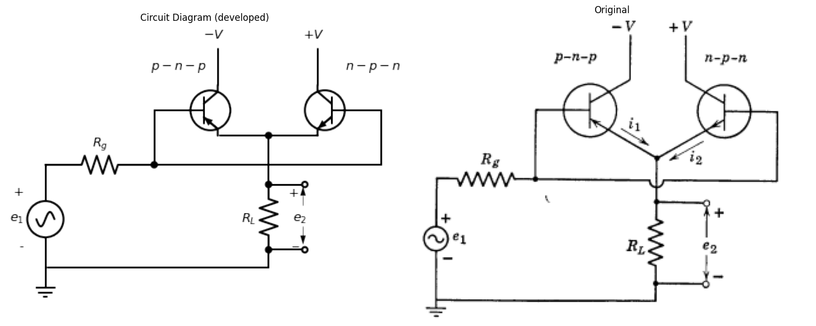
5.26. Using piecewise-linear models for the n-p-n and p-n-p transistors in the circuit shown in Fig. P5.20, find $e_{2}$ as a function of $e_{1}$, and show the result in graphical form (transfer plot). Assume that $r_{c}=∞$, $r_{e}=r_{b}=0$, and that $α$ for both transistors is 0.95.
import matplotlib.pyplot as plt
import numpy as np
import schemdraw
from schemdraw import dsp
import schemdraw.elements as e
import matplotlib.image as mpimg
d = schemdraw.Drawing()
tr1 = d.add(e.BjtPnp(circle=True).reverse().theta(180))
R0 = d.add(e.Resistor(l=1.8).up().label('$R_2$',ofst=0.1).at(tr1.collector).dot().idot())
tr2 = d.add(e.BjtNpn(l=0.5,circle=True).reverse().theta(180).at(R0.end).anchor('collector'))
R1 = d.add(e.Resistor().left().label('$R_1$',ofst=0.1).at(tr2.base).dot(open=True))
R2 = d.add(e.Resistor().left().label('$R_1$',ofst=0.1).at(tr1.base).dot(open=True))
l1 = d.add(e.Line().length(1).right().at(R0.start).dot(open=True))
l2 = d.add(e.Line().length(1).right().at(R0.end).dot(open=True))
l3 = d.add(e.Line().length(2.5).right().at(tr2.emitter))
E = d.add(e.Battery(l=1.6).down().label(["-","V","+"]).reverse())
l4 = d.add(e.Line().length(3).down())
l5 = d.add(e.Line().length(2.5).left())
d += e.Arrow().up().length(1).linewidth(0.6).color('white').label('$e_1$', loc='start', color='black',ofst=0.3). at((-4.2,1.9))
d += e.Arrow().up().length(1).linewidth(0.6).color('black').label('+',loc='end', color='black',ofst=0.4). at((-4.5,2.1))
d += e.Arrow().down().length(1).linewidth(0.6).color('black').label(r'_', loc='end', color='black',ofst=(-0.3,-0.3)). at((-4.5,1.3))
d += e.Arrow().up().length(0.7).linewidth(0.6).color('white').label('$e_2$', loc='start', color='black',ofst=0.3). at((0.9,1.8))
d += e.Arrow().up().length(0.5).linewidth(0.6).color('black').label('+',loc='end', color='black',ofst=0.4). at((0.6,1.9))
d += e.Arrow().down().length(0.5).linewidth(0.6).color('black').label(r'_', loc='end', color='black',ofst=(-0.3,-0.3)). at((0.6,1.4))
d.draw()
d.save('./Drawings5/p5-20.png')
d.save('./Drawings5/p5-20.svg')
fig, axs = plt.subplots(1, 2, figsize=(15,7))
img = mpimg.imread('./Drawings5/p5-20.png')
axs[0].imshow(img)
axs[0].axis('off')
axs[0].set_title('Circuit Diagram (developed)')
img_sample = mpimg.imread('./images5/p5-20.png')
axs[1].imshow(img_sample)
axs[1].axis('off')
axs[1].set_title('Original')
plt.tight_layout()
plt.show()
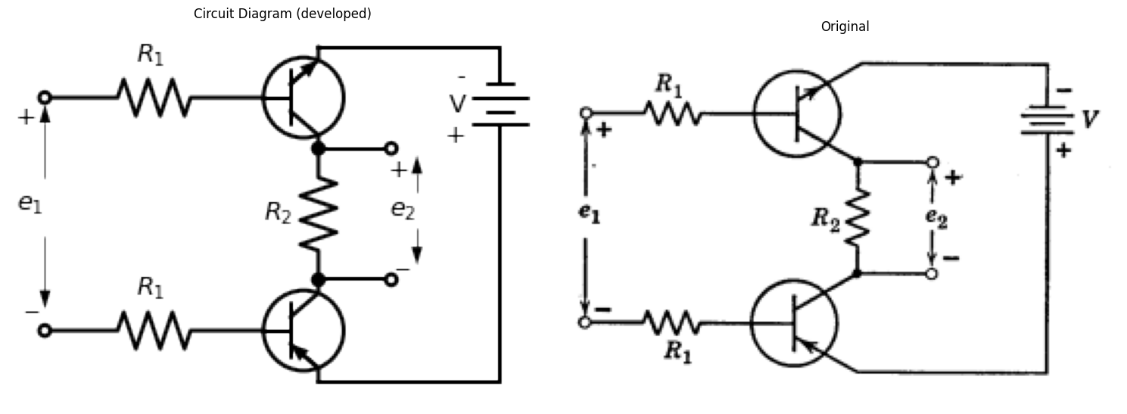
5.27. The signal from a source having an internal resistance of 350 ohms is amplified by a single-stage amplifier which uses a p-n-p junction transistor in the common-base connection. The amplified signal is delivered to a purely resistive 5000-ohm load. Assume that the transistor is sufficiently well represented by the circuit of Fig. P5.21.
(a) At the d-c operating point, with $e_{s}\left(t\right)=0$, compute the power flowing out of $V_{e}$ and $V_{c}$, the power flowing into the load ($R_{L}$), the power flowing into the source terminals, and the power flowing into the transistor.
(b) When amplifying a signal from a source of square waves with an open-circuit voltage varying between +1 and -1, compute the average power flowing into $R_{L}$, the average power flowing out of the source terminals, and the average power flowing into the transistor.
(c) Is the average power flowing into the transistor greater or less in part (b) than in part (a)? Explain briefly.
(d) What is the maximum possible power that could be supplied by the source if it were disconnected from the transistor amplifier and reconnected to a resistance that matches its internal resistance? Is this greater or less than the power from the source in part (b)?
(e) Construct an incremental circuit for the source, transistor, and load, and compute the ratio of signal power in the load to the signal power flowing out of the source terminals in your equivalent circuit. This is one possible definition of power gain (called "network efficiency", and for most practical amplifiers is a number greater than unity and a function of the load impedance). Compute the ratio of signal power in the load to the maximum signal power available at the source terminals. This is the usual definition of "power gain."
import matplotlib.pyplot as plt
import numpy as np
import schemdraw
from schemdraw import dsp
import schemdraw.elements as e
import matplotlib.image as mpimg
d = schemdraw.Drawing()
R1 = d.add(e.Resistor(l=2).up().label('$R_{source}$ \n= $350 Ω$',ofst=0.1))
s01 = d.add(e.SourceSin(l=2).up().label('$e_s(t)$',ofst=(0,0.1)))
l0 = d.add(e.Line().length(3.5).right().dot(open=True))
l1 = d.add(e.Line().length(3.5).right().at(R1.start).dot(open=True))
l2 = d.add(e.Line().length(2.5).right())
l22 = d.add(e.Line().length(3).down().dot(open=True))
l3 = d.add(e.Line().length(1.5).down())
l4 = d.add(e.Line().length(2).right().at(l0.end)) #.label('>\n$i_e$',ofst=-1))
R2 = d.add(e.Resistor(l=1).right().label('$47$ Ω',ofst=0.1))
D1 = d.add(e.Diode(l=2.5,fill=True).right().dot())
E = d.add(e.Battery().right().label("$V_e$=1 volt",ofst=-1.1).at(l3.end).dot())
l5 = d.add(e.Line().length(1.5).up().dot(open=True))
E2 = d.add(e.Battery().right().label("$V_c$=25 volts",ofst=-1.1).at(E.end).dot())
l6 = d.add(e.Line().length(1.5).up().dot(open=True))
l7 = d.add(e.Line().length(3).up())
l8 = d.add(e.Line().length(2.5).right().dot(open=True))
l9 = d.add(e.Line().length(2.5).right())
R3 = d.add(e.Resistor(l=4).up().label('$R_L$ \n= 5 $kΩ$',ofst=0.1))
l10 = d.add(e.Line().length(2.5).left().dot(open=True))
l11 = d.add(e.Line().length(2.2).left().dot())
l12 = d.add(e.Line().length(0.6).up())
s03 = d.add(e.SourceI(l=2.3).left().reverse().label('$0.95i_e$',ofst=(0,-0.1)))
l14 = d.add(e.Line().length(0.6).down().dot())
l15 = d.add(e.Line().length(0.6).down())
D2 = d.add(e.Diode(l=2.3,fill=True).reverse().right())
l16 = d.add(e.Line().length(0.6).up())
l17 = d.add(e.Line().length(3).left().at(l14.end))
l18 = d.add(e.Line().length(2.5).up().at(l5.end))
R4 = d.add(e.Resistor(l=4.5).up().label('$60$ Ω',ofst=0.1))
l01 = d.add(e.Line().length(4.5).right().linestyle('--').at((-2,6)))
l02 = d.add(e.Line().length(7.7).down().linestyle('--'))
l03 = d.add(e.Line().length(4.5).left().linestyle('--'))
l04 = d.add(e.Line().length(7.7).up().linestyle('--'))
l01 = d.add(e.Line().length(9.2).right().linestyle('--').at((4.5,6)))
l02 = d.add(e.Line().length(7.7).down().linestyle('--'))
l03 = d.add(e.Line().length(9.2).left().linestyle('--'))
l04 = d.add(e.Line().length(7.7).up().linestyle('--'))
l01 = d.add(e.Line().length(4.5).right().linestyle('--').at((15.2,6)))
l02 = d.add(e.Line().length(7.7).down().linestyle('--'))
l03 = d.add(e.Line().length(4.5).left().linestyle('--'))
l04 = d.add(e.Line().length(7.7).up().linestyle('--'))
l01 = d.add(e.Line().length(9.2).right().linestyle('--').at((4.5,-3.5)))
l02 = d.add(e.Line().length(2.5).down().linestyle('--'))
l03 = d.add(e.Line().length(9.2).left().linestyle('--').label('Power supply',ofst=-0.6))
l04 = d.add(e.Line().length(2.5).up().linestyle('--'))
d += e.Arrow().right().linewidth(0.6).length(0.7).label('$i_e$', loc='top',ofst=0.2).at((4.7,4.3))
d.draw()
d.save('./Drawings5/p5-21.png')
d.save('./Drawings5/p5-21.svg')
fig, axs = plt.subplots(1, 2, figsize=(14,14))
img = mpimg.imread('./Drawings5/p5-21.png')
axs[0].imshow(img)
axs[0].axis('off')
axs[0].set_title('Circuit Diagram (developed)')
img_sample = mpimg.imread('./images5/p5-21.png')
axs[1].imshow(img_sample)
axs[1].axis('off')
axs[1].set_title('Original')
plt.tight_layout()
plt.show()
