GROWTHMAK
CONFIDENTIAL CLIENT CASE STUDY
Industry: Motorcycle Parts & Accessories • Market: USA
From Invisible
to Sales Machine
How we helped a US motorcycle brand generate a full year of revenue in six months — using the same ad budget they started with.

$628K  REVENUE IN 20 MONTHS | 12.15x  PEAK RETURN ON AD SPEND | 6 months  TO MATCH A FULL YEAR

214  ORDERS IN ONE MONTH | $0.53  AVG. COST PER CLICK | Page 1  ON COMPETITIVE TERMS

BEFORE YOU READ A SINGLE NUMBER

Here’s what the founder tells other founders
When another business owner was considering working with us, they messaged this client directly — out of the blue — to ask if we were the real deal. This was his reply. We didn’t write it, we didn’t ask for it, and honestly it’s the best compliment we’ve ever received:

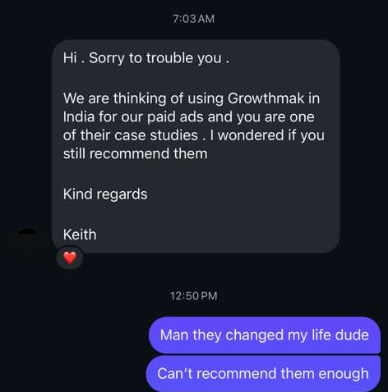
An unprompted referral from our client to another founder who asked about us.

“Man they changed my life dude. Can’t recommend them enough.”

That’s the whole point of what follows. The numbers below are impressive — but this is what they feel like from the inside. Here’s exactly how we got there.

THE STORY

Stuck at $50K a month — and invisible to the people ready to buy
They were doing around $50,000 a month and hadn’t moved in a long time. Not because the product was weak — the opposite. They build premium aftermarket parts for Harley-Davidson Sportster motorcycles, with a loyal, almost cult-like following in the US and serious engineering behind every part. The problem was simpler and more frustrating than that.
Thousands of riders were searching for exactly what this brand sold every single day — and the brand was invisible to nearly all of them. A great product that the right people simply couldn’t find. When we looked under the hood, three things were quietly holding everything back:
- Scattered advertising. Ad money was spread thin, with a lot of spend going to people who were never going to buy.
- A heavy, slow website. The store wasn’t built to handle real traffic or make buying effortless — and 4 out of 5 visitors were on phones.
- No lasting free traffic. Almost every sale had to be “rented” through ads. The moment spending paused, sales would stop.

“We didn’t just run ads. We rebuilt the entire way this brand makes money online — the advertising, the free traffic, and the website itself.”

WHY THIS WORKED

We’re not an agency. We’re a growth partner.
This is the difference that made everything else possible. Most agencies are hired to “run ads” — they optimise one channel, send a report, and stay in their lane. We don’t work that way. We take ownership of the whole business result, the same way a partner with skin in the game would.

Every decision was driven by data — never opinion
We rebuilt the brand’s tracking so every single dollar became accountable. That meant we never guessed. When Meta creatives returned 12x and a campaign returned 1.4x, we didn’t debate it — we moved the budget. When a webpage leaked buyers, the data showed us where. Every move in this case study came from a number telling us what to do next.

We act as a direct reason for the business to grow
Because we owned the full picture — ads, search, website, retention and data together — we could make calls a single-channel agency simply can’t. Migrating the store. Cutting spend that looked busy but didn’t convert. Building free traffic that pays off for years. These weren’t “ad tweaks.” They were business decisions, and we made them like it was our own company on the line.

“A growth partner doesn’t optimise your ads. A growth partner is the direct reason your business grows.”

THE PLAN

We rebuilt the whole revenue engine
Instead of throwing more money at a leaky system, we treated the business as one connected engine. Ads bring the right people in. Free search traffic keeps them coming for years. A fast, custom-built website turns visitors into buyers. And clean data tells us exactly what to scale. Here’s everything we took on:

Performance marketing (Google & Meta Ads)
We rebuilt their Google and Facebook/Instagram advertising from the ground up, focusing only on people ready to buy — and only on the campaigns that actually made money.

SEO content marketing (AEO / GEO / SEO)
We optimised their product and category pages so the brand shows up at the top of search — for free — when riders look for specific parts. This is traffic that keeps paying off long after the work is done.

Custom website development
We didn’t drop them onto a generic template. We built a custom, pixel-perfect store — hand-coded in Liquid, not a theme — designed to be lightning-fast on mobile and make checkout effortless. After testing options, we migrated the brand onto Shopify because it’s purpose-built for eCommerce at scale.

Retention marketing
We layered in email and lifecycle sequences so existing customers come back and buy again — turning one-time buyers into repeat revenue.

Tracking & data
We rebuilt the measurement stack so every dollar is accountable. When you can see exactly what’s working, you stop guessing and start scaling winners.

THE RESULT — PART 1

Same budget. Far bigger returns.
Here’s the part most founders don’t believe at first: we scaled this business on roughly the same ad budget they started with. We didn’t win by spending more — we won by spending smarter, cutting the traffic that never converted and pouring budget into the campaigns that were printing returns.

7.56x  RETURN ON GOOGLE ADS | 12.15x  RETURN ON META ADS | $0.53  AVG. COST PER CLICK

In plain terms: for roughly every $1 spent on Meta ads, the brand earned about $12 back. On Google, about $7.50 for every $1. That’s what happens when the right people land on a store built to sell.

A peak month, broken down

Channel | Ad Spend | Revenue | Return (ROAS)
Google Ads | $5,663 | $42,808 | 7.56x
Meta Ads | $1,727 | $20,985 | 12.15x
Combined | $7,390 | $63,793 | 8.63x

From a combined ad spend of roughly $7,400, the brand generated $63,793 in a single month across 214 orders — an 8.63x blended return. Every dollar of budget made to work more than eight times harder, without inflating spend.

“The 12x return on Meta wasn’t luck. The data told us which creatives and product-catalog ads were winning — so we doubled down on those and cut the rest.”

THE RESULT — PART 2

Free traffic that doesn’t switch off
Ads cost money every time someone clicks. So we built something that keeps working even when the ads are paused: a free search presence the brand owns outright. With proper AEO, GEO and SEO optimisation, we got their pages ranking for the exact terms real buyers type into Google — and, crucially, for the competitive non-branded terms where new customers actually come from.

Page 1  COMPETITIVE NON-BRAND TERMS | 62.8%  VISITOR ENGAGEMENT RATE | 80%  TRAFFIC FROM MOBILE

Ranking for the terms buyers actually search
These aren’t the brand’s own name — anyone can rank for that. These are the competitive Harley-Davidson and accessory searches where the real buyers (and the real competition) live:

Search Term (non-branded) | Rank Now | Improved From
harley sportster custom exhaust | #1.7 | #3.3
custom harley exhaust | #4.8 | #7.6
harley davidson sportster exhaust | #5.8 | #12.5
sportster exhaust | #5.8 | #7.7
harley sportster handlebars | #3.7 | #6.7
handlebars for harley sportster | #3.1 | #5.7
custom handlebars for motorcycles | #7.3 | #23.8
motorcycle custom exhaust | #10.9 | #32.2
harley davidson light bar | #9.9 | #15.8
harley davidson light bar kit | #12.5 | #20.5

Look at the direction of travel — nearly every term is climbing, and several made huge leaps. “Motorcycle custom exhaust” went from position 32 (page 4, where nobody looks) to the top of page one. That’s the difference between being invisible and being the first thing a ready-to-buy rider sees.

Why this matters more than any single ad
Ads are rented traffic — you stop paying, it stops. Search rankings are an asset you own. At its peak, this free organic traffic contributed over $26,000 in monthly sales on its own. Even if every ad were switched off tomorrow, the brand would keep generating meaningful revenue from traffic it doesn’t pay for. That’s permanent growth — not a monthly rental bill.

THE RESULT — PART 3

A website built to sell, not just to look good
None of the traffic matters if the store loses people at the finish line. A slow, clunky website is a silent sales killer — especially when four out of five visitors are on their phones. So we built the brand a custom, hand-coded store, not a generic off-the-shelf theme.
Every part of it was coded pixel-by-pixel in Liquid for speed and for the way riders actually shop. We migrated the brand onto Shopify — a platform built purely for eCommerce — so the store stays fast under heavy traffic, makes checkout effortless, and won’t buckle as the business grows toward $100K months and beyond.

“When you’re ready to grow, your website has to be a sales machine — not a roadblock your customers fight through.”

How the whole engine fits together
Each piece is good on its own. Together, they compound. This is the system that took the brand past its ceiling:

1 | Ads bring the right people  Precise Google and Meta campaigns put the brand in front of riders already searching to buy — not just browsing.

2 | Free search keeps them coming  Strong rankings mean the brand shows up for product searches for free, month after month, without paying per click.

3 | The website turns visits into sales  A fast, mobile-first, custom-built store makes buying effortless and converts that traffic into paying customers.

4 | Data closes the loop  Full tracking means every dollar is accountable. We scale what works and cut what doesn’t — no guessing, ever.

THE HEADLINE

A full year of revenue — in half the time
Here’s the number we’re proudest of. Look at what the business did across the period we’ve worked together — straight from the client’s own sales dashboard, nothing dressed up:

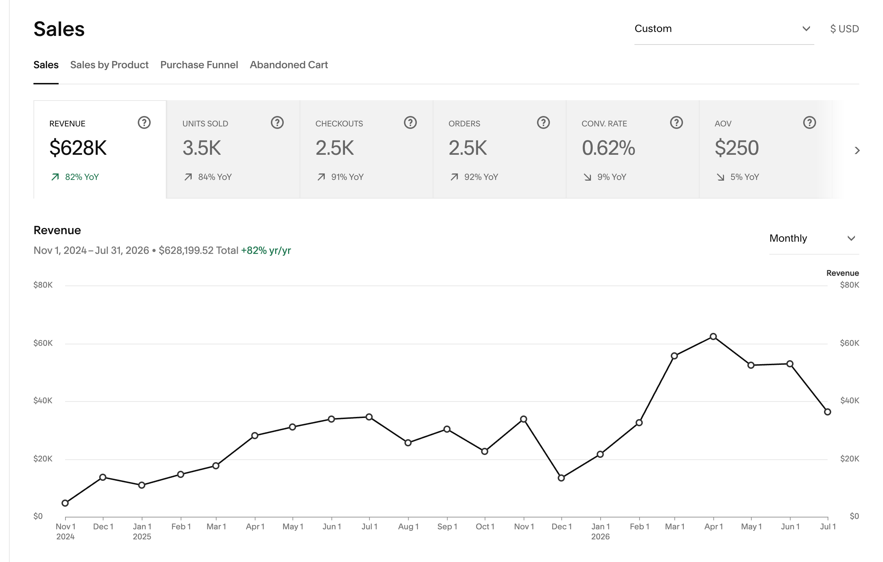
The client’s own store analytics: $628,199 total revenue, Nov 2024 – Jul 2026.

Time Period | Revenue
All of last year (Jan–Dec 2025) | $296,441
This year, first 6 months only (Jan–Jun 2026) | $277,302
Full engagement to date (Nov 2024–Jul 2026) | $628,200

Read that middle row again. In just the first six months of this year, the brand generated almost the entire revenue of the previous twelve months combined — on the same disciplined, efficient ad spend. That’s what a properly built revenue engine does: it doesn’t just add sales, it changes the speed the whole business moves at.

THE CLIMB

What the growth actually looked like
Growth is never a straight line, and we’d rather show you the real one than a polished lie. Here’s the month-by-month climb off that $50K plateau to a $63K peak — dips, recoveries and all:

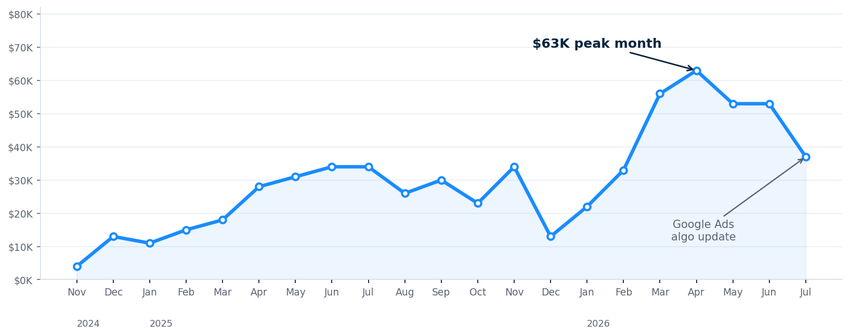
Monthly revenue, Nov 2024 – Jul 2026. Real data — including the July dip.

About that dip in July — and why we’re showing it to you
You can see revenue soften at the far right of that chart. We’re not hiding it — we’re showing it, because how a partner handles a setback matters more than a flawless highlight reel. In July, a Google Ads algorithm update hit accounts across our client base, temporarily pulling Google’s return down and dropping impression share as competitors surged. Here’s the important part:
- We caught it immediately, because our tracking made the shift obvious within days — not at the end of a monthly report.
- The other channels held. Meta stayed strong at a 6.2x return and organic search kept producing, because we’d built an engine that doesn’t depend on any single source.
- We restructured and monitored the account, adjusting budgets and setup to reclaim impression share — exactly the kind of active, hands-on response a growth partner exists for.

“Any agency can show you a good month. A growth partner shows you the hard one — and what they did about it.”

WHAT’S NEXT

Now we take this brand global
The engine is proven, the demand is there, and the new custom Shopify store is live. The next phase is already underway: we’re structuring the brand to scale into new countries, starting with the international markets that are already showing organic demand. The same system that broke one ceiling is now being pointed at a much bigger map — and we’re preparing the ad accounts and fulfilment to match.

$296K  ALL OF 2025 | $277K  FIRST HALF OF 2026 | $628K  TOTAL, NOV ’24–JUL ’26

Sound familiar?
If you’ve got a genuinely great product and loyal customers, but you can feel a ceiling on your growth you can’t break — the problem usually isn’t your product. It’s the system you’re using to sell it. That’s exactly what we fix: smarter ads, free search traffic you own, a website built to convert, and repeat customers who come back. Same budget, far bigger returns — with a partner, not an agency.

Book a Free Growth Audit
We’ll look at your business, show you where the growth is leaking, and map out exactly how we’d build your revenue engine — no obligation.
booking.in/ruync
GROWTHMAK · YOUR GROWTH PARTNER

Confidential case study. Figures are drawn from the client’s own analytics and ad platforms. Individual results depend on product, market, and starting point.

