Experiment 1: Select the distinct department id from employees file

Aim
To write a Pandas program to select the distinct DEPARTMENT_ID values from the employees file.

Algorithm
- Start the program.
- Import the pandas library.
- Read the employees data from 'employees.csv' into a DataFrame.
- Apply the unique() function on the DEPARTMENT_ID column to obtain the distinct department ids.
- Print the resulting distinct DEPARTMENT_ID values.
- Stop the program.

Program
import pandas as pd

df = pd.read_csv("employees.csv")

print("Original employees data:")
print(df)

distinct_dept = df['DEPARTMENT_ID'].unique()

print("\nDistinct department id from employees file:")
print(distinct_dept)

Input
employees.csv file containing DEPARTMENT_ID, DEPARTMENT_NAME, MANAGER_ID, LOCATION_ID columns.

Output
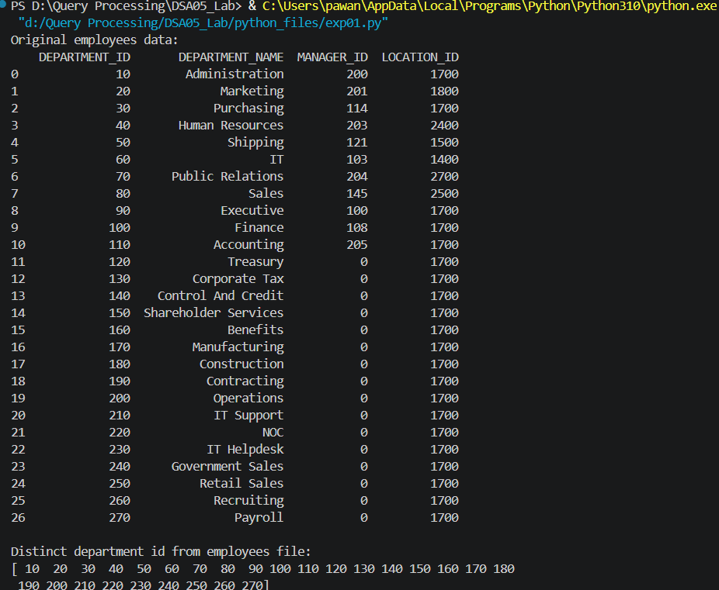

Result
The Python program to select the distinct department id from employees file was executed successfully and the output was verified.

