Experiment 2: Display the IDs of employees who have done two or more jobs in the past

Aim
To write a Pandas program to display the IDs of employees who have held two or more jobs in the past, using the job history data.

Algorithm
- Start the program.
- Import the pandas library.
- Read the job history data from 'job_history.csv' into a DataFrame.
- Group the DataFrame by EMPLOYEE_ID and count the number of JOB_ID entries for each employee.
- Filter the grouped result to keep only employees whose job count is 2 or more.
- Print the IDs of the employees satisfying the condition.
- Stop the program.

Program
import pandas as pd

df = pd.read_csv("job_history.csv")

print("Original job history data:")
print(df)

job_counts = df.groupby('EMPLOYEE_ID')['JOB_ID'].count()

result = job_counts[job_counts >= 2]

print("\nIDs of employees who have done two or more jobs in the past:")
print(result.index.tolist())

Input
job_history.csv file containing EMPLOYEE_ID, START_DATE, END_DATE, JOB_ID, DEPARTMENT_ID columns.

Output
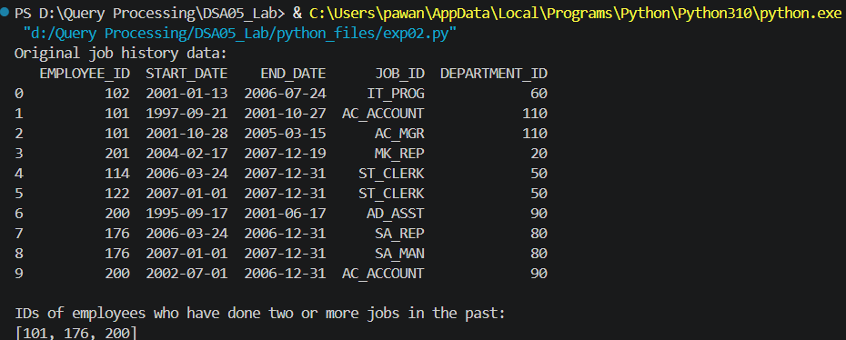

Result
The Python program to display the IDs of employees who have done two or more jobs in the past was executed successfully and the output was verified.

