Experiment 3: Display the details of jobs in descending sequence on job title

Aim
To write a Pandas program to display the details of jobs sorted in descending order of job title.

Algorithm
- Start the program.
- Import the pandas library.
- Read the jobs data from 'jobs.csv' into a DataFrame.
- Use sort_values() on the JOB_TITLE column with ascending=False.
- Print the sorted DataFrame.
- Stop the program.

Program
import pandas as pd

df = pd.read_csv("jobs.csv")

print("Original jobs data:")
print(df)

result = df.sort_values('JOB_TITLE', ascending=False)

print("\nJobs details in descending order of job title:")
print(result)

Input
jobs.csv file containing JOB_ID, JOB_TITLE, MIN_SALARY, MAX_SALARY columns.

Output
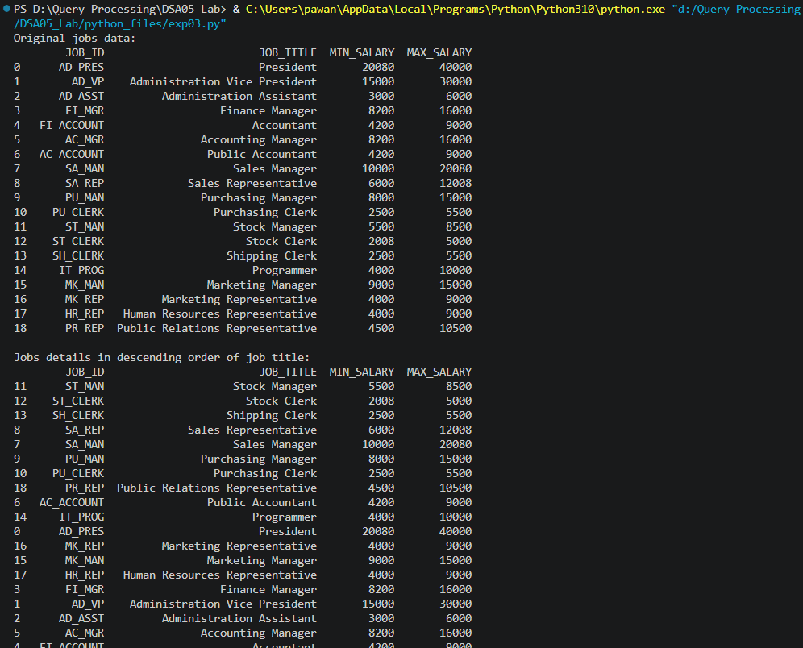

Result
The Python program to display the details of jobs in descending sequence on job title was executed successfully and the output was verified.

