Experiment 4: Line plot of the historical stock prices of Alphabet Inc. between two specific dates

Aim
To write a Pandas program to create a line plot of the historical closing stock prices of Alphabet Inc. between two specific dates.

Algorithm
- Start the program.
- Import pandas and matplotlib.pyplot.
- Read the alphabet stock data from 'alphabet_stock_data.csv' with the Date column parsed as dates.
- Filter the DataFrame to keep records that fall between the two specified dates.
- Plot the Close price column against the Date column using a line plot.
- Label the x-axis, y-axis and give the plot a title.
- Display the plot.
- Stop the program.

Program
import pandas as pd
import matplotlib.pyplot as plt

df = pd.read_csv("alphabet_stock_data.csv", parse_dates=['Date'], dayfirst=True)
df = df.sort_values('Date')

start_date = '2020-04-06'
end_date = '2020-04-24'
mask = (df['Date'] >= start_date) & (df['Date'] <= end_date)
filtered_df = df.loc[mask]

print("Filtered stock data between", start_date, "and", end_date)
print(filtered_df)

plt.figure(figsize=(8, 5))
plt.plot(filtered_df['Date'], filtered_df['Close'], color='blue', marker='o')
plt.xlabel('Date')
plt.ylabel('Closing Stock Price')
plt.title('Alphabet Inc. Closing Stock Price')
plt.xticks(rotation=45)
plt.tight_layout()
plt.show()

Input
alphabet_stock_data.csv containing Date, Open, High, Low, Close, Adj Close, Volume columns; start and end date given in the program.

Output
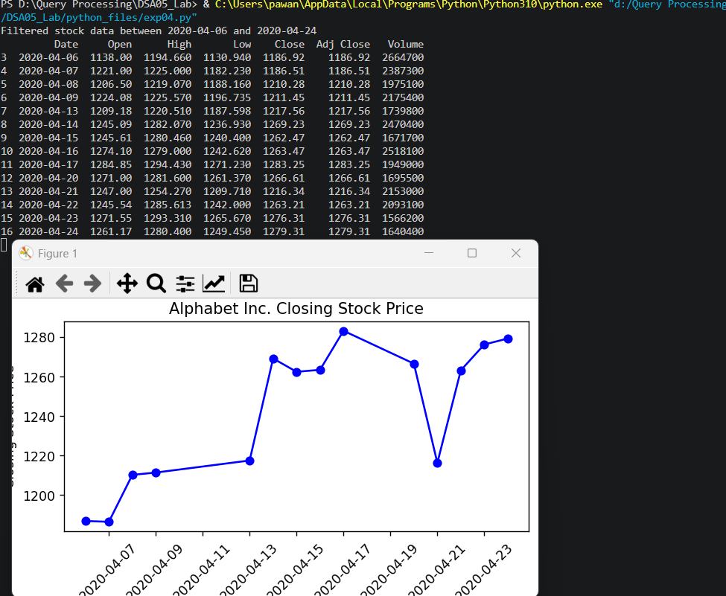

Result
The Python program to line plot of the historical stock prices of Alphabet Inc. between two specific dates was executed successfully and the output was verified.

