Experiment 5: Bar plot of the trading volume of Alphabet Inc. stock between two specific dates

Aim
To write a Pandas program to create a bar plot of the trading volume of Alphabet Inc. stock between two specific dates.

Algorithm
- Start the program.
- Import pandas and matplotlib.pyplot.
- Read the alphabet stock data from 'alphabet_stock_data.csv' with the Date column parsed as dates.
- Filter the DataFrame to keep records between the two specified dates.
- Plot the Volume column against Date using a bar plot.
- Label the axes and give the plot a title.
- Display the plot.
- Stop the program.

Program
import pandas as pd
import matplotlib.pyplot as plt

df = pd.read_csv("alphabet_stock_data.csv", parse_dates=['Date'], dayfirst=True)
df = df.sort_values('Date')

start_date = '2020-04-06'
end_date = '2020-04-24'
mask = (df['Date'] >= start_date) & (df['Date'] <= end_date)
filtered_df = df.loc[mask]

print("Filtered stock data between", start_date, "and", end_date)
print(filtered_df)

plt.figure(figsize=(9, 5))
plt.bar(filtered_df['Date'].dt.strftime('%d-%m'), filtered_df['Volume'], color='orange')
plt.xlabel('Date')
plt.ylabel('Trading Volume')
plt.title('Alphabet Inc. Trading Volume')
plt.xticks(rotation=45)
plt.tight_layout()
plt.show()

Input
alphabet_stock_data.csv containing Date, Open, High, Low, Close, Adj Close, Volume columns; start and end date given in the program.

Output
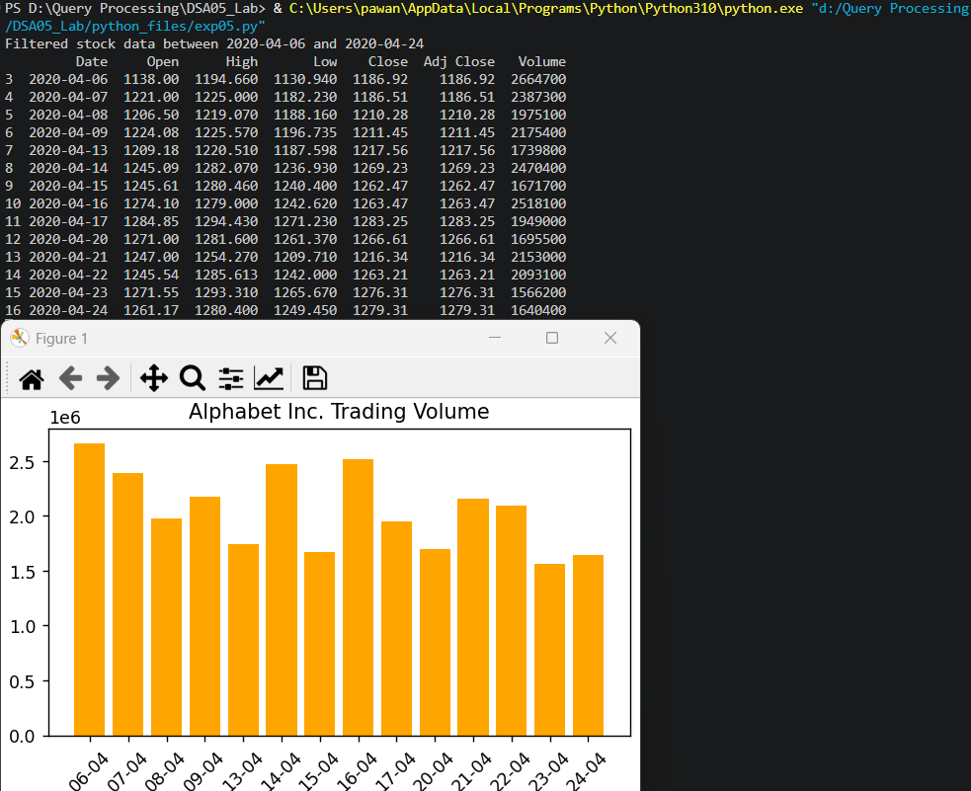

Result
The Python program to bar plot of the trading volume of Alphabet Inc. stock between two specific dates was executed successfully and the output was verified.

