Experiment 6: Scatter plot of the trading volume/stock prices of Alphabet Inc. stock between two specific dates

Aim
To write a Pandas program to create a scatter plot of the trading volume against the closing stock price of Alphabet Inc. between two specific dates.

Algorithm
- Start the program.
- Import pandas and matplotlib.pyplot.
- Read the alphabet stock data from 'alphabet_stock_data.csv' with the Date column parsed as dates.
- Filter the DataFrame to keep records between the two specified dates.
- Create a scatter plot with Close price on one axis and Volume on the other.
- Label the axes and give the plot a title.
- Display the plot.
- Stop the program.

Program
import pandas as pd
import matplotlib.pyplot as plt

df = pd.read_csv("alphabet_stock_data.csv", parse_dates=['Date'], dayfirst=True)
df = df.sort_values('Date')

start_date = '2020-04-06'
end_date = '2020-04-24'
mask = (df['Date'] >= start_date) & (df['Date'] <= end_date)
filtered_df = df.loc[mask]

print("Filtered stock data between", start_date, "and", end_date)
print(filtered_df)

plt.figure(figsize=(8, 5))
plt.scatter(filtered_df['Close'], filtered_df['Volume'], color='green')
plt.xlabel('Closing Stock Price')
plt.ylabel('Trading Volume')
plt.title('Alphabet Inc. Volume vs Closing Price')
plt.tight_layout()
plt.show()

Input
alphabet_stock_data.csv containing Date, Open, High, Low, Close, Adj Close, Volume columns; start and end date given in the program.

Output
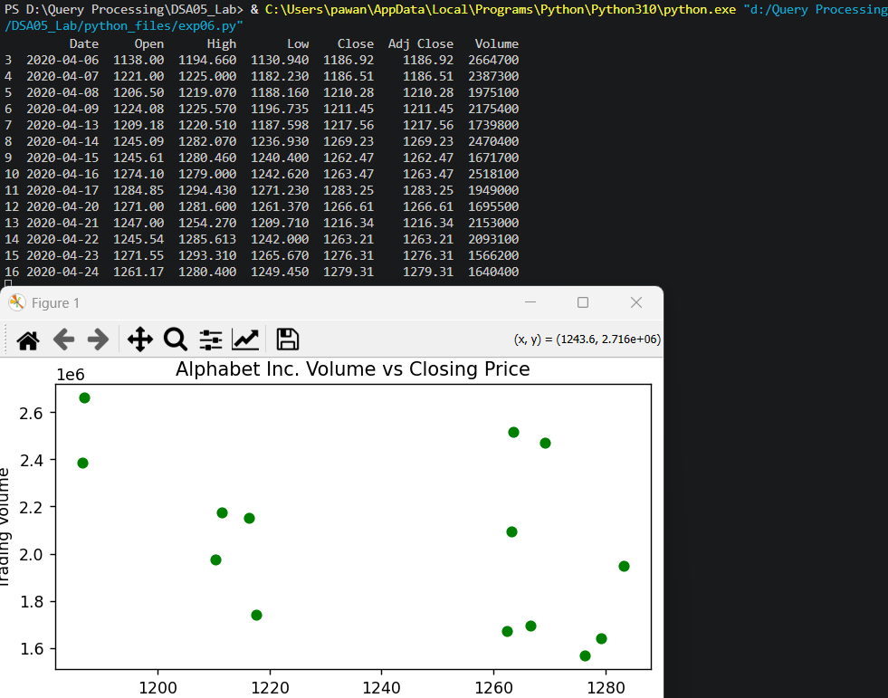

Result
The Python program to scatter plot of the trading volume/stock prices of Alphabet Inc. stock between two specific dates was executed successfully and the output was verified.

