Experiment 7: Pivot table to find the maximum and minimum sale value of the items

Aim
To write a Pandas program to create a pivot table from the sales data and find the maximum and minimum sale value for each item.

Algorithm
- Start the program.
- Import the pandas library.
- Read the sales data from 'sales_data.csv' into a DataFrame.
- Use pivot_table() with 'Item' as the index, 'Sale_amt' as values, and aggfunc as ['max', 'min'].
- Print the resulting pivot table.
- Stop the program.

Program
import pandas as pd

df = pd.read_csv("sales_data.csv")

print("Original sales data:")
print(df)

pivot = pd.pivot_table(df, index='Item', values='Sale_amt', aggfunc=['max', 'min'])

print("\nMaximum and minimum sale value of the items:")
print(pivot)

Input
sales_data.csv containing OrderDate, Region, Manager, SalesMan, Item, Units, Unit_price, Sale_amt columns.

Output
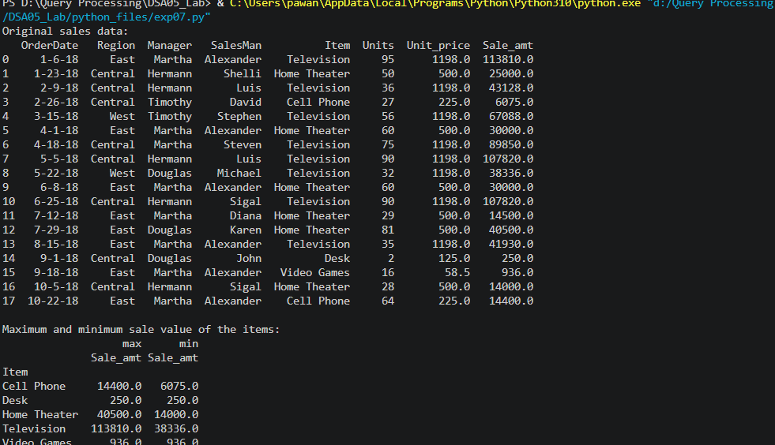

Result
The Python program to pivot table to find the maximum and minimum sale value of the items was executed successfully and the output was verified.

