Experiment 8: Pivot table to find the item wise unit sold

Aim
To write a Pandas program to create a pivot table from the sales data and find the total number of units sold, item wise.

Algorithm
- Start the program.
- Import the pandas library.
- Read the sales data from 'sales_data.csv' into a DataFrame.
- Use pivot_table() with 'Item' as the index, 'Units' as values and aggfunc as 'sum'.
- Print the resulting pivot table.
- Stop the program.

Program
import pandas as pd

df = pd.read_csv("sales_data.csv")

print("Original sales data:")
print(df)

pivot = pd.pivot_table(df, index='Item', values='Units', aggfunc='sum')

print("\nItem wise unit sold:")
print(pivot)

Input
sales_data.csv containing OrderDate, Region, Manager, SalesMan, Item, Units, Unit_price, Sale_amt columns.

Output
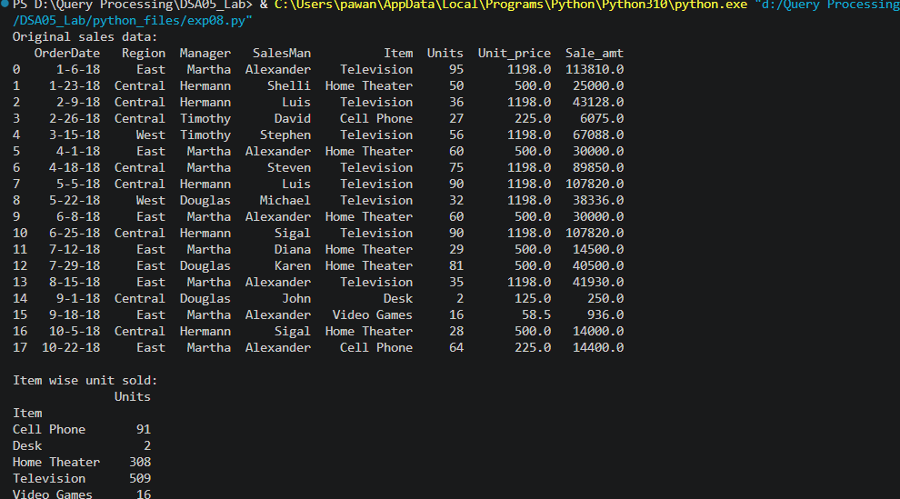

Result
The Python program to pivot table to find the item wise unit sold was executed successfully and the output was verified.

